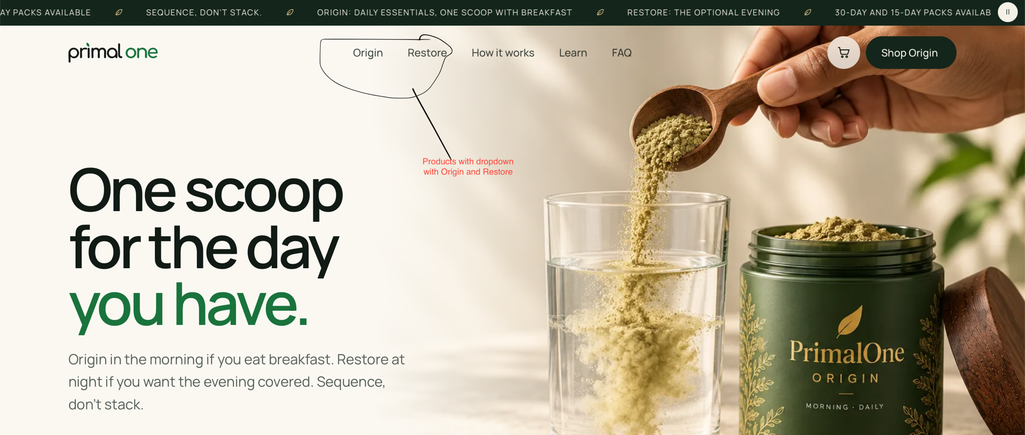
Shop with dropdown with Origin and Restore something like below
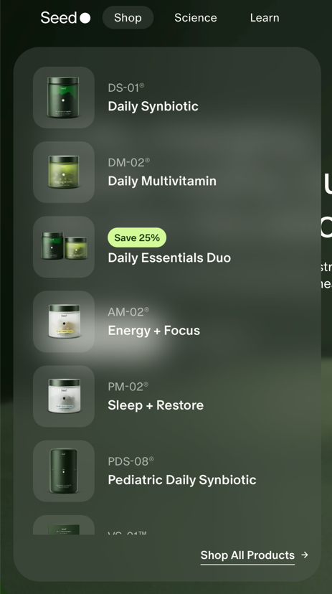
Instead of Shop Origin (in right corner), it will be Log In / Sign up to visit a different page for Access account and manage your orders. Also pls see, If we can add as below then great.
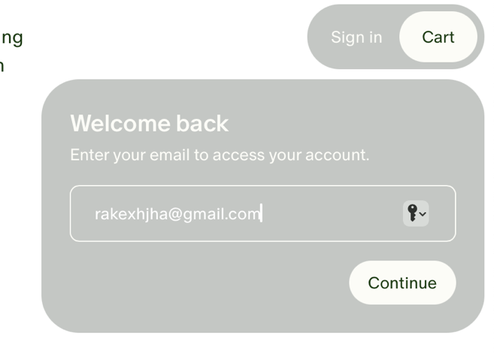

Remove this link as it should be only on product page from second and third block

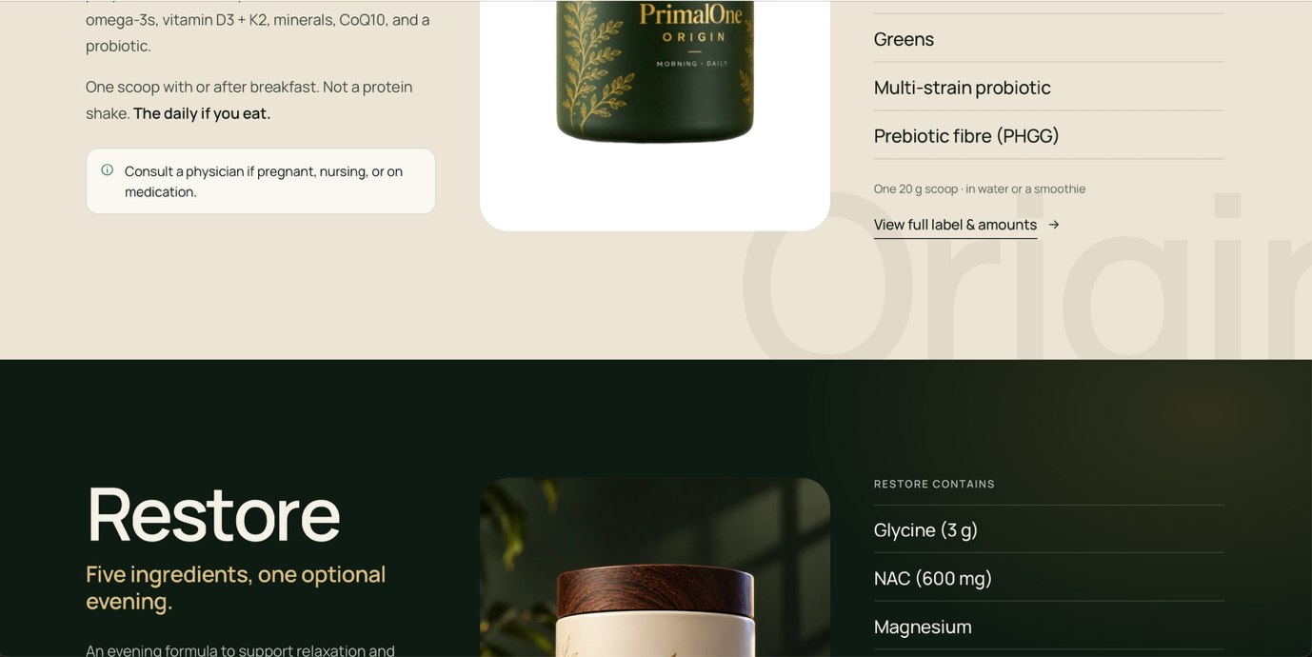
Both these blocks should be sideways and with animation of movement as we scroll up / down. Example below for animation scrolling

Restore
Origin

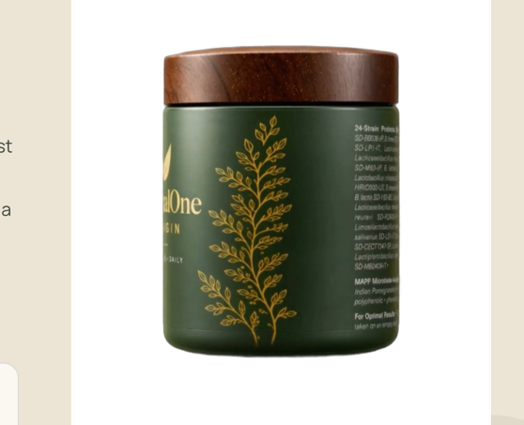
This circling product should be linking with above scrolling effect.
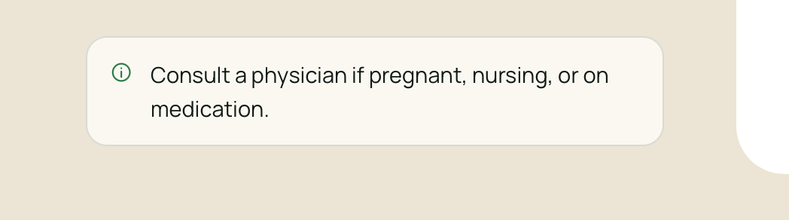
this warning should only in product page not on all pages. Also remove other warning from entire page.

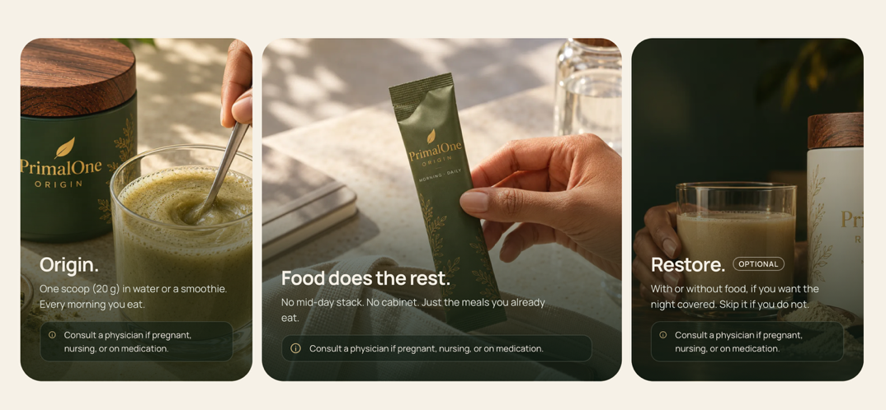
The above one should be replaced with something similar as below :

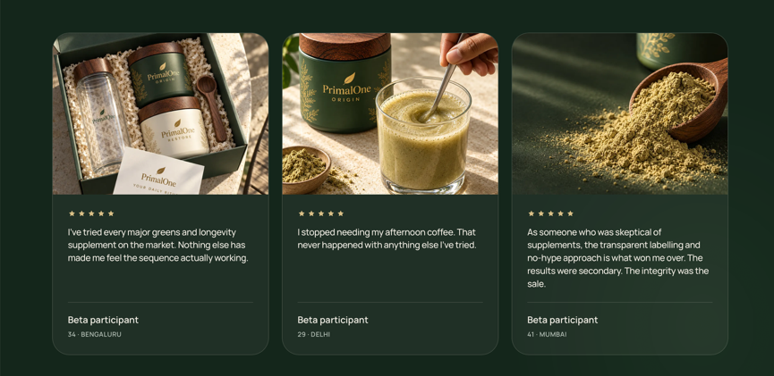
Replace the photo testimonies to video testimonies one as below :
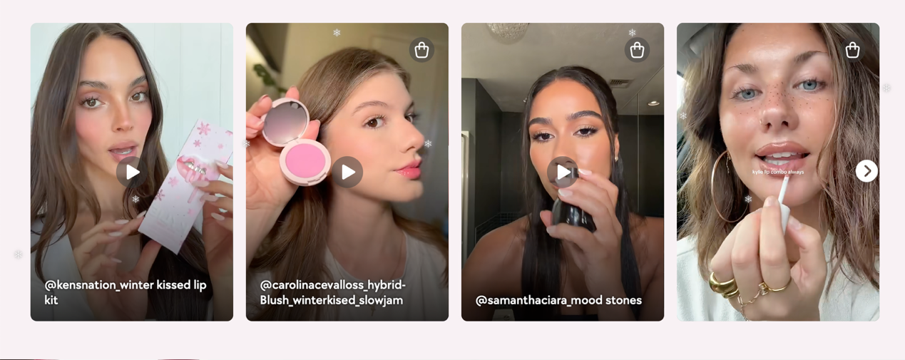

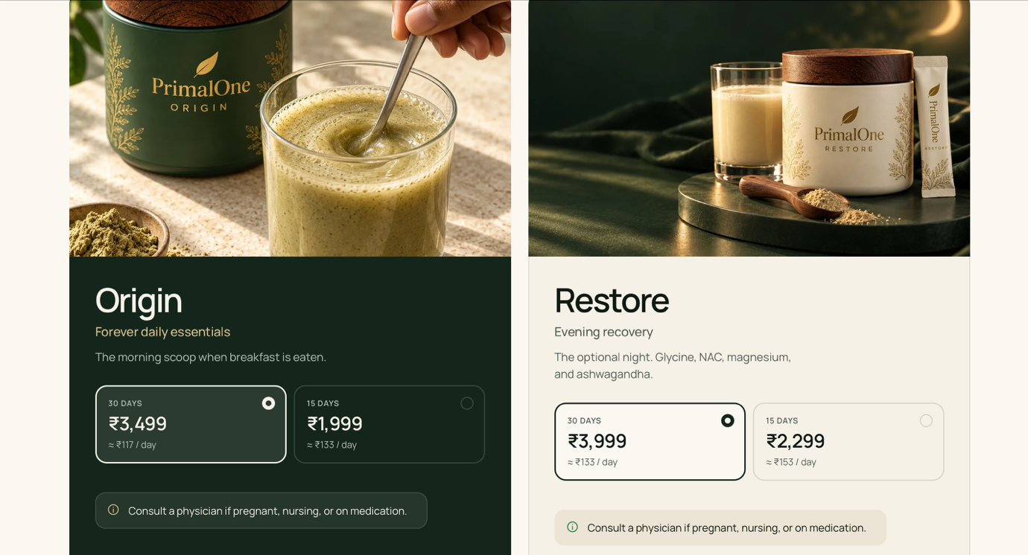
Instead of this big pallet build something small and sophisticated like below :
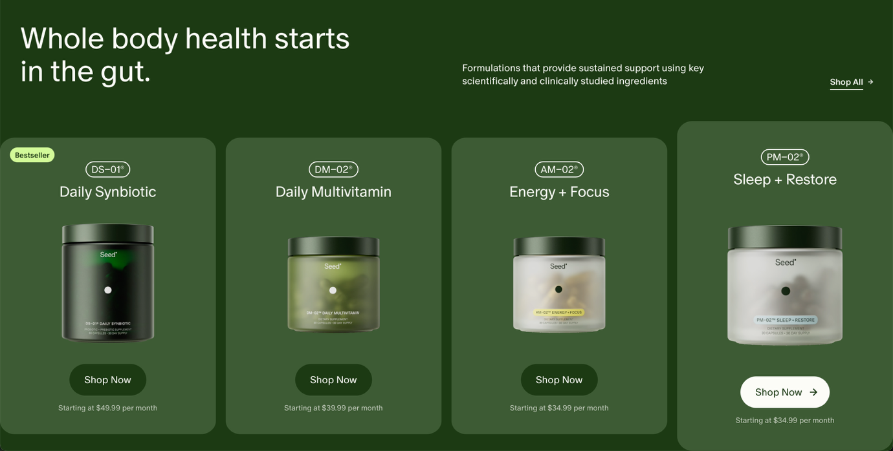

Remove below page :
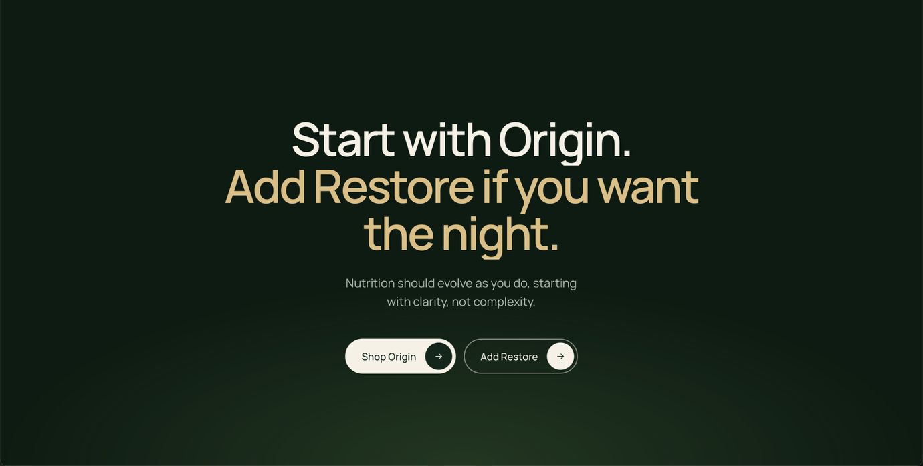
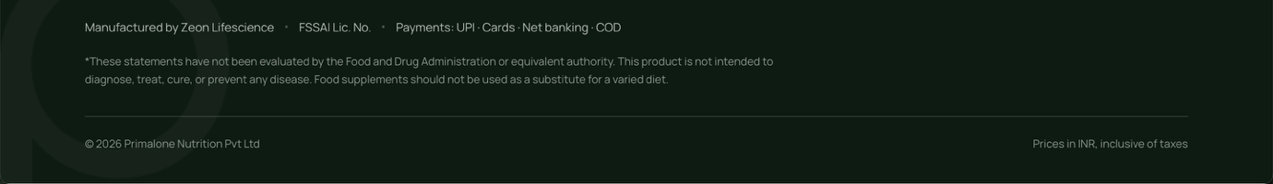
replace the above statement with below : (don’t mention the Zeon lifescience anywhere on website or contract manufacturer name anywhere else)
Manufactured in a facility certified to FSSAI, WHO-GMP, FSSC 22000, and NSF standards aligned with U.S. cGMP (21 CFR Part 111). The manufacturing site is U.S. FDA registered. Products are tested in an NABL-accredited laboratory.

Cart look and feel like below with showing options of Bundle + save discount and suggesting more products along with Promo code etc.
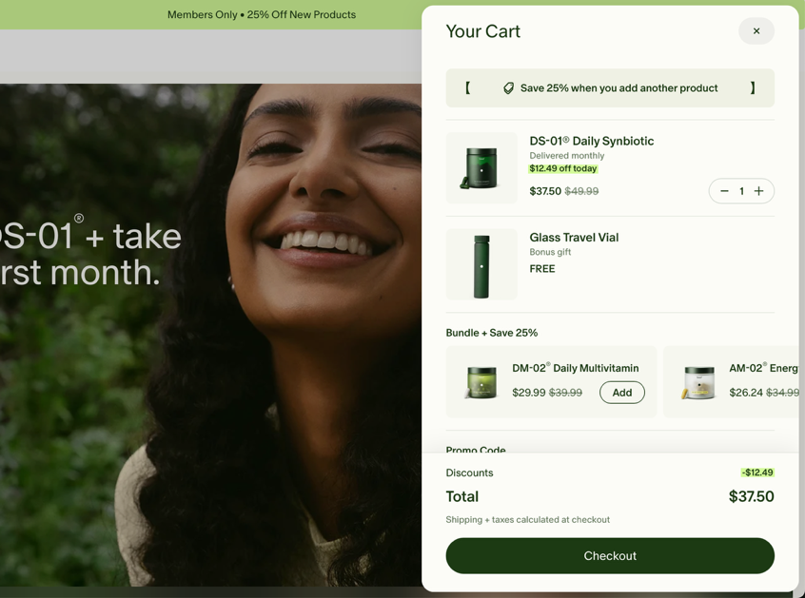

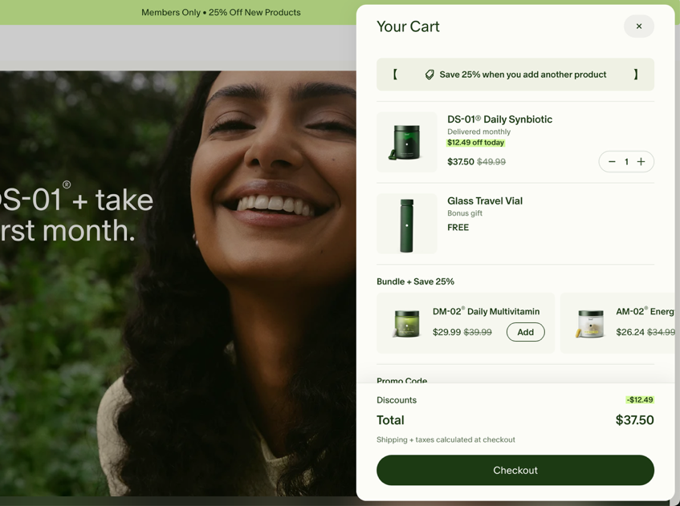

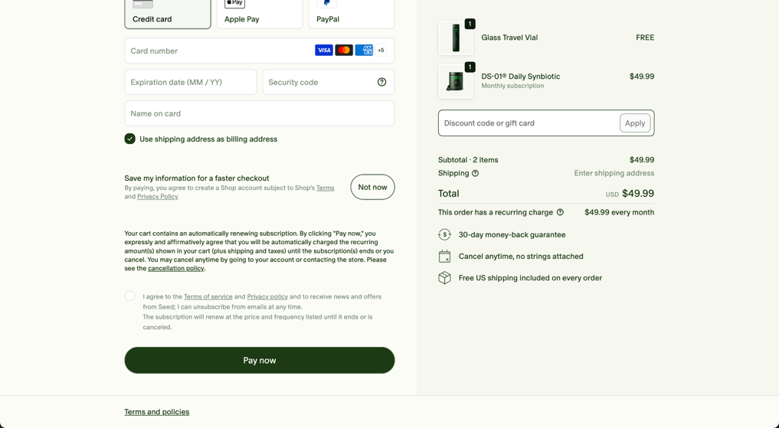
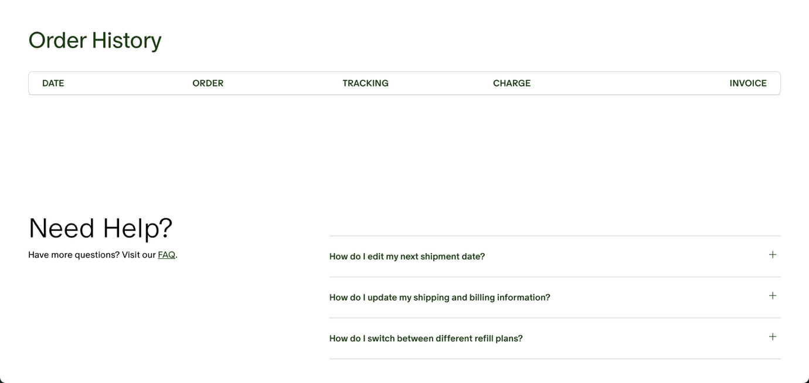

Remove - Prices in INR, inclusive of taxes from home page
We do not do COD.
Add social media links in footer

