1. INTRODUCTION

The project titled as “NP COMPUTERS” is done to manage all COMPUTERS shopping. It solves all types of hurdles that occur is Manual Booking maintenance and provides an effective way to keep car booking information.

The main aim of the project was to develop a website which would facilitate the online car booking through an effective and yet simple GUI for a normal customer intending to book a car. Apart from Course detail, through our system a can compare online fares ‘from’ various cities.

This is done with the usage of fallowing technologies
Front End: - Java, Java Script, HTML
Back End: - My SQL, Apache Tomcat Server

We begin with the frontend i.e. HTML, JAVASCRIPT and retrieve data in database i.e. MySql through ODBC connector 3.51.

Today most of the existing systems are operating manually resulting into several problems and hence causing Ambiguity and Business failure due to poor data base and customized, traditional, operational
Methodologies. To solve all these problems our developed system aims at computerized operation methods and data recording. And also improve the Business Strategies’.
The software is developed to meet the user’s requirement, which is made easy and user friendly. Here the user has full facility to book the car as per their requirements.

2. Feasibility Study

Feasibility is the determination of whether or not a project is worth doing. The process followed in making this determination is called a Feasibility Study. Once it has been determined that the project is feasible keeping the benefit of the Organization in mind, the analyst can go ahead and prepare the project specification, which finalizes the project requirements. Different tests of feasibility are studied during the investigation. The main of them are –
- Technical feasibility
- Economical feasibility
- Operational feasibility
2.1 Technical feasibility:
This is concerned with specifying equipment and software that will successfully satisfy the user requirement. It involves determining whether or not a system can actually be constructed or upgraded to solve the problem at hand. The technical needs of a system may vary considerably, but might include the following:
- The necessary technology of both hardware and software existed and also could be acquired for the new system.
- As the improvement in storage technology has developed over the recent years, data storage is becoming easier and safer.
- The new system with powerful database technology has the capacity to hold the proposed data.
Technically, the system is designed in such a way that it provides accuracy, reliability, easy access, data security and integrity. Hence this project is technically feasible.
2.2 Economical Feasibility
Economical feasibility involves estimating benefits and costs. These benefits and costs may be tangible or intangible. It is seen whether the expenditure incurred for developing the new system will be cost effective or not. Because of the confusion between the types of costs, it is sometimes very difficult to decide if the benefits outweigh the costs. This basically involves top-level management of the company who are the decision makers. Some Key findings from the study are listed below.

- There was no extra cost burden to conduct a full systems investigation.
- Basic Hardware and Software would ensure the smooth run of the application, as the necessary tools were easily available.
- The benefits are in the form of reduced costs with merely any errors, thus reducing the manual work.
- If the system were used without any major changes to it, no extra costs would be incurred.
The cost of the overall functionalities is less than the usability. Hence this project is economically feasible.

2.3 Operational Feasibility
Operational feasibility deals with the human aspect of the organization. Proposed projects are beneficial only if they can be turned into information systems that will meet the organization’s operating requirements. This feasibility test asks whether the system will work when developed and installed. The users need to be convinced about the advantages of the new system.
Unless this is done effectively, the system would not be implemented even after its development and the old system would continue to be used. Some key findings from the study are as follows.
- It has been found to be well supportive by both the Management and the Users. If changes are needed, it has been notified and comprehensive solution has been designed.
Hence this project is operationally feasible.

3. LITERATURE SURVEY

3.1 PRESENT SYSTEMS
This existing system is either partially or wholly paper based and manual. It involves front office staff of the organization in question painstakingly maintaining and updating records into diaries, day sheets and application. The limitations of such a system are common to most other systems involving reservations and the subsequent management of large quantities of data. They are:

DRAWBACKS
- The redundancy of stored data
- Inconsistencies in the stored data
- Human error
- Slower updating of data and slower retrieval
- Clumsy and error prone
- Time consuming as every day entries have to be made in many books
- Limited information can be entered about the case. So for more information the owner has to look elsewhere

3.2 PROPOSED SYSTEM
The proposed system aims to get rid of the books and applications. Here the same information is to be stored in a computer database. And as the data stored in a computer database can be manipulated to suit our needs we can get whatever information we want more easily. In this we can send SMS to customer about their Insurance information such as policy_number, unit_price and Net Asset Value(NAV). To send this SMS we need information of customer such as contact no and so on.
The proposed system will incorporate all the functional requirements. The requirements are as follows:

3.2.1 REQUIREMENT SPECIFICATION
The s/w is designed to make mediator between the Employee, Customer and Agent as needed by most large policy and customer details, employed Agents. The s/w will have the ability to respond to a wide range of queries of adding a particular client for new policy. The employee details, and policy generated and the claim received of specific customer. The databases will store and easily retrieve large quantities of data easily and elegantly.

3.2.2 NEED FOR COMPUTERISATION
The increasing complexity of services and hence the large quantities of information necessary to be maintained by modern day company has made the computerization of the front office system a necessity, and this system is specifically designed for the owner in mind as the end user.

3.2.3 BENEFITS OF THE PROPOSED SYSTEM
The proposed system automates the existing system, which improves its convenience, efficiency, and usability and also makes it cost effective. Especially in case of complex systems like General Insurance Management System, automation is very much necessary as a huge amount of information exchange and workflow is involved between the major entities of the system. The information like Agent Management & claim tracking has to be properly processed and stored for later use like Renewals.
4. Requirement Specifications
4.1 HARDWARE REQUIREMENT FOR THE APPLICATION
- Processor : Pentium-IV 2.4GHz
- Hard Disk : 5 GB
- Main Memory : 100 MB
- Cache : 512 KB
- I/O device : 15” color monitor, optical mouse, 104 keyboards.
- Other device : Graphic card

4.2 SOFTWARE REQUIREMENT FOR THE APPLICATION
This project is developed using the Java, JSP & HTML technologies mentioned below.

- Operating System : Windows 95/ 98/ 2000/ XP/ NT/ VISTA/Windows 7
- Front End : JAVA, JSP & HTML
- Back End : MySQL
- Connector : ODBC connector
- Server : Apache Tomcat Server

5. ARCHITECTURE OF THE PROJECT

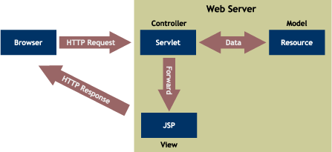

In the Design of our website we made an assumption that we are accessing the database of different city Dealers to get the Booking information. Any last minute changes to the Car Booking. Schedule are taken care by the respective Dealers. Presently we are accessing database. In our website we will be maintaining the table to hold user information, his booking details only.

The figure shows how our website is organized. The Servlet accesses the Database, which use the bean. The Servlet generates a DOM tree, which contains the required information. This HTML it transformed in to a code containing, JAVASCRIPT code. This is displayed to the user in a web browser. In case of a PDA device WML code is generated by the Web Application.

5.1 CONTROL FLOW IN A TYPICAL USER SESSION:-

      - User will type the URL of our site: www.SIS.com in the browser.
      - User will be shown our homepage containing various page links and search option.
      - The user is directed to the home page where he can start his search for his Favorite Course.
      - User can select the Course which he/she want to take admission.
      - User can see the particular Course Specification, Features etc.
      - User can also view the particular Course , Fee.
      - Administrator will click on the Login button to log on into our admin account.
      - The user-id and password are validated and the administrator is allowed to login.
      - The administrator can view the insert, delete, view ,update by click on the Search button.
      - Administrator will maintain all information of Student.

6. TECHNOLOGY USED IN PROJECT
6.1 INTRODUCTION TO HTML
HTML (Hypertext Markup Language) is used to create document which capability of World Wide Web. It is simply a collection of certain keywords called ‘Tags’ that are helpful in writing the document to be displayed using a browser on internet.

It is a platform independent language that can be used on any platform such as windows, Linux, Macintosh and so on. To display a document in web it is essential to mark-up the different elements (headings, paragraphs, tables and so on) of the document with the HTML tags. To view a mark-up document, user has to open the document in the browser. A browser understands and interprets the HTML tags, identifies the structure of the document and makes decision about presentation (how the parts look) of the document

HTML also provides tags to make the document look attractive using graphics, font size and colors. User can make a link to the other document or the different section of the same document by creating Hypertext links also known as Hyperlinks.

HTML TAGS
Tag | Name | Code Example | Browser View
<!-- | Comment | <!--This can be viewed in the HTML part of a document--> | Nothing will show (Tip)
<a - | Anchor | <a href="http://www.domain.com/">  Visit Our Site</a> | Visit Our Site (Tip)
<b> | Bold | <b>Example</b> | Example
<big> | big (text) | <big>Example</big> | Example (Tip)
<body> | body of HTML document | <body>The content of your HTML page</body> | Contents of your web page (Tip)
<br> | line break | The contents of your page<br>The contents of your page | The contents of your web page  The contents of your web page
<center> | Center | <center>This will center your contents</center> | This will center your contents
<dd> | definition description | <dl>  <dt>Definition Term</dt>  <dd>Definition of the term</dd>  <dt>Definition Term</dt>  <dd>Definition of the term</dd>  </dl> | Definition Term  Definition of the term  Definition Term  Definition of the term
<dl> | definition list | <dl>  <dt>Definition Term</dt>  <dd>Definition of the term</dd>  <dt>Definition Term</dt>  <dd>Definition of the term</dd>  </dl> | Definition Term  Definition of the term  Definition Term  Definition of the term
<dt> | definition term | <dl>  <dt>Definition Term</dt>  <dd>Definition of the term</dd>  <dt>Definition Term</dt>  <dd>Definition of the term</dd>  </dl> | Definition Term  Definition of the term  Definition Term  Definition of the term
<em> | Emphasis | This is an <em>Example</em> of using the emphasis tag | This is an Example of using the emphasis tag
<embed> | embed object | <embed src="yourfile.mid" width="100%" height="60" align="center"> | (Tip)

<font> | font | <font face="Times New Roman">Example</font> | Example (Tip)
<font> | font | <font face="Times New Roman" size="4">Example</font> | Example (Tip)
<font> | font | <font face="Times New Roman" size="+3" color="#ff0000">Example</font> | Example (Tip)
<form> | form | <form action="mailto:you@yourdomain.com">  Name: <input name="Name" value="" size="10"><br>  Email: <input name="Email" value="" size="10"><br>  <center><input type="submit"></center>  </form> | Name: 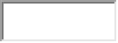(Tip)  Email:  
<h1>  <h2>  <h3>  <h4>  <h5>  <h6> | heading 1  heading 2  heading 3  heading 4  heading 5  heading 6 | <h1>Heading 1 Example</h1>  <h2>Heading 2 Example</h2>  <h3>Heading 3 Example</h3>  <h4>Heading 4 Example</h4>  <h5>Heading 5 Example</h5>  <h6>Heading 6 Example</h6> | 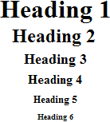
<head> | heading of HTML document | <head>Contains elements describing the document</head> | Nothing will show
<hr> | horizontal rule | <hr /> | Contents of your web page (Tip)  Contents of your web page
<hr> | horizontal rule | <hr width="50%" size="3" /> | Contents of your web page  Contents of your web page
<hr> | horizontal rule | <hr width="50%" size="3" noshade /> | Contents of your web page  Contents of your web page
<hr>  (Internet  Explorer) | horizontal rule | <hr width="75%" color="#ff0000" size="4" /> | Contents of your web page  Contents of your web page
<hr>  (Internet  Explorer) | horizontal rule | <hr width="25%" color="#6699ff" size="6" /> | Contents of your web page  Contents of your web page

6.2 Introduction to JSP (Java Server Pages)
Java Server Pages (JSP) is a technology based on the Java language and enables the development of dynamic web sites. JSP was developed by Sun Microsystems to allow server side development. JSP files are HTML files with special Tags containing Java source code that provide the dynamic content.
What is JavaScript?

- JavaScript was designed to add interactivity to HTML pages
- JavaScript is a scripting language
- JavaScript is usually embedded directly into HTML pages
- JavaScript is an interpreted language (means that scripts execute without preliminary compilation)
- Everyone can use JavaScript without purchasing a license

Why we use JSP?
JSP is easy to learn and allows developers to quickly produce web sites and applications in an open and standard way. JSP is based on Java,an object-oriented language. JSP offers a robust platform for web development.
Main reasons to use JSP:
- Multi platform
- Component reuse by using Javabeans and EJB.
- Advantages of Java.
- You can take one JSP file and move it to another platform,web server or JSP Servlet engine.

6.3 JavaScript
- JavaScript was basically used for client-side validation.
- JavaScript is compatible with all versions of Microsoft Internet Explorer and Netscape Navigator.
- We have small java scripts, which are lightweight and will not hinder the download time of the HTML document significantly.
6.4 ABOUT TO MYSQL
MYSQL provides data storage for the data what we entered in the JAVA this acts as media for storing data. A database is a collection of data with a given structure for accepting, storing and providing on demand, data for one or multiple uses.
In database environment common data are available and are used by several users. Instead of each program managing its own data, data across applications are shared by authorized users with the database software managing the data as an entity. A program now requests data through the data base management system (DBMS), which determines data sharing.
Objectives of Database are

Controlled redundancy: the redundant data occupies space and therefore, is wasteful. A unique aspect of database design is storing data only once, which controls redundancy and improves system performance.

Accuracy and Integrity: the accuracy of a database ensures that data quality and content remains constant. Integrity controls, detect data inaccuracies where they occur.
Performance this objective emphasizes response time to inquiries suitable to the users of the data. How satisfactory the response time is depends on the nature of the user- database dialogue.

6.5 APACHE TOMCAT SERVER

Apache Tomcat is a servlet container developed by the Apache Software Foundation (ASF). Tomcat implements the Java Servlet and the Java Server Pages (JSP) specifications from Sun Microsystems, and provides a "pure Java" HTTP web server environment for Java code to run.

Tomcat should not be confused with the Apache web server, which is a C implementation of an HTTP web server; these two web servers are not bundled together. Apache Tomcat includes tools for configuration and management, but can also be configured by editing XML configuration files.

Apache software is built in a community process, with both user and developer mailing lists. The developer list is where discussion on building and testing the next release takes place, while the user list is where users can discuss their problems with the developers and other users.

A number of free Apache Tomcat resources and communities have developed in 2010 including Tomcatexpert.com, a Spring Source sponsored community for developers and operators who are running Apache Tomcat in large-scale production environments, and MuleSoft's Apache Tomcat Resource Center, where you can find instructional guides on installing, updating, configuring, monitoring, troubleshooting and securing various versions of Tomcat.

Tomcat is enterprise class, robust web server which comes bundled with Java Servlets and JSP that provides a java application server environment

One of the other major issues why we chose Tomcat was Scalability. Presently Java is our core technology used for portability and in future if we want to make our site be reachable to users using Microsoft products we would be having no conflicts between the servers because Tomcat can be deployed as either a standalone product with its own internal Web server or in conjunction with several other Web servers, including

- Netscape Enterprise Server.
- Microsoft Internet Information Server.
- Microsoft Personal Web Server.

It adheres to the latest standards, which expands the security features.
Configuration, tuning and maintenance are lot easier than compared to other prevailing web servers.
Since we were not going for enterprise java beans in our project we didn’t feel the necessity of going for other application servers like J2EE or JBOSS .We were basically looking for a reliable web server which would be compatible with both the front-end and back-end technologies we were using and our ultimate choice was Apache’s Tomcat Web Server.


Screenshot [show]
Developer(s) | Apache Software Foundation
Stable release | 7.0.22^{[1]} / October 1, 2011; 40 days ago
Development status | Active
Written in | Java
Operating system | Cross-platform
Type | Servlet container  HTTP web server
License | Apache License 2.0
Website | http://tomcat.apache.org

7. DETAIL DESIGN

Detailed design covers the study of the major entities involved in the system, their attributes and relationships, how they can be transformed into normalized tables and what is the dependency among the tables. While system definition is design oriented, detailed design is implementation oriented. By defining logical and physical structure of the database, detailed design guides the implementation phase.

7.1 Table Design
7.1.1 inc
Field | Data Type | Null | Key
pid | varchar(45) |  | Primary
brand | varchar(45) |  | Primary
prg | varchar(45)
price | varchar(56)

8. SNAPSHOTS
Home

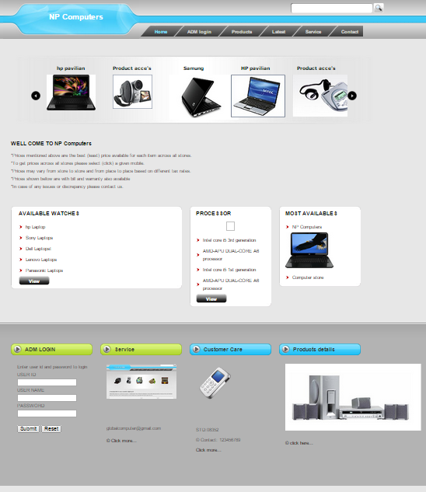

Login

Insert

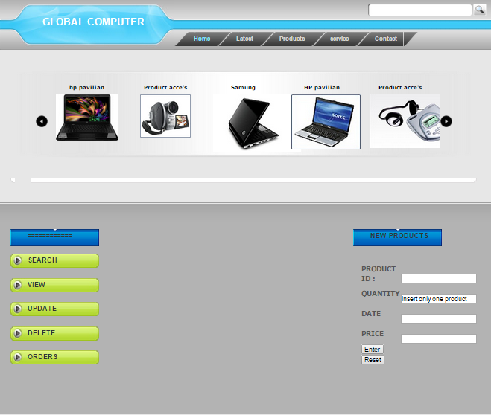
Delete

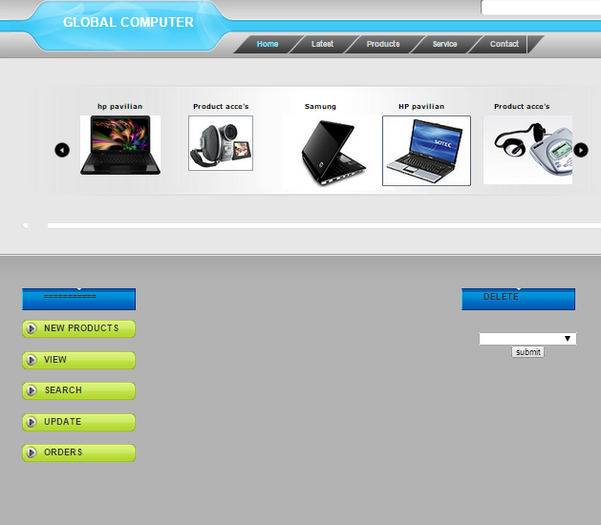

Update

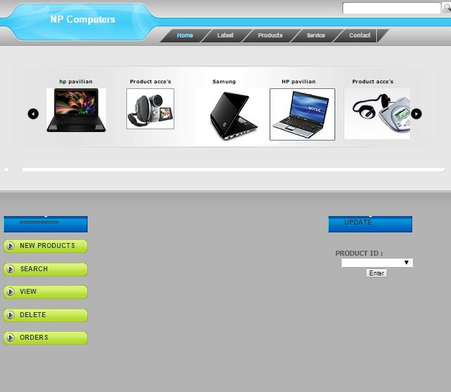

8. CONCLUSION

10. FUTURE ENHANCEMENT

Future enhancements are given below,

- Our project can implement in new version of JDK Package.

- This can be implementing in Mobile technology. Through Mobile also user can take appointments of doctor.

- As of now, the questions are directly asked to call center, or through Showroom, etc, in future queries written into tables, site, problems can be solved by the administrator. Creating a computerized module for it.

- In future it can also modified or make some changes or more user friendly and more easy to access or maintained.

- This project can also implement in more other languages. For platform independent.

- Customer can get E–Mail from Company, Dealer about Models

BIBLIOGRAPHY

- Programming with JAVA

-By Balaguruswamy.

- Java Complete Reference

-By Herbert Schildt.

- www.Google.com

- www.w3schools.com

