Milestone 4 Report
Security Risk Assessment, Predictive Intelligence & Executive Analytics
Advanced Threat Incident Analytics and Security Visualization Framework

Objective
This milestone extends the Power BI cybersecurity analytics project built in Milestones 1-3 by adding three new capabilities: a Security Risk Assessment dashboard that scores and ranks risk across locations and departments, a Predictive Intelligence dashboard that forecasts incident trends and flags emerging high-risk zones, and an Executive Intelligence dashboard that condenses both into decision-ready metrics for leadership. Together, these dashboards move the project from describing what has already happened to identifying where risk is concentrated now and where it is likely to grow.

Dashboard Screenshots
Security Risk Assessment Dashboard
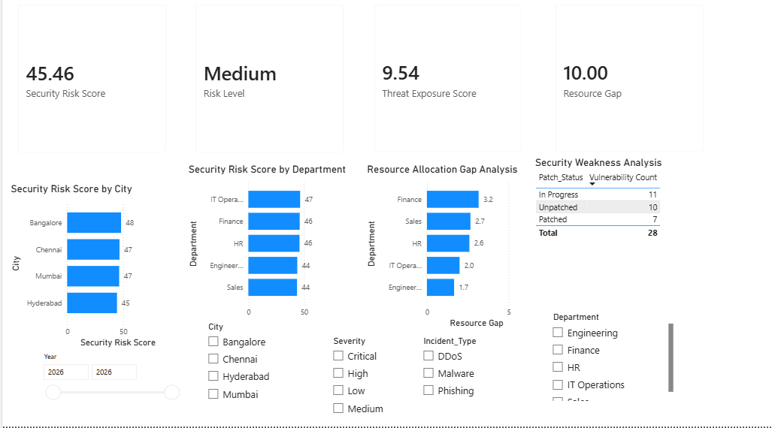
Predictive Intelligence Dashboard
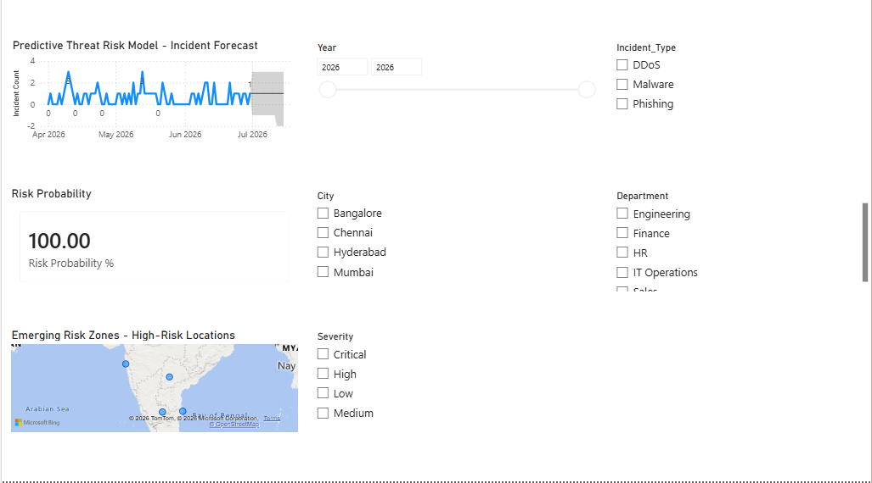
Executive Intelligence Dashboard
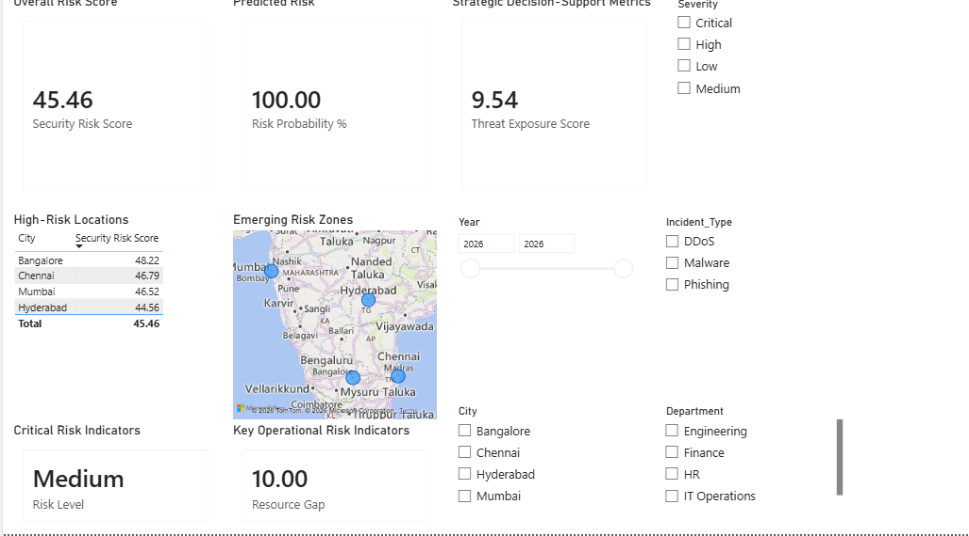

Five Key Insights
- Overall risk sits at a Medium level (Security Risk Score 45.46 of 100), indicating a manageable but non-trivial threat posture across the organization rather than an isolated hotspot.
- Risk is fairly evenly distributed across locations: Bangalore (48), Chennai and Mumbai (47 each), and Hyderabad (45) all fall within a narrow band, meaning no single city can be treated as a standalone outlier for remediation planning.
- Finance and HR carry the highest resource strain, each averaging 2.0 incidents per analyst, while Finance also has the highest Resource Allocation Gap (3.2) - these two departments are the most understaffed relative to their incident load.
- Of the 28 tracked vulnerabilities, 21 (75%) are not yet fully remediated - 11 In Progress and 10 Unpatched versus only 7 Patched - pointing to a patch-management backlog as a primary driver of the current Threat Exposure Score (9.54).
- IT Operations and Finance post the highest departmental risk scores (47 and 46), aligning with where both incident volume and resourcing gaps are concentrated, and marking them as the priority departments for the recommendations below.

Predictive Findings
The Predictive Threat Risk Model, built using Power BI's native Forecast analytics on a daily incident-count series, projects the near-term trajectory of incidents forward from the end of the observed data window. Because the underlying dataset covers a short window (roughly two to three months), the forecast should be read as an early trend indicator rather than a long-range prediction, and this is reflected in a wide confidence band on the forecast chart.
The Risk Probability % measure, which compares the most recent 30-day incident count against the prior 180-day average, is currently at its ceiling of 100%. This reflects a recent 30-day incident count that meets or exceeds six times the historical daily average - a signal worth flagging to stakeholders as "elevated relative to baseline" but tempered by the limited historical baseline available for comparison.
The Emerging Risk Zones map, which sizes each city's bubble by its Security Risk Score, visually confirms the location findings above: Bangalore, Chennai, and Mumbai form the largest bubbles, indicating these three cities warrant closer monitoring as forecasted incident volume grows.

Three Strategic Recommendations
- Prioritize patch remediation for the 10 Unpatched and 11 In-Progress vulnerabilities, targeting the Unpatched group first since it directly drives the Threat Exposure Score - clearing this backlog is the single highest-leverage action available to reduce overall risk.
- Reallocate analyst capacity toward Finance and HR, the two departments with the highest incidents-per-analyst ratio (2.0) - either by adding headcount or by redistributing lower-priority work from better-resourced departments such as Sales and Engineering.
- Treat Bangalore, Chennai, and Mumbai as a joint monitoring group rather than ranking them individually, since their risk scores are closely clustered - apply any citywide mitigation (e.g., updated response protocols) across all three simultaneously rather than sequentially.
Note on methodology: Risk Probability % and the forecast model are built using Power BI's native DAX and Forecast analytics rather than a trained machine-learning model, and are presented here as risk-scoring heuristics, not statistical predictions.

