**1. Two Sum**

Easy

374461195Add to ListShare

Given an array of integers nums and an integer target, return *indices of the two numbers such that they add up to target*.

You may assume that each input would have ***exactly* one solution**, and you may not use the *same* element twice.

You can return the answer in any order.

**Example 1:**

**Input:** nums = [2,7,11,15], target = 9

**Output:** [0,1]

**Explanation:** Because nums[0] + nums[1] == 9, we return [0, 1].

**Example 2:**

**Input:** nums = [3,2,4], target = 6

**Output:** [1,2]

**Example 3:**

**Input:** nums = [3,3], target = 6

**Output:** [0,1]

**Constraints:**

* 2 <= nums.length <= 104
* -109 <= nums[i] <= 109
* -109 <= target <= 109
* **Only one valid answer exists.**

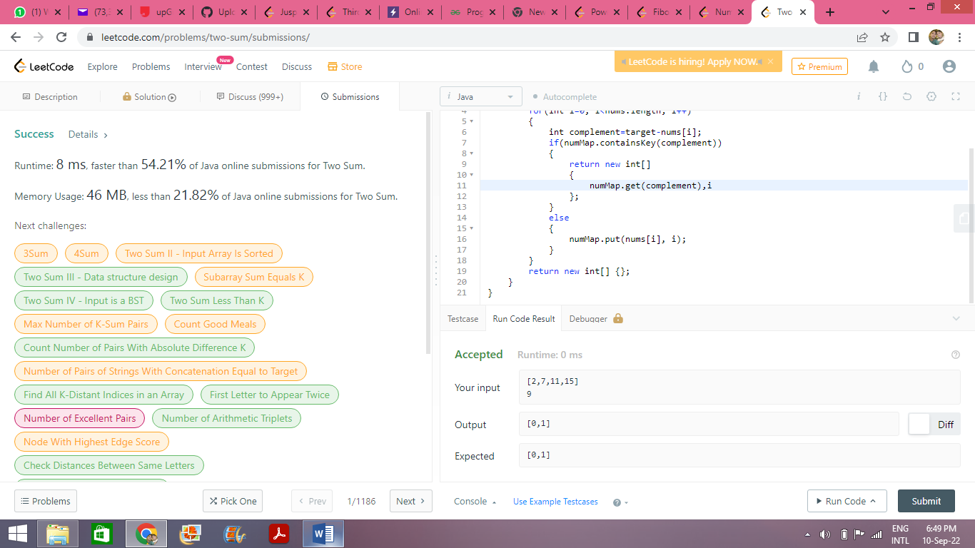

class Solution {

public int[] twoSum(int[] nums, int target) {

Map<Integer,Integer> numMap=new HashMap<>();

for(int i=0; i<nums.length; i++)

{

int complement=target-nums[i];

if(numMap.containsKey(complement))

{

return new int[]

{

numMap.get(complement),i

};

}

else

{

numMap.put(nums[i], i);

}

}

return new int[] {};

}

}