**Problem Statement**

1. Create a REST API using .Net Core MVC and write a method to return a sorted list of these by Publisher, Author (last, first), then title.
2. Write another API method to return a sorted list by Author (last, first) then title.
3. If you had to create one or more tables to store the Book data in a SQL Server/Sql Lite database, outline the table design along with fields and their datatypes.
4. Write stored procedures for steps 1 and 2 and use them in separate API methods to return the same results.
5. Write an API method to return the total price of all books in the database.
6. If you have a large list of these in memory and want to save the entire list to the database, with only one call to the DB server.
7. Add a property to the Book class that outputs the MLA (Modern Language Association) style citation as a string (<https://images.app.goo.gl/YkFgbSGiPmie9GgWA>). Please add whatever additional properties the Book class needs to generate the citation.
8. Add another property to generate a Chicago style citation (Chicago Manual of Style) (<https://images.app.goo.gl/w3SRpg2ZFsXewdAj7>).

**Please Find My Answers Below**

**\*\* Used Entity Framework Code-First Approach for DB Connectivity.**

**\*\*Used SQL Server for Data Storage**

1. Created API to return the sorted list based on Publisher, Author (last, first), then title.

2. Created API to return the sorted list based on Author (last, first), then title.

3. As per my understanding and knowledge, the Books table can be designed like mentioned below class diagram which will provide a decoupled and well structured database instead of above given sample class.

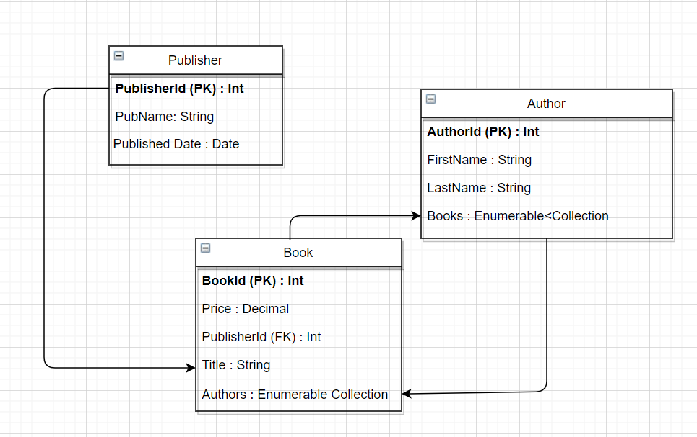

4.Created an API to return the same result as point number 1 and 2 above by using Stored Procedure

5. Created an API to return the sum of prices for all Books.

6. If we have 1 million records, using an EF Db Context will not be the best approach as it will take a round trip to the DB for each single record. The best way to insert using **BULK INSERT** by specifying batch size which will insert the records in batches. And one more efficient way would be using Reddish cache to handle large volumes of in-memory representations efficiently.

7. Used the below MLA format as reference

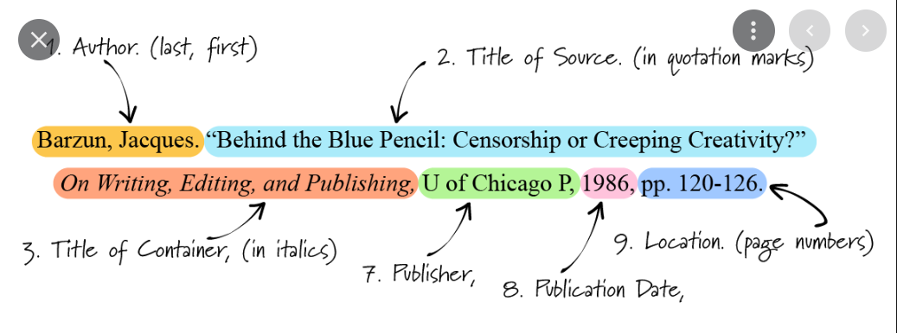

1. Used the below Chicago format as reference

