**ELECTRIC VEHICLE MARKET SEGMENTATION IN INDIA**

**AMBIKA P(TL)**

**(20/1/2025)**

**INTRODUCTION**

The rapid growth of India’s electric vehicle (EV) market has sparked interest in adoption trends, charging infrastructure, and state-wise manufacturer presence to identify opportunities. Global collaborations and national goals like reducing emissions and fossil fuel dependence are driving EV adoption. However, challenges like charging time and range persist, highlighting the urgent need for efficient infrastructure. This study explores barriers to e-mobility, advancements in charging infrastructure, and the current state of installed stations, emphasizing the importance of robust infrastructure to boost EV adoption and sustainability.

India’s transition to electric mobility requires a well-established charging infrastructure along national highways to support long-distance EV travel. The limited number of charging stations on these key routes, such as the Golden Quadrilateral and high-traffic corridors, creates range anxiety and hinders EV adoption for inter-city travel and logistics. Expanding the number of fast-charging stations at strategic intervals is essential to ensure seamless mobility, promote EV usage, and advance sustainable transportation across the country.

**2. STATUS OF TRANSPORTATION ELECTRIFICATION IN INDIA**

The progress of transportation electrification in India has been slower than anticipated. Initially, India aimed to become a fully electric vehicle (EV) nation by 2030, but this ambitious goal was revised after the government realized the country was not fully prepared for such a transition. As a result, the target has been adjusted to a 30% EV adoption rate by 2030. Shifting policies and unclear plans have hindered EV sales, impacting the overall status of transportation electrification in India. EV sales in India are still low compared to developed nations, with uneven adoption across the country’s 29 states. Maharashtra led in EV sales in 2022 with 34,013 EVs sold, followed by Gujarat and Uttar Pradesh.

**3. MARKET ANALYSIS**

* The Indian electric vehicle (EV) market is one of the fastest-growing in the world, expected to grow at a compound annual growth rate (CAGR) of 94.4% from 2021 to 2030.
* Two-wheelers currently dominate the market, but there is growing demand for electric cars and buses.
* The Indian government is offering several incentives to promote EV adoption, including tax breaks, subsidies, and access to restricted lanes.
* The government has set a target of achieving 30% electrification of the country’s vehicle fleet by 2030.
* The EV market in India is projected to be worth around USD 152.21 billion by 2030, with the market size in 2022 estimated at USD 4.15 billion.
* The two-wheeler segment accounted for the largest share of the market, with 96% of the sales, followed by the passenger car segment (3%) and the bus segment (1%).
* The Indian government offers tax rebates for electric vehicles, including up to INR 1.5 lakh (USD 1,900) for cars and INR 50,000 (USD 640) for two-wheelers.
* A production-linked incentive (PLI) scheme has been announced for manufacturing electric vehicles and components, expected to attract investments of around INR 45 billion (USD 570 million) and create over 75,000 jobs in the sector.

**Promising Trajectory**: The electric vehicle market in India is on a promising trajectory, with strong government support, increasing consumer awareness, and a growing infrastructure. This sector is poised for substantial growth in the coming years, offering environmental and economic benefits, including job creation and reduced carbon emissions.

**4. CHARGING TECHNOLOGY**

Although the load from electric vehicles (EVs) is relatively small compared to the total system load, the ability to manage charging times significantly impacts emissions. A shortage of charging infrastructure and the absence of standardized charging stations contribute to "charging point anxiety," where EV owners worry about the availability and compatibility of connectors at charging stations. Currently, there is a lack of interoperability, as the EV and Electric Vehicle Service Equipment (EVSE) market is dominated by three distinct technologies, each with its own connectors and communication protocols. Charging technology plays a critical role in connecting EVs to the power grid.

**5. MARKET SEGMENTATION ANALYSIS**

This analysis integrates five types of datasets from various sources, such as government websites, EV charging stations on national highways, and market research.

**5.1Visualization Analysis:**

The electric vehicle market in India is segmented into two-wheelers, passenger cars, three-wheelers, and commercial vehicles. The market is growing rapidly, driven by government incentives, technological advancements, and rising consumer awareness. Key stakeholders include policymakers, EV manufacturers, charging providers, and tech enablers. By 2025, two-wheelers will remain at the forefront of EV adoption, although infrastructure gaps and high battery costs must be addressed for continued growth.

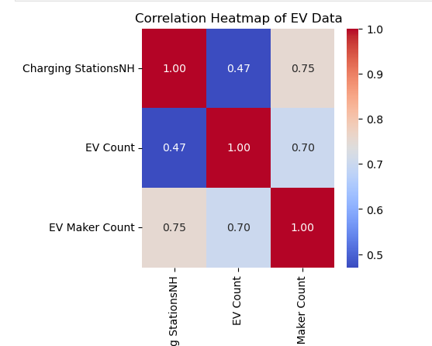

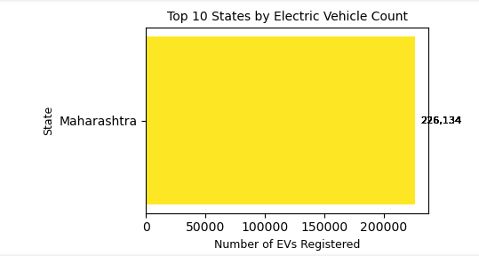

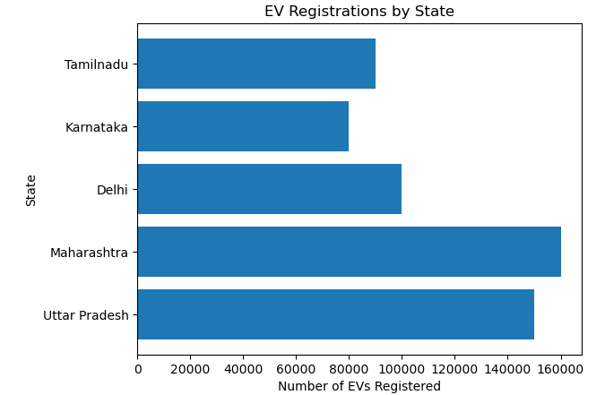

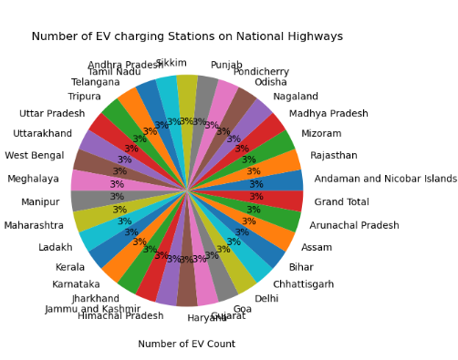

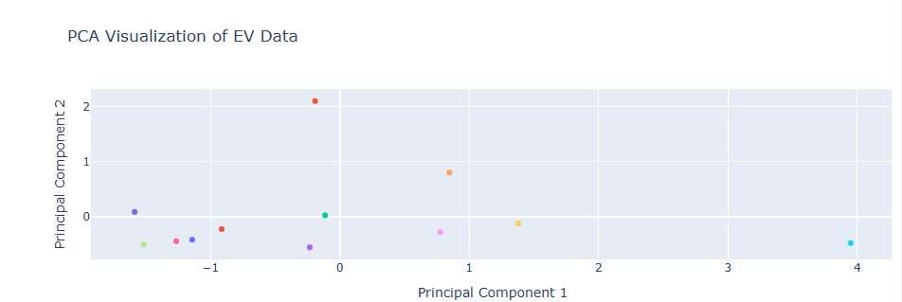

**5.2By EV Maker:** **Government Support**:

* Policies like FAME India, tax rebates, and subsidies for EV purchases and infrastructure development.
* State-specific incentives in Maharashtra, Gujarat, Delhi, etc.

**5.3** **Market Drivers**:

* Rising fuel costs and environmental awareness.
* Urbanization driving the demand for two-wheelers and passenger cars.
* Key Players: EVManufacturers: Tata Motors, Mahindra Electric, Ola Electric, Ather Energy.
* Battery Innovators: Exide, Amara Raja, and new startups focusing on advanced battery tech.

**5.4. Top Performing States:**

* **By EV Count**: Bihar, Uttar Pradesh, and Maharashtra lead in EV registrations, highlighting significant adoption in populous states. However, infrastructure may lag in certain regions.

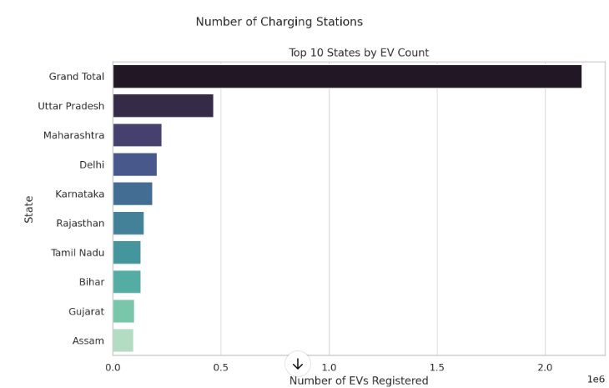

**5.5EV Adoption Breakdown by Vehicle Type:**

* Two-Wheelers: With around 1.1 million EVs, two-wheelers dominate the Indian market. The growth is driven by the demand for affordable urban mobility solutions in cities like Delhi, Bengaluru, and Mumbai. Key players include Ola Electric, Ather Energy, Hero Electric, and Bajaj Auto.
* Passenger Vehicles: Approximately 350,000 EVs in this segment are spurred by rising fuel prices, environmental awareness, and government incentives. Key models include Tata Nexon EV, Mahindra e2o, MG ZS EV, and Hyundai Kona EV.
* Three-Wheelers: E-rickshaws and electric auto-rickshaws are popular in urban and semi-urban areas due to lower operational costs. Key players include Mahindra Electric, Piaggio, Kinetic Green, and various startups.
* Commercial Vehicles: Around 30,000-40,000 electric commercial vehicles are in use, including electric buses and small cargo vehicles. Key players include Ashok Leyland, Tata Motors, Eicher Motors, and BYD India.

**5.6Annual Growth and Trends:**

* The Indian EV market is growing at 40-50% annually, with two-wheelers leading the adoption rate. This growth is expected to continue in the coming years.
* Government schemes like FAME II (Faster Adoption and Manufacturing of Hybrid and Electric Vehicles) and state-specific incentives are crucial enablers.
* As of 2024, India has around 9,000 public charging stations, and this number is expected to grow to 50,000 by 2030.

**5.7Regional Distribution:**

* Urban Areas: Metropolitan cities like Delhi, Mumbai, Bangalore, and Chennai account for over 70% of the total EV fleet in India.
* Tier-2 and Tier-3 Cities: Adoption is growing but slower, with state-specific policies and subsidies aimed at increasing EV penetration.
* Rural Areas: Two-wheelers and three-wheelers dominate in rural areas, providing practical solutions for last-mile connectivity.

**6. CURRENT STATE OF CHARGING INFRASTRUCTURE**

As of 2024, India has approximately 9,000 public EV charging stations, with most concentrated in major cities. The government aims to establish 2,700 new charging stations under the FAME II scheme by 2025. A growing number of fast-charging stations are being set up along highways and in urban centers to facilitate long-distance travel. Companies like Tata Power EZ Charge, Charge Grid (EESL), and Fortum India are key players in this space.

**6.1 Geographic Distribution of Charging Stations**:

* Urban Areas: Major cities like Delhi, Bangalore, and Mumbai have the highest concentration of charging stations.
* Highway**s**: Development of charging stations along key National Highways is crucial for inter-city travel. Companies are focusing on setting up fast-charging stations to ensure a smooth EV experience.
* Rural and Tier-2 Cities: Although adoption is slower in rural areas, there is increasing push to expand coverage.

**6.2 Public Charging Stations in India on March 2024**

As of 2024, India is experiencing a rapid expansion of its public electric vehicle (EV) charging infrastructure, reflecting the growing adoption of electric vehicles across the country.

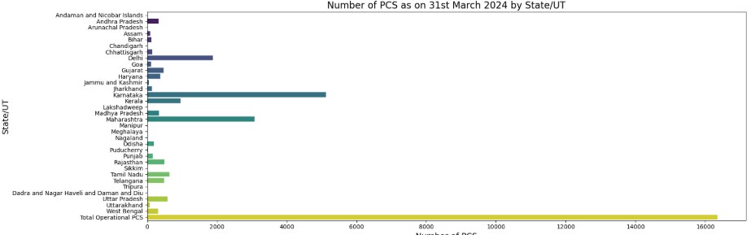

* **Total Number of Charging Stations**: By September 2024, India had 25,202 public EV charging stations.
* **State Distribution**:
  + **Karnataka** leads with the highest number, boasting 5,705 stations.
  + **Maharashtra** follows with 3,615 stations.
  + **Delhi** has 1,931 stations.
  + Other states also show significant numbers, contributing to the increasing accessibility of EV charging options.

This increase is driven by government incentives and a growing focus on green mobility solutions. However, the development of charging infrastructure, especially in rural and remote areas, remains a key challenge to address for further market penetration. The continued expansion of charging stations, along with improvements in battery technology, will be crucial for the sustainable growth of India's EV ecosystem.

**6.3 Region wise Number of EV**

As of 2024, India's electric vehicle (EV) market has seen significant growth, with total sales reaching nearly 1.94 million units, marking a 26.5% increase from the previous year.

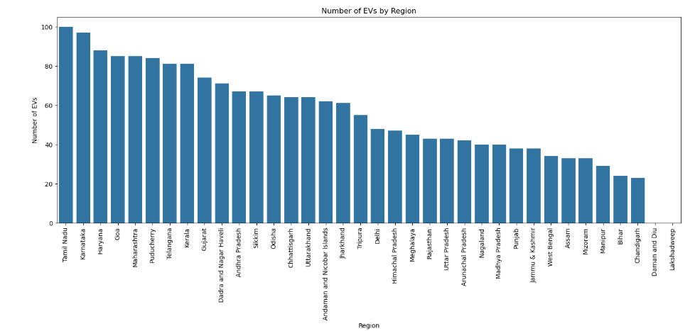

### ****6.4 Regional EV Sales Distribution****:

* **Uttar Pradesh**: Leads in EV sales, contributing the highest number of units.
* **Maharashtra**: Follows closely, playing a significant role in the national market.
* **Karnataka**: Ranks third, with a substantial share of EV sales.
* **Tamil Nadu**: Emerging as a strong player in EV adoption**.**
* **Rajasthan**: Contributing notably to the overall sales.

Together, these regions account for over 50% of total EV sales in India, reflecting a concentrated adoption in these states.

### ****Market Segmentation****:

* **Electric Two-Wheelers:** The dominant segment, with 1.14 million units sold, representing 59% of total EV sales.
* **Electric Three-Wheelers**: Showing rapid growth, with 694,466 units sold in 2024, up 18% from the previous year.
* **Electric Passenger Cars**: Gaining traction as a growing segment within the overall market.

This regional distribution and segmentation highlight varied adoption trends across India, influenced by state policies, infrastructure development, and local consumer preferences.

**7. CHALLENGES AND RECOMMENDATIONS**

**Challenges**:

* High Initial Costs: EVs remain expensive due to the cost of batteries.
* Infrastructure Deficit: Uneven distribution of charging stations.
* Battery Technology and Supply: Reliance on imported lithium-ion batteries.
* Grid Capacity: The existing power grid needs significant upgrades to support the increased load from EV charging stations.

**Recommendations**:

* Accelerate EV Adoption: Lower battery costs and improve charging infrastructure.
* Promote Local Manufacturing: Focus on "Make in India" initiatives.
* Research Alternative Batteries: Invest in solid-state and sodium-ion batteries.
* Government and Private Collaboration: Expand charging infrastructure, particularly in underserved areas.

### ****8. Solution: National Highway Charging Stations in India****

To cater to the needs of EV users on India’s national highways, the company’s requirements must align with the vehicles it supports, its target customer segments, and the geographical considerations. Here's a detailed breakdown:

#### ****8.1 . What Type of EVs Will the Company Support?****

The charging stations will be designed to accommodate a wide range of EVs suitable for highway travel:

1. **Passenger EVs**:
   * Long-range electric cars such as **sedans, SUVs, and premium vehicles** capable of 300–600 km per charge.
   * Affordable mid-range EVs for budget-conscious travelers with ranges of 200–300 km.
2. **Commercial EVs**:
   * **Electric buses** for inter-city public transport.
   * **Electric trucks and delivery vehicles** for logistics and freight services.
3. **Two-Wheelers and Three-Wheelers**:
   * Special provisions for charging electric two-wheelers and three-wheelers used by smaller logistics companies and individual travelers.
4. **Charging Technology**:
   * **Fast DC Chargers**: 50–350 kW for rapid charging (15–45 minutes for 80% charge).
   * **AC Chargers**: 7–22 kW for vehicles requiring longer stops.
   * **Battery Swapping** (optional): For commercial vehicles needing ultra-quick turnarounds.

#### ****8.2. Target Customer Segments****

1. **Private Vehicle Owners**:
   * Long-distance travelers and families who frequently use highways for vacations or inter-city commutes.
   * Eco-conscious travelers transitioning to EVs.
2. **Commercial Operators**:
   * **Fleet operators** for ride-hailing companies like Ola and Uber who are adding EVs to their inter-city fleets.
   * **Logistics companies** using electric trucks and vans for cargo transportation between cities.
3. **Public Transportation**:
   * Operators of electric buses for long-distance and inter-city routes, collaborating with government and private transport agencies.
4. **Small Businesses**:
   * Owners of electric two-wheelers or three-wheelers engaged in last-mile deliveries (e.g., e-commerce, courier services).
5. **Highway Travelers**:
   * Tourists and business professionals traveling between Tier-1 and Tier-2 cities, requiring charging stations with additional facilities like food courts and rest areas.

#### ****8.3. Geography****

1. **Primary Routes**:
   * Focus on India's **major national highways**, including:
     + **Golden Quadrilateral (GQ)**: Connecting Delhi, Mumbai, Chennai, and Kolkata.
     + **North-South Corridor**: Srinagar to Kanyakumari.
     + **East-West Corridor**: Silchar to Porbandar.
     + High-density corridors such as **Delhi-Jaipur**, **Mumbai-Pune**, **Bengaluru-Chennai**, and **Hyderabad-Vijayawada**.
2. **High Traffic Zones**:
   * **Tier-1 Cities**: Delhi, Mumbai, Bengaluru, Chennai, Hyderabad, and Kolkata, which serve as EV hubs.
   * **Tier-2 Cities**: Jaipur, Indore, Lucknow, Ahmedabad, Coimbatore, and Kochi, where EV adoption is growing.
3. **Strategic Locations**:
   * Stations placed every **50–100 km along highways** to reduce range anxiety.
   * Focus on **rest areas, toll plazas, and intersections** for easy access.
   * Integrate **renewable energy sources** like solar panels to power stations sustainably.
4. **Infrastructure Integration**:
   * Collaborate with **National Highways Authority of India (NHAI)** to secure prime locations.
   * Align with government policies under **FAME-II** to benefit from subsidies for charging infrastructure.

### ****Value-Added Services****

* **Digital Connectivity**: Mobile app integration for locating stations, checking availability, and making payments.
* **Amenities**: Food courts, retail stores, and rest areas to enhance customer experience.
* **Maintenance Support**: On-site EV maintenance services at key charging hubs.

### ****Conclusion****

To successfully develop **national highway charging stations**, the company should support **passenger, commercial, and small utility EVs**, targeting private travelers, fleet operators, and logistics businesses. Strategically placing stations along India’s high-density national highways will ensure seamless travel and promote widespread EV adoption, while partnerships with government agencies and renewable energy integration will enhance long-term sustainability and cost-effectiveness.

In **conclusion**, while India’s EV adoption lags behind that of developed nations, the market’s long-term potential remains strong. By addressing key barriers related to cost, infrastructure, and technology, and fostering collaboration between government, manufacturers, and consumers, India can pave the way for a cleaner, more sustainable future in transportation. The coming years will be crucial in determining how quickly India can meet its EV adoption targets and play a leadership role in the global shift towards electric mobility.