Overview
This application implements a RESTful Email OTP (One-Time Password) generation and validation module using ASP.NET Core and Entity Framework Core (In-Memory database). It is designed for use in enterprise applications requiring secure, time-bound authentication mechanisms.

Architecture
- Backend Framework: ASP.NET Core Web API
- ORM: Entity Framework Core (InMemory provider for demo/testing)
- Design Principles:
  - SOLID Principles
  - Layered Architecture (Controllers, Services, DTOs, Models, Data)
  - Separation of Concerns

Folder Structure
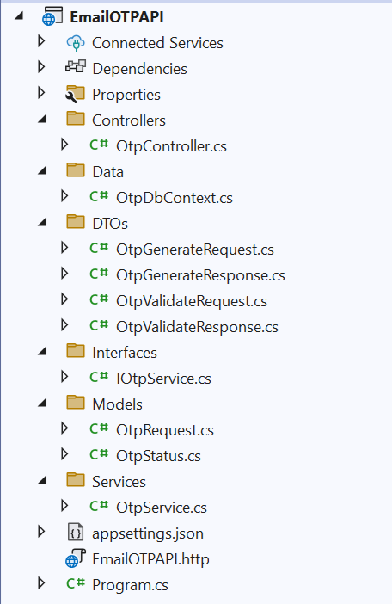

Features Implemented
- Generate 6-digit numeric OTP for valid emails with @dso.org.sg domain
- Send OTP via email (email sending mocked for this implementation)
- OTP is valid for 1 minute
- OTP is checked for 10 attempts
- Validate OTP against the most recent generated value
- Return meaningful status codes as response payload
- Swagger UI for API exploration and testing

API Endpoints

1. Generate OTP
- Method: POST
- Endpoint: /api/otp/generate
- Request Body:
{
"email": "user@dso.org.sg"
}
- Response:
{
"status": "STATUS_EMAIL_OK",
"message": "OTP sent successfully."
“Otp”:”Random generated number”(Displayed to validate OTP testing purpose)
}

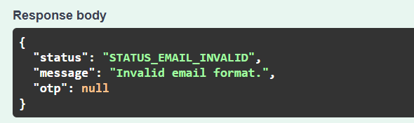
Error Message

2. Validate OTP
- Method: POST
- Endpoint: /api/otp/validate
- Request Body:
{
"email": "user@dso.org.sg",
"otp": "123456"
}
- Response:
{
"status": "STATUS_OTP_OK",
"message": "OTP validated successfully."
}

Error Messages
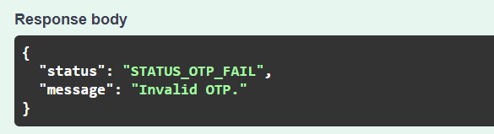

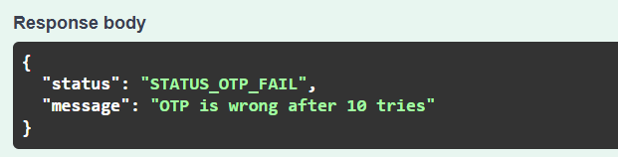

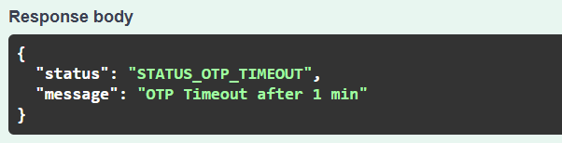

Assumptions Made
- Email Validation:
  - Only email addresses with the domain @dso.org.sg are considered valid.
  - Regex used: ^[^@\s]+@dso\.org\.sg$
- OTP Format:
  - 6-digit random numeric string.
  - Generated using Random().Next(100000, 999999).
- OTP Expiry:
  - OTP is valid for exactly 1 minute (60 seconds) from generation.
  - OTP is valid only for 10 attempts.
- Email Sending:
  - Email is not actually sent in this implementation.
  - SendEmail() is mocked to always return true.
- OTP Storage:
  - Stored in memory using DbContext with UseInMemoryDatabase.
  - Each OTP is associated with an email and timestamp.
- Security:
  - No encryption/hashing of OTPs in memory (due to demo scope).
  - Not suitable for production without secure handling.
- Environment:
  - Designed to run in .NET 6+ environment with minimal hosting model.
  - Uses Swagger for testing and API discovery.

Technologies Used
- ASP.NET Core Web API
- Entity Framework Core (In-Memory)
- Swagger / Swashbuckle

Status Codes Summary
These constants are defined in OtpStatus.cs:
- STATUS_EMAIL_OK
- STATUS_EMAIL_FAIL
- STATUS_EMAIL_INVALID
- STATUS_OTP_OK
- STATUS_OTP_FAIL
- STATUS_OTP_TIMEOUT

