PRACTICAL NO. 4: MULTIPLE LINEAR REGRESSION
- Establish the linear relationship of value of house on salary of employee and number of bed room in the house.
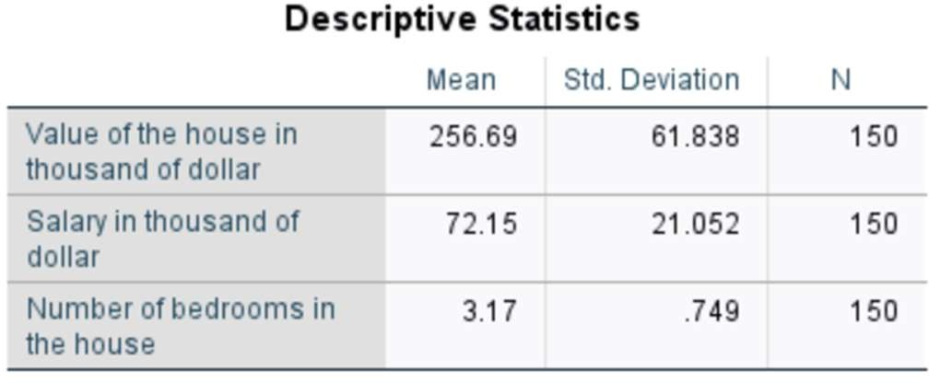
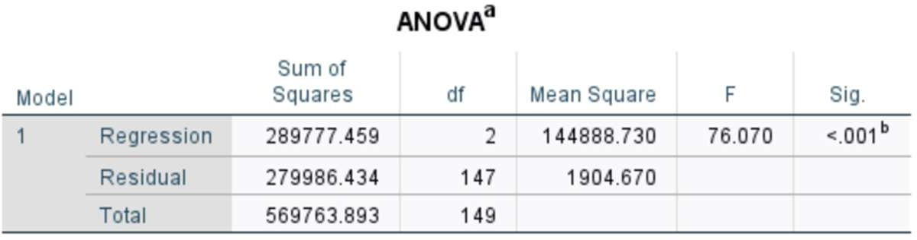
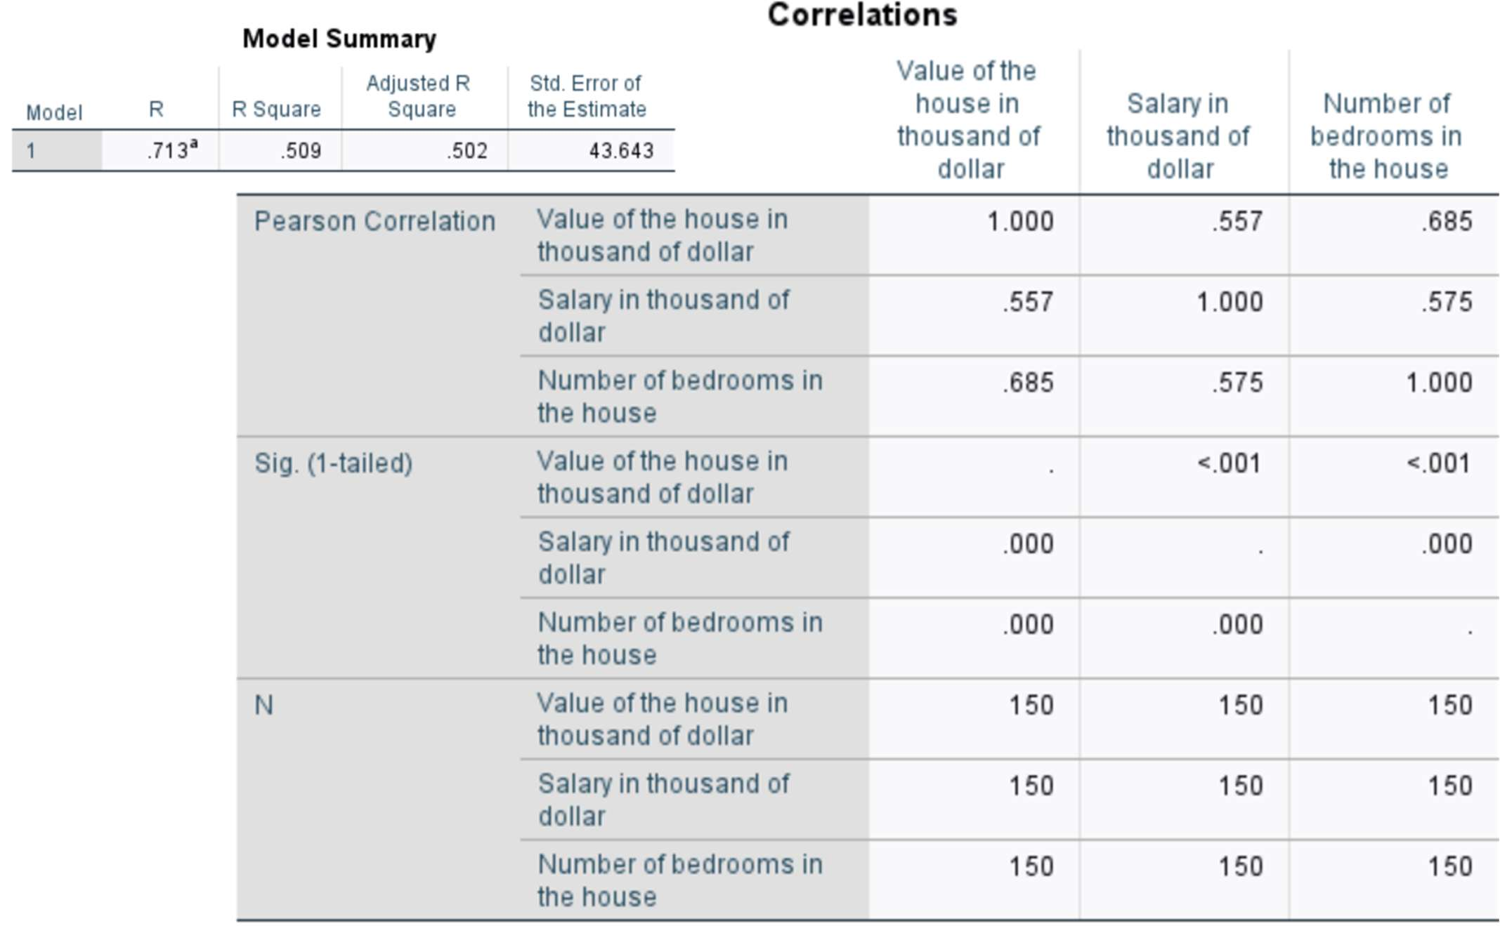

Interpretation: The regression equation is Y = 62.267 + 0.717X1 + 44.972X2 Where Y = value of house, X1 = salary of the employee and X2 = No of bedrooms.
  - What is the value of the house can we expect with the salary of the employee is 90 thousand dollar and having 5 bed rooms.
Solution: Here, X1 = 90 thousand and X2 = 5 bedrooms. Now Y = 62.267 + 0.717(90) + 44.972(5) = 351.66
Hence, the expected house value is approximately 351.66 thousand dollars.

  - Test the significance of regression coefficients and overall fit of the model.

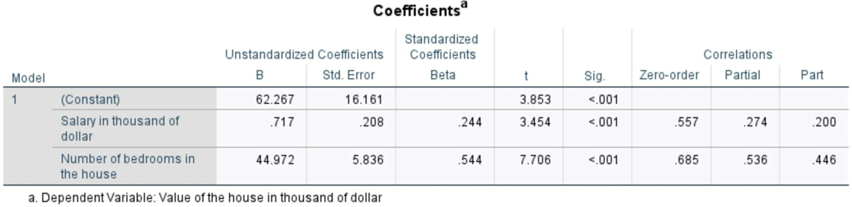
Solution:

Interpretation: Since p-value < 0.001 < 0.05. So, we reject H0 and the model is significant.
Hence, there is significant evidence that salary and number of bedrooms influence the value of the house.

  - Determine simple, partial correlation coefficients and coefficient of determination and interpret it.

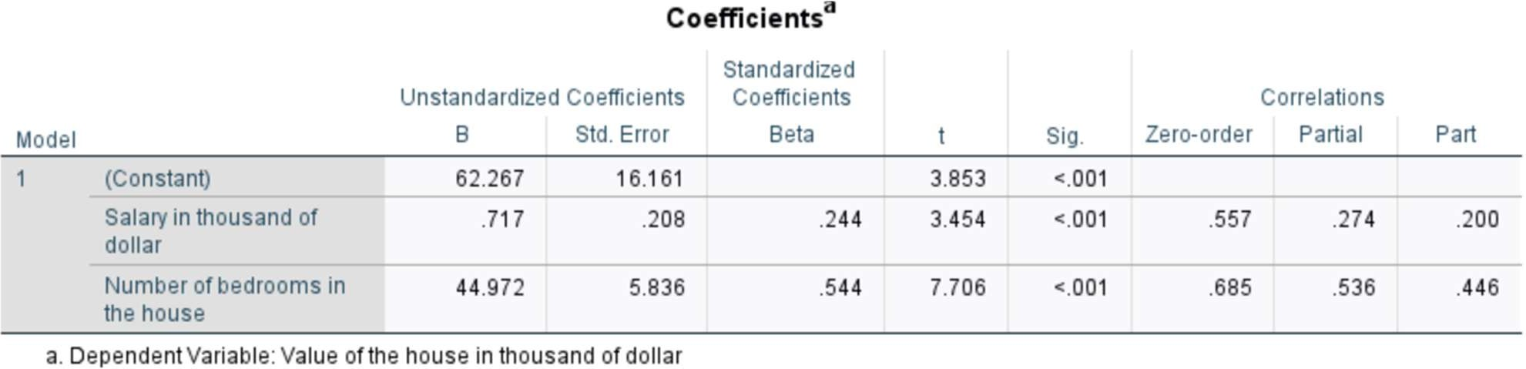
Solution:

Interpretation: Simple correlation shows a moderate positive relationship between salary and house value (r = 0.557) and a strong positive relationship between bedrooms and house value (r = 0.685).
After controlling for the other variable, partial correlation reduces to weak for salary (r = 0.274) and moderate for bedrooms (r = 0.536).
Part correlation indicates that salary uniquely explains 4.0% of the variance in house value, while bedrooms uniquely explains 19.9%, confirming that number of bedrooms is a stronger unique predictor.
Thus, salary and number of bedrooms are significant factors influencing house value, with number of bedrooms showing the strongest relationship.

- Determine the linear relationship of salary of employee and number of years in the office, education level, Sick days taken during the previous year.
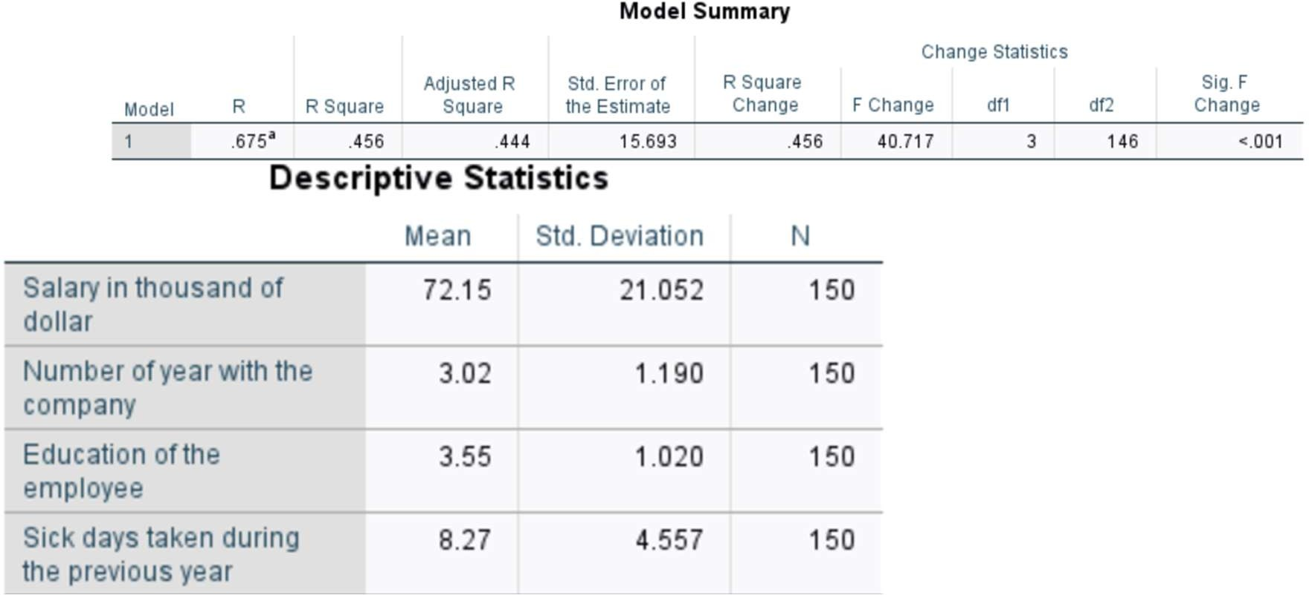
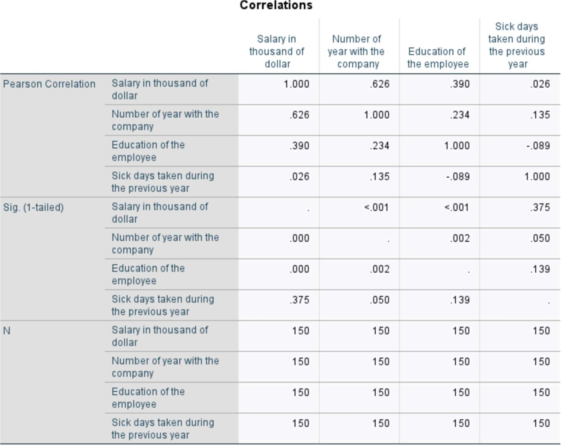

Interpretation: The regression equation is Y = 24.143+10.099(X1)+5.231(X2)−0.131(X3)
Where Y = Salary, X1 = No of Years with the company, X2 = Education of employee and X3 = Sick days taken during the previous year

- Test the significance of regression coefficients and overall fit of the model.

Solution:
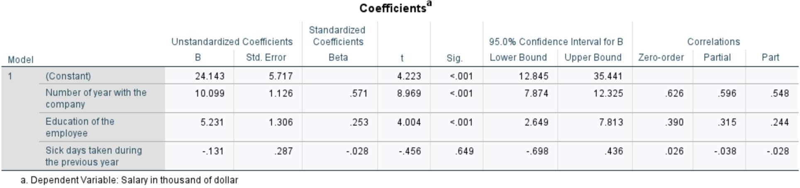
Interpretation: Since p-value < 0.001 < 0.05. Hence, we reject H0. So, the model is Significant.
There is significant evidence that years in the company, education level, and sick days collectively influence the salary of employees.

- Test the partial correlation coefficient and zero order correlation coeff. and interpret it.

Solution:
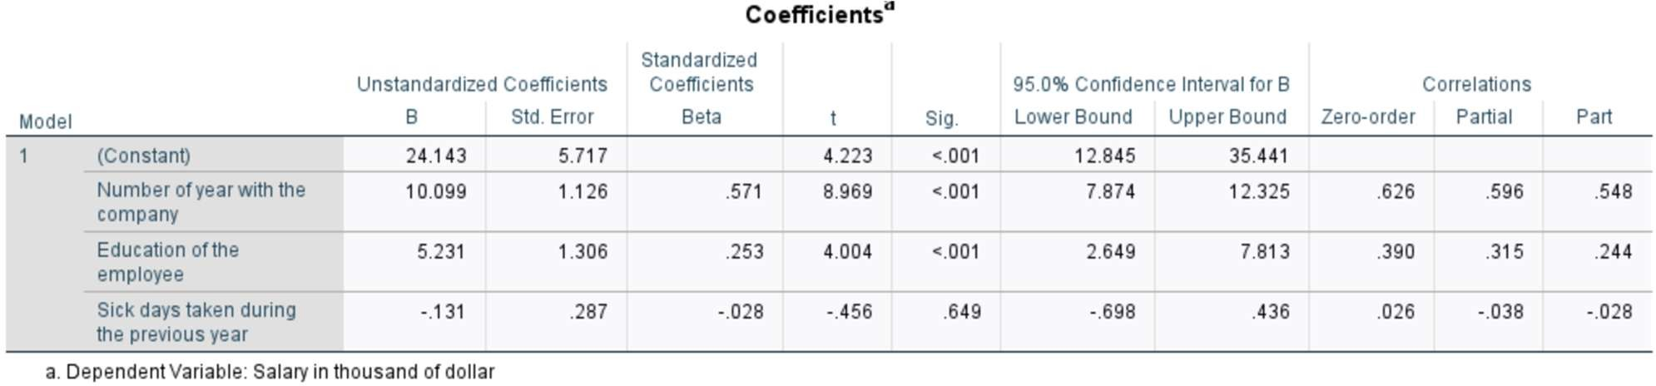
Interpretation: Zero-order correlation: Years with company (r = 0.626) and education level (r = 0.390) show moderate to strong positive correlation with salary. Sick days (r = 0.026) show no correlation with salary.
Partial correlation (after controlling for other predictors): Years (r = 0.596) and education (r = 0.315) still show positive correlation with salary. Sick days (r = -0.038) show negligible correlation.
Part correlation (unique contribution): Years uniquely explains 30.0% of variance in salary. Education uniquely explains 5.95% of variance. Sick days explains only 0.08%, which is negligible.
Thus, years in the company and education level are significantly related to salary, whereas sick days taken during the previous year are not significantly related to salary.

PRACTICAL NO. 5: NON-PARAMETRIC TEST

- Run test: The sequence of 150 employees (male and female) is given in the data set. Test at 5% level of significance that whether the sequence of male and female is in random order?

Hypothesis:

H₀: Sequence of male and female employees is random
v/s H₁: Sequence is not random
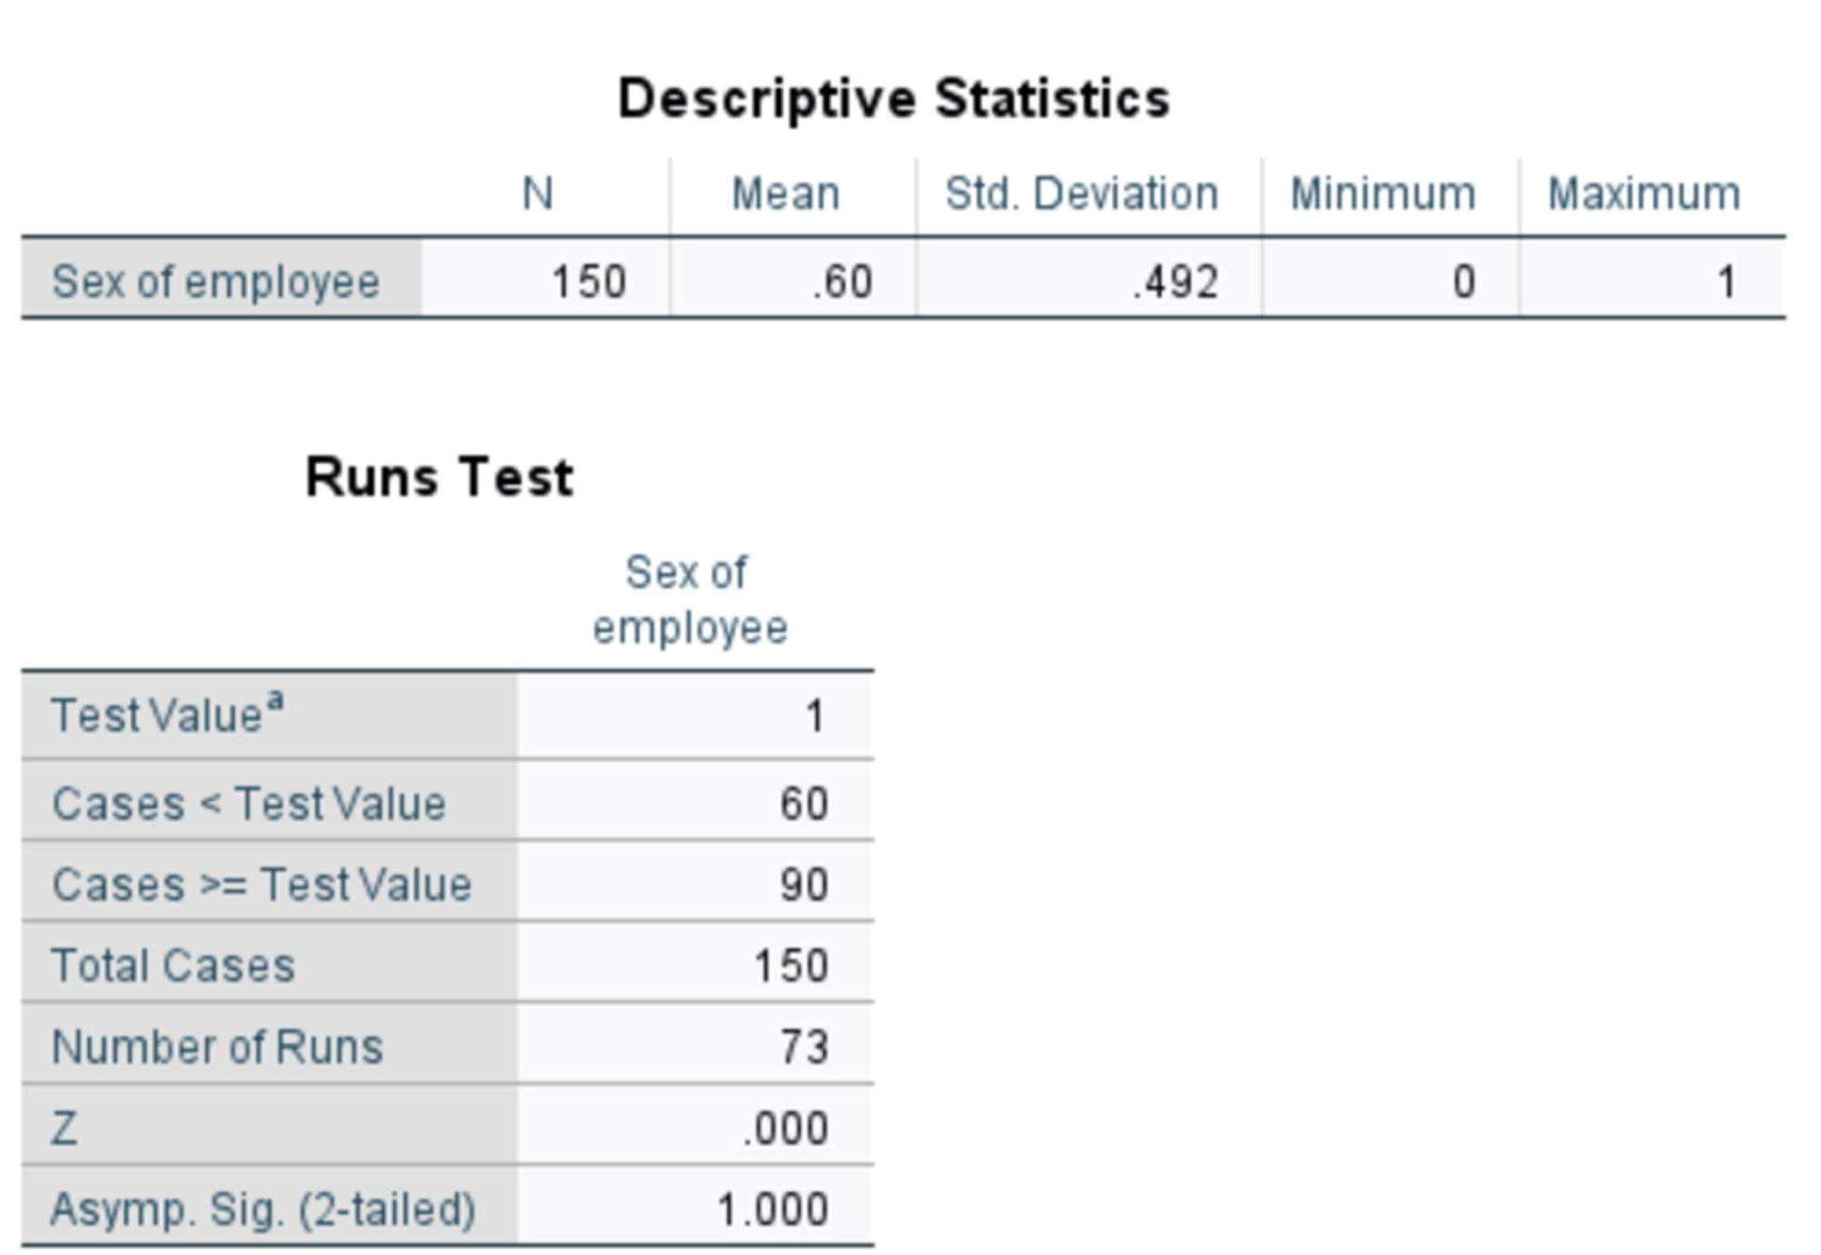

Interpretation: Here, no of runs = 73. Since p-value = 1.000 > 0.05. Hence, we do not reject H0.
There is strong evidence to say that the sample is in random order.

- Binomial test: Out of 150 employees, use binomial test to test the hypothesis that male and female are equally employed.

Hypothesis:
H0: P = 0.5
v/s H1: P ≠ 0.5

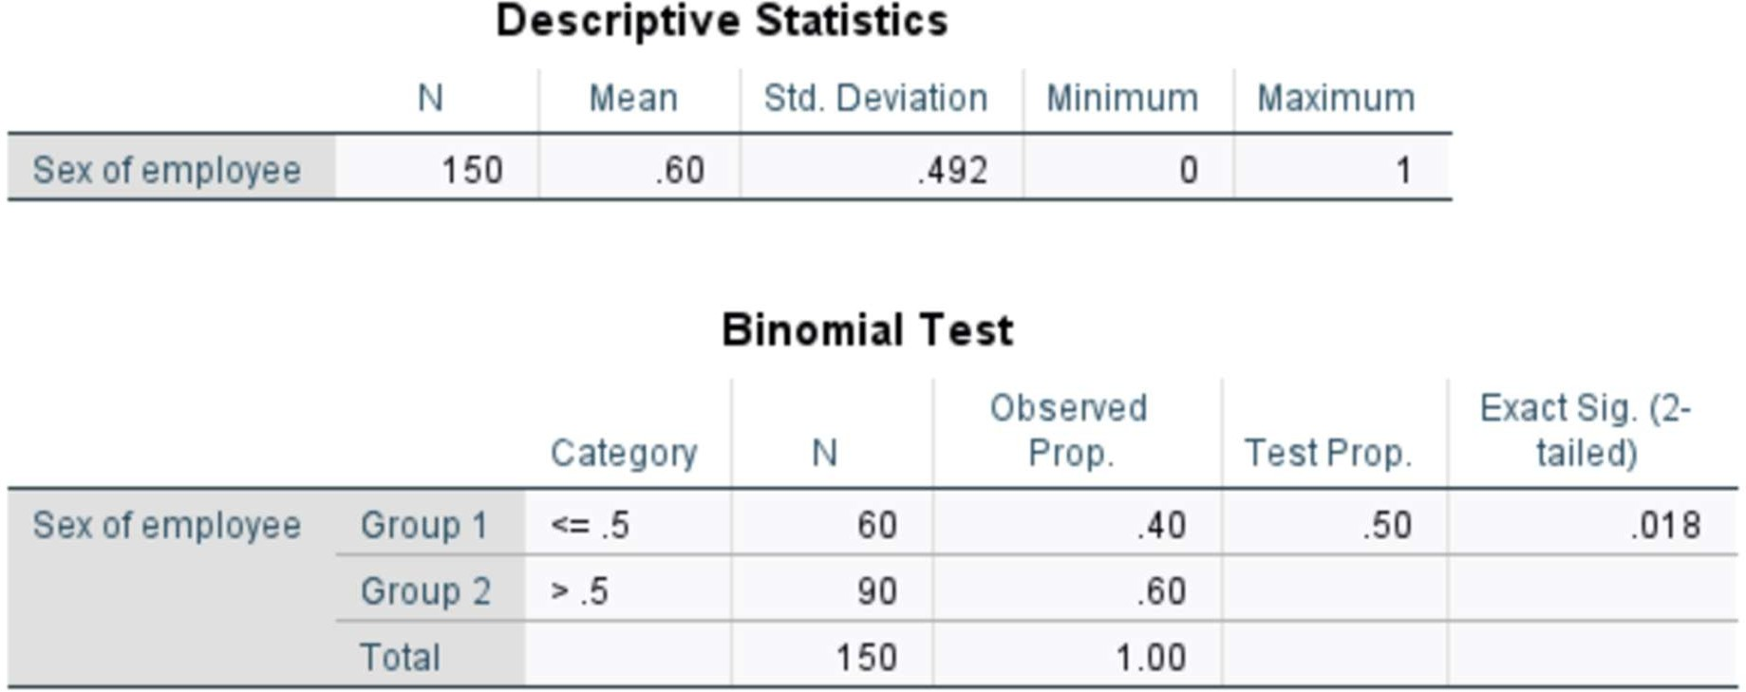

Interpretation: Since p-value = 0.018 < 0.05, we reject H0.
There is significant evidence that males and females are not equally employed.
The proportion of male employees (60%) is significantly higher than female employees (40%).

- Kolmogorov – Smirnov test: Given that random sample of 150 employee’s value of houses (in thousands of rupees). Apply the Kolmogorov- Smirnov test for testing that value of the house is uniformly distributed.

Hypothesis:
H0: Samples come from population with equal distribution
v/s H1: Samples come from population not with equal distribution
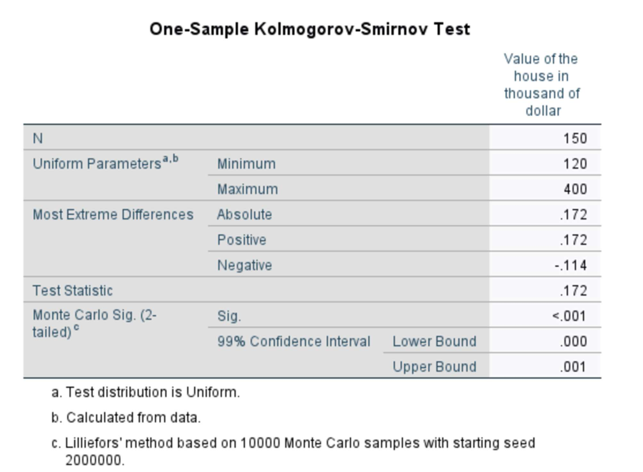
Interpretation: Since p-value < 0.05, we reject the H0.
There is significant evidence that the value of houses does not follow a uniform distribution. The observed distribution differs significantly from a uniform distribution.

- Mann Whitney U test: Test the hypothesis of no difference between the salary of the employee of swimming pool in house or not, using Mann Whitney U test for the sample data of 150 employees of the company.

Hypothesis:
H0: Md1 = Md2
v/s H1: Md1 ≠ Md2

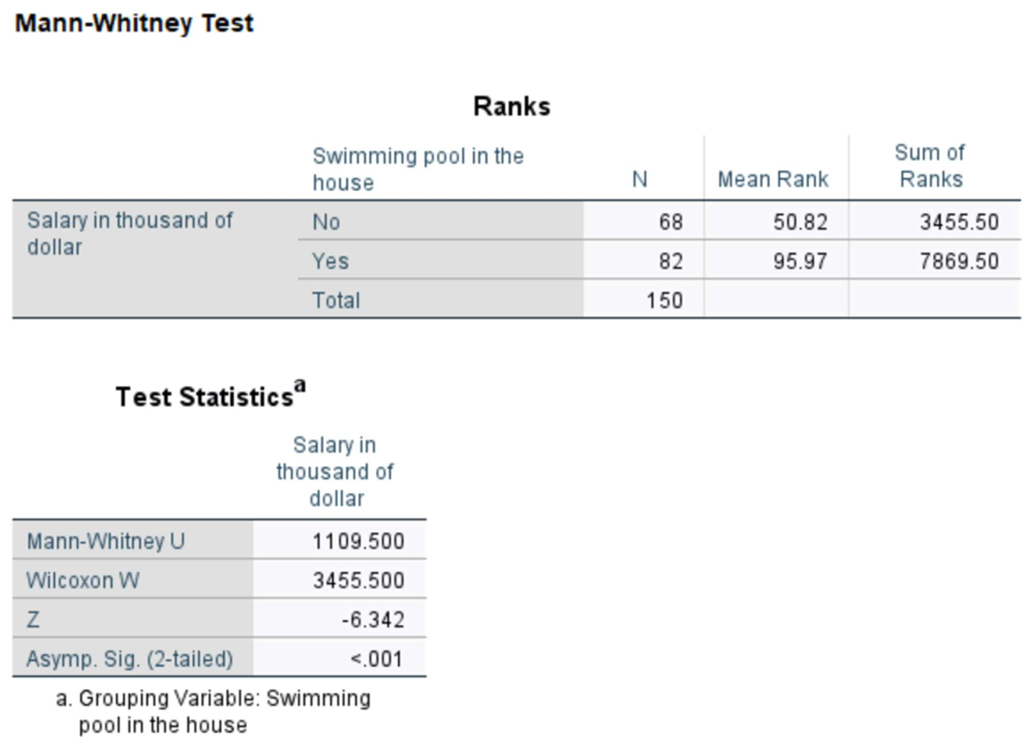
Interpretation: Since p-value < 0.05, we reject H0.
There is significant evidence of a difference in salary between employees with and without a swimming pool. Employees with a swimming pool have significantly higher salary than those without.

- Chi square test: use Chi square test of independence to determine an association between education and number of years in the company.
Hypothesis:
H0: Oi = Ei
v/s H1: Oi ≠ Ei

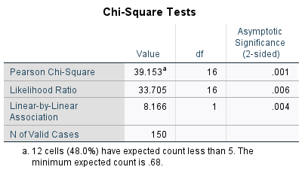

Interpretation: Since p-value = 0.001 < 0.05, we reject H0.
There is significant evidence of an association between education level and number of years in the company. The two variables are not independent; education level and tenure are related.

- Median test: Use the median test to determine whether the distance (in miles) from house to work for male and female are same in the company.
Hypothesis:
H₀: Median distance to work for male and female employees is the same
H₁: Medians are different

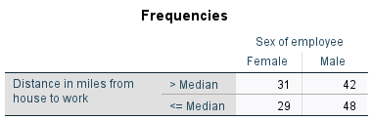
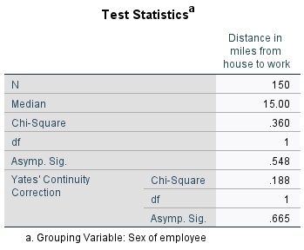

Interpretation: Since p-value = 0.548 > 0.05, we do not reject H0.
p-value = 0.548 > 0.05 → Do not reject H0.
Median commuting distance is the same for male and female employees.

