AMBLYOPIA
TREATMENT PLATFORM
USER STORIES & FEATURE SPECIFICATION
Doctor Dashboard • Parent Dashboard • Child Dashboard
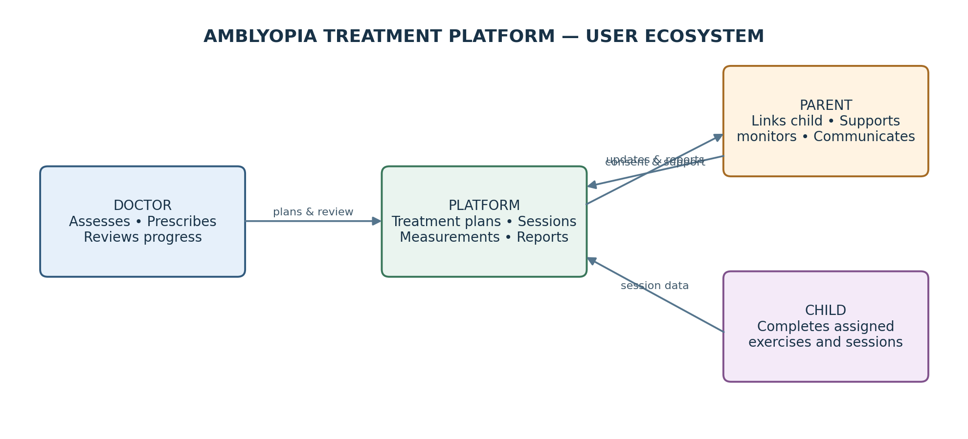
Prepared from the supplied project feature specification and data-model diagrams

1. Doctor features — user stories
The doctor workspace supports account verification, patient oversight, assessment, treatment planning and follow-up.

D-01 — Doctor account and verification
Primary user | Doctor
User story | As a doctor, I want to create and manage my account and have my professional account verified, so that I can access the platform with permissions appropriate to my verification status.
Main benefit | Establishes a controlled doctor onboarding process and prevents unapproved accounts from using doctor permissions.
How it works | The doctor can register, log in and out, reset a password and edit basic account data. The account displays Pending, Approved or Rejected. Once approved, the platform generates a unique DoctorCode that parents use to link children.
Acceptance criteria | • A doctor can register and authenticate with an account.  • The doctor can log out, reset the password and edit basic account information.  • Verification status is visible as Pending, Approved or Rejected.  • Doctor permissions are activated only after approval.  • An approved doctor receives a unique DoctorCode.

D-02 — Doctor dashboard and case overview
Primary user | Doctor
User story | As a doctor, I want a dashboard summarizing my linked children and cases requiring attention, so that I can prioritize follow-up without opening every patient file.
Main benefit | Provides a quick overview of workload, active treatment and potential follow-up needs.
How it works | The dashboard shows total registered children, children with active plans, missed sessions and cases needing follow-up. It may show alerts for declining adherence or notable result changes when data is available. The child list contains only children linked to that doctor and supports search and filtering.
Acceptance criteria | • The dashboard displays the total number of linked children and children on active plans.  • Children with missed sessions and cases needing follow-up are identifiable.  • Alerts are shown for declining adherence or notable result changes when supporting data exists.  • The doctor can search the linked-child list by name.  • The doctor can filter children by treatment status or adherence level.  • The doctor cannot browse children not linked to their account.

D-03 — Patient management and medical file
Primary user | Doctor
User story | As a doctor, I want to open and maintain a separate medical file for each linked child, so that I can review the child's history and make informed follow-up decisions.
Main benefit | Keeps patient information, treatment history and session records organized in one place.
How it works | The file includes the child's name and date of birth, parent details and available contact method, case history, recorded measurements, current and previous treatment plans, session and exercise history, results, and doctor-entered medical notes. A doctor can manage multiple children, each with a separate file.
Acceptance criteria | • Each linked child has a separate medical file.  • The file shows the child's basic data and the parent's available contact details.  • The doctor can review case history, measurements and current and past treatment plans.  • The doctor can review session and exercise history and their results.  • The doctor can add medical notes.  • Only the authorized doctor and authorized parent can view the child's medical data.

D-04 — Vision assessment and progress comparison
Primary user | Doctor
User story | As a doctor, I want to record and compare dated vision assessments for each eye, so that I can review recorded changes over time before adjusting treatment.
Main benefit | Makes assessment history visible and supports evidence-informed clinical review.
How it works | The doctor records right- and left-eye measurements as clinically defined, along with assessment date and notes. The platform presents previous and current measurements and a progress chart over time.
Acceptance criteria | • The doctor can create a dated assessment for a child.  • The assessment stores right-eye and left-eye measurements and notes.  • The doctor can view earlier assessments and compare them with the current assessment.  • A chart presents recorded measurements over time.  • The doctor can review earlier results before modifying a treatment plan.

D-05 — Personalized treatment plan management
Primary user | Doctor
User story | As a doctor, I want to create and manage an individualized treatment plan for each child, so that the child performs activities that match my instructions and can be reviewed at the appropriate time.
Main benefit | Makes treatment instructions specific, trackable and adjustable as the child's care progresses.
How it works | The doctor sets plan start and end dates or a review date, exercise/activity types, frequency, duration and difficulty. The doctor can modify, pause or end a plan, retain previous versions and modification history, and set the next follow-up date.
Acceptance criteria | • The doctor can create a plan for a specific child.  • The plan records start date and end date or review date.  • The doctor can define exercises or activities, frequency, duration and difficulty.  • The doctor can modify, pause or end the current plan.  • Previous plans and their modification history remain available.  • The doctor can set the next follow-up date.

D-06 — Treatment adherence monitoring
Primary user | Doctor
User story | As a doctor, I want to review completed, missed and unrecorded sessions and adherence trends, so that I can identify when parent follow-up may be needed.
Main benefit | Helps the doctor detect changes in participation without treating missing records as proof that practice did not occur.
How it works | The doctor sees completed and missed sessions, adherence rate over a selected period, comparisons between periods and the last exercise time. The platform flags lower adherence and can indicate when parent follow-up may be needed.
Acceptance criteria | • The doctor can see completed and missed session counts.  • The doctor can select a period and view its adherence rate.  • The doctor can compare adherence between periods.  • The last exercise time is visible.  • Lower adherence can be highlighted for review.  • A session not performed is distinguished from a session whose result was not recorded.

D-07 — Reports and analytics
Primary user | Doctor
User story | As a doctor, I want to generate a progress report for a selected period, so that I can review the child's recorded progress and prepare for follow-up appointments.
Main benefit | Consolidates measurements, adherence, session activity and clinical notes into a reviewable summary.
How it works | The report includes comparisons of recorded measurements over time, adherence summary, completed and missed session counts, medical notes and important changes. The doctor can print or download the report as a PDF.
Acceptance criteria | • The doctor can choose the reporting period.  • The report summarizes recorded measurements and changes over time.  • The report includes adherence and completed/missed session counts.  • Relevant medical notes and important changes are included.  • The report can be printed and downloaded as a PDF.

D-08 — Notifications and parent communication
Primary user | Doctor
User story | As a doctor, I want to receive relevant alerts and communicate with parents, so that I can respond to missed sessions, adherence concerns and parent questions.
Main benefit | Supports timely follow-up and a communication channel between the care provider and family.
How it works | The doctor receives notifications about follow-up appointments, missed sessions, lower adherence and new parent messages. The feature description proposes in-platform chat if the team decides to include it. The doctor can send reminders and receive parent updates and questions.
Acceptance criteria | • Notifications can identify follow-up appointments, missed sessions and lower adherence.  • The doctor is notified when a parent message arrives, if messaging is enabled.  • The doctor can send reminders to parents to follow the plan.  • The doctor can receive parent updates and questions.  • In-platform chat is treated as conditional on the project team's decision.

2. Parent features — user stories
The parent dashboard helps families link children to the doctor, support sessions and understand progress without replacing clinical judgment.

P-01 — Parent registration and child profile
Primary user | Parent
User story | As a parent, I want to register, add my child and link the child to the treating doctor, so that I can access the correct treatment plan and monitor my child's activity.
Main benefit | Creates the authorized parent-child-doctor connection required for the platform to work.
How it works | The parent registers using email and password, enters the child's name and date of birth, and chooses an avatar. The parent enters the doctor-provided code specific to the child. The plan appears after doctor approval. The same child-specific code is used by the child to log in. Camera consent is collected.
Acceptance criteria | • A parent can register with an email and password.  • The parent can add a child with name, date of birth and avatar.  • The parent can enter the doctor-provided child code to request linking.  • The treatment plan appears after the doctor approves the link.  • The child-specific code is available for the child's login flow.  • Camera consent is collected before camera use.

P-02 — Parent home dashboard
Primary user | Parent
User story | As a parent, I want to see a concise summary of my child's weekly activity and current plan, so that I can understand what has been completed and what needs attention.
Main benefit | Makes the child's current treatment activity easy to understand at a glance.
How it works | The home screen includes a child selector for parents with multiple children, weekly adherence percentage, actual training minutes, attention level as a supporting indicator, daily adherence chart, today's session and plan, latest alerts and the latest weekly or monthly PDF report.
Acceptance criteria | • A parent with multiple children can switch between them.  • The home screen displays weekly adherence and actual training time.  • An attention-level indicator is displayed as supporting information.  • A chart shows session activity by day for the week.  • Today's session status and current plan information are visible.  • Latest alerts and the latest downloadable report are accessible.

P-03 — Child progress and session history
Primary user | Parent
User story | As a parent, I want to review my child's progress charts and detailed session log, so that I can understand activity over time and discuss it with the doctor.
Main benefit | Provides a history of adherence, scores and recorded exercise outcomes.
How it works | The child page displays charts for adherence, scores and attention over a selectable period. The session log lists each session and the result of each exercise.
Acceptance criteria | • The parent can open the child's progress page.  • Charts show adherence, scores and attention over time.  • The parent can select the period displayed.  • The session log lists individual sessions.  • Exercise results are available in the relevant session details.

P-04 — Parent reports and doctor's notes
Primary user | Parent
User story | As a parent, I want to view simplified weekly and monthly reports, so that I can follow the child's recorded activity and understand the doctor's notes.
Main benefit | Turns treatment activity into a readable summary for family follow-up.
How it works | The reports area provides weekly and monthly summaries, doctor's notes and PDF downloads.
Acceptance criteria | • Weekly and monthly reports are available when generated.  • Reports present a simplified summary of recorded information.  • Doctor's notes are shown to the authorized parent.  • The parent can download reports as PDF.

P-05 — Camera and recording consent management
Primary user | Parent
User story | As a parent, I want to grant or withdraw camera and recording consent at any time, so that I remain in control of whether camera-based monitoring is used.
Main benefit | Protects family choice and ensures camera operation follows consent.
How it works | A consent page allows the parent to grant or withdraw camera and recording consent. The camera must not run without consent.
Acceptance criteria | • The parent can grant camera consent.  • The parent can withdraw camera consent.  • The parent can manage recording consent.  • Camera-based monitoring does not start without the required parent consent.

P-06 — Messages with the doctor
Primary user | Parent
User story | As a parent, I want to communicate directly with the doctor, so that I can ask questions and share updates about my child's treatment.
Main benefit | Creates a direct route for questions and relevant family updates.
How it works | A messages page supports communication with the doctor. This capability depends on the platform's messaging/chat scope.
Acceptance criteria | • The parent can access the messages area if messaging is enabled.  • The parent can send a message or update to the doctor.  • The parent can receive doctor responses or reminders.  • New-message notifications are presented when supported.

P-07 — Reminder and alert preferences
Primary user | Parent
User story | As a parent, I want to choose how and when reminders arrive, so that notifications fit my availability and help me support the treatment plan.
Main benefit | Makes reminders more useful and less disruptive to the family.
How it works | Settings allow the parent to choose reminder delivery through email, message or browser notification, as supported by the platform.
Acceptance criteria | • The parent can access notification settings.  • Available delivery methods are presented.  • The parent can select preferred reminder methods.  • Alerts can cover relevant reminders such as missed sessions or plan follow-up.

P-08 — Videos and practical tips
Primary user | Parent
User story | As a parent, I want simple guidance on encouraging my child and setting up the session environment, so that I can help the child complete activities appropriately.
Main benefit | Supports a more consistent session setup and positive encouragement at home.
How it works | The parent can access videos and tips about encouraging the child and arranging suitable lighting and distance.
Acceptance criteria | • A guidance area is available to the parent.  • It provides simple encouragement advice.  • It provides setup guidance for lighting and distance.

P-09 — Session preparation and parent alerts
Primary user | Parent
User story | As a parent, I want to confirm that the required patch or glasses are worn and receive alerts about missed sessions or removal during a session, so that I can support the plan as prescribed.
Main benefit | Helps the family prepare for sessions and respond to relevant interruptions.
How it works | Before a session, the parent or child confirms that the patch or glasses required by the plan are worn. The parent receives an alert if a session is missed or the required patch/glasses are removed during a session.
Acceptance criteria | • The pre-session flow asks for confirmation of the prescribed patch or glasses.  • The check reflects the child's current plan.  • The parent can be alerted when a session is missed.  • The parent can be alerted if patch or glasses removal is detected during a session, where monitoring supports it.

3. Child features — user stories
The child experience is intentionally simple, encouraging and limited to carrying out activities defined by the doctor.

C-01 — Child login using a unique code
Primary user | Child
User story | As a child, I want to enter my own code instead of using email and a password, so that I can open my assigned activities easily.
Main benefit | Reduces login complexity for a child and opens the correct personal plan.
How it works | The child enters the code specific to them, supplied by the doctor through the parent/doctor linking process. The plan configured for that child appears after the code is entered.
Acceptance criteria | • The child can log in using the child-specific code.  • The child is not required to use an email address or password.  • The activities shown belong to the child associated with that code.

C-02 — Simple child home screen
Primary user | Child
User story | As a child, I want a colorful home screen with large, clear activity buttons and a friendly character, so that I can understand what to do and start a session confidently.
Main benefit | Makes the training experience accessible and engaging for a young user.
How it works | The home screen welcomes the child by name and avatar. It shows a patch section, a glasses section or both, depending on the doctor's plan. Each applicable section includes exercises, a progress bar and a Start button. Weekly progress, stars and badges are also shown.
Acceptance criteria | • The home screen displays the child's name and avatar.  • Only the patch and/or glasses sections required by the current plan are shown.  • Each applicable section shows assigned exercises, progress and a Start button.  • Weekly progress shows sessions completed out of those required.  • Stars and badges encourage adherence without creating competition.  • A cheerful character provides encouragement.

C-03 — Pre-session environment check
Primary user | Child
User story | As a child, I want the platform to guide me through a short check before training, so that I can get ready for the session in a suitable position and environment.
Main benefit | Helps the child prepare before exercises begin.
How it works | When Start is pressed, and after parent consent, the camera checks whether the face is visible, lighting is good and distance is suitable. The child is asked to confirm wearing the patch or glasses if the plan requires them.
Acceptance criteria | • The pre-check begins when the child starts a session.  • Camera use occurs only when parent consent is active.  • The system checks face visibility, lighting and suitable distance as described in the feature specification.  • The child is asked about patch/glasses only when required by the plan.  • The session can proceed through the intended ready flow.

C-04 — Complete assigned exercises
Primary user | Child
User story | As a child, I want to complete a sequence of simple, game-like exercises, so that I can carry out the activities in my treatment plan in an engaging way.
Main benefit | Turns the prescribed activities into a structured and child-friendly session.
How it works | Exercises appear one after another in the order set by the doctor. Each activity has a timer and pause button. Examples in the feature specification include following a moving ball, fixating on a target, finding the odd shape, connecting dots, a Gabor exercise or watching a short video.
Acceptance criteria | • Exercises appear in the order defined by the doctor.  • The child sees only activities assigned in the current plan.  • Each exercise displays its timer and a pause control.  • The session supports the exercise types configured for the child.  • The child can pause an exercise/session as described.

C-05 — Camera-based session monitoring and gentle prompts
Primary user | Child
User story | As a child, I want gentle reminders if I move out of the suitable position or the camera cannot see my face, so that I can return to the activity without confusing or harsh feedback.
Main benefit | Encourages a suitable session setup while keeping feedback child-friendly.
How it works | With parent consent, camera monitoring runs during the session and checks face visibility, distance and whether the child is looking at the target. If the face disappears or the child comes too close, a gentle reminder appears.
Acceptance criteria | • Monitoring is active only after parent consent.  • The system checks face visibility and suitable distance during the session.  • The system checks looking toward the target as described in the feature specification.  • A gentle prompt appears when the face disappears or the child comes too close.  • Monitoring information is recorded for the parent and doctor views.

C-06 — Session completion and encouragement
Primary user | Child
User story | As a child, I want to see an encouraging completion screen with the stars I earned and a simple summary, so that I feel motivated to return to my next session.
Main benefit | Provides positive feedback at the end of an activity without exposing clinical reporting to the child.
How it works | At the end of the session, the child sees an encouragement screen, earned stars and a simple summary, then returns to the home screen.
Acceptance criteria | • A completion screen appears when the session finishes.  • The child sees stars earned and a simple session summary.  • The experience returns to the child home screen.  • The child is not shown the detailed clinical numbers or reports intended for adults.

C-07 — Gabor exercise
Primary user | Child
User story | As a child whose plan includes Gabor training, I want to find and identify the target in a simple visual pattern activity, so that I can complete the Gabor exercise assigned by my doctor.
Main benefit | Adds the Gabor technique as a configurable exercise type in the activity library.
How it works | The child sees low-contrast Gabor patches and identifies the location of the target or the screen containing it. Difficulty can be raised or lowered according to the child's level; the exercise may also support both-eyes-together (dichoptic) training if implemented and prescribed. The doctor sets duration, difficulty and weekly frequency; the platform records the score after each session.
Acceptance criteria | • Gabor is available as an exercise type in the library.  • The child performs the target-location/target-screen task.  • Difficulty adjustment follows the configured level behavior.  • The doctor controls duration, difficulty and weekly frequency.  • The platform records the child's score after each session.  • Dichoptic mode is included only if supported and prescribed.

4. Key workflows and diagrams

4.1 Child session lifecycle
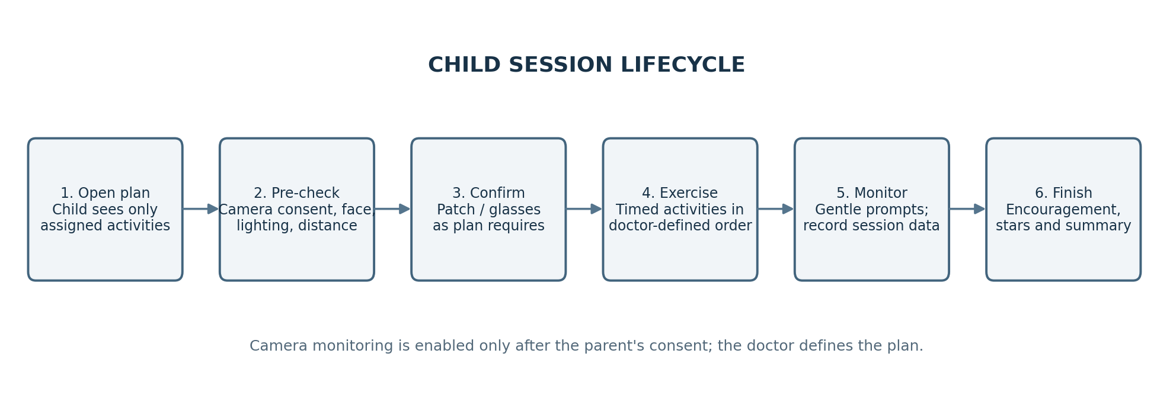
The flow follows the supplied description: the child starts an assigned plan, completes a pre-check, confirms the required patch or glasses, performs the ordered exercises, receives camera-based prompts where consented, and sees an encouraging finish screen.

4.2 Information flow from activity to dashboards
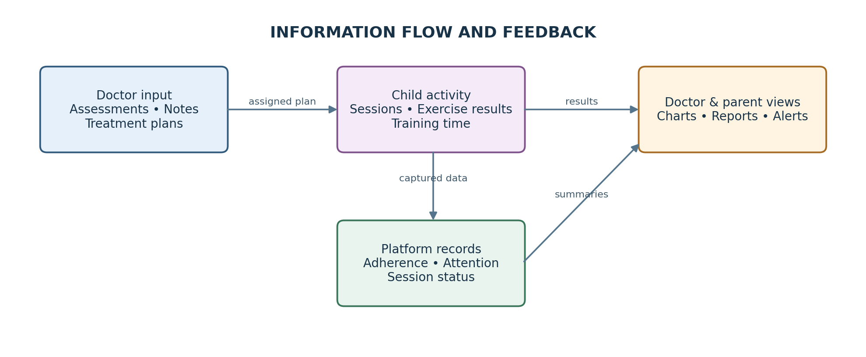
The feature specification states that the platform records whether sessions were done or missed, actual training time, performance in each exercise and attention level. These records are presented to the doctor and parent as dashboard charts and numbers. The child is not shown the adult-facing reports or detailed numbers.

