AMBLYOPIA TREATMENT
MONITORING PLATFORM
Project delivery roadmap, sprint plan & team responsibilities
Planning window: November 2026 – May 2027
MVP target: 31 January 2027 | Full testing target: 30 April 2027 | Final release: May 2027
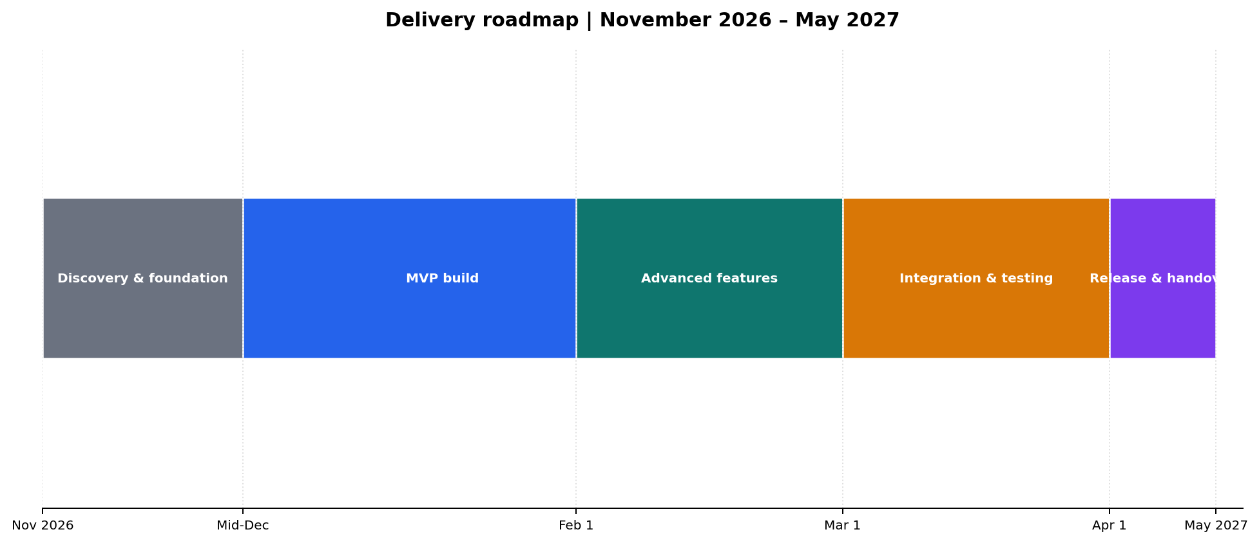
Prepared from the uploaded platform feature specification, ERD drafts and team skills inventory.

1. Executive plan
The project will be delivered in two product increments. Increment 1 establishes a dependable, demonstrable core product before February 2027. Increment 2 adds the advanced experience and completes integration, validation and release readiness before May. May is deliberately kept for final submission, demonstration and handover rather than major feature development.
Milestone | Target date | Exit condition
Scope and architecture baseline | 13 November 2026 | Agreed MVP backlog, user journeys, data model decisions, acceptance criteria and development environment.
MVP feature freeze | 22 January 2027 | Core doctor, parent and child journeys work end-to-end; critical defects triaged.
MVP demo / prototype sign-off | 29–31 January 2027 | Stable demo build, seeded demo data, known-limitations list and supervisor feedback captured.
Advanced feature complete | 9 April 2027 | Planned AI/CV, Gabor, analytics, messaging/reminders and advanced workflows integrated behind tested controls.
Full testing exit | 30 April 2027 | Regression, role/security, usability, performance and UAT evidence reviewed; no open critical/high defects.
Final release and handover | May 2027 | Release candidate, final documentation, presentation, deployment guide and backup/restore evidence.

2. Product scope and release boundaries

Increment 1 — MVP before February
- Authentication and role-based access for doctor, parent and child; doctor verification status and doctor code workflow.
- Doctor: child list, child record, assessment entry/history, treatment-plan creation and editing, basic session/adherence view.
- Parent: registration, child creation/linking, consent capture, current plan, weekly adherence and session history.
- Child: code-based entry, age-appropriate home screen, assigned exercise sequence, timer/pause, session completion and encouragement/reward feedback.
- Core exercise library with a small set of safe, demonstrable exercises; record session status, actual duration and exercise result where available.
- Basic dashboard summaries and a simple export or printable report if time permits; no AI-derived clinical conclusions.

Increment 2 — advanced features and full product
- Camera pre-check and in-session monitoring for face visibility, approximate distance and looking direction, only after explicit parent consent.
- Gabor exercise and expanded game-like exercise library, including score capture and controlled difficulty progression.
- Richer adherence analytics, progress charts, period comparisons and downloadable PDF reports.
- Notifications/reminders for missed sessions, follow-ups and parent updates; in-platform messaging only if the core backlog is on track.
- More complete doctor workflow: follow-up alerts, plan history, medical notes, filters and multi-child management.
- Security, privacy, auditability, accessibility, responsive behavior, deployment automation and full test evidence.
Scope control: The uploaded feature specification describes intended capabilities, but it does not define clinical thresholds, validated camera accuracy, or approved ophthalmic measurement protocols. These must be confirmed by the medical supervisor before implementation or demonstration as clinically meaningful.

3. Sprint roadmap
Use two-week sprints where possible, with a short MVP hardening sprint at the end of January. Sprint dates are proposed working dates and can be shifted to match academic calendars; preserve the milestone gates.
Sprint | Dates | Focus | Main work | Definition of done
S0 | 2–13 Nov 2026 | Discovery & setup | Confirm MVP vs later scope; user stories and acceptance criteria; review both ERD drafts; choose one canonical schema; repo, branching, issue board, environments; UI flow and API contract. | Approved backlog, architecture decision record, initial clickable wireframes, working CI/checks.
S1 | 16–27 Nov | Platform foundation | Database migrations and core entities; authentication, roles and authorization; doctor verification states; API skeleton; React app shell and navigation. | Users can register/login; role-specific routes; schema and API smoke tests pass.
S2 | 30 Nov–11 Dec | Doctor core | Doctor profile and verification workflow; child list/search; child profile and case history; assessment create/list; treatment plan create/edit/status and history model. | Doctor can manage a child, record an assessment and assign a plan in a test environment.
S3 | 14–25 Dec | Parent onboarding | Parent registration; child creation; doctor-code linking and approval; parent-child authorization; consent capture/withdrawal state; parent dashboard summary. | Parent can link a child to a doctor; cross-parent/doctor access tests prove isolation.
S4 | 28 Dec–8 Jan 2027 | Child experience & session engine | Child code entry; child home screen; plan-driven patch/glasses sections; session start/pause/finish; exercise sequencing and timers; session status and duration persistence. | A child completes an assigned session and the parent/doctor can see the recorded event.
S5 | 11–22 Jan | MVP reporting & polish | Adherence calculation rules; distinguish missed vs not recorded; basic charts/session log; starter exercise library; UI polish, responsive checks, demo data and integration fixes. | MVP acceptance checklist passes; demo script and seeded accounts are ready.
S6 | 25–29 Jan | MVP hardening / release | End-to-end regression; defect burn-down; backup/restore check; deployment rehearsal; freeze non-critical changes; capture supervisor feedback and MVP limitations. | Signed MVP gate; stable prototype demonstrated before February.
S7 | 1–12 Feb | Camera feasibility & consent | Prototype camera permission flow; lighting/face-presence/distance feasibility; privacy-safe processing design; collect test cases and limitations; do not persist video by default. | Feasibility report, consent-gated proof of concept, measurable acceptance criteria.
S8 | 15–26 Feb | Exercise expansion & Gabor | Gabor exercise prototype; exercise configuration and score capture; difficulty-level controls; expanded game interactions and child-friendly feedback. | Gabor flow integrated with session engine; repeatable score logging.
S9 | 1–12 Mar | Monitoring integration | Integrate CV checks into pre-check/session; gentle prompts; monitoring events and confidence/unknown states; graceful fallback when camera unavailable. | Camera monitoring works in supported test conditions and fails safely when uncertain.
S10 | 15–26 Mar | Analytics & reports | Doctor/parent progress views; date-range filters; adherence comparisons; PDF report generation; medical notes and follow-up summary. | Report totals reconcile to session records; sample PDF reviewed by supervisor.
S11 | 29 Mar–9 Apr | Notifications & communication | Missed-session and follow-up reminders; parent update alerts; notification preferences; evaluate in-platform messaging as a stretch feature. | Notification events are reliable, configurable and permission-aware.
S12 | 12–23 Apr | System integration & quality | Full integration; API and database hardening; role/permission matrix; audit logging; accessibility/responsive review; load/performance and security checks; deployment rehearsal. | All critical user journeys pass; no open critical/high defects; deployment checklist complete.
S13 | 26–30 Apr | Full regression & UAT exit | Cross-browser/device regression; doctor/parent/child usability sessions; defect retest; test report; release candidate and sign-off. | Test evidence, UAT feedback disposition, release candidate and go/no-go decision.
Release | May 2027 | Submission & handover | Final presentation/demo; architecture and user documentation; deployment and recovery guide; known limitations; source-control/tag and handover. | Final deliverables submitted and platform handed over.

4. At-a-glance milestone plan
Manage the deadline through three protected gates: MVP by 31 January, feature-complete build by 9 April, and full testing exit by 30 April. May is reserved for final release, documentation and submission—not core feature development.
WHEN | MILESTONE | WHAT MUST BE WORKING | GO / NO-GO CHECK
13 Nov 2026 | PLAN LOCKED | MVP scope, canonical ERD/schema, user journeys, sprint backlog and development setup approved. | No unresolved blocker prevents Sprint 1.
22 Jan 2027 | MVP FEATURE FREEZE | Doctor, parent and child core journeys connected; only critical fixes accepted after this date. | No new MVP features; every remaining issue has an owner.
31 Jan 2027 | MVP + PROTOTYPE DEMO | Doctor assigns plan → parent links child → child completes session → session appears in dashboards. | Stable demo, seeded accounts, access checks and known-limitations list.
9 Apr 2027 | FEATURE COMPLETE | Gabor/exercise expansion, consent-gated camera/CV, analytics, reports and notifications integrated; messaging is stretch scope. | No major agreed feature remains in development.
30 Apr 2027 | FULL TESTING EXIT | Regression, security/privacy, role isolation, usability, performance and UAT completed. | No open critical/high defects; test evidence and release candidate approved.
May 2027 | FINAL RELEASE & SUBMISSION | Deployment, documentation, final demo, handover and presentation completed. | Final package submitted; deployment and recovery steps documented.
Gantt chart — planned work by month
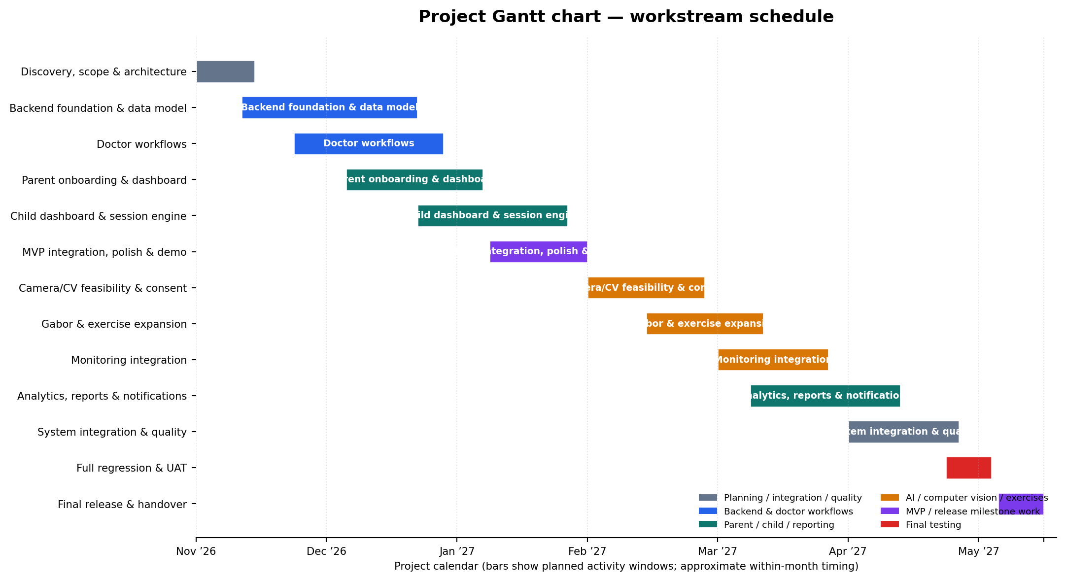

5. Proposed technical structure
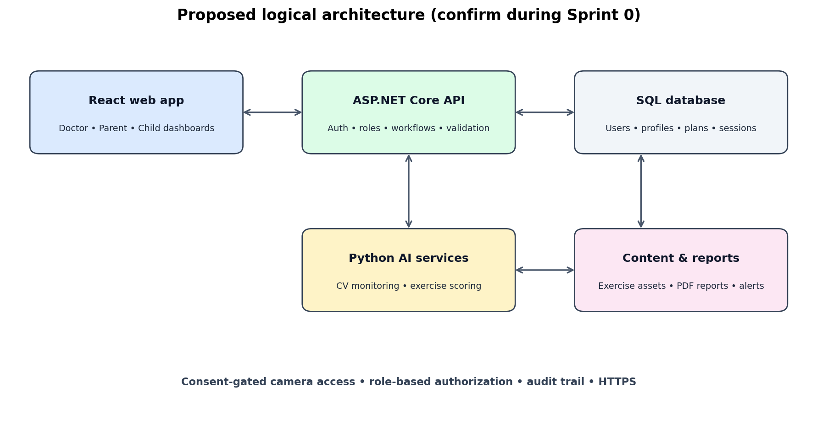
The uploaded ERD drafts share a core domain: Users, ParentProfile, DoctorProfile, ChildProfile, TreatmentPlan, Session, Assessment and ContentItem. Before Sprint 1, the team should reconcile naming and cardinalities into one canonical schema. The diagram above is a proposed implementation boundary, not a claim that the uploaded ERD already specifies this exact architecture.
- Keep one authoritative relational database for users, child/doctor relationships, plans, assessments and sessions. Choose the database technology in Sprint 0 and document the decision.
- Use ASP.NET Core as the primary business API to leverage the three C#/.NET backend skill profiles; expose a separate Python service only for AI/CV capabilities that need it.
- Keep all clinical and treatment-plan decisions doctor-controlled. AI/CV output should be a supporting session signal, not a diagnosis or autonomous treatment adjustment.
- Enforce authorization at the API/data layer: a parent sees only their linked children; a doctor sees only assigned children; a child sees only their own assigned plan.
- Record camera consent state and timestamp. Camera features must not start without consent; provide a clear withdrawal path and a non-camera fallback.

6. Testing strategy
Test level | When | Coverage / examples
Unit tests | Every sprint | Business rules, adherence calculations, validators, authorization helpers, session state transitions, AI preprocessing/scoring functions.
API & integration tests | S1 onward; expand S12 | Authentication, role claims, doctor-code linking, CRUD flows, plan/session persistence, report data, notification events, AI service contract.
End-to-end tests | S4 onward; full in April | Doctor assigns plan → parent sees plan → child performs session → records appear in dashboards and reports.
Security/privacy tests | S3 onward; full in April | Cross-account data isolation, role bypass, consent withdrawn, unauthorized camera access, token/session handling, sensitive-data exposure.
Usability/accessibility | S5 and S13 | Child can start a session with minimal guidance; parent understands adherence; doctor can find child and review progress; responsive layouts and readable controls.
AI/CV evaluation | S7–S9; regression in April | Controlled test matrix for lighting, camera angle, occlusion, distance and device; report precision/recall or suitable task metrics; document unsupported cases.
Performance/reliability | S12–S13 | Dashboard/report response, session event persistence, concurrent user smoke test, service failure and recovery behavior.

7. Risks, dependencies and mitigations
Risk / dependency | Impact | Mitigation / decision needed
Clinical measurements and thresholds are not fully defined in source files. | Incorrect or misleading clinical interpretation. | Medical supervisor approves assessment fields, terminology and report wording before these are treated as clinical outputs.
Camera-based attention/distance estimation may be unreliable across devices and environments. | False alerts, poor user trust, schedule slippage. | Run feasibility spike in February; use confidence/unknown state, test matrix and manual fallback; do not label as diagnostic.
Two ERD drafts show overlapping but not identical detail. | Rework, inconsistent APIs and database. | Resolve one canonical ERD and data dictionary in S0; record changes through migrations.
Large scope for a 10-person student team. | MVP slips and testing gets squeezed. | Protect January MVP scope; move chat and non-essential AI/LLM work to stretch; freeze features before April test cycle.
Integration delays between .NET frontend and Python AI services. | Late end-to-end failures. | Agree API contracts early; use mocked service responses before the CV model is ready; run weekly integration builds.
Camera consent, child privacy and sensitive health data. | Privacy and compliance risk. | Collect explicit parent consent, support withdrawal, minimize retention, restrict access, encrypt transport and consult institutional requirements.
Limited time for cross-device testing. | Bugs on actual user devices. | Start responsive checks during MVP; reserve April for a documented device/browser matrix and UAT.

8. MVP acceptance checklist
- ☐ Doctor can register/login, see verification status, and manage a child linked to their account.
- ☐ Parent can register, create a child profile and link the child using the doctor-provided code/approval flow.
- ☐ Parent and doctor cannot access another user's child data; this is verified with negative tests.
- ☐ Doctor can create and update a treatment plan and record a vision assessment using supervisor-approved fields.
- ☐ Child can enter with the child code, view only the assigned activities and complete a session.
- ☐ Session record stores planned duration, actual duration and status; missing result data is not automatically classified as a missed session.
- ☐ Parent and doctor can view basic session/adherence summaries derived from persisted records.
- ☐ Camera is off by default and is not activated without parent consent; MVP can be demonstrated without camera AI.
- ☐ Core flows have unit/API/E2E test coverage, and the team has a stable demo environment and seeded demo accounts.

9. Decisions to lock in during Sprint 0
- Confirm the medical supervisor and the exact approved assessment measurements and report language.
- Choose the canonical database (the ERD drafts do not conclusively settle every implementation detail) and publish a data dictionary.
- Confirm deployment target, environments, repository structure, branch/PR rules and CI checks.
- Agree how doctor verification is performed and who can approve/reject a doctor account.
- Agree whether parent-doctor messaging is MVP, post-MVP or stretch; recommended: post-MVP after reminders and reports.
- Agree camera/video retention policy. Recommended starting point: process locally/in-session where feasible, do not store raw video unless explicitly approved and necessary.
- Define MVP demo devices/browsers and test accounts for doctor, parent and child.

