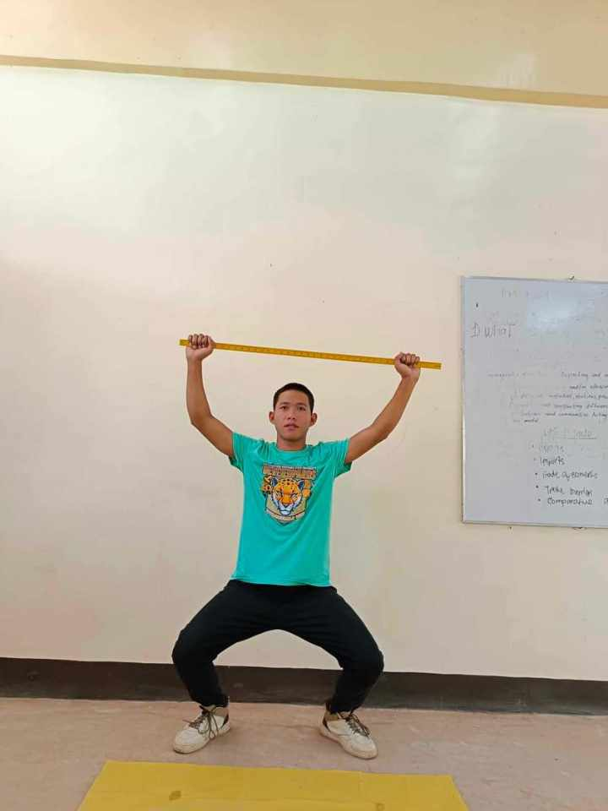DEEP SQUAT

A deep squat refers to a full-range-of-motion squat exercise where an individual lowers their body to the point where their hips are below the level of their knees. In a deep squat, the individual flexes their hips, knees, and ankles to achieve a lower position, engaging various muscle groups such as the quadriceps, hamstrings, glutes, and calves.

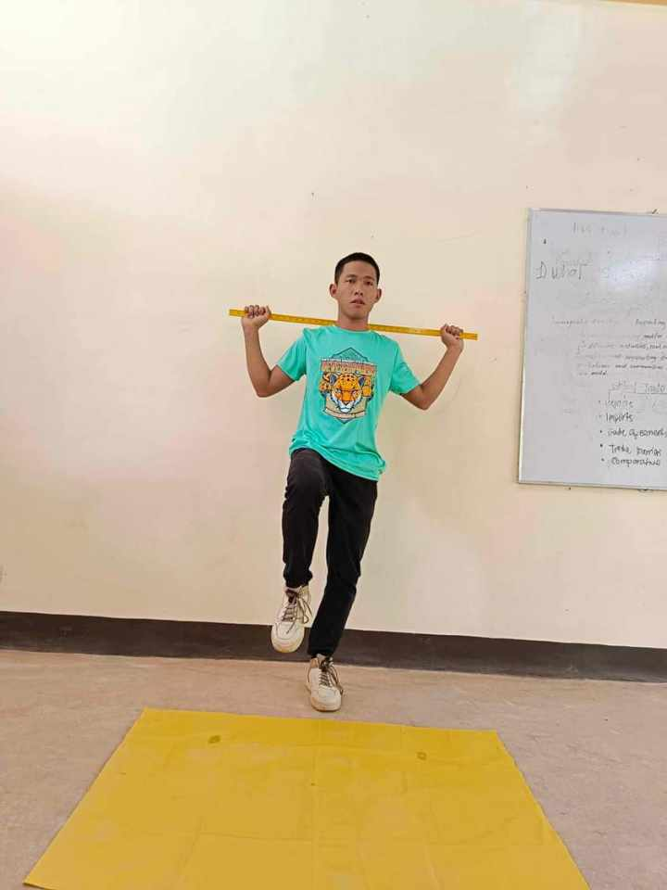Hurdle step

The hurdle step is a functional movement assessment used in fitness and rehabilitation to evaluate an individual's balance, stability, and coordination. In the hurdle step, a person is asked to step over an object (such as a hurdle or a raised platform) while maintaining proper posture and balance.

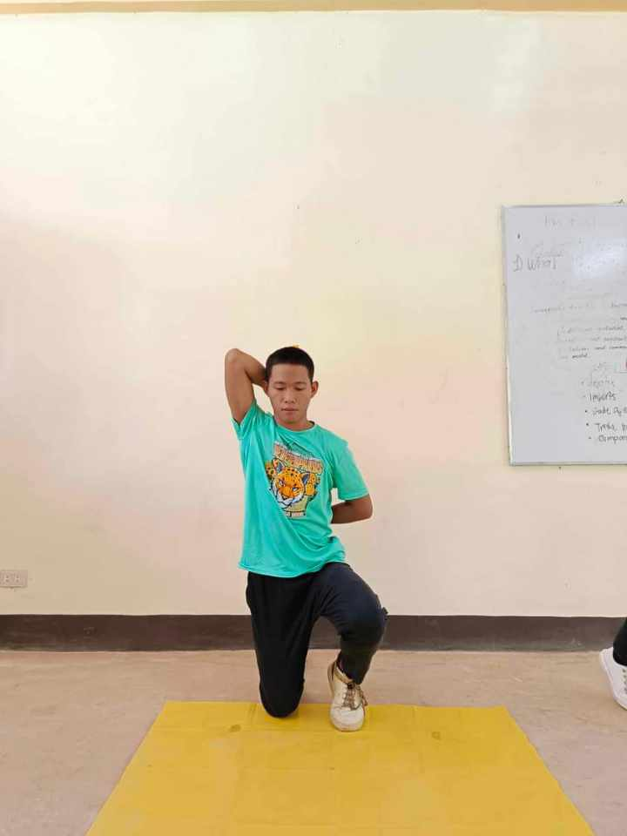In line lunge

The in-line lunge is a functional movement assessment used in fitness and rehabilitation to evaluate an individual's lower body mobility, stability, and alignment. This assessment involves performing a lunge in a straight line, which helps assess the person's ability to move with proper form and control.

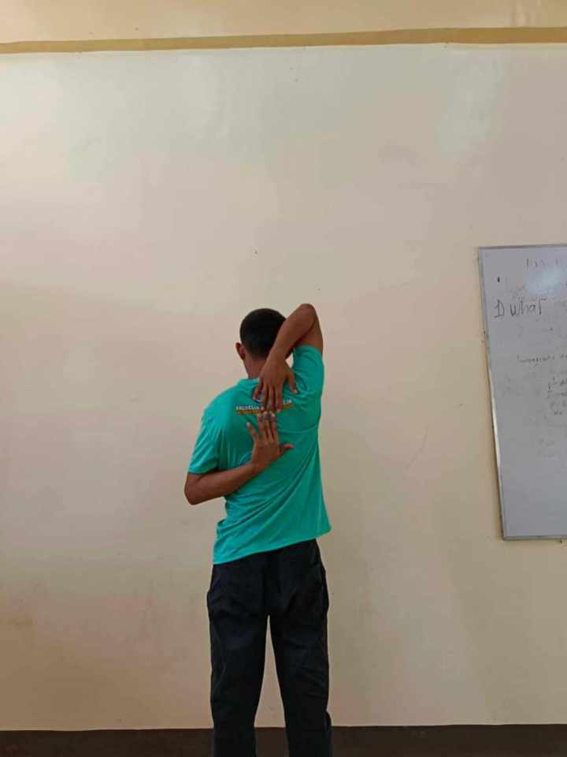Shoulder mobility

Shoulder mobility refers to the range of motion and flexibility of the shoulder joint and its surrounding structures. It involves the ability of the shoulder to move freely and efficiently through various movements, such as flexion, extension, abduction, adduction, internal rotation, and external rotation.

Active leg raise

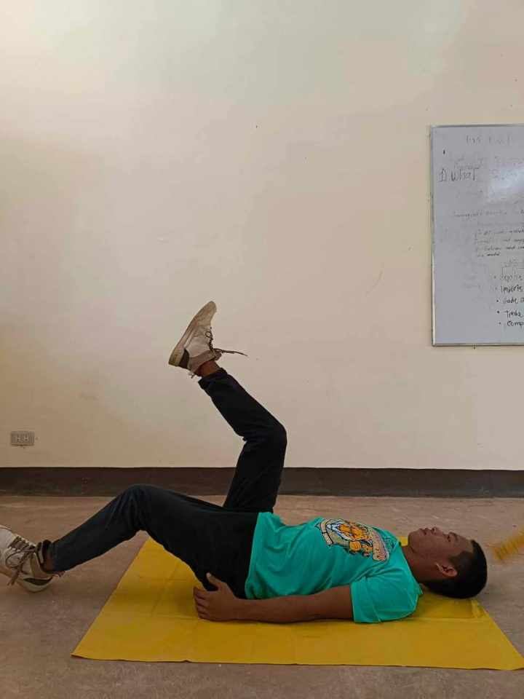

The active leg raise is an exercise that involves lifting one leg at a time while maintaining control and engagement of the core muscles. This movement is commonly used in fitness and rehabilitation programs to assess and improve hip flexor strength, hamstring flexibility, and overall core stability.

Trunk stability push up

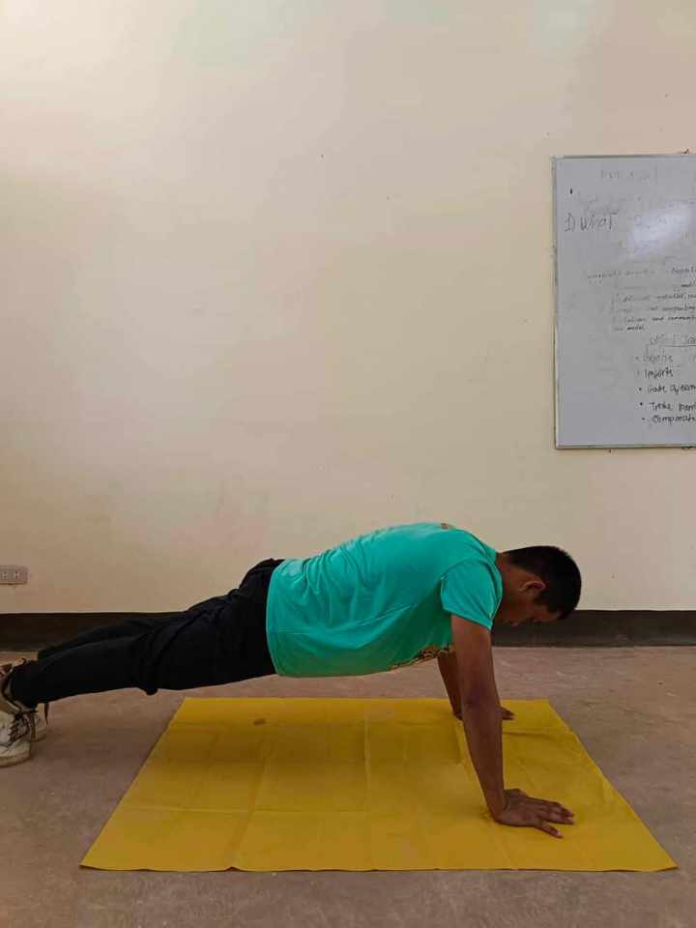

The trunk stability push-up, also known as the TSPU or torso stability push-up, is an exercise that focuses on improving core strength, stability, and control. It's a variation of the traditional push-up, incorporating elements that challenge the muscles responsible for stabilizing the spine.

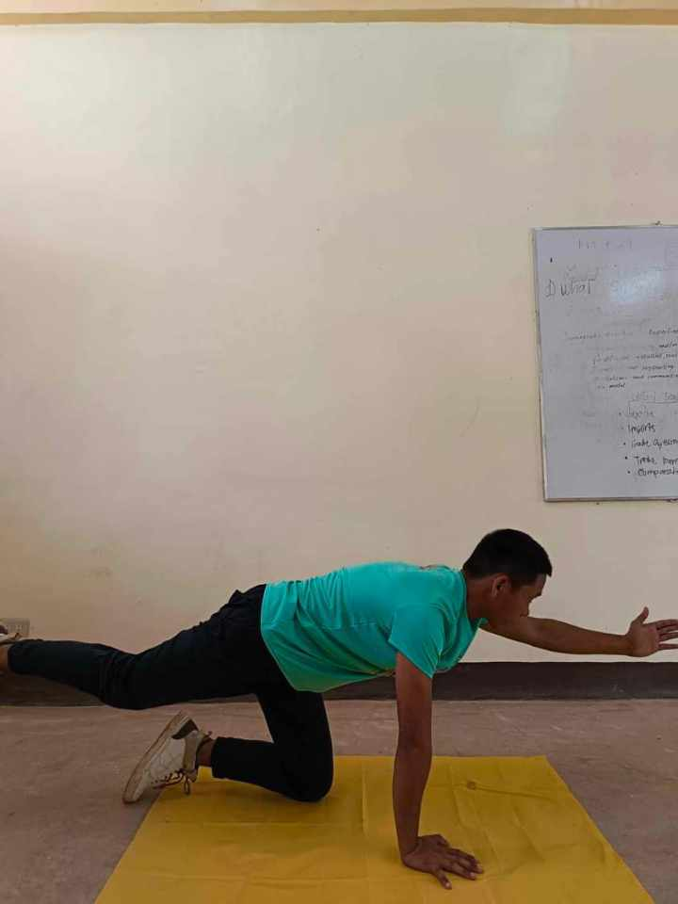Rotary stability

Rotary stability refers to the ability of the body to maintain control and support during movements that involve rotation, typically around the spine. It is a critical aspect of overall core stability and is essential for various functional activities and sports that require twisting and turning motions.

7 Functional Movement Screen in

PATHFIT 1

(Movement Competency Training)

BS Info. Tech 1B

Submitted by: JOSEPH S. ANABIEZA

Submitted to: EARL U. VASQUEZ

insights gained

The Functional Movement Screen (FMS) is a system designed to evaluate movement patterns in individuals. It consists of seven fundamental movement patterns, aiming to identify imbalances and potential issues. The seven movements are:

Deep Squat: Assessing bilateral, symmetrical, and functional mobility of the hips, knees, and ankles.

Hurdle Step: Evaluating bilateral and symmetrical mobility of the hips, knees, and ankles, as well as stability of the core.

Inline Lunge: Examining hip mobility, knee stability, and ankle mobility in a split stance.

Shoulder Mobility: Focusing on flexibility, mobility, and stability of the shoulders, as well as identifying any asymmetries.

Active Straight Leg Raise: Assessing hamstring flexibility, hip mobility, and core stability while lifting one leg.

Trunk Stability Push-Up: Evaluating core stability, upper body strength, and coordination during a pushing movement.

Rotary Stability: Assessing integrated stability, mobility, and motor control in a rotational pattern.

These screens help fitness professionals, physical therapists, and trainers to identify movement deficiencies and create targeted exercise programs to improve overall functional movement patterns, reduce injury risk, and enhance performance.