**Understanding the Self**

**The Self from Various Perspective: Philosophy**

**Learning Objectives:**

At the end of the lesson, students will be able to:

• Discuss the different representation and conceptualization of the self from various disciplinal perspective.

• Compare and contrast how the self has been represented across different disciplines and perspectives. • Examine the different influences, factors, and forces that shape the self.

• Demonstrate critical and reflective thought in analyzing the development of one’s self and identity by developing a theory of the self.

**Introduction:**

How well do you know yourself? Are you aware of your talents? Skills? Weaknesses? Strengths? The Persistent question, “Who am I?” is rooted in the human need to understand the basis of the experiences of the self. When people are asked to explain their understanding of the word, the usual answers are: “It’s who I am.” “It’s me, my essence.” “It’s what makes me unique and different from everyone else.”

For a more meaningful understanding of the self, numerous studies have been conducted and various approaches have been developed from concepts about it. Important philosophers from ancient to contemporary times sought to describe the essential qualities that compose a person’s uniqueness. On the other hand, sociology sees the self as a product of social interactions, developed overtime through social activities and experiences.

Anthropology views the self as a culturally shaped construct or idea. Anthropologists assert that it is an autonomous participant in the society as much as it is submerged in the community. Meanwhile, rather than giving a definition, psychology sees the self as having characteristics or properties that can be used to describe it. Pioneers in the study pointed out that the self is related to its physical and social environment, it is unique, and it is necessary to its experiences.

Eastern and western civilizations have always sought to understand the self. Their views,

however, stand on different perspective. British philosopher Alan Watts (known for his

interpretations of Eastern philosophy and mythology) talked about the great myths of the self.

However, it should be noted that the term myth here is not used to described a false story, rather it

is used as a means to interpret a reality.

According to Watts, the pervading myth in the West is that the world is an artefact. This

means there is a clear distinction between the creator and the creation. This perspective indicates

that the Western interpretation of the self-possesses an internal distinction from its external

environment. That even though the “self” functions in the world, the self is still its own. In the

East however, the myth is that the world is a drama and all things are actors with specific parts to

play. There is no distinction between the creator and the creation as all that exists is immersed in

one and the same existence. This perspective suggests that the self in Eastern traditions is seen

through the eyes of a community, rather than a detached, single, entity. However, Watts further

clarified that his statements on the two great myths of the self is only a description of what is like

in that civilization, and not a definition of what it is.

Learning the various fundamental concepts of the self is significant because these ideas lay

the foundation that will foster in you, the learner, a deep reflection and insight into the continuous

pursuit of self-discovery.

PHILOSOPHY

Socrates

Socrates was a Greek Philosopher and one of the very few individuals who shaped Western

thoughts. However, unlike the other philosophers during his time, Socrates never wrote anything.

Knowledge about Socrates is through-second hand information from the writings of his student

Plato and historian Xenophon.

Socrates was known for his method of inquiry in testing an idea. This is called the Socratic

Method whereby an idea was tested by asking a series of questions o determine underlying beliefs

and the extent of knowledge to guide the person toward better understanding (Maxwell, 2015).

Socrates was described to have gone about in Athens questioning everyday views and popular

Athenian beliefs. This apparently offended the leaders in his time. He was then accused of impiety

or lack of reverence for the Gods and for corrupting the minds of the youth. At 70 years old,

Socrates was sentenced to death by drinking a cup of poison hemlock (Brickhouse & Smith, 2002).

Some of Socrates’ idea were:

• The soul of immortal

• The care of the soul is the task of Philosophy

• Virtue is necessary to attain happiness

Socrates believed that philosophy had a very important role to play in the lives of the

Eastern and western civilizations have always sought to understand the self. Their views, however, stand on different perspective. British philosopher Alan Watts (known for his interpretations of Eastern philosophy and mythology) talked about the great myths of the self. However, it should be noted that the term myth here is not used to described a false story, rather it is used as a means to interpret a reality.

According to Watts, the pervading myth in the West is that the world is an artefact. This means there is a clear distinction between the creator and the creation. This perspective indicates that the Western interpretation of the self-possesses an internal distinction from its external environment. That even though the “self” functions in the world, the self is still its own. In the East however, the myth is that the world is a drama and all things are actors with specific parts to play. There is no distinction between the creator and the creation as all that exists is immersed in one and the same existence. This perspective suggests that the self in Eastern traditions is seen through the eyes of a community, rather than a detached, single, entity. However, Watts further clarified that his statements on the two great myths of the self is only a description of what is like in that civilization, and not a definition of what it is.

Learning the various fundamental concepts of the self is significant because these ideas lay the foundation that will foster in you, the learner, a deep reflection and insight into the continuous pursuit of self-discovery.

**PHILOSOPHY**

1. **Socrates**

Socrates was a Greek Philosopher and one of the very few individuals who shaped Western thoughts. However, unlike the other philosophers during his time, Socrates never wrote anything. Knowledge about Socrates is through-second hand information from the writings of his student Plato and historian Xenophon.

Socrates was known for his method of inquiry in testing an idea. This is called the Socratic Method whereby an idea was tested by asking a series of questions o determine underlying beliefs and the extent of knowledge to guide the person toward better understanding (Maxwell, 2015). Socrates was described to have gone about in Athens questioning everyday views and popular Athenian beliefs. This apparently offended the leaders in his time. He was then accused of impiety or lack of reverence for the Gods and for corrupting the minds of the youth. At 70 years old, Socrates was sentenced to death by drinking a cup of poison hemlock (Brickhouse & Smith, 2002).

**Some of Socrates’ idea were:**

• The soul of immortal

• The care of the soul is the task of Philosophy

• Virtue is necessary to attain happiness

Socrates believed that philosophy had a very important role to play in the lives of the people. One of his most-quoted phrases is, “The unexamined is not worth living.” According to him, self-knowledge or the examination of one’s self, as well as the question about how one ought to live one’s life are very important concerns because only by knowing yourself can you hope to improve your life (Rappe, 1995). Socrates believed that you as a person should consciously contemplate, turn your gazed inward and analyze the true nature and values that are guiding your life.

He added that self-knowledge would open your eyes to your true nature; which contrary to pop culture, is not about what you own, how many likes you get in your social media posts, or how successful you are in your career. In fact, your real self is not your own body. According to Socrates, the state of your inner being (soul/self) determines the quality of your life.

**Socrates said existence is of two kinds:**

1. The visible

2. The invisible

The visible existence changes while the invisible existence remains constant (Connolly, 2017). According to Socrates, this is the state of the human being. The body which is visible, changes; the other part, the kind that is invisible to humans yet sensed and understood by the mind remains constant. In the Socratic dialogue, Plato wrote what Socrates have said about the body and soul; “When the soul and the body are together nature assigns our body to be a slave and to be ruled and the soul to be the ruler and master” (Hamilton et al., 1961; Organ, 1986). However, Socrates said that the body was a reluctant slave, and the soul get dragged towards what is always changing. This would leave the soul confused (Organ, 1986)

Socrates also believed that the goal of life is to be happy. How does one become happy? According to him, the virtuous man is a happy man, and that virtue alone is the one and only supreme good that will secure his/her happiness. Virtue is defined as moral excellence, and an individual is considered virtuous if his/her character is made up of the moral qualities that are accepted as virtues, 1.e., courage, temperance, prudence and justice. According to Socrates, even death is a trivial matter for the truly virtuous because he/she has realized that the most important in life is that state of his/her soul and the acts taken from taking care of the soul through self-knowledge.

1. **Plato**

Plato was the student of Socrates. He wrote the Socratic dialogue where Socrates was the main character and speaker. Plato’s philosophical method was what he identified as “collection and division.” In this method, the philosopher would collect all the generic ideas that seemed to have a common characteristic and then divided then into different kinds until the subdivisions of ideas became specific. He is best known for his ‘Theory of Forms’ that asserted the physical world is not really the real world because the ultimate reality exists beyond the physical world.

Plato is perhaps the single most important influence of the western concept of self. According to Plato, the soul is indeed the most divine aspect of the human being. However, his concept of the divine is not a spiritual being but rather one that ha intellectual connotation. The self/soul/mind according to Plato is the aspect of the human beings by which the Forms (ideas) are known.

The three parts of the soul according to Plato are:

• The appetitive (sensual) The Element that enjoys sensual experiences, such as food, drink, and sex.

• The rational (reasoning) The element that forbids the person to enjoy the sensual experiences; the part that loves truth hence, should rule over the other parts of the soul through the use of reason.

• The Spirited (feeling) The element that is inclined toward reason but understands the demands of passion; the part that loves honor and victory.

1. **St. Augustine**

St. Augustine, also called St. Augustine of Hippo, is one of the Latin fathers of the church, one of the Doctors of the church, and one of the most significant Christian thinkers. His philosophical approach to Christian thinking is the most influential theological system. His written works are among the foundations of medieval and modern Christian thought.

He was deeply influenced by Plato’s ideas. Not surprisingly, he adopted Plato’s view that the self is an immaterial (but rational) soul. Giving the Theory of Forms a Christian perspective, Augustine asserted that these Forms were concepts exiting within the perfect and eternal God where the soul belonged. Saint Augustine said that the soul held the truth and was capable of scientific thinking. Saint Augustine’s concept of Self was an inner, immaterial ‘I’ that had self-knowledge and self-awareness. He believed that the human being was both a soul and a body, and the body possessed senses, such as imagination, memory, reason and mind through which the soul experience the world.

He also reasoned that human beings through the senses could sense the material, temporal objects as we interacted with the material world; the immaterial but intelligible (def. able to understood only by the intellect, not by the senses) God would only be clear or obvious to the mind if one tunes into his/her immaterial self/soul.

**The aspect of the self/soul according to St. Augustine are;**

• It is able to be aware of itself

• It recognizes itself a holistic one.

• It is aware of its unity

Saint Augustine believed that the human being who is both soul and body is meant to tend to higher, divine, and heavenly matters because of his/her capacity to ascend and comprehend truths through the mind. He connected the ascension of the soul with his assertion that everything related to the physical world belongs to the physical body, and if a person concerns himself/herself with this physical world then he/she will not be any different from animals. Saint Augustine pointed out that a person is similar to God as regards to the mind and its ability; that by ignoring use his/her mind (or the incorrect use of the mind) he/she would lose his/her possibility to reach real and lasting happiness.

1. **Rene Descartes**

Rene Descartes was a French philosopher, mathematician, and scientist. He is considered the Father of Modern Western Philosophy. Descartes is often regarded as the first thinker to emphasize the use of reason to describe, predict and understand natural phenomena based on observational and empirical evidence.

Descartes proposed that doubt as a principal tool of disciplined inquiry. His method was called hyperbolical/metaphysical doubt, also sometimes referred a methodological skepticism. It is a systematic process of being skeptical about the truth of one’s beliefs in order to determine which beliefs could be ascertained as true.

Rene Descartes’ famous line “Cogito Ergo Sum” translated as “I think; therefore, I am” became a fundamental element of western philosophy as it secured the foundation for knowledge in the face of radical doubt. He asserted that everything perceived by the senses could not be used as proof of existence because human senses could be fooled. He added that there was only one thing we could be sure of this world, and that was everything could be doubted. In turn, by doubting his own existence, Descartes proved that there is thinking entity that is doing the act of doubting.

**Descartes’ claims about the self are:**

• It is constant; it is not prone to change; and it is not affected by time

• Only the immaterial soul remains the same throughout time

• The immaterial soul is the source of our identity.

The further asserted that this thinking entity could exist without the body because it is an immaterial substance. Nevertheless, this immaterial substance (self) possesses a body and is so intimately bound/joined by it that the ‘self’ forms a union with its body. Despite this body soul union, Descartes reasoned that the soul is still distinct from the body. Some distinctions between the soul and the body as pointed out by Descartes are:

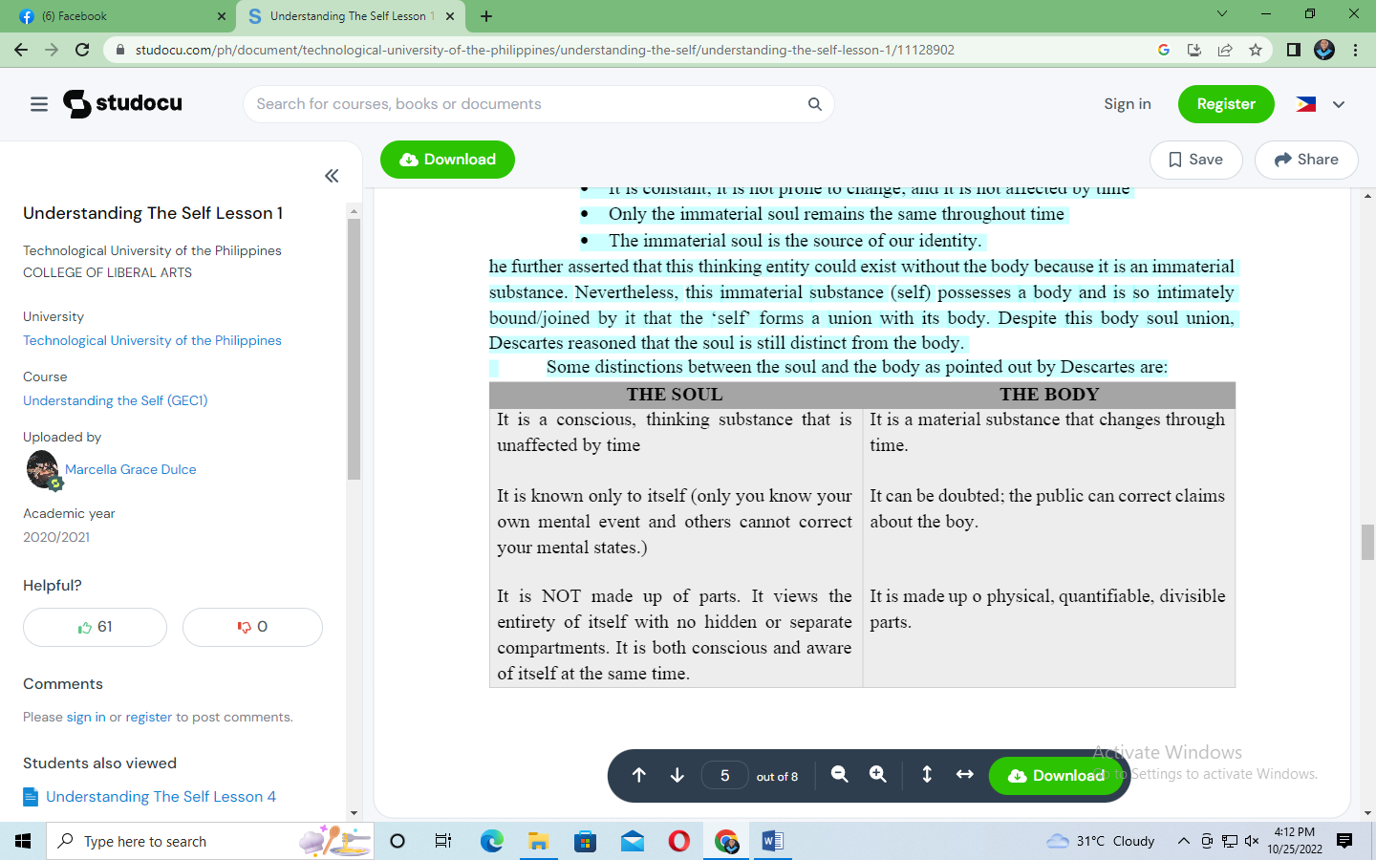

1. **John Locke**

John Locke was a philosopher and physician and was one of the most influential Enlightenment thinkers. The Age of Enlightenment or the Age of Reason was an intellectual and philosophical movement that dominated the ideas in Europe during the 18th century.

If Descartes describe the self as a thinking thing, Locke expanded this definition of self to include the memories of that thinking thing. Locke believed that the self is identified with consciousness and this self consists of sameness of consciousness. This usually interpreted to mean that the self consists of memory; that the person existing now is the same person yesterday because he/she remembers the thoughts, experiences, or actions of the earlier self.

For Locke, a person’s memories provide a continuity of experience that allows him/her to identify him/herself as the same person over time. This theory of personal identity allows Locke to justify a defense accountability. According to Locke, since the person is the same self in the passing time, he/she can be held accountable for past behaviors. However, Locke insisted that a person could only be held accountable for behaviors he/she can remember. Locke believe that punishing someone for behaviors he/she has no recollection of doing is equivalent to punishing him/her for actions that was never performed. He asserted that the state of the person who cannot remember his/her behavior is the same as the state of the person who never committed the act, which meant the person was ignorant.

1. **David Hume**

David Hume (1711-1776) was a Scottish philosopher, economist and historian during the age of Enlightenment. He was a fierce opponent of Descartes’s Rationalism. Rationalism is the theory that reason, rather that experience, is the foundation of all knowledge. Hume alongside with John Locke ad bishop George Berkeley, was one of the three main figureheads of the influential British Empiricism movement. Empiricism is the idea that the origin of all knowledge is sense experience. It emphasized the role of experience and evidence (especially sensory perceptions) in forming concept, while discounting the notion of innate ideas.

Hume is identified with the bundle theory wherein he described the self or person (which Hume assumed to be the mind) as a bundle or a collection of a different perceptions that are moving in a very fast and successive manner; therefore, it is in a perpetual flux. Hume’s theory began by denying Descartes’ view of immaterial soul and of its experiences. Empiricists like Hume believed that human intellect and experiences are limited; therefore, it is impossible to attribute it to an independent persisting entity (i.e., soul). David Hume concluded that the self is merely made up of successive impressions.

Hume divided the mind’s perceptions into two groups stating that the difference between the two “consists in the degrees of force and liveliness with which they strike upon the mind.”

1. Impressions. These are the perceptions that are the most string. They enter the senses with most force. These are directly experienced; they result from inward and outward sentiments.
2. Ideas. These are the less forcible and less lively counterparts of impressions. These are mechanisms that copy and reproduce sense data formulated based upon the previously perceived impressions.

Hume asserted that the notion of the self could not be verified through observation. He argued that if can directly know, then what you know are mere objects of what your senses are experiencing. With this idea, he believed that there are no logical justifications for the existence of anything other that on what your senses experienced. For Hume, the self was nothing but a series of incoherent impressions received by the senses. This description of senses revealed, according to Hume, no permanently subsisting self.

Hume compared the self to a notion; whereby a nation retains its “being a nation” not by some single core or identity but by being composed or different, constantly changing elements, such as people, systems, culture and beliefs. In the same manner, the ‘self’ according to Hume is not just one impression but mix and a loose cohesion of various personal experiences. Hume insisted that there is no one constant impression that endures throughout your life.

Hume did not believe on the existence of the self. He stressed that your perceptions are only active for a long as you are conscious. According to Hume, should your perception be removed for any time (such as when you are sleeping), and you can no longer sense yourself then you also cease to exist. In this line, Hume seemed to reduce the self as a light bulb that may be switched on or off. Hume’s self is a passive observer similar to watching one’s life pass before the eyes like a play or on a screen; whereby the total annihilation of the self comes at death.

1. **Immanuel Kant**

Philosopher Immanuel Kant is a central figure in modern philosophy. His contributions to metaphysics, epistemology, ethics, and aesthetics have had a profound impact on almost every philosophical movement that followed him. Among other ideas that Kant proposed was that, the human mind creates the structure of human experience.

Kant’s view of the self is transcendental, which means the self is related to a spiritual and nonphysical realm. For Kant, the self is not in the body. The self is outside the body, and it does not have the qualities of the body. Despite being transcendental, Kant stressed that the body and its qualities are rooted to the self. He proposed that it is knowledge that bridges the self and the material things together.

**Two kinds of consciousness of self (rationality):**

1. Consciousness of oneself and one’s psychological states in inner sense, and

2. Consciousness of oneself and one’s states y performing acts of apperception.

**Apperception** is the material process by which a person makes sense of an idea by assimilating it to the body or ideas he or she already possesses.

Kant’s point is that what truly exist are your ideas and your knowledge of your ideas; that you perceived the outside world through the self with your ideas. Kant pointed out that the materialworld is not just an extension, and that you are merely seeing objects. He insisted that you perceived the outside world because there is already an idea residing within you. These ideas are what connect you to the external world. He defended the diverse quality or state of the body and soul (self) presenting that “bodies are objects of outer sense; souls are objects of inner sense.”

**Two components of the self:**

1. Inner self. The self by which you are aware of alteration in your own state. This includes your rational intellect and your psychological state, such a moods, feelings, and sensation, pleasure, and pain.

2. Outer self. It includes your senses and the physical world it is the common boundary between the external world and the inner self. It gathers information from the external world through the senses, which the inner self interprets and coherently expresses.

**Kant proposed that the self organizes information in three ways:**

• Raw perceptual input

• Recognizing the concept

• Reproducing in the imagination

Kant’s self has a unified point of self-reference you are conscious of yourself as the subject, and you are conscious of yourself a common subject of different representations. Here Kant confirms that the impressions you perceive point to one single common fact- the self is the subject of these experiences.