
Spring-2025 Semester
Data Structures and Algorithms
FINAL PROJECT (AI CHATBOT)
LUMA
REPORT:

Submitted By:

- Ambreen Naeem
- Sameea M Amjad
- Muhammad Ibrahim
- Muhammad Shayaan
- Sadaf Fatima

Instructor:
Maam Maleeha Mujahid

- Introduction:
In this project, we developed a console-based C++ application that integrates a user authentication system with an interactive chatbot. The aim was to implement secure registration and login features, followed by a natural question-answer session with a basic AI-powered chatbot. The chatbot is capable of handling common queries and maintains conversation history and undo functionality.
- Objectives:
Implement user registration with input validation.
Secure login system with password checking.
Integrate a chatbot capable of natural interaction.
Store and manage question-answer pairs.
Provide features like undo and chat history.
- System Requirements:
Software Requirements:
-> Programming Language: C++
-> IDE: Visual Studio
-> Compiler: G++ (C++ Compiler)
Libraries Used:
-> <iostream> Input/output operations (e.g., cin, cout)
-> <unordered_map> Hash table for fast key-value lookups (used to store users and Q&A)
-> <vector> Dynamic array (used to store multiple answers per question)
-> <string> String manipulation and input
-> <algorithm> STL functions (e.g., transform, though not directly used here)
-> <stack> LIFO data structure for undo functionality
-> <queue> FIFO data structure to maintain conversation history
-> <ctime> Random number seed initialization using system time
-> <cctype> Character utilities (e.g., tolower, isalnum, isspace)
- System Design:
Flowchart Overview:
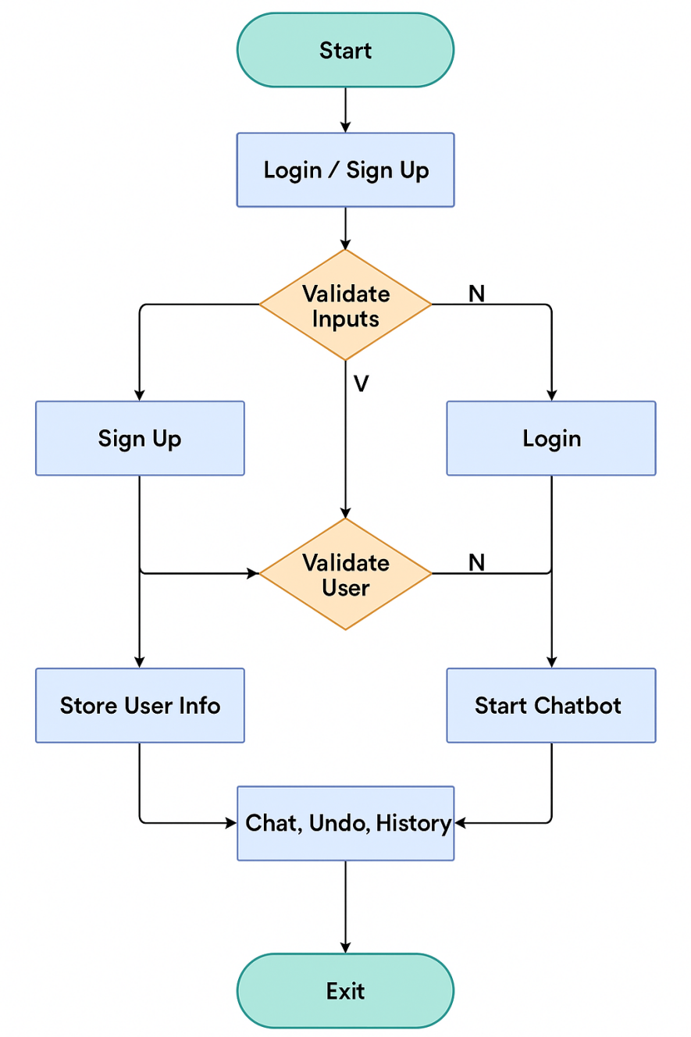
- Class Diagram:
-> User:
Attributes: name, email, password, dob, language, age
-> AuthenticationSystem:
Attributes: users (unordered_map)
Methods: signUp(), login()
-> Chatbot:
Attributes: qa (question-answer Datatbase), history (queue), undoStk (stack)
Methods: normalize(), record(), showHistory(), undo(), start()
- Key Functionalities:
-> Sign Up:
Validates email format.
Ensures password strength (≥ 8 characters).
Confirms password match.
Extracts age from DOB and checks minimum age (15).
Stores user in a map using email as the key.
-> Login:
Verifies email existence and correct password.
Starts chatbot session upon successful login.
-> Chatbot Features:
Responds to over 100 hardcoded common questions.
Normalizes input (lowercased, removes punctuation).
Maintains a queue for last 10 conversation pairs.
Allows user to undo the last message (stack-based).
Supports special commands:
"history": View chat history
"undo": Remove last interaction
"bye": Exit chatbot
- Code:
#include <iostream>
#include <unordered_map>
#include <vector>
#include <string>
#include <algorithm>
#include <stack>
#include <queue>
#include <ctime>
#include <cctype>
using namespace std;
struct User {
string name;
string email;
string password;
string dob;
string language;
int age;
User() {}
User(string n, string e, string p, string d, string l, int a)
: name(n), email(e), password(p), dob(d), language(l), age(a) {
}
};
class AuthenticationSystem {
private:
unordered_map<string, User> users;
const int MIN_AGE = 15;
bool isValidEmail(const string& email) {
size_t at = email.find('@');
size_t dot = email.find('.', at);
return at != string::npos && dot != string::npos;
}
bool isStrongPassword(const string& pwd) {
return pwd.length() >= 8;
}
bool checkAge(const string& dob) {
if (dob.size() < 10) return false;
int year = stoi(dob.substr(6, 4));
int age = 2025 - year;
return age >= MIN_AGE;
}
public:
bool signUp() {
cout << "\n--- SIGN UP ---\n";
string name, email, pwd, confirm, dob, lang;
cout << "Name: ";
getline(cin, name);
if (name.empty()) {
cout << "Name cannot be empty.\n";
return false;
}
cout << "Email: ";
getline(cin, email);
if (!isValidEmail(email)) {
cout << "Invalid email.\n";
return false;
}
if (users.count(email)) {
cout << "Email already registered.\n";
return false;
}
cout << "Password (min 8 chars): ";
getline(cin, pwd);
if (!isStrongPassword(pwd)) {
cout << "Password too weak.\n"; return false;
}
cout << "Confirm Password: ";
getline(cin, confirm);
if (pwd != confirm) {
cout << "Passwords do not match.\n";
return false;
}
cout << "DOB (DD-MM-YYYY): ";
getline(cin, dob);
if (!checkAge(dob)) {
cout << "You must be at least " << MIN_AGE << " years old.\n";
return false;
}
cout << "Preferred Language: ";
getline(cin, lang);
if (lang.empty()) lang = "English";
int year = stoi(dob.substr(6, 4));
int age = 2025 - year;
users[email] = User(name, email, pwd, dob, lang, age);
cout << "Registration successful! You can now log in.\n";
return true;
}
bool login(string& userEmail) {
cout << "\n--- LOGIN ---\n";
string email, pwd;
cout << "Email: "; getline(cin, email);
if (!users.count(email)) {
cout << "No account with that email.\n";
return false;
}
cout << "Password: "; getline(cin, pwd);
if (users[email].password != pwd) {
cout << "Incorrect password.\n";
return false;
}
userEmail = email;
cout << "Login successful! Welcome, " << users[email].name << ".\n";
return true;
}
};
class Chatbot {
private:
unordered_map<string, vector<string>> qa;
queue<pair<string, string>> history;
stack<string> undoStk;
const size_t MAX_HISTORY = 10;
string normalize(const string& s) {
string r;
for (char c : s) if (isalnum(c) || isspace(c)) r += tolower(c);
size_t b = r.find_first_not_of(' ');
size_t e = r.find_last_not_of(' ');
return b == string::npos ? "" : r.substr(b, e - b + 1);
}
void record(const string& q, const string& a) {
if (history.size() == MAX_HISTORY) history.pop();
history.push({ q,a });
undoStk.push(a);
}
void showHistory() {
if (history.empty()) { cout << "No history.\n"; return; }
auto tmp = history;
cout << "--- Conversation History ---\n";
while (!tmp.empty()) {
cout << "You: " << tmp.front().first << "\n";
cout << "Bot: " << tmp.front().second << "\n";
tmp.pop();
}
cout << "----------------------------\n";
}
void undo() {
if (undoStk.empty()) {
cout << "Nothing to undo.\n";
return;
}
cout << "Removed: " << undoStk.top() << "\n";
undoStk.pop();
if (!history.empty()) history.pop();
}
public:
Chatbot() {
vector<pair<string, string>> pairs = {
{"hi", "Good! What about you?"},
{"hello", "Hello there! How can I help?"},
{"hey", "Hey! What's up?"},
{"how are you", "I'm doing great, thanks!"},
{"what is your name", "I'm your friendly chatbot."},
{"who are you", "I'm an AI assistant."},
{"help", "Sure—ask away!"},
{"thank you", "You're welcome!"},
{"thanks", "Anytime!"},
{"bye", "Goodbye!"},
{"good morning", "Good morning to you!"},
{"good night", "Good night, sleep tight."},
{"joke", "Why don't scientists trust atoms? Because they make up everything!"},
{"weather", "I can't fetch live weather yet."},
{"time", "I don't have a clock."},
{"date", "I have no calendar."},
{"programming", "I love coding talk!"},
{"sports", "Which sport do you like?"},
{"music", "Music soothes the soul."},
{"movie", "I enjoy sci-fi films."},
{"what can you do", "I answer questions, tell jokes, and help with info!"},
{"tell me a fact", "Honey never spoils—archaeologists found edible 3000-year-old honey!"},
{"define AI", "AI stands for Artificial Intelligence—machines that mimic human thinking."},
{"who made you", "I was created by developers using machine learning."},
{"are you human", "Nope, I’m a program, but I try my best!"},
{"do you sleep", "I don’t need sleep, but servers need breaks!"},
{"favorite book", "I can’t read, but users love *The Hitchhiker’s Guide to the Galaxy*!"},
{"meaning of life", "42 (according to Douglas Adams) or your own purpose!"},
{"how old are you", "I’m ageless—just code running on servers!"},
{"capital of japan", "Tokyo!"},
{"best programming language", "Depends! Python for beginners, C++ for speed, JavaScript for web."},
{"how to learn coding", "Try free platforms like Codecademy or freeCodeCamp!"},
{"what is chatgpt", "An AI chatbot by OpenAI, similar to me!"},
{"do you dream", "Only of electric sheep (kidding—I don’t dream)."},
{"favorite movie", "I can’t watch films, but *The Matrix* is a classic!"},
{"tell me a riddle", "What has keys but no locks? A piano!"},
{"how big is the universe", "Observable universe: ~93 billion light-years across!"},
{"why is the sky blue", "Rayleigh scattering—sunlight disperses blue light more!"},
{"best pizza topping", "Controversial! Pepperoni or mushrooms?"},
{"how to meditate", "Sit quietly, focus on breath, let thoughts pass."},
{"what is love", "A complex emotion—or a Haddaway song!"},
{"how to tie a tie", "YouTube has great tutorials for the Windsor knot!"},
{"who won the world cup", "Argentina in 2022 (as of now)."},
{"best phone brand", "Subjective! Apple, Samsung, or Google Pixel?"},
{"how to lose weight", "Eat balanced meals, exercise, and stay consistent."},
{"what is bitcoin", "A decentralized digital cryptocurrency."},
{"how to invest", "Start with index funds or consult a financial advisor."},
{"best travel destination", "Bali for beaches, Japan for culture!"},
{"how to cook pasta", "Boil water, add salt, cook al dente (~8 mins)!"},
{"what is blockchain", "A secure, decentralized digital ledger system."},
{"how to write a resume", "Keep it concise, highlight skills, use action verbs."},
{"funny meme", "Why did the scarecrow win an award? Because he was outstanding in his field!"},
{"how to study better", "Use the Pomodoro Technique (25-min focused sessions)."},
{"what is python", "A versatile, easy-to-learn programming language."}
{"how to make coffee", "Brew ground beans with hot water—or use a machine!"},
{"who is elon musk", "CEO of Tesla, SpaceX, and X (formerly Twitter)."},
{"how to fix a leak", "Use plumber’s tape or call a professional!"},
{"what is covid", "A disease caused by the SARS-CoV-2 virus."},
{"how to save money", "Budget, cut unnecessary expenses, automate savings."},
{"best gaming console", "PS5, Xbox Series X, or Nintendo Switch—depends on games!"},
{"how to train a dog", "Positive reinforcement (treats/praise) works best!"},
{"what is netflix", "A streaming service for movies/TV shows."},
{"how to take a screenshot", "On Windows: PrtScn. On Mac: Cmd+Shift+4."},
{"who is shakespeare", "A famous English playwright (*Romeo and Juliet*)."},
{"how to be happy", "Practice gratitude, connect with others, pursue passions."},
{"what is instagram", "A photo/video-sharing social media app."},
{"how to start a blog", "Pick a niche, use WordPress, write consistently!"},
{"who is the richest person", "Elon Musk or Jeff Bezos (varies by stock prices)."},
{"how to change a tire", "Loosen lug nuts, jack up car, replace tire."},
{"what is a nft", "A non-fungible token—unique digital asset on blockchain."},
{"how to get a job", "Network, tailor your resume, practice interviews."},
{"best car brand", "Toyota for reliability, Tesla for tech!"},
{"how to draw", "Start with basic shapes, practice daily!"},
{"what is twitter", "A social media platform for short posts (now X)."},
{"how to grow plants", "Water, sunlight, and good soil are key!"},
{"who is einstein", "A physicist famous for E=mc² and relativity."},
{"how to make friends", "Be genuine, join clubs, listen actively."},
{"what is youtube", "A video-sharing platform for creators."},
{"how to clean a laptop", "Use microfiber cloth + isopropyl alcohol."},
{"who is messi", "A legendary Argentine soccer player."},
{"how to speak french", "Try Duolingo or immersion!"},
{"what is amazon", "An e-commerce and cloud computing giant."},
{"how to reduce anxiety", "Deep breathing, exercise, limit caffeine."},
{"best laptop brand", "Apple, Dell, or HP for reliability."},
{"how to bake a cake", "Mix flour, sugar, eggs, and bake at 350°F!"},
{"who is beethoven", "A German composer (*Moonlight Sonata*)."},
{"how to use excel", "Learn formulas (=SUM), pivot tables, shortcuts!"},
{"what is tiktok", "A short-form video-sharing app."},
{"how to swim", "Take lessons, practice floating/kicking."},
{"who is ronaldo", "A Portuguese soccer superstar."},
{"how to write a novel", "Outline your plot, write daily, edit later!"},
{"what is facebook", "A social media platform for connecting."},
{"how to delete files", "Right-click → Delete or use Shift+Del (permanent)."},
{"who is tesla", "Nikola Tesla—inventor of AC electricity."},
{"how to paint", "Start with basic brushes, mix colors, practice!"},
{"what is linkedIn", "A professional networking platform."},
{"how to train for a marathon", "Start with 5Ks, increase mileage slowly."},
{"who is hawking", "Stephen Hawking—cosmologist (*A Brief History of Time*)."},
{"how to use photoshop", "Learn layers, masks, and shortcuts!"},
{"what is spotify", "A music/podcast streaming service."},
{"how to fix wifi", "Restart router, check cables, update firmware."},
{"who is gandhi", "Indian leader of nonviolent independence movement."},
{"how to make tea", "Steep tea leaves in hot water for 3-5 mins."},
{"what is zoom", "A video conferencing app for meetings."},
{"how to train your brain", "Solve puzzles, learn new skills, meditate."},
{"who is napoleon", "French military leader/emperor in the 1800s."},
{"how to use github", "Commit code, push repos, collaborate!"},
{"what is reddit", "A forum-based social media platform."},
{"how to build muscle", "Lift weights, eat protein, rest well."},
{"who is da vinci", "Renaissance artist (*Mona Lisa*) and inventor."},
{"how to make sushi", "Prepare rice, slice fish, roll with seaweed!"},
{"what is whatsapp", "A messaging app for texts/calls."},
{"how to stop procrastinating", "Break tasks into chunks, set deadlines."},
{"who is cleopatra", "Last active ruler of ancient Egypt."},
{"how to use canva", "Drag-and-drop design tool for graphics."},
{"what is discord", "A chat app for gamers/communities."},
{"how to improve memory", "Use mnemonics, sleep well, stay organized."},
{"who is mozart", "Classical composer (*The Magic Flute*)."},
{"how to make pancakes", "Mix flour, milk, eggs; cook on a griddle!"},
{"what is a meme", "A humorous image/video spread online."},
{"how to be confident", "Practice, positive self-talk, fake it till you make it!"},
{"who is van gogh", "Dutch painter (*Starry Night*)."},
{"how to use python", "Install Python, write scripts, run them!"},
{"what is a vpn", "Virtual Private Network—encrypts internet traffic."},
{"how to stop overthinking", "Distract yourself, set time limits for decisions."}
};
for (auto& p : pairs) qa[p.first].push_back(p.second);
srand((unsigned)time(nullptr));
}
void start() {
cout << "\nChatbot: Hello! (type 'history','undo','bye')\n";
string line;
while (true) {
cout << "You: "; getline(cin, line);
string cmd = normalize(line);
if (cmd == "bye") {
cout << "Chatbot: Goodbye!\n";
break;
}
if (cmd == "history") { showHistory(); continue; }
if (cmd == "undo") { undo(); continue; }
string reply;
auto it = qa.find(cmd);
if (it != qa.end()) reply = it->second[rand() % it->second.size()];
else reply = "I'm sorry, I don't know how to answer that.";
cout << "Chatbot: " << reply << "\n";
record(cmd, reply);
}
}
};
int main() {
AuthenticationSystem auth;
while (true) {
cout << "\n1) Login\n2) Sign Up\n3) Exit\nChoose: ";
string opt; getline(cin, opt);
if (opt == "1") {
string user;
if (auth.login(user)) {
Chatbot bot;
bot.start();
break;
}
}
else if (opt == "2") {
auth.signUp();
}
else if (opt == "3") {
cout << "Exiting...\n";
break;
}
else {
cout << "Invalid option.\n";
}
}
return 0;
}
- Screenshots:
- Start Screen:
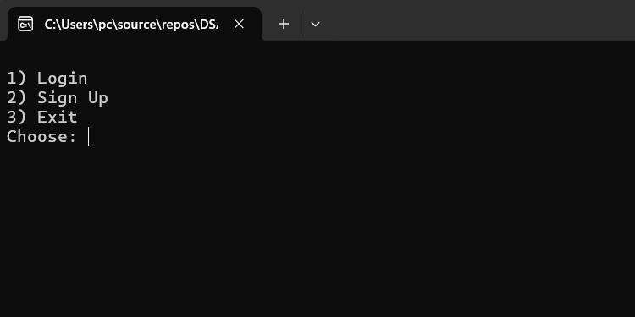
- Successful Sign-Up:
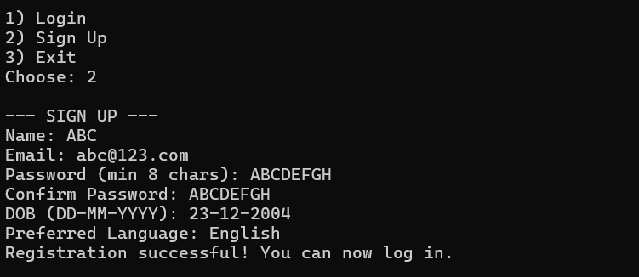

- Successful Login:
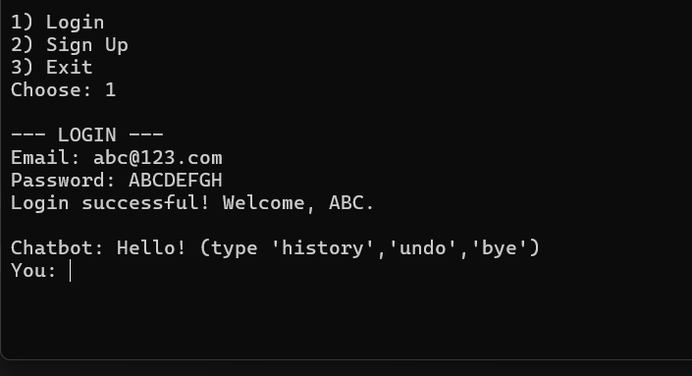
- Chat:
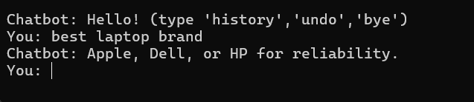
- History:
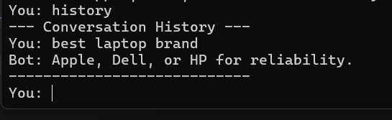
- Undo:
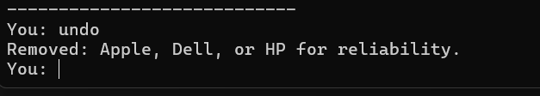
- Bye:
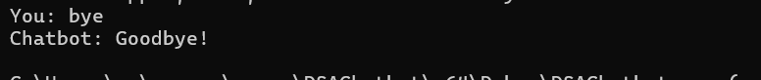
- Limitations:
-> No persistent storage (users are lost on exit).
-> Chatbot answers are hardcoded.
-> No advanced AI or natural language processing.
-> Date of birth is assumed in DD-MM-YYYY format without full validation.

- Future Improvements:
Add file/database-based user storage.
Integrate NLP tools (like spaCy or GPT via API).
GUI using Qt or external UI libraries.
Add voice support using speech-to-text engines.
Expand chatbot to perform tasks (reminders, search, etc.)

- Conclusion:
This project demonstrates the integration of user authentication with a simple chatbot engine using core concepts of C++ like OOP, STL, string processing, and control structures. It provides a solid foundation for more complex AI assistant systems and teaches important real-world programming skills like input validation, data handling, and user interaction design.

