Министерство образования Российской Федерации

Пензенский государственный университет

Кафедра «Системы автоматизированного проектирования»

**ОТЧЕТ**

по лабораторной работе №1

по курсу «Информационное обеспечение САПР»

на тему: «Разработка инфологической модели данных с

помощью CASE-средства ERWin»

Выполнили:

студенты группы 16ВВ3

Страхов А.В.

Самушкин А.Д.

Борисов Д.А.

Приняли:

Глотова Т.В.

Евсеева Ю.И.

Пенза 2018

**Цель работы:** Изучение возможностей CASE- средств проектирования баз данных.

|  |  |
| --- | --- |
| **Сущность** | **Тип** |
| Institute | Независимая |
| Faculty | Зависимая |
| Speciality | Зависимая |
| Department | Зависимая |
| Groups | Зависимая |
| Student | Зависимая |
| Professor | Зависимая |
| Evalution | Зависимая |
| Work | Независимая |
| Term | Независимая |
| PlaceWork | Зависимая |

|  |  |
| --- | --- |
| **Связь** | **Тип** |
| IncludeFaculty | Неидентифицирующая, полная |
| IncludeDepartment | Неидентифицирующая, полная |
| IncludeSpeciality | Неидентифицирующая, полная |
| IncludeGroup | Неидентифицирующая, полная |
| IncludeStudent | Неидентифицирующая, полная |
| IncludeProfessor | Неидентифицирующая, полная |
| Create | Идентифицирующая, полная |
| Teach | Неидентифицирующая, полная |
| When | Идентифицирующая, полная |
| MadeOn | Неидентифицирующая, полная |
| Evaluate | Идентифицирующая, полная |

|  |  |  |
| --- | --- | --- |
| **Сущность** | **Связь** | **Сущность** |
| Institute | IncludeFaculty | Faculty |
| Faculty | IncludeDepartment | Department |
| Faculty | IncludeSpeciality | Speciality |
| Speciality | IncludeGroup | Group |
| Department | IncludeProfessor | Professor |
| Group | IncludeStudent | Student |
| Student | Create | Work |
| Professor | Teach | Work |
| Term | When | Work |
| Work | MadeOn | PlaceWork |
| Work | Evaluate | Evaluation |

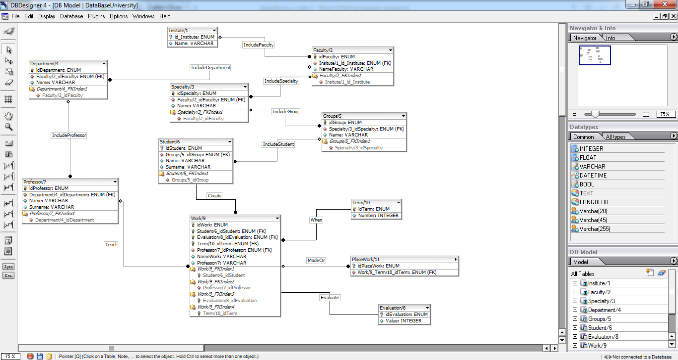

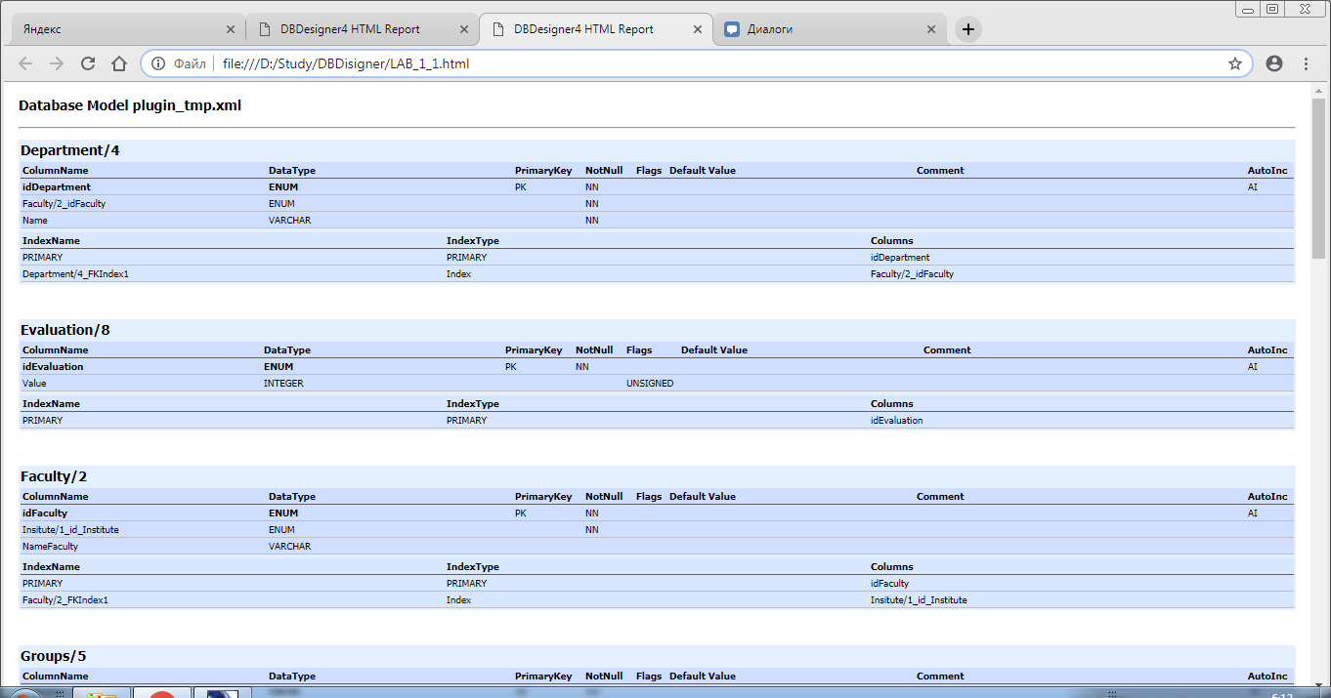

SQL Script:

CREATE TABLE Insitute/1 (

id_Institute INTEGER UNSIGNED NOT NULL AUTO_INCREMENT,

Name VARCHAR NULL,

PRIMARY KEY(id_Institute)

);

CREATE TABLE Faculty/2 (

idInstitute(FK) INTEGER UNSIGNED NOT NULL AUTO_INCREMENT,

Insitute/1_id_Institute INTEGER UNSIGNED NOT NULL,

NameFaculty VARCHAR NULL,

PRIMARY KEY(idInstitute(FK)),

FOREIGN KEY(Insitute/1_id_Institute)

REFERENCES Insitute/1(id_Institute)

ON DELETE NO ACTION

ON UPDATE NO ACTION

);

CREATE TABLE Specialty/3 (

idFaculty(FK) INTEGER UNSIGNED NOT NULL AUTO_INCREMENT,

Faculty/2_idInstitute(FK) INTEGER UNSIGNED NOT NULL,

Name VARCHAR NULL,

PRIMARY KEY(idFaculty(FK)),

INDEX Specialty/3_FKIndex1(Faculty/2_idInstitute(FK)),

FOREIGN KEY(Faculty/2_idInstitute(FK))

REFERENCES Faculty/2(idInstitute(FK))

ON DELETE NO ACTION

ON UPDATE NO ACTION

);

CREATE TABLE Department/4 (

idFaculty(FK) INTEGER UNSIGNED NOT NULL AUTO_INCREMENT,

Faculty/2_idInstitute(FK) INTEGER UNSIGNED NOT NULL,

Name VARCHAR NOT NULL,

PRIMARY KEY(idFaculty(FK)),

INDEX Department/4_FKIndex1(Faculty/2_idInstitute(FK)),

FOREIGN KEY(Faculty/2_idInstitute(FK))

REFERENCES Faculty/2(idInstitute(FK))

ON DELETE NO ACTION

ON UPDATE NO ACTION

);

CREATE TABLE Groups/5 (

idSpecialty(FK) INTEGER UNSIGNED NOT NULL AUTO_INCREMENT,

Specialty/3_idFaculty(FK) INTEGER UNSIGNED NOT NULL,

Name VARCHAR NULL,

PRIMARY KEY(idSpecialty(FK)),

INDEX Groups/5_FKIndex1(Specialty/3_idFaculty(FK)),

FOREIGN KEY(Specialty/3_idFaculty(FK))

REFERENCES Specialty/3(idFaculty(FK))

ON DELETE NO ACTION

ON UPDATE NO ACTION

);

CREATE TABLE Professor/7 (

idStudent(FK) INTEGER UNSIGNED NOT NULL AUTO_INCREMENT,

idDepartment(FK) INTEGER UNSIGNED NOT NULL,

Department/4_idFaculty(FK) INTEGER UNSIGNED NOT NULL,

Name VARCHAR NULL,

Surname VARCHAR NULL,

PRIMARY KEY(idStudent(FK), idDepartment(FK)),

INDEX Professor/7_FKIndex1(Department/4_idFaculty(FK)),

FOREIGN KEY(Department/4_idFaculty(FK))

REFERENCES Department/4(idFaculty(FK))

ON DELETE NO ACTION

ON UPDATE NO ACTION

);

CREATE TABLE Student/6 (

idGroup(FK) INTEGER UNSIGNED NOT NULL AUTO_INCREMENT,

Groups/5_idSpecialty(FK) INTEGER UNSIGNED NOT NULL,

Name VARCHAR NULL,

Surname VARCHAR NULL,

PRIMARY KEY(idGroup(FK)),

INDEX Student/6_FKIndex1(Groups/5_idSpecialty(FK)),

FOREIGN KEY(Groups/5_idSpecialty(FK))

REFERENCES Groups/5(idSpecialty(FK))

ON DELETE NO ACTION

ON UPDATE NO ACTION

);

CREATE TABLE Evaluation/8 (

idStudent(FK) INTEGER UNSIGNED NOT NULL AUTO_INCREMENT,

Student/6_idGroup(FK) INTEGER UNSIGNED NOT NULL,

Value INTEGER UNSIGNED NULL,

PRIMARY KEY(idStudent(FK), Student/6_idGroup(FK)),

INDEX Evaluation/8_FKIndex1(Student/6_idGroup(FK)),

FOREIGN KEY(Student/6_idGroup(FK))

REFERENCES Student/6(idGroup(FK))

ON DELETE NO ACTION

ON UPDATE NO ACTION

);

CREATE TABLE PlaceWork (

idPlaceWork INTEGER UNSIGNED NOT NULL AUTO_INCREMENT,

Student/6_idGroup(FK) INTEGER UNSIGNED NOT NULL,

Name VARCHAR NULL,

PRIMARY KEY(idPlaceWork, Student/6_idGroup(FK)),

INDEX PlaceWork_FKIndex1(Student/6_idGroup(FK)),

FOREIGN KEY(Student/6_idGroup(FK))

REFERENCES Student/6(idGroup(FK))

ON DELETE NO ACTION

ON UPDATE NO ACTION

);

CREATE TABLE Work/9 (

idStudent(FK) INTEGER UNSIGNED NOT NULL AUTO_INCREMENT,

Student/6_idGroup(FK) INTEGER UNSIGNED NOT NULL,

NameWork VARCHAR NULL,

Professor/7 VARCHAR NULL,

PRIMARY KEY(idStudent(FK), Student/6_idGroup(FK)),

INDEX Work/9_FKIndex1(Student/6_idGroup(FK)),

FOREIGN KEY(Student/6_idGroup(FK))

REFERENCES Student/6(idGroup(FK))

ON DELETE NO ACTION

ON UPDATE NO ACTION

);

CREATE TABLE Term/10 (

idStudent(FK) INTEGER UNSIGNED NOT NULL AUTO_INCREMENT,

Student/6_idGroup(FK) INTEGER UNSIGNED NOT NULL,

Number INTEGER UNSIGNED NULL,

PRIMARY KEY(idStudent(FK), Student/6_idGroup(FK)),

INDEX Term/10_FKIndex1(Student/6_idGroup(FK)),

FOREIGN KEY(Student/6_idGroup(FK))

REFERENCES Student/6(idGroup(FK))

ON DELETE NO ACTION

ON UPDATE NO ACTION

);

|  |  |
| --- | --- |
| **Сущность** | **Тип** |
| Institute/1 | Независимая |
| Faculty/2 | Зависимая |
| Speciality/3 | Зависимая |
| Department/4 | Зависимая |
| Groups/5 | Зависимая |
| Student/6 | Зависимая |
| Professor/7 | Зависимая |
| Evalution/8 | Зависимая |
| Work/9 | Зависимая |
| Companies/10 | Независимая |
| Commission/11 | Зависимая |
| Originality/12 | Зависимая |
| Workers/13 | Зависимая |
| Member/14 | Зависимая |

|  |  |
| --- | --- |
| **Связь** | **Тип** |
| IncludeFaculty | Неидентифицирующая, полная |
| IncludeDepartment | Неидентифицирующая, полная |
| IncludeSpeciality | Неидентифицирующая, полная |
| IncludeGroup | Неидентифицирующая, полная |
| IncludeStudent | Неидентифицирующая, полная |
| IncludeProfessor | Неидентифицирующая, полная |
| Create | Неидентифицирующая, полная |
| Mentor | Неидентифицирующая, полная |
| Evaluation | Идентифицирующая, полная |
| Comission | Неидентифицирующая, полная |
| Workers | Неидентифицирующая, полная |
| Originality | Идентифицирующая, полная |
| Member_1 | Идентифицирующая, полная |
| Member_2 | Идентифицирующая, полная |
| Member_3 | Идентифицирующая, полная |

|  |  |  |
| --- | --- | --- |
| **Сущность** | **Связь** | **Сущность** |
| Institute/1 | IncludeFaculty | Faculty/2 |
| Faculty/2 | IncludeDepartment | Department/4 |
| Faculty/2 | IncludeSpeciality | Speciality/3 |
| Speciality/3 | IncludeGroup | Groups/5 |
| Department/4 | IncludeProfessor | Professor/7 |
| Groups/5 | IncludeStudent | Student/6 |
| Student | Create | Work/9 |
| Professor | Mentor | Work/9 |
| Groups/5 | Comission | Comission/11 |
| Work/9 | Evaluation | Evaluation/8 |
| Work/9 | Originality | Originality/12 |
| Companies/10 | Workers | Workers/13 |
| Evaluation/8 | Member_1 | Member/14 |
| Comission/11 | Member_2 | Member/14 |
| Workers/13 | Member_3 | Member/14 |

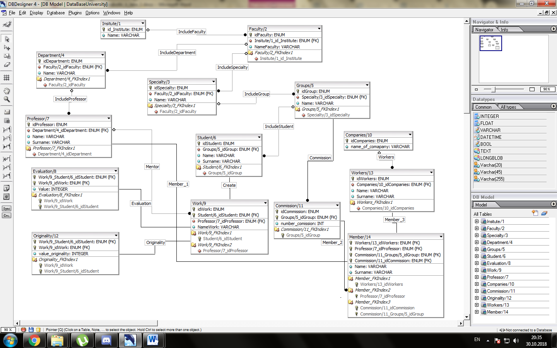

SQLScript:

CREATE TABLE Insitute/1 (

id_Institute INTEGER UNSIGNED NOT NULL AUTO_INCREMENT,

Name VARCHAR NULL,

PRIMARY KEY(id_Institute)

);

CREATE TABLE Companies/10 (

idCompanies INTEGER UNSIGNED NOT NULL AUTO_INCREMENT,

name_of_comapany VARCHAR NULL,

PRIMARY KEY(idCompanies)

)

TYPE=InnoDB;

CREATE TABLE Workers/13 (

idWorkers INTEGER UNSIGNED NOT NULL AUTO_INCREMENT,

Companies/10_idCompanies INTEGER UNSIGNED NOT NULL,

Name VARCHAR NULL,

PRIMARY KEY(idWorkers),

INDEX Workers_FKIndex1(Companies/10_idCompanies),

FOREIGN KEY(Companies/10_idCompanies)

REFERENCES Companies/10(idCompanies)

ON DELETE NO ACTION

ON UPDATE NO ACTION

)

TYPE=InnoDB;

CREATE TABLE Faculty/2 (

idFaculty INTEGER UNSIGNED NOT NULL AUTO_INCREMENT,

Insitute/1_id_Institute INTEGER UNSIGNED NOT NULL,

NameFaculty VARCHAR NULL,

PRIMARY KEY(idFaculty),

INDEX Faculty/2_FKIndex1(Insitute/1_id_Institute),

FOREIGN KEY(Insitute/1_id_Institute)

REFERENCES Insitute/1(id_Institute)

ON DELETE NO ACTION

ON UPDATE NO ACTION

);

CREATE TABLE Specialty/3 (

idSpecialty INTEGER UNSIGNED NOT NULL AUTO_INCREMENT,

Faculty/2_idFaculty INTEGER UNSIGNED NOT NULL,

Name VARCHAR NULL,

PRIMARY KEY(idSpecialty),

INDEX Specialty/3_FKIndex1(Faculty/2_idFaculty),

FOREIGN KEY(Faculty/2_idFaculty)

REFERENCES Faculty/2(idFaculty)

ON DELETE NO ACTION

ON UPDATE NO ACTION

);

CREATE TABLE Department/4 (

idDepartment INTEGER UNSIGNED NOT NULL AUTO_INCREMENT,

Faculty/2_idFaculty INTEGER UNSIGNED NOT NULL,

Name VARCHAR NOT NULL,

PRIMARY KEY(idDepartment),

INDEX Department/4_FKIndex1(Faculty/2_idFaculty),

FOREIGN KEY(Faculty/2_idFaculty)

REFERENCES Faculty/2(idFaculty)

ON DELETE NO ACTION

ON UPDATE NO ACTION

);

CREATE TABLE Groups/5 (

idGroup INTEGER UNSIGNED NOT NULL AUTO_INCREMENT,

Specialty/3_idSpecialty INTEGER UNSIGNED NOT NULL,

Name VARCHAR NULL,

PRIMARY KEY(idGroup),

INDEX Groups/5_FKIndex1(Specialty/3_idSpecialty),

FOREIGN KEY(Specialty/3_idSpecialty)

REFERENCES Specialty/3(idSpecialty)

ON DELETE NO ACTION

ON UPDATE NO ACTION

);

CREATE TABLE Professor/7 (

idProfessor INTEGER UNSIGNED NOT NULL AUTO_INCREMENT,

Department/4_idDepartment INTEGER UNSIGNED NOT NULL,

Name VARCHAR NULL,

Surname VARCHAR NULL,

PRIMARY KEY(idProfessor),

INDEX Professor/7_FKIndex1(Department/4_idDepartment),

FOREIGN KEY(Department/4_idDepartment)

REFERENCES Department/4(idDepartment)

ON DELETE NO ACTION

ON UPDATE NO ACTION

);

CREATE TABLE Student/6 (

idStudent INTEGER UNSIGNED NOT NULL AUTO_INCREMENT,

Groups/5_idGroup INTEGER UNSIGNED NOT NULL,

Name VARCHAR NULL,

Surname VARCHAR NULL,

PRIMARY KEY(idStudent),

INDEX Student/6_FKIndex1(Groups/5_idGroup),

FOREIGN KEY(Groups/5_idGroup)

REFERENCES Groups/5(idGroup)

ON DELETE NO ACTION

ON UPDATE NO ACTION

);

CREATE TABLE Commission/11 (

idCommission INTEGER UNSIGNED NOT NULL AUTO_INCREMENT,

Groups/5_idGroup INTEGER UNSIGNED NOT NULL,

composition VARCHAR NULL,

PRIMARY KEY(idCommission, Groups/5_idGroup),

INDEX Commission/11_FKIndex1(Groups/5_idGroup),

FOREIGN KEY(Groups/5_idGroup)

REFERENCES Groups/5(idGroup)

ON DELETE NO ACTION

ON UPDATE NO ACTION

)

TYPE=InnoDB;

CREATE TABLE Work/9 (

idWork INTEGER UNSIGNED NOT NULL AUTO_INCREMENT,

Student/6_idStudent INTEGER UNSIGNED NOT NULL,

Professor/7_idProfessor INTEGER UNSIGNED NOT NULL,

NameWork VARCHAR NULL,

Professor/7 VARCHAR NULL,

PRIMARY KEY(idWork, Student/6_idStudent),

INDEX Work/9_FKIndex1(Student/6_idStudent),

INDEX Work/9_FKIndex2(Professor/7_idProfessor),

FOREIGN KEY(Student/6_idStudent)

REFERENCES Student/6(idStudent)

ON DELETE NO ACTION

ON UPDATE NO ACTION,

FOREIGN KEY(Professor/7_idProfessor)

REFERENCES Professor/7(idProfessor)

ON DELETE NO ACTION

ON UPDATE NO ACTION

);

CREATE TABLE Member/14 (

Workers/13_idWorkers INTEGER UNSIGNED NOT NULL,

Professor/7_idProfessor INTEGER UNSIGNED NOT NULL,

Commission/11_Groups/5_idGroup INTEGER UNSIGNED NOT NULL,

Commission/11_idCommission INTEGER UNSIGNED NOT NULL,

Name VARCHAR NULL,

PRIMARY KEY(Workers/13_idWorkers, Professor/7_idProfessor, Commission/11_Groups/5_idGroup, Commission/11_idCommission),

INDEX Member_FKIndex1(Workers/13_idWorkers),

INDEX Member_FKIndex2(Professor/7_idProfessor),

INDEX Member_FKIndex3(Commission/11_idCommission, Commission/11_Groups/5_idGroup),

FOREIGN KEY(Workers/13_idWorkers)

REFERENCES Workers/13(idWorkers)

ON DELETE NO ACTION

ON UPDATE NO ACTION,

FOREIGN KEY(Professor/7_idProfessor)

REFERENCES Professor/7(idProfessor)

ON DELETE NO ACTION

ON UPDATE NO ACTION,

FOREIGN KEY(Commission/11_idCommission, Commission/11_Groups/5_idGroup)

REFERENCES Commission/11(idCommission, Groups/5_idGroup)

ON DELETE NO ACTION

ON UPDATE NO ACTION

)

TYPE=InnoDB;

CREATE TABLE Originality/12 (

Work/9_Student/6_idStudent INTEGER UNSIGNED NOT NULL,

Work/9_idWork INTEGER UNSIGNED NOT NULL,

value_originality INTEGER UNSIGNED NULL,

PRIMARY KEY(Work/9_Student/6_idStudent, Work/9_idWork),

INDEX Originality_FKIndex1(Work/9_idWork, Work/9_Student/6_idStudent),

FOREIGN KEY(Work/9_idWork, Work/9_Student/6_idStudent)

REFERENCES Work/9(idWork, Student/6_idStudent)

ON DELETE NO ACTION

ON UPDATE NO ACTION

)

TYPE=InnoDB;

CREATE TABLE Evaluation/8 (

Work/9_Student/6_idStudent INTEGER UNSIGNED NOT NULL,

Work/9_idWork INTEGER UNSIGNED NOT NULL,

Value INTEGER UNSIGNED NULL,

PRIMARY KEY(Work/9_Student/6_idStudent, Work/9_idWork),

INDEX Evaluation/8_FKIndex1(Work/9_idWork, Work/9_Student/6_idStudent),

FOREIGN KEY(Work/9_idWork, Work/9_Student/6_idStudent)

REFERENCES Work/9(idWork, Student/6_idStudent)

ON DELETE NO ACTION

ON UPDATE NO ACTION

);

**Описание сущностей и связей в БД «Курсовые работы»**

|  |  |
| --- | --- |
| Сущность | Тип |
| *Institute/1* | *Независимая* |
| *Faculty/2* | *Зависимая* |
| *Specialty/3* |
| *Department/4* |
| *Groups/5* |
| *Student/6* |
| *Professor/7* |
| *Mark/8* |
| *CourseWork/9* |
| *Originality /10* |
| *Discipline /11* |

|  |  |  |  |
| --- | --- | --- | --- |
| Связь | Тип | Образующие сущности | |
| *WhatFaculty* | *Неидентифицирующая, полная, 1:n* | *Institute/1* | *Faculty/2* |
| *WhatDepartment* | *Неидентифицирующая, полная, 1:n* | *Faculty/2* | *Department/4* |
| *WhatSpecialty* | *Неидентифицирующая, полная, 1:n* | *Faculty/2* | *Specialty/3* |
| *WhatGroup* | *Неидентифицирующая, полная, 1:n* | *Specialty/3* | *Groups/5* |
| *WhoIsInGroup* | *Неидентифицирующая, полная, 1:n* | *Groups/5* | *Student/6* |
| *WhoIsInCharge* | *Неидентифицирующая, полная, 1:n* | *Department/4* | *Professor/7* |
| *Create* | *Неидентифицирующая, полная, 1:1* | *CourseWork/9* | *Student/6* |
| *WhatWork* | *Идентифицирующая, полная, 1:n* | *Professor/7* | *CourseWork/9* |
| *WhatDiscipline* | *Идентифицирующая, полная, 1:1* | *CourseWork/9* | *Discipline /11* |
| *Originality* | *Идентифицирующая, полная, 1:1* | *CourseWork/9* | *Originality /10* |
| *WhatMark* | *Идентифицирующая, полная, 1:1* | *CourseWork/9* | *Mark/8* |
| *ProfDisc* | *Неидентифицирующая, полная, 1: n* | *Professor/7* | *Discipline /11* |
| *StudDisc* | *Неидентифицирующая, полная, 1:n* | *Student/6* | *Discipline /11* |

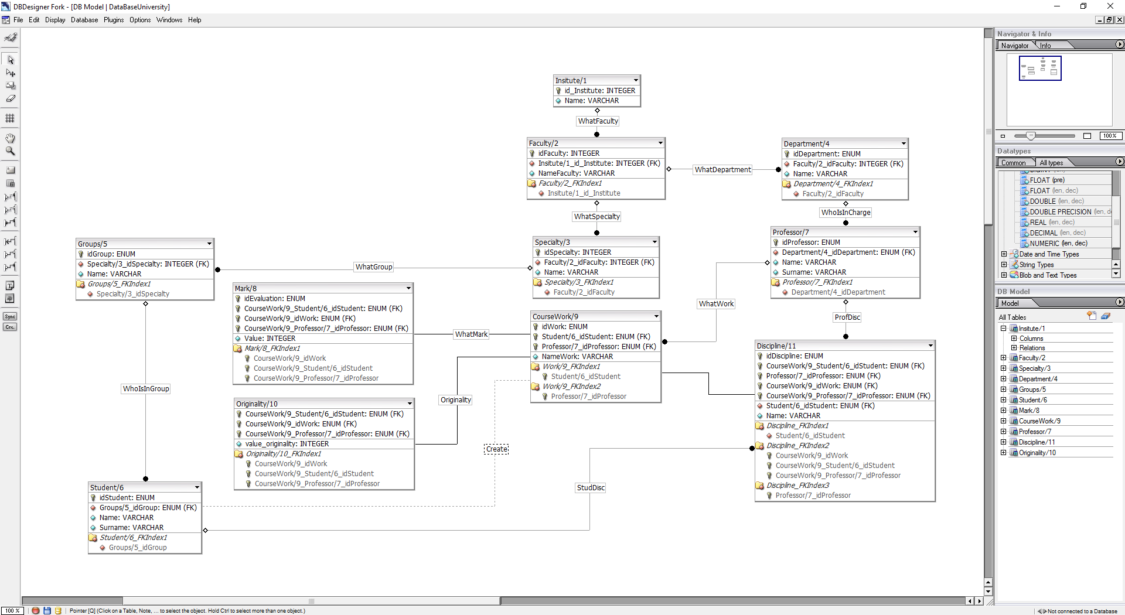Инфологическая модель с типами данных БД «Курсовые работы»

Выгрузка БД «Курсовые работы» в HTML-файл:

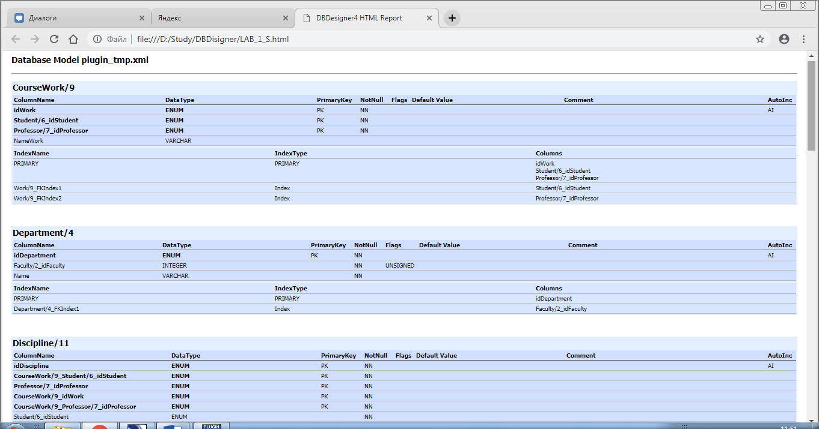

SQLScript:

CREATE TABLE Insitute/1 (

id_Institute INTEGER UNSIGNED NOT NULL AUTO_INCREMENT,

Name VARCHAR NULL,

PRIMARY KEY(id_Institute)

);

CREATE TABLE Faculty/2 (

idFaculty INTEGER UNSIGNED NOT NULL AUTO_INCREMENT,

Insitute/1_id_Institute INTEGER UNSIGNED NOT NULL,

NameFaculty VARCHAR NULL,

PRIMARY KEY(idFaculty),

INDEX Faculty/2_FKIndex1(Insitute/1_id_Institute),

FOREIGN KEY(Insitute/1_id_Institute)

REFERENCES Insitute/1(id_Institute)

ON DELETE NO ACTION

ON UPDATE NO ACTION

);

CREATE TABLE Specialty/3 (

idSpecialty INTEGER UNSIGNED NOT NULL AUTO_INCREMENT,

Faculty/2_idFaculty INTEGER UNSIGNED NOT NULL,

Name VARCHAR NULL,

PRIMARY KEY(idSpecialty),

INDEX Specialty/3_FKIndex1(Faculty/2_idFaculty),

FOREIGN KEY(Faculty/2_idFaculty)

REFERENCES Faculty/2(idFaculty)

ON DELETE NO ACTION

ON UPDATE NO ACTION

);

CREATE TABLE Department/4 (

idDepartment INTEGER UNSIGNED NOT NULL AUTO_INCREMENT,

Faculty/2_idFaculty INTEGER UNSIGNED NOT NULL,

Name VARCHAR NOT NULL,

PRIMARY KEY(idDepartment),

INDEX Department/4_FKIndex1(Faculty/2_idFaculty),

FOREIGN KEY(Faculty/2_idFaculty)

REFERENCES Faculty/2(idFaculty)

ON DELETE NO ACTION

ON UPDATE NO ACTION

);

CREATE TABLE Groups/5 (

idGroup INTEGER UNSIGNED NOT NULL AUTO_INCREMENT,

Specialty/3_idSpecialty INTEGER UNSIGNED NOT NULL,

Name VARCHAR NULL,

PRIMARY KEY(idGroup),

INDEX Groups/5_FKIndex1(Specialty/3_idSpecialty),

FOREIGN KEY(Specialty/3_idSpecialty)

REFERENCES Specialty/3(idSpecialty)

ON DELETE NO ACTION

ON UPDATE NO ACTION

);

CREATE TABLE Professor/7 (

idProfessor INTEGER UNSIGNED NOT NULL AUTO_INCREMENT,

Department/4_idDepartment INTEGER UNSIGNED NOT NULL,

Name VARCHAR NULL,

Surname VARCHAR NULL,

PRIMARY KEY(idProfessor),

INDEX Professor/7_FKIndex1(Department/4_idDepartment),

FOREIGN KEY(Department/4_idDepartment)

REFERENCES Department/4(idDepartment)

ON DELETE NO ACTION

ON UPDATE NO ACTION

);

CREATE TABLE Student/6 (

idStudent INTEGER UNSIGNED NOT NULL AUTO_INCREMENT,

Groups/5_idGroup INTEGER UNSIGNED NOT NULL,

Name VARCHAR NULL,

Surname VARCHAR NULL,

PRIMARY KEY(idStudent),

INDEX Student/6_FKIndex1(Groups/5_idGroup),

FOREIGN KEY(Groups/5_idGroup)

REFERENCES Groups/5(idGroup)

ON DELETE NO ACTION

ON UPDATE NO ACTION

);

CREATE TABLE CourseWorkName/9 (

idWork INTEGER UNSIGNED NOT NULL AUTO_INCREMENT,

Student/6_idStudent INTEGER UNSIGNED NOT NULL,

Professor/7_idProfessor INTEGER UNSIGNED NOT NULL,

NameWork VARCHAR NULL,

Professor/7 VARCHAR NULL,

PRIMARY KEY(idWork, Student/6_idStudent),

INDEX Work/9_FKIndex1(Student/6_idStudent),

INDEX Work/9_FKIndex2(Professor/7_idProfessor),

FOREIGN KEY(Student/6_idStudent)

REFERENCES Student/6(idStudent)

ON DELETE NO ACTION

ON UPDATE NO ACTION,

FOREIGN KEY(Professor/7_idProfessor)

REFERENCES Professor/7(idProfessor)

ON DELETE NO ACTION

ON UPDATE NO ACTION

);

CREATE TABLE Discipline/11 (

idDiscipline INTEGER UNSIGNED NOT NULL AUTO_INCREMENT,

CourseWorkName/9_Student/6_idStudent INTEGER UNSIGNED NOT NULL,

CourseWorkName/9_idWork INTEGER UNSIGNED NOT NULL,

Professor/7_idProfessor INTEGER UNSIGNED NOT NULL,

Student/6_idStudent INTEGER UNSIGNED NOT NULL,

PRIMARY KEY(idDiscipline, CourseWorkName/9_Student/6_idStudent, CourseWorkName/9_idWork, Professor/7_idProfessor),

INDEX Discipline_FKIndex1(Student/6_idStudent),

INDEX Discipline_FKIndex2(CourseWorkName/9_idWork, CourseWorkName/9_Student/6_idStudent),

INDEX Discipline_FKIndex3(Professor/7_idProfessor),

FOREIGN KEY(Student/6_idStudent)

REFERENCES Student/6(idStudent)

ON DELETE NO ACTION

ON UPDATE NO ACTION,

FOREIGN KEY(CourseWorkName/9_idWork, CourseWorkName/9_Student/6_idStudent)

REFERENCES CourseWorkName/9(idWork, Student/6_idStudent)

ON DELETE NO ACTION

ON UPDATE NO ACTION,

FOREIGN KEY(Professor/7_idProfessor)

REFERENCES Professor/7(idProfessor)

ON DELETE NO ACTION

ON UPDATE NO ACTION

)

TYPE=InnoDB;

CREATE TABLE Mark/8 (

idEvaluation INTEGER UNSIGNED NOT NULL AUTO_INCREMENT,

CourseWorkName/9_Student/6_idStudent INTEGER UNSIGNED NOT NULL,

CourseWorkName/9_idWork INTEGER UNSIGNED NOT NULL,

Value INTEGER UNSIGNED NULL,

PRIMARY KEY(idEvaluation, CourseWorkName/9_Student/6_idStudent, CourseWorkName/9_idWork),

INDEX Evaluation/8_FKIndex1(CourseWorkName/9_idWork, CourseWorkName/9_Student/6_idStudent),

FOREIGN KEY(CourseWorkName/9_idWork, CourseWorkName/9_Student/6_idStudent)

REFERENCES CourseWorkName/9(idWork, Student/6_idStudent)

ON DELETE NO ACTION

ON UPDATE NO ACTION

);

CREATE TABLE Originality/10 (

CourseWorkName/9_Student/6_idStudent INTEGER UNSIGNED NOT NULL,

CourseWorkName/9_idWork INTEGER UNSIGNED NOT NULL,

value_originality INTEGER UNSIGNED NULL,

PRIMARY KEY(CourseWorkName/9_Student/6_idStudent, CourseWorkName/9_idWork),

INDEX Originality_FKIndex1(CourseWorkName/9_idWork, CourseWorkName/9_Student/6_idStudent),

FOREIGN KEY(CourseWorkName/9_idWork, CourseWorkName/9_Student/6_idStudent)

REFERENCES CourseWorkName/9(idWork, Student/6_idStudent)

ON DELETE NO ACTION

ON UPDATE NO ACTION

)

TYPE=InnoDB;

**Вывод:** в этой работе мы получили навыки создания баз данных, изучили возможности CASE- средств проектирования баз данных.