Model_card.md

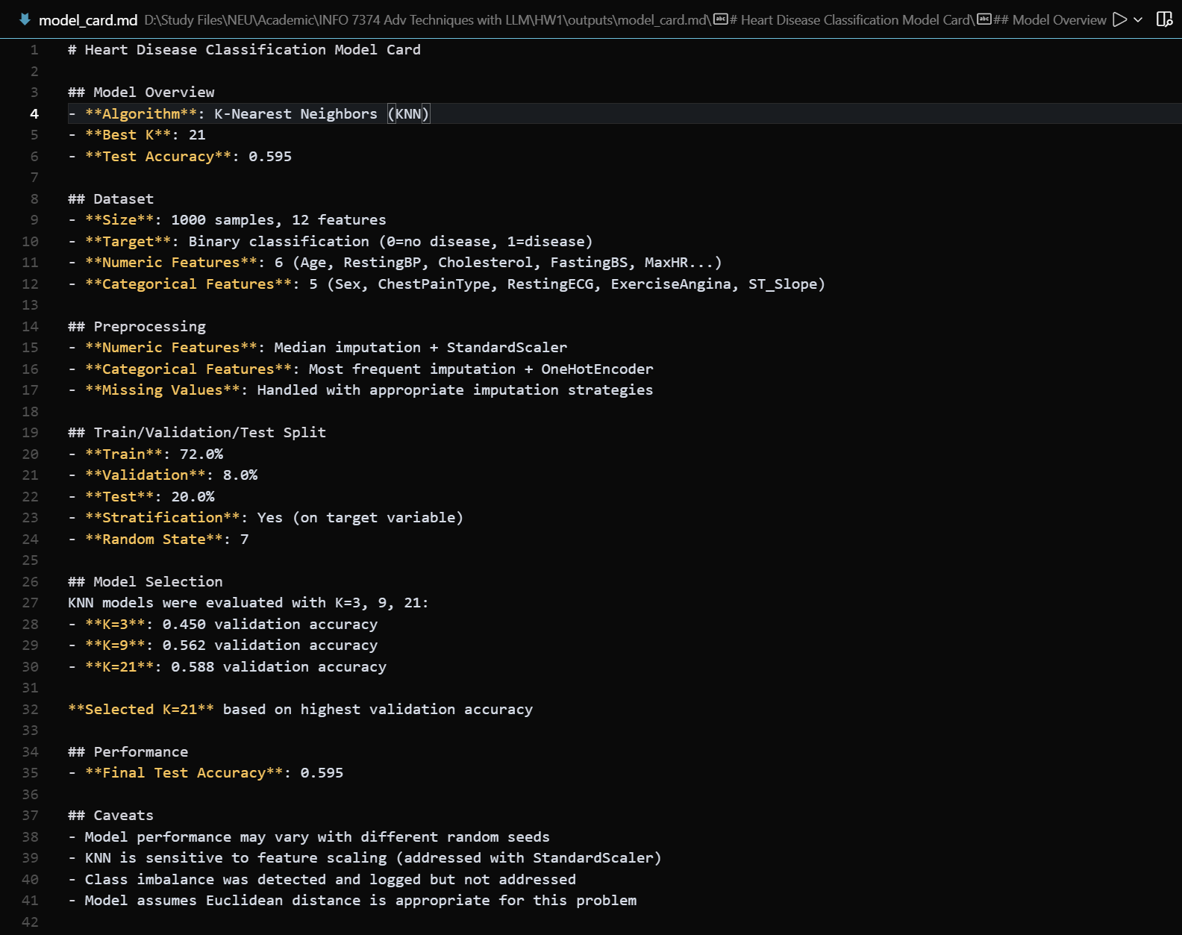

Metrics.json

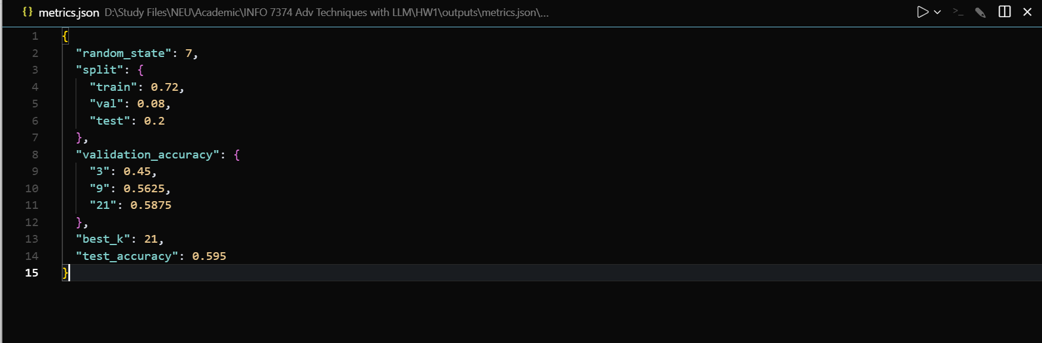

cluster_scatter_MaxHR_vs_Age.png

