/\*\* \*\*\*\*\*\*\*\*\*\*\*\*\*\*\*\*\*\*\*\*\*\*\*\*\*\*\*\*\*\*\*\*\*\*\*\*\*\*\*\*\*\*\*\*\*\*\*\*\*\*\*\*\*\*\*\*\*\*\*\*\*\*\*\*\*\*\*\*\*\*\*\*\*\*\*\*

\* Program Name: Lab06

\* Program Description: This program calls a method to calculate a tiered commission rate

\*

\* Program Author: Richard Ruiz

\* Date Created: 4/07/2021

\*

\* Change# Change Date Programmer Name Description

\* ------- ------------ ------------------- ---------------------

\*\*\*\*\*\*\*\*\*\*\*\*\*\*\*\*\*\*\*\*\*\*\*\*\*\*\*\*\*\*\*\*\*\*\*\*\*\*\*\*\*\*\*\*\*\*\*\*\*\*\*\*\*\*\*\*\*\*\*\*\*\*\*\*\*\*\*\*\*\*\*\*\*\*\*\*\* \*/

package lab06;

Trouble I ran into:

1. Tried to do the problem in one piece
   1. Needed to break it down into modules
      1. Declare tableStart and tableEnd as a double
2. Which inputs do I need?
   1. Which variables do I need?
      * 1. tableStart
        2. tableEnd
        3. salesAmount
        4. Commission
           1. Some logic to increment the outputs By 1000 units and 5000 units
   2. I used this as a model

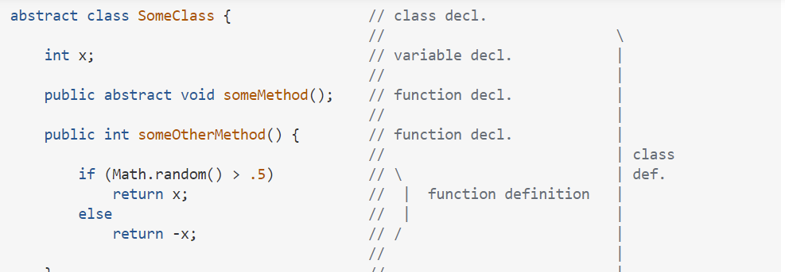

* 1. A tableStart input = min. starting point
  2. A tableEnd input = max. endingpoint
  3. saleAmount = independent variable
  4. Commission = The Returned value after the calculation

1. Which are the outputs?
   1. For Main method?
      1. Returns Void?
      2. computeCommission Method
         1. Holds the main calculation for the commission structure
2. Loops, is it a while loop or a for loop?
   1. 3 steps to writing a loop
      1. Identify the statement that need to be repeated
      2. Wrap these statements like this.
         1. While (true){ Statements; }
      3. Code the loop-continuation-condition

While ( loop-continuation-condition){ Statements; additional statements controlling the loop}

1. Incrementation
   1. How do I get the table’s output to increment by a give number?
      1. To determine the number of times a table should increment you must take the difference from tableEnd as the max, and tableStart as the min ( max – min) = the value the loop needs to reach before stopping.
      2. I used this as a model for salesAmount:

/\* Initialize Number Value \*/

int num = 0;

/\* Initialize Increment Value \*/

int increment = 10;

/\* Print First Number \*/

System.out.println(num);

for(int i = 0; i < 10; i++) {

/\* Increment Number \*/

num += increment;

/\* Print Next Number In List \*/

System.out.println(num);

/\* Increment The Increment Counter \*/

++increment;