DATABASE : A database is a structured set of data held in a computer, especially one that is accessible in various ways.

DATABASE MANAGEMENT SYSTEM: software that handles the storage, retrieval, and updating of data in a computer system.

Database Technology:
- The essential feature of database technology is that it provides an INTERNAL Representation (model) of the EXTERNAL world of interest.
- Examples are the representation of a particular date/time/flight/aircraft in airline reservation or of item code/item description/quantity on hand/reorder level/reorder quantity in a stock control system.
- The TECHNOLOGY involved is concerned primarily with maintaining the internal representation consistent with external reality; this involves the results of extensive R&D over the past 30 years in areas such as user requirements analysis, data modelling, process modelling, data integrity, concurrency, transactions, file organisation, indexing, rollback and recovery, persistent programming, object-orientation, logic programming, deductive database systems, active database systems and in all these (and other) areas there remains much to be done.

Application Areas:
1. Culture&scientific information
2. Tourism
3. Telemedicine
4. Natural resources management
5. Production engineering
all of which have been mentioned above as typical DB application areas.

FRONT END DESIGN OPTIONS:
- HTML
- JAVASCRIPT
- CSS

BACK END DESIGN OPTIONS:
- PHP
- MySQL

SQL: (Structured Query Language) is a domain-specific language used in programming and designed for managing data held in a relational database management system (RDBMS), or for stream processing in a relational data stream management system (RDSMS). In comparison to older read/write APIs like ISAM or VSAM, SQL offers two main advantages: first, it introduced the concept of accessing many records with one single command; and second, it eliminates the need to specify how to reach a record, e.g. with or without an index.

Normalization:
Database Normalisation is a technique of organizing the data in the database. Normalization is a systematic approach of decomposing tables to eliminate data redundancy and undesirable characteristics like Insertion, Update and Deletion Anamolies. It is a multi-step process that puts data into tabular form by removing duplicated data from the relation tables.
Normalization is used for mainly two purpose,
- Eliminating reduntant(useless) data.
- Ensuring data dependencies make sense i.e data is logically stored.

Problem Without Normalization
Without Normalization, it becomes difficult to handle and update the database, without facing data loss. Insertion, Updation and Deletion Anamolies are very frequent if Database is not Normalized. To understand these anomalies let us take an example of Student table.
S_id | S_Name | S_Address | Subject_opted
401 | Adam | Noida | Bio
402 | Alex | Panipat | Maths
403 | Stuart | Jammu | Maths
404 | Adam | Noida | Physics

- Updation Anomaly : To update address of a student who occurs twice or more than twice in a table, we will have to update S_Address column in all the rows, else data will become inconsistent.
- Insertion Anomaly : Suppose for a new admission, we have a Student id(S_id), name and address of a student but if student has not opted for any subjects yet then we have to insert NULL there, leading to Insertion Anomaly.
- Deletion Anomaly : If (S_id) 401 has only one subject and temporarily he drops it, when we delete that row, entire student record will be deleted along with it.

Normalization Rule
Normalization rule are divided into following normal form.
- First Normal Form
- Second Normal Form
- Third Normal Form
- BCNF

First Normal Form (1NF)
As per First Normal Form, no two Rows of data must contain repeating group of information i.e each set of column must have a unique value, such that multiple columns cannot be used to fetch the same row. Each table should be organized into rows, and each row should have a primary key that distinguishes it as unique.
The Primary key is usually a single column, but sometimes more than one column can be combined to create a single primary key. For example consider a table which is not in First normal form
Student Table :
Student | Age | Subject
Adam | 15 | Biology, Maths
Alex | 14 | Maths
Stuart | 17 | Maths
In First Normal Form, any row must not have a column in which more than one value is saved, like separated with commas. Rather than that, we must separate such data into multiple rows.
Student Table following 1NF will be :
Student | Age | Subject
Adam | 15 | Biology
Adam | 15 | Maths
Alex | 14 | Maths
Stuart | 17 | Maths
Using the First Normal Form, data redundancy increases, as there will be many columns with same data in multiple rows but each row as a whole will be unique.

Second Normal Form (2NF)
As per the Second Normal Form there must not be any partial dependency of any column on primary key. It means that for a table that has concatenated primary key, each column in the table that is not part of the primary key must depend upon the entire concatenated key for its existence. If any column depends only on one part of the concatenated key, then the table fails Second normal form.
In example of First Normal Form there are two rows for Adam, to include multiple subjects that he has opted for. While this is searchable, and follows First normal form, it is an inefficient use of space. Also in the above Table in First Normal Form, while the candidate key is {Student, Subject}, Age of Student only depends on Student column, which is incorrect as per Second Normal Form. To achieve second normal form, it would be helpful to split out the subjects into an independent table, and match them up using the student names as foreign keys.
New Student Table following 2NF will be :
Student | Age
Adam | 15
Alex | 14
Stuart | 17
In Student Table the candidate key will be Student column, because all other column i.e Age is dependent on it.
New Subject Table introduced for 2NF will be :
Student | Subject
Adam | Biology
Adam | Maths
Alex | Maths
Stuart | Maths
In Subject Table the candidate key will be {Student, Subject} column. Now, both the above tables qualifies for Second Normal Form and will never suffer from Update Anomalies. Although there are a few complex cases in which table in Second Normal Form suffers Update Anomalies, and to handle those scenarios Third Normal Form is there.

Third Normal Form (3NF)
Third Normal form applies that every non-prime attribute of table must be dependent on primary key, or we can say that, there should not be the case that a non-prime attribute is determined by another non-prime attribute. So this transitive functional dependency should be removed from the table and also the table must be in Second Normal form. For example, consider a table with following fields.
Student_Detail Table :
Student_id | Student_name | DOB | Street | city | State | Zip
In this table Student_id is Primary key, but street, city and state depends upon Zip. The dependency between zip and other fields is called transitive dependency. Hence to apply 3NF, we need to move the street, city and state to new table, with Zip as primary key.
New Student_Detail Table :
Student_id | Student_name | DOB | Zip
Address Table :
Zip | Street | city | state

The advantage of removing transtive dependency is,
- Amount of data duplication is reduced.
- Data integrity achieved.

Boyce and Codd Normal Form is a higher version of the Third Normal form. This form deals with certain type of anomaly that is not handled by 3NF. A 3NF table which does not have multiple overlapping candidate keys is said to be in BCNF. For a table to be in BCNF, following conditions must be satisfied:
- R must be in 3rd Normal Form
- and, for each functional dependency ( X → Y ), X should be a super Key.
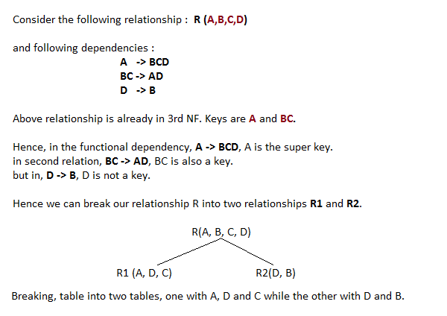
CONCPETUAL MODEL
A conceptual model is a representation of a system, made of the composition of concepts which are used to help people know, understand, or simulate a subject the model represents. It is also a set of concepts. Some models are physical objects; for example, a toy model which may be assembled, and may be made to work like the object it represents.
The term conceptual model may be used to refer to models which are formed after a conceptualization or generalization process.[1] Conceptual models are often abstractions of things in the real world whether physical or social. Semantics studies are relevant to various stages of concept formation and use as Semantics is basically about concepts, the meaning that thinking beings give to various elements of their experience.

Type and scope of conceptual models
Conceptual models (models that are conceptual) range in type from the more concrete, such as the mental image of a familiar physical object, to the formal generality and abstractness of mathematical models which do not appear to the mind as an image. Conceptual models also range in terms of the scope of the subject matter that they are taken to represent. A model may, for instance, represent a single thing (e.g. the Statue of Liberty), whole classes of things (e.g. the electron), and even very vast domains of subject matter such as the physical universe. The variety and scope of conceptual models is due to then variety of purposes had by the people using them. Conceptual modeling is the activity of formally describing some aspects of the physical and social world around us for the purposes of understanding and communication."[3]

Fundamental objectives
A conceptual model's primary objective is to convey the fundamental principles and basic functionality of the system which it represents. Also, a conceptual model must be developed in such a way as to provide an easily understood system interpretation for the models users. A conceptual model, when implemented properly, should satisfy four fundamental objectives.[4]
- Enhance an individual's understanding of the representative system
- Facilitate efficient conveyance of system details between stakeholders
- Provide a point of reference for system designers to extract system specifications
- Document the system for future reference and provide a means for collaboration
The conceptual model plays an important role in the overall system development life cycle. Figure 1[5] below, depicts the role of the conceptual model in a typical system development scheme. It is clear that if the conceptual model is not fully developed, the execution of fundamental system properties may not be implemented properly, giving way to future problems or system shortfalls. These failures do occur in the industry and have been linked to; lack of user input, incomplete or unclear requirements, and changing requirements. Those weak links in the system design and development process can be traced to improper execution of the fundamental objectives of conceptual modeling. The importance of conceptual modeling is evident when such systemic failures are mitigated by thorough system development and adherence to proven development objectives/techniques.
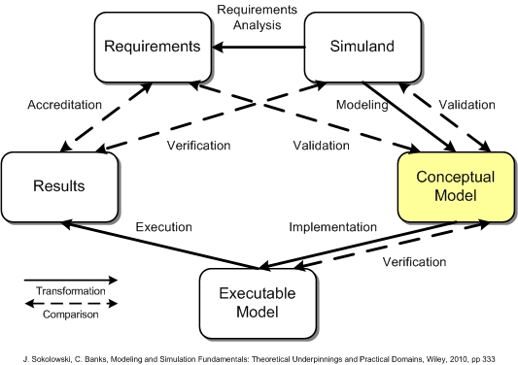

ER DIAGRAM

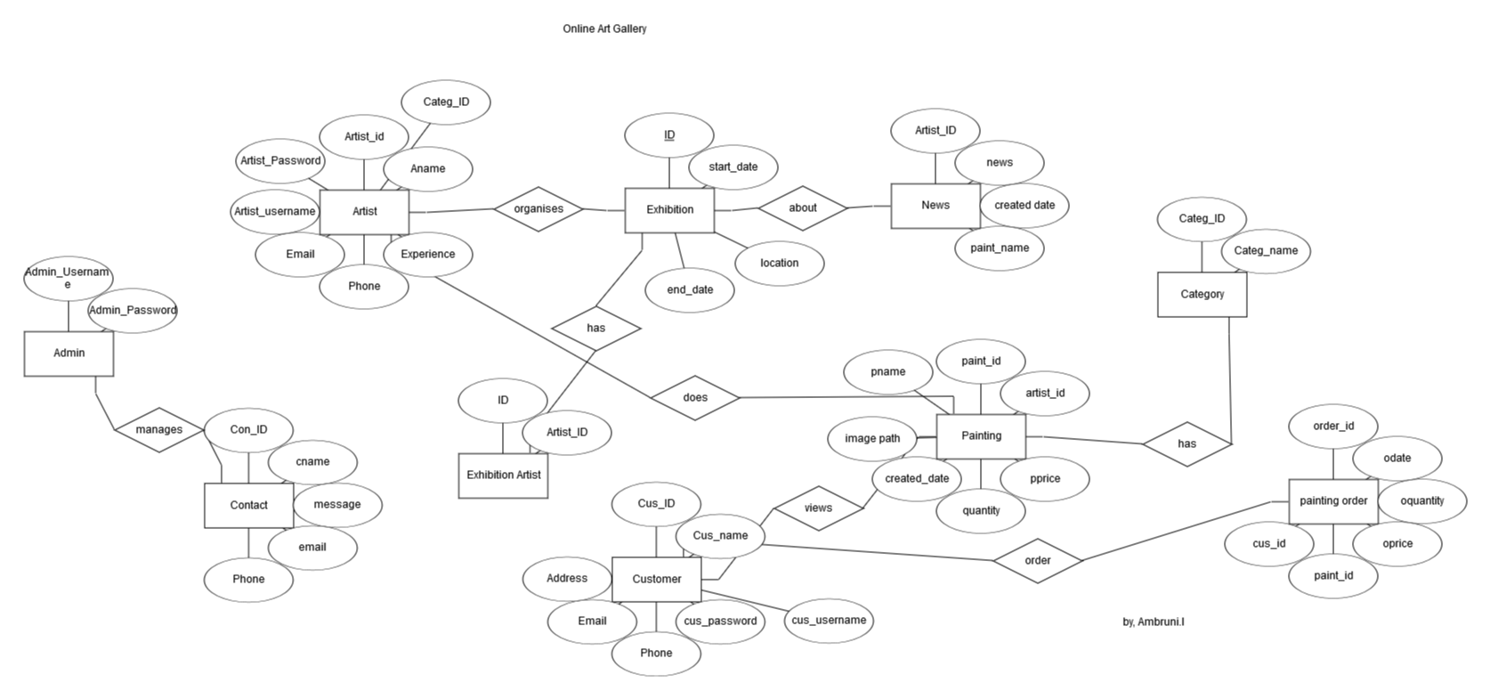
SCHEMA DIAGRAM
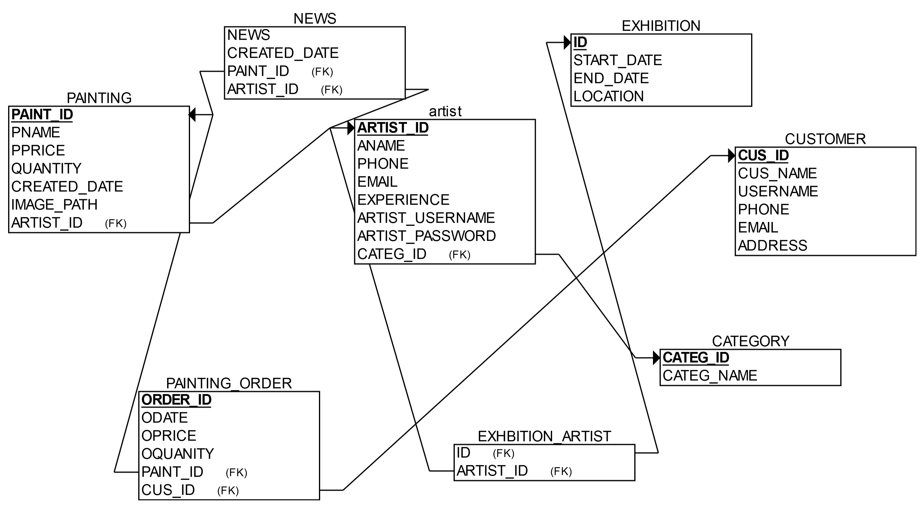

USE CASE DIAGRAM
