This is just a simple description of the Mongo Db. project .i have used the terminal assuming that one has installed the mongo DB version 4.40 .Then set the bin variable as an environment variable assuming that you are using a windows platform for testing or running the scripts.

The queries that I used are attached along this document as mongo.txt and here are the screenshots for the code .Also I have used .pretty () inbuilt mongo DB function for aligning the data in a human readable format.

1. Initializing the database.

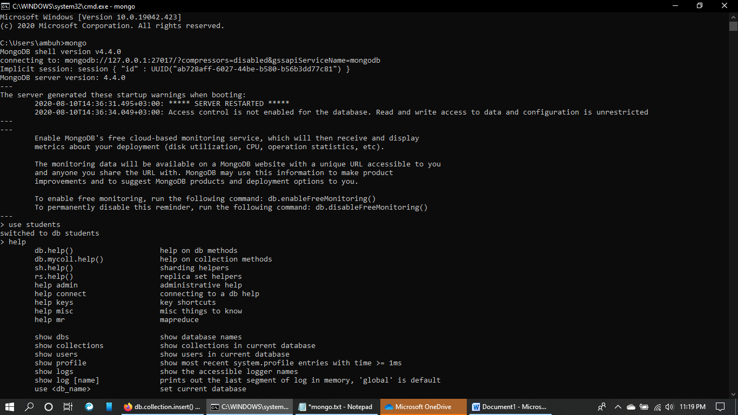

2. Fetching and inserting data into the database

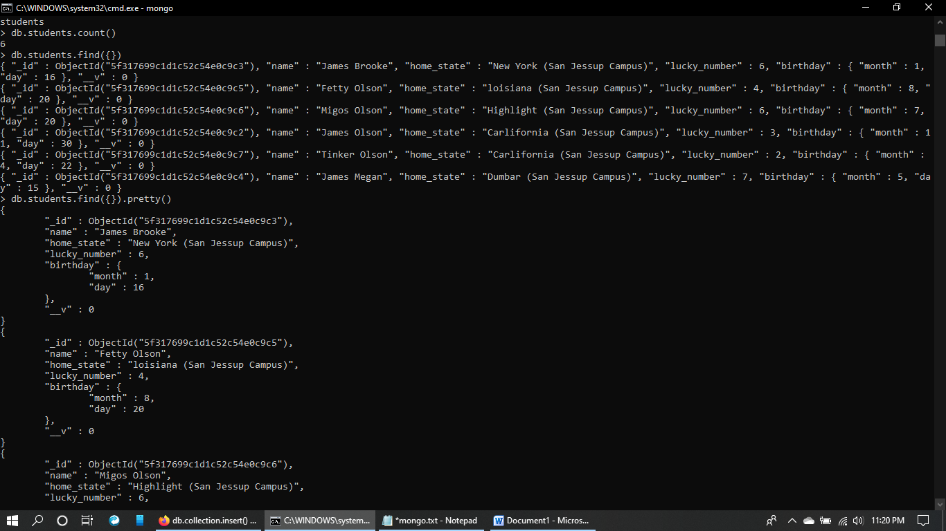

3.filtering data 

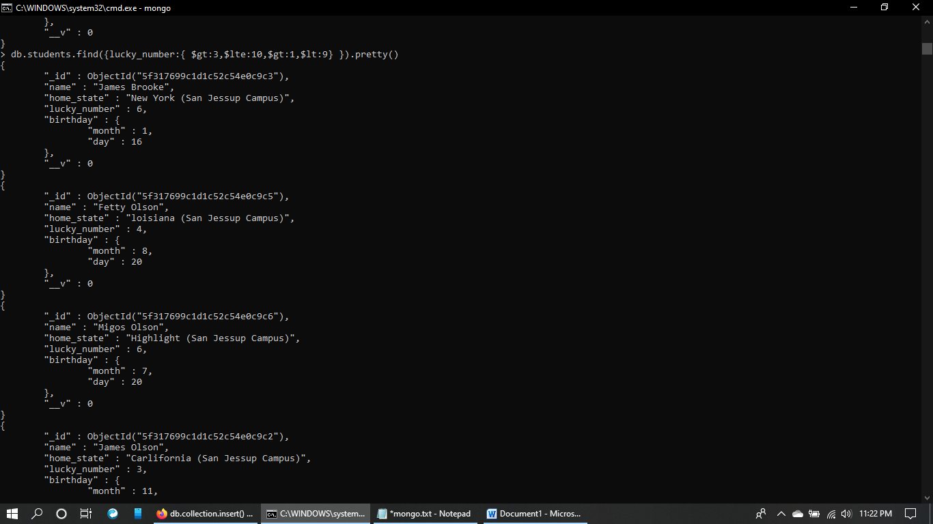

4. Updating the fields and also the elements in the collection

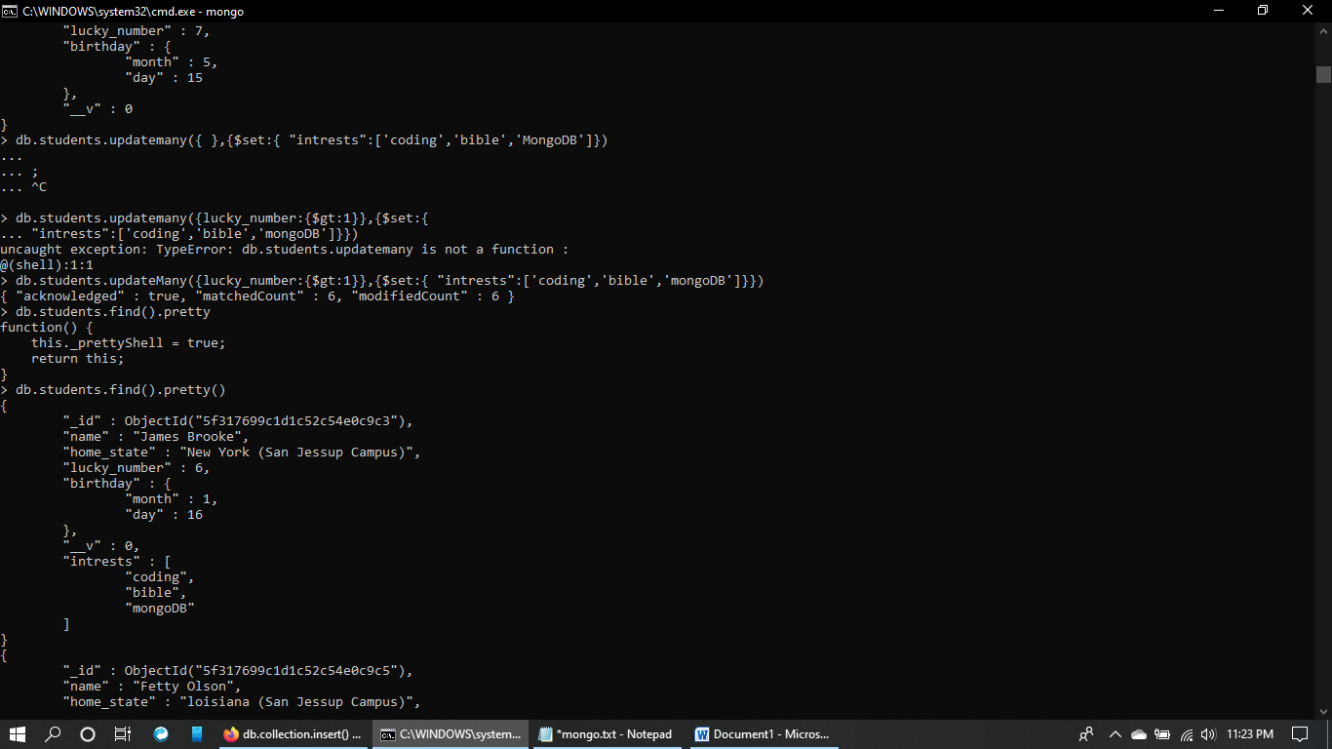

5. Removing data from an array of a field and also adding to the array value.

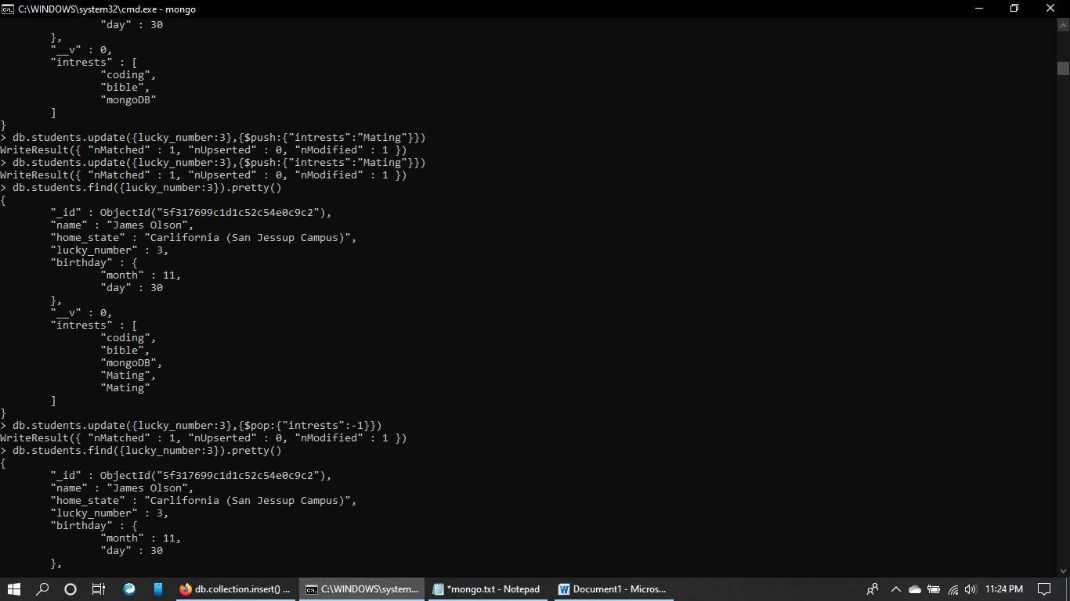

6. Removing elements and updating columns in the collection.

