Composite Design Pattern
- Composite – Introduction:
Now let's see how we can implement a Composite design pattern in your application and why we need this Structural design pattern. So first of all, why we need the Composite design pattern and when can we use it? So whenever we have a tree structure of objects in our application, or you can call that a part-whole relationship, that means multiple objects create or make up one whole object, in those situations, if we want to treat all objects in that hierarchy or in that tree in similar way, then we can use the Composite design pattern. So this design pattern allows us to treat objects in a tree structure, the similar way, whether they have their own children or whether an object is a leaf node(having no children) in a tree. And that's the benefit or that's the value that this design pattern provides you. Now, one thing to remember is that this is not the simple composition concept that we know from Object Oriented Programming, because a composition in Object Oriented Programming simply means that we have an object with a reference inside it which points to another object. That's the composition. Composite design pattern uses composition. There is no question about it. However, it goes one step further and it allows you to treat objects which have composition or which are using composition and which don't in similar way. Okay, so that's the value of this Composite design pattern. Now, whenever you have a tree structure of objects in your application, you will be using Composite design pattern in one way or another.
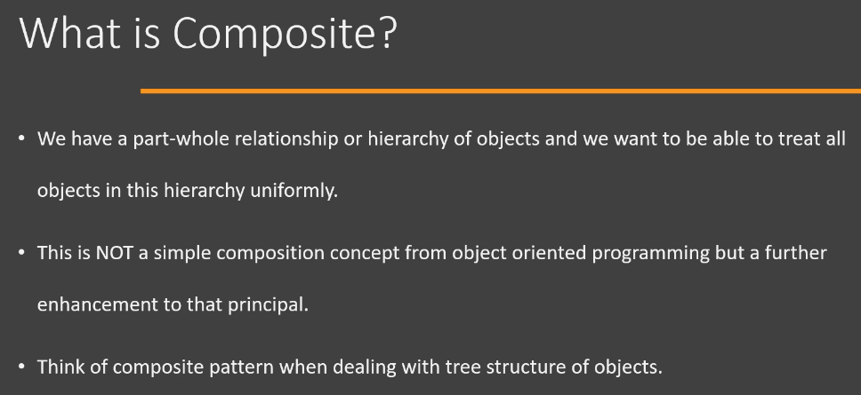
Now let's look at the UML diagram of this design pattern. It's quite a simple UML diagram. So we start with Component. Now this will be our base class, abstract base class or an interface, and it defines methods that are common to all nodes in a tree. And that's pretty simple to understand. What is strange or what is different here is that this design pattern demands that you also add methods that allow access[get() method], addition and removal of children in the base class or interface. Now, this is a point of some argument because a point can be made that having these children management methods in the base class or interface forces our leaf node to provide implementation when it cannot. And another side of argument is that the purpose of composite design pattern is to be able to treat our classes(i.e., composite or leaf nodes) in similar way. So that means we need to have these operations. So I'm going to leave the decision to you whether you want to keep the children management operations in the leaf node or whether you want to keep that operation or move those operations to class where it actually needs it. Anyways, the next class in the hierarchy(i.e., in the design pattern) is the leaf node. Now this is the class(i.e., Leaf) which represents leaf objects in our tree structure and it has implementation for the operation(), the actual operation that is needed by client, and it provides the actual functionality in that method. Next up, we have Composite. So Composite is the one which has the children within it. So it is using the composition concept and it has also provided implementation for operation() or the functionality that his client is requesting. Now, in the implementation of operation(), this class(i.e., Composite) is going to delegate it to all of its children. So that's the difference between the implementation of core functionality between composite and leaf. Leaf is going to provide the actual functionality. Composite is going to delegate that to its children. Additionally, it defines methods or provides implementation for methods that allow you to add and remove a leaf node from composite. Lastly, we have Client. Now this is the class that is going to use our Composite design pattern. And the benefit of using Composite design pattern is that Client is always going to work with our Component interface. So this is the UML diagram for Composite design pattern. Once again, to highlight the point is that Component interface is defining methods such as add a child or remove a child. And a point can be made that these operations[i.e., add() and remove()] belong only to Composite class and it should be defined in Composite class only, not in the base class(i.e., Component), because now Leaf has to provide implementation for these methods[i.e., add() and remove()] where we don't need those methods. But another side of argument is that since Client wants to work only with the Component interface and that's the whole purpose of Composite design pattern, so we need these methods defined in Component. So I'm not going to take a side here. I'm just making you aware that a point can be made on both sides of arguments and it's up to you how you implement this design pattern in your code, because ultimately design patterns are nothing but guides on how you can do things. They are not rules. So you can of course change them as per your requirement. So this is the introduction to Composite design pattern.
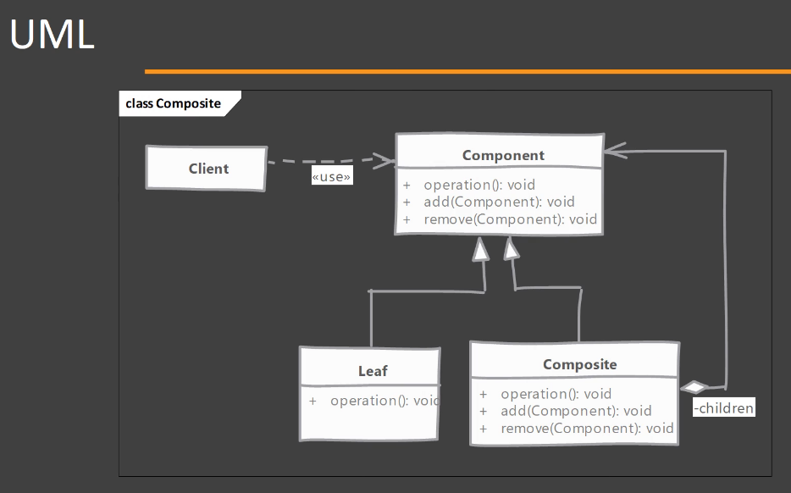
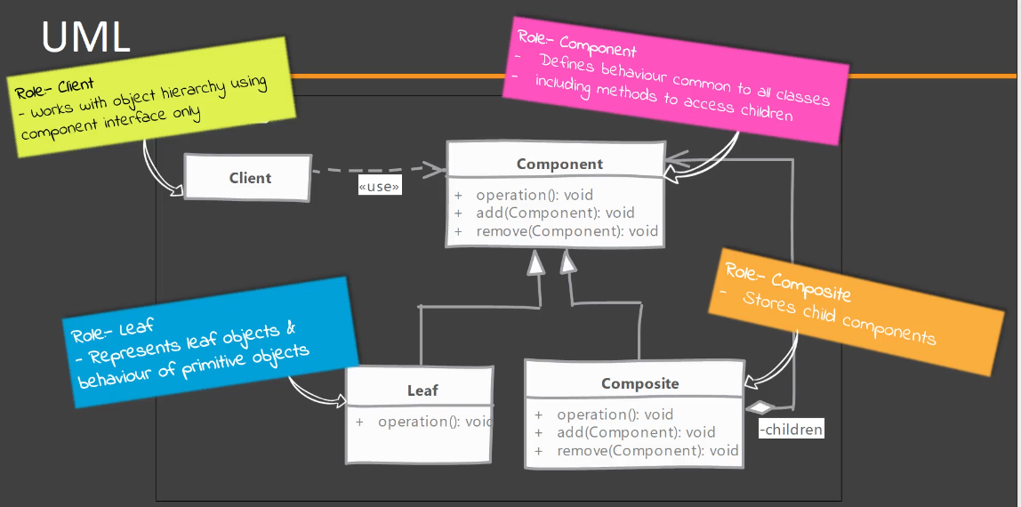
- Composite – Implementation Steps:
Let's look at the steps that are needed or that you would typically follow if you are implementing a Composite design pattern. So we start by creating our abstract class or interface, which has the role of Component. Now this defines methods that are common to both the composite node and a leaf node. Now, next up, we need to choose where we want to define methods that allow you to add and remove nodes from Composite. You can put them in Component, but then your leaf node will be forced to provide implementation for those methods OR you can put it in Composite, but then you have to make your Client code aware that there is a separate class type called as Composite, which has children. Whatever the decision you need to make, you need to make while you are implementing Component. Next, we implement the Composite and we need to make sure that whenever an operation(), actual operation is invoked on the Composite, we are delegating that operation() to its children. In leaf nodes, we need to handle the non-applicable operations. So, for example, if you have defined the add() and remove() operations in the Component, then you need to provide some implementation in Leaf. And typically that means throwing an exception saying that we do not support this type of operation. Of course, it is applicable only if you have defined add() and remove() operations in your Component class. In the end, the Composite design pattern implementation allows us to write algorithms in our Client code without worrying about whether it is a leaf node or composite node. There should not be a frequent check about whether it is a leaf node, then do this, whether it is a composite node, then do this. It should not happen at all in our Client code and that's the whole purpose of Composite design pattern.
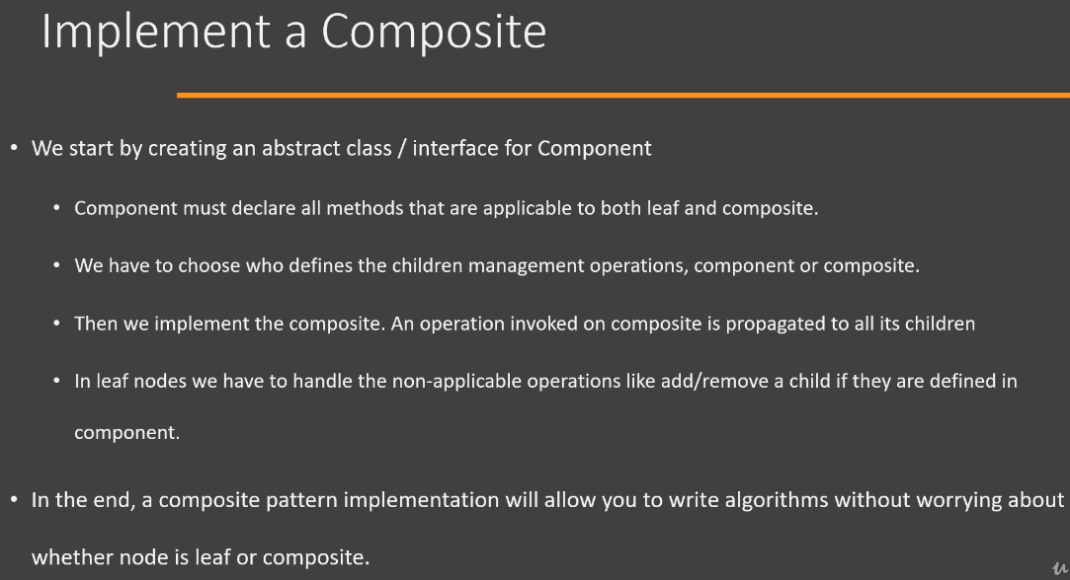
- Composite – Hands-on Example UML:
Now let's look at the UML diagram of the example that we are going to follow in order to implement the Composite design pattern. So first of all, we have an interface here called as File, OR an abstract class called as File, and this will be our Component. So, we are going to define methods that are common to both our leaf node and composite node in File. What I've done here is I have defined the operations[i.e., removeFile() and addFile()], that allow you to add and remove children, in this particular base component class(i.e., File). And of course, I'm telling you that this is not the only way you can have these operations defined in your Composite design pattern. So next, we have BinaryFile class which represents our leaf node, and it has provided the implementation for methods that are applicable. It's going to also provide implementation for methods that do not apply to it([i.e., removeFile() and addFile()]. Directory is a Composite here, so this class will provide the implementation for adding and removing children. Any operation that we actually call on this Directory object should be delegated to the children. Next, we have the Client, which is going to use our File interface in order to work with our tree structure. So this is how we are going to implement a Composite design pattern in Java code.
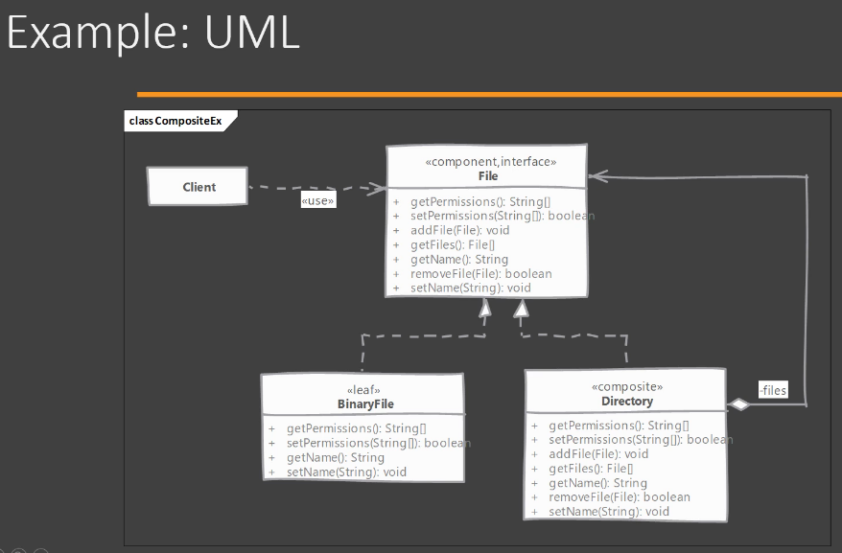
- Composite – Implementation:
Now it's time to see how we can implement Composite design patterns. Now, I have written the abstract Component class(i.e., File) that we are going to use, so I will explain what that class is doing. So here, we have an abstract class called as File, and this will be the Component in our Composite design pattern. That means our leaf node and the composite node is going to extend from this File class. In this File class, I have a single field called as 'name'. We have a constructor that accepts the file name. We have a getter method and the setter method. Then we have defined an abstract operation called as ls(). So this is the operation that our client code is actually going to be interested in. I have added the children management operations, which are addFile(), getFiles() and removeFile(), these are only applicable to Composite here, just to show you how you would implement such a type of implementation of Composite design pattern. So let's jump to BinaryFile and this will be our leaf node in the Composite design pattern. So let's implement BinaryFile. So we're going to extend from our File class, which is our Component. In the BinaryFile, I'm going to add a property/field called as 'size'. So this will represent the size of our file. Then I need to declare a constructor. So I'm going to accept a name for our binary file(i.e., BinaryFile) and the size information. We are going to pass on the name to our base class(i.e., File) by using 'super' keyword and then we're going to set up our size(i.e., 'size' field of BinaryFile class), which is equal to whatever is given to us in the constructor. Next, we need to override all of these methods[i.e., addFile(), getFiles(), ls() and removeFile()] of File class because they are abstract methods. So these are the methods that we are going to override in order to make this class(i.e., BinaryFile) non-abstract. So what happens in the ls() operation? Well, we are simply going to print a name of our file and I'm going to append the size information for this particular file. So whenever somebody calls ls() on our BinaryFile, we are going to print the file name and file size. Now we have these operations called as addFile(), getFiles() and removeFile(), and these are not applicable to our leaf node. So this is the problem that you will face if you move/have all of your operations into the base Component(i.e., File). So addFile() has no meaning for this particular class(i.e., BinaryFile) but since we have it, we are going to throw an exception called as UnsupportedOperationException and we are going to print or pass on the message saying that the "Leaf node doesn't support add operation". And this is what we are going to do in all of other methods which are actually meant for our Composite. And this is how your leaf node(i.e., BinaryFile) is going to look if you add your children management operations in the base class(i.e., File). Whether this is correct thing to do or not, I will leave that decision up to you, but, with the current approach, you will end up with classes which have these methods which should not be there. Anyways, moving on, we have a Directory class, so this is our Composite. So in order to implement this, we are again going to extend from our File class, which is our base class. And here instead of 'size' field, what we are going to do is we're going to maintain/define a list of File objects and we're going to call/name this field as 'children'. So this is the Composite class in our Composite design pattern. I'm going to initialize it(i.e., 'children' field) with ArrayList. So we will have an empty directory if we create a new Directory object. It won't throw an exception since there are no files in it. Next, we need to implement our constructor of Directory class. So we're going to have a constructor here and we only need name of our directory and that too we are going to pass on to our base class(i.e., File) using 'super' keyword. Next, we need to provide the implementation for the abstract operations/methos that are defined in our base class(i.e., File). Now let's look at the implementation of each operation/method here. Firstly, we have the ls() method and what we want to do is we want to call this operation[i.e., ls()] on all of our children. So if you do an 'ls'(Linux command) on a directory, you will see that we get the information of files which are present in that directory. So to begin with, I'm going to simply say that we are going to print the name of our directory and on the next line we want to print the information of our files present in that directory by iterating through the list of File objects and calling the ls() method on each File object. Next, we have the addFile() method and this is simple. We are simply going to add whatever is given to us in our collection/list of nodes/files. Similarly we can implement the getFiles() by returning the list of files and removeFile() by removing the file from the directory. This is how you would implement your Composite. So we would have a collection which contains the children, and then we provide the implementation of children management operations here. And in our actual operation[i.e., ls()], we are going to delegate to our children. So now let's see how we can use this Composite design pattern in our Client code. Now, let's move to Client.java file. So what I've done here is I have written two private methods[i.e., createTreeOne() and createTreeTwo()] that create our tree structure. And one thing that you should note is that this design pattern doesn't say anything about how you're going to create your tree. So what I've done here[i.e., inside createTreeOne()] is I have created a couple of File and Directory objects and I have added these File objects into one of the Directory object. Important thing to remember here is that I'm returning an object of Directory. So, 'dir2' is an object of Directory. So this method[i.e., createTreeOne()] will create a tree of objects and it will return a Composite. The second method[i.e., createTreeTwo()] returns simply a leaf node.
Inside main() method, I am going to create the tree using the createTreeOne() method and store it in the 'root1' reference variable. And I can invoke the ls() operation on this particular node(i.e., 'root1', which the Directory object). Now, if we use the second private method that we have written. So I'm going to call createTreeTwo(). So this is the second method that we have written and if you remember, this method returns an object of BinaryFile, which is our leaf node, but still our Client is able to call the ls() method on it and we will get the 'ls' output of that particular file. So this is what we mean, that our Client should not worry about which object it is using. It is still able to call the ls() operation on it and get the desired output. So this is how you can implement a Composite design pattern in Java. In this approach, what we have done is we have added the children management operations in the File class which is our Component. But you can also remove these operations[i.e., addFile(), getFiles() and removeFile()] from here and keep them only in Directory class which is our Composite. Both ways are valid. Do what you feel is the correct way, but remember, if you put these methods in the Directory class then you have to provide a way to make Client differentiate between Directory and BinaryFile objects. Suppose that a given reference variable of type File is holding an object is of Directory class and another given reference variable of type File object is holding an object is of BinaryFile type, then how the Client will differentiate between these two given File object.
- Composite – Implementation & Design Considerations:
Let's look at some of the implementation and design considerations when working with Composite design pattern. So one point is that you can provide a method in your class that allows you to traverse back to parent of that node, and this will make the traversal of your tree structure easy. Again, it is up to you whether you need this convenience in your class or if you are not traversing your tree structures at all then it doesn't make sense. However, there is an option for you that you can add an operation that allows any node to give back its parent. On the similar lines, you can have the collection/list field which holds the children of Composite, you can define that field in the base Component and that will make it somewhat easier to provide some default implementations. However, the leaf node is again not going to need that collection/list field. So again, it's up to you where you define that collection/list field. Now the last point is suppose you have a tree structure in your application and that has thousands of nodes in it. And if you find that some of these nodes can be cached, that means we have a node which is immutable and it is repeated several hundreds of times in our tree, then you can cache that particular node. So you will have one object and which is referred from hundreds of places(i.e., hundreds of times) in your tree structure. So that will save you on to some memory. But again, it depends on how many number of nodes you have in your tree. If there are very few, then caching is actually going to cost you more in terms of performance. But this is an option. The point of these slides is to highlight some of the points that you can take into consideration while you're working on your specific problem.

Now let's look at the design considerations. And again, I'm going to highlight here the point that I made while we were discussing the UML for the Composite design pattern. And it is where the operations which deal with children management, where to put those operations. So that is the decision which needs to be made. This design pattern suggests that you should have it in Component so that the Client doesn't ever need to know that there is a class called as Composite. However, there is another viewpoint that says that we are forcing our leaf node to provide implementation for a method which it doesn't need or it doesn't make sense for a leaf node to have that operation in it. So again, it's a decision that you need to make based upon your preference and based upon the problem that you are dealing with. Overall goal of this design pattern is to make sure that the Client code or the code which is working with our tree structure, is able to work without doing any casting(i.e., casting up or casting down) to whatever you need. So it should not have to deal with those type of issues. That's the whole purpose of Composite design pattern. If you can achieve that, then the design pattern is implemented or fulfilled its purpose. That's the end goal here.
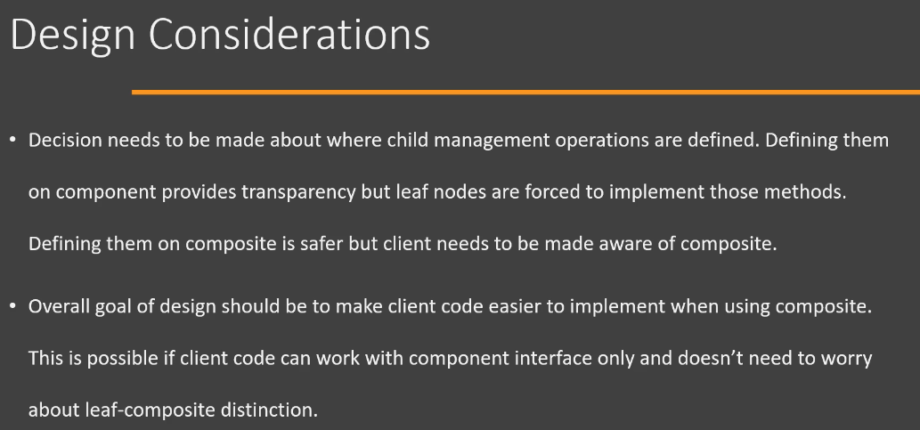
- Composite – Real-world Example:
Let's look at an example of Composite design pattern. Now, after studying this design pattern, you will get an idea that there are many applications of this design pattern when working with UI frameworks. Because in UI frameworks we often run into situations where we have a tree of UI controls or where we have some sort of container where other UI components like buttons, text boxes are added. And in those situations, Composite design pattern is really useful. And that's why the example that we are going to look at for this design pattern is from the JavaServer Faces(JSF) framework. So in JSF, we have a class called as UIViewRoot. Now if you have worked with JSF, you will find that this class can contain other UIComponent inside of it. UIViewRoot is the UIComponent that represents the root of the UIComponent tree. So we have UIComponent(UI components) like UIOutput, UIMessage which act as kind of a leaf node in the Composite design pattern. So let's look at the UML diagram of only these classes. So in JSF, we have a common interface called as UIComponent, which is implemented by all UI components in the JSF framework. Then we have a common base class called as UIComponentBase and in this base class, we also have methods that are related to children management. So we have a method called as getChildren() and getChildCount(), which are actually implemented or useful when working with UIViewRoot. So UIViewRoot in the JSF is actually an example of Composite design pattern and object of this class can contain other objects of UIComponent type, for example, UIOutput, UIMessage and many other classes are acting like leaf nodes in the Composite and in the implementation of getChildren(), it will not return anything(may be empty list). From the getChildCount() method, these objects(i.e., object of UIOutput and UIMessage) will return zero. So UIViewRoot in JSF is an example of Composite design pattern.
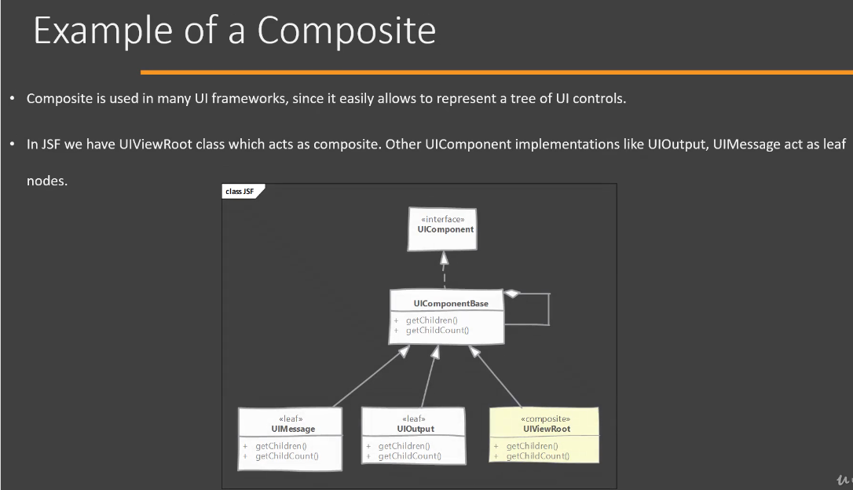
- Composite – Comparison with Decorator:
Now let us compare our Composite design pattern with Decorator design pattern. So the Composite deals with a tree structure of objects. So our Composite class will have multiple children within it. A decorator, on the other hand, deals with a single object which is contained within itself. It doesn't have this concept of children. Next, leaf nodes and composites, they have the same interface. However, composites only delegate the operation to their children. Decorators, on the other hand, are supposed to add or modify the behavior that is contained within them. So that is the whole purpose of a Decorator. So Decorator will always add something or change something from the behavior of the original object. Now, Decorator, of course, doesn't have the notion of children, which the Composite have. So this is the difference between the Composite design pattern and Decorator design pattern.

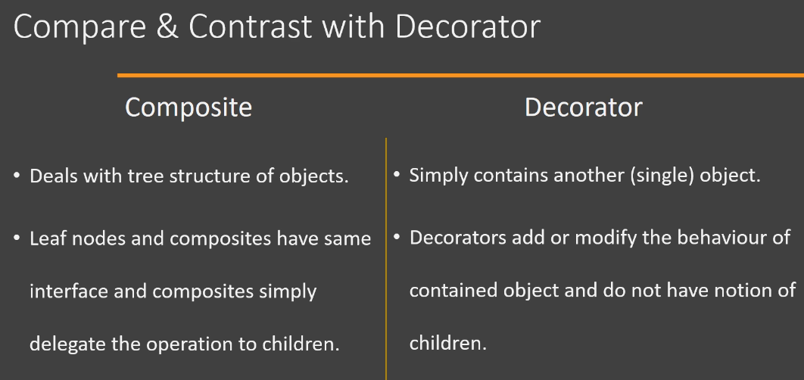
- Composite – Pitfalls:
Now let's look at some of the pitfalls of the Composite design pattern. Now, it is quite difficult to restrict what gets added to our tree or our hierarchy. And if you have multiple types of leaf nodes, which is somewhat common in real life, then the client code again ends up doing runtime checks to see whether it is calling the operation on correct type of a node. So again, there is a chance that the whole purpose of having the Composite is defeated because now the client is doing the runtime check because it is quite difficult to provide all of these operations in Component class(i.e., in the base class or base interface) because they(i.e., different operations) may not apply to all of the nodes or all of the child classes. So that's a pitfall of Composite design pattern. So you should be on the lookout where you are running into that kind of scenario. Now, creating the original hierarchy or original tree can still be a complex operation because the design pattern doesn't tell you how to build your tree. It simply tells what the structure of your already built object tree is. So it's upto you to implement, or upto you to create that original tree and it can be quite a complex process. And if you are using caching for your nodes in order to save onto some memory or on the initialization cost, then the creation of this Composite tree can be a complicated operation. So you should be aware that the design pattern doesn't tell you anything about how you are creating your tree.
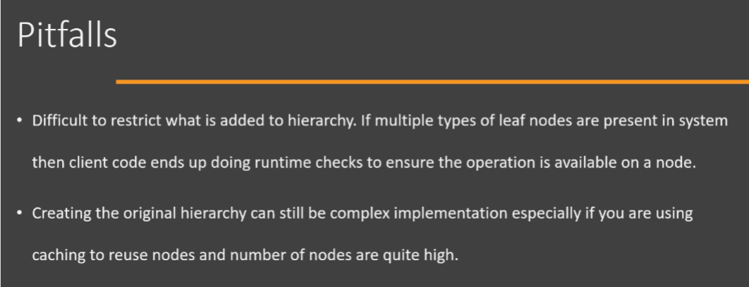
- Composite – Summary:
Now let's look at a summary of Composite design pattern. So whenever we have a parent child relationship or a tree data structure of objects in our application, then we can use the Composite design pattern in order to simplify dealing with such a data structure. Goal of this design pattern is to simplify the client code, which works with these data structures, and it simplifies it by allowing the client code to treat our composite object and leaf object in the similar way. So client doesn't need to worry what type of object it is currently dealing with. Next, Composites, which are the classes in our tree structure which have children in them, they will delegate the operation to the leaf node or children which are present in them, and the leaf nodes are the ones which actually provide the implementation or which provide the functionality which is needed by the client. Next, we have to decide what is present in our base component. We can add all the methods that are needed by the client in the component node, but it can force some of our classes to implement methods which they cannot provide implementation for. So this is a decision that you need to make while implementing this design pattern.
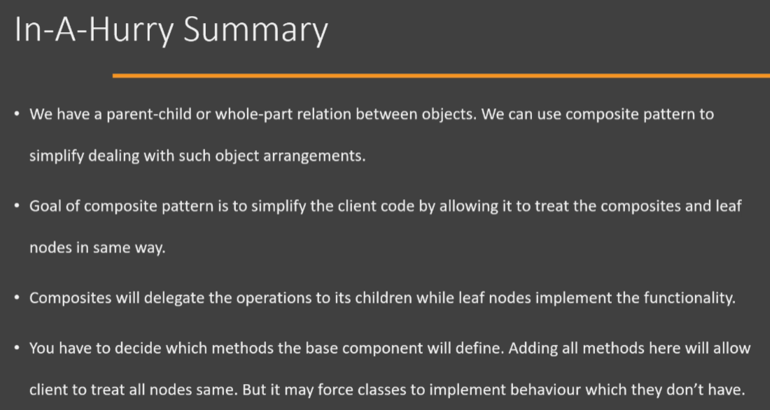
Now let's look at the UML diagram for Composite design pattern. To begin with, we have the Component interface and this is the base interface which is used by our Client. It defines the operations which are needed by client and it can define operations that deal with children management in it. Now, this is an optional thing(i.e., children management). You can keep these operations(i.e., children management) in Composite as well. For this Component, we have two child classes. We have a Leaf class which actually provides implementation for the operation() and then we have a Composite, which again implements our Component interface, but it also has a collection of children within it. Now, whenever we call the operation() on our Composite, the Composite is going to delegate that operation to the children, which it has. Client is always going to work with the Component interface. It doesn't need to know what type of actual implementation of Component object it is using.
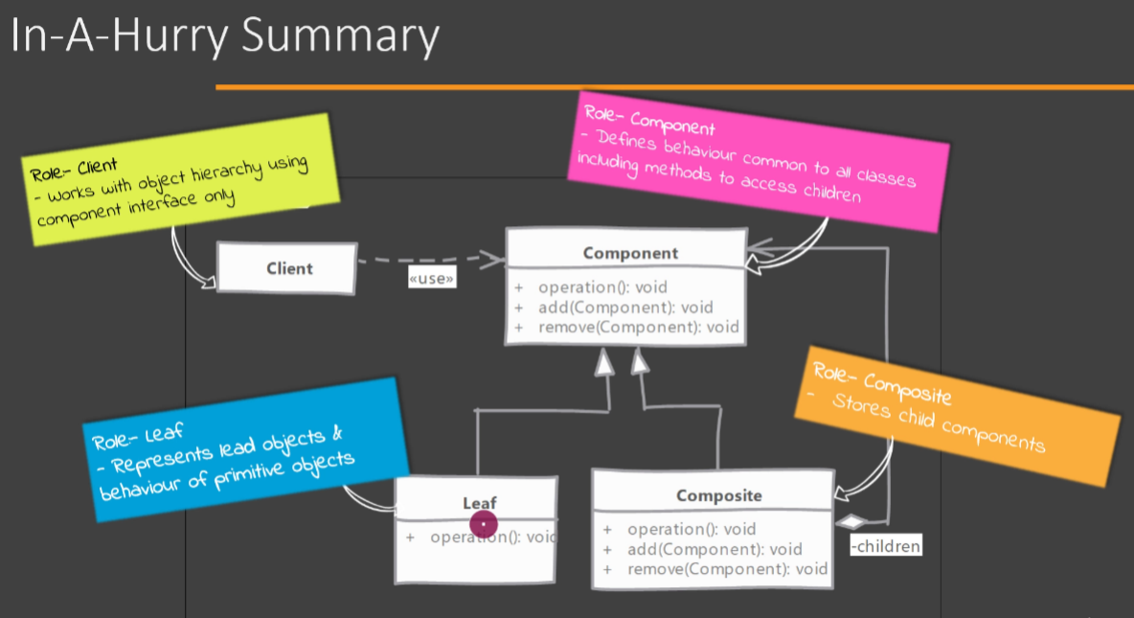
Now let's look at the implementation of Composite design pattern. So here I have a Component class which has not defined the children management operations in it. So we have a File, which is an abstract class, and which is our Component. So it has defined operation like 'ls', which gives you the file information for any of its children. Then we have BinaryFile. So this is our leaf node. Now, BinaryFile doesn't have any children of its own and it provides the actual implementation of the 'ls' operation. Then we have a Directory and this class represents Composite in our design pattern. So it will have a collection of children in it, and these children can refer to either another Directory or the Leaf node, which is BinaryFile. Whenever we have the operation called on our Composite object, it's going to delegate that operation to its children. Additionally, our Composite(i.e., Directory) class also defines operation that allow the Client code to do children management. So it(i.e., Directory) will have a method that can be used to add a node to its children. It can have a method that can remove a node from children and we can get hold of all the children of this Composite(i.e., Directory). So, this is one way that we can implement the Composite design pattern.
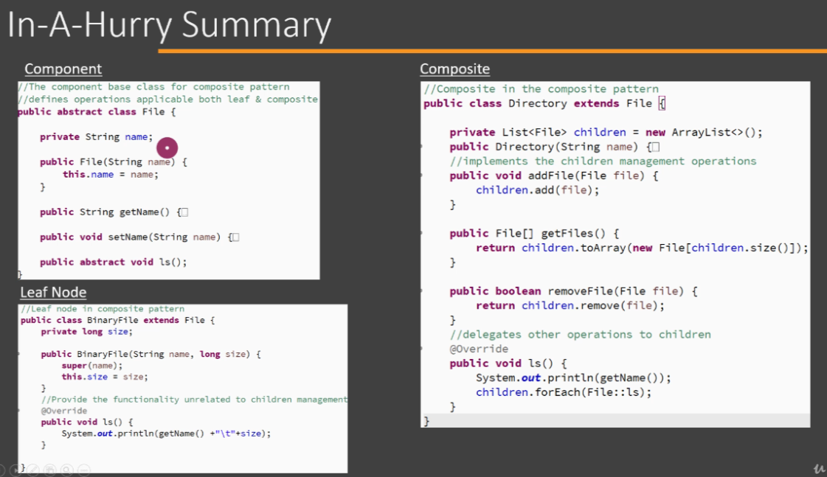
Next up, we are going to see how we can use this Composite design pattern in our Client code. So here we have two methods createTreeOne() and createTreeTwo(). The difference between these two methods is that the first method createTreeOne() returns an object which is a Composite. So 'dir2' is an object of Directory, which is a Composite. The method createTreeTwo() returns a leaf node. In our Client, however, it doesn't matter which type of object that we are dealing with. Client can simply call the operation that it needs, and it works whether the node is a Composite node or whether the node is a Leaf node. All right, so this is how you can use and implement Composite design pattern in Java.
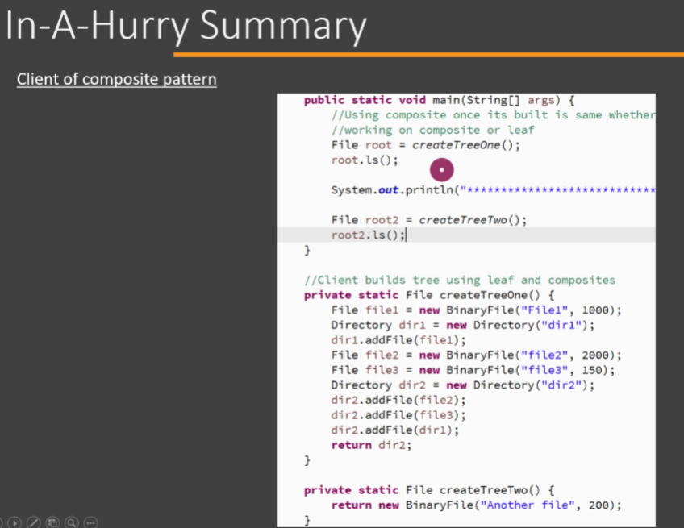
How is the Composite design pattern different from the simple composition?
Composite pattern allows us to treat all objects, whether they are using composition(i.e., Composite) or not(i.e., Leaf)in same way. Remember without Composite pattern, client code will have to write code differently to handle object which has children. Composite pattern allows client to call a method on object and pattern takes care of handling children if present.
Which of the following statements is a valid benefit of using Composite pattern?
Composite pattern allows us to work with objects arranged in tree structure in easier fashion. Once a tree structure is created, the client code does not need to worry about whether an object is a leaf node or not.
Leaf node and Composite node must implement/extend from same interface/class. In order for client code to treat them uniformly, they must have common interface.
What is the main purpose of Composite role in Composite design pattern?
It delegates the operations to all of its children. Main role of Composite is to delegate operations to its children.

