Facade Design Pattern
- Facade - Introduction
Facade uses structural design pattern, which is easy to understand. It's quite easy to implement and it's of great help, especially if you're working with legacy systems or code that is already present. So let's jump into it and see what facade does and why we need it. So if you have a client code which interacts with large number of classes and interfaces, which are part of a subsystem, and this interaction is because client code needs some functionality that is provided by this particular subsystem. So client can carry out its work. That is fine, but what happens in this process is that the code becomes tightly coupled with our interfaces and classes which are part of our subsystem. So if you want to make any changes to those classes or interfaces, you have to make sure that your client is going to work with those changes. And facade design pattern tries to solve this problem. It tries to reduce the coupling of these classes and interfaces, multiple classes and interfaces in our subsystem with the code which is using that subsystem. So facade provides a very simple and unified interface to our subsystem. So our subsystem may provide one or more functionalities or it can carry out one or more tasks which our code needs, and we expose that functionality in this single facade class or facade interface and client can only interact with our facade. He doesn't have to know about all the inner classes and interfaces and it can still get the same result. Now one thing that you should remember is facade is not just a one-to-one method forwarding, so you are not going to have a method in the facade which simply going to call onto a particular method in your subsystem. Okay, it is more than that and we are going to see what we mean by that when we are trying out the example of implementing Facade design pattern.
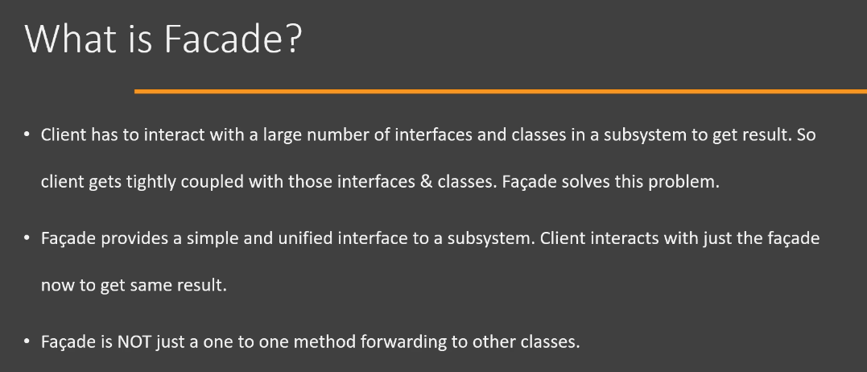
Now let's see a UML diagram of this Facade design pattern. First of all, we have the subsystem here, so this subsystem may comprise of multiple packages, classes and interfaces. These classes, inside subsystem, may have their own relationship between them. All right, then we have the facade. So facade provides a simple method definition which corresponds to use case which is needed by the client code. And this particular facade will interact with these classes, inside subsystem, from within the method. So anybody who wants to use functionality of our subsystem will talk to facade and facade will in turn talk with all these inner classes and interfaces that are part of our subsystem. So it's pretty simple design pattern to understand and you will see that it is of great use, especially if you have some legacy code and you want to provide a simplified interface to access functionality there. Next, we are going to see how we can implement facade in our code.
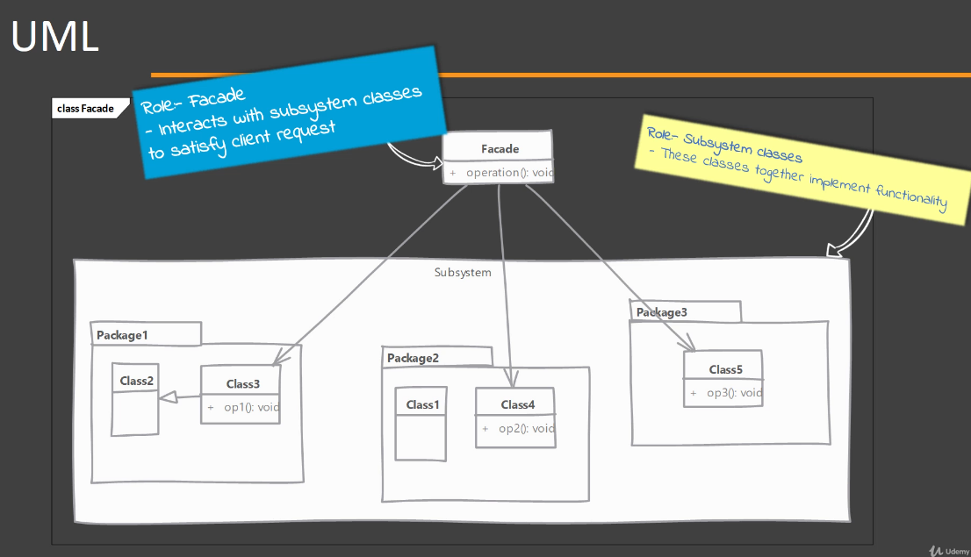
- Facade – Implementation:
Now let's see what we need in order to implement the Facade design pattern. So we start by creating a class that will serve as a facade, the class which will be used by our client. And we define operations or methods in this particular facade class. But we take into consideration the overall use case or task that our subsystem is designed and implemented for. For example, if you have a subsystem that is responsible for, let's say, printing documents, then you will have a simple method that takes an object of a class or a file, i.e., a FileInputStream object, and it simply prints that content of that particular file or input stream. So we are thinking about use cases, overall use case that the client code is interested in. We are not going to write methods that correspond to another method which is part of a class in our subsystem. And that is the important part here that facade should be readily usable and it should expose our use cases or tasks as simple operations. And this method, which we have defined in Facade class, it takes care of interacting or calling into our subsystem and using those multiple classes and interfaces which are part of our subsystem. Now next, we are going to see how we can implement this by looking at the UML of example.
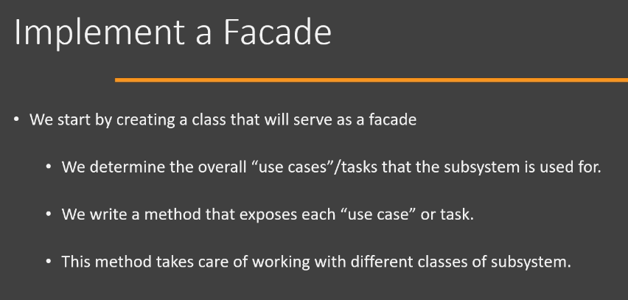
- Facade – Example UML:
Now we're going to look at the UML of the example that we are going to implement. So in this example, we are going to have an email subsystem. Of course, this subsystem will be not sending an actual emails, but it represents all the classes that you would typically use if you are sending an email. So in this email subsystem we have classes like Mailer, Email, EmailBuilder, Stationery and all sorts of classes. So if our client wanted to send an email using our subsystem and there was no facade, client code would interact with all of these classes one by one. And that means this particular client code now becomes tightly coupled with all of these inner classes of our subsystem. To solve this problem, we're going to create an EmailFacade which has a simple method that corresponds to the use case which is implemented by our email subsystem. And that use case is sendOrderEmail. And this method is going to simply take an object of Order class, which we are going to implement, and it's simply going to tell whether the email was sent successfully or not. So Client now only interacts with the EmailFacade. He doesn't need to know what exactly are we using inside this subsystem. All right, so let's jump into Java code and see how we can implement it.
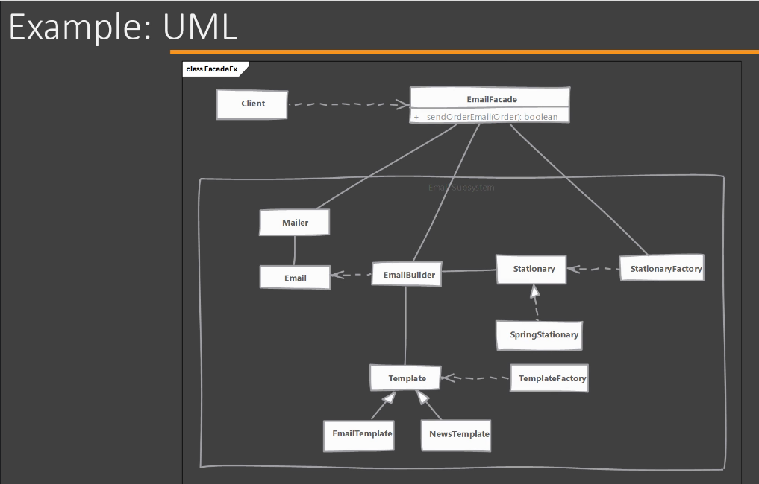
- Facade – Implementation:
Let's jump into Eclipse and see how we can implement the Facade design pattern. So again, I have gone ahead and implemented some of the classes that we are going to use in this example. So in the email(i.e., com.coffeepoweredcrew.facade.email) package, you will see that we have multiple classes which are part of our email subsystem. And using these classes, we are going to send email. Of course, these classes don't do anything much, but they are placeholders in order to indicate the amount of classes that you would typically interact with if you wanted to send an actual email. So if you look at our client code(unzip facade_begin.zip), which is using this system, we have a main method here and we want to send an order email. So we have written a method in our Client which interacts with these many classes(Template, Stationary, Email, etc) of email subsystem. So it uses Template factory to create a Template first, then it uses Stationery factory to create Stationery object. Then it gets email builder and builds the actual Email using the Template and Stationery objects, as well as the Order object for which we want to send an email. It finally builds that Email object, uses Mailer class and sends that email. It returns whether the email was sent successfully or not, and it prints an appropriate message. If you even look at the import statements that are needed in this Client class(unzip facade_begin.zip), you can see that we have a tight coupling between our client code and all of these classes which are part of our email subsystem. So to solve this problem, we are going to implement an email facade. So here I have created an empty class(i.e, EmailFacade) where we are going to implement our Facade design pattern. So to begin with, we don't need to implement any interface or extend from any class. While writing facade, you are in control of how you are defining the operations. The only goal here is to make it simple for our client code to use our subsystem. So what I'm going to do is I'm going to define a same method called as "public Boolean sendOrderEmail()", which accepts an Order object and using this Order object it can send an email. I have copied the same logic, which uses the classes of email subsystem, to send email. And, in the Client class, instead of using the method[i.e., sendOrderEmailWithoutFacade()], which was defined here(unzip facade_begin.zip), what we are going to do is we're going to create an object of EmailFacade in the main() method and using that facade object, we are going to send the email. So, now, this is what is needed for the client to send an order email. If you look at the import of this Client class, you can quickly see that we are now only interacting with a single facade class(i.e., EmailFacade) from our email subsystem and we can still get the exact same result that we were getting when we were using the classes ourselves. So, this is the benefit of the facade design pattern. It makes it easy for the client to use our subsystem and it also avoids tight coupling with all of these classes which are part of our subsystem. There is nothing to implementation of a facade. Only goal is to make sure that you are sticking with the use cases and sticking with the point that it should make life easier for the client code.
- Facade – Implementation and Design Considerations:
Now let's look at some of the implementation and design considerations when using the Facade design pattern. First of all, the main purpose of facade should be that it should minimize the complexity of using our subsystem. So, that should be your main criteria when you're defining methods and defining interactions that happen between the client code and facade. Next, you can have an interface or an abstract class as a facade and you can have multiple implementations of that. So client can now use a subclass and that can interact with different subsystem implementations. For example, in our hands-on example, we had email subsystem, we had a single facade called as EmailFacade. Instead of that, you can have an email system (that works)/(that uses), for example, Microsoft Exchange, another email subsystem that uses something else, and you can have a facade as a interface and two implementations of that facade. Now, facade is not a replacement for regular uses of your classes that are in your subsystem. So we saw, in our hands-on example, that client was getting to interact with these classes and there was an issue of tight coupling and we added facade to that, solved that problem. But that doesn't mean our regular classes cannot be used outside of our subsystem. So do not make any assumptions while you are implementing classes in your subsystem that there is going to be a facade and then through facade only our client can interact with these classes. And this is true if you are making assumptions regarding the validation that can happen in a facade, do not make any such assumptions. Write your classes in subsystem as if they were they were going to be used as regular classes and then implement facade.
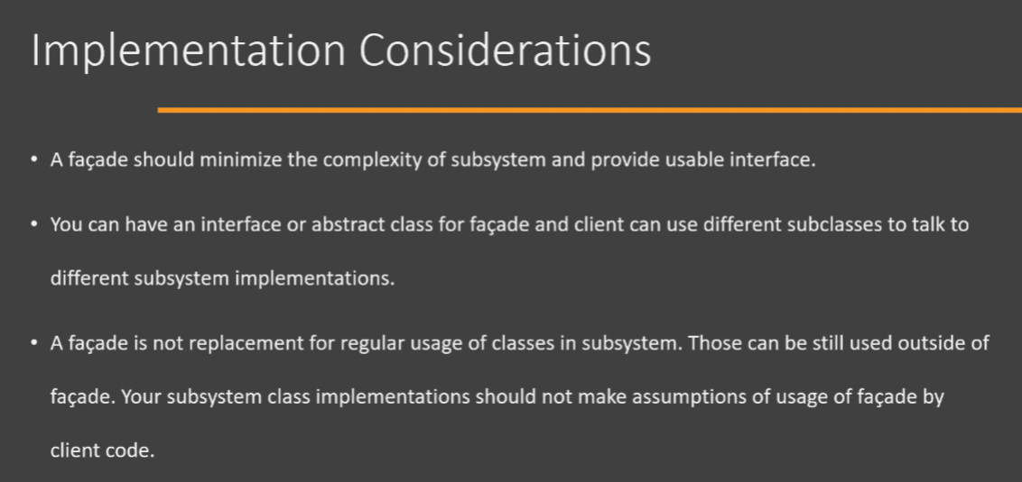
Now let's look at the design considerations when working with facade. The facade is really a great solution if you want to reduce coupling between two different subsystems. Because often you end up with classes in this subsystem which know too much about how another subsystem is implemented and facade is a great way to reduce that kind of coupling. So two subsystems can interact through facade and avoid knowing too much about another subsystem. Now, main purpose of facade, of course, is to provide simplicity of usage of our subsystem. However, if your only concern is the tight coupling that happens between the client code and classes of our subsystem, then you don't even need a facade. You can use another design pattern like Abstract Factory, which solves this problem of tight coupling between client code and classes of our subsystem. So facade's purpose is to reduce the coupling, but it is also important to note that facade also serves to simplify usage of our subsystem. So it serves these two important purposes.
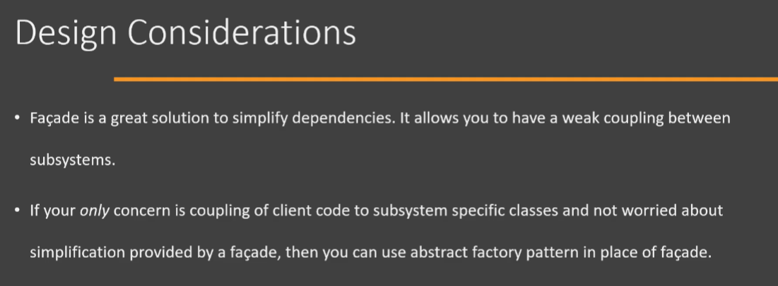
- Facade – Example:
Now let's look at an example of Facade design pattern in Java class library. The URL class, which is present in the java.net package is a great example of facade. We use this class URL in order to represent a unified resource which is present on the network, which can be a URL that we can type in the browser, or it can also point to a resource that is present on a file system. Now this class provides a method called as openStream(), which returns us an input stream to the resource which is pointed to by the URL object. Now opening a stream to a remote server requires interacting with a lot of different classes and all that complexity is hidden by the URL class. And that is why this is a great example of Facade design pattern. So, this class takes care of dealing with multiple classes in the Java.net package as well as dealing with some internal sun packages. This is what facade design pattern is, because there are two main goals or two main purposes when using Facade design pattern. The first goal of facade is to reduce the coupling between the number of classes in a particular package and the client code. We do not want our client code to be coupled with multiple classes from a package. That is the first goal. Second goal of facade is to simplify usage of the functionality that is provided by those classes in a particular package and URL class covers both of these goals beautifully. Now let's look at the UML diagram of these classes. So we first of all, we have the client code that is going to interact with our URL class. Now this class is actually what is a facade. This is part of java.net package. Now when we communicate with URL class and call the openStream() method, this class[i.e., URL] is actually dealing with multiple classes[i.e., URLStreamHandler, URLStreamHandlerFactory, etc] which are present in the java.net package, which are again dealing with some other classes[i.e., file.Handler, ftp.Handler, http.Handler, etc] which are internal to Java class library. So if we are using URL, we are simply going to create the object of this class and provide the url to the remote resource. And then we are simply going to call the openStream() method, which will return us an object of InputStream, and then we can use that input stream to read data from that server. So you will see that using this class from the perspective of the client code is very easy. We do not have to deal with multiple classes. We only deal with the single URL class, which is the facade. Now if you take a look at the code which is present in this particular URL class, you will see that it deals with multiple classes internally. So this second code snippet is taken from the rt.jar file and here is an example of a method that is present in this class. So we have a method called as getURLStreamHandler() and you will see that this class is internally dealing with classes like URLStreamHandler. It is also dealing with particular factory in order to get the particular type of protocol handler and it is dealing with security as well. So all those classes are not coupling with our client code when we are using the URL object. So this is a great example of Facade design pattern.
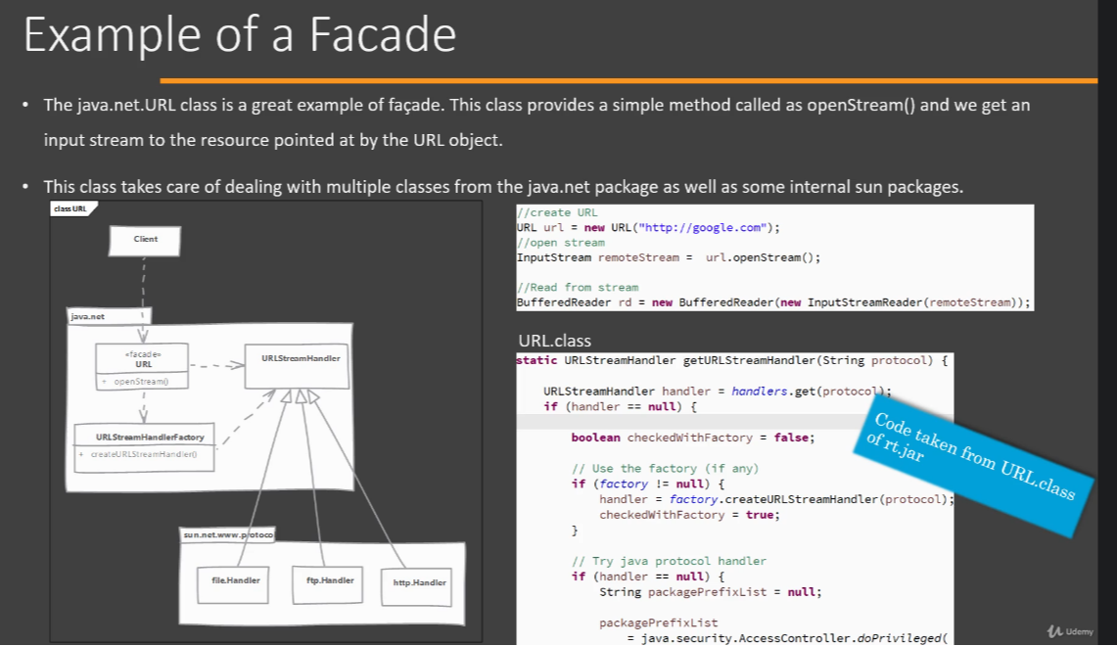
- Facade – Comparison with Adapter:
Now let's compare our Facade design pattern with Adapter. Now you may find them to be somewhat similar because Adapter also provides an interface which client code uses and Facade also provides an interface which the client code uses. But there are some great differences between these two design patterns. So first of all, the intent behind facade is to simplify the usage of our entire subsystem. Facade is not written for one single class. So for example, if you have one class, you won't write a facade, just use that single class. It is typically used when you have a subsystem which consists of multiple classes and interfaces, and you want to simplify how the client uses our subsystem. You would use facade design pattern. Adapter, on the other hand, is meant to simply adapt an existing object to a different interface. So, Adapter works on a single object, and the purpose or intent of Adapter design pattern is to adapt that object to a different interface. Next difference is that facade is not restricted by any existing interface. So when you are designing facade, you can write any method that you want. You will have only one purpose or only one goal that whatever operation we define in facade is easy to use. You don't have any restriction that you have to implement this interface or you have to follow these particular method templates. There is no such restriction. Adapter, on the other hand, is always written to confirm to a particular interface which the client code needs. So this is another difference between Facade and Adapter.
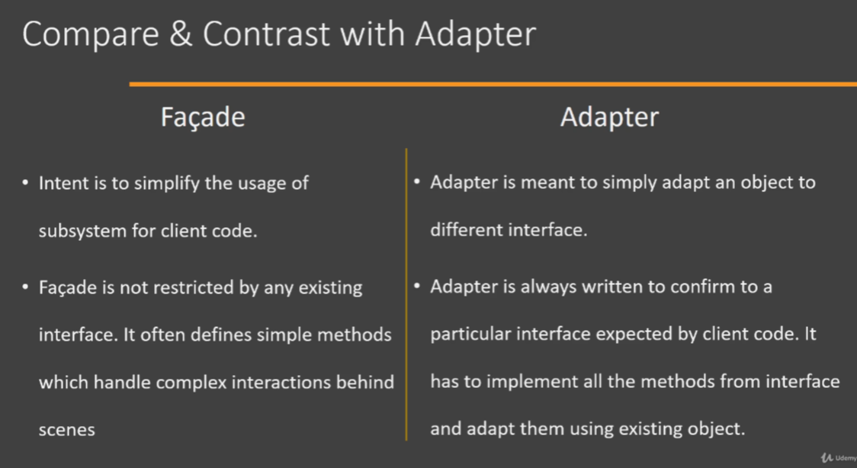
- Facade: Pitfalls:
Let's discuss pitfalls of Facade design pattern. Now, first of all, not the pitfall of the design pattern itself, but needing a facade pattern for a system that you are designing and implementing right now is typically a signal that you need to take another look at how you are designing your subsystem. If you are designing it and it is becoming quite complex to use for the client code, then instead of writing a facade, you should take a look at how you are designing your classes and interfaces and try to make them easier to use. Again, this is not the pitfall of the Facade design pattern, but it indicates that in your system you should not typically need a facade. Now this design pattern is also often overused or misused pattern and it can hide improperly designed API. One of the common misuse that I have seen is that people use facade as 'containers of related methods', so they will have methods that are related to, let's say, printing and they will throw them in our facade. And these methods will simply call whatever classes they need from our printing subsystem. That is not what facade is meant for. Facade is meant to simplify the usage for the client code. So always be look out on such cases when you are doing code reviews. So as you can see, these are not the pitfalls of Facade design pattern because it is quite a simple design pattern and if you use it correctly, there is nothing wrong about this design pattern. So these are pitfalls for facade design pattern.
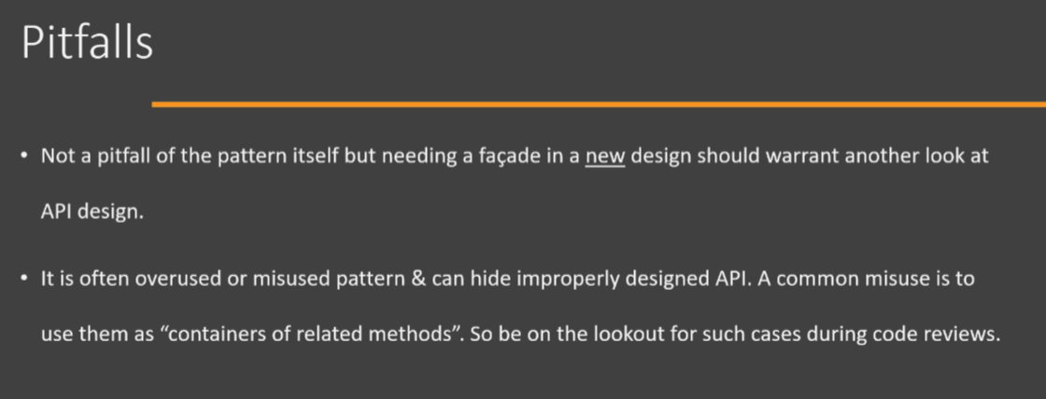
- Facade: Summary:
Let's look at the summary of Facade design pattern. So we will use facade design pattern whenever using our subsystem requires dealing with lot of classes and interfaces by the client code. So this code(i.e., Client code) now becomes tightly coupled with these classes, which are part of our subsystem. Using Facade design pattern, we can provide a simple interface which client can use, and that particular interface will provide the exact same functionality, or it will satisfy the use case which is needed by the client code. Now, facade is not simply a method forwarding. Methods inside Facade encapsulate the interactions that are needed to achieve a functionality or to achieve a task, and they encapsulate that interaction so that the client code doesn't have to do those in its own. So that's the purpose of facade. It will not simply do a method forwarding as we see in Adapter design pattern. Now, facades are often used whenever there is a legacy code and we have a new system that is going to use that legacy code, to avoid the coupling of our newer code with the legacy system, we add a facade over the legacy code and that way our new code doesn't become tightly coupled with that legacy code, which can be improved or replaced in future releases.
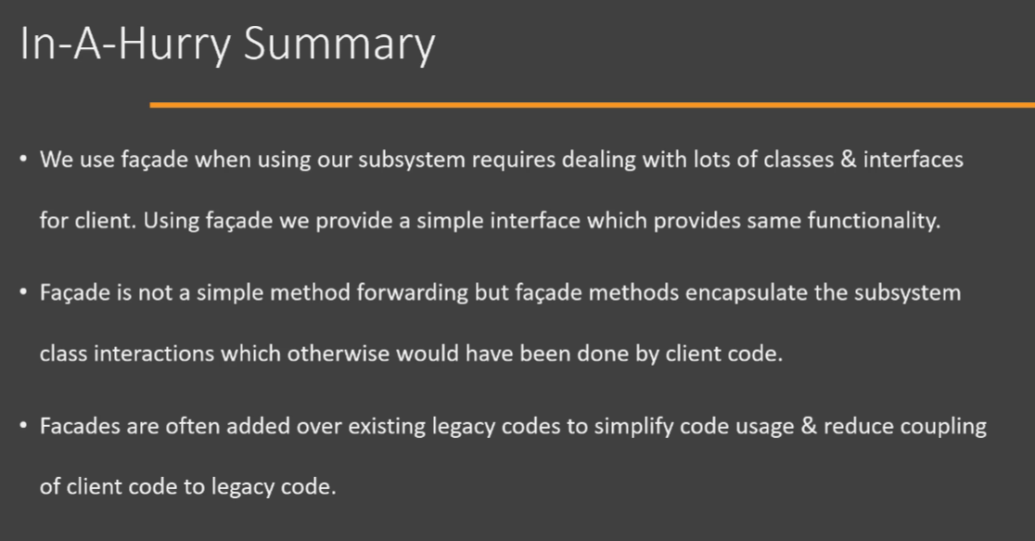
Now let's look at the UML diagram for the Facade design pattern. It's quite a simple design pattern. Here we have a subsystem that has multiple packages, multiple classes and interfaces which are needed for getting a functionality out of this subsystem. Then we have our facade, which can be a simple class which defines a simple operation which encapsulates the interaction that is needed with these classes from our subsystem. So this is the UML for facade design pattern.
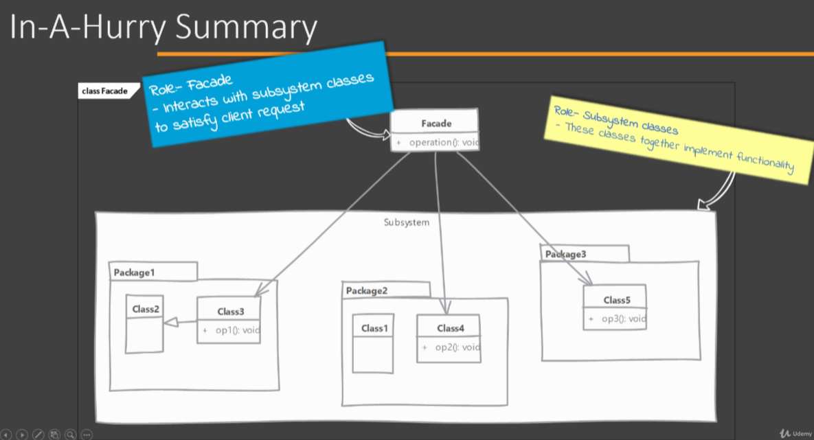
Now let's look at the implementation of a typical Facade design pattern. So here we have a new class called as EmailFacade, and this is a facade over our email subsystem. It has defined a simple operation called as sendOrderEmail(), which accepts an Order object and returns whether the email was sent successfully or not. Now you will see that this method, which is defined in facade, encapsulates all the interactions that are needed in order to send email. So it will interact with classes like factories. It will deal with classes like Template, Stationary class. It will work with the Mailer, which actually sends the email. So using the EmailFacade, the client will only know about our single method i.e., sendOrderEmail(). It won't get coupled with these classes of email subsystem that are needed in order to achieve that functionality. So this is the Facade design pattern.
