AgloMonster Flowchart

What is it?
The AlgoMonster flowchart, developed by ex-Googlers and competitive programmers, is based on solving thousands of problems and identifying common patterns. Its purpose is to provide a structured method for solving coding problems.
How to use it?
Internal nodes (diamonds) are decisions based on problem descriptions. Leaf nodes (purple boxes) are the algorithms you would need to solve the problem. Traverse the tree from the root until you reach a leaf node, and that is the algorithm you need to solve the problem. Select a node to see more explanations, or watch the video below for a walkthrough.
Do I memorize this?
This is a common question, and the answer is NO. The flowchart is a tool and a reference to help you understand the patterns. As you work through problems using the flowchart, you will naturally get better at recognizing the patterns. "Education is not the learning of facts, but the training of the mind to think." Practice and you shall learn. No memorization needed!

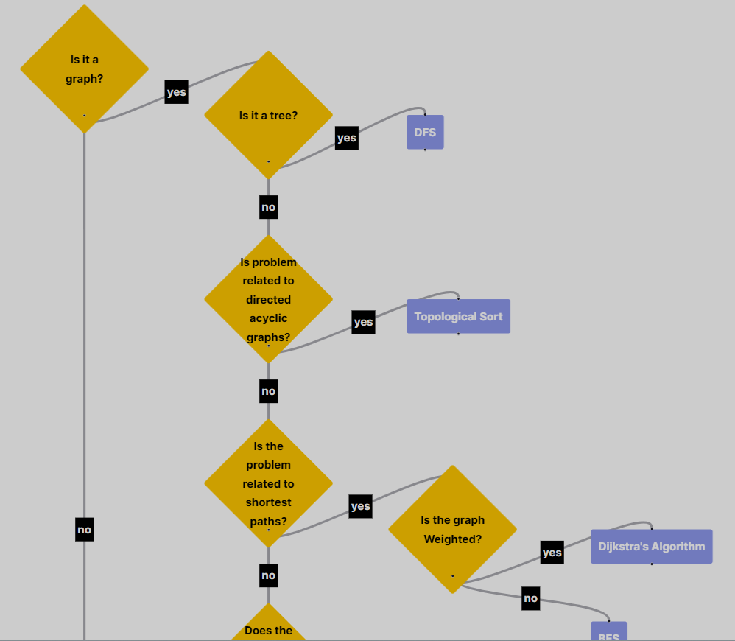
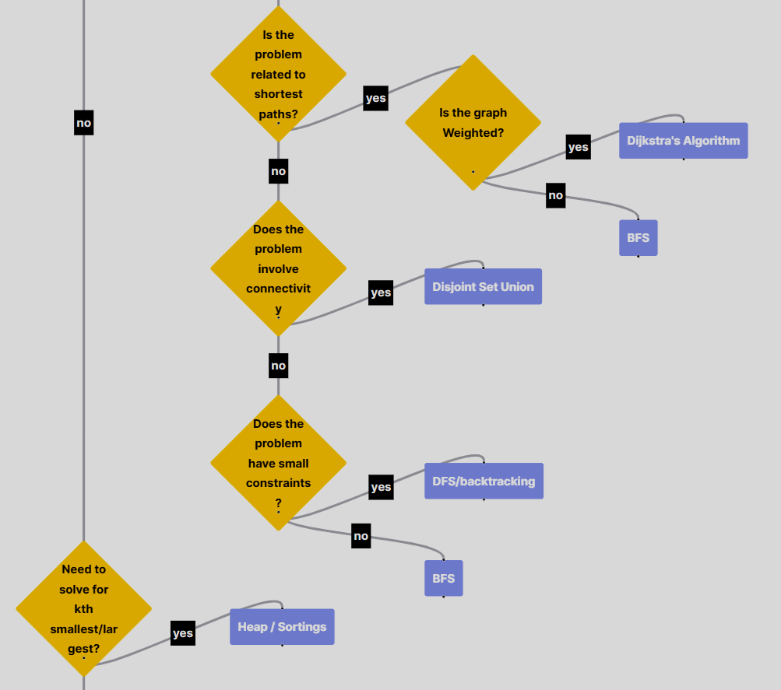
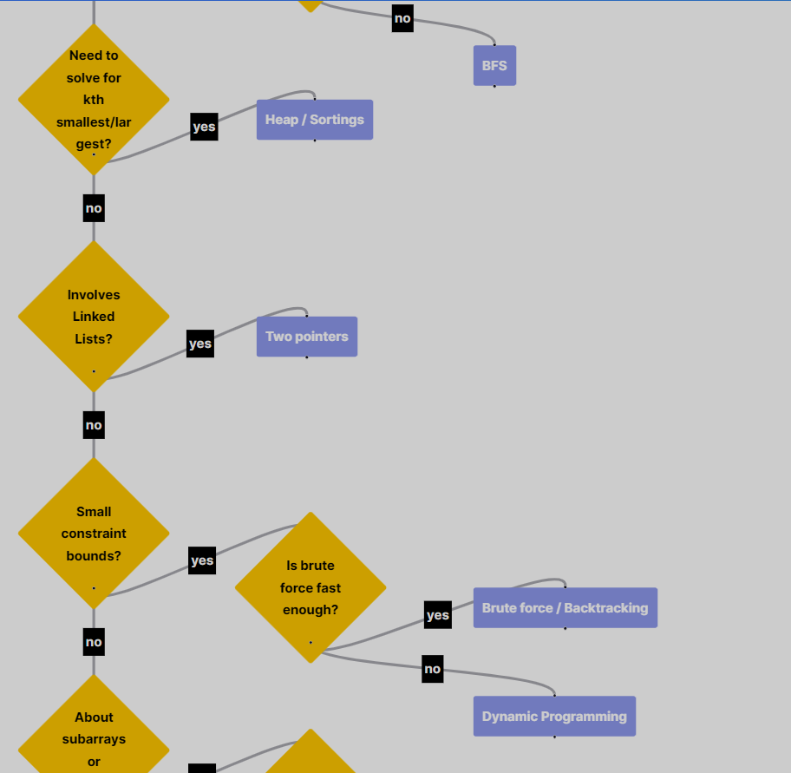
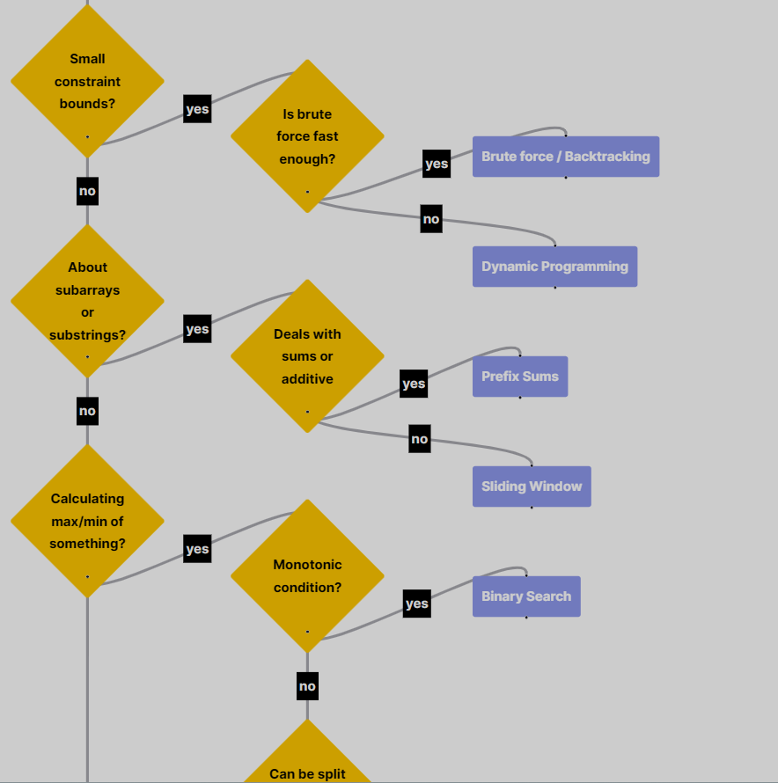
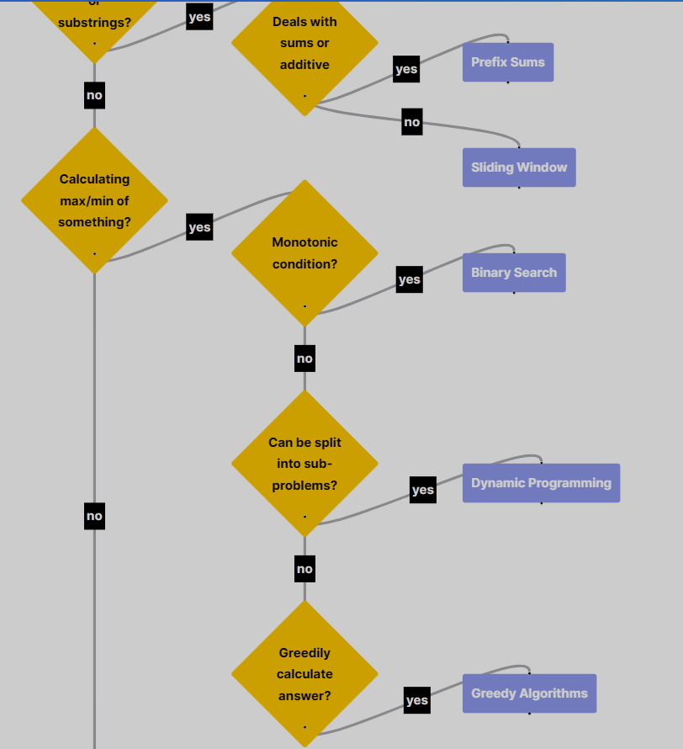
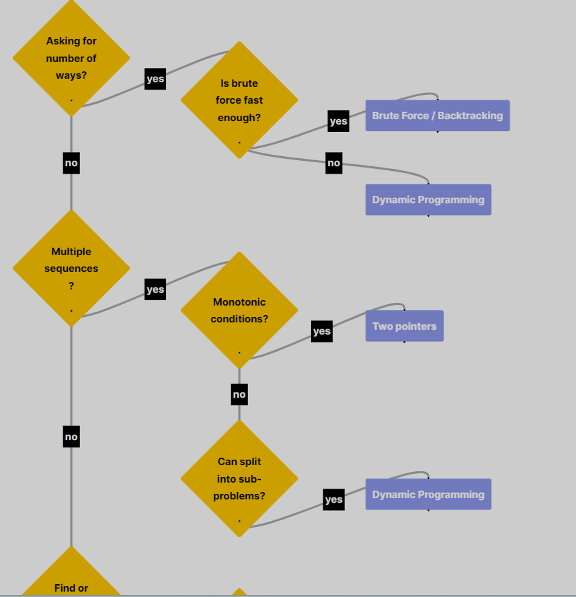
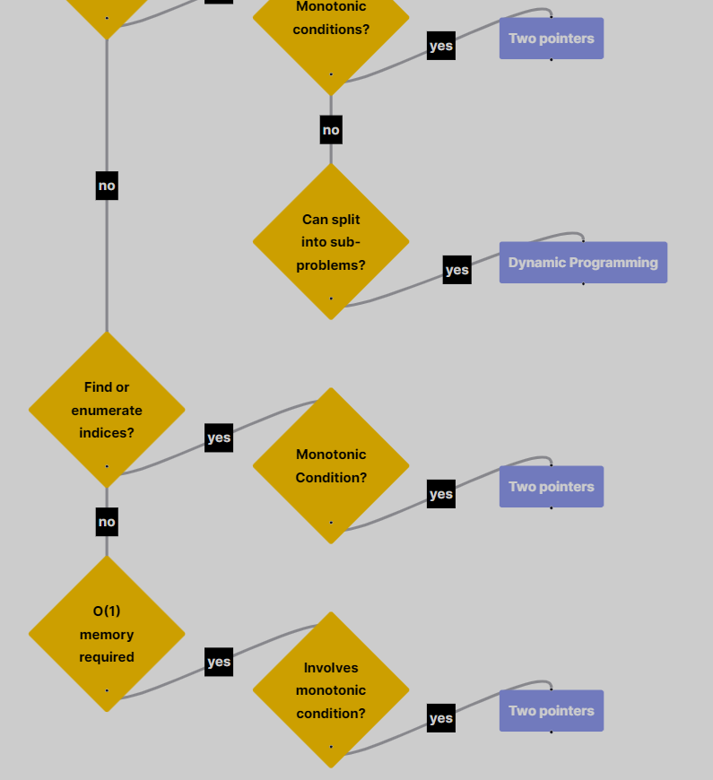

Same Flowchart in Smaller view:
