**IFT 485 / 544: Middle Programming and Database Security**

Harshal Arun Yeole

Section: C

Department of Information Technology, Arizona State University

Module 2 Assignment : Exploring JavaScript Topics with EJS, Node.js, and Express

Professor: Dinesh Stapith

Due: Sunday Sept 3

**Installation and Setup**

**Visual Studio Code Installation**

**Node and npm version:**

**Express installation:**

**EJS Installation:**

**Project Setup and express server:**

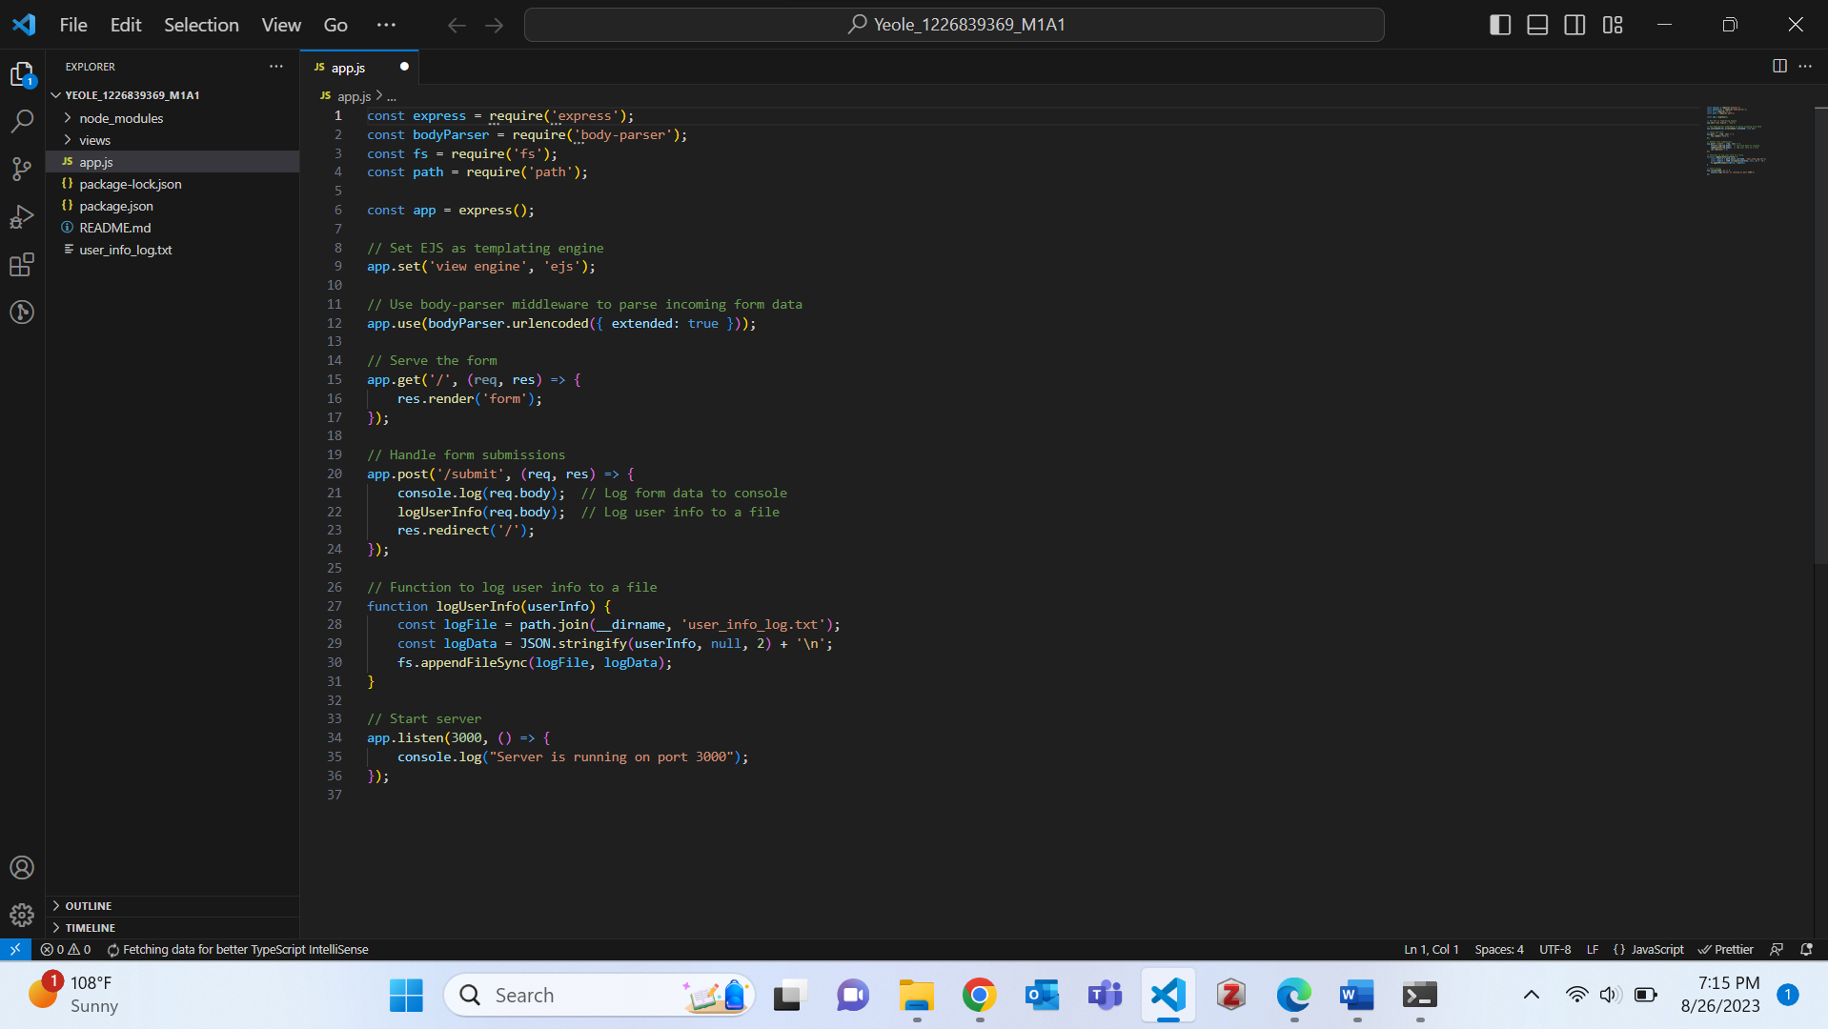

**Creating form:**

**Handling Form Submissions:**

**Form:**

**Server side form handling:**

**Function to log info on server:**

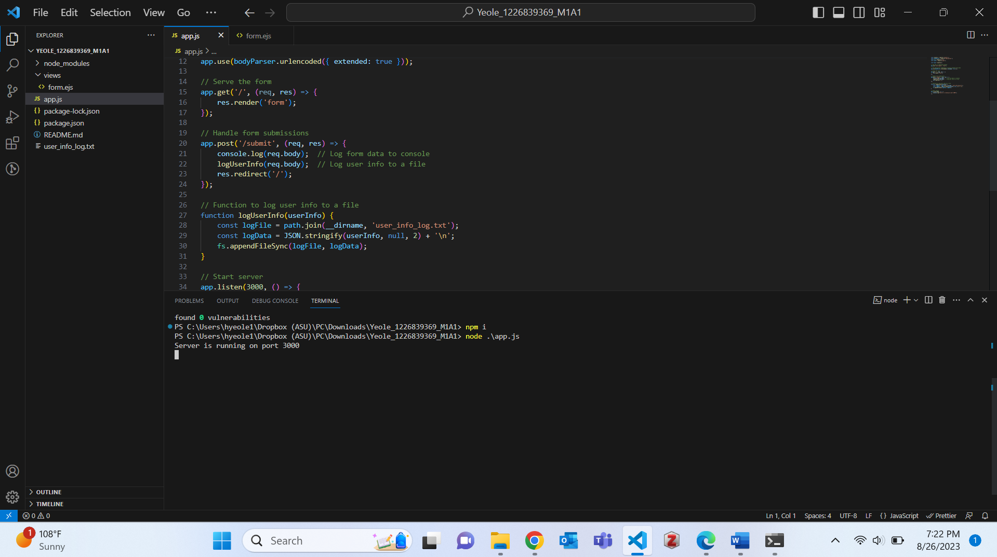

**Add details in form and check Terminal:**

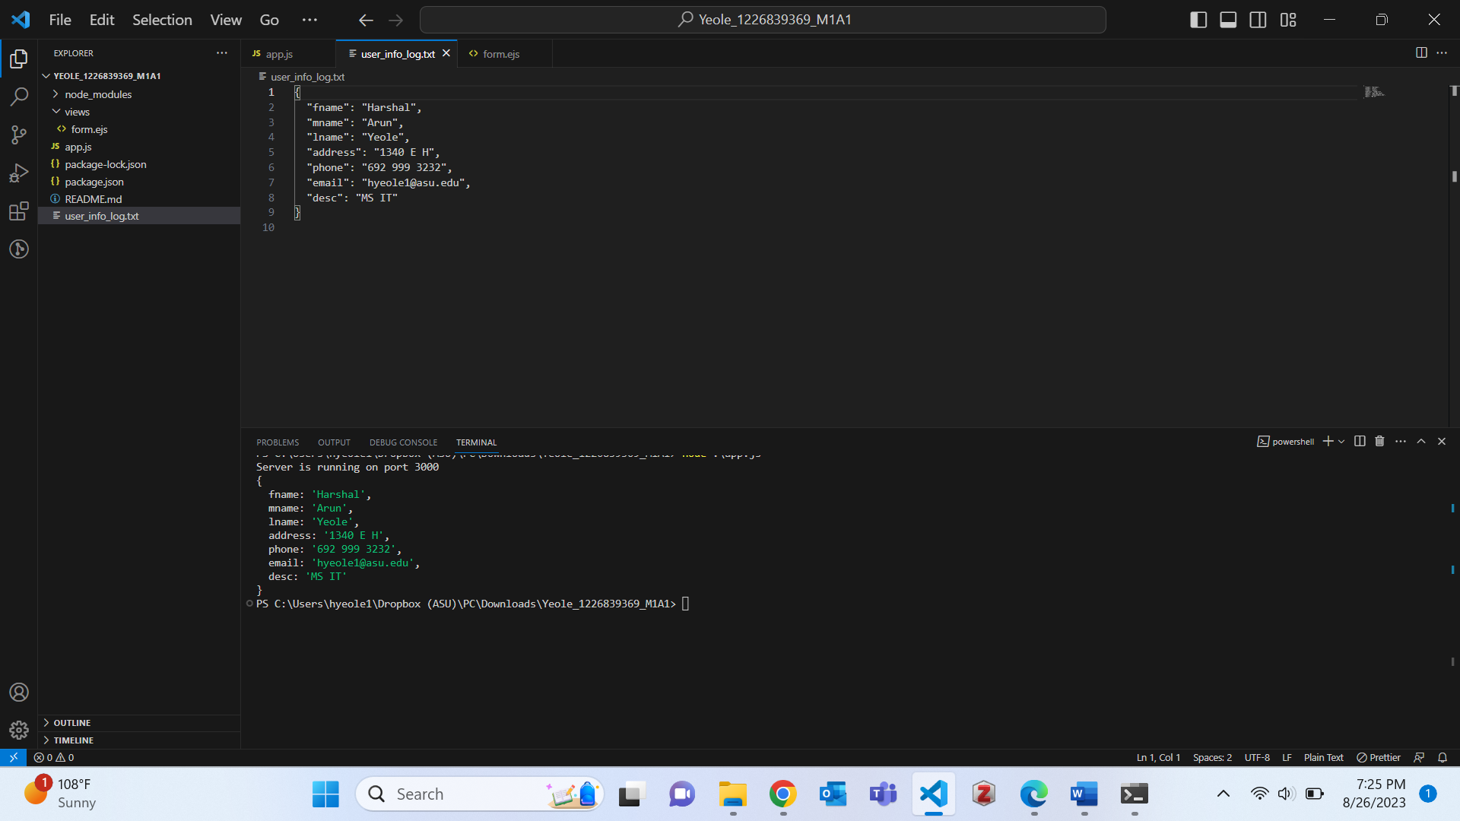

**Documentation:**

**References**

*Documentation*. Node.js. (n.d.). <https://nodejs.org/en/docs>

*Node.js web application framework*. Express. (n.d.). https://expressjs.com/