POSITIVE:

The overall look and feel of your bioSite is really nice. It is evident that you are following the format of what we have been learning so far.

The header graphics you chose are interesting and I like the fact that you incorporated the name of the main character into them as well.

It has a clean and intuitive layout and navigation which makes it easy to use.  Your website provides valuable information about Keith, and I am able to navigate your site easily and find all the information I need without any much effort on my part.  It is pleasing to look at and visually appealing as well as consistent in its design and aesthetics. My favorite color is blue, but I also love white backgrounds, so it could be said that your background is one of my favorites as well.

AREAS OF IMPROVEMENT: Minor issue I found. 😉

1. It would be very helpful if you could add an attribute like target="_blank", so that when a user clicks on an external link it will open a new tab leaving the original page open in the original tab.  In the example below, 1st picture, I clicked your bioSite landing page located from the discussion part of our school's discussion site, and it opened to our school's discussion site as well. When I clicked the About page located from our school's discussion section, I got a 404 error page as a result.  (second picture below). The same thing happens to the hobby page when I double click on it as well.

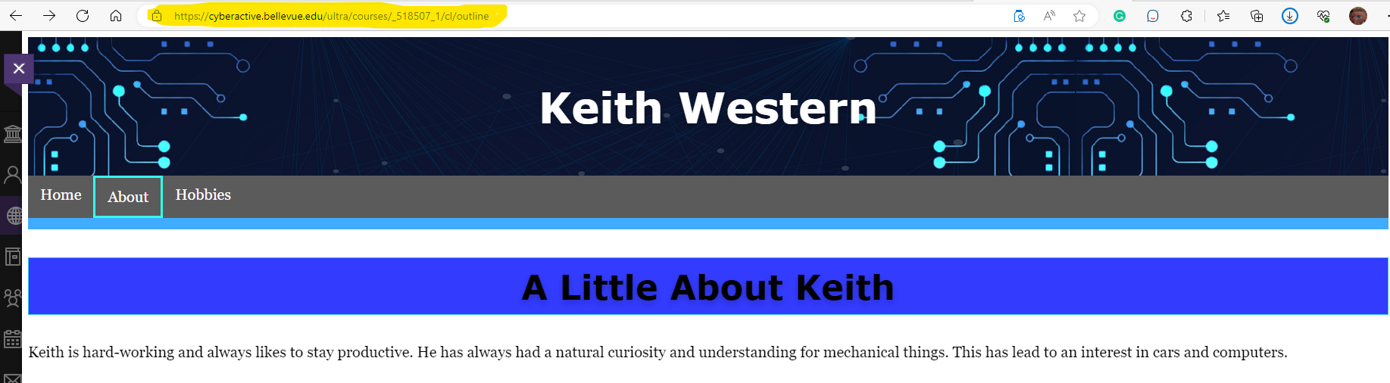

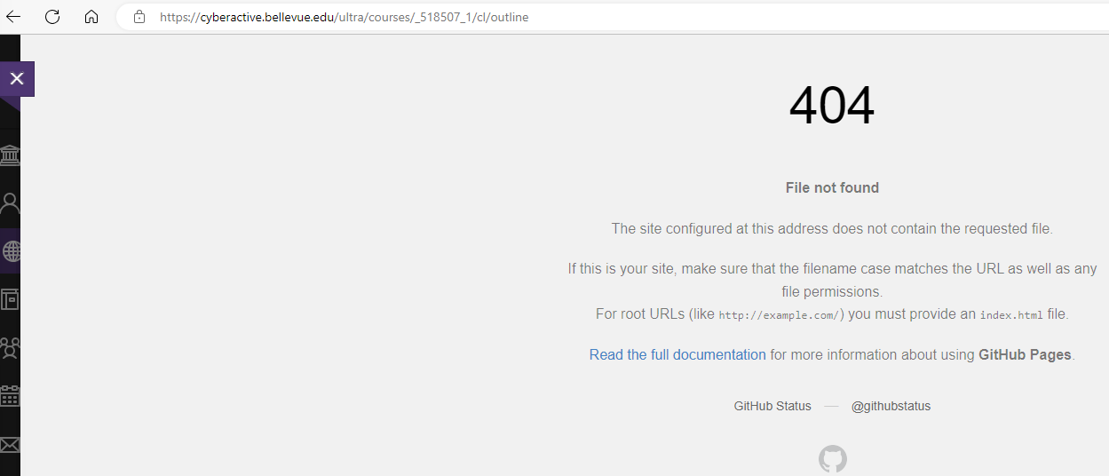

1. I also suggest to remove the table line from the Home and Hobbies pages and format them the same way as the About pages, whereby if you hover your mouse over the objects, the pictures are highlighted, which is a really cool feature.

Overall, you did a great job.

As a side note, I would like to thank you very much for your comments regarding my bioSite.  The best!