<https://github.com/Ambuklao/csd-310.git>

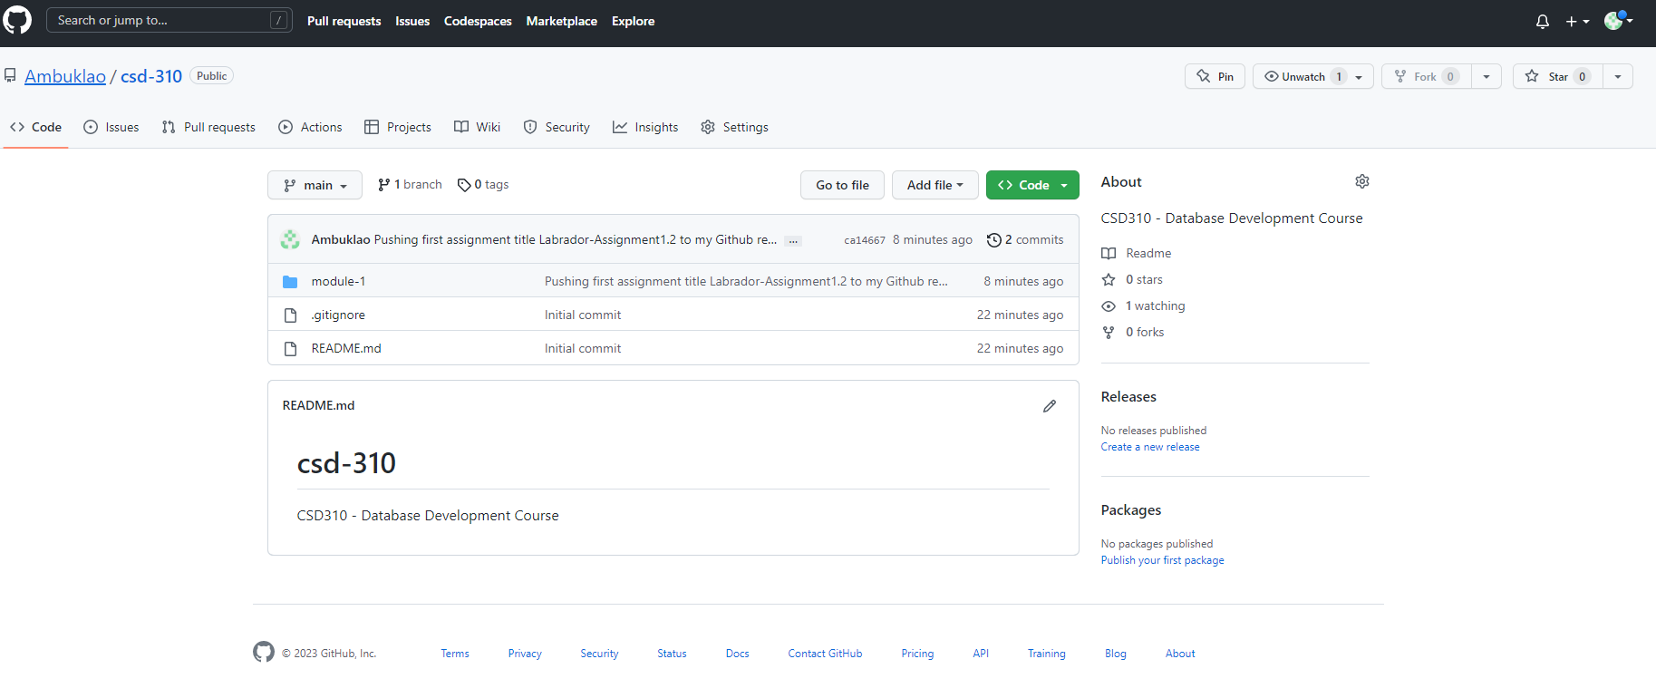Screenshot of GitHub repository

Screenshot of your local directory 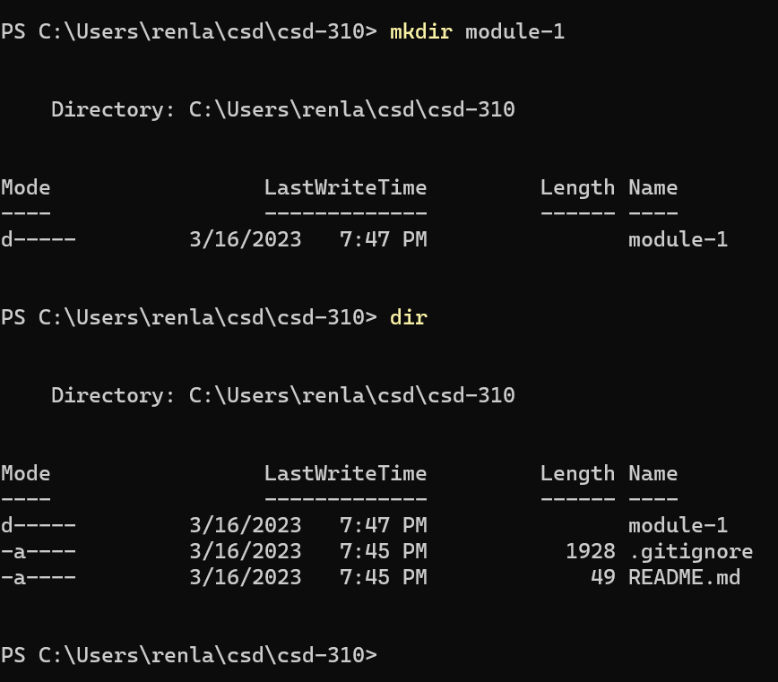

**Screenshot with first assignment 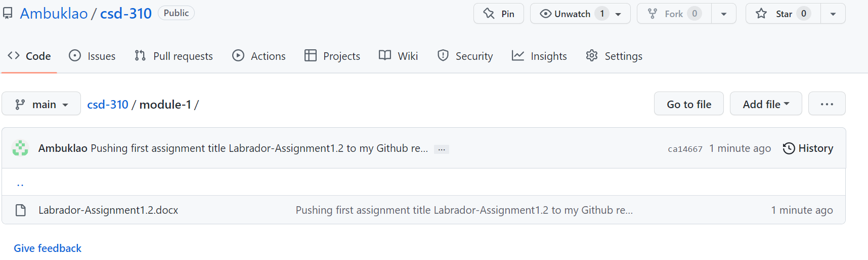under the Module 1**