
THE YENEPOYA INSTITUTE OF ARTS, SCIENCE, COMMERCE AND MANAGEMENT
IBM Innovation Centre for Education

Project – High Level Design
on
Design and Development of Honeypot Network for Finance Threat Intelligence

ABDUL MIRSAB C
23BCCE096

Table of Contents

1. Introduction ------------------------------------------------------------------------------------------------------ 3
1.1 Scope of the Document -------------------------------------------------------------------------- 3
1.2 Intended Audience -------------------------------------------------------------------------------- 4
1.3 System Overview ---------------------------------------------------------------------------------- 4
2. System Design -------------------------------------------------------------------------------------------------6
2.1 Application Design -------------------------------------------------------------------------------- 6
2.2 Process Flow --------------------------------------------------------------------------------------- 8
2.3 Information Flow ----------------------------------------------------------------------------------- 9
2.4 Components Design ------------------------------------------------------------------------------10
2.5 Key Design Considerations ---------------------------------------------------------------------12
2.6 API Catalogue --------------------------------------------------------------------------------------13
3. Data Design -----------------------------------------------------------------------------------------------------14
3.1 Data Model ------------------------------------------------------------------------------------------14
3.2 Data Access Mechanism ------------------------------------------------------------------------16
3.3 Data Retention Policies --------------------------------------------------------------------------16
3.4 Data Migration --------------------------------------------------------------------------------------17
4. Interfaces --------------------------------------------------------------------------------------------------------18
5. State and Session Management --------------------------------------------------------------------------19
6. Caching ----------------------------------------------------------------------------------------------------------20
7. Non-Functional Requirements -----------------------------------------------------------------------------21
7.1 Security Aspects -----------------------------------------------------------------------------------21
7.2 Performance Aspects ----------------------------------------------------------------------------22
8. References -----------------------------------------------------------------------------------------------------23

1. Introduction
This document presents the High-Level Design (HLD) for the project titled Design and Development of Honeypot Network for Finance Threat Intelligence (Project Code: PRJN26-213). The system is a multi-layered deception infrastructure designed to attract, capture, and analyze malicious actors targeting financial services. It deploys multiple honeypot services including an SSH Honeypot, a Multi-service Honeypot (FTP, Telnet, MySQL, Redis), a Banking Portal Honeypot, and a Finance API Honeypot — all containerized within Docker and integrated into a unified threat intelligence pipeline powered by Filebeat, Logstash (with GeoIP enrichment), Elasticsearch, and Kibana.
The system is intended to provide real-time visibility into attack patterns directed at financial sector infrastructure, enabling security analysts to proactively understand adversarial techniques, credential harvesting attempts, and service-level exploitation trends. The ELK Stack (Elasticsearch, Logstash, Kibana) backend provides scalable indexing and visualization capabilities for all collected threat data.

1.1 Scope of the Document
This HLD document covers the following aspects of the Honeypot Network for Finance Threat Intelligence system:
- Overall system architecture and interaction between honeypot containers and the ELK pipeline
- Application design including process flow, information flow, and component descriptions
- Data design covering the attack event data model, access mechanisms, and retention policies
- API catalogue for the Finance API Honeypot and internal service interfaces
- Non-functional requirements including security controls and performance considerations
- Deployment architecture based on Docker containerization
This document does not cover low-level implementation logic such as raw code, configuration file syntax, or low-level debugging procedures. Those details are addressed in the Low-Level Design (LLD) document.

1.2 Intended Audience
This document is intended for the following stakeholders:
- Academic evaluators and faculty reviewing the project submission at Yenepoya Institute of Arts, Science, Commerce and Management
- IBM Innovation Centre for Education mentors and industry advisors who guide the project development
- Cybersecurity researchers and students seeking to understand deception-based threat intelligence architectures
- Developers or practitioners who may extend, replicate, or build upon this honeypot infrastructure
- Security operations personnel interested in applying honeypot intelligence in financial sector threat monitoring

1.3 System Overview
The Honeypot Network for Finance Threat Intelligence system is a containerized deception environment that simulates financial services infrastructure to attract and capture real-world cyber attacks. The system is composed of four distinct honeypot services deployed within a Docker environment on a host machine. Each honeypot service listens on specific network ports, mimics real system behaviors, and captures attacker interactions including credentials attempted, commands executed, and connection metadata.
All honeypot services write structured JSON log entries to a shared Docker volume mounted at the /logs directory. Filebeat continuously monitors this log directory and forwards new entries to Logstash, which applies JSON parsing and GeoIP enrichment to resolve attacker source IP addresses to geographic locations. Enriched event documents are indexed into Elasticsearch under the honeypot-events-* index pattern. Kibana provides the security analyst with a visual dashboard for querying, filtering, and analyzing attack data in real time.

The table below summarizes the core components of the system and their respective technologies:

Component | Technology | Purpose
SSH Honeypot | Python, Paramiko, Port 2222 | Capture SSH brute-force attempts and credential harvesting
Multi-Service Honeypot | Python, FTP/Telnet/MySQL/Redis emulators | Simulate financial infrastructure services for multi-protocol attack capture
Banking Portal Honeypot | Flask, HTML/CSS mimicry | Decoy banking web portal to capture credential stuffing and form-based attacks
Finance API Honeypot | Flask REST API, Port 8081 | Simulate financial API endpoints to capture automated exploitation attempts
Filebeat | Elastic Filebeat | Log shipping agent that monitors /logs and forwards to Logstash
Logstash | Elastic Logstash, GeoIP plugin | JSON parsing, field enrichment, and GeoIP resolution
Elasticsearch | Elastic Elasticsearch | Distributed index and storage for all honeypot event documents
Kibana | Elastic Kibana | Interactive dashboard for security analysts to visualize attack data

2. System Design

2.1 Application Design
The Honeypot Network for Finance Threat Intelligence system is architected as a distributed, containerized application deployed within a single Docker environment on the host machine. The application design follows a layered deception model in which the decoy layer, log aggregation layer, processing layer, and analytics layer each operate independently through well-defined interfaces, ensuring modularity and fault isolation between components.
The decoy layer consists of four Docker containers: the SSH Honeypot listening on port 2222 using the Paramiko library to emulate an OpenSSH server; the Multi-Service Honeypot exposing emulated FTP, Telnet, MySQL, and Redis endpoints to simulate common financial infrastructure services; the Banking Portal Honeypot serving a Flask-based fake banking web application; and the Finance API Honeypot exposing RESTful endpoints on port 8081 to lure automated API scanners. All four honeypot containers write structured JSON logs to a shared Docker volume at the /logs path, ensuring that log collection is centralized and decoupled from the individual service implementations.
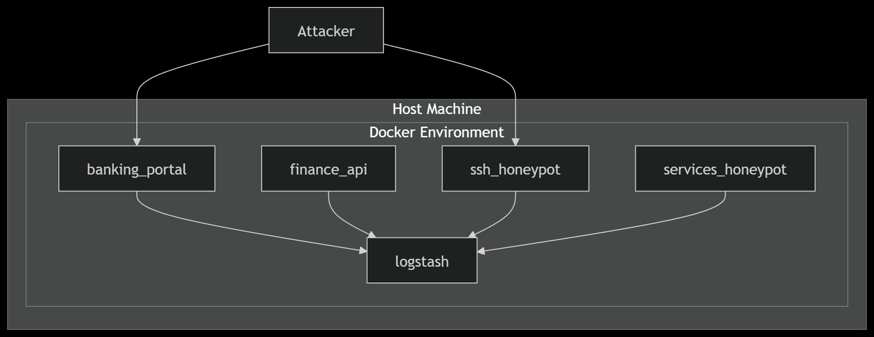
Figure 2.1 — System Architecture Diagram
The architecture diagram above illustrates how an attacker interacting with any of the honeypot services triggers log generation, which flows through the centralized Logstash pipeline. Each honeypot container operates independently, and all logs converge at Logstash before being indexed into Elasticsearch and visualized in Kibana. This design ensures that the compromise or disruption of any single honeypot service does not affect the integrity of the overall intelligence collection pipeline.

The full deployment architecture, including the layered structure from the decoy layer through shared storage, processing layer, and analytics layer, is illustrated below:

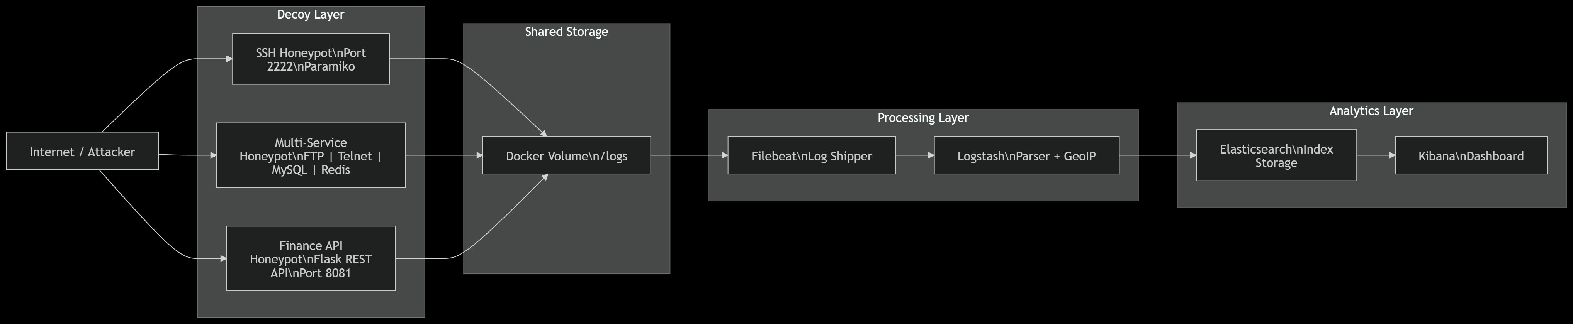
Figure 2.1b — Deployment Architecture Diagram
The deployment diagram shows the complete end-to-end flow from the Internet or Attacker source, through the Decoy Layer containing the SSH Honeypot, Multi-Service Honeypot, and Finance API Honeypot, into the Shared Storage (Docker Volume /logs), through the Processing Layer (Filebeat Log Shipper and Logstash Parser with GeoIP), and finally into the Analytics Layer (Elasticsearch Index Storage and Kibana Dashboard).

2.2 Process Flow
The process flow of the system follows a sequential pipeline from initial attacker interaction to final visualization on the security analyst's dashboard. The process is fully automated once deployed, requiring no human intervention to capture, enrich, and index threat data.
The flow begins when an external attacker initiates a connection to one of the exposed honeypot services. The relevant honeypot service emulates a legitimate system response, engages the attacker, and simultaneously captures all interaction data including source IP address, attempted credentials, commands issued, and protocol-specific metadata. This interaction data is immediately serialized into a structured JSON log entry and appended to the appropriate log file within the shared /logs Docker volume.

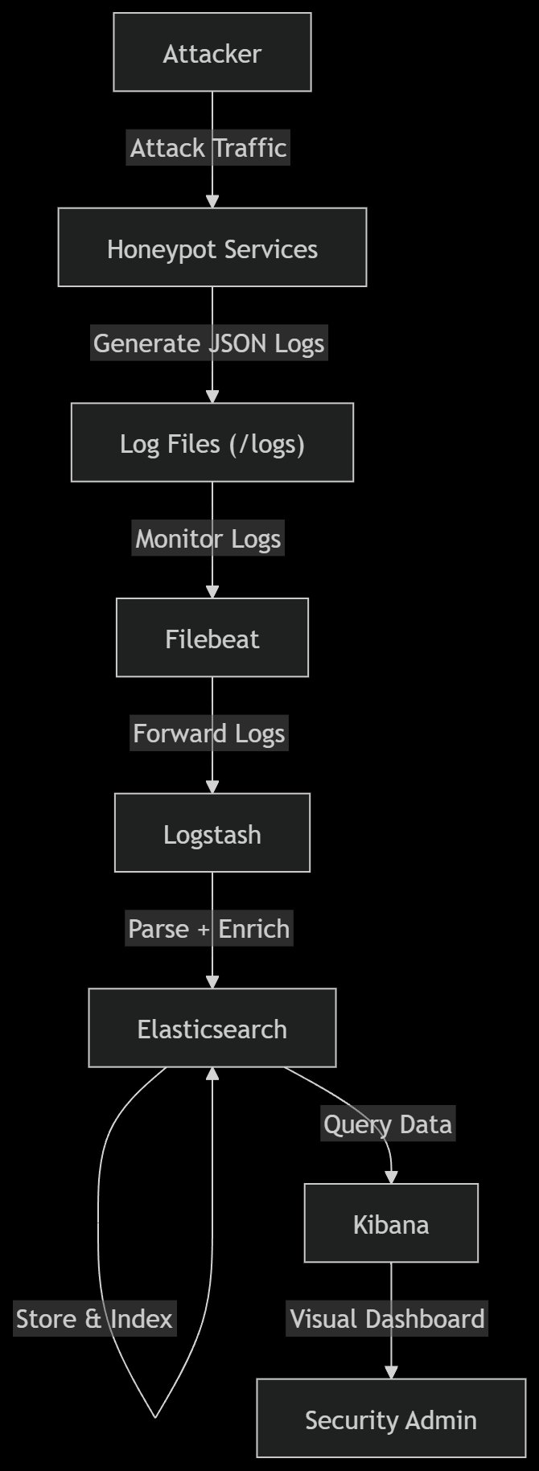
Figure 2.2 — Process Flow Diagram

Filebeat continuously monitors the /logs directory using file-based tail following. When a new log entry is detected, Filebeat ships the raw log event to Logstash over the configured Beats input port. Logstash applies a JSON filter to parse the structured log fields, executes the GeoIP filter plugin to resolve the source IP address into geographic attributes (country, city, latitude, longitude), and applies any additional field mutations required for index consistency. The enriched document is then sent to Elasticsearch and indexed under the honeypot-events-* pattern with a daily date suffix. Once indexed, the data becomes immediately queryable through Kibana, where the security analyst can view dashboards, run Kuery-based filters, and inspect individual attack events.

2.3 Information Flow
Information flows through the system in a strictly unidirectional pipeline, ensuring that no response data from the analytics layer can reach or alert the attacker. The information flow begins with attacker-generated traffic and terminates at the security analyst's Kibana dashboard.
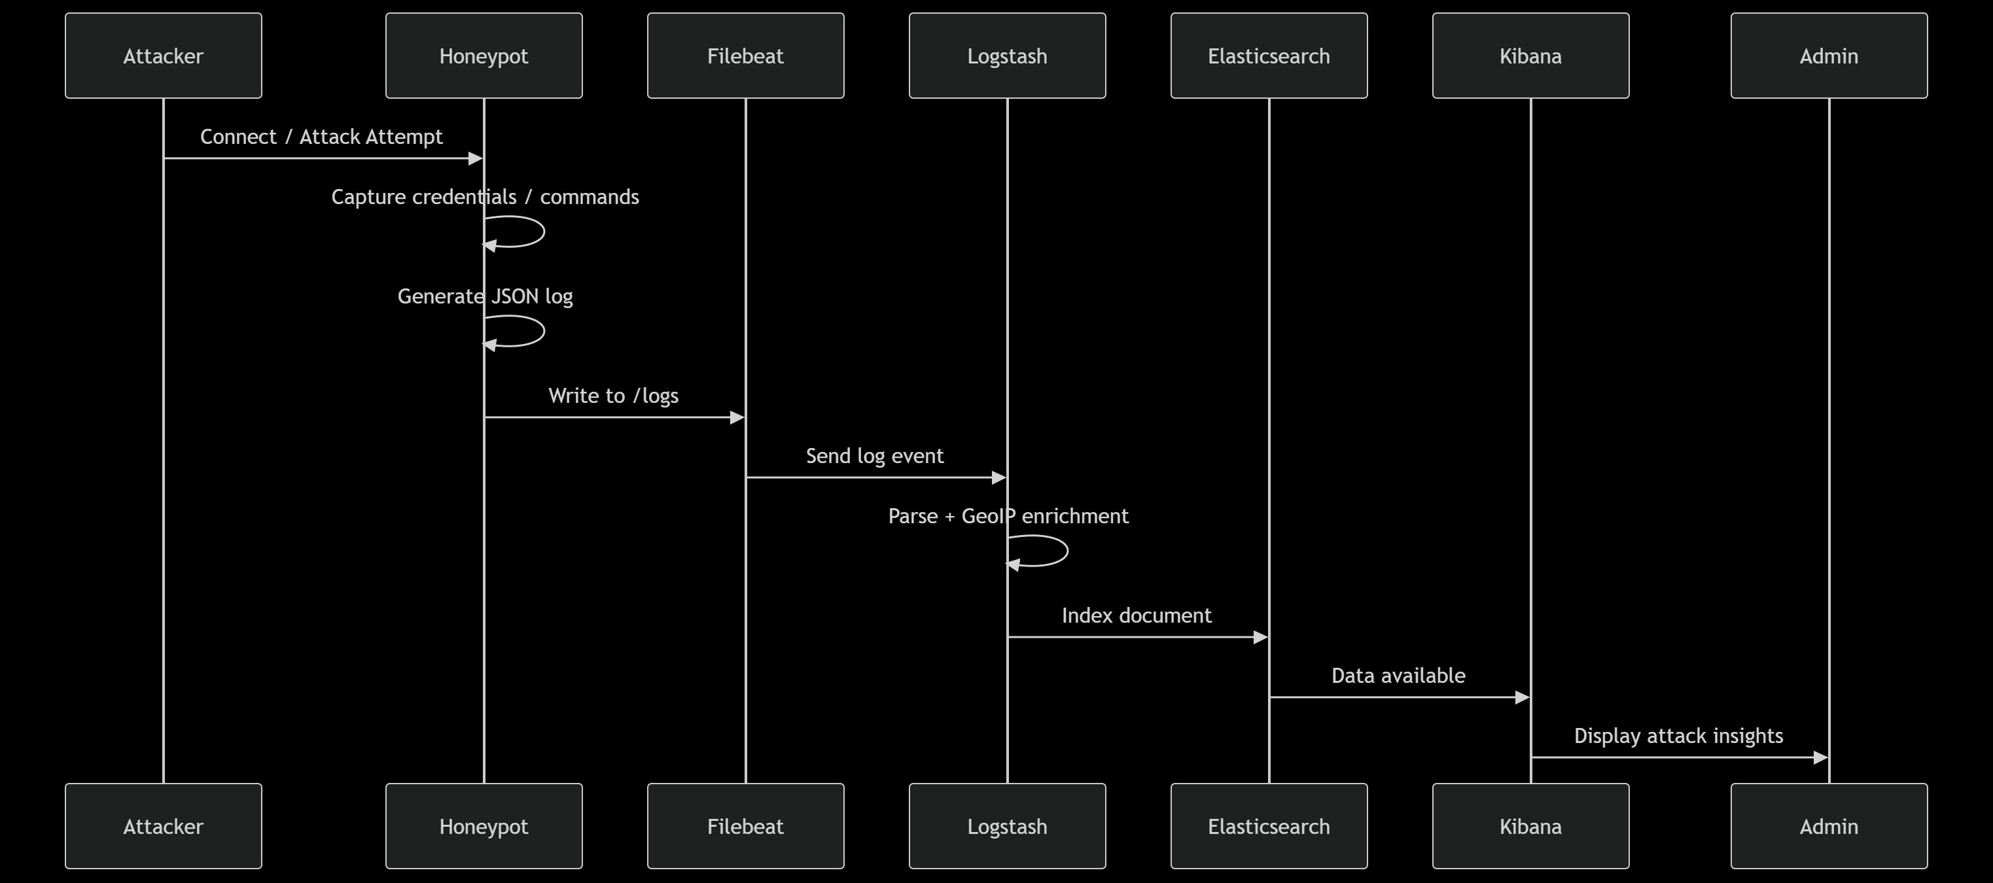
Figure 2.3 — Sequence Diagram (Attack Capture to Dashboard)
The sequence diagram above illustrates the temporal ordering of interactions between system components. The attacker initiates a connection or attack attempt against the honeypot service. The honeypot captures the credentials and commands submitted by the attacker and generates a JSON log entry for each interaction event. The log entry is written to the /logs shared Docker volume. Filebeat detects the new log entry and forwards the log event to Logstash. Logstash performs JSON parsing and GeoIP enrichment and sends the enriched document to Elasticsearch, which indexes it. Elasticsearch signals data availability, Kibana queries the new document, and the security analyst's dashboard is updated to display the latest attack insights.

2.4 Components Design
The system is composed of seven major components, each with a clearly defined responsibility within the overall architecture. The components are designed to be loosely coupled, independently scalable, and replaceable without affecting the broader pipeline.
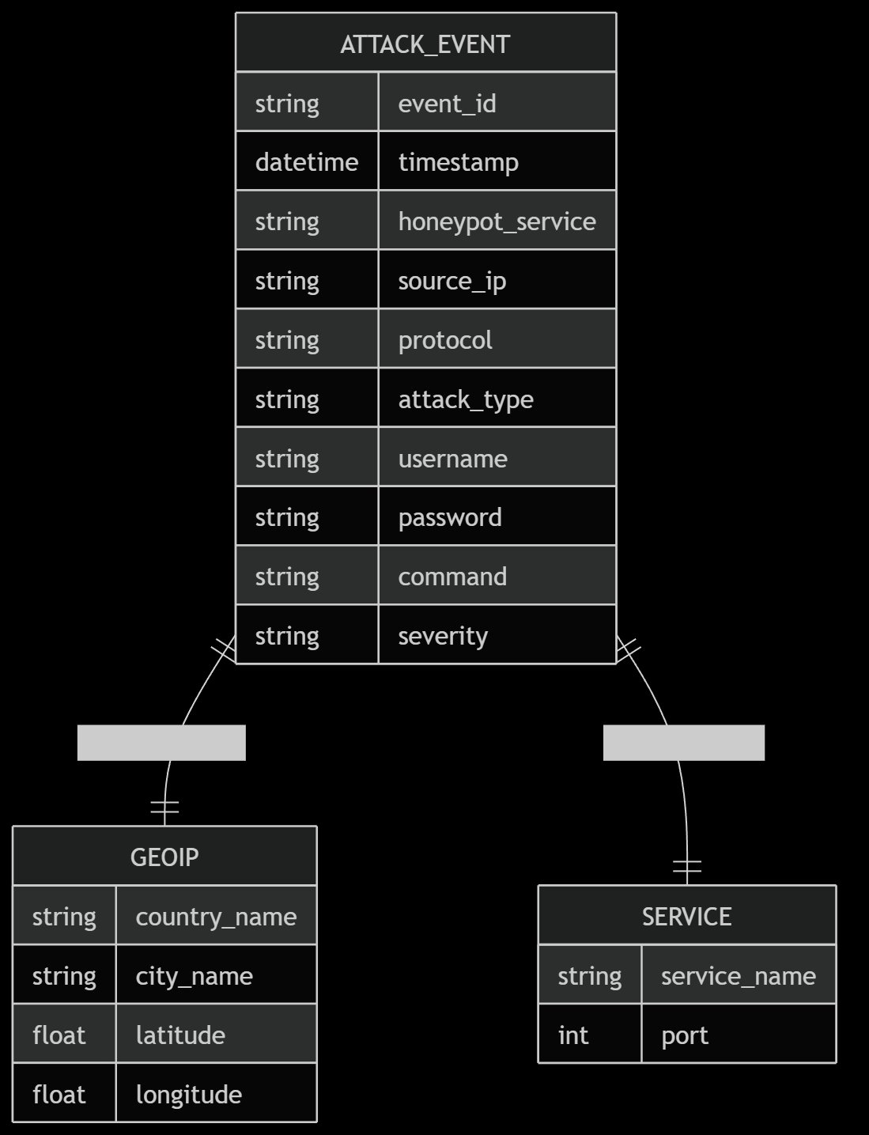
Figure 2.4 — Component Diagram
The component diagram above shows the logical grouping of components into the Honeypots tier (SSH Honeypot, FTP/Telnet/MySQL/Redis Honeypot, and Finance API), the Logging tier (Structured JSON Logs), the Pipeline tier (Filebeat and Logstash Filters with JSON, GeoIP, and Mutations), the Storage tier (Elasticsearch Index: honeypot-events-*), and the UI tier (Kibana Dashboard accessed by the Security Analyst).

The following table provides a detailed description of each component:
Component | Description
SSH Honeypot | Listens on port 2222 using Paramiko to emulate an OpenSSH server. Captures brute-force login attempts, logs attempted usernames and passwords, and records the source IP and timestamp in JSON format.
Multi-Service Honeypot | Emulates FTP (port 21), Telnet (port 23), MySQL (port 3306), and Redis (port 6379) services. Captures protocol-specific handshakes and authentication attempts across all four services.
Banking Portal Honeypot | Serves a Flask-based fake banking web portal. Captures credential stuffing attempts, form-based login submissions, and HTTP request metadata from attackers attempting to access fake banking accounts.
Finance API Honeypot | Exposes fake RESTful financial API endpoints on port 8081. Captures automated API scanning attempts, unauthorized endpoint access, and API key theft attempts. Built using Flask REST framework.
Filebeat (Log Shipper) | Deployed as a Docker container monitoring the shared /logs volume. Tails new log entries from each honeypot log file and forwards them to Logstash using the Beats protocol. Provides reliable, at-least-once delivery with offset tracking.
Logstash (Parser + GeoIP) | Receives raw Beats events from Filebeat. Applies the JSON filter plugin to parse structured log fields. Applies the GeoIP filter plugin to resolve source_ip into country_name, city_name, latitude, and longitude. Outputs enriched documents to Elasticsearch.
Elasticsearch | Distributed full-text search and analytics engine. Indexes all enriched honeypot event documents under the honeypot-events-YYYY.MM.dd index pattern. Provides the query API consumed by Kibana for dashboard visualization.
Kibana (Dashboard) | Web-based analytics UI connected to Elasticsearch. Provides the security analyst with real-time visualizations including geographic attack maps, protocol distribution charts, top attacker IP rankings, and credential frequency analysis.

2.5 Key Design Considerations
Several critical design decisions were made during the architectural planning of this system to ensure operational security, data integrity, and analytical effectiveness:
- Isolation by Container: Each honeypot service runs in an isolated Docker container, ensuring that a compromised honeypot cannot be used to pivot into the analysis infrastructure. The ELK stack components are on a separate internal Docker network not exposed to the Internet.
- Shared Volume for Log Aggregation: Rather than having each honeypot push logs directly to Logstash, all honeypots write to a shared Docker volume. This decouples log production from log shipping and ensures no log data is lost if Filebeat or Logstash experiences a transient failure.
- Structured JSON Logging: All honeypots produce structured JSON logs with consistent field names (event_id, timestamp, honeypot_service, source_ip, protocol, attack_type, username, password, command, severity). This consistency eliminates complex Logstash parsing rules and ensures all fields are directly indexable in Elasticsearch.
- GeoIP Enrichment in Pipeline: Geographic enrichment is performed in the Logstash pipeline rather than at the honeypot level, ensuring that GeoIP database updates do not require changes to the honeypot service code.
- No Real Functionality: All honeypot services are designed to respond with believable but non-functional outputs. No real authentication is performed, no real data is stored, and no real transactions are executed, eliminating the risk of inadvertent data breach through the honeypot.
- Port Selection Mimicking Real Services: Service ports are chosen to match real-world service port assignments (2222 for SSH, 21 for FTP, 23 for Telnet, 3306 for MySQL, 6379 for Redis, 8081 for Finance API), ensuring that automated scanners and targeted attackers are effectively attracted.

2.6 API Catalogue
The Finance API Honeypot exposes the following fake RESTful endpoints designed to simulate a financial services API. All endpoints accept requests from unauthenticated callers and log the full request metadata including headers, source IP, and request body for intelligence collection purposes.
Endpoint | Method | Response | Purpose
/api/v1/accounts | GET | 200 OK (fake list) | Simulates bank account listing endpoint; attracts unauthorized data enumeration attempts
/api/v1/transfer | POST | 200 OK (fake confirm) | Simulates fund transfer endpoint; captures automated transaction manipulation attempts
/api/v1/login | POST | 200 OK (fake token) | Simulates API authentication; captures credential stuffing and token harvesting attempts
/api/v1/balance | GET | 200 OK (fake balance) | Simulates balance inquiry endpoint; captures reconnaissance and data exfiltration attempts
/admin | GET/POST | 200 OK (fake admin) | Simulates admin panel; captures privilege escalation and admin takeover attempts

The internal system does not expose additional REST APIs between components. Filebeat communicates with Logstash via the Elastic Beats binary protocol, and Logstash communicates with Elasticsearch via the native Elasticsearch HTTP API. Kibana communicates with Elasticsearch via the Kibana backend proxy.

3. Data Design

3.1 Data Model
The primary data model for the system is the ATTACK_EVENT document, which represents a single interaction event captured by any honeypot service. All events share a common schema regardless of the originating honeypot, enabling unified querying and cross-service correlation in Kibana. The data model is stored as JSON documents within Elasticsearch and is not backed by a traditional relational database.
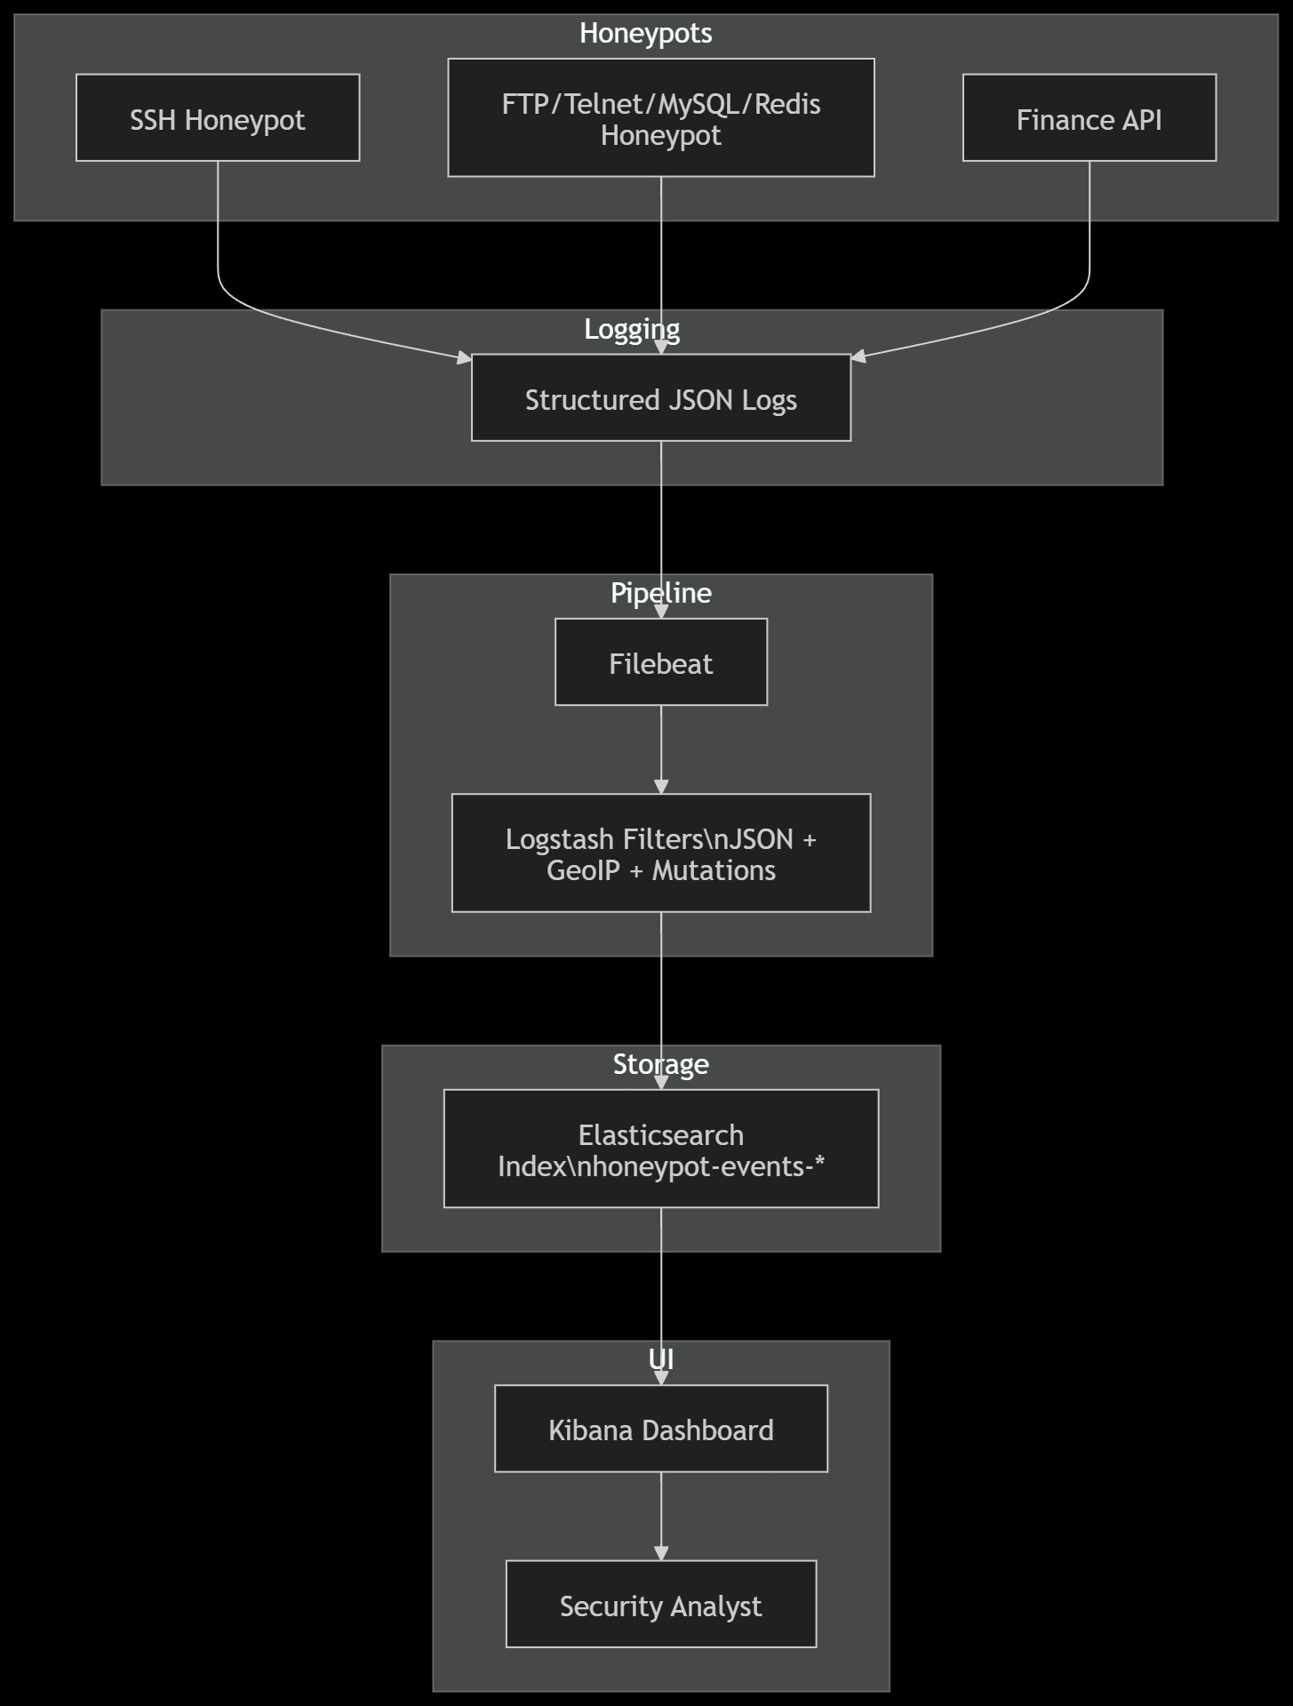
Figure 3.1 — Entity Relationship / Data Model Diagram

The ER diagram above illustrates the three logical entities within the data model. The central ATTACK_EVENT entity captures the core attributes of each attack interaction. It maintains a one-to-many relationship with the GEOIP entity, which stores the geographic enrichment data resolved from the source IP address (country_name, city_name, latitude, longitude). It also maintains a many-to-one relationship with the SERVICE entity, which maps each event to the originating honeypot service (service_name and port).

The ATTACK_EVENT schema is defined as follows:

Field | Data Type | Description
event_id | String (UUID) | Unique identifier for each attack event, generated at the honeypot level
timestamp | Datetime (ISO 8601) | Date and time of the attack event in UTC format
honeypot_service | String | Name of the honeypot that captured the event (ssh, ftp, telnet, mysql, redis, banking_portal, finance_api)
source_ip | String (IPv4/IPv6) | IP address of the attacking host as captured by the honeypot socket
protocol | String | Network protocol used in the attack (SSH, FTP, Telnet, MySQL, Redis, HTTP)
attack_type | String | Classified attack type (brute_force, credential_stuffing, api_scan, command_injection, reconnaisance)
username | String | Username attempted by the attacker during authentication; null if not applicable
password | String | Password attempted by the attacker; captured in plaintext for intelligence purposes
command | String | Command or payload submitted by the attacker after authentication (SSH, Telnet, Redis)
severity | String (Enum) | Severity classification of the event: low, medium, high, critical
geoip.country_name | String | Country resolved from source_ip via GeoIP enrichment in Logstash
geoip.city_name | String | City resolved from source_ip via GeoIP enrichment in Logstash
geoip.location | geo_point (lat/lon) | Geospatial coordinates stored as Elasticsearch geo_point type for map visualization in Kibana

3.2 Data Access Mechanism
All data access within the system is performed through the Elasticsearch REST API. There is no direct database query language used, as Elasticsearch operates on a document-store model with full-text search capabilities. The primary access patterns are as follows:
- Write Access (Logstash to Elasticsearch): Logstash uses the Elasticsearch output plugin to POST enriched ATTACK_EVENT documents to the Elasticsearch bulk indexing API. Documents are indexed under the honeypot-events-YYYY.MM.dd index template on a daily rolling basis. Index templates define the field mappings for the ATTACK_EVENT schema including the geo_point mapping for geoip.location.
- Read Access (Kibana to Elasticsearch): Kibana communicates with Elasticsearch exclusively through the Kibana backend proxy, which translates user dashboard interactions into Elasticsearch Query DSL (Domain Specific Language) requests. Security analysts do not interact with the Elasticsearch API directly; all queries are generated by Kibana visualizations and dashboards.
- Index Pattern: The Kibana index pattern honeypot-events-* matches all daily indices, enabling analysts to query historical data across multiple days within a single dashboard view.
- No External Application Access: The Elasticsearch and Kibana interfaces are accessible only on the internal Docker network and the host machine's loopback interface. No external application or third-party system has direct access to the raw data store.

3.3 Data Retention Policies

The system does not implement automated data expiry or index lifecycle management in the current version. The following retention behaviors apply:
- Elasticsearch Indices: Indices are created on a daily rolling basis (honeypot-events-YYYY.MM.dd) and are retained indefinitely on disk until manually deleted by the system administrator. For academic demonstration purposes, all captured data is retained for the full project evaluation period.
- Log Files in /logs Volume: Raw JSON log files written by honeypot services to the shared Docker volume are retained indefinitely. Filebeat maintains an offset registry to avoid re-shipping already-processed log lines in the event of a Logstash or Filebeat restart.
- Filebeat Registry: The Filebeat internal registry file is stored within the Filebeat container's persistent volume and tracks the read offset of each monitored log file, ensuring at-least-once delivery guarantees.
- Future Enhancement: In a production deployment, Elasticsearch Index Lifecycle Management (ILM) policies would be configured to transition indices through hot, warm, and cold phases, and to delete indices older than a defined retention window (e.g., 90 days) to manage disk utilization.

3.4 Data Migration
The current system does not involve data migration between heterogeneous storage systems. All data originates from honeypot log files and is ingested directly into Elasticsearch through the Logstash pipeline. There is no legacy database or prior data store from which existing records need to be migrated.
If the system is upgraded to a newer version of Elasticsearch or if the index schema is updated (for example, to add new honeypot services or additional GeoIP fields), index migration can be performed using Elasticsearch's native Reindex API, which copies documents from the old index to a new index with the updated mapping. Field additions are backwards compatible in Elasticsearch's dynamic mapping model, meaning new fields can be added to log entries without requiring a full reindex operation.

4. Interfaces
The system provides two primary user-facing interfaces and several internal service interfaces between system components. The primary interface for security analysts is the Kibana Web Dashboard, accessible via a web browser at http://localhost:5601 on the host machine. The secondary interface is the raw Elasticsearch REST API, accessible at http://localhost:9200, intended for administrative queries and index management.
The Kibana dashboard interface provides the following visualization and interaction capabilities for the security analyst:

UI Element | Description
Attack World Map | Geographic map visualization showing the origin countries of all attacker IP addresses, using Elasticsearch geo_point coordinates enriched by Logstash GeoIP. Allows filtering by time range and country.
Protocol Distribution Chart | Pie or bar chart displaying the proportion of attack events per honeypot service protocol (SSH, FTP, HTTP, etc.), enabling the analyst to identify the most frequently targeted service.
Top Attacker IPs Table | Data table ranking the top attacker IP addresses by event count, enabling identification of repeat offenders and targeted blocking or investigation.
Credential Frequency Table | Table listing the most frequently attempted username and password combinations across all brute-force honeypot events, providing insight into common credential lists used by attackers.
Timeline Chart | Time series chart showing attack event volume over time, allowing the analyst to identify attack spikes, campaign patterns, and off-hours activity.
Severity Filter Panel | Filter panel allowing the analyst to narrow the dashboard view to events of a specific severity classification (low, medium, high, critical).

The internal interfaces between system components are as follows. Honeypot services write to the shared /logs Docker volume via standard file I/O with no network communication required. Filebeat reads from the /logs volume and communicates with Logstash via the Elastic Beats protocol on TCP port 5044. Logstash communicates with Elasticsearch via the Elasticsearch REST API on TCP port 9200. Kibana communicates with Elasticsearch via TCP port 9200 through its internal backend proxy.

5. State and Session Management
The Honeypot Network for Finance Threat Intelligence system is designed as a predominantly stateless architecture. Individual honeypot services do not maintain persistent session state between attacker connections. Each connection attempt to an SSH, FTP, Telnet, MySQL, Redis, Banking Portal, or Finance API honeypot is treated as an independent event, and the interaction data is immediately serialized to a JSON log entry upon connection close or timeout.
The following state management behaviors apply across the system:
- SSH Honeypot Session: The SSH Honeypot maintains a lightweight in-memory session state for the duration of an active Paramiko session, tracking the negotiated authentication method, attempted credentials, and any shell commands submitted. Upon session termination (either by attacker disconnect or configurable timeout), the session state is flushed to the JSON log file and discarded from memory.
- Banking Portal Honeypot: The Flask-based Banking Portal Honeypot uses Flask's built-in request context for per-request state management. No server-side session cookies or tokens are issued to attackers. Each HTTP request is treated as a discrete interaction event and logged independently.
- Finance API Honeypot: The Finance API Honeypot is fully stateless. Each API request is an independent event. No authentication tokens are validated or stored, and no session context is maintained between requests from the same source IP.
- Filebeat State: Filebeat maintains persistent state in an internal registry file stored in a named Docker volume. This registry tracks the file read offset for each monitored log file, enabling Filebeat to resume log shipping from the correct position after a container restart without re-shipping already-processed events.
- Elasticsearch State: Elasticsearch maintains all persistent state for the system in the form of indexed documents within its internal storage. The Elasticsearch cluster state, which includes index metadata and shard allocation, is managed internally by Elasticsearch and is not exposed to the application layer.

6. Caching
The Honeypot Network for Finance Threat Intelligence system does not implement application-level caching within the honeypot services, as caching would reduce the responsiveness and realism of the honeypot interactions — a characteristic that is critical for deception effectiveness. However, caching is employed at the infrastructure level in the following capacities:
- Logstash GeoIP Cache: Logstash's GeoIP filter plugin maintains an internal in-memory cache of recently resolved IP-to-location mappings. This cache significantly reduces the latency of GeoIP enrichment for repeated events originating from the same source IP address, which is common in sustained brute-force attacks.
- Elasticsearch Query Cache: Elasticsearch maintains an internal request cache for frequently executed aggregate queries, such as those used by Kibana dashboard visualizations. When a Kibana dashboard is refreshed, Elasticsearch returns cached aggregation results for unchanged time ranges rather than re-executing the full aggregation query against the index, reducing dashboard load time.
- Elasticsearch Field Data Cache: Elasticsearch caches field data for fields used in aggregations and sorting operations (such as source_ip and honeypot_service) in memory, improving the performance of repeated Kibana visualizations that aggregate on these fields.
- Kibana Browser Cache: The Kibana web interface leverages standard HTTP browser caching for static assets (JavaScript bundles, CSS, fonts). This reduces the initial load time of the Kibana UI for returning security analysts.
No distributed caching layer such as Redis or Memcached is used in the current architecture. The Finance API and Banking Portal honeypots intentionally avoid response caching to ensure that each attacker interaction generates a unique log event.

7. Non-Functional Requirements

7.1 Security Aspects
Security is the foundational concern of the entire system design, and multiple layers of protection are implemented to ensure that the honeypot infrastructure does not itself become a vector for real-world harm:
- Network Isolation: Honeypot containers are connected to a Docker bridge network that is intentionally exposed to the Internet only on the honeypot service ports. The ELK stack containers (Filebeat, Logstash, Elasticsearch, Kibana) are on a separate internal Docker network with no inbound Internet connectivity, ensuring that the analytics infrastructure is completely isolated from attacker-accessible services.
- No Outbound Attacker Communication: Honeypot services are configured to only respond to attacker-initiated connections and do not make any outbound network calls on behalf of attacker-supplied input. Command injection attempts in the SSH and Telnet honeypots are logged but never executed on the host system.
- Credential Handling: Captured attacker credentials (usernames and passwords) are stored in plain text within the JSON log entries for intelligence purposes. These log files are stored exclusively within the Docker volume, which is accessible only to containers within the Docker environment. No captured credentials are transmitted outside the host machine.
- Container Resource Limits: Docker resource limits (CPU and memory caps) are applied to honeypot containers to prevent a denial-of-service attack against the honeypot services from consuming host machine resources and affecting the ELK stack performance.
- Elasticsearch and Kibana Access Control: Elasticsearch and Kibana are not exposed on public network interfaces. Access is restricted to localhost or a VPN-connected administrative network segment. Basic authentication is enabled on the Elasticsearch API to prevent unauthorized data access.
- Log Integrity: JSON log files written to the shared Docker volume are append-only by convention. No honeypot service modifies or deletes existing log entries, ensuring a complete and tamper-evident audit trail of all captured attack events.

7.2 Performance Aspects
While the system is designed for academic demonstration rather than hyperscale production deployment, performance requirements are addressed to ensure stable operation under realistic attack volumes:
- Honeypot Response Latency: Each honeypot service is designed to respond to attacker connections within 200 milliseconds of connection establishment, maintaining a believable service emulation that prevents attackers from detecting the honeypot through abnormal response timing.
- Log Write Performance: All honeypot services use buffered file I/O for JSON log writing, minimizing the impact of disk write latency on connection handling capacity. Log entries are written synchronously to ensure no events are lost in the event of a process crash.
- Filebeat Throughput: Filebeat is configured to harvest log files at a 1-second polling interval, providing near-real-time log shipping with minimal delay between honeypot event capture and Logstash ingestion. Filebeat's bulk sending mode groups multiple log entries into a single Beats protocol transmission for network efficiency.
- Logstash Pipeline Throughput: Logstash is configured with a pipeline batch size of 125 events and a batch delay of 50 milliseconds, balancing throughput and latency for GeoIP-enriched event processing. The GeoIP filter is configured to use Logstash's built-in GeoIP cache to handle repeated source IPs from sustained attack campaigns efficiently.
- Elasticsearch Indexing Capacity: For the expected academic deployment scale (up to 10,000 events per day), a single Elasticsearch node with 4 GB JVM heap is sufficient to maintain indexing throughput greater than 1,000 events per second and query response times under 500 milliseconds for Kibana dashboard visualizations.
- Scalability Path: In a production deployment, the system can be horizontally scaled by adding additional Elasticsearch data nodes, increasing the Logstash pipeline worker count, and deploying multiple Filebeat instances monitoring different log subdirectories, each corresponding to a separate honeypot service.

8. References
The following references were consulted in the design and development of the Honeypot Network for Finance Threat Intelligence system:
- Elastic N.V. (2024). Filebeat Documentation. https://www.elastic.co/guide/en/beats/filebeat/current/index.html
- Elastic N.V. (2024). Logstash Reference. https://www.elastic.co/guide/en/logstash/current/index.html
- Elastic N.V. (2024). Elasticsearch Reference. https://www.elastic.co/guide/en/elasticsearch/reference/current/index.html
- Elastic N.V. (2024). Kibana Guide. https://www.elastic.co/guide/en/kibana/current/index.html
- Docker Inc. (2024). Docker Documentation. https://docs.docker.com/
- Paramiko Project. (2024). Paramiko — Python SSH Library. https://www.paramiko.org/
- Flask Project. (2024). Flask Documentation. https://flask.palletsprojects.com/
- MaxMind Inc. (2024). GeoIP2 Database Documentation. https://dev.maxmind.com/geoip/
- Spitzner, L. (2002). Honeypots: Tracking Hackers. Addison-Wesley Professional.
- Provos, N., & Holz, T. (2007). Virtual Honeypots: From Botnet Tracking to Intrusion Detection. Addison-Wesley Professional.
- MITRE ATT&CK Framework. (2024). MITRE ATT&CK for Financial Services. https://attack.mitre.org/
- IBM Innovation Centre for Education. (2024). HLD Document Format Guidelines. Internal Reference.
- Yenepoya Institute of Arts, Science, Commerce and Management. (2024). Project Evaluation Rubric. Internal Reference.

