 | 


YENEPOYA INSTITUTE OF ARTS, SCIENCE, COMMERCE AND MANAGEMENT
A Constituent Unit of Yenepoya (Deemed to be University)
Balmatta, Mangalore
A Low-Level Design On
DESIGN AND DEVELOPMENT OF HONEYPOT NETWORK FOR FINANCE THREAT INTELLIGENCE
SUBMITTED BY
ABDUL MIRSAB C
VI Sem BCA
Cybersecurity, Ethical Hacking, Cloud Computing
23BCCE096
DEPARTMENT OF COMPUTER SCIENCE
IN PARTIAL FULFILMENT OF THE REQUIREMENT FOR THE AWARD OF THE DEGREE OF
BACHELORS IN COMPUTER SCIENCE
MAY 2026

Table of Content

Table of Content 2
1. Introduction 4
1.1 Purpose of the Document 4
1.2 Scope 4
1.3 Glossary and Acronyms 5
2. System Overview 6
3. Detailed Design 7
3.1 Component Design 7
3.1.1 SSH Honeypot Component 8
3.1.2 Multi-Service Honeypot Component 8
3.1.3 Banking Portal and Finance API Honeypot Components 8
3.1.4 Filebeat, Logstash, Elasticsearch, and Kibana Components 8
3.2 Class Design 9
3.2.1 HoneypotManager Class 10
3.2.2 LogManager Class 10
3.2.3 FilebeatAgent Class 10
3.2.4 LogstashProcessor Class 11
3.3 Sequence Flow 11
3.3.1 Detailed Step Descriptions 12
3.4 Process Flow 13
3.4.1 Internal Processing Logic 14
4. Deployment Design 15
4.1 Container Configuration 16
4.2 Network Topology 16
4.3 Docker Compose Configuration Summary 17
5. Data Handling and Logging 18
5.1 ATTACK_EVENT JSON Schema 18
5.2 Logstash Pipeline Configuration 19
5.3 Elasticsearch Index Mapping 19
5.4 Data Retention 19
6. Interfaces and APIs 20
6.1 Finance API Honeypot — External REST Endpoints 20
6.2 Internal Service Interfaces 21
7. Security Considerations 22
7.1 Network Isolation Controls 22
7.2 Command Injection Prevention 22
7.3 Credential and Data Handling Security 22
7.4 Log Integrity 23
7.5 Access Control 23
8. Conclusion 24

1. Introduction

1.1 Purpose of the Document
This Low-Level Design (LLD) document provides a detailed, granular technical blueprint for the implementation of the Honeypot Network for Finance Threat Intelligence system (Project Code: PRJN26-213). While the High-Level Design (HLD) document defines the overarching system architecture, component responsibilities, and data flow, this LLD specifies the internal logic of each module, the precise class structures and method signatures, the exact data schemas, inter-module interfaces, security implementation details, and deployment configuration required to build and operate the complete system. This document serves as the authoritative technical reference for developers, evaluators, and security researchers seeking to understand, replicate, or extend the honeypot infrastructure.

1.2 Scope
This document covers the low-level technical design of the following modules: the SSH Honeypot (Paramiko-based), the Multi-Service Honeypot (FTP, Telnet, MySQL, Redis emulators), the Banking Portal Honeypot (Flask-based), the Finance API Honeypot (Flask REST), the JSON Logging subsystem, the Filebeat log shipping agent, the Logstash processing pipeline, the Elasticsearch indexing engine, and the Kibana analytics dashboard. All modules are containerized using Docker and deployed on a single host machine within a controlled Docker bridge network.

1.3 Glossary and Acronyms

Acronym / Term | Definition
ELK Stack | Elasticsearch, Logstash, and Kibana — the unified log analytics platform
HoneypotManager | Central orchestration class managing all honeypot service instances
JSON | JavaScript Object Notation — structured log format used by all honeypot services
GeoIP | Geographic IP resolution performed by Logstash to enrich source IP with location data
Filebeat | Elastic log shipping agent that monitors log files and forwards events to Logstash
Logstash | Data processing pipeline that parses, enriches, and routes events to Elasticsearch
Elasticsearch | Distributed full-text search and analytics engine used for event indexing and storage
Kibana | Web-based analytics UI for querying, visualizing, and exploring Elasticsearch data
Docker | Container runtime used to deploy and isolate all system components
LLD | Low-Level Design — this document
HLD | High-Level Design — the preceding architectural document
UUID | Universally Unique Identifier — used for unique event_id generation
ILM | Index Lifecycle Management — Elasticsearch policy for automated index management
DSL | Domain Specific Language — Elasticsearch query language used by Kibana

2. System Overview
The Honeypot Network for Finance Threat Intelligence is a containerized deception platform designed to simulate real-world financial services infrastructure for the purpose of attracting, capturing, and analyzing malicious cyber activity. The system is composed of four distinct honeypot service containers — an SSH Honeypot, a Multi-Service Honeypot, a Banking Portal Honeypot, and a Finance API Honeypot — each mimicking legitimate financial system behaviors to lure attackers into engaging with the decoy infrastructure.
All captured interaction data is serialized into structured JSON log events and written to a shared Docker volume at the /logs path. Filebeat monitors this volume and continuously ships new log entries to Logstash, which applies JSON parsing and GeoIP enrichment before indexing the enriched event documents into Elasticsearch under the honeypot-events-* index pattern. Kibana provides the security analyst with a real-time interactive dashboard for querying, filtering, and visualizing the collected threat intelligence.
The architecture follows a strictly unidirectional data pipeline: attacker interactions flow into the decoy layer, through the log aggregation layer, through the Logstash processing layer, into Elasticsearch storage, and ultimately to the Kibana analytics layer. No data flows in reverse — the analytics infrastructure is completely isolated from attacker-accessible services, ensuring that the compromise of any honeypot container cannot affect the integrity of the collected intelligence.

3. Detailed Design
This section provides the granular internal design of all system components. Each subsection covers the module's responsibilities, internal structure, class definitions, method signatures, and design logic. The five primary UML diagrams — Component, Class, Sequence, Process Flow, and Deployment — are placed within their relevant subsections to provide precise visual context.

3.1 Component Design
The system is structured into five logical tiers: the Honeypots Tier, the Logging Tier, the Processing Tier, the Storage Tier, and the UI Tier. Each tier contains one or more components with clearly defined responsibilities and inter-component interfaces. The component diagram below illustrates the logical grouping and data flow between all components.
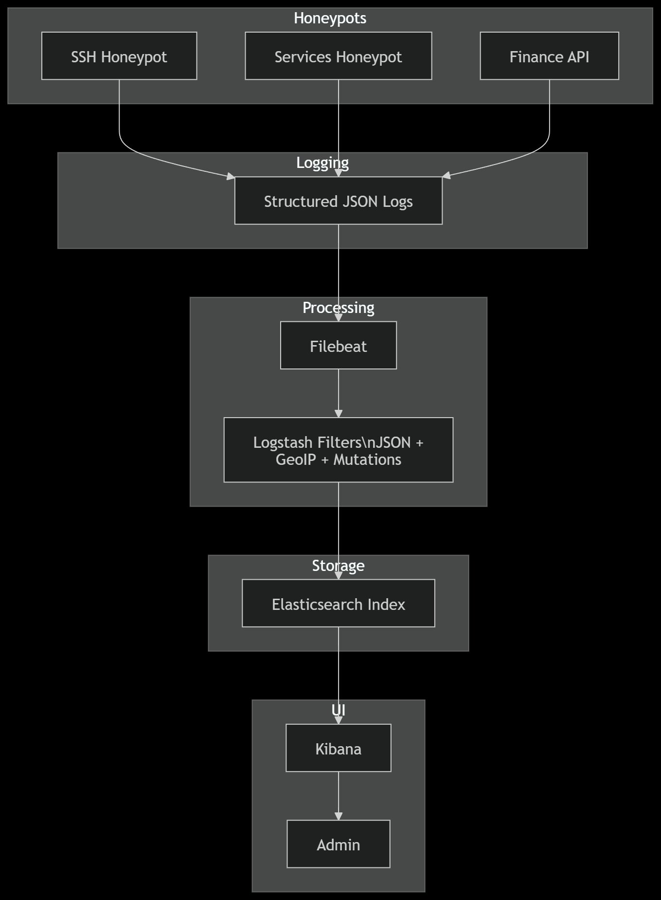
Figure 3.1 — Component Diagram
The Component Diagram shows the Honeypots tier containing the SSH Honeypot, Services Honeypot, and Finance API containers, all feeding structured JSON logs into the shared Logging tier. The Processing tier consists of Filebeat (log shipper) and Logstash (JSON parser with GeoIP enrichment and field mutations). Enriched events flow into the Storage tier (Elasticsearch Index) and are visualized in the UI tier through Kibana, accessed by the Security Analyst.

3.1.1 SSH Honeypot Component
The SSH Honeypot runs as an isolated Docker container built with Python and the Paramiko library. It listens on TCP port 2222 and emulates an OpenSSH server, presenting a believable banner and accepting connection handshakes. When an attacker submits authentication credentials, the honeypot captures the source IP, attempted username, and attempted password, constructs a structured JSON event document, and appends it to /logs/ssh_honeypot.log. The service always returns an authentication failure response to prevent any attacker from gaining persistent access, while simultaneously presenting a simulated shell session for post-authentication interaction logging.

3.1.2 Multi-Service Honeypot Component
The Multi-Service Honeypot container exposes emulated FTP (port 21), Telnet (port 23), MySQL (port 3306), and Redis (port 6379) endpoints. Each protocol handler is implemented as a separate Python socket server thread within the same container, allowing the container to simultaneously listen on all four ports. Each handler captures protocol-specific handshakes — such as MySQL handshake packets, Redis RESP protocol commands, FTP USER/PASS sequences, and Telnet login prompts — and logs the captured interaction data as JSON events to /logs/services_honeypot.log.

3.1.3 Banking Portal and Finance API Honeypot Components
The Banking Portal Honeypot serves a Flask-based fake banking web portal on port 80. It captures HTTP request metadata, POST body parameters (including submitted login credentials), and user agent strings from credential stuffing attacks. The Finance API Honeypot exposes fake RESTful financial endpoints on port 8081, including /api/v1/accounts, /api/v1/transfer, /api/v1/login, /api/v1/balance, and /admin. All endpoints return realistic but fabricated JSON responses while logging the complete request context — headers, source IP, HTTP method, path, and request body — to /logs/finance_api.log.

3.1.4 Filebeat, Logstash, Elasticsearch, and Kibana Components
Filebeat is configured via filebeat.yml to tail all log files within the /logs Docker volume using the log input type with JSON decoding enabled. It ships events to Logstash on TCP port 5044 using the Beats protocol with at-least-once delivery semantics and maintains an internal file offset registry. Logstash applies a JSON filter to parse all incoming event fields, a GeoIP filter to resolve source_ip into geographic coordinates, and field mutation operations to normalize severity and honeypot_service values before outputting enriched documents to Elasticsearch via the elasticsearch output plugin on port 9200. Elasticsearch stores all documents in the honeypot-events-YYYY.MM.dd rolling index pattern with a predefined mapping template that classifies geoip.location as a geo_point type for map-based visualization. Kibana connects to Elasticsearch and renders dashboards including the Attack World Map, Protocol Distribution Chart, Top Attacker IPs Table, Credential Frequency Table, and Timeline Chart.

3.2 Class Design
The class diagram below illustrates the internal object model of the honeypot system. The central HoneypotManager class orchestrates all honeypot service instances, while the LogManager class handles structured JSON event formatting and file writing. The FilebeatAgent class abstracts log reading and forwarding, the LogstashProcessor class handles parsing and GeoIP enrichment, and the ElasticsearchClient class manages event indexing.
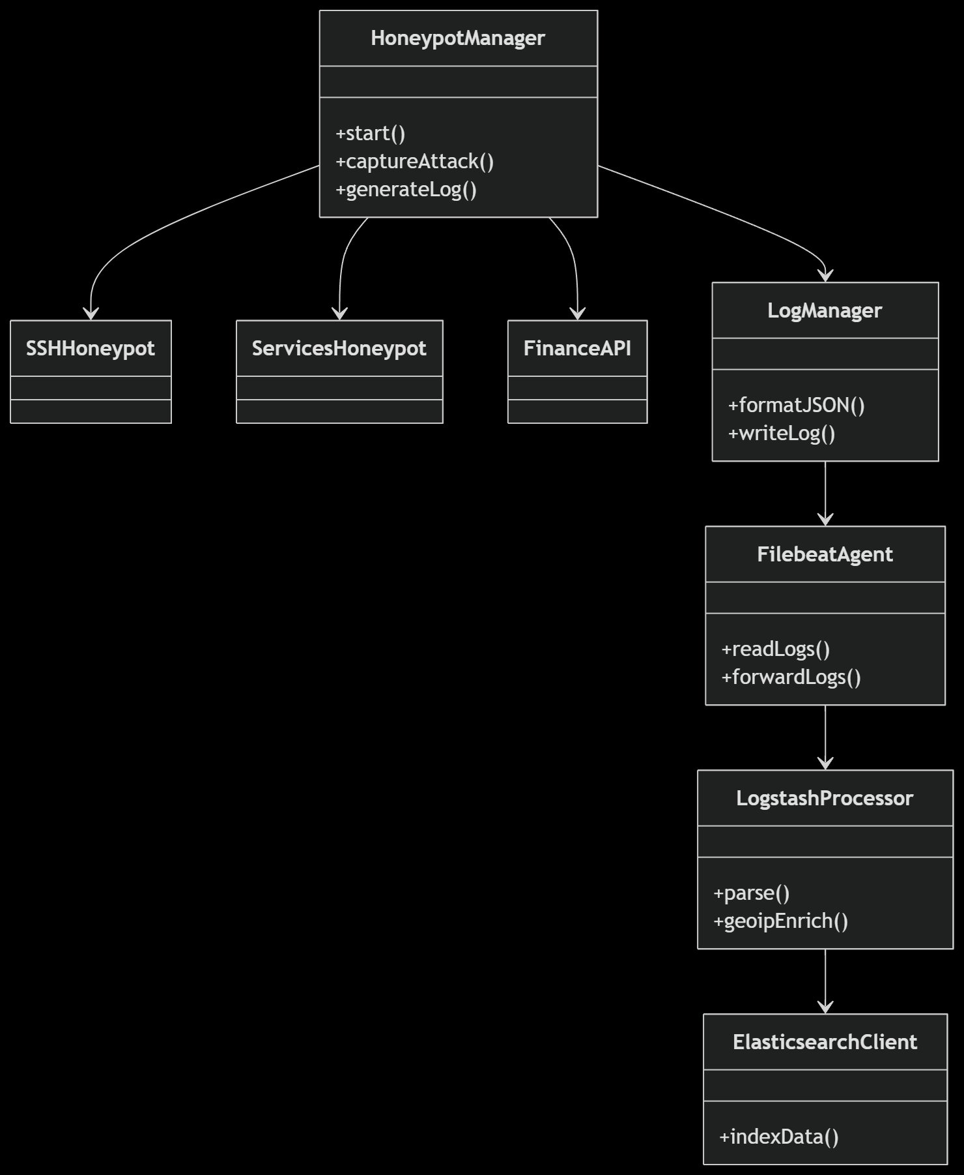
Figure 3.2 — Class Diagram
The Class Diagram shows HoneypotManager at the root with +start(), +captureAttack(), and +generateLog() methods. It aggregates SSHHoneypot, ServicesHoneypot, and FinanceAPI as child components, and delegates log operations to LogManager (+formatJSON(), +writeLog()). LogManager directs formatted logs to FilebeatAgent (+readLogs(), +forwardLogs()), which forwards to LogstashProcessor (+parse(), +geoipEnrich()), which outputs to ElasticsearchClient (+indexData()) for final indexing.

3.2.1 HoneypotManager Class

Method | Signature | Description
start() | start() -> None | Initializes and starts all honeypot service threads; registers signal handlers for graceful shutdown
captureAttack() | captureAttack(conn: socket, addr: tuple) -> dict | Accepts a raw socket connection; extracts metadata (source_ip, port, protocol); returns an attack event dict
generateLog() | generateLog(event: dict) -> None | Delegates the formatted event dict to LogManager.writeLog() for JSON serialization and file persistence

3.2.2 LogManager Class

Method | Signature | Description
formatJSON() | formatJSON(event: dict) -> str | Serializes the event dictionary to a JSON string; enforces schema consistency for all required fields
writeLog() | writeLog(json_str: str, log_path: str) -> None | Appends the JSON string as a newline-delimited entry to the designated honeypot log file in the /logs volume

3.2.3 FilebeatAgent Class

Method | Signature | Description
readLogs() | readLogs(log_dir: str) -> Iterator[str] | Tails all log files in the specified directory; maintains per-file byte offset in the Filebeat registry for at-least-once delivery
forwardLogs() | forwardLogs(event: str, logstash_host: str, port: int) -> None | Encodes the log event in the Beats protocol framing and transmits it to the Logstash Beats input over TCP

3.2.4 LogstashProcessor Class

Method | Signature | Description
parse() | parse(raw_event: str) -> dict | Applies the Logstash JSON filter plugin to decode the raw event string into a structured field dictionary
geoipEnrich() | geoipEnrich(event: dict) -> dict | Applies the Logstash GeoIP filter to resolve event["source_ip"] into country_name, city_name, latitude, and longitude fields appended under event["geoip"]

3.3 Sequence Flow
The sequence diagram below captures the temporal ordering of all inter-component interactions from the moment an attacker initiates a connection to the moment the security analyst's Kibana dashboard is updated. The flow is fully automated and requires no human intervention at any stage of the pipeline once the system is deployed and running.
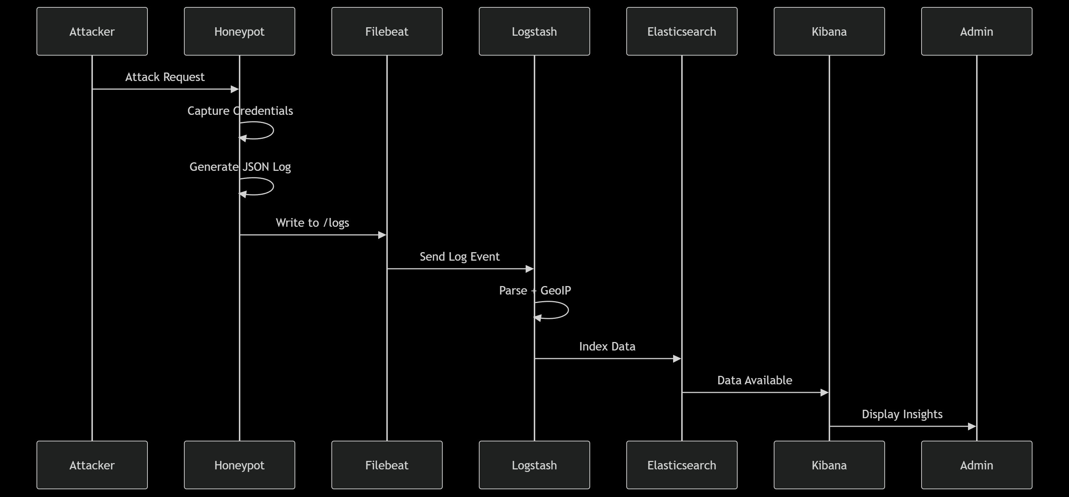
Figure 3.3 — Sequence Diagram
The Sequence Diagram shows: (1) Attacker sends an Attack Request to the Honeypot; (2) the Honeypot captures credentials and generates a JSON log entry via self-loops; (3) the Honeypot writes the log to the Shared Volume (/logs); (4) Filebeat detects the new entry and sends a Log Event to Logstash; (5) Logstash performs Parse + GeoIP enrichment internally; (6) Logstash indexes the enriched document into Elasticsearch; (7) Elasticsearch signals Data Available to Kibana; (8) Kibana renders Display Insights on the Admin dashboard.

3.3.1 Detailed Step Descriptions
- Attack Request: The attacker initiates a TCP connection to the honeypot on the targeted service port (e.g., 2222 for SSH, 21 for FTP, 8081 for Finance API). The honeypot service accepts the connection and begins the protocol-specific emulation sequence.
- Capture Credentials: The honeypot engages the attacker through the protocol handshake (e.g., SSH banner exchange, FTP 220 response, MySQL handshake packet). All submitted credentials, commands, and metadata are captured in memory during the active connection.
- Generate JSON Log: Upon session termination or timeout, the honeypot constructs a complete ATTACK_EVENT JSON document containing all captured fields (event_id, timestamp, honeypot_service, source_ip, protocol, attack_type, username, password, command, severity) and writes it as a newline-delimited JSON entry to the appropriate log file.
- Write to /logs: The JSON entry is appended to the shared Docker volume at /logs/{service}_honeypot.log using buffered file I/O to minimize write latency.
- Send Log Event: Filebeat detects the new log entry via its file tailing mechanism and forwards the raw event to Logstash over TCP port 5044 using the Beats protocol framing.
- Parse + GeoIP: Logstash applies the JSON filter to decode all structured fields, then applies the GeoIP filter to resolve source_ip into geographic attributes using the MaxMind GeoLite2 database.
- Index Data: Logstash outputs the fully enriched ATTACK_EVENT document to Elasticsearch, which indexes it into the honeypot-events-YYYY.MM.dd index using the bulk API.
- Display Insights: Kibana continuously polls Elasticsearch for new documents. The security analyst's dashboard is updated in near-real-time with new attack events on the World Map, Protocol Chart, and Credential Tables.

3.4 Process Flow
The process flow diagram below illustrates the internal data transformation pipeline from the moment a raw honeypot event is generated to its final availability in Kibana. It emphasizes the sequential processing stages and the intermediate data representations at each step in the pipeline.
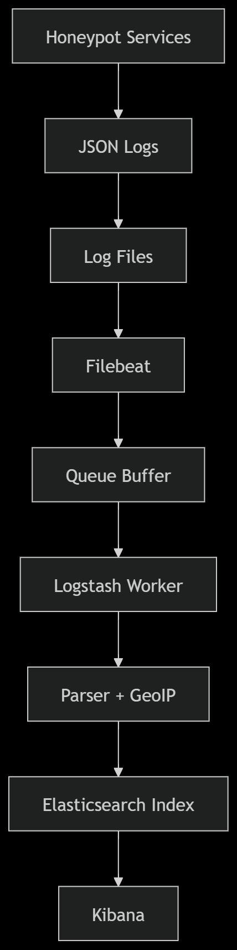
Figure 3.4 — Process Flow Diagram
The Process Flow Diagram illustrates the following pipeline: Honeypot Services emit raw interaction data, which is serialized into JSON Logs written as Log Files in the /logs Docker volume. Filebeat tails these files and places events into a Queue Buffer, which is consumed by the Logstash Worker. Logstash applies Parser + GeoIP transformations to produce enriched documents that are written to the Elasticsearch Index. Kibana queries the index and renders visualizations for the security analyst.

3.4.1 Internal Processing Logic
Each stage in the pipeline applies a specific transformation to the event data:

Stage | Input | Processing | Output
Honeypot Services | Attacker TCP/HTTP connection | Protocol emulation; credential capture; timeout enforcement | In-memory event dict
JSON Serialization | In-memory event dict | json.dumps() with UTC timestamp; schema validation | Newline-delimited JSON string
Log File | JSON string | Buffered append-only file write to /logs volume | Persistent .log file entry
Filebeat Queue | .log file entry | File tail; offset tracking; Beats framing | Beats protocol event
Logstash Worker | Beats protocol event | JSON filter; GeoIP filter; field mutation | Enriched ATTACK_EVENT dict
Elasticsearch Index | Enriched ATTACK_EVENT dict | Bulk API POST; geo_point mapping; daily index routing | Indexed document
Kibana | Elasticsearch query results | Dashboard aggregation; map rendering; chart generation | Visual analytics output

4. Deployment Design
The entire system is deployed as a set of Docker containers orchestrated within a single host machine's Docker environment. Each component runs in its own isolated container, connected through a custom Docker bridge network that controls which services are accessible from the external internet and which remain on the internal analytics network.
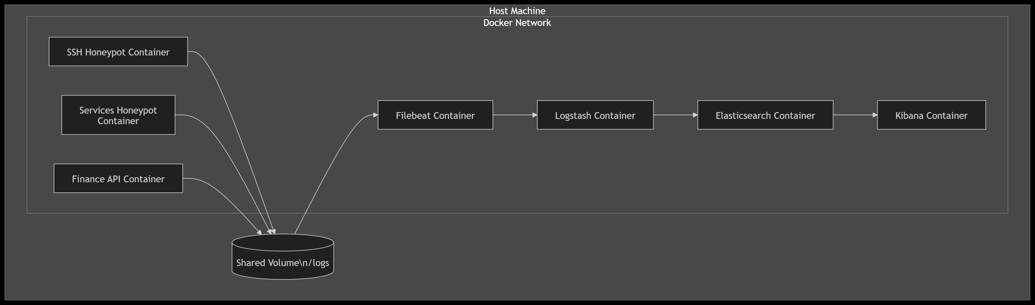
Figure 4.1 — Deployment Diagram
The Deployment Diagram shows the Host Machine Docker Network containing the SSH Honeypot Container, Services Honeypot Container, and Finance API Container, all writing to a shared Shared Volume (/logs). Filebeat reads from this volume and forwards events to Logstash, which processes and sends data to Elasticsearch, which is visualized by the Kibana Container.

4.1 Container Configuration

Container Name | Base Image | Exposed Port(s) | Network | Volume Mount
ssh_honeypot | python:3.11-slim | 2222:2222 | honeypot_net (public) | /logs:/logs
services_honeypot | python:3.11-slim | 21, 23, 3306, 6379 | honeypot_net (public) | /logs:/logs
banking_portal | python:3.11-slim | 80:80 | honeypot_net (public) | /logs:/logs
finance_api | python:3.11-slim | 8081:8081 | honeypot_net (public) | /logs:/logs
filebeat | docker.elastic.co/beats/filebeat:8.x | None | elk_net (internal) | /logs:/logs:ro
logstash | docker.elastic.co/logstash/logstash:8.x | 5044 (internal) | elk_net (internal) | config volume
elasticsearch | docker.elastic.co/elasticsearch/elasticsearch:8.x | 9200 (internal) | elk_net (internal) | es_data volume
kibana | docker.elastic.co/kibana/kibana:8.x | 5601:5601 (localhost) | elk_net (internal) | None

4.2 Network Topology
Two Docker bridge networks are defined. The honeypot_net network is the publicly accessible network on which all four honeypot containers operate. Ports on this network are port-mapped to the host machine's public network interface to accept inbound attacker connections. The elk_net network is a strictly internal Docker network with no inbound port mappings from the public interface. All ELK stack containers (Filebeat, Logstash, Elasticsearch, Kibana) operate exclusively on this internal network. Kibana's port 5601 is mapped to localhost only (127.0.0.1:5601) for analyst access via the host machine's loopback interface.
The /logs Docker volume is shared between the honeypot_net containers (with read-write access) and the Filebeat container on elk_net (with read-only access), creating the only data pathway between the two networks. This design ensures that even if a honeypot container is fully compromised, the attacker cannot reach the Elasticsearch or Kibana interfaces, which are not reachable from the honeypot_net network.

4.3 Docker Compose Configuration Summary
The system is launched using a single docker-compose.yml file that defines all eight services, their build contexts or base images, port mappings, volume mounts, network assignments, restart policies (restart: unless-stopped for ELK components), and resource limits (mem_limit for honeypot containers to prevent DoS-induced memory exhaustion). Environment variables for Elasticsearch heap size (ES_JAVA_OPTS: -Xms512m -Xmx512m) and Logstash pipeline configuration path are injected via the environment block of each service definition.

5. Data Handling and Logging
This section defines the precise data schemas, log formats, Logstash pipeline configuration, Elasticsearch index mapping, and data retention behaviors that govern how attack event data is captured, transformed, stored, and retained throughout the system lifecycle.

5.1 ATTACK_EVENT JSON Schema
All honeypot services produce JSON log events conforming to the following unified ATTACK_EVENT schema. This schema is enforced at the application level within each honeypot service's LogManager.formatJSON() method. All fields are required except command, username, and password, which are null when not applicable to the honeypot service type.

Field Name | Type | Required | Description
event_id | String (UUID v4) | Yes | Unique identifier for each attack event; generated via uuid.uuid4() at honeypot level
timestamp | String (ISO 8601 UTC) | Yes | Date-time of event capture; format: YYYY-MM-DDTHH:MM:SS.sssZ
honeypot_service | String (Enum) | Yes | Originating service: ssh | ftp | telnet | mysql | redis | banking_portal | finance_api
source_ip | String (IPv4/IPv6) | Yes | Attacker IP address captured from socket.getpeername() at connection time
protocol | String (Enum) | Yes | Network protocol: SSH | FTP | Telnet | MySQL | Redis | HTTP
attack_type | String (Enum) | Yes | Classified type: brute_force | credential_stuffing | api_scan | command_injection | reconnaisance
username | String | null | Conditional | Username submitted by attacker; null if honeypot_service is finance_api (GET endpoints)
password | String | null | Conditional | Password submitted by attacker; stored as plaintext for intelligence analysis
command | String | null | Conditional | Post-auth command or payload; applicable for SSH, Telnet, Redis honeypots only
severity | String (Enum) | Yes | Event severity: low | medium | high | critical; derived from attack_type classification logic

5.2 Logstash Pipeline Configuration
The Logstash pipeline is defined in the honeypot.conf configuration file with three pipeline blocks: input, filter, and output. The input block uses the beats input plugin listening on TCP port 5044 to receive events from Filebeat. The filter block first applies the json filter with source => "message" to parse the raw log line into structured fields, then applies the geoip filter with source => "source_ip" to append geographic enrichment fields (country_name, city_name, location) under the geoip namespace, and finally applies a mutate filter to remove the original message and host fields that are injected by Filebeat but not required in Elasticsearch. The output block uses the elasticsearch plugin with hosts => ["elasticsearch:9200"], index => "honeypot-events-%{+YYYY.MM.dd}", and ilm_enabled => false for manual index management in the academic deployment.

5.3 Elasticsearch Index Mapping
An index template named honeypot-events-template is applied to all indices matching the honeypot-events-* pattern. The template defines explicit field mappings to ensure correct data type handling. Key mappings include: event_id as keyword, timestamp as date with strict_date_optional_time_nanos format, source_ip as ip type, attack_type and severity as keyword, username and password as keyword with index: false to prevent credential terms from appearing in search suggestions, and geoip.location as geo_point type to enable Kibana's geographic map visualizations.

5.4 Data Retention
In the current academic deployment, Elasticsearch indices and raw log files in the /logs Docker volume are retained indefinitely for the duration of the project evaluation period. Filebeat's internal registry file persists across container restarts in a named volume to prevent duplicate event shipping. For future production deployment, an Elasticsearch ILM policy would transition indices from a hot phase (active indexing, SSD storage) to a warm phase (read-only, lower-cost storage) after 7 days, and delete indices after a configurable retention window of 90 days to manage disk utilization.

6. Interfaces and APIs
The system exposes two categories of interfaces: the Finance API Honeypot's external REST endpoints (designed to attract attackers and capture API exploitation attempts), and the internal service interfaces between system components. All internal interfaces are non-HTTP protocol bindings with no external accessibility.

6.1 Finance API Honeypot — External REST Endpoints

Endpoint | Method | Fake Response | Attack Captured
/api/v1/accounts | GET | 200 OK — fake account list | Unauthorized data enumeration; reconnaissance
/api/v1/transfer | POST | 200 OK — fake confirmation | Automated transaction manipulation; injection attempts
/api/v1/login | POST | 200 OK — fake JWT token | Credential stuffing; API token harvesting
/api/v1/balance | GET | 200 OK — fake balance data | Data exfiltration; financial reconnaissance
/admin | GET / POST | 200 OK — fake admin panel | Privilege escalation; admin takeover attempts

All endpoints are implemented in Flask. Each endpoint handler extracts and logs the complete request context — source IP (request.remote_addr), HTTP method, path, all request headers, and the raw request body — into a JSON event before returning the fake response. No input validation is performed, allowing the honeypot to capture malformed, injected, or malicious payloads in their original form for intelligence analysis.

6.2 Internal Service Interfaces

Interface | Protocol | Port | Direction | Description
Honeypot → /logs Volume | File I/O (POSIX) | N/A | Write | Honeypot services append JSON events to log files in the shared Docker volume
Filebeat → Logstash | Elastic Beats Protocol (TCP) | 5044 | Outbound | Filebeat ships log events to Logstash using the Lumberjack v2 / Beats framing protocol
Logstash → Elasticsearch | HTTP REST (JSON) | 9200 | Outbound | Logstash bulk-indexes enriched documents via the Elasticsearch bulk API
Kibana → Elasticsearch | HTTP REST (JSON) | 9200 | Outbound | Kibana queries Elasticsearch using DSL generated by dashboard visualizations
Analyst → Kibana | HTTP (Browser) | 5601 | Inbound | Security analyst accesses the Kibana dashboard via web browser on localhost

7. Security Considerations
Security is the foundational design principle of this system. The following low-level security controls are implemented to ensure that the honeypot infrastructure does not itself become a vector for harm, that collected data is protected from unauthorized access, and that the deception layer operates with maximum fidelity to real-world service behavior.

7.1 Network Isolation Controls
The honeypot containers and ELK stack containers are assigned to separate Docker bridge networks (honeypot_net and elk_net respectively). No route exists between these two networks at the Docker layer — the only data pathway is the read-only /logs volume mount on the Filebeat container. This architecture ensures that a fully compromised honeypot container has no network-level access to Elasticsearch, Logstash, or Kibana.
- Honeypot containers have no outbound network capabilities beyond accepting inbound attacker connections on their designated ports.
- ELK stack containers have no inbound ports exposed on the public network interface; Kibana port 5601 is bound exclusively to 127.0.0.1.
- Docker resource limits (mem_limit, cpu_quota) are applied to honeypot containers to prevent resource exhaustion from high-volume brute-force attacks.

7.2 Command Injection Prevention
Commands submitted by attackers through the SSH and Telnet honeypots are captured as string data and logged as JSON field values. At no point are attacker-supplied commands passed to the host operating system shell, subprocess module, or any evaluation function. The SSH honeypot presents a simulated shell prompt and returns a static or randomized fake output (e.g., a fake directory listing or command not found message) for all submitted commands, preventing any form of command execution on the host system.

7.3 Credential and Data Handling Security
Captured attacker credentials are stored as plaintext within JSON log events for intelligence analysis purposes. These log files are confined to the /logs Docker volume, which is accessible only to containers within the Docker environment — they are not transmitted to any external service, cloud storage, or third-party system. The Elasticsearch and Kibana interfaces, which expose these credentials in query results, are restricted to localhost access only and require administrative authorization for access.

7.4 Log Integrity
All honeypot services write log entries using append-only file operations. No service modifies or deletes existing log entries after they are written. This ensures a complete, tamper-evident audit trail of all captured attack events. The Filebeat registry prevents re-shipping of already-processed entries but does not modify the source log files. Elasticsearch indices are managed as write-once, read-many stores with no update operations applied to indexed attack event documents.

7.5 Access Control
Basic authentication is enabled on the Elasticsearch REST API using Elasticsearch's built-in security features. Kibana is configured with a corresponding service account credential to connect to Elasticsearch. These credentials are injected via environment variables in the Docker Compose configuration and are not hardcoded in any application source file. No authentication credentials are exposed on honeypot-facing ports or in any externally accessible log output.

8. Conclusion
This Low-Level Design document provides a complete and precise technical specification for the Honeypot Network for Finance Threat Intelligence system. It defines the internal class structures, method signatures, data schemas, component interfaces, deployment architecture, security controls, and data handling policies required to implement the system as specified in the High-Level Design.
The LLD establishes that the system is composed of eight Docker containers operating in two isolated network segments, connected only through a shared read-only log volume. The four honeypot containers (SSH, Multi-Service, Banking Portal, Finance API) capture attacker interactions as structured JSON events, which are shipped by Filebeat to Logstash for GeoIP enrichment and then indexed in Elasticsearch for real-time visualization in Kibana.
The five UML diagrams — Component, Class, Sequence, Process Flow, and Deployment — provide visual documentation of the system's structural composition, object model, temporal interaction ordering, data transformation pipeline, and physical deployment topology respectively. Together with the textual specifications in this document, they constitute a complete, submission-ready low-level design for academic evaluation and technical reference.
The design decisions made in this LLD — including Docker network isolation, append-only logging, schema-consistent JSON events, Logstash-side GeoIP enrichment, and read-only volume mounting for Filebeat — collectively ensure that the system achieves its core objectives of deception effectiveness, data integrity, operational security, and analytical utility for financial sector threat intelligence.

