
Faculty of Engineering and Technology
Department of Electrical & Computer Engineering
ENCS5140
Real-Time and Interfacing Techniques Laboratory

Smart Egg Incubator
Design and Implementation Report
Ameed Rajab 1232942
Yazan Ghunaim 1234567
Mohamad Ewais 1220053
Arkan Aljayyouse 1163018
Khaled Hamad 1234567
Instructor Name: Wasel Ghanim
Teaching Assistant: Nedal Zabadi
Date: 28 September 2026

Abstract
This report presents the design and implementation of a smart egg incubator based on an ESP32 running FreeRTOS, with a DHT22 sensor, a lamp-based heater, a relay-controlled fan, servo-control support, an OLED display, and a Blynk dashboard. The project applies concurrent embedded control to environmental monitoring, temperature regulation, scheduled egg turning, alarm handling, and remote interaction. Seven tasks separate sensing, actuation, safety, display updates, and network communication. A one-element queue distributes the latest sensor sample, while mutexes protect selected shared resources and software timers drive the incubation-day counter and automatic turning.
The implemented heater uses a 37.5 °C setpoint with 0.2 °C hysteresis. Humidity control switches a fan above stage-dependent upper limits of 55% and 70% relative humidity. The current turning configuration runs the servo for 10 seconds every 20 seconds, making it suitable for a short demonstration rather than a normal incubation schedule. Photographs document the assembled enclosure and local display, and the dashboard image shows 26 °C, 66% relative humidity, and day 1. These observations establish prototype integration, but do not establish temperature stability, timing compliance, or hatch performance. The report explains the implemented behavior, relates it to the project requirements, and identifies the measurements and refinements needed for a validated incubation system.

Keywords
ESP32; FreeRTOS; smart incubator; DHT22; hysteresis control; Blynk; real-time monitoring.

Contents
Abstract I
List of Figures III
List of Tables and Listings IV
1. Theoretical Background 1
2. Procedure 2
2.1 System Architecture 2
2.2 Prototype Assembly 2
2.3 Hardware and Connections 3
2.4 Photographic Documentation 4
2.5 Local Display and Chamber View 5
2.6 FreeRTOS Task Implementation 6
2.7 Temperature and Humidity Control 7
2.8 Turning and Incubation Timing 8
2.9 Blynk Dashboard and Remote Operation 9
2.10 Safety and Fault Handling 10
3. Testing and Results 11
3.3 Requirements Assessment 12
3.4 Recommended Validation Procedure 13
Conclusion 14
References 14
Appendix 15

List of Figures
Figure 1: Implemented control and monitoring architecture 2
Figure 2: Front view of the assembled prototype with the lamp illuminated. 2
Figure 3: Top views of the lid-mounted wiring, controller assembly, and fan. 4
Figure 4: Angled and side views showing the enclosure, fan, wiring, and internal sensor. 4
Figure 5: Close-up of the OLED and breadboard during the local monitoring demonstration. 5
Figure 6: Side view of the enclosure with the internal lamp illuminated. 5
Figure 7: Programmed hysteresis thresholds 7
Figure 8: Blynk dashboard showing 26 °C, 66% RH, day 1, and the Normal alarm state. 9

List of Tables
Table 1: Implemented hardware connection schedule. 3
Table 2: Task configuration as implemented; stack values are the source arguments. 6
Table 3: Default automatic control thresholds. 7
Table 4: Actual Blynk virtual-pin assignments. 9
Table 5: Implemented safety thresholds and alarm behavior. 10
Table 6: Evidence-based assessment of the demonstration. 11
Table 7: Functional requirement traceability to the source and demonstration. 12
Table 8: Proposed validation matrix and acceptance criteria. 13

List of Listings
Listing 1: Heater hysteresis excerpt from HeaterCtrlTask. 7
Listing 2: Demonstration turning parameters and timer notification. 8
Listing 3: Latest-value sensor publication and fixed-period release. 15
Listing 4: Notification-driven servo operation under motorMutex. 15

1. Theoretical Background

1.1 Project Objective
The Smart Egg Incubator project combines environmental sensing, closed-loop control, scheduled mechanical activity, and an IoT interface in one autonomous embedded system. The project brief specifies chicken-egg reference targets of 37.2–37.8 °C, 50–55% relative humidity during days 1–17, and 65–70% during lockdown from day 18. Turning must stop during lockdown, while local control must remain available if the network connection is lost [1].

1.2 Real-Time Task Decomposition
FreeRTOS allows the controller to divide its work into independently scheduled tasks. In this implementation, safety receives the highest application-task priority, while display activity runs at the lowest. Sensor and control tasks run on core 1; the Blynk task runs on core 0. This arrangement separates network activity from the main control workload, although timing guarantees still require measurement under load [2].

1.3 Feedback and Hysteresis
A feedback controller compares a measured variable with a threshold and changes an actuator command. Hysteresis uses different switching thresholds for opposite transitions, so small fluctuations near one threshold do not repeatedly toggle the output. The heater turns on below 37.3 °C and off at or above 37.5 °C. Between these values, its previous state is retained. The fan follows the opposite direction: high humidity enables ventilation [2].

1.4 Design Scope
The prototype is a benchtop demonstration of sensing, local outputs, task coordination, and remote monitoring. A successful demonstration is distinct from a complete incubation trial. Thermal uniformity, sustained humidity control, physical tray movement, and operation throughout a 21-day cycle require additional evidence. The project brief itself allows calibration and demonstration within the 15-day project period [1].

2. Procedure

2.1 System Architecture
Figure 1 summarizes the implemented signal paths. The DHT22 supplies temperature and humidity to a latest-value queue. Local control tasks consume this data and command the heater and fan. Software timers maintain the day count and trigger the turning task. The safety task supervises readings and drives the local alarm, while the network task exchanges state and commands with Blynk [2].
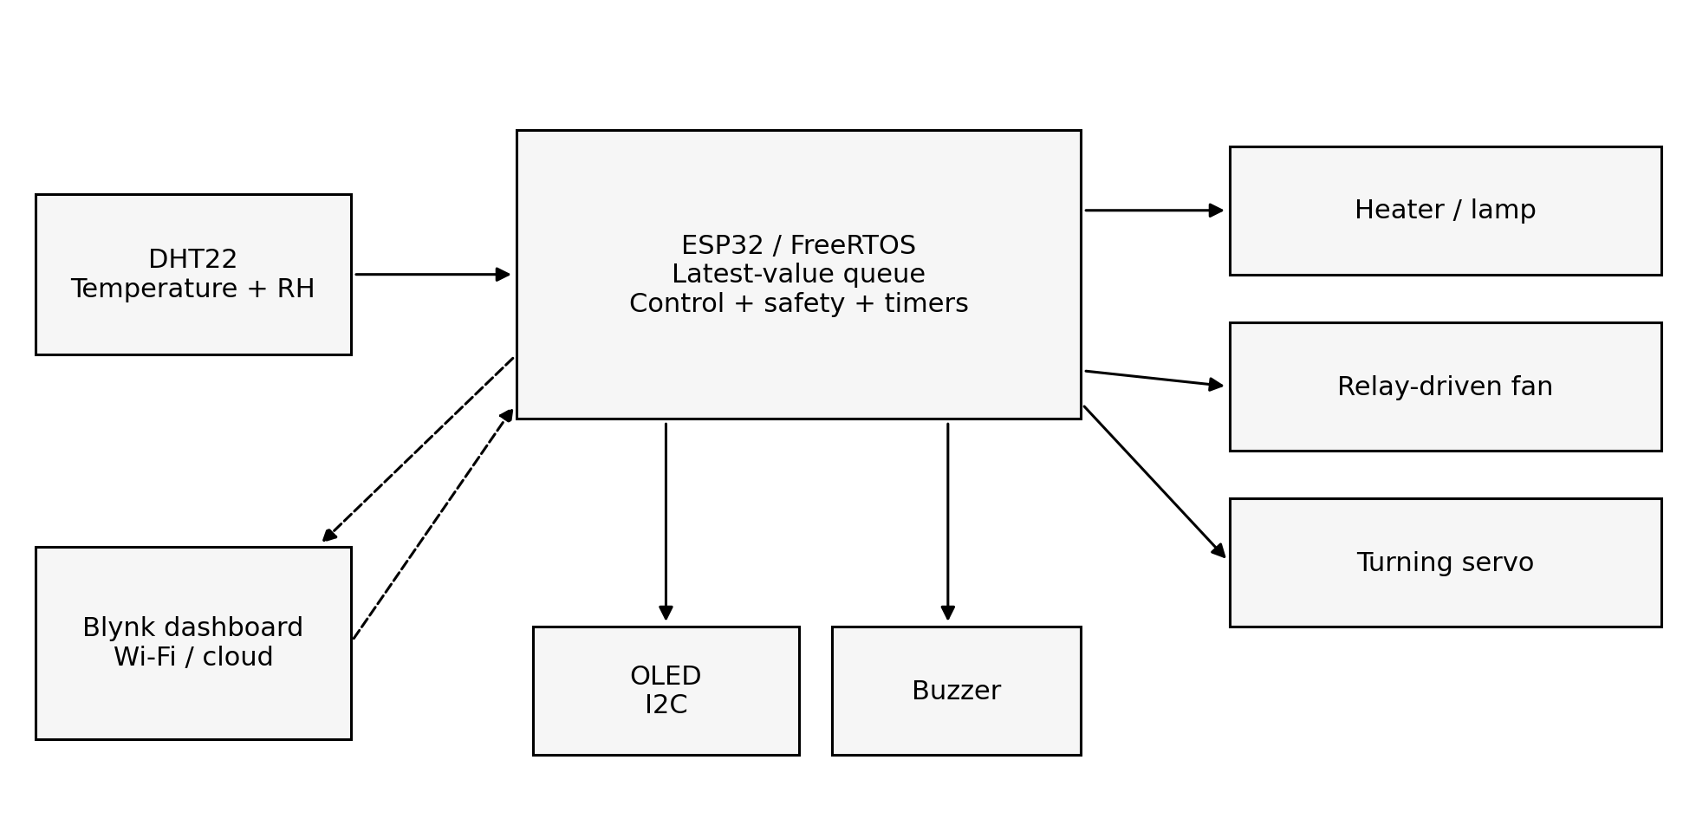
Figure 1: Implemented control and monitoring architecture. Solid arrows show local paths; dashed arrows show network exchange.

2.2 Prototype Assembly
The photographed assembly uses a transparent plastic container with a lamp inside and a fan, breadboard wiring, and controller electronics mounted around the lid. This provides access for laboratory testing and a clear view of the heat source. Figure 2 shows the enclosure from the front; later photographs document the wiring, sensor placement, and display [3].
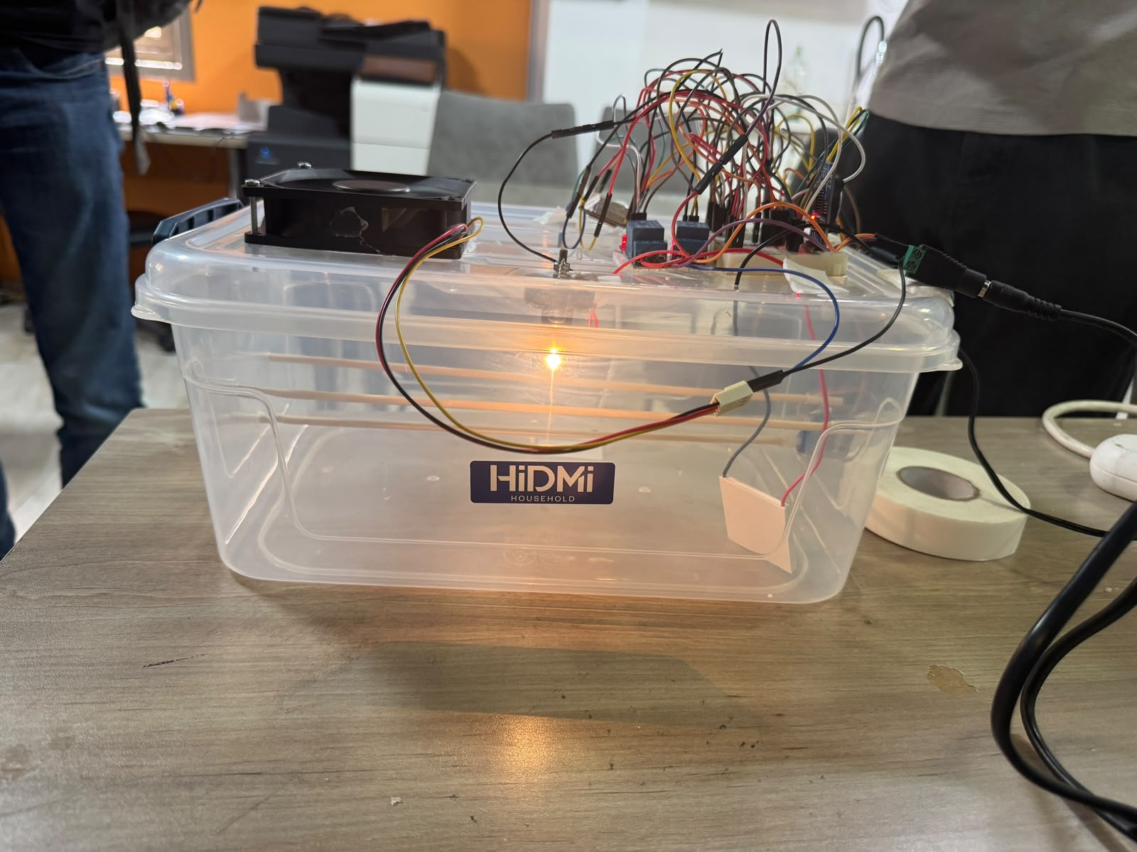
Figure 2: Front view of the assembled prototype with the lamp illuminated.

2.3 Hardware and Connections
Table 1 summarizes the final hardware inventory and the GPIO assignments in the submitted sketch. The build includes two separate 5 V relay modules, a lamp as the heat source, an RTC module, and the wiring and power supplies needed for integration [2, 7].
Table 1: Implemented hardware connection schedule.
Device or signal | Connection | Role
ESP32 WROOM | 5 V control supply; Wi-Fi | Main controller
DHT22 | Data: GPIO16 | Temperature and humidity
Lamp | Switched by heater relay | Heat source; replaces heating plate
Heater relay (1 × 5 V) | Command: GPIO15 | JQC-3F-05VDC-C; lamp switching
Fan relay (1 × 5 V) | Command: GPIO23 | JQC-3F-05VDC-C; fan switching
AFB0912VH fan | 12 V; switched by fan relay | Air circulation / ventilation
0.91-inch SSD1306 OLED | SDA21; SCL22; 0x3C | 128 × 32 display (hardware list)
ZS-042 RTC (DS3231) | I2C; CR2032 backup battery | Timekeeping module; not read by sketch
TMB112A05 buzzer | GPIO19 command; rated 6 V | Local alarm
Power supplies | 5 V / 2 A and 12 V / 2 A | Control-side and load-side supplies
Jumper wires / breadboard | Signal and power connections | Interconnection and assembly
Servo output (experimental) | GPIO18; 50 Hz | Present in code; not in final hardware list

2.3.1 Hardware Substitutions
A lamp replaces the heating plate as the heat source. The two JQC-3F-05VDC-C relay modules switch the lamp and the AFB0912VH fan separately. The ZS-042 DS3231 RTC with a CR2032 battery is included in the hardware; the submitted sketch still counts days using a software timer and does not initialize or read the RTC [2, 7].

2.3.2 Electrical Integration
Jumper wires, a breadboard, and the necessary power wiring interconnect the modules. The listed 0.91-inch OLED is 128 × 32, whereas the sketch configures 128 × 64; this setting should match the installed display. The heater code uses active-HIGH control and the fan uses an input-mode off workaround, so both relay interfaces must be checked against the actual wiring [2, 7].

2.4 Photographic Documentation
The top views in Figure 3 show the relationship between the controller wiring and the fan. The assembly is suitable for tracing signals during a demonstration, while the loose leads and exposed modules indicate that permanent mounting and cable management remain important next steps.
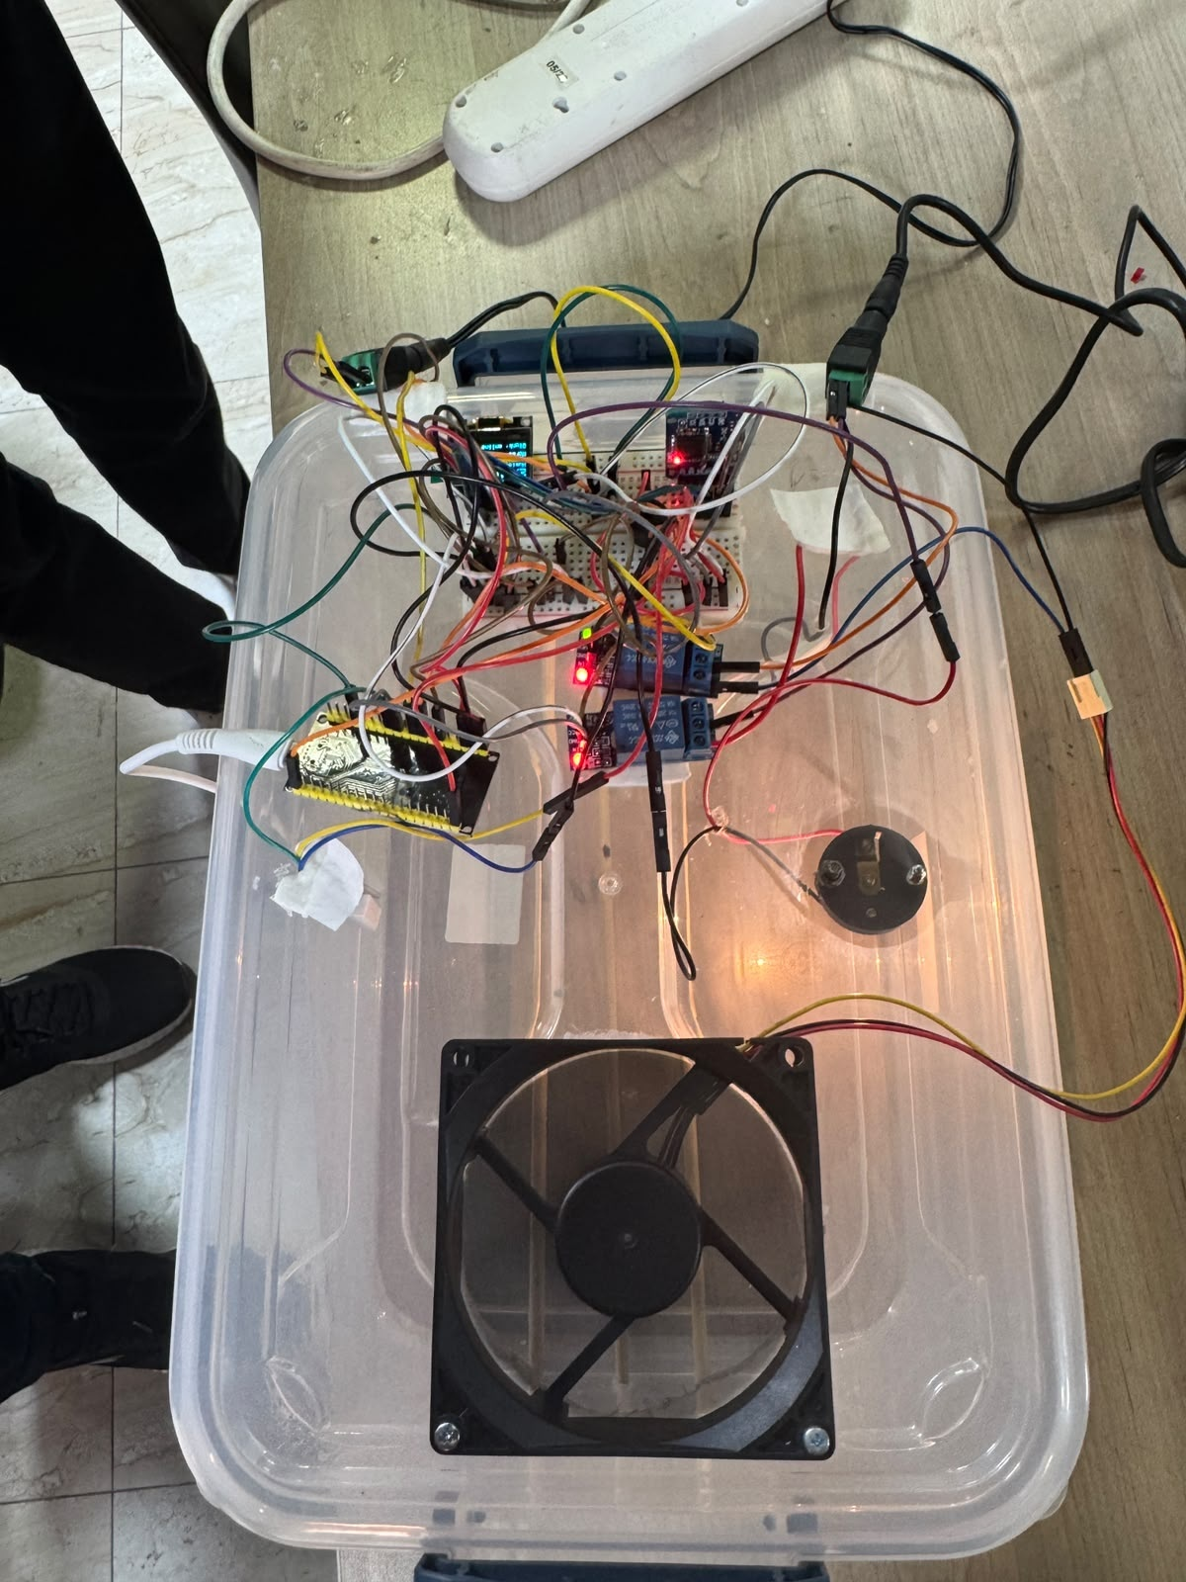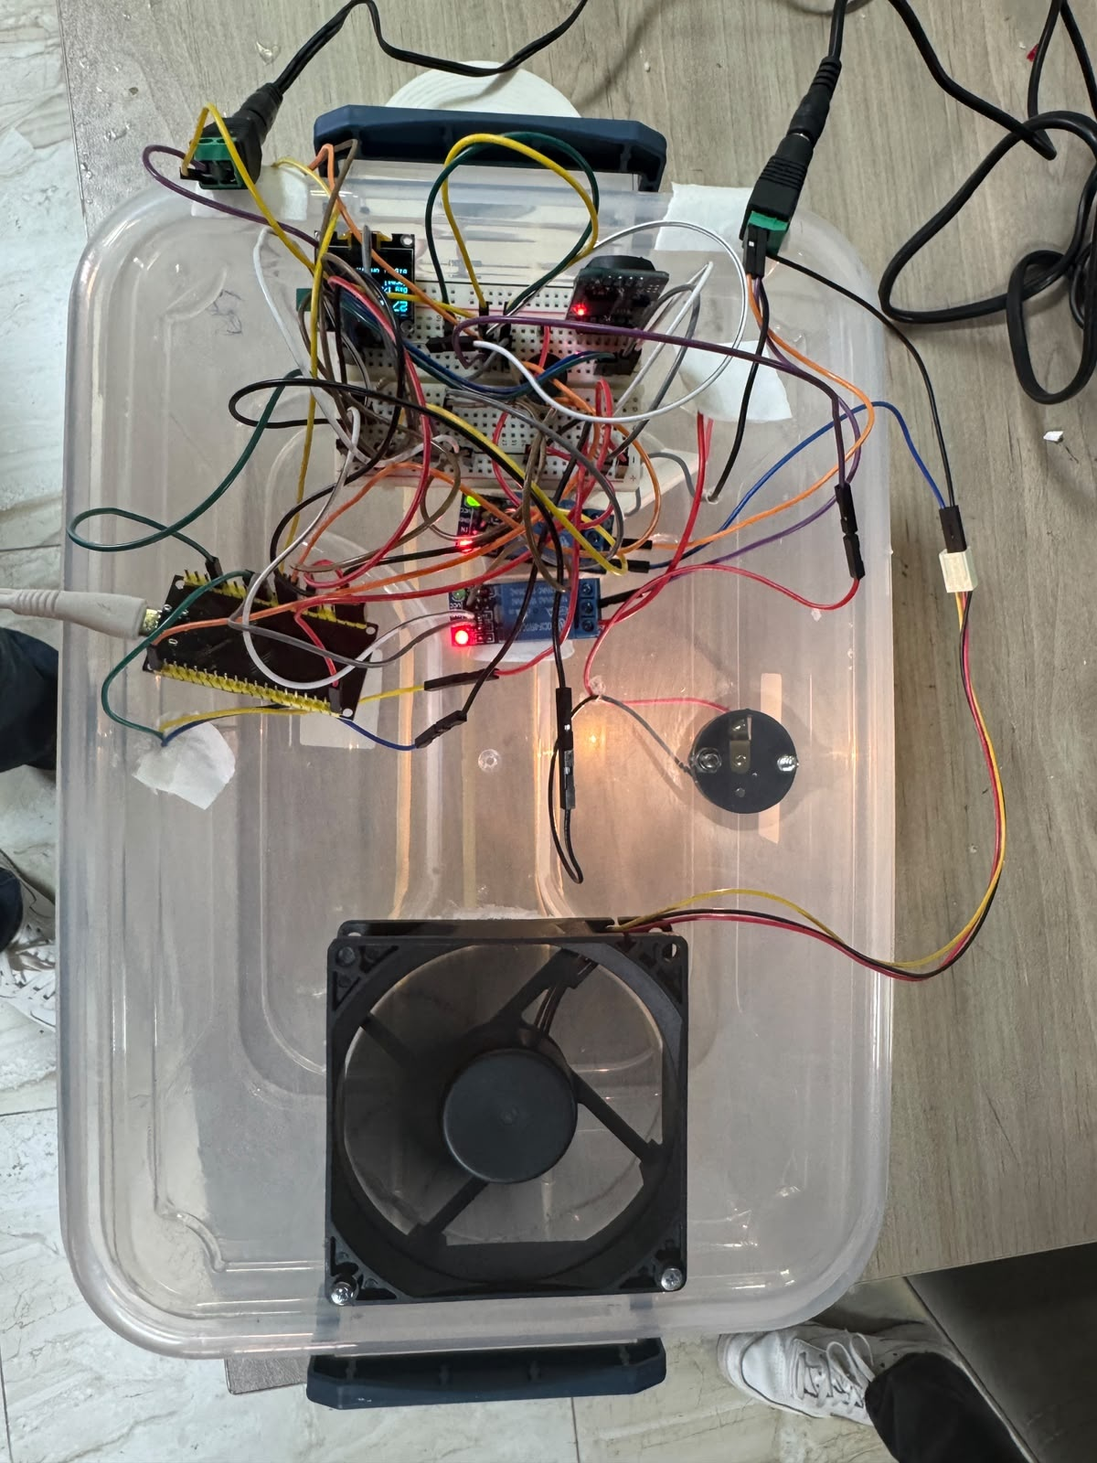
Figure 3: Top views of the lid-mounted wiring, controller assembly, and fan.
The angled and side views in Figure 4 show how the electronics sit above the enclosure and the sensor lead enters the chamber. The transparent walls make the illuminated lamp visible, but the images alone do not establish insulation quality or airflow through the enclosure.
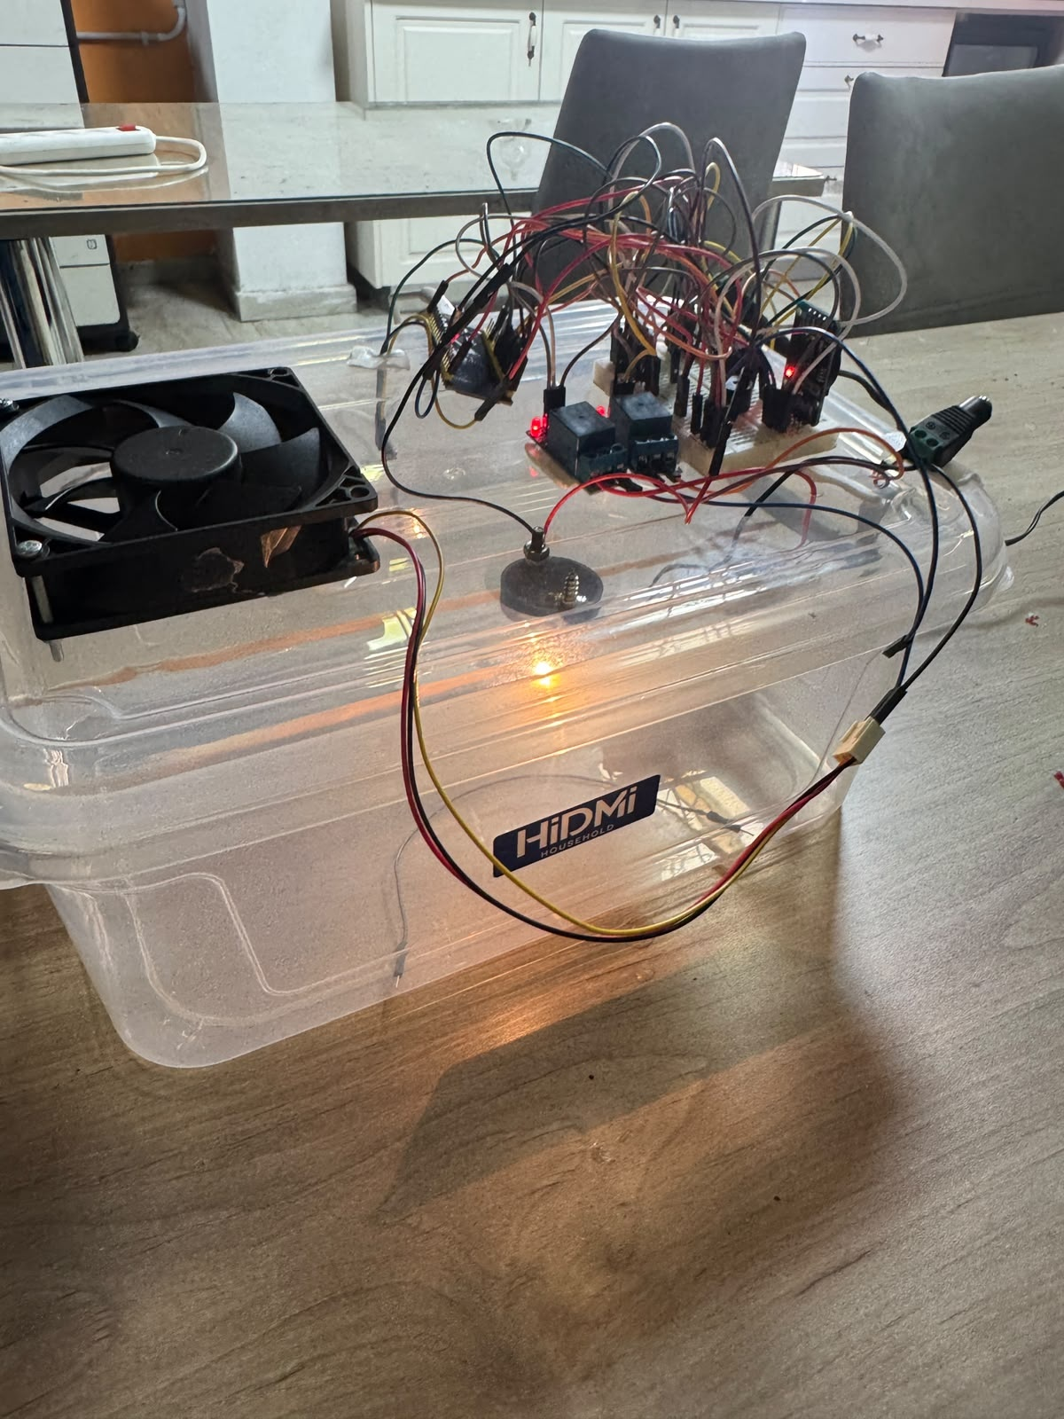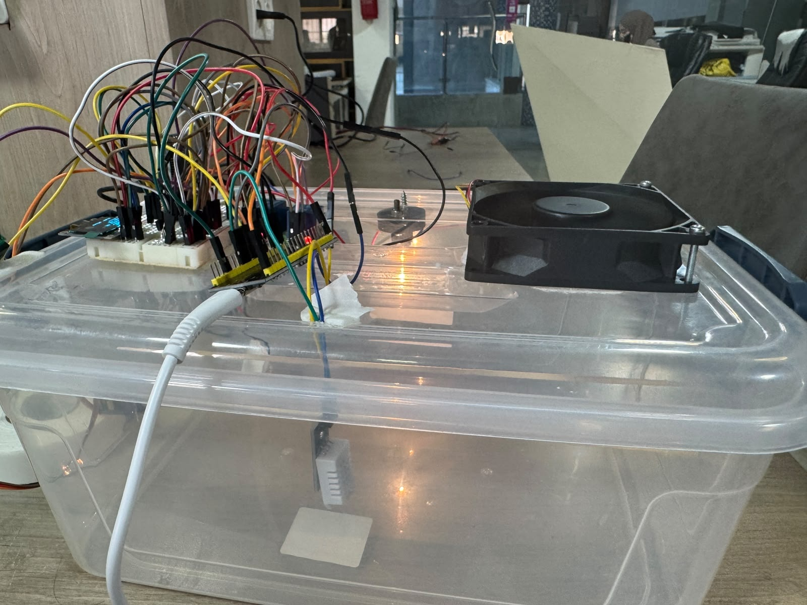
Figure 4: Angled and side views showing the enclosure, fan, wiring, and internal sensor.

2.5 Local Display and Chamber View
The OLED provides a local interface that does not require the dashboard. Its code displays temperature, humidity, the day count, alarm text, and connection status. Figure 5 records the display during the photographed demonstration; the temperature is approximately 27 °C, below the normal incubation target [2, 3].
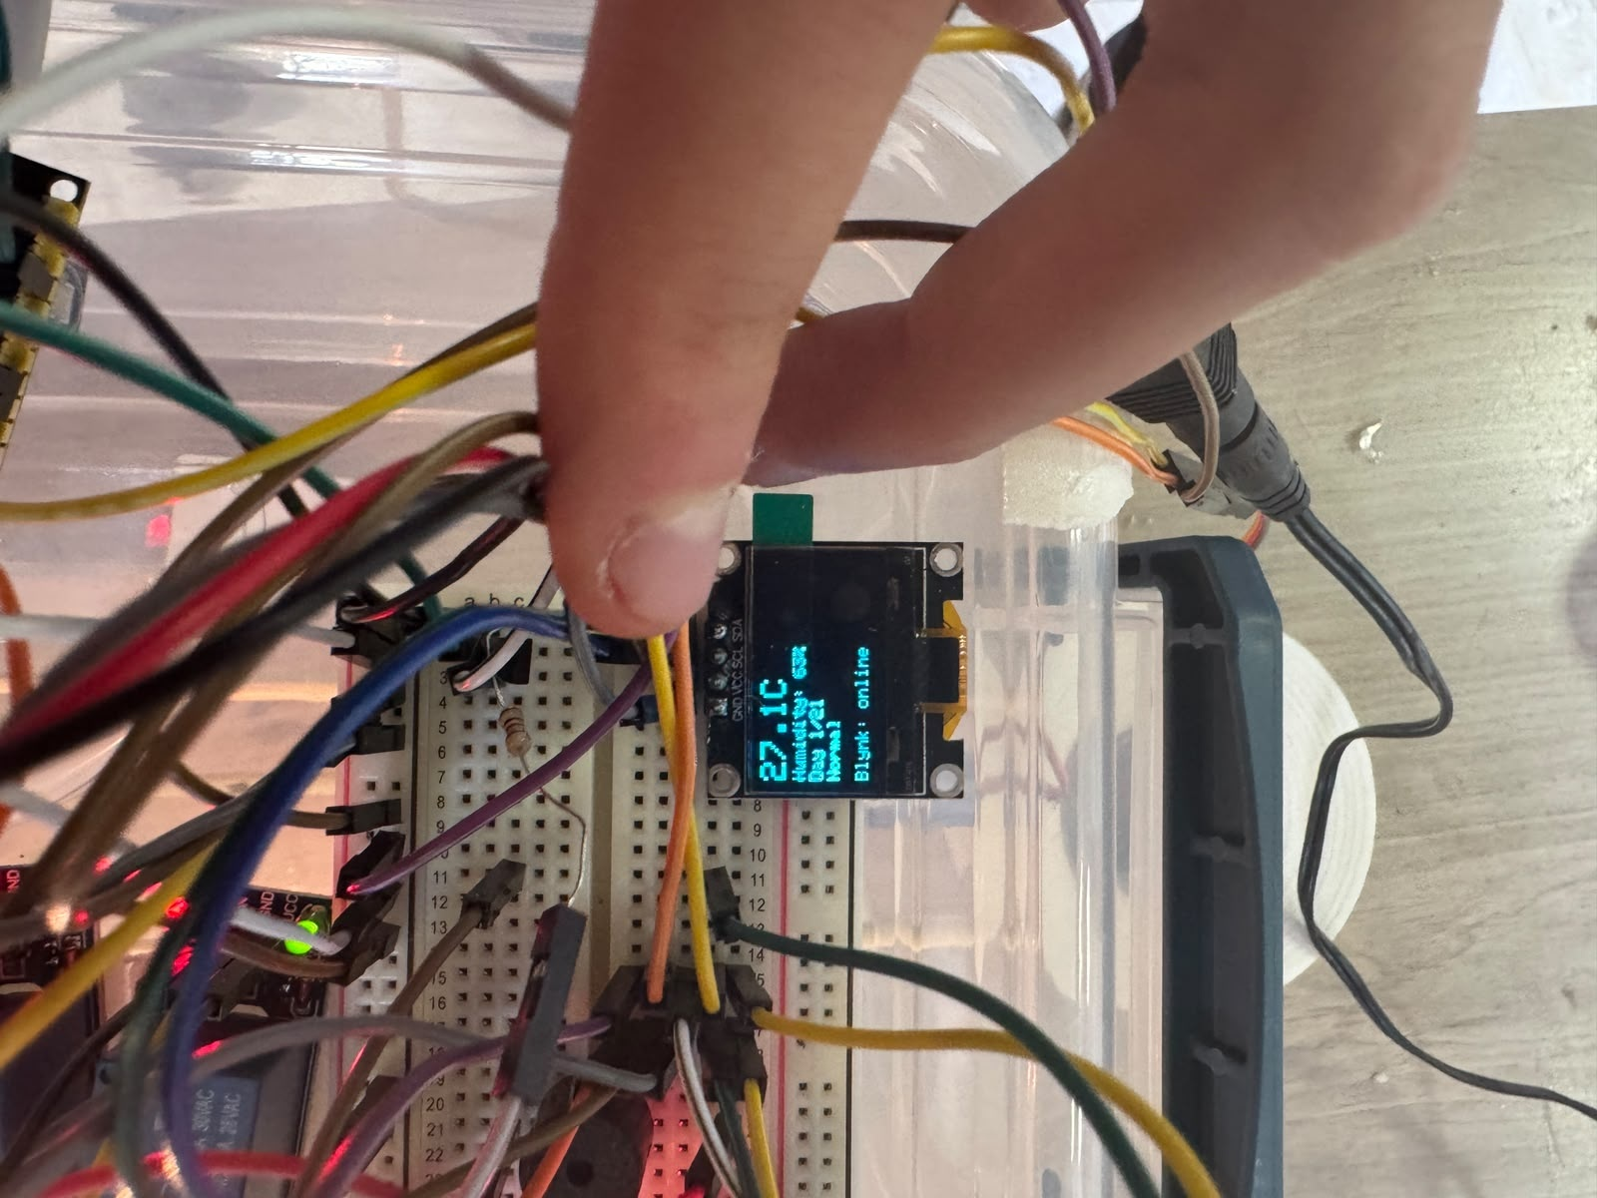
Figure 5: Close-up of the OLED and breadboard during the local monitoring demonstration.
Figure 6 provides a low side view of the chamber with the lamp energized. This supports the presence of a functioning light source at the time of capture. A still image does not establish the switching threshold, delivered heating power, or the temperature distribution around an egg tray.
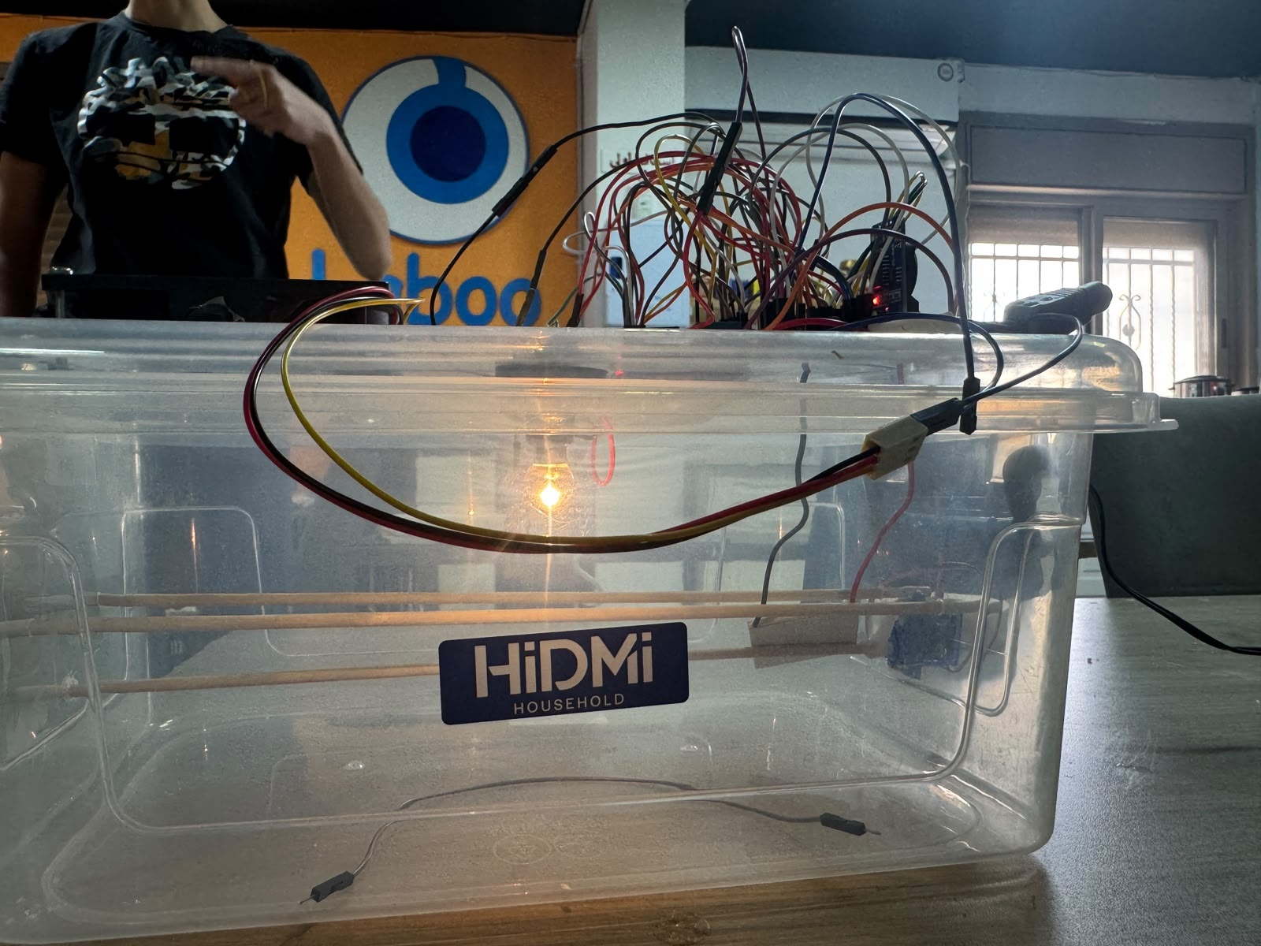
Figure 6: Side view of the enclosure with the internal lamp illuminated.

2.6 FreeRTOS Task Implementation
The sketch creates seven application tasks. Table 2 uses the actual names, priorities, stack arguments, and delays from setup() and the task functions. Only the sensor task uses vTaskDelayUntil(); other periodic tasks use relative delays, so their true cycle time includes execution and blocking time [2].
Table 2: Task configuration as implemented; stack values are the source arguments.
Task | Period or trigger | Priority | Core | Stack
SensorRead | 1000 ms, fixed release | 3 | 1 | 4096
HeaterCtrl | 1000 ms delay | 3 | 1 | 4096
HumidityCtrl | 2000 ms delay | 2 | 1 | 4096
EggTurn | Task notification | 2 | 1 | 4096
SafetyWatchdog | 500 ms delay | 4 | 1 | 4096
Display | 1000 ms delay | 1 | 1 | 4096
BlynkSync | 10 ms loop delay | 2 | 0 | 8192

2.6.1 Communication and Synchronization
SensorReadTask overwrites a one-element SensorData_t queue containing temperature, humidity, a timestamp, and a validity flag. Consumers peek at the newest sample without removing it. heaterMutex protects selected control settings and output states; displayMutex protects OLED access; motorMutex serializes servo commands. A binary alarm semaphore signals the network path, and task notifications wake the turning task.

2.6.2 Timing Considerations
The fixed one-second sensor release is a scheduling design, not proof of a fresh physical conversion every second. Sensor-library behavior and measured timestamps should be checked. The two-second humidity delay also leaves no margin for a strict two-second actuation deadline. Similarly, a 500 ms watchdog delay plus execution time can exceed a 500 ms period. Separate core placement improves isolation but does not, by itself, prove deadline compliance.

2.7 Temperature and Humidity Control
The default temperature setpoint is 37.5 °C. In automatic mode, missing or invalid data, sensorFault, or overTemp force the heater off. Otherwise, the heater turns on below setpoint minus 0.2 °C and turns off at the setpoint. The intervening band preserves the last state [2].
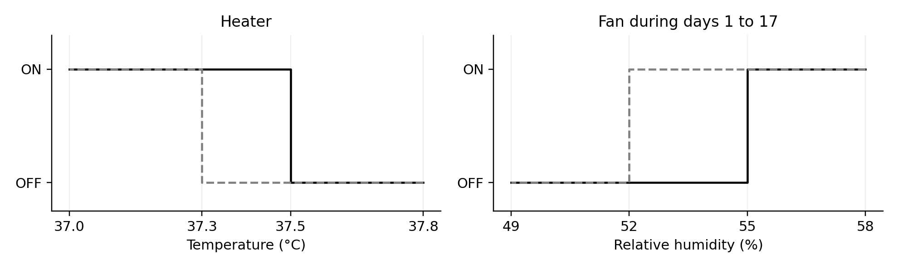
Figure 7: Programmed hysteresis thresholds. These are control rules, not measured response curves.
Table 3: Default automatic control thresholds.
Operating stage | Heater thresholds | Fan thresholds
Days 1–17 | ON < 37.3 °C; OFF ≥ 37.5 °C | ON > 55%; OFF < 52%
Days 18–21 | Same default thresholds | ON > 70%; OFF < 67%

At exactly 55% or 52% during the setting stage, neither fan condition changes the output. The corresponding lockdown boundaries are 70% and 67%. This follows the strict greater-than and less-than comparisons in the sketch. Raising the upper threshold at lockdown reduces ventilation demand; it does not actively add moisture.
else if (data.temperature < setPoint - HEATER_HYST) {
heaterOn();
}
else if (data.temperature >= setPoint) {
heaterOff();
}
Listing 1: Heater hysteresis excerpt from HeaterCtrlTask.

2.8 Turning and Incubation Timing
The automatic turn timer notifies EggTurnTask every 20 seconds when the controller is in automatic mode and before lockdown. The turning task acquires motorMutex, commands 1200 µs pulses, waits 10 seconds, and commands 1500 µs to stop. Because it uses a continuous-rotation servo, this controls run duration rather than a calibrated tray angle [2].
#define SERVO_SPIN_US 1200
#define SERVO_STOP_US 1500
#define TURN_SPIN_MS 10000UL
#define TURN_INTERVAL_MS 20000UL

void turnTimerCallback(TimerHandle_t xTimer) {
if (!manualMode && !isLockdown()) {
xTaskNotifyGive(eggTurnTaskHandle);
}
}
Listing 2: Demonstration turning parameters and timer notification.

2.8.1 Demonstration Schedule
A 20-second period corresponds to 4320 requested turns per day and a nominal 50% motor duty cycle. This is a demonstration configuration. For an evenly spaced four-turn daily schedule, the interval would be six hours. The final interval and mechanical travel must be selected and verified before incubation. A 10-second delay also leaves no execution margin below the brief’s 10-second completion limit.

2.8.2 Day Counter and Lockdown
The day counter starts at 1. An auto-reload software timer advances it every 24 hours until day 21; isLockdown() becomes true at day 18. Blynk can write a clamped day value through V5. On the first cloud connection after startup, V5 and V7 are synchronized from the server. This is not RTC-backed elapsed-time recovery: the 24-hour timer restarts after reboot, and offline elapsed time is not reconstructed.

2.8.3 Motion Constraints
The timer suppresses new automatic requests during lockdown, but EggTurnTask does not recheck the mode or day after waking. A pending request or active turn can therefore cross a mode transition. Manual V8 operation can run continuously and is not subject to the automatic 10-second stop or lockdown check. No end-position sensor or confirmed tray angle appears in the source.

2.9 Blynk Dashboard and Remote Operation
Figure 8 shows the project dashboard. The screenshot contains temperature and humidity gauges, an incubation-day indicator, manual controls, a setpoint slider, and alarm text. The actual virtual-pin mapping differs from the example mapping in the project brief [1, 2, 4].
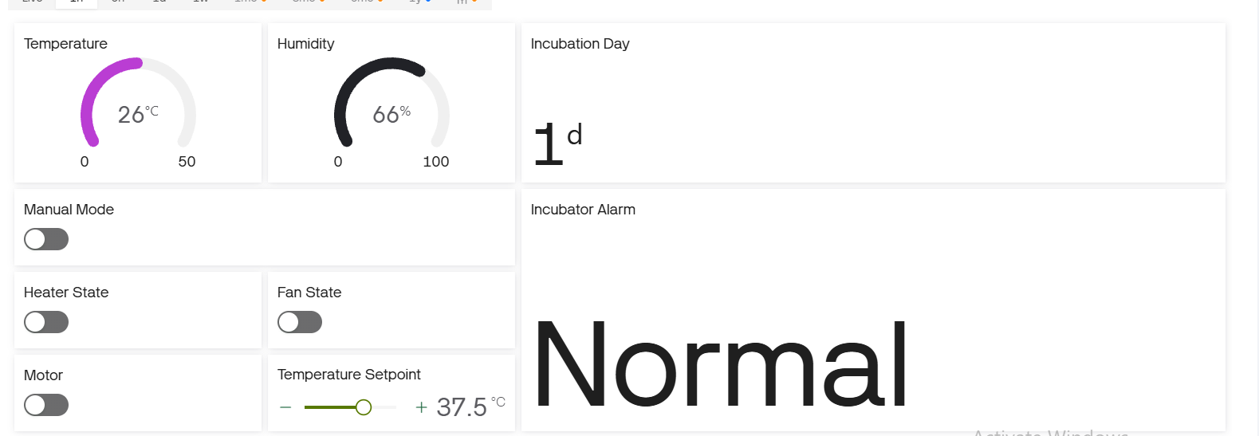
Figure 8: Blynk dashboard showing 26 °C, 66% RH, day 1, and the Normal alarm state.
Table 4: Actual Blynk virtual-pin assignments.
Pin | Published or received value | Behavior
V0 | Temperature | Published when queue data is valid
V1 | Relative humidity | Published when queue data is valid
V2 | Heater state / command | Command accepted in manual mode
V3 | Fan state / command | Command accepted in manual mode
V4 | Alarm text | Normal or active alarm description
V5 | Incubation day | Published; writable from 1 to 21
V6 | Manual mode | 1 = manual; 0 = automatic
V7 | Temperature setpoint | Clamped from 35 to 39 °C
V8 | Motor state / command | Manual motor start or stop

Telemetry is attempted every two seconds while connected. The screenshot is an individual state, not a history plot. Its 26 °C reading and Normal label can coexist during the programmed warm-up allowance; the capture does not establish the runtime or explain all displayed switch states.

2.10 Safety and Fault Handling
SafetyWatchdogTask has priority 4, the highest priority among the seven application tasks. It checks missing data, NaN validity, a timestamp older than three seconds, and plausibility bounds of 0–60 °C and 0–100% RH. A bad reading sets sensorFault and requests both heater and fan off immediately in that iteration. The five-second grace delays the sensor alarm, not the output shutdown [2].
Table 5: Implemented safety thresholds and alarm behavior.
Condition | Action or threshold
Missing, invalid, stale, or implausible data | Heater and fan off; sensor alarm after 5 s
Temperature > 39.5 °C | Heater off; over-temperature alarm
Temperature > 38.5 °C | Alarm after 120 s continuously out of range
Temperature < 36.5 °C | Low alarm suppressed for first 20 min; then 120 s grace
Humidity < 40% or > 80% | Alarm after 120 s continuously out of range
Active alarm | Buzzer HIGH; semaphore signals network path

2.10.1 Network Independence
Wi-Fi initialization occurs within BlynkSyncTask rather than before local task creation. Disconnected Wi-Fi is retried after 15 seconds, while local tasks continue. New alarm codes give a binary semaphore, and the Blynk task calls logEvent with the incubator_alarm event when connected. Cloud notification delivery still depends on configuring that event and the dashboard correctly.

2.10.2 Implementation Limits
The watchdog is a software supervision task, not a configured hardware watchdog reset mechanism. A manual heater command can request ON without checking the fault flags; the safety task may turn it off later, so the cutoff is not an atomic interlock. The network task receives the alarm semaphore before alarmCode is assigned in the watchdog, allowing a cross-core ordering race. A queued alarm record and a fault check inside the actuator command would make these paths more robust.

3. Testing and Results

3.1 Demonstration Evidence
The photographs establish a physically assembled prototype, an illuminated internal lamp, and an active local display. The dashboard screenshot establishes that the interface displayed sensor values and status fields at capture. The two short clips provide additional views of the prototype; they are not a continuous calibration record. No measured timing log, thermal trend, humidity recovery curve, or completed hatch record accompanies the demonstration [3–5].
Table 6: Evidence-based assessment of the demonstration.
Check | Evidence and result | Assessment
Enclosure and assembly | Visible in seven photographs | Observed
Lamp operation | Lamp visibly illuminated | Observed at capture
OLED interface | Local display active in close-up | Observed
Blynk values | 26 °C; 66% RH; day 1 | Snapshot observed
37.2–37.8 °C regulation | No steady-state temperature log | Not demonstrated
Lockdown and tray travel | Rules present in source; no measured travel | Needs test
Alarm delivery and clearing | Buzzer and event path in source | Needs controlled test
24-hour offline operation | Local tasks separated from network | Needs endurance test

3.2 Interpretation
The system has the central elements needed for a laboratory demonstration of a concurrent IoT controller. The available evidence supports integration, but it does not justify declaring every functional requirement passed. In particular, low humidity has no active recovery actuator, the turning interval remains configured for demonstration, and the timing requirements have not been established by measurements.

3.3 Requirements Assessment
Table 7: Functional requirement traceability to the source and demonstration.
ID | Assessment against the submitted implementation
FR1 | One-second task release implemented; fresh acquisition rate and ±50 ms timing not measured.
FR2 | Heater hysteresis implemented; required chamber temperature band not demonstrated.
FR3 | Stage-dependent fan limits implemented; no active low-humidity restoration.
FR4 | Automatic turning and lockdown gate implemented; 20-second demo period and physical turning require correction or validation.
FR5 | Day shown locally and remotely; days remaining printed to Serial but not shown on OLED or Blynk.
FR6 | Two-second publish path implemented with fan state replacing humidifier state; actual timing unmeasured.
FR7 | Local alarm and Blynk event path implemented; delivery, grace timing, and recovery unverified.
FR8 | Local tasks independent of connectivity; extended offline behavior unverified.
FR9 | Manual heater, fan, and motor commands implemented; safety and duration constraints need refinement.
FR10 | NaN, missing, stale, and implausible sensor data handled in software.

3.3.1 Real-Time and Synchronization Gaps
NFR5 is only partially satisfied: incubationDay has writers in both the timer callback and V5 handler, and several flags are shared without a queue or consistent mutex discipline. Atomic access and volatile declarations do not establish a synchronized multi-field state. The motor and display use separate mutexes, so the specific mutual-exclusion condition in NFR7 is not implemented. Resource allocation and task-creation return values are also not checked comprehensively [1, 2].

3.4 Recommended Validation Procedure
The following tests would turn the demonstration evidence into a reproducible engineering evaluation. Acceptance criteria come from the project brief; they are proposed checks and are not reported as completed tests [1].
Table 8: Proposed validation matrix and acceptance criteria.
Test | Procedure | Acceptance or observation
Sensor timing | Log acquisition and release times under network load | 1 s ± 50 ms; verify fresh readings
Control latency | Time a threshold-crossing sample and output transition | At most 2 s end to end
Thermal stability | Log chamber and reference-sensor readings after warm-up | 37.2–37.8 °C; report overshoot and spatial variation
Sensor fault | Disconnect sensor; then restore valid data | Outputs off; alarm grace and recovery verified
Over-temperature | Use a controlled simulated reading above 39.5 °C | Heater off even during manual requests
Lockdown transition | Set day to 17, advance to 18, inspect timer and motion | Correct humidity stage; no new or pending automatic turn
Offline endurance | Disconnect Wi-Fi for 24 h in automatic mode | Local control, display, and alarm remain operational
Manual mode | Exercise V2, V3, V8 and then reconnect network | Interlocks retained; motor stops predictably

3.4.1 Priority Improvements
Before extended operation, change the turning interval and verify tray mechanics; provide a means to raise humidity; enforce faults inside every heater-on path; and give the manual motor a bounded run time. Then synchronize shared state, preserve elapsed incubation time across power loss, and record timing and environmental data. Hardware mounting, a defined relay off state, and an independent thermal cutoff complete the transition from an accessible bench assembly to a more dependable prototype.

Conclusion
The Smart Egg Incubator demonstrates the integration of an ESP32, environmental sensing, local actuation, an OLED interface, and Blynk monitoring through a seven-task FreeRTOS design. The implementation uses a latest-value sensor queue, priority-based task separation, hysteresis control, timer-triggered servo operation, and a dedicated alarm path. The photographs and dashboard illustrate the physical build and its local and remote interfaces.
The principal engineering limitation is the gap between implemented logic and verified incubation performance. The fan manages an upper humidity threshold but does not add moisture, the automatic turn period remains set to 20 seconds, and several synchronization and manual-control details require refinement. The available demonstration does not establish sustained temperature accuracy, guaranteed response deadlines, or hatch success. With the proposed control corrections and measured validation, the project provides a clear foundation for a complete smart incubation system.

References
[1] Birzeit University, ENCS5140 Smart Egg Incubator Project Brief. Supplied file: Smart_Egg_Incubator_Project_Brief(1).pdf, sections 3–13 and 15.
[2] SmartIncubator3(1).ino. Submitted ESP32 Arduino sketch; reviewed task functions, Blynk handlers, constants, and setup configuration.
[3] Prototype photographs. Seven supplied WhatsApp images dated 28 September 2026, 7.25.27 PM. Figures 2–6 reproduce the corresponding views.
[4] Blynk dashboard screenshot. Supplied PNG beginning 825312106_1474214934764723; reproduced as Figure 8.
[5] Prototype demonstration clips. WhatsApp videos dated 28 September 2026, 7.25.30 PM and 7.25.32 PM; approximately 16.6 s and 11.8 s.
[6] Laboratory report formatting reference. Supplied templete(1).pdf.
[7] Project team hardware inventory and corrections, supplied 30 September 2026. Includes component specifications, two relay modules, RTC, power supplies, and wiring.

Appendix

A. Sensor Queue and Timed Motion
The excerpts below preserve the implementation structure of the submitted sketch. Configuration credentials are not reproduced. These listings document the current code and do not incorporate the improvements discussed in Section 3.
data.temperature = dht.readTemperature();
data.humidity = dht.readHumidity();
data.timestamp = millis();
data.valid = !isnan(data.temperature) &&
!isnan(data.humidity);
xQueueOverwrite(sensorQueue, &data);
vTaskDelayUntil(&lastWake, pdMS_TO_TICKS(1000));
Listing 3: Latest-value sensor publication and fixed-period release.
The queue holds the latest sample rather than a history. A timestamp is attached on each task iteration; the distinction between task execution and a fresh sensor conversion must be checked during timing validation.
ulTaskNotifyTake(pdTRUE, portMAX_DELAY);
if (xSemaphoreTake(motorMutex,
pdMS_TO_TICKS(500)) == pdTRUE) {
turning = true;
Serial.println("[EggTurn] Rotating...");
eggServo.writeMicroseconds(SERVO_SPIN_US);
vTaskDelay(pdMS_TO_TICKS(TURN_SPIN_MS));
eggServo.writeMicroseconds(SERVO_STOP_US);
turning = false;
Serial.println("[EggTurn] Stopped.");
xSemaphoreGive(motorMutex);
}
Listing 4: Notification-driven servo operation under motorMutex.
The motor mutex remains held during the automatic run. A manual motor command that cannot acquire it within 100 ms fails and restores the dashboard indication. Consequently, a manual stop is not guaranteed to interrupt an automatic turn already in progress.

