Bahria University,
Karachi Campus

LAB EXPERIMENT NO.

8

LIST OF TASKS
TASK NO | OBJECTIVE
1. | Build and train an Artificial Neural Network (ANN) using the Pima Indians Diabetes dataset provided in the lab. Preprocess the dataset by separating input and output variables, scaling the input data, and splitting it into training and testing sets. Design a suitable ANN architecture with input, hidden, and output layers. Train the model, evaluate its performance using accuracy or other metrics, and interpret the results to understand how well the model predicts diabetes cases..
2. | Create and train an Artificial Neural Network (ANN) using the Iris dataset to classify different types of iris flowers. Perform necessary preprocessing steps such as one-hot encoding and data normalization. Build the neural network model, train it using the training data, and test its performance on the testing data. Finally, discuss the accuracy, compare predicted versus actual results, and explain how the ANN model effectively distinguishes between different flower species.
.

Submitted On:

11/20/2025
(Date: DD/MM/YY)

Lab No. 8

Task No. 1:
Build and train an Artificial Neural Network (ANN) using the Pima Indians Diabetes dataset provided in the lab. Preprocess the dataset by separating input and output variables, scaling the input data, and splitting it into training and testing sets. Design a suitable ANN architecture with input, hidden, and output layers. Train the model, evaluate its performance using accuracy or other metrics, and interpret the results to understand how well the model predicts diabetes cases.

Solution:
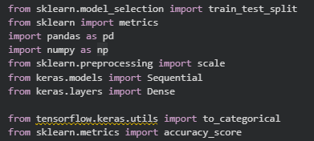
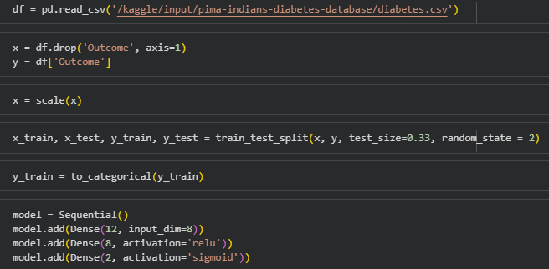
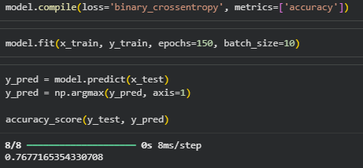

Task No. 2:
Create and train an Artificial Neural Network (ANN) using the Iris dataset to classify different types of iris flowers. Perform necessary preprocessing steps such as one-hot encoding and data normalization. Build the neural network model, train it using the training data, and test its performance on the testing data. Finally, discuss the accuracy, compare predicted versus actual results, and explain how the ANN model effectively distinguishes between different flower species.

Solution:
