**Functional Requirments:**

* User shall go to the homepage, view news, photos and trailers about the most recent movies(box office hits) and search for movies he likes and he shall have the option of signing in to create his own account and he will get some cool benefits :

1. Ratings: user shall rate any movie or TV show.
2. Your Watchlist: user shall be able to make his own list of movies he like the most, edit the list anytime and track everything he wants.
3. User shall be able to review any movie or TV show.

* User shall be able to modify his information and appearance (password ,email,username).
* PieMeter rating based on the published opinions of hundreds of film and television critics - is a trusted measurement of movie and TV programming quality for millions of moviegoers.
* The PieMeter rating represents the percentage of professional critic reviews that are positive for a given film or television show.
* User shall be able to view information about the Editorial Team: five favorite movies or TV shows with their own rating, Facebook and twitter account.
* Customer support: user shall be able to submit a question to the support team by visiting FAQs or filling out our email form.
* User shall be able tell us about missing or incorrect movie or TV information.

**NonFunctional Requirments:**

• Availability: the web site should be available 24/7

• Privacy: our site shall prevent private user data to appear in public

• Usability: our site shall be a user friendly and easy to use

• Dependability: our site information should be based on reliable, published sources, making sure that all majority and significant minority views that have appeared in those sources are covered

• Portability: web application that works on different platforms

• Security.

**Web programming Languages** : HTML,JavaScript,css,php.

**Data** **base** :MySQL.

**Tools**: xamp serve PHPStorm.

**Use case diagram**

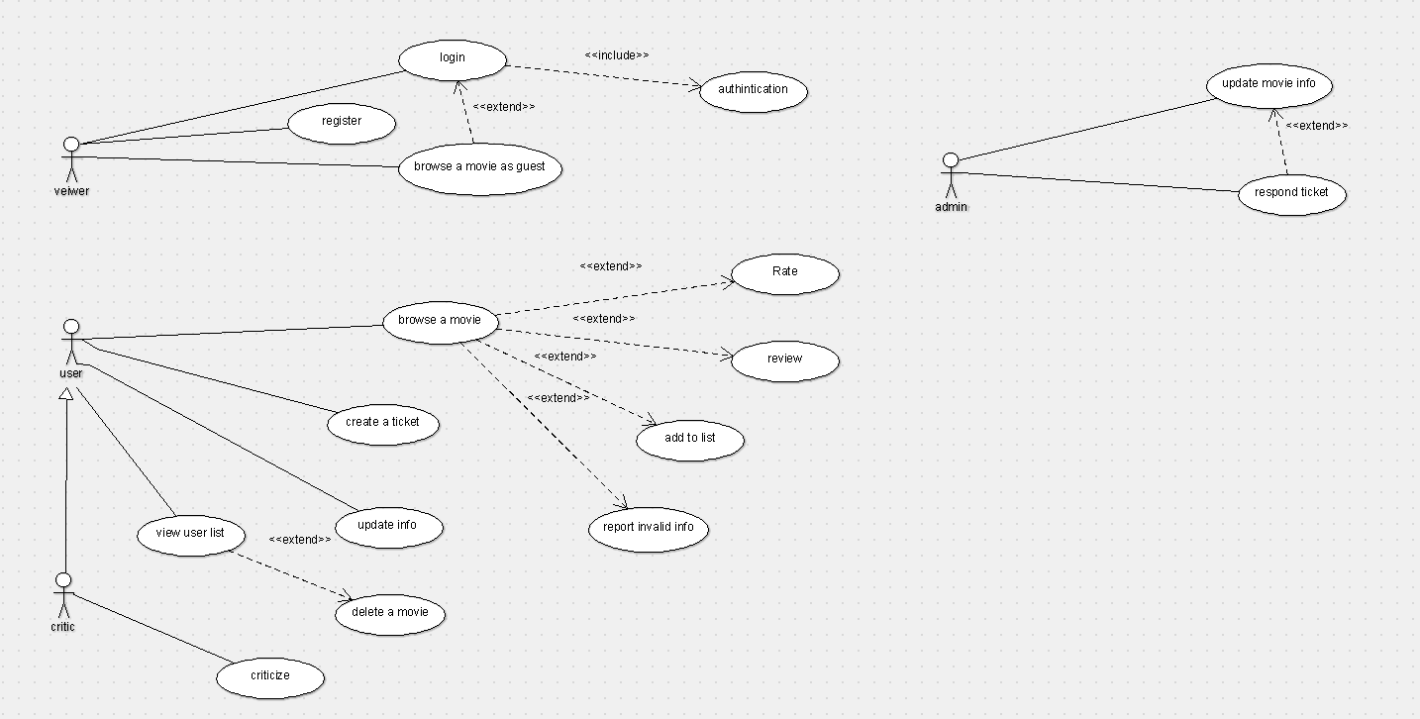

**Class diagram**

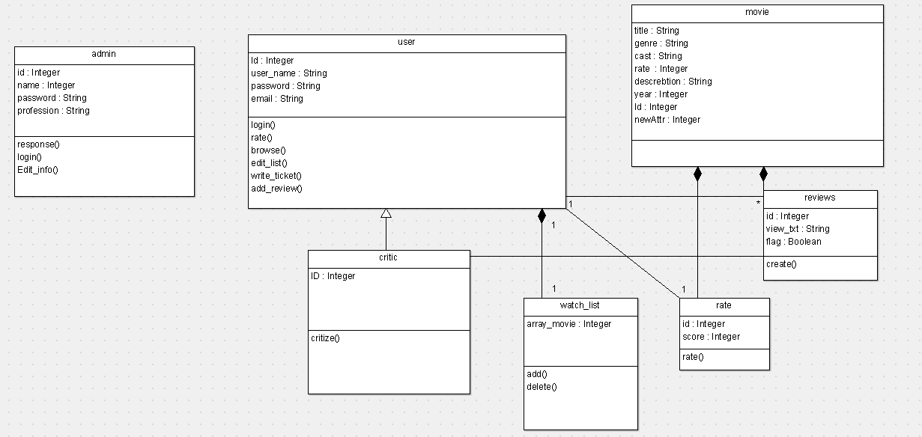

**Sequence diagram**

