Unlocking Equity and Efficiency: A Data-Driven Analysis and Predictive Modelling of India’s Crop Insurance Schemes
- Abstract
This project presents an end-to-end, data-driven analysis of India’s flagship crop insurance schemes, primarily the Pradhan Mantri Fasal Bima Yojana (PMFBY), using district-level data spanning 2018–2022. The primary problem addressed is the “one-size-fits-all” approach to policy design, which overlooks deep regional and demographic variations.
The methodology follows a comprehensive data science workflow:
(1) Exploratory Data Analysis (EDA) to identify key trends,
(2) K-Means Clustering to segment districts into archetypes, and
(3) Comparative predictive modeling to forecast gross premiums.
Four regression models were built and evaluated: Simple Linear Regression, Multiple Linear Regression (OLS), a Deep Learning Neural Network (ANN), and an XGBoost model.
Key findings include the discovery of a “Vulnerable Farmer Paradox”, where an 80% surge in policy participation coincided with a decline in the average insured sum, driven by 81.1% participation from small and marginal farmers. Clustering revealed five distinct district archetypes (e.g., “Inclusive Powerhouse” vs. “Mainstream Heartland”). The XGBoost model achieved a 55.7% error reduction over the baseline and 12.3% greater accuracy than the Deep Learning model. Notably, percentage of female and marginal farmers emerged as top predictors, showing that social equity metrics are critical financial indicators.
The project culminates in an interactive Streamlit dashboard enabling real-time exploration and premium prediction.

Keywords: - Data Science, Machine Learning, PMFBY, Crop Insurance, Predictive Modeling, XGBoost, K-Means Clustering, Regression Analysis
- Introduction
Crop insurance is a critical financial tool for mitigating risk among millions of Indian farmers. The Pradhan Mantri Fasal Bima Yojana (PMFBY), launched in 2016, is one of the largest such schemes in the world. However, its performance is often evaluated at an aggregate level, overlooking India’s demographic, geographic, and economic diversity. This “one-size-fits-all” approach risks inefficiency.
This study aims to move beyond aggregate statistics through granular, district-level analysis. The objectives are to:
(1) Identify key performance trends and paradoxes through EDA.
(2) Discover data-driven “district archetypes” via clustering.
(3) Build and compare multiple ML models to predict gross_premium.
(4) Consolidate findings into an interactive dashboard.
The novelty lies in its end-to-end approach, particularly the rigorous comparison between OLS, XGBoost, and Deep Learning, and in proving that demographic equity metrics are strong financial predictors.
- Literature Review
While extensive literature exists on PMFBY’s socio-economic impact [1], [2], the application of advanced machine learning techniques to model the scheme’s financial dynamics remains limited. This project bridges that gap using clustering and predictive modeling with XGBoost and ANN applied directly to district-level data.
Reference | Method Used | Findings | Results | Limitations
[1] | Policy Review & Statistical Analysis | Identified key challenges in claim settlement and awareness. | Recommended structural reforms. | Lacked granular district-level data.
[2] | Socio-economic Surveys | Found adoption linked to education, land size, and trust. | Showed uneven adoption rates. | Limited to few regions.
[3] | Machine Learning (Random Forest) | Predicted crop yield using weather and soil data. | High accuracy in yield prediction. | Did not analyze insurance scheme.
This Project | EDA, K-Means, OLS, XGBoost, ANN | Found 5 district archetypes and a “Vulnerable Farmer Paradox.” | 55.7% error reduction in premium prediction. | Lacks claims data (next step).
Table 1. Empirical Review of Existing Methods

- Methodology
This project follows a five-step data science workflow, from data collection to deployment.

4.1 Data Collection and Preprocessing
Data Source: District-level PMFBY and WBCIS records (India Data Portal, 2018–2022).
Initial Dataset: 6,161 rows × 28 columns.
Final Dataset: 5,694 rows after cleaning.
Step | Action | Justification
1 | Dropped invalid rows | Removed 10 rows with negative demographic values.
2 | Reconciled farmer counts | Computed total_policies = loanee + non_loanee.
3 | Removed invalid zeros | Dropped 457 rows with inconsistent policy–sum pairs.
4 | Preserved valid zeros | Retained 70 valid “zero-uptake” rows.
5 | Clipped demographic bounds | Ensured all demographic % between 0–100.
6 | Corrected data types | Converted identifiers to categorical.
7 | Reset index | Finalized cleaned dataset.
Table 2. Data Cleaning Summary

4.2 Feature Engineering and Model Design
Feature Engineering:
- Applied logarithmic transformation (np.log1p) to skewed numeric features.
- One-hot encoded categorical variables (scheme, season, state_name).
- Created interaction terms (e.g., scheme_x_log_sum_insured).
Phase 1 – Clustering:
Used K-Means (K = 5) on features like log_total_policies, log_sum_insured, % marginal, and % female to identify district archetypes.
Phase 2 – Predictive Modeling:
- Simple Linear Regression: Baseline with log_sum_insured.
- Multiple OLS Regression: Interpretable model with 21 features.
- ANN: Three-layer neural network with ReLU activations.
- XGBoost: Gradient-boosted model trained on 26 features (including cluster IDs).
Evaluation Metric: Mean Absolute Error (MAE) on 80/20 train-test split.
- Implementation
Technologies Used: Python, Pandas, NumPy, Scikit-learn, Statsmodels, XGBoost, TensorFlow/Keras, Plotly, Streamlit.
Challenges and Solutions:
- Data Integrity: Resolved with total_policies recalculation.
- Heteroscedasticity: Corrected via log transformations.
- GeoJSON Matching: Normalized state names for map visualization.
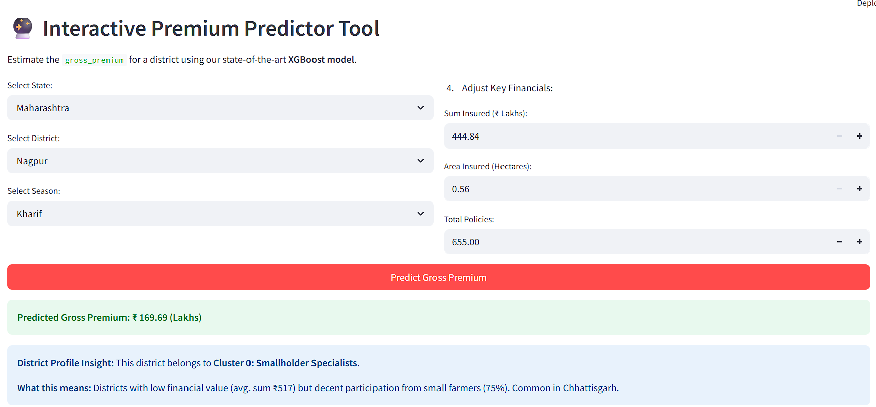
Figure 1. Streamlit dashboard featuring the “Premium Predictor” tool powered by XGBoost.
6. Results and Discussion

6.1 Exploratory and Clustering Insights
Vulnerable Farmer Paradox: Policy participation increased by +80% (2018–2022), while the average insured sum decreased due to dominance of small (60.7%) and marginal (21.5%) farmers.
Insurance Heartland: Choropleth maps (Figure 2) revealed high participation in Maharashtra, Rajasthan, and Madhya Pradesh.
District Archetypes: K-Means (K=5) segmentation confirmed distinct district profiles across “Scale vs. Inclusivity” axes.
Cluster ID | Archetype | Size | Avg Policies | Avg Sum Insured (₹) | % Marginal | % Female | Key State
1 | Mainstream Heartland | 1751 | 131,474 | 37,343 | 22.4 | 9.9 | Madhya Pradesh
3 | Inclusive Powerhouse | 1107 | 111,978 | 27,011 | 11.6 | 20.9 | Maharashtra
0 | Smallholder Specialists | 1451 | 5,002 | 517 | 13.6 | 14.6 | Chhattisgarh
4 | Vulnerable & Low-Scale | 822 | 7,834 | 2,799 | 51.9 | 15.7 | Uttar Pradesh
2 | Niche Outliers (WBCIS) | 492 | 2,666 | 392 | 13.5 | 7.1 | Rajasthan
Table 3. Cluster Profile Summary
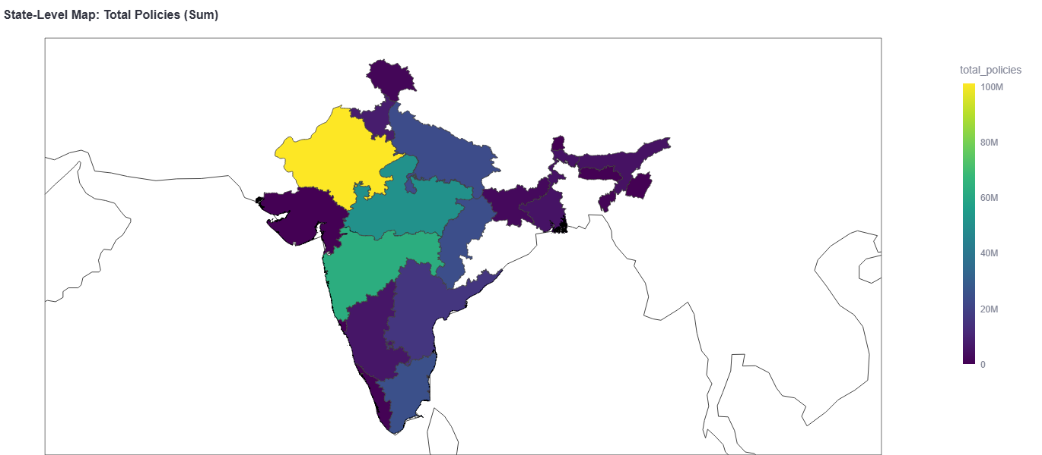
Figure 2. Choropleth map highlighting India’s “Insurance Heartland.”

6.2 Predictive Modeling Performance
Model | MAE (₹) | % Improvement vs. Baseline | % Improvement vs. OLS
Simple Linear | 1,515.83 | — | —
Multiple OLS | 884.00 | 41.7 | —
ANN (Deep Learning) | 766.34 | 49.4 | 13.3
XGBoost (Champion) | 672.19 | 55.7 | 23.9
Table 4. Model Comparison (Test Set)
Model Champion: XGBoost achieved the lowest MAE (₹672.19).
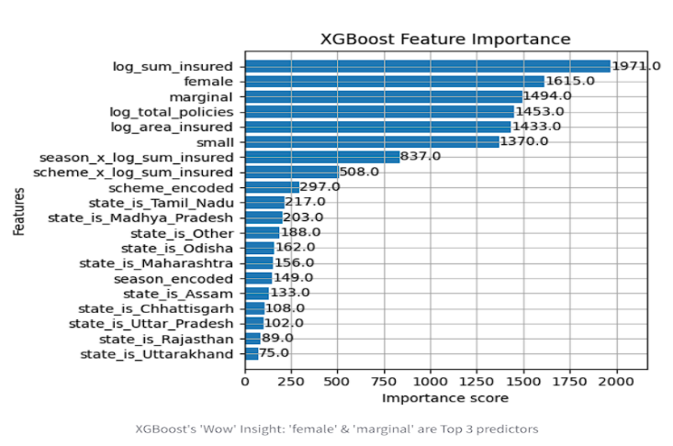
Feature Importance: As shown in Figure 3, female (%) and marginal (%) farmers ranked as the second and third most influential predictors after log_sum_insured, proving the financial significance of social equity variables.
Figure 3. XGBoost feature importance showing demographic equity variables among top predictors.

7. Conclusion and Future Work

7.1 Summary
This study demonstrated a full data science pipeline for crop insurance analytics. It revealed the Vulnerable Farmer Paradox, identified five district archetypes, and proved that equity indicators such as female and marginal participation rates are powerful financial predictors. The XGBoost model outperformed ANN and OLS in accuracy and interpretability.

7.2 Limitations and Future Scope
The main limitation is the absence of claims_paid data. Future work will integrate claims to conduct Loss Ratio Analysis (Claims/Premium) and develop Risk Prediction Models for district-level vulnerability assessment.

8. References
[1] A. K. Mishra, “Challenges in Pradhan Mantri Fasal Bima Yojana (PMFBY) Implementation: A Review,” Agricultural Economics Research Review, vol. 32, no. 1, pp. 119–130, 2019.
[2] S. S. Raju, “Socio-economic factors influencing farmers’ enrollment in Pradhan Mantri Fasal Bima Yojana in India,” Indian Journal of Agricultural Economics, vol. 75, no. 3, pp. 315–328, 2020.
[3] P. Kumar, R. Singh, and V. K. Singh, “Crop Yield Prediction using Machine Learning: A Random Forest Approach,” in Proc. 5th Int. Conf. on Computing Methodologies and Communication (ICCMC), Erode, India, 2021, pp. 1192–1197.
[4] “Pandas – Python Data Analysis Library,” Online: https://pandas.pydata.org/
[5] “Streamlit – The fastest way to build and share data apps,” Online: https://streamlit.io/
[6] T. Chen and C. Guestrin, “XGBoost: A Scalable Tree Boosting System,” in Proc. 22nd ACM SIGKDD Int. Conf. on Knowledge Discovery and Data Mining, 2016, pp. 785–794.

