**Work on windows**

1. Download dataset from kaggle both [emotion](https://www.kaggle.com/datasets/msambare/fer2013) & [drowsiness](https://www.kaggle.com/datasets/ismailnasri20/driver-drowsiness-dataset-ddd)
   1. Download the all files from repository
   2. Open the train model script from repository for emotion and drowsiness in vscode
   3. Download the libraries:
      1. pip install tensorflow
      2. pip install numpy
   4. Adjust the dataset path in train model files
   5. Run the file, one by one –it takes time
   6. After completion it makes .h5 file in same folder
   7. Run the conversion script , update the path of .h5 file in script 🡪it converts .h5 into tflite
2. Install Lubuntu from [website](https://cdimage.ubuntu.com/lubuntu/releases/jammy/release/#:~:text=64%2Dbit%20PC%20(AMD64)%20desktop%20image)
3. Install virtual box from [website](https://www.virtualbox.org/wiki/Downloads#:~:text=VirtualBox%207.0.14%20platform,%E2%80%8BWindows%20hosts)
4. Install virtual box extension pack from [website](https://www.virtualbox.org/wiki/Downloads#:~:text=VirtualBox%207.0.14%20Oracle,All%20supported%20platforms)

Virtual box setting

* Insert ISO File of lubuntu
* CPU 1
* Base Memory 4096 MB

After install lubuntu

* Go to the setting of your machine in virtual box -> USB -> Add usb filter “Quanta Computer”

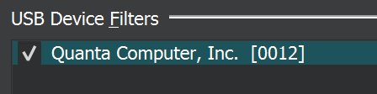

* Go to tools option -> Extension

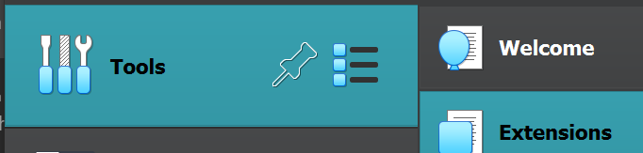

* Add the virtual box extension pack

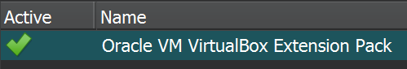

if there is green tick it means you installed correctly

**Work on lubuntu**

1. Installed lubuntu successfully
2. Open terminal and run these commands to install packages

**# Install required packages**

sudo apt-get update

sudo apt update

sudo apt upgrade

sudo apt install python3-pip

**# Install Python packages**

sudo apt install libopencv-dev python3-opencv

pip3 install numpy

pip install tensorflow

pip3 install tflite-runtime

**This assumes that you have Python 3 installed on your Lubuntu machine. If you don't have Python 3, you can install it using:**

sudo apt-get install -y python3

1. Install vscode for Linux , [website](https://code.visualstudio.com/download)
2. Install python extension in vscode
3. Download the files from repository & trained model folder from Gmail which I sent to sir Iqbal

Or

If you trained model by yourself keep the trained model file here and update the path

1. Make a folder on desktop “fyp” keep all files from repository in this folder and also keep trained model folder

As like that:

Fyp 1. Repository files , 🡪 harcascade folder & .py files

2. Trained model 🡪1. drowsiness_detection_model_100epochs_no_opt.tflite

2. emotion_detection_model_100epochs_no_opt.tflite

1. Check the camera option

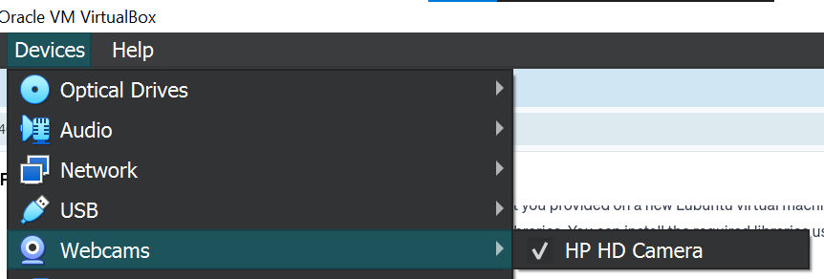

1. Run the “inference_script_emotion_drowsinessV2.py” file for detection

**I write all steps very carefully if there is something that I missed, please let me know. Jazakallah**