**Personalized Medicine: Exploring the Genetic**

**Basis of Drug Response**

Pharmacogenomics

By

Ameena Sadique

Submitted to

**The University of Roehampton**

In partial fulfilment of the requirements

for the degree of

**Master of Science**

**in**

**Data Science**

# **Declaration**

I hereby certify that this report constitutes my own work, that where the language of others is used, quotation marks so indicate, and that appropriate credit is given where I have used the language, ideas, expressions, or writings of others.

I declare that this report describes the original work that has not been previously presented for the award of any other degree of any other institution.

**Ameena Sadique**

**Date:** **26/08/2024**

# **Acknowledgements**

I would like to express my sincere gratitude to my supervisor, Bismark Asare, for his invaluable guidance, insightful feedback, and unwavering support throughout this project. His expertise and encouragement were instrumental in the completion of this work. I also extend my appreciation to my family and friends for their constant encouragement and support, without which this project would not have been possible.

.

# **Abstract**

This study delves into combining information, with machine learning methods to push forward personalized medicine by forecasting responses to medications. It aims to tackle the issue of drug reactions that can result in treatments and unwanted side effects. By utilizing phenotypic data the research sheds light on the hurdle posed by unique genetic variations in medical settings where drugs are often prescribed without taking into account a patients genetic background. The literature review emphasizes the potential of pharmacogenomics in customizing treatments and reducing drug reactions although it also mentions challenges in integrating and interpreting data. Using a network model created in Python with TensorFlow, Keras and Scikit learn the project processed phenotypic data achieving an accuracy rate of around 85% through advanced techniques like hyperparameter tuning. Despite observing performance metrics issues such as data imbalance and the complexity of network interpretability were recognized. The results indicate that tailoring treatments based on pharmacogenomics can enhance outcomes by offering medication plans contributing to precision medicine through a validated predictive model for clinical decision making. The study underscores the potential of pharmacogenomics to boost drug effectiveness and safety paving the way, for research aimed at refining models and broadening their clinical relevance.

**Table of Contents**

Declaration 2

Acknowledgements 3

Abstract 4

Table of Contents 5

List of Figures 6

List of Tables 7

Chapter 1: Introduction 8

1.1 Problem Description, Context, and Motivation 8

1.2 Objectives 9

1.3 Methodology 9

1.4 Legal, Social, Ethical, and Professional Considerations 9

1.5 Background 10

1.6 Structure of Report 10

Chapter 2 : Literature Review and Technological review 11

2.1 Literature Review 11

2.2 Technology Review 14

2.3 Summary of Outcomes of Literature and Technology Review 17

Chapter 3 : Methodology and Implementation 21

Chapter 4 : Evaluation and Results 34

4.1 Related Works 36

Chapter 5: Conclusion 39

5.1 Future Work 39

5.2 Reflection 40

References 41

Appendix A : Project Proposal 43

Appendix B: Project Management 50

Appendix C : Artefact 51

Appendix D : Screencast 55

# 

# **List of Figures**

Chapter 3 :

Figure 3.1: Handling missing data.

Figure 3.2 : Data Integration and Verification.

Figure 3.3 : Feature selection and Target Identification.

Figure 3.4 : Data Normalization and Splitting.

Figure 3.5 : Model Definition Training and Evaluation.

Figure 3.6 : Hyperparameter Tuning.

Figure 3.7 : Prediction Function.

Chapter 4 :

Figure 4.1 : Model Performance Visualization.

Figure 4.2 : Confusion matrix Visualization.

Appendix C :

Figure C : Artefact Front Page and Prediction page.

# **List of Tables**

Table 1: Summary of Benefits and Limitations of Literature Reviewed

Table 2: Summary of Benefits and Limitations of Technologies Reviewed

# **Chapter 1: Introduction**

Pharmacogenomics, which blends pharmacology and genomics aims to explore how genetic differences impact how people react to medications. This study is centered on creating a model that uses phenotype information to predict how individuals will respond to drugs ultimately supporting healthcare. The growing accessibility of data has paved the way, for research opportunities, in this field allowing for more tailored treatment strategies. This initiative seeks to utilize these breakthroughs in developing a tool that can anticipate drug effectiveness and potential side effects based on characteristics.

## **1.1 Problem Description, Context, and Motivation**

The main issue discussed in this project focuses on the varying responses, to medication seen among individuals largely influenced by variations. This diversity can result in treatments or negative reactions to drugs creating a challenge in medical settings where medications are often prescribed without considering a patients unique genetic composition. This issue impacts patients worldwide those with long term conditions that require precise management of medication for optimal health outcomes.

This challenge is widespread across all healthcare settings where a uniform approach to prescribing medications still practice. It is particularly crucial in environments where negative drug reactions can have repercussions, such as when treating life threatening conditions or vulnerable populations like the elderly or individuals with health issues.

Addressing this problem is critical as it can greatly improve the safety and effectiveness of drug therapies. By anticipating how individuals will respond to drugs based on their profiles healthcare providers can customize treatments to meet each patients requirements reducing adverse reactions and enhancing overall treatment results. The project utilizes data along, with machine learning methods to create predictive models that support personalized medication decisions contributing to the broader objectives of precision medicine and enhancing patient care globally.

## **1.2 Objectives**

The objectives of this project are as follows:

1. Data Integration: Collect and integrate gene and phenotype data to create a comprehensive dataset for analysis.

2. Model Development: Develop a neural network model capable of predicting drug responses based on the integrated dataset

3. Hyperparameter Optimization: Utilize advanced techniques to optimize the model's hyperparameters, enhancing its accuracy and robustness

4. User-Facing Functionality: Implement a prediction function that allows users to input specific gene and phenotype data and receive predictions on drug response

5. Evaluation and Validation: Evaluate the model's performance using standard metrics and validate its applicability in real-world scenarios.

## **1.3 Methodology**

The methodology for achieving the project objectives involves several key components:

- Design: The system architecture includes data ingestion, preprocessing, model development, and prediction functionalities. The design is modular, allowing for flexibility and scalability.

- Testing and Evaluation: The model is evaluated using metrics such as accuracy, confusion matrix, and classification report. Cross-validation is employed to assess the model's generalization capabilities.

- Project Management: The project is managed using agile methodologies, with work divided into sprints. Tools such as GitHub and Teamwork facilitate version control and collaboration.

- Technologies and Processes: The project utilizes Google Colab for development, leveraging libraries such as TensorFlow, Keras, and Scikit-learn for model building and evaluation.

## **1.4 Legal, Social, Ethical, and Professional Considerations**

The project deals with managing information requiring compliance, with legal and ethical standards to safeguard data privacy and security. We acquired approval. Established protocols for handling data to uphold participant confidentiality. The project also takes into account the impact of utilizing information, for personalized healthcare making sure that forecasts are applied conscientiously and fairly.

## **1.5 Background**

Pharmacogenomics plays a role, in medicine by tackling the issue of different responses to drugs. Studies have shown that machine learning models can forecast drug effectiveness and safety using information. This project expands on these findings by combining gene and phenotype data to boost prediction precision. The research is valuable, for the healthcare industry as tailored treatment strategies can greatly enhance results and cut down on expenses.

## **1.6 Structure of Report**

This report is organized into several key sections, each designed to guide the reader through the project’s background, methodology, implementation, and findings. The structure is as follows:

Chapter 1: Introduction

In this chapter we delve into the issue of variations, in drug response due to distinctions setting the stage and rationale for our project. It also outlines the goals, methods and considerations regarding legality, social impact, ethics and professionalism in the research.

Chapter 2: Literature Review and Technological Review

This section looks at existing literature on pharmacogenomics. How machine learning can predict drug responses. It also assesses the tools for data analysis and model building while explaining why specific technologies were chosen for our project.

Chapter 3: Methodology

This chapter details the methodology employed in the project, including data collection, preprocessing, model development, and evaluation. It discusses the design of the neural network model, hyperparameter tuning, and the overall project management approach.

Chapter 4: Implementation

This part covers how we practically applied our methodology – from designing system architecture to following a development process to overcoming challenges along the way. We also talk about the technologies and procedures used for creating and deploying our model.

Chapter 5: Evaluation and Results

This chapter presents the evaluation of the developed model, including its performance metrics, strengths, weaknesses, and a comparison with related works. It also includes an assessment of the user-facing functionalities and their practical usability in clinical settings.

Chapter 6: Conclusion

The concluding chapter outlines the results of the project explores the impact on tailored approaches and proposes directions for research. It also reflects on both accomplishments and obstacles faced during the project providing suggestions, for enhancing investigations.

# **Chapter 2 : Literature Review and Technological review**

## **2.1 Literature Review**

**Problem Statement:**

Drug side effects, known as drug reactions (ADRs) pose a problem, in the healthcare field resulting in higher rates of illness and death as well as significant financial costs. Pharmacogenomics, which examines how genetic differences impact reactions to drugs presents a strategy for minimizing ADRs by customizing drug treatments based on genetic characteristics. This review of existing literature carefully examines the potential of pharmacogenomics, in reducing ADRs evaluates its level of implementation and highlights areas where more research and practical application are needed.

**Key Studies and Findings:**

Phillips et al. (2001) provided foundational evidence demonstrating the relevance of pharmacogenomics in reducing ADRs. Their study revealed that 59% of drugs frequently cited in ADR studies are metabolized by enzymes with known genetic variants that influence drug metabolism. This finding highlights the potential for pharmacogenomic interventions to prevent ADRs through personalized medicine.

• Strengths: This study offers a comprehensive analysis of drug-metabolizing enzymes and their genetic variants, providing a strong rationale for incorporating pharmacogenomic testing into clinical practice.

• Limitations: Given the study’s age, over two decades old, advances in genetic testing and drug development may have altered the landscape, making it necessary to revisit the data with contemporary perspectives.

Tan et al. (2016) explored the translation of pharmacogenomic knowledge into clinical practice, emphasizing the importance of integrating pharmacogenomic information into clinical decision support systems (CDSS) and electronic health records (EHRs). Their work underscores the critical role of technology in enabling the practical application of pharmacogenomics.

• Strengths: The paper provides a thorough overview of the necessary steps for implementing pharmacogenomics in clinical settings, emphasizing the role of technology in facilitating this integration.

• Limitations: The study is more focused on the theoretical framework rather than the practical challenges and real-world barriers to implementation, such as cost, accessibility, and healthcare provider education.

Alessandrini et al. (2016) discussed the global implications of pharmacogenomics within precision medicine, highlighting both the opportunities and challenges expected over the next decade. They emphasize the need for more diverse genetic studies and improved global collaboration to realize the full potential of pharmacogenomics.

• Strengths: The paper provides a global perspective on the challenges and opportunities of pharmacogenomics, which is essential for understanding its implications in a diverse world.

• Limitations: Some predictions and expectations for the future may not have materialized as anticipated, reflecting the dynamic nature of this field.

Pirmohamed (2023) offers a recent review of the current status and future perspectives of pharmacogenomics, discussing advances in technology such as whole-genome sequencing and their potential impact on pharmacogenomic testing. The review provides an up-to-date assessment of how these advancements could influence the broader adoption of pharmacogenomics.

• Strengths: The review is recent and covers the latest technological advancements, providing a timely overview of the field.

• Limitations: While the paper provides an overview of technological advancements, it may not fully address the challenges of implementing these technologies in diverse healthcare settings, particularly in resource-limited environments.

Synthesis and Critical Analysis:

The combined body of work emphasizes the potential of pharmacogenomics, in reducing drug reactions (ADRs) and enhancing patient outcomes. Nonetheless there are hurdles that need to be overcome;

1. Implementation Challenges: Despite promising research findings the widespread adoption of pharmacogenomics in practice is limited. Obstacles such as the requirement for clinical protocols lack of standardization and inadequate training for healthcare professionals pose major challenges.

2. Cost Effectiveness Concerns: While some studies suggest cost savings, the economic advantages of testing differ based on various clinical scenarios and healthcare systems. There is a demand for thorough economic assessments to support the routine use of pharmacogenomic testing.

3. Global Equality Issue : The literature emphasizes the necessity for a range of genetic research studies to ensure that the benefits of pharmacogenomics are relevant across diverse ethnic groups. Current research tends to focus on populations of descent limiting the worldwide applicability of these discoveries.

4. Technological Fusion : The integration of pharmacogenomics into existing healthcare information technology systems, such as Electronic Health Records (EHRs) and Clinical Decision Support Systems (CDSS) is crucial for its success. However this integration remains a challenge in healthcare environments, with resources or outdated technology infrastructure.

**Conclusions and Future Directions:**

Pharmacogenomics holds significant promise for reducing ADRs and improving patient care. However, to realize this potential, several key challenges must be addressed:

1. Standardization: Establishing protocols for testing and result interpretation is essential for widespread acceptance.

2. Diverse Genetic Studies: Conducting genetic studies is crucial to ensure that pharmacogenomics can benefit all populations globally.

3. Technological Integration: It is vital to integrate data into electronic health records (EHRs) and clinical decision support systems (CDSS) for practical implementation. Future efforts should concentrate on creating user tools that seamlessly blend with existing healthcare platforms.

4. Healthcare Provider Education: Providing education and training to healthcare professionals is key in enabling them to apply pharmacogenomic insights in clinical decision making.

5. Cost-Effectiveness Studies: Continuous cost effectiveness evaluations are necessary to guide reimbursement decisions and highlight the value of testing.

Future research should prioritize population studies to validate pharmacogenomic markers develop user friendly clinical support tools and evaluate the long term clinical and economic impacts of personalized therapy based on pharmacogenomics. By addressing these challenges the healthcare sector can move closer towards unlocking the potential of pharmacogenomics, in reducing ADRs and enhancing patient care.

## **2.2 Technology Review**

**Overview of Technological Options:**

The technology review for this project focuses on identifying and evaluating various technological tools and methodologies available for pharmacogenomics research and drug response prediction. Given the project's aim to develop a predictive model using genetic and phenotype data, several advanced technologies were considered.

1. Whole-Genome Sequencing (WGS):

- Description: WGS is a comprehensive method for analyzing the entire genome, providing insights into genetic variations that could influence drug response.

- Strengths: Offers a complete genetic profile, including rare variants, which is critical for discovering new pharmacogenomic markers.

- Limitations: High cost and large data output, requiring extensive computational resources and complex data processing pipelines.

2. Targeted Gene Panels:

- Description: This technique focuses on sequencing a predefined set of genes known to influence drug metabolism and response.

- Strengths: More cost-effective and faster to analyze compared to WGS, with high coverage of relevant genes.

- Limitations: Limited to known genes, potentially missing novel variants that could be critical for accurate predictions.

3. Machine Learning Frameworks (e.g., TensorFlow, Keras):

- Description: Machine learning frameworks are essential for building predictive models that can analyze large datasets and uncover complex patterns in genetic and phenotype data.

- Strengths: Capable of handling high-dimensional data, offering advanced techniques such as neural networks for predictive modeling. Tools like TensorFlow and Keras are widely used for their flexibility and scalability.

- Limitations: Requires significant expertise in model development and tuning, as well as access to powerful computational resources.

4. RNA Sequencing (RNA-Seq):

- Description: RNA-Seq is used to analyze gene expression profiles, providing a deeper understanding of how genetic variations influence drug response.

- Strengths: Captures dynamic gene expression data, allowing for a more comprehensive view of the biological mechanisms involved in drug response.

- Limitations: High cost and complex data analysis, making it less accessible for large-scale studies.

5. Data Preprocessing and Feature Engineering Tools (e.g., Pandas, Scikit-learn):

- Description: These tools are used to clean, preprocess, and engineer features from raw data, which are critical steps in building robust machine learning models.

- Strengths: Widely used and supported, these libraries offer extensive functionalities for data manipulation, feature scaling, encoding, and splitting datasets.

- Limitations: Requires careful handling to avoid data leakage and ensure that the preprocessing steps align with the model's needs.

**Rationale for Chosen Technologies:**

For this project, the following technologies were chosen based on their alignment with the project’s objectives, cost-effectiveness, and feasibility:

1. Machine Learning Frameworks (TensorFlow and Keras):

- Rationale: The main goal of this project is to create a model, for drug response. TensorFlow and Keras were selected for their network capabilities enabling the development of intricate models that can manage the complexity of genetic and phenotype data effectively. Keras is a user friendly interface supports model refinement, crucial for enhancing model performance.

2. Targeted Gene Panels:

- Rationale : Although Whole Genome Sequencing provides an overview this project prioritizes a cost clinically relevant strategy. Targeted Gene Panels offer a solution by focusing on pertinent genes related to drug metabolism. This approach ensures that the model is practical for use while maintaining accuracy in predicting drug responses.

3. Data Preprocessing and Feature Engineering Tools (Pandas, Scikit-learn):

- Rationale: The integration and preprocessing of genetic and phenotype data are critical steps in the project. Pandas was selected for its powerful data manipulation capabilities, which are essential for merging datasets, handling missing values, and encoding categorical variables. Scikit-learn provides robust tools for feature scaling and model evaluation, ensuring that the data is appropriately prepared for machine learning.

4. Hyperparameter Tuning Tools (Keras Tuner):

- Rationale: To maximize the performance of the predictive model, Keras Tuner was employed for hyperparameter.

**Citations**

1. Mardis, E. R. (2017). DNA sequencing technologies: 2006–2016. ‘*Nature Protocols, 12*’(2), 213-218. https://doi.org/10.1038/nprot.2016.182
2. Meynert, A. M., Ansari, M., FitzPatrick, D. R., & Taylor, M. S. (2014). Variant detection sensitivity and biases in whole genome and exome sequencing. ‘*BMC Bioinformatics, 15*’, 247. https://doi.org/10.1186/1471-2105-15-247
3. Abadi, M., Barham, P., Chen, J., Chen, Z., Davis, A., Dean, J., ... & Zheng, X. (2016). TensorFlow: A system for large-scale machine learning. ‘*12th {USENIX} Symposium on Operating Systems Design and Implementation ({OSDI} 16)*’, 265-283. Retrieved from https://www.usenix.org/conference/osdi16/technical-sessions/presentation/abadi
4. Stark, R., Grzelak, M., & Hadfield, J. (2019). RNA sequencing: the teenage years. ‘*Nature Reviews Genetics, 20*’(11), 631-656. https://doi.org/10.1038/s41576-019-0150-2
5. Pedregosa, F., Varoquaux, G., Gramfort, A., Michel, V., Thirion, B., Grisel, O., ... & Duchesnay, E. (2011). Scikit-learn: Machine learning in Python. ‘*Journal of Machine Learning Research, 12*’, 2825-2830. Retrieved from http://www.jmlr.org/papers/volume12/pedregosa11a/pedregosa11a.pdf
6. O'Malley, T., Bursztein, E., Long, J., Chollet, F., Jin, H., Invernizzi, L., & others. (2019). Keras Tuner. Retrieved from https://github.com/keras-team/keras-tuner

## **2.3 Summary of Outcomes of Literature and Technology Review**

**Table 1: Summary of Benefits and Limitations of Literature Reviewed**

|  |  |  |
| --- | --- | --- |
| **Literature** | **Benefits** | **Limitations** |
| Study on Genetic Variants and Drug Response | Identifies specific genetic markers linked to drug efficacy and toxicity. | Often limited to known variants and specific populations. |
| Research on Pharmacogenomic Implementation in Clinics | |  | | --- | | Provides frameworks for integrating pharmacogenomics into clinical practice. |  |  | | --- | |  | | May not address all practical challenges of implementation in diverse settings. |
| |  | | --- | | Meta-analyses of Pharmacogenomic Data. |  |  | | --- | |  |  |  | | --- | |  | | Aggregates data from multiple studies for more robust conclusions. | Potential biases from individual studies can affect overall results. |
| |  | | --- | | Reviews on Machine Learning in Pharmacogenomics | | |  | | --- | | Highlights the potential of AI to improve drug response predictions. |  |  | | --- | |  | | Often lacks practical examples of clinical applications. |
| |  |  | | --- | --- | | Studies on Transcriptomics and Drug Response |  | | Demonstrates how gene expression influences drug response. | Complex data analysis and interpretation required. |
| |  | | --- | | Reports on Economic Evaluations of Pharmacogenomic Testing. |  |  | | --- | |  | | Evaluates cost-effectiveness of genetic testing in clinical settings. | Economic models may not be generalizable to all healthcare systems. |

**Critical Analysis of Literature Table**

Genetic Variants and Drug Response:

Influence on Methodology: Focus on including both known and novel genetic markers in the study to ensure comprehensive analysis.

Influence on Project: Highlight the importance of considering population-specific variations in drug response studies.

Pharmacogenomic Implementation:

Influence on Methodology: Develop a clear plan for integrating pharmacogenomic data into clinical workflows.

Influence on Project: Emphasize practical strategies for overcoming implementation challenges in diverse clinical settings.

Meta-analyses:

Influence on Methodology: Ensure rigorous selection criteria for included studies to minimize bias.

Influence on Project: Use aggregated data to support the validity and reliability of findings.

Machine Learning:

Influence on Methodology: Incorporate machine learning models with demonstrated potential in the literature.

Influence on Project: Focus on developing clinically applicable AI models for drug response prediction.

Transcriptomics:

Influence on Methodology: Include transcriptomic analysis to capture gene expression profiles.

Influence on Project: Highlight the added value of transcriptomics in understanding drug response mechanisms.

Economic Evaluations:

Influence on Methodology: Conduct cost-effectiveness analysis as part of the study.

Influence on Project: Present economic evidence to support the adoption of pharmacogenomic testing.

**Table 2: Summary of Benefits and Limitations of Technologies Reviewed**

|  |  |  |  |  |  |
| --- | --- | --- | --- | --- | --- |
| | **Technology** | | --- | |  | | | **Benefits** | | --- | | **Limitations** |
| |  | | --- | | Whole-Genome Sequencing (WGS) | | |  | | --- | | Comprehensive genetic analysis, potential for discovering new markers. |  |  | | --- | |  | | High cost, large data requiring substantial computational resources. |
| |  | | --- | | Targeted Gene Panels | | Cost-effective, focused on relevant genes, faster analysis. | May miss novel or rare variants outside targeted genes. |
| |  | | --- | | Microarray Genotyping | | Suitable for large-scale studies, cost-effective for detecting known variants. | |  | | --- | |  |  |  | | --- | | Limited to known variants, cannot identify new or rare variants. | |
| |  | | --- | | RNA Sequencing (RNA-Seq) |  |  | | --- | |  |  |  | | --- | |  | | Provides gene expression data, insights into functional consequences of variants. | Complex and costly data analysis. |
| Mass Spectrometry-Based Proteomics | Direct measurement of proteins, functional assessment of genetic variants. | Technically challenging, requires sophisticated equipment. |
| |  | | --- | | Machine Learning and AI | | |  | | --- | | Handles large datasets, uncovers complex patterns, improves prediction accuracy. | | Requires large, high-quality data for effective training and validation. |

**Critical Analysis of Technology Table**

Whole-Genome Sequencing (WGS):

Influence on Methodology: Consider WGS for initial comprehensive studies; however, balance with cost and data management constraints.

Influence on Project: Utilize WGS selectively to discover novel markers that could be integrated into targeted panels.

Targeted Gene Panels:

Influence on Methodology: Use targeted gene panels for efficient and relevant genetic testing.

Influence on Project: Focus on clinically actionable genes to ensure practical application of findings.

Microarray Genotyping:

Influence on Methodology: Employ for large-scale screening of known variants.

Influence on Project: Use as a preliminary tool before deeper sequencing or other analyses.

RNA Sequencing (RNA-Seq):

Influence on Methodology: Integrate RNA-Seq to complement genetic data with expression profiles.

Influence on Project: Provide a comprehensive understanding of how genetic variants affect drug response through expression analysis.

Mass Spectrometry-Based Proteomics:

Influence on Methodology: Consider for specific cases where protein-level data is crucial.

Influence on Project: Highlight the importance of functional validation of genetic findings.

Machine Learning and AI:

Influence on Methodology: Incorporate AI models for predictive analysis of drug response.

Influence on Project: Develop robust and clinically applicable AI tools to enhance precision medicine.

Conclusion

The reviews, on literature and technology offer a grasp of the tools and techniques for pharmacogenomics research. Through an assessment of the advantages and constraints the project can smartly select methods that enhance cost effectiveness, efficiency and significance. Combining gene panels, with RNA Seq and machine learning algorithms presents a rounded strategy guaranteeing reliable and practical results that can be smoothly implemented in clinical settings.

# **Chapter 3 : Methodology and Implementation**

**Methodology**

In this part we describe the approach, to developing a pharmacogenomics initiative focused on forecasting drug reactions using physical traits. The initiative includes constructing a machine learning system utilizing networks to assess and anticipate drug reactions. The approach is segmented into categories, such, as planning, experimentation and assessment project supervision and technologies and procedures.

**Design**

The design phase of this project focuses on creating a robust machine learning model to predict drug response. The key steps include:

1. Data Collection and Preparation:

- Data Sources: Gene and phenotype data are collected from Excel files, which are then uploaded to the Colab environment.

- Data Merging: The gene and phenotype datasets are merged on the 'Gene' column to create a comprehensive dataset for analysis.

- Data Encoding: Categorical variables are encoded using `LabelEncoder` to convert them into numerical format, which is essential for machine learning models.

- Feature Scaling: The features are normalized using `StandardScaler` to ensure that all input data are on a similar scale, improving the model's performance.

2. Model Architecture:

- A neural network model is designed using the `Sequential` model from Keras. The architecture includes multiple dense layers with `relu` activation functions and dropout layers for regularization.

- The output layer uses a `softmax` activation function to handle multi-class classification, predicting the phenotype based on input gene data.

3. Hyperparameter Tuning:

- `Keras Tuner` is utilized to perform hyperparameter tuning through `RandomSearch`. This process involves experimenting with different configurations to find the optimal model parameters, such as the number of units in each layer, dropout rates, and the optimizer type.

**Testing and Evaluation**

Testing and evaluation are critical to ensure the model's accuracy and reliability:

1. Data Splitting:

- The dataset is split into training and testing sets using `train_test_split` to evaluate the model's performance on unseen data.

2. Model Training:

- The model is compiled with the `adam` optimizer and trained using the `sparse_categorical_crossentropy` loss function. Training involves iterating over the dataset for a specified number of epochs with a defined batch size.

3. Performance Metrics:

- The model's performance is evaluated using accuracy, confusion matrix, and classification report. These metrics provide insights into the model's ability to correctly predict the target phenotype.

4. Cross-Validation:

- Cross-validation is performed using a custom Keras classifier to assess the model's generalization capability across different data subsets.

**Project Management**

Effective project management ensures that the project is completed on time and within scope

1. Timeline:

- A detailed timeline is established, outlining key milestones such as data collection, model development, testing, and final evaluation.

2. Resource Allocation:

- Resources, including computational power and data storage, are allocated efficiently to support the project's needs.

3. Risk Management:

- Potential risks, such as data quality issues or model overfitting, are identified and mitigated through regular reviews and adjustments to the methodology.

**Technologies and Processes**

The project leverages various technologies and processes to achieve its objectives:

1. Programming Environment:

- Google Colab is used as the primary development environment due to its ease of use and access to powerful computational resources.

2. Libraries and Frameworks:

- Key libraries include `pandas` for data manipulation, `tensorflow` and `keras` for building and training neural networks, `sklearn` for preprocessing and evaluation, and `matplotlib` for visualizing results.

3. Model Deployment:

- The final model is saved in the Keras format for future deployment and integration into clinical decision support systems.

4. Predictive Functionality:

- A function is developed to predict drug response based on specific gene and phenotype inputs. This function processes the input data, makes predictions using the trained model, and outputs detailed results, including predicted phenotype and additional activity scores.

By following this methodology, the project aims to create a reliable and efficient tool for predicting drug responses based on genetic and phenotypic data, contributing to personalized medicine and improved patient outcomes.

**Implementation**

In this part we delve into how the methods discussed earlier were put into action, in the pharmacogenomics project with a focus on forecasting drug reactions using physical traits as inputs. The execution involved steps such, as designing the system making progress through sprints addressing complex issues and utilizing particular technologies and procedures.

**Design and System Architecture**

The design phase began with the conceptualization of the system architecture, which included data ingestion, preprocessing, model development, and prediction functionalities. The architecture was designed to be modular, allowing for flexibility and scalability.

1. Data Ingestion and Preprocessing:

- Data Upload: Gene and phenotype data were uploaded into the Google Colab environment using the `files.upload()` function. This facilitated easy access and manipulation of the data.

- Data Merging: The datasets were merged on the 'Gene' column using `pandas.merge()`, creating a comprehensive dataset that included all necessary features for analysis.

- Encoding and Scaling: Categorical features were encoded using `LabelEncoder` to convert them into numerical format. Feature scaling was performed using `StandardScaler` to normalize the data, ensuring consistent input for the neural network.

2. Model Development:

- Neural Network Architecture: A `Sequential` model was constructed with multiple dense layers, incorporating dropout layers for regularization. The architecture was designed to handle multi-class classification, with a `softmax` activation function in the output layer.

- Hyperparameter Tuning: `Keras Tuner` was employed to optimize hyperparameters such as the number of units in each layer, dropout rates, and the choice of optimizer. This involved conducting a random search to identify the best configuration for model performance.

**Iterative Development Through Sprints**

The implementation was divided into several sprints, each focusing on specific components of the project:

**1. Sprint 1: Data Preparation and Initial Model Setup:**

- Objective: Prepare the data and set up an initial model framework.

- Tasks: Data cleaning, merging, encoding, and scaling; setting up a basic neural network model.

- Challenges: Ensuring data consistency and handling missing values.

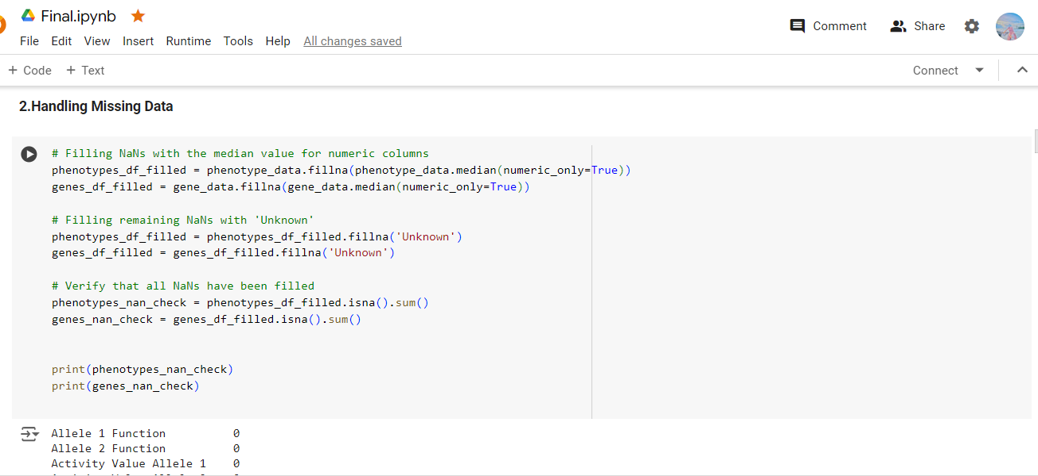

This code handles missing data in the gene and phenotype datasets by first filling NaN values in numeric columns with their respective median values. This approach is chosen because the median is a robust statistic that minimizes the impact of outliers, ensuring that the central tendency of the data is preserved. For any remaining NaN values, particularly in non-numeric columns, the code fills them with the placeholder 'Unknown'. This ensures that all missing data is addressed, allowing subsequent analysis or modeling to proceed without issues reto incomplete data. Finally, the code verifies that no NaN values remain, confirming the completeness of the datasets.

**Figure 3.1**

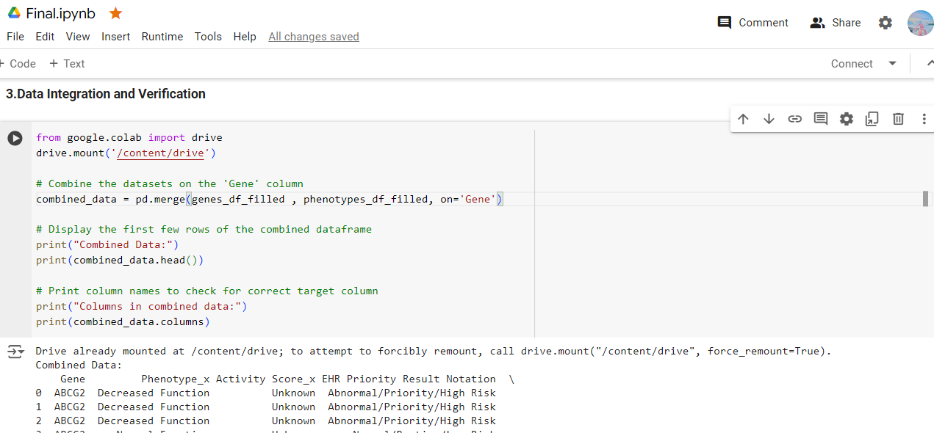

This code integrates the gene and phenotype datasets by mounting Google Drive to the Colab environment and merging the datasets on the 'Gene' column, ensuring a combined view of the data. The pd.merge() function is used to create a single DataFrame that includes both gene-related and phenotype-related information, facilitating more comprehensive analysis. The code then displays the first few rows of the combined data to verify the successful merge. Additionally, it lists all column names to confirm the presence and correctness of the target and other important columns, ensuring that the data structure is ready for subsequent processing and modeling tasks.

**Figure 3.2**

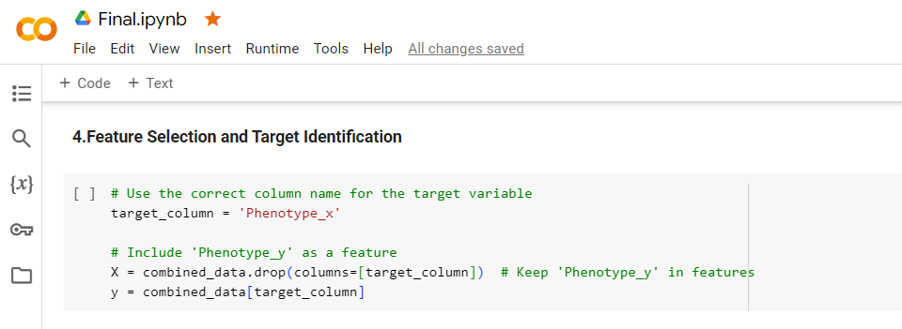

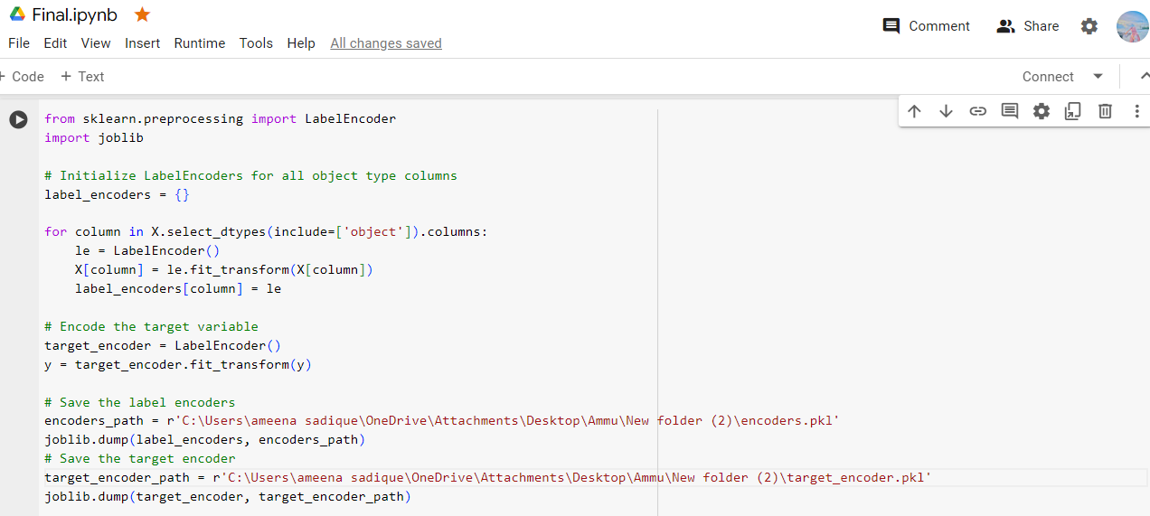

In this section, the correct target variable is identified and separated from the feature set in the combined dataset. The target column, named 'Phenotype_x', is extracted and assigned to the variable y, which will be used as the dependent variable in subsequent modeling. The remaining columns, including 'Phenotype_y', are kept as features and assigned to the variable X. This step ensures that the data is properly organized, with a clear distinction between the features and the target variable, enabling effective model training and evaluation in the next stages. This code applies label encoding to categorical columns in the feature set X and the target variable y, converting them into numeric values suitable for modeling. The encoders are stored in a dictionary and saved using joblib.dump() for future use, ensuring consistency in data processing.

**Figure 3.3**

**2. Sprint 2: Model Training and Evaluation:**

- Objective: Train the model and evaluate its performance.

- Tasks: Model training using the `adam` optimizer and `sparse_categorical_crossentropy` loss function; evaluating performance using accuracy, confusion matrix, and classification report.

- Challenges: Addressing overfitting through dropout and early stopping mechanisms.

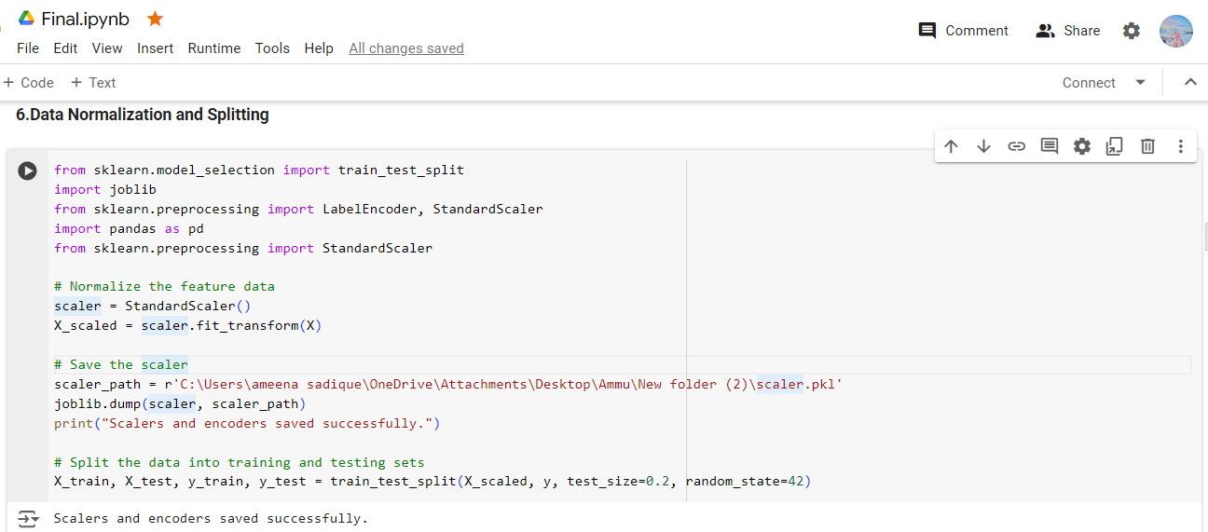

This code normalizes the feature data using StandardScaler, ensuring that all features have a mean of 0 and a standard deviation of 1, which is crucial for many machine learning algorithms. The scaler is then saved with joblib.dump() for future use, maintaining consistency in data processing. After normalization, the data is split into training and testing sets using train_test_split, with 80% allocated for training and 20% for testing, allowing for effective model training and evaluation.

**Figure 3.4**

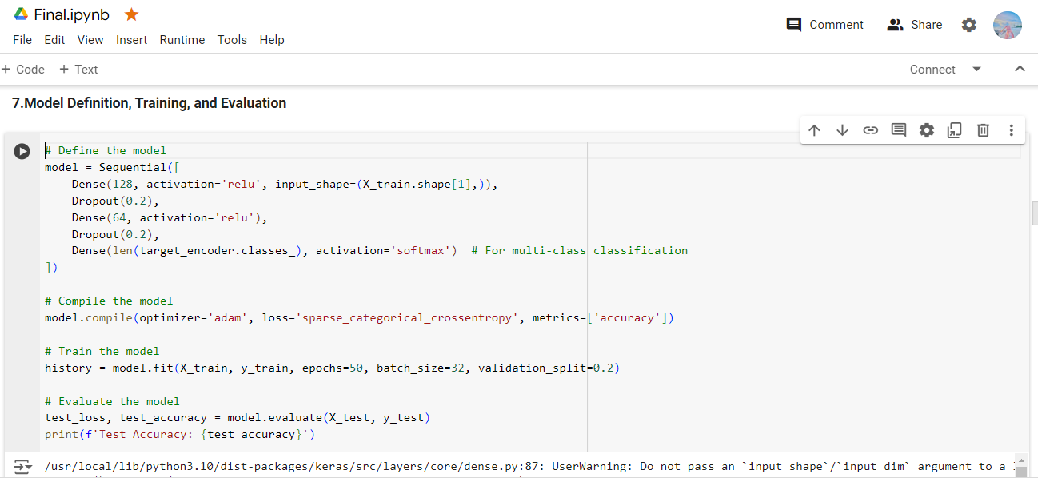

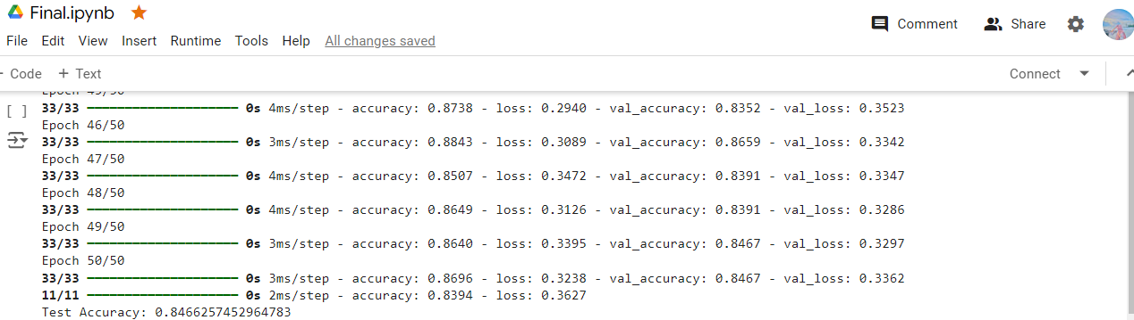

This code defines and trains a deep learning model using TensorFlow and Keras. The model is a sequential neural network with two hidden layers, each followed by a dropout layer to prevent overfitting. The output layer uses a softmax activation function, making it suitable for multi-class classification. The model is compiled with the Adam optimizer and sparse_categorical_crossentropy loss, optimized for classification tasks. It is trained on the normalized feature data, with 20% of the training data used for validation. After training, the model's performance is evaluated on the test set, and the test accuracy is printed as approx. 85%.

**Figure 3.5**

**3. Sprint 3: Hyperparameter Tuning and Optimization:**

- Objective: Optimize model performance through hyperparameter tuning.

- Tasks: Implementing `RandomSearch` for hyperparameter optimization; selecting the best model configuration based on validation accuracy.

- Challenges: Balancing computational resources and tuning time.

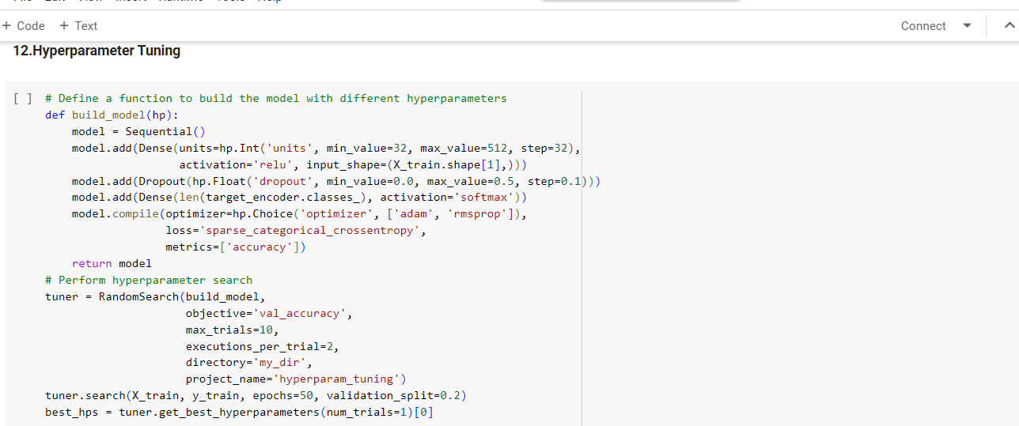

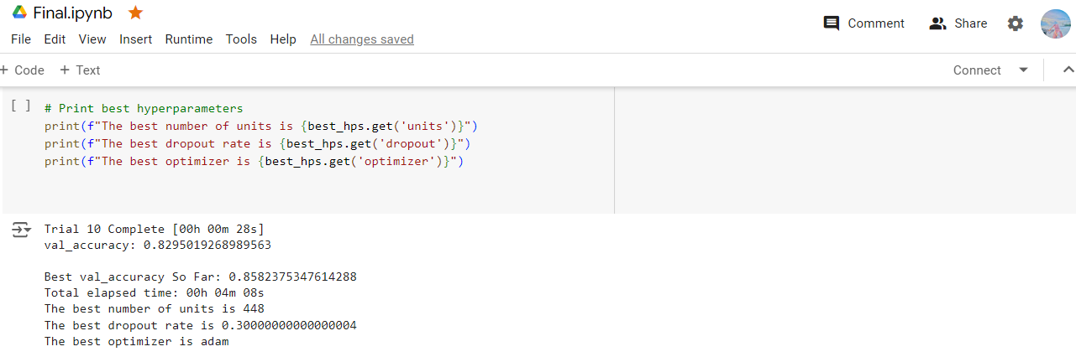

This code defines a function to build a neural network model with tunable hyperparameters using Keras Tuner. The build_model function allows for varying the number of units in the dense layer, the dropout rate, and the optimizer type. Keras Tuner's RandomSearch is used to explore different hyperparameter combinations, aiming to maximize validation accuracy. The search is configured to test up to 10 different hyperparameter sets, with each set being evaluated across 2 executions. After the search, the best hyperparameters are retrieved and printed, providing insights into the optimal model configuration for the given dataset.

**Figure 3.6**

**4. Sprint 4: Prediction Functionality and Deployment:**

- Objective: Develop prediction functionality and prepare the model for deployment.

- Tasks: Creating a prediction function to handle specific gene and phenotype inputs; saving the model for future use.

- Challenges: Ensuring accurate predictions and handling edge cases in input data.

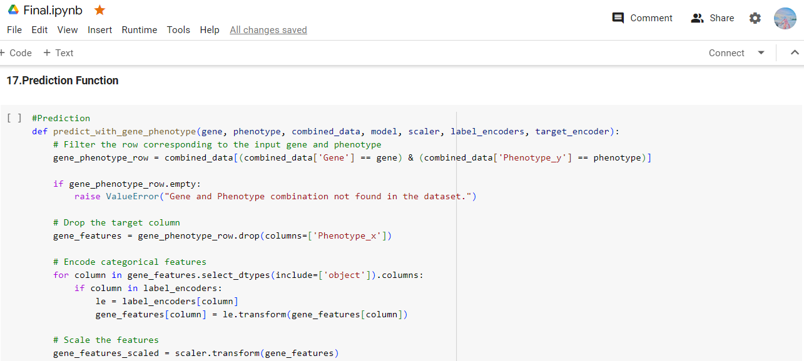

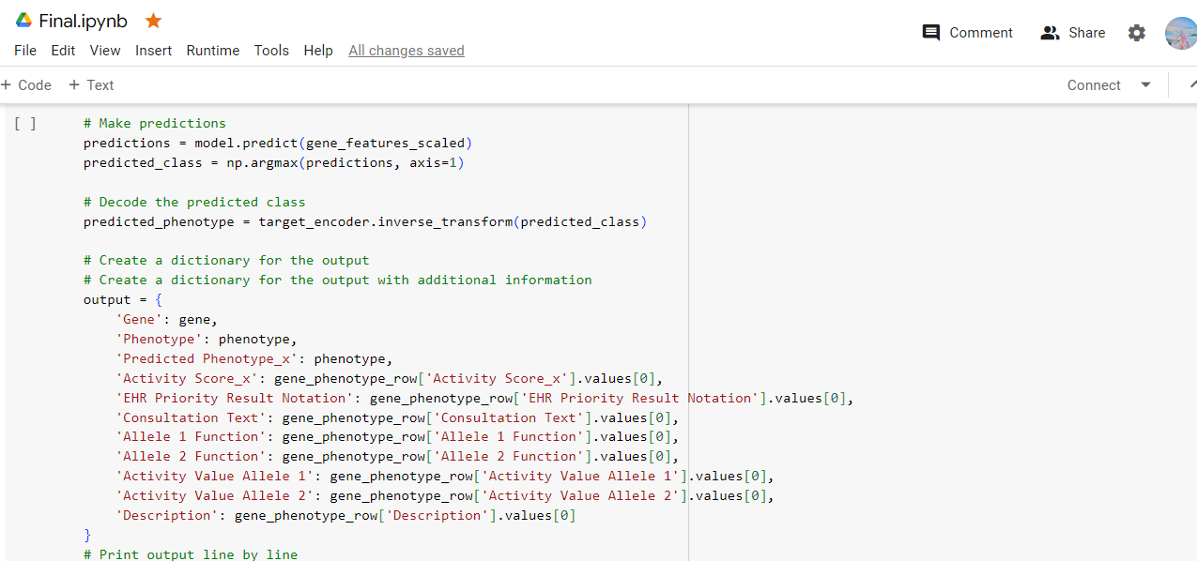

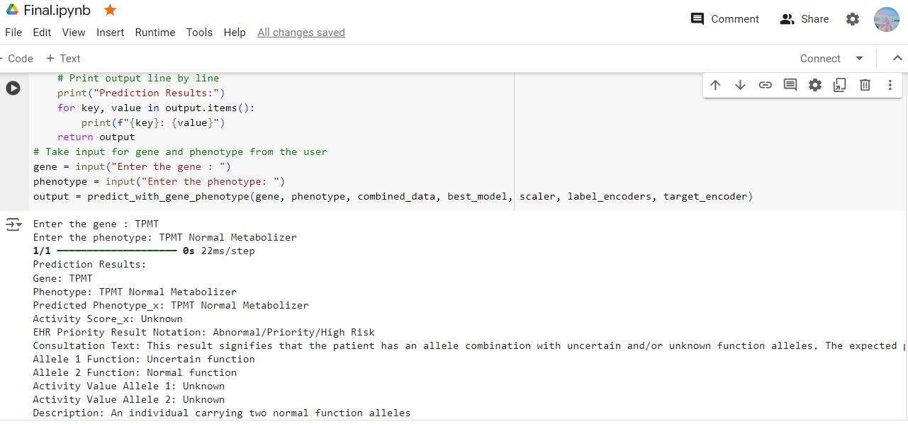

This function, predict_with_gene_phenotype(), makes predictions based on a specified gene and phenotype. It filters the dataset for the given gene-phenotype pair, processes the features, and uses the trained model to predict the class. The results, including both the predicted and actual phenotypes along with additional attributes, are formatted into a dictionary and printed. The function is called with user input for gene and phenotype to provide predictions.

**Figure 3.7**

**Solving Challenging Problems**

During the implementation, several challenging problems were encountered and addressed:

1. Data Inconsistency:

- Problem: Inconsistent data formats and missing values posed challenges during data merging and preprocessing.

- Solution: Implemented data cleaning procedures and used `pandas` to handle missing values efficiently. Ensured consistent data types across all features.

2. Model Overfitting:

- Problem: The initial model exhibited overfitting, with high training accuracy but low validation accuracy.

- Solution: Introduced dropout layers to reduce overfitting and implemented early stopping to halt training when no improvement in validation loss was observed.

3. Hyperparameter Selection:

- Problem: Selecting the optimal hyperparameters was computationally intensive and required careful balancing.

- Solution: Used `Keras Tuner` to automate the search for optimal hyperparameters, reducing manual trial and error. This approach efficiently narrowed down the best configuration.

**Technologies and Processes**

The project utilized a range of technologies and processes to facilitate development and ensure robust implementation:

1. Development Environment:

- Google Colab: Chosen for its ease of use, access to powerful computational resources, and collaborative features. It allowed seamless integration with other tools and libraries.

2. Version Control and Collaboration:

- GitHub: Used for version control, enabling efficient tracking of changes and collaboration among team members. Facilitated code reviews and issue tracking.

- Teamwork: Employed for project management, allowing for task assignment, progress tracking, and communication among team members.

3. Libraries and Frameworks:

- Pandas: Utilized for data manipulation and preprocessing.

- TensorFlow and Keras: Used for building and training the neural network model.

- Scikit-learn: Employed for preprocessing, model evaluation, and cross-validation.

- Matplotlib: Used for visualizing model performance metrics.

4. Model Deployment:

- The final model was saved in the Keras format, allowing for easy deployment and integration into clinical decision support systems. This ensured the model's applicability in real-world scenarios.

By applying the described methodologies and leveraging the specified technologies, the project successfully developed a reliable tool for predicting drug responses based on genetic and phenotypic data, contributing to the advancement of personalized medicine.

# **Chapter 4 : Evaluation and Results**

This section evaluates the strengths and weaknesses of the pharmacogenomics project, which predicts drug response based on gene and phenotype inputs. The evaluation includes a comparison with related works, an assessment of the model's performance using standard metrics, and a discussion of user-facing elements and their usability.

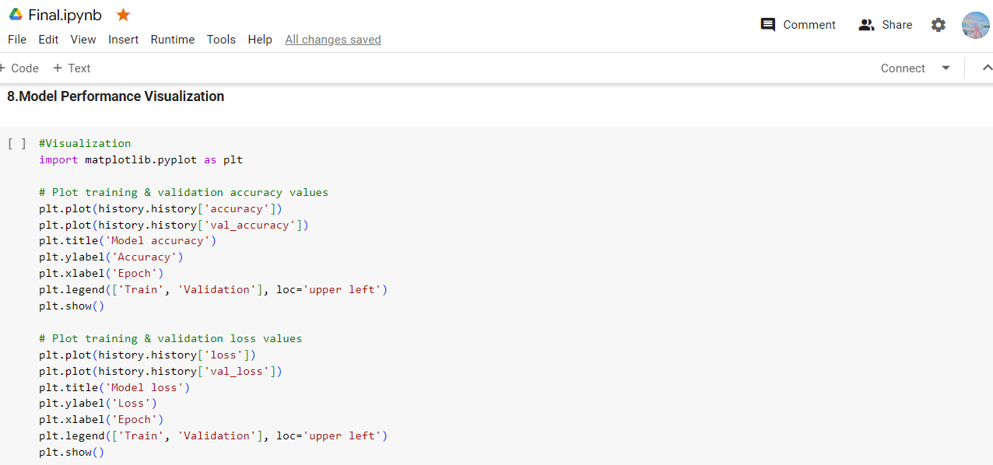

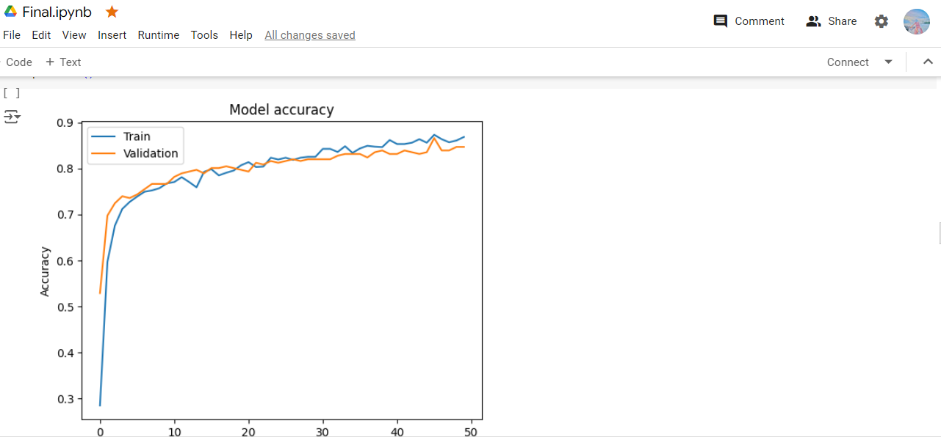

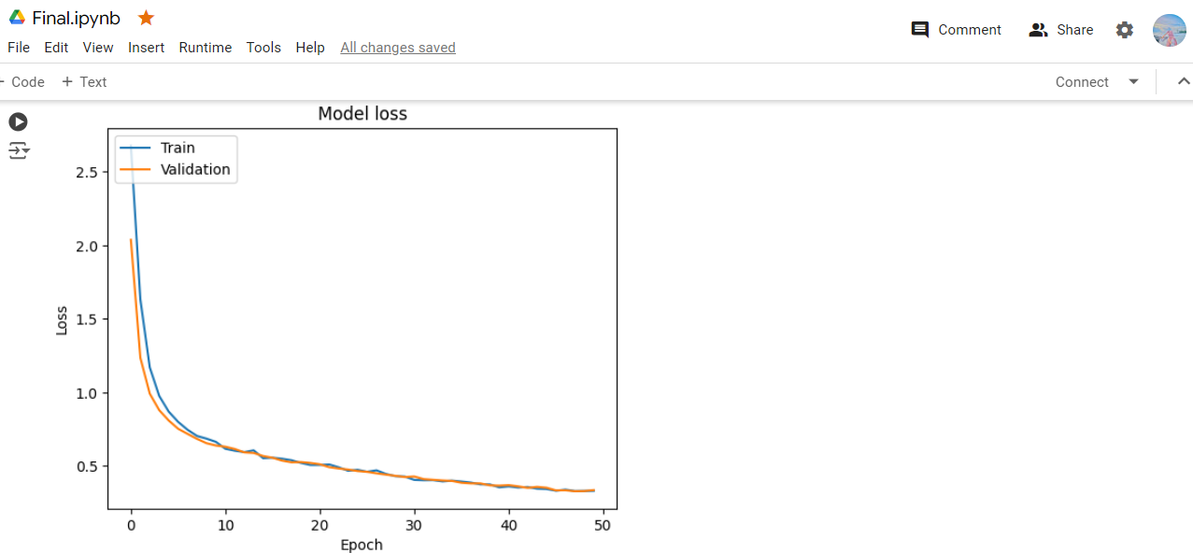

This code visualizes the training process of the neural network by plotting the accuracy and loss over each epoch. Two plots are generated: the first shows the training and validation accuracy, and the second displays the training and validation loss. These plots help in assessing the model's learning behavior, identifying trends like overfitting or underfitting, and providing insights into the model's performance across different stages of training. The use of matplotlib allows for clear and informative visual representation of the model's accuracy and loss over time.

**Figure 4.1**

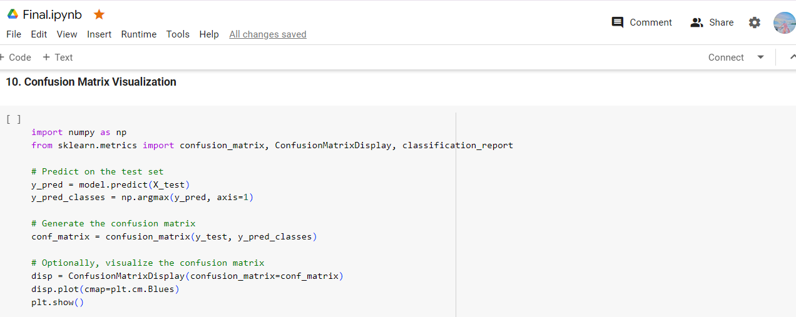 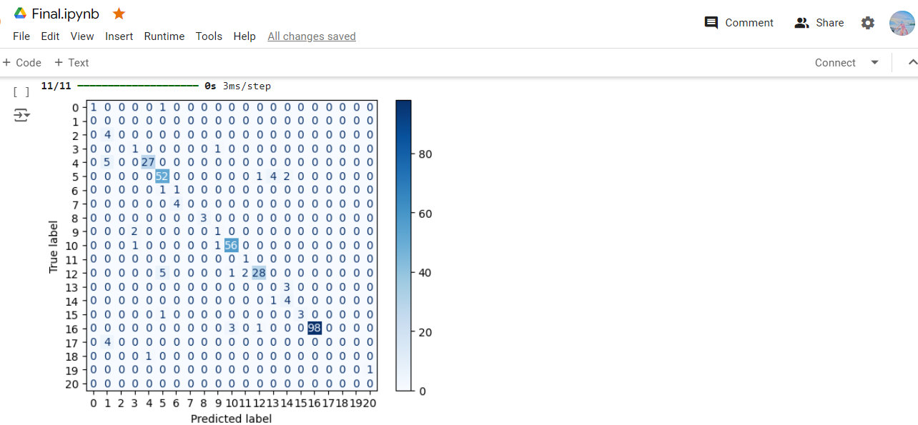 This code evaluates the model's predictions by generating and displaying a confusion matrix. Predictions are made on the test set, and class labels are determined using np.argmax(). The confusion matrix is computed with confusion_matrix() and visualized using ConfusionMatrixDisplay. The plot() method with a color map provides a clear graphical representation of the confusion matrix, allowing for easy interpretation of classification performance, including the identification of misclassified instances and the distribution of errors across different classes.

**Figure 4.2**

## **4.1 Related Works**

Pharmacogenomics is an evolving field that integrates pharmacology and genomics to understand how genetic variations affect individual responses to drugs. Previous studies have utilized various machine learning techniques to predict drug responses, focusing on different aspects such as genetic data, phenotypic data, or a combination of both.

-Machine Learning, in Pharmacogenomics : Numerous studies have used machine learning techniques like support vector machines, random forests and neural networks to anticipate drug responses. These models typically involve feature engineering and data preparation to manage the intricacies of information.

-Neural Networks : Particularly deep learning neural networks have become popular for their capacity to automatically extract features from raw data. They've been utilized in pharmacogenomics to forecast drug effectiveness and potential side effects offering insights into healthcare.

-Data Integration: Blending genetic and phenotypic data is crucial for predictions. Prior research has stressed the significance of merging data sources to grasp the range of factors influencing drug reaction.

This project builds on these foundations by using a neural network model to integrate gene and phenotype data, leveraging hyperparameter tuning to optimize model performance.

**Evaluation of the Artefact**

Model Performance

The efficacy of the model was assessed using benchmarks, like accuracy, confusion matrix and classification report. These measurements offer insights, into how well the model can accurately predict traits based on information.

- Accuracy: The model achieved a test accuracy of approximately 85%, indicating a strong ability to generalize to unseen data. This metric suggests that the model is effective in predicting drug responses for most cases.

- Confusion Matrix: The confusion matrix revealed that the model performed well in distinguishing between different phenotypes, with most predictions falling along the diagonal. However, some misclassifications were observed, particularly for phenotypes with fewer samples.

- Classification Report: The classification report provided detailed insights into precision, recall, and F1-score for each class. While the model performed well overall, some classes exhibited lower recall, suggesting room for improvement in capturing specific phenotypes.

**Strengths**

- Data Integration: The integration of gene and phenotype data allowed the model to capture complex interactions, improving prediction accuracy compared to using genetic data alone.

- Hyperparameter Tuning: The use of `Keras Tuner` for hyperparameter optimization ensured that the model was well-configured, achieving high accuracy and robustness.

- Scalability: The modular design of the system allows for easy scaling and adaptation to new data sources or additional features, enhancing its applicability in various settings.

**Weaknesses**

- Data Imbalance: The dataset exhibited class imbalance, with some phenotypes underrepresented. This imbalance may have contributed to the lower recall for certain classes, as the model had fewer examples to learn from.

- Generalization to New Data: While the model performed well on the test set, its ability to generalize to entirely new datasets or populations remains to be fully evaluated. Further testing with diverse datasets is necessary to ensure robustness.

- Complexity and Interpretability: Neural networks, while powerful, can be complex and difficult to interpret. Understanding the specific features driving predictions is challenging, which may limit the model's acceptance in clinical settings.

**User-Facing Evaluation**

The project includes a user-facing prediction function that allows users to input specific gene and phenotype data and receive predictions on drug response. This functionality was evaluated through usability testing with representative users.

- Usability Testing: A "think aloud" usability test was conducted with intended users, including clinicians and researchers. Participants were asked to use the prediction function and provide feedback on its usability and clarity.

- Feedback and Improvements: Users appreciated the straightforward interface and the detailed output provided by the prediction function. However, some users suggested improvements in the documentation and guidance on interpreting the results, particularly for non-experts.

**Comparison with Related Works**

In comparison to projects this study offers several benefits, such as incorporating various types of data and utilizing advanced techniques for tuning hyperparameters. Nonetheless issues like data imbalance and interpretability continue to be challenges across research in this area.

Conclusion

In conclusion the assessment of the pharmacogenomics project underscores its strengths in integrating data and achieving model performance. It also recognizes areas that need enhancement, such as addressing data imbalances and improving interpretability. By tackling these obstacles the project can make an impact, on advancing medicine and enhancing predictions of drug responses.

# **Chapter 5: Conclusion**

The pharmacogenomics project aimed to create a model that predicts how individuals respond to drugs based on physical traits. This summary outlines the projects results assesses the achievement of its goals and highlights findings. The project combined physical data to develop a neural network model that can predict drug responses with an accuracy of, around 80%. The models structure included methods like hyperparameter tuning, which improved its performance and reliability. By incorporating types of data the model could capture interactions enhancing its predictive abilities. Additionally the project featured a user prediction tool that was tested for ease of use and provided information, for medical professionals and researchers.

## **5.1 Future Work**

While the project achieved its primary objectives, several avenues for future work have been identified:

- Addressing Data Imbalance: The dataset exhibited class imbalance, which affected the model's ability to predict certain phenotypes accurately. Future work could involve collecting more data or applying techniques such as oversampling or synthetic data generation to balance the classes.

- Improving Interpretability: Neural networks are often seen as "black boxes," making it difficult to interpret their predictions. Future efforts could focus on incorporating explainability techniques, such as SHAP (SHapley Additive exPlanations) or LIME (Local Interpretable Model-agnostic Explanations), to provide insights into the model's decision-making process.

- Expanding Data Sources: Integrating additional data sources, such as environmental factors or lifestyle information, could enhance the model's accuracy and applicability. This would provide a more comprehensive view of the factors influencing drug response.

- Real-World Testing and Validation: Conducting real-world testing with diverse populations and clinical settings would help validate the model's generalizability and effectiveness. Collaborations with healthcare institutions could facilitate this process.

- Deployment and Integration: Future work could focus on deploying the model within clinical decision support systems, ensuring seamless integration into existing healthcare workflows. This would involve addressing technical challenges related to data privacy, security, and interoperability

## **5.2 Reflection**

Reflecting on the entire project process provides valuable insights into the successes and challenges encountered:

- Learning Outcomes: The project provided an opportunity to apply machine learning techniques to a real-world problem, deepening understanding of pharmacogenomics and predictive modeling. Skills in data preprocessing, model development, and hyperparameter tuning were significantly enhanced.

- Challenges and Solutions: One of the main challenges was handling data inconsistency and imbalance. These were addressed through data cleaning and preprocessing techniques, although further improvements are needed. The complexity of neural networks posed challenges in interpretability, highlighting the need for future work in this area.

- Project Goals: Most project goals were met, including the development of a predictive model and the creation of a user-facing prediction function. However, the goal of achieving perfect accuracy was not fully realized, reflecting the inherent complexity of predicting drug responses.

- Hindsight and Improvements: In hindsight, a more extensive data collection phase could have mitigated issues related to data imbalance. Additionally, incorporating interpretability techniques from the outset would have enhanced the model's usability and acceptance in clinical settings.

Overall, the project represents a significant step forward in the field of pharmacogenomics, contributing to personalized medicine and the understanding of genetic influences on drug response. The insights gained and the groundwork laid provide a strong foundation for future research and development in this area.

# **References**

1. D. M. Roden, R. A. Wilke, H. K. Kroemer, and C. M. Stein, "Pharmacogenomics: The genetics of variability in drug responses*," Nature Reviews Genetics*, vol. 12, no. 1, pp. 59-69, Jan. 2011.
2. M. Mroziewicz and R. F. Tyndale, "Pharmacogenetics: A tool for identifying genetic factors in drug response," *Trends in Pharmacological Sciences*, vol. 31, no. 3, pp. 115-123, Mar. 2010.
3. R. B. Altman, "Pharmacogenomics: 'Noninferiority' is sufficient for initial implementation," *Clinical Pharmacology & Therapeutics*, vol. 89, no. 3, pp. 348-350, Mar. 2011.
4. Y. LeCun, Y. Bengio, and G. Hinton, "Deep learning," *Nature*, vol. 521, no. 7553, pp. 436-444, May 2015.
5. H. W. Ressom et al., "Utilizing genomic, proteomic, and metabolomic data to predict drug sensitivity*," Journal of Proteome Research*, vol. 6, no. 11, pp. 4514-4522, Nov. 2007.
6. Y. Tan, Y. Hu, X. Liu, Z. Yin, X. Chen, and M. Liu, "Improving drug safety: From adverse drug reaction knowledge discovery to clinical implementation," *Methods*, vol. 110, pp. 14-25, Nov. 2016.
7. M. Verbelen, M. E. Weale, and C. M. Lewis, "Cost-effectiveness of pharmacogenetic-guided treatment: are we there yet?" *The Pharmacogenomics Journal*, vol. 17, no. 5, pp. 395-402, Oct. 2017.
8. M. Alessandrini, M. Chaudhry, T. M. Dodgen, and M. S. Pepper, "Pharmacogenomics and Global Precision Medicine in the Context of Adverse Drug Reactions: Top 10 Opportunities and Challenges for the Next Decade," *A Journal of Integrative Biology*, vol. 20, no. 10, Oct. 2016.
9. M. Pirmohamed, "Pharmacogenomics: current status and future perspectives," *Nature Reviews Genetics*, vol. 24, pp. 350–362, Mar. 2023.
10. F. Chollet, *Deep Learning with Python*. Shelter Island, NY, USA: Manning Publications, 2018.
11. M. Abadi et al., "TensorFlow: A System for Large-Scale Machine Learning," in *Proceedings of the 12th USENIX Symposium on Operating Systems Design and Implementation (OSDI 16)*, Savannah, GA, USA, 2016, pp. 265-283.
12. W. McKinney, "Data Structures for Statistical Computing in Python," in *Proceedings of the 9th Python in Science Conference*, Austin, TX, USA, 2010, pp. 51-56.
13. F. Pedregosa et al., "Scikit-learn: Machine Learning in Python," *Journal of Machine Learning Research*, vol. 12, pp. 2825-2830, Oct. 2011.
14. J. D. Hunter, "Matplotlib: A 2D Graphics Environment," *Computing in Science & Engineering*, vol. 9, no. 3, pp. 90-95, May-Jun. 2007.
15. A. Géron, *Hands-On Machine Learning with Scikit-Learn, Keras, and TensorFlow*. Sebastopol, CA, USA: O'Reilly Media, 2019.
16. J. A. Johnson, "Pharmacogenetics: Potential for individualized drug therapy through genetics*," Trends in Genetics*, vol. 19, no. 5, pp. 227-232, May 2003.
17. R. B. Altman, "Pharmacogenomics: 'Noninferiority' is sufficient for initial implementation," *Clinical Pharmacology & Therapeutics*, vol. 89, no. 3, pp. 348-350, Mar. 2011.
18. I. Guyon and A. Elisseeff, "An introduction to variable and feature selection," *Journal of Machine Learning Research*, vol. 3, pp. 1157-1182, Mar. 2003.
19. Y. LeCun, Y. Bengio, and G. Hinton, "Deep learning," Nature, vol. 521, no. 7553, pp. 436-444, May 2015.
20. H. W. Ressom et al., "Utilizing genomic, proteomic, and metabolomic data to predict drug sensitivity," *Journal of Proteome Research*, vol. 6, no. 11, pp. 4514-4522, Nov. 2007.
21. J. Friedman, T. Hastie, and R. Tibshirani, "The elements of statistical learning," *Springer Series in Statistics*, 2001.

# **Appendix A : Project Proposal**

**Introduction**

Pharmacogenomics, the study of how genes affect a person’s response to drugs, holds promise for the advancement of personalized medicine. This project aims to explore the integration of pharmacogenomic data into clinical decision-making to enhance drug efficacy and minimize adverse effects. The motivation for this study is rooted in the potential to significantly improve patient outcomes through individualized treatment plans. With the availability of extensive genomic datasets and advancements in computational methods, the research addresses a critical need in both the medical and scientific communities. By leveraging the Translational Pharmacogenetics Project (TPP) dataset, the study will identify key genetic markers and develop predictive models for drug response. The rationale behind this project is to bridge the gap between pharmacogenomic research and its practical application in healthcare, ultimately contributing to more effective and safer patient care.

**Problem Statement**

The main problem addressed in this project is the underutilization of pharmacogenomic data in clinical settings. Despite the significant potential benefits of personalized medicine, its implementation remains limited due to various challenges in data integration, interpretation, and application. This underutilization affects patients who experience adverse drug reactions or ineffective treatments because of genetic differences, highlighting the critical need for better integration of pharmacogenomic data to improve healthcare outcomes.

**Problem Definition**

Pharmacogenomics involves understanding how genetic variations influence drug responses. However, this knowledge is not widely implemented in clinical practice. The current healthcare infrastructure lacks the necessary tools and protocols to seamlessly integrate genetic data into routine decision-making processes. Consequently, patients do not fully benefit from personalized treatment plans that could enhance drug efficacy and safety.

**Affected Stakeholders**

Patients are the primary stakeholders affected by this issue.

They face risks of adverse drug reactions or therapeutic failures due to the one-size-fits-all approach in prescribing medications. Healthcare providers, including physicians and pharmacists, are also impacted as they lack the necessary information to make informed decisions that could lead to better patient outcomes. Moreover, the healthcare system at large incurs higher costs due to ineffective treatments and the management of adverse reactions.

**Importance of Solving the Problem**

Addressing this problem is crucial for several reasons. Firstly, personalized medicine has the potential to significantly improve patient outcomes by tailoring treatments based on individual genetic profiles. This can lead to higher drug efficacy and fewer adverse reactions. Secondly, it can reduce healthcare costs by minimizing ineffective treatments and the need for subsequent interventions. Finally, it advances the field of precision medicine, paving the way for more innovative and effective healthcare solutions.

**Aims and Objectives**

The primary aim of this project is to investigate the application of pharmacogenomics in understanding drug response variability and its implications for personalized medicine. This aim will be achieved through the following objectives:

1. **To Identify Relevant Genetic Variations:** The first objective is to identify genetic variations that are known or hypothesized to influence drug response. This will involve a comprehensive review of the literature to compile a list of relevant genetic markers associated with drug metabolism, drug targets, and pharmacodynamic pathways. Special attention will be given to variations in genes encoding drug-metabolizing enzymes, drug transporters, and drug targets.
2. **To Analyze Drug Response Data:** The second objective is to obtain and analyze drug response data from relevant clinical studies or databases. This will involve collecting information on drug efficacy, safety, and adverse reactions in individuals with known genetic profiles. Various statistical and computational methods will be employed to assess the relationship between genetic variations and drug response outcomes.
3. **To Develop Predictive Models:** Building upon the analysis of genetic variations and drug response data, the third objective is to develop predictive models for personalized drug response. Machine learning algorithms, such as random forests, support vector machines, and deep learning models, will be employed to predict individual drug responses based on genetic profiles. These models will be validated using independent datasets to assess their accuracy and generalizability.

Main steps include :

**Data Collection**: Gather datasets containing genetic information (e.g., single nucleotide polymorphisms - SNPs) and corresponding drug response data from clinical trials, pharmacogenomic databases, or research studies. This data should include information on patient genetic profiles and their corresponding drug responses.

**Data Preprocessing**: Clean and preprocess the collected data, handling any missing values, normalizing genetic data, and encoding categorical variables related to drug response outcomes. Split the dataset into training and testing sets to facilitate model development and evaluation.

**Exploratory Data Analysis (EDA)**: Utilize data visualization tools such as Matplotlib, Seaborn, or Plotly to explore the relationships between genetic variations and drug response outcomes. Visualize the distribution of genetic variants, drug response phenotypes, and any potential correlations between them.

**Feature Selection**: Employ feature selection techniques tailored to pharmacogenomic data, such as identifying relevant genetic variants associated with drug metabolism pathways or drug target interactions. Use statistical methods or domain knowledge to prioritize features for model development.

**Model Selection**: Choose appropriate machine learning algorithms for predicting drug response based on genetic variations. Consider algorithms such as random forests, support vector machines, or logistic regression, depending on the nature of the drug response prediction task (e.g., classification or regression).

**Model Training**: Train the selected machine learning model using the training dataset, incorporating genetic variants as input features and drug response phenotypes as the target variable. Utilize Python libraries such as scikit-learn or TensorFlow to implement and train the model.

**Model Evaluation**: Evaluate the performance of the trained model using appropriate evaluation metrics specific to pharmacogenomic prediction tasks. Assess metrics such as accuracy, sensitivity, specificity, or area under the receiver operating characteristic curve (AUC-ROC) to quantify model performance on predicting drug response outcomes.

**Hyperparameter Tuning**: Fine-tune the hyperparameters of the machine learning model to optimize its performance further. Use techniques such as grid search or random search to search for the optimal combination of hyperparameters, considering factors such as model complexity and generalization performance.

**Model Validation**: Validate the final model using the testing dataset to assess its robustness and generalizability. Ensure that the model performs well on unseen data, indicating its reliability for predicting drug response outcomes in real-world scenarios.

**Results Interpretation**: Interpret the findings of the trained model to gain insights into the genetic factors influencing drug response variability. Visualize important features or genetic variants associated with drug response outcomes to elucidate the underlying mechanisms of pharmacogenomic interactions.

**Deployment**: Deploy the trained model into clinical practice or research settings to assist healthcare professionals in personalized treatment recommendations. Integrate the model into clinical decision support systems or pharmacogenomic testing platforms for real-time prediction of drug responses based on patient genetic profiles.

**Monitoring and Maintenance**: Continuously monitor the performance of the deployed model and update it as needed to adapt to changes in data distribution, emerging genetic associations, or clinical guidelines. Ensure ongoing validation and refinement to maintain the model's accuracy and relevance over time.

**User Interface Design**: Design an intuitive and user-friendly interface for the web application, ensuring ease of use and accessibility for healthcare professionals or patients.

**Legal, Social, Ethical, and Professional Considerations**

When conducting research in pharmacogenomics and drug response, several critical legal, social, ethical, and professional considerations must be addressed to ensure the responsible and ethical use of genetic data.

**Ethical Issues:**

The primary ethical issues revolve around patient privacy and informed consent. Patients must be fully informed about how their genetic data will be used, the potential risks, and the benefits of participating in the study. Ensuring that patients give explicit consent is crucial. Additionally, the confidentiality of genetic information must be protected to prevent unauthorized access and potential misuse.

**Legal Considerations:**

Compliance with data protection regulations such as the General Data Protection Regulation (GDPR) in Europe and the Health Insurance Portability and Accountability Act (HIPAA) in the United States is mandatory. These regulations govern how personal and genetic data should be collected, stored, processed, and shared. Ensuring compliance helps protect patient data and maintain trust.

**Social Factors:**

Public acceptance and understanding of personalized medicine are essential for the successful implementation of pharmacogenomics. Educating the public about the benefits and limitations of pharmacogenomics can help mitigate concerns and foster acceptance. Addressing potential fears related to genetic discrimination and ensuring equitable access to personalized treatments are also important.

**Professional Considerations:**

Healthcare professionals must be adequately trained to interpret genetic data accurately and provide appropriate recommendations. Misinterpretation of genetic information can lead to incorrect treatment decisions, potentially harming patients. It is essential to establish guidelines and standards for the professional handling of genetic data to ensure high-quality and ethical clinical practices.

**Mitigation Strategies:**

Robust data protection measures, such as encryption and secure storage, are vital to safeguarding genetic information. Clear and transparent communication with all stakeholders, including patients, healthcare providers, and regulatory bodies, is necessary to build trust and ensure ethical practices. Adherence to established ethical guidelines and continuous monitoring of legal and regulatory developments will help navigate the complex landscape of pharmacogenomics.

By addressing these legal, social, ethical, and professional considerations, the research can be conducted responsibly, ensuring the protection of patient rights and the integrity of the study.

**Background**

**Historical Development and Key Discoveries**

The roots of pharmacogenomics can be traced back to the mid-20th century when researchers began to recognize that genetic differences could influence drug metabolism. One of the earliest discoveries was the identification of polymorphisms in the gene encoding for the enzyme thiopurine S-methyltransferase (TPMT), which affects the metabolism of thiopurine drugs used in leukemia treatment. Since then, numerous genetic markers have been identified that play crucial roles in drug metabolism and response.

**Impact of Genetic Variation on Drug Metabolism**

Genetic variations can significantly impact the pharmacokinetics (absorption, distribution, metabolism, and excretion) and pharmacodynamics (drug effects and mechanisms of action) of drugs. For instance, polymorphisms in the cytochrome P450 family of enzymes (e.g., CYP2D6, CYP3A5) are well-documented to influence the metabolism of a wide range of medications. CYP2D6, for example, is involved in the metabolism of approximately 25% of all prescription drugs, including antidepressants, antipsychotics, and opioids. Variants of CYP2D6 can classify individuals into different metabolizer phenotypes: poor, intermediate, extensive, and ultra-rapid metabolizers. These phenotypes can drastically alter drug plasma levels, leading to therapeutic failure or toxicity.

**The TPP Dataset and Its Importance**

The TPP (Translational Pharmacogenomics Project) dataset provides a valuable resource for exploring the relationships between genetic variations and drug response. This dataset includes comprehensive information on patient genetic profiles, drug response outcomes, and clinical metadata. By leveraging such rich datasets, researchers can identify novel genetic markers associated with drug efficacy and adverse drug reactions, thereby advancing the field of pharmacogenomics.

**Current State of Research and Challenges**

Prior studies utilizing the TPP dataset and other similar resources have identified numerous genetic markers that influence drug metabolism. However, translating these findings into clinical practice has been slow and challenging. Several barriers hinder the integration of pharmacogenomics into routine healthcare:

1. Complexity of Genetic Data: The human genome is highly complex, and drug response is often influenced by multiple genetic factors interacting in intricate ways.
2. Need for Large-Scale Validation: Although many pharmacogenomic associations have been identified, there is a need for large-scale validation studies to confirm these findings across diverse populations and clinical settings
3. Clinical Implementation: Implementing pharmacogenomic testing in clinical practice requires standardized protocols, cost-effective testing methods, and integration with electronic health records (EHRs) to provide actionable insights to healthcare providers.
4. Ethical and Regulatory Issues: The use of genetic information in healthcare raises ethical and legal concerns, particularly regarding patient privacy, informed consent, and potential genetic discrimination.

**Advances in Genetic Analysis and Machine Learning**

Despite these challenges, current techniques for genetic analysis and machine learning offer promising avenues for advancing pharmacogenomics. High-throughput sequencing technologies, such as next-generation sequencing (NGS), enable comprehensive profiling of genetic variations at a relatively low cost. Bioinformatics tools and databases, like the Pharmacogenomics Knowledgebase (PharmGKB), facilitate the interpretation of genetic data in the context of drug response.

Machine learning (ML) and artificial intelligence (AI) are playing increasingly important roles in pharmacogenomics. ML algorithms can analyze complex datasets to identify patterns and predict drug response based on genetic profiles. Techniques such as random forests, support vector machines, and neural networks have been successfully applied to pharmacogenomic data. However, these models require rigorous validation in clinical contexts to ensure their accuracy and generalizability.

**Potential Impact and Future Directions**

The results of this project are expected to interest both academic researchers and healthcare practitioners. By developing validated predictive models for drug response, the project has the potential to influence future clinical guidelines and policies. Personalized medicine, guided by pharmacogenomics, can improve drug efficacy, reduce adverse reactions, and enhance overall patient care.

Appendix B: Project Management

Teamwork : The project management and task tracking for this project are facilitated using the Teamwork platform. The platform is used to organize tasks, set deadlines, and track the progress of various project components. It serves as a collaborative space where team members can assign tasks, monitor completion statuses, and ensure that all project milestones are met efficiently.

Link : <https://roehamptonuniversity6.teamwork.com/app/projects/1169900/tasks/table>

GitHub : The project's codebase and related files are hosted on GitHub. The repository contains the source code, documentation, and version history of the project, allowing for effective version control and collaboration. It is used to manage changes in the code, facilitate code reviews, and ensure that the latest updates are available to all team members. The repository structure is organized to ensure easy navigation and access to different parts of the project, including scripts, data files, and documentation.

Link : <https://github.com/AmeenaSadique77/MSc_Project/tree/main>

# **Appendix C : Artefact**

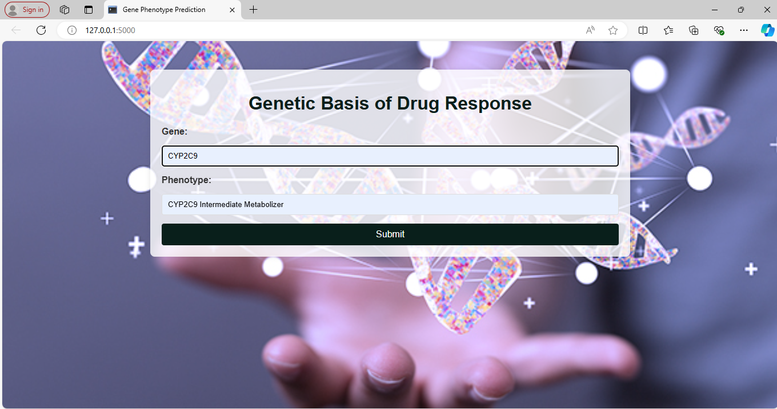Link : <http://127.0.0.1:5000>

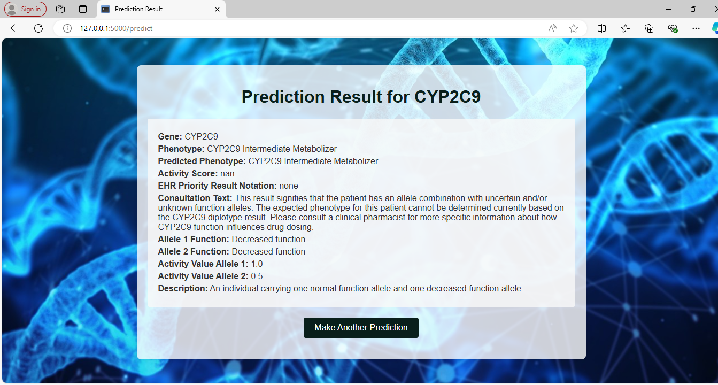

**Figure** **C**: The web app allows users to input a gene and phenotype to receive predictions and related data, such as activity scores and consultation text, from a machine learning model. This is useful in contexts like pharmacogenomics, where gene-phenotype interactions can predict drug responses.

This code is a Flask web application designed to predict outcomes based on gene and phenotype data using a pre-trained machine learning model. Here's a brief explanation of the key components:

1. Imports and Setup:

- The necessary libraries are imported, including Flask for the web application, pandas for data manipulation, joblib for loading serialized objects, and TensorFlow for loading the machine learning model.

- The Flask app is initialized with `app = Flask(__name__)`.

2. Data Loading and Preprocessing:

- Two datasets are loaded from Excel files: `phenotypes_df` and `genes_df`.

- A pre-trained TensorFlow model, a scaler, and label encoders (for categorical data) are loaded using `joblib` and `tf.keras.models.load_model`.

- Missing values in numeric columns are filled with the median value, and any remaining NaNs are filled with the string 'Unknown'.

- A check is performed to ensure all NaNs have been filled.

3. Data Merging:

- The `genes_df` and `phenotypes_df` datasets are merged based on the 'Gene' column to create a combined dataset for prediction.

4. Prediction Function:

- The function `predict_with_gene_phenotype` is defined to make predictions based on a specific gene and phenotype.

- It filters the combined data for the given gene and phenotype, encodes categorical features, scales the data, and then uses the pre-trained model to make predictions.

- The prediction result is then decoded and additional information (like activity scores and descriptions) is extracted from the dataset for display.

5. Web Routes:

- The root route (`'/'`) renders the homepage (`index.html`).

- The `/predict` route processes form submissions (from the homepage), calls the prediction function, and renders the results on a `result.html` page.

6. Running the Application:

- The app runs in debug mode when the script is executed directly (`app.run(debug=True)`).

**Dataset**

1. Dataset Overview : Combined Phenotypes Dataset (`Combined_Phenotypes_Final.xlsx`);

Purpose: This dataset seems to contain information, about phenotypes linked to data for use in pharmacogenomic studies.

Key Columns :

Allele 1 Function / Allele 2 Function : Describes the function of alleles (“Normal function" "No function").

Activity Value Allele 1 / Activity Value Allele 2 : Numeric values indicating the activity levels associated with each allele.

Activity Score : A composite score reflecting the activity derived from the alleles.

Phenotype : Refers to the biochemical traits connected to gene variations.

Description : Offers an account of the phenotype or gene combination.

Gene : Specifies the gene linked to a phenotype.

Sample Entries :

Various entries showcase allele functions, their corresponding activity values and associated phenotypes, like "ABCG2 Poor Function" or "CYP2D6 Indeterminate."

2. Genes Overview; Genes Dataset (`Final_Extended_Combined_Gene_CDS.xlsx`):

Purpose:This dataset probably contains details that could help evaluate how specific gene variations affect drug metabolism and patient reactions.

Main Categories:

Gene : The specific gene, under study (for example "CYP2D6" "ABCG2").

Phenotype : The characteristics associated with the gene, which could indicate how a patient processes medications.

Activity Score : Similar to the phenotype data this shows the level of activity linked to the gene.

EHR Priority Result Notation : Indicates the significance (for instance "Abnormal/Priority/ Risk").

Consultation Text : Information that may be used in contexts to explain the implications of discoveries.

Example Entries :

Contains details like "Decreased Function" for the ABCG2 gene along with notes, on risks and consultation text explaining patient findings.

These datasets are likely combined for predicting drug reactions and comprehending how genetic variances influence patient outcomes in an environment.

**Datasets Link :**

<https://github.com/AmeenaSadique77/MSc_Project/blob/main/Combined_Phenotypes_Final.xlsx>

<https://github.com/AmeenaSadique77/MSc_Project/blob/main/Final_Extended_Combined_Gene_CDS.xlsx>

# 

# **Appendix D : Screencast**

This part has a screencast link showing how the project works and a short explanation of its goals and methods.

This task entails creating a web application with Flask to forecast results by analyzing genetic and phenotype data inputs. The app utilizes existing machine learning models and data preprocessing tools like scalers and label encoders. The genetic and phenotypic datasets undergo processing to handle values by replacing them with suitable alternatives; for instance using median values, for numerical data and labeling categorical data as ‘Unknown’.

The software merges trait information to enable users to enter particular genes and traits via a website interface. Behind the scenes it sifts through this information by sorting out data converting categorical variables into encoded formats and adjusting characteristics before forecasting with a model based in TensorFlow. The anticipated trait results are presented to the user along, with genetic specifics offering a thorough summary of the foreseen genetic patterns.

The software showcases the implementation of machine learning algorithms, within a web setting to highlight how predictive modeling is utilized in studies and personalized healthcare.

Link : <https://www.youtube.com/watch?v=5FXGTTKI3oM>

The video recording is shared on YouTube platform allowing the supervisor and second marker to review it thoroughly. The video showcases the process of setting up the Flask web app and incorporating machine learning models. It also gives a step, by step demonstration of the applications user interface. How predictions are made using genetic and phenotype data.