
An-Najah National University
Factuality of Engineering
Computer Engineering department
Software Engineering (10636312)

Happy Grade

JDI Group
Instructor’s Name : Shatha Ajaj

Lecture meeting :( 12 :30-2 :00)

Table of Contents

Table of Contents 2
Group member & activity 3
Calender 4
Interview with Customer 7
User Stories 7
UML for Project 9
PRODUCT BACKLOG 10
Get Hub link 13
Trello Link 14

Group member & activity

Name | ID | % worke
Mohee Qwareeq | 11821353 | 100/6
Hadi Nassar | 11820612 | 100/6
Ameer Yaish | 11819809 | 100/6
Mohammad Zaied | 11924576 | 100/6
Nasser Khaled | 11819303 | 100/6
Abd Al-kareem Salah | 11819572 | 100/6

Calender

Metting Date | Documentation
6/Oct/2021 | - In a lecture on Tuesday, we chose group from 6 members and created a messenger group to organize appointments and to facilitate communication.  - We wrote 17 User Stories for the system.
10/Oct/2021 | - In a lecture on Sunday, the team decided Scrum Master the student Amir Yaish .  - And we decided to call the team GDI, which is an abbreviation for ( just do it).  - We met with customer.
15/Oct/2021 | - We made a Zoom metting and we distribut the work into team member as this table :  Name ID Position  Ameer Yaish 11819809 Scrum Master  Mohee Qwareeq 11821353 Documentation  Mohammad Zaied 11924576 Documentation  Nasser Khaled 11819303 Programing  Abd Al-kareem Salah 11819572 Programing  Hadi Nassar 11820612 Programing
17/Oct/2021 | - Here the soties we start with :  - As a student I want to login.  - As a prof I want to login.  - As a TAs I want to login.  - As a student I want to edit my account information.  5- As a prof I want to edit my information.  6- As a TAs I want to edit my information.  - We identified an open source product name: Bees Gate

24/Oct/2021 | We Start front-end for our system as picture below :  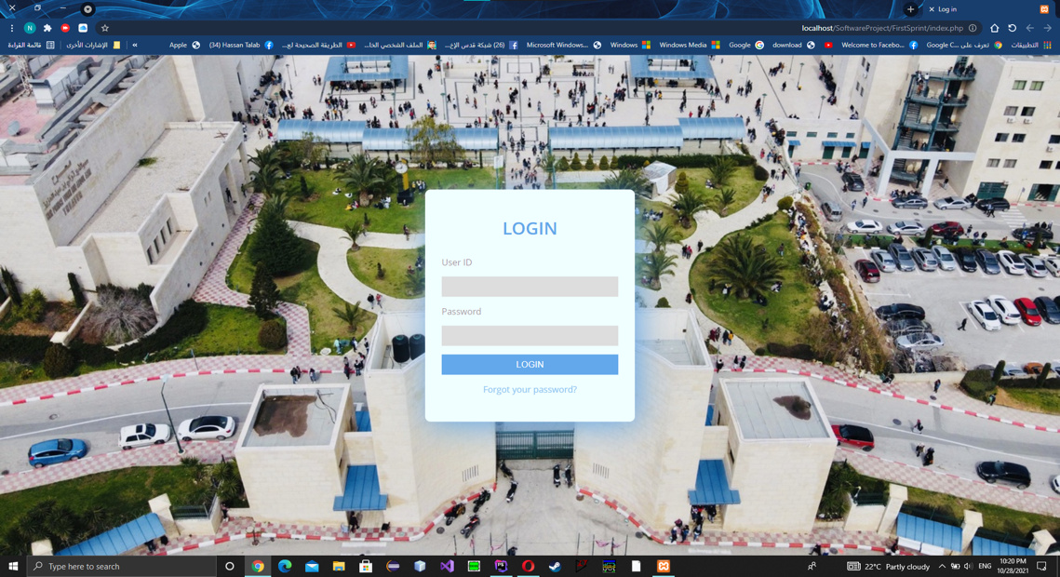  Sign in page  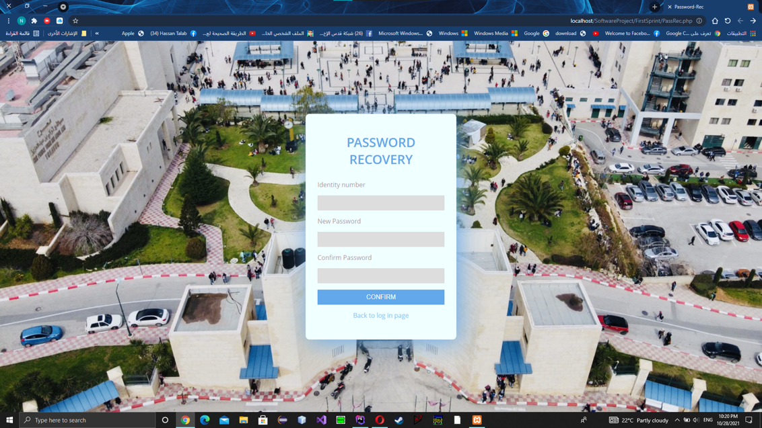  Page for edit information for all user
28/Oct/2021 | - We finished coding for the first sprint now we have a database and any user for the system can sign in his profile and edit his information like photos below :  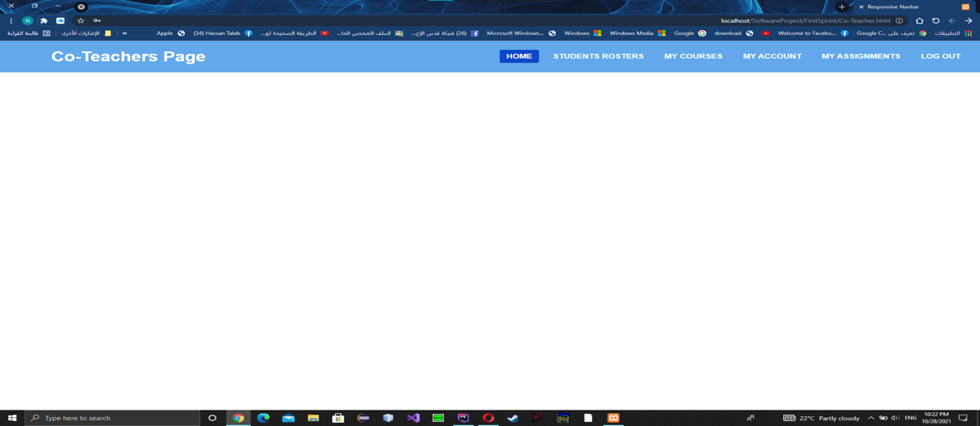  Page for TA’s  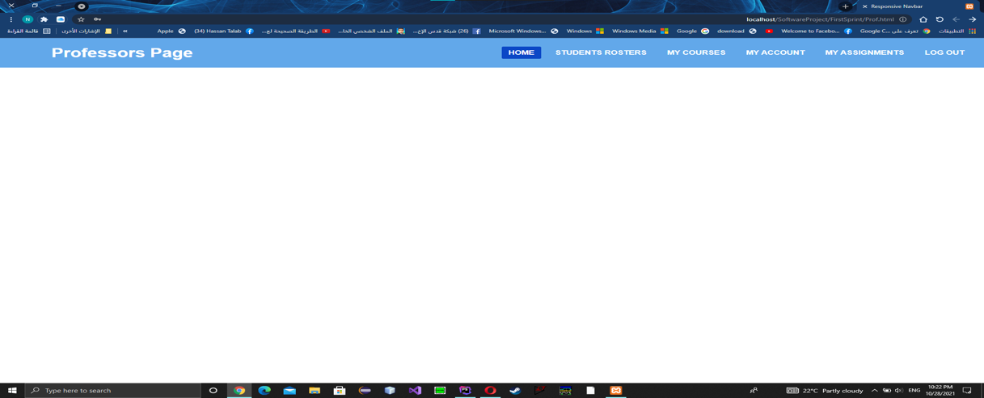  Page for professors  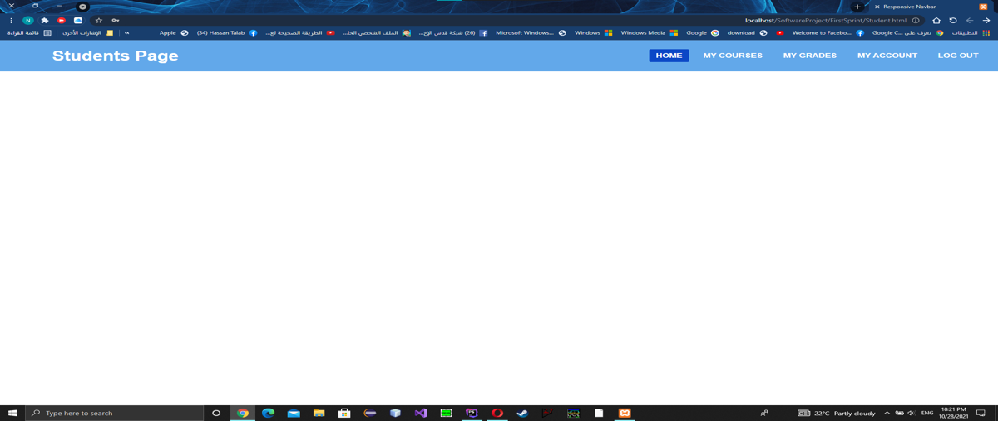  Page for student

Interview with Customer

First interview (6/10/2021)
• The customer requested that there be a record show all modifications to the mark and be visible to the professor.

• The customer requested that there be messages between the students and the professor and be public.

• The customer requested that the color coordination be like the Model site of An-Najah University.

Questions:
1- Is the TAs able to view the record of mark modifications?
A: No, just the professor able to show modifications.
2- Is there a conversation between teacher and student where the assignment is delivered?
A: No, There will be a general conversation between the students and the professor.

User Stories

- As a student I want to login.
- As a student I want to interact with my courses.
- As a student I want to see my grades.
- As a student I want to edit my account information.
- As a student I want to submit my assignment.
- As a student I want to remove the submission before the deadline.

- As a prof I want to login.
- As a prof I want to get access to the student’s rosters.
- As a prof I want to add and edit the grades for each student in order to show them to the student’s.
- As a prof I want to add an assignment.
- As a prof I want to remove an assignment only when no grades have been entered for it.
- As a prof I want to edit my information.

- As a TAs I want to login.
- As a TAs I want to see my courses.
- As a TAs I want to get access to the student’s roster.
- As a TAs I want to enter and modify grades for each student.
- As a TAs I want to edit my information.

UML for Project

PRODUCT BACKLOG

Backlogs Tasks
I divided this project into ten backlogs, these backlogs are:
- B1: Authentication Backlog, it contains tasks: T1,T2
- B2: Courses Backlog, it contains tasks: T8,T3
- B3: Contact Backlog: it contains tasks:. T6,T7
- B4: Assignments Backlog: it contains tasks:.T16
- B5: ADD Backlog: it contains tasks:.T10,T15
- B6: Remove Backlog: it contains tasks:.T11,T14
- B7: Submission Backlog: it contains tasks:.T12
- B8: Edit Backlog: it contains tasks:.T17
- B9: Demo Backlog: it contains tasks:.,T4,T9
- B10: Feedback Backlog: it contains tasks:.T5,T13,T18

Backlog  ID | Backlog | Backlogs Tasks | Sprint  Number
B1 | Authentication | T1+T2 | 1
B2 | Courses | T8+T3
B3 | Contact | T6+T7
B4 | Assignments | T16
B5 | ADD | T10+T15
B6 | Remove | T11+T14
B7 | Submission | T12
B8 | Edit | T17
B9 | Demo | T4+T9
B10 | Feedback | T5+T13+T18

Sprints List

ID | Sprint Number | Start-Date | End-Date | Duration  (Days)
1 | S1 | Friday, October 15, 2021 | Wednesday, October 20, 2021 | 5
2 | S2
3 | S3
4 | S4

Task List (user may be student or professor or TA)
Priority | Task  ID | Backlog Task | Duration  (days) | Sprint  Number
1 | T1 | As a user, I need to be able to log in into the “Grade Happy” using a registration number, and my  password. | 1 | 1
2 | T2 | As a user, I need to be able to change my password if I forget it | 1 | 1
3 | T3 | As a student, I need to be able to see registered courses,
4 | T4 | As a student, I need to be able to see the instructor's name of my  courses
5 | T5 | As a student, I need to be able to  see a description for my registered  courses
6 | T6 | As a student, I need to be able to contact with my professor
 | T7 | As a Teacher Assistant, I need to be able to contact with the professor
7 | T8 | As a professor or a Teacher Assistant I need to be able to see my courses
8 | T9 | As a Teacher Assistant or a professor, I need to see the students which  enrolled in the course
9 | T10 | As a Professor, I need to be able to add assignments for students  .
 | T11 | As a Professor, I need to be able to remove assignments for students, unless no grades have been entered for them
11 | T12 | As a student, I need to be able to add a solution for the assignment before the deadline
12 | T13 | As a student, I need to be able to write a comment about assignment
13 | T14 | As a student, I need to be able to remove the submission before the deadline
14 | T15 | As a professor, I need to be able to  Add grades for assignments
15 | T16 | As a student, I need to be able to  see my grades only in assignments
16 | T17 | As a professor, I need to be able to  edit the grade of assignments
17 | T18 | As a Teacher Assistant, I need to  be able to write feedback about  assignment for each student

Get Hub link

https://github.com/Ameer-yaish/Happy-Grades

Trello Link

https://trello.com/b/sjvuiFG0/happy-grade

