Emergency Vehicle Navigation in a Vehicular Network
A simulation study of Fog and Mist routing with dynamic updates and fallback
SUMO + OMNeT++ + Veins
4 routing configurations | 3 traffic levels | 30 seeds
360 primary runs + 90 waiting controls | 48 result graphs
October 2026

Project overview
An emergency vehicle needs to reach an accident quickly. It must first learn where the accident is, then choose a road route while normal traffic keeps moving. This project tests four ways to make that route decision in a simulated vehicular network.
The central question is how the location of route computation, live traffic updates, and a Fog backup affect message delivery, routing work, and the emergency vehicle's journey. All four approaches use traffic-light priority for the emergency vehicle.

The simulated road and communication system
The road is a 4 by 4 grid of signalized junctions. SUMO moves the vehicles and operates the traffic lights. OMNeT++ and Veins simulate wireless messages between vehicles and three roadside units (RSUs). The RSUs have a 400 m communication neighborhood. The accident vehicle, RSUs, and emergency vehicle exchange the information needed to start the response.
Normal traffic comes in three levels: 72 vehicles in low traffic, 144 in medium traffic, and 200 in high traffic. Thirty random seeds create different trips at each level. The same seed and traffic are used for each routing approach so the comparisons are fair.

How the system works, step by step
- Create a small road network with 16 junctions and traffic lights. Put three roadside units (RSUs) beside the roads. Each RSU can communicate within a 400 m radio neighborhood.
- Add normal traffic to the roads. The low, medium, and high traffic scenarios contain 72, 144, and 200 background vehicles. Thirty random seeds give different trips for each scenario.
- Start the emergency event. An accident vehicle stops, and the nearby RSU sends one 256-byte emergency message through the vehicle and roadside network to the emergency vehicle (EV).
- When the EV receives the message, calculate a route to the accident using the selected routing configuration. Some configurations use a fixed A* route; the dynamic configurations review live road costs every five seconds.
- While the EV drives under SUMO car-following and signal safety rules, it requests traffic-light priority within 100 m or eight seconds. The controller preserves a minimum ten-second green for traffic already being served, then clears the junction with yellow and all-red before changing priority.
- Mist normally computes the route with no added telemetry validation delay. Eight independently selected seeds receive a controlled 900 ms Mist stall in all three Mist approaches. In Mist with Fog, unfinished work after 500 ms triggers a Fog request. These are labeled fault tests, not naturally occurring failures.
- Record whether the message arrived, how long communication and route decisions took, how the EV traveled, and how many reviews, route changes, and fallback events occurred. Each run has a 900 second observation window.
- Repeat the four primary configurations at three traffic levels and 30 matched seeds: 360 runs. Add 90 no-preemption control runs, displayed only for traffic-light waiting. Calculate averages and 95% confidence intervals, report normal and controlled-stall results separately, and draw the graphs.

The four routing approaches
Approach | Plain-English description
FogCloudAStar | Fog and cloud services calculate the first A* route. The EV follows that route without periodic route reviews.
MistAStar | The EV's nearby Mist layer calculates the first A* route. There are no periodic route reviews.
MistDynamicAStar | Mist calculates the route and checks live road costs every five seconds. A better, stable route can replace the current route.
MistDynamicFogFallback | Dynamic Mist routing runs normally. If the initial Mist decision exceeds the 500 ms watchdog, Fog calculates the route instead.

A* is a shortest-path search. The dynamic versions use recent vehicle and roadside messages to estimate changing road costs. A route review is only a check; it counts as a route change when the EV actually receives a replacement route.

What was measured
Main measure | What it tells us
Packet delivery ratio (PDR) | The share of accident alerts that reached the emergency vehicle.
Normalized routing load (NRL) | The number of message transmissions per delivered accident alert.
EM throughput | Delivered emergency-message payload bits per second of the fixed observation window.
EM end-to-end delay | Milliseconds from sending the accident alert to its arrival at the emergency vehicle.
Route decision latency | Milliseconds from alert reception until the first route is applied.
EV response time | Seconds from alert generation until the emergency vehicle reaches the accident.
EV traffic-light waiting time | Seconds the emergency vehicle waits near a signal stop line.

We also counted Fog fallback activations, actual route changes, five-second route reviews, and the time taken to apply a Fog route after fallback. Each graph shows an average with a 95% confidence interval.

Main results
The accident alert reached the emergency vehicle in 332 of the 360 primary runs. The delivery and timing outcomes reflect this grid, its radio connections, and its traffic trips. A higher traffic count does not guarantee a particular direction of change in every measure.
The tables give the average, its 95% confidence interval in brackets, and the number of valid runs. Delivery ratio and EM throughput use all 30 runs at each traffic level. Travel and timing measures use runs in which the alert arrived.

Low traffic
Metric | Fog/Cloud | Mist | Mist Dynamic | Mist + Fog
PDR  (ratio) | 0.800  [0.627, 0.905]  n=30 | 0.800  [0.627, 0.905]  n=30 | 0.800  [0.627, 0.905]  n=30 | 0.800  [0.627, 0.905]  n=30
NRL  (packets/delivery) | 22,039  [21,725, 22,354]  n=24 | 22,046  [21,727, 22,364]  n=24 | 22,038  [21,722, 22,353]  n=24 | 22,033  [21,717, 22,349]  n=24
EM throughput  (bit/s) | 1.820  [1.475, 2.166]  n=30 | 1.820  [1.475, 2.166]  n=30 | 1.820  [1.475, 2.166]  n=30 | 1.820  [1.475, 2.166]  n=30
EM end-to-end delay  (ms) | 44.4  [40.3, 48.4]  n=24 | 44.4  [40.3, 48.4]  n=24 | 44.4  [40.3, 48.4]  n=24 | 44.4  [40.3, 48.4]  n=24
Route decision latency  (ms) | 626.5  [626.5, 626.5]  n=24 | 588.5  [412.0, 765.0]  n=24 | 588.5  [412.0, 765.0]  n=24 | 472.0  [373.9, 570.1]  n=24
EV response time  (s) | 153.3  [152.7, 153.9]  n=24 | 153.1  [152.3, 153.8]  n=24 | 152.5  [151.6, 153.5]  n=24 | 152.5  [151.6, 153.5]  n=24
EV traffic-light waiting time  (s) | 1.5  [1.1, 2.0]  n=24 | 1.6  [1.1, 2.1]  n=24 | 2.0  [1.5, 2.4]  n=24 | 2.0  [1.5, 2.5]  n=24

Medium traffic
Metric | Fog/Cloud | Mist | Mist Dynamic | Mist + Fog
PDR  (ratio) | 0.967  [0.833, 0.994]  n=30 | 0.967  [0.833, 0.994]  n=30 | 0.967  [0.833, 0.994]  n=30 | 0.967  [0.833, 0.994]  n=30
NRL  (packets/delivery) | 39,771  [39,368, 40,175]  n=29 | 39,739  [39,340, 40,137]  n=29 | 39,766  [39,377, 40,155]  n=29 | 39,738  [39,354, 40,123]  n=29
EM throughput  (bit/s) | 2.200  [2.045, 2.355]  n=30 | 2.200  [2.045, 2.355]  n=30 | 2.200  [2.045, 2.355]  n=30 | 2.200  [2.045, 2.355]  n=30
EM end-to-end delay  (ms) | 37.1  [33.7, 40.5]  n=29 | 37.1  [33.7, 40.5]  n=29 | 37.1  [33.7, 40.5]  n=29 | 37.1  [33.7, 40.5]  n=29
Route decision latency  (ms) | 626.5  [626.5, 626.5]  n=29 | 574.3  [418.6, 730.0]  n=29 | 574.3  [418.6, 730.0]  n=29 | 464.1  [377.5, 550.7]  n=29
EV response time  (s) | 154.6  [153.4, 155.8]  n=29 | 155.5  [152.6, 158.3]  n=29 | 154.4  [151.4, 157.4]  n=29 | 154.1  [151.0, 157.2]  n=29
EV traffic-light waiting time  (s) | 0.9  [0.5, 1.4]  n=29 | 1.6  [0.3, 3.8]  n=29 | 1.7  [0.4, 3.9]  n=29 | 1.7  [0.4, 4.0]  n=29

High traffic
Metric | Fog/Cloud | Mist | Mist Dynamic | Mist + Fog
PDR  (ratio) | 1.000  [0.886, 1.000]  n=30 | 1.000  [0.886, 1.000]  n=30 | 1.000  [0.886, 1.000]  n=30 | 1.000  [0.886, 1.000]  n=30
NRL  (packets/delivery) | 54,379  [53,910, 54,848]  n=30 | 54,257  [53,783, 54,731]  n=30 | 54,211  [53,730, 54,691]  n=30 | 54,257  [53,754, 54,760]  n=30
EM throughput  (bit/s) | 2.276  [2.276, 2.276]  n=30 | 2.276  [2.276, 2.276]  n=30 | 2.276  [2.276, 2.276]  n=30 | 2.276  [2.276, 2.276]  n=30
EM end-to-end delay  (ms) | 32.2  [29.2, 35.1]  n=30 | 32.2  [29.2, 35.1]  n=30 | 32.2  [29.2, 35.1]  n=30 | 32.2  [29.2, 35.1]  n=30
Route decision latency  (ms) | 626.5  [626.5, 626.5]  n=30 | 566.0  [414.8, 717.2]  n=30 | 566.0  [414.8, 717.2]  n=30 | 459.5  [375.4, 543.6]  n=30
EV response time  (s) | 156.3  [154.4, 158.2]  n=30 | 157.0  [154.8, 159.2]  n=30 | 154.4  [152.1, 156.7]  n=30 | 154.3  [152.1, 156.6]  n=30
EV traffic-light waiting time  (s) | 0.7  [0.3, 1.0]  n=30 | 0.6  [0.3, 1.0]  n=30 | 0.7  [0.3, 1.0]  n=30 | 0.6  [0.3, 0.9]  n=30

What the main results mean
The alert is delivered before the EV calculates its route. PDR and EM end-to-end delay therefore measure the same radio event in every routing approach. EM throughput is calculated from those same deliveries and a fixed payload, so it also can match across approaches. These values should change with density when the number of successful deliveries changes; they do not have to change just because the route calculator is different.

How the measured results change with traffic density
Traffic | Trips | Mean peak vehicles | PDR | EM throughput (bit/s) | Mean NRL | Dynamic Mist response (s)
Low | 72 | 33.2 | 0.800 | 1.820 | 22,039 | 152.52
Medium | 144 | 66.4 | 0.967 | 2.200 | 39,754 | 154.40
High | 200 | 93.1 | 1.000 | 2.276 | 54,276 | 154.38

This shows real density effects: generated demand rises from 72 to 200 trips, PDR from 0.800 to 1.000, throughput from 1.820 to 2.276 bit/s, and the mean number of active background vehicles rises from about 33 to 93. Throughput is similar across routing approaches within each density because their alert delivery counts match; it is not constant across all three densities.

What changes between routing approaches
Traffic | Mist A* response (s) | Dynamic Mist response (s) | Dynamic Mist + Fog response (s) | Dynamic Mist route changes
Low | 153.06 | 152.52 | 152.54 | 4
Medium | 155.48 | 154.40 | 154.14 | 7
High | 156.98 | 154.38 | 154.35 | 10

Mist A* and Dynamic Mist can have the same initial decision latency because both use the same Mist A* calculation. Dynamic Mist then reviews live road costs every five seconds; the logs show applied route changes in the table. The response-time means differ, but their confidence intervals overlap in several comparisons, so small mean differences alone do not establish that one approach is generally faster.
In low traffic, the four average EV response times range from 152.52 to 153.29 seconds. Read the intervals alongside these averages; a small difference alone does not prove a general advantage.
In medium traffic, the four average EV response times range from 154.14 to 155.48 seconds. Read the intervals alongside these averages; a small difference alone does not prove a general advantage.
In high traffic, the four average EV response times range from 154.35 to 156.98 seconds. Read the intervals alongside these averages; a small difference alone does not prove a general advantage.

Normal operation and controlled stalls
The main averages include 22 normal seeds and eight independently selected fault-test seeds. To show how the routing approaches behave in each condition, the next tables separate their initial decision times. All Mist approaches face the same injected stall in the selected seeds. The experiment does not estimate how often such a fault occurs on real hardware.

Low traffic decision time
Condition | Fog/Cloud | Mist | Mist Dynamic | Mist + Fog
Normal seeds | 626.54 ms | 326.00 ms | 326.00 ms | 326.00 ms
Controlled stall seeds | 626.54 ms | 1226.00 ms | 1226.00 ms | 826.54 ms

Medium traffic decision time
Condition | Fog/Cloud | Mist | Mist Dynamic | Mist + Fog
Normal seeds | 626.54 ms | 326.00 ms | 326.00 ms | 326.00 ms
Controlled stall seeds | 626.54 ms | 1226.00 ms | 1226.00 ms | 826.60 ms

High traffic decision time
Condition | Fog/Cloud | Mist | Mist Dynamic | Mist + Fog
Normal seeds | 626.54 ms | 326.00 ms | 326.00 ms | 326.00 ms
Controlled stall seeds | 626.54 ms | 1226.00 ms | 1226.00 ms | 826.63 ms

Traffic-light waiting with and without priority
The no-preemption control uses Fog/Cloud routing with priority disabled. It appears only in this waiting comparison and the three waiting graphs. The priority controller preserves a minimum current green and safe clearance before serving the EV. Some requests can finish before arrival; others require the EV to wait. Waiting is measured from movement rather than added artificially.
Traffic | Fog/Cloud | Mist | Mist Dynamic | Mist + Fog | No preemption
Low | 1.54 s | 1.58 s | 1.96 s | 2.02 s | 26.29 s
Medium | 0.95 s | 1.62 s | 1.71 s | 1.74 s | 27.34 s
High | 0.67 s | 0.62 s | 0.65 s | 0.60 s | 22.72 s

Fallback and route changes
Traffic | Fog takeovers | Dynamic Mist route changes | Dynamic Mist reviews | Mist + Fog route changes | Mist + Fog reviews
Low | 7/30 (23.3%) | 4 | 657 | 4 | 660
Medium | 8/30 (26.7%) | 7 | 820 | 8 | 815
High | 8/30 (26.7%) | 10 | 853 | 10 | 855

Fog took over in 23 of 90 Mist with Fog runs: 7 in low, 8 in medium, and 8 in high traffic. The controlled 900 ms stall delays initial Mist work beyond the 500 ms watchdog. For example, in low traffic seed 4, Fog applied the route after 826.53 ms.
The table counts actual route changes separately from five-second reviews. A review that finds no sufficiently better route keeps the existing route. The routing logs record both the current route cost and the candidate cost, so these decisions can be checked from the evidence.

Why EM throughput is similar across routing approaches
The accident alert has a fixed 256-byte useful payload. Throughput divides the delivered alert bits by the same 900 second window in every run. One successful delivery therefore contributes 2.27556 bit/s, regardless of how many normal vehicles are on the road. This measure describes emergency-message delivery over the observation window; it is not the total capacity of the wireless network.
Traffic does change with density: the scenarios contain 72, 144, or 200 normal vehicles; trip starting points differ between random seeds; and the dynamic route logs contain different live road costs and route changes. The throughput means are 1.820, 2.200, and 2.276 bit/s from low to high density. Within each density, the four routing approaches have similar throughput because they delivered the same number of alerts.

Conclusion and limits
The experiment compares alert delivery, route computation, and vehicle movement as separate parts of the response. Dynamic routing uses current road reports and only replaces a route when its stability rules are met. The controlled stall tests show how Fog recovery behaves under a defined fault. The response and waiting tables show the measured journey outcomes rather than assuming every route change saves time.
These findings apply to the simulated 4 by 4 grid, three RSUs, 400 m radio setting, traffic scenarios, and controlled stall model. They should be tested on other road layouts and with measured onboard processing times before being generalized to real emergency deployments.

How to read every graph
Each bar is a mean for one configuration at one density. Error bars show the 95% confidence interval; the method used for each metric is specified in docs/METHODOLOGY.md. PDR and EM throughput include all 30 scheduled runs. Delivery-dependent measures use only runs with a delivered emergency message. A graph can contain fewer than four bars when a metric applies only to dynamic routing or fallback. Only the waiting graphs add a fifth bar for the no-preemption control.
The following gallery contains all 48 result graphs.

Complete graph gallery

Packet delivery ratio
The share of generated emergency messages that reached the EV. Higher is better.
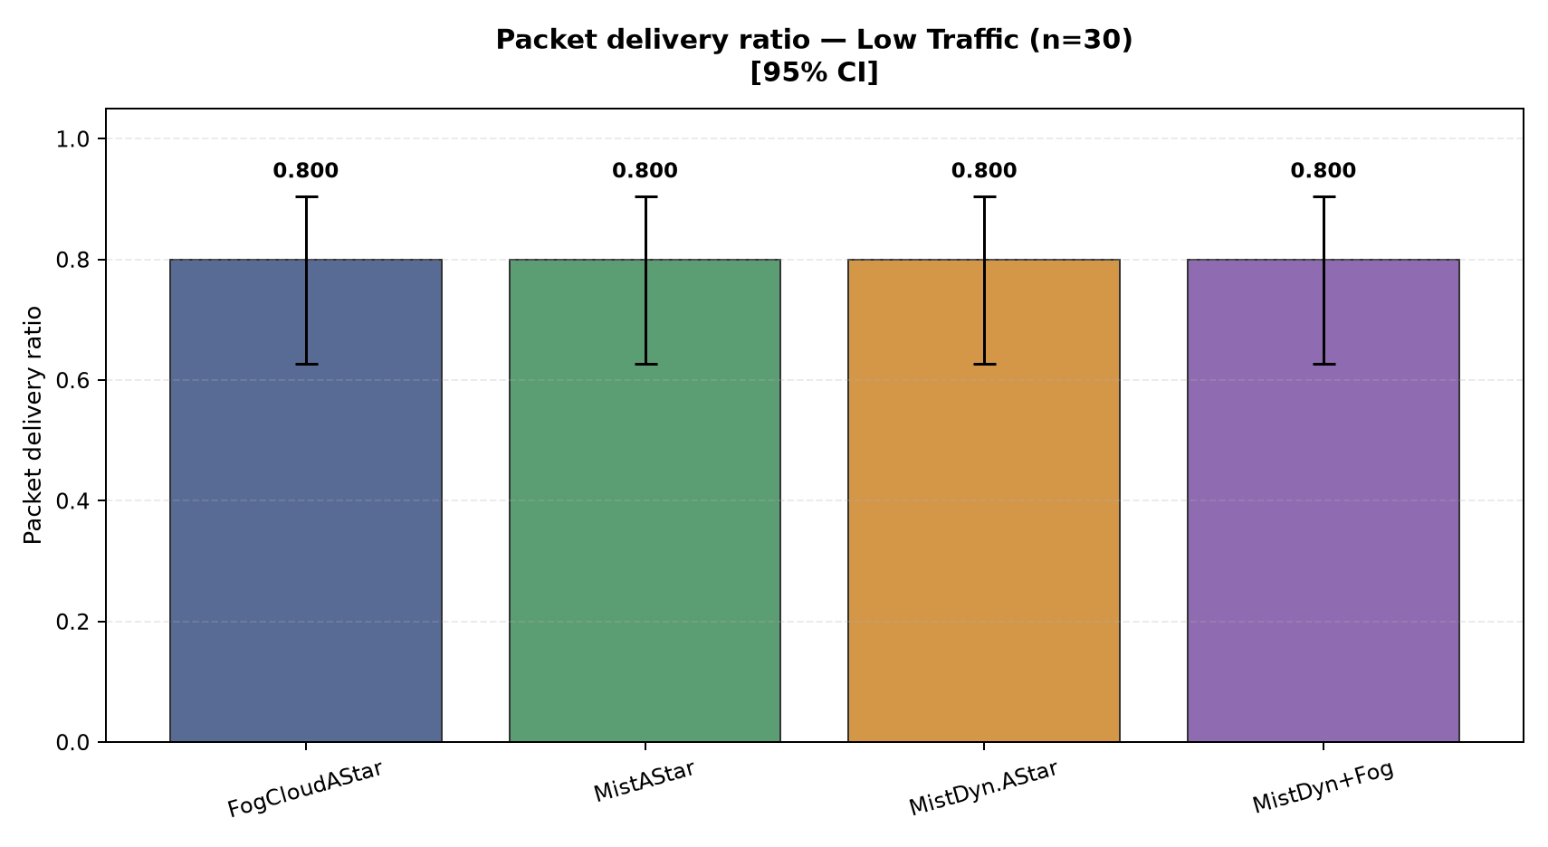
Figure 1. Low traffic (72 background vehicles): Fog/Cloud 0.800; Mist 0.800; Mist Dynamic 0.800; Mist + Fog 0.800. Bars show means and 95% confidence intervals.
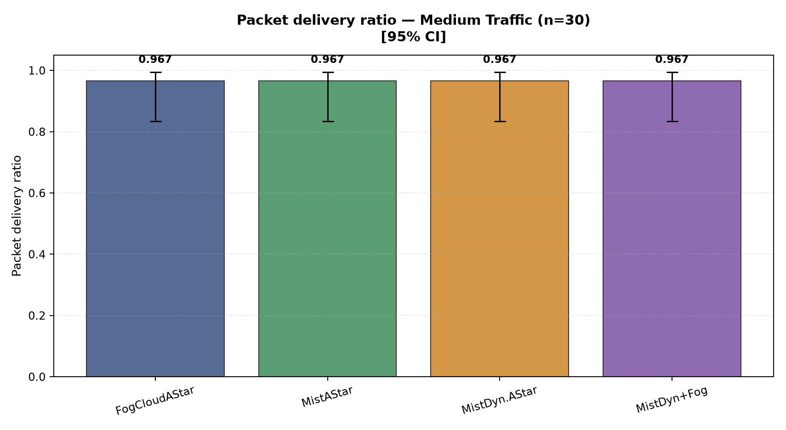
Figure 2. Medium traffic (144 background vehicles): Fog/Cloud 0.967; Mist 0.967; Mist Dynamic 0.967; Mist + Fog 0.967. Bars show means and 95% confidence intervals.
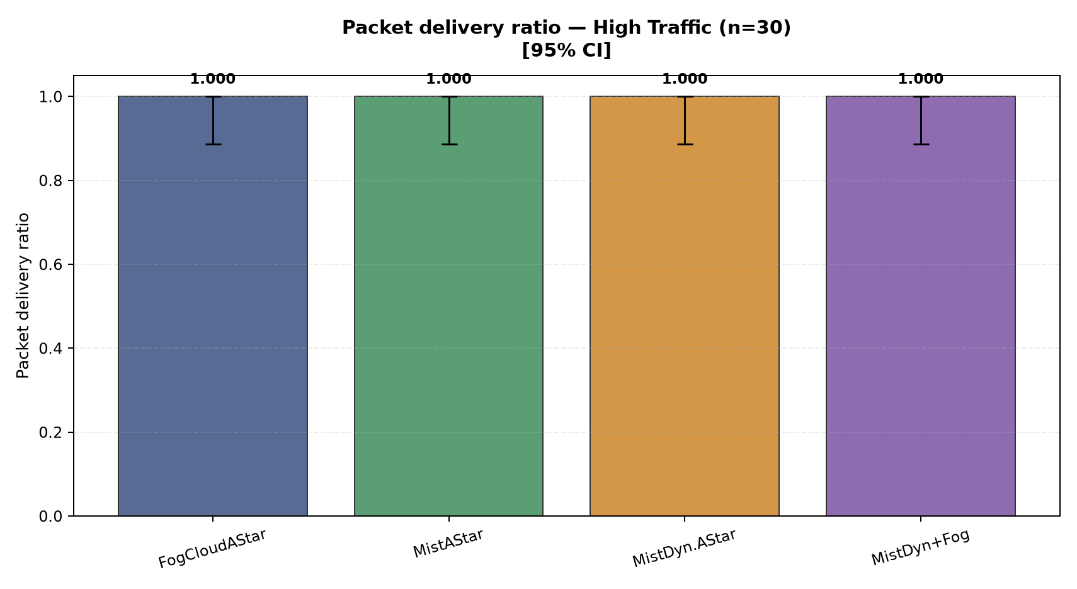
Figure 3. High traffic (200 background vehicles): Fog/Cloud 1.000; Mist 1.000; Mist Dynamic 1.000; Mist + Fog 1.000. Bars show means and 95% confidence intervals.

Normalized routing load
Control and EM transmissions per delivered emergency message. Lower means less communication overhead.
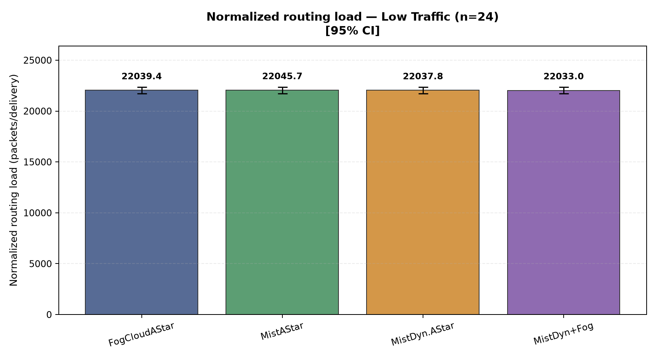
Figure 4. Low traffic (72 background vehicles): Fog/Cloud 22,039; Mist 22,046; Mist Dynamic 22,038; Mist + Fog 22,033. Bars show means and 95% confidence intervals.
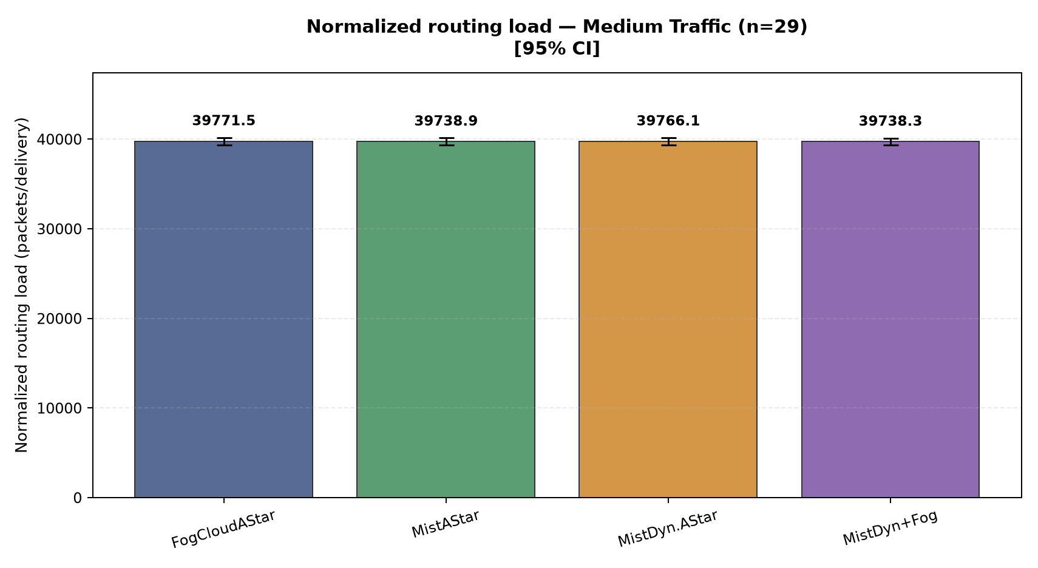
Figure 5. Medium traffic (144 background vehicles): Fog/Cloud 39,771; Mist 39,739; Mist Dynamic 39,766; Mist + Fog 39,738. Bars show means and 95% confidence intervals.
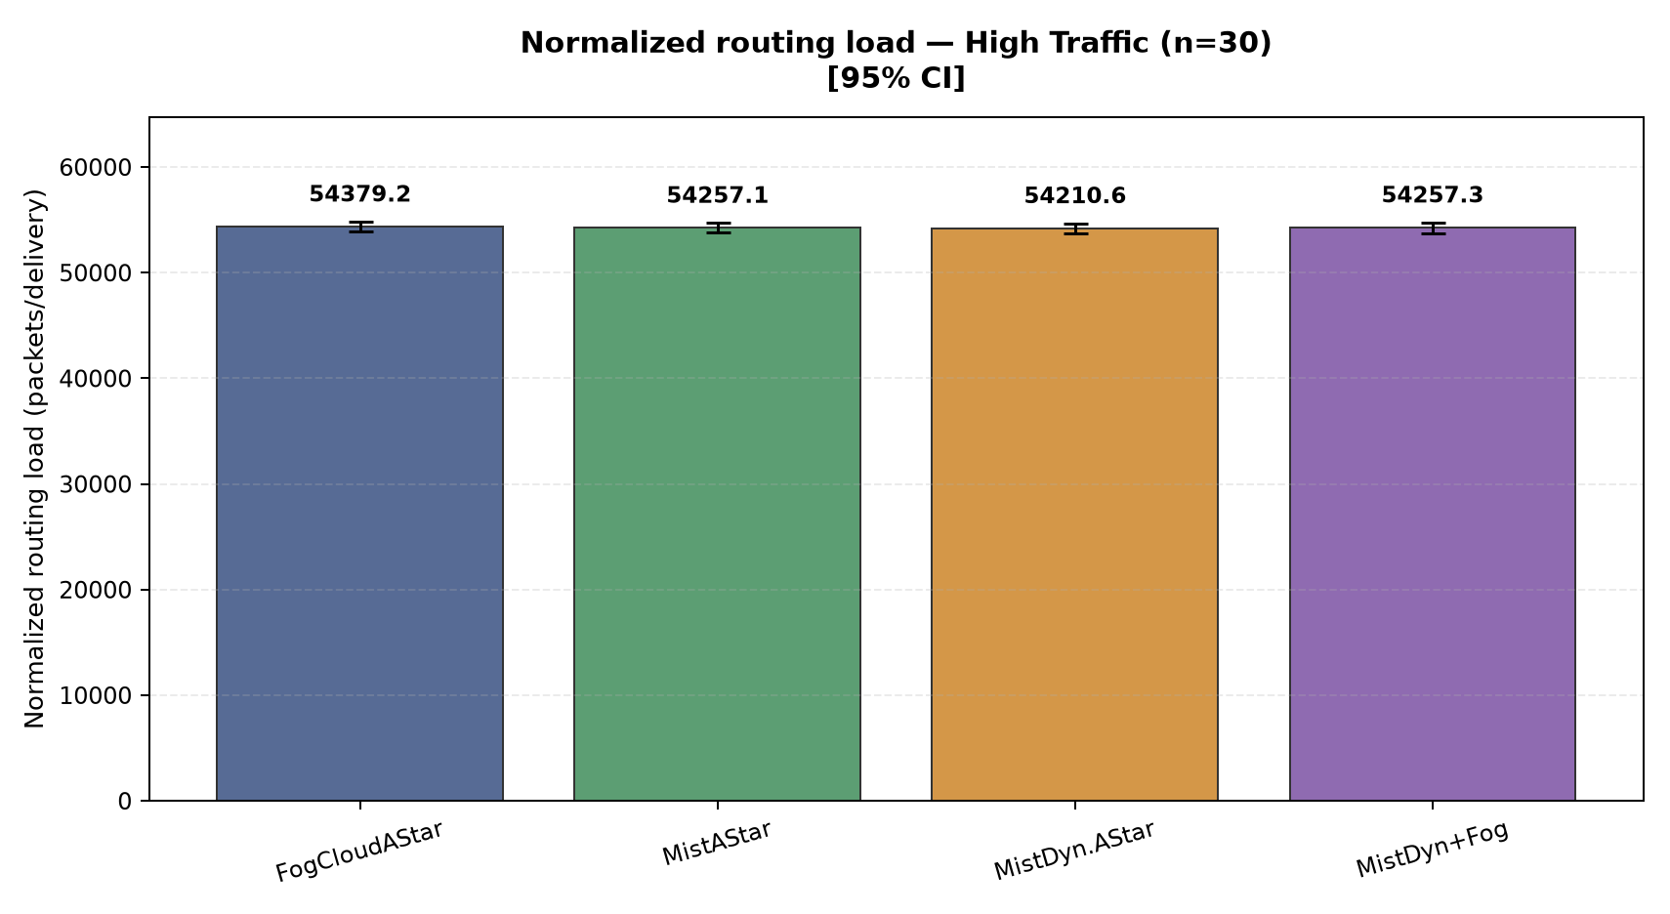
Figure 6. High traffic (200 background vehicles): Fog/Cloud 54,379; Mist 54,257; Mist Dynamic 54,211; Mist + Fog 54,257. Bars show means and 95% confidence intervals.

EM throughput
Delivered EM payload bits divided by the fixed 900 second observation window. One delivery contributes 2.27556 bit/s.
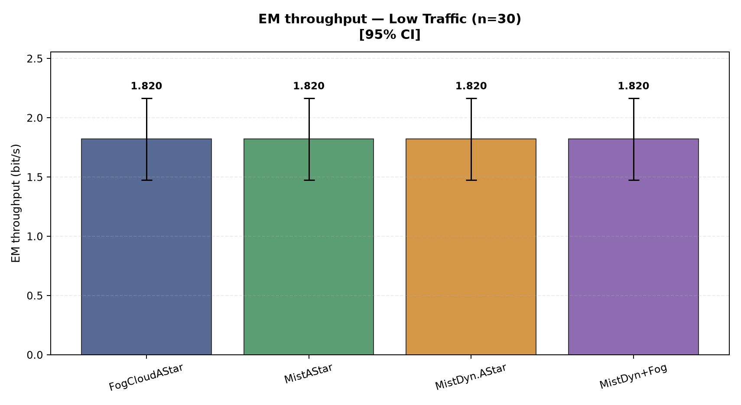
Figure 7. Low traffic (72 background vehicles): Fog/Cloud 1.820; Mist 1.820; Mist Dynamic 1.820; Mist + Fog 1.820. Bars show means and 95% confidence intervals.
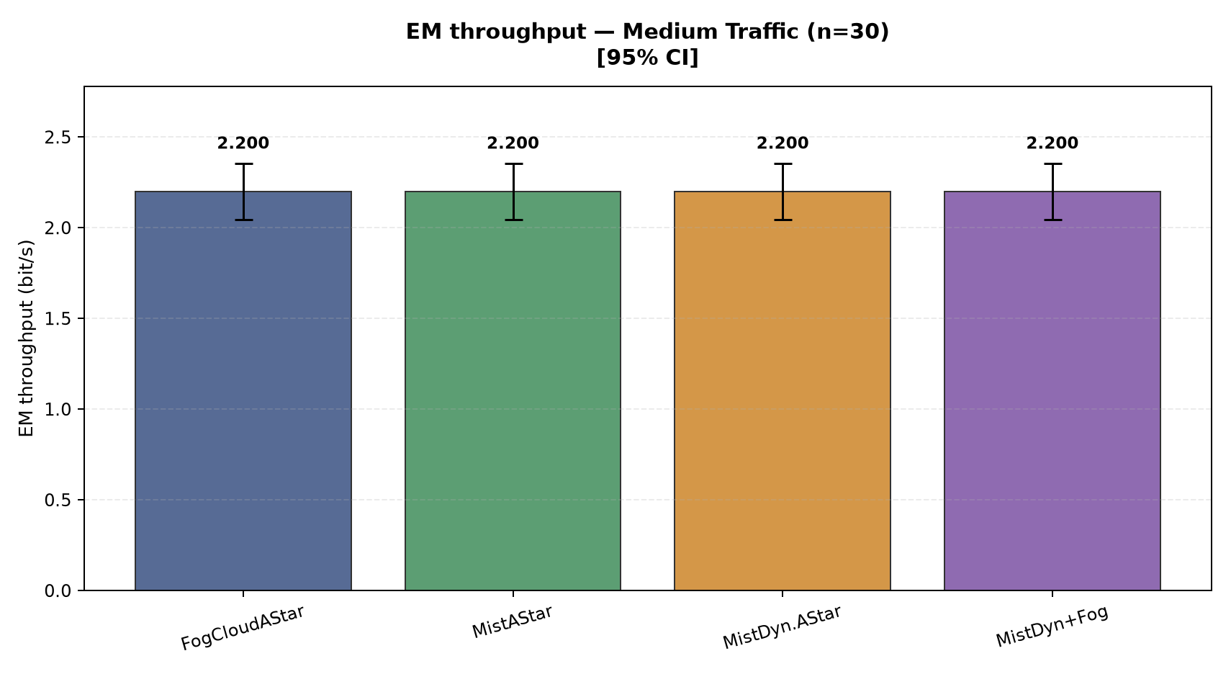
Figure 8. Medium traffic (144 background vehicles): Fog/Cloud 2.200; Mist 2.200; Mist Dynamic 2.200; Mist + Fog 2.200. Bars show means and 95% confidence intervals.
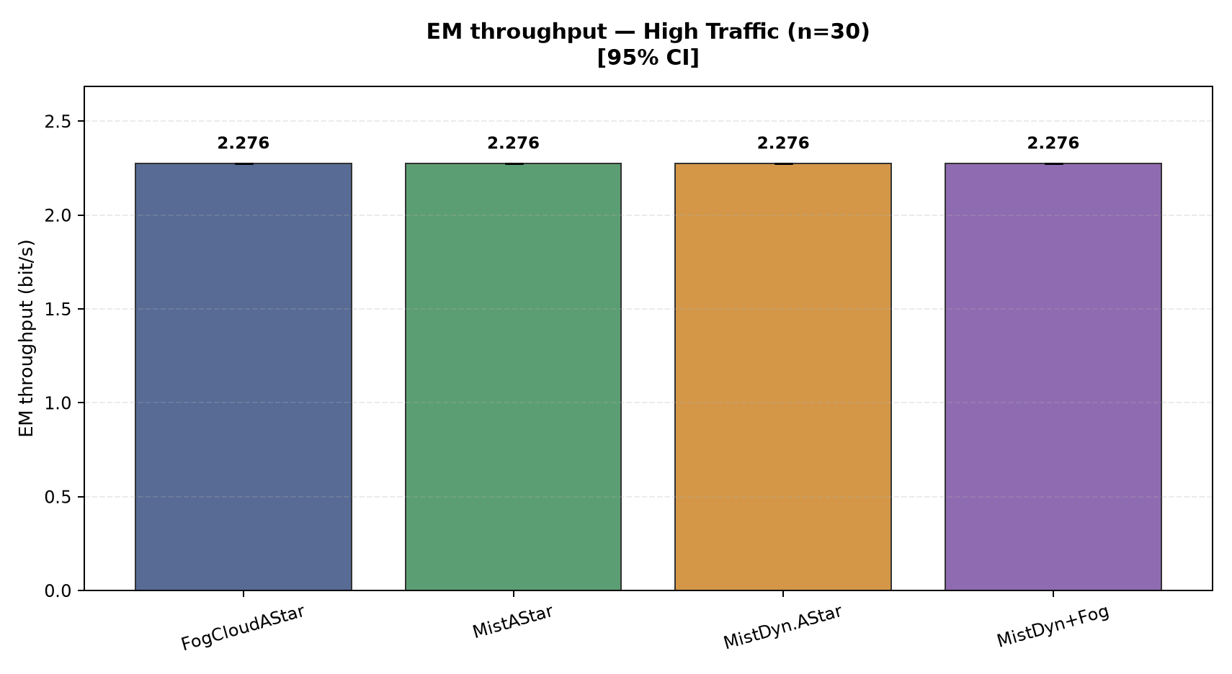
Figure 9. High traffic (200 background vehicles): Fog/Cloud 2.276; Mist 2.276; Mist Dynamic 2.276; Mist + Fog 2.276. Bars show means and 95% confidence intervals.

EM end-to-end delay
Time from RSU message generation to EV reception, in milliseconds. Lower is faster.
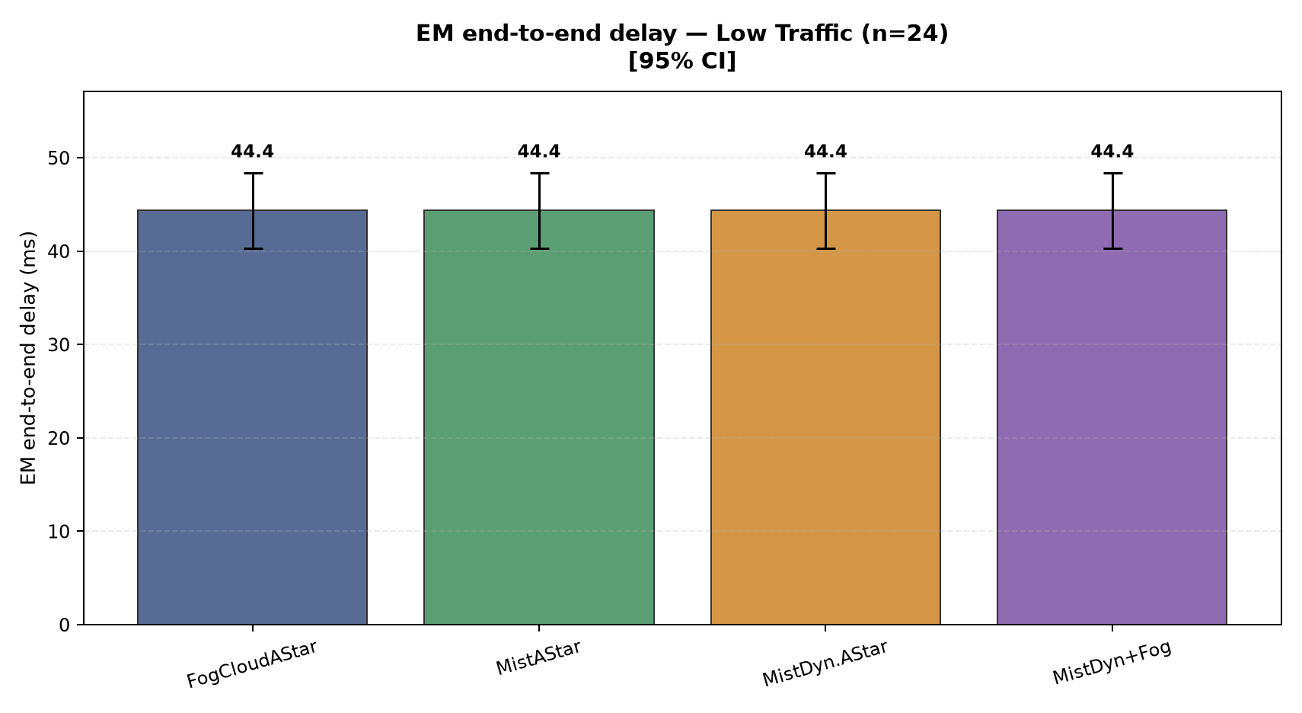
Figure 10. Low traffic (72 background vehicles): Fog/Cloud 44.4; Mist 44.4; Mist Dynamic 44.4; Mist + Fog 44.4. Bars show means and 95% confidence intervals.
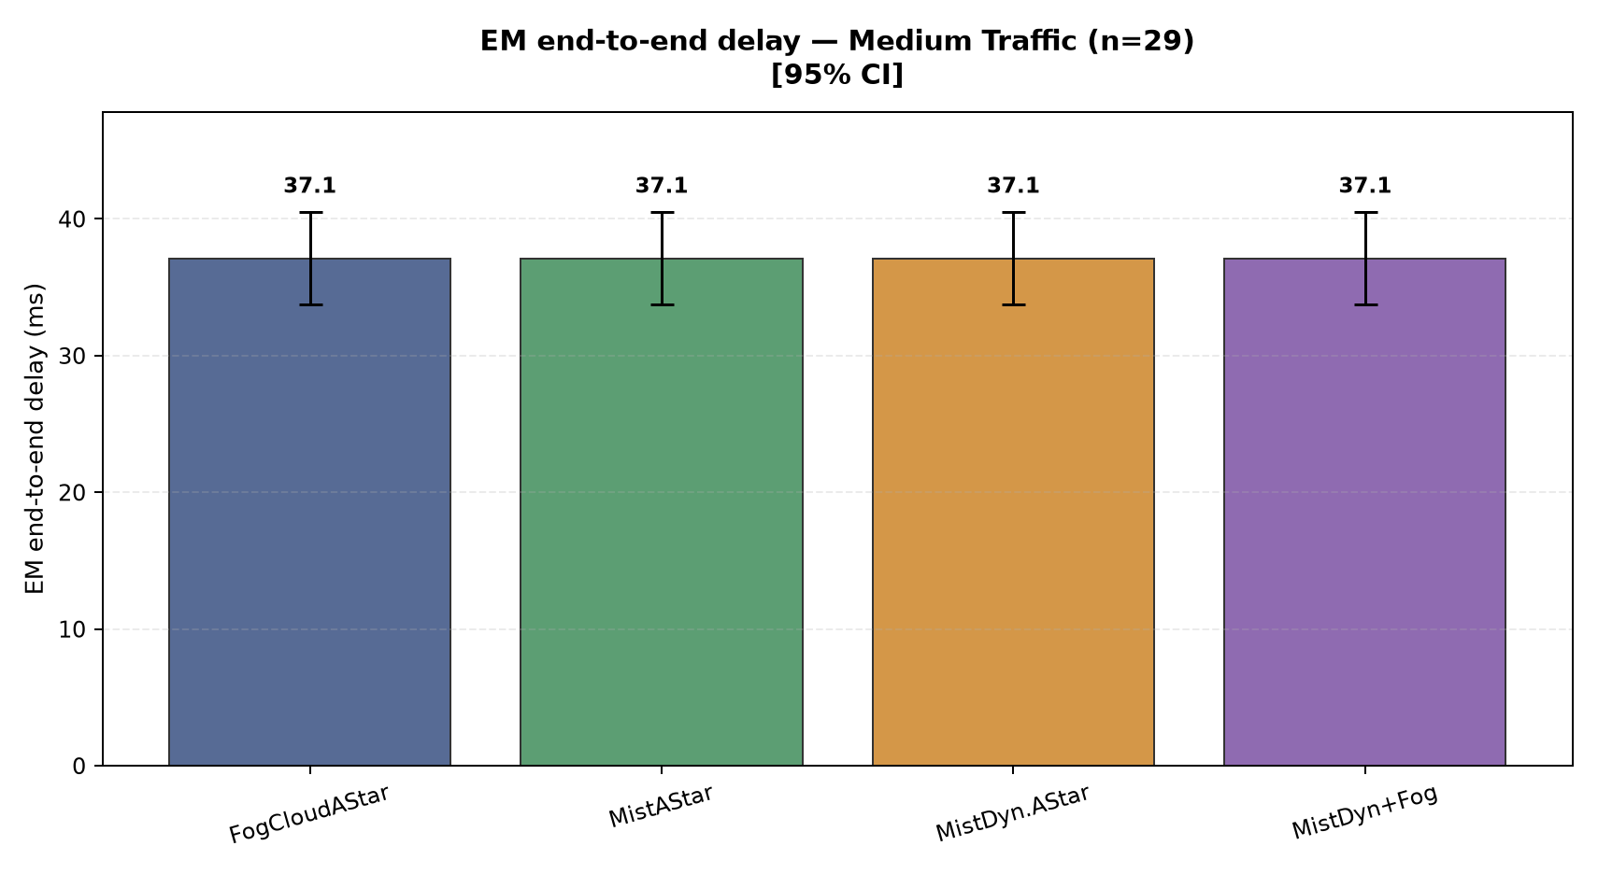
Figure 11. Medium traffic (144 background vehicles): Fog/Cloud 37.1; Mist 37.1; Mist Dynamic 37.1; Mist + Fog 37.1. Bars show means and 95% confidence intervals.
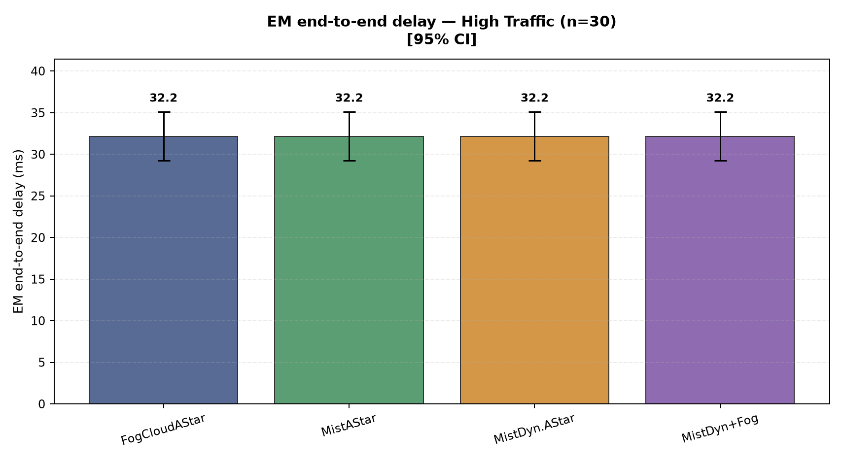
Figure 12. High traffic (200 background vehicles): Fog/Cloud 32.2; Mist 32.2; Mist Dynamic 32.2; Mist + Fog 32.2. Bars show means and 95% confidence intervals.

Route decision latency
Time from EV message reception to the initial route being applied, in milliseconds.
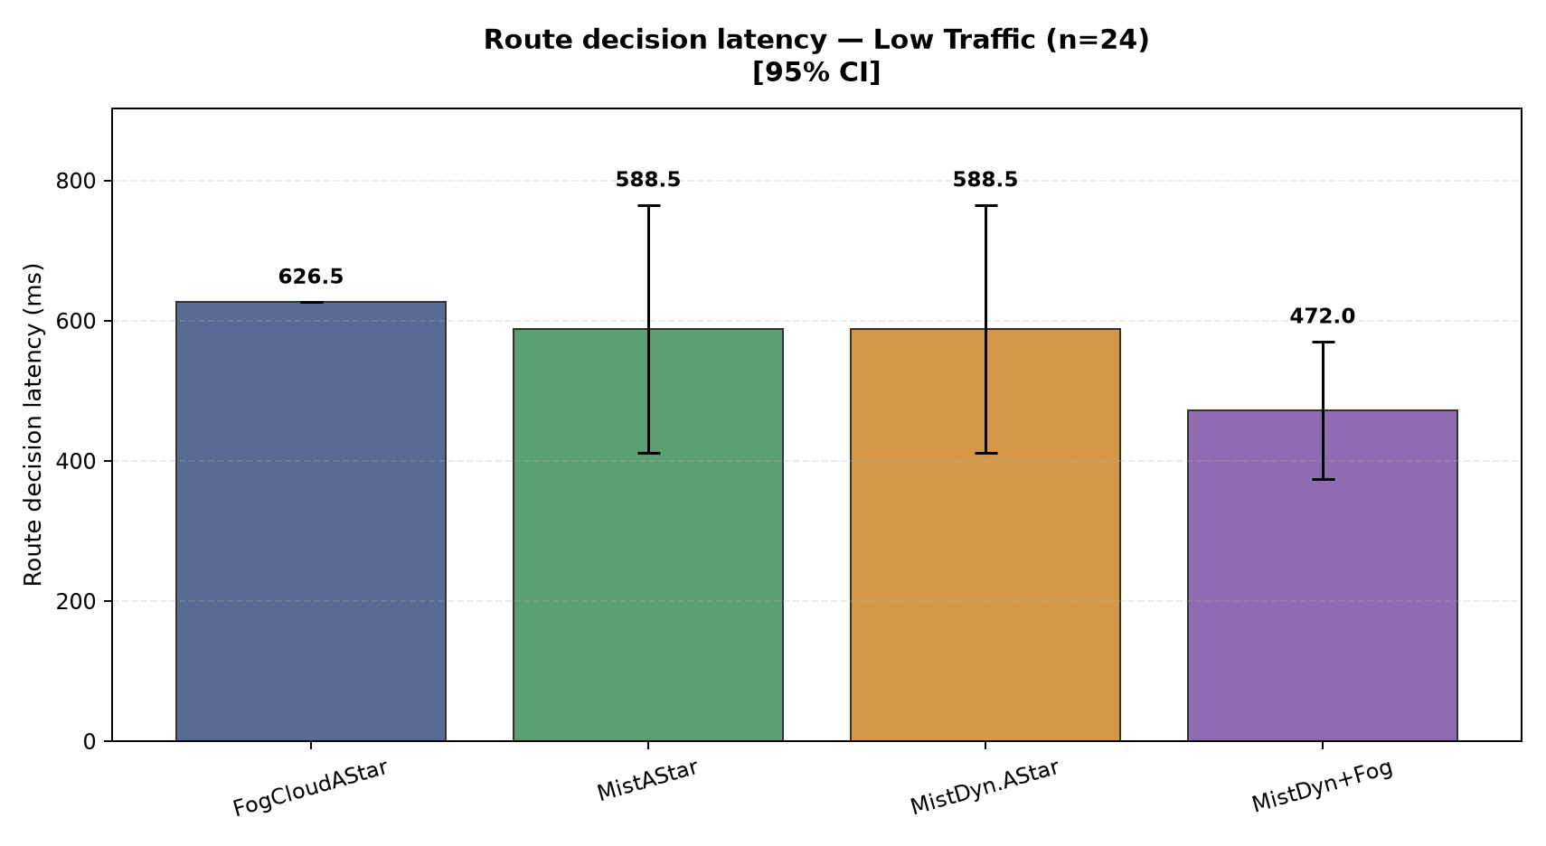
Figure 13. Low traffic (72 background vehicles): Fog/Cloud 626.5; Mist 588.5; Mist Dynamic 588.5; Mist + Fog 472.0. Bars show means and 95% confidence intervals.
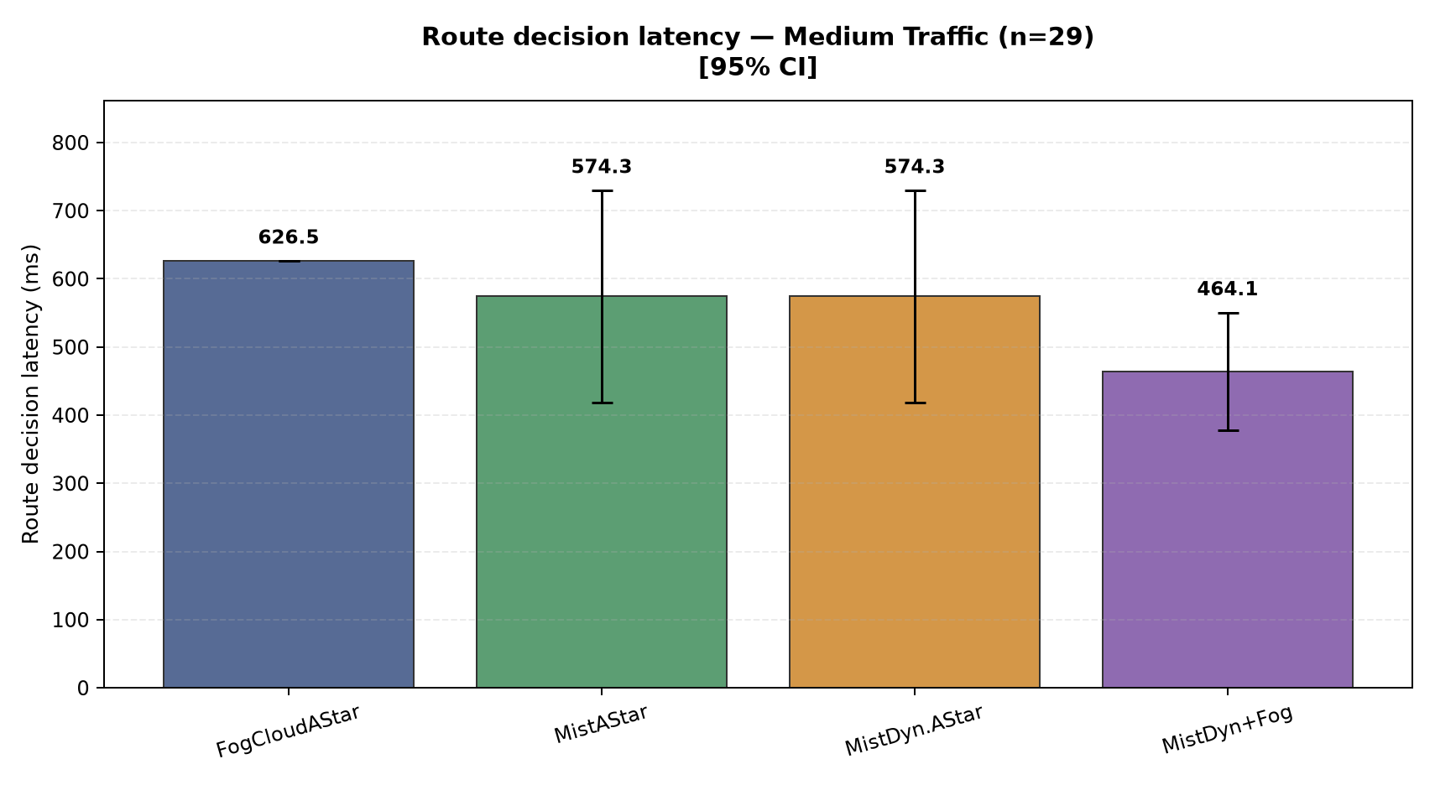
Figure 14. Medium traffic (144 background vehicles): Fog/Cloud 626.5; Mist 574.3; Mist Dynamic 574.3; Mist + Fog 464.1. Bars show means and 95% confidence intervals.
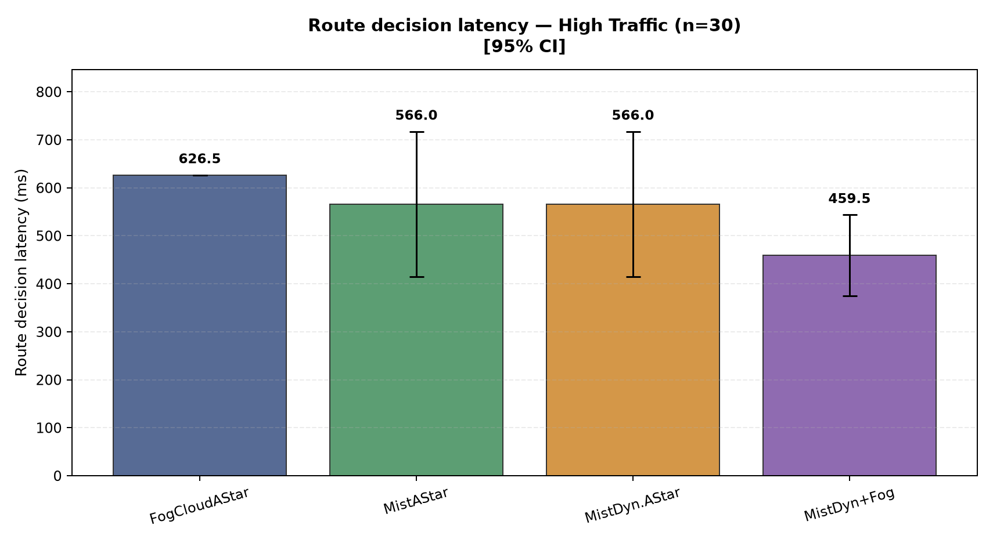
Figure 15. High traffic (200 background vehicles): Fog/Cloud 626.5; Mist 566.0; Mist Dynamic 566.0; Mist + Fog 459.5. Bars show means and 95% confidence intervals.

EV response time
Time from emergency message generation until the EV reaches the accident, in seconds.
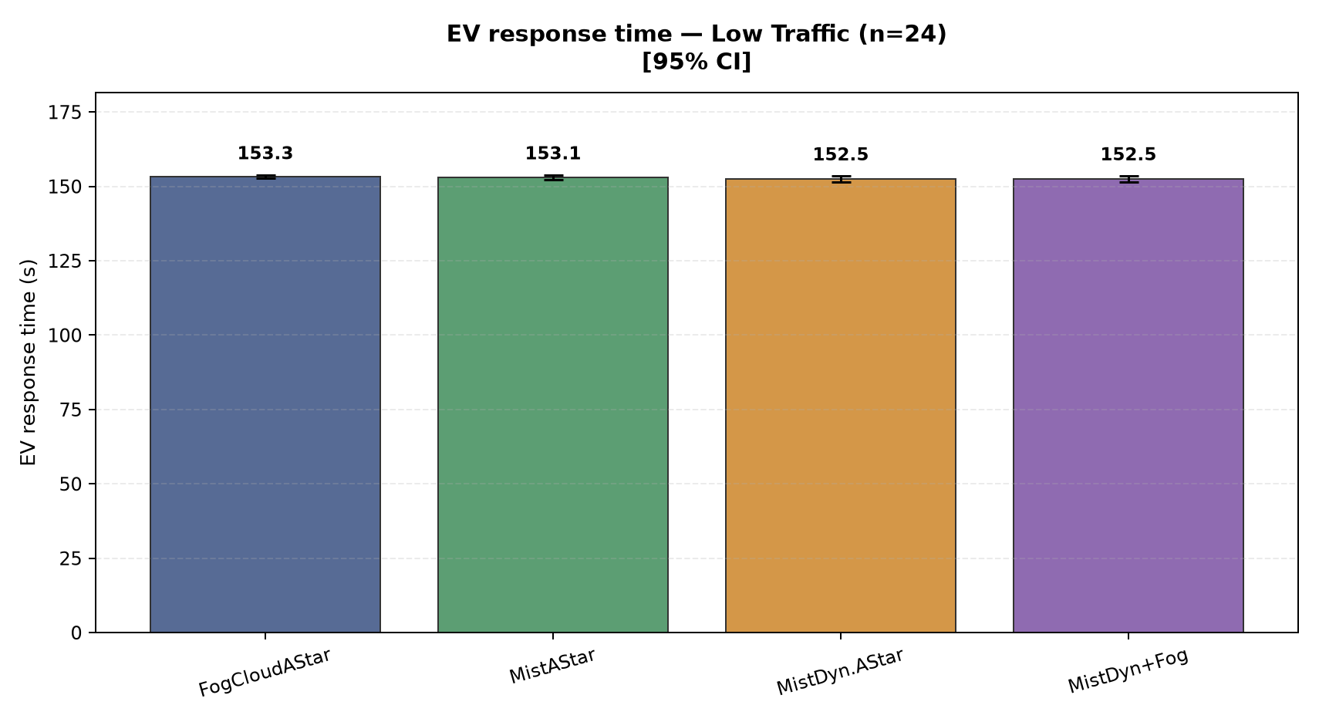
Figure 16. Low traffic (72 background vehicles): Fog/Cloud 153.3; Mist 153.1; Mist Dynamic 152.5; Mist + Fog 152.5. Bars show means and 95% confidence intervals.
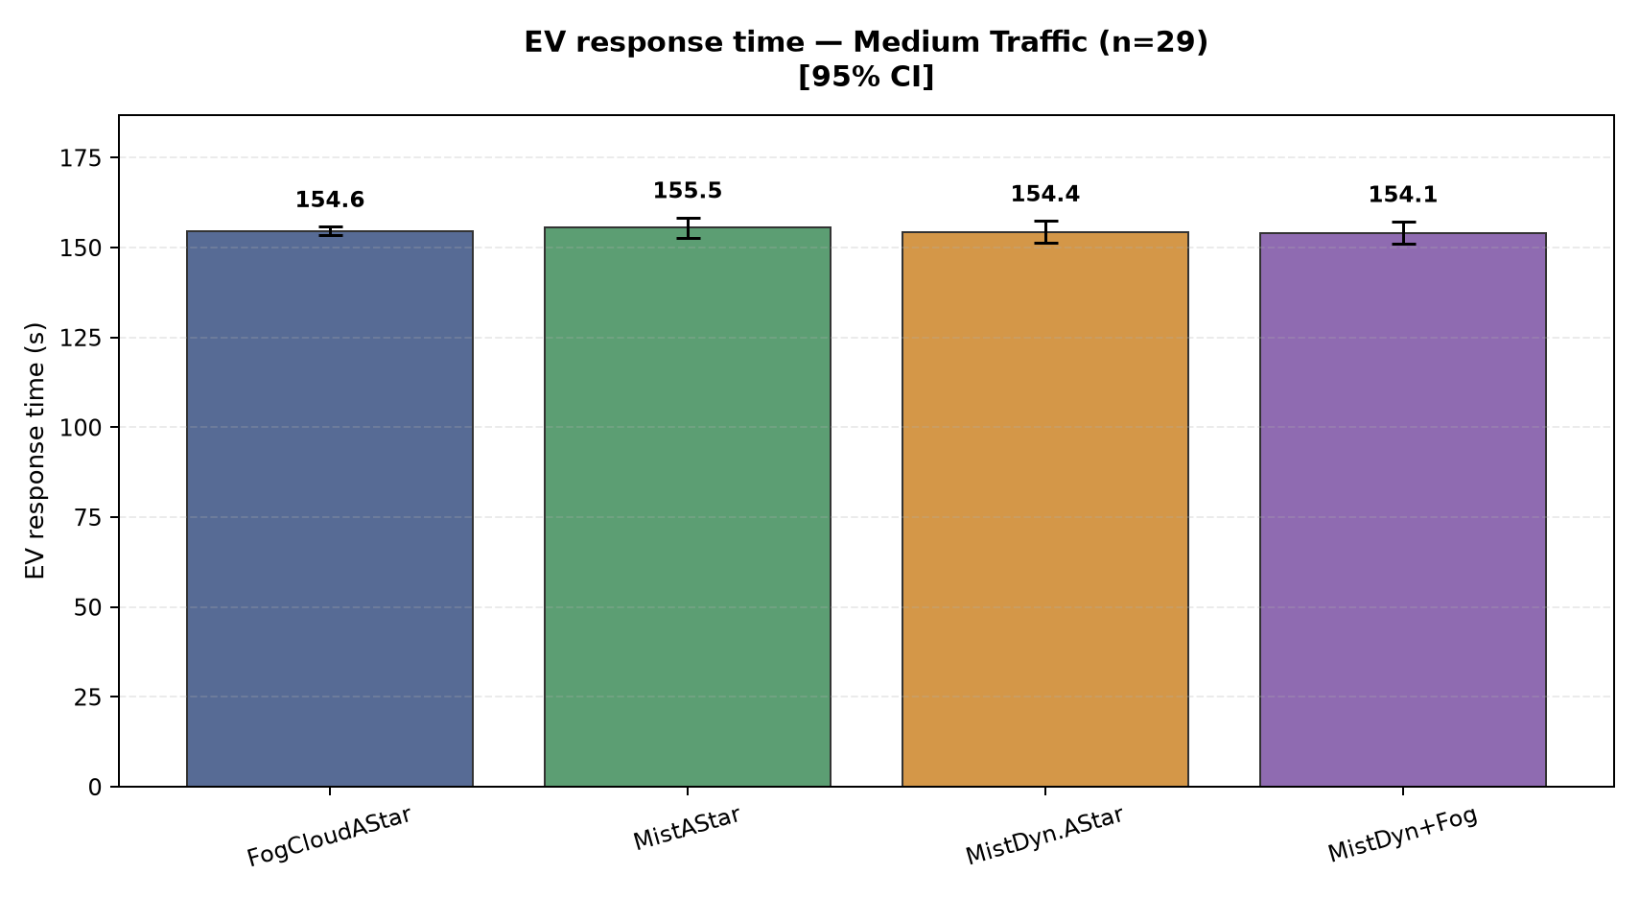
Figure 17. Medium traffic (144 background vehicles): Fog/Cloud 154.6; Mist 155.5; Mist Dynamic 154.4; Mist + Fog 154.1. Bars show means and 95% confidence intervals.
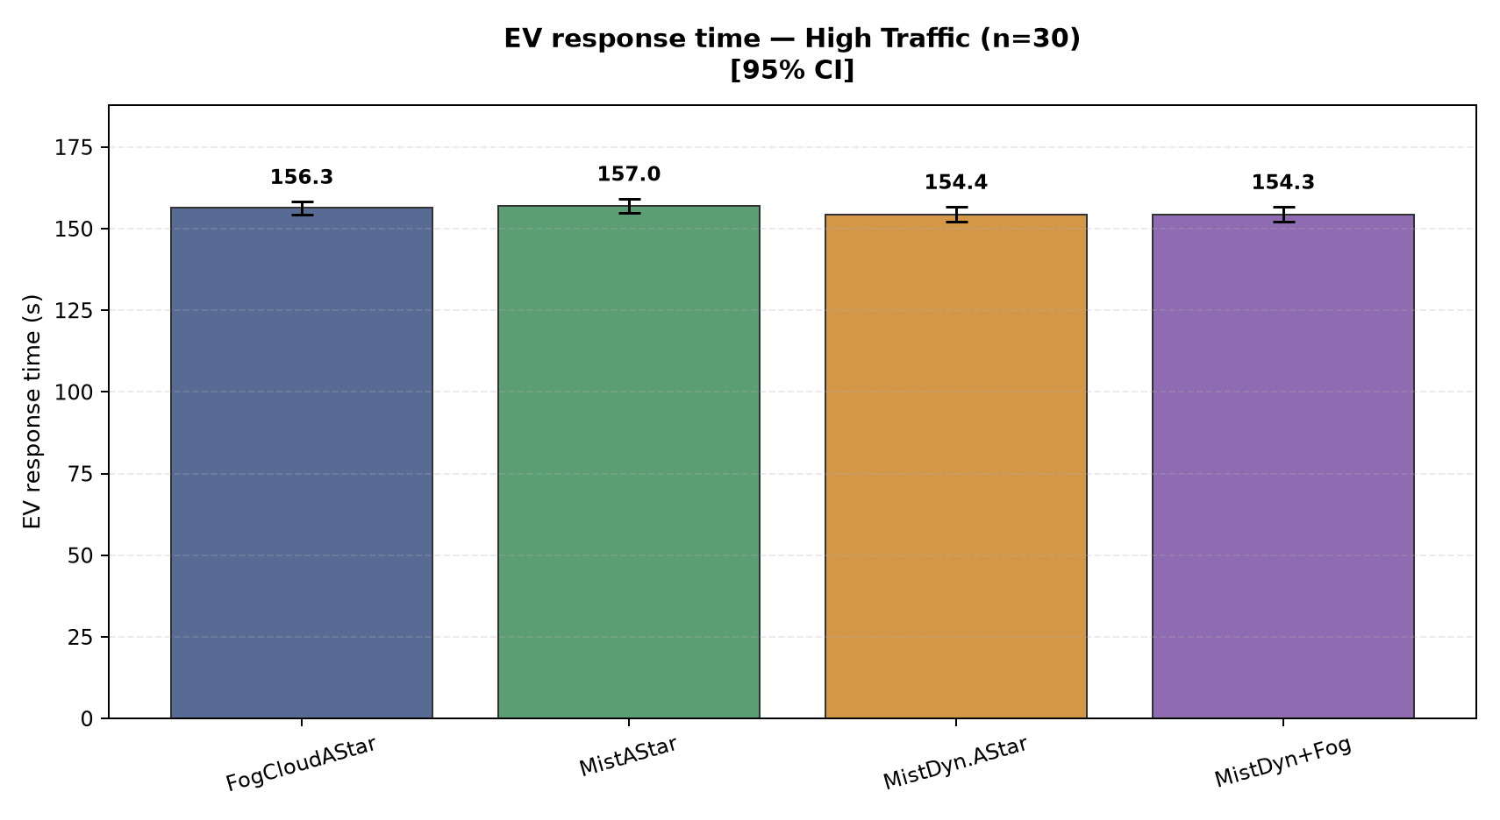
Figure 18. High traffic (200 background vehicles): Fog/Cloud 156.3; Mist 157.0; Mist Dynamic 154.4; Mist + Fog 154.3. Bars show means and 95% confidence intervals.

EV traffic-light waiting time
EV standstill near a signal stop line, in seconds. A value of zero means no measured wait.
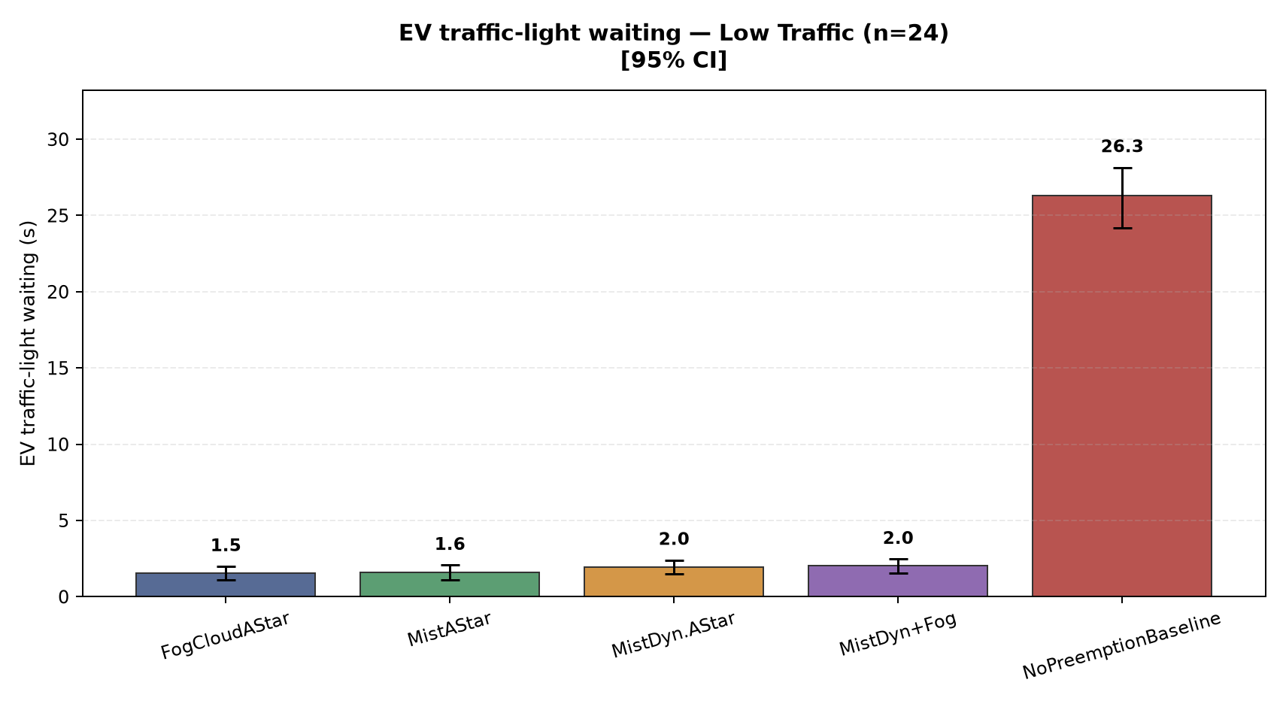
Figure 19. Low traffic (72 background vehicles): Fog/Cloud 1.5; Mist 1.6; Mist Dynamic 2.0; Mist + Fog 2.0; No preemption 26.3. Bars show means and 95% confidence intervals.
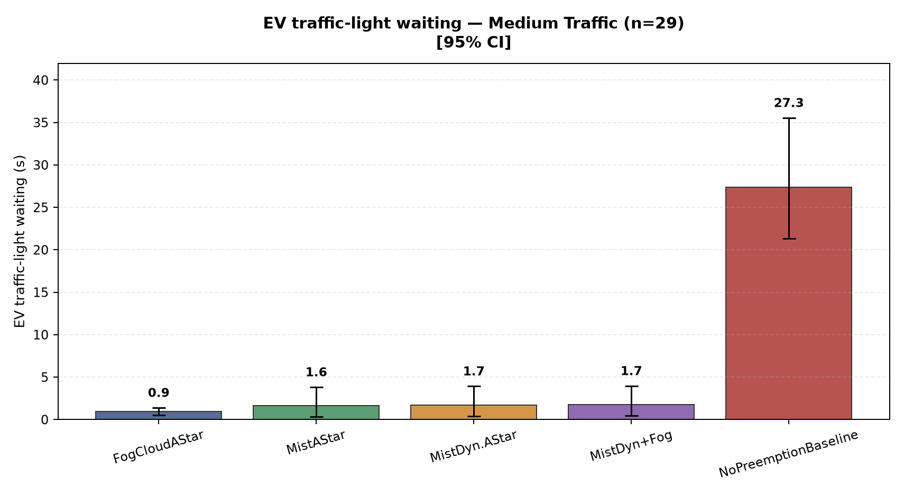
Figure 20. Medium traffic (144 background vehicles): Fog/Cloud 0.9; Mist 1.6; Mist Dynamic 1.7; Mist + Fog 1.7; No preemption 27.3. Bars show means and 95% confidence intervals.
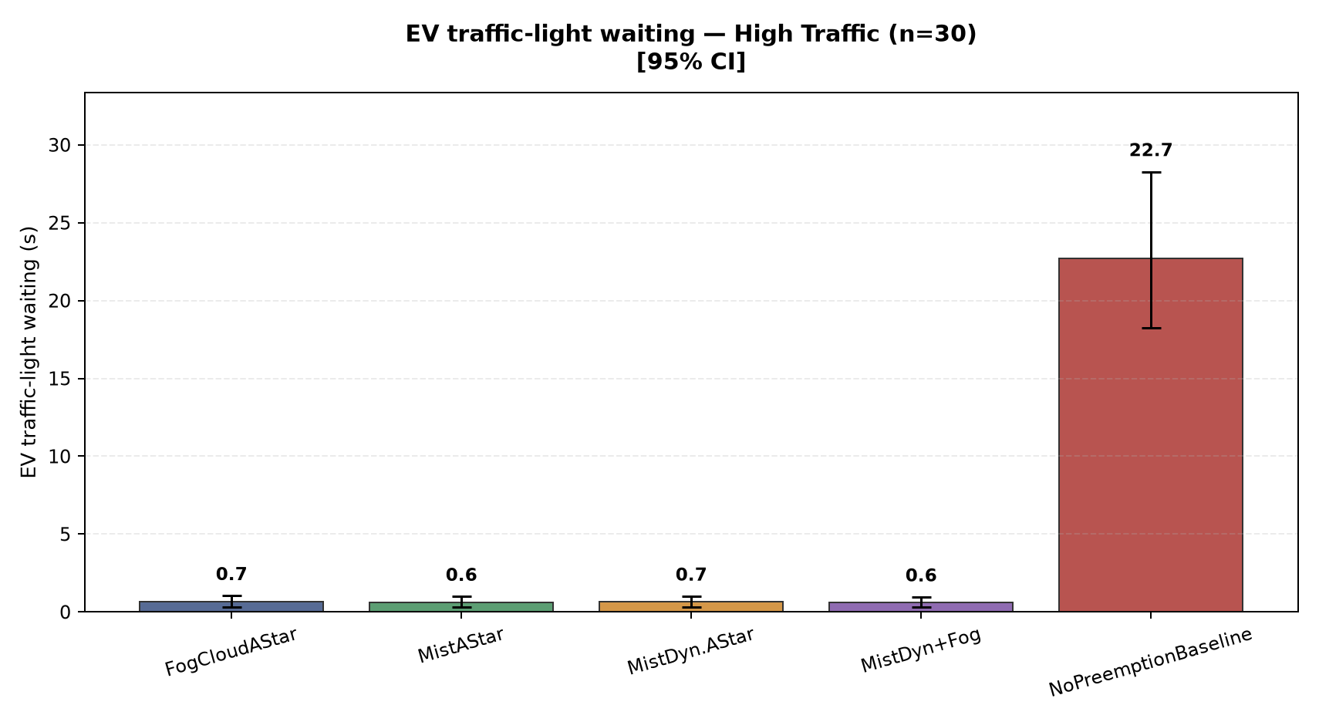
Figure 21. High traffic (200 background vehicles): Fog/Cloud 0.7; Mist 0.6; Mist Dynamic 0.7; Mist + Fog 0.6; No preemption 22.7. Bars show means and 95% confidence intervals.

Fallback activation rate
Share of Mist with Fog runs where the 500 ms watchdog requested Fog. Controlled stalls are explicitly injected in eight of the 30 seeds.
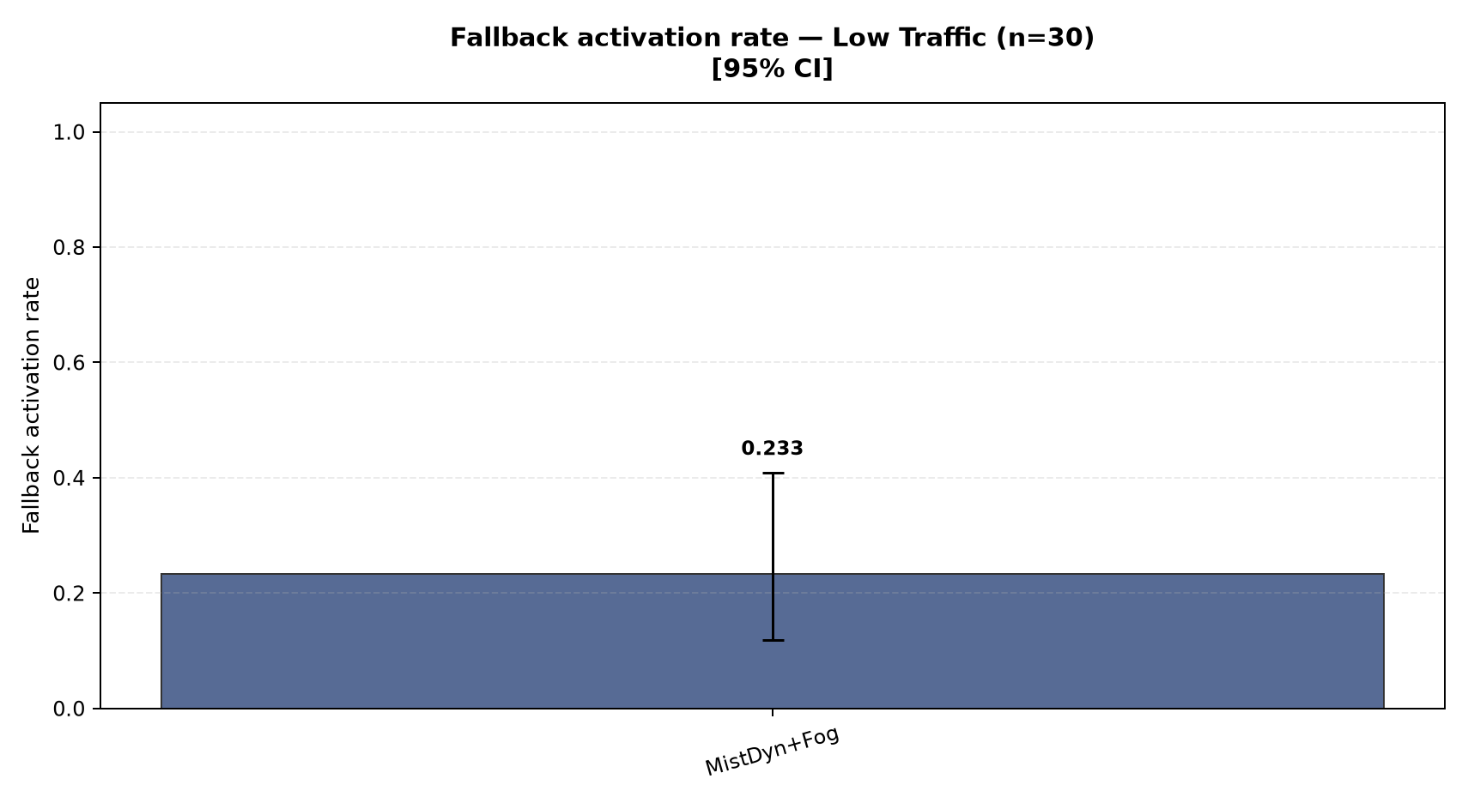
Figure 22. Low traffic (72 background vehicles): Mist + Fog 0.233. Bars show means and 95% confidence intervals.
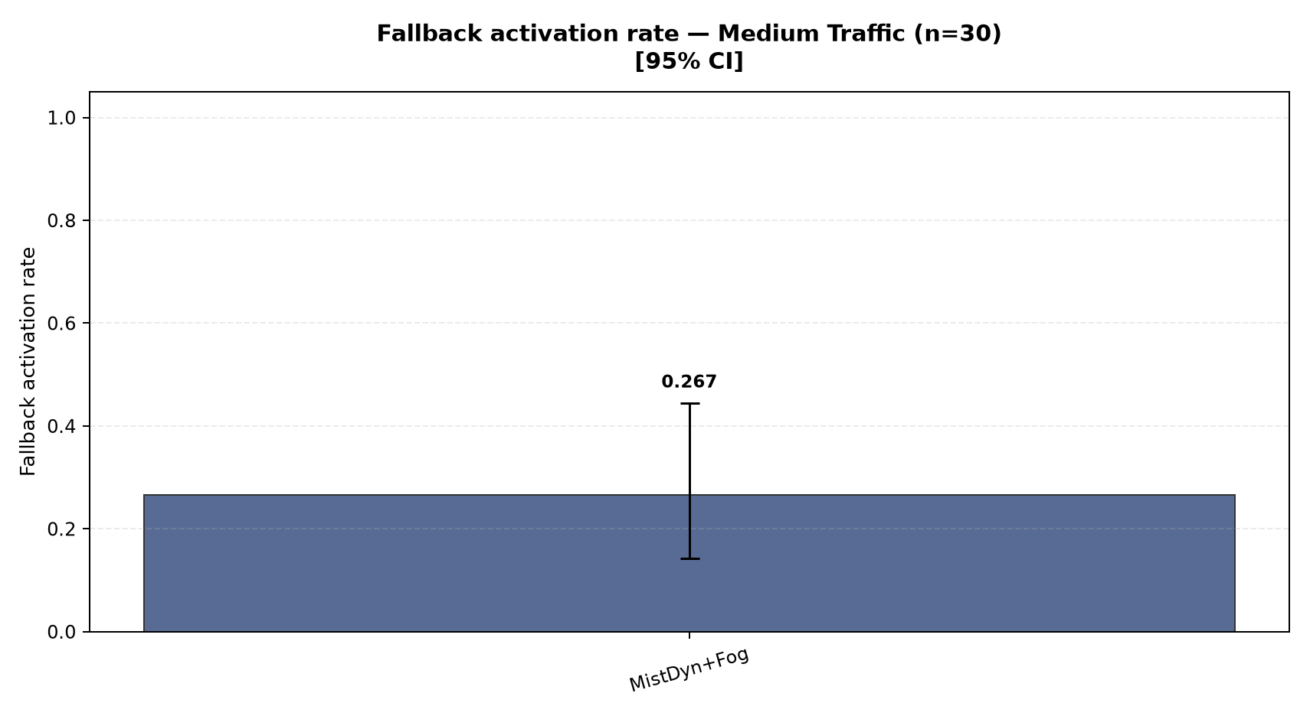
Figure 23. Medium traffic (144 background vehicles): Mist + Fog 0.267. Bars show means and 95% confidence intervals.
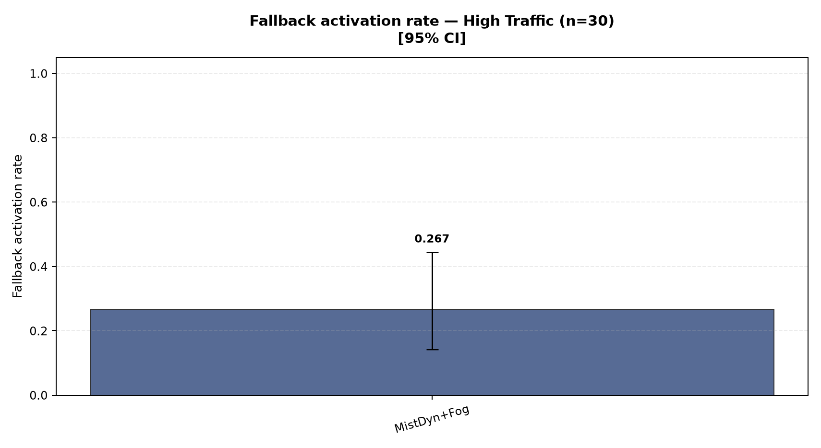
Figure 24. High traffic (200 background vehicles): Mist + Fog 0.267. Bars show means and 95% confidence intervals.

Applied route changes
Mean number of actual congestion or cost reroutes per run. Reviews without a replacement are excluded.
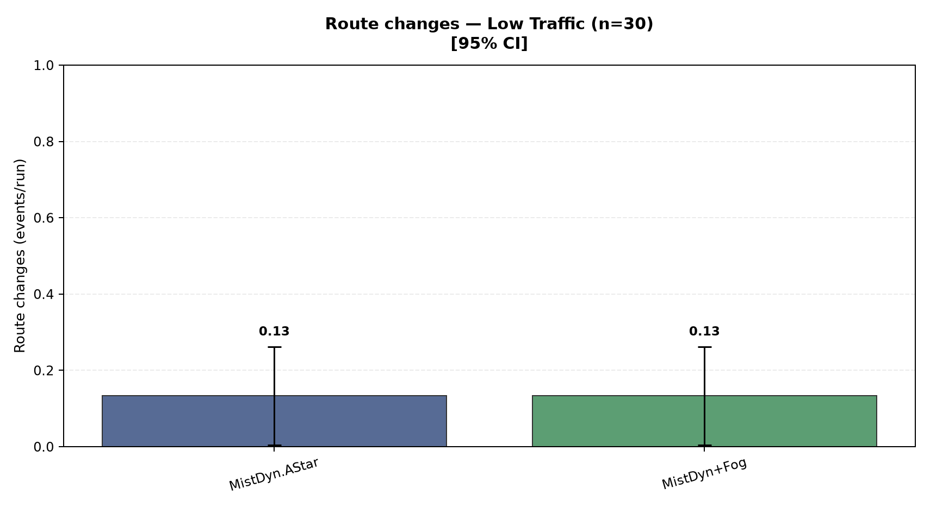
Figure 25. Low traffic (72 background vehicles): Mist Dynamic 0.13; Mist + Fog 0.13. Bars show means and 95% confidence intervals.
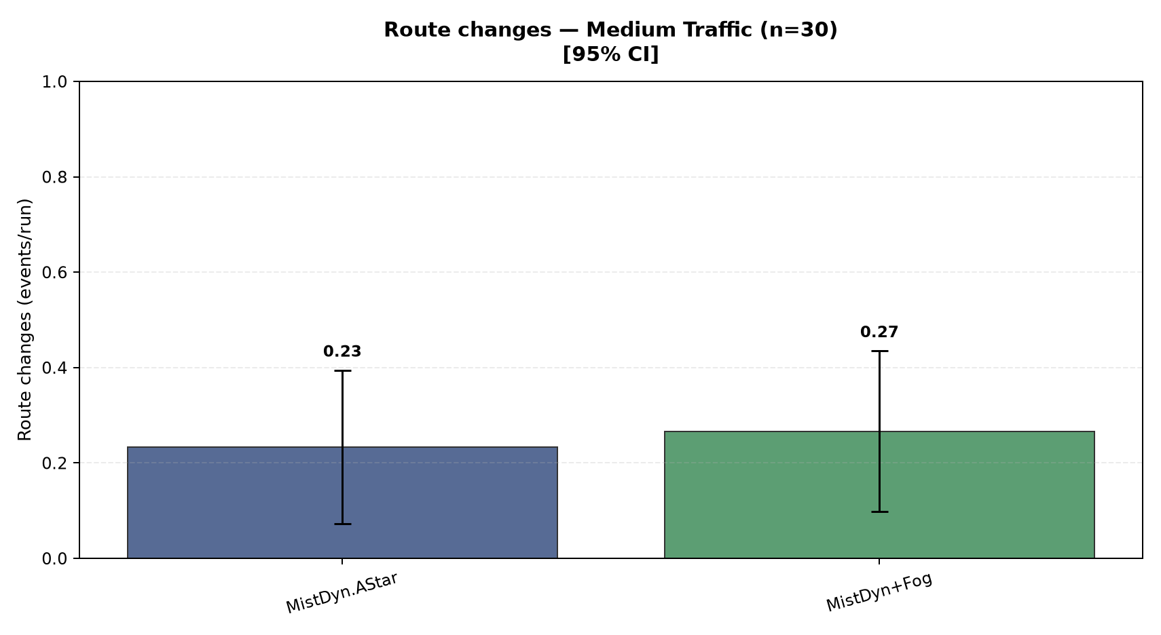
Figure 26. Medium traffic (144 background vehicles): Mist Dynamic 0.23; Mist + Fog 0.27. Bars show means and 95% confidence intervals.
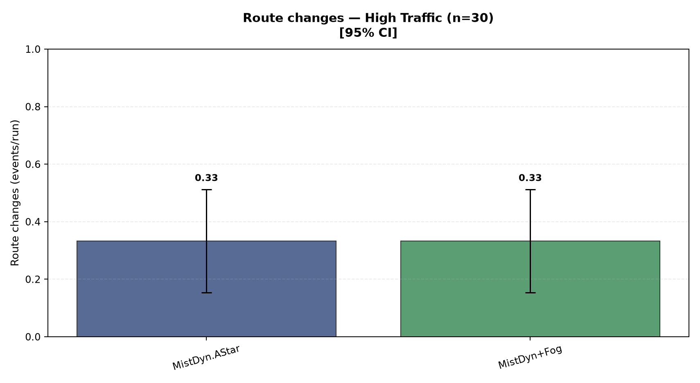
Figure 27. High traffic (200 background vehicles): Mist Dynamic 0.33; Mist + Fog 0.33. Bars show means and 95% confidence intervals.

Route computation frequency
Mean number of periodic Dynamic A* route evaluations per run, normally scheduled every five seconds.
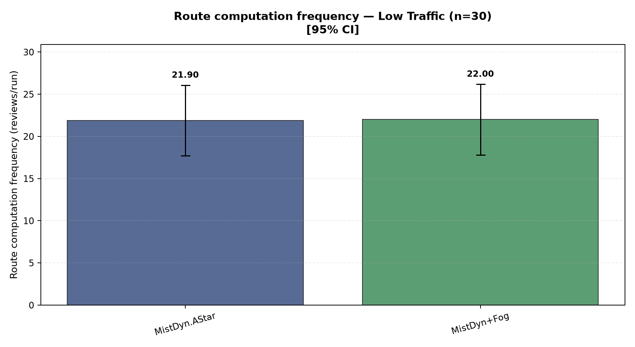
Figure 28. Low traffic (72 background vehicles): Mist Dynamic 21.90; Mist + Fog 22.00. Bars show means and 95% confidence intervals.
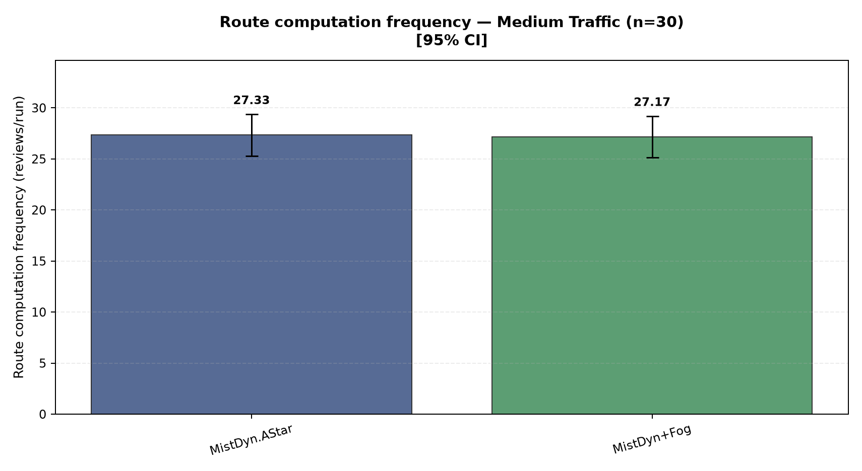
Figure 29. Medium traffic (144 background vehicles): Mist Dynamic 27.33; Mist + Fog 27.17. Bars show means and 95% confidence intervals.
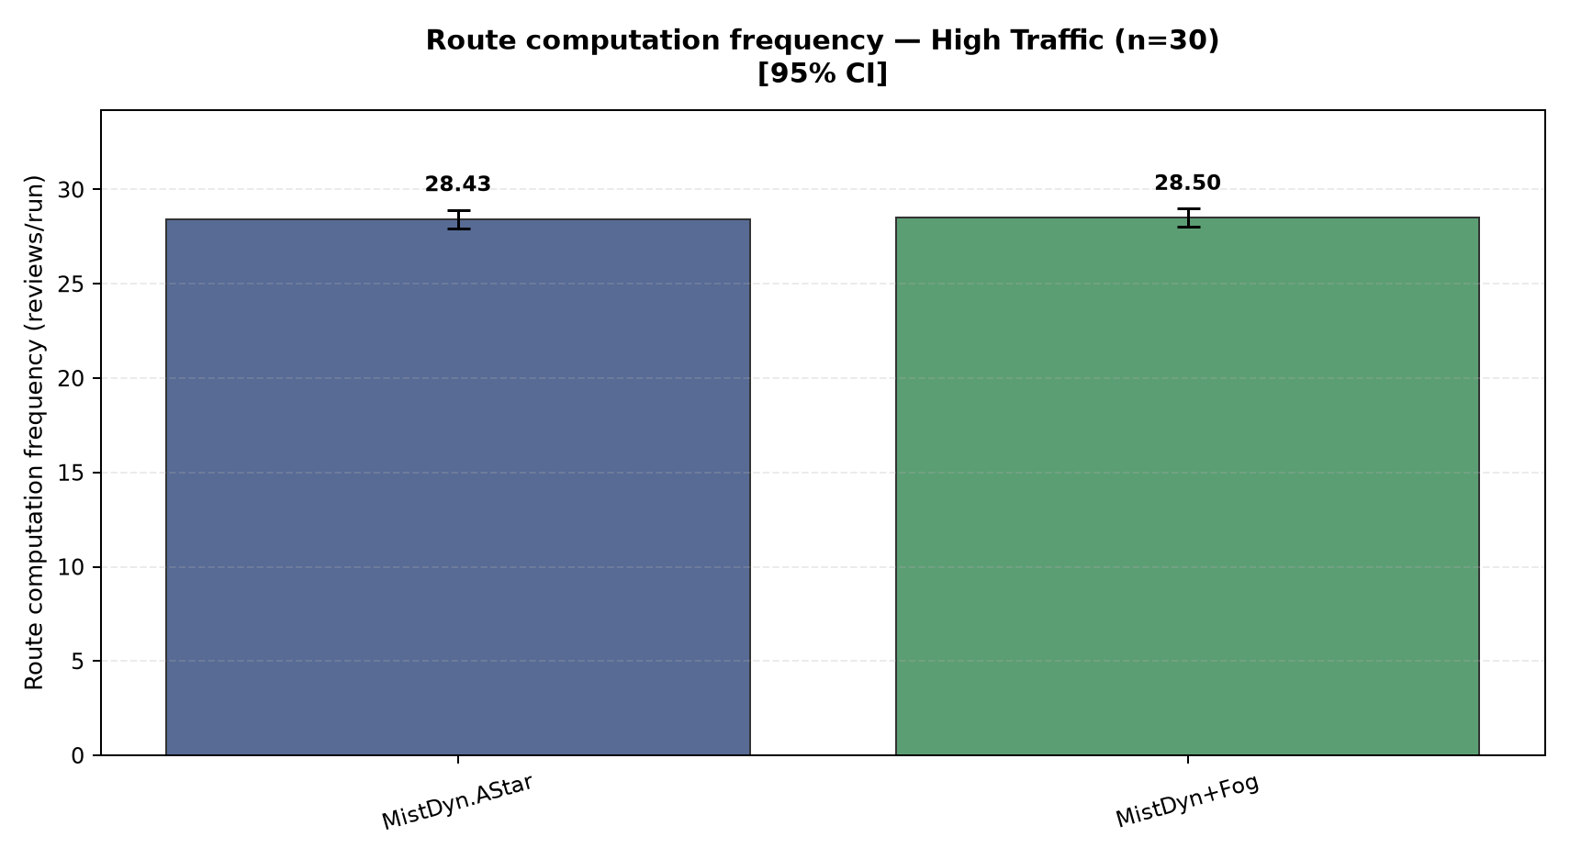
Figure 30. High traffic (200 background vehicles): Mist Dynamic 28.43; Mist + Fog 28.50. Bars show means and 95% confidence intervals.

Fallback decision latency
Time to apply the Fog route in runs where the watchdog actually triggered, in milliseconds.
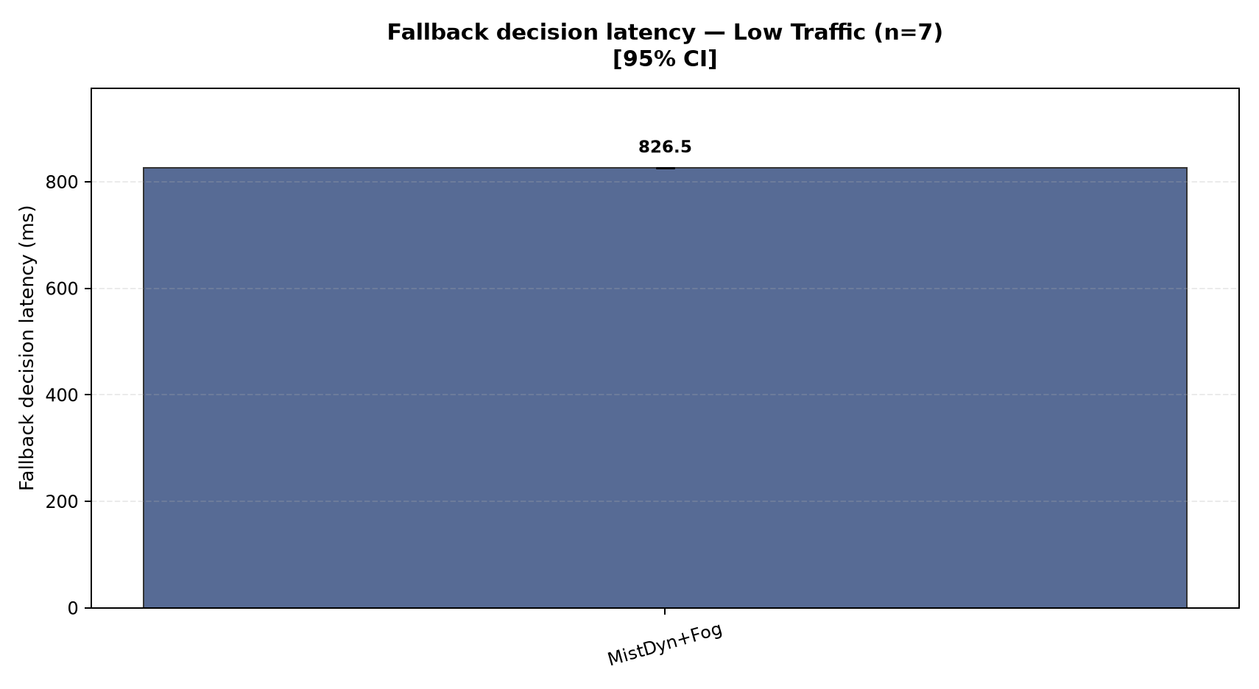
Figure 31. Low traffic (72 background vehicles): Mist + Fog 826.5. Bars show means and 95% confidence intervals.
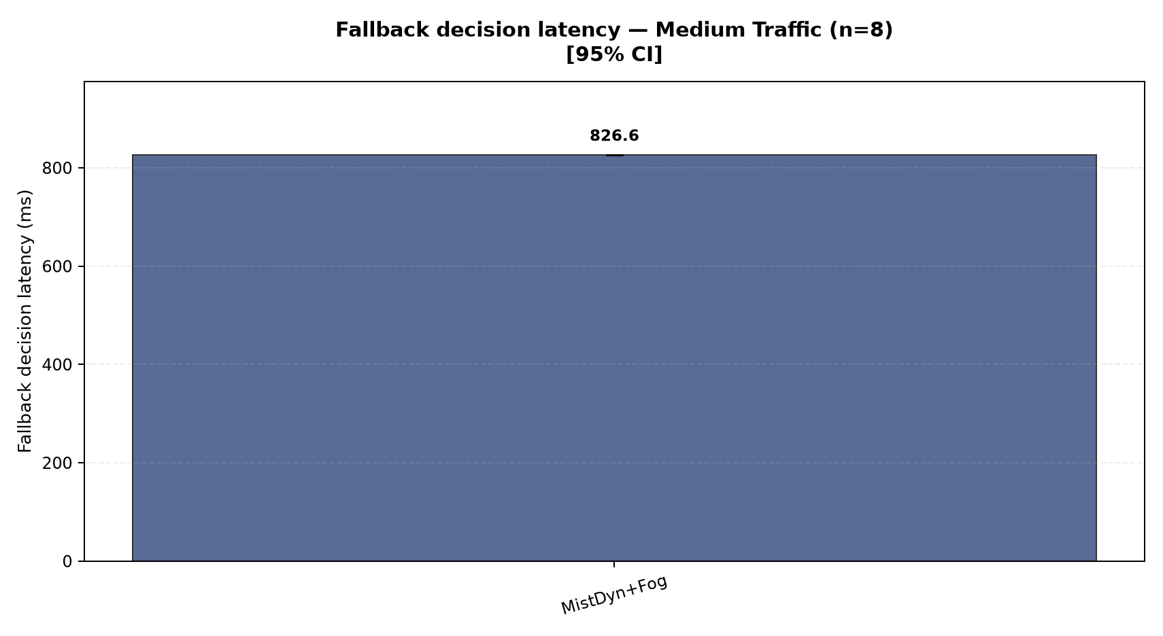
Figure 32. Medium traffic (144 background vehicles): Mist + Fog 826.6. Bars show means and 95% confidence intervals.
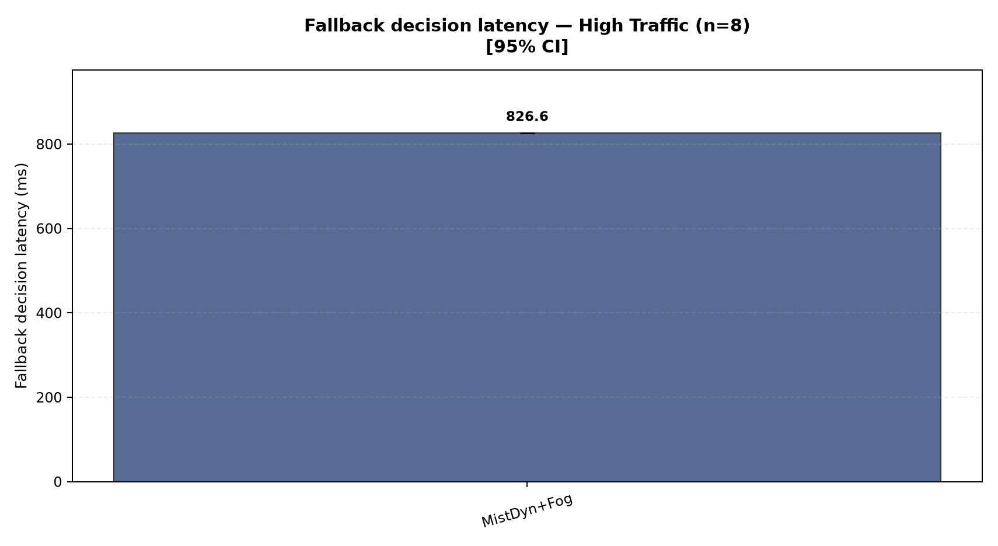
Figure 33. High traffic (200 background vehicles): Mist + Fog 826.6. Bars show means and 95% confidence intervals.

Control transmissions
Mean number of control-packet transmissions per run. This is supporting communication-load evidence.
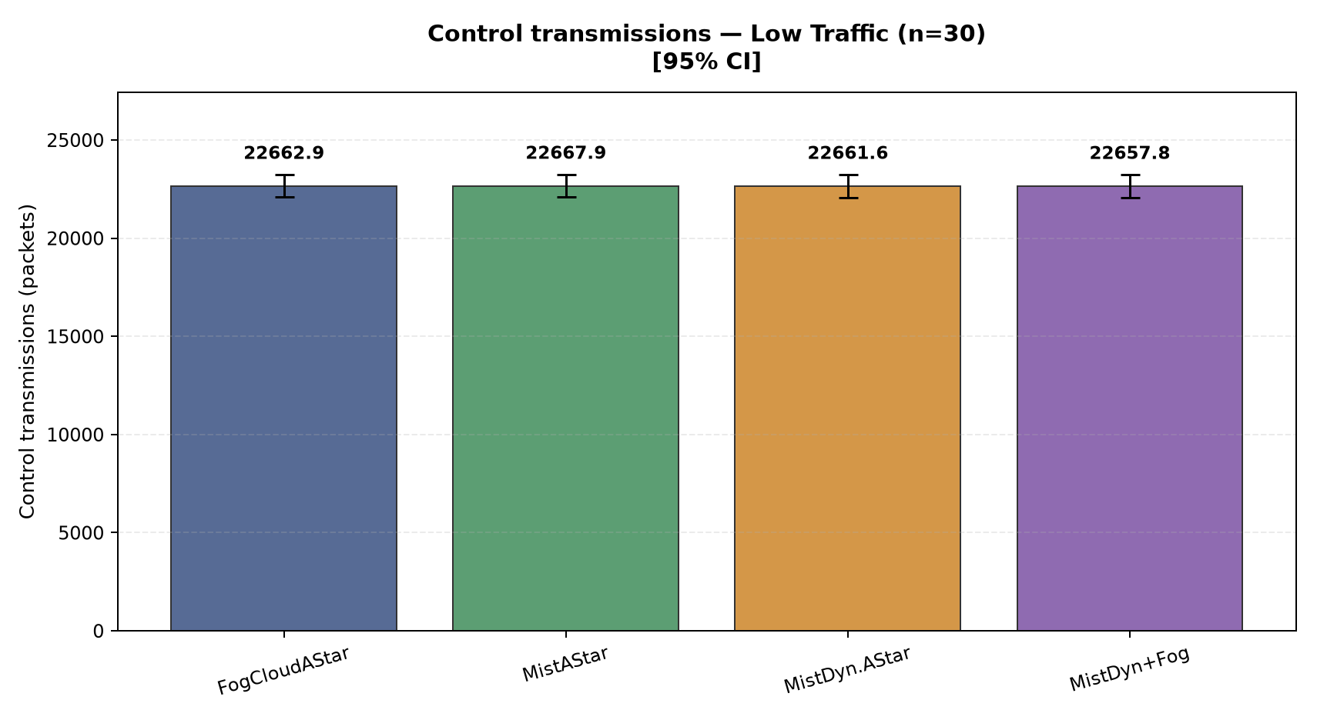
Figure 34. Low traffic (72 background vehicles): Fog/Cloud 22,663; Mist 22,668; Mist Dynamic 22,662; Mist + Fog 22,658. Bars show means and 95% confidence intervals.
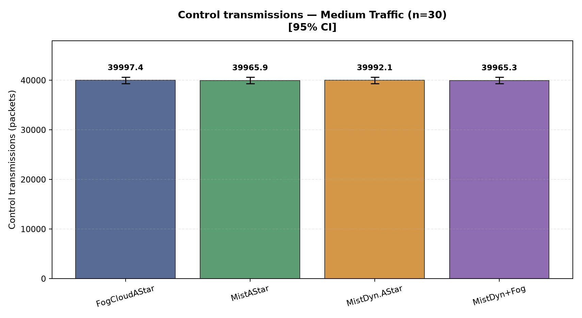
Figure 35. Medium traffic (144 background vehicles): Fog/Cloud 39,997; Mist 39,966; Mist Dynamic 39,992; Mist + Fog 39,965. Bars show means and 95% confidence intervals.
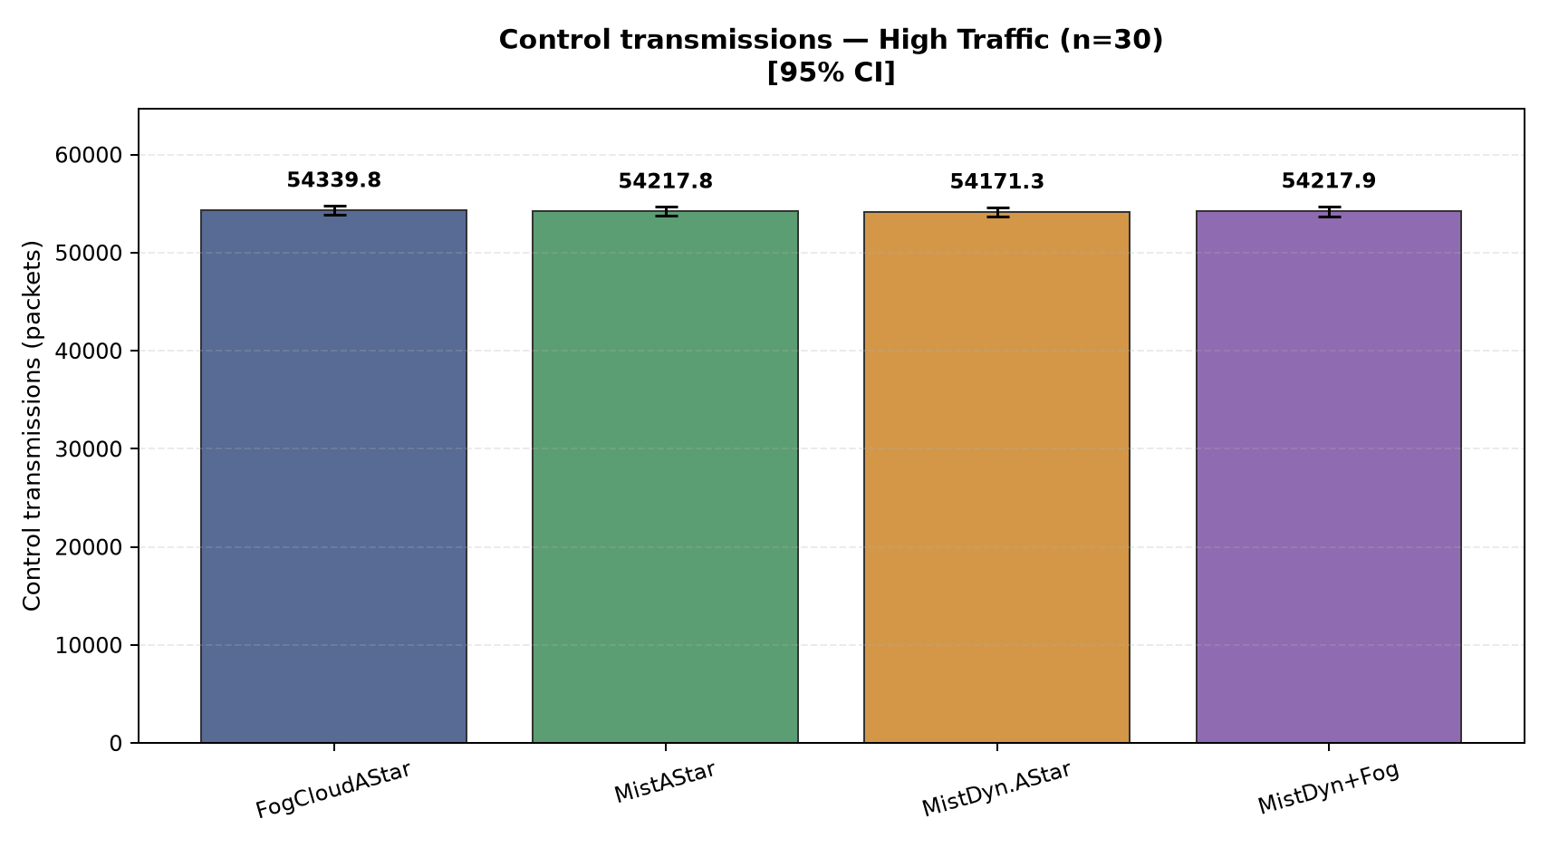
Figure 36. High traffic (200 background vehicles): Fog/Cloud 54,340; Mist 54,218; Mist Dynamic 54,171; Mist + Fog 54,218. Bars show means and 95% confidence intervals.

Control bytes
Mean control traffic volume in bytes per run. This is supporting communication-load evidence.
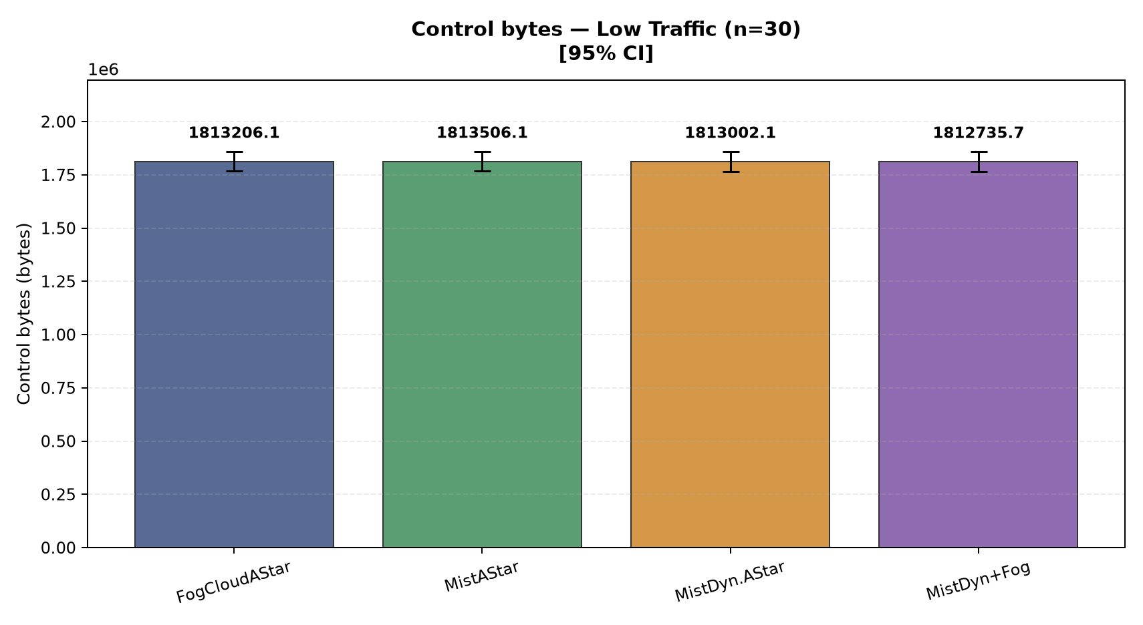
Figure 37. Low traffic (72 background vehicles): Fog/Cloud 1,813,206; Mist 1,813,506; Mist Dynamic 1,813,002; Mist + Fog 1,812,736. Bars show means and 95% confidence intervals.
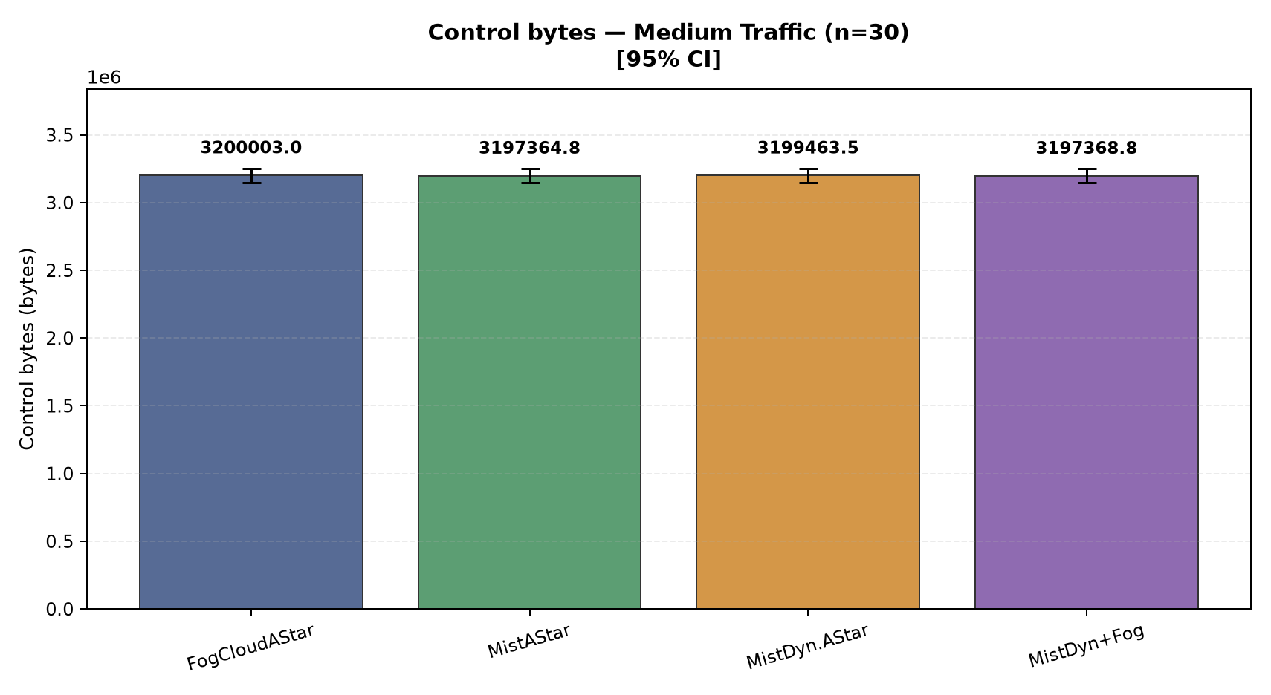
Figure 38. Medium traffic (144 background vehicles): Fog/Cloud 3,200,003; Mist 3,197,365; Mist Dynamic 3,199,463; Mist + Fog 3,197,369. Bars show means and 95% confidence intervals.
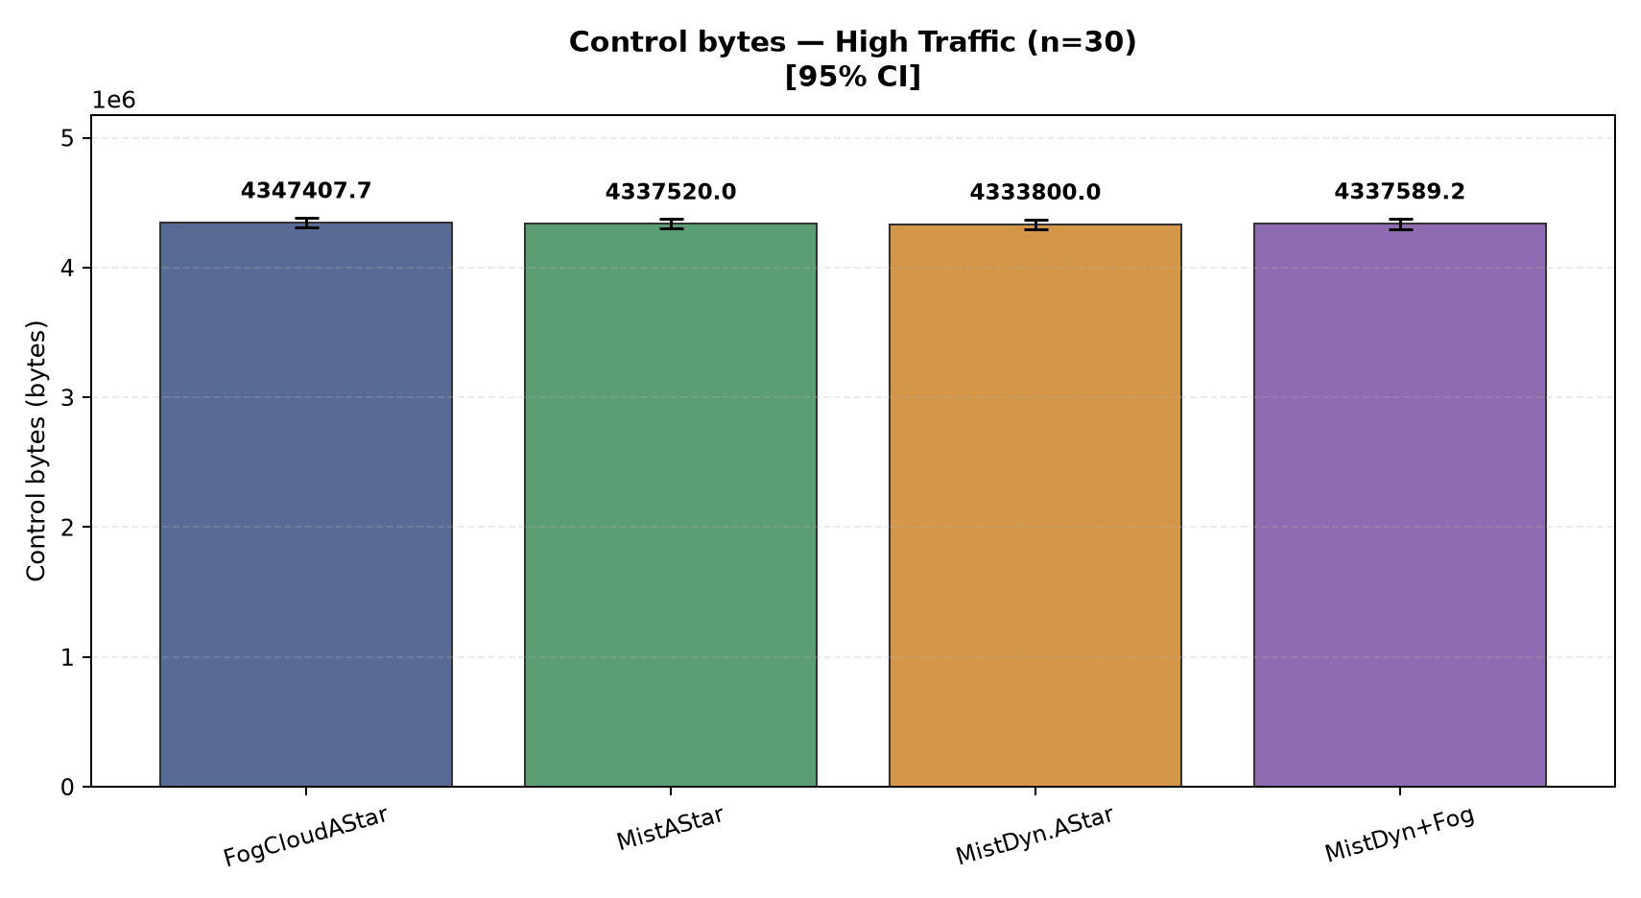
Figure 39. High traffic (200 background vehicles): Fog/Cloud 4,347,408; Mist 4,337,520; Mist Dynamic 4,333,800; Mist + Fog 4,337,589. Bars show means and 95% confidence intervals.

EV corridor delay versus free flow
Extra travel time relative to the modeled free-flow corridor, in seconds.
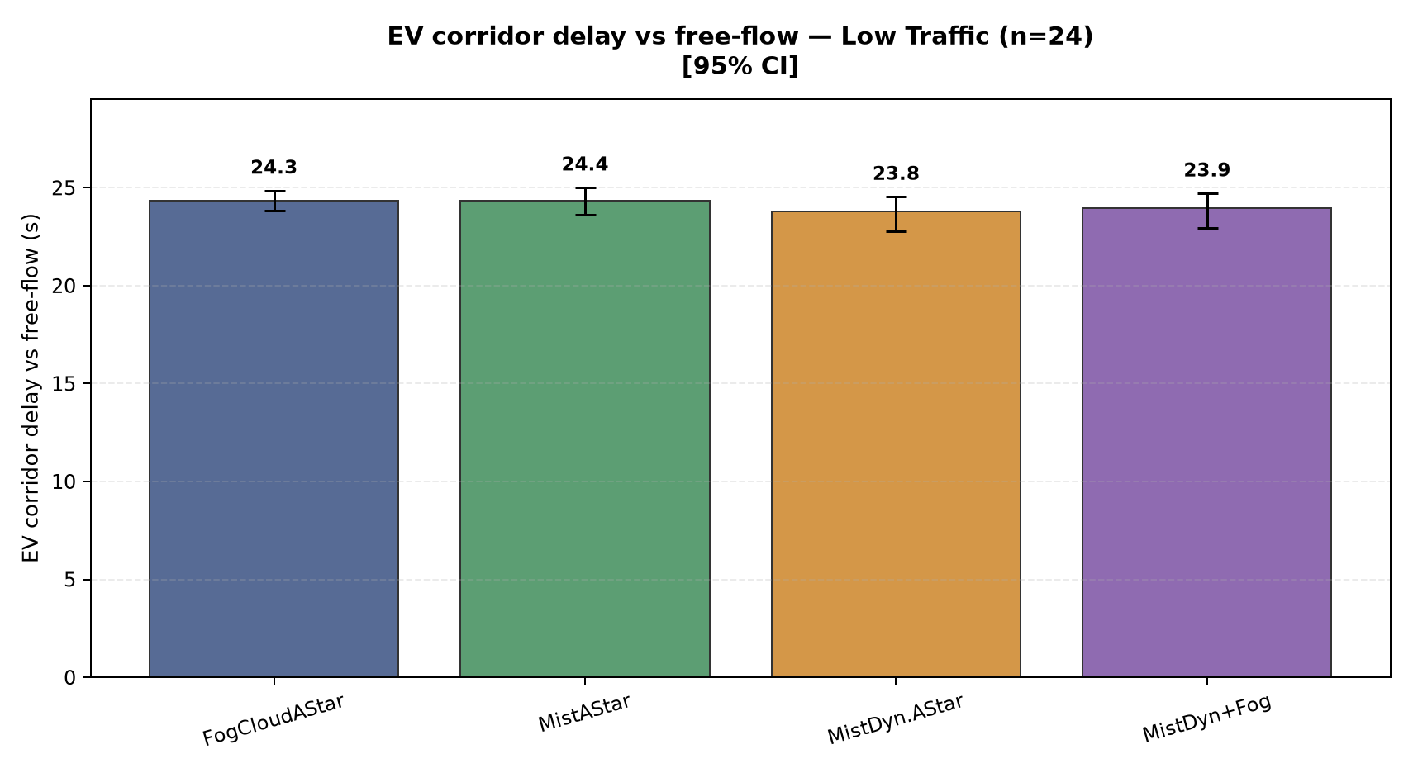
Figure 40. Low traffic (72 background vehicles): Fog/Cloud 24.3; Mist 24.4; Mist Dynamic 23.8; Mist + Fog 23.9. Bars show means and 95% confidence intervals.
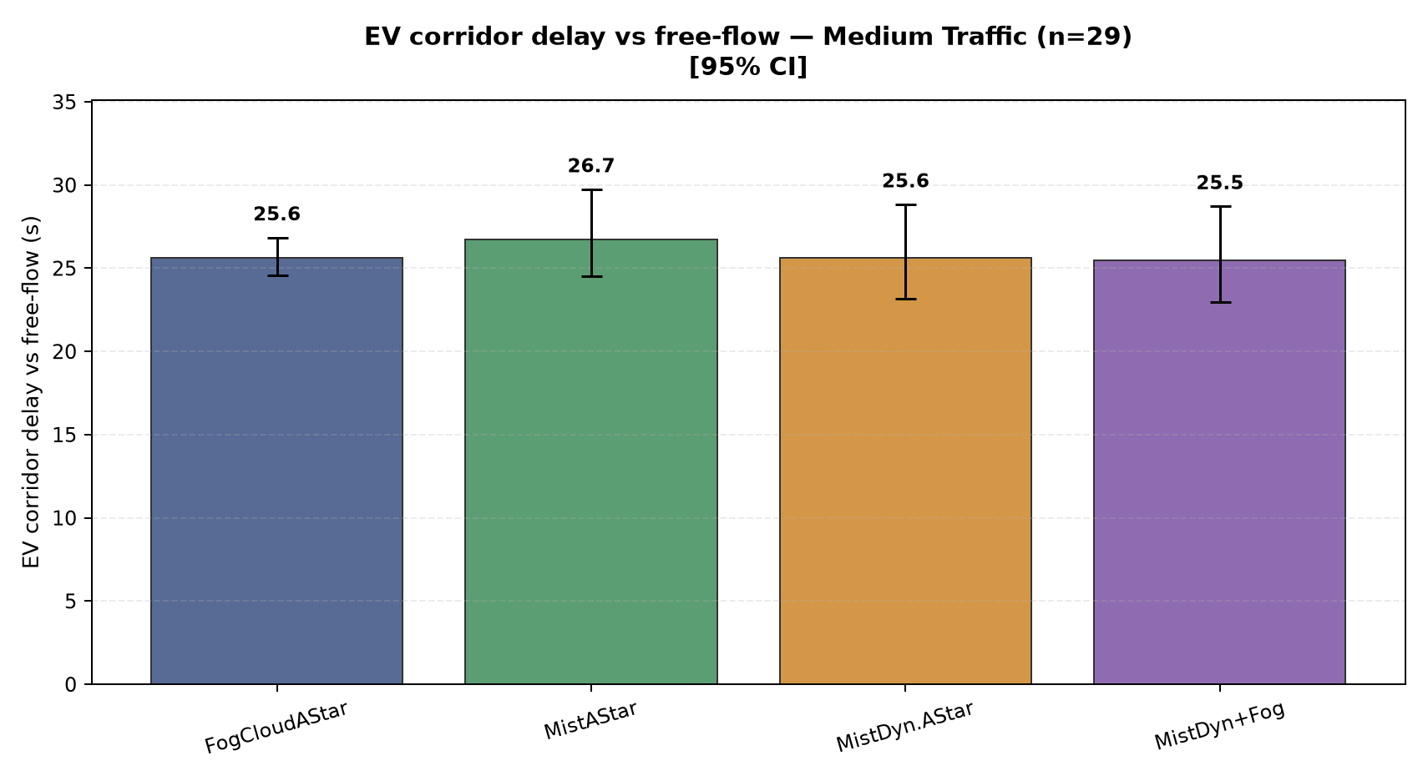
Figure 41. Medium traffic (144 background vehicles): Fog/Cloud 25.6; Mist 26.7; Mist Dynamic 25.6; Mist + Fog 25.5. Bars show means and 95% confidence intervals.
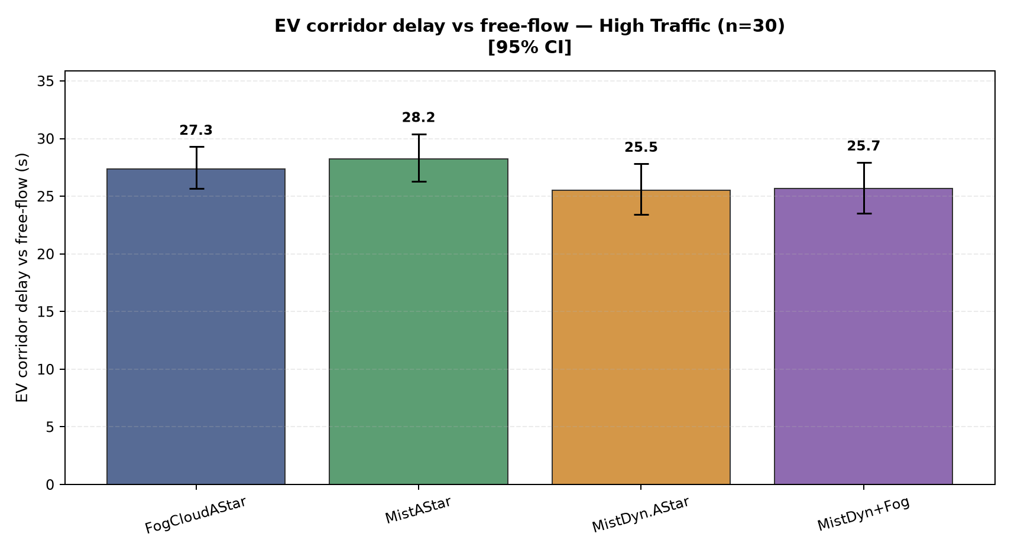
Figure 42. High traffic (200 background vehicles): Fog/Cloud 27.3; Mist 28.2; Mist Dynamic 25.5; Mist + Fog 25.7. Bars show means and 95% confidence intervals.

EV route distance
Distance traveled by the EV to reach the accident, in metres.
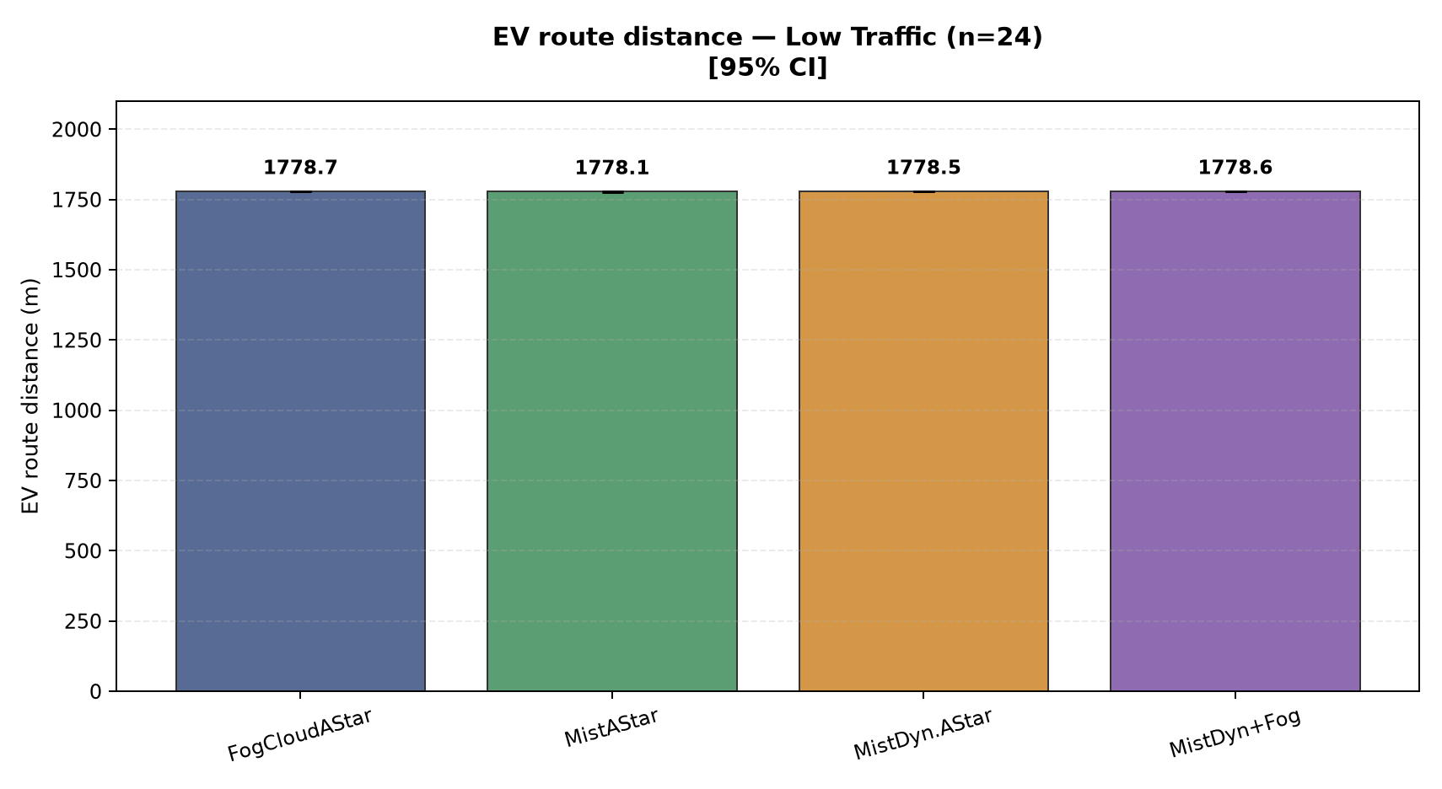
Figure 43. Low traffic (72 background vehicles): Fog/Cloud 1778.7; Mist 1778.1; Mist Dynamic 1778.5; Mist + Fog 1778.6. Bars show means and 95% confidence intervals.
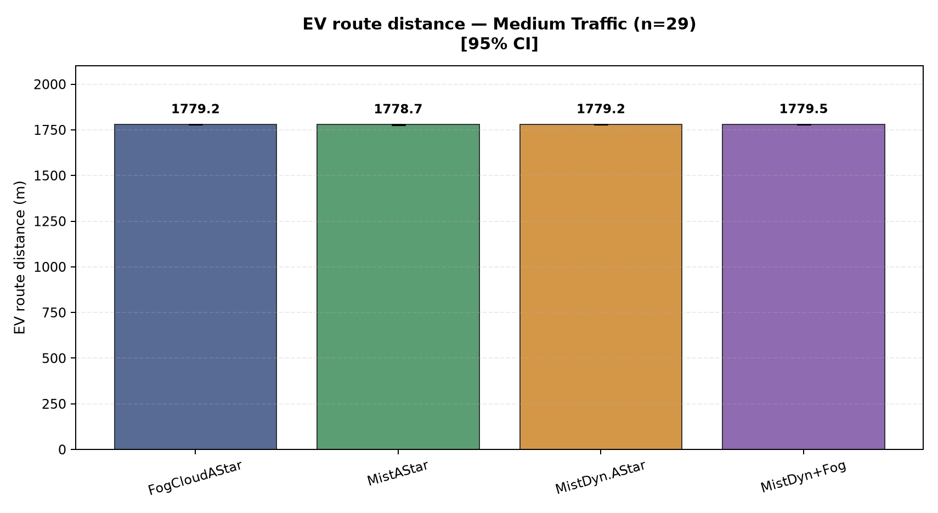
Figure 44. Medium traffic (144 background vehicles): Fog/Cloud 1779.2; Mist 1778.7; Mist Dynamic 1779.2; Mist + Fog 1779.5. Bars show means and 95% confidence intervals.
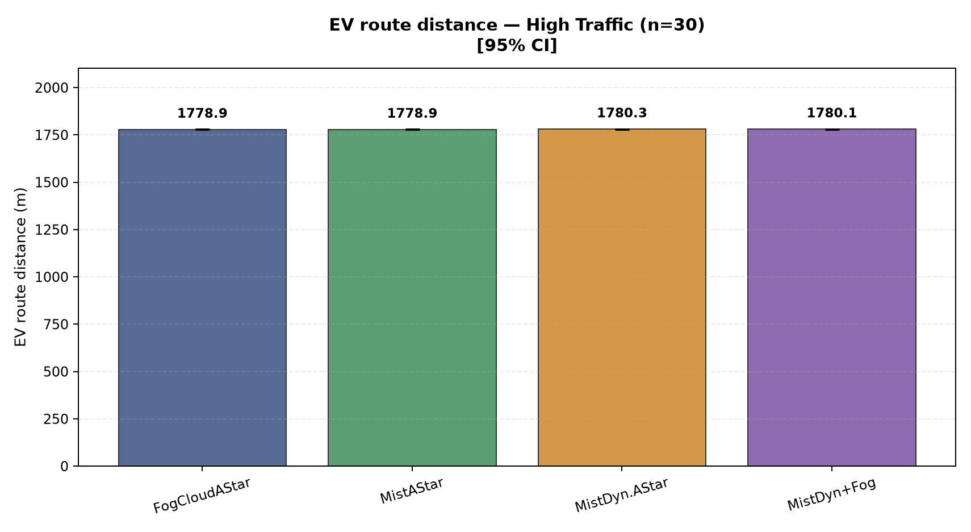
Figure 45. High traffic (200 background vehicles): Fog/Cloud 1778.9; Mist 1778.9; Mist Dynamic 1780.3; Mist + Fog 1780.1. Bars show means and 95% confidence intervals.

EV travel time
EV movement time from departure to accident arrival, in seconds.
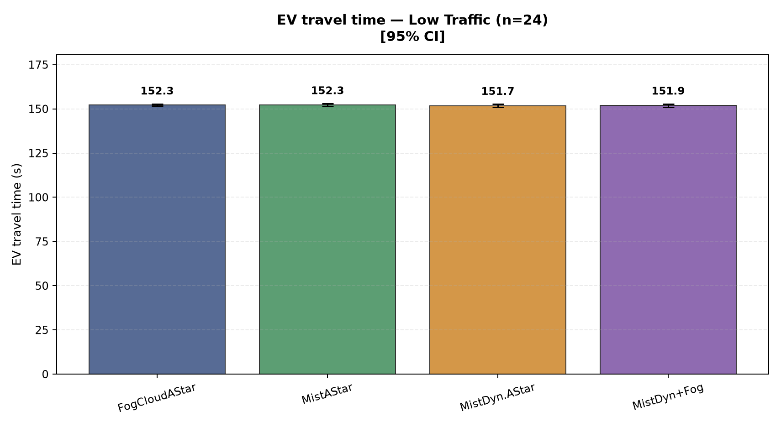
Figure 46. Low traffic (72 background vehicles): Fog/Cloud 152.3; Mist 152.3; Mist Dynamic 151.7; Mist + Fog 151.9. Bars show means and 95% confidence intervals.
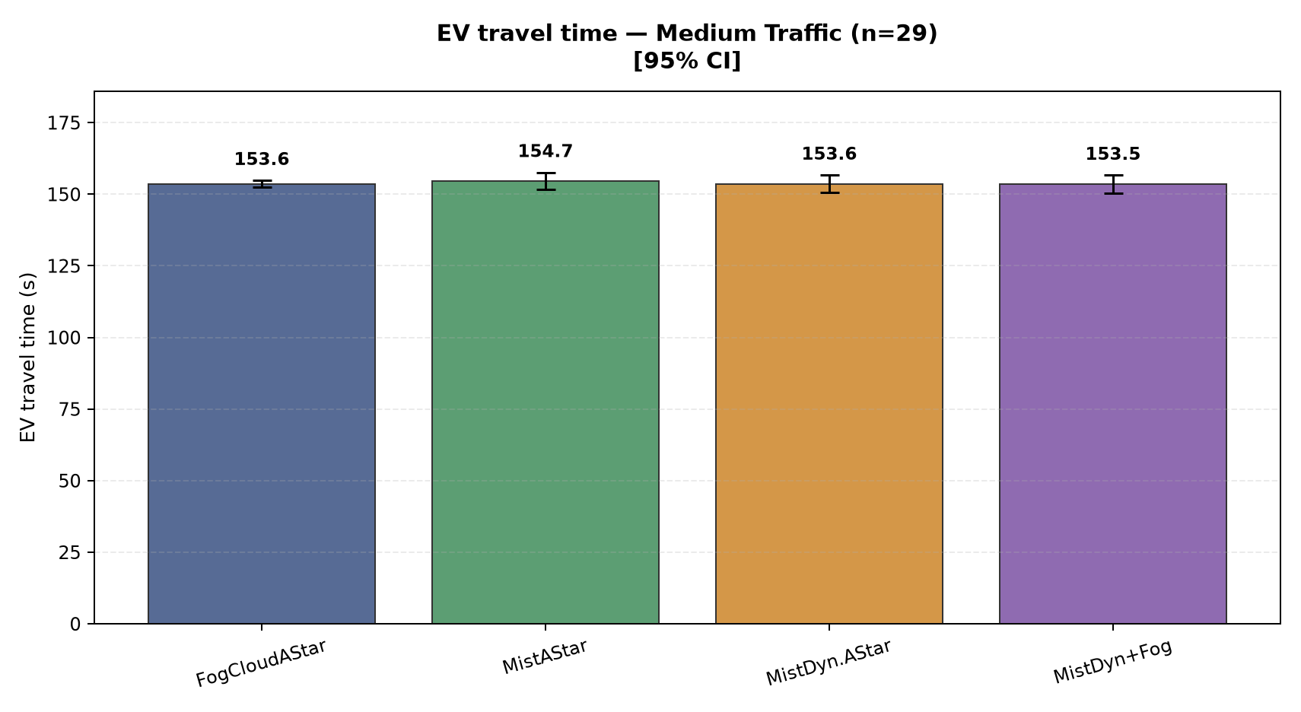
Figure 47. Medium traffic (144 background vehicles): Fog/Cloud 153.6; Mist 154.7; Mist Dynamic 153.6; Mist + Fog 153.5. Bars show means and 95% confidence intervals.
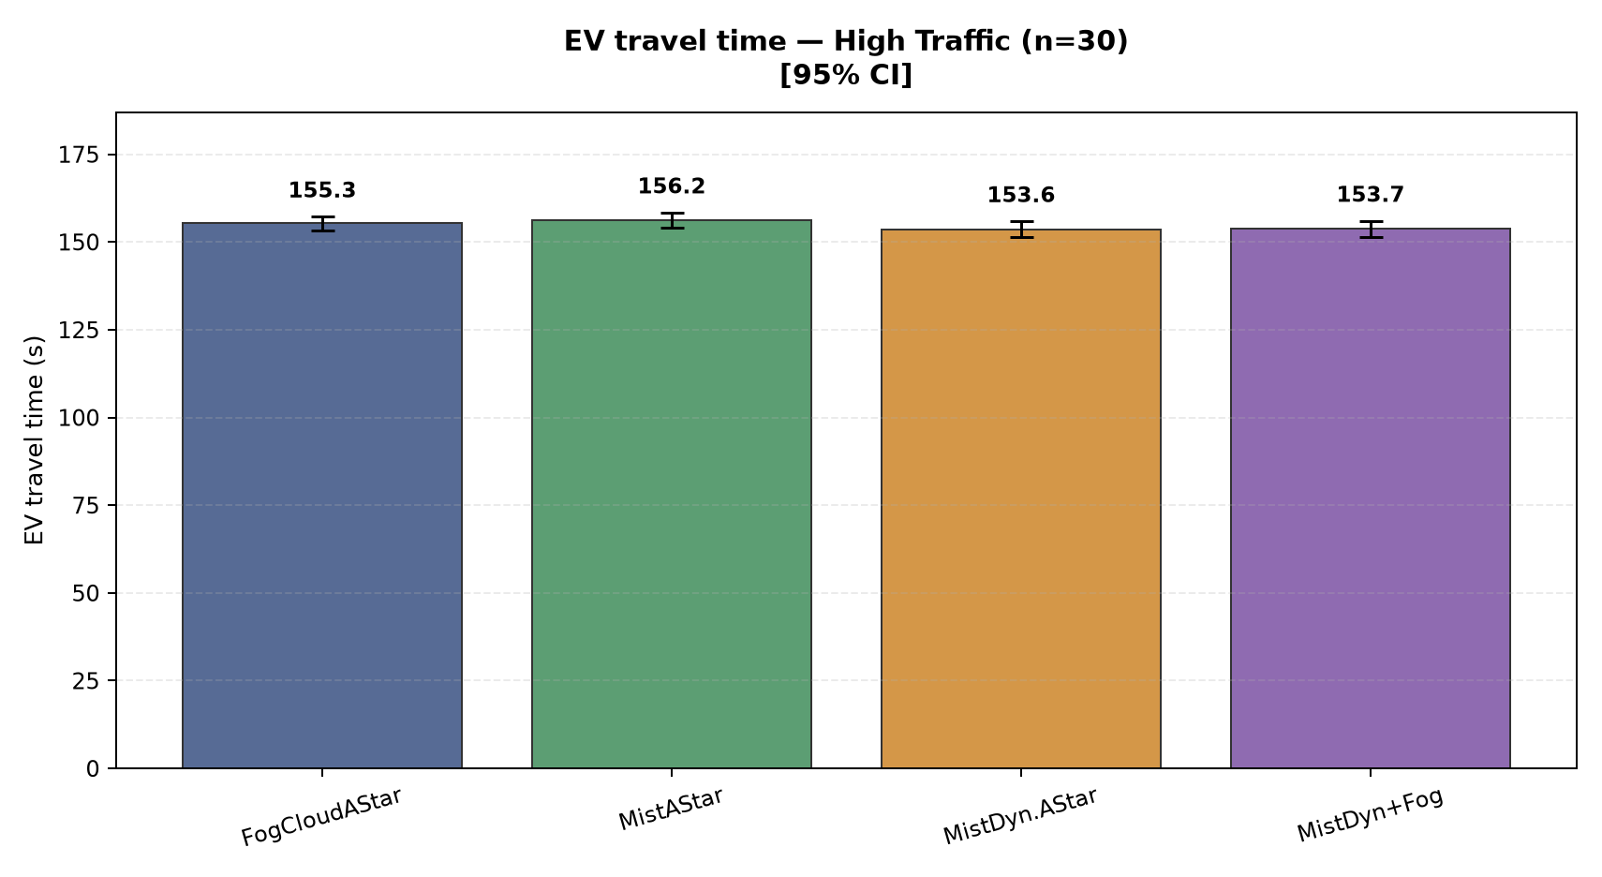
Figure 48. High traffic (200 background vehicles): Fog/Cloud 155.3; Mist 156.2; Mist Dynamic 153.6; Mist + Fog 153.7. Bars show means and 95% confidence intervals.
Detailed metric definitions and model assumptions are in METHODOLOGY.md. The processed data and individual graph files accompany this report.

