TASK 1: Docker Individual Build & Run
Frontend Build
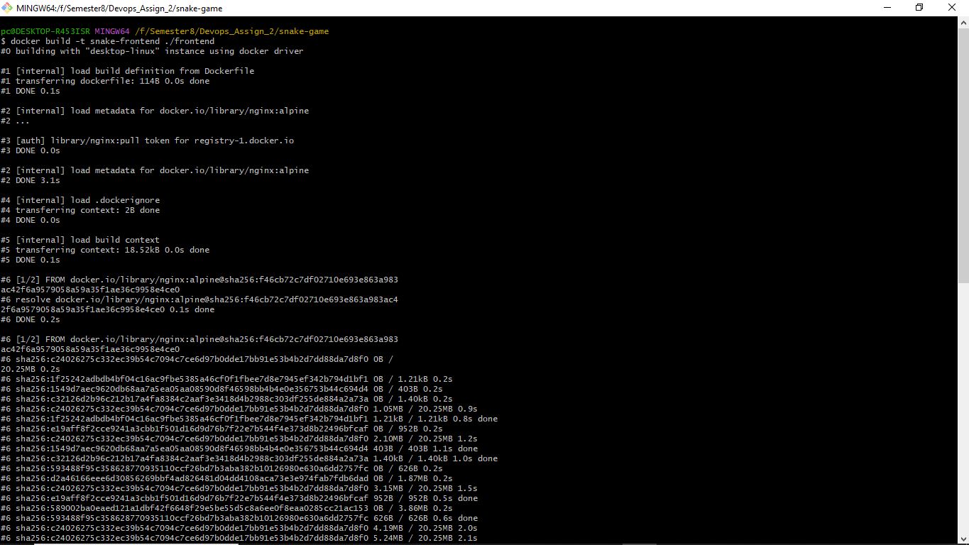
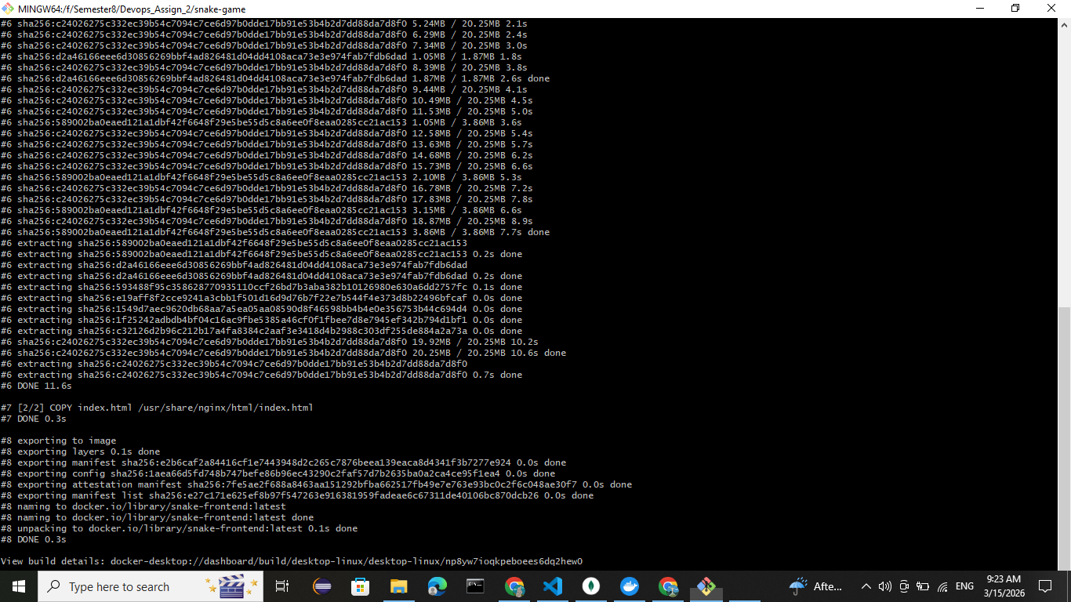
Backend Build
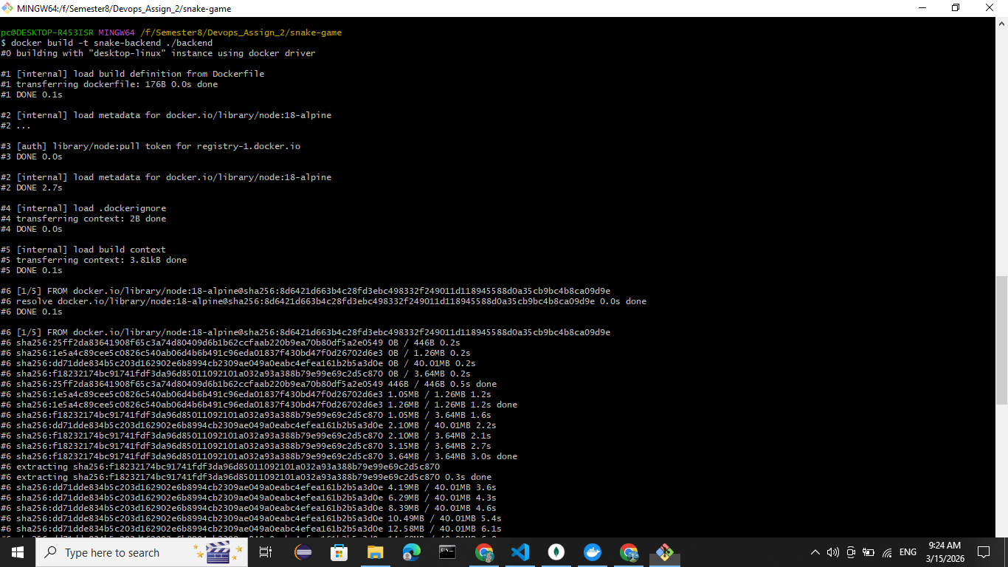
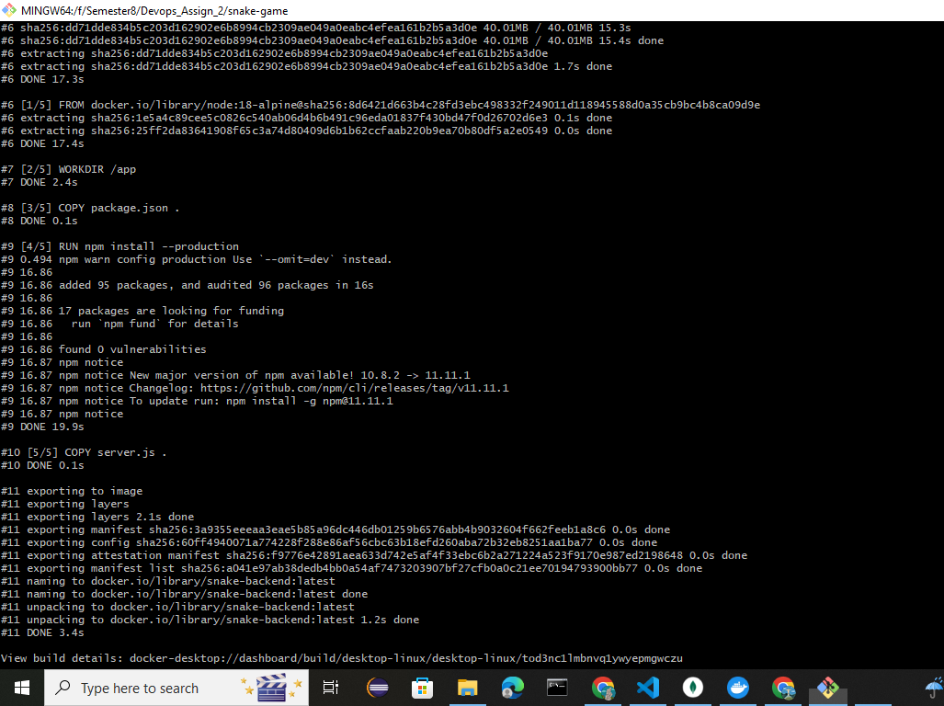
Run MongoDB Container

Run MongoDB Container
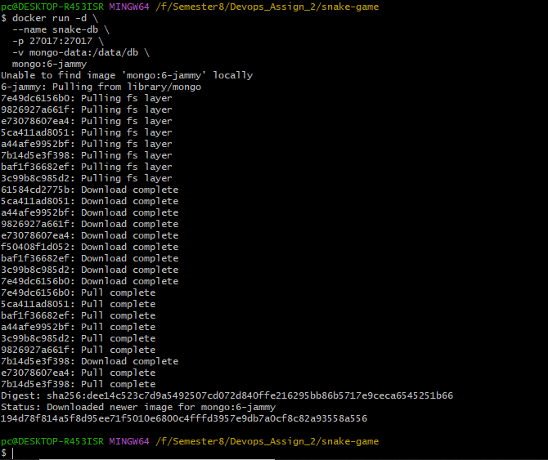
Run Backend Container
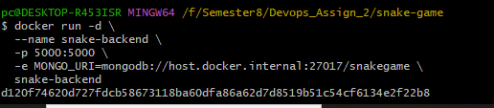
Run Frontend Container
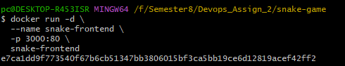
docker ps
Game SS:
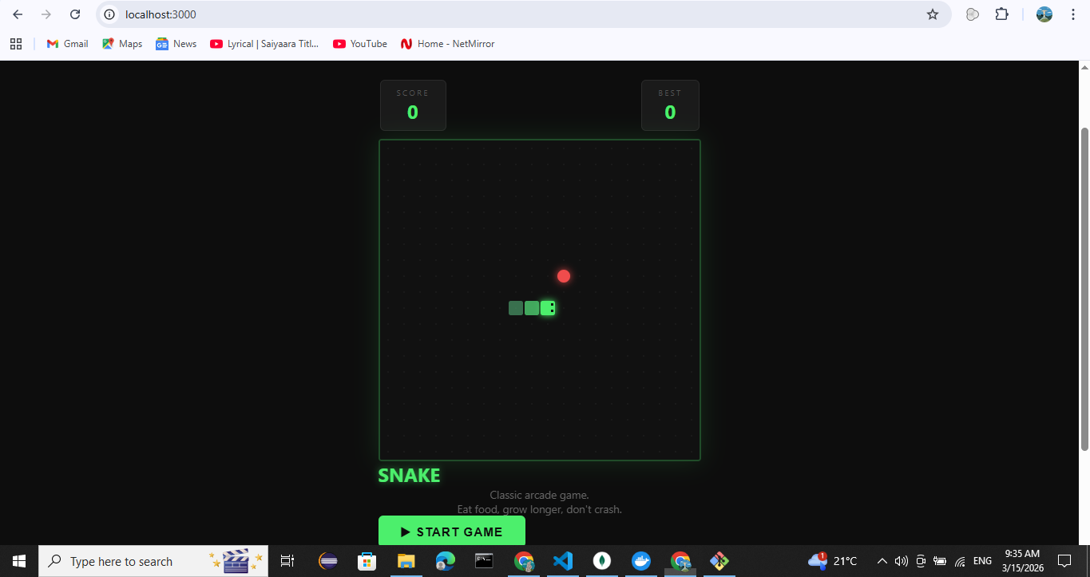
Task 2:
Multi-Container Setup using Docker Compose
Pre-pull MongoDB
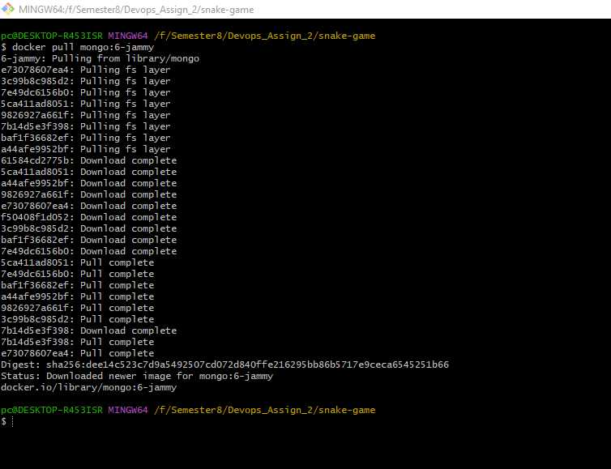
Start Docker Compose:
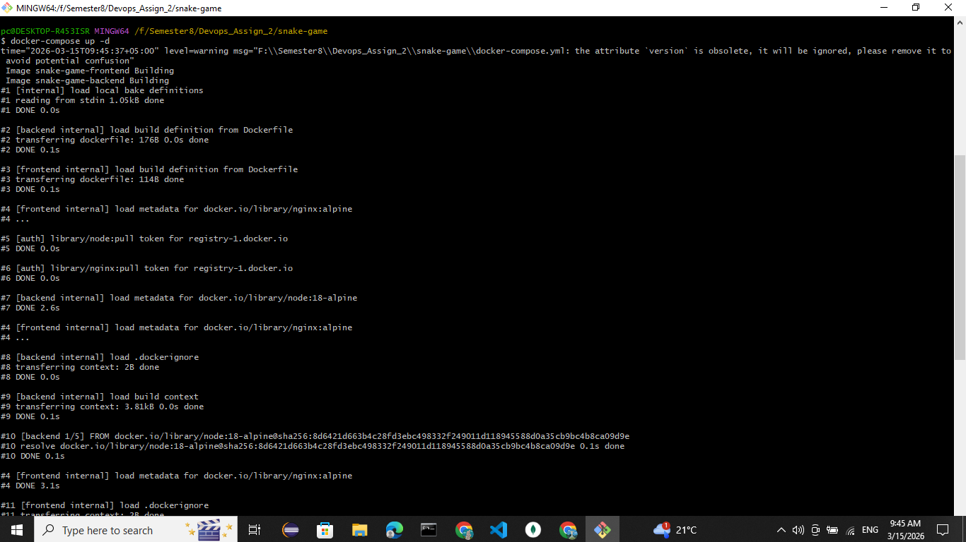
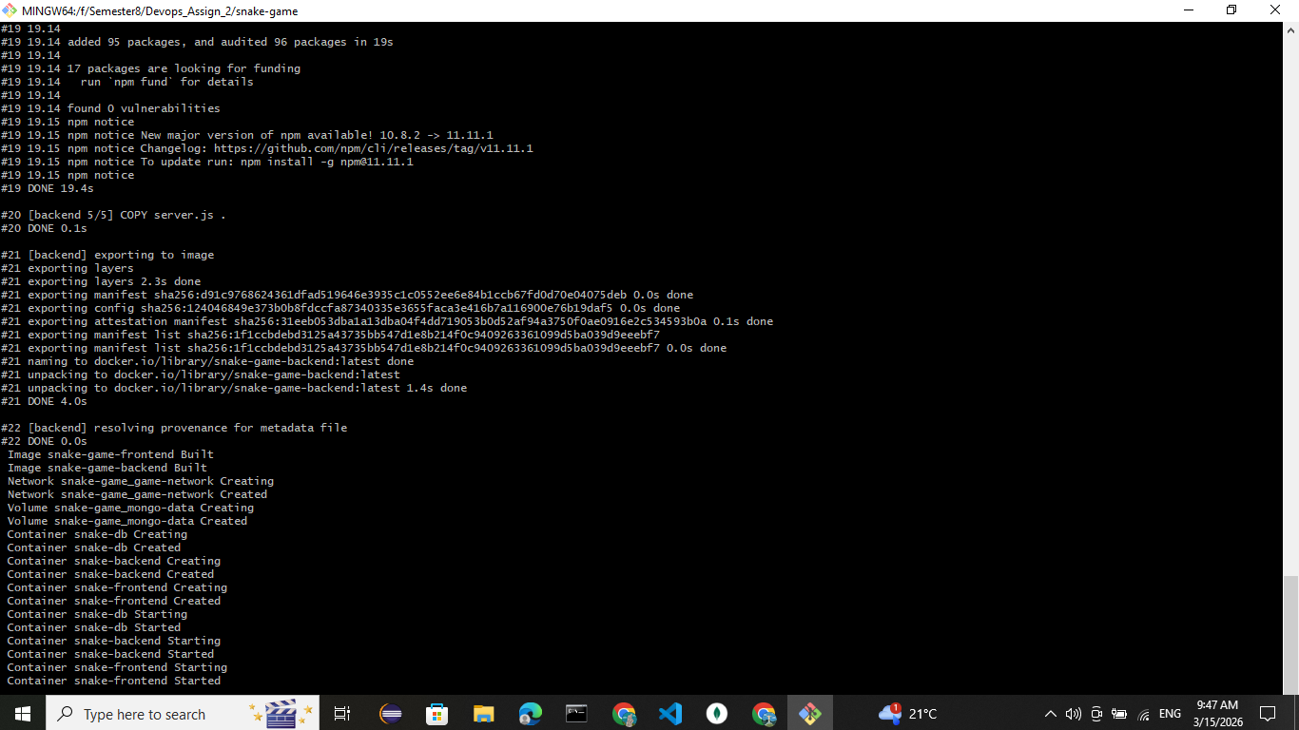
docker-compose ps:
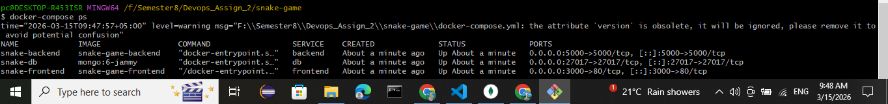
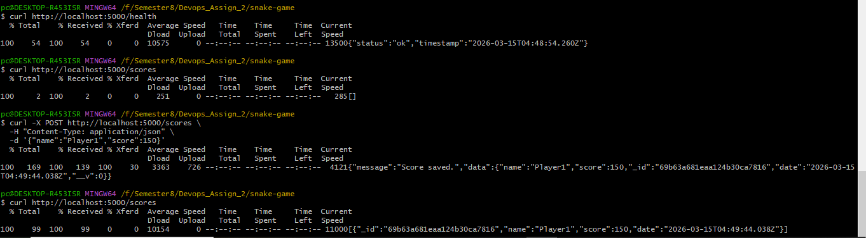
Frontend SS
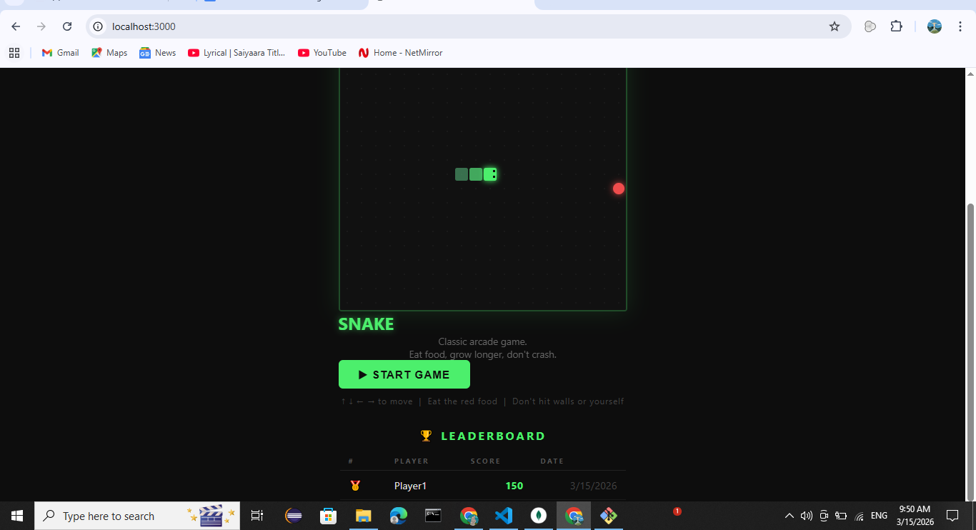
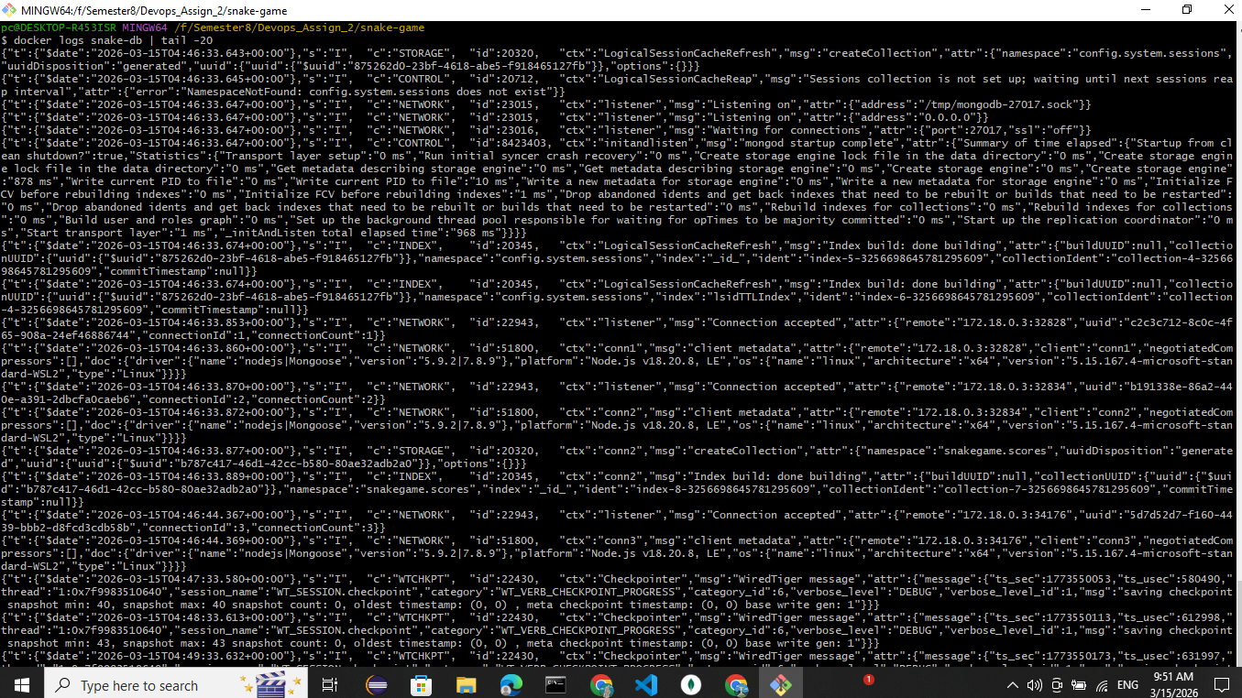
TASK 3: Kubernetes Deployment
Minicube Start
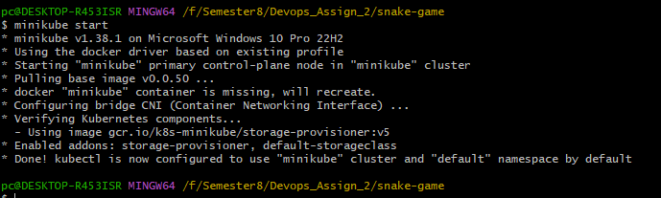
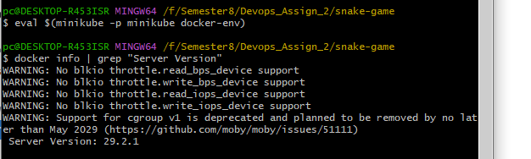
Build Images Inside Minikube
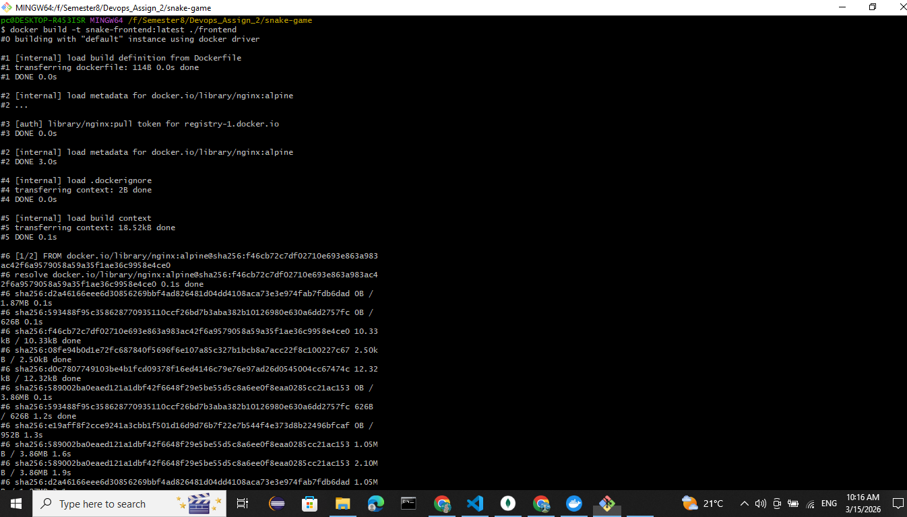
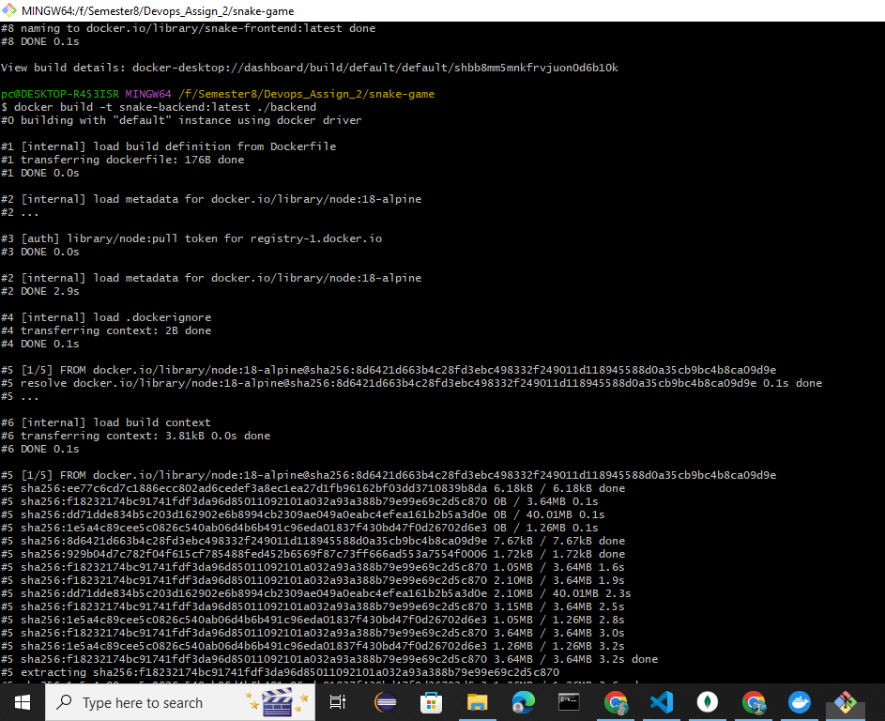
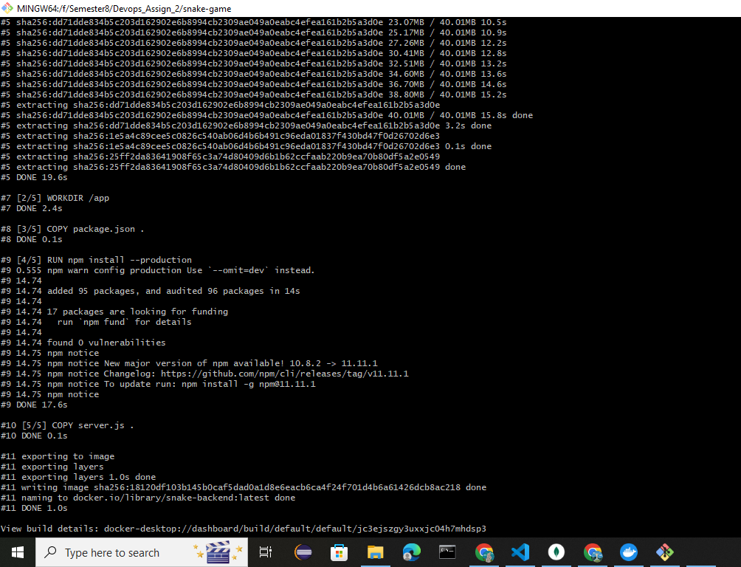
Apply Storage (PV)
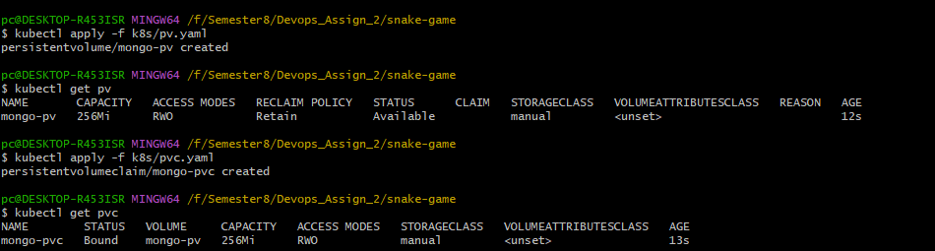
Deploy MongoDB
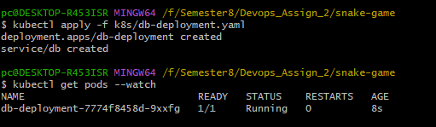
Deploy Backend

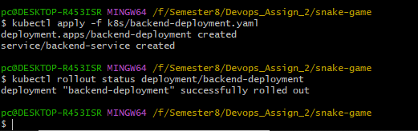
Deploy Frontend
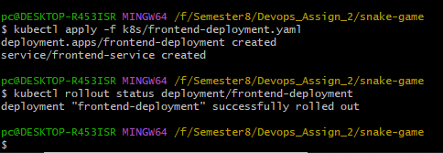
kubectl get pods
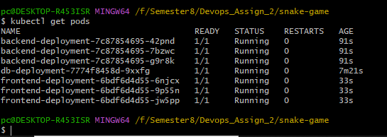
kubectl get deployments
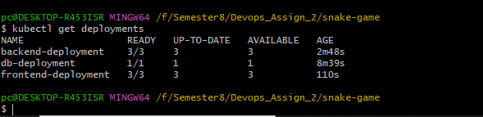
kubectl get services
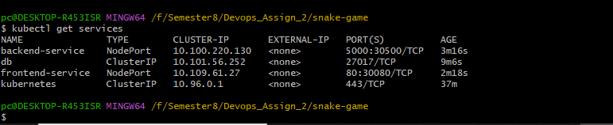
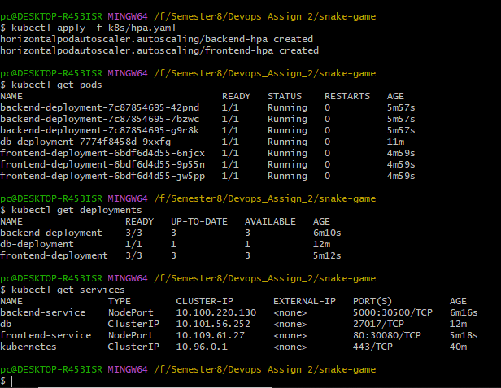
minikube ip
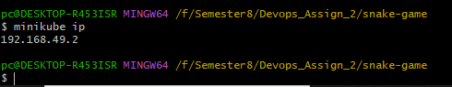
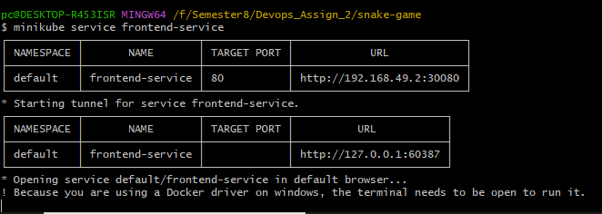
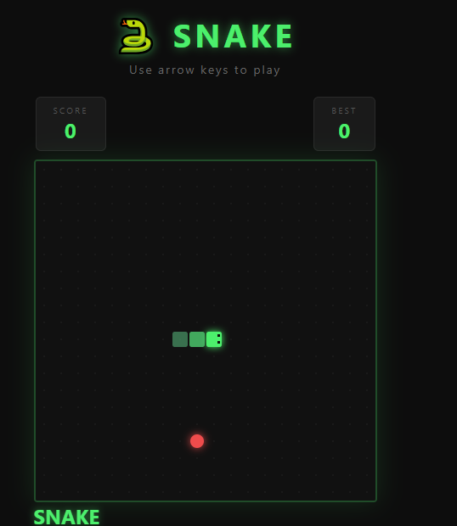
TASK 4: Persistent Storage Verification
Verify PV/PVC Binding
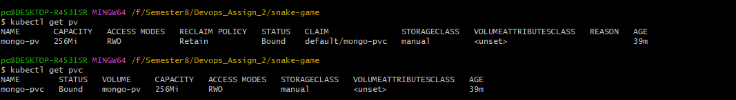
Check MongoDB Pod with PVC
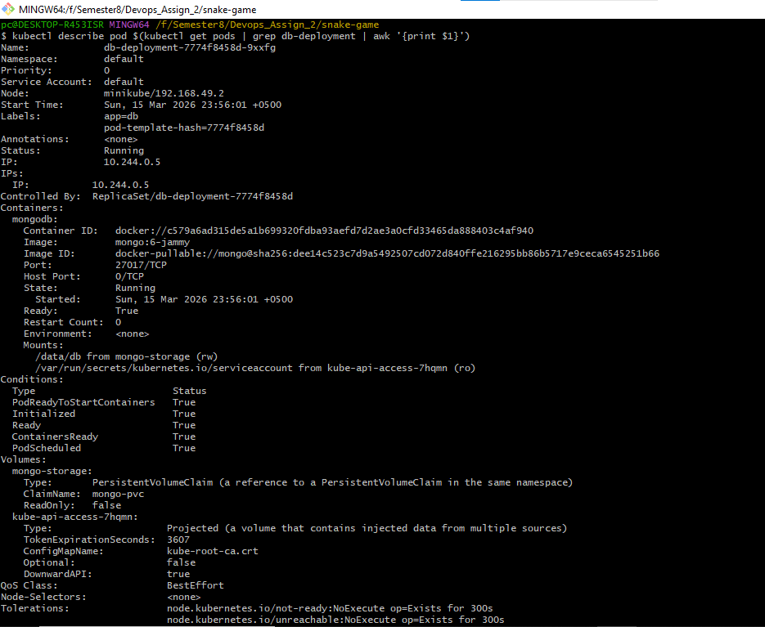
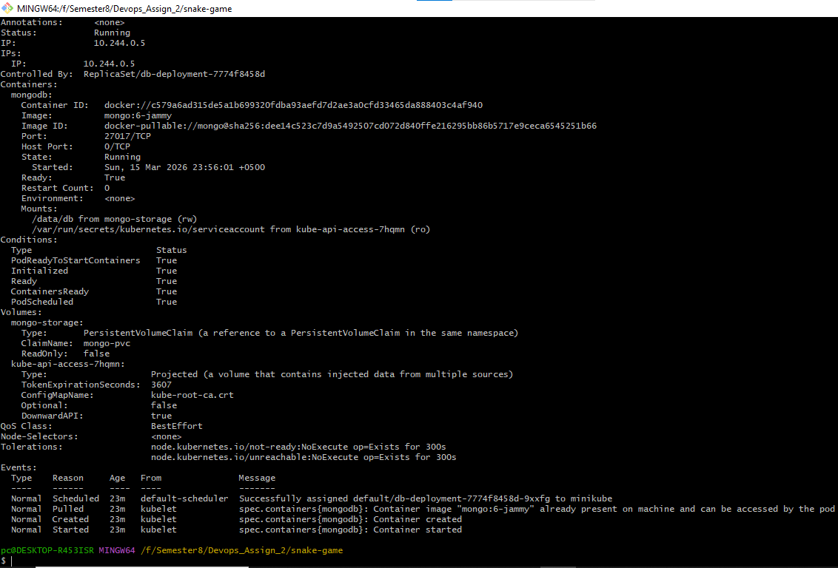
Insert Data into MongoDB (via K8s)
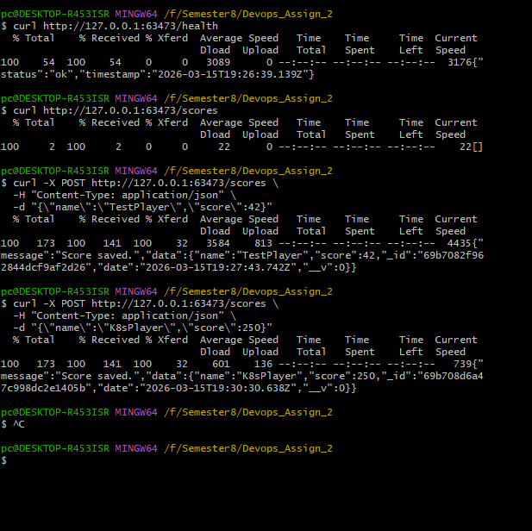
Retrieve Scores
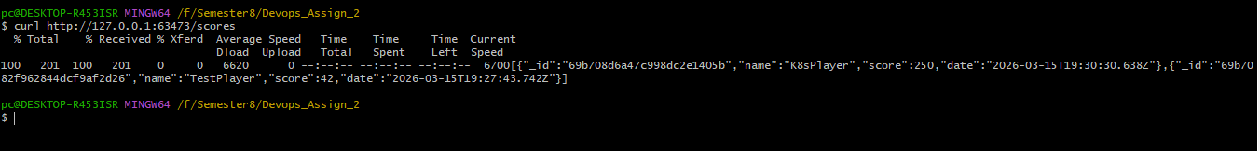
Delete MongoDB Pod
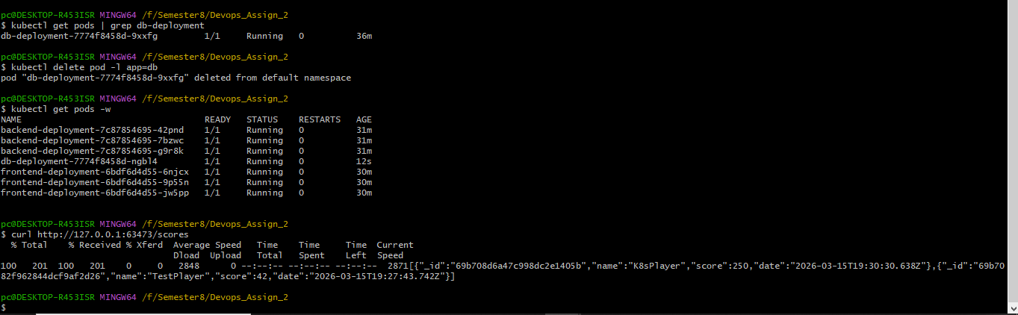
TASK 5: HPA (Horizontal Pod Autoscaler) Configuration
Enable Metrics Server
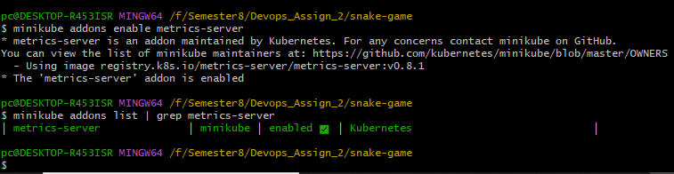
Apply HPA
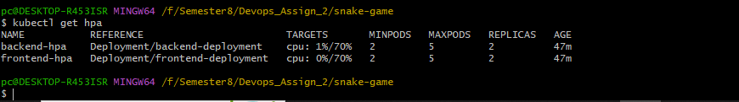
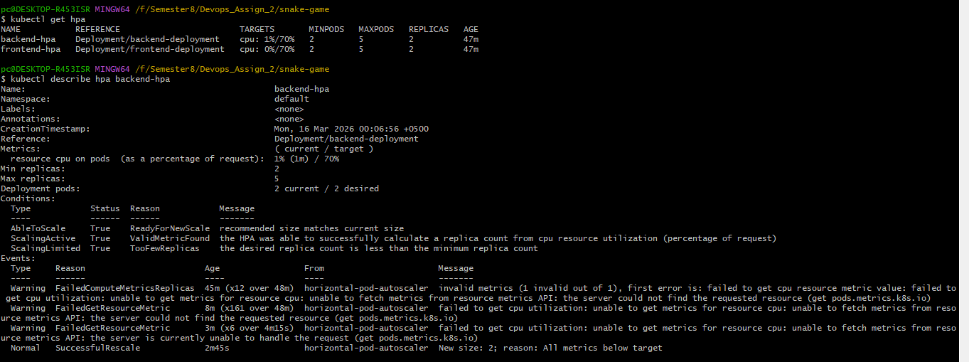
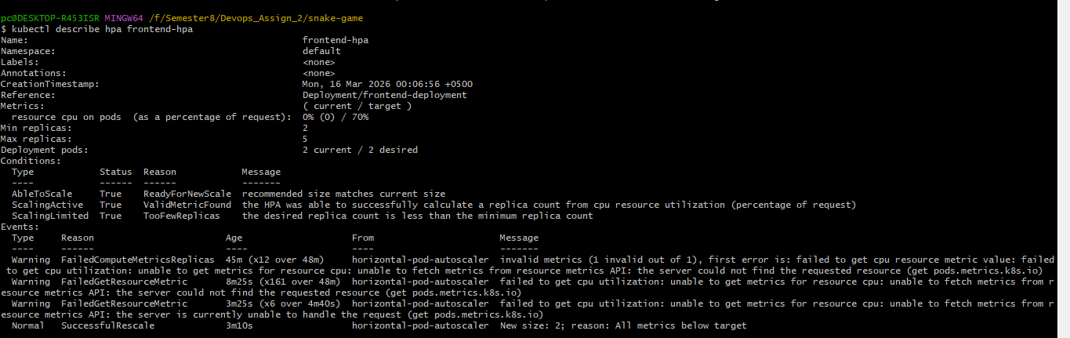
CPU Metrics
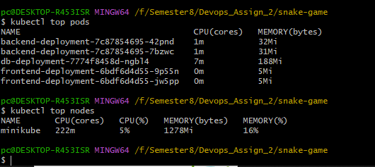
Watch HPA
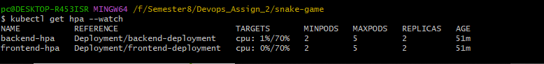
Final overview
