  

To Supply Leftover Food to Poor

# Project Overview

The To Supply Leftover Food to Poor initiative aims to efficiently coordinate food collecting, volunteer administration, and transportation to several drop-off outlets. Utilizing the Salesforce platform, the solution will facilitate real-time tracking and simplify data administration. The long-term goals of this project are to improve data quality, user experience, and operational performance in order to reduce food waste and assist underprivileged areas.

# Objectives

## Business Goals:

• Create a workable plan for dealing with extra food gifts.   
• Simplify coordination between delivery, volunteers, and collecting sites to improve the efficiency of food distribution.  
• To facilitate impact analysis and decision-making, provide real-time tracking and reporting.   
  
**Particular Results:**

• Custom objects and connections were made to handle locations, volunteers, drop-off locations, and job assignments.   
• A real-time reporting system provides data on the distribution of food.   
• Dashboards that display information on food distribution, volunteer activity, and location-specific needs.

# Salesforce Key Features and Concepts Utilized

Several Salesforce features are used in this project, including:

• **New Objects:** New objects were made to monitor information such the Venue, Drop-Off Point, Task, Volunteer, and Execution Details.   
• **Triggers:** A unique Apex trigger named DropOffTrigger was used to automatically establish distance values.   
• **Lighting App with Custom Tabs:** The Food Connect Lightning App was created with custom tabs to provide easy navigation across all items.   
• **Sharing Rules:** Sharing rules were set up based on distance in order to restrict user access depending on proximity.

# Detailed Steps to Solution Design

The design and development process consisted of the following steps:

* + **Data Models:** Developed data models for Venue, Drop-Off Point, Task, Volunteer, and Execution Details, including necessary fields and associations (Lookup and MasterDetail).
  + **User Interface Design**: Created custom tabs for simple navigation in

***FoodConnect*** Lightning App.

* + **Business Logic**: Developed the ***DropOffTrigger*** to automatically assign distances to the Distance Calculation field, enabling easy rule assignment.

## Screenshots:

**Screenshot of the UI**

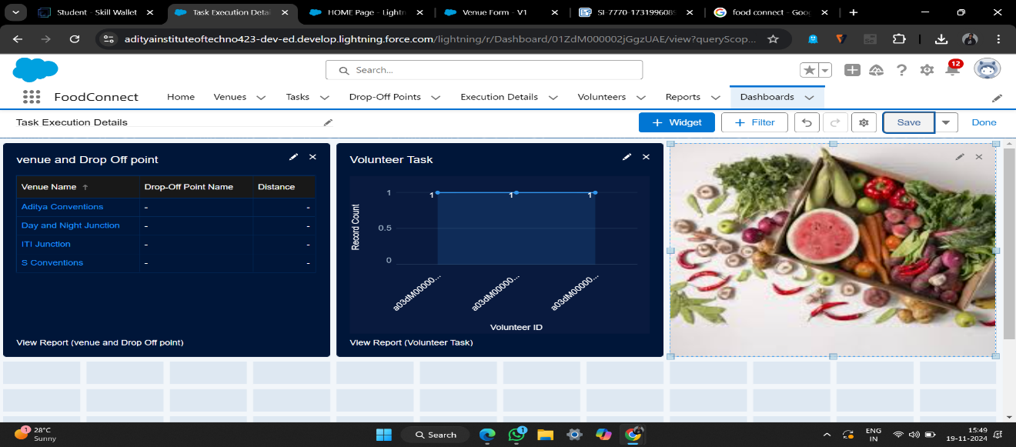

## Ameer Add Screenshot of the Flow.

## 

  

# Testing and Validation

The testing strategy included:

* + **Unit Testing:** Unit tested Apex Classes and Triggers, including ***DropOffTrigger***

and custom field changes.

* + **User Interface Testing:** Validated each user interface component for ease of use and accurate data flow across bespoke tabs and the ***FoodConnect*** App.

# Key Scenarios Addressed by Salesforce in the Implementation Project

## Scenario 1: Coordinating Food Collection and Distribution

* + - Establish drop-off points and coordinate distances with specified sharing groups.

## Scenario 2: Volunteer Tracking and Assignment

* + - Ensured effective food collection and delivery by monitoring volunteer availability and tasks.

## Scenario 3: Feedback and Reporting

* + - Volunteers can provide feedback on deliveries, gather ratings, and track capacity for future improvements.

# Conclusion

The project effectively established a simplified system for organizing food contributions, coordinating volunteers, and arranging delivery to specified areas through the use of Salesforce. A scalable and practical answer to food security, this platform greatly reduces food waste while advancing the objective of providing food to underserved areas.