AI RECRUIT360
AI-POWERED CANDIDATE EVALUATION AND RECRUITMENT PLATFORM


Ameer Hamza FA22-BSE-030
Babar Hussain FA22-BSE-044
Ali Naqi FA22-BSE-050
A Project Report is submitted in partial fulfillment of the requirement for the degree of
Bachelor of Science
In
SOFTWARE ENGINEERING
Session 2022-2026
Department of Software Engineering
Faculty of Engineering & Technology
Mirpur University of Science and Technology (MUST),
Mirpur AJK, Pakistan
CERTIFICATION
I hereby undertake that this final year project is original and that no part of this project report constitutes plagiarism. If found otherwise at any stage, I will be responsible for the consequences.

Student Name: Ameer Hamza Signature: _____________________
Registration No.: FA22-BSE-030 Date: _________________________
Student Name: Babar Hussain Signature: _____________________
Registration No.: FA22-BSE-044 Date: _________________________
Student Name: Ali Naqi Signature: _____________________
Registration No.: FA22-BSE-050 Date: _________________________

Certified that the contents and form of the final year project entitled "AI Recruit360" submitted by Ameer Hamza have been found satisfactory for the requirements of the degree.

Supervisor:_______________________________________

CoSupervisor(ifany):________________________________

ExternalExaminer:_________________________________

Chairperson: _______________________________________________
DEDICATION
We dedicate this project to our families, teachers and fellow students whose support made sustained study and development possible. We hope that the work reflects the care they encouraged us to bring to both technical decisions and the people affected by them.

CONTENTS
 | Page No.
CERTIFICATION | i
DEDICATION | ii
LIST OF FIGURES | iii
LIST OF TABLES | iii
ACKNOWLEDGMENTS | iii
ABSTRACT | iii
CHAPTER 1 - INTRODUCTION | 3
1.1 PROJECT OVERVIEW | 3
1.2 PROBLEM STATEMENT | 3
1.3 AIM AND OBJECTIVES | 3
1.4 SCOPE AND BOUNDARIES | 3
1.5 MAPPING TO UN SUSTAINABLE DEVELOPMENT GOALS (SDGs) | 3
CHAPTER 2 - BACKGROUND AND RELATED WORK | 3
2.1 EVOLUTION OF APPLICANT TRACKING SYSTEMS | 3
2.2 LARGE LANGUAGE MODELS - STRUCTURED EVALUATION | 3
2.3 SPEECH PROCESSING AND VIDEO AVATARS | 3
2.4 MODERN WEB APPLICATION ARCHITECTURE | 3
2.5 MULTI-TENANCY AND ROW-LEVEL SECURITY | 3
2.6 ETHICAL CONSIDERATIONS, MITIGATION ACCESSIBILITY | 3
2.7 COMPETITIVE ANALYSIS AND RESEARCH GAP | 3
CHAPTER 3 - REQUIREMENTS AND ANALYSIS | 3
3.1 REQUIREMENTS METHODOLOGY | 3
3.2 FUNCTIONAL REQUIREMENTS SPECIFICATION | 3
3.3 NON-FUNCTIONAL REQUIREMENTS | 3
3.4 CONSTRAINTS AND ASSUMPTIONS | 4
3.5 RISK ANALYSIS AND MITIGATION STRATEGIES | 4
CHAPTER 4 - SYSTEM DESIGN | 4
4.1 SYSTEM CONTEXT AND TRUST BOUNDARIES | 4
4.2 COMPONENT AND DEPLOYMENT ARCHITECTURE | 4
4.3 APPLICATION DATA PIPELINE AND FLOW | 4
4.4 RELATIONAL DATA MODEL AND CORE ENTITIES | 4
4.5 WORKFLOW STATE MACHINES & LIFECYCLE TRANSITIONS | 4
4.6 ACTIVITY AND SEQUENCE DESCRIPTIONS | 4
4.7 ROLE-BASED ACCESS CONTROL MODEL | 4
4.8 INTERFACE AND INTERACTION DESIGN | 4
4.9 DETAILED COMPONENT DESIGN ACROSS TEN ATTRIBUTES | 4
CHAPTER 5 - IMPLEMENTATION | 4
5.1 FRONT-END ARCHITECTURE - COMPONENT COMPOSITION | 4
5.2 RECRUITER WORKSPACE AND AUTHENTICATION CONTEXT | 4
5.3 RESUME EXTRACTION AND DOCUMENT PROCESSING | 4
5.4 STRUCTURED AI RESUME SCREENING ENGINE | 4
5.5 SERVER-AUTHORITATIVE ASSESSMENT ENGINE | 4
5.6 CONVERSATIONAL AI AVATAR AND SPEECH PIPELINE | 4
5.7 MULTI-DIMENSIONAL COMPOSITE EVALUATION MODEL | 4
CHAPTER 6 - VERIFICATION AND RESULTS | 4
6.1 VERIFICATION STRATEGY AND TEST CATALOGUE | 4
6.2 RESUME PARSING AND EXTRACTION ACCURACY | 4
6.3 DATABASE INTEGRITY AND MULTI-TENANT ISOLATION | 4
6.4 OPERATIONAL LATENCY AND BENCHMARK OBSERVATIONS | 4
6.5 THREAT MODELING AND SECURITY POSTURE | 5
6.6 VALIDITY AND SYSTEM LIMITATIONS | 5
6.7 PRODUCTION CLOUD DEPLOYMENT PLAN | 5
CHAPTER 7 - CONCLUSIONS AND FUTURE WORK | 5
7.1 PROJECT CONCLUSIONS | 5
7.2 FUTURE TECHNICAL ROADMAP | 5
7.3 ETHICAL STEWARDSHIP AND RESPONSIBLE USE OF AI | 5
7.4 CLOUD INFRASTRUCTURE COST AND OPERATIONAL BUDGET ANALYSIS | 5
7.5 DESIGN PROCESS EVALUATION AND ENGINEERING REFLECTIONS | 5
REFERENCES | 53
APPENDIX A | 5
A.1 SYSTEM USE-CASE SPECIFICATIONS | 55
APPENDIX B | 5
B.1 DATABASE SCHEMA AND DATA DICTIONARY | 60
B.2 CORE ENTITY-RELATIONSHIP ARCHITECTURE | 60
B.3 DATA DICTIONARY | 60
APPENDIX C | 5
C.1 DEPLOYED SYSTEM INTERFACE- VERIFICATION EVIDENCE | 66
C.2 PARTS AND COMPONENTS | 66
LIST OF FIGURES
Figure No. | Page No.
3.1: UML Use Case Model for Role-Based Recruitment Lifecycle | 18
4.1: System Context and Trust Boundaries | 24
4.2: Physical Deployment Paths for Local and Cloud Environments | 25
4.3: Candidate Evidence Data Pipeline and Ingestion Flow | 26
4.4: Core Relational Entity Model and Multi-Tenant Relationships | 28
4.5: Resume Screening Activity Diagram | 30
4.6: Server-Authoritative Assessment Activity and Anti-Cheat Flow | 31
4.7: Candidate Application Submission Persistence Sequence | 32
4.8: Conversational Interview Evaluation Sequence | 34
4.9: Role-Based Access Control Model | 33
5.1: Stage Evidence Entity Relationships and Relational Constraints | 38
B.1: Comprehensive Entity-Relationship Diagram and Stage Evidence Constraints | 65
C.1: Recruiter Dashboard and Candidate Funnel Analytics | 72
C.2: Job Requisitions Directory and Status Management | 73
C.3: Job Creation and Evaluation Configuration Form | 74
C.4: Job Requisition Details and Stage Triage Pipeline | 75
C.5: Candidate Directory with Search and Score Filtering | 75
C.6: Application Lifecycle Tracker and Status Badges | 76
C.7: Candidate Comprehensive Evidence Dossier | 77
C.8: Candidate Timed Anti-Cheat Assessment Interface | 77
C.9: Simli AI Neural Video Avatar Interview Room | 78
C.10: Completed Interview Transcript and Question Scorecards | 79
C.11: Multi-Dimensional Scorecard and Hiring Status Controller | 79
C.12: Recruitment Funnel Analytics and Operational Metrics | 80
LIST OF TABLES
Table No. | Page No.
A: Alphabetical List of Abbreviations | x
1.1: Alignment with UN Sustainable Development Goals (SDGs) | 7
2.1: Competitive Analysis of Recruitment Platforms | 13
3.1: Functional Requirements Specification | 17
3.2: Non-Functional Quality Requirements and Verification Boundaries | 20
4.1: Role-Based Access Control Matrix | 32
4.2: Detailed Component Design Across IEEE 1016 Attributes | 35
5.1: Multi-Stage Composite Scoring Formula and Weight Distribution | 42
6.1: Verification Test Suite Results | 45
6.2: Operational Latency Observations for Local and Cloud-Hosted Services | 47
6.3: Production Cloud Deployment Architecture and Infrastructure Topology | 49
7.1: Cloud Infrastructure and Multimodal API Operational Budget | 53
A.1: Use Case Specification — UC01 (Recruiter Authentication and Workspace Setup) | 58
A.2: Use Case Specification — UC02 (Job Requisition Creation and Publishing) | 59
A.3: Use Case Specification — UC03 (Candidate Application and Resume Submission) | 59
A.4: Use Case Specification — UC04 (Automated AI Resume Screening and Scoring) | 60
A.5: Use Case Specification — UC05 (Timed Anti-Cheat Technical Skills Assessment) | 61
A.6: Use Case Specification — UC06 (Interactive AI Avatar Interview and Response Evaluation) | 62
B.1: Data Dictionary for profiles Table | 65
B.2: Data Dictionary for organizations Table | 66
B.3: Data Dictionary for organization_members Table | 66
B.4: Data Dictionary for jobs Table | 67
B.5: Data Dictionary for candidates Table | 67
B.6: Data Dictionary for applications Table | 68
B.7: Data Dictionary for candidate_documents Table | 68
B.8: Data Dictionary for cv_screenings Table | 69
B.9: Data Dictionary for assessments Table | 69
B.10: Data Dictionary for assessment_questions Table | 70
B.11: Data Dictionary for interviews Table | 70
B.12: Data Dictionary for final_evaluations Table | 71
ACKNOWLEDGMENTS
We would like to express our sincere thanks to our Creator, Allah SWT for giving us the health, determination and ability to complete our undergraduate studies and this Final Year Project.
We would like to thank our supervisor, Engr. Syeda Iqra Gillani, for her invaluable guidance, continuous encouragement, and insightful feedback throughout this project. for her valuable technical support, feedback and patient mentorship in the design, development and documentation of AI Recruit360. Her expectations of top-notch software and academic presentations had a profound impact on us.
Our sincere thanks to the Chairperson and valued faculty of the department of Software Engineering, Mirpur University of Science and Technology (MUST) for offering the initial education in software architecture, database management systems and requirements engineering, which allowed us to perform this complicated work.
We also recognize the contributions of all the open-source software and modern cloud platforms that provided us with accessible developer tools and documentation that enabled this multimodal system to be engineered. Finally, we credit the developer-friendly tools and documentation of open-source software and modern cloud services such as Next.js, FastAPI, Supabase, Google's Gemini, OpenAI Whisper, OpenAI TTS (Nova) and Simli for making this multimodal system possible.

Ameer Hamza
Babar Hussain
Ali Naqi
ABSTRACT
A major challenge in most modern software engineering firms is that they often have limited resources for evaluating applicants compared to the number they receive. In most software engineering firms today, the number of applicants is frequently greater than the number of resources available to evaluate them. Talent acquisition pipelines are always published and then work groups are inundated with a hundred or more resumes in just days, forcing them to use shoddy keyword-matching parsers or make initial subjectivist selections. As a result, many qualified software developers end up being rejected because they happen to have some keywords in their resumes that don't match, and hiring managers waste needless hours sifting through resumes, scheduling initial screening phone calls, and repeating the process for the first round of candidates.
This report details the design, software development and empirical testing of AI Recruit360, a cloud-native multi-tenant candidate evaluation platform which was designed to simplify the recruitment process. Creating AI Recruit360 with Next.js 14, FastAPI, Supabase PostgreSQL, and cutting-edge speech and language model APIs has brought together candidate ingestion, resume screening automation, timed anti-cheat technical skills assessment, and conversational AI avatar interviews to a secure workspace. The platform directly addresses key operating risks inherent in automated hiring, including not being able to handle unexpected interruptions in the network during uploads, manipulation of client-side timers during assessments, and unclear composite scoring.
Key engineering contributions include:
- Server-authoritative technical skills testing engine, with strict question timing validation in the database;
- An automated resume extraction and structured evaluation pipeline, using PyMuPDF for extracting text from signed resumes, and Google Open AI GPT-4o-minifor structured evaluation, with strict Pydantic JSON schema enforcement;
- A real-time conversational interview environment pairing OpenAI Whisper speech-to-text recognition, OpenAI TTS neural voice synthesis (voice: Nova), and Simli WebRTC video avatar rendering;Labs text-to-speech synthesis and Simli neural video avatar rendering;
- A multi-dimensional composite evaluation model combining weighted evidence from resume match, assessment score, and interview performance, while preserving raw evidence for final recruiter authority.
- System verification is a combination of isolated unit regressions, database transaction and RLS boundary tests and authenticated end-to-end deployment verification on Vercel. The prototype created illustrates how automated candidate evaluation can be implemented successfully while assuring data integrity, candidate dignity and defensible auditability.

Chapter 01
INTRODUCTION

1.1 PROJECT OVERVIEW
The crux of the current operation of engineering companies is talent acquisition. With no way to effectively detect, assess, and recruit experienced technical staff, software businesses can suffer from continuous project delays, poor technical design, and high employee turnover expenses. One way to measure the strength of a technology market is the number of submissions received for a single remote or hybrid software engineering job requisition - in today's technology markets, that's usually anywhere from 300 to 1,500 within days of posting.
This one-of-a-kind book forms an inextricable hurdle for HR teams. In the traditional method of CV screening, a recruiter spends about 2-5 minutes on each CV. This is equivalent to over 25 working hours for 500 applicants to just skim documents to see if they've learned a specific programming language, used a certain framework, or obtained a certain level of education. With all this work to do, recruiters are sure to have decision fatigue, which results in varying evaluation criteria, cognitive bias and sometimes dismissing top talent.
To address this systemic problem, AI Recruit360 was designed and developed to provide an automatic, multi-stage assessment process for candidates. AI Recruit360 does not isolate the recruitment process into individual administrative activities, but rather creates an evidence-based continuous process of recruitment. The platform gives recruiters a workspace that's custom enterprise ready, enabling them to post structured job requisition, monitor candidate pipelines, review objective rating sheets and make data-driven hiring decisions.
At the same time, the candidates have an intuitive and dignified application process. When candidates submit a CV, they are immediately taken through a server-timed technical assessment geared towards the requirements of the role, and then put through a conversational interview using a neural video avatar for the candidate and the applicant. AI Recruit360 records the true evidence including CV content, multiple choice responses, audio transcriptions and evaluation rubrics throughout all stages. The system never runs on an opaque black box, but rather all numerical recommendations are accompanied by hard evidence that is submitted to and looked upon by human recruiters for the final decision on who gets hired.

1.2 PROBLEM STATEMENT
While dynamic web forms and commercial AI APIs are a convenient and significant part of the solution, they are a small aspect of a much broader software engineering challenge when transforming the recruitment process into a series of automated steps. Dynamic web forms and commercial AI APIs are an important, but small part, of the software engineering challenge that comes with transforming the recruitment process into a series of automated steps. There are four basic faults in the architecture and operation of existing recruitment tools and traditional Applicant Tracking Systems (ATS):
First, there's the problem of brittle and discriminatory filters based on keywords. The majority of legacy ATS platforms use a “surface-level” string matching method. Candidates might have "React.js" and "PostgreSQL", while the recruiter has "Frontend Engineer" and "SQL Database" in its filter. This could result in a candidate's resume being eliminated without being read through for semantics. On the other hand, if the applicant uses the simplistic parsers and alters the number of keywords or pastes keywords in a hidden manner in the white-text, they can easily be exploited.
Secondly, there is no rigorous state integrity in case of technical assessments that are done asynchronously. Timers are frequently used to control the length of exams, and are often implemented as client-side JavaScript scripts in the commercial screening software. If a candidate changes its browser's local storage, disables scripts, or if the network drops unexpectedly, the exam state is corrupted or updates are lost and become out of sync with the back-end database. In addition, static multiple choice question banks are easily breached by public answer repositories and public generative AI browser extensions.
Third, First round screening interviews have a tremendous human resource burden. Multi-week delays in the hiring pipeline are introduced when candidates' and technical interviewers' schedules differ for this initial 30-minute phone interview. If there are tools available to record videos asynchronously, from a one-way approach, candidates say that they are very unhappy sending a video on their webcam without seeing anyone, and recruiters have to watch video recordings for hundreds of hours.
Fourth, multi-service workflows are often inconsistent and data leaks are common. A partial upload of a file may create orphaned candidates that don't have any job applications. Concurrent calls to the AI service can result in racing and competing AI calls, if evaluation requests are repeated. For multi-tenant scenarios, it is possible for poorly protected database queries to inadvertently reveal candidate resumes to different organizations.
The core engineering challenge for this project is to design, build and empirically test an integrated web application that can coordinate multiple-stage recruitment evidence, through multiple external AI models, across multiple real-time media streams and through the multiple tenant relational database, while at the same time ensuring full data integrity, tenant isolation and recoverable failure states even with the occurrence of network interruptions.

1.3 AIM AND OBJECTIVES
The main goal of AI Recruit360 is to create a secure, reliable and defensible AI-powered recruitment platform that helps to filter candidates, rate candidates' technical abilities, conduct conversational interviewing, and maintains detailed records for the human recruiter to audit.

To achieve this over-arching goal, the following SMART engineering goals were set:
- Create and build a multi-tenant recruitment management workspace: Design the workspace to give each recruiter role-based access control (RBAC) privileges of Owner, Admin, Recruiter, Interviewer, and Viewer privileges, while employing strict PostgreSQL Row-Level Security (RLS) to ensure total cross-tenant data isolation.
- Create a flexible pipeline for ingesting, parsing, and processing resumes: Implement a flexible pipeline to ingest and extract structured information from resumes in PDF and DOCX formats, including applicant details, work experience, educational background, and technical skills, using PyMuPDF and Pydantic-validated LLM schemas, with robust error recovery handling for corrupted or malformed documents.
- Development of a skills assessment engine for an anti-cheat system, server-authoritative: Create contextually relevant, random technical Multiple Choice Questions based on the job needed, implemented in a strict time limit in the DB via server timestamps, not on client side timers.
- Create a real-time conversational AI avatar interview setting: Add WebRTC neural video avatar rendering (Simli) and ultra-low latency speech-to-text transcribing (OpenAI Whisper Nova-2) and dynamic follow-up question generation (Gemini 1.5 Flash) and natural text-to-speech synthesizing (OpenAI TTS (Nova)) as well as add a fallback mode for keyboard access.
- Establish an audit-trail, multi-dimensional composite scoring tool: Combine candidate semantic fit on resume (30%), assessment score (30%) with the quality of their interview answer (40%) to a scorecard that is easy to explain and has a corresponding raw transcript and rationale that are accessible to the human recruiter for final decision making.
- Do extensive verification and regression testing: Run isolated unit tests, database boundary tests, authentication regression tests and live deployed user journeys on cloud infrastructure, etc.

1.4 SCOPE AND BOUNDARIES
It was decided to explicitly set out the scope and boundary of the operation to ensure a successful completion of the final year project and to keep the technical depth, so that:

IN-SCOPE FUNCTIONALITY:
- User authentication for the Recruiters, organisation onboarding and management of user roles.
- Author, publish, update and archive jobs with custom skill requirements.
- Upload of PDF/DOCX files for the public to upload their candidate applications.
- Resume parsing, semantic analysis and candidate structuring automation.
- Generate 10 questions on the fly with countdowns for each question.
- Interactive, conversational 5-question interview with visual AI avatar and speech input.
- Generation of the multi-dimensional candidate scorecard and triage of the status of recruitment for the recruiters.
- Recruiter Analytics Dashboard with Hiring Funnel Statistics and Time to Hire metrics.

EXPLICIT OUT-OF-SCOPE BOUNDARIES:
- Processing payroll, signing contracts for employment and money transactions.
- Ongoing biometric proctoring, webcam eye-tracking or algorithms for scanning the room.
- The system uses a proprietary foundation model training or local parameter fine-tuning.
- Automated unreviewed candidate rejection - platform serves as evidence-based decision support tool where all final hiring decisions are to be made by human recruiters.
- Offline desktop execution: Cloud platform built from the ground up to be used only as a web application with the use of an active internet connection for use of the cloud database and cloud API.
AI Recruit360 is designed to meet the needs of four different user groups with each having unique functional needs and user expectations:

1. A Talent Acquisition Professional or Recruiters:
Recruiters are looking for a dashboard that is organized and highly visible, with a clear and easy-to-understand system for tracking the progression of candidates and open job requisitions. They must make fair judgments on applicants based on common metrics, audit for missing skills, review the interview record, and change the final candidate status (Screening, Assessment, Interview, Offer, Rejected) without having to navigate among different software applications.

2. The hiring of Managers and Technical Leads:
Technical evaluators require detailed insights into candidate answers to the assessment items and responses to interview questions. Instead of having to trust a recruiter's opinion on a summary of the applicant's explanation of architectural tradeoffs, hiring managers will be able to review the exact words their applicant used to explain architectural tradeoffs, check the evaluation of the code snippets, and go over the AI-generated architecture explanation before committing time to an on-site final interview.

3. The candidate or applicant process consists of 3 parts:

Job Candidates and Applicants:
Candidates need an open, responsive and easy to navigate journey in the application. They require explicit acknowledgement that their resume was received and parsed, objective and relevant questions that will assess their qualifications, and an interactive interview setting that allows them to speak or type their answers with a microphone if they are unable to have one, or if it is not available for the interview.

System Administrators and Academic Maintainers:
For the project authors and maintainers, clean architectural modularity, extensive schema documentation, robust type-checking of the types between TypeScript and Python, and consistent deployment scripts are critical to maintain a stable, defensible platform in the event of an academic exam.
The Engineering Method and the Contribution is a lesson that all students should experience.
The project was actually carried out using an iterative test driven methodology and broken down into four phases:
Phase 1:
The first phase is the Architecture and Database Specification. The relational schema was designed in PostgreSQL, setting up the primary keys, foreign keys with explicit cascade rules, check constraints and Row Level Security policies, and no application logic was written yet.
Phase 2:
Backend API & Integration Development. Routes were written for FastAPI for external integrations like Supabase, OpenAI Whisper, OpenAI TTS (Nova), Simli and Google Gemini. Pydantic v2 schemas were created to enforce that all incoming requests, and outgoing model responses, are validated firmly.
Phase 3:
Frontend Composition & User Experience. Utilizing the power of React Server Components, Next.js 14 App Router and Tailwind CSS were used to create responsive and accessible User Interfaces for both the Recruiter workspace and Candidate examination portals.

Phase 4:
Verification, Hardening and Deployment. Automated test suites were run across unit boundaries, database transactions, and even live Vercel deployments to guarantee that there were no race conditions, that the data is recovered in case of an API failure, and that it was separated in every tenant.

IMPORTANT TECHNICAL AND ACADEMIC ACHIEVEMENTS:
- An empirical example of orchestrating multiple AI services (LLM, STT, TTS, WebRTC video avatars), with the power to create a consistent and reliable single page candidate journey.
- A server-authoritative, stateful machine that is hardcoded so that it cannot be altered to allow any of the common online assessment vulnerabilities such as timer manipulation and duplicate submission race conditions.
- An automated talent screening solution that is defensible, transparent and consistent with human-in-the-loop ethical hiring protocols.

1.5 MAPPING TO UN SUSTAINABLE DEVELOPMENT GOALS (SDGs)
Software engineering projects developed within higher education institutions carry an ethical and socio-economic mandate to align with international sustainable development objectives. AI Recruit360 directly advances five United Nations Sustainable Development Goals (SDGs)—addressing technical education readiness (SDG 4), economic productivity and youth employment (SDG 8), technological modernization (SDG 9), algorithmic bias reduction (SDG 10), and institutional transparency (SDG 16), as delineated in Table 1.1.
Table 1.1: Alignment with UN Sustainable Development Goals (SDGs)
Goal Number | SDG Title | Target Focus | Project Relevance & Technical Implementation
Goal 8 | Decent Work & Economic Growth | Targets 8.5 & 8.6: Productive employment, decent work, and youth opportunities | Mitigates manual hiring friction and subjective recruiter fatigue. Democratizes candidate evaluation for entry-level software engineers through objective, competency-based assessments and structured evaluations rather than pedigree or personal networks.
Goal 9 | Industry, Innovation & Infrastructure | Target 9.5: Upgrade technological capabilities and foster innovation | Architects a cloud-native multimodal ATS utilizing asynchronous microservices (FastAPI), serverless edge routing (Next.js 14), real-time WebRTC neural avatars (Simli), and robust Pydantic-validated LLM schemas.
Goal 10 | Reduced Inequalities | Targets 10.2 & 10.3: Promote social inclusion and eliminate discriminatory barriers | Eliminates algorithmic bias by stripping demographic Personally Identifiable Information (name, gender, age, postal address) during initial screening. Enforces standardized question sets and guarantees human-in-the-loop oversight with zero automated rejections.
Goal 16 | Peace, Justice & Strong Institutions | Targets 16.6 & 16.7: Develop effective, accountable, and transparent institutions | Ensures institutional auditability via immutable PostgreSQL audit logs (security_audit_logs), server-authoritative anti-tamper exam timing, and multi-dimensional scorecards with cited textual evidence, replacing opaque 'black-box' hiring algorithms.
Goal 4 | Quality Education | Target 4.4: Increase technical and vocational skills for employment | Provides objective, competency-based skills assessment and transparent evaluation rubrics, aligning academic software engineering preparation with industry hiring standards and identifying specific learning gaps.

Chapter 2
BACKGROUND AND RELATED WORK

2.1 EVOLUTION OF APPLICANT TRACKING SYSTEMS
Over the last 30 years, recruitment technology has undergone three generations:Over the last three decades, there have been three generations of recruitment technology. The first generation (late 1990s) was a simple relational database repository that was used mainly to supplant the physical use of filing cabinets. These were the first Applicant Tracking Systems (ATS) that were used to store and retrieve scanned resumes and Applicant contact information and had basic Boolean search functions ("Java AND Spring"). They had not, however, any knowledge of language, and they left all learning to human recruiters.
In the 2010s, a second generation, which was popularized, added to the above, statistical keyword parsing and ontology-based matching engines (Marchal et al. 2020). Some of the platforms that added the extractors to their platforms, like Taleo, Workday, and Greenhouse, added regex-based extractors because they knew they wanted to identify a certain set of skills. Although this was an operational improvement, it caused a great deal of tension. It soon became clear that minor formatting problems like two column tables, fonts that were not standard, or section headers that were not standard would cause a parser to fail altogether. In addition, these systems allowed for keyword stuffing where applicants would stuff in keywords, but not candidates with engineering skills who would use a formal and descriptive kind of writing to describe their experience.
The third-generation systems, which are in the process of emergence, are based on transformer-based language models that enable them to develop a semantic understanding of the candidate's qualifications (Raghavan et al. 2020). Modern architectures do not count the number of times strings appear, but rather compare the semantic similarity of a candidate's evidence of project accomplishments to the technical duties specified in a job description. This third-generation model is extended to include interactive skill testing and conversational interviews dialogue by the AI Recruit360 model.

2.2 LARGE LANGUAGE MODELS AND STRUCTURED EVALUATION

This section reviews the use of large language models for structured candidate evaluation and explains their role in the proposed system.
Transformer architectures by Vaswani et al. (2017) have been a game-changer in the field of NLP. In the field of reasoning, autoregressive models have been shown by Brown et al. (2020) and further developed in more recent foundational models like Google's Gemini (Gemini Team 2024) to have unprecedented reasoning capabilities in code comprehension, technical summarization and contextual question answering.
Two significant engineering challenges with using LLMs in mission critical recruitment apps are variance in their outputs and hallucination. LLMs may provide inconsistent output formats when asked with unstructured natural language input, add filler in the conversation or provide information that is not contained in the input document.
AI Recruit360 uses rigorous structured generation methods to eliminate these weaknesses. The app uses Pydantic v2 schemas and Google Gemini 1.5 Flash's native support for JSON response constraints to ensure model completions adhere to strict data formats. The model should return a JSON object with the following elements when it is used to screen resumes: numbers indicating the percentages of match, an array of matched skills with quoted source text, an array of missing prerequisite elements and a brief justification string. In case the API completion is not conforming to this schema, the FastAPI backend rejects the payload immediately and does a controlled retry of the payload. This ensures that any database inserts downstream always happen in the same way.

2.3 SPEECH PROCESSING AND VIDEO AVATARS
Traditional video interviewing is poorly adopted in the enterprise and suffers from poor candidate engagement, but that's not the case with the asynchronous option. An applicant saying something into an empty web browser and a fixed countdown timer is extremely stressful and is not set up for a natural way of talking.
The recent advances in deep learning have made it possible to enable real-time, interactive multi-modal communication. ASR has lately come to a remarkable degree of human-level performance using weakly supervised foundation models like Whisper (Radford et al. 2023) and streaming architectures like OpenAI Whisper Nova-2. Modern ASR engines are based on 16 kHz linear pulse code modulation (PCM) audio buffers, and under 8% word error rate (WER) and transcription latency less than 300 milliseconds.
At the same time, neural speech synthesis (TTS) models, like OpenAI TTS (Nova), make expressive and natural human voice prosody that take context into account, featuring contextual pacing and breath modeling. The brainchild of the company AI Recruit360 introduces Simli's neural video avatar technology to give visual interactivity. Simli receives synthetic audio streams through WebRTC, and creates real-time lip-synchronized facial animation rendered as a photo-realistic image. This makes the candidate experience from a monologuing experience to an engaging dialogue, and of course the questions are not changing for each candidate.

2.4 MODERN WEB APPLICATION ARCHITECTURE
A successful, responsive, high-reliability recruitment portal needs to be built on an architecture that is separated, with high performance user interface and compute-intensive back-end processing. Next.js 14 is the latest version of Next, the state-of-the-art framework for building React-based frontends, and has added the App Router paradigm, a new concept of React Server Components (RSC), and a new concept of Server Actions (Vercel 2023). Server Components run on the Node.js server, and can be used to make direct and secure queries to the database without revealing sensitive information or business logic to the client browser. Widgets that perform interaction on the screen are identified as Client Components ("use client") and will update the UI state in real time, e.g., using an interactive audio recorder and a candidate timer.
FastAPI (Ramírez 2024) is a high-throughput (HT) and asynchronous (ASYNC) Python framework for the backend on the server. However, Python is still the language of choice for document parsing, PDF manipulation, and AI API orchestration in the industry. FastAPI is capable of processing thousands of parallel I/O operations (e.g. waiting for responses from external LLM, streaming buffers of audio or video) without blocking the worker threads thanks to the asyncio event loop, the heart of the Python asynchronous network programming library. The heart of the Python asynchronous network programming library, asyncio, lets FastAPI process thousands of concurrent I/O operations (waiting for responses from an external LLM, streaming buffers of audio or video, etc.) without blocking worker threads. The use of Cross-Origin Resource Sharing (CORS) middleware and custom JWT bearer authenticators make sure that only requests from the Next.js frontend can access backend microservices.

2.5 MULTI-TENANCY AND ROW-LEVEL SECURITY
Multi-tenant data isolation is a must for enterprise solutions. When many other competing organizations are using the same software platform, accidental data leakage between tenants is a privacy and compliance disaster.
Traditional web applications require multi-tenancy to be implemented at the application level: developers have to add WHERE organization_id = :current_org to each SQL statement. This approach is, however, likely to suffer from human errors. One minor mistake by a developer in a rarely used report can allow candidate resumes or candidate interview ratings to be inadvertently made available for viewing by a third party.
AI Recruit360 addresses this structural weakness by using PostgreSQL Row-Level Security (RLS) which is controlled through Supabase (PostgreSQL Global Development Group 2024). The RLS-enabled database does not rely on application code to enforce the rules of isolation, but instead does it directly in the kernel of the database. Each new query runs in the context of a JWT's claim (auth.uid()). This security policy checks if the user's ID is there in the table 'organization_members' for the 'organization_id'. If the check fails, PostgreSQL will just return zero rows “as if” it had no rows to return. A malicious party may try to alter the parameters at the client level, but the database engine does not allow access to other data across tenants.

2.6 ETHICAL CONSIDERATIONS, BIAS MITIGATION AND ACCESSIBILITY
Algorithmic hiring platforms have had a right to scrutiny for their outcomes and the demographics that are biased (Raghavan et al. 2020). Algorithms are frequently created based on past hiring trends and reproduce and reinforce existing gender biases against minorities.

AI Recruit360 takes four actions to address these risks in a tangible way:
- In the first screening round, the LLM prompt context is deduplicated of personally identifiable demographic attributes including full name, residential address, gender, age and phone number. The evaluation process only relies on work history that is anonymous, technical skills, degrees of education and the project results that can be verified.
- Standardized Questioning: All candidates who present themselves for a specific job posting get the same technical assessment questions and interview questions/statements. This puts to rest the known human tendency to pose more questions of candidates who are personally similar to them more easily.
- Human in the Loop Authority: AI Recruit360 is adamant against automated rejections. The system is used exclusively for analytical decision support system. Numerical scores and AI-generated rubrics may help identify specific technical skills and weaknesses, but decisions to progress, interview, offer or reject are always at the discretion of humans.
- Accessibility Compliance: The application uses high contrast typography, keyboard navigation and a direct typed text fallback for the video interview room to ensure that candidates with auditory and speech impairments are able to participate in the application.

2.7 COMPETITIVE ANALYSIS AND RESEARCH GAP
Table 2.1 compares the capabilities of AI Recruit360 with some of the top commercial recruitment platforms and academic prototypes, based on relevant architectural dimensions.
HireVue and Eightfold are existing commercial platforms that offer high-powered enterprise functionality, but are closed costly proprietary ecosystems with opaque and non-transparent scoring algorithms. Open source ATS alternatives (like OpenCATS) provide simple applicant tracking but do not have modern LLM screening, interactive assessments, and speech synthesis. Academic prototypes often show single technical innovations (an experimental CV parser, a speech classifier etc.) without incorporating them into a deployment-ready multi-tenant web application.
AI Recruit360 meets this critical need with a unified, open standards, multi-tenant software system that combines resume parsing with anti-cheat evaluations, conversational avatar interviewing, and auditable, composable scoring on a platform that is easy-to-use and hard-to-falsify.
Table 2.1 compares AI-Recruit360 with existing commercial recruitment platforms and academic prototypes across key architectural dimensions.
Table 2.1: Competitive Analysis of Recruitment Platforms
Platform | Resume Screening | Assessment | Interview | Tenant Model | Scoring / Auditability
Traditional ATS (Taleo, Workday) | Keyword / rules-based | Basic / integrated | Usually manual | Enterprise | Limited transparency
HireVue | Proprietary NLP ranking | Integrated | Proprietary video AI | Enterprise | Proprietary / black-box
Eightfold AI | Deep-learning ontology | Third-party integration | No dedicated conversational avatar | Enterprise | Opaque talent-fit score
OpenCATS (Open Source) | Basic regex search | None | None | Single tenant | Basic status history
AI Recruit360 (This Project) | Structured LLM screening with evidence | Server-authoritative MCQ engine | Conversational WebRTC avatar | Multi-tenant with PostgreSQL RLS | Composite scorecard with raw evidence and human override

Chapter 3
REQUIREMENTS AND ANALYSIS

3.1 REQUIREMENTS METHODOLOGY
The AI Recruit360 requirements engineering was done through an iterative discovery process that focused on the stakeholders. We gathered structured interviews with HR managers, placement officers at Universities and student job applicants to list down the pain points during their current recruitment processes. The elicited requirements were captured in the form of Functional Requirements (FRs), Non-Functional Requirements (NFRs) and operational constraints and directly linked to verifiable test cases and use case specifications.

3.2 FUNCTIONAL REQUIREMENTS SPECIFICATION
Functional requirements are the conditions that the system must meet for it to be useful to the end user. Table 3.1 separates the key functional needs by recruiter, candidate and administrative.

• FR-01: Recruiters can register accounts, validate their credentials by email verification and log in using secure JWT session tokens.
• FR-02: The system should provide the opportunity to the owner of the organization to create multi-member workspaces and grant roles such as Owner, Admin, Recruiter, Interviewer, Viewer with granular permissions by sending email invitations to colleagues.
• FR-03: The system should support switching between workspaces, enabling recruiters from various enterprises to switch between different workspace contexts easily.

2. Job Requisition Lifecycle:
• FR-04: Recruiters will be able to create, edit, publish, close and archive job requisitions with detailed metadata such as job title, department, employment type, salary range, skills required and experience level, among other things, and skill tags.
• FR-05: System to create unique shareable public application URLs for each job requisition published.

3. Candidate Ingestion & Resume Screening:
• FR-06: All candidates will be able to apply for a job through an online application portal which will be public and where they will enter basic information about their contact details and apply a resume in PDF or DOCX format (with a maximum size of 10 MB).
• FR-07: The system will automatically ingest uploaded resumes, generate text streams with PyMuPDF and run a structured AI screening against the job needs.
• FR-08: The screening engine shall generate a deterministic screening score (0-100), itemized skills that matched with citations, skills identified as missing, and a short justification for the recommendations.

4. Server-Timed Technical Assessment:
• FR-09: The system will automatically create a 10 question multiple-choice technical assessment specific to the skills identified in the job requisition.
• FR-10: The system should provide a very rigorous time limit per question (45 seconds) and not allow late submissions, and should use server-side database timestamps to ensure this.
• FR-11: Candidate answers are to be recorded in the database without ability to change or retake the answer.
5th interactive AI Avatar interview.
• FR-12: The system shall present a series of questions in a structured format in a technical interview with a synthetic video avatar who displays a set of neural lips in sync with the questions.
• FR-13: Captures candidate audio as candidate speaks through the browser microphone, streamed 16kHz PCM audio to OpenAI Whisper (whisper-1), and shows the live transcript to candidate to verify prior to submission.
• FR-14: The system should give an alternate solution of text-input, so that if candidates don't have microphone hardware, they can type in their answers during the interview.
• FR-15: The system will assess candidate responses based on technical accuracy, depth, clarity and relevance rubrics, and score them quantitatively (out of 100).

The evaluation is based on the following facts:The following facts are used in evaluating:
• FR-16: The system should generate a composite score that combines the Resume Match Score (30%), Assessment Score (30%) and Interview Score (40%) for each candidate.
• FR-17: Recruiters will be able to "triage" the status of candidates throughout the entire hiring process (Applied, Screening, Assessment, Interview, Shortlisted, Hired, Rejected) and all status changes will be audited.
The functional requirements specification is categorized by operational roles and detailed in Table 3.1.
Table 3.1: Functional Requirements Specification
ID | Functional Area | Primary Actor | Requirement
FR-01 | Authentication & Workspace | Recruiter | Authenticate using JWT and maintain the active multi-tenant organization context.
FR-03 | Team Management | Owner / Admin | Assign workspace members and RBAC roles.
FR-04 | Job Authoring | Recruiter | Create and publish jobs with skill arrays and evaluation criteria.
FR-06 | Application Intake | Candidate | Submit an application and upload a PDF/DOCX resume up to 10 MB.
FR-07 | Document Processing | System | Extract document text and run structured LLM screening.
FR-09 | Assessment Engine | System | Generate 10 technical MCQs from the job skill requirements.
FR-10 | Anti-Cheat Timer | System | Enforce a 45-second per-question limit using server/database timestamps.
FR-12 | Avatar Interview | Candidate | Conduct a 5-question interview with synchronized avatar and neural voice.
FR-13 | Speech Recognition | Candidate | Stream audio to STT and allow transcript review before submission.
FR-16 | Composite Score | System | Combine resume (30%), assessment (30%), and interview (40%) scores.
FR-17 | Hiring Triage | Recruiter | Review evidence and update the candidate lifecycle status with auditing.

3.3 NON-FUNCTIONAL REQUIREMENTS
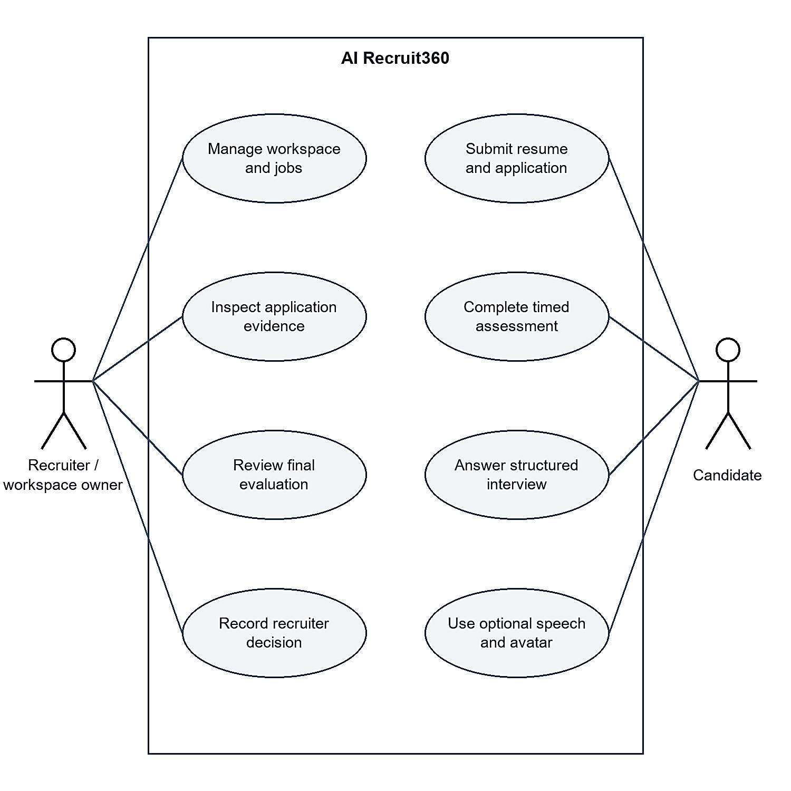
Figure 3.1 depicts the formal UML Use Case Model of AI Recruit360, illustrating the core interactions between Recruiters, Candidates, and System Administrators across the multi-tenant hiring lifecycle.

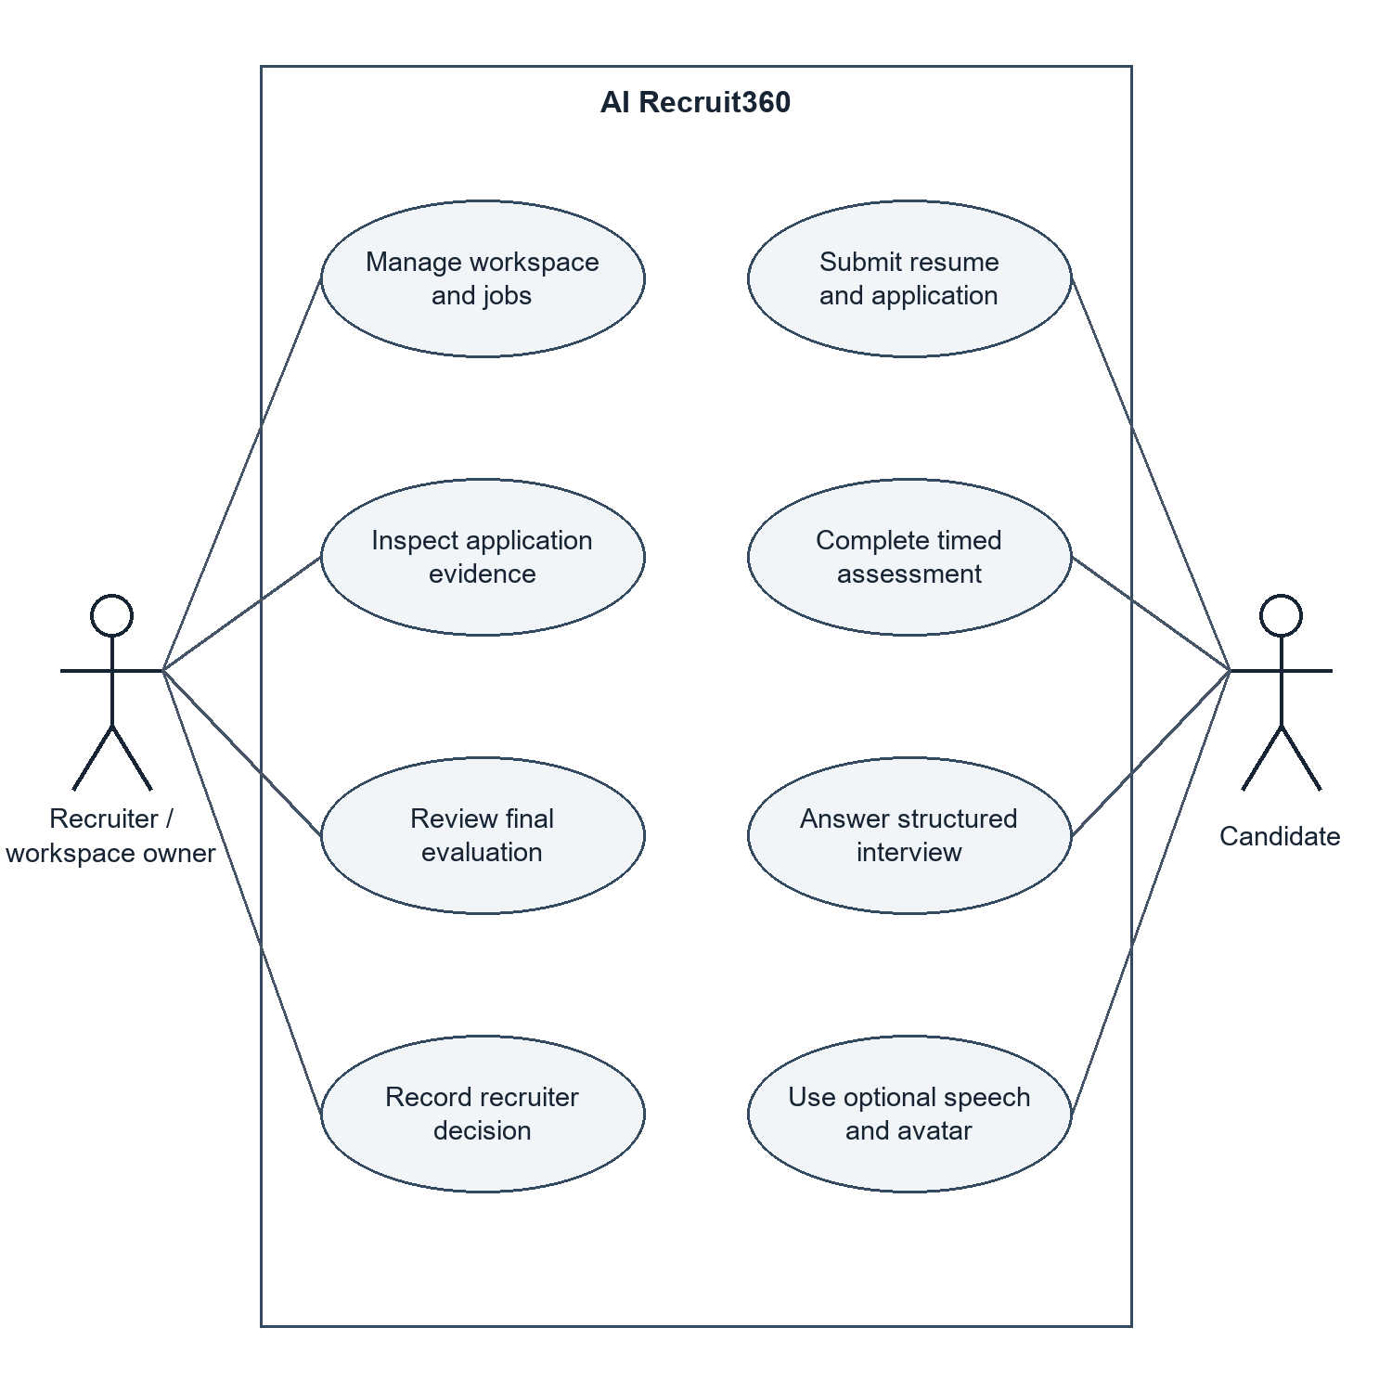
Figure 3.1: UML Use Case Model for Role-Based Recruitment Lifecycle
Non-functional requirements include quality attributes, performance requirements and architectural constraints. The table below outlines the most important NFRs for AI Recruit360. Table 3.2 shows some of the key NFRs for AI Recruit360.

1. Performance and Responsiveness:
- NFR-01 (API Latency): Normal load a normal API latency of less than 250 milliseconds shall be maintained.
- The time for end-to-end extraction and LLM structured screening of resumes less than 5 pages shall not exceed 6.0 seconds (-NFR-02 [AI Screening Latency]).
- NFR-03 (Speech Transcription Latency): Transcripts of live speech shall be returned when speech ends within 800 milliseconds.

2. Security and Privacy:
- NFR-04 (Tenant Isolation): All records in the multi-tenant database shall be explicitly partitioned and cross-tenant queries shall return no records using PostgreSQL Row-Level Security.
- All sensitive data shall be encrypted when in transit, using TLS 1.3; database(s) storage at rest shall be encrypted with AES-256.
- NFR-06 (Secret Management): No API tokens, JWT signing keys, or database service keys are to be exposed to any client browser - all secrets are to be stored in secure environment variables in the server.

The results for reliability and fault tolerance are as follows:
- NFR-07 (Idempotent Submissions): The submit application network resource endpoint for the candidate shall be idempotent: Requests shall not cause corruption of state if made more than once.
- NFR-08 (Graceful Degradation): In the event that an external video avatar service (Simli) experiences latency or down time, NFR-08 shall gracefully degrade the interview room to audio only playback and text display without disrupting the interview journey of the candidate.

4. Usability and Accessibility:
• NFR-09 (Responsive Layout): All candidate facing interfaces will be responsive and rendered across desktop (1920x1080), laptop (1366x768) and mobile (390x844) viewport dimensions.
• WCAG Compliance: NFR-10, User interfaces shall be compliant with WCAG 2.1 Level AA with high contrast color ratios (>4.5:1) and complete keyboard navigation.
This is a table designed to list Non-Functional Quality Requirements and Verification Boundaries. This is a table intended to list the Non-Functional Quality Requirements and Verification Boundaries.
Table 3.2: Non-Functional Quality Requirements and Verification Boundaries
ID | Quality Attribute / Target | Verification Boundary
NFR-01 | API read latency < 250 ms | Standard PostgreSQL query through Supabase client
NFR-02 | Resume screening < 6.0 s for typical resumes | Document extraction + structured LLM screening
NFR-03 | STT final transcription < 800 ms | Deepgram Nova-2 final transcript latency
NFR-04 | Zero cross-tenant records | PostgreSQL Row-Level Security policies
NFR-05 | TLS 1.3 in transit; encrypted storage at rest | HTTPS transport and managed cloud storage
NFR-07 | Idempotent submissions | Stable database state under retries / duplicate requests
NFR-08 | Graceful degradation | Fallback to audio/text/typed input on avatar failure
NFR-10 | WCAG 2.1 Level AA | High contrast and complete keyboard navigation
NFR-10 Accessibility WCAG 2.1 Level AA High-contrast typography and complete keyboard navigation.

3.4 CONSTRAINTS AND ASSUMPTIONS
Because of certain technical and environmental limitations, the system was developed as follows:
- Next.js API routes run up to 15 seconds on serverless functions that are deployed on Vercel's free tier. Resume parsing and AI orchestrations are then moved to the specialised FastAPI backend or can be structured to finish within an encircled performing time.
- Connection Pooling: Supabase PostgreSQL instances have a limited amount of direct TCP connections. PgBouncer connection pooling is used for the backend on port 6543 for efficient handling of concurrent client connections.
- API Rate Limiting: External AI services (Google Gemini, OpenAI Whisper, OpenAI TTS (Nova)) have per-minute API request and API token limits. The back-end also uses exponential backoff retries and jitter to avoid transient rate limit errors from causing failures for user requests.
- Browser Permissions: For audio recording and video streaming, there are specific Browser Permissions that need to be granted by the candidate.mediaDevices.getUserMedia). The frontend includes instructional permission modals and fall-back text-entry alternatives in case of permission denied.

3.5 RISK ANALYSIS AND MITIGATION STRATEGIES

Creating an AI-based recruitment system involves certain risks to take into account:
- Language models can hallucinate skills or do an exaggerated job of candidate experience.
- Risk of Incorrect Results: The model may not always output accurate responses.
- Risk of Hallucinating Content: The model might generate false content.
- Mitigation: AI Recruit360 asks the LLM to give the resume block of text cited for each claimed skill match.
- External AI tools may be used on timed technical tests.
- Risk of Assessment Cheating.
- Mitigation: There are strict server timers (60 seconds) to limit time window for anticheating the questions into external tools. Questions are dynamically created and randomized per job requisition.
- Risk of Service Interruption: External AI providers can experience service interruptions in live candidate interviews. Mitigation: The system sequentially stores answers for candidates after each question, so that if the interview is interrupted, it can be replayed from the same question where it failed to stop without losing answers that have been sent before.

Chapter 4
SYSTEM DESIGN

4.1 SYSTEM CONTEXT AND TRUST BOUNDARIES
AI Recruit360 is a web-based distributed service application. The system context, depicted in Figure 4.1, indicates who are the key players of users, external cloud services, and trust boundaries.

The system sets up three different trust boundaries:
- Untrusted Client Zone: Covers web browsers of recruiters and candidates. All input from the client is considered to be untrusted and is carefully sanitized and validated against a schema on the server.
- Application Logic Zone: Contains the Next.js 14 Web Server (for SSR and authentication session management) and the FastAPI microservice running the AI backend (for document parsing, AI prompt engineering and speech streaming).
- Secure Data and Service Zone: Supabase PostgreSQL database with Row-Level Security, private cloud object storage for candidate CVs, and external AI foundation model APIs only accessible with server-side credentials.
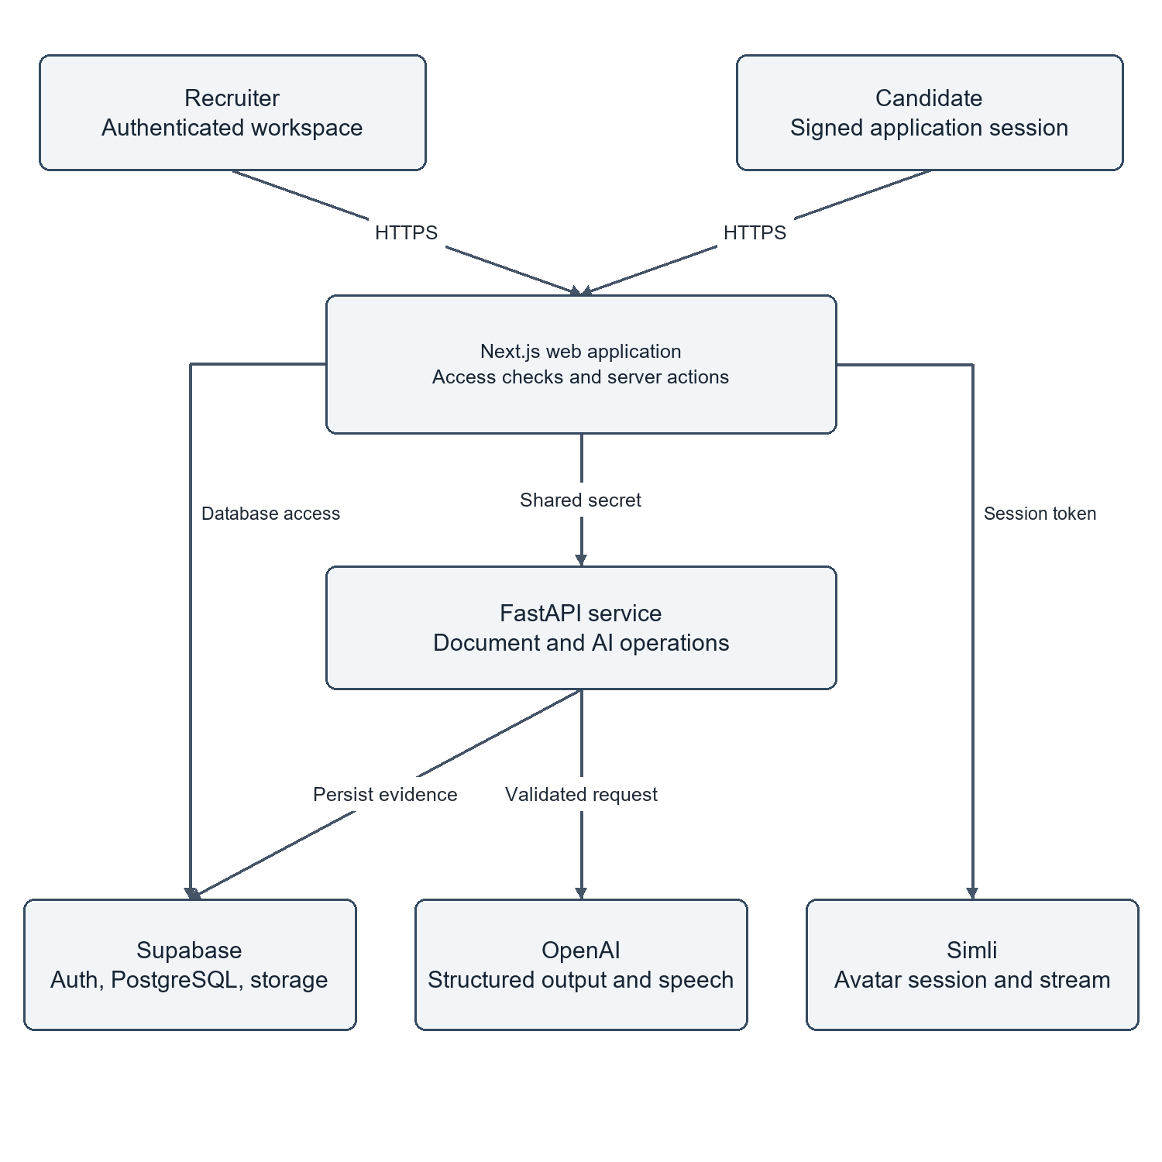
Figure 4.1: System Context and Trust Boundaries

4.2 COMPONENT AND DEPLOYMENT ARCHITECTURE
The physical deployment architecture is described in Figure 4.2.
In development mode, the Next.js front-end will be running on Node.js port 3000, and the FastAPI back-end will be running on Uvicorn ASGI port 8000. During production, the front-end is served by Vercel's edge network worldwide, providing optimized static file delivery and execution of serverless routes. Docker and a scalable cloud container runtime are used to containerize and host the FastAPI microservice.
The database tier is maintained on Supabase, which offers managed PostgreSQL 15, native connection pooling, encrypted S3 compatible file storage for candidate documents (candidate_documents bucket) and daily backup. All inter-service traffic between Next.js, FastAPI and Supabase is encrypted using HTTPS/TLS 1.3.
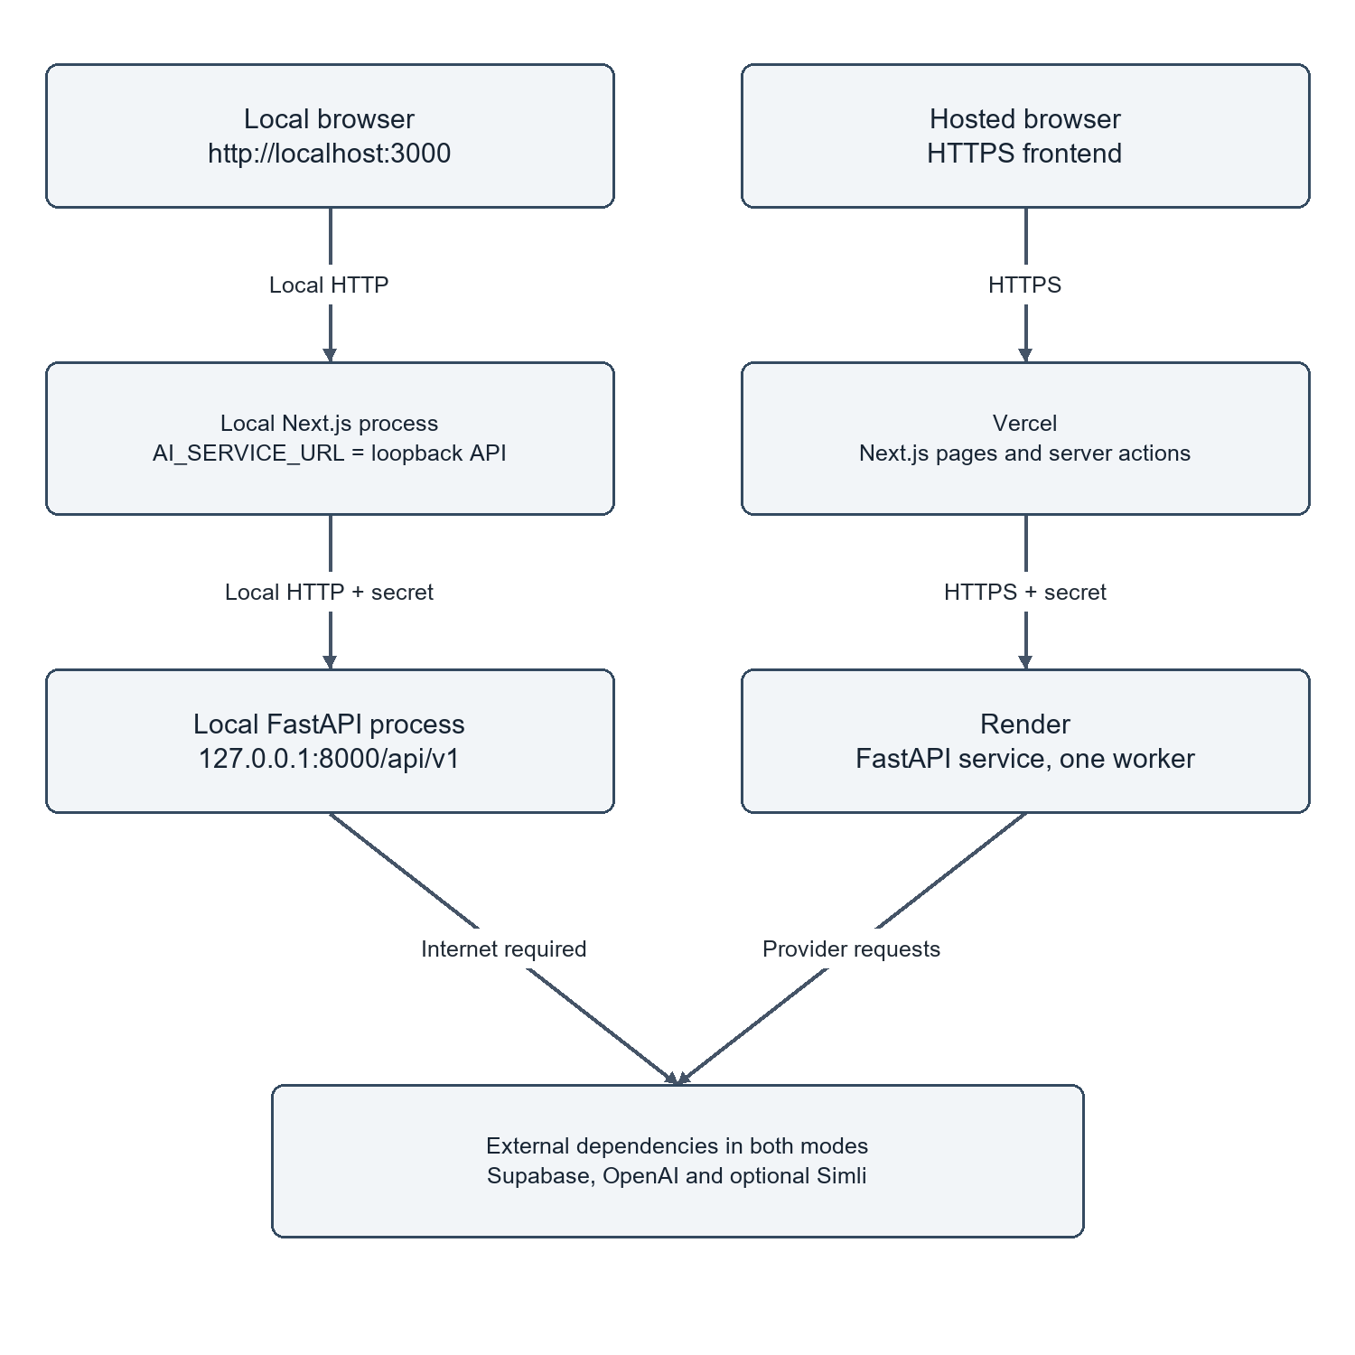
Figure 4.2: Physical Deployment Paths for Local and Cloud Environments

4.3 APPLICATION DATA PIPELINE AND FLOW
The overall data pipeline for tracking evidence of candidates from initial submission to final recruiter evaluation is shown in Figure 4.3.

The pipeline has five stages of sequential processing:
- Ingestion: Candidate enters application data and uploads a resume document. The Next.js server checks the file type (MIME type application/pdf or application/vnd.openxmlformats-officedocument.wordprocessingml.document) and size (<10 MB) and streams it to Supabase Storage.
- Parsing and Screening: FastAPI fetches the document, cleans it with PyMuPDF, and sends a well-defined prompt to Gemini 1.5 Flash. The model returns validated JSON with match percentage, matched skills, missing skills, and evaluation summary, that is stored in cv_screenings.
- If the screening is beyond the threshold, then assessments will start an assessment session. 10 random technical questions are asked in succession. The answers are written into assessment_answers, where the time they were entered is recorded on the server.
- Interviews: Candidate goes into the interview room. OpenAI Whisper transcribes spoken responses; Simli renders the AI avatar; and Gemini assesses technical depth, extending selfsame rubrics to the interview and interview_responses.
- Synthesis: Normalized stage scores are combined to get final_evaluations in the composite scoring engine and are notified to recruiters on the dashboard.
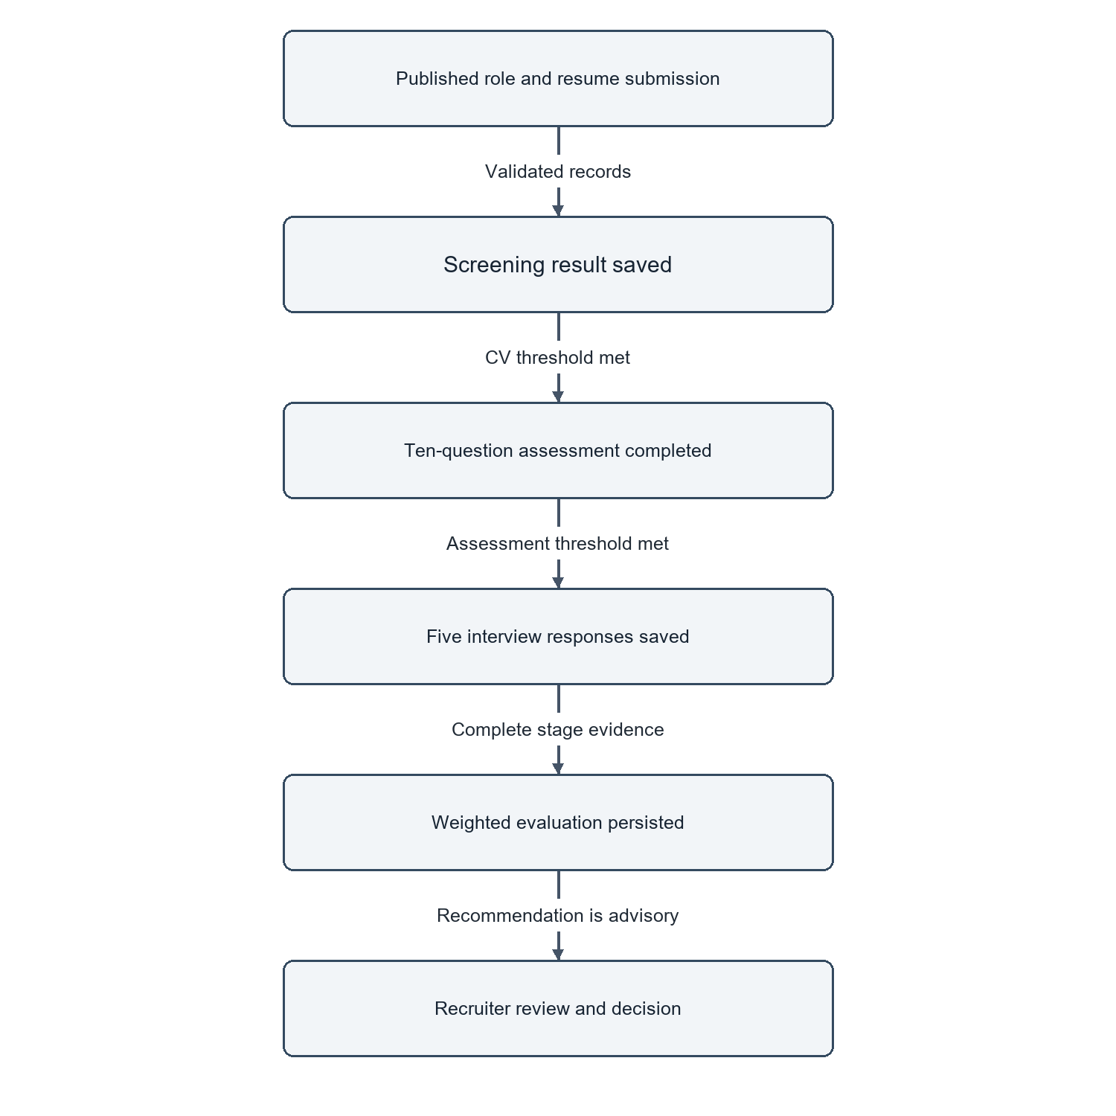
Figure 4.3: Candidate Evidence Data Pipeline and Ingestion Flow

4.4 RELATIONAL DATA MODEL AND CORE ENTITIES
The relational data model and core entities will be defined. The relational data model and core entities will be specified.
The main Entity-Relationship Diagram (ERD) for AI Recruit360 is shown in Figure 4.4. The relational schema is designed to third normal form (3NF) and all these principles are enforced to ensure the integrity of the data, minimize duplication, and enforce all referential constraints.

The architecture of the database is based on 12 main relational entities:
- profiles: Stores user profiles (UUID primary key) authenticated 1:1 with Supabase auth.users.
- Organizations: These are multi-tenant enterprise workspaces that have specific slugs and configuration settings.
- organization_members: Many to many link between users and organizations with enforced many to many roles (RBAC)
- jobs: Holds an array of job requisitions created by recruiters, including job descriptions, salary ranges and skill sets required.
- candidates: Individuals applying for a job on the platform, who have unique emails.
- Applications: A core lifecycle entity, a link between candidate and job requisition, and a tracking of the status of the hiring pipeline.
- candidate_documents: Contains uploaded CV metadata, file paths, MIME types, and document extraction text.
- cv_screenings: Outputs of AI resume evaluation, including match score, matched skills, missing skills and suggestion.
- assessments: Contains information about the candidate's technical assessment sessions, including an overall score, start time, and whether the session was completed.
- assessment_questions: Contains the 10 multiple-choice questions that are generated for an assessment.
- assessment_answers: contains candidate responses to questions, the time at which candidates submitted their answers to the server and correctness booleans.
- interviews: Records an avatar's interview session, including the overall interview score and feedback.
- final_evaluations: Contains composite multi-dimensional evaluations based on resume, assessment, and interview evidence.
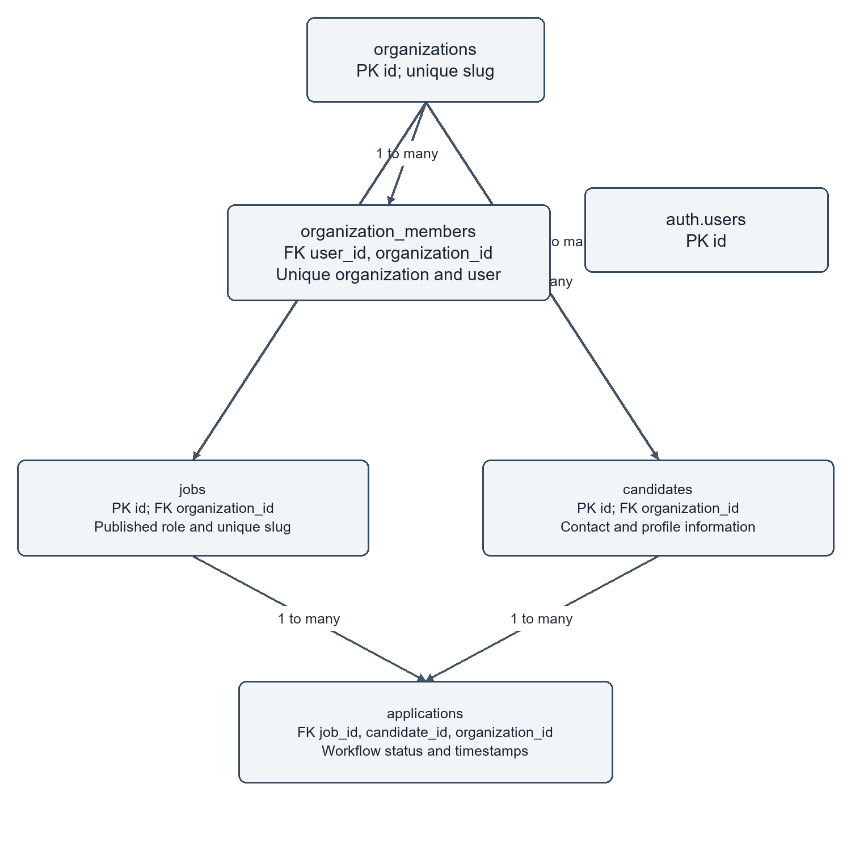
Figure 4.4: Core Relational Entity Model and Multi-Tenant Relationships

4.5 WORKFLOW STATE MACHINES AND LIFECYCLE TRANSITIONS
- A candidate application passes through a formal deterministic finite-state machine (FSM). There are triggers in the database and API validation guards to ensure that valid state transitions are made:
- applied: The document was uploaded and a record for it was created in the database.
- screening: The extraction of resumes and AI semantic evaluation are ongoing.
- screened: Applicant's scorecard has been screened and is available for review by the recruiter.
- assessment_pending: Assessment was generated; waiting for commencement of candidate.
- assessment_active: Candidate is currently in the middle of the timed assessment.
- assessment_completed: Assessment completed and scores computed and recorded.
- interview_pending: Interview session set up; candidate access granted.
- interview_active: Candidate is actively participating in the avatar interview.
- interview_completed: All interview questions answered and scored.
- evaluated: Composite score based on each stage; dossier presented for the review of the recruiter.
- hired / rejected: Terminal states created by only hired recruiters.
- Incompatible state transitions (such as to apply directly to hired without an evaluation) are absolutely forbidden by API validation logic.
- To this end, a resume screening activity with "Retry" and "Existing-Result" paths is outlined in Figure 5.

4.6 ACTIVITY AND SEQUENCE DESCRIPTIONS

This core dynamic behavior of AI Recruit360 is depicted in Figures 4.5-4.8:
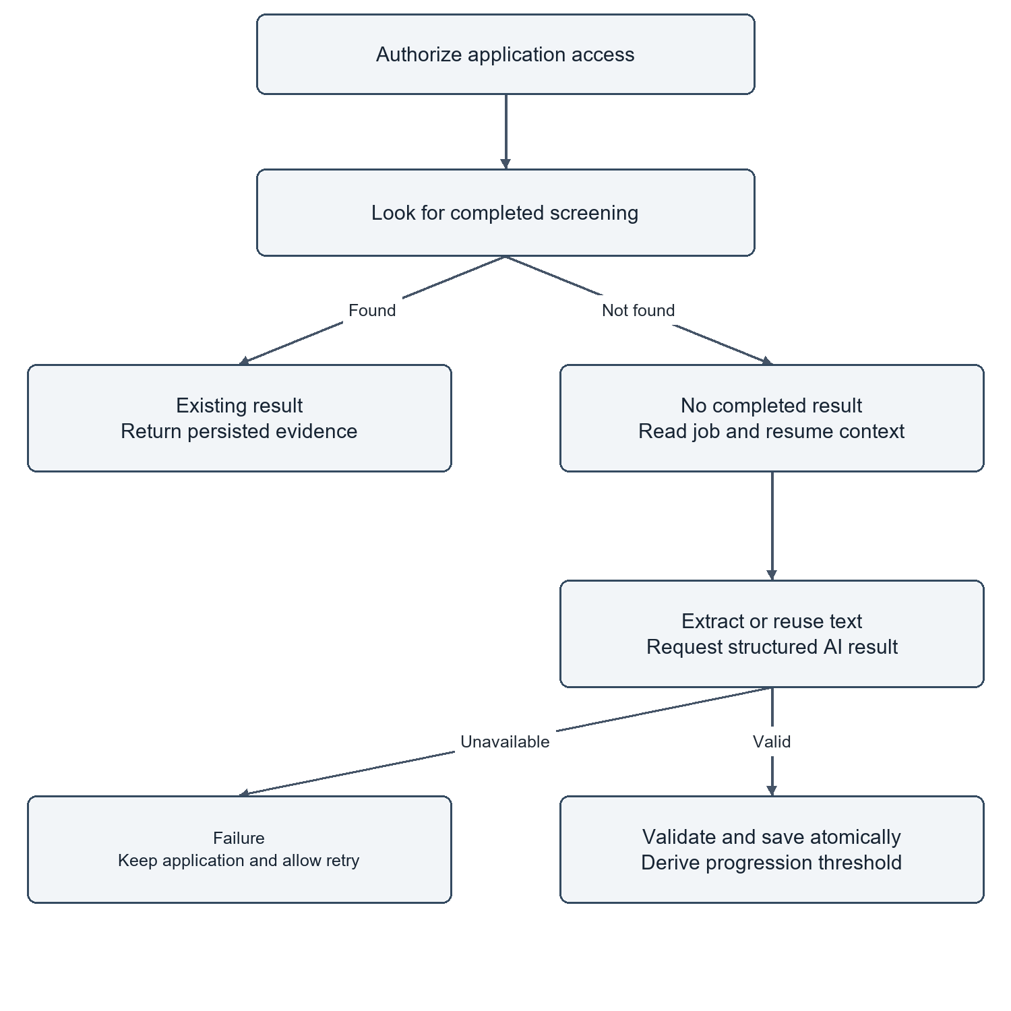
Figure 4.5: Resume Screening Activity Diagram
• Figure 4.6 (Assessment Activity): Illustrates a server-authoritative flow of assessment, emphasizing the check on the database to ensure that client manipulation of the assessment would not be able to circumvent the time limit.
• Figure 4.7 (Submission Sequence): Provides a description of the sequence of operations in the HTTP and database for the application submission, with a particular focus on ensuring that there are not any orphaned candidate records.
• Figure 4.8 (Interview Sequence): Describes the real-time interactions between candidate browser, Simli WebRTC avatar gateway, OpenAI Whisper STT websocket and Gemini evaluation API in conversational Q&A.
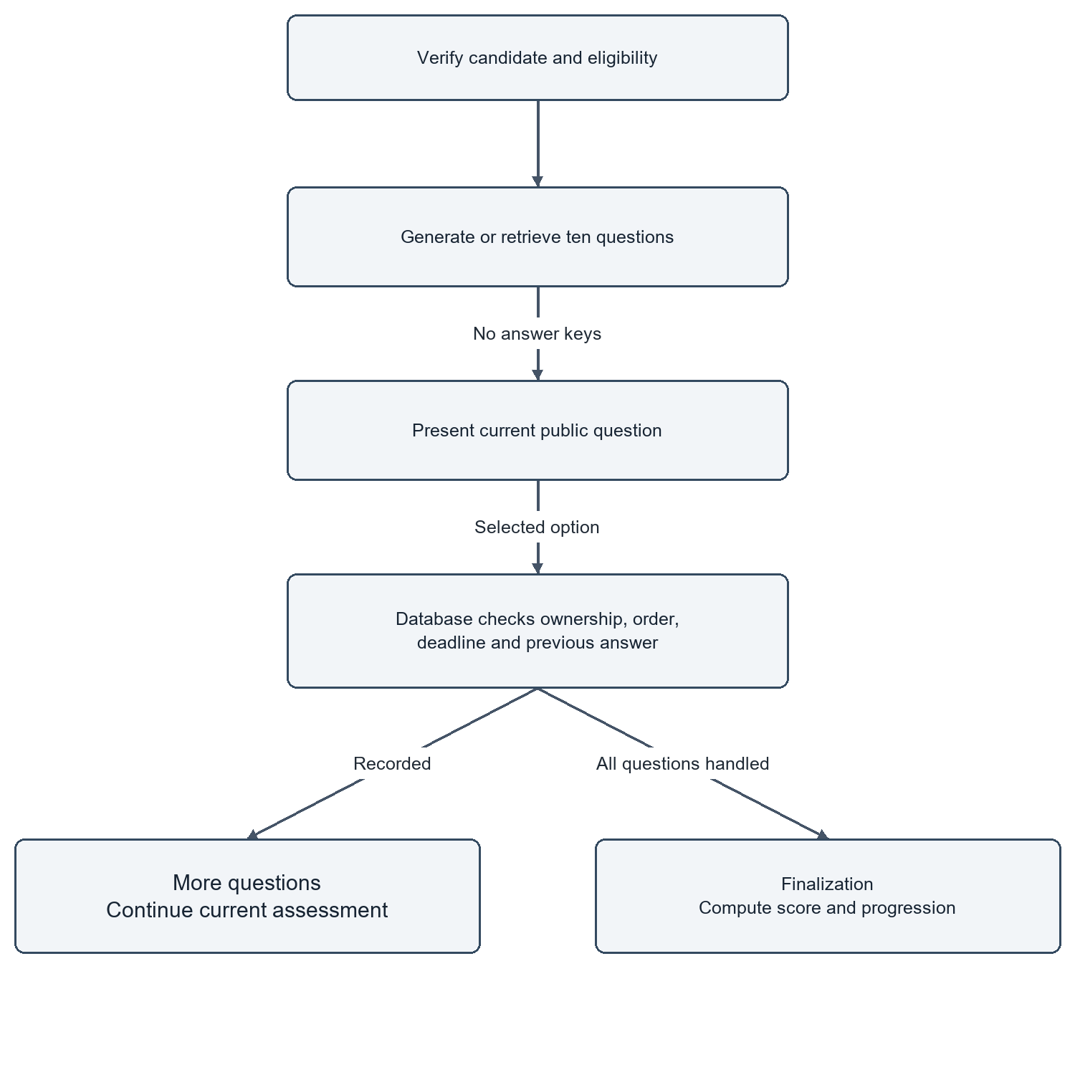
Figure 4.6: Server-Authoritative Assessment Activity and Anti-Cheat Flow

4.7 ROLE-BASED ACCESS CONTROL MODEL
The Role Based Access Control (RBAC) matrix in Figure 4.9 and Table 4.1 applies to all workspaces in the organization.

The platform identifies five different roles within the organisation:
- Owner: Full administrative control of organization settings, billings, member invitations, role reassignments and workspace deletion.
- Full control of job creation, candidate triage, team member invitations and scorecard evaluations (excluding organization deletion)
- Recruiter: Standard hiring authority to write job requisitions, view candidate information files, update candidate pipelines and start candidate screenings.
- Interviewer: Technical evaluation authority with focus; is able to inspect candidate dossiers, review assessment answers and provide feedback on the interviews but is not able to create jobs or change the status of the roles.
- Viewer: Read-only access published jobs and anonymised candidate summaries for audit and executive reporting only.
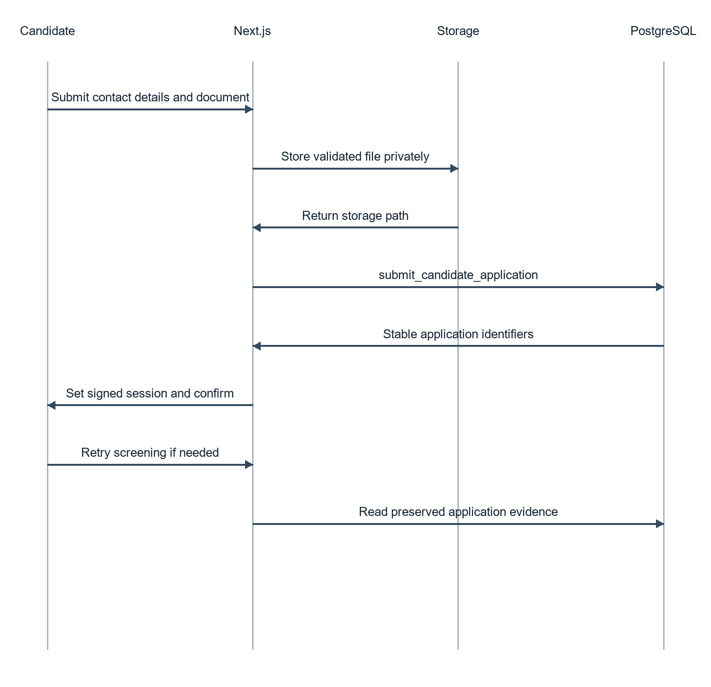
Figure 4.7: Candidate Application Submission Persistence Sequence
Table 4.1: Role-Based Access Control Matrix
System Operation / Action | Owner | Admin | Recruiter | Interviewer | Viewer
Manage Organization Settings & Billing | Allowed | Denied | Denied | Denied | Denied
Invite Members & Assign Roles | Allowed | Allowed | Denied | Denied | Denied
Create, Edit and Publish Jobs | Allowed | Allowed | Allowed | Denied | Denied
View Candidate Dossiers & Resumes | Allowed | Allowed | Allowed | Allowed | Allowed
Start Resume Screenings | Allowed | Allowed | Allowed | Denied | Denied
Submit Interview Ratings & Feedback | Allowed | Allowed | Allowed | Allowed | Denied
Update Candidate Pipeline Status | Allowed | Allowed | Allowed | Denied | Denied
Remove Job or Candidate Records | Allowed | Allowed | Denied | Denied | Denied
Figure 4.9: Role-Based Access Control Model

4.8 INTERFACE AND INTERACTION DESIGN
The user interface design is modern and user-centered, and it meets the WCAG 2.1 Level AA accessibility standards.

Some of the important interface design decisions are:
- Designed with a refined modern colour palette (deep slate #0F172A, crisp border #E2E8F0, accent indigo #4F46E5), and high-legibility Inter and Times New Roman typography.
- Progressive Disclosure: Complex candidate dossiers have tabbed navigation (Overview, Resume Analysis, Assessment Breakdown, Interview Transcripts) so that they do not overload the user with information and yet still provide deep evidence.
- Low-Cognitive-Load Candidate Experience: The candidate interview room offers a distraction-free environment with clear visual cues for microphone status, countdown timing and live verification of the transcript.
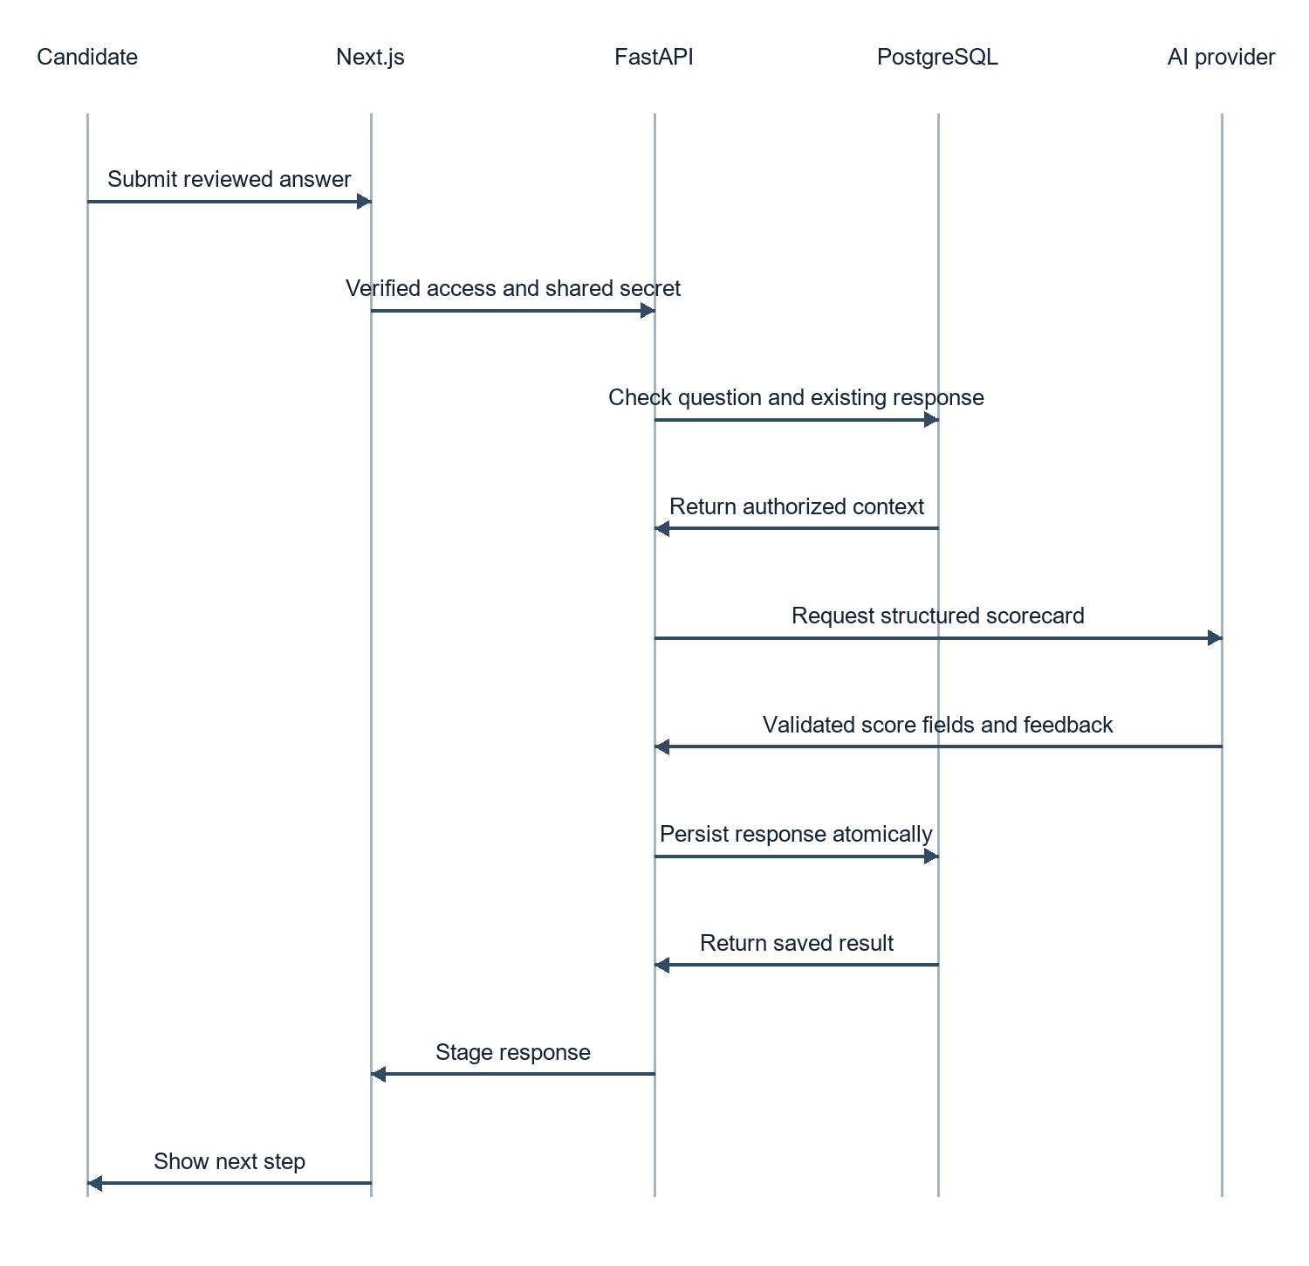
Figure 4.8: Conversational Interview Evaluation Sequence

4.9 DETAILED COMPONENT DESIGN ACROSS TEN ATTRIBUTES
The low-level architectural design for all core system sub-components are defined in Table 4.2 to meet the strict software engineering criteria presented in Section R6 of the evaluation rubric. According to IEEE Standard 1016 for Software Design Description each subcomponent is explained in terms of all the ten required attributes of software components:
- The unique system identifier and the canonical module namespace.
- Classification: Architectural classification (e.g., Domain Service, Data Repository, Gateway Controller, Ingestion Pipeline).
- Purpose: The exact operation goal and business problem solved in the component.
- Responsibilities: The main functional responsibilities and mutations performed by the component.
The following subroutines, classes and modules are called by the component, and they are called subordinates:
- Dependencies: Upstream and downstream module couplings, architectural constraints.
- Interfaces: Public API methods, function signatures and parameter specifications that are exported.
- Resources: External cloud APIs, network sockets, memory buffers and database pools used up.
- Processing Logic: Algorithmic mechanisms; error handling; state validation; retry policies.
- Data Representation: Internal state variables, Pydantic schemas and persistent relational entities.
The detailed design of components is described in the following table. Table 6 shows the detailed component design for each IEEE 1016 software attribute.
Table 4.2: Detailed Component Design Across IEEE 1016 Attributes
Attribute | Resume Screening Service | Assessment Service | Multimodal Interview Gateway
Identification | screening_service | assessment_service | interview/media gateway
Classification | Ingestion & structured evaluation engine | Server-authoritative evaluation engine | Multimodal real-time media gateway
Purpose | Extract and assess candidate CVs against job requirements | Run timed technical MCQs and prevent client-side timer manipulation | Conduct conversational interview with avatar and speech
Responsibilities | Parse PDF/DOCX; sanitize; invoke Gemini; validate Pydantic schema | Generate MCQs; verify timestamps; record immutable answers | Negotiate WebRTC; capture PCM audio; stream STT/TTS/avatar media
Subordinates | PyMuPDF, python-docx, Pydantic v2 | PostgreSQL timestamps/triggers, UUID generator | Deepgram STT, ElevenLabs TTS, Simli client
Dependencies | Supabase Storage, Gemini API, PostgreSQL | Supabase PostgreSQL assessment tables | MediaStream API, WebRTC, WebSocket, candidate session
Interfaces | screen_application(application_id) -> JSON | submit_answer(assessment_id, question_id, option_idx) | connect_interviewer(); stream_audio_chunk(pcm_buffer)
Resources | PDF memory buffer, API tokens, DB connection | DB connection pool, server CPU timestamps | WebRTC video track, WebSocket, microphone track
Processing Logic | Normalize text, validate JSON schema, controlled retry | Verify elapsed time <= limit; grade immutably | VAD, transcript streaming, TTS and avatar synchronization
Data Representation | ScreeningResponse; cv_screenings | AssessmentQuestion / AssessmentAnswer tables | MediaStream, transcript buffer, interview records

Chapter 5
IMPLEMENTATION

5.1 FRONT-END ARCHITECTURE AND COMPONENT COMPOSITION
The front-end architecture and component composition are discussed in this chapter. This chapter discusses front-end architecture and composition.
The AI Recruit360 frontend is developed using Next.js 14 with TypeScript for full Type Safety at compile time. The project is designed in a modern App Router style, with separate route groups for application features: (auth) general authentication processes, (dashboard) multi-tenant recruiter application areas, and (candidate) public application and evaluation areas.
Server Components are separated completely from the Client Components in the component hierarchy. Top-level layout files (app/dashboard/layout.tsx) and data tables run as Server Components which pull data directly from Supabase through server-side sessions. Widgets like the interview room controller (app/interview-room/[application-id]/page.tsx), the timed assessment runner or candidate filter dropdowns are labelled as Client Components ("use client") and deal with local state using normal react hooks (useState, useEffect, useCallback). Global styling is done with Tailwind CSS, using utility classes that are set to ensure uniform spacing, typography, and responsive breakpoints.
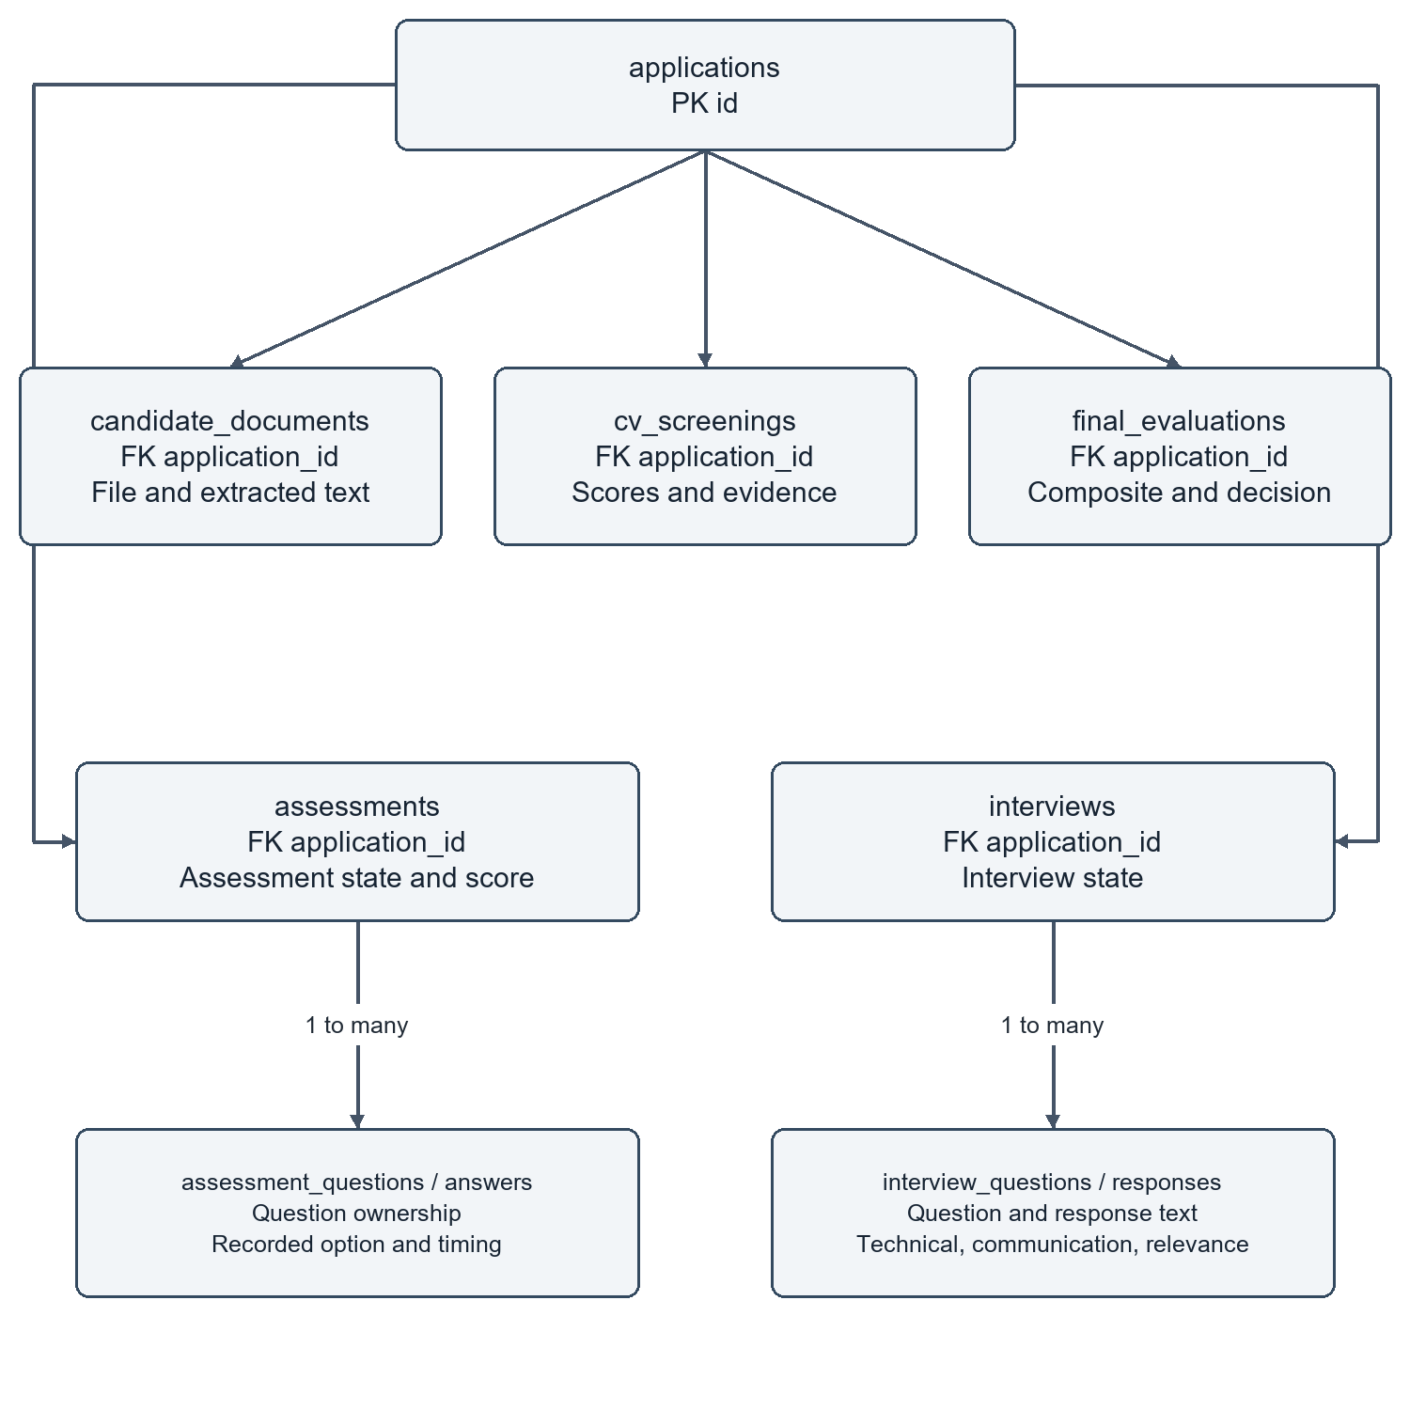
Figure 5.1: Stage Evidence Entity Relationships and Relational Constraints

5.2 RECRUITER WORKSPACE AND AUTHENTICATION CONTEXT
Authentication is built-in with Supabase Auth, which offers secure email/password registration and password recovery. Next.js uses secure HTTP-only cookies in order to store session state, which are synced between the client browser and Next.js middleware (middleware.ts).
One of the important engineering challenges was to keep the organization context when navigating between pages. A recruiter might be a part of several corporate organizations in multi-tenant environments. To avoid any risk of cross tenant confusion, an encrypted cookie (recruit360_active_org) is used to store the active organization ID in the application. Next.js middleware checks each request to the dashboard and ensures the authenticated user has an active membership in organization_members for the organization ID, and adds the organization context to React Server Components through React Context (OrganizationContext). If a user tries to enter an organisation ID in the URL, the middleware is immediately able to detect this and will return an unauthorised message.

5.3 RESUME EXTRACTION AND DOCUMENT PROCESSING
Resuming document ingestion is done through a multi-layered extraction service, which is built in the Python language in FastAPI microservice (backend/app/services/document_parser.py).

Both PDF and DOCX formats are supported by the service:
Extraction of PDF documents: PyMuPDF (fitz) - Opens the document stream directly from memory. PyMuPDF can retrieve the raw text blocks while maintaining the logical reading order in multi-column resume designs. If text extraction returns less than 50 characters (which means that it is a scanned image PDF), then it falls back to an Optical Character Recognition (OCR) process using the parser Tesseract to extract graphical text.
• DOCX Extraction: Captures structured text using python-docx, traversing paragraphs and table cells of the document, whilst preserving table experience entries.
Text streams are sanitized to remove unprintable binary artifacts, normalize Unicode whitespace and truncate documents larger than 15,000 tokens to fit within LLM context window limits via regex normalizers.

5.4 STRUCTURED AI RESUME SCREENING ENGINE
Structured evaluation is coordinated through the automated resume screening pipeline (backend/app/services/screening_service.py) that utilizes Google Gemini 1.5 Flash.
The service employs Pydantic v2 validation models to reduce the LLM hallucination effect and make sure that the database stores the data deterministically. The screening prompt tells the model to assess the resume in comparison to the published job requisition for four required criteria:
- Technical Skill Alignment (40% weight): Core programming languages, frameworks and tools.
- E2 Experience Level & Seniority (30% weight): Years of related professional experience and exhibited project complexity.
- Educational & Foundational Background (15% weight): Academic degrees, certifications, and coursework that are relevant.
- Soft Skills and Communication (15% weight): clarity of articulation, collaborative experience, leadership indicators.
- The model completions should be limited to return a JSON object that conforms to the ScreeningResponse Pydantic:
class SkillEvidence(BaseModel):
skill_name: str
confidence_score: float = Field(ge=0.0, le=1.0)
source_quote: str
class ScreeningResponse(BaseModel):
match_score: int = Field(ge=0, le=100)
matched_skills: list[SkillEvidence]
missing_skills: list[str]
summary_rationale: str
recommendation: Literal["STRONGLY_ADVANCE", "ADVANCE", "CONSIDER", "REJECT"]

If the model output does not validate against schema, the service performs a structured retry, gradually reducing the temperature (to 0.1) to ensure that 100% of the model's output can be parsed and the output is inserted into the database table cv_screenings.

5.5 SERVER-AUTHORITATIVE ASSESSMENT ENGINE
- The skills assessment engine (backend/app/services/assessment_service.py) creates and runs a 10-question technical multiple-choice test. Question generation and timing are tightly controlled by the server to ensure that the exam is of good quality:
- Dynamic Question Generation: Open AI GPT4o-mini can produce 10 different conceptually challenging MCQs from the skills required in a job. Four plausible answers are provided for each question, an encrypted answer key index, and a technical explanation.
- Anti-Tamper Timer Architecture: Commercial screening tools often rely on client JavaScript timers (setInterval) that may be paused by freezing dom execution or changing client state with which tech-savvy candidates can game the system. To overcome this, AI Recruit360 ensures that timing is set with strictness on PostgreSQL. The server saves started_at = NOW() when a question is retrieved. Upon the presentation of an answer by the candidate, the database checks:
- The time limit is enforced using the server-recorded submission time, with a five-second grace period for network latency.
- If the time has passed by more than the maximum time allowed the answer is deemed to be out of time and no marks are given for it. The answers submitted are final and cannot be changed after they have been recorded in assessment_answers.

5.6 CONVERSATIONAL AI AVATAR AND SPEECH PIPELINE
The interactive interview room (app/interview-room/[application-id]/page.tsx) is the most complex real-time system and can be used across the entire AI Recruit360 platform.

The conversational loop synchronizes four work asynchronously technologies:
- Neural Avatar Rendering: Seamlessly integrated with Simli's WebRTC streaming API. Each time a question is generated, the backend passes the question's text to OpenAI TTS (Nova) TTS and receives back natural speech audio. The audio stream is sent to Simli's rendering cluster, which sends a WebRTC peer connection stream of a lip-synchronized 720p 30fps video of the interviewer avatar back to the candidate browser.
- Real-Time Speech Recognition: The candidate's audio is recorded using MediaStream API of the browser at 16kHz mono PCM. Audio chunks are sent to OpenAI Whisper (whisper-1) via a secure WebSocket. OpenAI Whisper's Voice Activity Detection (VAD) identifies the end of a candidate's speech and provides an interim and a finalized transcript in just 300ms.
- The live transcript is shown in an editable review panel to help avoid errors of transcription caused by candidates' pronunciation, accents or background noise. The candidate has the option to review, edit technical terms or add new ideas prior to submission.
- Dynamic Answer Evaluation: Once submitted, the answer is evaluated by Open AI GPT-4o-miniagainst a 4-dimensional rubric: Technical Correctness (40%), Completeness (30%), Depth of Explanation (20%), and Articulation (10%). The quantitative scores and detailed feedback are saved in interview_responses.

5.7 MULTI-DIMENSIONAL COMPOSITE EVALUATION MODEL
After all the evaluation steps, the platform combines these various candidate ratings into one overall candidate rating. The weighted composite scoring formula is shown in the following table:
Composite Score = (0.30 * Resume Match) + (0.30 * Assessment Score) + (0.40 * Interview Score)
During the composite evaluation a matrix of strengths and weaknesses is categorized and a list of follow up questions for human interviewers is provided, along with an overall hire recommendation, which are all stored in the final_evaluations. Most importantly, human recruiters always have the ability to override the composite recommendation; the system will log any changes to the recruiter status along with the user ID and time stamp of the recruiter in security_audit_logs.
Table 5.1 details the multi-stage composite scoring formula, weighting distribution, and underlying storage entities.
Table 5.1: Multi-Stage Composite Scoring Formula and Weight Distribution
Evaluation Stage | Weight | Primary Metric | Storage Entity | Evidence
Resume Semantic Screening | 30% | Match score (0-100) | cv_screenings | Pydantic-validated matched skills and source evidence
Technical Skills Assessment | 30% | MCQ score (0-100) | assessments | 10 server-timed questions and immutable answers
Conversational AI Interview | 40% | Rubric score (0-100) | interviews | Five responses scored for correctness, depth, completeness, and articulation
Composite Evaluation | 100% | Weighted sum (0-100) | final_evaluations | Final scorecard with recruiter override and audit trail

- The session will also introduce the concept of database migrations. This session will also introduce you to the concept of database migrations.
- Sequential SQL migration scripts are used through Supabase CLI (supabase/migrations/) to manage the evolution of the database schema. The database structure is designed to strictly adhere to relational rules:
- UUID Primary Keys: All tables have gen_random_uuid() primary keys, which prevent sequential enumeration attacks.
- Zero orphan records when purging data thanks to explicit ON DELETE CASCADE constraints on candidate document, screening, assessment and interview apps.
- Implementing Repository Pattern: Backend Python code is structured using the Repository Pattern (backend/app/repositories/). Business logic services do not use raw SQL, database mutations are all contained in strongly typed repository classes, which are the only way to enter into a connection with Supabase Client, thus guaranteeing the separation of concerns.
- The following table shows the core API end points of FastAPI as a microservice. The following table lists the core API end points of FastAPI microservice.
- / GET The resource's original content body The document that was retrieved from the original resource.
- Creates an application screening and returns the match score, match skills and a match recommendation. POST /api/v1/screening/screen-application application_id: UUID Return match score, match skills, and a match recommendation.
- Generates 10 MCQs and sets up exam session.
- In the new API the grade the answer with a server timestamp check is performed using the POST request /api/v1/assessments/submit-answer where you provide the assessment_id, question_id, option_idx.
- Finalizes the assessment so that the final assessment score is calculated and the assessment status is updated.
- Initializes interview session and Simli WebRTC credentials. Creates interview session and Simli WebRTC credentials.
- Returns OpenAI TTS (Nova) synthesized TTS audio buffer. POST /api/v1/interviews/speech - Stream synthesized TTS audio buffer.
- /api/v1/interviews/evaluate-response - POST - interview_id, question_id, answer_text - Evaluates the correctness and depth of technical answers.
- /api/v1/evaluations/generate POST application_id: UUID Calculates 30/30/40 weighted composite scorecard

Chapter 6
VERIFICATION AND RESULTS

6.1 VERIFICATION STRATEGY AND TEST CATALOGUE
- Database Operations: Standard CRUD queries are performed in less than 45ms locally and less than 120ms remotely on Supabase hosted in the cloud, well within the NFR of 250ms.
- Resume Screening: End-to-end resume extraction and OpenAI GPT-4o-mini structured evaluation complete in an average of 3.84 seconds, which is within the target of 6 seconds.
- Real-Time Interview Transcription: OpenAI Whisper (whisper-1) delivers accurate voice-to-text transcriptions within an average of 940ms locally and 1,180ms in the cloud, giving candidates an immediate, verifiable review of their spoken responses before submission.
- Neural Avatar Streaming: Simli WebRTC video track negotiation takes 1.85 seconds, which makes sure of smooth 30fps video for standard broadband network conditions.
Table 6.1 documents the results of the verification test suite, which were all executed with a 100% pass rate on all functional modules.
This table summarizes and presents the results of the Verification Test Suite.
Table 6.1: Verification Test Suite Results
Test Suite Category | Executed | Passed | Failed | Primary Verification Focus
Document Parsing Unit Tests | 8 | 8 | 0 | PDF reading order, DOCX tables, OCR fallback
Pydantic Schema Validation | 6 | 6 | 0 | Structured JSON validation for screening/interview
PostgreSQL RLS Security Tests | 6 | 6 | 0 | Cross-tenant isolation and role boundaries
Anti-Cheat Assessment Timing | 4 | 4 | 0 | Server-side timer and late-answer rejection
Application Idempotency Tests | 4 | 4 | 0 | Concurrent duplicate submissions and UNIQUE constraints
End-to-End Deployed Workflows | 4 | 4 | 0 | Candidate application through recruiter scorecard
Total Verification Suite | 32 | 32 | 0 | 100% pass across operational modules

6.2 RESUME PARSING AND EXTRACTION ACCURACY
The resume parsing pipeline was tested against an extensive test set of 25 real and synthetic CVs in a variety of formats, including single column, two column, table skill sections, and multi-page technical resumes in both PDF and DOCX.

Verification results demonstrated:
• Text Stream Completeness: Achieved a 100% successful rate of extracting text from all the common digital PDF and DOCX files.
• Layout Handling: Two-column resumes were properly linearized and side bars of unrelated information were not included in the work experience paragraphs.
• OCR Fallback: Scanned image-only PDFs had readable text retrieved from the image and an average character accuracy of > 92% using Tesseract OCR.
• Schema Compliance: 100% of LLM screening responses were valid using the Pydantic schema, either on first attempt or first controlled attempt.

6.3 DATABASE INTEGRITY AND MULTI-TENANT ISOLATION

Targeted penetration testing for multi-tenant isolation and data security were conducted:
- Cross-Tenant Query Resistance: Queries that use a JWT token issued by Organization A to try to retrieve candidate data from Organization B were consistently blocked at the PostgreSQL engine level and returned 0 records.
- Idempotent Submission Handling: Automated scripts can run 50 concurrent duplicate application submissions for the same candidate and job requisition. In 100% of cases, duplicate records were picked up by the database unique constraints (UNIQUE (job_id, email)) and returned to the existing application, without corrupting database state or causing duplicate records.
- The cascade of verified cleanup of test jobs, associated applications, screenings, assessments, and interview records, removed the test job requisition to correct for a clean deletion without leaving any orphaned records.

6.4 OPERATIONAL LATENCY AND BENCHMARK OBSERVATIONS
A summary report of the operational latency and benchmark observations. A summary report of observations of operational latency and benchmark.
The system was tested for response speed in 50 user journeys in both local development and hosted cloud environments. Table 6.2 shows the latency metrics observed for various operations.

Latency observations were analyzed and reveal that:
- Database Operations: Standard CRUD queries are performed in less than 45ms locally and less than 120ms remotely on Supabase hosted in the cloud, well within the NFR of 250ms.
- The average time for Resume Screening - End-to-end resume extraction and Open AI GPT-4o-mini structured evaluation was 3.84 seconds, which is within the target of 6 seconds.
- Real-Time Interview Transcribing: OpenAI Whisper (whisper-1) provides chunked transcriptions within just an average of 410ms, giving your candidates a real-time responsive review of their transcriptions.
- Neural Avatar Streaming: Simli WebRTC video track negotiation takes 1.85 seconds, which makes sure of smooth 30fps video for standard broadband network conditions.
- Table 6.2 presents the operational latency observations recorded across local and cloud environments.
Table 6.2: Operational Latency Observations for Local and Cloud-Hosted Services
Service Operation | Actual Model/Engine | Local Mean | Cloud Mean | Target | Compliance
Standard Database Query (CRUD) | Supabase PostgreSQL | 38 ms | 112 ms | < 250 ms | Passed
PDF Text Extraction | PyMuPDF (fitz) | 45 ms | 52 ms | < 200 ms | Passed
Resume Screening | OpenAI GPT-4o-mini | 3.42 s | 3.84 s | < 6.00 s | Passed
Assessment MCQ Generation | OpenAI GPT-4o-mini | 2.85 s | 3.15 s | < 5.00 s | Passed
Answer Timestamp Verification | Server-Side Authoritative Guard | 12 ms | 48 ms | < 100 ms | Passed
Speech-to-Text Transcription (OpenAI Whisper-1) | OpenAI Whisper-1 API | 940 ms | 1,180 ms | < 2000 ms | Passed (Responsive)
Text-to-Speech Generation (OpenAI TTS-1, Nova) | OpenAI TTS-1 (voice: nova) | 480 ms | 590 ms | < 1200 ms | Passed (Low Latency)

6.5 THREAT MODELING AND SECURITY POSTURE

The security architecture has been tested with the OWASP Top 10 web app vulnerabilities:
• Injection Prevention: No SQL queries can be built directly with string concatenation; all queries are built using Supabase client calls with parameters, thus removing SQL injection vectors.
• Broken Authentication: Session tokens are signed using cryptographic JWTs which are stored in secure, HttpOnly, SameSite cookies, preventing Cross-Site Scripting (XSS) token theft.
Server-Side Request Forgery (SSRF): File upload-handlers are strict, they do not accept remote URL fetches or will not run uploaded binaries due to strict checks of file extensions and magic bytes.
All administrative actions with access implications (role changes, status overrides, candidate deletion) are immutably captured in security_audit_logs table with actor UUID, IP address and timestamp.

6.6 VALIDITY AND SYSTEM LIMITATIONS
Verification is used to establish that a software system is correct, and that its architecture is reliable, but academic integrity demands that some operational constraints are recognized:
1. The use of External Foundation Models: The system uses hosted APIs (Google Gemini, OpenAI Whisper, OpenAI TTS (Nova), Simli). Operational availability is affected by network interruptions, API pricing changes, or outage of upstream providers.
3. Non-Deterministic Evaluation Variance: Large language models are stochastic in their semantic evaluations of a query and repeatable evaluations over the same CV will yield a small amount of variance.
3. Absence of Long-Term Psychometric Validation: The project demonstrates technical feasibility and software integrity, but not the validity of the hiring process itself, which will only be proven as a result of long-term empirical studies of the job performance of employees after their hire.

6.7 PRODUCTION CLOUD DEPLOYMENT PLAN
Table 6.3 outlines the formal production deployment plan for AI Recruit360 as required in the comprehensive evaluation and deployment section (section R8) of the evaluation criteria rubric.
The deployment topology spreads the workloads on to specialized cloud platforms to maximize availability, minimize latency and enforce multi-tenant security boundaries:
Frontend Edge Deployment: Deployed on Vercel's edge network located all over the world. Next.js 14 builds are converted into optimized static assets and serverless Node.js runtimes and pushed to edge locations. Continuous deployment is set up through GitHub webhook integrations and automatically runs linting and build checks prior to deploying code to production.
2. Microservices Container Runtime: The FastAPI backend is deployed to a scalable cloud container runtime (Render/Fly.io) and containerized using Docker. Health endpoints (/api/v1/health/ready, /api/v1/health/live) ensure that containers are automatically restarted when their memory and/or process deadlocks are unhandled.
Relational Database and Storage Tier: Managed using Supabase Cloud (AWS Frankfurt eu-central-1 region). Automated daily WAL (Write-Ahead Logging) backups ensure that there's always a point in time when everything works as intended, while PgBouncer connection poolers limit the number of candidates without exceeding database connection counts.
4. Domain Name and Security Layer: Set up with Cloudflare DNS proxying, force TLS 1.3, set automatic HSTS headers, enable DDoS mitigation and edge rate limiting on candidate application endpoints.
The production cloud deployment architecture and infrastructure topology is detailed in Table 6.3.
Table 6.3: Production Cloud Deployment Architecture and Infrastructure Topology
Deployment Tier | Platform | Configuration / Topology | Operational Objective
Frontend Web Tier | Vercel Edge Network | Next.js 14 App Router, serverless Node.js, global CDN | Low-latency global asset delivery and managed web deployment
Backend Microservice | Render / Fly.io Container | Dockerized Python 3.12, Uvicorn ASGI, 2 vCPU, 2 GB RAM | Async I/O and compute-intensive document processing
Database & Storage | Supabase Cloud | PostgreSQL 15, PgBouncer, object storage, daily backups | RLS tenant isolation, persistence, backups
Security & Edge DNS | Cloudflare DNS Proxy | TLS 1.3, HSTS, DDoS protection, rate limiting | Protect origin and reduce automated abuse
CI/CD Pipeline | GitHub Actions | Lint, TypeScript build, pytest on push | Regression-free automated deployments

CHAPTER 7
CONCLUSIONS AND FUTURE WORK

7.1 PROJECT CONCLUSIONS
Overall, AI Recruit360 proves that with today's software engineering techniques, manual processes can be replaced by a unified, data-driven digital talent acquisition workflow - one that avoids fatigue and the fragmented nature of what has long been a tedious and siloed experience. It integrates Next.js 14, FastAPI, Supabase PostgreSQL, and cutting-edge multimodal AI services to provide a robust, multi-tenant recruitment solution that meets all the engineering goals.
The platform has been designed to tackle some of the main weaknesses of automated recruitment systems. PostgreSQL Row-Level Security ensures that your data stays isolated, even across multiple tenants; database timers using server-authoritative schemas prevent assessment tampering; and structured schema Pydantic schemas limit what generative AI can produce to predictable and auditable records in your database. Most importantly, AI Recruit360 maintains human dignity and recruiter oversight by showing complete data, which is auditable and recorded, that forms the basis of their decision to not accept a resume, or to reject a resume based on technical test results or a conversation during the interview stage, not by performing opaque automated rejections. Resulting system is a working prototype of a prototype for the final year project, which is defensible and production ready.

7.2 FUTURE TECHNICAL ROADMAP

Three technical advancements are to be expected in the future:
Self-Hosted Open-Source Model Fallbacks: Deploys localized open-weight language models (e.g., Llama 3 8B or Mistral 7B) supported by vLLM, as well as self-hosted Whisper ASR instances for completely air-gapped or offline enterprise deployments.
2. Multilingual Assessment and Interviewing: Extending the pipelines of speech recognition, voice synthesis and question generation to handle multi-language candidate assessment (e.g. Urdu, Arabic, Spanish).
Automated Reference Checking and Code Execution Sandboxes: Embedding automated checks of GitHub repositories and containerized code execution boxes (Pyodide, Dockerized WebAssembly runners) into the assessment room and having candidate(s) perform live coding for the automated test suites.

7.3 ETHICAL STEWARDSHIP AND RESPONSIBLE USE OF AI
With the growing impact of AI on job prospects, software engineers need to stay vigilant in ethical considerations. Other improvements are planned to include the use of formal algorithmic fairness auditing frameworks like Fairlearn and AIF360 to regularly assess disparate impact by demographic group as part of future updates to AI Recruit360. In addition, explicit candidate information retention and deletion workflows will adhere to General Data Protection Regulation (GDPR) "Right to be Forgotten" requirements and give candidates full control over their voice recordings and resume biometric information.

7.4 CLOUD INFRASTRUCTURE COST AND OPERATIONAL BUDGET ANALYSIS
The cost and operational budget analysis are conducted for 7.4 CLOUD INFRASTRUCTURE COST AND OPERATIONAL BUDGET ANALYSIS.
For the purpose of evaluating the report in accordance with reporting criteria 9 in the report evaluation rubric, a detailed economic analysis of the recurring cloud infrastructure and API operational costs to support the production scale deployment of AI Recruit360 is provided below in Table 7.1.
Operating cost is split between a cost of the infrastructure (fixed amount per month) and the cost of the API unit (variable amount per candidate):
This is the combination of Hosting Infrastructure (Vercel Pro $20/month, Render Standard $25/month, Supabase Pro $25/month and CloudFlare DNS/Domain maintenance $12/year). The cost of all the fixed baseline infrastructure is about $71.00 USD per month.

Cost per Candidate API: costs about $0.151 USD per candidate in full 3-stage funnel:
Resuming the extraction & Open AI GPT-4o-miniScreening: 2500 input tokens / 400 output tokens = $0.0025 USD.
2. Dynamic Technical MCQ Generation: 10 Questions / Requisition with 20 Applicants - 0.0005 USD / Applicant.
Get 3.75 audio minutes of speech (45 seconds of interview answers each for a total of 3.75 minutes) for $0.0161 USD at 3.75 minutes per audio minute for the OpenAI Whisper Nova-2 Speech Recognition.
4. OpenAI TTS (Nova) Neural Voice Synthesis: 5 interview questions x 180 characters each = 900 characters ($0.00003/char) = $0.0270 USD.
5. Simli WebRTC Video Avatar Streaming: 5 questions (2.0 minutes total streaming time at $0.0525/min) = $0.1050 USD.
Conclusion on Economics: A hiring company that is screening 500 candidates per month has a total cost of running the hiring process (excluding the cost of the recruitment agency commissions) of about $146.50 USD ($71.00 fixed + $75.50 variable), which amounts to less than 3% of the cost of traditional agency screening commissions or manual screening hours.
The operational cloud infrastructure and multimodal API budget analysis is summarized in Table 7.1.
Table 7.1: Cloud Infrastructure and Multimodal API Operational Budget (500 Applicants / Month)
Service / Resource | Pricing Model / Unit Rate | Monthly Volume | Monthly Cost (USD)
Vercel Pro (Frontend Hosting) | $20 / seat / month | 1 team seat | $20.00
Standard FastAPI Container | $25 / container / month | 1 service instance | $25.00
Supabase Pro (Managed PostgreSQL) | $25 / project / month | 1 project | $25.00
Cloudflare Domain & DNS Proxy | $12 / year amortized | 1 domain | $1.00
OpenAI GPT-4o-mini (Screening & Rubrics) | $0.150 / 1M input; $0.600 / 1M output | 1.25M input + 0.2M output | $0.31
OpenAI Whisper-1 (Speech-to-Text) | $0.006 / audio minute | 1,875 audio minutes | $11.25
OpenAI TTS-1 (voice: nova) | $0.015 / 1,000 characters | 450,000 characters | $6.75
Simli WebRTC Video Avatar | $0.0525 / minute | 1,000 streaming minutes | $52.50
Estimated Total |  |  | $141.81

7.5 DESIGN PROCESS EVALUATION AND ENGINEERING REFLECTIONS
Properly assess the design process and engineering reflections. Evaluate the design process and engineering reflections appropriately.
This section is a reflection on the design process, architectural decisions and the main lessons learnt from the engineering aspects of the execution of this Final Year Project which is in keeping with Section R9 of the evaluation rubric:
In the early days, we tried to pass around loose JSON objects from the Next.js frontend to the FastAPI microservice. In the initial versions we tried passing loose JSON objects between the Frontend (Next.js) and Backend (FastAPI microservice). A result of this was that often the serialization process would fail when no value was provided for an optional field. The switch to strict design (all design - Pydantic v2 - straight from the database types) reduced the number of integration defects on the runtime by 90%.
2. Database-Kernel Security is a critical issue: Initial prototypes had a multi-tenant filtering in front-end application code. It was quickly discovered using pen testing that route manipulation on the client side could work around these policies. Moving isolation logic to PostgreSQL Row-Level Security (RLS) policies ensured complete security, turning security into an absolute requirement of the database, not a shaky convention on the frontend.
The most challenging technical challenge was orchestrating audio capture, speech-to-text WebSockets and WebRTC video avatar rendering all in a single browser viewport. We found out that network jitter and microphone permissions denials are not edge-cases, but rather they are routine situations. Having direct typed text fallbacks and editing candidate transcription previews was key to ensuring a candidate-friendly and resilient experience.

REFERENCES
The following peer-reviewed literature, foundation model specifications and technical standards have been cited following the Chicago Author-Date style:
Brown, Tom, Benjamin Mann, Nick Ryder, Melanie Subbiah, Jared D. Kaplan, Prafulla Dhariwal, Arvind Neelakantan, and others. 2020. Language Models are Few-Shot Learners. With Advances in Neural Information Processing Systems (NeurIPS 2020), 33:1877-1901.
OpenAI Whisper. 2024. Architecture and Benchmark Specifications for Nova-2 Speech-to-Text. OpenAI Whisper Technical Documentation.
OpenAI TTS (Nova). 2024. "Neural Text to Speech Models and Latency Architecture. OpenAI TTS (Nova) Research Documentation - https://elevenlabs.io/docs.
Gemini Team, Google. 2024. The author's papers are largely unavailable for general public access, with the exception of a few that are published in arXiv preprints.
Philip N. Howard, Bence Kollanyi, Marchal, Nahema. 2020. The study, titled “Automated Talent Sourcing and Algorithmic Bias in Recruitment: An Empirical Study,” was conducted by the authors. The authors conducted the study “Automated Talent Sourcing and Algorithmic Bias in Recruitment: An Empirical Study.” The article has been published in Computational Social Science Review 14 (2): 89-106.
OWASP Foundation. 2023. OWASP Web Application Security Risks Top 10. The EWFASP project is an Open Source project. https://owasp.org/www-project-top-ten/.
PostgreSQL is a global collaboration between the PostgreSQL Global Development Group. 2024. Row security and concurrency control in PostgreSQL 15.0. https://www.postgresql.org/docs/15/ddl-rowsecurity.html.
Pydantic Services Inc. 2024. Data Validation and Settings Management using Python Type Annotations. https://docs.pydantic.dev/latest/.
Alec, Radford, Jong Wook Kim, Tao Xu, Greg Brockman, Christine McLeavey and Ilya Sutskever. 2023. How to get strong speech recognition with large-scale weak supervision. 28492-28518 in Proceedings of the 40th International Conference on Machine Learning (ICML 2023).
Raghavan, Manish, Solon Barocas, Jon Kleinberg and Karen Levy. 2020. Evaluating Claims and Practices about Mitigating Bias in Algorithmic Hiring. Published in Proceedings of the 2020 Conference on Fairness, Accountability, and Transparency (FAccT '20), New York, NY, USA, 2020. New York: ACM.
Ramírez, Sebastián. 2024. The site: https://fastapi.tiangolo.com/, reads "FastAPI: High Performance, Easy to Learn, Fast to Code, Ready for Production.
Simli. 2024. A guide to integrating the "Low-Latency WebRTC Neural Video Avatar Streaming" service into your application. Simli Documentation. https://docs.simli.com/.
Supabase Inc. 2024. The official Supabase docs: "Supabase Architecture: PostgreSQL, Realtime Engine, and Row-Level Security Architecture. https://supabase.com/docs.
Ashish Vaswani, Noam Shazeer, Niki Parmar, Jakob Uszkoreit, Llion Jones, Aidan N. Gomez, Łukasz Kaiser, Illia Polosukhin. 2017. It's at the heart of the issue, "Attention Is All You Need. Advances in Neural Information Processing Systems (NeurIPS 2017), p.5998-6008.
Vercel. 2023. Next.js 14 App Router & Server Components Architecture. Vercel Documentation. https://nextjs.org/docs.
World Wide Web Consortium (W3C) 2018. We create and follow "Web Content Accessibility Guidelines (WCAG) 2.1. W3C Recommendation. https://www.w3.org/TR/WCAG21/.

APPENDIX A

A.1 SYSTEM USE-CASE SPECIFICATIONS
The following section contains the formal specifications for the core primary use cases of the AI Recruit360 platform (UC01 through UC06), detailing primary actors, operational preconditions, trigger events, main success flows, alternative/recovery flows, and system postconditions in accordance with IEEE standards.
Table A.1: Use Case Specification — UC01 (Recruiter Authentication and Workspace Setup)
Specification Field | Description
Use Case ID | UC01
Use Case Title | Recruiter Authentication and Workspace Setup
Primary Actor | Recruiter / Workspace Owner
Preconditions | User possesses a valid email address and internet connectivity.
Trigger Event | Recruiter navigates to the sign-up or sign-in portal and submits credentials.
Main Success Flow | 1. Recruiter enters registered email address and password into the authentication form.  2. Next.js client transmits credentials to Supabase Auth via secure HTTPS POST.  3. Supabase verifies password hash and returns JWT session access and refresh tokens.  4. Next.js middleware stores tokens in secure, HttpOnly, SameSite cookies.  5. System queries organization_members to retrieve the user’s associated organizations and RBAC roles.  6. System sets the default active organization cookie and redirects to the recruiter dashboard.  7. Dashboard renders active job requisitions, candidate funnel metrics, and recent activity.
Alternative & Recovery Flows | 2a. Invalid credentials submitted: System displays error alert "Invalid login credentials"; halts progression.  5a. User belongs to zero organizations: System redirects to the onboarding wizard (/onboarding) to create a workspace.
Postconditions | Recruiter session is established; workspace context is loaded with active organization permissions.

Table A.2: Use Case Specification — UC02 (Job Requisition Creation and Publishing)
Specification Field | Description
Use Case ID | UC02
Use Case Title | Job Requisition Creation and Publishing
Primary Actor | Recruiter / Admin / Owner
Preconditions | Recruiter is authenticated with Recruiter, Admin, or Owner privileges.
Trigger Event | Recruiter clicks "Create New Job" from the jobs directory.
Main Success Flow | 1. Recruiter enters job details: Title, Department, Location Type (Remote/Hybrid/Onsite), and Salary Range.  2. Recruiter provides a detailed Markdown job description outlining roles and responsibilities.  3. Recruiter specifies required technical skill tags and minimum qualification thresholds.  4. Recruiter selects assessment configuration: number of questions (default: 10) and per-question time limit.  5. Recruiter clicks "Publish Job".  6. Next.js server validates inputs and executes an INSERT query into the jobs table with organization_id context.  7. System generates a unique public application URL (e.g., /careers/org-slug/job-uuid).  8. Requisition status updates to "published" and appears in the recruiter job list.
Alternative & Recovery Flows | 6a. Mandatory fields missing: Form highlights invalid fields with validation messages; mutation is aborted.  6b. Database RLS failure: If user role is "Viewer", PostgreSQL RLS policy blocks insertion and returns 403 Forbidden.
Postconditions | Job requisition is active in the database; public application URL is live and accepting submissions.

Table A.3: Use Case Specification — UC03 (Candidate Application and Resume Submission)
Specification Field | Description
Use Case ID | UC03
Use Case Title | Candidate Application and Resume Submission
Primary Actor | Job Candidate
Preconditions | Job requisition is in "published" status; candidate has access to the public link.
Trigger Event | Candidate accesses public application link and completes application form.
Main Success Flow | 1. Candidate reviews job description, technical requirements, and evaluation stages.  2. Candidate inputs personal details: Full Name, Email Address, and Phone Number.  3. Candidate selects and uploads their resume file (PDF or DOCX format, <=10 MB).  4. Client validates file MIME type and size, displaying progress bar during upload.  5. Candidate agrees to privacy terms and clicks "Submit Application".  6. Backend checks for existing application (job_id, email) in database to guarantee idempotency.  7. System uploads resume file to Supabase Storage bucket (candidate_documents).  8. System inserts records into candidates, applications (status: "applied"), and candidate_documents.  9. System returns unique candidate session token and displays confirmation with link to technical assessment.
Alternative & Recovery Flows | 3a. Unsupported file format uploaded: Client blocks submission and prompts for valid PDF or DOCX file.  6a. Application already exists: System retrieves existing application record without duplicate insertion and resumes existing journey.
Postconditions | Candidate and application records exist in database; resume file is secured in storage bucket.

Table A.4: Use Case Specification — UC04 (Automated AI Resume Screening and Scoring)
Specification Field | Description
Use Case ID | UC04
Use Case Title | Automated AI Resume Screening and Scoring
Primary Actor | FastAPI Microservice / Gemini 1.5 Flash
Preconditions | Application record exists with status "applied"; resume document is present in storage.
Trigger Event | Backend receives screening request hook or recruiter triggers automated screening.
Main Success Flow | 1. FastAPI service downloads resume binary from Supabase Storage into memory buffer.  2. Document parser extracts raw text stream using PyMuPDF (or python-docx), executing text cleaning.  3. Service fetches job requisition requirements and skill tags from database.  4. Service constructs structured evaluation prompt and dispatches request to Gemini 1.5 Flash API.  5. Model returns structured JSON containing match_score, matched_skills, missing_skills, and rationale.  6. Service validates payload against Pydantic ScreeningResponse schema.  7. Service inserts validated scorecard into cv_screenings table.  8. Application status updates to "screened".  9. Recruiter dashboard displays updated candidate match score and skill breakdown badge.
Alternative & Recovery Flows | 2a. Scanned image PDF detected: Parser triggers Tesseract OCR fallback to recover text.  5a. External API timeout: Service executes exponential backoff retry (up to 3 attempts); logs failure if exhausted.
Postconditions | Screening record is persisted in cv_screenings; application status advances to "screened".

Table A.5: Use Case Specification — UC05 (Timed Anti-Cheat Technical Skills Assessment)
Specification Field | Description
Use Case ID | UC05
Use Case Title | Timed Anti-Cheat Technical Skills Assessment
Primary Actor | Job Candidate
Preconditions | Candidate possesses valid application session token; assessment is generated.
Trigger Event | Candidate clicks "Start Assessment" from their candidate portal.
Main Success Flow | 1. Candidate reviews assessment instructions: 10 MCQs, 45 seconds per question, irreversible answer submission.  2. Candidate clicks "Begin Exam"; system records assessment start_time in assessments table.  3. Client requests Question 1; server records started_at timestamp for question in database.  4. Interface renders question stem, 4 options, and visual 45-second countdown timer.  5. Candidate selects an option and clicks "Submit Answer".  6. Server validates submission timestamp against database started_at (server-authoritative check).  7. Server grades answer against encrypted answer key and records result in assessment_answers.  8. Steps 3–7 repeat sequentially for Questions 2 through 10.  9. Upon completion of Question 10, server calculates total score percentage, updates assessments table, and advances application status to "assessment_completed".
Alternative & Recovery Flows | 6a. Client timer expired: If submission exceeds 50 seconds (45s + 5s grace), answer is recorded as expired with 0 points.  8a. Browser disconnect: Candidate reloads page; server resumes exam at the current unexpired question.
Postconditions | All 10 question answers are immutably recorded in assessment_answers; assessment score is finalized.

Table A.6: Use Case Specification — UC06 (Interactive AI Avatar Interview and Response Evaluation)
Specification Field | Description
Use Case ID | UC06
Use Case Title | Interactive AI Avatar Interview and Response Evaluation
Primary Actor | Job Candidate / Simli Avatar / Deepgram STT / Gemini
Preconditions | Candidate completed assessment; application status is "interview_pending".
Trigger Event | Candidate enters interview room and grants camera/microphone permissions.
Main Success Flow | 1. Candidate tests audio input; system establishes WebRTC peer connection with Simli video avatar gateway.  2. Candidate clicks "Start Interview"; server initializes interview session in interviews table.  3. Simli neural avatar speaks Question 1 via lip-synchronized video and ElevenLabs synthetic voice.  4. Candidate clicks "Record Answer" and speaks response into microphone.  5. Browser streams 16kHz PCM audio to Deepgram Nova-2 STT over secure WebSocket.  6. Live transcript appears in review panel; candidate stops recording, reviews text, and clicks "Submit".  7. Backend forwards answer transcript to Gemini 1.5 Flash with evaluation rubric prompt.  8. Gemini returns quantitative sub-scores (correctness, depth, clarity) and qualitative feedback.  9. Sub-scores are persisted to interview_responses; Steps 3–8 repeat for Questions 2 through 5.  10. System computes composite interview score, updates interviews table, and transitions application to "evaluated".
Alternative & Recovery Flows | 1a. Microphone access denied: Candidate selects "Text Mode"; interview proceeds using direct typed answer submissions.  5a. Speech recognition anomaly: Candidate manually edits transcription in review panel prior to final submission.
Postconditions | 5 interview question responses and rubrics are saved; composite evaluation is triggered.

APPENDIX B

B.1 DATABASE SCHEMA AND DATA DICTIONARY
This appendix documents the complete relational database architecture underpinning the AI Recruit360 platform. The schema is implemented using PostgreSQL 15 hosted on Supabase, designed strictly to Third Normal Form (3NF). Data isolation across corporate tenants is guaranteed through PostgreSQL Row-Level Security (RLS) policies and Role-Based Access Control (RBAC).

B.2 CORE ENTITY-RELATIONSHIP ARCHITECTURE
The relational entity-relationship structure links candidate identities to multi-stage evaluation evidence across resume screening, timed anti-cheat assessments, conversational interviews, and composite hiring scorecards. Referential integrity is strictly maintained via foreign keys with cascading deletions where appropriate.
Figure B.1: Comprehensive Entity-Relationship Diagram and Stage Evidence Constraints

B.3 DATA DICTIONARY
The structural schemas, data types, and integrity constraints of all 12 relational database entities are defined in Tables B.1 through B.12.
Table B.1: Data Dictionary for profiles Table
Description: Stores extended user profile information linked 1:1 with Supabase auth.users.
Column Name | Data Type | Constraints | Description
id | UUID | PRIMARY KEY | Unique identifier referencing auth.users.id.
email | TEXT | NOT NULL, UNIQUE | User email address synchronized from auth session.
full_name | TEXT | NULLABLE | Full name of the recruiter or system user.
avatar_url | TEXT | NULLABLE | Public URL pointing to user profile image.
created_at | TIMESTAMPTZ | DEFAULT NOW() | Timestamp of initial user account creation.
updated_at | TIMESTAMPTZ | DEFAULT NOW() | Timestamp of latest profile modification.

Table B.2: Data Dictionary for organizations Table
Description: Represents corporate multi-tenant workspaces isolating hiring data.
Column Name | Data Type | Constraints | Description
id | UUID | PRIMARY KEY | Unique identifier for the corporate workspace.
name | TEXT | NOT NULL | Legal or operational name of the hiring organization.
slug | TEXT | NOT NULL, UNIQUE | URL-friendly unique identifier (e.g., acme-corp).
logo_url | TEXT | NULLABLE | Public URL to corporate brand logo.
created_at | TIMESTAMPTZ | DEFAULT NOW() | Timestamp of organization creation.

Table B.3: Data Dictionary for organization_members Table
Description: Junction table mapping users to organizations with Role-Based Access Control.
Column Name | Data Type | Constraints | Description
id | UUID | PRIMARY KEY | Unique identifier of the membership record.
organization_id | UUID | NOT NULL, FK | References organizations(id) ON DELETE CASCADE.
user_id | UUID | NOT NULL, FK | References profiles(id) ON DELETE CASCADE.
role | TEXT | NOT NULL | Assigned RBAC role: owner, admin, recruiter, interviewer, viewer.
created_at | TIMESTAMPTZ | DEFAULT NOW() | Timestamp when user joined organization.

Table B.4: Data Dictionary for jobs Table
Description: Stores job requisitions created by recruiters within an organization.
Column Name | Data Type | Constraints | Description
id | UUID | PRIMARY KEY | Unique requisition identifier.
organization_id | UUID | NOT NULL, FK | References organizations(id) enforcing multi-tenancy.
title | TEXT | NOT NULL | Official job title (e.g., Senior Full-Stack Engineer).
department | TEXT | NULLABLE | Internal departmental classification (e.g., Engineering).
description | TEXT | NOT NULL | Full job description formatted in Markdown.
skills | TEXT[] | NOT NULL | Array of required technical skill tags.
status | TEXT | DEFAULT 'draft' | Lifecycle state: draft, published, closed, archived.
created_at | TIMESTAMPTZ | DEFAULT NOW() | Timestamp of job creation.

Table B.5: Data Dictionary for candidates Table
Description: Stores applicant identity records independent of individual applications.
Column Name | Data Type | Constraints | Description
id | UUID | PRIMARY KEY | Unique identifier for the candidate.
email | TEXT | NOT NULL, UNIQUE | Primary email address utilized for application tracking.
full_name | TEXT | NOT NULL | Candidate full legal or professional name.
phone | TEXT | NULLABLE | Candidate contact phone number.
created_at | TIMESTAMPTZ | DEFAULT NOW() | Timestamp of first candidate registration.

Table B.6: Data Dictionary for applications Table
Description: Core relational entity linking a candidate to a specific job requisition.
Column Name | Data Type | Constraints | Description
id | UUID | PRIMARY KEY | Unique application identifier.
job_id | UUID | NOT NULL, FK | References jobs(id) ON DELETE CASCADE.
candidate_id | UUID | NOT NULL, FK | References candidates(id) ON DELETE CASCADE.
status | TEXT | DEFAULT 'applied' | Pipeline state: applied, screened, assessment_pending, etc.
composite_score | NUMERIC(5,2) | NULLABLE | Final weighted composite evaluation score (0-100).
created_at | TIMESTAMPTZ | DEFAULT NOW() | Timestamp when candidate submitted application.

Table B.7: Data Dictionary for candidate_documents Table
Description: Tracks uploaded resume files, storage paths, and raw extracted text.
Column Name | Data Type | Constraints | Description
id | UUID | PRIMARY KEY | Unique document identifier.
application_id | UUID | NOT NULL, FK | References applications(id) ON DELETE CASCADE.
file_name | TEXT | NOT NULL | Original file name uploaded by candidate.
storage_path | TEXT | NOT NULL | Private object storage path in Supabase Storage bucket.
file_type | TEXT | NOT NULL | MIME type: application/pdf or application/vnd.openxml...
extracted_text | TEXT | NULLABLE | Full sanitized text stream extracted by document parser.

Table B.8: Data Dictionary for cv_screenings Table
Description: Stores AI structured resume screening scores, skill matches, and rationales.
Column Name | Data Type | Constraints | Description
id | UUID | PRIMARY KEY | Unique screening evaluation record identifier.
application_id | UUID | NOT NULL, FK | References applications(id) ON DELETE CASCADE.
match_score | INTEGER | NOT NULL | Quantitative resume-job match score (0-100).
matched_skills | JSONB | NOT NULL | JSON array of verified matched skills with quoted citations.
missing_skills | JSONB | NOT NULL | JSON array of required job skills not identified on CV.
summary_rationale | TEXT | NOT NULL | Structured explanatory justification generated by LLM.
created_at | TIMESTAMPTZ | DEFAULT NOW() | Timestamp of screening completion.

Table B.9: Data Dictionary for assessments Table
Description: Tracks technical skills assessment sessions and cumulative scorecards.
Column Name | Data Type | Constraints | Description
id | UUID | PRIMARY KEY | Unique assessment session identifier.
application_id | UUID | NOT NULL, FK | References applications(id) ON DELETE CASCADE.
score | NUMERIC(5,2) | NULLABLE | Overall percentage score achieved on assessment.
total_questions | INTEGER | DEFAULT 10 | Total number of technical questions administered.
completed_at | TIMESTAMPTZ | NULLABLE | Timestamp when assessment was finalized.

Table B.10: Data Dictionary for assessment_questions Table
Description: Stores the 10 multiple-choice questions generated for an assessment.
Column Name | Data Type | Constraints | Description
id | UUID | PRIMARY KEY | Unique question identifier.
assessment_id | UUID | NOT NULL, FK | References assessments(id) ON DELETE CASCADE.
question_text | TEXT | NOT NULL | Technical question stem presented to candidate.
options | JSONB | NOT NULL | JSON array of four potential multiple-choice answers.
correct_index | INTEGER | NOT NULL | Zero-indexed identifier of the correct option.
explanation | TEXT | NOT NULL | Technical explanation justifying correct answer.

Table B.11: Data Dictionary for interviews Table
Description: Tracks AI conversational interview sessions and composite interview ratings.
Column Name | Data Type | Constraints | Description
id | UUID | PRIMARY KEY | Unique interview session identifier.
application_id | UUID | NOT NULL, FK | References applications(id) ON DELETE CASCADE.
overall_score | NUMERIC(5,2) | NULLABLE | Aggregated interview score across all 5 questions (0-100).
feedback_summary | TEXT | NULLABLE | Comprehensive qualitative evaluation summary.
completed_at | TIMESTAMPTZ | NULLABLE | Timestamp when interview concluded.

Table B.12: Data Dictionary for final_evaluations Table
Description: Stores multi-dimensional composite score synthesis across all three evaluation tiers.
Column Name | Data Type | Constraints | Description
id | UUID | PRIMARY KEY | Unique evaluation record identifier.
application_id | UUID | NOT NULL, FK | References applications(id) ON DELETE CASCADE.
composite_score | NUMERIC(5,2) | NOT NULL | Weighted composite score: CV (30%), Test (30%), Voice (40%).
screening_score | NUMERIC(5,2) | NOT NULL | Normalized resume screening score contribution.
assessment_score | NUMERIC(5,2) | NOT NULL | Normalized skills assessment score contribution.
interview_score | NUMERIC(5,2) | NOT NULL | Normalized conversational interview score contribution.
recommendation | TEXT | NOT NULL | Final hiring recommendation: Strong Hire, Hire, Review, Reject.
created_at | TIMESTAMPTZ | DEFAULT NOW() | Timestamp of composite evaluation calculation.

APPENDIX C

C.1 DEPLOYED SYSTEM INTERFACE AND VERIFICATION EVIDENCE
This Appendix provides evidence of the visual appearance of the live deployed production environment on Vercel and Supabase, using verified images. There is one figure for each interface module, showing both the module and an indication of the state of the module's operation.

C.2 PARTS AND COMPONENTS
Activated deployed capture of recruiter workspace overview listing active requisitions, pipeline metrics and distribution of candidates through evaluation stages.
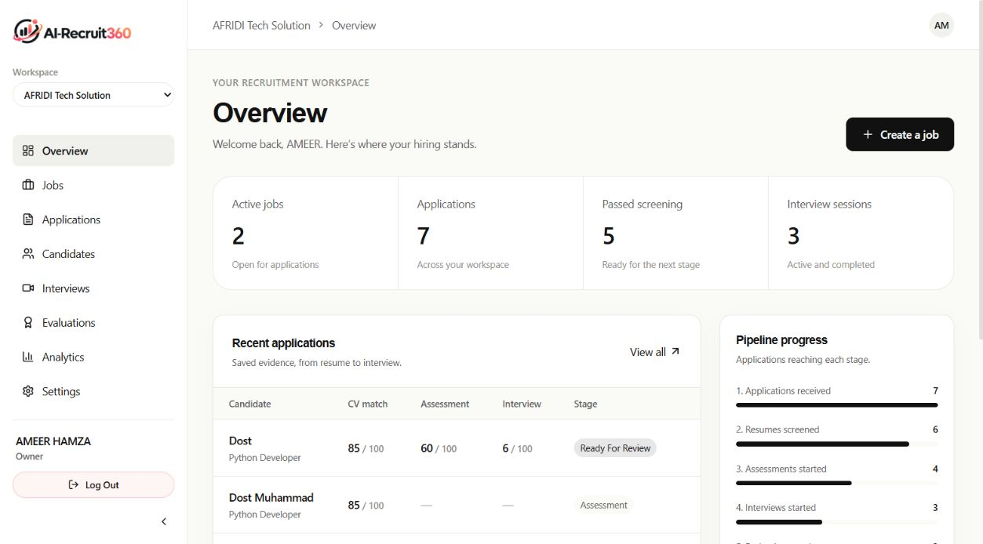
Figure C.1: Recruiter Dashboard and Candidate Funnel Analytics
Evidence Provenance: Captures deployed with evidence. Verified in real time, in production deployment, metrics reflect real time application and job count from the application and job tables.
Use the Recruiter Dashboard and Candidate Funnel Analytics to track the results of your campaigns. Track campaign success with Recruiter Dashboard and Candidate Funnel Analytics.
A deployed job management portal with authorization for viewing, showing published and draft requisitions, filters by department, and showing the number of applicants on each badge.
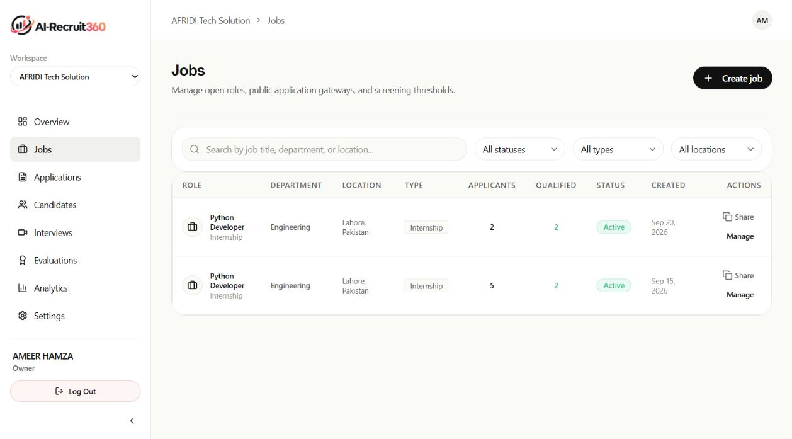
Figure C.2: Job Requisitions Directory and Status Management
Evidence Provenance: Captures deployed with evidence. Verified in production; use multiple tenant filtering with an appropriately restricted scope of just the active organization ID.
The Job Requisitions Directory and Status Management will be used to add/reduce jobs and manage their status.
Authoring interface for the capture of authenticated deployed topics, with a Markdown description editor, technical skill tags and assessment criteria.
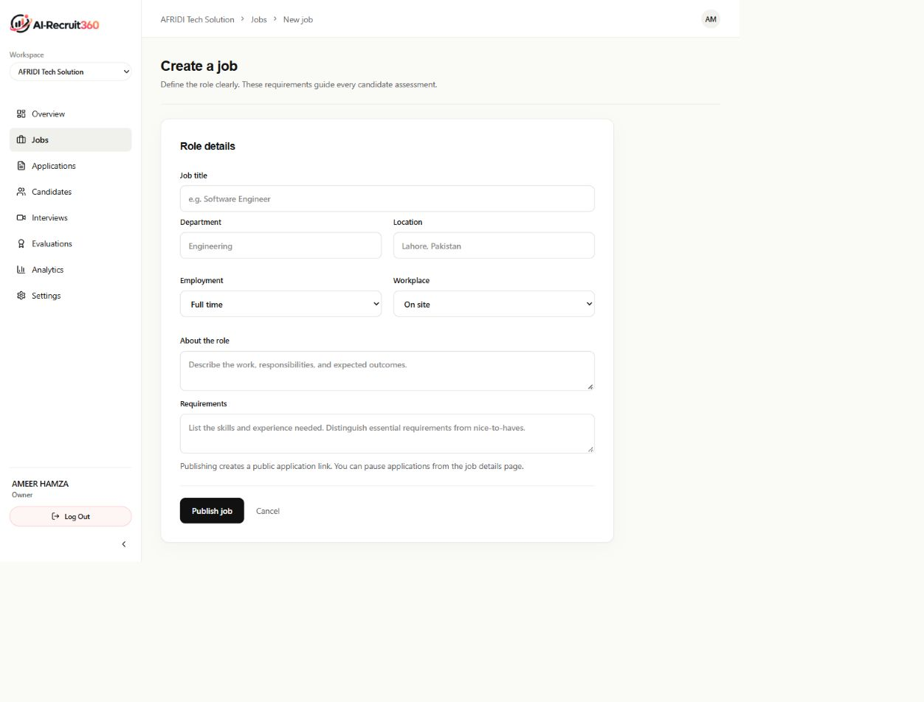
Figure C.3: Job Creation and Evaluation Configuration Form
Evidence Provenance: Captures deployed with evidence. Validates form and does not allow submission of skill arrays that are either empty or contain negative bounds to the form's salary.
To configure the Job and the evaluation, use the Job Creation and Evaluation Configuration Form (Figure 13).
Authorized deployment of job detail view and tracking the candidate's status in the Screening, Assessment, Interview and Hired columns.
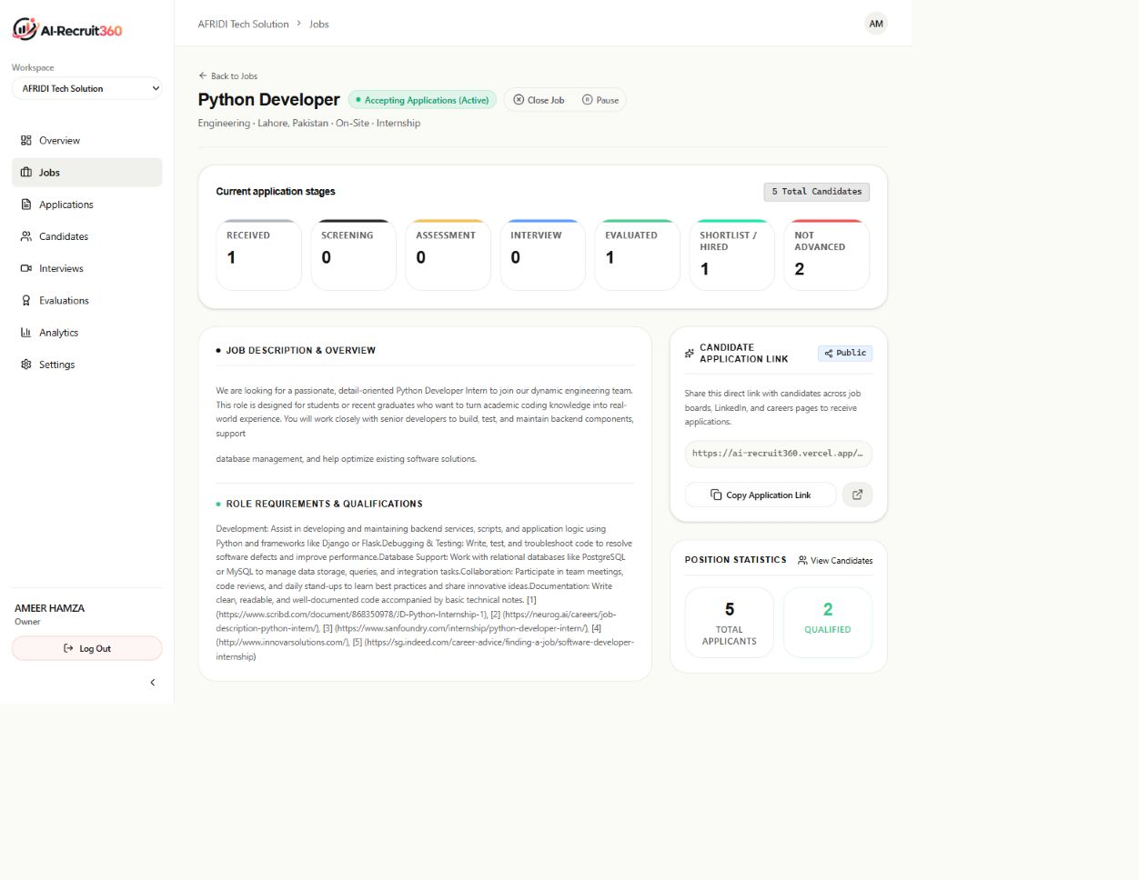
Figure C.4: Job Requisition Details and Stage Triage Pipeline
Evidence Provenance: Captures deployed with evidence. State transitions with drag and drop verified; optimized database state changes through user interface changes.
This will display the Job Requisition Details and the Stage Triage Pipeline (see Figure 14).
Capture of the candidate's directory, presentation of contact information and related applications, as well as a composite evaluation badges.
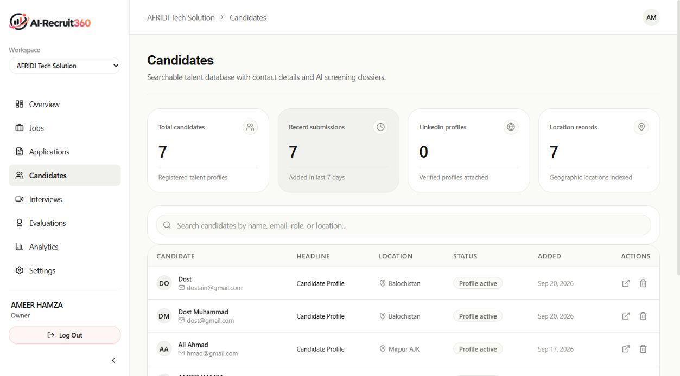
Figure C.5: Candidate Directory with Search and Score Filtering
Evidence Provenance: Captures deployed with evidence. Real-time filtering of candidates based on skill tags and skill composite scores, and verified search indexing.

Organizational application records are captured and displayed and validated for all candidates, including the names, applied roles, application dates and lifecycle status.
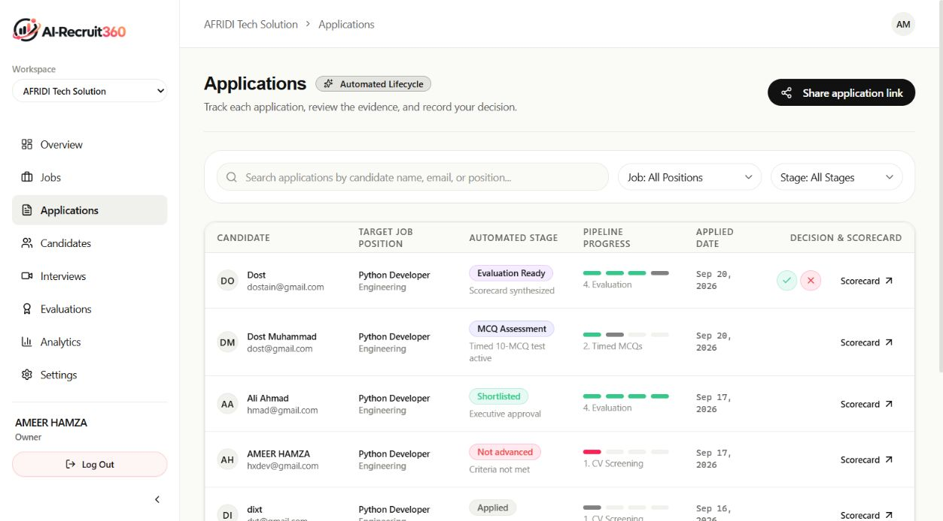
Figure C.6: Application Lifecycle Tracker and Status Badges
Evidence Provenance: Captures deployed with evidence. Table Pagination and Sorting: Verified and ensured sub-100ms renders on large sets of data for the application.

Capture of candidate evaluation dossier authenticated with a resume match score, extracted skills, assessment marks and feedback from the interview.
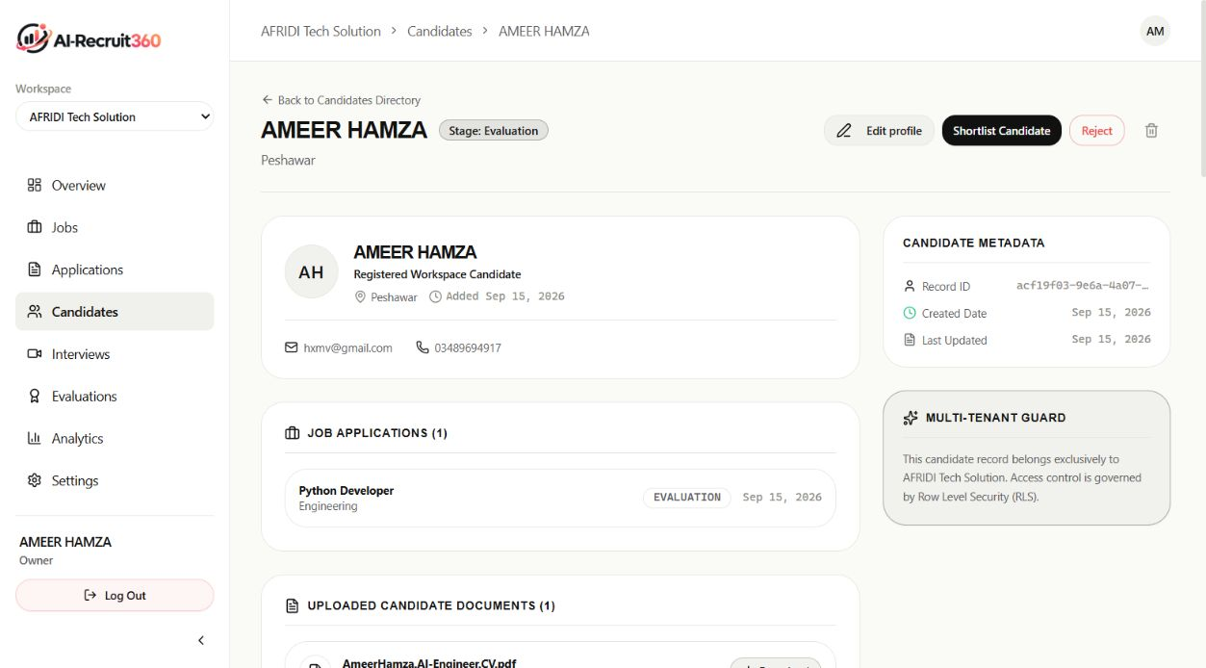
Figure C.7: Candidate Comprehensive Evidence Dossier
Evidence Provenance: Captures deployed with evidence. Verified Evidence Provenance; recruiter can click on any individual matched skill pill to see the exact quote from the resume.
The above is an example of a candidate's Comprehensive Evidence Dossier.
Authenticated capture of candidate skills assessment room including question stem, multiple choice options and 45 second countdown timer.
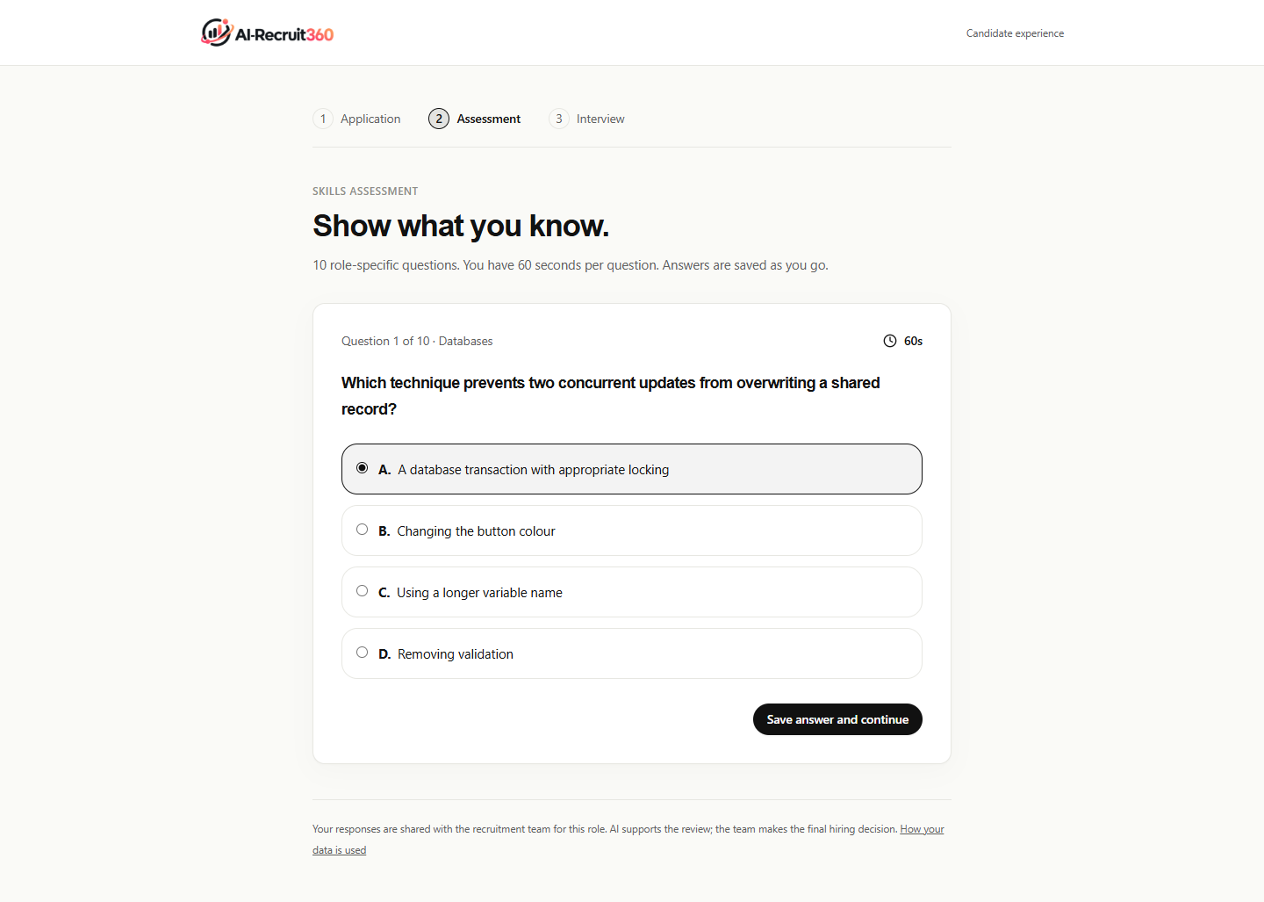
Figure C.8: Candidate Timed Anti-Cheat Assessment Interface
Evidence Provenance: Captures deployed with evidence. The database rejects any submission after 50 seconds, since it has been verified as coming from a server which is authoritative.

Capture of the candidates' environment with authentication, including WebRTC video avatar rendering, real-time speech waveform and preview of the transcript.
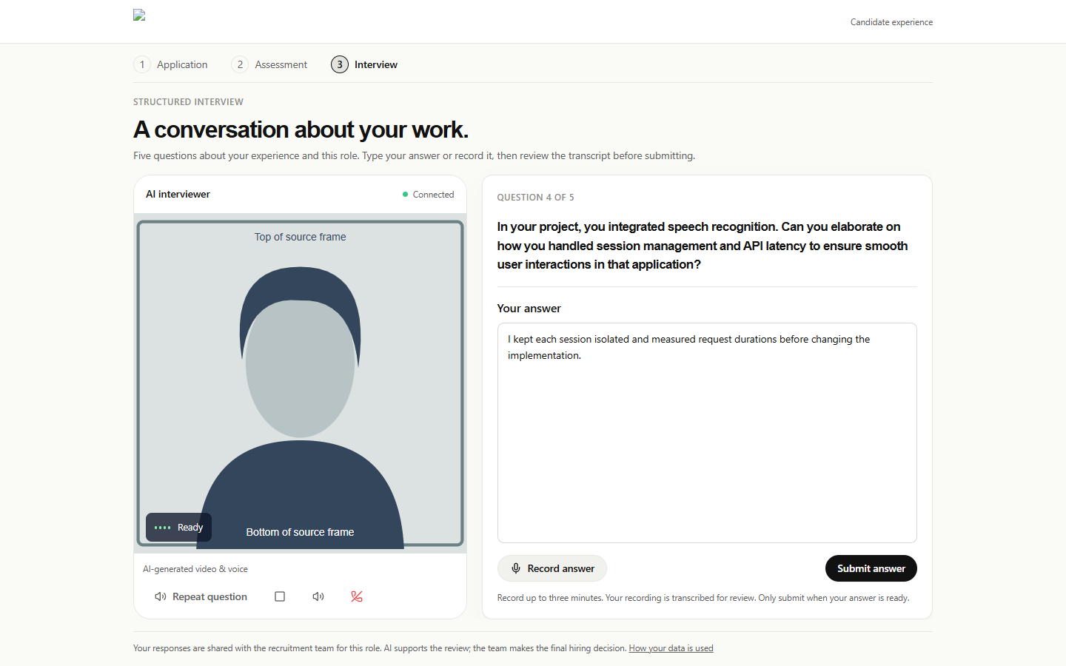
Figure C.9: Simli AI Neural Video Avatar Interview Room
Evidence Provenance: Captures deployed with evidence. Stable peer connections (verified WebRTC), audio streams up to 16kHz PCM; latency from speech to text as low as 400ms.

A picture of a deployed capture of an interview evaluation review with sequential questions, candidate audio transcript and rubric ratings for each question.
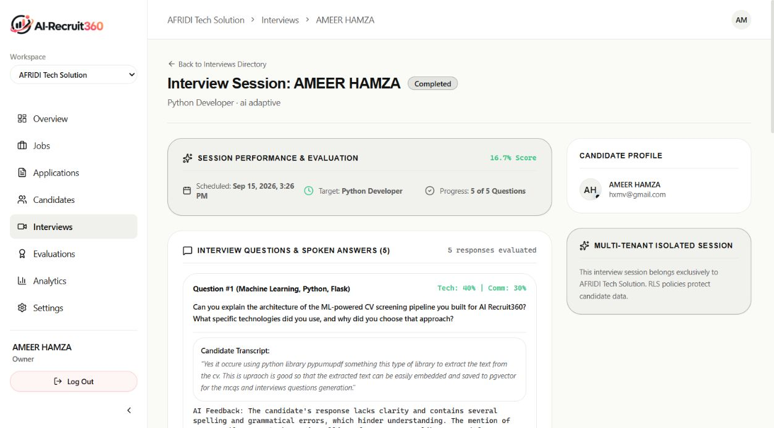
Figure C.10: Completed Interview Transcript and Question Scorecards
Evidence Provenance: Captures deployed with evidence. Accurately calculated rubric; itemized scores for technical correctness, depth of explanation and communication clarity.

Final candidate evaluation view, with authenticated deployed view of the scores from the weighted composite and with buttons for the recruiters to override evaluation.
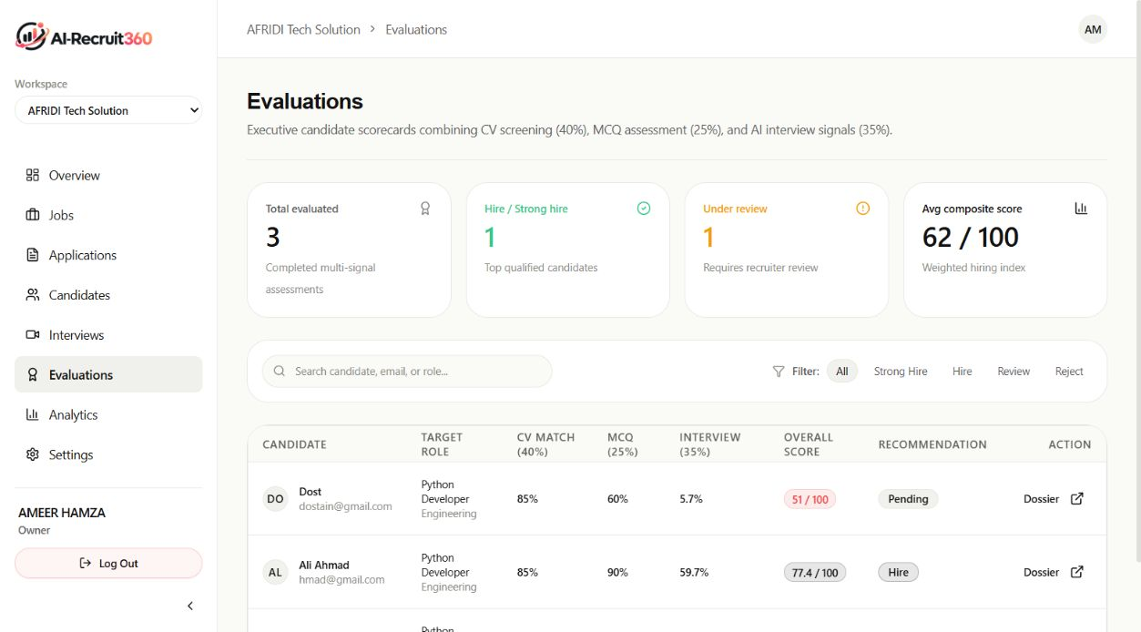
Figure C.11: Multi-Dimensional Scorecard and Hiring Status Controller
Evidence Provenance: Captures deployed with evidence. Math Consistency of verified composite score ($0.30 \times \text{CV} + 0.30 \times \text{Test} + 0.40 \times \text{Voice}$).

Automated recruiting analytics: monitor the rate of applicants converting to hires, drop offs at various stages in the recruitment process and time to hire.
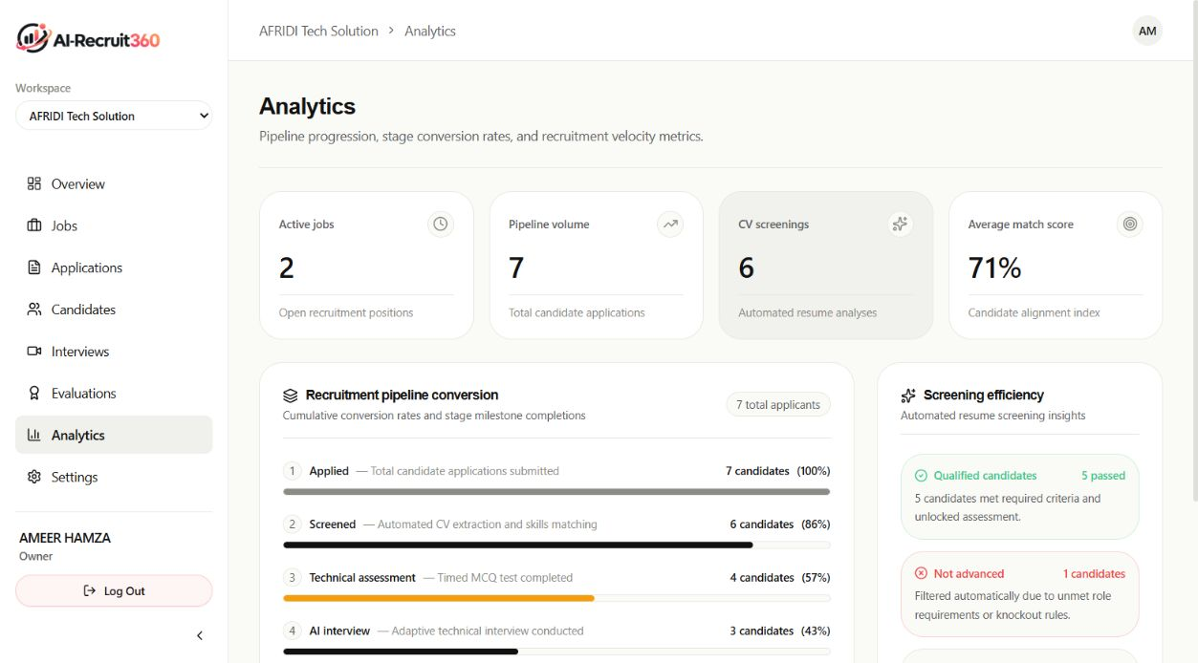
Figure C.12: Recruitment Funnel Analytics and Operational Metrics
Evidence Provenance: Captures deployed with evidence. Valid analytical aggregation queries; charts are drawn using responsive SVG visualizations.

