AI RECRUIT360
AN AI ASSISTED RECRUITMENT AND CANDIDATE EVALUATION SYSTEM

Ameer Hamza
FA22-BSE-030
Babar Hussain
FA22-BSE-044
Ali Naqi
FA22-BSE-050
Session 2022–2026
Department of Software Engineering
Faculty of Engineering & Technology
Mirpur University of Science and Technology
Mirpur AJK Pakistan

AI RECRUIT360
AN AI ASSISTED RECRUITMENT AND CANDIDATE EVALUATION SYSTEM
By
Ameer Hamza FA22-BSE-030
Babar Hussain FA22-BSE-044
Ali Naqi FA22-BSE-050
A project report submitted in partial fulfillment of
the requirements for the degree of
Bachelor of Science
in
SOFTWARE ENGINEERING
Supervised by
Engr. Syeda Iqra Gillani
Session 2022–2026
Department of Software Engineering
Faculty of Engineering & Technology
Mirpur University of Science and Technology
Mirpur AJK Pakistan

CERTIFICATION
We submit this final-year project report as our account of the design, implementation and evaluation of AI Recruit360. Sources used in the report are acknowledged in the text and references. The report distinguishes implemented behaviour, observed test evidence and work that remains to be validated. We accept responsibility for reviewing the submitted report and complying with the university requirements for originality and attribution.
Ameer Hamza FA22-BSE-030
Signature ____________________ Date ____________________
Babar Hussain FA22-BSE-044
Signature ____________________ Date ____________________
Ali Naqi FA22-BSE-050
Signature ____________________ Date ____________________
Project title: AI RECRUIT360 An AI Assisted Recruitment and Candidate Evaluation System
Submitted for examination in partial fulfillment of the requirements for the degree of Bachelor of Science in Software Engineering.
Supervisor: Engr. Syeda Iqra Gillani
Signature ____________________
External Examiner ____________________
Chairperson ____________________

DEDICATION
We dedicate this project to our families, teachers and fellow students whose support made sustained study and development possible. We hope that the work reflects the care they encouraged us to bring to both technical decisions and the people affected by them.

CONTENTS
CERTIFICATION i
DEDICATION ii
CONTENTS iii
LIST OF FIGURES viii
LIST OF TABLES x
ACKNOWLEDGMENTS xii
ABSTRACT xiii
ABBREVIATIONS xiv
CHAPTER 1 INTRODUCTION 1
1.1 PROJECT OVERVIEW 1
1.2 PROBLEM STATEMENT 1
1.3 AIM AND OBJECTIVES 2
1.4 SCOPE AND BOUNDARIES 3
1.5 STAKEHOLDERS AND INTENDED USE 3
1.6 ENGINEERING METHOD AND CONTRIBUTION 5
CHAPTER 2 BACKGROUND AND RELATED WORK 6
2.1 RECRUITMENT EVIDENCE AND AUTOMATION 6
2.2 LANGUAGE MODELS AND STRUCTURED GENERATION 6
2.3 SPEECH AND CONVERSATIONAL PRESENTATION 7
2.4 WEB APPLICATION ARCHITECTURE 8
2.5 TRANSACTIONS AND TENANT ISOLATION 8
2.6 RISK AND ACCESSIBILITY GUIDANCE 9
2.7 COMPARISON AND RESEARCH GAP 9
CHAPTER 3 REQUIREMENTS AND ANALYSIS 11
3.1 REQUIREMENTS METHOD 11
3.2 RECRUITER REQUIREMENTS 11
3.3 CANDIDATE REQUIREMENTS 12
3.4 INTEGRITY AND STATE REQUIREMENTS 12
3.5 PERFORMANCE AND AVAILABILITY REQUIREMENTS 13
3.6 SECURITY AND PRIVACY REQUIREMENTS 14
3.7 FEASIBILITY AND TRADEOFFS 15
CHAPTER 4 SYSTEM DESIGN 16
4.1 SYSTEM CONTEXT AND TRUST BOUNDARIES 16
4.2 COMPONENT AND DEPLOYMENT STRUCTURE 18
4.3 DATA FLOW FROM APPLICATION TO REVIEW 20
4.4 RELATIONAL MODEL 22
4.5 WORKFLOW STATES AND TRANSITIONS 24
4.6 SEQUENCE AND CONCURRENCY DESIGN 26
4.7 ACCESS CONTROL MODEL 28
4.8 INTERFACE AND INTERACTION DESIGN 30
CHAPTER 5 IMPLEMENTATION 32
5.1 FRONTEND COMPOSITION 32
5.2 RECRUITER AUTHENTICATION AND WORKSPACE CONTEXT 32
5.3 JOB AND CANDIDATE ACCESS 33
5.4 SUBMISSION AND DOCUMENT EXTRACTION 33
5.5 STRUCTURED RESUME SCREENING 34
5.6 ASSESSMENT GENERATION AND TIMING 35
5.7 INTERVIEW ORCHESTRATION AND RESPONSE SCORING 37
5.8 SPEECH AND AVATAR INTEGRATION 39
5.9 FINAL EVALUATION AND RECRUITER DECISION 39
5.10 DATABASE MIGRATIONS AND COMPATIBILITY 40
5.11 OPERATIONAL CONFIGURATION AND LIMITS 42
CHAPTER 6 VERIFICATION AND RESULTS 43
6.1 VERIFICATION APPROACH 43
6.2 BACKEND AND EXTRACTION TESTS 44
6.3 DATABASE INTEGRITY TESTS 44
6.4 AUTHENTICATION AND BROWSER REGRESSIONS 45
6.5 OBSERVED PERFORMANCE AND INTERPRETATION 46
6.6 OPTIMIZATION EVIDENCE 46
6.7 VALIDITY AND LIMITATIONS 47
6.8 ACCEPTANCE AND MEASUREMENT PLAN 48
CHAPTER 7 CONCLUSIONS AND FUTURE WORK 49
7.1 CONCLUSIONS 49
7.2 FUTURE TECHNICAL DEVELOPMENT 49
7.3 FUTURE EVALUATION AND RESPONSIBLE USE 50
REFERENCES 51
PROJECT EVIDENCE SOURCES 52
APPENDIX A DETAILED USE CASES 53
A.1 SIGN IN TO A WORKSPACE 54
A.2 CREATE A RECRUITER ACCOUNT 55
A.3 RECOVER A PASSWORD 56
A.4 CREATE AN ORGANIZATION 57
A.5 SWITCH ORGANIZATION CONTEXT 58
A.6 CREATE AND PUBLISH A JOB 59
A.7 FIND A JOB OR APPLICATION 60
A.8 SUBMIT A CANDIDATE APPLICATION 61
A.9 SCREEN A STORED RESUME 62
A.10 RETRY INTERRUPTED SCREENING 63
A.11 GENERATE A SKILLS ASSESSMENT 64
A.12 ANSWER A TIMED QUESTION 65
A.13 FINALIZE AN ASSESSMENT 66
A.14 ANSWER AN INTERVIEW QUESTION 67
A.15 RECORD AND REVIEW AN ANSWER 68
A.16 USE THE INTERVIEWER AVATAR 69
A.17 CALCULATE THE FINAL EVALUATION 70
A.18 REVIEW AND DECIDE ON AN APPLICATION 71
A.19 INSPECT CANDIDATE DOCUMENTS 72
A.20 UPDATE PROFILE AND WORKSPACE SETTINGS 73
APPENDIX B DATABASE DICTIONARY 74
B.1 PROFILES 75
B.2 ORGANIZATIONS 76
B.3 ORGANIZATION MEMBERS 77
B.4 JOBS 78
B.5 CANDIDATES 79
B.6 APPLICATIONS 80
B.7 CANDIDATE DOCUMENTS 81
B.8 CV SCREENINGS 82
B.9 ASSESSMENTS 83
B.10 ASSESSMENT QUESTIONS 84
B.11 ASSESSMENT ANSWERS 85
B.12 INTERVIEWS 86
B.13 INTERVIEW QUESTIONS 87
B.14 INTERVIEW RESPONSES 88
B.15 FINAL EVALUATIONS 89
B.16 AI ACTIVITY LOGS 90
B.17 SECURITY AUDIT LOGS 91
APPENDIX C INTERFACE EVIDENCE AND USER GUIDE 92
C.1 ORGANIZATION ONBOARDING 93
C.2 JOB CREATION FORM 94
C.3 ACCOUNT AND WORKSPACE SETTINGS 95
C.4 TIMED ASSESSMENT QUESTION 96
C.5 LANDING PAGE 97
C.6 RECRUITER SIGN-IN 98
C.7 ACCOUNT REGISTRATION 99
C.8 PASSWORD RECOVERY REQUEST 100
C.9 PASSWORD RESET ENTRY 101
C.10 CANDIDATE PRIVACY INFORMATION 102
C.11 WORKSPACE OVERVIEW 103
C.12 JOB MANAGEMENT 104
C.13 APPLICATION LIFECYCLE 105
C.14 CANDIDATE DIRECTORY 106
C.15 INTERVIEW REVIEW LIST 107
C.16 EVALUATION REVIEW LIST 108
C.17 RECRUITMENT ANALYTICS 109
C.18 CANDIDATE APPLICATION FORM 110
C.19 DESKTOP INTERVIEW COMPOSITION 111
C.20 MOBILE INTERVIEW COMPOSITION 112
C.21 JOB DETAILS AND PIPELINE 113
C.22 CANDIDATE EVIDENCE DOSSIER 114
C.23 COMPLETED INTERVIEW EVIDENCE 115
APPENDIX D TEST AND ACCEPTANCE CATALOGUE 116
D.1 REJECT FORGED RECRUITER IDENTITY 117
D.2 RESOLVE A STALE ORGANIZATION COOKIE 118
D.3 DEDUPLICATE REQUEST CONTEXT 119
D.4 PRESERVE LARGE AGGREGATE COUNTS 120
D.5 CREATE ONE APPLICATION ON RETRY 121
D.6 PRESERVE LEGACY RESUME EVIDENCE 122
D.7 REJECT FOREIGN ASSESSMENT QUESTIONS 123
D.8 ENFORCE SERVER ANSWER TIMING 124
D.9 KEEP AN ANSWER IMMUTABLE 125
D.10 PRESERVE THE RECRUITER DECISION 126
D.11 HANDLE AN AI SCREENING OUTAGE 127
D.12 REUSE COMPLETED SCREENING 128
D.13 VALIDATE GENERATED ASSESSMENT KEYS 129
D.14 AVOID FABRICATED FALLBACK QUESTIONS 130
D.15 REUSE STORED INTERVIEW FEEDBACK 131
D.16 REJECT UNRELATED INTERVIEW SPEECH 132
D.17 USE STORED TEXT AND CONFIGURED VOICE 133
D.18 EXTRACT A TABLE-BASED RESUME 134
D.19 REJECT AN EMPTY TEXT PDF 135
D.20 RECOVER A STALLED LOGIN 136
D.21 COMPLETE A REAL CANDIDATE JOURNEY 137
D.22 VALIDATE MEDIA PERMISSIONS AND RECOVERY 138
D.23 MEASURE COLD AND WARM LATENCY 139
D.24 REVIEW EVIDENCE CORRECTNESS 140
APPENDIX E API CONTRACT INVENTORY 141
E.1 /api/v1/health 141
E.2 /api/v1/health/live 141
E.3 /api/v1/health/ready 142
E.4 /api/v1/screening/screen-application 142
E.5 /api/v1/assessments/generate 142
E.6 /api/v1/assessments/submit-answer 143
E.7 /api/v1/assessments/finalize 143
E.8 /api/v1/interviews/speech 144
E.9 /api/v1/interviews/initialize 144
E.10 /api/v1/interviews/next-question 145
E.11 /api/v1/interviews/evaluate-response 145
E.12 /api/v1/interviews/stt 146
E.13 /api/v1/evaluations/generate 146
APPENDIX F LOCAL DEMONSTRATION AND MAINTENANCE 147
F.1 LOCAL STARTUP 147
F.2 ENVIRONMENT CONFIGURATION 147
F.3 DATABASE READINESS 147
F.4 SUPERVISOR DEMONSTRATION ORDER 147
F.5 DIAGNOSING SLOW OPERATIONS 148
F.6 RECOVERING A SAVED APPLICATION 148
F.7 INTERVIEW TROUBLESHOOTING 148
F.8 REGRESSION WORKFLOW 148
F.9 BACKUP AND RELEASE DISCIPLINE 149
F.10 RESPONSIBLE REPORT MAINTENANCE 149

LIST OF FIGURES
Figure 1 System context and service boundaries 17
Figure 2 Local and hosted deployment paths 19
Figure 3 Application evidence flow 21
Figure 4 Core tenant and application relationships 23
Figure 5 Screening activity with retry and existing-result paths 25
Figure 6 Submission persistence sequence 27
Figure 7 Actors and use case overview 29
Figure 8 Interview activity and optional media paths 31
Figure 9 Assessment activity and database authority 36
Figure 10 Interview answer evaluation sequence 38
Figure 11 Stage evidence relationships 41
Figure 12 Migration-derived structure of profiles 75
Figure 13 Migration-derived structure of organizations 76
Figure 14 Migration-derived structure of organization_members 77
Figure 15 Migration-derived structure of jobs 78
Figure 16 Migration-derived structure of candidates 79
Figure 17 Migration-derived structure of applications 80
Figure 18 Migration-derived structure of candidate_documents 81
Figure 19 Migration-derived structure of cv_screenings 82
Figure 20 Migration-derived structure of assessments 83
Figure 21 Migration-derived structure of assessment_questions 84
Figure 22 Migration-derived structure of assessment_answers 85
Figure 23 Migration-derived structure of interviews 86
Figure 24 Migration-derived structure of interview_questions 87
Figure 25 Migration-derived structure of interview_responses 88
Figure 26 Migration-derived structure of final_evaluations 89
Figure 27 Migration-derived structure of ai_activity_logs 90
Figure 28 Migration-derived structure of security_audit_logs 91
Figure 29 Organization onboarding — Actual component fixture 93
Figure 30 Job creation form — Authenticated deployed capture 94
Figure 31 Account and workspace settings — Authenticated deployed capture 95
Figure 32 Timed assessment question — Actual component with synthetic data 96
Figure 33 Landing page — Local public page 97
Figure 34 Recruiter sign-in — Local public page 98
Figure 35 Account registration — Local public page 99
Figure 36 Password recovery request — Local public page 100
Figure 37 Password reset entry — Local public page 101
Figure 38 Candidate privacy information — Local public page 102
Figure 39 Workspace overview — Authenticated deployed capture 103
Figure 40 Job management — Authenticated deployed capture 104
Figure 41 Application lifecycle — Authenticated deployed capture 105
Figure 42 Candidate directory — Authenticated deployed capture 106
Figure 43 Interview review list — Authenticated deployed capture 107
Figure 44 Evaluation review list — Authenticated deployed capture 108
Figure 45 Recruitment analytics — Authenticated deployed capture 109
Figure 46 Candidate application form — Actual component with a synthetic job 110
Figure 47 Desktop interview composition — Layout fixture with frame marker 111
Figure 48 Mobile interview composition — Layout fixture with frame marker 112
Figure 49 Job details and pipeline — Authenticated deployed capture 113
Figure 50 Candidate evidence dossier — Authenticated deployed capture 114
Figure 51 Completed interview evidence — Authenticated deployed capture 115

LIST OF TABLES
Table 1 Quality requirements and evidence boundaries 14
Table 2 Selected role permissions 30
Table 3 Illustrative weighted score calculation 40
Table 4 Verification summary 44
Table 5 Recorded point observations rather than a benchmark 46
Table 6 UC01 use case specification 54
Table 7 UC02 use case specification 55
Table 8 UC03 use case specification 56
Table 9 UC04 use case specification 57
Table 10 UC05 use case specification 58
Table 11 UC06 use case specification 59
Table 12 UC07 use case specification 60
Table 13 UC08 use case specification 61
Table 14 UC09 use case specification 62
Table 15 UC10 use case specification 63
Table 16 UC11 use case specification 64
Table 17 UC12 use case specification 65
Table 18 UC13 use case specification 66
Table 19 UC14 use case specification 67
Table 20 UC15 use case specification 68
Table 21 UC16 use case specification 69
Table 22 UC17 use case specification 70
Table 23 UC18 use case specification 71
Table 24 UC19 use case specification 72
Table 25 UC20 use case specification 73
Table 26 T01 test record 117
Table 27 T02 test record 118
Table 28 T03 test record 119
Table 29 T04 test record 120
Table 30 T05 test record 121
Table 31 T06 test record 122
Table 32 T07 test record 123
Table 33 T08 test record 124
Table 34 T09 test record 125
Table 35 T10 test record 126
Table 36 T11 test record 127
Table 37 T12 test record 128
Table 38 T13 test record 129
Table 39 T14 test record 130
Table 40 T15 test record 131
Table 41 T16 test record 132
Table 42 T17 test record 133
Table 43 T18 test record 134
Table 44 T19 test record 135
Table 45 T20 test record 136
Table 46 T21 test record 137
Table 47 T22 test record 138
Table 48 T23 test record 139
Table 49 T24 test record 140
Table 50 API contract /api/v1/health 141
Table 51 API contract /api/v1/health/live 141
Table 52 API contract /api/v1/health/ready 142
Table 53 API contract /api/v1/screening/screen-application 142
Table 54 API contract /api/v1/assessments/generate 142
Table 55 API contract /api/v1/assessments/submit-answer 143
Table 56 API contract /api/v1/assessments/finalize 143
Table 57 API contract /api/v1/interviews/speech 144
Table 58 API contract /api/v1/interviews/initialize 144
Table 59 API contract /api/v1/interviews/next-question 145
Table 60 API contract /api/v1/interviews/evaluate-response 145
Table 61 API contract /api/v1/interviews/stt 146
Table 62 API contract /api/v1/evaluations/generate 146

ACKNOWLEDGMENTS
We are grateful to Almighty Allah for the strength and opportunity to complete this work. We thank our supervisor, Engr. Syeda Iqra Gillani, for her guidance during the project. We also thank the faculty of the Department of Software Engineering at Mirpur University of Science and Technology for the foundations on which this work builds.
We appreciate the support of our families and peers throughout the development process. The project also depends on open-source libraries and published technical documentation; their contributions are acknowledged through the references and implementation discussion. We remain responsible for the decisions, limitations and final presentation of this report.
Ameer Hamza
Babar Hussain
Ali Naqi

ABSTRACT
AI Recruit360 is a browser-based recruitment system that connects resume screening, skills assessment, structured interviews and recruiter review. The project addresses an engineering problem: preserving candidate evidence and application state while several external services participate in the workflow. It supports separate recruiter and candidate journeys, organization-scoped access and recoverable processing failures.
The system uses Next.js 16, React and TypeScript for the frontend; FastAPI and Python for AI operations; and Supabase authentication, PostgreSQL and private storage for durable records. Structured language-model responses support resume analysis, ten-question assessments and five-question interviews. Candidates can type answers or review speech transcripts before submitting. Optional Simli avatar playback presents interview questions with generated speech. Final evaluation combines resume, assessment and interview scores using weights of 40, 25 and 35 percent, while the recruiter retains the final decision.
Verification includes 25 backend tests, isolated migration and workflow checks on two schema layouts, authentication regressions and responsive browser checks. These checks provide evidence for the tested integrity and access-control paths; they do not establish predictive hiring accuracy, demographic fairness or production-scale performance. The developer reports successful use of the hosted services, while a fully recorded real-provider acceptance journey and repeated latency measurements remain outstanding. The project demonstrates how a small AI-assisted recruitment application can preserve evidence and support human review without treating generated scores as verified hiring decisions.

ABBREVIATIONS
Term | Meaning
AI | Artificial intelligence
API | Application programming interface
ASGI | Asynchronous server gateway interface
ATS | Applicant tracking system
CV | Curriculum vitae
DOCX | Office Open XML document
FYP | Final-year project
HTTP | Hypertext transfer protocol
JSON | JavaScript Object Notation
JWT | JSON Web Token
LLM | Large language model
MCQ | Multiple-choice question
PCM | Pulse-code modulation
PDF | Portable document format
RLS | Row-level security
RPC | Remote procedure call
SQL | Structured Query Language
STT | Speech to text
TTS | Text to speech
UI | User interface
UX | User experience
WCAG | Web Content Accessibility Guidelines
WebRTC | Web Real-Time Communication

CHAPTER 1
INTRODUCTION
This chapter defines the problem, scope and engineering contribution of the project.

1.1 PROJECT OVERVIEW
Recruitment produces several kinds of evidence: a candidate's account of previous work, answers to knowledge questions, explanations of technical decisions, and the recruiter's final judgement. These records are related, but they are often collected in different places. The engineering problem addressed by AI Recruit360 is to connect them within one application lifecycle while keeping their meaning distinct. A resume match is not an interview result, and neither is an employment decision.
The project provides a browser-based workspace for recruiters and a separate application journey for candidates. A recruiter publishes a job and shares its application link. A candidate uploads a resume, proceeds through an eligible skills assessment, and answers structured interview questions. The system stores stage-specific evidence and calculates a composite score. The recruiter can then inspect the underlying responses and record a decision. The optional interviewer avatar presents questions; it does not infer personality from the candidate's face.
The implementation uses Next.js and React for the web application, FastAPI for document and AI operations, and Supabase for authentication, PostgreSQL and private file storage. OpenAI supplies structured language-model responses and speech services. Simli supplies avatar playback. The contribution is the integration and control of this workflow, rather than a newly trained recruitment model. The system remains a final-year engineering prototype whose predictions require human review.

1.2 PROBLEM STATEMENT
A recruitment application must do more than display attractive forms. An interrupted upload can create a candidate without an application. A repeated screening request can produce competing scores. A browser timer can disagree with the server. A scorecard can overwrite a recruiter decision if retry behaviour is not designed carefully. Such failures undermine the usefulness of the workflow even when the language model returns fluent text.
The central problem is therefore to coordinate recruitment evidence across multiple services without confusing a temporary service failure with a candidate outcome. A network timeout should leave a recoverable operation; it should not assign a failing score. A candidate's access should be tied to the intended application; knowing another application identifier should not reveal its questions or answers. Recruiters in one organization should not read another organization's documents.
The project also faces practical presentation constraints. It must be understandable to a small student team, run locally for demonstration, and deploy without a complex operations platform. These constraints favour a small number of components, explicit database contracts and bounded requests. They do not justify claims of production-scale throughput or unbiased hiring. The evaluation in this report separates software correctness checks from the additional studies needed to validate recruitment quality.

1.3 AIM AND OBJECTIVES
The aim is to develop an understandable AI-assisted recruitment system that preserves application progress and presents evidence for recruiter review. The first objective is to provide a consistent journey from a published role to a final evaluation. The second is to make state transitions enforceable on the server and database rather than relying on interface controls alone.
The third objective is to protect workspace data through verified user identity, organization membership and role-aware access. The fourth is to integrate structured AI output with validation and recoverable failure states. The fifth is to provide a responsive interface that supports typed answers as well as optional recording and avatar playback. The sixth is to reduce avoidable waiting by limiting repeated queries, redundant extraction and uncontrolled requests.
These objectives are assessed through source inspection, isolated database tests, backend tests and browser regressions. They are not expressed as a promised percentage improvement in hiring accuracy. A valid completion condition is that a repeated submission returns the existing application without corrupting its evidence. A separate research question is whether the generated assessment predicts job performance. The current project addresses the first condition and supplies a design for studying the second.

1.4 SCOPE AND BOUNDARIES
The supported workflow covers recruiter authentication, organization context, job publication, candidate records, PDF or DOCX submission, resume screening, ten-question assessments, five-question interviews, evaluation and recruiter review. Organization roles include owner, admin, recruiter, interviewer and viewer. Their permissions differ; a visible page is not proof of permission to perform its mutations.
The implementation does not provide payroll, employment contracts, payment subscriptions, video proctoring, biometric identity verification or a validated psychometric test. It does not train its own language model. Historical vector-related columns and activity-log tables remain in the schema, but the active screening pipeline does not perform embedding search or retrieval-augmented generation. Retaining compatibility data is different from using that data as an active feature.
Local hosting runs the web application and FastAPI on the same computer. Supabase, OpenAI and Simli remain external services. Consequently, a local demonstration still depends on internet connectivity for authentication, storage, generation and playback. The system is not represented as an offline recruitment product. These boundaries are important when interpreting the architecture and the test results presented later.

1.5 STAKEHOLDERS AND INTENDED USE
The primary stakeholders are candidates, recruiters, workspace owners and the student maintainers. Candidates need clear instructions, confirmation that their resume was saved, and a way to continue after a recoverable failure. Recruiters need meaningful comparisons without losing access to the original evidence. Owners need control over the organization context and membership. Maintainers need a code structure that makes a failed stage traceable.
The intended deployment is a small recruitment workflow or academic demonstration. A supervisor should be able to follow one application through its stored stages and distinguish database logic from model output. This is more informative than a demonstration that shows only the avatar or a final score. The presentation should include a failed request and recovery where practical, because reliable behaviour under interruption is a central engineering concern.
Candidates should understand that the interviewer and its voice are generated. Typed input remains available when microphone access is denied or speech services are unavailable. A recruiter must examine weak or ambiguous evidence before acting on a recommendation. The interface supports this review, but no controlled usability study or employment-outcome study has yet established how users behave in practice.

1.6 ENGINEERING METHOD AND CONTRIBUTION
Development followed an iterative engineering method: identify a workflow problem, express an invariant, implement the change, and check both the successful and failing paths. For example, a retry-safe application requires more than disabling the submit button. The database transaction must return a stable result when the same submission is repeated. The corresponding regression can then submit twice and inspect the resulting record count.
The technical contribution is a set of connected boundaries: a verified recruiter context, a signed candidate session, a server-only backend credential, validated AI payloads and database functions for important transitions. These boundaries provide a practical way to reason about a distributed workflow without introducing a queue or a separate agent framework. The code uses explicit services and repositories that can be explained individually.
The report uses code and test artefacts as the primary evidence of implementation. External literature supplies background and design context. User reports of successful deployment are recorded separately from reproducible local checks. The remaining acceptance work includes a recorded real-candidate journey and a repeated latency study. This distinction keeps the project defensible without diminishing the value of the engineering work already completed.

CHAPTER 2
BACKGROUND AND RELATED WORK
This chapter relates the design to published research and technical guidance while identifying the limits of that comparison.

2.1 RECRUITMENT EVIDENCE AND AUTOMATION
Recruitment automation can be understood as a sequence of information-processing tasks. Documents must be collected, claims organized, relevant knowledge assessed, and decisions recorded. Automating these tasks does not automatically validate the criteria used to judge candidates. A system may be reliable at storing a score while the score itself remains a poor indicator of future performance.
Raghavan et al. (2020) examine algorithmic hiring vendors and the difficulty of evaluating their claims about assessment and bias mitigation. Their work motivates a careful distinction between providing an assessment tool and demonstrating that the tool is fair or valid. This project responds by retaining stage evidence and avoiding claims that AI removes discrimination. It does not reproduce the study's empirical investigation or claim equivalent validation.
For AI Recruit360, the practical implication is to treat the composite score as a review aid. Resume screening, multiple-choice answers and interview responses are displayed as distinct sources. The recruiter can question a missing-skill judgement or inspect an answer rather than receiving only a rank. Whether this presentation improves decisions is a question for a future user study, not a conclusion drawn from the presence of an evidence panel.

2.2 LANGUAGE MODELS AND STRUCTURED GENERATION
Large language models can respond to task descriptions and examples expressed in natural language. Brown et al. (2020) provide foundational evidence for few-shot language-model capabilities, but their findings do not establish recruitment validity for this project. AI Recruit360 uses a hosted model through an API; no model training, fine-tuning or benchmark reproduction is performed here.
The project requests structured outputs matching Pydantic models. Screening expects numeric scores, matched and missing skills, quoted evidence and a reasoning summary. Assessments expect a complete collection of questions and options. This reduces the amount of fragile free-text parsing required by the application. The service rejects incomplete payloads rather than pretending that any fluent response is usable.
A structural guarantee is narrower than a semantic guarantee. A score may be within the accepted range while still being poorly justified. A quoted phrase may be plausible but require comparison with extracted resume text. The system therefore preserves source material and leaves final decisions with a recruiter. Prompt injection, inconsistent judgement and hallucinated evidence remain meaningful limitations even when JSON validation succeeds.

2.3 SPEECH AND CONVERSATIONAL PRESENTATION
Speech recognition turns an audio signal into text; speech synthesis turns text into an audio presentation. Radford et al. (2022) describe the large-scale weak supervision underlying Whisper. That research supports the choice of a general speech-recognition service, but it does not provide an accuracy result for the accents, microphones or environments used in this project.
AI Recruit360 records a candidate response, sends it for transcription, and gives the candidate an opportunity to review the text before submission. This creates a useful separation between recognition error and the answer that is evaluated. A candidate can correct a technical name or supply typed text if recording is unavailable. No claim is made that the transcription is always exact.
The avatar is a presentation channel for an already stored interview question. The configured face and voice are separate settings. In the current configuration, text-to-speech uses the nova voice while Simli animates the selected face. Synchronizing a face to audio can improve the conversational appearance of the interface, but the thesis does not treat this as evidence of improved assessment validity or a fully live human interview.

2.4 WEB APPLICATION ARCHITECTURE
Next.js distinguishes server components from client components, allowing data access to remain on the server while interactive controls run in the browser (Vercel n.d.a). AI Recruit360 uses this separation for initial workspace data and client-side filtering, input and playback. It does not require every page to become a large client application.
FastAPI's asynchronous programming model is useful when tasks wait for external services (Ramírez n.d.). The project wraps synchronous Supabase operations through a helper and overlaps independent reads where their dependencies permit. Asynchronous syntax does not make model inference instantaneous. The benefit is that the service need not spend every waiting interval blocking unrelated work.
The two application runtimes have distinct responsibilities. Next.js knows the browser session and validates application access. FastAPI performs document extraction and AI-stage orchestration. Supabase stores durable progress. This separation introduces network boundaries but gives the student team a clear place to inspect an authorization failure, an extraction failure or a model failure. A single-machine demonstration uses the same contracts over loopback addresses.

2.5 TRANSACTIONS AND TENANT ISOLATION
PostgreSQL row security can restrict which rows are visible or writable for a particular role. Its guarantees depend on the policies, roles and privileges actually used (PostgreSQL Global Development Group n.d.a). Supabase service credentials can bypass row security, so a server holding them must perform its own access checks before privileged operations (Supabase n.d.).
AI Recruit360 uses both authenticated database access and server-only privileged access. A recruiter request resolves an authenticated user and organization membership. A candidate request uses a signed application session because candidates do not create ordinary recruiter accounts. The service-role path exists to perform specific validated operations, not to expose an unrestricted database interface to the browser.
Transactions are important when several records represent one user action. PostgreSQL documents how concurrent statements and isolation levels affect visibility (PostgreSQL Global Development Group n.d.b). The project applies this principle through functions that lock and update the relevant assessment or interview state together. The database, not a disabled button, becomes the authority on whether an answer is already recorded.

2.6 RISK AND ACCESSIBILITY GUIDANCE
The NIST AI Risk Management Framework organizes AI risk work around governance, mapping, measurement and management (Tabassi 2023). It is used here as a way to structure limitations and future validation rather than as a certification. In this project, measurement of model quality remains less complete than verification of data flow. That gap is explicitly reported.
OWASP identifies prompt injection as a risk when untrusted text can influence a language model's instructions (OWASP 2025). A resume is untrusted input even when it is a valid PDF. The project constrains output schemas and application actions, but these controls do not prove that all malicious instructions are neutralized. A dedicated adversarial resume test set is proposed later.
WCAG 2.2 provides accessibility criteria covering interaction, perception and understandable use (W3C 2024). The interface supports keyboard controls and reduced motion in the revised product preview, and interview answers can be typed. These are useful design decisions, but the project has not completed a full accessibility conformance audit. Timed assessments and third-party avatar controls require additional review with users who have different access needs.

2.7 COMPARISON AND RESEARCH GAP
A manual document workflow offers direct human interpretation but depends on disciplined record keeping. A conventional record-management application can organize candidates without generating questions. A standalone language-model chat can generate useful material but does not inherently preserve tenant boundaries, stage ownership or immutable assessment answers. AI Recruit360 combines organization and generation in a defined application lifecycle.
The comparison is architectural rather than a vendor ranking. No unsupported feature matrix is attributed to commercial products. The prototype's distinctive emphasis is that saved records, retry behaviour and access checks remain visible engineering responsibilities even when external AI services are used. It is possible to evaluate these responsibilities independently of whether the model is judged useful.
The remaining research gap is empirical: the project has not established agreement with expert raters, equivalent difficulty across personalized assessments, candidate satisfaction or demographic fairness. The proposed evaluation design requires a consented dataset, independent ratings and repeated observations. Until then, claims are limited to implemented behaviour and the explicitly described test evidence.

CHAPTER 3
REQUIREMENTS AND ANALYSIS
This chapter separates required behaviour, quality goals and implementation constraints.

3.1 REQUIREMENTS METHOD
Requirements were derived from the implemented recruiter and candidate journeys and refined through observed failures. Each requirement identifies an actor, a required behaviour and a condition that can be inspected. This approach avoids vague requirements such as making the system intelligent or completely secure. A useful requirement can fail in a specific way and has an associated verification method.
Functional requirements describe what the system must allow: publishing a role, accepting a resume, storing an answer or showing an evaluation. Non-functional requirements describe qualities such as bounded waiting, tenant isolation and readable layouts. Constraints include the selected stack, the single-worker backend and the hosting payload limit. These are treated separately because a deployment constraint is not a user feature.
The use-case identifiers in Appendix A connect the narrative to detailed use cases. Their acceptance criteria are specifications, not assertions that every real-provider scenario has been tested. Chapter 6 identifies which criteria have automated evidence and which remain in the acceptance plan. This separation makes the report usable as a maintenance document when the project changes.

3.2 RECRUITER REQUIREMENTS
A recruiter must authenticate before entering the workspace. The server must derive identity from the authentication service and must not accept identity supplied through arbitrary request headers. An organization preference cookie may select among memberships, but it cannot create permission. Every data request must operate within the resolved organization context.
Authorized staff can create and update jobs, share application links, examine candidate records and review evaluation evidence. Read-only users should be able to inspect permitted information without acquiring management rights. The permission map includes five roles, with management operations withheld from viewers. Role names are not inferred from a screen label; server actions and database policies must enforce their meaning.
The workspace needs search, filters and pagination because displaying all records at once is not a durable design. Summary counts should reflect the database rather than the number of records downloaded into a page. When an organization changes, stateful lists must reset to avoid showing the previous workspace's rows while a new request is pending. These requirements connect usability directly to correctness.

3.3 CANDIDATE REQUIREMENTS
Candidates enter through a published job link rather than a recruiter dashboard. The application form must explain accepted file formats, show meaningful validation errors and confirm successful storage. Uploads are limited to PDF or DOCX within four megabytes. A saved application and a failed screening request are different states and must be communicated separately.
A candidate who qualifies can continue to an assessment and then to an interview when eligible. The application session is signed and scoped so that another identifier cannot be substituted to obtain access. The same browser can resume within the session period; expiration requires an explicit recovery process rather than silently extending access forever.
During interviews, candidates must be able to read the question, enter an answer, optionally record speech and review the transcript before submitting. Avatar failure must not remove the text question. The final screen should make completion understandable and avoid promising a hiring outcome. These requirements reduce dependence on a specific browser permission or media provider while preserving the required evidence.

3.4 INTEGRITY AND STATE REQUIREMENTS
An application is the central unit that links a job to a candidate. Screening, assessment, interview and evaluation records must refer to that same application. Tenant identifiers must remain consistent across the relationship. A valid foreign key alone is not always enough to prove that a job and candidate belong to the same organization, so the submission function checks the intended context.
Assessment answers must belong to the current assessment and question order. The server controls timing and scoring. A repeated answer must not let the candidate replace an earlier selection after learning the outcome. Finalization should produce a stable result when retried. Interview responses similarly require ownership checks and persistence of a complete scorecard.
Final evaluation must not erase a recruiter's existing decision. The weighted score is evidence produced by the workflow, while shortlist or rejection is a separate review action. This distinction supports safe retries and preserves accountability. The database regression suite explicitly includes repeated submissions, immutable answers and preservation of recruiter decisions.

3.5 PERFORMANCE AND AVAILABILITY REQUIREMENTS
The project aims to remove avoidable latency without promising a universal response time. Database reads should be combined or overlapped when safe. Search should not issue a request for every keystroke. Already extracted resume text should be reused. These requirements can be checked by request counts and source inspection even before a realistic performance study is available.
External requests need deadlines and useful failure states. A request that never returns is a poor experience even if the server eventually becomes available. The login form therefore has a finite waiting period. AI operations have separate budgets because they may require document access, generation and persistence. A timeout is reported as service unavailability, not as evidence that the candidate failed.
The project also needs operational clarity. Liveness checks indicate that the API process is running; readiness checks include a database request. A local process can be alive while the network to Supabase is unavailable. The distinction is relevant to the supervisor demonstration, where weak Wi-Fi may affect remote dependencies even when the frontend and backend both run on the laptop.

3.6 SECURITY AND PRIVACY REQUIREMENTS
Private resumes, interview answers and evaluation notes should be available only through the intended application access path. Storage links must be short lived and issued only after an access check. Provider secrets belong on servers, while only the intended public Supabase configuration is exposed to the browser. Error messages should help recovery without exposing credentials or full database internals.
The requirements also include bounded upload size and accepted formats. File extension validation alone does not make a document safe; parsing can fail and text may contain adversarial instructions. The project rejects unreadable content rather than inventing an empty score. It does not claim malware scanning, automatic anonymization or regulatory certification.
Data minimization and retention require an organizational policy beyond code. The current database stores resume text and assessment evidence to support review. Before operational use, administrators should define who can access that evidence, when it is deleted, and how a candidate can request correction. These are documented as governance requirements rather than implemented guarantees.
Table 1 Quality requirements and evidence boundaries
Quality concern | Design requirement | Evidence boundary
Tenant isolation | Verify identity, membership and object context | Isolated auth and SQL regressions
Progress preservation | Persist stages with retry rules | Submission and stage-function tests
Bounded waiting | Timeouts and recoverable messages | Controlled sign-in and backend tests
Media access | Typed answer remains available | Layout and source inspection; real media pending
Model validity | Human review of generated evidence | No fairness or predictive benchmark

3.7 FEASIBILITY AND TRADEOFFS
The chosen stack is feasible for a student team because its main boundaries are familiar web and database interfaces. A TypeScript frontend supports typed forms and server actions. Python supports document parsing and AI integration. PostgreSQL stores relationships and implements transactional rules. The use of managed services reduces infrastructure work but creates dependence on connectivity and provider accounts.
The design intentionally avoids a message queue, distributed cache and multi-agent orchestration framework. For a small demonstration, a synchronous retryable workflow is easier to inspect. This choice means the system has limited tolerance for very long operations and is not ready for unbounded horizontal scaling. Per-resource locks and rate limits are process-local, so the current backend should run with one worker.
Financial feasibility depends on provider usage and hosting plans, which were not measured as a formal cost study. The thesis therefore describes cost drivers instead of inventing a monthly bill. A later study should record token usage, speech duration, avatar session duration, storage and hosting charges for a representative cohort.

CHAPTER 4
SYSTEM DESIGN
This chapter describes the boundaries, data model and workflow decisions that organize the implementation.

4.1 SYSTEM CONTEXT AND TRUST BOUNDARIES
The context diagram identifies the actors and the external services that participate in the system. Recruiters and candidates interact with a web application, but they do not have the same identity model. Recruiters authenticate through Supabase Auth. Candidates receive a signed session associated with an application after submission. Both paths converge on stored application evidence while retaining different authorization checks.
The browser is an untrusted boundary. It can display question order and countdowns, but it cannot define the official answer deadline or grant access by changing a URL. Next.js verifies access before calling privileged storage or backend functions. FastAPI receives a shared server credential, not the recruiter's public browser key. Supabase applies row policies for authenticated access and executes restricted workflow functions for server operations.
OpenAI and Simli are external processors. Requests to them consume time and depend on account configuration. Their availability must not be confused with the availability of the local web process. The design therefore keeps persistent progress in PostgreSQL and makes the media presentation optional. The context boundary is also the starting point for privacy review: administrators need to understand which candidate content leaves the application for processing.
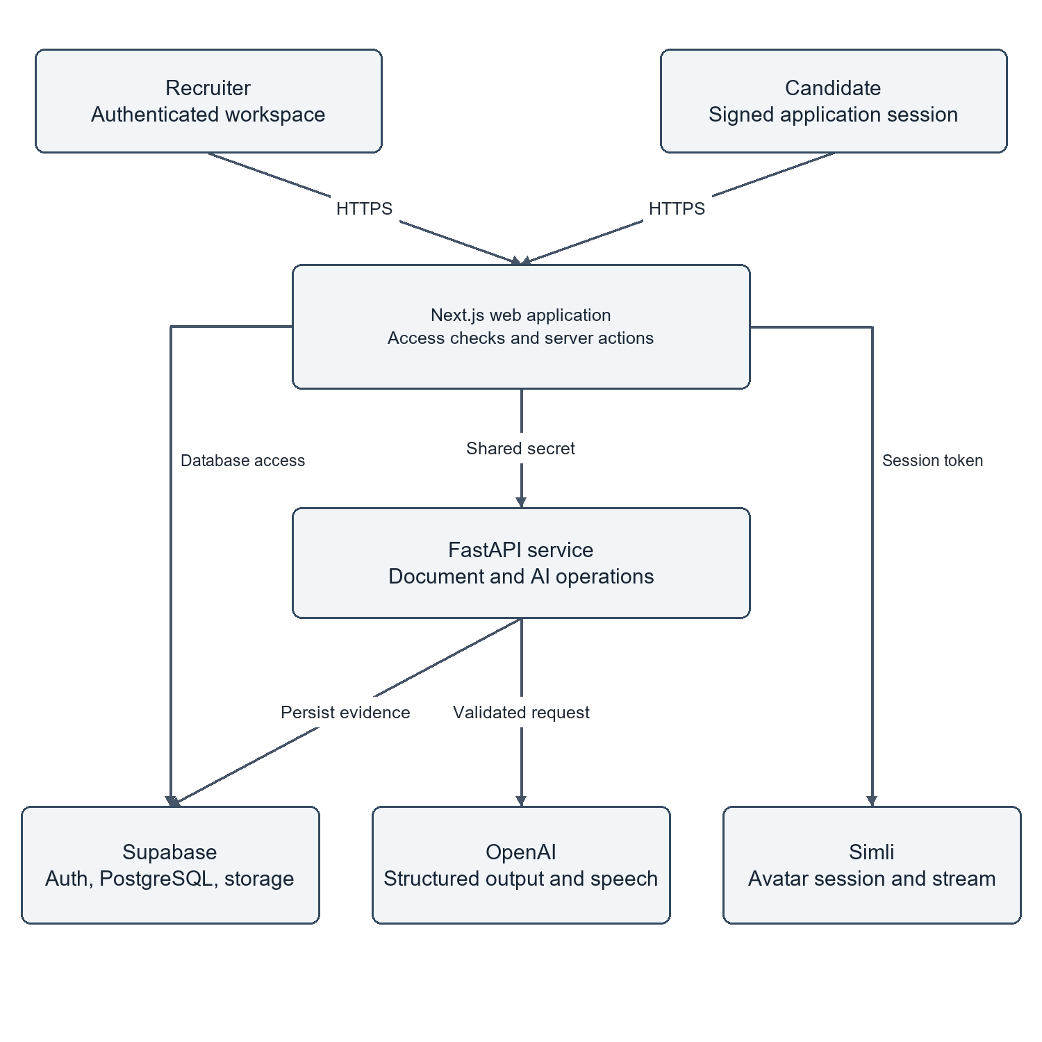
Figure 1 System context and service boundaries
Source: original diagram derived from the local implementation and migration contracts. Arrows show the principal relationship or request direction; optional and failure paths are described in the surrounding section.

4.2 COMPONENT AND DEPLOYMENT STRUCTURE
The code is organized into frontend pages and components, server actions, service functions, backend routes, orchestration services, repositories and database migrations. These layers are not separate microservices. The project has two application processes and a managed data service. Calling every module a microservice would misrepresent the deployment and make the architecture harder to explain.
In local mode, Next.js listens on port 3000 and FastAPI on port 8000. The frontend's server-side API URL points to the loopback backend path ending in /api/v1. In hosted mode, Vercel runs Next.js and Render runs FastAPI. Their environment variables hold the corresponding URLs and matching shared secret. Supabase remains hosted in both modes.
The deployment diagram distinguishes build-time public configuration from server secrets. The local public application URL may be included in the frontend build, so a production build must be regenerated after it changes. A restarted development server reads the local environment. Credentials are not written into this report or the diagrams. The diagram describes connectivity rather than a measured geographic latency advantage.
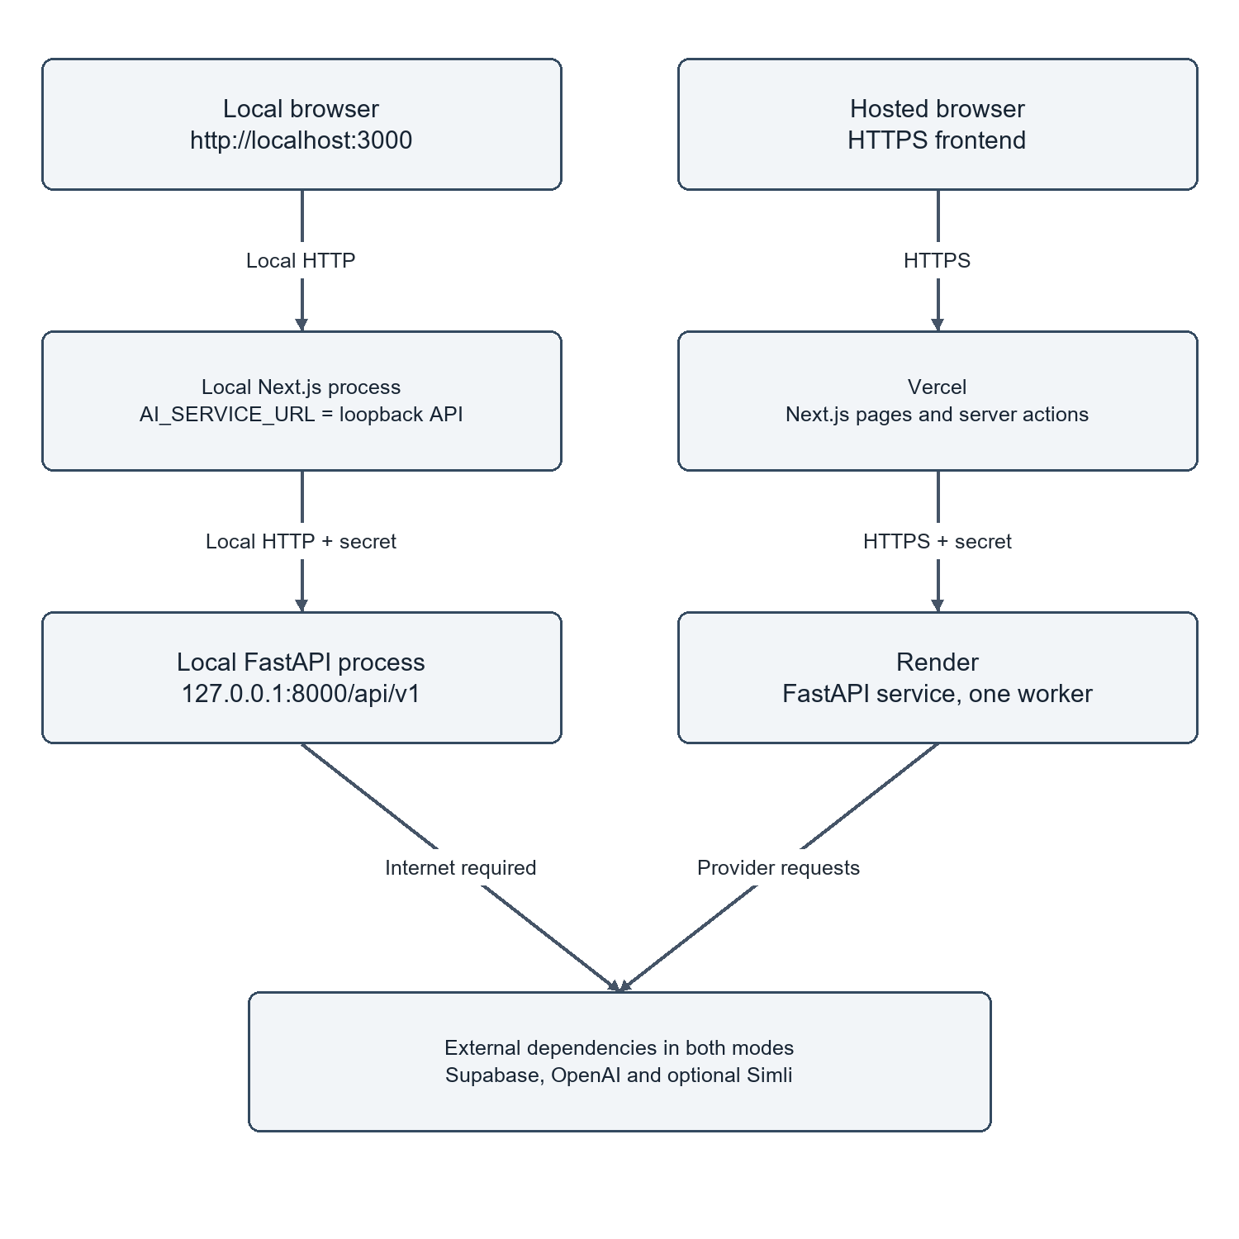
Figure 2 Local and hosted deployment paths
Source: original diagram derived from the local implementation and migration contracts. Arrows show the principal relationship or request direction; optional and failure paths are described in the surrounding section.

4.3 DATA FLOW FROM APPLICATION TO REVIEW
The main data flow begins with a published job. The candidate supplies contact details and a document; the server validates the file and creates linked application records through a database function. Screening obtains the stored document or existing extracted text, combines it with job context, and requests a structured evaluation. A completed screening result is saved before the interface moves forward.
Eligible candidates receive a stored assessment. Questions and answer keys remain distinct from the public question representation. Answers are recorded under server-enforced order and time rules. Interview initialization follows an eligible assessment and generates or retrieves the next question. Each submitted response receives a persisted evaluation. Final evaluation reads the completed stage records and calculates a deterministic weighted score.
The design includes recovery edges rather than only a straight success path. Failed question generation can be retried without assigning an assessment score. Completed screening can be returned instead of generated again. A repeated response submission must return stable stored evidence. The diagrams use these recovery edges to show why persistent identifiers and database invariants matter more than a sequence of browser screens.
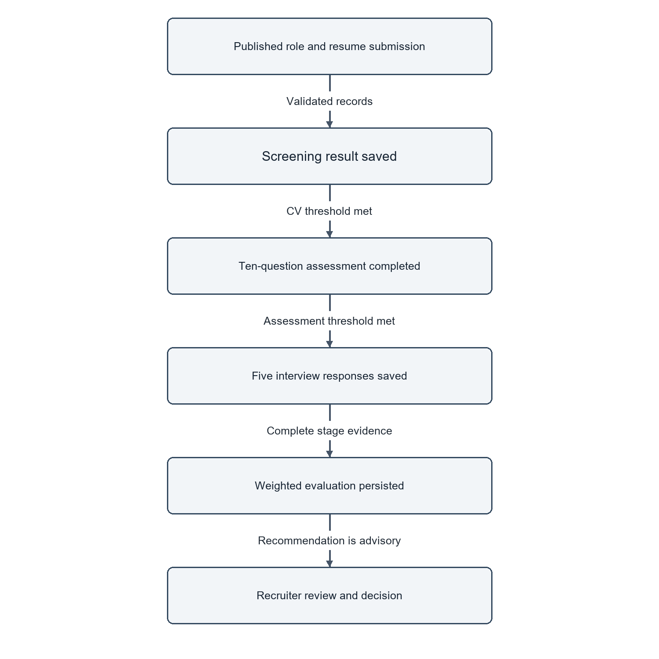
Figure 3 Application evidence flow
Source: original diagram derived from the local implementation and migration contracts. Arrows show the principal relationship or request direction; optional and failure paths are described in the surrounding section.

4.4 RELATIONAL MODEL
The organization is the tenant boundary and the application is the workflow boundary. An organization has memberships and jobs. A candidate belongs to an organization and may be linked to an application for a particular job. Candidate documents hold storage references and extracted text. Screening, assessment, interview and final evaluation records attach to the application.
Assessment questions and answers are separate relations because a question's authoritative answer must not be included in the candidate's public payload. Interview questions and response evaluations are similarly separated. This structure permits the recruiter to inspect individual evidence rather than receiving only an aggregate. Unique constraints help establish one stage record or one numbered question within the intended parent.
The schema includes retained legacy columns and two historical logging tables. The active interface no longer offers an Activity tab, but the existing records were not deleted. Appendix B documents the migrated schema produced in an isolated PostgreSQL-compatible engine, including retained structures. It should not be interpreted as a fresh screenshot of the hosted Supabase schema or as proof that every pending remote migration has been applied.
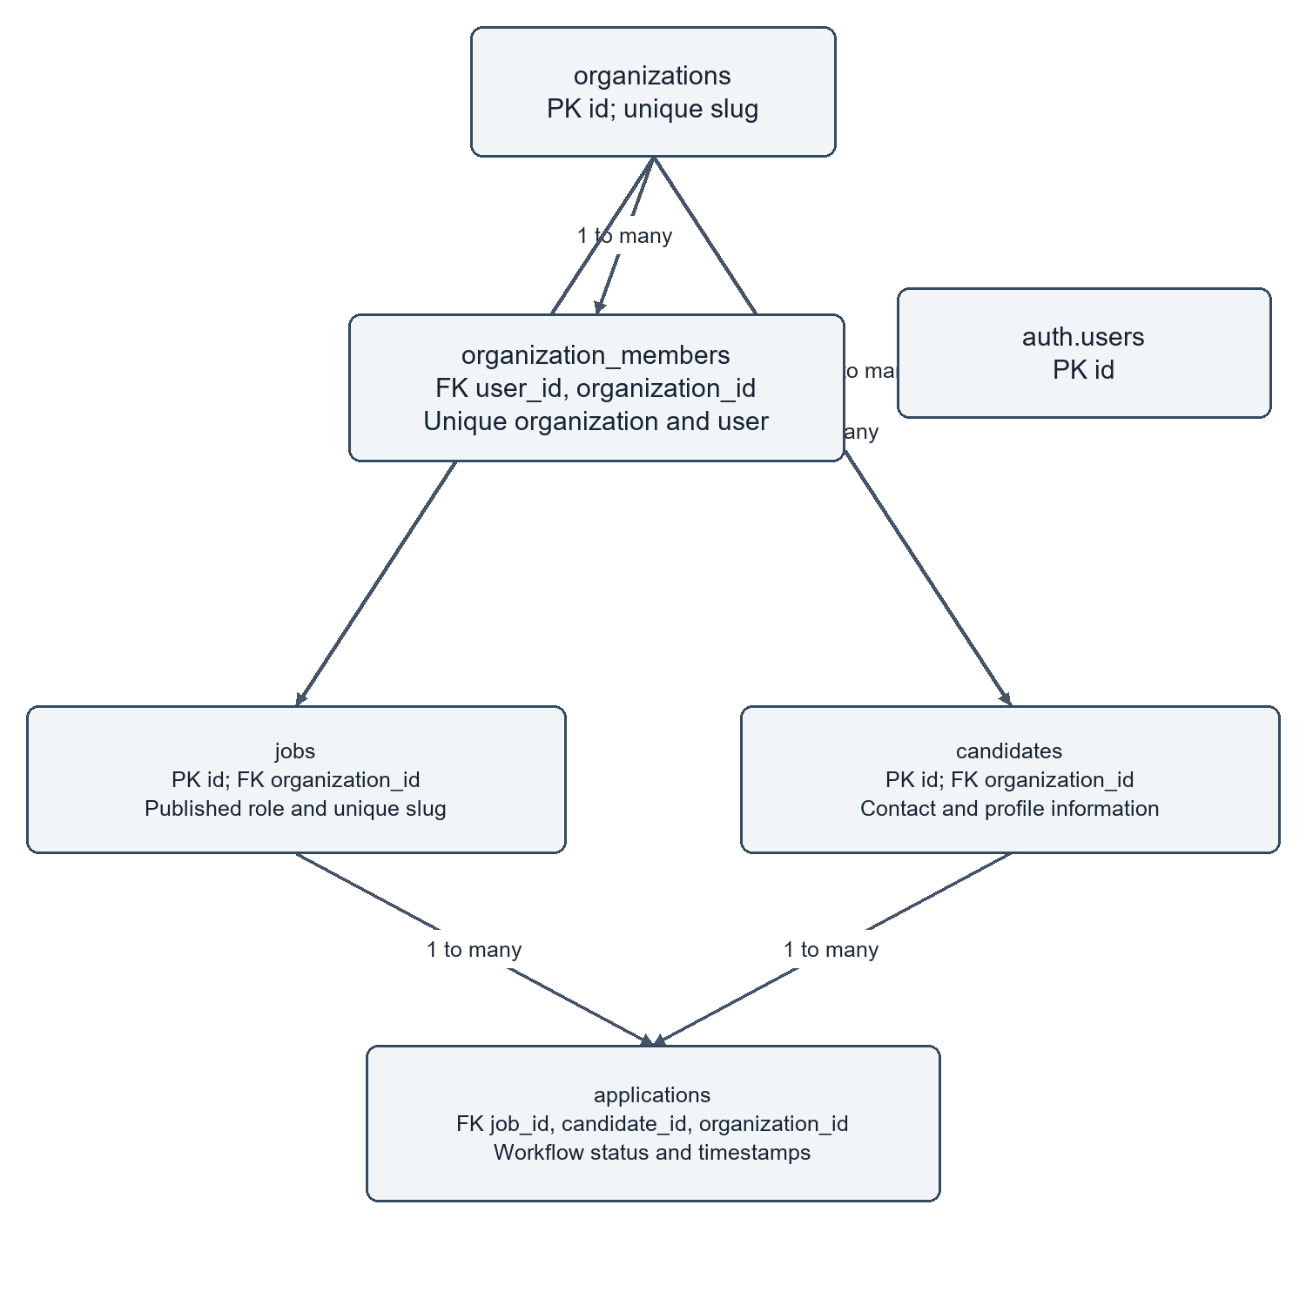
Figure 4 Core tenant and application relationships
Source: original diagram derived from the local implementation and migration contracts. Arrows show the principal relationship or request direction; optional and failure paths are described in the surrounding section.

4.5 WORKFLOW STATES AND TRANSITIONS
A status value represents progress, not merely a visual badge. Application transitions are associated with persistence functions that know whether the necessary evidence exists. An assessment cannot be considered completed just because the browser has displayed ten questions. Its completion is based on recorded answers, server timing and finalization. An interview requires its stored responses before final evaluation.
State diagrams are useful because they expose routes that should not be possible. For example, direct access to an interview URL should not bypass eligibility, and a failed AI call should not silently turn an application into a rejection. The project distinguishes knocked-out progression outcomes from recruiter review decisions. The implementation also preserves decisions when evaluation is retried.
The diagrams summarize the operational lifecycle rather than claiming a formally verified state machine. The detailed SQL functions remain the authority on accepted transitions. When adding a new state, a maintainer should update the database contract, API response type, interface labels and tests together. Changing only a badge risks making the interface disagree with the stored workflow.
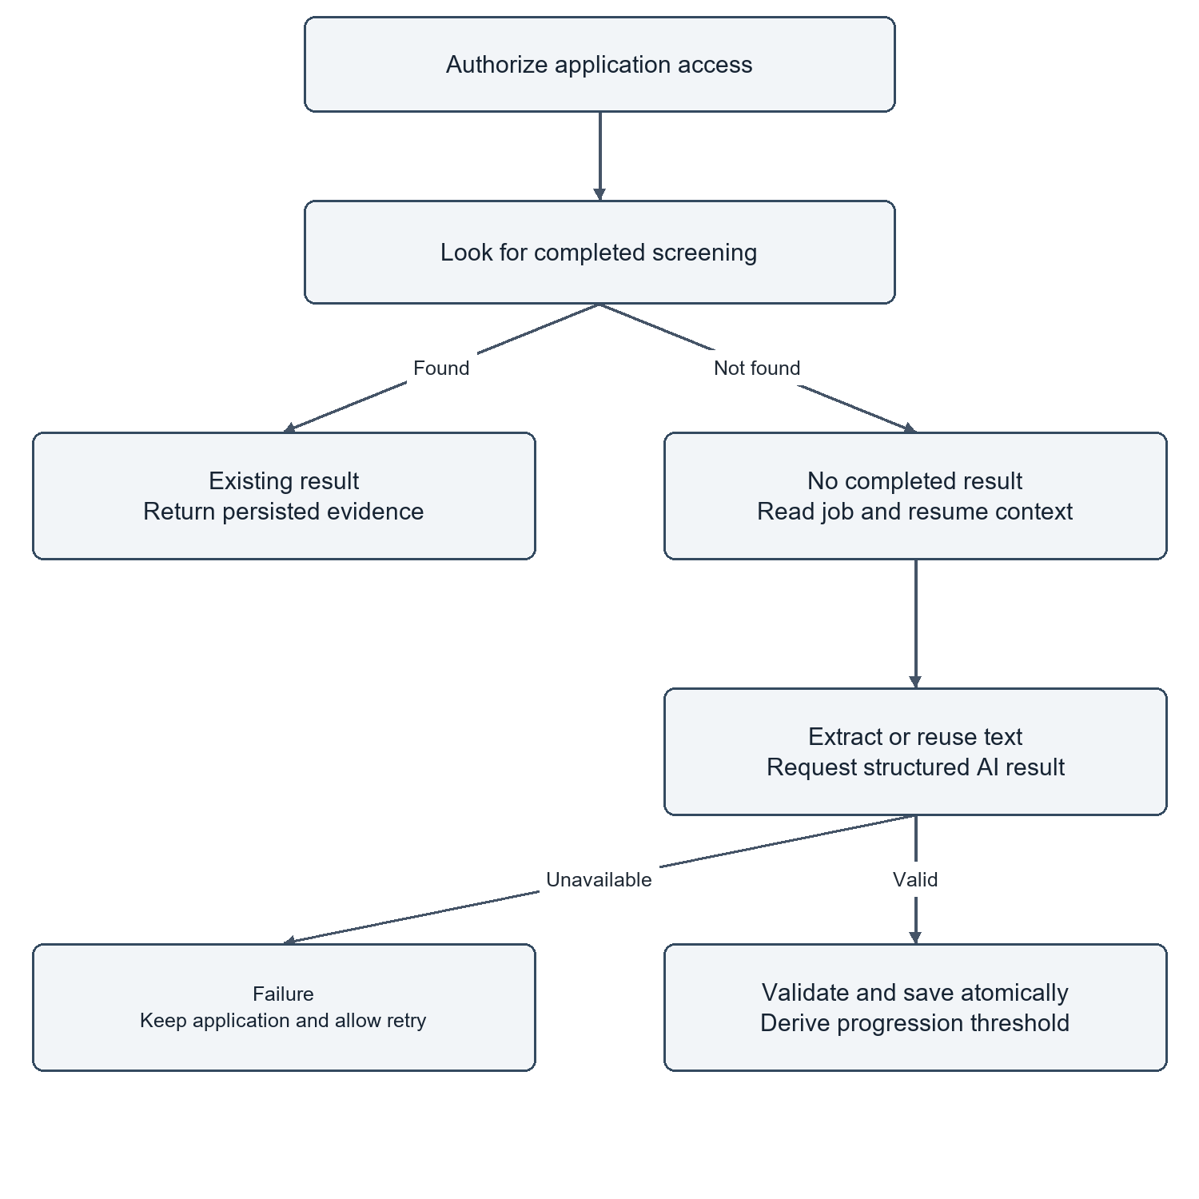
Figure 5 Screening activity with retry and existing-result paths
Source: original diagram derived from the local implementation and migration contracts. Arrows show the principal relationship or request direction; optional and failure paths are described in the surrounding section.

4.6 SEQUENCE AND CONCURRENCY DESIGN
A typical request passes through several independently failing components. The sequence diagrams show when the browser waits, where access is checked, and when an operation becomes durable. Returning a successful AI payload before saving it would expose the user to a result that cannot be resumed. The implementation treats persistence as part of successful stage completion.
Concurrency is handled at more than one level. Independent reads can run together to shorten the critical path. Per-resource asyncio locks serialize selected expensive operations inside one backend process. Database functions and constraints protect durable state when requests overlap. These mechanisms have different scopes; a process-local lock cannot coordinate multiple Render instances.
The design therefore keeps the current backend at one worker and relies on database rules for the transitions that must survive retries. A future horizontally scaled deployment would need cross-process job ownership, bounded queues or another coordination mechanism. Adding workers without revisiting this design could repeat generation even if a unique database key later prevents duplicate rows.
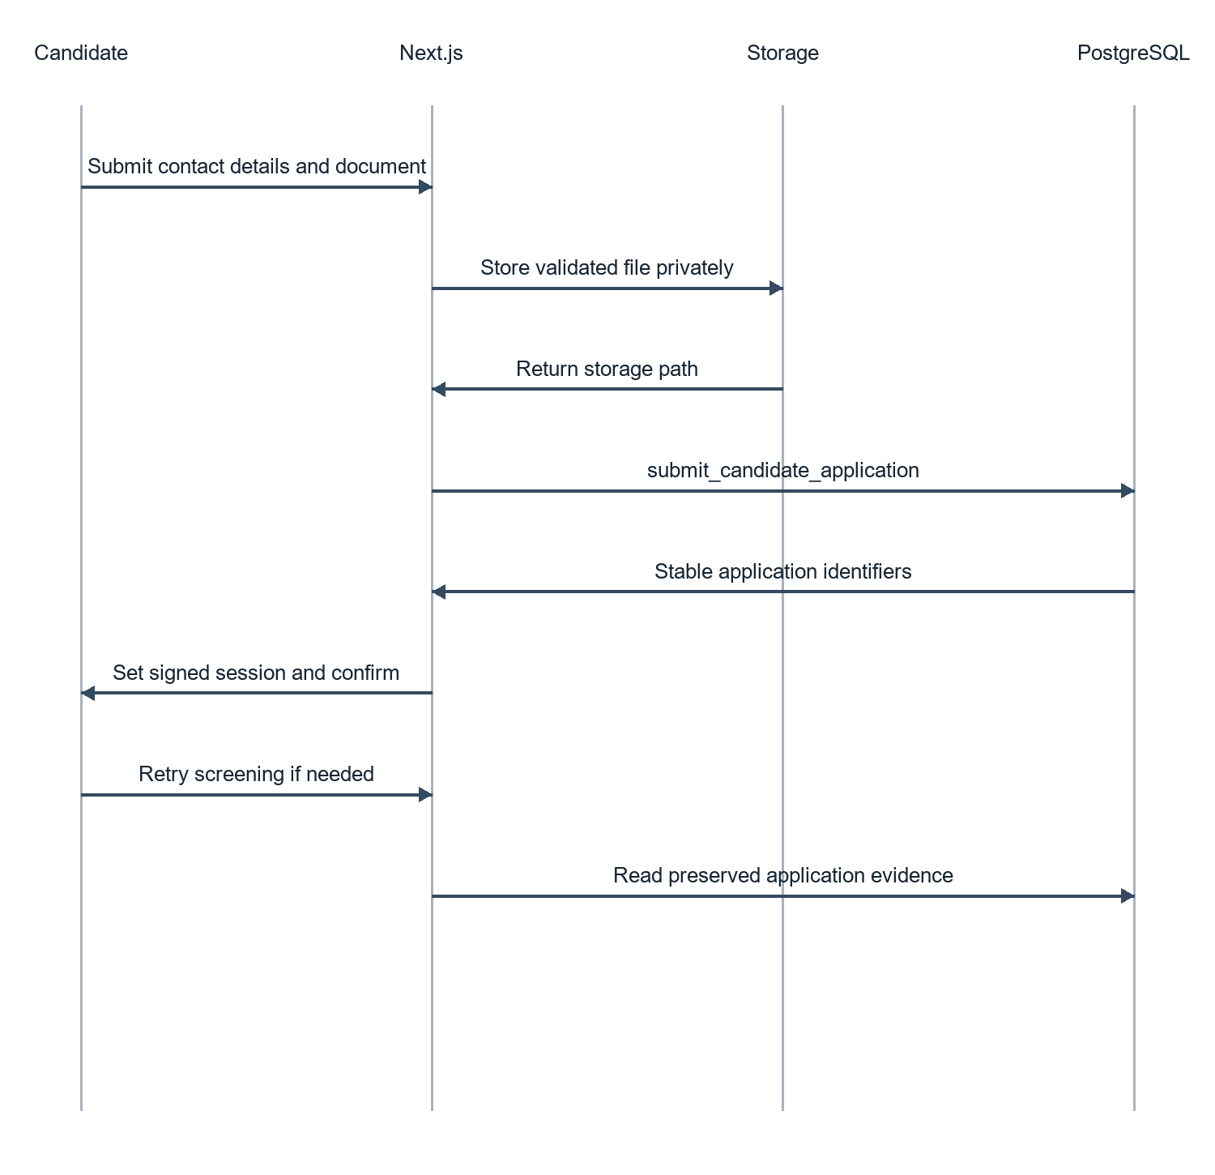
Figure 6 Submission persistence sequence
Source: original diagram derived from the local implementation and migration contracts. Arrows show the principal relationship or request direction; optional and failure paths are described in the surrounding section.

4.7 ACCESS CONTROL MODEL
The permission model separates authentication, membership, role permissions and object ownership. Authentication establishes a user identity. Membership connects that identity to an organization. Role permissions describe which actions are permitted within that organization. Object ownership checks ensure that a particular application, document or interview belongs to the authorized context.
For recruiter access, the server uses Supabase getUser rather than trusting client-controlled headers. Organization selection is resolved against real memberships. For candidate access, signed session data is verified before application-specific actions. Privileged database access is created only on the server. Interview avatar sessions also require access to an active interview before a short-lived provider token is issued.
The permission matrix in this chapter represents the code's intended role mapping. Isolated tests exercise tenant and viewer restrictions, but they are not a penetration test. Retained audit permission labels do not imply an active Activity page. The design could be strengthened further with systematic route-by-route authorization testing and review of every security-definer function after future migrations.
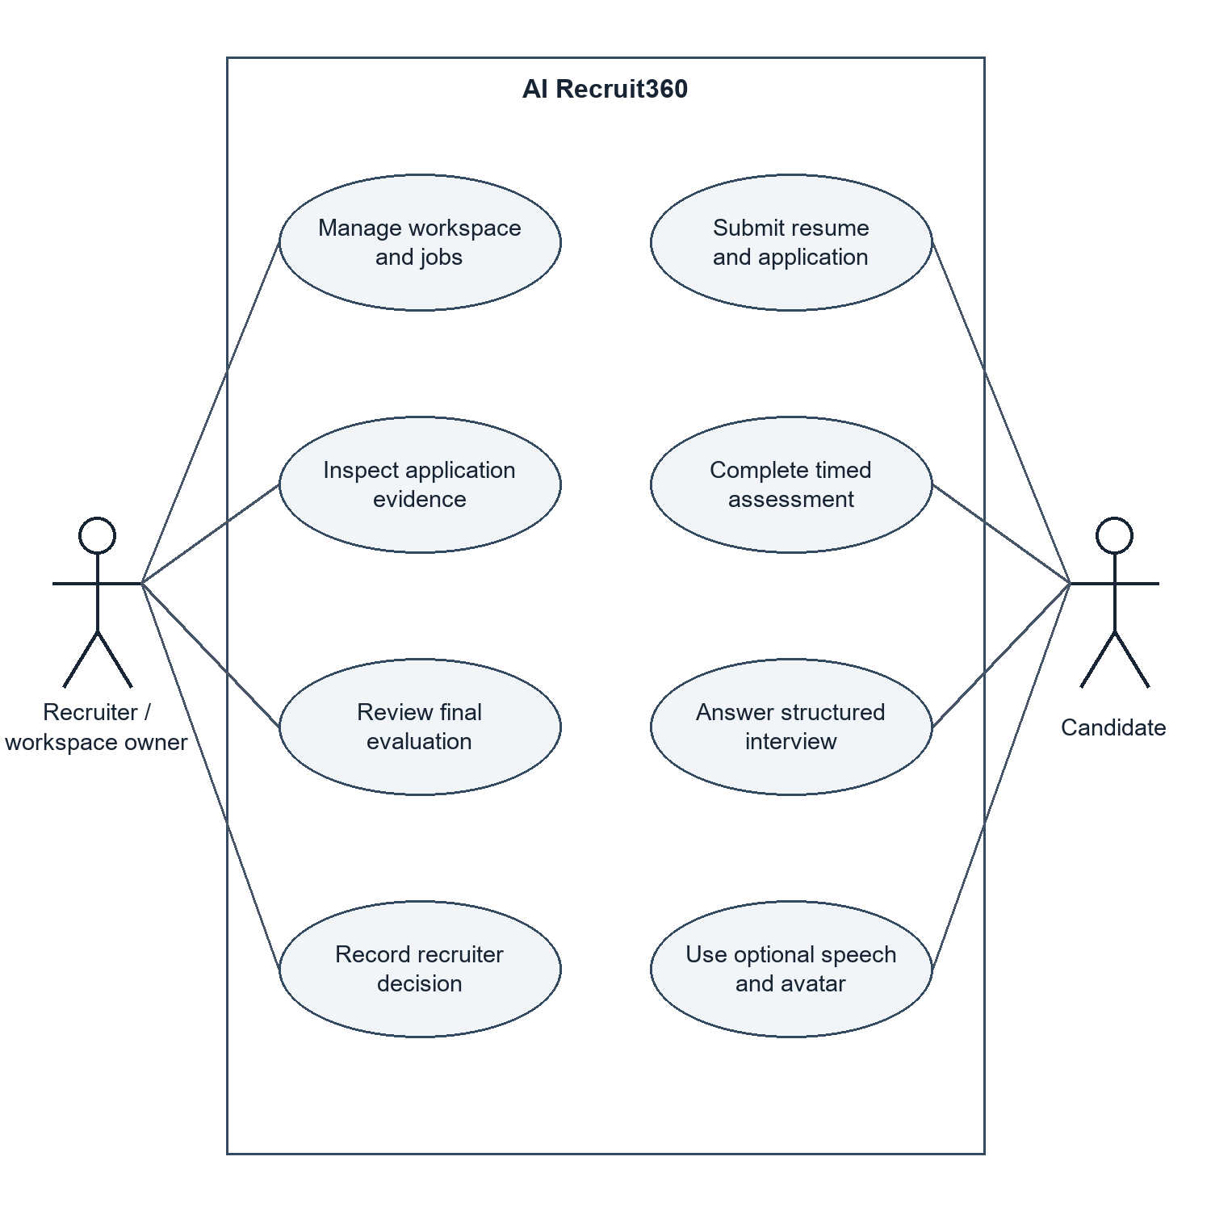
Figure 7 Actors and use case overview
Source: original diagram derived from the local implementation and migration contracts. Arrows show the principal relationship or request direction; optional and failure paths are described in the surrounding section.
Table 2 Selected role permissions
Role | View evidence | Manage jobs | Manage interviews | Manage workspace
Owner | Yes | Yes | Yes | Yes
Admin | Yes | Yes | Yes | Yes
Recruiter | Yes | Yes | Yes | No
Interviewer | Yes | No | Yes | No
Viewer | Yes | No | No | No

4.8 INTERFACE AND INTERACTION DESIGN
The workspace groups operational screens around jobs, applications, candidates, interviews, evaluations, analytics and settings. Each screen should answer a specific question: which roles are active, where an application is stalled, or what evidence supports an evaluation. A dashboard summary complements these screens rather than replacing them with decorative charts.
The revised landing page uses an interactive sample preview with explicit sample-data labelling. Hover effects and short CSS transitions indicate interaction without concealing content until an animation finishes. Reduced-motion settings disable unnecessary movement. The interview layout places the avatar and answer workflow side by side on suitable desktop screens and stacks them on narrow screens. The avatar preserves its full source frame rather than cropping the face to fill an arbitrary box.
Errors are part of the interface design. A saved resume with unavailable screening is presented as recoverable progress. Sign-in failures release the loading state. Speech failure leaves typed input available. These decisions make the interface more credible than a design that displays a spinner indefinitely or turns every provider interruption into a generic connection error.
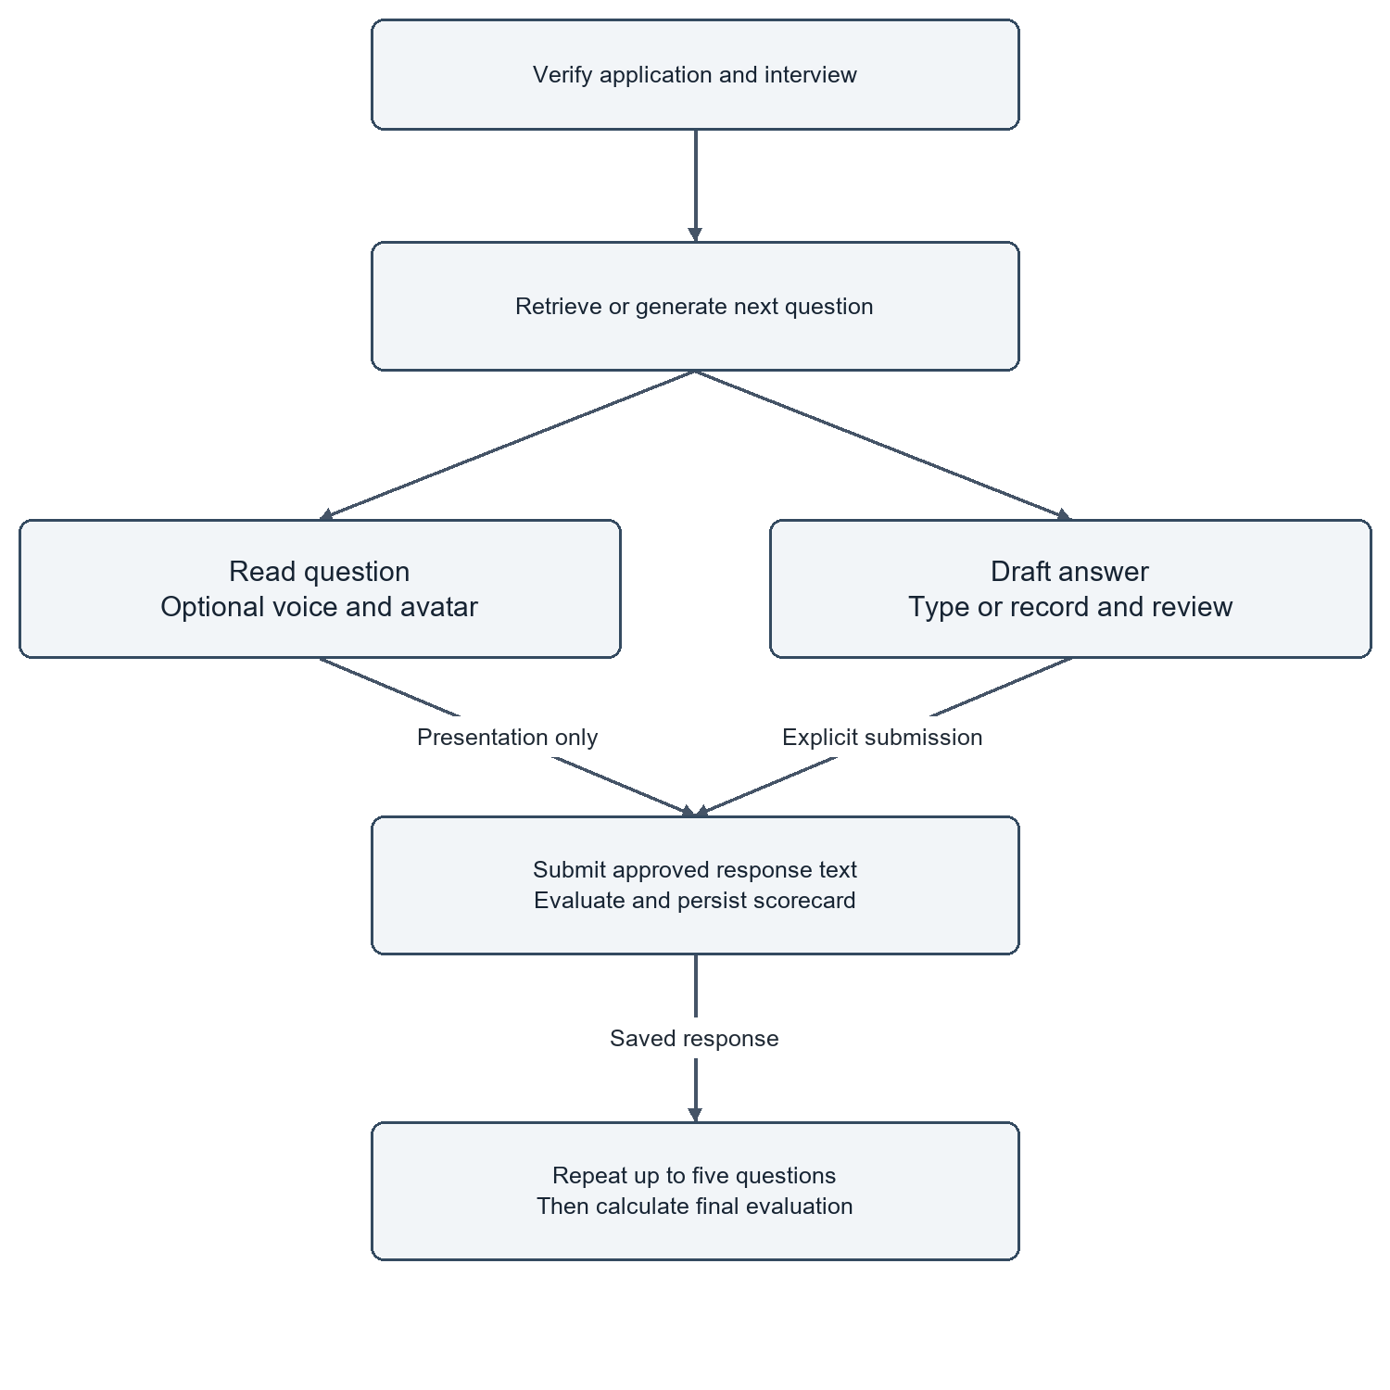
Figure 8 Interview activity and optional media paths
Source: original diagram derived from the local implementation and migration contracts. Arrows show the principal relationship or request direction; optional and failure paths are described in the surrounding section.

CHAPTER 5
IMPLEMENTATION
This chapter explains how the current source code realizes the design and where its operational limits remain.

5.1 FRONTEND COMPOSITION
The frontend is implemented with Next.js 16.3.5, React 19 and TypeScript. Route-level components obtain initial workspace context and pass data into client views. The browser owns transient interaction state such as search text, selected tabs, draft answers and media controls. Server actions handle mutations and provider calls after access checks.
The small landing preview is a client component because selecting a sample candidate changes the visible evidence. The rest of the landing content does not require an animation framework. Shared buttons use hover and focus feedback, while motion respects the reduced-motion preference. The implementation aims to improve interaction without introducing continuous animation loops or extra API requests.
The distinction between client and server code also supports secrecy. A browser needs the public authentication configuration, but it does not need the backend shared secret, service-role key or Simli API key. Sensitive provider operations are represented as server actions with narrow inputs. This is an implementation boundary, not a substitute for validating the requested interview or application.

5.2 RECRUITER AUTHENTICATION AND WORKSPACE CONTEXT
Authentication is coordinated by a browser provider and server-side context helpers. The browser handles the initial session event once rather than issuing a second startup session load that repeats profile and membership queries. Database work is scheduled outside the synchronous auth callback to avoid holding the authentication callback while waiting for operations that depend on the same client.
The server verifies the user and builds a request-scoped context containing profile, memberships and the selected organization. Request-scoped caching avoids repeated reads within one render without retaining one user's authorization result across unrelated requests. Membership and profile reads can proceed in parallel after the user is known.
A reported sign-in loading problem led to a bounded browser auth request and a form-level watchdog. Requests abort after fifteen seconds; the form stops waiting after twenty-five seconds if initialization or refresh remains unresolved. Successful authentication starts a fresh document navigation after session cookies are saved. The original failing network request was not captured, so this repair is supported by regression scenarios rather than a claim of having measured the original network cause.

5.3 JOB AND CANDIDATE ACCESS
Job listing retrieves embedded counts instead of downloading all application rows and counting them in JavaScript. This avoids undercounting when a data API row limit truncates the downloaded records. Candidate and job summaries similarly use count queries. An error remains an error rather than being converted to a reassuring but false zero.
Search inputs are debounced for 300 milliseconds. Each request is associated with a version so that a slower earlier response cannot replace a newer result. Organization changes reset stateful lists through organization-specific keys. The application list initially uses its server-provided data rather than immediately repeating the same request in the browser.
Document access uses batches of signed URLs where a list needs several files. The URLs are obtained after the intended access checks and do not make the storage bucket public. The lifetime of a signed link is still a period of bearer access, so it should not be copied into public documentation. The thesis figures use synthetic records and do not include private document links.

5.4 SUBMISSION AND DOCUMENT EXTRACTION
The submission path validates candidate fields, file size and accepted format before storing linked records. PDF and DOCX are supported; the older binary DOC format is not advertised. The four-megabyte limit is consistent across the candidate form, recruiter uploader and backend recording path, leaving overhead below the hosting request limit described by Vercel (n.d.b).
The extraction service uses a PDF fast path with a fallback parser and reads DOCX paragraphs and tables in document order. This matters because many resumes place skills and employment history inside table cells. An empty or unreadable PDF produces a meaningful failure rather than a fabricated candidate summary. OCR for image-only documents is not implemented.
When extracted text is already stored, screening reuses it. This avoids another storage download, parsing operation and redundant write. Tests cover generated text PDFs, table-only DOCX content and the empty-PDF failure path. These are parser regressions with synthetic documents; they do not establish successful extraction from every resume format, language or unusual layout.

5.5 STRUCTURED RESUME SCREENING
The screening orchestrator first checks for a completed result. If one exists, it reconstructs the typed response from persisted fields. Otherwise it resolves the application context, obtains resume text and sends a structured request to the configured provider. The OpenAI adapter uses a sixty-second timeout, no automatic retry and a semaphore limiting concurrent generation inside the process.
The payload includes a match score, component scores, matched and missing skills, evidence quotes and a reasoning summary. Numeric fields are constrained to the expected range. The server then derives qualification from the configured threshold, currently seventy percent, and maps the recommendation band. The model's own qualified flag is not the final authority on progression.
Persistence uses save_screening_result so that the score record and application transition are coordinated. A failure to save is reported and can be retried. The evidence quotes support recruiter inspection, but the current implementation does not independently verify every quote against the resume. Accordingly, the result is described as AI-assisted evidence organization, not a proof of candidate competence.

5.6 ASSESSMENT GENERATION AND TIMING
Assessment generation requests exactly ten technical questions linked to the job context and the candidate's summarized background. Each item includes four options, a correct option, an explanation, a skill category and a difficulty label. The backend checks that the question numbers form the complete sequence from one to ten before persisting the set.
The candidate receives a public representation that excludes the answer key. Recording an answer calls record_assessment_answer, which enforces assessment ownership, order, server timing and immutable prior answers. Finalization calls finish_assessment and uses the configured pass threshold, currently sixty percent. The browser countdown is a presentation of server rules rather than their replacement.
Personalized questions improve contextual relevance in the intended design, but they introduce a comparability issue. Two candidates may receive questions with different actual difficulty even if both are labelled medium. The prompt's request for varied answer positions is not proof of a statistically balanced distribution. A calibrated question bank or independent review would be needed for high-stakes assessment use.
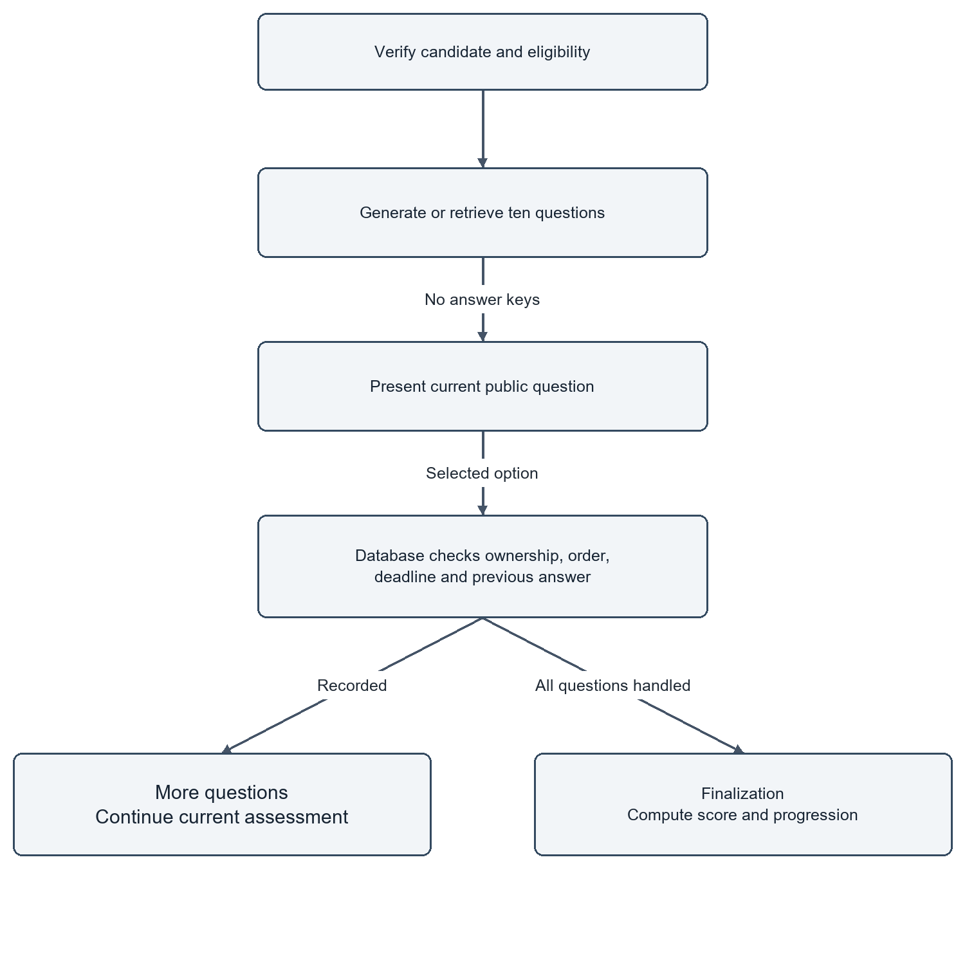
Figure 9 Assessment activity and database authority
Source: original diagram derived from the local implementation and migration contracts. Arrows show the principal relationship or request direction; optional and failure paths are described in the surrounding section.

5.7 INTERVIEW ORCHESTRATION AND RESPONSE SCORING
Interview initialization verifies eligible preceding stages and creates or retrieves the application's interview record. The next-question operation uses stored progress to retrieve or generate the next item. The interview is limited to five questions. Question generation can use role information, candidate context and prior conversation, but it is bounded rather than an open-ended autonomous interview agent.
Each submitted answer is evaluated for technical quality, communication and relevance. The saved response contains both the candidate text and the resulting scorecard. The persistence function coordinates the answer and interview progress and provides retry-safe behaviour. A candidate cannot submit an answer for an unrelated question merely by changing its identifier.
Communication scoring applies to the submitted textual response in this workflow. It is not facial-expression analysis or a validated measure of personality. Transcription quality may affect the text, which is why review before submission is important. The report avoids describing the system as lie detection, emotion recognition or proof of authorship; none of those capabilities is implemented.
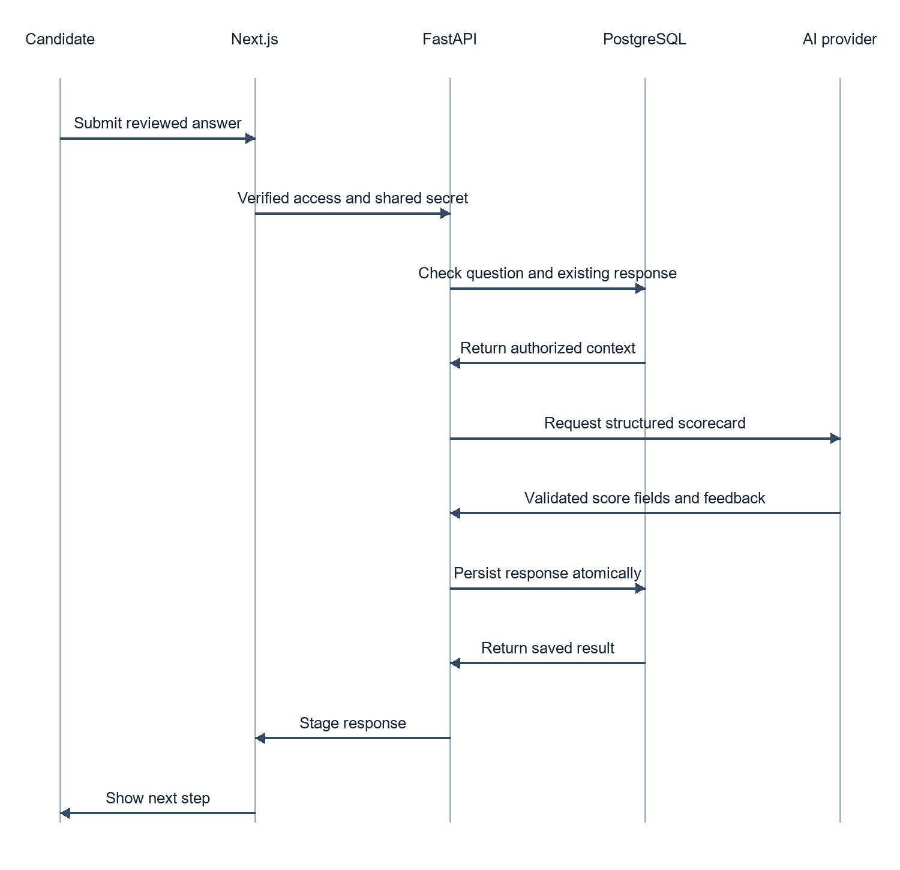
Figure 10 Interview answer evaluation sequence
Source: original diagram derived from the local implementation and migration contracts. Arrows show the principal relationship or request direction; optional and failure paths are described in the surrounding section.

5.8 SPEECH AND AVATAR INTEGRATION
The recording interface captures an answer and sends supported audio to the transcription endpoint. The backend limits input size and uses a bounded, properly closed client for the speech request. Candidates can edit the transcript before it becomes the submitted answer. A denied microphone permission does not remove the typed-answer path.
For interviewer playback, the server obtains the question text associated with the authorized active interview and synthesizes speech. The browser converts audio to the format required by the avatar client and plays the corresponding stream. A short-lived Simli session token is created on the server after access checks. The API key is not sent to the candidate browser.
Controls expose connection, repeat-question, mute and disconnect behaviour. The interface labels the video and voice as AI-generated. The selected female face and the nova speech voice are separately configured. The avatar is optional: the stored question, answer field and submission remain the core interview mechanism when media services fail or the candidate prefers text.

5.9 FINAL EVALUATION AND RECRUITER DECISION
Final evaluation reads screening, assessment and interview evidence only after required stages are completed. For each interview response, available technical, communication and relevance scores are averaged; the response averages are then averaged to obtain the interview score. Missing interview evidence prevents evaluation rather than silently substituting zero.
The composite is calculated as S = 0.40C + 0.25A + 0.35I and rounded to one decimal place, where C, A and I are the resume, assessment and interview scores on a hundred-point scale. Recommendation bands begin at eighty-five for strong hire, seventy for hire and fifty-five for review; lower scores receive no hire. These are project rules, not empirically calibrated employment thresholds.
For an illustrative candidate with C = 80, A = 70 and I = 90, the composite is 32 + 17.5 + 31.5 = 81.0. This arithmetic example demonstrates the formula and is not a measured candidate result. The recruiter should inspect the stage evidence before acting. Retrying the final evaluation preserves an existing recruiter decision through the database persistence function.
Table 3 Illustrative weighted score calculation
Input | Value | Weighted contribution
Resume match C | 80 | 32.0
Assessment A | 70 | 17.5
Interview I | 90 | 31.5
Composite | 81.0 | Hire band; illustrative only

5.10 DATABASE MIGRATIONS AND COMPATIBILITY
The migration sequence begins with a canonical schema and then adds data-contract alignment, candidate submission, assessment integrity, pipeline persistence, dashboard aggregation, application search, function permissions and performance indexes. Existing records and legacy field names are retained where compatibility requires them. The migration strategy is additive rather than a database reset.
Two isolated test layouts are used: a legacy layout and a layout with selected fields already renamed. This catches migration assumptions that would succeed on a fresh schema but fail on an existing copy. The tests also verify that previously stored resume evidence survives alignment. The schema dictionary in Appendix B is derived after executing the local migration sequence.
Migration tests stub managed authentication and storage structures and omit extensions that the isolated engine does not provide. They therefore validate the relevant SQL contracts under a controlled setup, not the complete hosted Supabase platform. A release still needs to confirm the remote migration history before applying only pending files. Re-running the initial schema or deleting data is not an acceptable repair for a missing function.
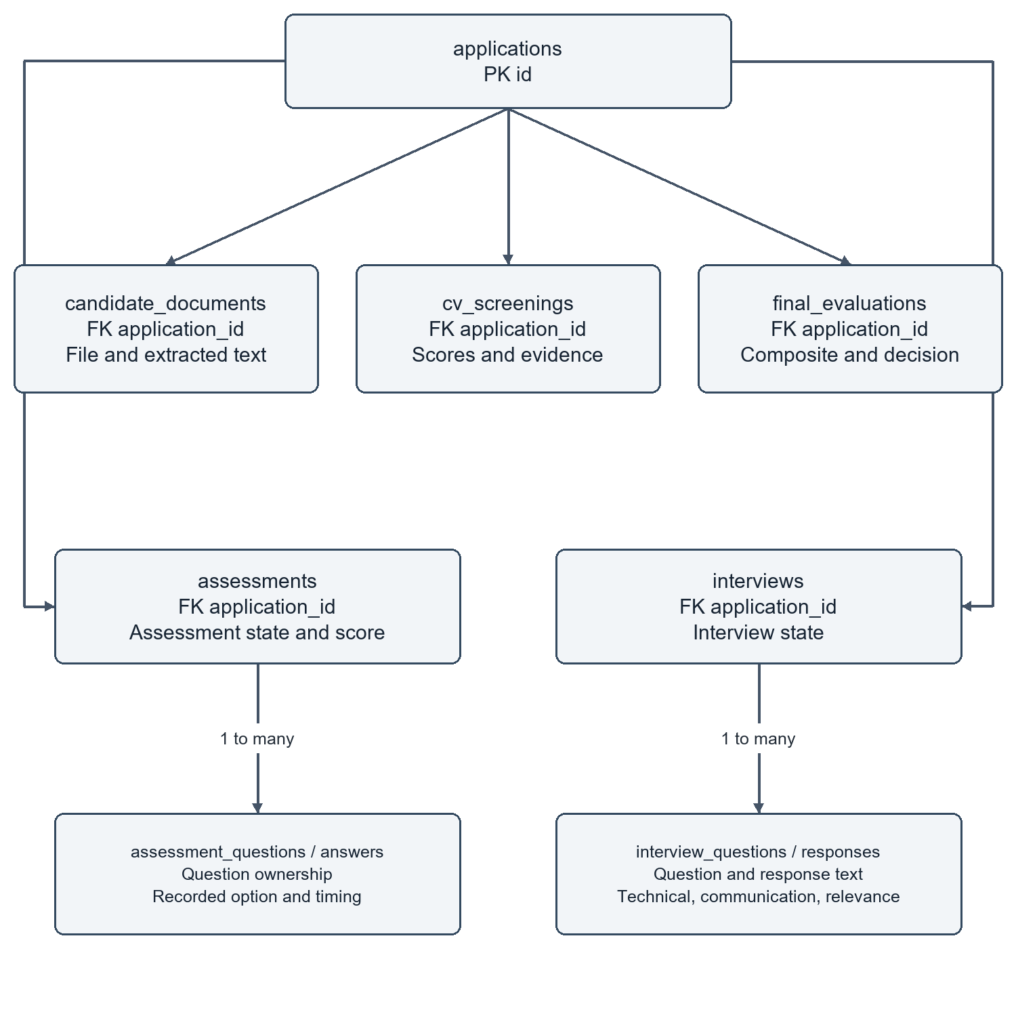
Figure 11 Stage evidence relationships
Source: original diagram derived from the local implementation and migration contracts. Arrows show the principal relationship or request direction; optional and failure paths are described in the surrounding section.

5.11 OPERATIONAL CONFIGURATION AND LIMITS
Configuration is split between frontend and backend environment files. Local frontend URLs point to localhost for the web application and the loopback /api/v1 endpoint for FastAPI. Hosted URLs are configured separately in Vercel and Render. The backend shared secret must match on both sides. Provider keys and private database credentials remain outside source-controlled examples.
The backend includes rate limiting and per-resource serialization. These mechanisms run inside one process and are not claimed to be distributed abuse protection. Public liveness reports process availability; readiness includes a database read. Error boundaries present recoverable messages, although a broader review of route-specific error detail remains advisable before production use.
Render documents that free services can sleep after inactivity (Render n.d.). The project's actual hosted plan was not confirmed, so a slow request cannot be attributed to that cause with certainty. Network quality, database location, model response time and frontend compilation can each contribute. A production frontend build is recommended for a demonstration because it removes development compilation from ordinary navigation.

CHAPTER 6
VERIFICATION AND RESULTS
This chapter reports observed local evidence separately from future acceptance and research studies.

6.1 VERIFICATION APPROACH
Verification combines code inspection, static checks, backend tests, database regressions and browser scenarios. Each level checks a different property. Type checking finds incompatible program interfaces, but it does not prove that the hosted database has the required migration. A browser fixture verifies rendering and interaction, but it does not prove that a real microphone or paid avatar session works.
The local verification run on 20 September 2026 passed frontend lint and TypeScript checks, twenty-five backend tests, authentication regressions and database suites for two layouts. A production build also passed during the preceding sign-in repair. Browser checks cover public routes, workspace layout, interview layout and authentication behaviour with controlled responses.
Authenticated read-only inspection of the deployed workspace on 20 September 2026 confirmed that the overview and seven workspace tabs displayed saved records. Job, candidate and completed-interview detail screens were also captured. These observations extend the interface evidence without replacing the controlled regression results or a recorded candidate journey.
The test catalogue distinguishes observed results from planned acceptance cases. This prevents the common error of listing an expected outcome as if it had been observed. The project team reported successful hosted use, but a timestamped, complete candidate journey with real providers was not captured in this evidence set. That remaining work is material to final operational acceptance.
Table 4 Verification summary
Verification layer | Recorded result | Scope
Lint and TypeScript | Passed | Local source checks
Backend suite | 25 passed | Synthetic/mocked regressions
Database layouts | Both passed | Migrations 01–09, isolated engine
Auth regressions | Passed | Identity, scope and requests
Browser sign-in | Three scenarios passed | Controlled auth responses
Live provider journey | Not recorded here | Final acceptance remains pending

6.2 BACKEND AND EXTRACTION TESTS
The backend suite contains twenty-five passing tests in the recorded local run. Relevant scenarios include repository concurrency, organization filters, reuse of stored resume text, PDF extraction, table-based DOCX extraction and error handling. Provider mocks allow deterministic assertions without sending private candidate records or consuming paid inference during the regression run.
The DOCX regression is particularly useful because document tables are common in resumes. It checks that text stored in cells is not ignored. The empty-PDF case checks that absence of readable text produces an error instead of a successful but empty profile. The repository tests check that independent context reads can overlap while preserving the organization condition.
There is an existing Starlette/httpx deprecation warning in the test environment. It does not indicate a failed assertion, but it should be addressed when dependencies are next updated. Passing this suite provides bounded evidence for the exercised cases. It is not a fuzzing campaign against arbitrary documents or a reliability estimate for external language-model responses.

6.3 DATABASE INTEGRITY TESTS
The migration suite runs SQL in an isolated PostgreSQL-compatible engine with synthetic records. Both the legacy and renamed layouts apply migrations 01 through 09. A repeated submission returns the same application, and duplicate candidate/job handling does not create partial records. Existing resume evidence remains after the alignment migration.
Assessment checks exercise question ownership, ordering, deadlines, repeated answer submission and finalization. Interview checks exercise response ownership, retries and atomic persistence of scorecards. Final evaluation checks preserve recruiter decisions. Tenant and viewer restrictions are also tested, alongside access to private workflow functions.
These results support the choice to enforce critical invariants close to the data. They do not replace a check against the hosted migration history. Storage and authentication are stubbed in the isolated environment, and extensions are treated differently from a managed Supabase deployment. The report therefore calls these database contract tests rather than a complete production database certification.

6.4 AUTHENTICATION AND BROWSER REGRESSIONS
The server authentication regression rejects forged identity headers and unauthorized organization selection. It also verifies request-level context deduplication and aggregate mapping above one thousand records. Browser startup is checked with a synthetic session to confirm one profile and one membership request rather than duplicate context loading.
The sign-in regression exercises three outcomes: invalid credentials return an error and restore the button, a successful response saves session cookies and initiates document navigation, and an endpoint that never responds eventually releases the loading state. The successful navigation uses a controlled destination; it is not evidence that a real account reached a populated hosted dashboard.
Public pages are checked at widths of 320, 375, 414, 768 and 1440 pixels. Workspace fixtures are checked at three widths, and interview layout at six desktop/mobile viewports. These checks find horizontal overflow and selected interaction failures. They do not establish full WCAG compliance, all-browser compatibility or usability for every candidate population.

6.5 OBSERVED PERFORMANCE AND INTERPRETATION
A previous read-only deployment probe recorded a frontend response with a first-byte time of 0.710 seconds and a total response time of 3.391 seconds. A backend readiness request first timed out after twenty-five seconds; a subsequent request returned successfully in 1.919 seconds. A later Supabase Auth settings probe returned HTTP 200 in approximately 740 milliseconds.
These are isolated observations from different endpoints and stages of the project. They are not a before-and-after benchmark, a percentile distribution or a measurement of AI screening time. The readiness endpoint includes a database read, so its duration cannot be interpreted as pure FastAPI execution. The original slow request may have involved hosting wake-up, networking or a dependency, but the evidence does not identify a unique cause.
Weak Wi-Fi is a plausible contributor to waiting, but its effect has not been measured. Local frontend/backend URLs remove one remote service hop while leaving Supabase and provider traffic online. A defensible latency study should measure repeated cold and warm requests, separate browser rendering from API processing, and report failures alongside successful durations.
Table 5 Recorded point observations rather than a benchmark
Observation | Recorded duration | Interpretation
Hosted frontend first byte | 0.710 s | Single previous sample
Hosted frontend response | 3.391 s | Single previous sample
Backend readiness attempt 1 | Timeout after 25 s | Cause not isolated
Backend readiness retry | 1.919 s | Includes database request
Auth settings probe | 0.740 s | Read-only endpoint probe

6.6 OPTIMIZATION EVIDENCE
Several changes have a direct structural basis for reducing unnecessary work. Embedded counts avoid downloading all application rows. Parallel context reads shorten a sequence of independent database waits. Search debouncing reduces the number of requests generated while typing. Signed-link batching replaces repeated storage calls with a batch. Stored extraction text avoids downloading and parsing the same resume again.
These improvements are supported by request-count regressions and code paths, not by a claimed universal percentage speedup. Removing unused files helps maintainability but does not by itself prove lower runtime latency. Similarly, a smaller landing animation system can reduce browser work without establishing a faster AI model response.
The most important performance lesson is to measure the actual critical path. If authentication waits on a remote endpoint, changing an icon will not solve it. If a model request dominates screening, optimizing a small SQL query may have little effect on total duration. The project now has clearer boundaries for collecting such measurements in a future study.

6.7 VALIDITY AND LIMITATIONS
Internal validity is limited by the use of controlled fixtures and mocks. These make regressions reproducible, but they omit real provider variability, intermittent networks and browser media permissions. External validity is limited by the absence of a representative candidate cohort and multiple organizations using the system over time.
Construct validity is also important. A passing SQL test measures integrity of the tested transaction; it does not measure fairness. A score within the allowed range measures schema compliance; it does not measure truth. A responsive screenshot measures layout at one state; it does not establish task completion time. The report keeps these meanings separate throughout the evidence tables.
The current system has no validated agreement rate with expert recruiters, no demographic fairness audit, no production load study and no independent penetration test. Personalized question difficulty is not calibrated. OCR is absent. Local demonstration still requires internet. These limitations define the next stage of work and prevent the prototype from being presented as a fully validated employment decision system.

6.8 ACCEPTANCE AND MEASUREMENT PLAN
Final acceptance should use a designated test workspace and a consented or synthetic candidate profile. The evaluator should record the job identifier, application stages, timestamps, visible recovery states and final evidence. Both typed and recorded interview paths should be exercised, and the configured avatar should connect, repeat, mute and disconnect without blocking the answer flow.
The measurement plan should record at least separate cold-start and warm-run groups and state the number of samples actually collected. Durations should be captured for authentication, initial dashboard data, screening, assessment generation, interview question generation, transcription and final evaluation. Median and tail latency should be computed only after enough samples exist; failed requests must not be silently dropped.
Model-quality evaluation needs independent reviewer rubrics and consented records. Reviewers should assess evidence correctness and question relevance before comparing composite scores. Multiple ratings can reveal disagreement that a single reviewer would hide. No values for these future experiments are filled into the results tables in this report.

CHAPTER 7
CONCLUSIONS AND FUTURE WORK
This chapter summarizes the contribution and identifies the next technical and empirical steps.

7.1 CONCLUSIONS
AI Recruit360 demonstrates an integrated recruitment workflow in which generated content is tied to persistent application evidence. Its main achievement is not a claim that a language model can hire better than a recruiter. It is the engineering of access boundaries, stage progression, recoverable operations and inspectable results across a browser, two application runtimes and managed services.
The local tests provide evidence that important submission, assessment, interview and authorization contracts behave correctly in their tested settings. The interface has been revised to present the workflow clearly and to avoid indefinite waiting during the tested sign-in failure cases. The deployed system has been reported as working by the project team, while formal real-provider acceptance remains distinct from automated checks.
The project meets its educational purpose by providing a system that can be explained from data entry through final review. Its limitations are equally instructive: structured output is not factual verification, score aggregation is not model validation, and local hosting is not offline operation. A responsible continuation should preserve these distinctions while expanding the evidence base.

7.2 FUTURE TECHNICAL DEVELOPMENT
The next technical priority is a repeatable operational acceptance suite with real providers and explicit timing records. This should precede broad feature expansion. Once reliability and latency are measured, the team can decide whether a queue or distributed job ownership is justified. Such infrastructure should solve an observed problem rather than make the architecture appear more sophisticated.
Document support could be extended with OCR, extraction confidence and a candidate correction step. Any new parser should receive adversarial and malformed-file tests. Speech support could be evaluated across microphones, background noise and accents, with improved transcript review for technical terminology. The avatar should remain optional so that media performance does not become an eligibility barrier.
Database evolution should preserve existing records and explicitly version contracts. Additional concurrency tests should precede multiple backend workers. A centralized retention policy, auditable access review and better structured error telemetry would improve operational readiness without changing the system's fundamental educational scope.

7.3 FUTURE EVALUATION AND RESPONSIBLE USE
A research extension should assess generated evidence rather than starting with a headline accuracy number. Reviewers can label whether a claimed resume match is supported, whether a question is relevant to the job, and whether feedback accurately describes the submitted answer. These smaller judgements are easier to inspect than an unexplained overall hiring label.
A fairness study would need a justified sampling plan, appropriate consent and careful handling of sensitive attributes. The team should not infer demographic fairness from the absence of demographic fields in a prompt; proxies may remain in education, experience and language. Candidate accessibility and willingness to use avatar interviewing should also be evaluated directly.
The final responsibility remains with the recruiting organization. Recommendations should be reviewed, disputed evidence should be correctable, and decisions should be recorded separately from model output. With this boundary maintained, the prototype offers a foundation for further study and a clear demonstration of practical software engineering around AI services.

REFERENCES
Chicago author-date references. Web documentation was consulted on 20 September 2026; implementation claims are also grounded in the project source locations listed in the appendices.
Brown, Tom B., et al. 2020. "Language Models Are Few-Shot Learners." Advances in Neural Information Processing Systems 33. https://arxiv.org/abs/2005.14165.
OWASP. 2025. "LLM Prompt Injection Prevention Cheat Sheet." OWASP Cheat Sheet Series. Accessed September 20, 2026. https://cheatsheetseries.owasp.org/cheatsheets/LLM_Prompt_Injection_Prevention_Cheat_Sheet.html.
PostgreSQL Global Development Group. n.d.a. "Row Security Policies." PostgreSQL 17 Documentation. Accessed September 20, 2026. https://www.postgresql.org/docs/17/ddl-rowsecurity.html.
PostgreSQL Global Development Group. n.d.b. "Transaction Isolation." PostgreSQL 17 Documentation. Accessed September 20, 2026. https://www.postgresql.org/docs/17/transaction-iso.html.
Radford, Alec, Jong Wook Kim, Tao Xu, Greg Brockman, Christine McLeavey, and Ilya Sutskever. 2022. "Robust Speech Recognition via Large-Scale Weak Supervision." arXiv. https://arxiv.org/abs/2212.04356.
Raghavan, Manish, Solon Barocas, Jon Kleinberg, and Karen Levy. 2020. "Mitigating Bias in Algorithmic Hiring: Evaluating Claims and Practices." Proceedings of the 2020 Conference on Fairness, Accountability, and Transparency, 469–481. https://arxiv.org/abs/1906.09208.
Ramírez, Sebastián. n.d. "Concurrency and async / await." FastAPI Documentation. Accessed September 20, 2026. https://fastapi.tiangolo.com/async/.
Render. n.d. "Deploy for Free." Render Documentation. Accessed September 20, 2026. https://render.com/docs/free.
Supabase. n.d. "Row Level Security." Supabase Documentation. Accessed September 20, 2026. https://supabase.com/docs/guides/database/postgres/row-level-security.
Tabassi, Elham. 2023. Artificial Intelligence Risk Management Framework AI RMF 1.0. NIST AI 100-1. Gaithersburg, MD: National Institute of Standards and Technology. https://doi.org/10.6028/NIST.AI.100-1.
Vercel. n.d.a. "Server and Client Components." Next.js Documentation. Accessed September 20, 2026. https://nextjs.org/docs/app/getting-started/server-and-client-components.
Vercel. n.d.b. "Vercel Functions Limits." Accessed September 20, 2026. https://vercel.com/docs/functions/limitations.
World Wide Web Consortium. 2024. Web Content Accessibility Guidelines WCAG 2.2. W3C Recommendation, December 12, 2024. https://www.w3.org/TR/WCAG22/.

PROJECT EVIDENCE SOURCES
The local project source reviewed for this report includes frontend/package.json, frontend/app, frontend/components, frontend/lib, ai-service/app, ai-service/tests, supabase/migrations and scripts. The local automated verification log dated 20 September 2026 records the test results discussed in Chapter 6. FINAL_AUDIT.md records earlier checks and the deployment point observations. HANDOVER.md records subsequent UI and sign-in repairs. These project artefacts establish implementation provenance; they are not independent research publications.
The university Project Report template-3.0.docx supplies formatting and front-matter conventions. GlucoSense_AI_Thesis_Final.pdf was used only to understand the depth and organization of a software-engineering report. Its prose, measurements and project figures were not used as evidence for AI Recruit360.

APPENDIX A
DETAILED USE CASES
The use cases specify actor goals and observable outcomes for the implemented workflow. The source locator identifies the controlling implementation. Alternative flows are requirements and recovery expectations; they are not all independently verified live-provider results. The test catalogue in Appendix D states the available evidence.

A.1 SIGN IN TO A WORKSPACE
Table 6 UC01 use case specification
Attribute | Specification
Identifier | UC01
Primary actor | Recruiter
Preconditions | An existing recruiter account and reachable Supabase Auth.
Trigger | The actor chooses sign in to a workspace.
Success condition | The recruiter reaches an authorized workspace or organization onboarding.

Main flow
1. Open the login page and enter email and password.
2. Submit once and observe the loading state.
3. The authentication SDK establishes the session and writes cookies.
4. Navigate to the workspace; the server verifies identity and resolves membership.

Alternative and recovery flow
Incorrect credentials restore the form with an error. An unanswered request is bounded; it must not leave the button spinning indefinitely.

Implementation trace
frontend/app/login/page.tsx; frontend/proxy.ts; scripts/check-sign-in.cjs

Review criterion
Check the success condition against the stored result as well as the visible page. Preserve the application and organization identifiers when reproducing this case; a screenshot alone does not establish authorization or persistence.

A.2 CREATE A RECRUITER ACCOUNT
Table 7 UC02 use case specification
Attribute | Specification
Identifier | UC02
Primary actor | Prospective recruiter
Preconditions | The organization permits registration and email delivery is configured.
Trigger | The actor chooses create a recruiter account.
Success condition | An authenticated identity can proceed to workspace onboarding.

Main flow
1. Open the signup page.
2. Provide the requested identity, email and password fields.
3. Submit account creation and follow any confirmation instruction.
4. After authentication, continue to the organization setup path when no membership exists.

Alternative and recovery flow
Existing email, weak credentials or email delivery issues require a visible recovery path. A submitted form does not prove that confirmation email was delivered.

Implementation trace
frontend/app/signup/page.tsx; frontend/app/auth/callback/route.ts

Review criterion
Check the success condition against the stored result as well as the visible page. Preserve the application and organization identifiers when reproducing this case; a screenshot alone does not establish authorization or persistence.

A.3 RECOVER A PASSWORD
Table 8 UC03 use case specification
Attribute | Specification
Identifier | UC03
Primary actor | Recruiter
Preconditions | The email belongs to an account and callback URLs are allowed.
Trigger | The actor chooses recover a password.
Success condition | The account can authenticate with the updated password.

Main flow
1. Open Forgot password and enter the account email.
2. Request a reset message.
3. Open the confirmation link in the intended environment.
4. Enter and save the new password through the reset page.

Alternative and recovery flow
An expired or invalid recovery session must not change a password. Delivery and redirects need real-email acceptance testing.

Implementation trace
frontend/app/forgot-password/page.tsx; frontend/app/reset-password/page.tsx

Review criterion
Check the success condition against the stored result as well as the visible page. Preserve the application and organization identifiers when reproducing this case; a screenshot alone does not establish authorization or persistence.

A.4 CREATE AN ORGANIZATION
Table 9 UC04 use case specification
Attribute | Specification
Identifier | UC04
Primary actor | Authenticated recruiter
Preconditions | The user has no active workspace membership.
Trigger | The actor chooses create an organization.
Success condition | Organization and ownership are available through verified membership.

Main flow
1. Open organization onboarding.
2. Enter the required organization details.
3. Submit the server action.
4. The stored membership permits entry to the new workspace.

Alternative and recovery flow
A duplicate or invalid organization name/slug must be handled without assuming that a client preference cookie grants membership.

Implementation trace
frontend/app/onboarding/organization/page.tsx; frontend/app/actions/organization.ts

Review criterion
Check the success condition against the stored result as well as the visible page. Preserve the application and organization identifiers when reproducing this case; a screenshot alone does not establish authorization or persistence.

A.5 SWITCH ORGANIZATION CONTEXT
Table 10 UC05 use case specification
Attribute | Specification
Identifier | UC05
Primary actor | Multi-workspace recruiter
Preconditions | The user is a member of more than one organization.
Trigger | The actor chooses switch organization context.
Success condition | All visible operational data belongs to the selected authorized workspace.

Main flow
1. Select another organization from the workspace control.
2. The server validates membership in that organization.
3. Store the selected preference and refresh context.
4. Reset organization-keyed lists and show data from the selected workspace.

Alternative and recovery flow
An arbitrary organization identifier is rejected. A stale selection cookie is only a preference, not proof of access.

Implementation trace
frontend/providers/auth-provider.tsx; frontend/lib/auth/session.ts

Review criterion
Check the success condition against the stored result as well as the visible page. Preserve the application and organization identifiers when reproducing this case; a screenshot alone does not establish authorization or persistence.

A.6 CREATE AND PUBLISH A JOB
Table 11 UC06 use case specification
Attribute | Specification
Identifier | UC06
Primary actor | Owner, admin or recruiter
Preconditions | The role permits job management in the active organization.
Trigger | The actor chooses create and publish a job.
Success condition | The published job can be opened by a candidate through its link.

Main flow
1. Open the job creation page.
2. Enter title, location, employment details and role text.
3. Save the job with the intended status.
4. Publish the role and copy its candidate application link.

Alternative and recovery flow
A draft or unavailable role must not behave as an active application destination. Invalid fields should prevent persistence.

Implementation trace
frontend/app/(workspace)/jobs/new/page.tsx; frontend/app/actions/jobs.ts

Review criterion
Check the success condition against the stored result as well as the visible page. Preserve the application and organization identifiers when reproducing this case; a screenshot alone does not establish authorization or persistence.

A.7 FIND A JOB OR APPLICATION
Table 12 UC07 use case specification
Attribute | Specification
Identifier | UC07
Primary actor | Recruiter or permitted viewer
Preconditions | The workspace contains records and the user can view them.
Trigger | The actor chooses find a job or application.
Success condition | The result corresponds to the latest filter state in the current organization.

Main flow
1. Open the relevant workspace list.
2. Type a search query and select filters.
3. Wait for the debounced request.
4. Inspect the returned page and summary counts.

Alternative and recovery flow
Late responses from earlier queries must not overwrite newer results. Request failure must not be shown as a valid zero count.

Implementation trace
frontend/components/jobs/jobs-client-view.tsx; frontend/components/applications/applications-client-view.tsx

Review criterion
Check the success condition against the stored result as well as the visible page. Preserve the application and organization identifiers when reproducing this case; a screenshot alone does not establish authorization or persistence.

A.8 SUBMIT A CANDIDATE APPLICATION
Table 13 UC08 use case specification
Attribute | Specification
Identifier | UC08
Primary actor | Candidate
Preconditions | The job is available and the resume is a readable PDF or DOCX within 4 MB.
Trigger | The actor chooses submit a candidate application.
Success condition | Linked candidate, application and document evidence is stored consistently.

Main flow
1. Open the job link and read the role.
2. Enter contact information and select a resume.
3. Submit validated data and the uploaded document reference.
4. Receive confirmation and a signed application session.

Alternative and recovery flow
A repeated submission key returns the existing result. Invalid or oversized files are rejected before continuing. Failed screening does not erase a saved application.

Implementation trace
frontend/app/apply/[job-slug]/apply-client.tsx; supabase/migrations/03_candidate_submission.sql

Review criterion
Check the success condition against the stored result as well as the visible page. Preserve the application and organization identifiers when reproducing this case; a screenshot alone does not establish authorization or persistence.

A.9 SCREEN A STORED RESUME
Table 14 UC09 use case specification
Attribute | Specification
Identifier | UC09
Primary actor | Candidate workflow
Preconditions | A valid application, job context and document are available.
Trigger | The actor chooses screen a stored resume.
Success condition | A saved result contains scores, evidence and a progression outcome.

Main flow
1. Verify access to the application.
2. Reuse a completed screening or obtain extracted resume text.
3. Request a structured evaluation against the role.
4. Apply the configured threshold and save the result atomically.

Alternative and recovery flow
Provider outage does not assign a zero or reject the candidate. Unreadable documents require a corrected upload or explicit handling.

Implementation trace
ai-service/app/services/screening/orchestrator.py; ai-service/tests/test_screening.py

Review criterion
Check the success condition against the stored result as well as the visible page. Preserve the application and organization identifiers when reproducing this case; a screenshot alone does not establish authorization or persistence.

A.10 RETRY INTERRUPTED SCREENING
Table 15 UC10 use case specification
Attribute | Specification
Identifier | UC10
Primary actor | Candidate
Preconditions | Application submission succeeded but screening did not complete.
Trigger | The actor chooses retry interrupted screening.
Success condition | The application advances without duplicate completed screening evidence.

Main flow
1. Keep the same browser session.
2. Use Retry screening from the saved-application state.
3. The service checks for an already completed result.
4. Return existing evidence or finish the pending operation.

Alternative and recovery flow
An expired candidate session blocks access. Repeated provider failure remains a recoverable service issue rather than a candidate judgement.

Implementation trace
frontend/app/actions/ai-screening.ts; ai-service/app/core/operation_lock.py

Review criterion
Check the success condition against the stored result as well as the visible page. Preserve the application and organization identifiers when reproducing this case; a screenshot alone does not establish authorization or persistence.

A.11 GENERATE A SKILLS ASSESSMENT
Table 16 UC11 use case specification
Attribute | Specification
Identifier | UC11
Primary actor | Eligible candidate
Preconditions | The application meets the screening threshold.
Trigger | The actor chooses generate a skills assessment.
Success condition | A complete persisted assessment is ready for sequential answers.

Main flow
1. Open the assessment stage.
2. Retrieve existing stored questions if available.
3. Otherwise generate and validate exactly ten questions.
4. Present the public question representation without correct options.

Alternative and recovery flow
Generation failure must not create generic fallback questions and assign an unearned score. Incomplete numbering is rejected.

Implementation trace
ai-service/app/services/assessment/generator.py; ai-service/tests/test_assessment.py

Review criterion
Check the success condition against the stored result as well as the visible page. Preserve the application and organization identifiers when reproducing this case; a screenshot alone does not establish authorization or persistence.

A.12 ANSWER A TIMED QUESTION
Table 17 UC12 use case specification
Attribute | Specification
Identifier | UC12
Primary actor | Candidate
Preconditions | The current assessment question is accessible and its server deadline is known.
Trigger | The actor chooses answer a timed question.
Success condition | One authoritative answer is recorded for the question.

Main flow
1. Read the current question and four choices.
2. Select an option and submit.
3. The database checks ownership, ordering, timing and prior answer.
4. Continue to the next permitted question or finalization.

Alternative and recovery flow
Changing the browser clock or submitting another question identifier must not override server rules. An already recorded answer cannot be replaced.

Implementation trace
supabase/migrations/04_assessment_integrity.sql; ai-service/app/services/assessment/scorer.py

Review criterion
Check the success condition against the stored result as well as the visible page. Preserve the application and organization identifiers when reproducing this case; a screenshot alone does not establish authorization or persistence.

A.13 FINALIZE AN ASSESSMENT
Table 18 UC13 use case specification
Attribute | Specification
Identifier | UC13
Primary actor | Candidate workflow
Preconditions | The assessment has reached the completion condition.
Trigger | The actor chooses finalize an assessment.
Success condition | Repeated finalization returns a stable result.

Main flow
1. Request finalization through the server action.
2. The database evaluates recorded answers and completion rules.
3. Persist the score and pass outcome.
4. Show the next eligible step or the non-progressing outcome.

Alternative and recovery flow
An incomplete or unauthorized assessment is not completed just because the browser requests it. The configured pass threshold remains server-controlled.

Implementation trace
finish_assessment function; scripts/check-database.mjs

Review criterion
Check the success condition against the stored result as well as the visible page. Preserve the application and organization identifiers when reproducing this case; a screenshot alone does not establish authorization or persistence.

A.14 ANSWER AN INTERVIEW QUESTION
Table 19 UC14 use case specification
Attribute | Specification
Identifier | UC14
Primary actor | Eligible candidate
Preconditions | The interview belongs to the application and preceding eligibility is satisfied.
Trigger | The actor chooses answer an interview question.
Success condition | The response is attached to the correct question and interview.

Main flow
1. Initialize or retrieve the interview.
2. Read the stored current question.
3. Draft a response and explicitly submit it.
4. Evaluate and persist its scorecard before advancing.

Alternative and recovery flow
A question from another interview is rejected before AI evaluation. A retry returns saved evidence where available.

Implementation trace
ai-service/app/services/interview/question_generator.py; response_evaluator.py

Review criterion
Check the success condition against the stored result as well as the visible page. Preserve the application and organization identifiers when reproducing this case; a screenshot alone does not establish authorization or persistence.

A.15 RECORD AND REVIEW AN ANSWER
Table 20 UC15 use case specification
Attribute | Specification
Identifier | UC15
Primary actor | Candidate
Preconditions | Microphone access is granted and an interview is active.
Trigger | The actor chooses record and review an answer.
Success condition | The evaluated text is the answer explicitly approved by the candidate.

Main flow
1. Start recording from the answer panel.
2. Stop within the time and size limits.
3. Request transcription and review the returned text.
4. Correct the text if necessary and submit the reviewed answer.

Alternative and recovery flow
Denied permission, oversized recording or transcription failure leaves typed input available. A missing API key must not fabricate an answer.

Implementation trace
frontend/app/interview-room/[application-id]/page.tsx; ai-service/app/services/interview/stt.py

Review criterion
Check the success condition against the stored result as well as the visible page. Preserve the application and organization identifiers when reproducing this case; a screenshot alone does not establish authorization or persistence.

A.16 USE THE INTERVIEWER AVATAR
Table 21 UC16 use case specification
Attribute | Specification
Identifier | UC16
Primary actor | Candidate
Preconditions | An active interview and valid Simli and speech configuration exist.
Trigger | The actor chooses use the interviewer avatar.
Success condition | The avatar presents the authorized question and shows connection state.

Main flow
1. Choose to connect the avatar.
2. Obtain a short-lived authorized session token.
3. Play the stored question with generated voice.
4. Use repeat, mute or disconnect controls while retaining the text workflow.

Alternative and recovery flow
Provider failure must not prevent typed answers. The face identifier does not automatically select a matching voice.

Implementation trace
frontend/app/actions/interview-avatar.ts; frontend/components/interview/simli-avatar-player.tsx

Review criterion
Check the success condition against the stored result as well as the visible page. Preserve the application and organization identifiers when reproducing this case; a screenshot alone does not establish authorization or persistence.

A.17 CALCULATE THE FINAL EVALUATION
Table 22 UC17 use case specification
Attribute | Specification
Identifier | UC17
Primary actor | Completed candidate workflow
Preconditions | Screening and assessment are complete and interview evidence exists.
Trigger | The actor chooses calculate the final evaluation.
Success condition | The scorecard remains explainable through its stage evidence.

Main flow
1. Read the completed stage records.
2. Average the available interview dimensions per response.
3. Calculate the 40/25/35 composite and recommendation band.
4. Save the final evaluation while preserving any recruiter decision.

Alternative and recovery flow
Missing assessment or interview evidence prevents completion. No missing score is invented to force a result.

Implementation trace
ai-service/app/services/evaluation/evaluator.py; save_final_evaluation function

Review criterion
Check the success condition against the stored result as well as the visible page. Preserve the application and organization identifiers when reproducing this case; a screenshot alone does not establish authorization or persistence.

A.18 REVIEW AND DECIDE ON AN APPLICATION
Table 23 UC18 use case specification
Attribute | Specification
Identifier | UC18
Primary actor | Authorized recruiter
Preconditions | An application and its evidence are visible in the current organization.
Trigger | The actor chooses review and decide on an application.
Success condition | The stored review outcome reflects the recruiter action.

Main flow
1. Open the application or evaluation.
2. Compare stage scores with original evidence.
3. Record the permitted review decision.
4. Refresh and confirm that the decision persists separately from generated scores.

Alternative and recovery flow
A viewer cannot perform the mutation. A later evaluation retry must not overwrite the existing human decision.

Implementation trace
frontend/app/actions/evaluations.ts; frontend/app/actions/applications.ts

Review criterion
Check the success condition against the stored result as well as the visible page. Preserve the application and organization identifiers when reproducing this case; a screenshot alone does not establish authorization or persistence.

A.19 INSPECT CANDIDATE DOCUMENTS
Table 24 UC19 use case specification
Attribute | Specification
Identifier | UC19
Primary actor | Permitted workspace user
Preconditions | The candidate and document belong to the authorized organization.
Trigger | The actor chooses inspect candidate documents.
Success condition | Private storage remains private while authorized review is possible.

Main flow
1. Open the candidate record.
2. Request permitted document links.
3. Issue short-lived signed URLs, batching list requests where possible.
4. Open the intended file during the link validity period.

Alternative and recovery flow
Knowing a storage path or another tenant identifier must not grant access. Expired signed URLs require renewed authorized access.

Implementation trace
frontend/lib/services/candidate-service.ts; frontend/app/actions/candidates.ts

Review criterion
Check the success condition against the stored result as well as the visible page. Preserve the application and organization identifiers when reproducing this case; a screenshot alone does not establish authorization or persistence.

A.20 UPDATE PROFILE AND WORKSPACE SETTINGS
Table 25 UC20 use case specification
Attribute | Specification
Identifier | UC20
Primary actor | Authorized user
Preconditions | The user is authenticated and has the relevant setting permission.
Trigger | The actor chooses update profile and workspace settings.
Success condition | The updated values are visible through verified workspace context.

Main flow
1. Open Settings.
2. Review current profile and organization values.
3. Edit the permitted fields and save.
4. Reload and verify the persisted values.

Alternative and recovery flow
Organization changes require the proper role. A failed save should be reported rather than displaying an unpersisted success.

Implementation trace
frontend/app/(workspace)/settings/page.tsx; frontend/app/actions/settings.ts

Review criterion
Check the success condition against the stored result as well as the visible page. Preserve the application and organization identifiers when reproducing this case; a screenshot alone does not establish authorization or persistence.

APPENDIX B
DATABASE DICTIONARY
The following structures were generated from migrations 01–09 executed in the isolated schema verification setup. They show column names, PostgreSQL data types and nullability, followed by relevant design notes. They are schema figures, not screenshots of private database rows. Managed auth and storage structures were stubbed for this exercise. Retained compatibility columns are deliberately included.
Foreign keys, uniqueness and check conditions were also extracted from the resulting schema. The diagrams in Chapter 4 summarize active relationships, while the per-table figures below provide a readable structural inventory. Tables retained only for compatibility are explicitly identified.

B.1 PROFILES
Recruiter profile details extend the managed authentication identity.
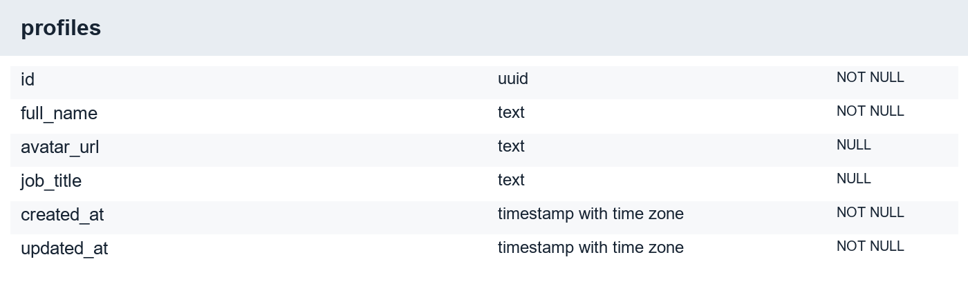
Figure 12 Migration-derived structure of profiles
The profile id references auth.users. A display name is not an authorization credential. Profile fallback text should not be mistaken for persisted user data.
Selected constraints: FOREIGN KEY (id) REFERENCES auth.users(id) ON DELETE CASCADE.

B.2 ORGANIZATIONS
Organizations define the tenant boundary for recruitment work.
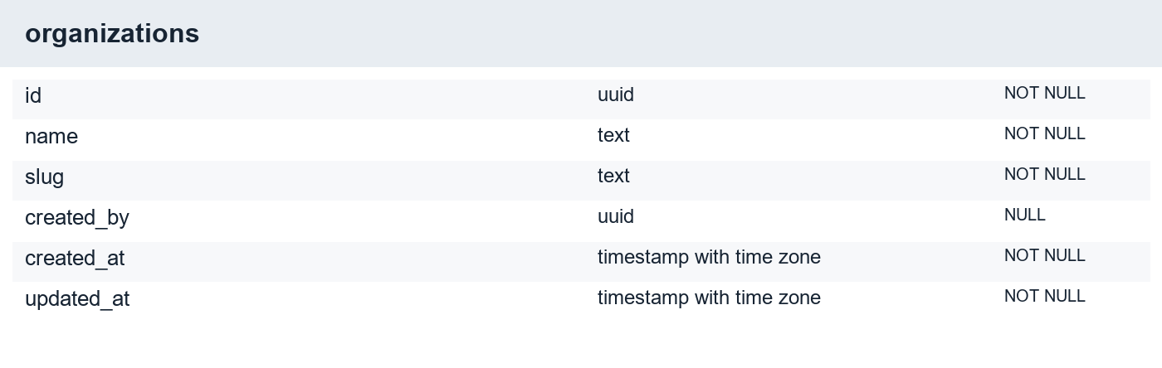
Figure 13 Migration-derived structure of organizations
The slug is unique and identifies a workspace. Ownership is represented through memberships; a preferred organization cookie only selects an already authorized context.
Selected constraints: UNIQUE (slug); FOREIGN KEY (created_by) REFERENCES auth.users(id) ON DELETE SET NULL.

B.3 ORGANIZATION MEMBERS
Memberships connect users to organizations and assign roles.
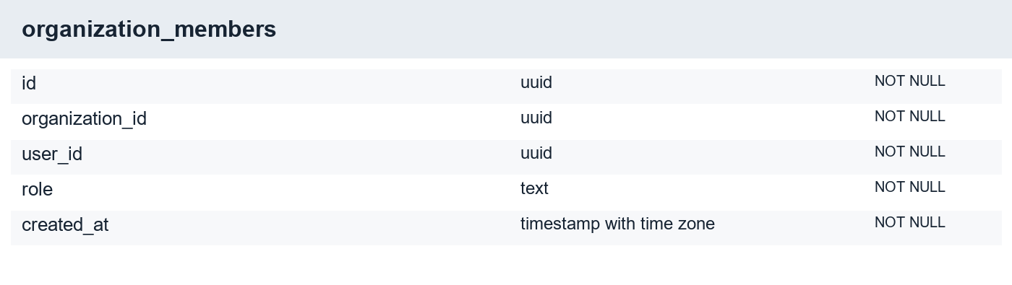
Figure 14 Migration-derived structure of organization_members
The organization and user combination is unique. Role checks must be applied to server mutations as well as interface controls. Deleting or changing membership changes authorization.
Selected constraints: FOREIGN KEY (organization_id) REFERENCES organizations(id) ON DELETE CASCADE; UNIQUE (organization_id, user_id); FOREIGN KEY (user_id) REFERENCES auth.users(id) ON DELETE CASCADE.

B.4 JOBS
Jobs store published roles and their descriptive requirements.
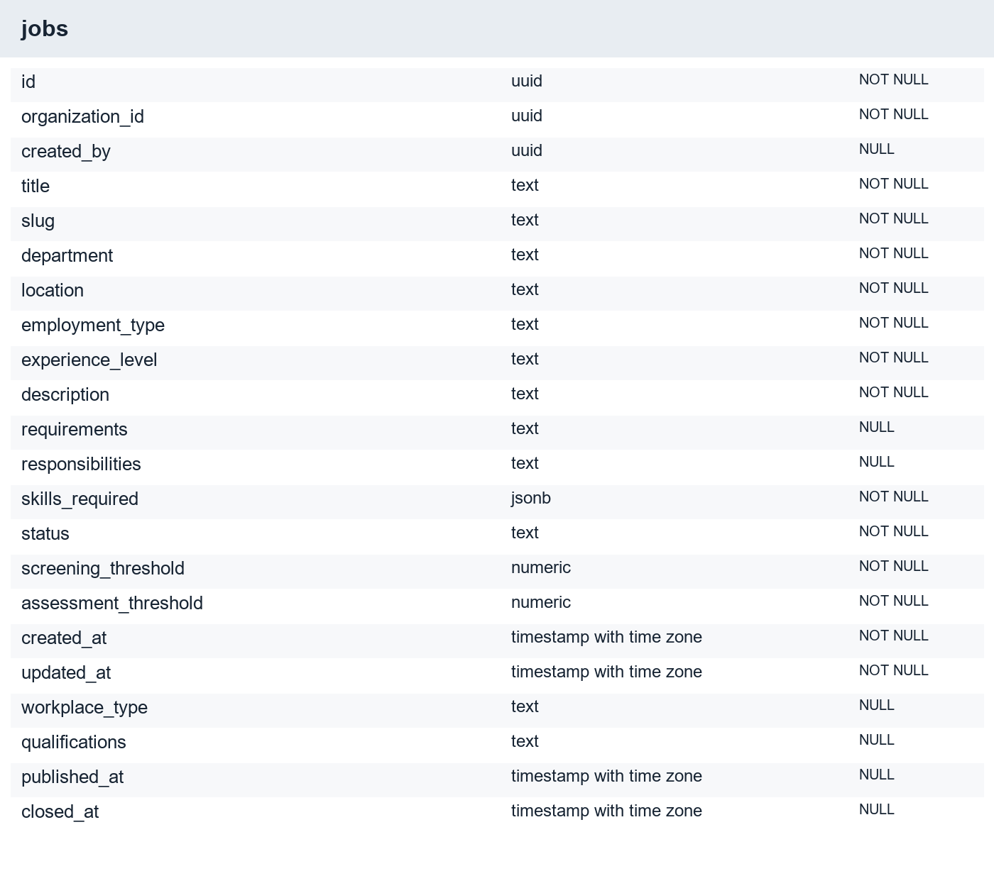
Figure 15 Migration-derived structure of jobs
A public application link should resolve only an available role. Job counts are computed through embedded aggregates. Description text becomes part of AI context and should be treated as business data, not executable instructions.
Selected constraints: FOREIGN KEY (created_by) REFERENCES auth.users(id) ON DELETE SET NULL; FOREIGN KEY (organization_id) REFERENCES organizations(id) ON DELETE CASCADE; UNIQUE (organization_id, slug).

B.5 CANDIDATES
Candidates store organization-scoped contact and profile information.
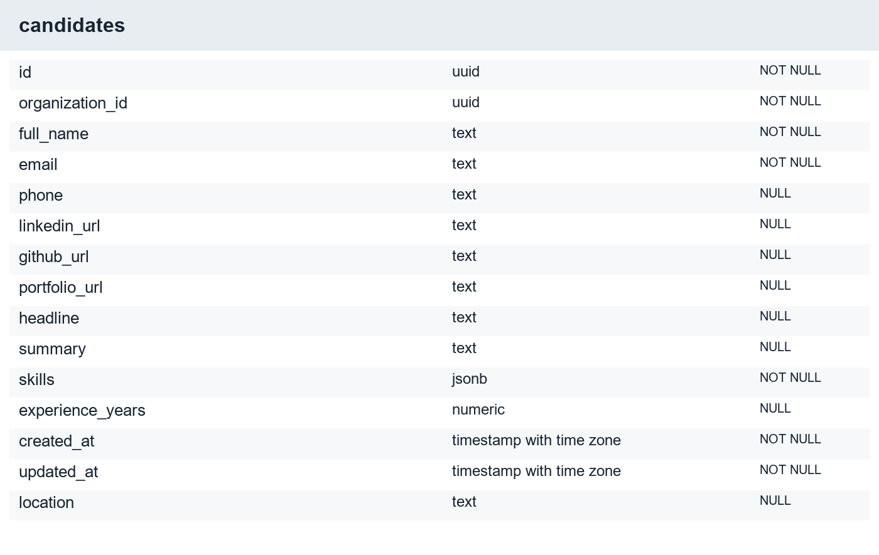
Figure 16 Migration-derived structure of candidates
The person record is distinct from an application. The application binds the person to one job and workflow. Contact identifiers require tenant-aware handling; they are not globally shared recruiter records.
Selected constraints: FOREIGN KEY (organization_id) REFERENCES organizations(id) ON DELETE CASCADE; UNIQUE (organization_id, email).

B.6 APPLICATIONS
Applications are the central link between a candidate, a job and workflow progress.
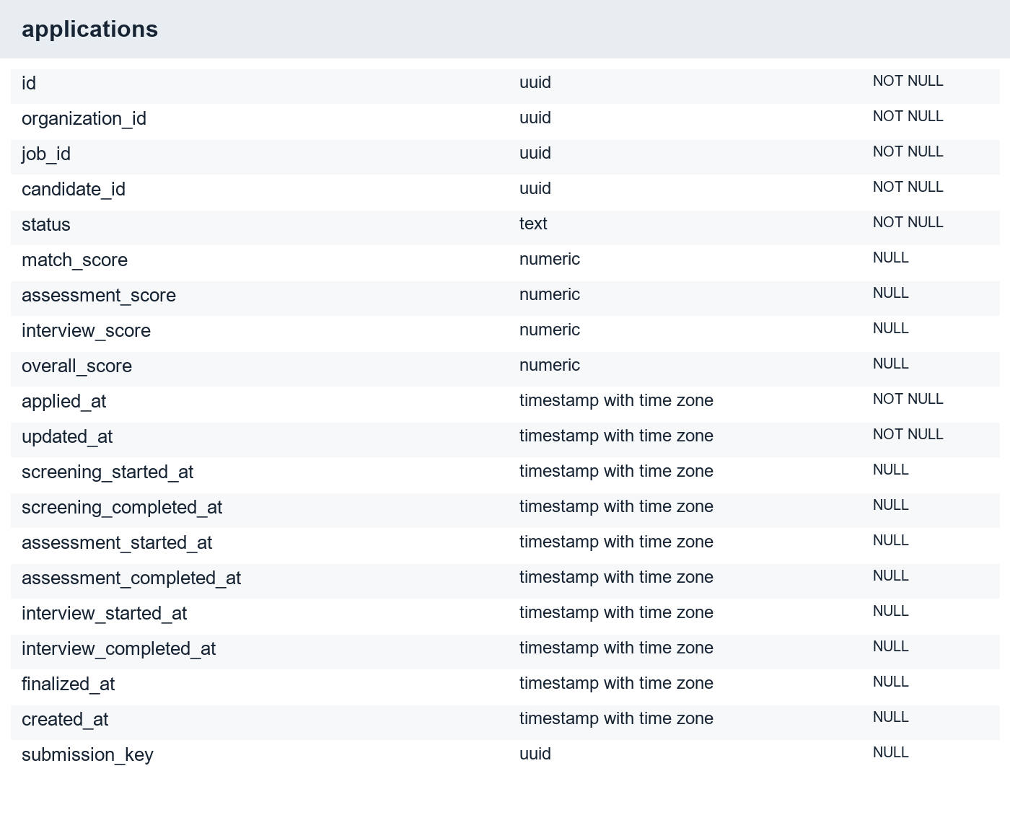
Figure 17 Migration-derived structure of applications
Submission keys support retry-safe creation. Stage timestamps and status must remain consistent with persisted screening, assessment and interview evidence. The row is not a substitute for the stage records.
Selected constraints: FOREIGN KEY (organization_id) REFERENCES organizations(id) ON DELETE CASCADE; FOREIGN KEY (job_id, organization_id) REFERENCES jobs(id, organization_id) ON DELETE CASCADE NOT VALID; UNIQUE (job_id, candidate_id).

B.7 CANDIDATE DOCUMENTS
Document records bind private storage objects and extracted text to candidate evidence.
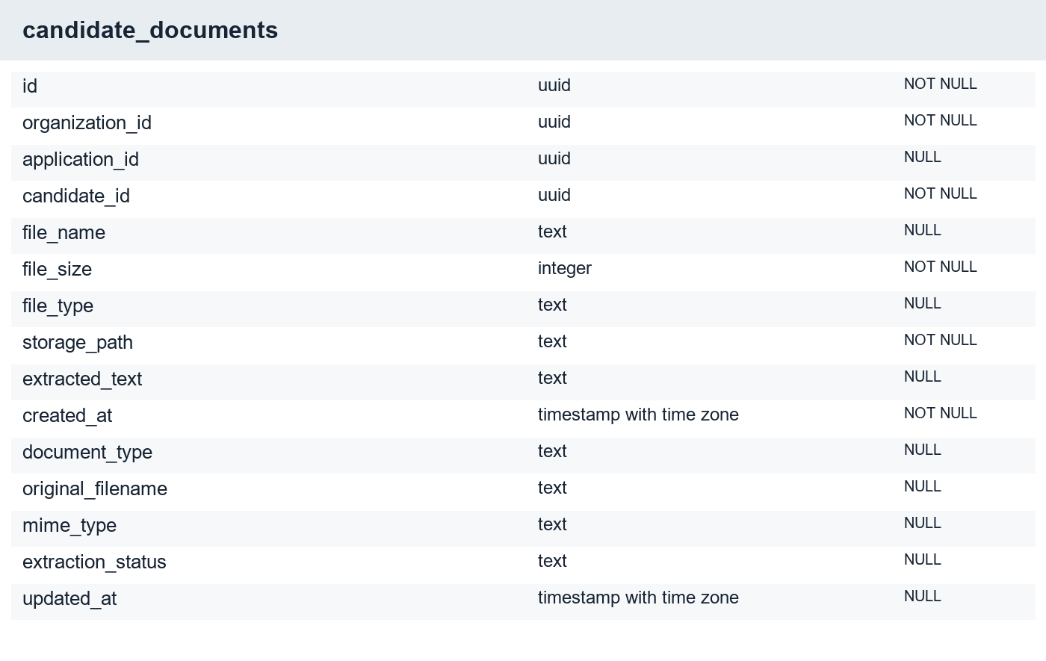
Figure 18 Migration-derived structure of candidate_documents
Legacy file_name/file_type and aligned original_filename/mime_type fields may coexist. Compatibility columns are retained to avoid data loss. A storage path is not a public URL, and extracted text remains sensitive candidate data.
Selected constraints: FOREIGN KEY (organization_id) REFERENCES organizations(id) ON DELETE CASCADE; FOREIGN KEY (application_id) REFERENCES applications(id) ON DELETE CASCADE; FOREIGN KEY (candidate_id) REFERENCES candidates(id) ON DELETE CASCADE.

B.8 CV SCREENINGS
Screening records store match scores and structured supporting evidence.
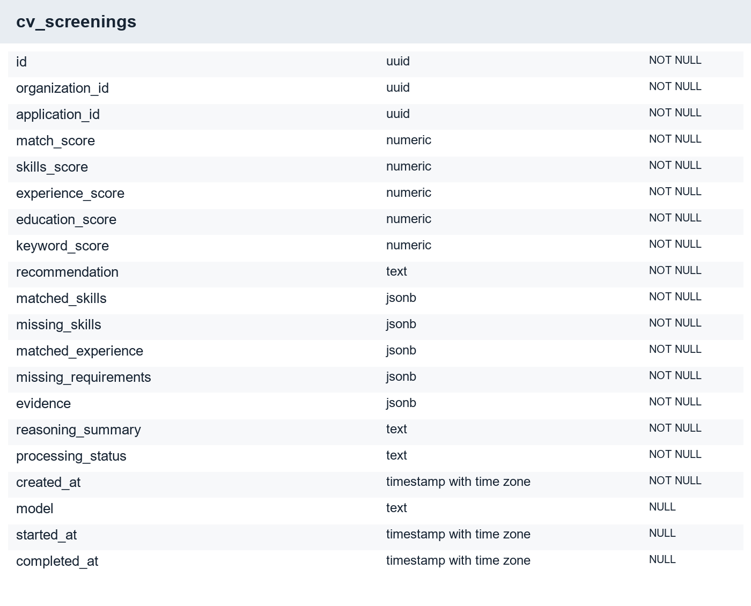
Figure 19 Migration-derived structure of cv_screenings
A completed result is reused on retry. Recommendation bands and qualification are derived by server rules. Evidence JSON is model-produced and still requires recruiter inspection against the resume.
Selected constraints: UNIQUE (application_id); FOREIGN KEY (organization_id) REFERENCES organizations(id) ON DELETE CASCADE; FOREIGN KEY (application_id) REFERENCES applications(id) ON DELETE CASCADE.

B.9 ASSESSMENTS
Assessment records hold lifecycle state and aggregate performance.
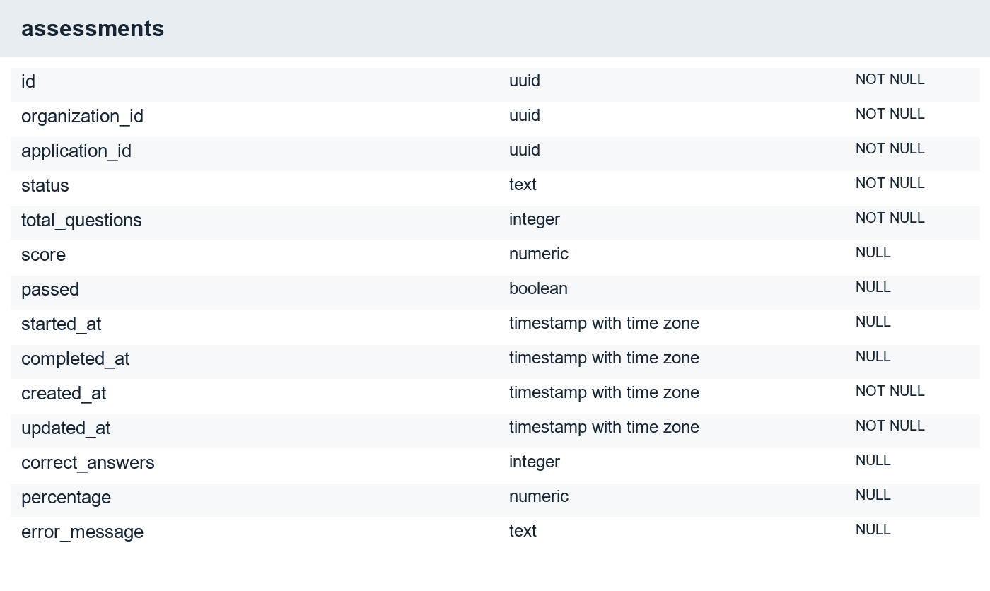
Figure 20 Migration-derived structure of assessments
The completed result is derived by the database from authoritative answers. Score, percentage and legacy pass fields can coexist under the alignment migration. Clients do not write a trusted final score directly.
Selected constraints: UNIQUE (application_id); FOREIGN KEY (application_id) REFERENCES applications(id) ON DELETE CASCADE; FOREIGN KEY (organization_id) REFERENCES organizations(id) ON DELETE CASCADE.

B.10 ASSESSMENT QUESTIONS
Questions contain both the public choices and private answer key.
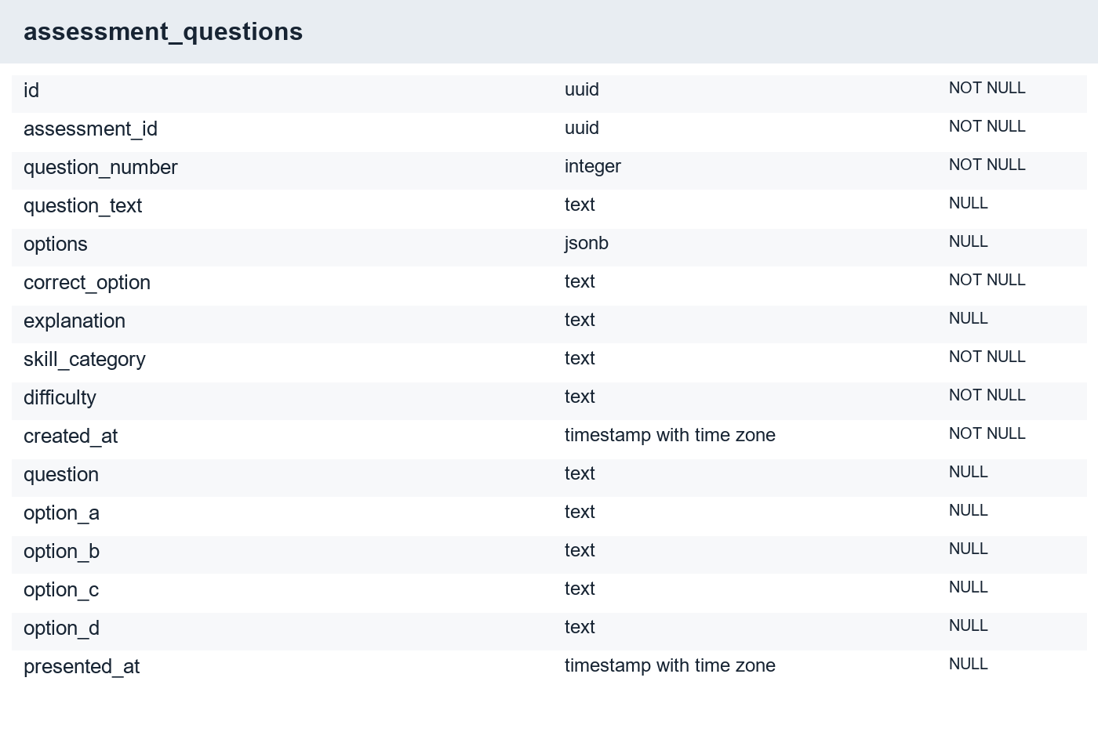
Figure 21 Migration-derived structure of assessment_questions
Public responses omit correct_option and explanation where the candidate must not see them. Numbering is unique within an assessment. The generator validates a complete ten-question sequence before use.
Selected constraints: FOREIGN KEY (assessment_id) REFERENCES assessments(id) ON DELETE CASCADE; UNIQUE (assessment_id, question_number).

B.11 ASSESSMENT ANSWERS
Answer records preserve the authoritative selected option and timing evidence.
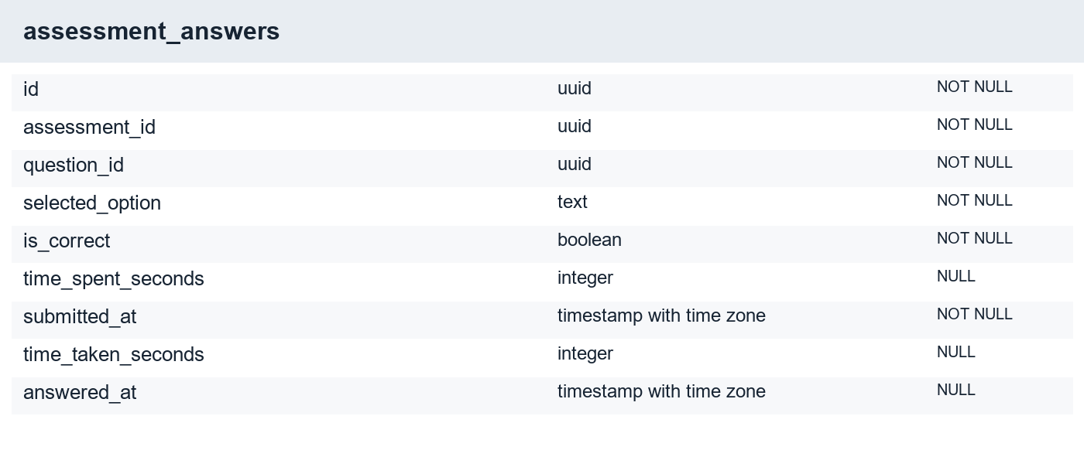
Figure 22 Migration-derived structure of assessment_answers
Question ownership and order are checked before persistence. Repeated submissions do not replace an earlier answer. Legacy time_spent_seconds and aligned time_taken_seconds are compatibility concerns, not two separate clocks.
Selected constraints: FOREIGN KEY (question_id) REFERENCES assessment_questions(id) ON DELETE CASCADE; FOREIGN KEY (assessment_id) REFERENCES assessments(id) ON DELETE CASCADE; UNIQUE (assessment_id, question_id).

B.12 INTERVIEWS
Interview records identify the application interview and its lifecycle.
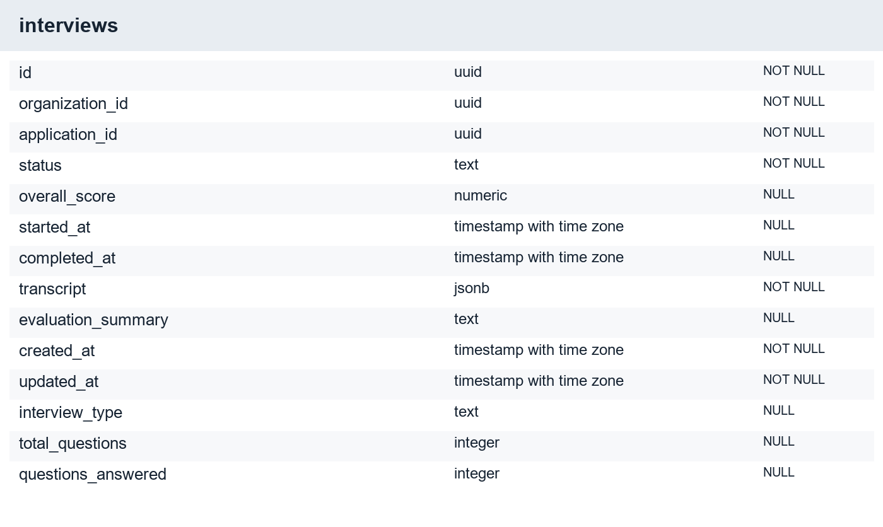
Figure 23 Migration-derived structure of interviews
Initialization follows eligible preceding stages. Status must not be advanced independently of response persistence. The current application uses five questions rather than an unbounded conversational session.
Selected constraints: UNIQUE (application_id); FOREIGN KEY (application_id) REFERENCES applications(id) ON DELETE CASCADE; FOREIGN KEY (organization_id) REFERENCES organizations(id) ON DELETE CASCADE.

B.13 INTERVIEW QUESTIONS
Interview questions preserve the prompts presented to a candidate.
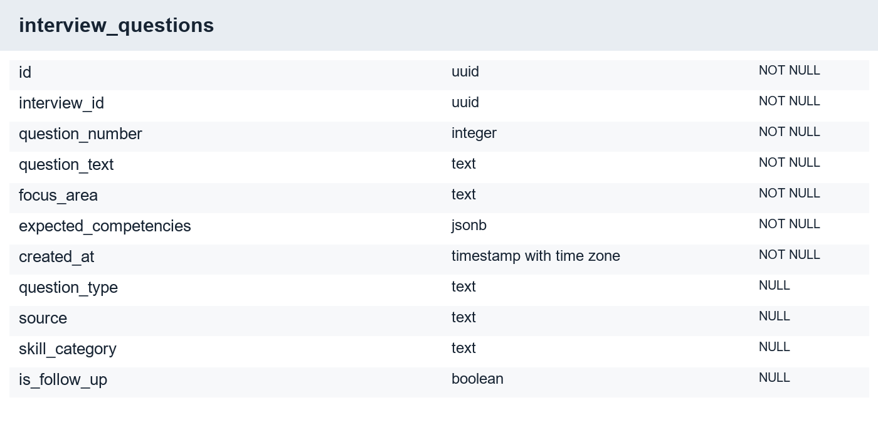
Figure 24 Migration-derived structure of interview_questions
Speech synthesis uses stored question text after verifying that the question belongs to the interview. This prevents a candidate from asking the speech endpoint to read arbitrary unrelated question content.
Selected constraints: FOREIGN KEY (interview_id) REFERENCES interviews(id) ON DELETE CASCADE; UNIQUE (interview_id, question_number).

B.14 INTERVIEW RESPONSES
Responses connect candidate text with technical, communication and relevance scores.
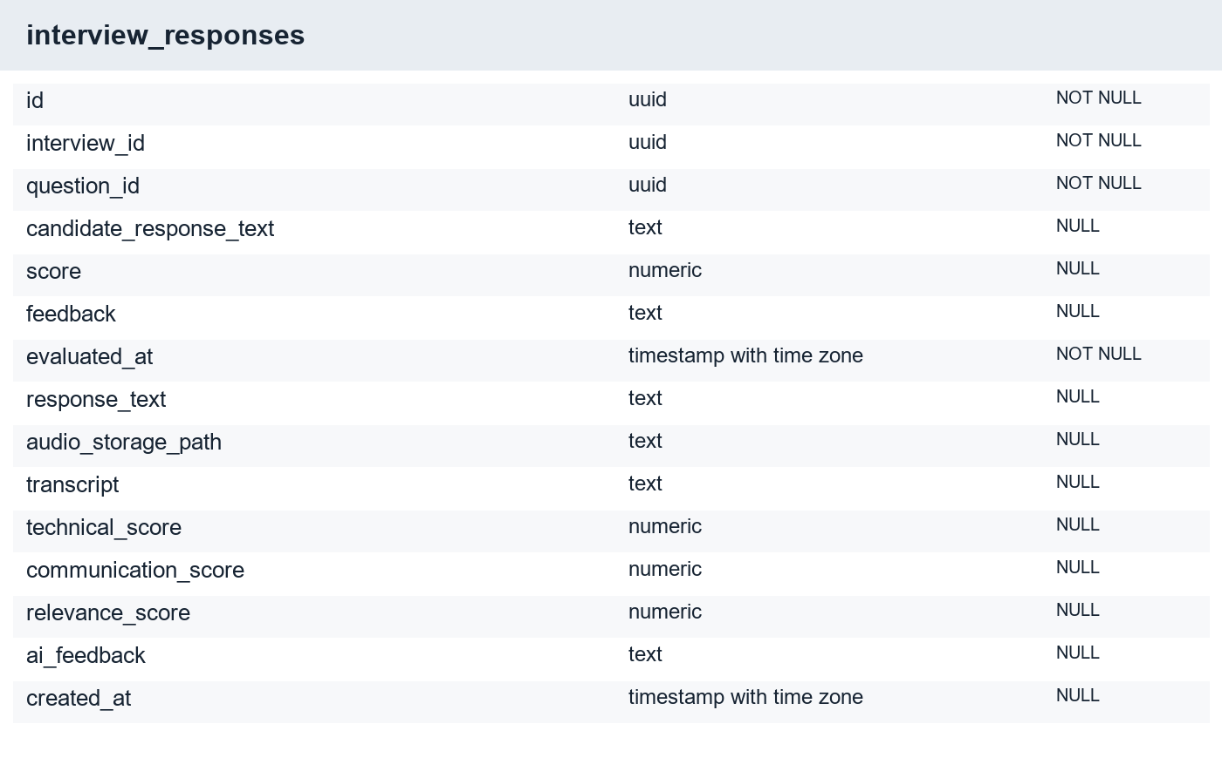
Figure 25 Migration-derived structure of interview_responses
The response and scorecard are persisted together through a controlled function. A repeated submission can return the saved result. Transcript review happens before the text becomes the authoritative answer.
Selected constraints: FOREIGN KEY (question_id, interview_id) REFERENCES interview_questions(id, interview_id) NOT VALID; FOREIGN KEY (question_id) REFERENCES interview_questions(id) ON DELETE CASCADE; FOREIGN KEY (interview_id) REFERENCES interviews(id) ON DELETE CASCADE.

B.15 FINAL EVALUATIONS
Final evaluations combine stage scores and retain review evidence.
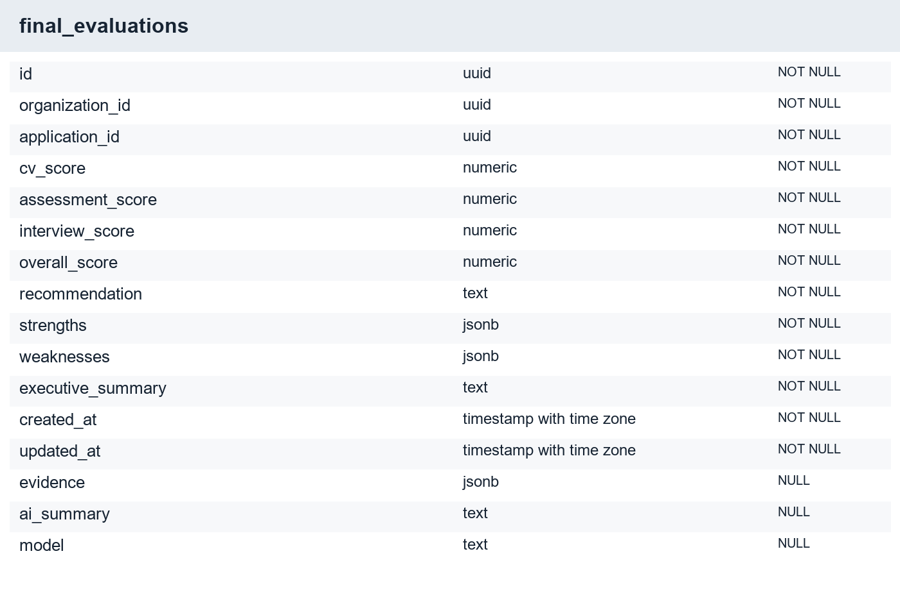
Figure 26 Migration-derived structure of final_evaluations
The composite weights are fixed project rules. Generated recommendation and recruiter decision have different meanings. Evaluation retries preserve an existing review decision instead of returning the application to an earlier stage.
Selected constraints: UNIQUE (application_id); FOREIGN KEY (organization_id) REFERENCES organizations(id) ON DELETE CASCADE; FOREIGN KEY (application_id) REFERENCES applications(id) ON DELETE CASCADE.

B.16 AI ACTIVITY LOGS
Historical AI activity records are retained for compatibility.
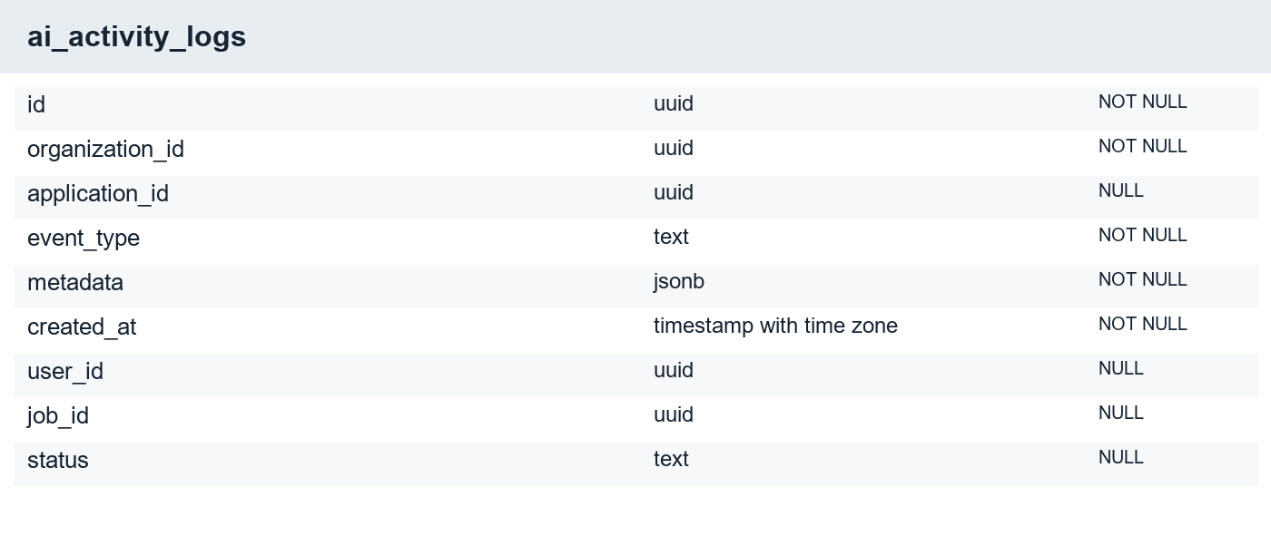
Figure 27 Migration-derived structure of ai_activity_logs
The Activity user interface and current writers were removed. This table is not evidence of an active audit feature. Existing records were preserved rather than deleted as part of cosmetic cleanup.
Selected constraints: FOREIGN KEY (organization_id) REFERENCES organizations(id) ON DELETE CASCADE; FOREIGN KEY (application_id) REFERENCES applications(id) ON DELETE SET NULL.

B.17 SECURITY AUDIT LOGS
A retained security-log structure exists in the canonical schema.
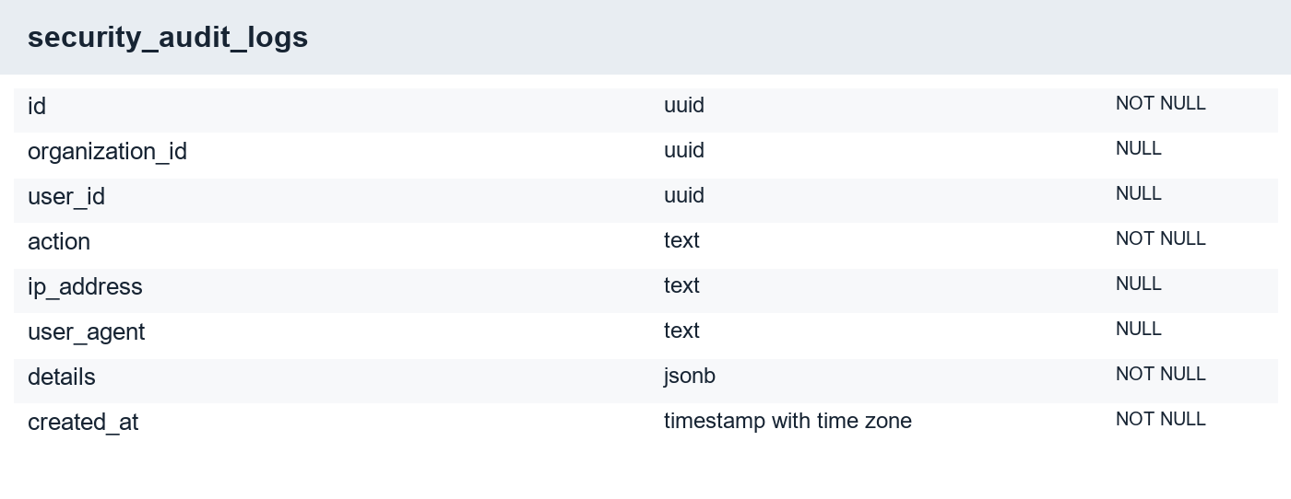
Figure 28 Migration-derived structure of security_audit_logs
The presence of a table does not establish comprehensive audit coverage. The thesis does not claim that every security-sensitive event is written here. Operational logging and retention require explicit verification.
Selected constraints: FOREIGN KEY (user_id) REFERENCES auth.users(id) ON DELETE SET NULL; FOREIGN KEY (organization_id) REFERENCES organizations(id) ON DELETE SET NULL.

APPENDIX C
INTERFACE EVIDENCE AND USER GUIDE
Public pages were captured from the local frontend. The principal workspace screens were captured from the deployed Vercel application on 20 September 2026 after the project owner signed in. These figures show the displayed workspace records and saved evidence. Capture was read-only: no application decisions or settings were changed.
Onboarding, the candidate assessment and interview compositions remain explicitly labelled component fixtures. The interview frame marker is not a live avatar. The live captures demonstrate accessible page states; they are not a newly recorded end-to-end acceptance test, performance benchmark or proof that every local change is deployed. Some figures contain account or candidate contact details; publication requires the appropriate permission and disclosure review.

C.1 ORGANIZATION ONBOARDING
Evidence type: Actual component fixture.
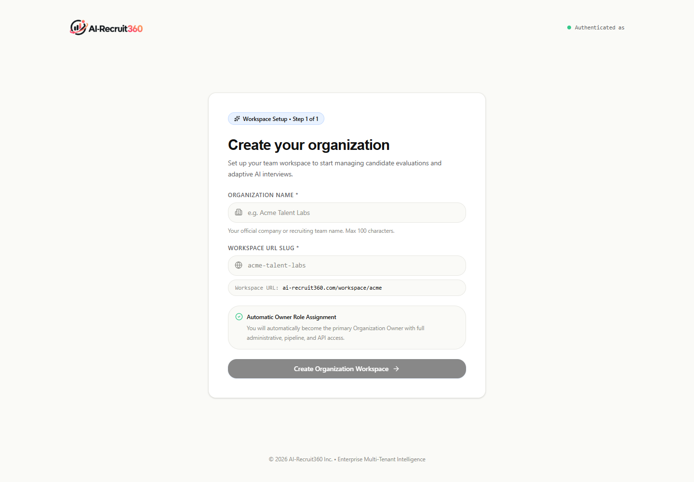
Figure 29 Organization onboarding — Actual component fixture
An authenticated recruiter without an organization can create a workspace. The fixture illustrates the setup form without creating a live organization. Membership validation remains server-controlled.

C.2 JOB CREATION FORM
Evidence type: Authenticated deployed capture.
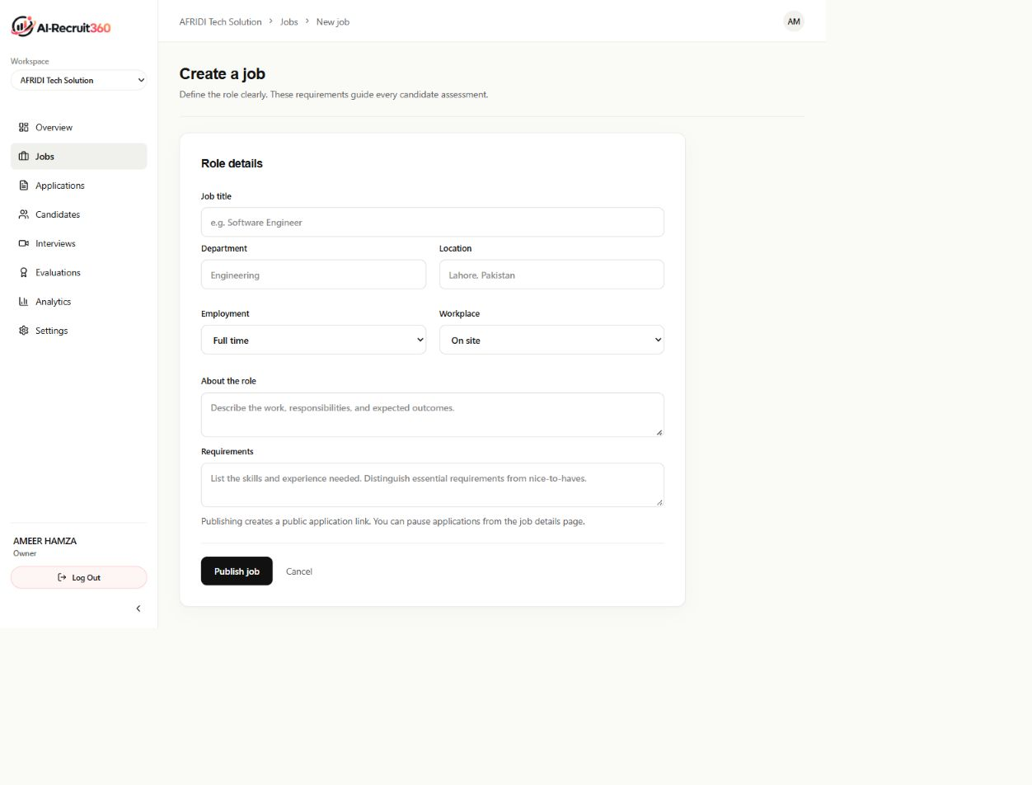
Figure 30 Job creation form — Authenticated deployed capture
The authenticated form collects role details and requirements before publication. This capture did not publish or modify a vacancy.

C.3 ACCOUNT AND WORKSPACE SETTINGS
Evidence type: Authenticated deployed capture.
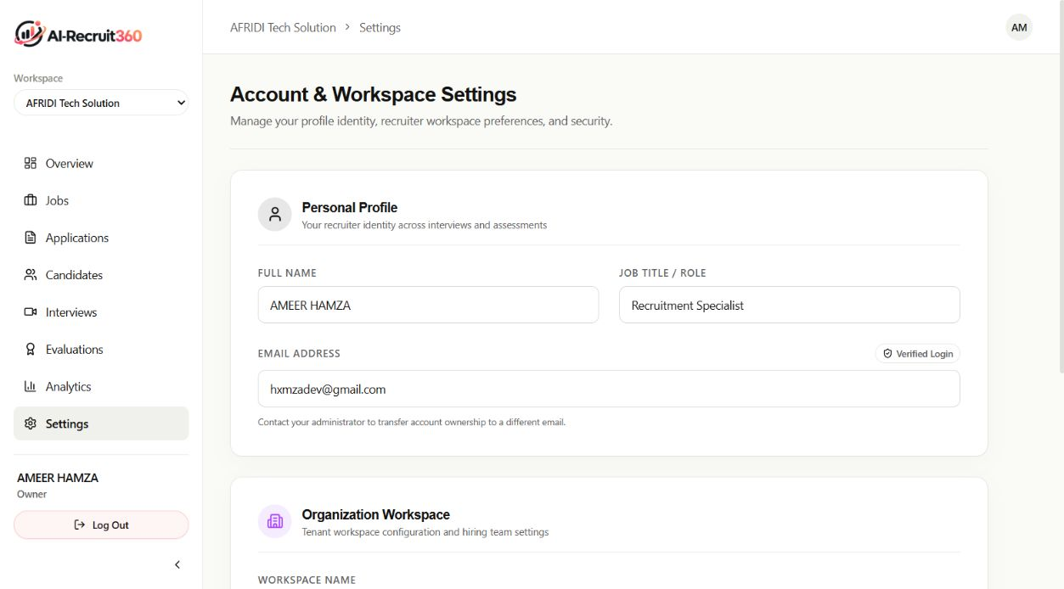
Figure 31 Account and workspace settings — Authenticated deployed capture
The signed-in owner can view profile and workspace configuration. This capture did not submit changes. Visible explanatory copy describes intended protection; it is not evidence of an independent compliance certification.

C.4 TIMED ASSESSMENT QUESTION
Evidence type: Actual component with synthetic data.
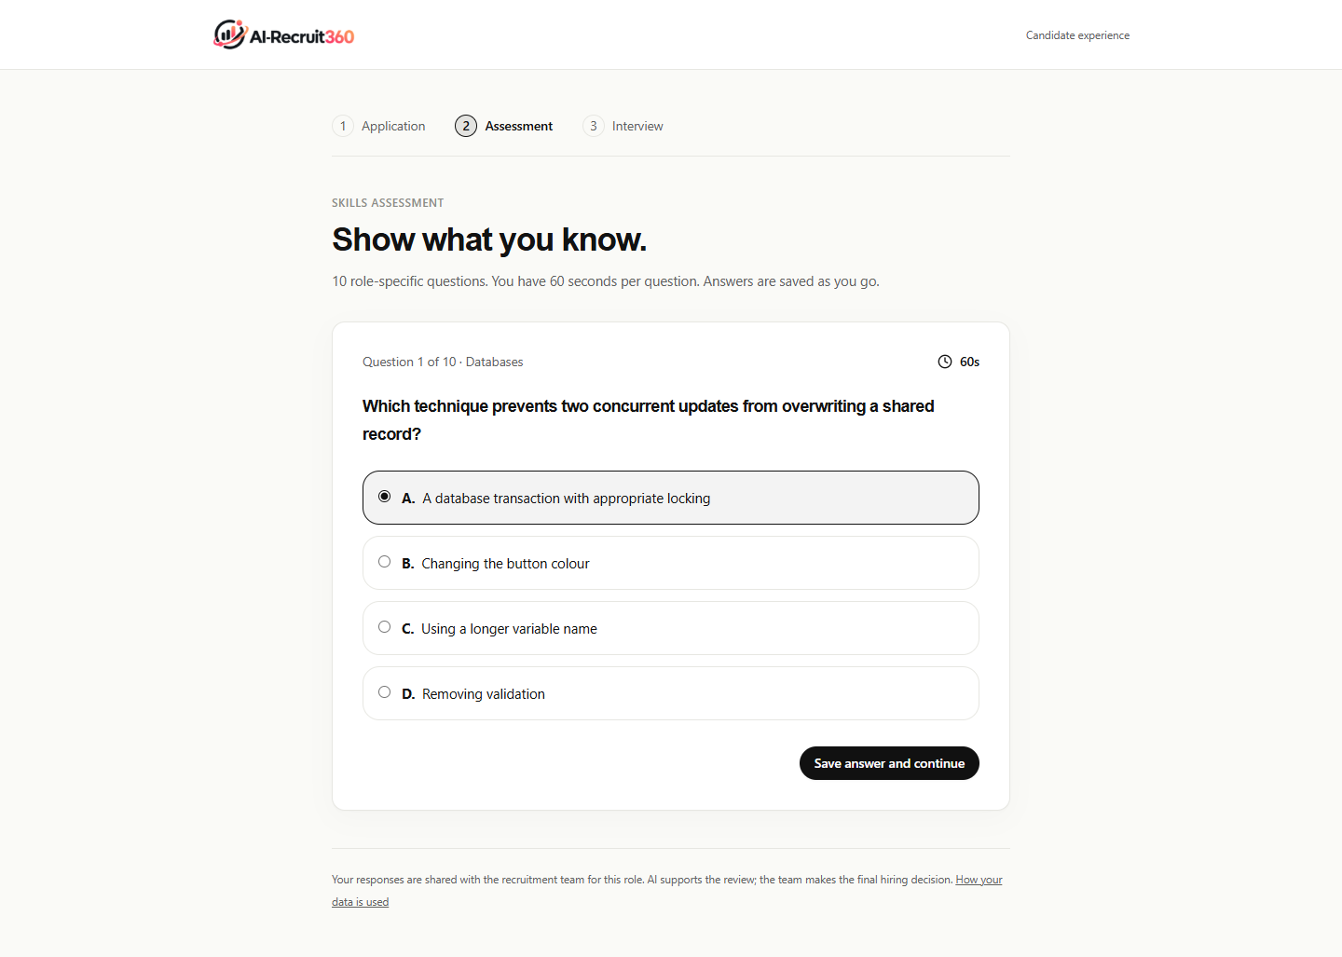
Figure 32 Timed assessment question — Actual component with synthetic data
The figure shows a sample question, four choices and a visible countdown. The database remains authoritative on deadlines and immutable answers. The sample question is fixture content rather than a real generated candidate assessment.

C.5 LANDING PAGE
Evidence type: Local public page.
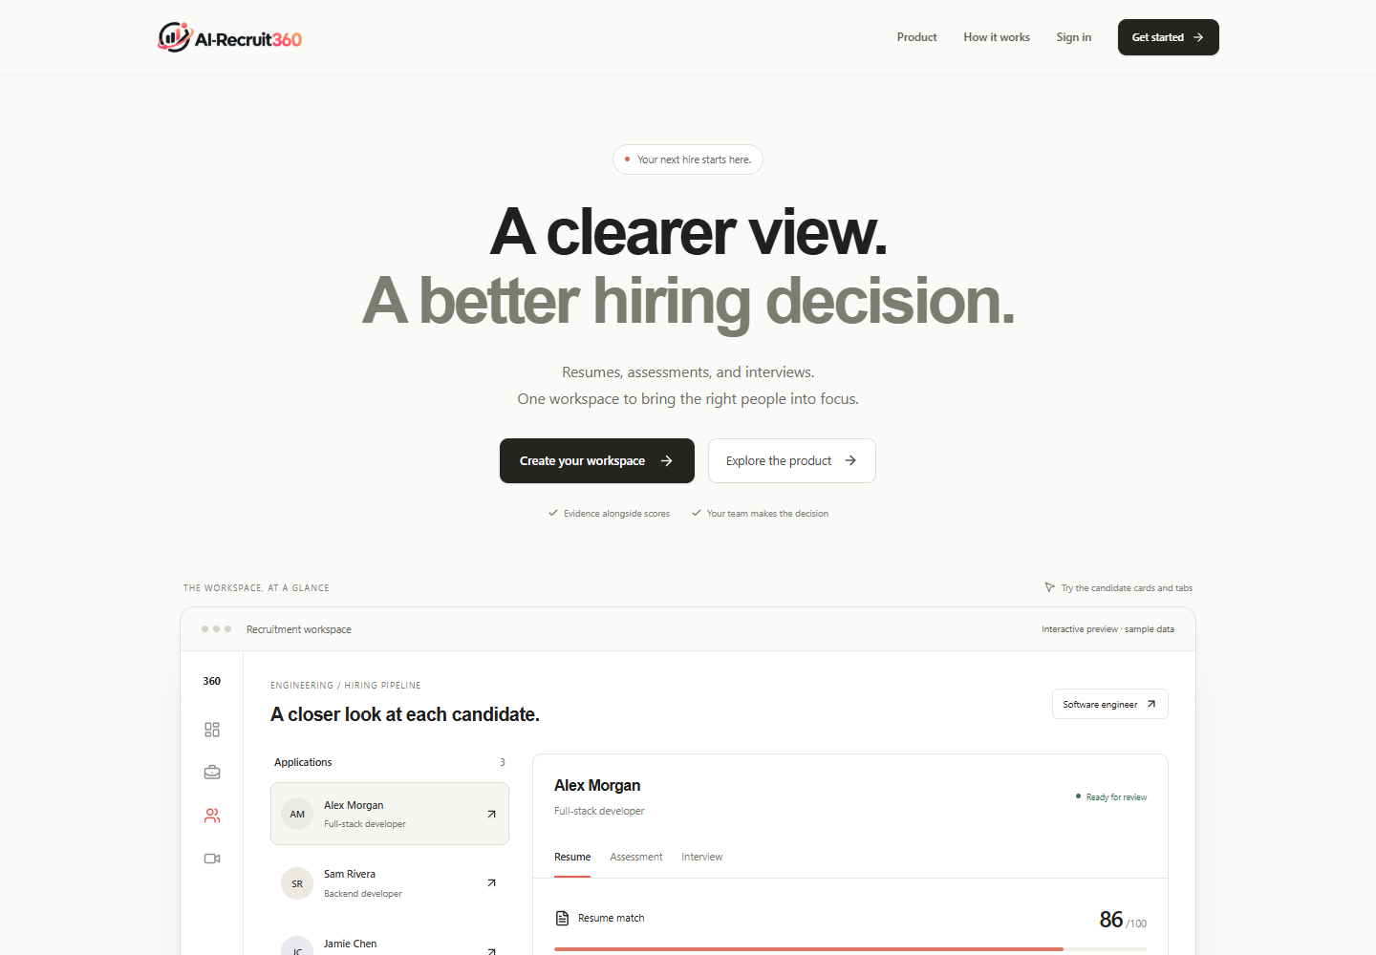
Figure 33 Landing page — Local public page
The landing page introduces the recruitment workflow and provides entry points for account creation and sign-in. Its sample preview is labelled as sample data. Selecting a preview candidate is a local interaction and does not read a real candidate record.

C.6 RECRUITER SIGN-IN
Evidence type: Local public page.
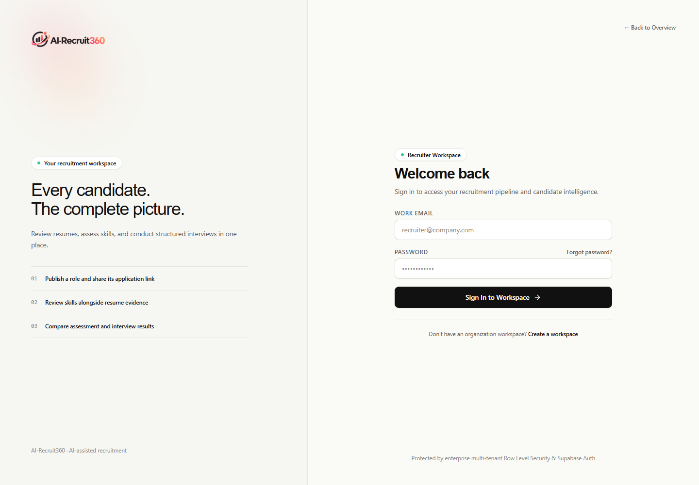
Figure 34 Recruiter sign-in — Local public page
Enter the account email and password. Failed credentials restore the form; stalled authentication has a bounded waiting period. Successful authentication establishes cookies before workspace navigation. The screenshot does not demonstrate a real login.

C.7 ACCOUNT REGISTRATION
Evidence type: Local public page.
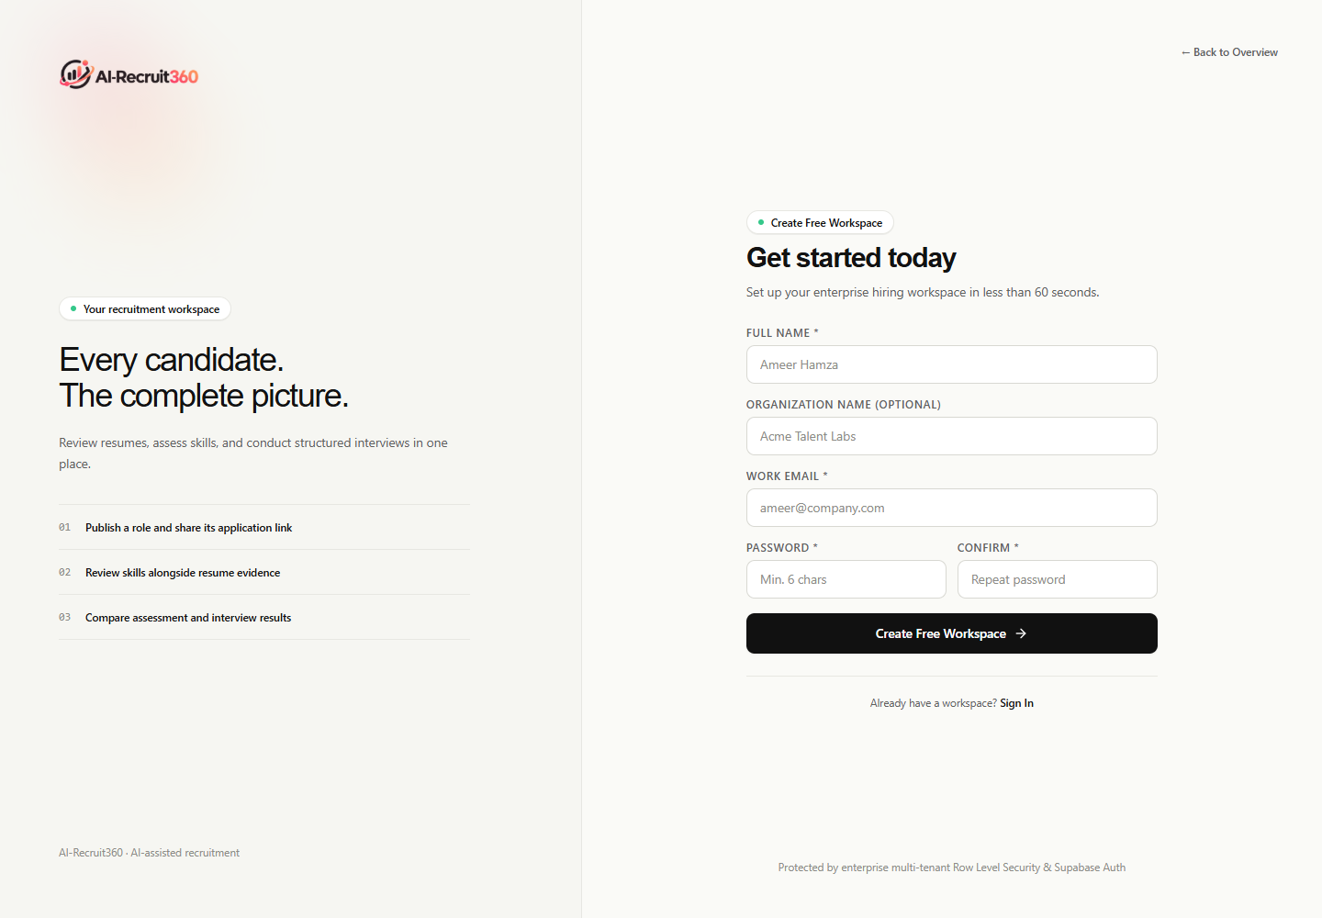
Figure 35 Account registration — Local public page
Registration starts recruiter account creation. Email confirmation depends on provider configuration and callback allowlists. Account creation and organization creation are separate steps, which prevents a display name from becoming an implicit tenant membership.

C.8 PASSWORD RECOVERY REQUEST
Evidence type: Local public page.
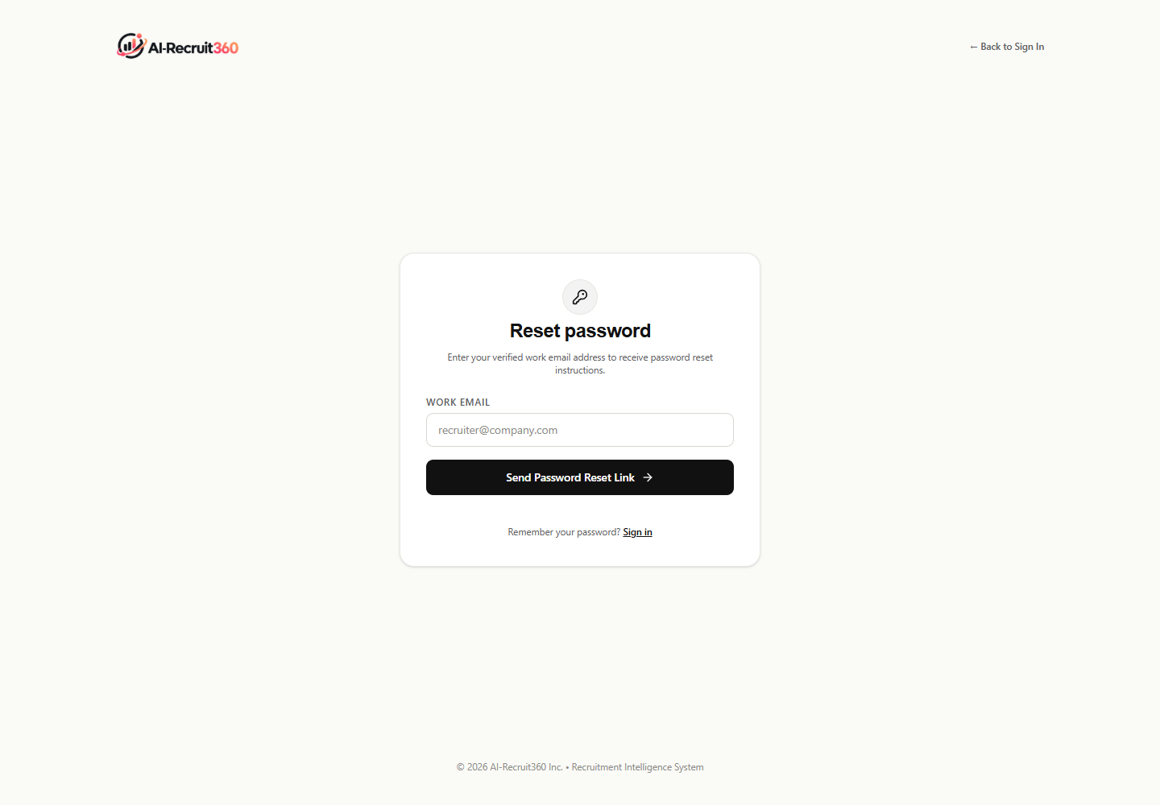
Figure 36 Password recovery request — Local public page
Request a recovery email using the account address. The local and deployed callback environments must be configured correctly. The presence of this form is not evidence that email delivery was tested during the screenshot capture.

C.9 PASSWORD RESET ENTRY
Evidence type: Local public page.
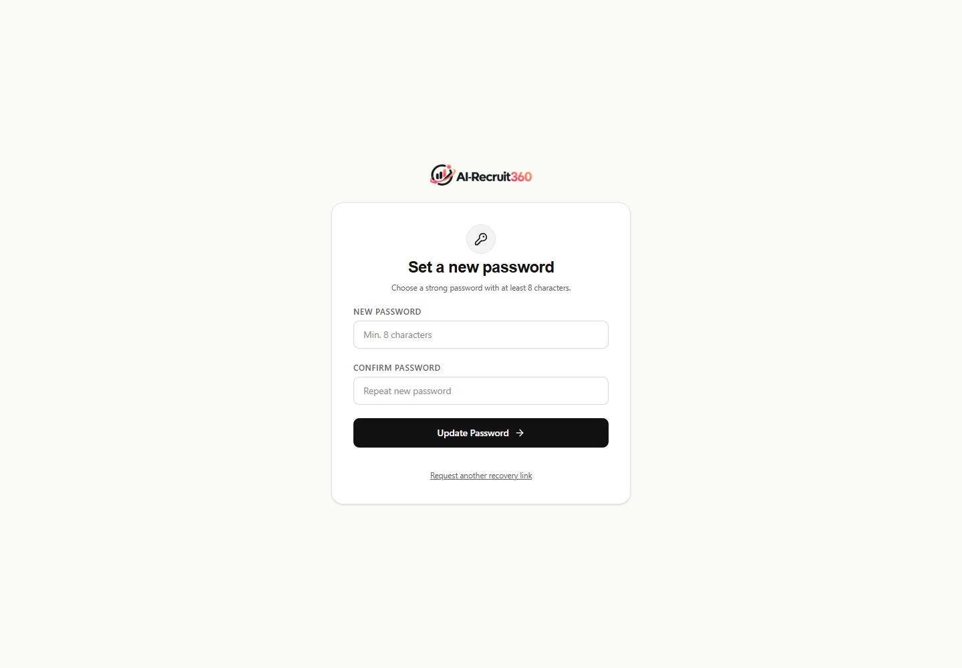
Figure 37 Password reset entry — Local public page
A password reset requires a valid recovery session. Directly opening the route may show an invalid or missing-session state. This is a security boundary, not a reason to bypass the recovery token.

C.10 CANDIDATE PRIVACY INFORMATION
Evidence type: Local public page.
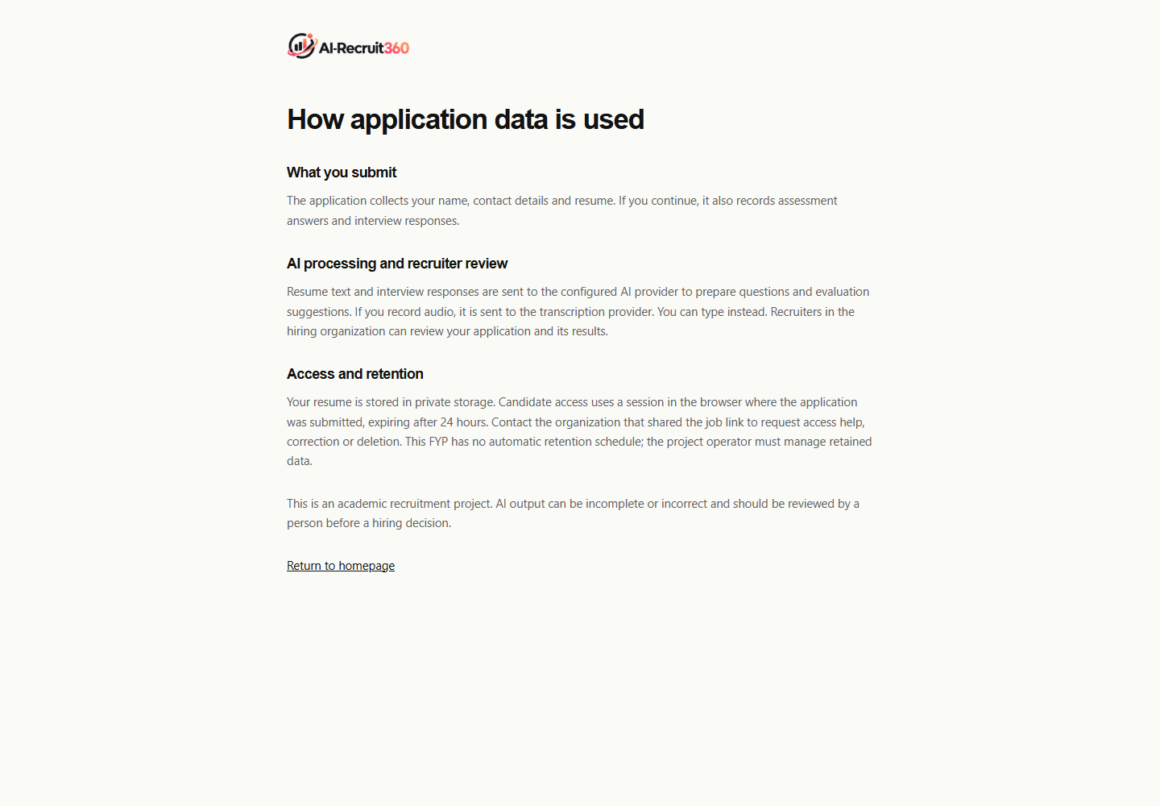
Figure 38 Candidate privacy information — Local public page
The privacy page explains the recruitment data flow and available information for candidates. An operational organization still needs a retention and correction policy. This page does not establish regulatory certification.

C.11 WORKSPACE OVERVIEW
Evidence type: Authenticated deployed capture.
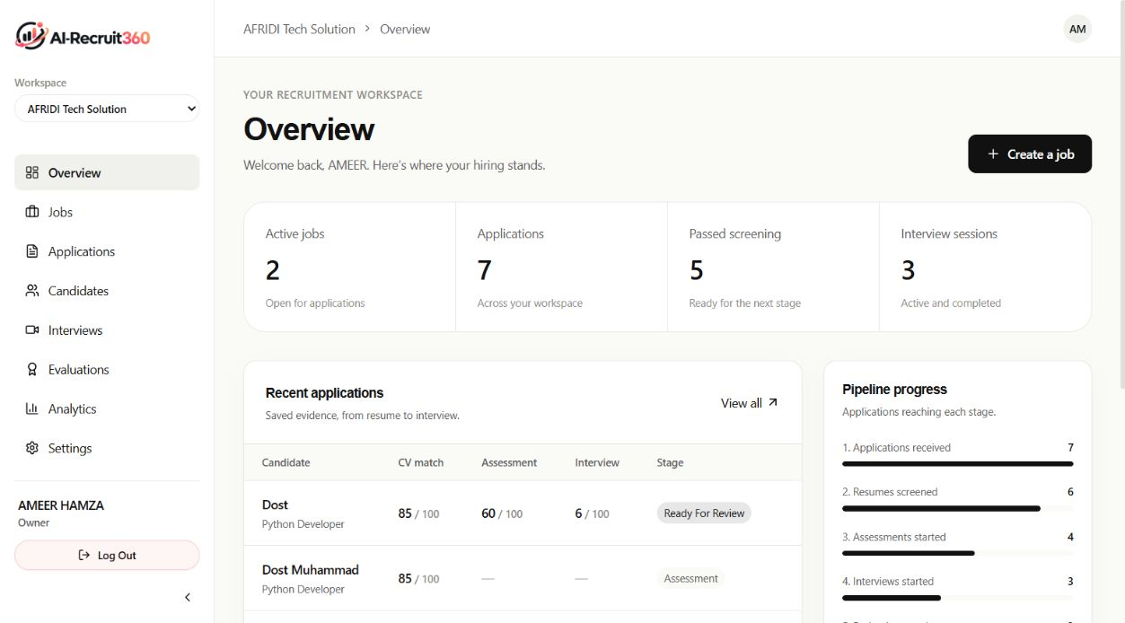
Figure 39 Workspace overview — Authenticated deployed capture
The captured workspace showed two active jobs, seven applications and three interview sessions. These are observed records at capture time, not a research sample or recruitment-quality benchmark. Counts and recent applications provide an entry point to detailed review.

C.12 JOB MANAGEMENT
Evidence type: Authenticated deployed capture.
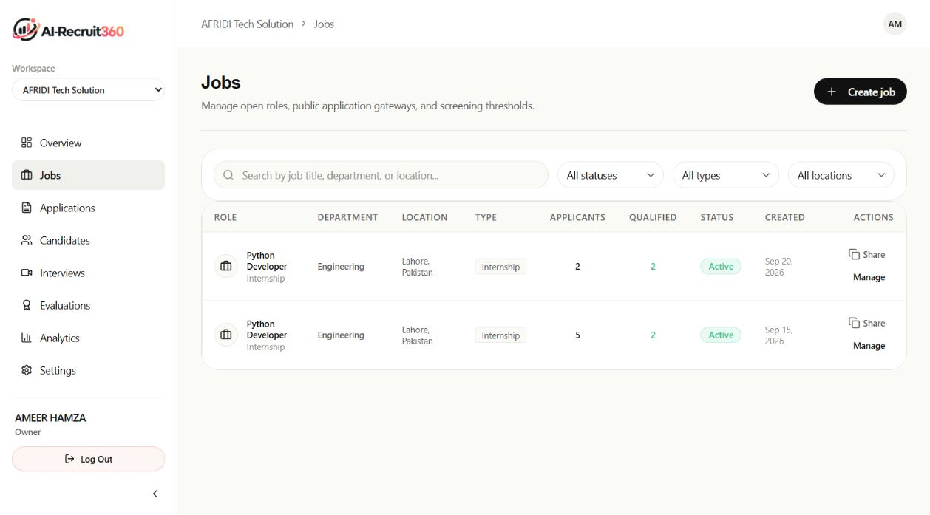
Figure 40 Job management — Authenticated deployed capture
Two published Python Developer roles were visible. Filters and management controls help the recruiter find a role and inspect its application pipeline. No job state was changed during capture.

C.13 APPLICATION LIFECYCLE
Evidence type: Authenticated deployed capture.
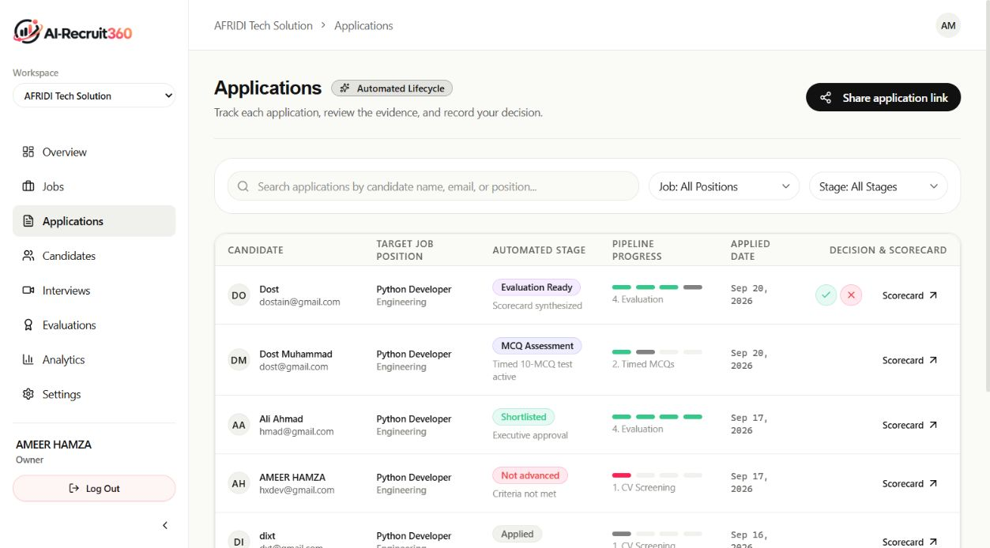
Figure 41 Application lifecycle — Authenticated deployed capture
The populated list shows saved applications at different workflow stages. Scorecard links and recruiter decision controls belong to each application. Capture did not shortlist or reject any candidate.

C.14 CANDIDATE DIRECTORY
Evidence type: Authenticated deployed capture.
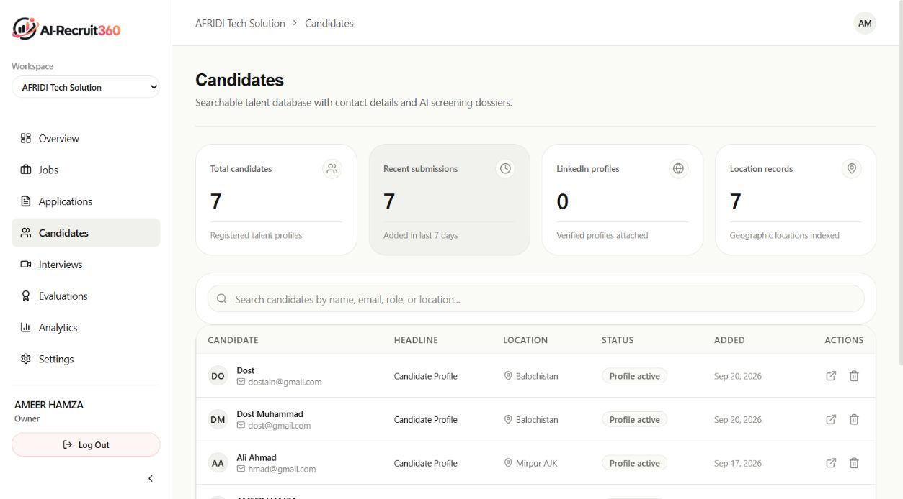
Figure 42 Candidate directory — Authenticated deployed capture
The directory displays workspace candidate records, search controls and profile actions. A person and an application remain separate data entities, allowing evidence to be associated with the intended job.

C.15 INTERVIEW REVIEW LIST
Evidence type: Authenticated deployed capture.
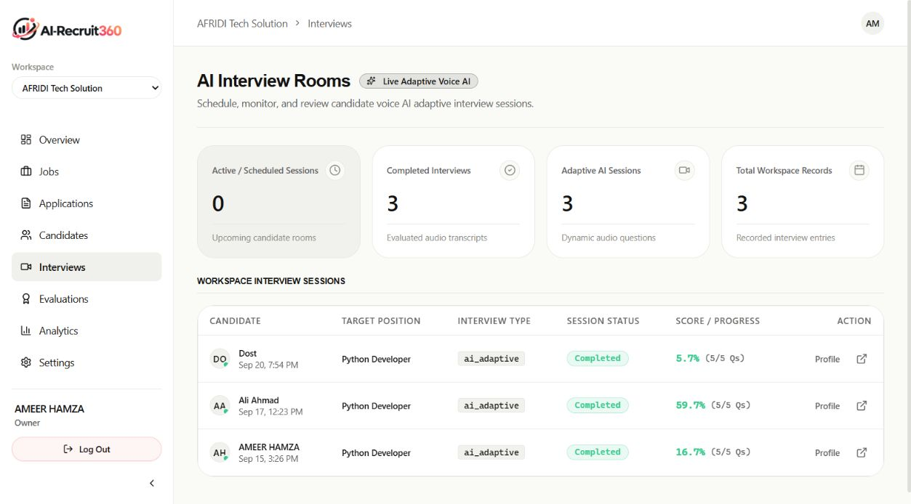
Figure 43 Interview review list — Authenticated deployed capture
Three completed sessions were visible with question progress and stored scores. Opening a completed session exposes its questions, submitted responses and feedback. These saved results predate capture and do not constitute a new live interview test.

C.16 EVALUATION REVIEW LIST
Evidence type: Authenticated deployed capture.
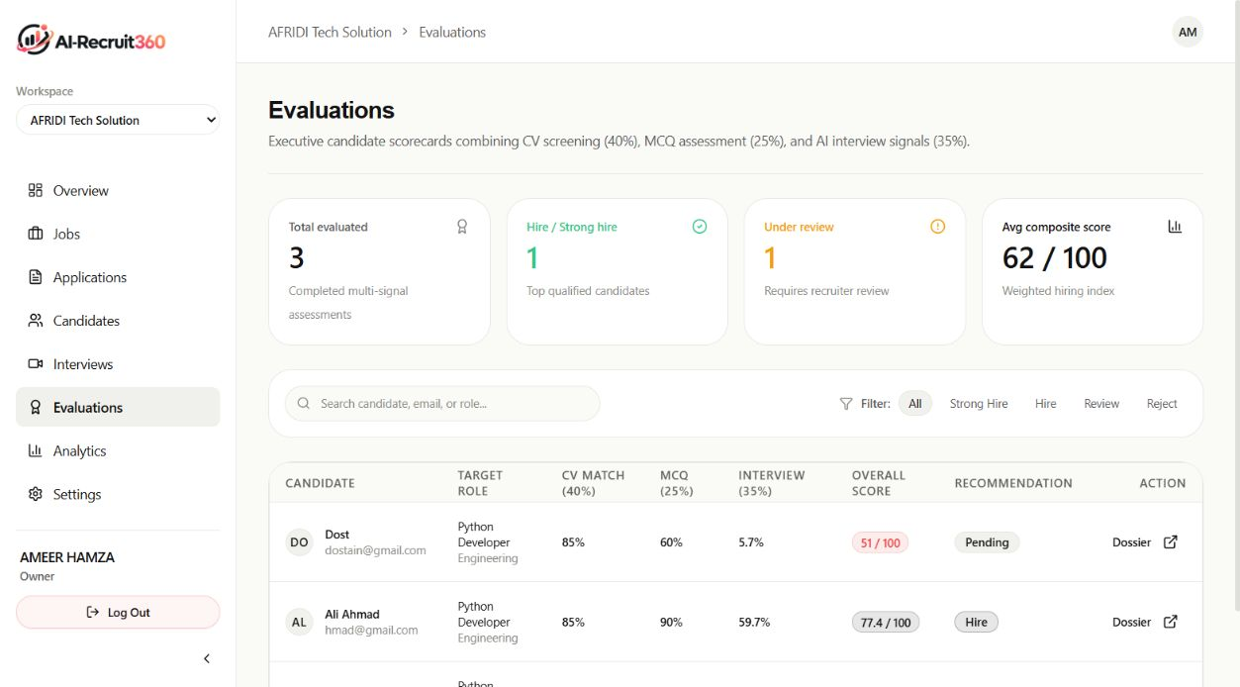
Figure 44 Evaluation review list — Authenticated deployed capture
The populated scorecards display the 40 percent resume, 25 percent assessment and 35 percent interview components. Recommendations support recruiter review. A displayed recommendation is not the final hiring decision or a validated prediction of job performance.

C.17 RECRUITMENT ANALYTICS
Evidence type: Authenticated deployed capture.
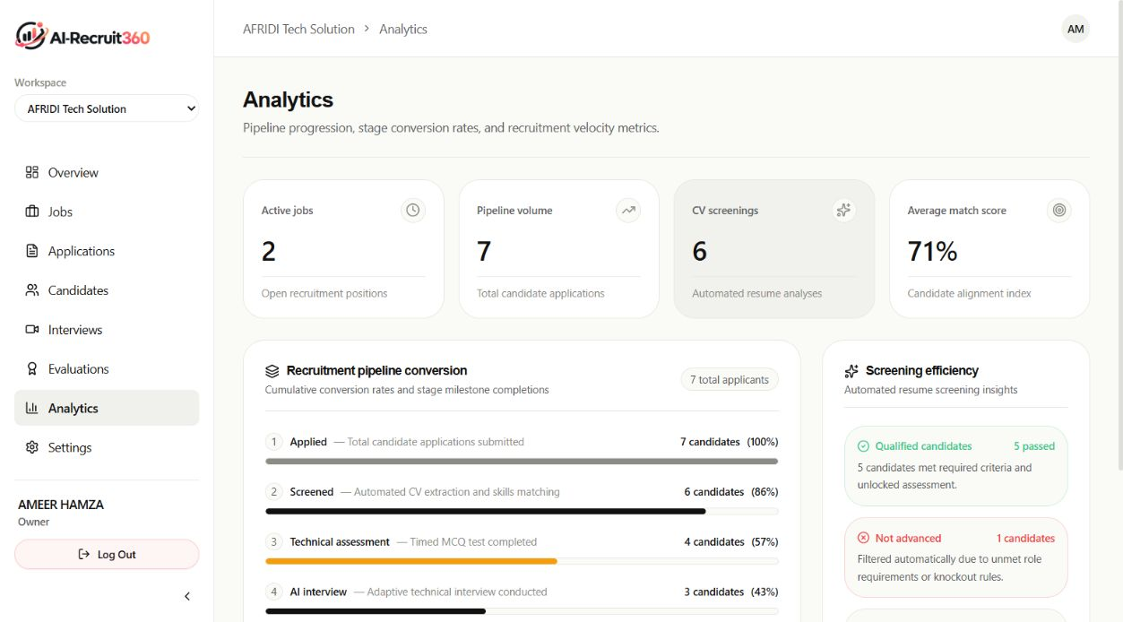
Figure 45 Recruitment analytics — Authenticated deployed capture
The deployed view summarizes recorded pipeline counts and screening results. These values describe this small workspace at capture time. They cannot support claims about general hiring accuracy, fairness or time savings.

C.18 CANDIDATE APPLICATION FORM
Evidence type: Actual component with a synthetic job.
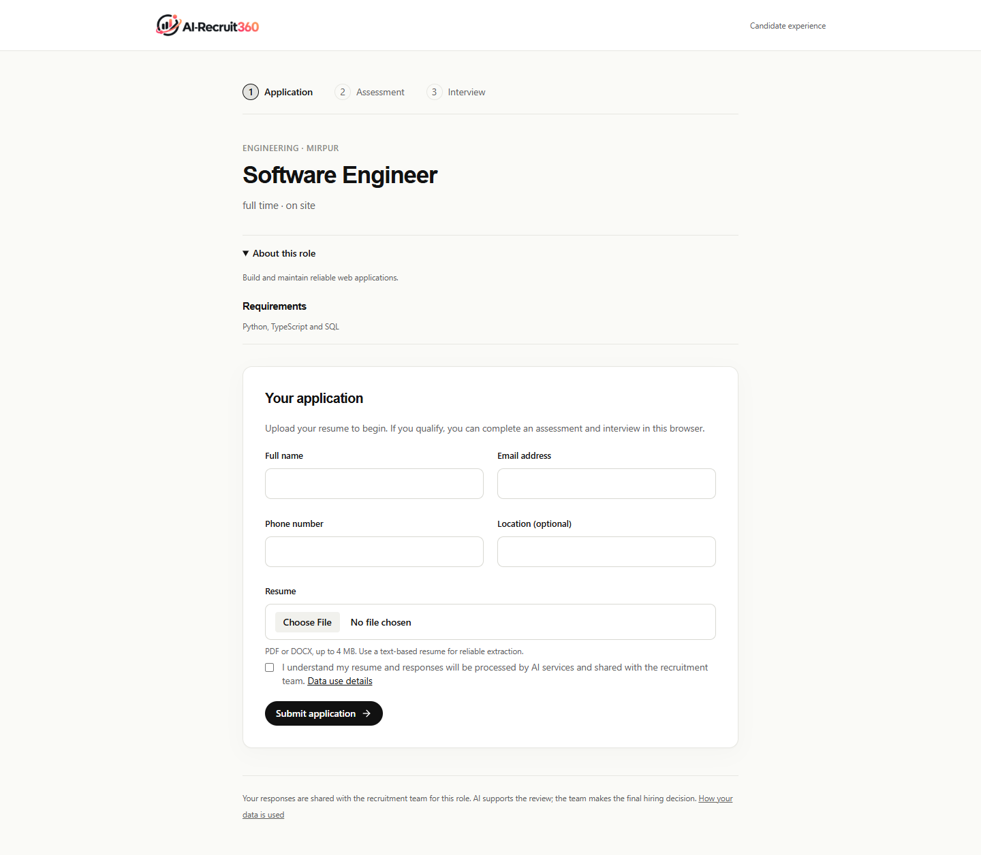
Figure 46 Candidate application form — Actual component with a synthetic job
The candidate reads the role, enters contact details and selects a resume. The form limits supported files to PDF and DOCX within four megabytes. Screening can be retried after a successful submission without implying that the resume must be uploaded again.

C.19 DESKTOP INTERVIEW COMPOSITION
Evidence type: Layout fixture with frame marker.
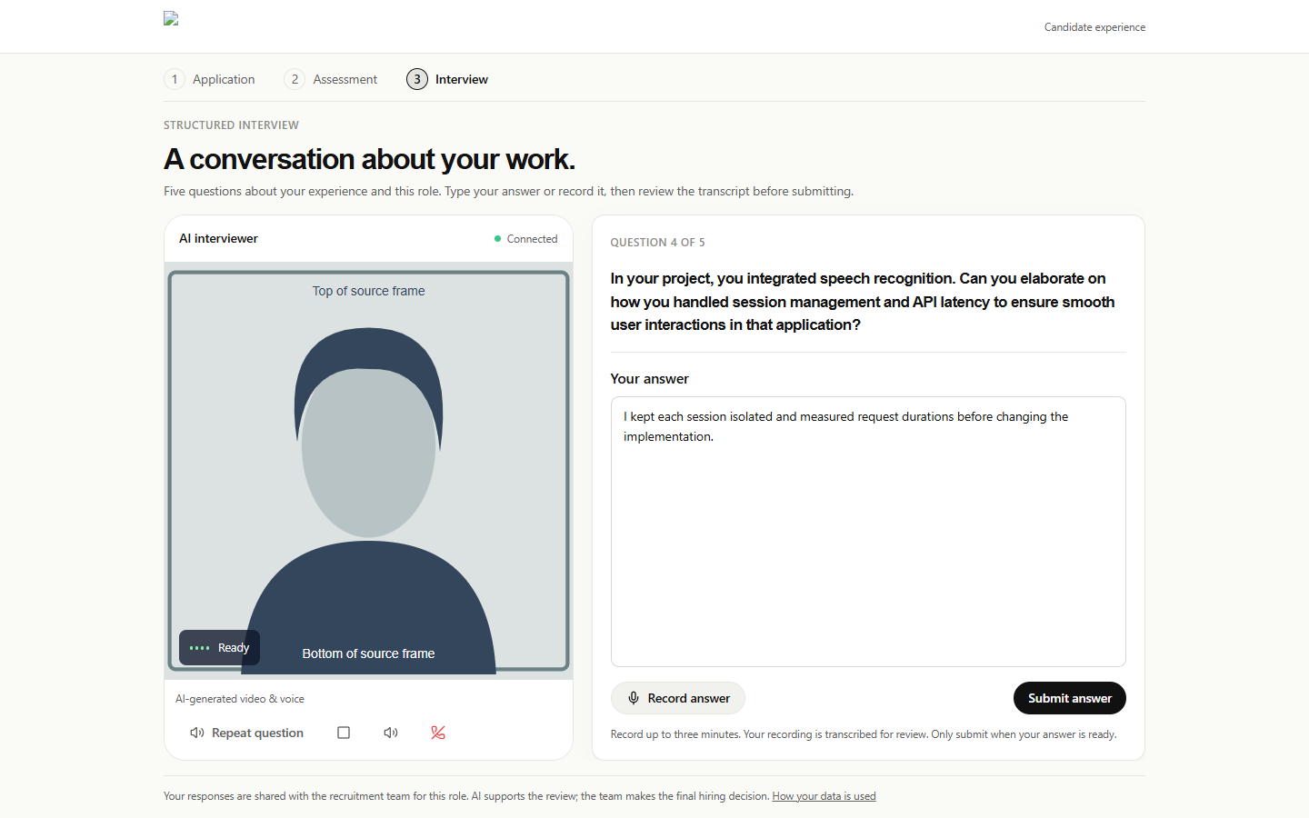
Figure 47 Desktop interview composition — Layout fixture with frame marker
The desktop composition places the full interviewer frame beside the question and answer workflow. The frame-marker image demonstrates that the source is not cropped. It is not a recording of a real Simli session. Typed answers remain the core accessible fallback.

C.20 MOBILE INTERVIEW COMPOSITION
Evidence type: Layout fixture with frame marker.
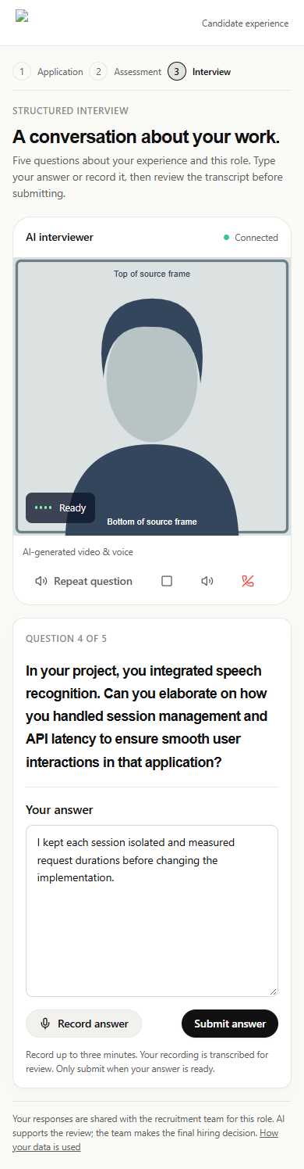
Figure 48 Mobile interview composition — Layout fixture with frame marker
The mobile arrangement stacks content to preserve readable text and usable controls. A long answer may require vertical scrolling. The objective is access to the complete content rather than forcing all mobile content into one fixed-height screen.

C.21 JOB DETAILS AND PIPELINE
Evidence type: Authenticated deployed capture.
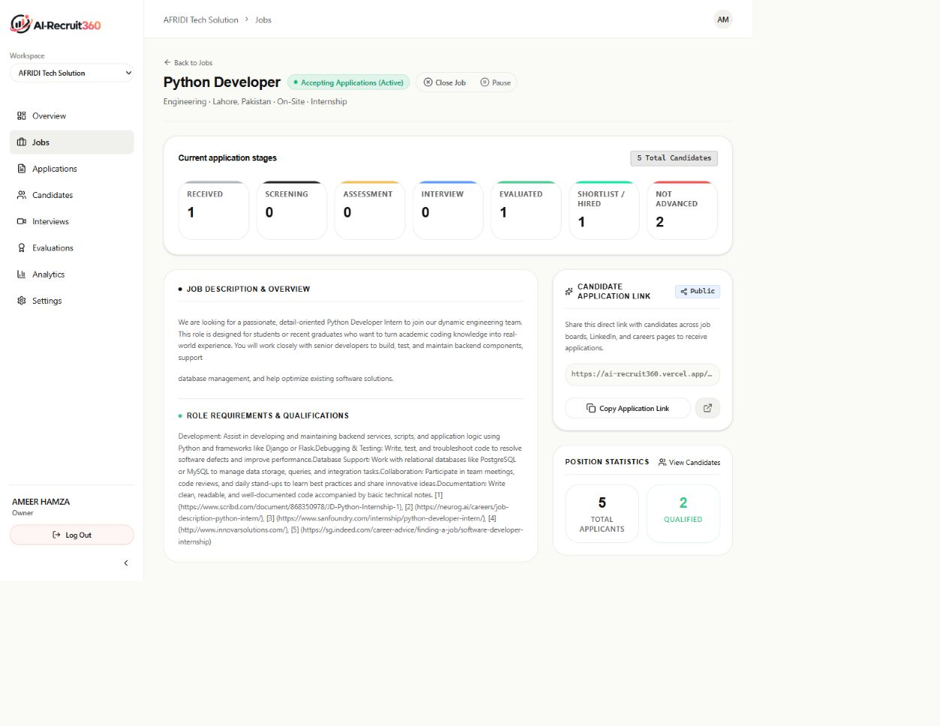
Figure 49 Job details and pipeline — Authenticated deployed capture
The role detail screen connects its description and requirements to current application stages and the public application link. The capture did not close or pause the role.

C.22 CANDIDATE EVIDENCE DOSSIER
Evidence type: Authenticated deployed capture.
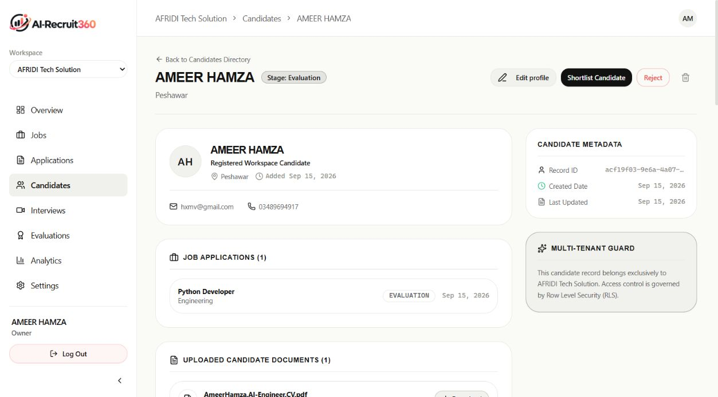
Figure 50 Candidate evidence dossier — Authenticated deployed capture
The dossier joins the candidate profile, uploaded document record, stage scores and recruiter review. Saved evidence must be read in context. A missing historical question payload is a data-availability limitation, not proof that the assessment was absent.

C.23 COMPLETED INTERVIEW EVIDENCE
Evidence type: Authenticated deployed capture.
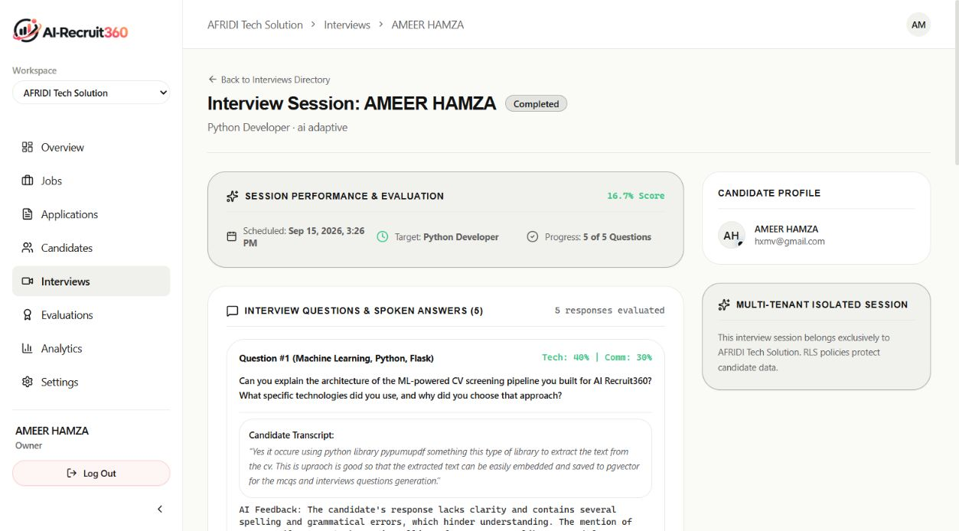
Figure 51 Completed interview evidence — Authenticated deployed capture
The completed session exposes each question, the submitted transcript and AI feedback. Candidate statements shown in a transcript are self-reported evidence and should not be read as verified architectural claims about this project.

APPENDIX D
TEST AND ACCEPTANCE CATALOGUE
The catalogue records conditions, procedures and expected behaviour together with the evidence status. A passed regression refers only to its stated controlled environment. Pending acceptance and research cases are deliberately retained without invented outcomes. The source names allow the team to rerun the checks and extend them after future changes.

D.1 REJECT FORGED RECRUITER IDENTITY
Table 26 T01 test record
Field | Test specification
Case | T01
Evidence status | Passed automated regression
Test source or environment | scripts/check-auth.cjs
Input and setup | Supply identity-like headers without a valid verified user.
Procedure | Request a protected workspace context.
Expected result | No authorized context is derived from headers.

Interpretation
This checks the identity source, not password strength or all session attacks.

Failure investigation
If this regression fails after a change, compare the failing assertion with the linked source contract. Reproduce it with the same controlled inputs before testing against live data. A changed assertion should be justified by a changed requirement rather than relaxed merely to obtain a passing run.

Evidence to retain
Keep the command output or observation record, the relevant source version and any sanitized error. Exclude passwords, bearer tokens, private document links and candidate records from shared test reports.

D.2 RESOLVE A STALE ORGANIZATION COOKIE
Table 27 T02 test record
Field | Test specification
Case | T02
Evidence status | Passed automated regression
Test source or environment | scripts/check-auth.cjs
Input and setup | Use a preference cookie naming a workspace outside actual membership.
Procedure | Evaluate auth/onboarding redirects and workspace selection.
Expected result | Selection is resolved against real membership rather than trusting the cookie.

Interpretation
The cookie remains a preference; remote membership freshness still depends on the request.

Failure investigation
If this regression fails after a change, compare the failing assertion with the linked source contract. Reproduce it with the same controlled inputs before testing against live data. A changed assertion should be justified by a changed requirement rather than relaxed merely to obtain a passing run.

Evidence to retain
Keep the command output or observation record, the relevant source version and any sanitized error. Exclude passwords, bearer tokens, private document links and candidate records from shared test reports.

D.3 DEDUPLICATE REQUEST CONTEXT
Table 28 T03 test record
Field | Test specification
Case | T03
Evidence status | Passed automated regression
Test source or environment | scripts/check-auth.cjs
Input and setup | Use repeated context consumers inside one request.
Procedure | Resolve user, profile and membership through the shared helpers.
Expected result | Request-scoped reads are reused without a cross-user global cache.

Interpretation
This is a query-count property, not a measured wall-clock speedup.

Failure investigation
If this regression fails after a change, compare the failing assertion with the linked source contract. Reproduce it with the same controlled inputs before testing against live data. A changed assertion should be justified by a changed requirement rather than relaxed merely to obtain a passing run.

Evidence to retain
Keep the command output or observation record, the relevant source version and any sanitized error. Exclude passwords, bearer tokens, private document links and candidate records from shared test reports.

D.4 PRESERVE LARGE AGGREGATE COUNTS
Table 29 T04 test record
Field | Test specification
Case | T04
Evidence status | Passed automated regression
Test source or environment | scripts/check-auth.cjs
Input and setup | Provide a count above one thousand applications.
Procedure | Map the embedded job count response.
Expected result | The total is preserved with one aggregate request.

Interpretation
The test does not generate a thousand real applications or load-test PostgreSQL.

Failure investigation
If this regression fails after a change, compare the failing assertion with the linked source contract. Reproduce it with the same controlled inputs before testing against live data. A changed assertion should be justified by a changed requirement rather than relaxed merely to obtain a passing run.

Evidence to retain
Keep the command output or observation record, the relevant source version and any sanitized error. Exclude passwords, bearer tokens, private document links and candidate records from shared test reports.

D.5 CREATE ONE APPLICATION ON RETRY
Table 30 T05 test record
Field | Test specification
Case | T05
Evidence status | Passed both schema layouts
Test source or environment | scripts/check-database.mjs
Input and setup | Submit the same synthetic job, candidate data and submission key twice.
Procedure | Compare identifiers and application counts after both calls.
Expected result | The same result is returned with no duplicated application.

Interpretation
The isolated engine stubs managed Auth and Storage; external upload failures need separate testing.

Failure investigation
If this regression fails after a change, compare the failing assertion with the linked source contract. Reproduce it with the same controlled inputs before testing against live data. A changed assertion should be justified by a changed requirement rather than relaxed merely to obtain a passing run.

Evidence to retain
Keep the command output or observation record, the relevant source version and any sanitized error. Exclude passwords, bearer tokens, private document links and candidate records from shared test reports.

D.6 PRESERVE LEGACY RESUME EVIDENCE
Table 31 T06 test record
Field | Test specification
Case | T06
Evidence status | Passed both schema layouts
Test source or environment | scripts/check-database.mjs
Input and setup | Insert a document using the supported legacy schema before migration.
Procedure | Apply the alignment and subsequent migrations.
Expected result | Original filename and extracted text survive.

Interpretation
Only the exercised layouts are covered; unknown historical schema edits need inspection.

Failure investigation
If this regression fails after a change, compare the failing assertion with the linked source contract. Reproduce it with the same controlled inputs before testing against live data. A changed assertion should be justified by a changed requirement rather than relaxed merely to obtain a passing run.

Evidence to retain
Keep the command output or observation record, the relevant source version and any sanitized error. Exclude passwords, bearer tokens, private document links and candidate records from shared test reports.

D.7 REJECT FOREIGN ASSESSMENT QUESTIONS
Table 32 T07 test record
Field | Test specification
Case | T07
Evidence status | Passed both schema layouts
Test source or environment | scripts/check-database.mjs
Input and setup | Use a question identifier belonging to another assessment.
Procedure | Attempt answer recording against the current assessment.
Expected result | The function rejects the mismatch before recording an answer.

Interpretation
Database enforcement is necessary even when the public interface never offers that identifier.

Failure investigation
If this regression fails after a change, compare the failing assertion with the linked source contract. Reproduce it with the same controlled inputs before testing against live data. A changed assertion should be justified by a changed requirement rather than relaxed merely to obtain a passing run.

Evidence to retain
Keep the command output or observation record, the relevant source version and any sanitized error. Exclude passwords, bearer tokens, private document links and candidate records from shared test reports.

D.8 ENFORCE SERVER ANSWER TIMING
Table 33 T08 test record
Field | Test specification
Case | T08
Evidence status | Passed automated regression
Test source or environment | scripts/check-database.mjs; test_assessment.py
Input and setup | Use deadline and ordering edge cases with synthetic assessment records.
Procedure | Submit the option through the scoring service and database function.
Expected result | Server rules determine acceptance; browser-provided time is not trusted.

Interpretation
The browser countdown is not an authoritative timer.

Failure investigation
If this regression fails after a change, compare the failing assertion with the linked source contract. Reproduce it with the same controlled inputs before testing against live data. A changed assertion should be justified by a changed requirement rather than relaxed merely to obtain a passing run.

Evidence to retain
Keep the command output or observation record, the relevant source version and any sanitized error. Exclude passwords, bearer tokens, private document links and candidate records from shared test reports.

D.9 KEEP AN ANSWER IMMUTABLE
Table 34 T09 test record
Field | Test specification
Case | T09
Evidence status | Passed both schema layouts
Test source or environment | scripts/check-database.mjs
Input and setup | Record a question answer and repeat with an alternative selection.
Procedure | Inspect the stored answer and returned outcome.
Expected result | The existing authoritative answer is not replaced.

Interpretation
This prevents retry manipulation but does not detect external assistance.

Failure investigation
If this regression fails after a change, compare the failing assertion with the linked source contract. Reproduce it with the same controlled inputs before testing against live data. A changed assertion should be justified by a changed requirement rather than relaxed merely to obtain a passing run.

Evidence to retain
Keep the command output or observation record, the relevant source version and any sanitized error. Exclude passwords, bearer tokens, private document links and candidate records from shared test reports.

D.10 PRESERVE THE RECRUITER DECISION
Table 35 T10 test record
Field | Test specification
Case | T10
Evidence status | Passed both schema layouts
Test source or environment | scripts/check-database.mjs
Input and setup | Save an evaluation and a recruiter decision.
Procedure | Retry the final evaluation persistence function.
Expected result | The human decision remains recorded.

Interpretation
The recommendation calculation and review action have separate responsibilities.

Failure investigation
If this regression fails after a change, compare the failing assertion with the linked source contract. Reproduce it with the same controlled inputs before testing against live data. A changed assertion should be justified by a changed requirement rather than relaxed merely to obtain a passing run.

Evidence to retain
Keep the command output or observation record, the relevant source version and any sanitized error. Exclude passwords, bearer tokens, private document links and candidate records from shared test reports.

D.11 HANDLE AN AI SCREENING OUTAGE
Table 36 T11 test record
Field | Test specification
Case | T11
Evidence status | Passed backend suite
Test source or environment | ai-service/tests/test_screening.py
Input and setup | Mock a provider failure during screening.
Procedure | Run the screening pipeline and inspect mutation calls.
Expected result | The candidate is not assigned zero or rejected because the provider failed.

Interpretation
Mocked outages are reproducible but do not measure real provider availability.

Failure investigation
If this regression fails after a change, compare the failing assertion with the linked source contract. Reproduce it with the same controlled inputs before testing against live data. A changed assertion should be justified by a changed requirement rather than relaxed merely to obtain a passing run.

Evidence to retain
Keep the command output or observation record, the relevant source version and any sanitized error. Exclude passwords, bearer tokens, private document links and candidate records from shared test reports.

D.12 REUSE COMPLETED SCREENING
Table 37 T12 test record
Field | Test specification
Case | T12
Evidence status | Passed backend suite
Test source or environment | ai-service/tests/test_screening.py
Input and setup | Return an existing completed screening record from the repository.
Procedure | Run the pipeline again.
Expected result | The existing result is returned without calling AI.

Interpretation
The result remains tied to the stored application; this is not cross-candidate caching.

Failure investigation
If this regression fails after a change, compare the failing assertion with the linked source contract. Reproduce it with the same controlled inputs before testing against live data. A changed assertion should be justified by a changed requirement rather than relaxed merely to obtain a passing run.

Evidence to retain
Keep the command output or observation record, the relevant source version and any sanitized error. Exclude passwords, bearer tokens, private document links and candidate records from shared test reports.

D.13 VALIDATE GENERATED ASSESSMENT KEYS
Table 38 T13 test record
Field | Test specification
Case | T13
Evidence status | Passed backend suite
Test source or environment | ai-service/tests/test_assessment.py
Input and setup | Construct an invalid answer-key payload.
Procedure | Validate the generated model and question sequence.
Expected result | Malformed generated output is rejected.

Interpretation
Schema validity does not establish that a valid-looking answer key is factually correct.

Failure investigation
If this regression fails after a change, compare the failing assertion with the linked source contract. Reproduce it with the same controlled inputs before testing against live data. A changed assertion should be justified by a changed requirement rather than relaxed merely to obtain a passing run.

Evidence to retain
Keep the command output or observation record, the relevant source version and any sanitized error. Exclude passwords, bearer tokens, private document links and candidate records from shared test reports.

D.14 AVOID FABRICATED FALLBACK QUESTIONS
Table 39 T14 test record
Field | Test specification
Case | T14
Evidence status | Passed backend suite
Test source or environment | ai-service/tests/test_assessment.py
Input and setup | Mock assessment generation unavailability.
Procedure | Request question generation.
Expected result | No generic fallback assessment or score is fabricated.

Interpretation
A retryable service failure is distinct from a candidate failing the assessment.

Failure investigation
If this regression fails after a change, compare the failing assertion with the linked source contract. Reproduce it with the same controlled inputs before testing against live data. A changed assertion should be justified by a changed requirement rather than relaxed merely to obtain a passing run.

Evidence to retain
Keep the command output or observation record, the relevant source version and any sanitized error. Exclude passwords, bearer tokens, private document links and candidate records from shared test reports.

D.15 REUSE STORED INTERVIEW FEEDBACK
Table 40 T15 test record
Field | Test specification
Case | T15
Evidence status | Passed backend suite
Test source or environment | ai-service/tests/test_interview.py
Input and setup | Provide a previously saved response scorecard.
Procedure | Retry the same response operation.
Expected result | The saved scorecard is returned without a conflicting evaluation.

Interpretation
This does not remove every concurrency risk across multiple backend processes.

Failure investigation
If this regression fails after a change, compare the failing assertion with the linked source contract. Reproduce it with the same controlled inputs before testing against live data. A changed assertion should be justified by a changed requirement rather than relaxed merely to obtain a passing run.

Evidence to retain
Keep the command output or observation record, the relevant source version and any sanitized error. Exclude passwords, bearer tokens, private document links and candidate records from shared test reports.

D.16 REJECT UNRELATED INTERVIEW SPEECH
Table 41 T16 test record
Field | Test specification
Case | T16
Evidence status | Passed backend suite
Test source or environment | ai-service/tests/test_interview_speech.py
Input and setup | Use a question outside the requested interview.
Procedure | Request speech synthesis.
Expected result | The operation fails before unrelated text is synthesized.

Interpretation
The frontend also verifies candidate access to the active interview.

Failure investigation
If this regression fails after a change, compare the failing assertion with the linked source contract. Reproduce it with the same controlled inputs before testing against live data. A changed assertion should be justified by a changed requirement rather than relaxed merely to obtain a passing run.

Evidence to retain
Keep the command output or observation record, the relevant source version and any sanitized error. Exclude passwords, bearer tokens, private document links and candidate records from shared test reports.

D.17 USE STORED TEXT AND CONFIGURED VOICE
Table 42 T17 test record
Field | Test specification
Case | T17
Evidence status | Passed backend suite
Test source or environment | ai-service/tests/test_interview_speech.py
Input and setup | Mock the speech provider and set the configured voice.
Procedure | Request audio for an authorized stored question.
Expected result | The provider receives the stored question and configured voice.

Interpretation
This verifies request construction, not the perceptual quality of real audio.

Failure investigation
If this regression fails after a change, compare the failing assertion with the linked source contract. Reproduce it with the same controlled inputs before testing against live data. A changed assertion should be justified by a changed requirement rather than relaxed merely to obtain a passing run.

Evidence to retain
Keep the command output or observation record, the relevant source version and any sanitized error. Exclude passwords, bearer tokens, private document links and candidate records from shared test reports.

D.18 EXTRACT A TABLE-BASED RESUME
Table 43 T18 test record
Field | Test specification
Case | T18
Evidence status | Passed backend suite
Test source or environment | ai-service/tests/test_extraction.py
Input and setup | Generate a DOCX whose resume evidence is in table cells.
Procedure | Run extraction on the document bytes.
Expected result | The table text is present in the extracted evidence.

Interpretation
Other unusual document structures and languages need additional cases.

Failure investigation
If this regression fails after a change, compare the failing assertion with the linked source contract. Reproduce it with the same controlled inputs before testing against live data. A changed assertion should be justified by a changed requirement rather than relaxed merely to obtain a passing run.

Evidence to retain
Keep the command output or observation record, the relevant source version and any sanitized error. Exclude passwords, bearer tokens, private document links and candidate records from shared test reports.

D.19 REJECT AN EMPTY TEXT PDF
Table 44 T19 test record
Field | Test specification
Case | T19
Evidence status | Passed backend suite
Test source or environment | ai-service/tests/test_extraction.py
Input and setup | Generate a PDF without usable text.
Procedure | Attempt resume extraction.
Expected result | Extraction fails explicitly rather than inventing content.

Interpretation
OCR is not implemented and is not implied by this result.

Failure investigation
If this regression fails after a change, compare the failing assertion with the linked source contract. Reproduce it with the same controlled inputs before testing against live data. A changed assertion should be justified by a changed requirement rather than relaxed merely to obtain a passing run.

Evidence to retain
Keep the command output or observation record, the relevant source version and any sanitized error. Exclude passwords, bearer tokens, private document links and candidate records from shared test reports.

D.20 RECOVER A STALLED LOGIN
Table 45 T20 test record
Field | Test specification
Case | T20
Evidence status | Passed browser regression
Test source or environment | scripts/check-sign-in.cjs
Input and setup | Intercept the Auth token endpoint so it never responds.
Procedure | Submit the synthetic login form and wait for the bounded failure.
Expected result | The form displays an error and restores the sign-in button.

Interpretation
No real account is used; the original reported network trigger was not captured.

Failure investigation
If this regression fails after a change, compare the failing assertion with the linked source contract. Reproduce it with the same controlled inputs before testing against live data. A changed assertion should be justified by a changed requirement rather than relaxed merely to obtain a passing run.

Evidence to retain
Keep the command output or observation record, the relevant source version and any sanitized error. Exclude passwords, bearer tokens, private document links and candidate records from shared test reports.

D.21 COMPLETE A REAL CANDIDATE JOURNEY
Table 46 T21 test record
Field | Test specification
Case | T21
Evidence status | Pending recorded acceptance
Test source or environment | Designated acceptance workspace
Input and setup | Use a consented or synthetic resume and configured real providers.
Procedure | Publish a role, apply, screen, assess, interview and review the final evaluation.
Expected result | Persisted records and visible stages agree from start to finish.

Interpretation
The developer reports hosted use; this catalogue does not convert that report into a recorded controlled test.

Failure investigation
Record the actual result, environment and timestamp when this case is executed. If it fails, preserve the stage identifiers and isolate the failing dependency before retrying. Do not replace the expected result with a success claim without a corresponding observation.

Evidence to retain
Keep the command output or observation record, the relevant source version and any sanitized error. Exclude passwords, bearer tokens, private document links and candidate records from shared test reports.

D.22 VALIDATE MEDIA PERMISSIONS AND RECOVERY
Table 47 T22 test record
Field | Test specification
Case | T22
Evidence status | Pending recorded acceptance
Test source or environment | Real browser and provider session
Input and setup | Test microphone allow/deny and avatar connect/disconnect with the configured accounts.
Procedure | Record, transcribe, edit, submit, repeat question and mute playback.
Expected result | Typed answers remain usable; media errors do not corrupt progress.

Interpretation
Layout fixtures cannot establish WebRTC, microphone or provider connectivity.

Failure investigation
Record the actual result, environment and timestamp when this case is executed. If it fails, preserve the stage identifiers and isolate the failing dependency before retrying. Do not replace the expected result with a success claim without a corresponding observation.

Evidence to retain
Keep the command output or observation record, the relevant source version and any sanitized error. Exclude passwords, bearer tokens, private document links and candidate records from shared test reports.

D.23 MEASURE COLD AND WARM LATENCY
Table 48 T23 test record
Field | Test specification
Case | T23
Evidence status | Pending measurement
Test source or environment | Timed deployment experiment
Input and setup | Record endpoint, network, hosting plan, region and idle interval.
Procedure | Collect repeated cold and warm timings with failures retained.
Expected result | Report actual sample counts, median, tail observations and failure counts.

Interpretation
Existing single-request observations are not a latency distribution.

Failure investigation
Record the actual result, environment and timestamp when this case is executed. If it fails, preserve the stage identifiers and isolate the failing dependency before retrying. Do not replace the expected result with a success claim without a corresponding observation.

Evidence to retain
Keep the command output or observation record, the relevant source version and any sanitized error. Exclude passwords, bearer tokens, private document links and candidate records from shared test reports.

D.24 REVIEW EVIDENCE CORRECTNESS
Table 49 T24 test record
Field | Test specification
Case | T24
Evidence status | Pending research study
Test source or environment | Consented dataset and independent reviewers
Input and setup | Define a resume-evidence rubric and prepare a representative review set.
Procedure | Compare model evidence quotes and matches with source documents.
Expected result | Report supported, unsupported and ambiguous findings with reviewer disagreement.

Interpretation
No agreement percentage or fairness result is claimed before this study occurs.

Failure investigation
Record the actual result, environment and timestamp when this case is executed. If it fails, preserve the stage identifiers and isolate the failing dependency before retrying. Do not replace the expected result with a success claim without a corresponding observation.

Evidence to retain
Keep the command output or observation record, the relevant source version and any sanitized error. Exclude passwords, bearer tokens, private document links and candidate records from shared test reports.

APPENDIX E
API CONTRACT INVENTORY
This inventory is derived from the running local FastAPI OpenAPI document. Health routes are operational checks. Recruitment-stage routes are server-to-server operations protected by the shared service secret at router inclusion. The public browser should use the authorized Next.js actions rather than holding that secret. Request identifiers still require application ownership checks at the frontend boundary.

E.1 /api/v1/health
Table 50 API contract /api/v1/health
Contract item | Value
Method | GET
Summary | Full service health check
Documented responses | 200

The OpenAPI response list describes the API schema; it does not enumerate every runtime failure or prove that the provider was called successfully.

E.2 /api/v1/health/live
Table 51 API contract /api/v1/health/live
Contract item | Value
Method | GET
Summary | Kubernetes liveness probe
Documented responses | 200

The OpenAPI response list describes the API schema; it does not enumerate every runtime failure or prove that the provider was called successfully.

E.3 /api/v1/health/ready
Table 52 API contract /api/v1/health/ready
Contract item | Value
Method | GET
Summary | Readiness
Documented responses | 200

The OpenAPI response list describes the API schema; it does not enumerate every runtime failure or prove that the provider was called successfully.

E.4 /api/v1/screening/screen-application
Table 53 API contract /api/v1/screening/screen-application
Contract item | Value
Method | POST
Summary | Screen Application
Body type | application/json
Fields | application_id (required)
Documented responses | 200, 422

The OpenAPI response list describes the API schema; it does not enumerate every runtime failure or prove that the provider was called successfully.

E.5 /api/v1/assessments/generate
Table 54 API contract /api/v1/assessments/generate
Contract item | Value
Method | POST
Summary | Generate Assessment
Body type | application/json
Fields | application_id (required)
Documented responses | 200, 422

The OpenAPI response list describes the API schema; it does not enumerate every runtime failure or prove that the provider was called successfully.

E.6 /api/v1/assessments/submit-answer
Table 55 API contract /api/v1/assessments/submit-answer
Contract item | Value
Method | POST
Summary | Submit Answer
Body type | application/json
Fields | assessment_id (required); question_id (required); question_number (required); selected_option (required); time_taken_seconds (required)
Documented responses | 200, 422

The OpenAPI response list describes the API schema; it does not enumerate every runtime failure or prove that the provider was called successfully.

E.7 /api/v1/assessments/finalize
Table 56 API contract /api/v1/assessments/finalize
Contract item | Value
Method | POST
Summary | Finalize Assessment
Body type | application/json
Fields | assessment_id (required)
Documented responses | 200, 422

The OpenAPI response list describes the API schema; it does not enumerate every runtime failure or prove that the provider was called successfully.

E.8 /api/v1/interviews/speech
Table 57 API contract /api/v1/interviews/speech
Contract item | Value
Method | POST
Summary | Interview Speech
Body type | application/json
Fields | interview_id (required); question_id (required)
Documented responses | 200, 422

The OpenAPI response list describes the API schema; it does not enumerate every runtime failure or prove that the provider was called successfully.

E.9 /api/v1/interviews/initialize
Table 58 API contract /api/v1/interviews/initialize
Contract item | Value
Method | POST
Summary | Initialize Interview
Body type | application/json
Fields | application_id (required)
Documented responses | 200, 422

The OpenAPI response list describes the API schema; it does not enumerate every runtime failure or prove that the provider was called successfully.

E.10 /api/v1/interviews/next-question
Table 59 API contract /api/v1/interviews/next-question
Contract item | Value
Method | POST
Summary | Next Question
Body type | application/json
Fields | interview_id (required)
Documented responses | 200, 422

The OpenAPI response list describes the API schema; it does not enumerate every runtime failure or prove that the provider was called successfully.

E.11 /api/v1/interviews/evaluate-response
Table 60 API contract /api/v1/interviews/evaluate-response
Contract item | Value
Method | POST
Summary | Evaluate Response
Body type | application/json
Fields | interview_id (required); question_id (required); response_text (required)
Documented responses | 200, 422

The OpenAPI response list describes the API schema; it does not enumerate every runtime failure or prove that the provider was called successfully.

E.12 /api/v1/interviews/stt
Table 61 API contract /api/v1/interviews/stt
Contract item | Value
Method | POST
Summary | Process Speech To Text
Body type | multipart/form-data
Fields | audio (required)
Documented responses | 200, 422

The OpenAPI response list describes the API schema; it does not enumerate every runtime failure or prove that the provider was called successfully.

E.13 /api/v1/evaluations/generate
Table 62 API contract /api/v1/evaluations/generate
Contract item | Value
Method | POST
Summary | Generate Evaluation
Body type | application/json
Fields | application_id (required)
Documented responses | 200, 422

The OpenAPI response list describes the API schema; it does not enumerate every runtime failure or prove that the provider was called successfully.

APPENDIX F
LOCAL DEMONSTRATION AND MAINTENANCE

F.1 LOCAL STARTUP
Run the frontend from its own folder and the backend from ai-service. The local frontend address is http://localhost:3000 and the backend API base is http://127.0.0.1:8000/api/v1. The Python environment belongs inside ai-service/.venv. Use the environment-specific Python executable to start uvicorn app.main:app with host 127.0.0.1 and port 8000. Keep one backend worker. The frontend can run with npm run dev while editing; for a presentation, build beforehand with npm run build and then use npm run start. Stop an existing process on the same port before starting another.

F.2 ENVIRONMENT CONFIGURATION
frontend/.env.local contains NEXT_PUBLIC_APP_URL and AI_SERVICE_URL for local addresses, plus existing authentication configuration and server secrets. ai-service/.env contains backend settings and provider credentials. AI_SERVICE_SHARED_SECRET must match between frontend and backend. Do not paste secrets into a thesis screenshot. Restart after environment changes, and rebuild a production frontend when a public value changes. The Vercel and Render environments retain their own hosted values; changing the ignored local files does not redeploy those services.

F.3 DATABASE READINESS
Use /api/v1/health/live to check that FastAPI is alive. Use /api/v1/health or /ready to include database connectivity. A healthy process can still have an unavailable database. Before applying a migration, inspect the remote history and apply only pending files. Never reset the database or rerun the initial schema as a shortcut for a missing workspace_dashboard function. Preserve existing records and test schema changes on a copy or isolated engine first.

F.4 SUPERVISOR DEMONSTRATION ORDER
Begin with a short explanation of the two user journeys and the organization boundary. Show a published job and its candidate link. Submit a consented or synthetic resume, then explain where the application is saved before AI processing. Continue through screening, the assessment, interview and evaluation. Show the underlying evidence and the human decision separately. If the network fails, demonstrate the preserved application and retry behaviour rather than claiming the system is offline-capable. Keep a known test job and synthetic document prepared before the session.

F.5 DIAGNOSING SLOW OPERATIONS
Separate browser compilation, authentication, database access, backend processing and provider time. A production build avoids development compilation during navigation. Local service URLs avoid the remote Render hop, but Supabase, OpenAI and Simli remain online. Record the endpoint and elapsed duration before attributing delay to Wi-Fi or hosting sleep. Compare repeated warm requests with the first request after an idle interval. A timeout is part of the result and must not be omitted from the measurement log.

F.6 RECOVERING A SAVED APPLICATION
If the resume is saved but screening is unavailable, use the recovery control in the same candidate browser session. Do not create repeated applications simply to retry the provider. If the signed session has expired, use the defined recruitment support process rather than editing a cookie or bypassing access checks. If extraction fails, verify that the file is a readable PDF or DOCX and within the size limit. Scanned-only PDFs need a readable replacement because OCR is not implemented.

F.7 INTERVIEW TROUBLESHOOTING
Check that the application is eligible and the current question belongs to the interview. For recording, verify microphone permission and keep the audio within the size limit. Review the transcript before submitting. For avatar playback, verify the server-side API key and face identifier and the backend speech configuration. The face and voice are separate settings. If playback fails, continue through the text question and typed response; do not discard already saved answers.

F.8 REGRESSION WORKFLOW
Run scripts/check.ps1 for lint, TypeScript, backend tests, auth regressions and both database layouts. Use the Build switch when a production build is required. Browser scripts expect the local production preview address documented in their source. The sign-in script uses synthetic authentication responses; database tests use isolated synthetic records. A successful regression run should be followed by a real-provider acceptance test when credentials, hosting or integration behaviour changes.

F.9 BACKUP AND RELEASE DISCIPLINE
Keep the original project and database separate from experimental changes. Preserve migration history and backups before a release. Record which source version and environment were used for the demonstration. A local build is not automatically the deployed build, and a new thesis screenshot does not establish deployment equivalence. Review environment URLs, shared secrets, pending migrations and provider account limits before publishing updated services.

F.10 RESPONSIBLE REPORT MAINTENANCE
When the code changes, review the associated requirement, diagram, database dictionary and test record. Update measured results only from retained observations. Do not carry forward unsupported claims from older drafts, including invented accuracy percentages, model-training claims, biometric analysis or anti-cheat guarantees. Similarity checking, supervisor review and signed certification remain institutional submission steps. The report provides technical evidence but does not predict an examination mark.

