AI RECRUIT360

AN AI ASSISTED RECRUITMENT AND CANDIDATE EVALUATION SYSTEM

Ameer Hamza
(FA22-BSE-030)
Babar Hussain
(FA22-BSE-044)
Ali Naqi
(FA22-BSE-050)

Session 2022-2026
Department of Software Engineering
Faculty of Engineering & Technology
Mirpur University of Science and Technology (MUST), Mirpur
AJK Pakistan

AI RECRUIT360
AN AI ASSISTED RECRUITMENT AND CANDIDATE EVALUATION SYSTEM
By
Ameer Hamza
(FA22-BSE-030)
Babar Hussain
(FA22-BSE-044)
Ali Naqi
(FA22-BSE-050)
A project report submitted in partial fulfillment of
the requirements for the degree of
Bachelor of Science
In
SOFTWARE ENGINEERING
Session 2022-2026
Department of Software Engineering
Faculty of Engineering & Technology
Mirpur University of Science and Technology (MUST), Mirpur AJK Pakistan

CERTIFICATION
We hereby undertake that this final year project is original and no part of this final year project falls under plagiarism. If found otherwise, at any stage, we will be responsible for the consequences.
Student’s Name: Ameer Hamza Signature: _____________
Registration No: FA22-BSE-030 Date: _________________
Student’s Name: Babar Hussain Signature: _____________
Registration No: FA22-BSE-044 Date: _________________
Student’s Name: Ali Naqi Signature: _____________
Registration No: FA22-BSE-050 Date: _________________

Certified that the contents and form of final year project entitled
“AI-RECRUIT360”
submitted by
“Ameer Hamza, Babar Hussain, Ali Naqi”
have been found satisfactory for the requirement of the degree.

Supervisor: ___________________________

Co-Supervisor (If any) : _________________

External Examiner: _____________________

Chairperson: _____________________

DEDICATION
We dedicate this project to our families, whose constant support, encouragement, patience, and prayers gave us the strength to continue throughout our academic journey. We are deeply grateful to our teachers and supervisor for their guidance, knowledge, and valuable feedback, which helped us improve both this project and ourselves as future software engineers. We also dedicate this work to our fellow students and friends who supported us through discussions, teamwork, motivation, and shared challenges. We hope this project reflects the effort, responsibility, and care that everyone around us encouraged us to bring to our technical decisions and to the people who may ultimately be affected by the systems we build.

CONTENTS
Page No.
LIST OF FIGURES vi
LIST OF TABLES vii
ACKNOWLEDGMENTS viii
ABSTRACT ix
ABBREVIATIONS x
1. INTRODUCTION 1
1.1 PROJECT OVERVIEW 1
1.2 PROBLEM STATEMENT 1
1.3 AIM AND OBJECTIVES 2
1.4 SCOPE AND BOUNDARIES 2
1.5 STAKEHOLDERS AND INTENDED USE 3
1.6 ENGINEERING METHOD AND CONTRIBUTION 3
1.7 SIGNIFICANCE OF THE PROJECT 3
1.8 ORGANIZATION OF THE REPORT 3
2. BACKGROUND AND RELATED WORK 4
2.1 RECRUITMENT EVIDENCE AND AUTOMATION 4
2.2 LANGUAGE MODELS AND STRUCTURED GENERATION 4
2.3 SPEECH AND CONVERSATIONAL PRESENTATION 5
2.4 WEB APPLICATION ARCHITECTURE 6
2.5 TRANSACTIONS AND TENANT ISOLATION 6
2.6 RISK AND ACCESSIBILITY GUIDANCE 7
2.7 COMPARISON AND RESEARCH GAP 7
2.8 COMPARATIVE ANALYSIS OF RELATED APPROACHES 8
2.9 DESIGN IMPLICATIONS FROM RELATED WORK 9
3. REQUIREMENTS AND ANALYSIS 10
3.1 REQUIREMENTS METHOD 10
3.2 RECRUITER REQUIREMENTS 10
3.3 CANDIDATE REQUIREMENTS 11
3.4 INTEGRITY AND STATE REQUIREMENTS 11
3.5 PERFORMANCE AND AVAILABILITY REQUIREMENTS 12
3.6 SECURITY AND PRIVACY REQUIREMENTS 12
3.7 FEASIBILITY AND TRADEOFFS 13
3.8 FUNCTIONAL REQUIREMENTS 14
3.9 NON-FUNCTIONAL REQUIREMENTS 15
3.10 USE-CASE MODEL 15
3.11 DEVELOPMENT METHODOLOGY 17
3.12 TOOLS AND TECHNOLOGIES 18
3.13 TECHNICAL CONSTRAINTS AND ASSUMPTIONS 19
4. SYSTEM DESIGN 20
4.1 SYSTEM CONTEXT AND TRUST BOUNDARIES 20
4.2 COMPONENT AND DEPLOYMENT STRUCTURE 21
Detailed component attributes 23
4.3 DATA FLOW FROM APPLICATION TO REVIEW 24
4.4 RELATIONAL MODEL 24
4.5 WORKFLOW STATES AND TRANSITIONS 25
4.6 SEQUENCE AND CONCURRENCY DESIGN 26
4.7 ACCESS CONTROL MODEL 27
4.8 INTERFACE AND INTERACTION DESIGN 28
4.9 CORE DATABASE TABLES 29
4.10 SECURITY ARCHITECTURE 31
4.11 DESIGN RATIONALE AND TRADE-OFFS 31
5. IMPLEMENTATION 33
5.1 FRONTEND COMPOSITION 33
5.2 RECRUITER AUTHENTICATION AND WORKSPACE CONTEXT 33
5.3 JOB AND CANDIDATE ACCESS 34
5.4 SUBMISSION AND DOCUMENT EXTRACTION 34
5.5 STRUCTURED RESUME SCREENING 35
5.6 ASSESSMENT GENERATION AND TIMING 35
5.7 INTERVIEW ORCHESTRATION AND RESPONSE SCORING 36
5.8 SPEECH AND AVATAR INTEGRATION 37
5.9 FINAL EVALUATION AND RECRUITER DECISION 38
5.10 DATABASE MIGRATIONS AND COMPATIBILITY 38
5.11 CONFIGURATION AND DEPLOYMENT LIMITS 39
5.12 USER INTERFACE IMPLEMENTATION 39
5.13 ERROR HANDLING AND RECOVERY 43
5.14 MODULE INTEGRATION FLOW 44
5.15 DEPLOYMENT WORKFLOW 45
5.16 DATA HANDLING AND PRIVACY IMPLEMENTATION 45
6. VERIFICATION AND RESULTS 47
6.1 VERIFICATION APPROACH 47
6.2 BACKEND AND EXTRACTION TESTS 48
6.3 DATABASE INTEGRITY TESTS 48
6.4 AUTHENTICATION AND BROWSER REGRESSIONS 49
6.5 TESTING STRATEGY 49
6.6 DETAILED SYSTEM TEST CASES 50
6.7 REQUIREMENT-TO-TEST TRACEABILITY 52
6.8 PERFORMANCE OBSERVATIONS 53
6.9 DISCUSSION OF RESULTS 53
6.10 LIMITATIONS AND ACCEPTANCE CRITERIA 54
7. CONCLUSIONS AND FUTURE WORK 55
7.1 CONCLUSIONS 55
7.2 FUTURE TECHNICAL DEVELOPMENT 55
7.3 FUTURE EVALUATION AND RESPONSIBLE USE 56
7.4 ACHIEVEMENT OF PROJECT OBJECTIVES 56
7.5 KNOWN LIMITATIONS 57
7.6 PROJECT CONTRIBUTIONS 58
7.7 CONTRIBUTION TO SUSTAINABLE DEVELOPMENT GOALS (SDGs) 58
7.8 CONCLUDING REMARKS 59
REFERENCES 61
APPENDIX A: CORE USE-CASE SUMMARY 64
APPENDIX B: API REFERENCE 64
APPENDIX C: INSTALLATION AND USER GUIDE 65
APPENDIX D: DEPLOYMENT AND MAINTENANCE CHECKLIST 66

LIST OF FIGURES
Figure No. Page No.
3.1: UML use-case diagram for recruiter and candidate workflows 16
4.1: System context and external service boundaries 21
4.2: Complete layered system architecture of AI Recruit360 21
4.3: Local and hosted deployment architecture 22
4.4: UML class diagram of core recruitment entities 23
4.5: Application evidence and evaluation data flow 24
4.6: Entity-relationship diagram and key cardinalities 25
4.7: UML activity diagram for resume screening 26
4.8: UML sequence diagram for candidate submission 27
4.9: UML activity diagram for the interview workflow 29
5.1: UML state-machine diagram for technical assessment 36
5.2: UML sequence diagram for interview answer evaluation 37
5.3: Relationships among stored recruitment evidence stages 39
5.4: Recruiter workspace overview 40
5.5: Job details and candidate pipeline 40
5.6: Candidate application form 41
5.7: Timed skills assessment 41
5.8: Desktop AI interview room 42
5.9: Completed interview evidence 42
5.10: Evaluation review list 43

LIST OF TABLES
Table No. Page No.
2.1: Qualitative comparison of recruitment approaches 8
3.1: Quality requirements and evidence boundaries 13
3.2: Functional requirements 14
3.3: Non-functional requirements 15
3.4: Complete use-case catalogue 16
3.5: Tools and technologies used in AI Recruit360 18
4.1: Selected role permissions 28
4.2: Core database tables and integrity controls 29
5.1: Illustrative weighted score calculation 38
5.2: Module integration across the recruitment workflow 44
6.1: Verification summary 48
6.2: Testing levels and evidence scope 50
6.3: Detailed verified system test cases 50
6.4: Use-case-to-test traceability 52
6.5: Recorded point observations 53
7.1: Achievement of project objectives 56
7.2: SDG alignment, implemented support and evidence limits 59

ACKNOWLEDGMENTS
We are grateful to Almighty Allah for the strength and opportunity to complete this work. We thank our supervisor, Engr. Syeda Iqra Gillani, for her guidance during the project. We also thank the faculty of the Department of Software Engineering at Mirpur University of Science and Technology for the foundations on which this work builds.
We appreciate the support of our families and peers throughout the development process. The project also depends on open-source libraries and published technical documentation; their contributions are acknowledged through the references and implementation discussion. We remain responsible for the decisions, limitations and final presentation of this report.
Ameer Hamza
Babar Hussain
Ali Naqi

ABSTRACT
AI Recruit360 is a browser-based recruitment system that connects resume screening, skills assessment, structured interviews and recruiter review. The project addresses an engineering problem: preserving candidate evidence and application state while several external services participate in the workflow. It supports separate recruiter and candidate journeys, organization-scoped access and recoverable processing failures.
The system uses Next.js 16, React and TypeScript for the frontend; FastAPI and Python for AI operations; and Supabase authentication, PostgreSQL and private storage for durable records. Structured language-model responses support resume analysis, ten-question assessments and five-question interviews. Candidates can type answers or review speech transcripts before submitting. Optional Simli avatar playback presents interview questions with generated speech. Final evaluation combines resume, assessment and interview scores using weights of 40, 25 and 35 percent, while the recruiter retains the final decision.
Verification includes 25 backend tests, isolated migration and workflow checks on two schema layouts, authentication regressions and responsive browser checks. These checks provide evidence for the tested integrity and access-control paths; they do not establish predictive hiring accuracy, demographic fairness or production-scale performance. The developer reports successful use of the hosted services, while a fully recorded real-provider acceptance journey and repeated latency measurements remain outstanding. The project demonstrates how a small AI-assisted recruitment application can preserve evidence and support human review without treating generated scores as verified hiring decisions.

ABBREVIATIONS
Term | Meaning
AI | Artificial intelligence
API | Application programming interface
ASGI | Asynchronous server gateway interface
ATS | Applicant tracking system
CV | Curriculum vitae
DOCX | Office Open XML document
FYP | Final-year project
HTTP | Hypertext transfer protocol
JSON | JavaScript Object Notation
JWT | JSON Web Token
LLM | Large language model
MCQ | Multiple-choice question
PCM | Pulse-code modulation
PDF | Portable document format
RLS | Row-level security
RPC | Remote procedure call
SQL | Structured Query Language
STT | Speech to text
TTS | Text to speech
UI | User interface
UX | User experience
WCAG | Web Content Accessibility Guidelines
WebRTC | Web Real-Time Communication

Chapter 01

INTRODUCTION
Recruitment decisions depend on resumes, technical skills, interview responses and human judgement. When these sources are handled in separate tools, recruiters may lose evidence and candidates may not understand their application status. AI Recruit360 provides a connected web workflow that records each stage and produces structured results for recruiter review. The project focuses on software reliability, access control and clear evidence rather than replacing human judgement with an AI score. This chapter presents the background, problem, objectives, scope, stakeholders and main contribution of the project [13], [32].

1.1 PROJECT OVERVIEW
Recruitment produces several kinds of evidence: details in a resume, answers to technical questions, interview explanations and the recruiter's final judgement. These records are often stored and reviewed separately. AI Recruit360 connects them to one application while keeping their meanings clear. A resume match indicates possible relevance to a job; it is not an interview result or a hiring decision. The system is designed to make this separation visible and to retain the original evidence for review.
A recruiter creates a job and shares an application link. The candidate uploads a PDF or DOCX resume, completes an eligible ten-question assessment and answers five interview questions. The system stores the results of each stage and presents a weighted evaluation for the recruiter, who makes the final decision. The browser interface uses Next.js and React; FastAPI handles document processing and AI operations; Supabase provides authentication, PostgreSQL and private storage. OpenAI supplies generated responses and speech functions, while Simli can present questions through an optional avatar. The contribution is a connected, recoverable recruitment workflow rather than a newly trained or scientifically validated hiring model [5], [17].

1.2 PROBLEM STATEMENT
AI-generated text alone cannot make a recruitment system reliable. An interrupted upload can leave records incomplete; a repeated screening request can create conflicting results; and a browser timer can disagree with the server. A recruiter may also see an incorrect decision if retries overwrite saved data. The problem is to coordinate these stages while keeping application progress and evidence correct. A temporary provider failure must never become a candidate failure, and users must not see records belonging to another application or organization.
The system must remain simple enough to demonstrate and maintain as a student project. It uses a limited number of services, server-side access checks and database rules for important changes. The project evaluates workflow correctness; it does not claim large-scale throughput or fair hiring outcomes without further testing.

1.3 AIM AND OBJECTIVES
The main aim is to build an AI-assisted recruitment system that preserves progress and provides reviewable evidence. The objectives are to connect job posting, resume submission, assessment, interview and review; enforce important state changes on the server; restrict workspace access by organization and role; validate AI outputs; support typed and optional speech answers; and avoid unnecessary repeated requests.
The objectives are assessed through source review, database tests, backend tests and browser checks. For example, submitting the same application again should return the saved record rather than create a duplicate. These checks demonstrate software behavior, not that AI scores predict job performance or improve hiring fairness.

1.4 SCOPE AND BOUNDARIES
The supported workflow covers recruiter authentication, organization context, job publication, candidate records, PDF or DOCX submission, resume screening, ten-question assessments, five-question interviews, evaluation and recruiter review. Organization roles include owner, admin, recruiter, interviewer and viewer. Their permissions differ; a visible page is not proof of permission to perform its mutations. The implementation does not provide payroll, employment contracts, payment subscriptions, video proctoring, biometric identity verification or a validated psychometric test. It does not train its own language model. Historical vector-related columns and activity-log tables remain in the schema, but the active screening pipeline does not perform embedding search or retrieval-augmented generation. Retaining compatibility data is different from using that data as an active feature.
Local hosting runs the web application and FastAPI on the same computer. Supabase, OpenAI and Simli remain external services. Consequently, a local demonstration still depends on internet connectivity for authentication, storage, generation and playback. The system is not represented as an offline recruitment product. These boundaries are important when interpreting the architecture and the test results presented later.

1.5 STAKEHOLDERS AND INTENDED USE
The main users are candidates, recruiters and workspace owners. Candidates need clear submission steps and recovery when a service fails. Recruiters need to inspect original resumes, answers and evaluations before deciding. Owners manage workspace access, while developers need understandable errors and maintainable records. A supervisor can follow one candidate from submission to a documented human decision.
The intended use is a small recruitment workflow and academic demonstration. The avatar and generated voice are identified as automated features, and typed answers remain available when speech or microphone access fails. Usability, predictive validity and candidate outcomes have not been established by a controlled study.

1.6 ENGINEERING METHOD AND CONTRIBUTION
Development followed repeated cycles of defining a workflow problem, implementing a control and testing the successful and failing cases. A retry-safe application, for example, requires a database operation that returns the same result for repeated submissions, not only a disabled button. Important boundaries include verified recruiter identity, signed candidate sessions, structured AI data and database-enforced transitions.
Code and repeatable tests are the primary evidence of implementation. External research explains the design choices. Reported hosted use is kept distinct from reproduced tests. A recorded end-to-end provider session and a repeated latency study remain future acceptance work.

1.7 SIGNIFICANCE OF THE PROJECT
AI Recruit360 brings resume screening, assessment, interviews and recruiter review into one traceable workflow. It also demonstrates separate identity checks, protected documents, structured AI responses and recoverable database operations. Generated scores remain review aids rather than hiring decisions. The project is supported by software tests, while fairness, job-performance prediction and production-scale performance remain untested. Section 7.7 explains its intended SDG alignment and limits.

1.8 ORGANIZATION OF THE REPORT
Chapters 2–7 cover related work, requirements, system design, implementation, verification, and conclusions, including SDG alignment and future work. Appendices summarize use cases, APIs, and deployment.
Chapter 02

BACKGROUND AND RELATED WORK
Recruitment software combines document processing, assessments and decision support, but each area has different technical and ethical limits. This chapter reviews research on algorithmic hiring and the technologies used for structured generation, speech, web services and protected data. It explains how the literature informed the architecture of AI Recruit360. It also identifies a critical limitation: successful software integration does not itself demonstrate fair or valid hiring decisions [3], [13], [22], [32].

2.1 RECRUITMENT EVIDENCE AND AUTOMATION
Recruitment automation can be understood as a sequence of information-processing tasks. Documents must be collected, claims organized, relevant knowledge assessed, and decisions recorded. Automating these tasks does not automatically validate the criteria used to judge candidates. A system may be reliable at storing a score while the score itself remains a poor indicator of future performance. The recent multidisciplinary survey of algorithmic hiring stresses that fairness depends on the full setting and the chosen assessment methods [32].
Raghavan et al. [13] examine algorithmic hiring vendors and the difficulty of evaluating their claims about assessment and bias mitigation. Köchling and Wehner [3] similarly identify fairness and discrimination concerns across human-resource applications, while Liem et al. [4] argue that candidate screening should connect machine-learning techniques with established selection research. These studies motivate a careful distinction between providing an assessment tool and demonstrating that the tool is fair or valid. This project responds by retaining stage evidence and avoiding claims that AI removes discrimination. It does not reproduce those empirical investigations or claim equivalent validation.
For AI Recruit360, the practical implication is to treat the composite score as a review aid. Resume screening, multiple-choice answers and interview responses are displayed as distinct sources. The recruiter can question a missing-skill judgement or inspect an answer rather than receiving only a rank. Whether this presentation improves decisions is a question for a future user study, not a conclusion drawn from the presence of an evidence panel.

2.2 LANGUAGE MODELS AND STRUCTURED GENERATION
Large language models can respond to task descriptions and examples expressed in natural language. Brown et al. [2] provide foundational evidence for few-shot language-model capabilities, but their findings do not establish recruitment validity for this project. AI Recruit360 uses a hosted model through an API; no model training, fine-tuning or benchmark reproduction is performed here.
The project requests structured outputs matching Pydantic models. OpenAI documents schema-constrained structured output, while Pydantic models validate the resulting Python data shape [5], [11]. Screening expects numeric scores, matched and missing skills, quoted evidence and a reasoning summary. Assessments expect a complete collection of questions and options. This reduces the amount of fragile free-text parsing required by the application. The service rejects incomplete payloads rather than pretending that any fluent response is usable.
A structural guarantee is narrower than a semantic guarantee. A score may be within the accepted range while still being poorly justified. A quoted phrase may be plausible but require comparison with extracted resume text. The system therefore preserves source material and leaves final decisions with a recruiter. Prompt injection, inconsistent judgement and hallucinated evidence remain meaningful limitations even when JSON validation succeeds.

2.3 SPEECH AND CONVERSATIONAL PRESENTATION
Speech recognition turns an audio signal into text; speech synthesis turns text into an audio presentation. Radford et al. [12] describe the large-scale weak supervision underlying Whisper. OpenAI's file-transcription and text-to-speech guidance defines the hosted interfaces used by the implementation [6], [7]. These sources support the choice of general speech services, but they do not provide an accuracy result for the accents, microphones or environments used in this project.
AI Recruit360 records a candidate response, sends it for transcription, and gives the candidate an opportunity to review the text before submission. This creates a useful separation between recognition error and the answer that is evaluated. A candidate can correct a technical name or supply typed text if recording is unavailable. No claim is made that the transcription is always exact.
The avatar is a presentation channel for an already stored interview question. The configured face and voice are separate settings. In the current configuration, text-to-speech uses the nova voice while Simli animates the selected face. Synchronizing a face to audio can improve the conversational appearance of the interface, but the thesis does not treat this as evidence of improved assessment validity or a fully live human interview.

2.4 WEB APPLICATION ARCHITECTURE
Next.js distinguishes server components from client components, allowing data access to remain on the server while interactive controls run in the browser [23]. Its server functions and backend-for-frontend guidance also support placing mutations and narrow API boundaries on the server [25], [26]. AI Recruit360 uses this separation for initial workspace data and client-side filtering, input and playback. It does not require every page to become a large client application.
FastAPI's asynchronous programming model is useful when tasks wait for external services [14]. The project wraps synchronous Supabase operations through a helper and overlaps independent reads where their dependencies permit. Asynchronous syntax does not make model inference instantaneous. The benefit is that the service need not spend every waiting interval blocking unrelated work.
The two application runtimes have distinct responsibilities. Next.js knows the browser session and validates application access. FastAPI performs document extraction and AI-stage orchestration. Supabase stores durable progress. This separation introduces network boundaries but gives the student team a clear place to inspect an authorization failure, an extraction failure or a model failure. A single-machine demonstration uses the same contracts over loopback addresses.

2.5 TRANSACTIONS AND TENANT ISOLATION
PostgreSQL row security can restrict which rows are visible or writable for a particular role. Its guarantees depend on the policies, roles and privileges actually used [9]. Supabase service credentials can bypass row security, so a server holding them must perform its own access checks before privileged operations [20].
AI Recruit360 uses both authenticated database access and server-only privileged access. Supabase documents authenticated sessions, server-side rendering with cookies, and time-limited signed storage URLs as separate controls [17], [18], [19]. A recruiter request resolves an authenticated user and organization membership. A candidate request uses a signed application session because candidates do not create ordinary recruiter accounts. The service-role path exists to perform specific validated operations, not to expose an unrestricted database interface to the browser.
Transactions are important when several records represent one user action. PostgreSQL documents how concurrent statements and isolation levels affect visibility [10]. The project applies this principle through functions that lock and update the relevant assessment or interview state together. The database, not a disabled button, becomes the authority on whether an answer is already recorded.

2.6 RISK AND ACCESSIBILITY GUIDANCE
The NIST AI Risk Management Framework organizes AI risk work around governance, mapping, measurement and management [22]. Suresh and Guttag [21] show that harms can enter at different points of an ML lifecycle, so a valid payload at the end cannot by itself validate the data and decisions that produced it. NIST's Secure Software Development Framework also treats security as work integrated across development rather than a final inspection [16]. These sources structure limitations and future validation here; they are not certifications of this project. NIST's 2024 Generative AI Profile offers additional practical guidance for identifying and assessing generative-model risks [28].
OWASP identifies prompt injection as a risk when untrusted text can influence a language model's instructions [8]. A resume is untrusted input even when it is a valid PDF. The project constrains output schemas and application actions, but these controls do not prove that all malicious instructions are neutralized. A dedicated adversarial resume test set is proposed later.
WCAG 2.2 provides accessibility criteria covering interaction, perception and understandable use [27]. The interface supports keyboard controls and reduced motion in the revised product preview, and interview answers can be typed. These are useful design decisions, but the project has not completed a full accessibility conformance audit. Timed assessments and third-party avatar controls require additional review with users who have different access needs.

2.7 COMPARISON AND RESEARCH GAP
Manual recruitment preserves direct human judgement but can fragment records across documents and tools. Conventional tracking systems organize candidates but do not generate assessment material, while a standalone language-model chat does not inherently enforce tenant boundaries, stage ownership or retry-safe workflow state. AI Recruit360 combines these concerns in one application lifecycle while retaining human review.
The remaining research gap is empirical. The project has not established agreement with expert raters, equal assessment difficulty, candidate satisfaction or demographic fairness. Those questions require consented data and independent evaluation; the present thesis therefore limits its claims to the implemented workflow and recorded software verification.

2.8 COMPARATIVE ANALYSIS OF RELATED APPROACHES
The related work suggests that recruitment systems differ not only in the intelligence of their models but also in the evidence and workflow controls around those models. The comparison in Table 2.1 is therefore qualitative rather than a product ranking. It identifies common approaches and the engineering gap that motivated the integrated design of AI Recruit360.
Table 2.1: Qualitative comparison of recruitment approaches
Approach | Typical strength | Typical limitation | Relevance to AI Recruit360
Manual recruitment | Direct human judgement and flexible discussion. | Records can be fragmented and repetitive tasks remain manual. | Human decision is retained, while evidence collection and stage tracking are organized digitally.
Conventional applicant tracking system | Centralized job, candidate and pipeline records. | Usually does not generate candidate-specific technical assessments or interview feedback. | The project keeps ATS-style workflow state and adds structured AI-assisted evidence.
Standalone language-model chat | Flexible natural-language generation. | No inherent tenant isolation, workflow ownership, retry rules or durable candidate record. | Language-model calls are wrapped by typed schemas, access checks and persistence rules.
Automated resume screening | Fast comparison of resumes with role criteria. | A single match score can hide weak or unsupported reasoning. | Screening stores matched skills, missing skills, evidence and reasoning for recruiter inspection.
Automated interview platform | Structured question delivery and recorded responses. | Media or scoring features can be mistaken for validated measures of personality or job success. | The avatar is presentation only; text evidence is scored and the recruiter retains the decision.
AI Recruit360 integrated workflow | Connected resume, assessment, interview and final-review evidence. | External services, academic-scale deployment and unvalidated hiring quality remain limitations. | The design focuses on traceability, recoverable state, tenant isolation and human review.

The comparison highlights why an AI recruitment system cannot be evaluated only by the fluency of generated text. A resume screen may produce a plausible explanation while still referencing the wrong application; an interview may generate coherent feedback while a retry overwrites an earlier response; or an attractive dashboard may display data from the wrong organization if tenant context is not resolved correctly. These are software-engineering failures even when the model output appears reasonable.
AI Recruit360 therefore combines model-facing controls with ordinary application controls. Structured output reduces parsing ambiguity, but persistence functions determine when a stage is complete. Signed sessions and organization membership determine access, while database constraints protect critical relations. This approach follows the broader lesson from the literature that risk can enter at multiple points of an AI-enabled lifecycle and cannot be addressed by a single model-level safeguard.

2.9 DESIGN IMPLICATIONS FROM RELATED WORK
The first design implication is to preserve source evidence. Research on algorithmic hiring repeatedly emphasizes the difficulty of evaluating automated claims when a user sees only a final score. In this project, resume evidence, assessment answers and interview responses are stored separately from the composite evaluation. The recruiter can therefore inspect the stage that produced a recommendation rather than treating the aggregate as a complete explanation.
The second implication is to make generated structure explicit. Language models are useful for producing candidate-specific questions and summaries, but unconstrained text is difficult to validate and persist. The backend requests data that matches typed schemas, checks ranges and required fields, and rejects malformed results. This reduces one class of integration failure while acknowledging that structurally valid output can still be semantically weak or unsupported.
The third implication concerns responsibility and access. Recruitment data includes personal information, uploaded documents and evaluative comments. The architecture therefore treats browser input as untrusted, resolves recruiter membership before workspace operations, keeps privileged credentials on servers and uses short-lived document access. These controls do not constitute a complete privacy program, but they place authorization decisions outside the language model and within inspectable application boundaries.
The final implication is to preserve alternatives when optional AI or media services fail. A candidate can type an interview answer when microphone access is unavailable, and a stored application can remain valid when screening must be retried. Accessibility guidance and secure-development guidance both support this preference for understandable failure states over silent assumptions. The resulting research gap is not whether a language model can generate recruitment text; it is whether the complete workflow can be validated for reliability, fairness, usability and predictive value in a consented real-world study.
Chapter 03

REQUIREMENTS AND ANALYSIS
Before implementation, the system must define what each user can do and what evidence must be saved. The requirements distinguish recruiter activities from the candidate application journey and separate functional behavior from performance, reliability and privacy concerns. This chapter describes the stakeholders, requirements, use cases, development method and supporting technologies. It also records the constraints of a final-year prototype, including external AI service dependencies.

3.1 REQUIREMENTS METHOD
Requirements were derived from the implemented recruiter and candidate journeys and refined through observed failures. Each requirement identifies an actor, a required behaviour and a condition that can be inspected. This approach avoids vague requirements such as making the system intelligent or completely secure. A useful requirement can fail in a specific way and has an associated verification method.
Functional requirements describe what the system must allow: publishing a role, accepting a resume, storing an answer or showing an evaluation. Non-functional requirements describe qualities such as bounded waiting, tenant isolation and readable layouts. Constraints include the selected stack, the single-worker backend and the hosting payload limit. These are treated separately because a deployment constraint is not a user feature.
The representative use cases in Appendix A summarize the end-to-end recruiter and candidate workflow. Chapter 6 reports the verification evidence separately from final acceptance activities.

3.2 RECRUITER REQUIREMENTS
A recruiter must authenticate before entering the workspace. The server must derive identity from the authentication service and must not accept identity supplied through arbitrary request headers. An organization preference cookie may select among memberships, but it cannot create permission. Every data request must operate within the resolved organization context.
Authorized staff can create and update jobs, share application links, examine candidate records and review evaluation evidence. Read-only users should be able to inspect permitted information without acquiring management rights. The permission map includes five roles, with management operations withheld from viewers. Role names are not inferred from a screen label; server actions and database policies must enforce their meaning.
The workspace needs search, filters and pagination because displaying all records at once is not a durable design. Summary counts should reflect the database rather than the number of records downloaded into a page. When an organization changes, stateful lists must reset to avoid showing the previous workspace's rows while a new request is pending. These requirements connect usability directly to correctness.

3.3 CANDIDATE REQUIREMENTS
Candidates enter through a published job link rather than a recruiter dashboard. The application form must explain accepted file formats, show meaningful validation errors and confirm successful storage. Uploads are limited to PDF or DOCX within four megabytes. A saved application and a failed screening request are different states and must be communicated separately.
A candidate who qualifies can continue to an assessment and then to an interview when eligible. The application session is signed and scoped so that another identifier cannot be substituted to obtain access. The same browser can resume within the session period; expiration requires an explicit recovery process rather than silently extending access forever.
During interviews, candidates must be able to read the question, enter an answer, optionally record speech and review the transcript before submitting. Avatar failure must not remove the text question. The final screen should make completion understandable and avoid promising a hiring outcome. These requirements reduce dependence on a specific browser permission or media provider while preserving the required evidence.

3.4 INTEGRITY AND STATE REQUIREMENTS
An application is the central unit that links a job to a candidate. Screening, assessment, interview and evaluation records must refer to that same application. Tenant identifiers must remain consistent across the relationship. A valid foreign key alone is not always enough to prove that a job and candidate belong to the same organization, so the submission function checks the intended context.
Assessment answers must belong to the current assessment and question order. The server controls timing and scoring. A repeated answer must not let the candidate replace an earlier selection after learning the outcome. Finalization should produce a stable result when retried. Interview responses similarly require ownership checks and persistence of a complete scorecard.
Final evaluation must not erase a recruiter's existing decision. The weighted score is evidence produced by the workflow, while shortlist or rejection is a separate review action. This distinction supports safe retries and preserves accountability. The database regression suite explicitly includes repeated submissions, immutable answers and preservation of recruiter decisions.

3.5 PERFORMANCE AND AVAILABILITY REQUIREMENTS
The project aims to remove avoidable latency without promising a universal response time. Database reads should be combined or overlapped when safe. Search should not issue a request for every keystroke. Already extracted resume text should be reused. These requirements can be checked by request counts and source inspection even before a realistic performance study is available.
External requests need deadlines and useful failure states. A request that never returns is a poor experience even if the server eventually becomes available. The login form therefore has a finite waiting period. AI operations have separate budgets because they may require document access, generation and persistence. A timeout is reported as service unavailability, not as evidence that the candidate failed.
The project also needs operational clarity. Liveness checks indicate that the API process is running; readiness checks include a database request. A local process can be alive while the network to Supabase is unavailable. The distinction is relevant to the supervisor demonstration, where weak Wi-Fi may affect remote dependencies even when the frontend and backend both run on the laptop.

3.6 SECURITY AND PRIVACY REQUIREMENTS
Private resumes, interview answers and evaluation notes should be available only through the intended application access path. Storage links must be short lived and issued only after an access check. Provider secrets belong on servers, while only the intended public Supabase configuration is exposed to the browser. Error messages should help recovery without exposing credentials or full database internals.
The requirements also include bounded upload size and accepted formats. File extension validation alone does not make a document safe; parsing can fail and text may contain adversarial instructions. The project rejects unreadable content rather than inventing an empty score. It does not claim malware scanning, automatic anonymization or regulatory certification.
Data minimization and retention require an organizational policy beyond code. The current database stores resume text and assessment evidence to support review. Before operational use, administrators should define who can access that evidence, when it is deleted, and how a candidate can request correction. These are documented as governance requirements rather than implemented guarantees.
Table 3.1: Quality requirements and evidence boundaries
Quality concern | Design requirement | Evidence boundary
Tenant isolation | Verify identity, membership and object context | Isolated auth and SQL regressions
Progress preservation | Persist stages with retry rules | Submission and stage-function tests
Bounded waiting | Timeouts and recoverable messages | Controlled sign-in and backend tests
Media access | Typed answer remains available | Layout and source inspection; real media pending
Model validity | Human review of generated evidence | No fairness or predictive benchmark

3.7 FEASIBILITY AND TRADEOFFS
The chosen stack is feasible for a student team because its main boundaries are familiar web and database interfaces. A TypeScript frontend supports typed forms and server actions. Python supports document parsing and AI integration. PostgreSQL stores relationships and implements transactional rules. The use of managed services reduces infrastructure work but creates dependence on connectivity and provider accounts.
The design intentionally avoids a message queue, distributed cache and multi-agent orchestration framework. For a small demonstration, a synchronous retryable workflow is easier to inspect. This choice means the system has limited tolerance for very long operations and is not ready for unbounded horizontal scaling. Per-resource locks and rate limits are process-local, so the current backend should run with one worker.
Financial feasibility depends on provider usage and hosting plans, which were not measured as a formal cost study. The thesis therefore describes cost drivers instead of inventing a monthly bill. A later study should record token usage, speech duration, avatar session duration, storage and hosting charges for a representative cohort.

3.8 FUNCTIONAL REQUIREMENTS
Functional requirements describe actions that an actor or workflow must be able to complete. They are written at a level that can be checked through the interface, service contract or stored records. Table 3.2 summarizes the principal functions implemented by the current project.
Table 3.2: Functional requirements
ID | Functional requirement | Primary actor
FR01 | Authenticate a recruiter and resolve an authorized organization workspace. | Recruiter
FR02 | Create, update, publish and browse jobs within the current organization. | Owner/Admin/Recruiter
FR03 | Expose a public application route for an available published job. | Candidate
FR04 | Accept candidate contact data and a readable PDF or DOCX resume. | Candidate
FR05 | Create linked candidate, application and document records without duplication on retry. | System
FR06 | Screen the stored resume against the role and persist structured evidence. | Candidate workflow
FR07 | Generate and persist a ten-question technical assessment for an eligible candidate. | Candidate workflow
FR08 | Record one authoritative assessment answer under server-controlled order and timing. | Candidate
FR09 | Finalize assessment results from persisted answers and prevent client-written final scores. | System
FR10 | Initialize an eligible interview and deliver the authorized current question. | Candidate workflow
FR11 | Support typed answers and optional speech transcription with candidate review before submission. | Candidate
FR12 | Present interview questions through optional generated speech and avatar playback. | Candidate
FR13 | Evaluate and persist each submitted interview response with its scorecard. | System
FR14 | Generate a final weighted evaluation only after required stage evidence is complete. | System
FR15 | Allow an authorized recruiter to review underlying evidence and record the human decision. | Recruiter
FR16 | Provide workspace search, filtering, analytics summaries and settings within the permitted role. | Authorized workspace user

3.9 NON-FUNCTIONAL REQUIREMENTS
Non-functional requirements define the qualities and constraints under which the functional workflow should operate. Because the project depends on managed services and external AI providers, several requirements are expressed as bounded behavior and evidence-preservation rules rather than unsupported guarantees of universal latency or availability.
Table 3.3: Non-functional requirements
ID | Quality area | Requirement
NFR01 | Security | Do not trust browser-supplied identity; verify recruiter sessions and candidate application sessions on the server.
NFR02 | Tenant isolation | Restrict workspace records to verified organization membership and role permissions.
NFR03 | Privacy | Keep candidate documents private and issue access only after authorization checks.
NFR04 | Integrity | Preserve one authoritative application stage record and protect immutable answers from replacement on retry.
NFR05 | Recoverability | Treat provider failure as recoverable service failure rather than as a candidate score or rejection.
NFR06 | Usability | Show clear stage status, validation messages and completion states for recruiter and candidate flows.
NFR07 | Accessibility | Keep typed interview input available when speech or avatar media is unavailable and respect reduced-motion preferences.
NFR08 | Performance | Reuse extracted text, debounce search, combine safe reads and avoid downloading unnecessary rows.
NFR09 | Availability | Provide distinct liveness and readiness checks and finite timeouts for remote operations.
NFR10 | Maintainability | Keep frontend, backend and migration responsibilities separated by inspectable module boundaries.
NFR11 | Compatibility | Apply schema migrations without deleting existing business data and verify both legacy and aligned layouts.
NFR12 | Auditability | Retain stage-specific evidence so a recruiter can review how a composite evaluation was produced.

3.10 USE-CASE MODEL
The use-case model covers both the recruiter workspace and the candidate journey. Recruiter use cases begin with authenticated organization context and continue through job management, evidence review and settings. Candidate use cases begin from a public job link and continue through application submission, screening, assessment, interview and completion. System use cases connect those actor actions to stored evidence and enforce the required transitions.
Table 3.4 intentionally omits source-file paths so that the analysis chapter remains focused on behavior. The detailed implementation is described in Chapter 5, while verification links are reported in Chapter 6.
Figure 3.1 shows the candidate and recruiter actors, the system boundary, and the optional speech extension of the interview use case.
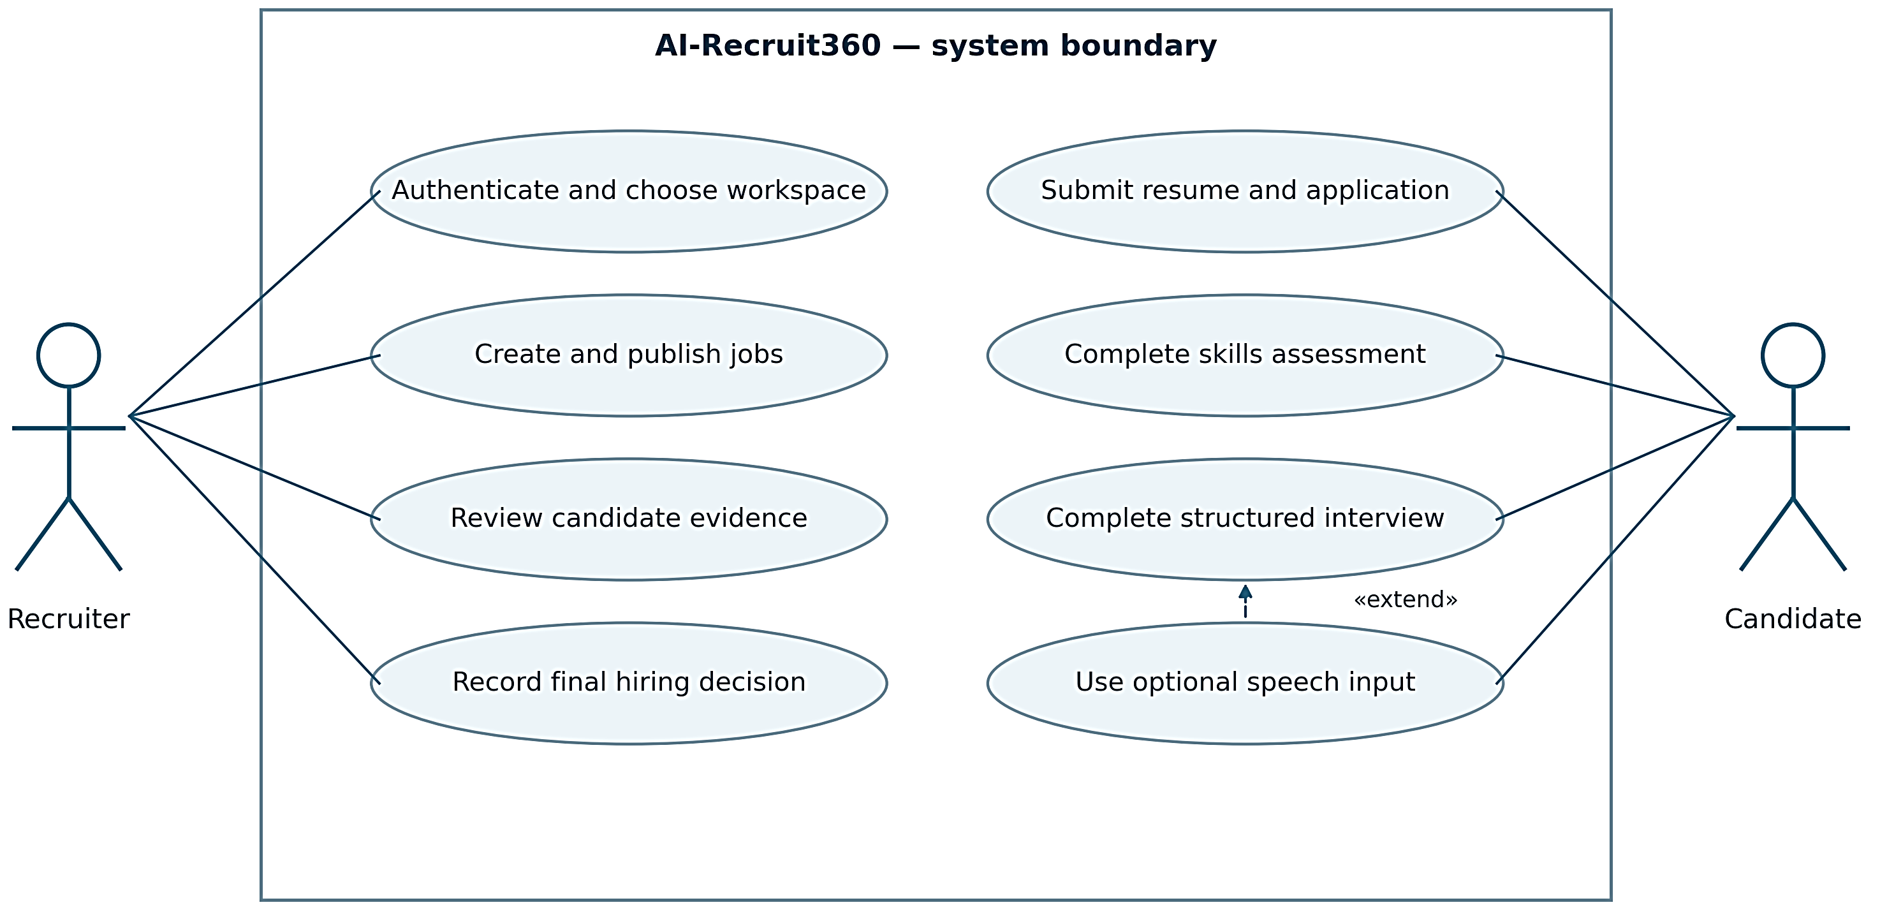
Figure 3.1: UML use-case diagram for recruiter and candidate workflows
Table 3.4: Complete use-case catalogue
ID | Use case | Primary actor | Successful outcome
UC01 | Sign in to a workspace | Recruiter | The recruiter reaches an authorized workspace or organization onboarding.
UC02 | Create a recruiter account | Prospective recruiter | An authenticated identity can proceed to workspace onboarding.
UC03 | Recover a password | Recruiter | The account can authenticate with the updated password.
UC04 | Create an organization | Authenticated recruiter | Organization and ownership are available through verified membership.
UC05 | Switch organization context | Multi-workspace recruiter | All visible operational data belongs to the selected authorized workspace.
UC06 | Create and publish a job | Owner, admin or recruiter | The published job can be opened by a candidate through its link.

ID | Use case | Primary actor | Successful outcome
UC07 | Find a job or application | Recruiter or permitted viewer | The result corresponds to the latest filter state in the current organization.
UC08 | Submit a candidate application | Candidate | Linked candidate, application and document evidence is stored consistently.
UC09 | Screen a stored resume | Candidate workflow | A saved result contains scores, evidence and a progression outcome.
UC10 | Retry interrupted screening | Candidate | The application advances without duplicate completed screening evidence.
UC11 | Generate a skills assessment | Eligible candidate | A complete persisted assessment is ready for sequential answers.
UC12 | Answer a timed question | Candidate | One authoritative answer is recorded for the question.
UC13 | Finalize an assessment | Candidate workflow | Repeated finalization returns a stable result.
UC14 | Answer an interview question | Eligible candidate | The response is attached to the correct question and interview.
UC15 | Record and review an answer | Candidate | The evaluated text is the answer explicitly approved by the candidate.
UC16 | Use the interviewer avatar | Candidate | The avatar presents the authorized question and shows connection state.
UC17 | Calculate the final evaluation | Completed candidate workflow | The scorecard remains explainable through its stage evidence.
UC18 | Review and decide on an application | Authorized recruiter | The stored review outcome reflects the recruiter action.
UC19 | Inspect candidate documents | Permitted workspace user | Private storage remains private while authorized review is possible.
UC20 | Update profile and workspace settings | Authorized user | The updated values are visible through verified workspace context.

3.11 DEVELOPMENT METHODOLOGY
Development followed an iterative and incremental method. Instead of attempting to implement the complete recruitment journey in one step, the team built and checked bounded slices: authentication and organization context, job and candidate records, candidate submission, screening, assessment, interview, evaluation and interface refinement. Each increment created a usable contract for the next one and exposed assumptions that needed to be moved from the browser into the server or database.
A typical iteration started with a workflow problem or failure condition. The team identified the invariant that should remain true, implemented the smallest coordinated change across frontend, backend or database layers, and then added or updated a regression. For example, the requirement that an answer cannot be replaced after submission is not satisfied by disabling a button alone; it is enforced by the database function and checked by repeated-submission tests.
The method also separated implementation verification from broader research validation. Static checks and automated tests can show that a route rejects a foreign question or that a migration preserves data, but they cannot prove that an AI score predicts job performance or treats demographic groups fairly. Those questions are recorded as future evaluation work rather than being treated as completed simply because the software runs.
This approach was appropriate for a final-year project because it supports demonstration and supervision. A reviewer can trace a requirement to a design decision, then to an implementation section and a test result. The method also reduces the risk that late interface changes silently violate an earlier database rule, because the important transitions are represented in both code and verification evidence.

3.12 TOOLS AND TECHNOLOGIES
The selected technologies reflect the existing project architecture rather than a comparison intended to identify a universally best stack. Each tool was assigned a bounded responsibility so that the system could be developed and demonstrated by a small team.
Table 3.5: Tools and technologies used in AI Recruit360
Technology | Role in the project | Reason for use
Next.js 16 / React 19 | Recruiter and candidate web application | Server and client composition, routing, forms and application actions.
TypeScript | Frontend application language | Typed interfaces for forms, service responses and component contracts.
FastAPI / Python | AI and document service | Document extraction, provider orchestration, validation and API endpoints.
Pydantic | Structured backend models | Validation of generated and request/response payloads before persistence.
Supabase Auth | Recruiter authentication | Managed identity used with server-side membership and organization checks.
PostgreSQL / Supabase | Durable relational storage | Tenant relationships, workflow state, constraints, functions and evaluation evidence.
Supabase Storage | Private candidate documents | Private resume objects with controlled server-issued access.
OpenAI services | Structured generation, transcription and speech | Resume analysis, assessment/interview generation and optional speech processing.
Simli | Optional interviewer avatar | Presents stored interview questions as generated media without controlling assessment state.
Vercel | Hosted Next.js frontend | Deployment of the web application and server actions.
Render | Hosted FastAPI service | Deployment of the Python service and health endpoints.
Automated scripts and tests | Regression verification | Checks authentication, database migrations, backend workflows and browser behavior.

3.13 TECHNICAL CONSTRAINTS AND ASSUMPTIONS
The hosted workflow depends on Supabase and the configured AI/media providers, so local execution of Next.js and FastAPI does not make the system offline. Provider or network failures are reported separately from local process health.
The current backend uses one worker for selected process-local operations, while database constraints protect durable state. Readable PDF and DOCX files are supported; scanned-only documents, malware scanning, automatic anonymization, and large-scale horizontal coordination remain outside the project scope.
Chapter 04

SYSTEM DESIGN
System design converts the requirements into components, data structures, access rules and measurable workflow states. AI Recruit360 separates the browser, trusted Next.js server operations, FastAPI processing service, managed database and external AI providers. The following diagrams show the complete architecture, UML relationships, database design and the interactions used to preserve evidence. The chapter also explains which system components control authorization, timing, validation and persistence.

4.1 SYSTEM CONTEXT AND TRUST BOUNDARIES
The context diagram identifies the actors and the external services that participate in the system. Recruiters and candidates interact with a web application, but they do not have the same identity model. Recruiters authenticate through Supabase Auth. Candidates receive a signed session associated with an application after submission. Both paths converge on stored application evidence while retaining different authorization checks.
The browser is an untrusted boundary. It can display question order and countdowns, but it cannot define the official answer deadline or grant access by changing a URL. Next.js verifies access before calling privileged storage or backend functions. FastAPI receives a shared server credential, not the recruiter's public browser key. Supabase applies row policies for authenticated access and executes restricted workflow functions for server operations.
OpenAI and Simli are external processors. Requests to them consume time and depend on account configuration. Their availability must not be confused with the availability of the local web process. The design therefore keeps persistent progress in PostgreSQL and makes the media presentation optional. The context boundary is also the starting point for privacy review: administrators need to understand which candidate content leaves the application for processing.
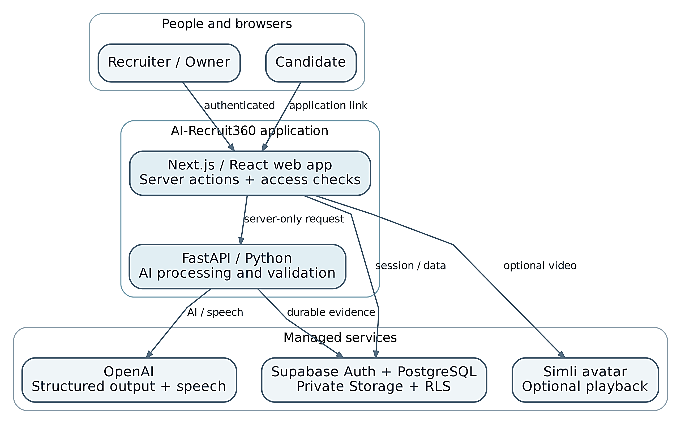
Figure 4.1: System context and external service boundaries
Figure 4.2 presents the application layers and highlights which services are trusted to store evidence and enforce access.
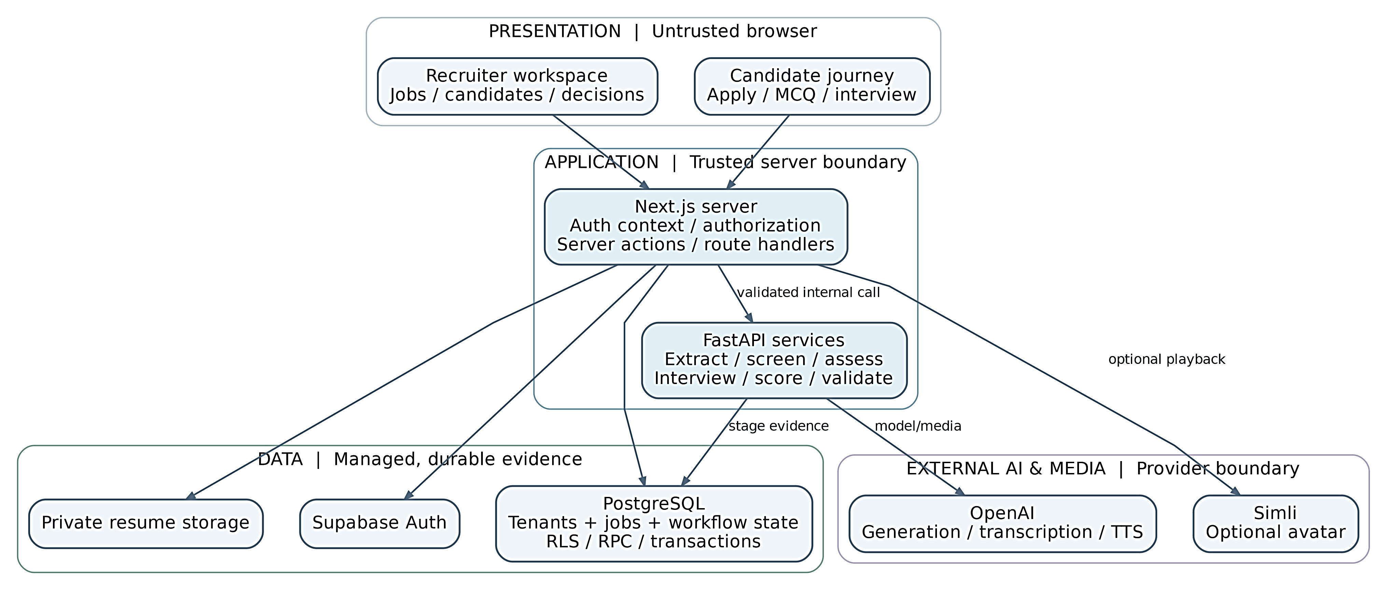
Figure 4.2: Complete layered system architecture of AI Recruit360

4.2 COMPONENT AND DEPLOYMENT STRUCTURE
The code is organized into frontend pages and components, server actions, service functions, backend routes, orchestration services, repositories and database migrations. These layers are not separate microservices. The project has two application processes and a managed data service. Calling every module a microservice would misrepresent the deployment and make the architecture harder to explain.
In local mode, Next.js listens on port 3000 and FastAPI on port 8000. The frontend's server-side API URL points to the loopback backend path ending in /api/v1. In hosted mode, Vercel runs Next.js and Render runs FastAPI [15]. Their environment variables hold the corresponding URLs and matching shared secret. Supabase remains hosted in both modes.
The deployment diagram distinguishes build-time public configuration from server secrets. The local public application URL may be included in the frontend build, so a production build must be regenerated after it changes. A restarted development server reads the local environment. Credentials are not written into this report or the diagrams. The diagram describes connectivity rather than a measured geographic latency advantage.
Figure 4.3 separates the local demonstration route from the hosted deployment route.
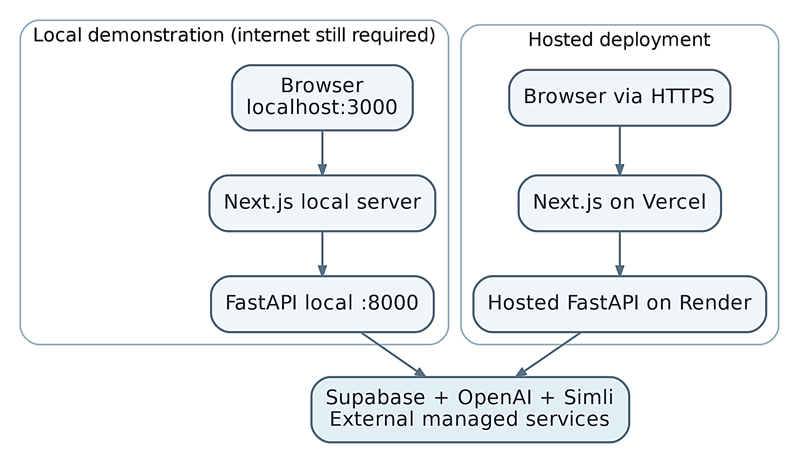
Figure 4.3: Local and hosted deployment architecture
Figure 4.4 uses UML classes with attributes, operations and relationship multiplicities to describe the principal domain entities. The diagram is a logical model; it is not a claim that every database table is implemented as a Python class.
Figure 4.4 describes the key recruitment entities using UML classes, attributes, operations, associations and cardinalities.
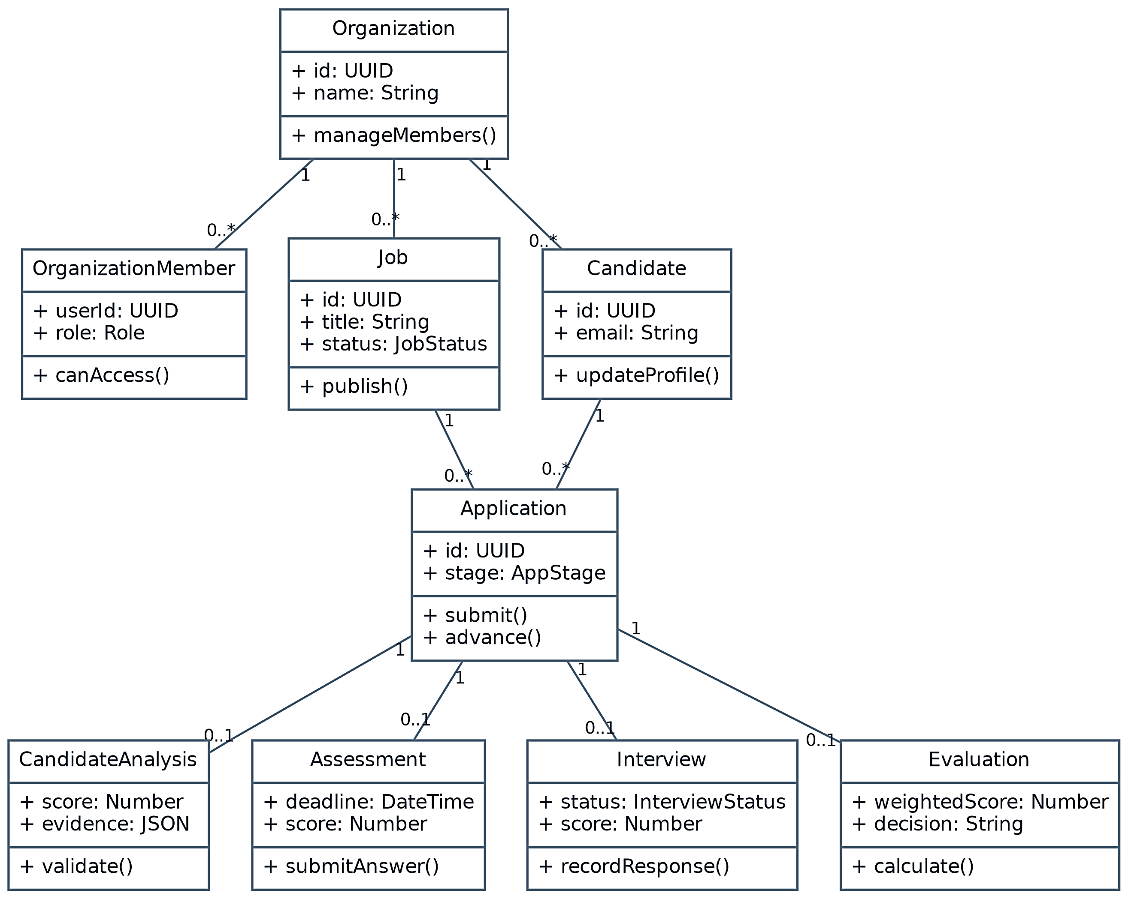
Figure 4.4: UML class diagram of core recruitment entities

DETAILED COMPONENT ATTRIBUTES
- Next.js web application: The frontend provides recruiter and candidate pages, validates user-facing input, resolves authenticated workspace context, and calls authorized server actions. It depends on Supabase authentication and storage plus the FastAPI service for AI operations.
- FastAPI AI service: The backend extracts document text, calls external AI services, validates structured responses with Pydantic, and persists stage results through repository functions. Health endpoints separate process liveness from database readiness.
- Supabase data platform: Supabase provides authentication, PostgreSQL persistence, row-level controls, database functions, and private document storage. Organization membership and application ownership are checked before sensitive records or signed file links are returned.
- External AI and media providers OpenAI supplies structured generation, transcription, and speech synthesis, while Simli provides optional avatar playback. These services are treated as external dependencies; failures remain recoverable and do not become candidate scores.

4.3 DATA FLOW FROM APPLICATION TO REVIEW
The main data flow begins with a published job. The candidate supplies contact details and a document; the server validates the file and creates linked application records through a database function. Screening obtains the stored document or existing extracted text, combines it with job context, and requests a structured evaluation. A completed screening result is saved before the interface moves forward.
Eligible candidates receive a stored assessment. Questions and answer keys remain distinct from the public question representation. Answers are recorded under server-enforced order and time rules. Interview initialization follows an eligible assessment and generates or retrieves the next question. Each submitted response receives a persisted evaluation. Final evaluation reads the completed stage records and calculates a deterministic weighted score.
The design includes recovery edges rather than only a straight success path. Failed question generation can be retried without assigning an assessment score. Completed screening can be returned instead of generated again. A repeated response submission must return stable stored evidence. The diagrams use these recovery edges to show why persistent identifiers and database invariants matter more than a sequence of browser screens.
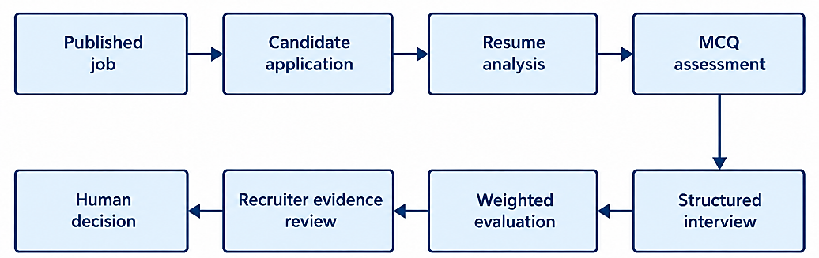
Figure 4.5: Application evidence and evaluation data flow

4.4 RELATIONAL MODEL
The organization is the tenant boundary and the application is the workflow boundary. An organization has memberships and jobs. A candidate belongs to an organization and may be linked to an application for a particular job. Candidate documents hold storage references and extracted text. Screening, assessment, interview and final evaluation records attach to the application.
Assessment questions and answers are separate relations because a question's authoritative answer must not be included in the candidate's public payload. Interview questions and response evaluations are similarly separated. This structure permits the recruiter to inspect individual evidence rather than receiving only an aggregate. Unique constraints help establish one stage record or one numbered question within the intended parent.
The schema includes retained legacy columns and two historical logging tables. The active interface no longer offers an Activity tab, but the existing records were not deleted. Section 4.9 summarizes the migrated schema and the main integrity controls. The summary is derived from the reviewed migration contracts and should not be interpreted as a fresh screenshot of the hosted Supabase schema or as proof that every pending remote migration has been applied.
Figure 4.6 gives the relational data model, including primary identifiers, foreign-key links and relationship cardinalities for organization, job, candidate, application and evidence records.
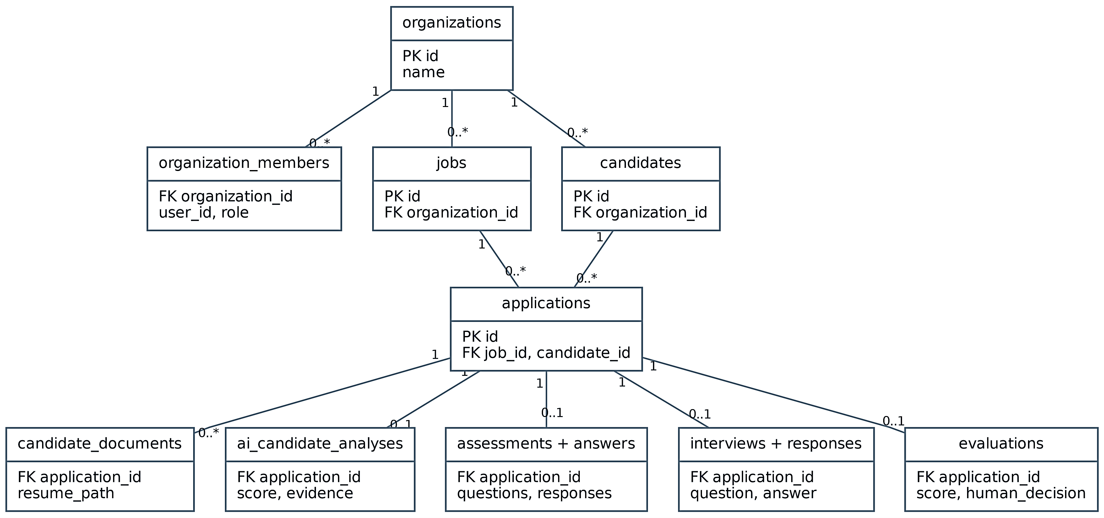
Figure 4.6: Entity-relationship diagram and key cardinalities

4.5 WORKFLOW STATES AND TRANSITIONS
A status value represents progress, not merely a visual badge. Application transitions are associated with persistence functions that know whether the necessary evidence exists. An assessment cannot be considered completed just because the browser has displayed ten questions. Its completion is based on recorded answers, server timing and finalization. An interview requires its stored responses before final evaluation.
State diagrams are useful because they expose routes that should not be possible. For example, direct access to an interview URL should not bypass eligibility, and a failed AI call should not silently turn an application into a rejection. The project distinguishes knocked-out progression outcomes from recruiter review decisions. The implementation also preserves decisions when evaluation is retried.
The diagrams summarize the operational lifecycle rather than claiming a formally verified state machine. The detailed SQL functions remain the authority on accepted transitions. When adding a new state, a maintainer should update the database contract, API response type, interface labels and tests together. Changing only a badge risks making the interface disagree with the stored workflow.
Figure 4.7 shows how completed screening results are reused and failures remain recoverable.
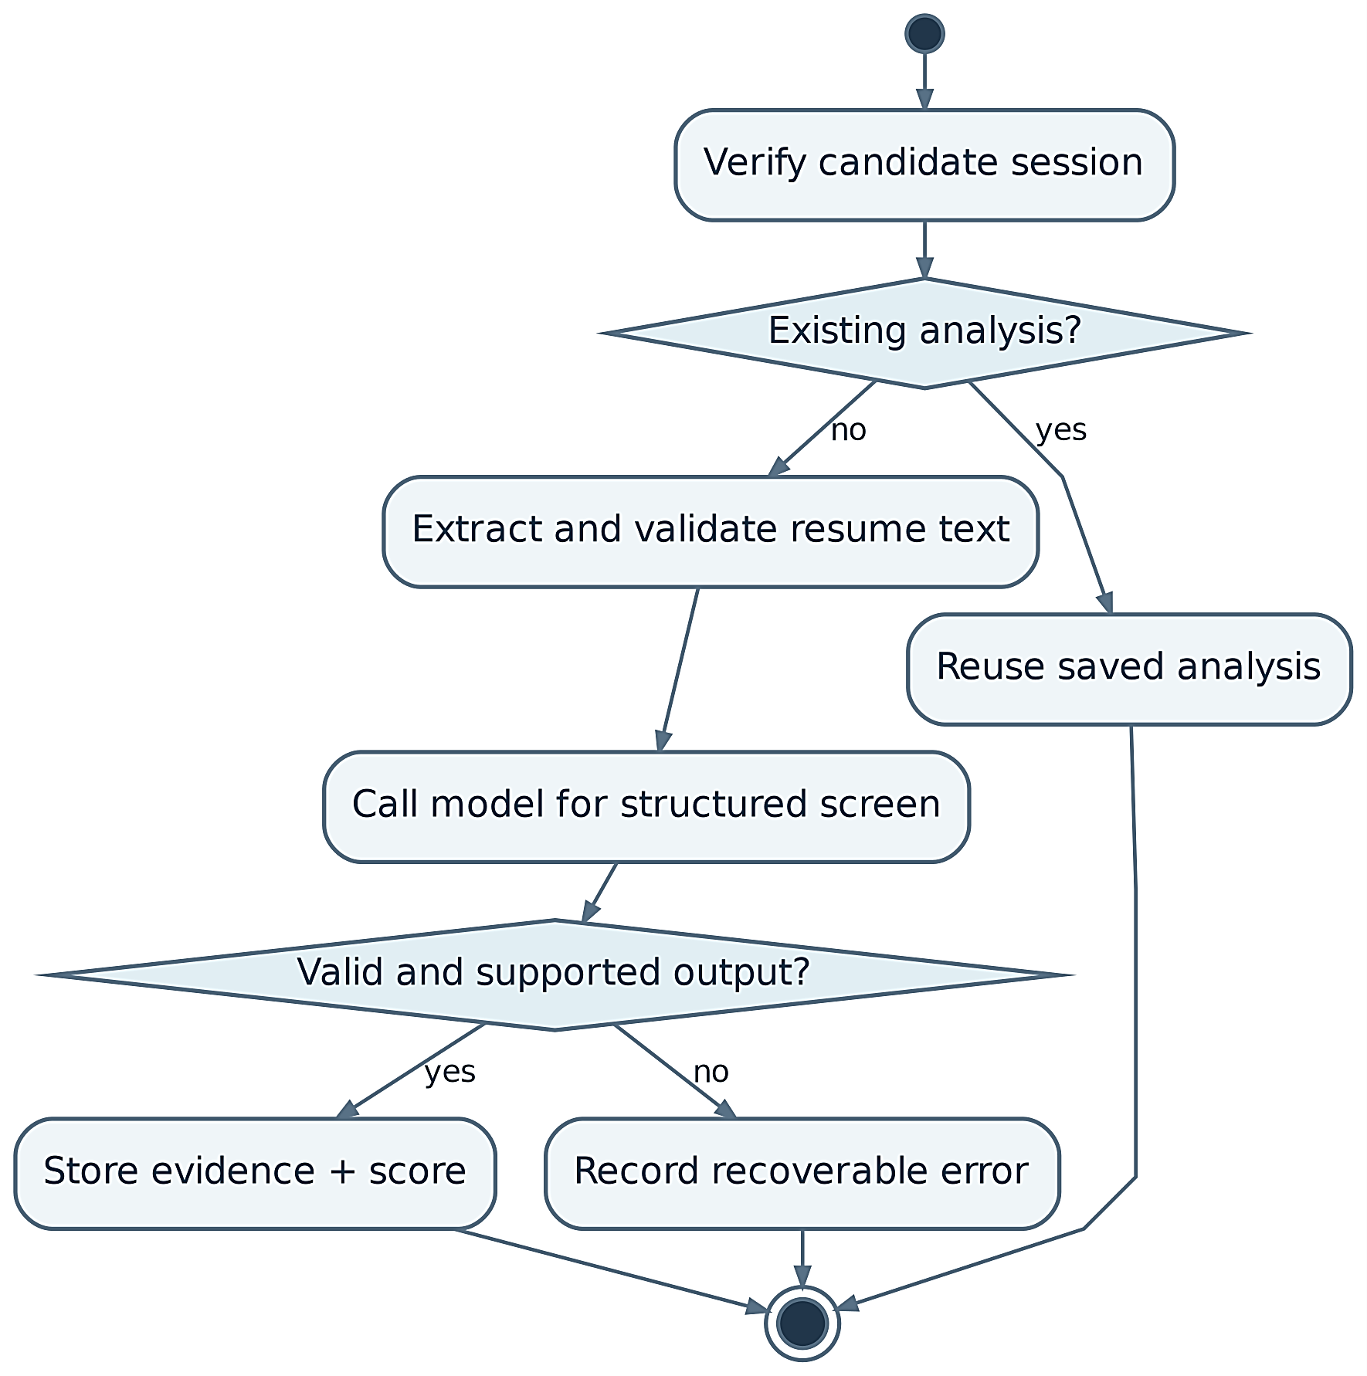
Figure 4.7: UML activity diagram for resume screening

4.6 SEQUENCE AND CONCURRENCY DESIGN
A typical request passes through several independently failing components. The sequence diagrams show when the browser waits, where access is checked, and when an operation becomes durable. Returning a successful AI payload before saving it would expose the user to a result that cannot be resumed. The implementation treats persistence as part of successful stage completion.
Concurrency is handled at more than one level. Independent reads can run together to shorten the critical path. Per-resource asyncio locks serialize selected expensive operations inside one backend process. Database functions and constraints protect durable state when requests overlap. These mechanisms have different scopes; a process-local lock cannot coordinate multiple Render instances.
The design therefore keeps the current backend at one worker and relies on database rules for the transitions that must survive retries. A future horizontally scaled deployment would need cross-process job ownership, bounded queues or another coordination mechanism. Adding workers without revisiting this design could repeat generation even if a unique database key later prevents duplicate rows.
Figure 4.8 illustrates the submission boundary between the candidate, application server and database.
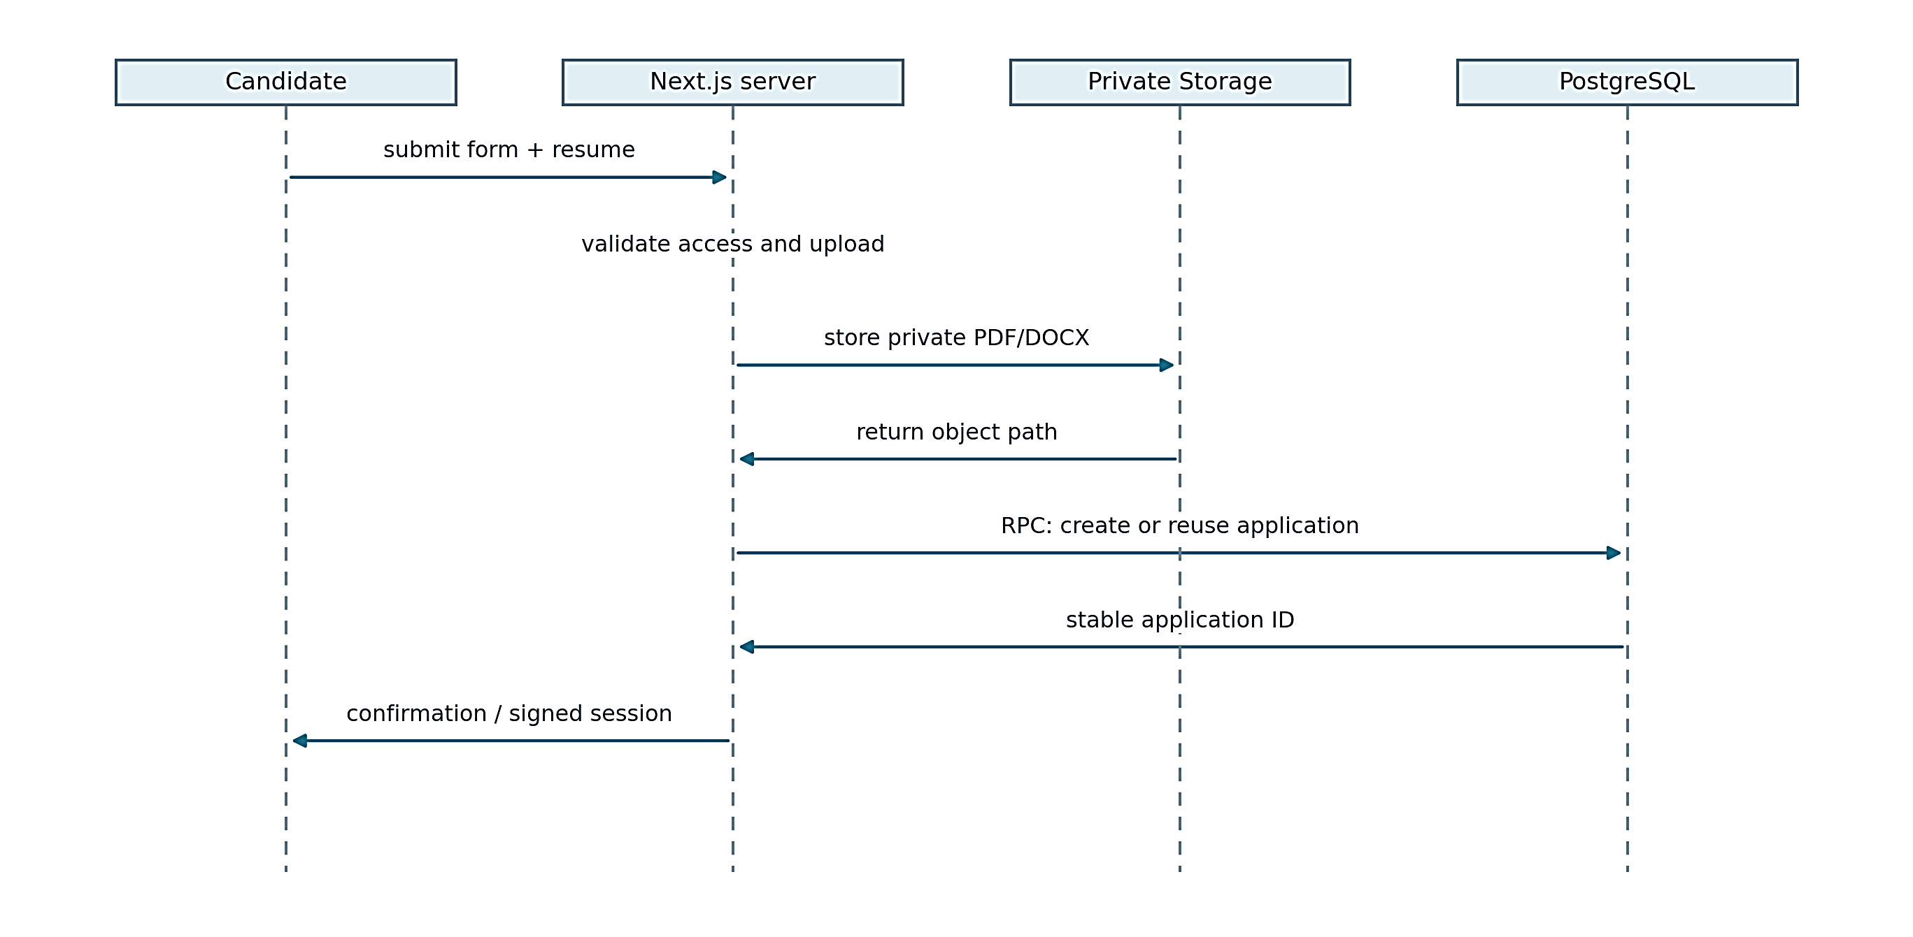
Figure 4.8: UML sequence diagram for candidate submission

4.7 ACCESS CONTROL MODEL
The permission model separates authentication, membership, role permissions and object ownership. Authentication establishes a user identity. Membership connects that identity to an organization. Role permissions describe which actions are permitted within that organization. Object ownership checks ensure that a particular application, document or interview belongs to the authorized context.
For recruiter access, the server uses Supabase getUser rather than trusting client-controlled headers. Organization selection is resolved against real memberships. For candidate access, signed session data is verified before application-specific actions. Privileged database access is created only on the server. Interview avatar sessions also require access to an active interview before a short-lived provider token is issued.
The permission matrix in this chapter represents the code's intended role mapping. Isolated tests exercise tenant and viewer restrictions, but they are not a penetration test. Retained audit permission labels do not imply an active Activity page. The design could be strengthened further with systematic route-by-route authorization testing and review of every security-definer function after future migrations.
Table 4.1 summarizes representative role permissions. These permissions are enforced by the application and database, not by hiding interface controls.
Table 4.1: Selected role permissions
Role | View evidence | Manage jobs | Manage interviews | Manage workspace
Owner | Yes | Yes | Yes | Yes
Recruiter | Yes | Yes | Yes | No
Interviewer | Yes | No | Yes | No
Viewer | Yes | No | No | No

4.8 INTERFACE AND INTERACTION DESIGN
The workspace groups operational screens around jobs, applications, candidates, interviews, evaluations, analytics and settings. Each screen should answer a specific question: which roles are active, where an application is stalled, or what evidence supports an evaluation. A dashboard summary complements these screens rather than replacing them with decorative charts.
The revised landing page uses an interactive sample preview with explicit sample-data labelling. Hover effects and short CSS transitions indicate interaction without concealing content until an animation finishes. Reduced-motion settings disable unnecessary movement. The interview layout places the avatar and answer workflow side by side on suitable desktop screens and stacks them on narrow screens. The avatar preserves its full source frame rather than cropping the face to fill an arbitrary box.
Errors are part of the interface design. A saved resume with unavailable screening is presented as recoverable progress. Sign-in failures release the loading state. Speech failure leaves typed input available. These decisions make the interface more credible than a design that displays a spinner indefinitely or turns every provider interruption into a generic connection error.
Figure 4.9 uses a UML activity diagram to show optional avatar presentation, answer submission, persistence and completion.
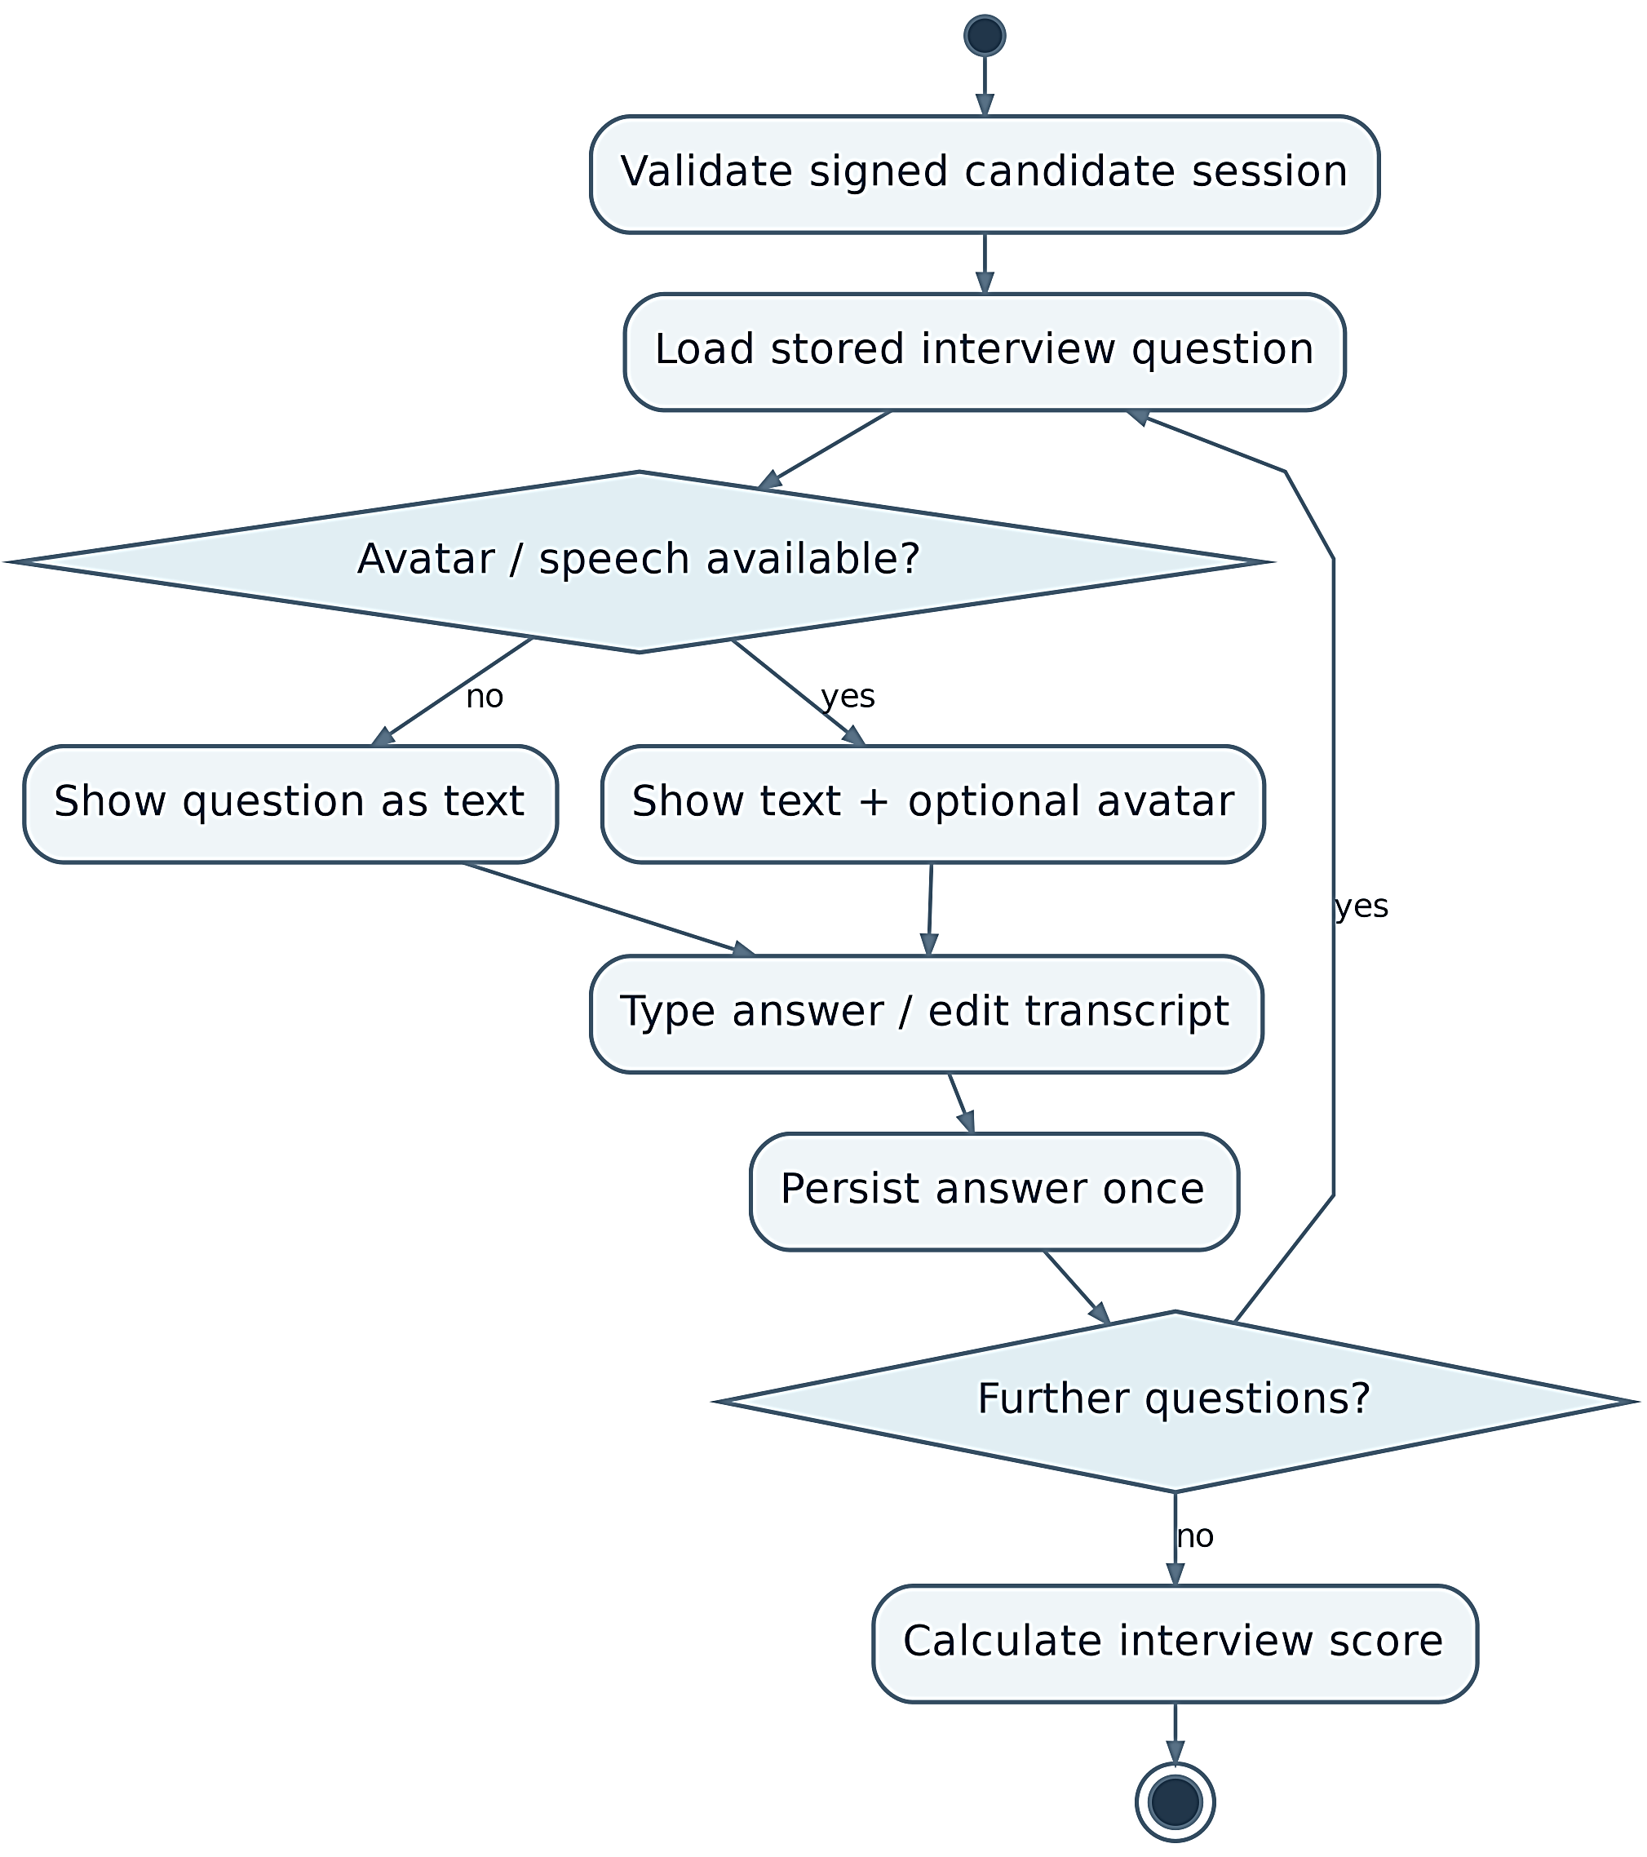
Figure 4.9: UML activity diagram for the interview workflow

4.9 CORE DATABASE TABLES
The relational design uses the organization as the tenant boundary and the application as the workflow boundary. Table 4.2 summarizes the active and retained tables that are most important when explaining the system to a supervisor. The summary focuses on purpose and integrity rather than reproducing every column from the migration files.
Table 4.2: Core database tables and integrity controls
Table | Purpose | Key integrity or access control
profiles | Recruiter profile details extend the managed authentication identity. | FK
organizations | Organizations define the tenant boundary for recruitment work. | FK, unique
organization_members | Memberships connect users to organizations and assign roles. | FK, unique, check
jobs | Jobs store published roles and their descriptive requirements. | FK, unique, check
candidates | Candidates store organization-scoped contact and profile information. | FK, unique
applications | Applications are the central link between a candidate, a job and workflow progress. | FK, unique, check
candidate_documents | Document records bind private storage objects and extracted text to candidate evidence. | FK
cv_screenings | Screening records store match scores and structured supporting evidence. | FK, unique, check
assessments | Assessment records hold lifecycle state and aggregate performance. | FK, unique, check
Table 4.2 (continued). The remaining records follow below.
Table | Purpose | Key integrity or access control
assessment_answers | Answer records preserve the authoritative selected option and timing evidence. | FK, unique, check
interviews | Interview records identify the application interview and its lifecycle. | FK, unique, check
interview_questions | Interview questions preserve the prompts presented to a candidate. | FK, unique
interview_responses | Responses connect candidate text with technical, communication and relevance scores. | FK, unique
final_evaluations | Final evaluations combine stage scores and retain review evidence. | FK, unique, check
The separation between candidates and applications is important. A candidate record represents a person within an organization, while an application represents that candidate's attempt for a specific job and owns the stage progression. This permits the same person to apply for different roles without making resume screening or interview evidence globally shared across unrelated applications.
Assessment and interview records use parent-child relationships so that public question payloads can exclude private answer keys and internal evaluation details. The final evaluation references completed stage evidence rather than acting as the only record of the process. This structure supports both retry safety and recruiter review because a composite result can be traced back to the records that contributed to it.

4.10 SECURITY ARCHITECTURE
Security is implemented as a sequence of boundaries rather than a single login check. Recruiter requests first establish an authenticated identity and then resolve organization membership. Role permissions are evaluated within that organization, and object-level checks confirm that a requested application, document or interview belongs to the same context. Candidate operations use a separate signed application session rather than granting a public browser unrestricted workspace access.
Privileged credentials remain on servers. The browser receives only the public configuration needed to communicate with the authentication platform, while service-role database access and the shared backend credential are kept in server environments. FastAPI operations are called through authorized application actions, and document links are generated only after the relevant access context has been checked.
Row-level security and database functions complement application checks. Policies restrict authenticated access to organization-scoped data, while controlled functions enforce important transitions such as candidate submission, assessment answers and final evaluation. This layered model is deliberate: interface visibility is not treated as authorization, and a hidden button is not a substitute for a server or database rule.
The architecture also recognizes limits. The current test suite is not a penetration test, historical audit tables do not prove complete operational logging, and prompt-injection resistance has not been established against a dedicated adversarial resume set. Before production use, security review should include route-by-route authorization tests, secret rotation, upload scanning, provider data-handling review and a defined retention policy for candidate evidence.

4.11 DESIGN RATIONALE AND TRADE-OFFS
The architecture favors explicit application services and database contracts over a large collection of independent microservices. This reduces deployment complexity and makes the end-to-end flow easier to explain, but it also means long-running AI operations share a relatively small backend process. For the academic workload, the trade-off is acceptable because correctness and traceability are prioritized over unbounded scale.
Managed services reduce the amount of infrastructure the team must operate. Supabase supplies identity, relational storage and private files; Vercel and Render provide hosted application runtimes; and external AI providers supply generation and speech capabilities. The cost of this simplicity is dependency on network availability, provider quotas and external data processing. The design therefore preserves progress before optional provider steps and exposes recoverable failure states where possible.
The project also chooses a deterministic weighted final score rather than asking the language model to decide the final ranking directly. This makes the combination rule easy to inspect and reproduce, while still leaving the meaning of the underlying stage scores subject to human review. The fixed weights are project rules, not scientifically validated predictors of job performance.
Finally, the interface prioritizes evidence review over maximum automation. Recruiters can inspect stage details and record a separate decision, and candidates can review speech transcripts before submitting them. These choices require additional screens and stored data, but they make the system more defensible than a design that hides intermediate evidence behind one generated recommendation.
Chapter 05

IMPLEMENTATION
Implementation translates the system design into working recruiter and candidate workflows. This chapter explains authentication, job publishing, resume processing, screening, assessments, interviews and final evaluation. It also shows the actual interface screens and how the system handles failures and external integrations. Each major function is described in relation to the stored application state so that the behavior can be checked during demonstration.

5.1 FRONTEND COMPOSITION
The frontend is implemented with Next.js 16.3.5, React 19 and TypeScript. Route-level components obtain initial workspace context and pass data into client views. The browser owns transient interaction state such as search text, selected tabs, draft answers and media controls. Server actions handle mutations and provider calls after access checks.
The small landing preview is a client component because selecting a sample candidate changes the visible evidence. The rest of the landing content does not require an animation framework. Shared buttons use hover and focus feedback, while motion respects the reduced-motion preference. The implementation aims to improve interaction without introducing continuous animation loops or extra API requests.
The distinction between client and server code also supports secrecy. A browser needs the public authentication configuration, but it does not need the backend shared secret, service-role key or Simli API key. Sensitive provider operations are represented as server actions with narrow inputs. This is an implementation boundary, not a substitute for validating the requested interview or application.

5.2 RECRUITER AUTHENTICATION AND WORKSPACE CONTEXT
Authentication is coordinated by a browser provider and server-side context helpers. The browser handles the initial session event once rather than issuing a second startup session load that repeats profile and membership queries. Database work is scheduled outside the synchronous auth callback to avoid holding the authentication callback while waiting for operations that depend on the same client.
The server verifies the user and builds a request-scoped context containing profile, memberships and the selected organization. Request-scoped caching avoids repeated reads within one render without retaining one user's authorization result across unrelated requests. Membership and profile reads can proceed in parallel after the user is known.
A reported sign-in loading problem led to a bounded browser auth request and a form-level watchdog. Requests abort after fifteen seconds; the form stops waiting after twenty-five seconds if initialization or refresh remains unresolved. Successful authentication starts a fresh document navigation after session cookies are saved. The original failing network request was not captured, so this repair is supported by regression scenarios rather than a claim of having measured the original network cause.

5.3 JOB AND CANDIDATE ACCESS
Job listing retrieves embedded counts instead of downloading all application rows and counting them in JavaScript. This avoids undercounting when a data API row limit truncates the downloaded records. Candidate and job summaries similarly use count queries. An error remains an error rather than being converted to a reassuring but false zero.
Search inputs are debounced for 300 milliseconds. Each request is associated with a version so that a slower earlier response cannot replace a newer result. Organization changes reset stateful lists through organization-specific keys. The application list initially uses its server-provided data rather than immediately repeating the same request in the browser.
Document access uses batches of signed URLs where a list needs several files. The URLs are obtained after the intended access checks and do not make the storage bucket public. The lifetime of a signed link is still a period of bearer access, so it should not be copied into public documentation. The thesis figures use synthetic records and do not include private document links.

5.4 SUBMISSION AND DOCUMENT EXTRACTION
The submission path validates candidate fields, file size and accepted format before storing linked records. PDF and DOCX are supported; the older binary DOC format is not advertised. The four-megabyte limit is consistent across the candidate form, recruiter uploader and backend recording path, leaving overhead below the hosting request limit described by Vercel [24].
The extraction service uses a PDF fast path with a fallback parser and reads DOCX paragraphs and tables in document order. PyMuPDF's documentation explains that PDF text order depends on how a document was created and may require block or word positioning to reconstruct natural order [1]. This matters because resumes use columns and because many DOCX resumes place skills and employment history inside table cells. An empty or unreadable PDF produces a meaningful failure rather than a fabricated candidate summary. OCR for image-only documents is not implemented.
When extracted text is already stored, screening reuses it. This avoids another storage download, parsing operation and redundant write. Tests cover generated text PDFs, table-only DOCX content and the empty-PDF failure path. These are parser regressions with synthetic documents; they do not establish successful extraction from every resume format, language or unusual layout.

5.5 STRUCTURED RESUME SCREENING
The screening orchestrator first checks for a completed result. If one exists, it reconstructs the typed response from persisted fields. Otherwise it resolves the application context, obtains resume text and sends a structured request to the configured provider. The OpenAI adapter uses a sixty-second timeout, no automatic retry and a semaphore limiting concurrent generation inside the process.
The payload includes a match score, component scores, matched and missing skills, evidence quotes and a reasoning summary. Numeric fields are constrained to the expected range. The server then derives qualification from the configured threshold, currently seventy percent, and maps the recommendation band. The model's own qualified flag is not the final authority on progression.
Persistence uses save_screening_result so that the score record and application transition are coordinated. A failure to save is reported and can be retried. The evidence quotes support recruiter inspection, but the current implementation does not independently verify every quote against the resume. Accordingly, the result is described as AI-assisted evidence organization, not a proof of candidate competence.

5.6 ASSESSMENT GENERATION AND TIMING
Assessment generation requests exactly ten technical questions linked to the job context and the candidate's summarized background. Each item includes four options, a correct option, an explanation, a skill category and a difficulty label. The backend checks that the question numbers form the complete sequence from one to ten before persisting the set.
The candidate receives a public representation that excludes the answer key. Recording an answer calls record_assessment_answer, which enforces assessment ownership, order, server timing and immutable prior answers. Finalization calls finish_assessment and uses the configured pass threshold, currently sixty percent. The browser countdown is a presentation of server rules rather than their replacement.
Personalized questions improve contextual relevance in the intended design, but they introduce a comparability issue. Two candidates may receive questions with different actual difficulty even if both are labelled medium. Figure 5.1 summarizes question generation, timing and persisted answers for the assessment.
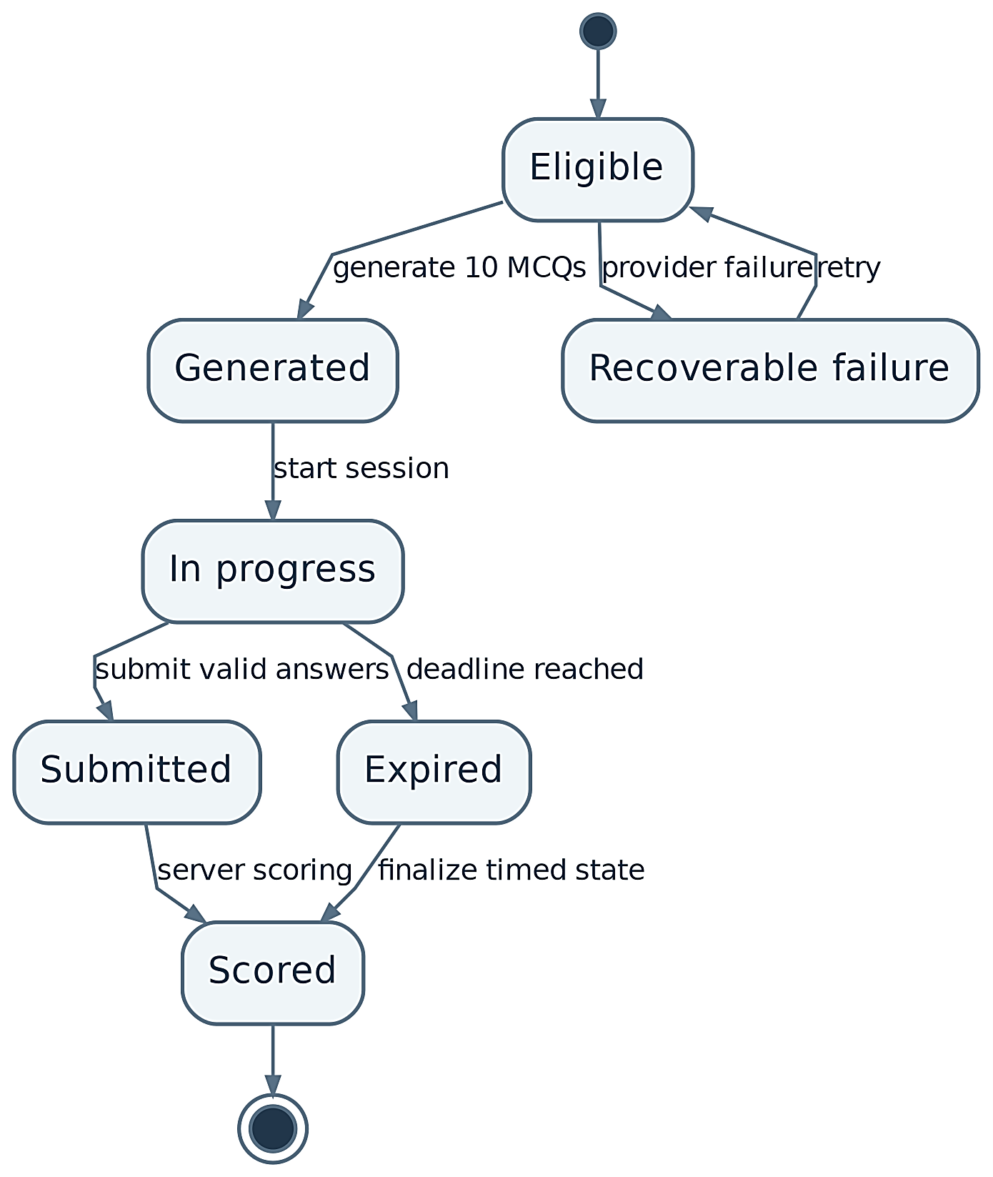
Figure 5.1: UML state-machine diagram for technical assessment

5.7 INTERVIEW ORCHESTRATION AND RESPONSE SCORING
Interview initialization verifies eligible preceding stages and creates or retrieves the application's interview record. The next-question operation uses stored progress to retrieve or generate the next item. The interview is limited to five questions. Question generation can use role information, candidate context and prior conversation, but it is bounded rather than an open-ended autonomous interview agent.
Each submitted answer is evaluated for technical quality, communication and relevance. The saved response contains both the candidate text and the resulting scorecard. The persistence function coordinates the answer and interview progress and provides retry-safe behaviour. A candidate cannot submit an answer for an unrelated question merely by changing its identifier.
Communication scoring applies to the submitted textual response in this workflow. It is not facial-expression analysis or a validated measure of personality. Transcription quality may affect the text, which is why review before submission is important. The report avoids describing the system as lie detection, emotion recognition or proof of authorship; none of those capabilities is implemented.
Figure 5.2 illustrates the saved-answer path for structured interview evaluation.
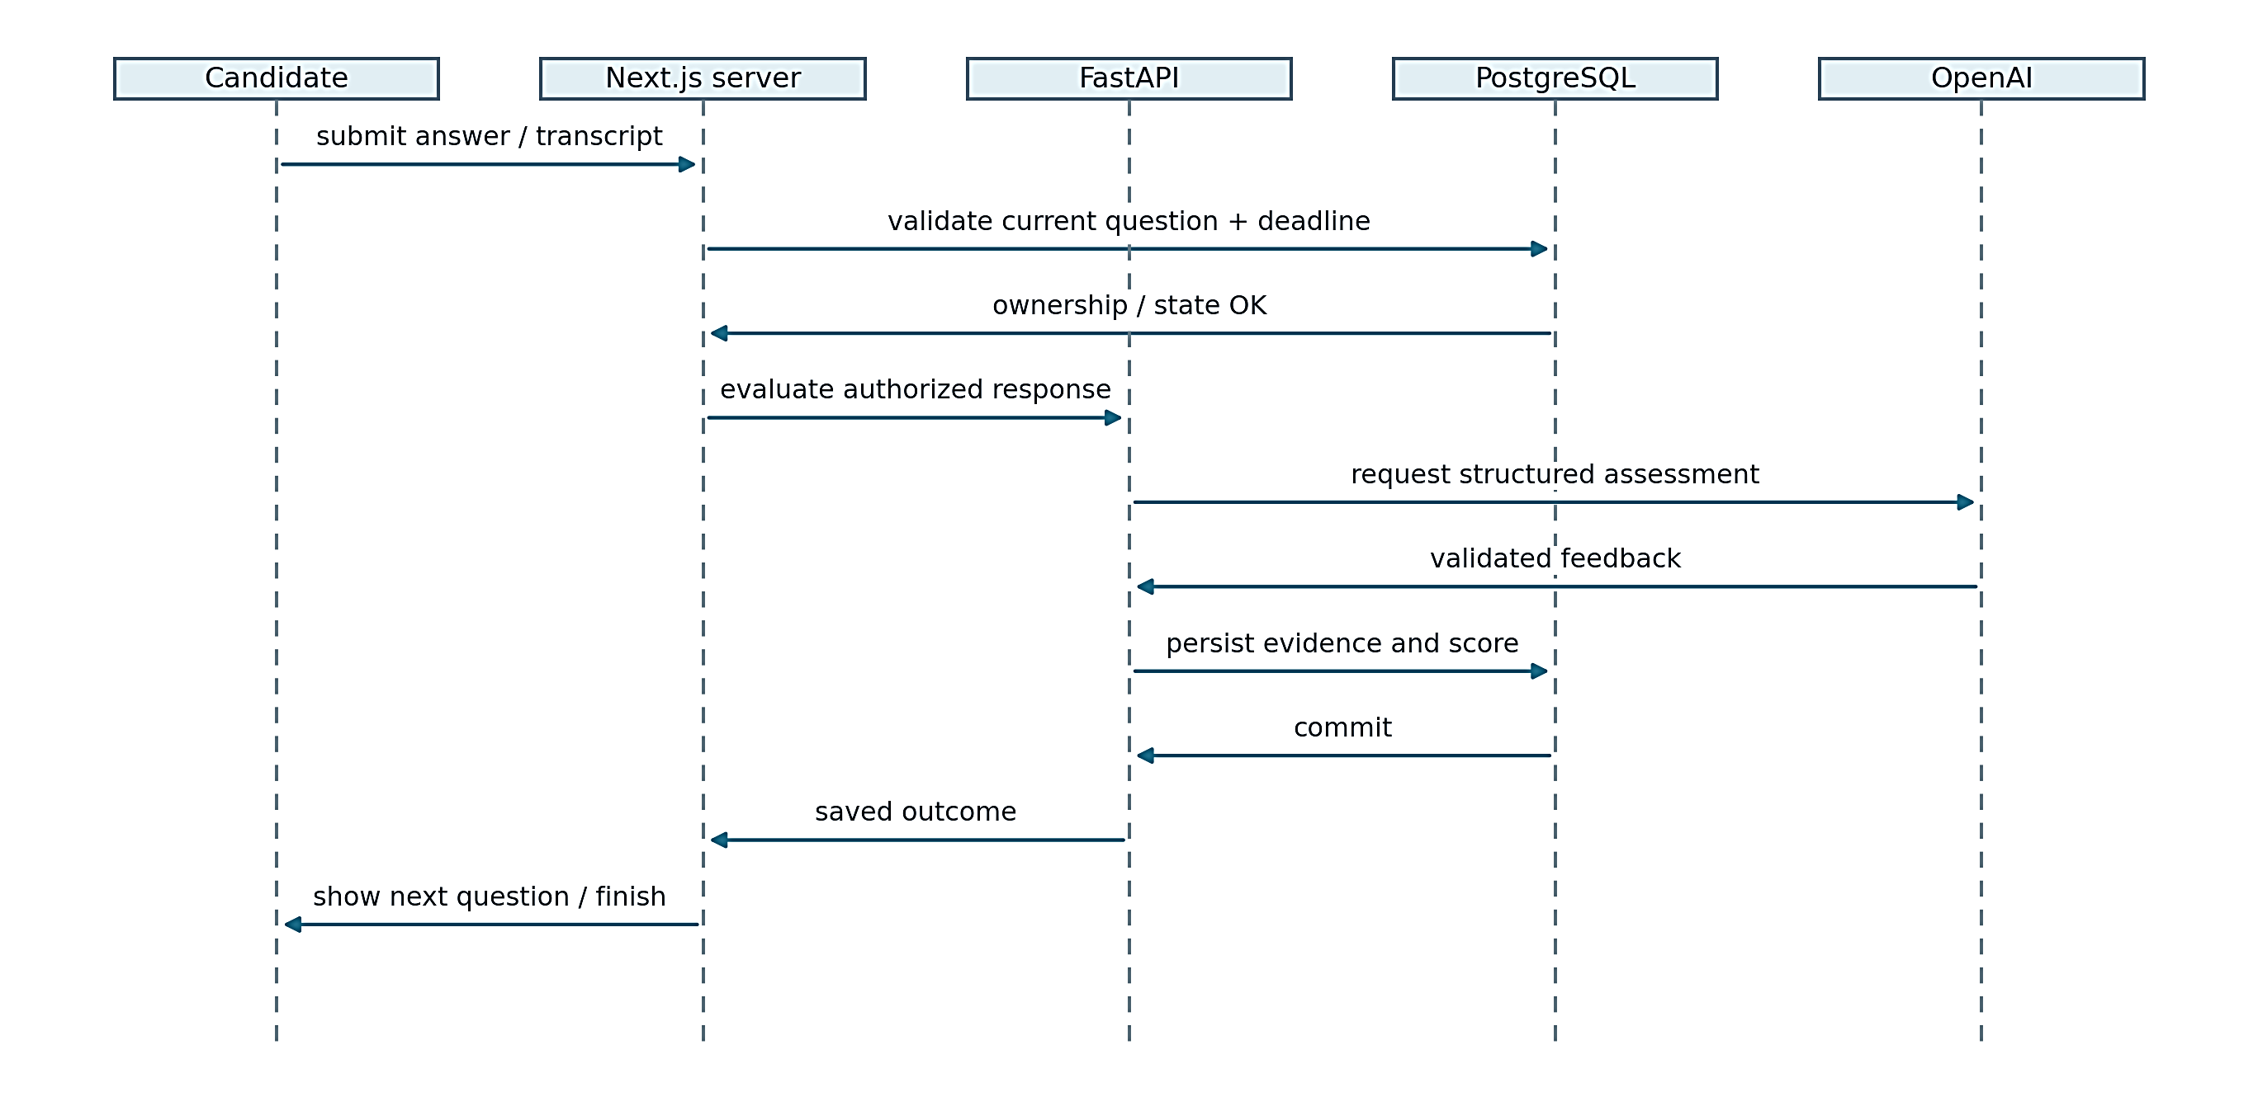
Figure 5.2: UML sequence diagram for interview answer evaluation

5.8 SPEECH AND AVATAR INTEGRATION
The recording interface captures an answer and sends supported audio to the transcription endpoint. The backend limits input size and uses a bounded, properly closed client for the speech request. Candidates can edit the transcript before it becomes the submitted answer. A denied microphone permission does not remove the typed-answer path.
For interviewer playback, the server obtains the question text associated with the authorized active interview and synthesizes speech. The browser converts audio to the format required by the avatar client and plays the corresponding stream. A short-lived Simli session token is created on the server after access checks. The API key is not sent to the candidate browser.
Controls expose connection, repeat-question, mute and disconnect behaviour. The interface labels the video and voice as AI-generated. The selected female face and the nova speech voice are separately configured. The avatar is optional: the stored question, answer field and submission remain the core interview mechanism when media services fail or the candidate prefers text.

5.9 FINAL EVALUATION AND RECRUITER DECISION
Final evaluation reads screening, assessment and interview evidence only after required stages are completed. For each interview response, available technical, communication and relevance scores are averaged; the response averages are then averaged to obtain the interview score. Missing interview evidence prevents evaluation rather than silently substituting zero.
The composite is calculated as S = 0.40C + 0.25A + 0.35I and rounded to one decimal place, where C, A and I are the resume, assessment and interview scores on a hundred-point scale. Recommendation bands begin at eighty-five for strong hire, seventy for hire and fifty-five for review; lower scores receive no hire. These are project rules, not empirically calibrated employment thresholds.
For an illustrative candidate with C = 80, A = 70 and I = 90, the composite is 32 + 17.5 + 31.5 = 81.0. This arithmetic example demonstrates the formula and is not a measured candidate result. The recruiter should inspect the stage evidence before acting. Retrying the final evaluation preserves an existing recruiter decision through the database persistence function.
Table 5.1: Illustrative weighted score calculation
Input | Value | Weighted contribution
Resume match C | 80 | 32.0
Assessment A | 70 | 17.5
Interview I | 90 | 31.5
Composite | 81.0 | Hire band; illustrative only

5.10 DATABASE MIGRATIONS AND COMPATIBILITY
The migration sequence begins with a canonical schema and then adds data-contract alignment, candidate submission, assessment integrity, pipeline persistence, dashboard aggregation, application search, function permissions and performance indexes. Existing records and legacy field names are retained where compatibility requires them. The migration strategy is additive rather than a database reset.
Two isolated test layouts are used: a legacy layout and a layout with selected fields already renamed. This catches migration assumptions that would succeed on a fresh schema but fail on an existing copy. The tests also verify that previously stored resume evidence survives alignment. The schema dictionary in Appendix B is derived after executing the local migration sequence.
Migration tests stub managed authentication and storage structures and omit extensions that the isolated engine does not provide. They therefore validate the relevant SQL contracts under a controlled setup, not the complete hosted Supabase platform. A release still needs to confirm the remote migration history before applying only pending files. Re-running the initial schema or deleting data is not an acceptable repair for a missing function.
Figure 5.3 links the main evidence records to each candidate application.
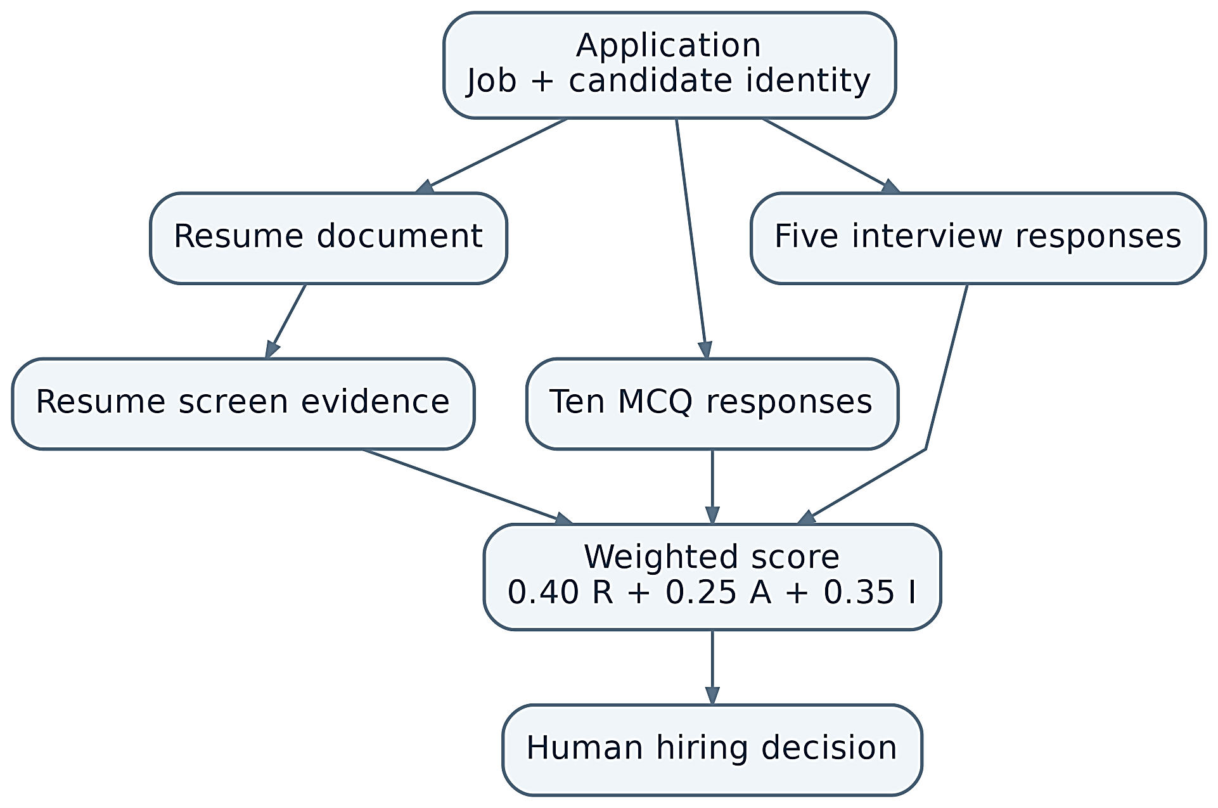
Figure 5.3: Relationships among stored recruitment evidence stages

5.11 CONFIGURATION AND DEPLOYMENT LIMITS
Local development uses separate frontend and FastAPI environment files. Public browser configuration is kept separate from server-side database and provider secrets. Health and readiness endpoints are used to confirm process availability and database connectivity.
The prototype is intended for controlled academic or small-workflow use. Authentication, storage, language-model, speech and avatar services depend on external providers and internet connectivity, so a production frontend build and verified provider settings should be used for a formal demonstration.

5.12 USER INTERFACE IMPLEMENTATION
The final interface keeps recruiter administration separate from the public candidate journey. The following screens are selected to show the main implemented workflow without reproducing every page of the application.
The recruiter workspace displays summary information and navigation for the selected organization.
Figure 5.4 shows the recruiter workspace used to navigate authorized jobs, candidates and application evidence.
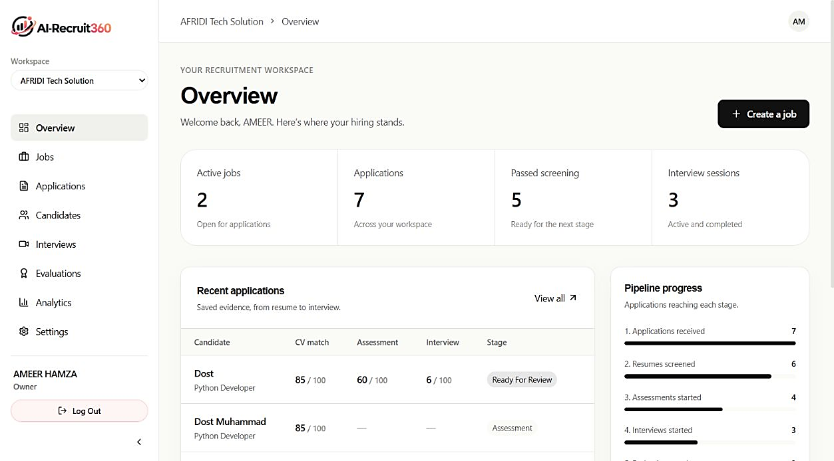
Figure 5.4: Recruiter workspace overview
The job details screen connects an open role with its candidate pipeline.
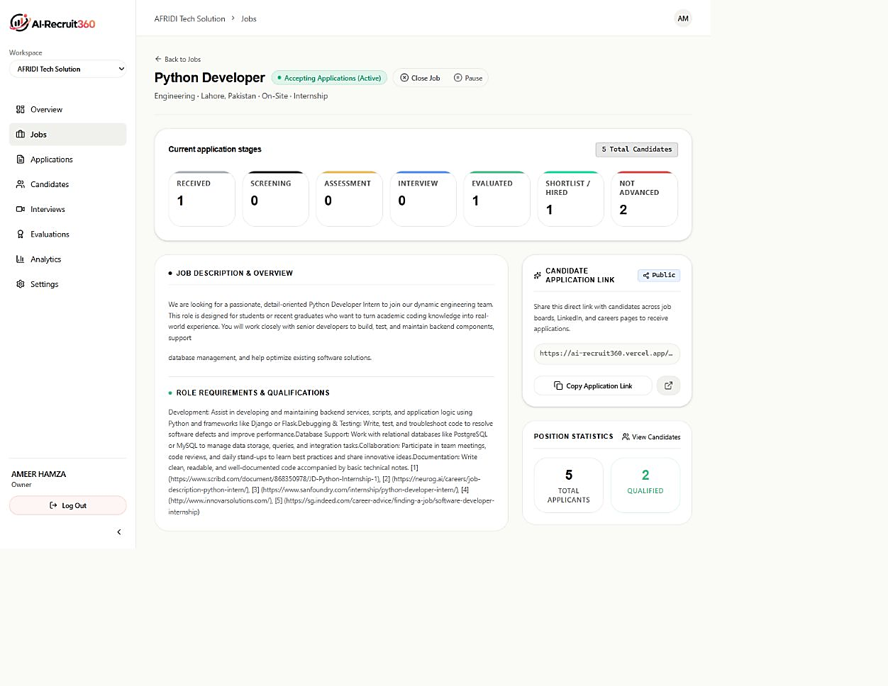
Figure 5.5: Job details and candidate pipeline

The application page collects candidate information and an uploaded resume.
Figure 5.6 illustrates the candidate-facing form that collects the required application data and uploaded resume.
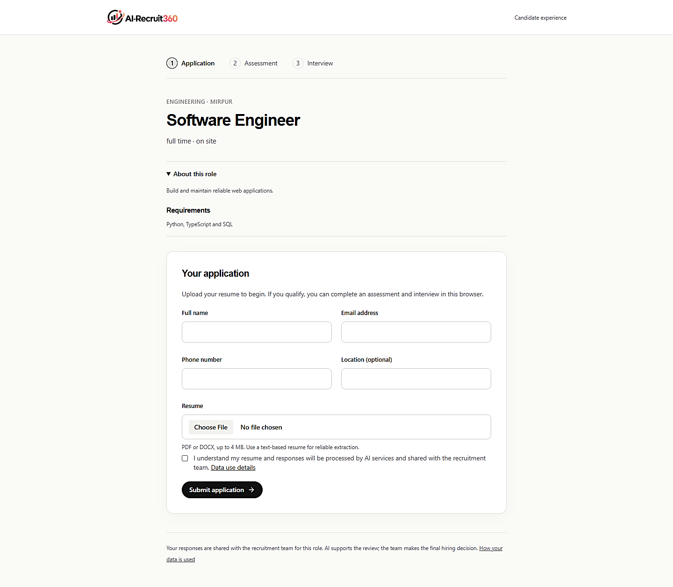
Figure 5.6: Candidate application form
The skills assessment presents one question at a time and records candidate answers.
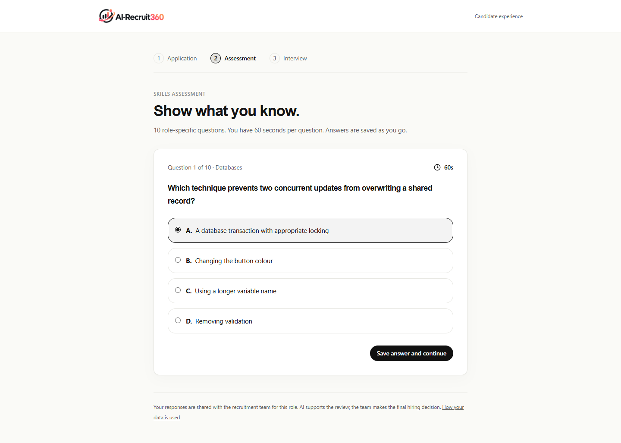
Figure 5.7: Timed skills assessment
The interview room shows the current question and the available response controls.
Figure 5.8 presents the interview interface where candidates read questions and respond using supported input methods.
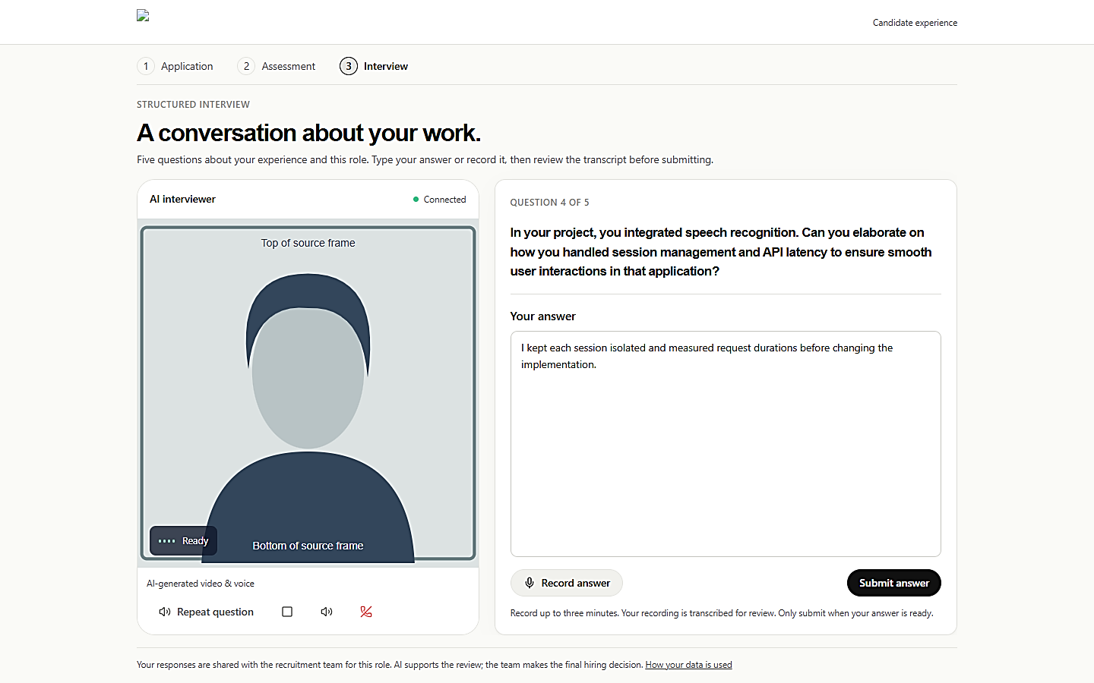
Figure 5.8: Desktop AI interview room
The completed interview screen retains question-level evidence for later review.
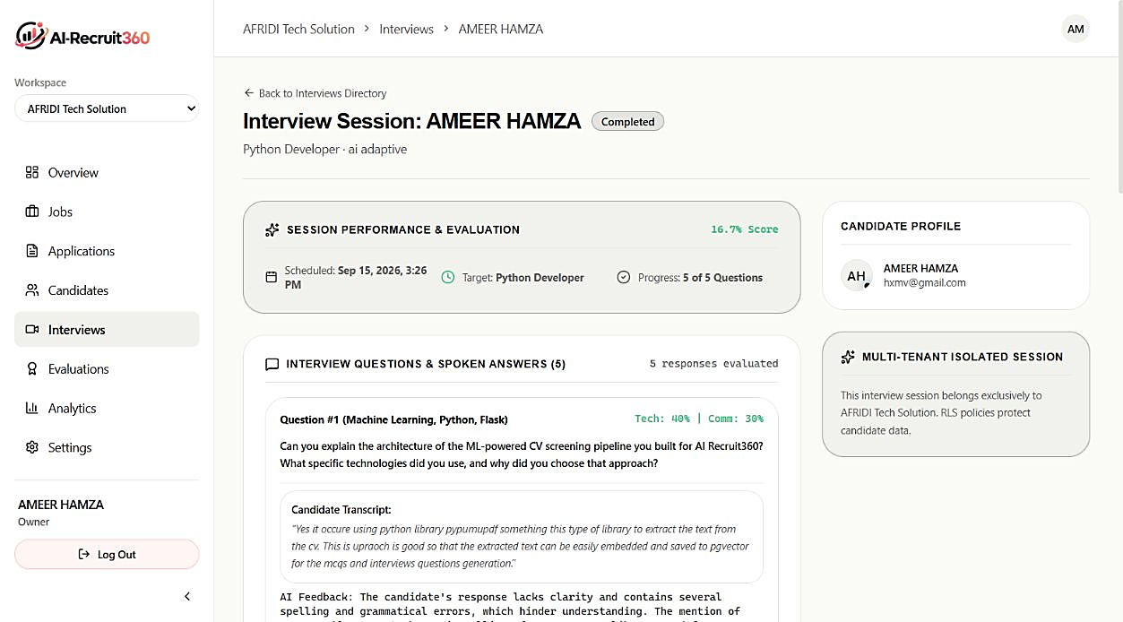
Figure 5.9: Completed interview evidence
The evaluation screen presents stage results while leaving the final decision to a recruiter.
Figure 5.10 presents the final evaluation screen, where stage evidence is available for human review.
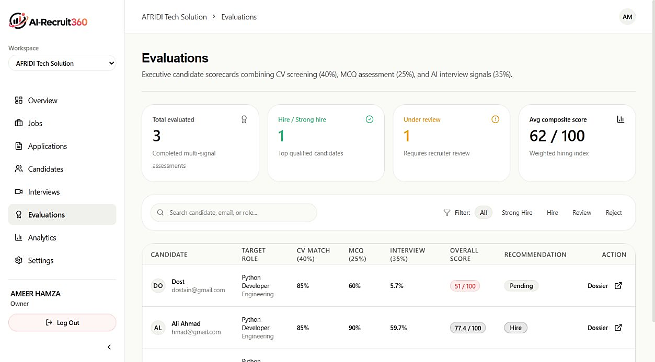
Figure 5.10: Evaluation review list

5.13 ERROR HANDLING AND RECOVERY
Error handling is designed around the difference between a failed operation and a failed candidate. An unavailable language-model request, storage timeout or media connection should not be translated into a zero score or rejection. Where a stage already has durable evidence, the application can return that evidence on retry. Where generation failed before persistence, the stage remains incomplete and can be attempted again without pretending that a valid result exists.
The candidate submission path validates the document before continuing and retains the saved application even if later screening is unavailable. Screening first checks for a completed result, which avoids duplicate provider calls. Assessment generation validates the complete ten-question structure before the candidate starts, and answer persistence rejects foreign questions or repeated replacement attempts. Interview evaluation similarly returns stored feedback where available rather than generating a conflicting scorecard.
Authentication and interface recovery use bounded waiting. The sign-in workflow restores the form after controlled failure or timeout instead of leaving an indefinite loading state. Search requests are versioned so a slower earlier response cannot overwrite newer filter results. Media controls show connection state and leave typed input available when microphone, speech or avatar playback cannot be used.
These recovery paths are important for demonstration because external providers and wireless connectivity can be variable. A supervisor should be able to distinguish a local process failure, a database-readiness failure and a provider failure. Health endpoints, explicit error messages and persistent application state make that diagnosis more practical than restarting the complete system or recreating candidate data after every interruption.
The current recovery model is still bounded by the single-process backend. It does not include a distributed queue, automatic replay across multiple workers or guaranteed exactly-once provider execution. Future scaling should introduce explicit job ownership and idempotency at the queue level rather than assuming that the process-local locks used by the prototype are sufficient for a multi-instance deployment.

5.14 MODULE INTEGRATION FLOW
Table 5.2 summarizes how the principal modules exchange data. The important point is that each AI-assisted stage ends in a durable record before the workflow advances, so browser navigation alone cannot create an authoritative completion state.
Table 5.2: Module integration across the recruitment workflow
Stage | Input | Main processing | Persisted or recovery outcome
Candidate submission | Job link, contact data, PDF/DOCX resume | Validate data, store private document, create candidate and application | Stable application identifiers; repeated submission key returns existing result.
Resume screening | Stored resume text and job context | Request structured screening, validate numeric and evidence fields | Screening evidence and progression status; provider failure leaves saved application recoverable.
Skills assessment | Eligible application and role/candidate context | Generate ten questions, hide answer keys, enforce timing and order | Questions and authoritative answers; malformed generation is rejected before use.
Interview | Eligible application and stored question sequence | Initialize interview, accept typed/transcribed text, evaluate each response | Five persisted response scorecards; retries reuse saved evidence where available.
Speech/avatar | Authorized current interview question | Synthesize stored text and issue short-lived media session | Optional presentation only; failure does not remove text question or typed answer path.
Final evaluation | Completed screening, assessment and interview evidence | Apply fixed project weights and prepare review evidence | Persisted composite and recommendation; existing recruiter decision is preserved on retry.
Recruiter review | Application dossier and stage evidence | Inspect evidence and record human outcome | Separate recruiter decision stored without rewriting generated stage evidence.

5.15 DEPLOYMENT WORKFLOW
A formal demonstration starts with configuration checks rather than with candidate data. The frontend and backend environment files must point to the intended local or hosted URLs, and the shared service credential must match on both application processes. Liveness confirms that the FastAPI process is running, while readiness confirms that the configured database can be reached. A production frontend build should be used for the final demonstration to avoid development compilation being mistaken for application latency.
The recommended demonstration order follows the persisted workflow: sign in to an authorized workspace, show a published job, submit a synthetic resume through the public link, verify the saved application, continue through screening and the timed assessment, answer the interview questions, generate the final evaluation and then record the recruiter decision. This order allows a supervisor to inspect both the candidate experience and the recruiter evidence associated with the same application.
Deployment maintenance should preserve migration history and existing records. New schema changes should be applied only after reviewing the remote migration state, and environment secrets should never be copied into screenshots or the report. When a failure occurs, the team should identify whether it belongs to the frontend, authentication service, database, FastAPI process or external provider before changing unrelated configuration.

5.16 DATA HANDLING AND PRIVACY IMPLEMENTATION
Candidate data is distributed across relational records and private document storage. Contact information and workflow identifiers are stored in organization-scoped tables, while resume files remain in private storage. Extracted document text is retained because it supports screening evidence and review, which makes it sensitive business data even though it is stored as text rather than as a file.
External processing is limited to the context required for the requested AI or speech operation. The backend, not the browser, invokes privileged provider and database operations. The current thesis does not claim automatic deletion schedules, anonymization or regulatory compliance; those require organizational policy in addition to code. Before operational deployment, retention periods and candidate correction/deletion processes should be defined explicitly.
The project also distinguishes auditability from logging volume. Persisted stage records make an evaluation explainable at the application level, but historical log tables alone do not prove that every security-sensitive action is captured. A production environment would need a documented logging policy, protected log access and retention rules in addition to the evidence records used by the current prototype.
Chapter 06

VERIFICATION AND RESULTS
Verification checks whether the implemented software follows its stated requirements. The project uses backend regression tests, isolated database checks and browser tests to examine important workflows and failure states. This chapter presents the test strategy, observed outcomes and requirement traceability. It clearly separates the evidence available from software checks from the additional studies required for production performance and trustworthy hiring decisions.

6.1 VERIFICATION APPROACH
Verification combines code inspection, static checks, backend tests, database regressions and browser scenarios. Each level checks a different property. Type checking finds incompatible program interfaces, but it does not prove that the hosted database has the required migration. A browser fixture verifies rendering and interaction, but it does not prove that a real microphone or paid avatar session works.
The local verification run on 20 September 2026 passed frontend lint and TypeScript checks, twenty-five backend tests, authentication regressions and database suites for two layouts. A production build also passed during the preceding sign-in repair. Browser checks cover public routes, workspace layout, interview layout and authentication behaviour with controlled responses.
Authenticated read-only inspection of the deployed workspace on 20 September 2026 confirmed that the overview and seven workspace tabs displayed saved records. Job, candidate and completed-interview detail screens were also captured. These observations extend the interface evidence without replacing the controlled regression results or a recorded candidate journey.
The test catalogue distinguishes observed results from planned acceptance cases. This prevents the common error of listing an expected outcome as if it had been observed. The project team reported successful hosted use, but a timestamped, complete candidate journey with real providers was not captured in this evidence set. That remaining work is material to final operational acceptance.
Table 6.1: Verification summary
Verification layer | Recorded result | Scope
Lint and TypeScript | Passed | Local source checks
Backend suite | 25 passed | Synthetic/mocked regressions
Database layouts | Both passed | Migrations 01-09, isolated engine
Auth regressions | Passed | Identity, scope and requests
Browser sign-in | Three scenarios passed | Controlled auth responses
Live provider journey | Not recorded here | Final acceptance remains pending

6.2 BACKEND AND EXTRACTION TESTS
The backend suite contains twenty-five passing tests in the recorded local run. Relevant scenarios include repository concurrency, organization filters, reuse of stored resume text, PDF extraction, table-based DOCX extraction and error handling. Provider mocks allow deterministic assertions without sending private candidate records or consuming paid inference during the regression run.
The DOCX regression is particularly useful because document tables are common in resumes. It checks that text stored in cells is not ignored. The empty-PDF case checks that absence of readable text produces an error instead of a successful but empty profile. The repository tests check that independent context reads can overlap while preserving the organization condition.
There is an existing Starlette/httpx deprecation warning in the test environment. It does not indicate a failed assertion, but it should be addressed when dependencies are next updated. Passing this suite provides bounded evidence for the exercised cases. It is not a fuzzing campaign against arbitrary documents or a reliability estimate for external language-model responses.

6.3 DATABASE INTEGRITY TESTS
The migration suite runs SQL in an isolated PostgreSQL-compatible engine with synthetic records. Both the legacy and renamed layouts apply migrations 01 through 09. A repeated submission returns the same application, and duplicate candidate/job handling does not create partial records. Existing resume evidence remains after the alignment migration.
Assessment checks exercise question ownership, ordering, deadlines, repeated answer submission and finalization. Interview checks exercise response ownership, retries and atomic persistence of scorecards. Final evaluation checks preserve recruiter decisions. Tenant and viewer restrictions are also tested, alongside access to private workflow functions.
These results support the choice to enforce critical invariants close to the data. They do not replace a check against the hosted migration history. Storage and authentication are stubbed in the isolated environment, and extensions are treated differently from a managed Supabase deployment. The report therefore calls these database contract tests rather than a complete production database certification.

6.4 AUTHENTICATION AND BROWSER REGRESSIONS
The server authentication regression rejects forged identity headers and unauthorized organization selection. It also verifies request-level context deduplication and aggregate mapping above one thousand records. Browser startup is checked with a synthetic session to confirm one profile and one membership request rather than duplicate context loading.
The sign-in regression exercises three outcomes: invalid credentials return an error and restore the button, a successful response saves session cookies and initiates document navigation, and an endpoint that never responds eventually releases the loading state. The successful navigation uses a controlled destination; it is not evidence that a real account reached a populated hosted dashboard.
Public pages are checked at widths of 320, 375, 414, 768 and 1440 pixels. Workspace fixtures are checked at three widths, and interview layout at six desktop/mobile viewports. These checks find horizontal overflow and selected interaction failures. They do not establish full WCAG compliance, all-browser compatibility or usability for every candidate population.

6.5 TESTING STRATEGY
Testing is organized in layers so that a passing result is interpreted within the scope of the check that produced it. Static analysis verifies source-level consistency, backend tests exercise service behavior with controlled dependencies, database regressions check durable invariants, authentication scripts test identity and organization context, and browser checks verify visible recovery and responsive layout. A successful result at one layer is not treated as evidence for a different property.
Table 6.2 summarizes the role of each verification layer. This structure is useful in an AI-assisted system because provider mocks can make backend behavior deterministic without implying that a live model will always return the same semantic quality. Live-provider acceptance is therefore kept as a separate activity.
Table 6.2: Testing levels and evidence scope
Level | Primary purpose | Representative evidence
Static checks | Detect TypeScript, lint and interface problems before execution | Frontend lint and TypeScript checks.
Backend unit/service tests | Verify extraction, generation validation, reuse and provider-failure behavior | Twenty-five passing backend tests in the recorded local run.
Database regression tests | Verify migrations, ownership, timing, immutability and retry-safe persistence | Legacy and aligned schema layouts both exercised.
Authentication regressions | Verify identity, membership resolution, request context and count handling | Controlled authentication script scenarios.
Browser regressions | Verify sign-in recovery and responsive composition under controlled responses | Sign-in scenarios and multi-width layout checks.
Live acceptance | Verify complete real-provider journey and deployment behavior | Explicitly retained as pending recorded acceptance where not yet captured.

6.6 DETAILED SYSTEM TEST CASES
The detailed cases in Table 6.3 consolidate the automated and controlled checks that are directly supported by the project evidence. Pending research or real-provider measurements are discussed separately so that expected outcomes are not presented as completed observations.
Table 6.3: Detailed verified system test cases
ID | Verification case | Recorded status | Observed or retained result
T01 | Reject forged recruiter identity | Passed automated regression | No authorized context is derived from headers.
T02 | Resolve a stale organization cookie | Passed automated regression | Selection is resolved against real membership rather than trusting the cookie.
T03 | Deduplicate request context | Passed automated regression | Request-scoped reads are reused without a cross-user global cache.
T04 | Preserve large aggregate counts | Passed automated regression | The total is preserved with one aggregate request.
T05 | Create one application on retry | Passed both schema layouts | The same result is returned with no duplicated application.
T06 | Preserve legacy resume evidence | Passed both schema layouts | Original filename and extracted text survive.
T07 | Reject foreign assessment questions | Passed both schema layouts | The function rejects the mismatch before recording an answer.
T08 | Enforce server answer timing | Passed automated regression | Server rules determine acceptance; browser-provided time is not trusted.

Table 6.3 (continued).
ID | Verification case | Recorded status | Observed or retained result
T09 | Keep an answer immutable | Passed both schema layouts | The existing authoritative answer is not replaced.
T10 | Preserve the recruiter decision | Passed both schema layouts | The human decision remains recorded.
T11 | Handle an AI screening outage | Passed backend suite | The candidate is not assigned zero or rejected because the provider failed.
T12 | Reuse completed screening | Passed backend suite | The existing result is returned without calling AI.
T13 | Validate generated assessment keys | Passed backend suite | Malformed generated output is rejected.
T14 | Avoid fabricated fallback questions | Passed backend suite | No generic fallback assessment or score is fabricated.
T15 | Reuse stored interview feedback | Passed backend suite | The saved scorecard is returned without a conflicting evaluation.
T16 | Reject unrelated interview speech | Passed backend suite | The operation fails before unrelated text is synthesized.
T17 | Use stored text and configured voice | Passed backend suite | The provider receives the stored question and configured voice.
T18 | Extract a table-based resume | Passed backend suite | The table text is present in the extracted evidence.
T19 | Reject an empty text PDF | Passed backend suite | Extraction fails explicitly rather than inventing content.
T20 | Recover a stalled login | Passed browser regression | The form displays an error and restores the sign-in button.

6.7 REQUIREMENT-TO-TEST TRACEABILITY
Traceability connects the user-facing workflow to the evidence used to check it. Some use cases are covered by deterministic regressions, while others still depend on a recorded live-provider acceptance session. The table does not convert a pending acceptance item into a pass; it shows where evidence currently exists and where additional demonstration is required.
Table 6.4: Use-case-to-test traceability
Use case | Goal | Linked evidence
UC01 | Sign in to a workspace | T01, T02, T03, T20
UC02 | Create a recruiter account | T20; email confirmation pending
UC03 | Recover a password | Recovery-email acceptance pending
UC04 | Create an organization | T02; live creation pending
UC05 | Switch organization context | T02, T03
UC06 | Create and publish a job | T21
UC07 | Find a job or application | T04 and browser list checks
UC08 | Submit a candidate application | T05, T06
UC09 | Screen a stored resume | T11, T12, T18, T19
UC10 | Retry interrupted screening | T11, T12
UC11 | Generate a skills assessment | T13, T14
UC12 | Answer a timed question | T07, T08, T09
UC13 | Finalize an assessment | T16, T17, T22
UC14 | Answer an interview question | T15, T22
UC15 | Record and review an answer | T22
UC16 | Use the interviewer avatar | T15, T17
UC17 | Calculate the final evaluation | T10, T21
UC18 | Review and decide on an application | T21
UC19 | Inspect candidate documents | T01, T02 and policy SQL checks

6.8 PERFORMANCE OBSERVATIONS
The project contains a small number of point observations from previous hosted checks. They are retained only as diagnostic examples and are not reported as a performance benchmark because the sample count is insufficient and the network or provider conditions were not controlled. Table 6.5 therefore includes an interpretation column rather than converting the observations into an average or service-level claim.
Table 6.5: Recorded point observations
Observation | Recorded duration | Interpretation
Hosted frontend first byte | 0.710 s | Single previous sample
Hosted frontend response | 3.391 s | Single previous sample
Backend readiness attempt 1 | Timeout after 25 s | Cause not isolated
Backend readiness retry | 1.919 s | Includes database request
The observations show why the system separates local liveness from remote readiness. A backend process can be running while a database request or provider dependency is slow. Likewise, a first frontend response can include hosting or network effects that are unrelated to ordinary client-side tab switching after the application is loaded.
A defensible performance study should record cold and warm runs separately, state the number of samples, capture failures and timeouts, and report the environment used. It should measure authentication, database, backend and provider stages independently where possible. Until that experiment is performed, the thesis limits its performance claims to structural optimizations and the recorded point observations above.

6.9 DISCUSSION OF RESULTS
The verification results support the project's strongest claim: critical workflow state is not controlled only by the browser. Tests cover retry-safe application creation, assessment question ownership and timing, immutable answers, preservation of recruiter decisions, reuse of completed screening, explicit provider-failure behavior and authorization context. These checks directly address the failure modes identified in the problem statement.
The results also show the value of retaining separate stage evidence. Backend and database checks can validate screening, assessment and interview behavior independently, while the recruiter interface can display their outputs together. This makes debugging more precise and reduces the risk that a composite score conceals which stage failed or was never completed.
The available evidence is narrower for live media and operational scale. Speech, avatar and hosted services depend on real provider sessions, permissions, network conditions and account configuration. Controlled tests can verify that the correct stored text is sent and that failure does not corrupt progress, but a recorded end-to-end provider session remains important for final acceptance.
Finally, software correctness should not be confused with recruitment validity. The project demonstrates that the implemented rules can be stored and repeated consistently in the tested environment. It does not demonstrate that the generated scores predict future job performance, that assessment difficulty is equivalent across candidates, or that outcomes are fair across demographic groups. Those questions require a separate research design and consented data.

6.10 LIMITATIONS AND ACCEPTANCE CRITERIA
The final supervisor acceptance run should use one designated workspace and a synthetic or explicitly consented candidate record. The team should begin with a clean published job, record the submission, demonstrate that the application and resume are stored, and then continue through every eligible stage without editing the database manually. The visible stage should agree with the persisted evidence after each transition.
At least one recovery condition should also be demonstrated where practical. Examples include an invalid sign-in, an unavailable media permission or a retried screening request that returns stored evidence instead of duplicating it. The purpose is not to create failure for its own sake, but to show that the system distinguishes recoverable operational problems from candidate outcomes.
The acceptance record should state the date, environment, provider configuration used, and any step that remained unavailable. If performance is discussed, cold and warm timings should be collected as a small experiment rather than recalled from memory. This produces an evidence trail that a supervisor can review without relying on unsupported claims.
The final submitted report should remain synchronized with the demonstrated build. If routes, database columns, weights, assessment length or interview length change after the report is printed, the corresponding diagrams, tables and verification statements should be updated as well. This consistency is part of the engineering quality of the project.
Chapter 07

CONCLUSIONS AND FUTURE WORK
This chapter summarizes the implemented contribution and what can reasonably be concluded from its verification. The project demonstrates an integrated, reviewable recruitment workflow, but further evaluation is needed before using its AI scores for important employment decisions. The chapter records the achieved objectives, known limitations, SDG alignment and practical future work. It ends by explaining the role of human recruiters in responsible deployment.

7.1 CONCLUSIONS
AI Recruit360 demonstrates an integrated recruitment workflow in which generated content is tied to persistent application evidence. Its main achievement is not a claim that a language model can hire better than a recruiter. It is the engineering of access boundaries, stage progression, recoverable operations and inspectable results across a browser, two application runtimes and managed services.
The local tests provide evidence that important submission, assessment, interview and authorization contracts behave correctly in their tested settings. The interface has been revised to present the workflow clearly and to avoid indefinite waiting during the tested sign-in failure cases. The deployed system has been reported as working by the project team, while formal real-provider acceptance remains distinct from automated checks.
The project meets its educational purpose by providing a system that can be explained from data entry through final review. Its limitations are equally instructive: structured output is not factual verification, score aggregation is not model validation, and local hosting is not offline operation. A responsible continuation should preserve these distinctions while expanding the evidence base.

7.2 FUTURE TECHNICAL DEVELOPMENT
The next technical priority is a repeatable operational acceptance suite with real providers and explicit timing records. This should precede broad feature expansion. Once reliability and latency are measured, the team can decide whether a queue or distributed job ownership is justified. Such infrastructure should solve an observed problem rather than make the architecture appear more sophisticated.
Document support could be extended with OCR, extraction confidence and a candidate correction step. Any new parser should receive adversarial and malformed-file tests. Speech support could be evaluated across microphones, background noise and accents, with improved transcript review for technical terminology. The avatar should remain optional so that media performance does not become an eligibility barrier.
Database evolution should preserve existing records and explicitly version contracts. Additional concurrency tests should precede multiple backend workers. A centralized retention policy, auditable access review and better structured error telemetry would improve operational readiness without changing the system's fundamental educational scope.

7.3 FUTURE EVALUATION AND RESPONSIBLE USE
A research extension should assess generated evidence rather than starting with a headline accuracy number. Reviewers can label whether a claimed resume match is supported, whether a question is relevant to the job, and whether feedback accurately describes the submitted answer. These smaller judgements are easier to inspect than an unexplained overall hiring label.
A fairness study would need a justified sampling plan, appropriate consent and careful handling of sensitive attributes. The team should not infer demographic fairness from the absence of demographic fields in a prompt; proxies may remain in education, experience and language. Candidate accessibility and willingness to use avatar interviewing should also be evaluated directly.
The final responsibility remains with the recruiting organization. Recommendations should be reviewed, disputed evidence should be correctable, and decisions should be recorded separately from model output. With this boundary maintained, the prototype offers a foundation for further study and a clear demonstration of practical software engineering around AI services.

7.4 ACHIEVEMENT OF PROJECT OBJECTIVES
The project objectives stated in Chapter 1 can be compared with the implemented evidence without treating broader research questions as completed. Table 7.1 records the present implementation status and the main evidence available for each objective.
Table 7.1: Achievement of project objectives
Objective | Implementation evidence | Current status
Provide a consistent journey from published job to final recruiter review | Job publication, candidate submission, screening, assessment, interview, evaluation and recruiter decision are connected by the application record. | Implemented in the reviewed workflow; full recorded live-provider acceptance remains an explicit final check.
Enforce workflow state on the server and database | Submission, assessment answers, interview responses and evaluation persistence use server/database rules and retry checks. | Implemented and covered by controlled database/backend regressions.
Protect workspace and candidate evidence | Verified recruiter identity, organization membership, role controls, signed candidate session and private storage paths are used. | Implemented for the reviewed paths; broader security assessment remains future work.
Integrate structured AI output with validation and recovery | Pydantic-validated screening, assessment and interview/evaluation responses; malformed output and provider failure are handled explicitly. | Implemented and covered by backend tests for representative failure cases.
Support responsive typed and optional media interaction | Responsive recruiter/candidate layouts, typed interview answers, transcription review and optional avatar/speech playback are present. | Implemented; broader accessibility and real-device media acceptance remain future evaluation.
Reduce avoidable waiting and repeated work | Debounced search, aggregate counts, reused extracted text, parallel safe reads and reuse of completed stage evidence are implemented. | Structural optimization implemented; statistically valid latency benchmark not yet established.

7.5 KNOWN LIMITATIONS
The strongest limitation is the absence of a completed research study on hiring validity and fairness. The system can calculate and store scores consistently, but consistency does not establish that those scores predict job performance or that candidates receive equivalent difficulty. A valid study would require consented data, independent reviewers, an appropriate sampling plan and clear criteria for supported or unsupported evidence.
The second limitation is operational scale. The current backend is designed for a controlled academic workload and uses process-local coordination for selected expensive operations. The database protects durable state, but a horizontally scaled deployment would need a queue or cross-process ownership mechanism, broader load testing and explicit rate-limit behavior across instances.
Document handling is limited to readable PDF and DOCX files. Scanned-only documents require OCR that is not implemented, and the project does not claim malware scanning or content sanitization for arbitrary uploads. Prompt injection from resume text also remains a relevant risk even though generated output is schema-constrained and application actions are separated from model text.
The media experience depends on microphones, browser permissions, speech services and the optional avatar provider. Typed answers provide a fallback, but a complete accessibility audit and a broad real-device test matrix have not been performed. These limitations do not invalidate the implemented workflow; they define the boundary between the final-year prototype and a production recruitment platform.

7.6 PROJECT CONTRIBUTIONS
- An organization-scoped recruitment workspace that connects jobs, candidates, applications and stage-specific evidence.
- A retry-aware candidate journey that preserves saved progress across resume screening, assessment, interview and final evaluation.
- Structured language-model integration in which generated payloads are validated before persistence and do not control authorization.
- A mixed typed-and-speech interview experience with transcript review and optional avatar presentation while retaining text as the authoritative submitted answer.
- A deterministic weighted evaluation that remains separate from the final human recruiter decision.
- A verification approach that links authentication, database, backend and browser evidence to explicit workflow claims while leaving unmeasured fairness, validity and scale questions visible.

7.7 CONTRIBUTION TO SUSTAINABLE DEVELOPMENT GOALS (SDGs)
The United Nations Sustainable Development Goals (SDGs) describe global priorities for development. AI Recruit360 has a limited and indirect connection to these goals because it organizes recruitment records and supports more transparent human review. It does not create jobs, prove equal treatment or measure national SDG outcomes. The mapping below identifies design intentions that can be checked within the academic project and separates them from social outcomes that require further evaluation [29]-[31].
SDG 8 (Decent Work and Economic Growth) is relevant to the organization of employment applications, particularly target 8.5 concerning productive employment and decent work [29]. AI Recruit360 can help a recruiter collect evidence consistently and keep records of decisions. This is an operational contribution only; the project does not measure changes in employment rates, wages or access to work.
SDG 9 (Industry, Innovation and Infrastructure) relates to responsible development of technological capability [30]. The prototype combines a web platform, validated AI output and a relational data model. Its contribution is an applied engineering demonstration. It should not be presented as evidence of increased research investment, sector-wide adoption or infrastructure growth.
SDG 10 (Reduced Inequalities) concerns equal opportunity, including target 10.3 [31]. Keeping the recruiter's final decision separate from generated scores, displaying evidence and preserving typed interview answers may support future fairer assessment practices. However, fairness has not been tested across demographic groups, and model-generated assessments can still reproduce harmful bias [21], [28], [32]. Thus, SDG 10 is a design responsibility and future evaluation goal, not a demonstrated project impact.
Table 7.2: SDG alignment, implemented support and evidence limits
SDG and target | Relevant project feature | Current evidence and limitation
SDG 8; target 8.5 | One workflow for applications, tests and human review | Supports organized recruitment; no employment outcome measured.
SDG 9; target 9.5 | Web/AI integration, validated data and engineering tests | Shows a working prototype; no sector-wide innovation indicator measured.
SDG 10; target 10.3 | Evidence review, typed input and human decision authority | Fairness is untested; demographic evaluation remains future work.
Table 7.2 shows why design alignment must not be confused with real-world impact. A future study should include candidate feedback, accessibility assessment, human-rater comparison and a consent-based fairness review. It should document whether the system supports appropriate use in practice before claiming contribution to SDG outcomes [27], [28], [32].

7.8 CONCLUDING REMARKS
AI Recruit360 demonstrates that useful AI recruitment functionality depends as much on state, access and evidence design as on generation itself. The project integrates modern web and AI services within a workflow that can recover from interruption, preserve stage evidence and keep the final employment decision with an authorized recruiter.
The prototype demonstrates a traceable recruitment workflow with recovery and human review. Future work should test end-to-end operation, assessment quality and fairness using consented data.

REFERENCES
[1] Artifex Software. n.d. "Text: How to Extract and Re-order Document Text." PyMuPDF Documentation. Accessed September 29, 2026. https://pymupdf.readthedocs.io/en/latest/recipes-text.html.
[2] Brown, Tom B., Benjamin Mann, Nick Ryder, et al. 2020. "Language Models Are Few-Shot Learners." Advances in Neural Information Processing Systems 33: 1877-1901. https://arxiv.org/abs/2005.14165.
[3] Köchling, Alina, and Marius Claus Wehner. 2020. "Discriminated by an Algorithm: A Systematic Review of Discrimination and Fairness by Algorithmic Decision-Making in the Context of HR Recruitment and HR Development." Business Research 13 (3): 795-848. https://doi.org/10.1007/s40685-020-00134-w.
[4] Liem, Cynthia C. S., Markus Langer, Andrew Demetriou, Annemarie M. F. Hiemstra, Achmadnoer Sukma Wicaksana, Marise Ph. Born, and Cornelius J. König. 2018. "Psychology Meets Machine Learning: Interdisciplinary Perspectives on Algorithmic Job Candidate Screening." In Explainable and Interpretable Models in Computer Vision and Machine Learning, edited by Hugo Jair Escalante, Isabelle Guyon, and Sergio Escalera, 197-253. Cham: Springer. https://doi.org/10.1007/978-3-319-98131-4_9.
[5] OpenAI. n.d.a. "Structured Outputs." OpenAI API Documentation. Accessed September 29, 2026. https://developers.openai.com/api/docs/guides/structured-outputs.
[6] OpenAI. n.d.b. "Speech to Text." OpenAI API Documentation. Accessed September 29, 2026. https://developers.openai.com/api/docs/guides/speech-to-text.
[7] OpenAI. n.d.c. "Text to Speech." OpenAI API Documentation. Accessed September 29, 2026. https://developers.openai.com/api/docs/guides/text-to-speech.
[8] OWASP. 2025. "LLM Prompt Injection Prevention Cheat Sheet." OWASP Cheat Sheet Series. Accessed September 29, 2026. https://cheatsheetseries.owasp.org/cheatsheets/LLM_Prompt_Injection_Prevention_Cheat_Sheet.html.
[9] PostgreSQL Global Development Group. n.d.a. "Row Security Policies." PostgreSQL Documentation. Accessed September 29, 2026. https://www.postgresql.org/docs/current/ddl-rowsecurity.html.
[10] PostgreSQL Global Development Group. n.d.b. "Transaction Isolation." PostgreSQL Documentation. Accessed September 29, 2026. https://www.postgresql.org/docs/current/transaction-iso.html.
[11] Pydantic. n.d. "Models." Pydantic Documentation. Accessed September 29, 2026. https://docs.pydantic.dev/latest/concepts/models/.
[12] Radford, Alec, Jong Wook Kim, Tao Xu, Greg Brockman, Christine McLeavey, and Ilya Sutskever. 2023. "Robust Speech Recognition via Large-Scale Weak Supervision." Proceedings of Machine Learning Research 202: 28492-28518. https://proceedings.mlr.press/v202/radford23a.html.
[13] Raghavan, Manish, Solon Barocas, Jon Kleinberg, and Karen Levy. 2020. "Mitigating Bias in Algorithmic Hiring: Evaluating Claims and Practices." In Proceedings of the 2020 Conference on Fairness, Accountability, and Transparency, 469-481. New York: ACM. https://doi.org/10.1145/3351095.3372828.
[14] Ramirez, Sebastian. n.d. "Concurrency and async / await." FastAPI Documentation. Accessed September 29, 2026. https://fastapi.tiangolo.com/async/.
[15] Render. n.d. "Deploy for Free." Render Documentation. Accessed September 29, 2026. https://render.com/docs/free.
[16] Souppaya, Murugiah, Karen Scarfone, and Donna Dodson. 2022. Secure Software Development Framework (SSDF) Version 1.1. NIST Special Publication 800-218. Gaithersburg, MD: National Institute of Standards and Technology. https://doi.org/10.6028/NIST.SP.800-218.
[17] Supabase. n.d.a. "Auth." Supabase Documentation. Accessed September 29, 2026. https://supabase.com/docs/guides/auth.
[18] Supabase. n.d.b. "Server-Side Rendering." Supabase Documentation. Accessed September 29, 2026. https://supabase.com/docs/guides/auth/server-side.
[19] Supabase. n.d.c. "Serving Assets from Storage." Supabase Documentation. Accessed September 29, 2026. https://supabase.com/docs/guides/storage/serving/downloads.
[20] Supabase. n.d.d. "Row Level Security." Supabase Documentation. Accessed September 29, 2026. https://supabase.com/docs/guides/database/postgres/row-level-security.
[21] Suresh, Harini, and John V. Guttag. 2021. "A Framework for Understanding Sources of Harm throughout the Machine Learning Life Cycle." In Equity and Access in Algorithms, Mechanisms, and Optimization, article 17, 1-9. New York: ACM. https://doi.org/10.1145/3465416.3483305.
[22] Tabassi, Elham. 2023. Artificial Intelligence Risk Management Framework (AI RMF 1.0). NIST AI 100-1. Gaithersburg, MD: National Institute of Standards and Technology. https://doi.org/10.6028/NIST.AI.100-1.
[23] Vercel. n.d.a. "Server and Client Components." Next.js Documentation. Accessed September 29, 2026. https://nextjs.org/docs/app/getting-started/server-and-client-components.
[24] Vercel. n.d.b. "Vercel Functions Limits." Vercel Documentation. Accessed September 29, 2026. https://vercel.com/docs/functions/limitations.
[25] Vercel. n.d.c. "Mutating Data." Next.js Documentation. Accessed September 29, 2026. https://nextjs.org/docs/app/getting-started/updating-data.
[26] Vercel. n.d.d. "Backend for Frontend." Next.js Documentation. Accessed September 29, 2026. https://nextjs.org/docs/app/guides/backend-for-frontend.
[27] World Wide Web Consortium. 2024. Web Content Accessibility Guidelines (WCAG) 2.2. W3C Recommendation, December 12, 2024. https://www.w3.org/TR/WCAG22/.
[28] Autio, Chloe, Reva Schwartz, Jesse Dunietz, Shomik Jain, Martin Stanley, Elham Tabassi, Patrick Hall, and Kamie Roberts. 2024. Artificial Intelligence Risk Management Framework: Generative Artificial Intelligence Profile. NIST AI 600-1. Gaithersburg, MD: National Institute of Standards and Technology. https://doi.org/10.6028/NIST.AI.600-1.
[29] United Nations, Department of Economic and Social Affairs. n.d.a. "Goal 8: Promote Sustained, Inclusive and Sustainable Economic Growth, Full and Productive Employment and Decent Work for All." Sustainable Development Goals. Accessed October 13, 2026. https://sdgs.un.org/goals/goal8.
[30] United Nations, Department of Economic and Social Affairs. n.d.b. "Goal 9: Build Resilient Infrastructure, Promote Inclusive and Sustainable Industrialization and Foster Innovation." Sustainable Development Goals. Accessed October 13, 2026. https://sdgs.un.org/goals/goal9.
[31] United Nations, Department of Economic and Social Affairs. n.d.c. "Goal 10: Reduce Inequality within and among Countries." Sustainable Development Goals. Accessed October 13, 2026. https://sdgs.un.org/goals/goal10.
[32] Fabris, Alessandro, Nina Baranowska, Matthew J. Dennis, David Graus, Philipp Hacker, Jorge Saldivar, Frederik Zuiderveen Borgesius, and Asia J. Biega. 2025. "Fairness and Bias in Algorithmic Hiring: A Multidisciplinary Survey." ACM Transactions on Intelligent Systems and Technology 16 (1): Article 16, 1-54. https://doi.org/10.1145/3696457.

APPENDIX A: CORE USE-CASE SUMMARY
The following representative use cases summarize the end-to-end recruiter and candidate workflow. Detailed implementation traces are omitted to keep the appendix focused on externally visible system behaviour.
Table A.1: Representative use cases
ID | Use case | Primary actor | Successful outcome
UC01 | Sign in to a workspace | Recruiter | Authorized workspace is opened.
UC06 | Create and publish a job | Recruiter | A role is published with a candidate application link.
UC08 | Submit an application | Candidate | Candidate, application and resume evidence are stored.
UC09 | Screen a resume | Candidate workflow | Structured screening evidence and progression status are saved.
UC11 | Generate assessment | Eligible candidate | A ten-question technical assessment is created.
UC12 | Answer timed question | Candidate | One authoritative answer is recorded for the question.
UC14 | Answer interview question | Candidate | Response and evaluation are attached to the correct interview.
UC16 | Use AI interviewer | Candidate | Authorized question is presented with optional voice/avatar playback.
UC17 | Generate final evaluation | System / recruiter | Stage scores are combined into a reviewable final scorecard.
UC18 | Record recruiter decision | Recruiter | Human review decision is stored separately from AI evidence.

APPENDIX B: API REFERENCE
The FastAPI service exposes a small set of recruitment endpoints. Browser requests reach these operations through authorized application actions; private service credentials are not exposed to candidates.
Table B.1: Core FastAPI routes
Method | Route | Purpose
GET | /api/v1/health | Full service health check
GET | /api/v1/health/live | Process liveness check
GET | /api/v1/health/ready | Database readiness check
POST | /api/v1/screening/screen-application | Screen the stored candidate resume
POST | /api/v1/assessments/generate | Generate a technical assessment
POST | /api/v1/assessments/submit-answer | Record one assessment answer
POST | /api/v1/assessments/finalize | Finalize assessment score
POST | /api/v1/interviews/initialize | Create or retrieve an interview
POST | /api/v1/interviews/next-question | Return the next authorized question
POST | /api/v1/interviews/stt | Transcribe a recorded answer
POST | /api/v1/interviews/speech | Generate speech for a stored question
POST | /api/v1/interviews/evaluate-response | Evaluate and store an interview response

APPENDIX C: INSTALLATION AND USER GUIDE

LOCAL DEMONSTRATION SETUP
- Configure the frontend and FastAPI environment files with the required URLs and credentials; keep private keys outside source control.
- Start Next.js and FastAPI. Use http://localhost:3000 for the web app and http://127.0.0.1:8000/api/v1 for the API.
- Verify API liveness and readiness before starting the demonstration.

USING THE SYSTEM
- Recruiter: sign in, select the workspace, create a job and share its application link.
- Candidate: submit contact details and a readable PDF or DOCX resume, then complete screening and assessment.
- Candidate: complete the interview by typed input or optional speech; review the transcript before submission.
- Recruiter: review the candidate evidence and record the final human decision.

APPENDIX D: DEPLOYMENT AND MAINTENANCE CHECKLIST
This checklist contains only the items needed for a repeatable supervisor demonstration and basic maintenance.
Table D.1: Demonstration and maintenance checklist
Area | Required practice
Startup | Start the frontend and FastAPI production build; verify health checks.
Configuration | Keep URLs and the shared secret consistent; protect all credentials.
Database | Check readiness and migrations; preserve existing data.
Demonstration | Run one synthetic application through all stages to the recruiter decision.
Recovery | Retry saved progress after provider failure; avoid duplicate applications.
Release | Back up data, review provider limits, and verify that no secrets appear in the report or repository.

