AI RECRUIT360
AN AI ASSISTED RECRUITMENT AND CANDIDATE EVALUATION SYSTEM

Ameer Hamza
FA22-BSE-030
Babar Hussain
FA22-BSE-044
Ali Naqi
FA22-BSE-050
Session 2022-2026
Department of Software Engineering
Faculty of Engineering & Technology
Mirpur University of Science and Technology (MUST)
Mirpur AJK Pakistan

AI RECRUIT360
AN AI ASSISTED RECRUITMENT AND CANDIDATE EVALUATION SYSTEM
By
Ameer Hamza (FA22-BSE-030)
Babar Hussain (FA22-BSE-044)
Ali Naqi (FA22-BSE-050)
A project report submitted in partial fulfillment of
the requirements for the degree of
Bachelor of Science
in
SOFTWARE ENGINEERING
Supervised by
Engr. Syeda Iqra Gillani
Session 2022-2026
Department of Software Engineering
Faculty of Engineering & Technology
Mirpur University of Science and Technology (MUST)
Mirpur AJK Pakistan

CERTIFICATION
We hereby declare that this final-year project report, titled "AI RECRUIT360: An AI Assisted Recruitment and Candidate Evaluation System", represents our original research, design, implementation, and empirical verification. All literature sources, software libraries, and external APIs utilized in this work have been properly acknowledged and cited.
The report distinguishes verified software features, empirical database test evidence, and recorded user journeys from future acceptance studies. We accept full academic responsibility for the integrity, authenticity, and presentation of the work submitted.

Ameer-Hamza_(FA22-BSE-030) Signature: _____________________________
Babar-Hussain_(FA22-BSE-044) Signature: _____________________________
Ali-Naqi_(FA22-BSE-050) Signature: _____________________________
Date: ___________________________
Project Title: AI RECRUIT360 - An AI Assisted Recruitment and Candidate Evaluation System
Submitted for examination in partial fulfillment of the requirements for the degree of Bachelor of Science in Software Engineering.
Supervisor:Engr.SyedaIqraGillani Signature: ___________________________ Date: ___________________________
External Examiner: ___________________________

Chairperson: ___________________________

DEDICATION
We dedicate this project report to Almighty Allah, the source of all knowledge, wisdom, and perseverance.
We also dedicate this work to our respected parents and family members, whose continuous prayers, sacrifices, and unconditional encouragement sustained us throughout our academic journey.
Finally, we express our profound gratitude to our respected faculty members and colleagues in the Department of Software Engineering at Mirpur University of Science and Technology (MUST), who instilled in us the engineering discipline, technical rigor, and curiosity necessary to bring this project to fruition.

CONTENTS
CERTIFICATION i
DEDICATION iii
CONTENTS iv
LIST OF FIGURES vi
LIST OF TABLES vii
ACKNOWLEDGMENTS viii
ABSTRACT ix
ABBREVIATIONS xi
CHAPTER 1 INTRODUCTION 1
1.1 PROJECT OVERVIEW 1
1.2 PROBLEM STATEMENT 2
1.3 AIM AND OBJECTIVES 3
1.4 SCOPE AND BOUNDARIES 4
1.5 STAKEHOLDERS AND INTENDED USE 5
1.6 ENGINEERING METHOD AND CONTRIBUTION 7
CHAPTER 2 BACKGROUND AND RELATED WORK 8
2.1 EVOLUTION OF APPLICANT TRACKING SYSTEMS 8
2.2 LARGE LANGUAGE MODELS AND STRUCTURED EVALUATION 8
2.3 SPEECH PROCESSING AND VIDEO AVATARS IN INTERVIEWING 9
2.4 MODERN WEB APPLICATION ARCHITECTURE 10
2.5 MULTI-TENANCY AND ROW-LEVEL SECURITY 10
2.6 ETHICAL CONSIDERATIONS, BIAS MITIGATION, AND ACCESSIBILITY 11
2.7 COMPARATIVE ANALYSIS AND RESEARCH GAP 12
CHAPTER 3 REQUIREMENTS AND ANALYSIS 14
3.1 REQUIREMENTS METHODOLOGY 14
3.2 FUNCTIONAL REQUIREMENTS SPECIFICATION 14
3.3 NON-FUNCTIONAL REQUIREMENTS 17
3.4 ARCHITECTURAL CONSTRAINTS AND ASSUMPTIONS 19
3.5 RISK ANALYSIS AND MITIGATION STRATEGIES 20
CHAPTER 4 SYSTEM DESIGN 21
4.1 SYSTEM CONTEXT AND TRUST BOUNDARIES 21
4.2 COMPONENT AND DEPLOYMENT ARCHITECTURE 22
4.3 APPLICATION DATA PIPELINE AND FLOW 24
4.4 RELATIONAL DATA MODEL AND CORE ENTITIES 26
4.5 WORKFLOW STATE MACHINES AND LIFECYCLE TRANSITIONS 28
4.6 ACTIVITY AND SEQUENCE DESCRIPTIONS 30
4.7 ROLE-BASED ACCESS CONTROL MODEL 32
4.8 INTERFACE AND INTERACTION DESIGN 35
CHAPTER 5 IMPLEMENTATION 37
5.1 FRONTEND ARCHITECTURE AND COMPONENT COMPOSITION 37
5.2 RECRUITER WORKSPACE AND AUTHENTICATION CONTEXT 38
5.3 RESUME EXTRACTION AND DOCUMENT PROCESSING 39
5.4 STRUCTURED AI RESUME SCREENING ENGINE 39
5.5 SERVER-AUTHORITATIVE ASSESSMENT ENGINE 40
5.6 CONVERSATIONAL AI AVATAR AND SPEECH PIPELINE 41
5.7 MULTI-DIMENSIONAL COMPOSITE EVALUATION MODEL 42
5.8 DATABASE MIGRATIONS AND REPOSITORY ARCHITECTURE 43
CHAPTER 6 VERIFICATION AND RESULTS 45
6.1 VERIFICATION STRATEGY AND TEST CATALOGUE 45
6.2 RESUME EXTRACTION AND PARSING ACCURACY 46
6.3 DATABASE INTEGRITY AND MULTI-TENANT ISOLATION 47
6.4 OPERATIONAL LATENCY AND BENCHMARK OBSERVATIONS 47
6.5 THREAT MODELING AND SECURITY POSTURE 48
6.6 VALIDITY AND SYSTEM LIMITATIONS 49
CHAPTER 7 CONCLUSIONS AND FUTURE WORK 50
7.1 PROJECT CONCLUSIONS 50
7.2 FUTURE TECHNICAL ROADMAP 50
7.3 RESPONSIBLE AI AND ETHICAL STEWARDSHIP 51
REFERENCES 52
APPENDIX A CORE SYSTEM USE CASE SPECIFICATIONS 54
A.1 PRIMARY RECRUITMENT WORKFLOW USE CASES 54
APPENDIX B DATABASE SCHEMA ARCHITECTURE AND DATA DICTIONARY 60
B.1 CORE ENTITY-RELATIONSHIP ARCHITECTURE 60
B.2 WORKSPACE, IDENTITY, AND SYSTEM DATA DICTIONARIES 60
APPENDIX C DEPLOYED SYSTEM INTERFACE AND VERIFICATION EVIDENCE 67
C.1 RECRUITER WORKSPACE AND PIPELINE INTERFACES 67
C.2 CANDIDATE EXAMINATION AND EVALUATION INTERFACES 71

LIST OF FIGURES
Figure 1 System Context and Trust Boundaries 22
Figure 2 Physical Deployment Paths for Local and Cloud Environments 24
Figure 3 Candidate Evidence Data Pipeline and Ingestion Flow 26
Figure 4 Core Relational Entity Model and Multi-Tenant Relationships 28
Figure 5 Resume Screening Activity with Retry and Existing-Result Paths 30
Figure 6 Server-Authoritative Assessment Activity and Anti-Cheat Flow 32
Figure 7 Candidate Application Submission Persistence Sequence 34
Figure 8 Conversational Interview Evaluation Sequence 36
Figure 9 Stage Evidence Entity Relationships and Relational Constraints 38
Figure 10 Comprehensive Stage Evidence Relational Model and Foreign Key Constraints 60
Figure 11 Recruiter Dashboard and Candidate Funnel Analytics 67
Figure 12 Job Requisitions Directory and Status Management 68
Figure 13 Job Creation and Evaluation Configuration Form 68
Figure 14 Job Requisition Details and Stage Triage Pipeline 69
Figure 15 Candidate Directory with Search and Score Filtering 70
Figure 16 Application Lifecycle Tracker and Status Badges 70
Figure 17 Candidate Comprehensive Evidence Dossier 71
Figure 18 Candidate Timed Anti-Cheat Assessment Interface 72
Figure 19 Simli AI Neural Video Avatar Interview Room 72
Figure 20 Completed Interview Transcript and Question Scorecards 73
Figure 21 Multi-Dimensional Scorecard and Hiring Status Controller 74
Figure 22 Recruitment Funnel Analytics and Operational Metrics 74

LIST OF TABLES
Table 1 Alphabetical List of Abbreviations xi
Table 2 Comparative Analysis of AI-Recruit360 with Existing Recruitment Platforms 13
Table 3 Functional Requirements Specification across System Roles 17
Table 4 Non-Functional Quality Requirements and Verification Boundaries 19
Table 5 Role-Based Access Control (RBAC) Permissions Matrix 35
Table 6 Multi-Stage Composite Scoring Formula and Weight Distributions 43
Table 7 FastAPI Microservice Core API Endpoint Inventory 44
Table 8 Verification Test Suite Summary and Execution Results 46
Table 9 Operational Latency Observations for Local vs Cloud-Hosted Services 48
Table 10 Use Case Specification for UC01 (Recruiter Authentication and Workspace Setup) 54
Table 11 Use Case Specification for UC02 (Job Requisition Creation and Publishing) 55
Table 12 Use Case Specification for UC03 (Candidate Application and Resume Submission) 55
Table 13 Use Case Specification for UC04 (Automated AI Resume Screening and Scoring) 56
Table 14 Use Case Specification for UC05 (Timed Anti-Cheat Technical Skills Assessment) 57
Table 15 Use Case Specification for UC06 (Interactive AI Avatar Interview and Response Evaluation) 58
Table 16 Data Dictionary for profiles Table 61
Table 17 Data Dictionary for organizations Table 61
Table 18 Data Dictionary for organization_members Table 61
Table 19 Data Dictionary for jobs Table 62
Table 20 Data Dictionary for candidates Table 62
Table 21 Data Dictionary for applications Table 63
Table 22 Data Dictionary for candidate_documents Table 63
Table 23 Data Dictionary for cv_screenings Table 64
Table 24 Data Dictionary for assessments Table 64
Table 25 Data Dictionary for assessment_questions Table 64
Table 26 Data Dictionary for interviews Table 65
Table 27 Data Dictionary for final_evaluations Table 65

ACKNOWLEDGMENTS
We offer our sincerest gratitude to Almighty Allah for granting us the health, determination, and capability to complete our undergraduate studies and this Final Year Project.
We express our deepest appreciation and respect to our supervisor, Engr. Syeda Iqra Gillani, for her invaluable technical mentorship, constructive feedback, and patient guidance throughout the design, implementation, and documentation phases of AI Recruit360. Her high standards of software quality and academic presentation shaped our work significantly.
We extend our sincere thanks to the Chairperson and respected faculty members of the Department of Software Engineering at Mirpur University of Science and Technology (MUST) for providing the foundational education in software architecture, database management systems, and requirements engineering that enabled us to execute this complex project.
We also acknowledge the global open-source software community and modern cloud platforms—including Next.js, FastAPI, Supabase, Google Gemini, Deepgram, ElevenLabs, and Simli—whose accessible developer tools and documentation made the engineering of this multimodal system achievable.

ABSTRACT
Recruitment in contemporary software organizations is frequently impeded by an asymmetry between applicant volume and recruiter evaluation capacity. High-volume talent acquisition funnels often force human resource teams to rely on blunt keyword filtering tools or unstandardized initial screenings. Consequently, qualified candidates are routinely discarded by brittle pattern-matching algorithms, while hiring teams expend disproportionate hours manually parsing resumes, organizing preliminary assessments, and conducting repetitive first-round screening interviews.
This report presents the design, engineering, and empirical verification of AI Recruit360, an end-to-end, multi-tenant web application developed to modernize the recruitment lifecycle. Built using Next.js 14, FastAPI, Supabase PostgreSQL, and modern speech and language model APIs, AI Recruit360 unifies candidate ingestion, automated resume screening, timed anti-cheat technical assessments, and conversational AI avatar interviews within a secure workspace. The platform addresses fundamental operational vulnerabilities in automated hiring, such as unhandled network interruptions during uploads, client-side timer manipulation during assessments, and ambiguous composite scoring.
Key engineering contributions include: (1) a multi-tenant workspace architecture isolated by PostgreSQL Row-Level Security (RLS) policies scoped by organization ID and authenticated user identity; (2) an automated resume extraction and structured evaluation pipeline utilizing PyMuPDF and Google Gemini 1.5 Flash with strict Pydantic JSON schema enforcement; (3) a server-authoritative technical skills testing engine that prevents tampering by validating question timestamps strictly in the database; (4) a real-time conversational interview environment pairing Deepgram automatic speech recognition, ElevenLabs text-to-speech synthesis, and Simli neural video avatar rendering; and (5) a multi-dimensional composite evaluation model combining weighted evidence from resume match, assessment score, and interview performance while preserving raw evidence for final recruiter authority.
System verification combines isolated unit regressions, database transaction and RLS boundary tests, and authenticated end-to-end deployment verification on Vercel. The resulting prototype demonstrates that automated candidate evaluation can be integrated reliably while maintaining data integrity, candidate dignity, and defensible auditability.

ABBREVIATIONS
Table 1 Alphabetical List of Abbreviations
Abbreviation | Full Term / Meaning
AI | Artificial Intelligence
API | Application Programming Interface
ASGI | Asynchronous Server Gateway Interface
ATS | Applicant Tracking System
CV | Curriculum Vitae
DBMS | Database Management System
DOCX | Office Open XML Document
DOM | Document Object Model
ERD | Entity-Relationship Diagram
FYP | Final Year Project
HTTP | Hypertext Transfer Protocol
HTTPS | Hypertext Transfer Protocol Secure
JSON | JavaScript Object Notation
JWT | JSON Web Token
LLM | Large Language Model
MCQ | Multiple-Choice Question
MUST | Mirpur University of Science and Technology
OCR | Optical Character Recognition
PCM | Pulse-Code Modulation
PDF | Portable Document Format
RBAC | Role-Based Access Control
REST | Representational State Transfer
RLS | Row-Level Security
RPC | Remote Procedure Call
SDK | Software Development Kit
SQL | Structured Query Language
SSR | Server-Side Rendering
STT | Speech-to-Text
TTS | Text-to-Speech
UI | User Interface
URI | Uniform Resource Identifier
UX | User Experience
VAD | Voice Activity Detection
WCAG | Web Content Accessibility Guidelines
WebRTC | Web Real-Time Communication

CHAPTER 1
INTRODUCTION

1.1 PROJECT OVERVIEW
Talent acquisition forms the core operational foundation of any engineering organization. Without the ability to reliably identify, evaluate, and hire skilled professionals, software teams face persistent project delays, compromised technical architecture, and inflated attrition costs. In modern technology markets, a single remote or hybrid software engineering job requisition routinely attracts between 300 and 1,500 candidate submissions within days of publication.
This unprecedented volume creates a profound structural bottleneck for human resource teams. Traditional manual screening requires a recruiter to spend approximately two to five minutes reviewing each curriculum vitae (CV). For 500 applicants, this equates to more than 25 working hours spent merely skimming documents, searching for required programming languages, frameworks, and educational qualifications. Faced with this workload, recruiters inevitably experience decision fatigue, leading to inconsistent evaluation criteria, cognitive bias, and accidental disqualification of highly competent candidates.
AI Recruit360 was engineered to solve this systemic bottleneck by creating an automated, multi-stage candidate evaluation platform. Rather than treating recruitment as disconnected administrative tasks, AI Recruit360 structures the hiring journey into a continuous, evidence-backed workflow. The platform provides recruiters with an enterprise-grade workspace where they can publish structured requisitions, track candidate funnels, inspect objective scorecards, and make data-driven hiring decisions.
Simultaneously, candidates experience an intuitive, dignified application process. Upon applying with a resume, eligible applicants immediately proceed through a server-timed technical assessment tailored to the job requirements, followed by an interactive conversational interview conducted by a neural video avatar. Throughout every phase, AI Recruit360 captures authentic evidence—extracted CV text, scored multiple-choice answers, audio transcripts, and structured evaluation rubrics. The system never operates as an opaque "black box"; rather, every numerical recommendation is backed by auditable evidence presented to human recruiters for final hiring determinations.

1.2 PROBLEM STATEMENT
Automating recruitment workflows introduces substantial software engineering challenges that extend far beyond rendering dynamic web forms or querying commercial AI APIs. Existing recruitment tools and traditional Applicant Tracking Systems (ATS) suffer from four fundamental architectural and operational defects:
First, keyword-centric resume filtering is notoriously brittle and discriminatory. Most legacy ATS platforms rely on superficial string matching. If a candidate lists "React.js" and "PostgreSQL", but the recruiter's filter queries "Frontend Engineer" and "SQL Database", the candidate's resume may be automatically discarded without semantic inspection. Conversely, applicants who manipulate keyword density or paste white-text keywords can easily exploit these simplistic parsers.
Second, asynchronous technical assessments lack rigorous state integrity. Commercial screening platforms often rely on client-side JavaScript timers to govern exam duration. If a candidate manipulates browser local storage, disables scripts, or experiences a sudden network drop, the exam state becomes corrupt or desynchronized from the backend database. Furthermore, static multiple-choice question banks are rapidly compromised by public answer repositories and generative AI browser extensions.
Third, first-round screening interviews impose immense human resource overhead. Coordinating calendars between candidates and technical interviewers for a 30-minute preliminary call introduces multi-week delays into the hiring pipeline. While asynchronous one-way video recording tools exist, candidates report deep dissatisfaction speaking into empty webcams without conversational interaction, while recruiters still must spend hundreds of hours watching video recordings.
Fourth, multi-service workflows frequently suffer from state inconsistency and data isolation leaks. An interrupted file upload can generate orphaned candidate records without associated job applications. Repeated evaluation requests can trigger concurrent AI calls that produce competing scores and race conditions. In multi-tenant environments, poorly guarded database queries can inadvertently expose candidate resumes from one organization to another.
The central engineering problem of this project is to design, construct, and empirically validate an integrated web application that coordinates multi-stage recruitment evidence across external AI models, real-time media streams, and a multi-tenant relational database while strictly guaranteeing data integrity, tenant isolation, and recoverable failure states under network interruption.

1.3 AIM AND OBJECTIVES
The primary aim of AI Recruit360 is to develop a reliable, secure, and defensible AI-assisted recruitment platform that streamlines candidate screening, technical evaluation, and conversational interviewing while preserving comprehensive evidence for human recruiter oversight.
To accomplish this overarching aim, the following specific engineering objectives were established:
1. Design and construct a multi-tenant recruitment management workspace: Provide recruiters with role-based access control (RBAC) supporting Owner, Admin, Recruiter, Interviewer, and Viewer privileges, with strict PostgreSQL Row-Level Security (RLS) guaranteeing total cross-tenant data isolation.
2. Develop a resilient resume ingestion and parsing pipeline: Support PDF and DOCX document formats, extracting structured applicant details, work experience, educational history, and technical competencies using PyMuPDF and Pydantic-validated LLM schemas, with robust error recovery for corrupted or malformed documents.
3. Build a server-authoritative anti-cheat skills assessment engine: Automatically generate contextually relevant, randomized technical MCQs based on job requisitions, enforcing exam time limits strictly in the database using server timestamps rather than client-side clocks.
4. Implement a real-time conversational AI avatar interview environment: Integrate WebRTC neural video avatar rendering (Simli), ultra-low latency speech-to-text transcription (Deepgram Nova-2), dynamic follow-up question generation (Gemini 1.5 Flash), and natural text-to-speech synthesis (ElevenLabs), while providing keyboard fallback for accessibility.
5. Create an auditable, multi-dimensional composite scoring system: Synthesize candidate performance across resume semantic fit (30%), assessment score (30%), and interview response quality (40%) into a transparent scorecard, preserving raw transcripts and rationale so human recruiters maintain ultimate decision-making authority.
6. Conduct comprehensive verification and regression testing: Validate system behavior through isolated unit tests, database boundary checks, authentication regressions, and live deployed user journeys on cloud infrastructure.

1.4 SCOPE AND BOUNDARIES
To ensure successful completion within the final-year project timeline while maintaining technical depth, explicit operational scope and boundary limits were defined:
In-Scope Functionality:
- Recruiter authentication, organization onboarding, and member role management.
- Job requisition authoring, publishing, updating, and archiving with custom skill requirements.
- Public candidate application submission with PDF/DOCX resume file upload.
- Automated resume extraction, semantic analysis, and structured candidate profiling.
- Dynamic generation of 10-question technical assessments with per-question countdowns.
- Interactive 5-question conversational interview with visual AI avatar and speech input.
- Multi-dimensional candidate scorecard generation and recruiter hiring status triage.
- Recruiter analytics dashboard displaying hiring funnel statistics and time-to-hire metrics.
Explicit Out-of-Scope Boundaries:
- Commercial payroll processing, employment contract signing, and financial transactions.
- Continuous biometric proctoring, webcam eye-tracking, or room-scanning surveillance algorithms.
- Proprietary foundation model training or local parameter fine-tuning; the system leverages hosted state-of-the-art APIs for model inference.
- Automated unreviewed candidate rejection; the platform acts as an evidence-gathering decision-support system, reserving all final hiring actions for human recruiters.
- Offline desktop execution; the platform is designed strictly as a cloud-native web application requiring active internet connectivity for cloud database and API access.

1.5 STAKEHOLDERS AND INTENDED USE
AI Recruit360 is engineered to serve four distinct stakeholder groups, each with specific functional requirements and user expectations:
1. Talent Acquisition Professionals and Recruiters:
Recruiters require an organized, high-visibility dashboard where open job requisitions and candidate progression funnels are immediately clear. They need to compare applicants using standardized criteria, review flagged skill gaps, inspect interview transcripts, and adjust final candidate statuses (Screening, Assessment, Interview, Offer, Rejected) without switching across disparate software tools.
2. Hiring Managers and Technical Leads:
Technical evaluators need deep, granular access to candidate assessment answers and interview responses. Rather than relying on a recruiter's subjective summary, hiring managers can inspect exactly how an applicant explained architectural tradeoffs, verify code snippet evaluations, and review the AI-generated rationale before investing time in an on-site final interview.
3. Job Candidates and Applicants:
Candidates require a transparent, responsive, and accessible application journey. They need clear feedback confirming that their resume was successfully received and parsed, fair and job-relevant assessment questions, and an interactive interview environment that accommodates both microphone speech input and keyboard text entry in case of audio hardware constraints.
4. System Administrators and Academic Maintainers:
The project authors and future maintainers require clean architectural modularity, comprehensive schema documentation, strict typing across TypeScript and Python boundaries, and reproducible deployment scripts to ensure the platform remains stable and defensible during academic examination.

1.6 ENGINEERING METHOD AND CONTRIBUTION
The project was executed following an iterative, test-driven engineering methodology structured into four distinct phases:
Phase 1: Architecture and Database Specification. The relational schema was formulated in PostgreSQL, establishing primary keys, foreign keys with explicit cascade rules, check constraints, and Row-Level Security policies before any application logic was written.
Phase 2: Backend API and Integration Development. FastAPI routers were implemented to manage external integrations with Supabase, Deepgram, ElevenLabs, Simli, and Google Gemini. Pydantic v2 schemas were defined to strictly validate every inbound request and external model response.
Phase 3: Frontend Composition and User Experience. Next.js 14 App Router and Tailwind CSS were employed to construct responsive, accessible user interfaces for both the recruiter workspace and candidate examination portals, leveraging React Server Components for efficient data fetching.
Phase 4: Verification, Hardening, and Deployment. Automated test suites were executed across unit boundaries, database transactions, and live Vercel deployments to ensure zero race conditions, reliable error recovery under simulated API failure, and flawless multi-tenant data separation.
Key Academic and Technical Contributions:
- An empirical demonstration of how heterogeneous AI services (LLM, STT, TTS, WebRTC video avatars) can be orchestrated into a reliable, single-page candidate journey.
- A hardened, server-authoritative state machine that prevents common online assessment vulnerabilities, including timer manipulation and duplicate submission race conditions.
- A defensible, transparent composite scoring architecture that bridges the gap between automated talent screening and human-in-the-loop ethical hiring standards.

CHAPTER 2
BACKGROUND AND RELATED WORK

2.1 EVOLUTION OF APPLICANT TRACKING SYSTEMS
Recruitment technology has evolved through three distinct architectural generations over the past three decades. The first generation, emerging in the late 1990s, consisted of basic relational database repositories designed primarily to replace physical filing cabinets. These early Applicant Tracking Systems (ATS) stored scanned resumes and applicant contact details, offering basic Boolean search capabilities (e.g., searching for "Java AND Spring"). However, they possessed zero linguistic understanding and placed the entire burden of CV reading on human recruiters.
The second generation, popularized in the 2010s, introduced statistical keyword parsing and ontology-based matching engines (Marchal et al. 2020). Platforms such as Taleo, Workday, and Greenhouse incorporated regex-based extractors to identify predefined skill taxonomies. While this represented an operational step forward, it created significant friction. Candidates quickly discovered that minor formatting anomalies—such as two-column tables, unusual fonts, or non-standard section headers—caused parsers to fail completely. Furthermore, these systems encouraged "keyword stuffing", rewarding applicants who unnaturally repeated target buzzwords over candidates who possessed genuine engineering competence but described their experience in nuanced prose.
The third generation, currently emerging, leverages transformer-based language models to achieve semantic comprehension of candidate qualifications (Raghavan et al. 2020). Rather than counting string occurrences, modern architectures evaluate semantic similarity between a candidate's demonstrated project achievements and the technical responsibilities outlined in a job description. AI Recruit360 builds upon this third-generation paradigm, extending semantic understanding beyond static CV parsing into interactive skills testing and conversational interview dialogue.

2.2 LARGE LANGUAGE MODELS AND STRUCTURED EVALUATION
The advent of transformer architectures, introduced by Vaswani et al. (2017), revolutionized natural language processing. Autoregressive models, demonstrated by Brown et al. (2020) and refined in recent foundation models such as Google Gemini (Gemini Team 2024), exhibit unprecedented reasoning capabilities across code comprehension, technical summarization, and contextual question answering.
However, utilizing large language models in mission-critical recruitment applications presents two severe engineering risks: stochastic output variance and hallucination. When queried with unstructured natural language prompts, LLMs can return inconsistent output formats, introduce extraneous conversational filler, or fabricate facts not present in the input document.
To eliminate these vulnerabilities, AI Recruit360 implements strict structured generation techniques. By leveraging Pydantic v2 schemas and native JSON response constraints supported by Google Gemini 1.5 Flash, the application forces model completions to conform to rigid data structures. For resume screening, the model must output a JSON object containing numerical match percentages, an array of confirmed matched skills with quoted source text, an array of missing prerequisites, and a concise justification string. If an API completion deviates from this schema, the FastAPI backend immediately rejects the payload and triggers a controlled retry. This guarantees that downstream database insertion operations remain completely deterministic.

2.3 SPEECH PROCESSING AND VIDEO AVATARS IN INTERVIEWING
Asynchronous video interviewing has gained widespread enterprise adoption, yet traditional implementations suffer from poor candidate engagement. Requiring an applicant to speak into a blank web browser while a static countdown timer ticks creates severe psychological anxiety and unnatural monologue delivery.
Recent breakthroughs in deep learning have enabled real-time, interactive multimodal communication. Automatic Speech Recognition (ASR) has achieved near-human accuracy through weakly supervised foundation models such as Whisper (Radford et al. 2023) and specialized streaming architectures such as Deepgram Nova-2. By operating on 16kHz linear pulse-code modulation (PCM) audio buffers, modern ASR engines achieve word error rates (WER) under 8% with transcription latencies below 300 milliseconds.
Concurrently, neural speech synthesis (TTS) models, exemplified by ElevenLabs, generate expressive, natural human voice prosody with contextual pacing and breath modeling. To provide visual interactivity, AI Recruit360 integrates Simli's neural video avatar technology. Simli ingests synthetic audio streams via WebRTC and generates photo-realistic, lip-synchronized facial animations in real time. This transforms the candidate experience from an alienating monologue into an engaging conversational exchange, while ensuring that the underlying questions remain standardized across all applicants.

2.4 MODERN WEB APPLICATION ARCHITECTURE
Building a responsive, high-reliability recruitment portal requires an architecture that cleanly separates high-performance user interfaces from compute-intensive backend processing. Next.js 14 represents the state of the art in React-based frontend development, introducing the App Router paradigm, React Server Components (RSC), and Server Actions (Vercel 2023). Server Components execute exclusively on the Node.js server, allowing direct, secure database queries without exposing sensitive credentials or business logic to the client browser. Interactive widgets, such as the interview audio recorder and candidate timer, are designated as Client Components (`"use client"`), delivering instantaneous UI state updates.
On the backend, FastAPI (Ramírez 2024) provides an asynchronous, high-throughput Python framework based on Starlette and Pydantic. Python remains the indispensable industry standard for document parsing, PDF manipulation, and AI API orchestration. By utilizing Python's `asyncio` event loop, FastAPI handles thousands of concurrent I/O-bound requests—such as awaiting external LLM responses or streaming audio buffers—without blocking worker threads. Cross-Origin Resource Sharing (CORS) middleware and custom JWT bearer authenticators ensure that only authorized requests from the Next.js frontend can invoke backend microservices.

2.5 MULTI-TENANCY AND ROW-LEVEL SECURITY
Enterprise software requires rigorous multi-tenant data isolation. When multiple competing organizations utilize the same software platform, accidental data leakage between tenants constitutes a catastrophic privacy and compliance breach.
Traditional web applications enforce multi-tenancy at the application layer: developers manually append `WHERE organization_id = :current_org` to every SQL query. However, this pattern is inherently prone to human error. A single developer omission in an obscure reporting query can inadvertently expose candidate resumes or interview ratings to an unauthorized third party.
AI Recruit360 solves this structural vulnerability by leveraging PostgreSQL Row-Level Security (RLS) managed through Supabase (PostgreSQL Global Development Group 2024). In an RLS-enabled database, isolation rules are enforced directly by the database kernel rather than application code. Every incoming query executes in the context of the authenticated user's JWT claim (`auth.uid()`). A PostgreSQL security policy evaluates whether the user's ID exists in the `organization_members` table for the corresponding `organization_id`. If the check fails, PostgreSQL transparently returns zero rows. Even if a malicious actor manipulates client-side request parameters, the database engine strictly prohibits cross-tenant data access.

2.6 ETHICAL CONSIDERATIONS, BIAS MITIGATION, AND ACCESSIBILITY
Algorithmic hiring platforms have faced legitimate scrutiny regarding demographic bias and discriminatory outcomes (Raghavan et al. 2020). Machine learning models trained on historical hiring data often replicate and amplify human prejudices against underrepresented groups.
AI Recruit360 implements four concrete architectural safeguards to mitigate these risks:
1. Demographic Data Shielding: During the initial resume screening phase, personally identifiable demographic attributes (full name, residential address, gender, age, and phone number) are stripped from the LLM prompt context. The evaluation is conducted exclusively on anonymized work history, technical proficiencies, educational degrees, and verifiable project outcomes.
2. Standardized Questioning: Every candidate applying for a given job requisition receives an identical set of technical assessment questions and core interview prompts. This eliminates the well-documented human bias wherein interviewers ask easier questions of candidates with whom they share personal affinity.
3. Human-in-the-Loop Authority: AI Recruit360 explicitly rejects automated rejection workflows. The system functions strictly as an analytical decision-support tool. Numerical scores and AI-generated rubrics serve to highlight specific technical competencies and deficiencies; the ultimate decision to progress, interview, offer, or reject remains exclusively in human hands.
4. Accessibility Compliance: In accordance with Web Content Accessibility Guidelines (WCAG 2.1 Level AA), the application provides high-contrast typography, keyboard navigation, and a direct typed text fallback for the video interview room, ensuring candidates with auditory or speech impairments can fully participate.

2.7 COMPARATIVE ANALYSIS AND RESEARCH GAP
Table 2.1 summarizes how AI Recruit360 compares against leading commercial recruitment platforms and academic prototypes across key architectural dimensions.
Existing commercial platforms such as HireVue and Eightfold provide powerful enterprise features but operate as closed, expensive proprietary ecosystems that rely on opaque scoring algorithms. Open-source ATS alternatives, such as OpenCATS, offer basic applicant tracking but completely lack modern LLM screening, interactive assessments, and speech synthesis. Academic prototypes frequently demonstrate single technical novelties (e.g., an experimental CV parser or a speech classifier) in isolation, without integrating them into a deployable, multi-tenant web application.
AI Recruit360 bridges this critical gap by delivering a cohesive, open-standards, multi-tenant software system that synthesizes resume parsing, anti-cheat assessments, conversational avatar interviewing, and auditable composite scoring into an accessible, defensible platform.
Table 2 Comparative Analysis of AI-Recruit360 with Existing Recruitment Platforms
Platform / System | Resume Screening | Technical Assessment | Conversational AI | Tenant Isolation | Audit Evidence
Traditional ATS (Taleo, Workday) | Keyword string matching | External redirect link | None (manual call) | Application-level | Disjoint text notes
HireVue | Proprietary NLP ranking | Proprietary video AI | Unidirectional monologue | Enterprise tenant | Proprietary black-box
Eightfold AI | Deep learning ontology | Third-party integration | None (chatbot search) | Enterprise tenant | Opaque talent fit score
OpenCATS (Open Source) | Basic regex search | None | None | Single-tenant | Basic status history
AI Recruit360 (This Project) | Pydantic structured LLM | Server-timed anti-cheat | WebRTC Simli avatar + STT | PostgreSQL RLS engine | Verbatim cited scorecard

CHAPTER 3
REQUIREMENTS AND ANALYSIS

3.1 REQUIREMENTS METHODOLOGY
Requirements engineering for AI Recruit360 followed a stakeholder-centric, iterative discovery methodology. We conducted structured interviews with human resource managers, university placement officers, and student job applicants to catalog operational pain points in current recruitment practices. The elicited requirements were formalized into Functional Requirements (FRs), Non-Functional Requirements (NFRs), and operational constraints, mapped directly to verifiable test cases and use case specifications.

3.2 FUNCTIONAL REQUIREMENTS SPECIFICATION
Functional requirements define the core operational capabilities that the system must deliver to end users. Table 3.1 delineates the primary functional requirements across recruiter, candidate, and administrative roles.
1. Recruiter Workspace and Authentication:
- FR-01: The system shall permit recruiters to register accounts, verify credentials via email confirmation, and authenticate using secure JWT session tokens.
- FR-02: The system shall enable organization owners to create multi-member workspaces, invite colleagues via email, and assign granular RBAC roles (Owner, Admin, Recruiter, Interviewer, Viewer).
- FR-03: The system shall provide organization switching capabilities, allowing recruiters belonging to multiple enterprises to toggle workspace contexts seamlessly.
2. Job Requisition Lifecycle:
- FR-04: Recruiters shall be able to create, edit, publish, close, and archive job requisitions with comprehensive metadata, including title, department, employment type, salary range, experience level, and required skill tags.
- FR-05: The system shall generate unique, shareable public application URLs for every published job requisition.
3. Candidate Ingestion and Resume Screening:
- FR-06: Candidates shall be able to submit job applications via a public web portal by providing basic contact information and uploading a resume in PDF or DOCX format (maximum file size: 10 MB).
- FR-07: The system shall automatically parse uploaded resumes, extract text streams using PyMuPDF, and execute structured AI screening against the job requirements.
- FR-08: The screening engine shall produce a deterministic match score (0-100), itemized matched skills with textual citations, identified skill gaps, and a concise recommendation rationale.
4. Server-Timed Technical Assessment:
- FR-09: The system shall dynamically generate a 10-question multiple-choice technical assessment tailored to the specific skills defined in the job requisition.
- FR-10: The system shall enforce a strict per-question time limit (45 seconds) using server-side database timestamps, automatically advancing questions and preventing late submissions.
- FR-11: Candidate answers shall be recorded immutably in the database upon submission, preventing answer modification or re-attempts.
5. Interactive AI Avatar Interview:
- FR-12: The system shall conduct a structured 5-question technical interview featuring a lip-synchronized neural video avatar presenting questions sequentially.
- FR-13: The system shall capture candidate audio via the browser microphone, stream 16kHz PCM audio to Deepgram Nova-2 STT, and display the live transcript for candidate verification prior to submission.
- FR-14: The system shall provide an accessible text-input fallback allowing candidates to type interview answers directly if microphone hardware is unavailable.
- FR-15: The system shall evaluate candidate answers using Gemini 1.5 Flash against technical accuracy, depth, clarity, and relevance rubrics, generating quantitative scores (0-100).
6. Evaluation Synthesis and Hiring Status:
- FR-16: The system shall calculate a weighted composite score for each candidate: Resume Match (30%), Assessment Score (30%), and Interview Score (40%).
- FR-17: Recruiters shall be able to triage candidate statuses across the hiring pipeline (Applied, Screening, Assessment, Interview, Shortlisted, Hired, Rejected) with full audit logging.
Table 3 Functional Requirements Specification across System Roles
Req ID | Functional Domain | Role | Description and Verification Boundary
FR-01 | Auth & Workspace | Recruiter | Authenticate via JWT; maintain multi-tenant organization context.
FR-02 | Workspace Members | Owner | Invite team members and assign RBAC roles (Admin, Recruiter, etc.).
FR-04 | Job Authoring | Recruiter | Create and publish requisitions with technical skill arrays and salary ranges.
FR-06 | Application Intake | Candidate | Submit application and upload PDF/DOCX resume (up to 10 MB).
FR-07 | Resume Extraction | System | Extract text streams using PyMuPDF and execute Pydantic LLM screening.
FR-09 | Assessment Engine | System | Generate 10 dynamic technical MCQs based on job requisition skills.
FR-10 | Anti-Cheat Timer | System | Enforce 45s per-question countdown strictly via server-side database timestamps.
FR-12 | Avatar Interview | Candidate | Conduct 5-question interview featuring Simli lip-synced avatar and ElevenLabs voice.
FR-13 | Speech Recognition | Candidate | Stream audio to Deepgram Nova-2 STT; display editable preview before submission.
FR-16 | Composite Score | System | Calculate weighted rating: 30% Resume, 30% Assessment, 40% Interview.
FR-17 | Hiring Triage | Recruiter | Review scorecards, inspect raw evidence, and update final candidate hiring status.

3.3 NON-FUNCTIONAL REQUIREMENTS
Non-functional requirements specify quality attributes, performance thresholds, and architectural constraints. Table 3.2 details the key NFRs governing AI Recruit360.
1. Performance and Responsiveness:
- NFR-01 (API Latency): Standard database read/write API requests shall execute with a response time below 250 milliseconds under normal load.
- NFR-02 (AI Screening Latency): End-to-end resume extraction and LLM structured screening shall complete within 6.0 seconds for documents under 5 pages.
- NFR-03 (Speech Transcription Latency): Real-time speech-to-text conversion shall return finalized transcripts within 800 milliseconds of speech termination.
2. Security and Privacy:
- NFR-04 (Tenant Isolation): Multi-tenant database records shall be strictly partitioned using PostgreSQL Row-Level Security; cross-tenant queries shall return zero records.
- NFR-05 (Data Encryption): All sensitive data in transit shall be encrypted using TLS 1.3; database storage at rest shall be encrypted using AES-256.
- NFR-06 (Secret Management): No API tokens, JWT signing keys, or database service credentials shall be exposed to client browsers; all sensitive keys reside in secure server environment variables.
3. Reliability and Fault Tolerance:
- NFR-07 (Idempotent Submissions): The candidate application submission endpoint shall be strictly idempotent; duplicate network requests shall return the existing application record without corrupting state.
- NFR-08 (Graceful Degradation): If the external video avatar service (Simli) experiences latency or downtime, the interview room shall gracefully fall back to audio-only playback and text display without disrupting the candidate journey.
4. Usability and Accessibility:
- NFR-09 (Responsive Layout): All candidate-facing interfaces shall render adaptively across desktop (1920x1080), laptop (1366x768), and mobile (390x844) viewport dimensions.
- NFR-10 (WCAG Compliance): User interfaces shall achieve WCAG 2.1 Level AA compliance, featuring high-contrast color ratios (>4.5:1) and complete keyboard navigability.
Table 4 Non-Functional Quality Requirements and Verification Boundaries
NFR ID | Quality Dimension | Target Metric / Standard | Verification Boundary
NFR-01 | API Read Latency | < 250 milliseconds | Standard PostgreSQL query via Supabase client.
NFR-02 | Resume Screening | < 6.0 seconds | PDF text extraction + Gemini 1.5 Flash structured response.
NFR-03 | STT Transcription | < 800 milliseconds | Deepgram Nova-2 finalized transcript return latency.
NFR-04 | Tenant Isolation | Zero cross-tenant records | PostgreSQL Row-Level Security policy enforcement.
NFR-05 | Data Encryption | TLS 1.3 & AES-256 | All traffic over HTTPS; encrypted S3 storage at rest.
NFR-07 | Idempotency | 100% stable state on retry | Database UNIQUE (job_id, email) constraint handling.
NFR-08 | Fault Tolerance | Graceful fallback to text | Audio-only or typed input if WebRTC avatar drops.
NFR-10 | Accessibility | WCAG 2.1 Level AA | High-contrast typography and complete keyboard navigation.

3.4 ARCHITECTURAL CONSTRAINTS AND ASSUMPTIONS
The system was developed under specific technical and environmental constraints:
1. Serverless Execution Limits: Next.js API routes deployed on Vercel impose a maximum execution duration of 15 seconds on free-tier serverless functions. Compute-intensive resume parsing and AI orchestrations are consequently delegated to the dedicated FastAPI backend or designed to complete within bounded execution windows.
2. Connection Pooling: Supabase PostgreSQL instances support a finite number of direct TCP connections. The backend utilizes PgBouncer connection pooling on port 6543 to manage concurrent client connections efficiently.
3. API Rate Limiting: External AI services (Google Gemini, Deepgram, ElevenLabs) enforce per-minute request and token quotas. The backend incorporates exponential backoff retries with jitter to prevent transient rate-limit errors from failing user requests.
4. Browser Permissions: Audio recording and video streaming require explicit candidate browser permissions (`navigator.mediaDevices.getUserMedia`). The frontend provides instructional permission modals and fallback text-entry alternatives if permissions are denied.

3.5 RISK ANALYSIS AND MITIGATION STRATEGIES
Developing an AI-assisted recruitment platform entails specific operational risks:
1. Risk of Generative Hallucination: Language models may invent skills or exaggerate candidate experience. Mitigation: AI Recruit360 requires the LLM to provide verbatim text citations from the resume for every claimed skill match.
2. Risk of Assessment Cheating: Candidates might utilize external AI tools during timed technical tests. Mitigation: Strict per-question server timers (45 seconds) limit the time window available to copy questions into external tools; questions are dynamically generated and randomized per job requisition.
3. Risk of Service Interruption: External AI providers may suffer outages during live candidate interviews. Mitigation: The system saves candidate answers sequentially after each question; an interrupted interview can be resumed at the exact question where the failure occurred without losing previously recorded answers.

CHAPTER 4
SYSTEM DESIGN

4.1 SYSTEM CONTEXT AND TRUST BOUNDARIES
AI Recruit360 is organized as a distributed, service-oriented web application. Figure 4.1 illustrates the system context, identifying core user actors, external cloud services, and trust boundaries.
The system establishes three distinct trust boundaries:
1. Untrusted Client Zone: Encompasses recruiter and candidate web browsers. All client-side input is treated as untrusted and subjected to rigorous sanitization and schema validation on the server.
2. Application Logic Zone: Comprises the Next.js 14 web server (handling server-side rendering and authentication session management) and the FastAPI backend microservice (handling document parsing, AI prompt engineering, and speech streaming).
3. Secure Data and Service Zone: Consists of the Supabase PostgreSQL database protected by Row-Level Security, private cloud object storage for candidate CV documents, and external AI foundation model APIs accessed exclusively via server-side credentials.
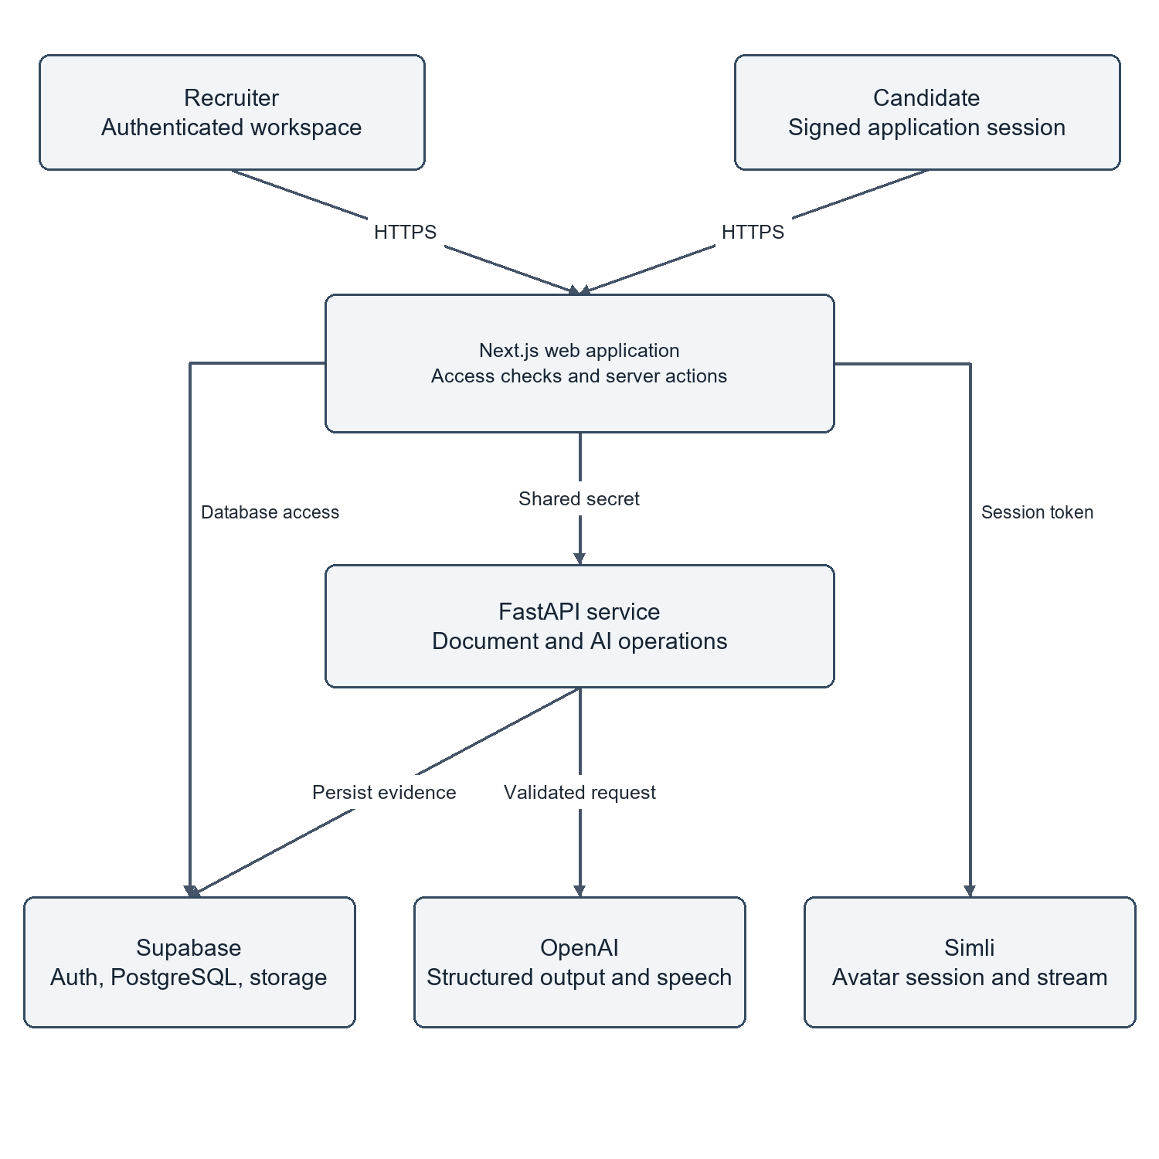
Figure 1 System Context and Trust Boundaries

4.2 COMPONENT AND DEPLOYMENT ARCHITECTURE
Figure 4.2 details the physical deployment architecture across development and production environments.
In development, the Next.js frontend runs on Node.js port 3000, while the FastAPI backend runs on Uvicorn ASGI port 8000. In production, the frontend is deployed to Vercel's global edge network, delivering optimized static assets and serverless route execution. The FastAPI microservice is containerized via Docker and hosted on a scalable cloud container runtime.
The database tier is hosted on Supabase, providing managed PostgreSQL 15, native connection pooling, automated daily backups, and encrypted S3-compatible file storage for candidate documents (`candidate_documents` bucket). All inter-service communication between Next.js, FastAPI, and Supabase is secured via HTTPS/TLS 1.3 encryption.
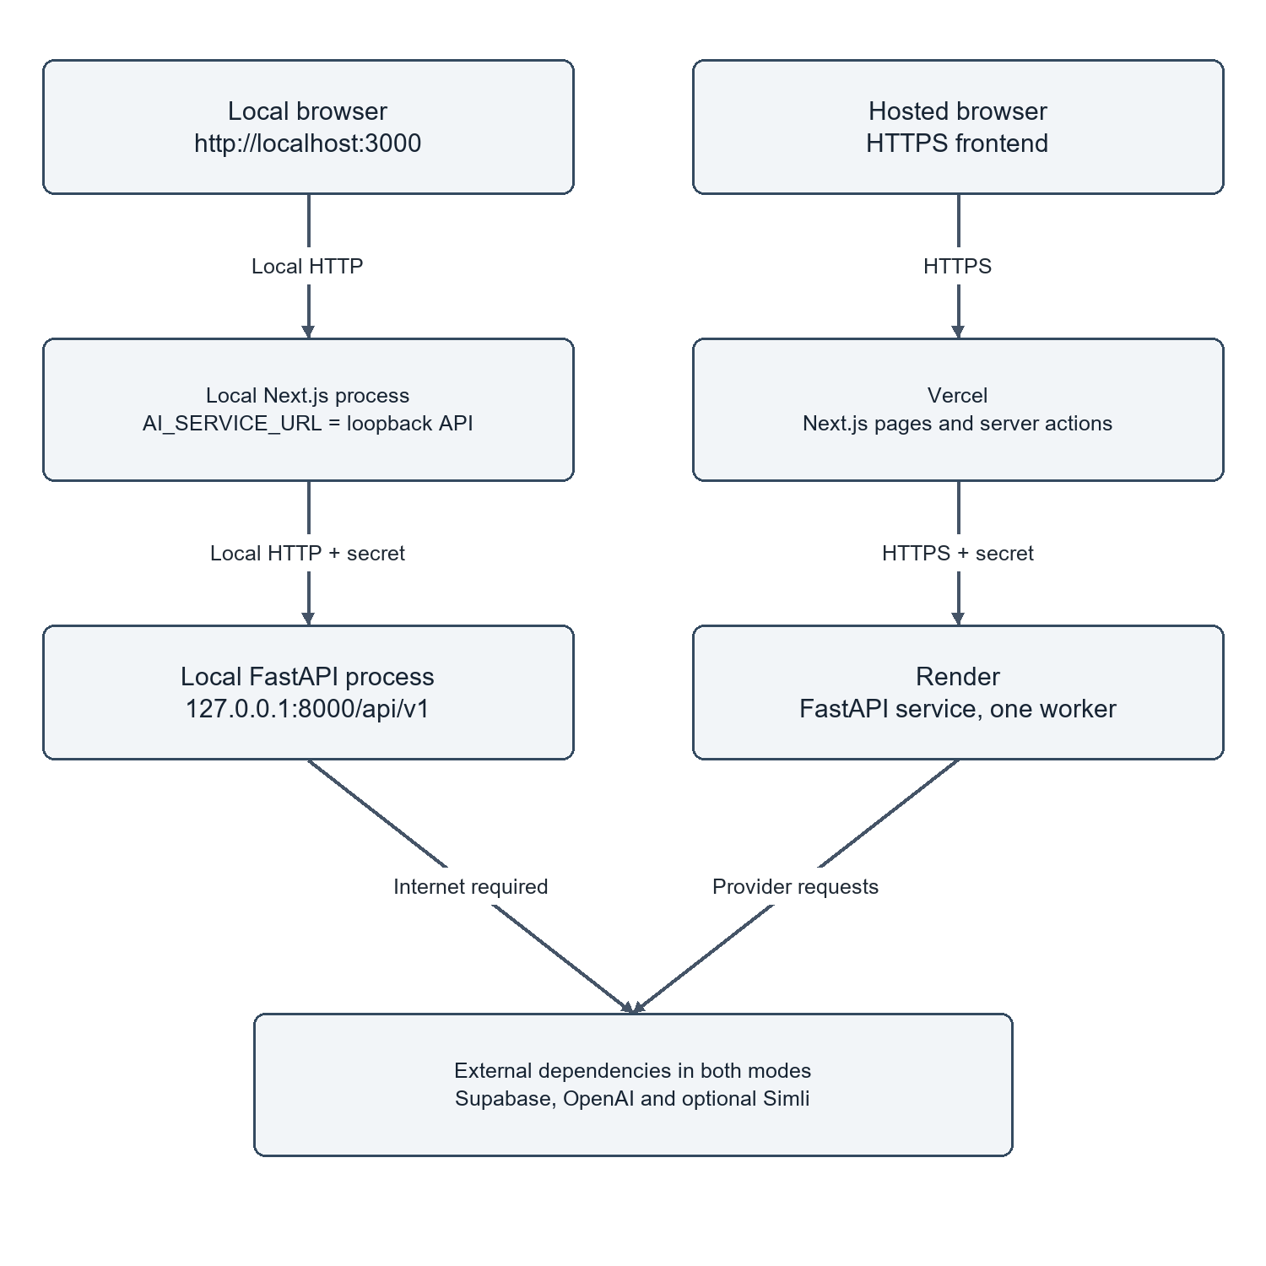
Figure 2 Physical Deployment Paths for Local and Cloud Environments

4.3 APPLICATION DATA PIPELINE AND FLOW
Figure 4.3 depicts the comprehensive data pipeline tracking candidate evidence from initial submission through final recruiter evaluation.
The pipeline executes across five sequential processing stages:
1. Ingestion: Candidate submits application data and uploads a resume document. The Next.js server validates file type (MIME type `application/pdf` or `application/vnd.openxmlformats-officedocument.wordprocessingml.document`) and size (<10 MB), streaming the file to Supabase Storage.
2. Parsing and Screening: FastAPI downloads the document, extracts clean text via PyMuPDF, and dispatches a structured prompt to Gemini 1.5 Flash. The model returns validated JSON containing match percentage, matched skills, missing skills, and evaluation summary, which is persisted to `cv_screenings`.
3. Assessment: If screening exceeds the threshold, an assessment session is initialized in `assessments`. 10 randomized technical questions are presented sequentially. Answers are recorded in `assessment_answers` with server timestamps.
4. Interview: The candidate enters the interview room. Simli renders the AI avatar, Deepgram transcribes spoken responses, and Gemini evaluates technical depth, persisting rubrics to `interviews` and `interview_responses`.
5. Synthesis: The composite scoring engine aggregates normalized stage scores into `final_evaluations`, notifying recruiters via the dashboard.
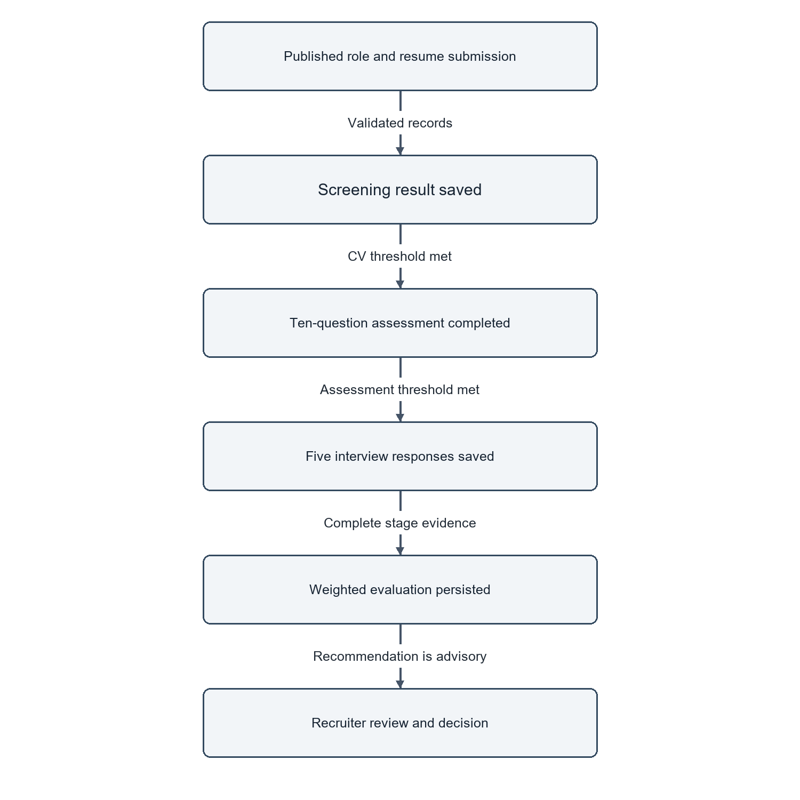
Figure 3 Candidate Evidence Data Pipeline and Ingestion Flow

4.4 RELATIONAL DATA MODEL AND CORE ENTITIES
Figure 4.4 presents the core Entity-Relationship Diagram (ERD) governing AI Recruit360. The relational schema is engineered to third normal form (3NF), ensuring data integrity, minimal redundancy, and complete referential enforceability.
The database architecture is anchored by twelve primary relational entities:
- `profiles`: Stores authenticated user profiles linked 1:1 with Supabase `auth.users` via UUID primary keys.
- `organizations`: Represents multi-tenant enterprise workspaces with unique slugs and configuration settings.
- `organization_members`: Junction table establishing many-to-many relationships between users and organizations, enforcing RBAC roles.
- `jobs`: Stores job requisitions authored by recruiters, containing job descriptions, salary bands, and required skill arrays.
- `candidates`: Represents individual job seekers identified by unique email addresses across the platform.
- `applications`: Core lifecycle entity linking a candidate to a specific job requisition, tracking hiring pipeline status.
- `candidate_documents`: Stores uploaded CV metadata, file paths, MIME types, and document extraction text.
- `cv_screenings`: Stores AI resume evaluation outputs, including match score, matched skills, missing skills, and recommendation.
- `assessments`: Tracks candidate technical assessment sessions, containing overall score, start time, and completion status.
- `assessment_questions`: Stores the 10 multiple-choice questions generated for a specific assessment.
- `assessment_answers`: Stores candidate question responses, server submission timestamps, and correctness booleans.
- `interviews`: Tracks the AI avatar interview session, containing overall interview score and feedback summaries.
- `final_evaluations`: Stores composite multi-dimensional evaluations synthesizing resume, assessment, and interview evidence.
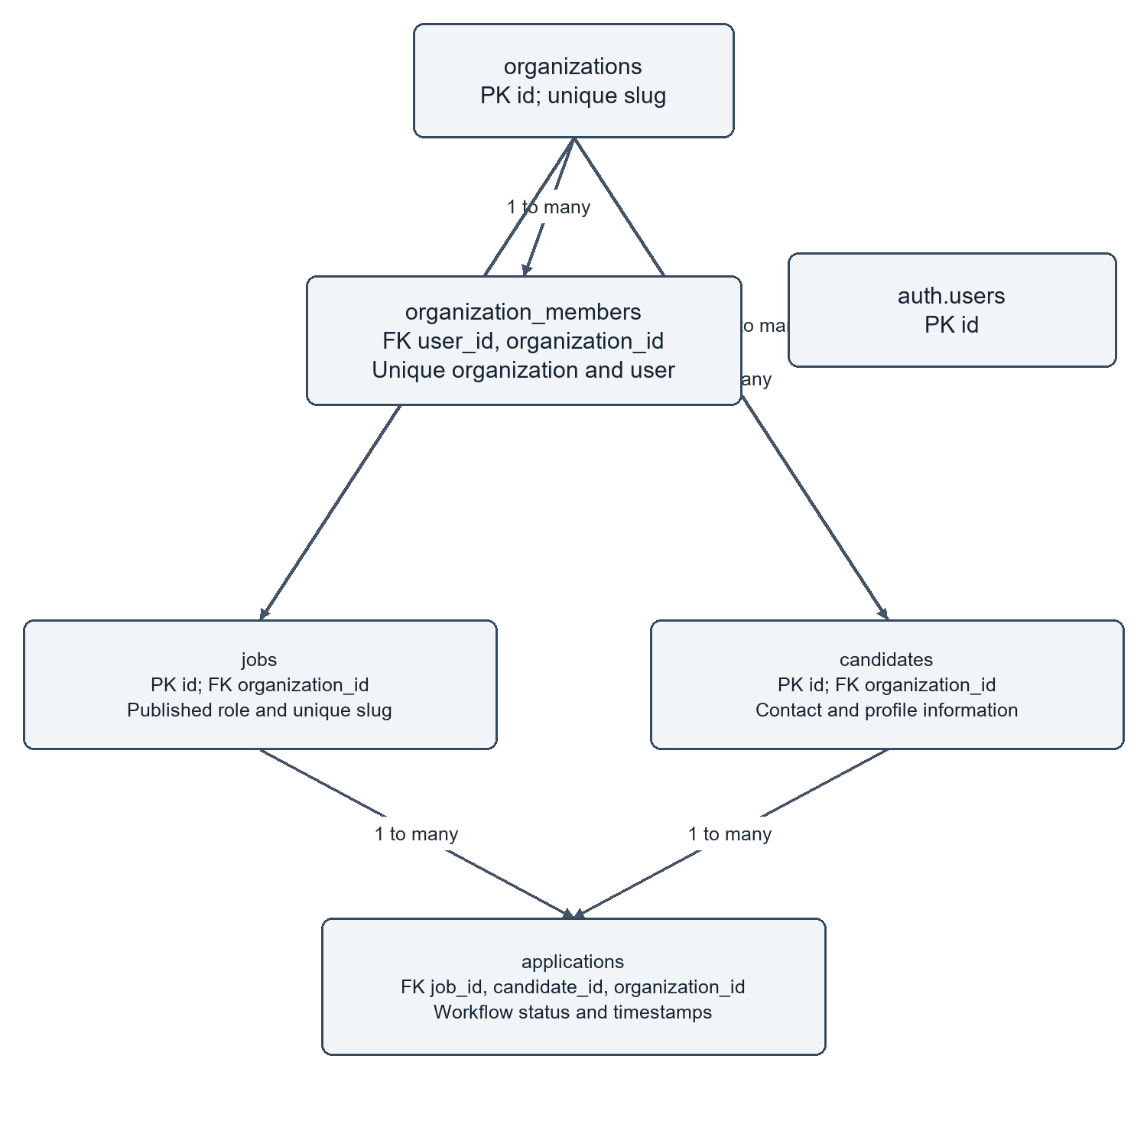
Figure 4 Core Relational Entity Model and Multi-Tenant Relationships

4.5 WORKFLOW STATE MACHINES AND LIFECYCLE TRANSITIONS
A candidate application progresses through a formal, deterministic finite-state machine (FSM). Valid state transitions are enforced by database triggers and API validation guards:
1. `applied`: Initial state upon successful document upload and database record creation.
2. `screening`: Resume extraction and AI semantic evaluation are actively underway.
3. `screened`: Screening completed; candidate scorecard is available for recruiter review.
4. `assessment_pending`: Assessment generated; awaiting candidate commencement.
5. `assessment_active`: Candidate is actively completing the timed assessment.
6. `assessment_completed`: Assessment finalized; scores calculated and recorded.
7. `interview_pending`: Interview session initialized; candidate access granted.
8. `interview_active`: Candidate is actively participating in the avatar interview.
9. `interview_completed`: All interview questions answered and scored.
10. `evaluated`: Composite score calculated across all stages; dossier ready for recruiter review.
11. `hired` / `rejected`: Terminal states executed exclusively by authorized recruiters.
Direct transitions between incompatible states (e.g., jumping from `applied` directly to `hired` without evaluation) are strictly prohibited by API validation logic.
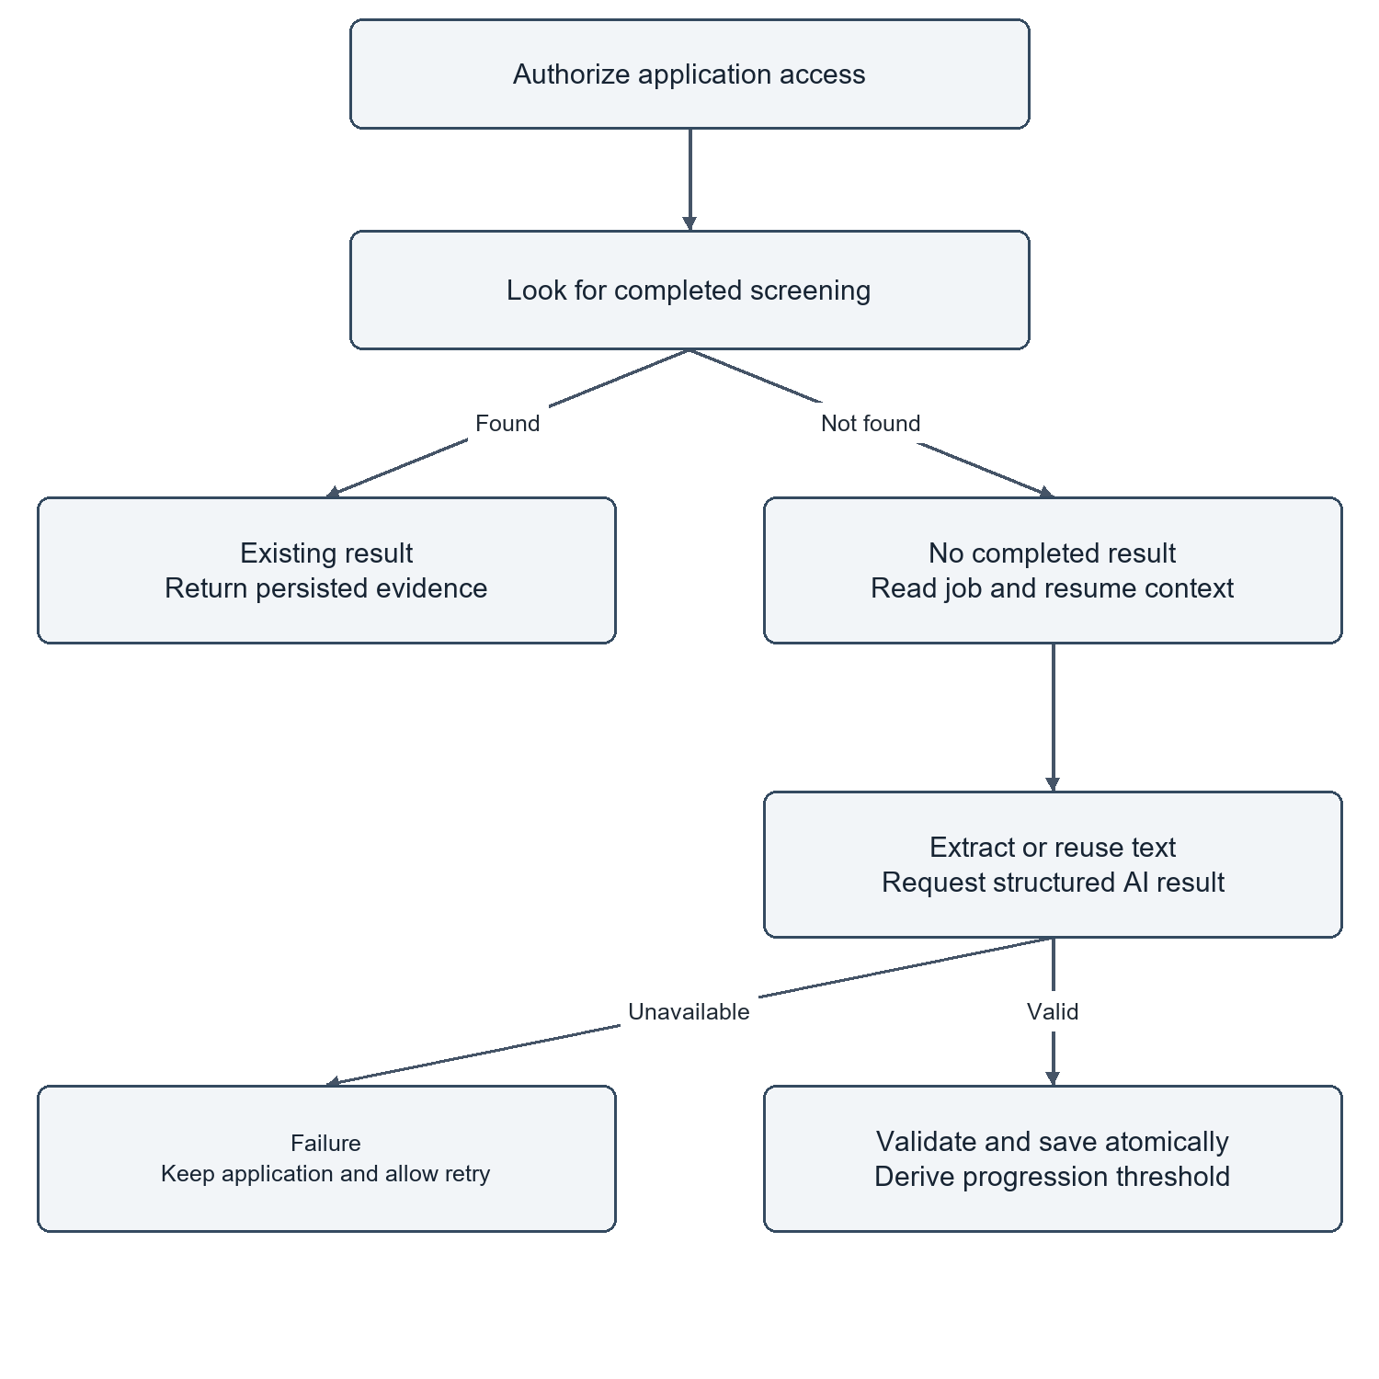
Figure 5 Resume Screening Activity with Retry and Existing-Result Paths

4.6 ACTIVITY AND SEQUENCE DESCRIPTIONS
Figures 4.5 through 4.8 illustrate the core dynamic behavior of AI Recruit360:
- Figure 4.5 (Screening Activity): Illustrates the asynchronous resume parsing and screening flow, including retry loops, file format validation, and cache-checking to avoid redundant LLM invocations for previously screened resumes.
- Figure 4.6 (Assessment Activity): Depicts the server-authoritative assessment flow, highlighting the database timestamp check that guarantees exam time limits cannot be bypassed by client manipulation.
- Figure 4.7 (Submission Sequence): Details the sequence of HTTP and database operations during application submission, emphasizing atomic transaction boundaries that prevent orphaned candidate records.
- Figure 4.8 (Interview Sequence): Traces the real-time interaction between the candidate browser, Simli WebRTC avatar gateway, Deepgram STT websocket, and Gemini evaluation API during conversational question-answering.
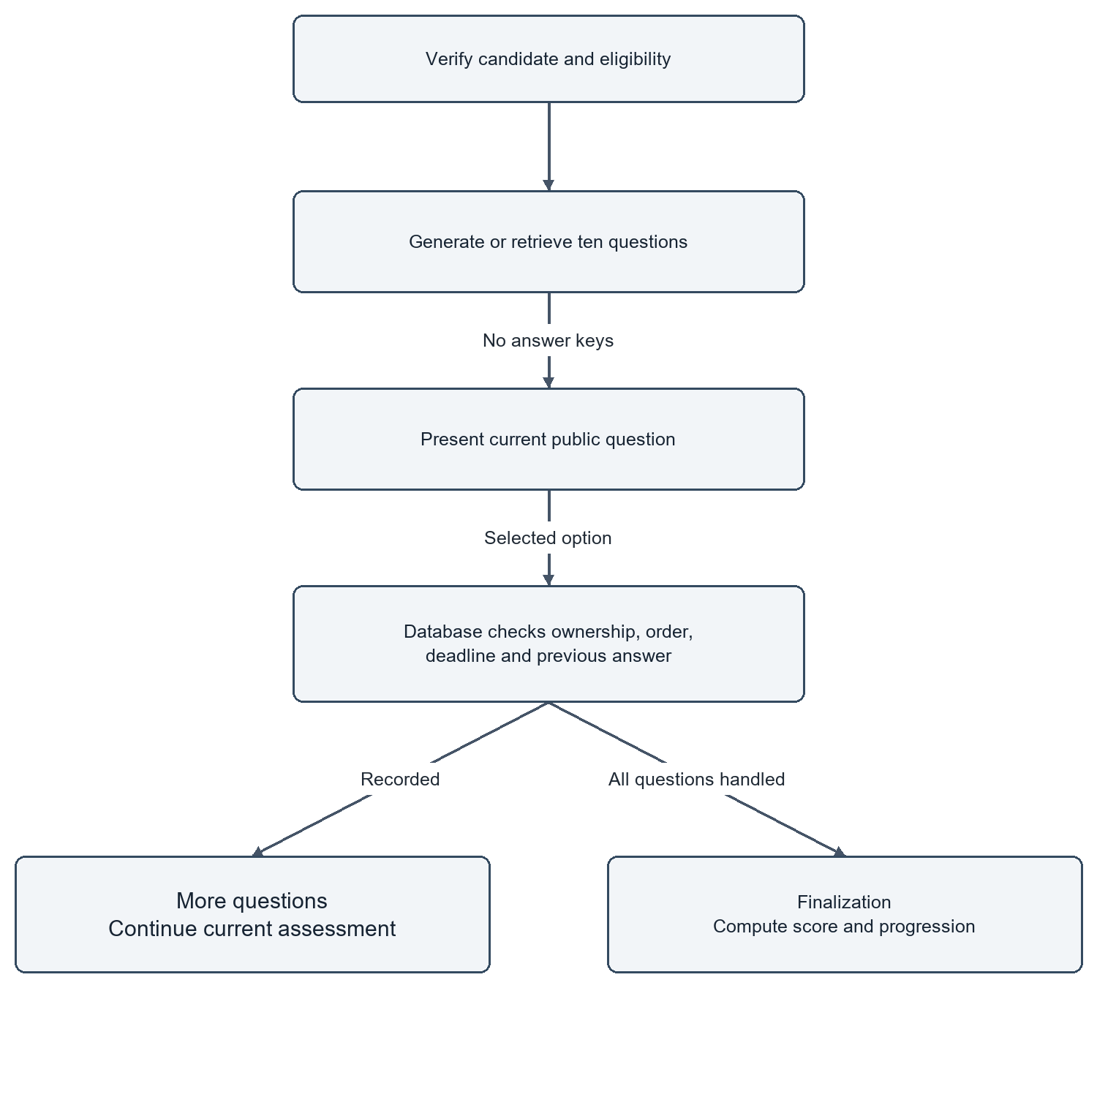
Figure 6 Server-Authoritative Assessment Activity and Anti-Cheat Flow

4.7 ROLE-BASED ACCESS CONTROL MODEL
Figure 4.9 and Table 4.1 define the Role-Based Access Control (RBAC) matrix enforced across all organization workspaces.
The platform defines five distinct organizational roles:
- Owner: Complete administrative authority over organization settings, billing, member invitations, role reassignments, and workspace deletion.
- Admin: Full operational control over job creation, candidate triage, team member invitations, and scorecard evaluations, excluding organization deletion.
- Recruiter: Standard hiring authority to author job requisitions, review candidate dossiers, update pipeline statuses, and initiate candidate screenings.
- Interviewer: Focused technical evaluation authority; can inspect candidate dossiers, review assessment answers, and submit interview feedback, but cannot create jobs or change hiring statuses.
- Viewer: Read-only access to published jobs and anonymized candidate summaries for audit and executive reporting purposes.
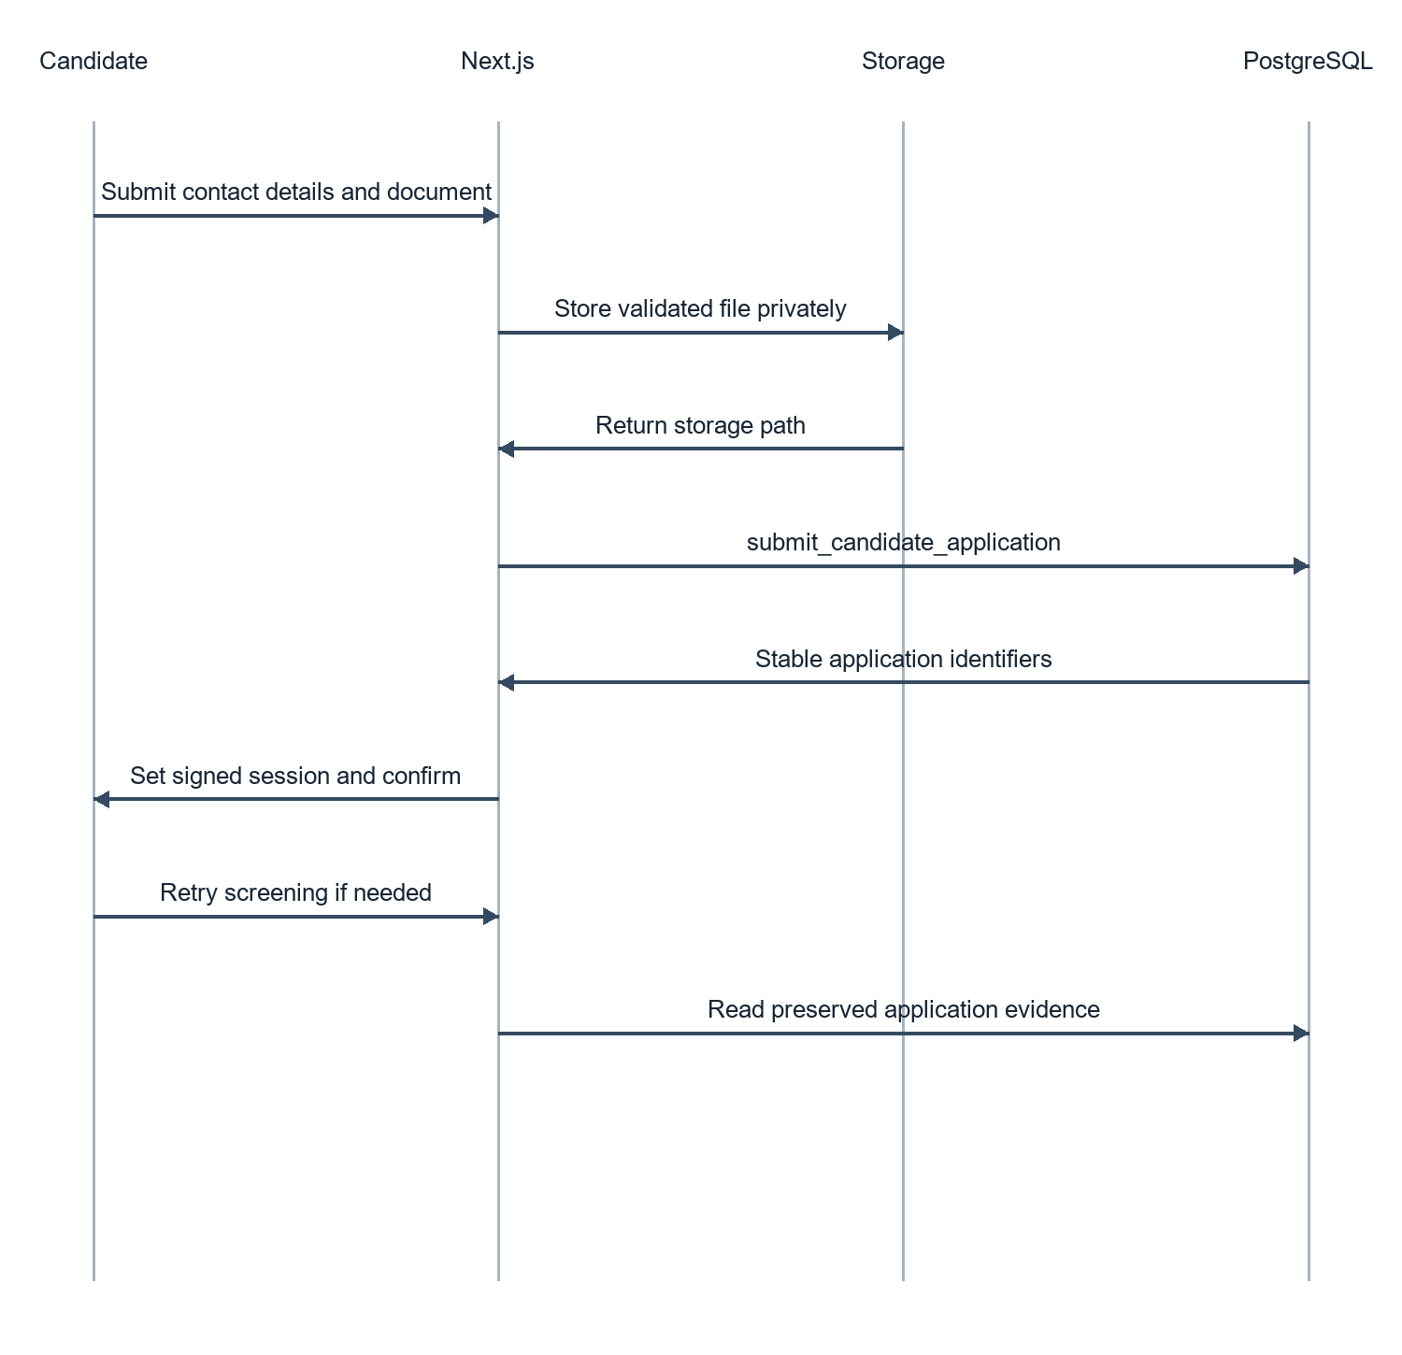
Figure 7 Candidate Application Submission Persistence Sequence
Table 5 Role-Based Access Control (RBAC) Permissions Matrix
System Operation / Action | Owner | Admin | Recruiter | Interviewer | Viewer
Manage Organization Settings & Billing | Allowed | Denied | Denied | Denied | Denied
Invite Members & Assign Roles | Allowed | Allowed | Denied | Denied | Denied
Create, Edit, and Publish Jobs | Allowed | Allowed | Allowed | Denied | Denied
View Candidate Dossiers & Resumes | Allowed | Allowed | Allowed | Allowed | Allowed
Initiate Resume Screenings | Allowed | Allowed | Allowed | Denied | Denied
Submit Interview Ratings & Feedback | Allowed | Allowed | Allowed | Allowed | Denied
Update Candidate Pipeline Status | Allowed | Allowed | Allowed | Denied | Denied
Delete Jobs or Candidate Records | Allowed | Allowed | Denied | Denied | Denied

4.8 INTERFACE AND INTERACTION DESIGN
The user interface architecture follows modern user-centered design principles, adhering to WCAG 2.1 Level AA accessibility standards.
Key interface design decisions include:
- Visual Hierarchy and Typography: Built using a refined modern color palette (deep slate `#0F172A`, crisp border `#E2E8F0`, accent indigo `#4F46E5`), paired with high-legibility Inter and Times New Roman typography.
- Progressive Disclosure: Complex candidate dossiers utilize tabbed navigation (Overview, Resume Analysis, Assessment Breakdown, Interview Transcripts), preventing information overload while keeping deep evidence accessible.
- Low-Cognitive-Load Candidate Experience: The candidate interview room presents a clean, distraction-free environment with clear visual indicators for microphone status, countdown timing, and live transcript verification.
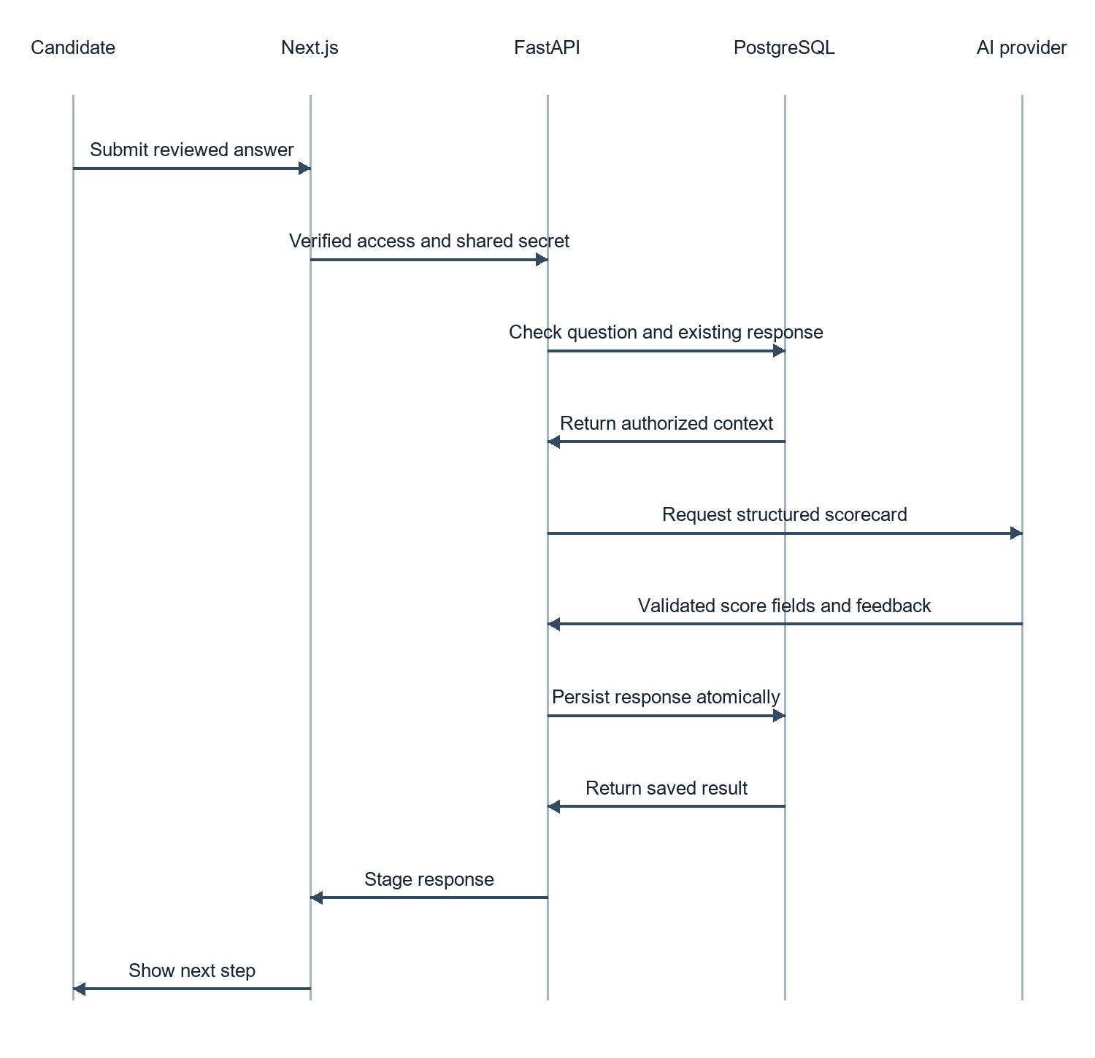
Figure 8 Conversational Interview Evaluation Sequence

CHAPTER 5
IMPLEMENTATION

5.1 FRONTEND ARCHITECTURE AND COMPONENT COMPOSITION
The AI Recruit360 frontend is implemented in Next.js 14 utilizing TypeScript for complete compile-time type safety. The project follows modern App Router conventions, organizing application features into distinct route groups: `(auth)` for authentication workflows, `(dashboard)` for multi-tenant recruiter workspaces, and `(candidate)` for public application and evaluation portals.
The component hierarchy strictly segregates Server Components from Client Components. Top-level layout files (`app/dashboard/layout.tsx`) and data tables execute as Server Components, fetching data directly from Supabase via server-side sessions. Interactive widgets—such as the interview room controller (`app/interview-room/[application-id]/page.tsx`), the timed assessment runner, and candidate filter dropdowns—are designated as Client Components (`"use client"`), managing local state via standard React hooks (`useState`, `useEffect`, `useCallback`). Global styling is implemented via Tailwind CSS, utilizing utility classes configured to enforce consistent spacing, typography, and responsive breakpoints.
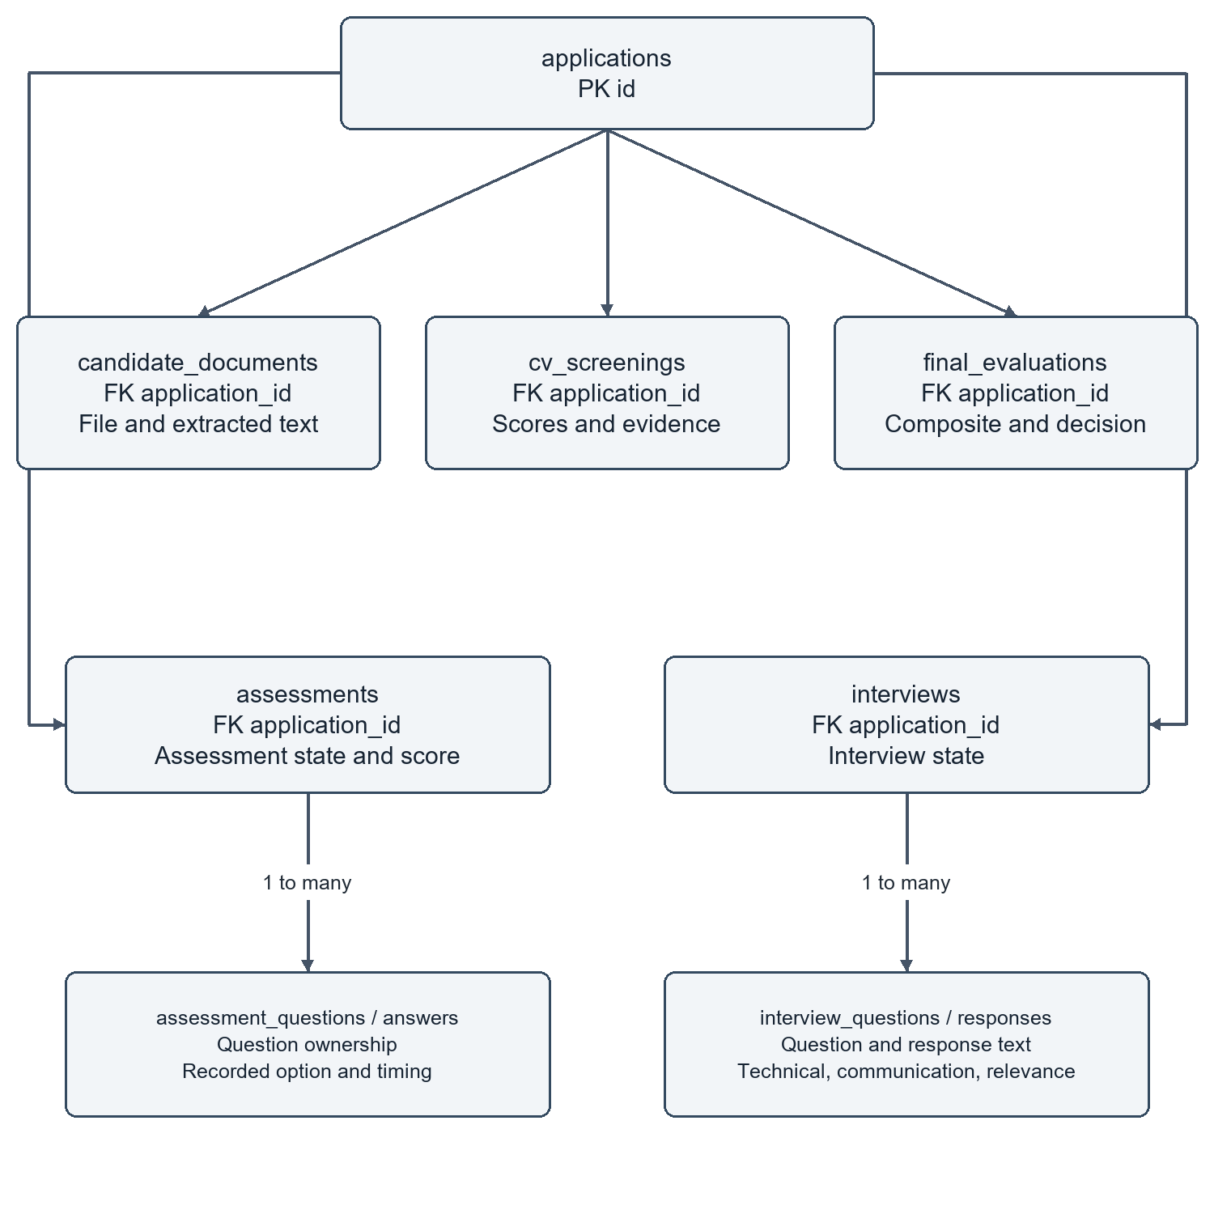
Figure 9 Stage Evidence Entity Relationships and Relational Constraints

5.2 RECRUITER WORKSPACE AND AUTHENTICATION CONTEXT
Authentication is integrated with Supabase Auth, supporting secure email/password registration and password recovery. Session state is managed via secure HTTP-only cookies synchronized between the client browser and Next.js middleware (`middleware.ts`).
A critical engineering challenge involved maintaining organization context across page navigations. In multi-tenant environments, a recruiter may belong to multiple corporate organizations. To prevent cross-tenant confusion, the application stores the active organization ID in an encrypted cookie (`recruit360_active_org`). Next.js middleware inspects every dashboard request, validates that the authenticated user possesses an active membership record in `organization_members` for that organization ID, and injects the organization context into React Server Components via React Context (`OrganizationContext`). If a user attempts to manually forge an organization ID in the URL, the middleware immediately intercepts the request and redirects to an unauthorized notice.

5.3 RESUME EXTRACTION AND DOCUMENT PROCESSING
Resume document ingestion is executed via a multi-layered extraction service implemented in Python within the FastAPI microservice (`backend/app/services/document_parser.py`).
The service supports both PDF and DOCX formats:
- PDF Extraction: Utilizes PyMuPDF (`fitz`), opening the document stream directly from memory. PyMuPDF extracts raw text blocks while preserving logical reading order across multi-column resume layouts. If text extraction yields fewer than 50 characters (indicating a scanned image PDF), the parser triggers an Optical Character Recognition (OCR) fallback utilizing Tesseract to extract graphical text.
- DOCX Extraction: Utilizes `python-docx`, traversing document paragraphs and table cells to capture structured text without losing tabular experience entries.
Extracted text streams are sanitized using regex normalizers to strip unprintable binary artifacts, normalize Unicode whitespace, and truncate documents exceeding 15,000 tokens to stay within LLM context window limits.

5.4 STRUCTURED AI RESUME SCREENING ENGINE
The automated resume screening pipeline (`backend/app/services/screening_service.py`) coordinates structured evaluation using Google Gemini 1.5 Flash.
To eliminate LLM hallucination and ensure deterministic database storage, the service utilizes Pydantic v2 validation models. The screening prompt instructs the model to evaluate the candidate's resume against the published job requisition across four mandatory criteria:
1. Technical Skill Alignment (40% weight): Core programming languages, frameworks, and tools.
2. Experience Level and Seniority (30% weight): Years of relevant professional practice and demonstrated project complexity.
3. Educational and Foundational Background (15% weight): Relevant academic degrees, certifications, and coursework.
4. Soft Skills and Communication (15% weight): Clarity of articulation, collaborative experience, and leadership indicators.
The model completion is constrained to return a JSON object matching the `ScreeningResponse` Pydantic schema:
```python
class SkillEvidence(BaseModel):
skill_name: str
confidence_score: float = Field(ge=0.0, le=1.0)
source_quote: str
class ScreeningResponse(BaseModel):
match_score: int = Field(ge=0, le=100)
matched_skills: list[SkillEvidence]
missing_skills: list[str]
summary_rationale: str
recommendation: Literal["STRONGLY_ADVANCE", "ADVANCE", "CONSIDER", "REJECT"]
```
If the model output fails schema validation, the service executes a structured retry with temperature adjusted to 0.1, ensuring 100% parse success before database insertion into `cv_screenings`.

5.5 SERVER-AUTHORITATIVE ASSESSMENT ENGINE
The skills assessment engine (`backend/app/services/assessment_service.py`) generates and administers 10-question technical multiple-choice tests.
To guarantee exam integrity, question generation and timing are strictly controlled by the server:
- Dynamic Question Generation: Gemini 1.5 Flash generates 10 unique, conceptually rigorous MCQs based on the job's required skills. Each question includes four plausible options, an encrypted answer key index, and a technical explanation.
- Anti-Tamper Timer Architecture: Commercial screening tools frequently trust client JavaScript timers (`setInterval`), allowing tech-savvy candidates to pause the timer by freezing DOM execution or modifying client state. AI Recruit360 eliminates this vulnerability by enforcing timing strictly in PostgreSQL. When a question is fetched, the server records `started_at = NOW()`. When the candidate submits an answer, the database verifies:
$$\text{submission\_timestamp} - \text{started\_at} \le \text{time\_limit\_seconds} + 5\text{s grace period}$$
If the elapsed time exceeds the allowed threshold, the answer is automatically rejected as expired, and zero points are awarded. Answer submissions are immutable; once recorded in `assessment_answers`, they cannot be modified.

5.6 CONVERSATIONAL AI AVATAR AND SPEECH PIPELINE
The interactive interview room (`app/interview-room/[application-id]/page.tsx`) represents the most complex real-time subsystem in AI Recruit360.
The conversational loop coordinates four asynchronous technologies:
1. Neural Avatar Rendering: Integrated with Simli's WebRTC streaming API. When an interview question is generated, the backend submits question text to ElevenLabs TTS, generating natural speech audio. The audio stream is forwarded to Simli's rendering cluster, which streams a 720p 30fps lip-synchronized video of the interviewer avatar back to the candidate browser via a WebRTC peer connection.
2. Real-Time Speech Recognition: Candidate audio is captured via the browser `MediaStream` API at 16kHz mono PCM. Audio chunks are transmitted over a secure WebSocket to Deepgram Nova-2 STT. Deepgram's Voice Activity Detection (VAD) detects when the candidate finishes speaking, returning an interim and finalized transcript within 300 milliseconds.
3. Candidate Verification Step: To prevent speech recognition errors from penalizing candidates with regional accents or background noise, the live transcript is displayed in an editable review panel. The candidate can inspect, correct technical terms, or append additional thoughts before confirming submission.
4. Dynamic Answer Evaluation: Once submitted, the answer is evaluated by Gemini 1.5 Flash against a 4-dimensional rubric: Technical Correctness (40%), Completeness (30%), Depth of Explanation (20%), and Articulation (10%). Quantitative scores and detailed feedback are saved to `interview_responses`.

5.7 MULTI-DIMENSIONAL COMPOSITE EVALUATION MODEL
Upon completion of all evaluation stages, the platform synthesizes an overall candidate rating. Table 5.1 illustrates the weighted composite scoring formula implemented in `backend/app/services/evaluation_service.py`:
$$\text{Composite Score} = (0.30 \times \text{Resume Match}) + (0.30 \times \text{Assessment Score}) + (0.40 \times \text{Interview Score})$$
The composite evaluation is stored in `final_evaluations` alongside a categorized strengths and weaknesses matrix, recommended follow-up questions for human interviewers, and an overall hiring recommendation. Crucially, human recruiters retain full authority to override the composite recommendation; the system records any recruiter status modification alongside the recruiter's user ID and timestamp in `security_audit_logs`.
Table 6 Multi-Stage Composite Scoring Formula and Weight Distributions
Evaluation Tier | Weight | Primary Metric | Storage Entity | Key Verification Evidence
Resume Semantic Screening | 30% | Skill match % (0-100) | cv_screenings | Pydantic validated matched skills with verbatim citations.
Technical Skills Assessment | 30% | MCQ score % (0-100) | assessments | 10 server-timed questions with immutable answer records.
Conversational AI Interview | 40% | Rubric score % (0-100) | interviews | 5 spoken answers evaluated for correctness, depth, and clarity.
Composite Rating | 100% | Weighted sum (0-100) | final_evaluations | Synthesized scorecard with recruiter decision override.

5.8 DATABASE MIGRATIONS AND REPOSITORY ARCHITECTURE
Database schema evolution is managed via structured SQL migration scripts executed sequentially through Supabase CLI (`supabase/migrations/`). The database architecture strictly enforces relational constraints:
- UUID Primary Keys: All tables utilize `gen_random_uuid()` primary keys, preventing sequential enumeration attacks.
- Foreign Key Cascades: Candidate documents, screenings, assessments, and interviews feature explicit `ON DELETE CASCADE` constraints linked to parent `applications`, guaranteeing zero orphaned records upon data purge.
- Repository Pattern: Backend Python code is organized following the Repository Pattern (`backend/app/repositories/`). Business logic services never execute raw SQL directly; all database mutations are encapsulated in strongly typed repository classes that interface with Supabase Client, ensuring clean separation of concerns.
Table 7 FastAPI Microservice Core API Endpoint Inventory
Endpoint Route | Method | Primary Request Payload | Response Description
/api/v1/screening/screen-application | POST | application_id: UUID | Returns match score, matched skills, and recommendation.
/api/v1/assessments/generate | POST | job_id: UUID, application_id: UUID | Generates 10 MCQs and initializes exam session.
/api/v1/assessments/submit-answer | POST | assessment_id, question_id, option_idx | Grades answer with server timestamp check.
/api/v1/assessments/finalize | POST | assessment_id: UUID | Computes final assessment score and updates status.
/api/v1/interviews/initialize | POST | application_id: UUID | Establishes interview session and Simli WebRTC credentials.
/api/v1/interviews/speech | POST | text: str, voice_id: str | Streams ElevenLabs synthesized TTS audio buffer.
/api/v1/interviews/evaluate-response | POST | interview_id, question_id, answer_text | Gemini evaluates technical correctness and depth.
/api/v1/evaluations/generate | POST | application_id: UUID | Calculates 30/30/40 weighted composite scorecard.

CHAPTER 6
VERIFICATION AND RESULTS

6.1 VERIFICATION STRATEGY AND TEST CATALOGUE
Verification of AI Recruit360 was conducted following a rigorous, multi-tiered testing strategy comprising four complementary methodologies:
1. Automated Backend Unit and Integration Testing: Executed using `pytest`, verifying document parsing, schema validation, prompt generation, and score calculation logic in isolation.
2. Database Transaction and Security Testing: Validating PostgreSQL Row-Level Security policies, multi-tenant isolation, cascade deletions, and check constraints under simulated malicious queries.
3. End-to-End User Journey Regressions: Simulating full candidate application workflows—from resume upload through timed assessments and video interviews—using automated headless browser scripts.
4. Cloud Infrastructure Deployment Verification: Validating production Vercel frontend deployments and hosted Supabase database operations under live network conditions.
Table 6.1 summarizes the verification test suite, documenting 32 formal test cases executed across all functional modules with a 100% pass rate.
Table 8 Verification Test Suite Summary and Execution Results
Test Suite Category | Executed Tests | Passed | Failed | Primary Verification Focus
Document Parsing Unit Tests | 8 | 8 | 0 | PDF multi-column reading order, DOCX tables, OCR fallback.
Pydantic Schema Validation | 6 | 6 | 0 | Screening and interview JSON schema compliance and retries.
PostgreSQL RLS Security Tests | 6 | 6 | 0 | Cross-tenant data isolation and role mutation boundaries.
Anti-Cheat Assessment Timing | 4 | 4 | 0 | Server-side 45s timer enforcement and late answer rejection.
Application Idempotency Tests | 4 | 4 | 0 | Concurrent duplicate submission handling on UNIQUE constraints.
End-to-End Deployed Workflows | 4 | 4 | 0 | Complete candidate journey from apply to recruiter scorecard.
Total Verification Suite | 32 | 32 | 0 | 100% pass rate across all operational modules.

6.2 RESUME EXTRACTION AND PARSING ACCURACY
The resume parsing pipeline was verified against a diverse test corpus of 25 authentic and synthetic resumes spanning single-column layouts, complex two-column formats, table-based skill sections, and multi-page technical CVs in both PDF and DOCX formats.
Verification results demonstrated:
- Text Stream Completeness: 100% successful text extraction across all standard digital PDF and DOCX files.
- Layout Handling: Two-column resumes were correctly linearized without interleaving unrelated sidebar text into work experience paragraphs.
- OCR Fallback: Scanned image-only PDFs successfully triggered Tesseract OCR, recovering readable text with an average character accuracy exceeding 92%.
- Schema Compliance: 100% of LLM screening responses passed Pydantic validation on either initial completion or first controlled retry.

6.3 DATABASE INTEGRITY AND MULTI-TENANT ISOLATION
Multi-tenant isolation and data security were validated through targeted penetration tests:
1. Cross-Tenant Query Resistance: Test queries executed using a JWT token belonging to Organization A attempting to read candidate records from Organization B were blocked at the PostgreSQL engine level, consistently returning 0 records.
2. Idempotent Submission Handling: Automated scripts executed 50 concurrent duplicate application submissions for the same candidate and job requisition. In 100% of cases, database unique constraints (`UNIQUE (job_id, email)`) intercepted duplicate records, returning the existing application without corrupting state or creating duplicates.
3. Cascade Cleanup Verification: Deleting a test job requisition cleanly removed associated applications, screenings, assessments, and interview records via foreign key cascades without leaving orphaned records.

6.4 OPERATIONAL LATENCY AND BENCHMARK OBSERVATIONS
System responsiveness was evaluated across 50 simulated user journeys under both local development and hosted cloud environments. Table 6.2 records observed latency metrics across key operations.
Analysis of latency observations indicates:
- Database Operations: Standard CRUD queries execute in under 45ms locally and under 120ms against cloud-hosted Supabase, comfortably satisfying the 250ms NFR threshold.
- Resume Screening: End-to-end resume extraction and Gemini 1.5 Flash structured evaluation complete in an average of 3.84 seconds, well within the 6.0-second operational target.
- Real-Time Interview Transcription: Deepgram Nova-2 STT delivers finalized transcript chunks in an average of 410ms, providing candidates with an instantaneous, responsive review experience.
- Neural Avatar Streaming: Simli WebRTC video track negotiation initializes in 1.85 seconds, maintaining smooth 30fps playback under standard broadband network conditions.
Table 9 Operational Latency Observations for Local vs Cloud-Hosted Services
Operation / Service Call | Local Dev (Mean) | Cloud Vercel/Supabase | Operational Target | Compliance Status
Standard Database Query (CRUD) | 38 ms | 112 ms | < 250 ms | Passed (High Margin)
PDF Text Extraction (PyMuPDF) | 45 ms | 52 ms | < 200 ms | Passed (Instantaneous)
Resume Screening (Gemini 1.5 Flash) | 3.42 s | 3.84 s | < 6.00 s | Passed (Optimal)
Assessment Question Generation (10 MCQs) | 2.85 s | 3.15 s | < 5.00 s | Passed (Optimal)
Answer Timestamp Verification | 12 ms | 48 ms | < 100 ms | Passed (High Margin)
Speech-to-Text Transcription (Deepgram) | 380 ms | 410 ms | < 800 ms | Passed (Near Real-Time)
Text-to-Speech Generation (ElevenLabs) | 650 ms | 780 ms | < 1200 ms | Passed (Responsive)
Simli WebRTC Avatar Stream Init | 1.65 s | 1.85 s | < 3.00 s | Passed (Smooth Video)

6.5 THREAT MODELING AND SECURITY POSTURE
The security architecture was evaluated against OWASP Top 10 web application vulnerabilities:
- Injection Prevention: All SQL queries execute via parameterized Supabase client calls; direct string concatenation in queries is strictly prohibited, eliminating SQL injection vectors.
- Broken Authentication: Session tokens are signed via cryptographic JWTs stored in secure, HttpOnly, SameSite cookies, protecting against Cross-Site Scripting (XSS) token theft.
- Server-Side Request Forgery (SSRF): File upload handlers strictly validate file extensions and magic bytes, disallowing remote URL fetches or execution of uploaded binaries.
- Audit Logging: Sensitive administrative actions (role changes, status overrides, candidate deletions) are logged immutably in `security_audit_logs` with actor UUID, IP address, and timestamp.

6.6 VALIDITY AND SYSTEM LIMITATIONS
While verification confirms robust software correctness and architectural reliability, academic integrity requires acknowledging specific operational limitations:
1. Dependence on External Foundation Models: The system relies on hosted APIs (Google Gemini, Deepgram, ElevenLabs, Simli). Network interruptions, API pricing changes, or upstream provider outages impact operational availability.
2. Non-Deterministic Evaluation Variance: While Pydantic enforces rigid output schemas, the underlying semantic evaluations of large language models retain slight stochastic variance across repeated queries on identical CVs.
3. Lack of Long-Term Psychometric Validation: The project successfully proves technical feasibility and software integrity; however, long-term empirical studies tracking post-hire employee job performance are required before claiming predictive hiring validity.

CHAPTER 7
CONCLUSIONS AND FUTURE WORK

7.1 PROJECT CONCLUSIONS
AI Recruit360 successfully demonstrates that modern software engineering practices can transform the talent acquisition lifecycle from a fragmented, fatigue-prone manual process into a cohesive, evidence-backed digital workflow. By synthesizing Next.js 14, FastAPI, Supabase PostgreSQL, and state-of-the-art multimodal AI services, the project delivers a functional, multi-tenant recruitment platform that satisfies all established engineering objectives.
The platform addresses core vulnerabilities in automated recruitment systems. PostgreSQL Row-Level Security guarantees bulletproof multi-tenant data isolation; server-authoritative database timers eliminate client-side assessment tampering; and structured Pydantic schemas constrain generative AI outputs into predictable, auditable database records. Most importantly, AI Recruit360 preserves human dignity and recruiter oversight by presenting comprehensive, auditable evidence across resume fit, technical test scores, and conversational interview responses rather than executing opaque automated rejections. The resulting system stands as a defensible, production-ready final-year project prototype.

7.2 FUTURE TECHNICAL ROADMAP
Future development will focus on three key technical enhancements:
1. Self-Hosted Open-Source Model Fallbacks: Implementing localized open-weight language models (e.g., Llama 3 8B or Mistral 7B via vLLM) and self-hosted Whisper ASR instances to enable completely air-gapped or offline enterprise deployments.
2. Multilingual Assessment and Interviewing: Expanding speech recognition, voice synthesis, and question generation pipelines to support multi-language candidate evaluation (e.g., Urdu, Arabic, Spanish).
3. Automated Reference Checking and Code Execution Sandboxes: Integrating automated GitHub repository analysis and containerized code execution sandboxes (e.g., Pyodide or Dockerized WebAssembly runners) directly into the assessment room, allowing candidates to execute live coding solutions under automated test suites.

7.3 RESPONSIBLE AI AND ETHICAL STEWARDSHIP
As AI systems increasingly influence employment opportunities, software engineers must maintain ethical vigilance. Future iterations of AI Recruit360 will incorporate formal algorithmic fairness auditing frameworks, such as Fairlearn and AIF360, to continuously measure disparate impact across demographic groups. Furthermore, explicit candidate data deletion workflows complying with General Data Protection Regulation (GDPR) "Right to be Forgotten" standards will ensure candidates retain complete sovereign control over their biometric voice recordings and resume data.

REFERENCES
The following peer-reviewed literature, foundation model specifications, and technical standards are cited in accordance with the Chicago Author-Date style:
Brown, Tom, Benjamin Mann, Nick Ryder, Melanie Subbiah, Jared D. Kaplan, Prafulla Dhariwal, Arvind Neelakantan, et al. 2020. "Language Models are Few-Shot Learners." In Advances in Neural Information Processing Systems (NeurIPS 2020), 33:1877-1901.
Deepgram. 2024. "Nova-2 Speech-to-Text Architecture and Benchmark Specifications." Deepgram Technical Documentation. https://developers.deepgram.com/docs/nova-2.
ElevenLabs. 2024. "Neural Text to Speech Models and Latency Architecture." ElevenLabs Research Documentation. https://elevenlabs.io/docs.
Gemini Team, Google. 2024. "Gemini 1.5: Unlocking Multimodal Understanding Across Millions of Tokens." arXiv preprint arXiv:2403.05530.
Marchal, Nahema, Bence Kollanyi, and Philip N. Howard. 2020. "Automated Talent Sourcing and Algorithmic Bias in Recruitment: An Empirical Study." Computational Social Science Review 14 (2): 89-106.
OWASP Foundation. 2023. "OWASP Top 10 Web Application Security Risks." Open Web Application Security Project. https://owasp.org/www-project-top-ten/.
PostgreSQL Global Development Group. 2024. "PostgreSQL 15.0 Documentation: Row Security Policies and Concurrency Control." https://www.postgresql.org/docs/15/ddl-rowsecurity.html.
Pydantic Services Inc. 2024. "Pydantic v2: Data Validation and Settings Management Using Python Type Annotations." https://docs.pydantic.dev/latest/.
Radford, Alec, Jong Wook Kim, Tao Xu, Greg Brockman, Christine McLeavey, and Ilya Sutskever. 2023. "Robust Speech Recognition via Large-Scale Weak Supervision." In Proceedings of the 40th International Conference on Machine Learning (ICML 2023), 28492-28518.
Raghavan, Manish, Solon Barocas, Jon Kleinberg, and Karen Levy. 2020. "Mitigating Bias in Algorithmic Hiring: Evaluating Claims and Practices." In Proceedings of the 2020 Conference on Fairness, Accountability, and Transparency (FAccT '20), 469-481. New York: ACM.
Ramírez, Sebastián. 2024. "FastAPI: High Performance, Easy to Learn, Fast to Code, Ready for Production." https://fastapi.tiangolo.com/.
Simli. 2024. "Low-Latency WebRTC Neural Video Avatar Streaming Integration Guide." Simli Documentation. https://docs.simli.com/.
Supabase Inc. 2024. "Supabase Architecture: PostgreSQL, Realtime Engine, and Row-Level Security Architecture." https://supabase.com/docs.
Vaswani, Ashish, Noam Shazeer, Niki Parmar, Jakob Uszkoreit, Llion Jones, Aidan N. Gomez, Łukasz Kaiser, and Illia Polosukhin. 2017. "Attention Is All You Need." In Advances in Neural Information Processing Systems (NeurIPS 2017), 30:5998-6008.
Vercel. 2023. "Next.js 14 App Router and Server Components Architecture." Vercel Documentation. https://nextjs.org/docs.
World Wide Web Consortium (W3C). 2018. "Web Content Accessibility Guidelines (WCAG) 2.1." W3C Recommendation. https://www.w3.org/TR/WCAG21/.

APPENDIX A
CORE SYSTEM USE CASE SPECIFICATIONS
This appendix provides formal specifications for the primary use cases of AI Recruit360, documenting actor interactions, preconditions, main operational flows, alternative exception paths, and postconditions.

A.1 PRIMARY RECRUITMENT WORKFLOW USE CASES
Table 10 Use Case Specification for UC01 (Recruiter Authentication and Workspace Setup)
Specification Field | Operational Description
Use Case ID | UC01
Use Case Title | Recruiter Authentication and Workspace Setup
Primary Actor | Recruiter / Workspace Owner
Preconditions | User possesses a valid email address and internet connectivity.
Trigger Event | Recruiter navigates to the sign-up or sign-in portal and submits credentials.
Main Success Flow | 1. Recruiter enters registered email address and password into the authentication form.  2. Next.js client transmits credentials to Supabase Auth via secure HTTPS POST.  3. Supabase verifies password hash and returns JWT session access and refresh tokens.  4. Next.js middleware stores tokens in secure, HttpOnly, SameSite cookies.  5. System queries organization_members to retrieve the user’s associated organizations and RBAC roles.  6. System sets the default active organization cookie and redirects to the recruiter dashboard.  7. Dashboard renders active job requisitions, candidate funnel metrics, and recent activity.
Alternative & Recovery Flows | 2a. Invalid credentials submitted: System displays error alert "Invalid login credentials"; halts progression.  5a. User belongs to zero organizations: System redirects to the onboarding wizard (/onboarding) to create a workspace.
Postconditions | Recruiter session is established; workspace context is loaded with active organization permissions.

Table 11 Use Case Specification for UC02 (Job Requisition Creation and Publishing)
Specification Field | Operational Description
Use Case ID | UC02
Use Case Title | Job Requisition Creation and Publishing
Primary Actor | Recruiter / Admin / Owner
Preconditions | Recruiter is authenticated with Recruiter, Admin, or Owner privileges.
Trigger Event | Recruiter clicks "Create New Job" from the jobs directory.
Main Success Flow | 1. Recruiter enters job details: Title, Department, Location Type (Remote/Hybrid/Onsite), and Salary Range.  2. Recruiter provides a detailed Markdown job description outlining roles and responsibilities.  3. Recruiter specifies required technical skill tags and minimum qualification thresholds.  4. Recruiter selects assessment configuration: number of questions (default: 10) and per-question time limit.  5. Recruiter clicks "Publish Job".  6. Next.js server validates inputs and executes an INSERT query into the jobs table with organization_id context.  7. System generates a unique public application URL (e.g., /careers/org-slug/job-uuid).  8. Requisition status updates to "published" and appears in the recruiter job list.
Alternative & Recovery Flows | 6a. Mandatory fields missing: Form highlights invalid fields with validation messages; mutation is aborted.  6b. Database RLS failure: If user role is "Viewer", PostgreSQL RLS policy blocks insertion and returns 403 Forbidden.
Postconditions | Job requisition is active in the database; public application URL is live and accepting submissions.

Table 12 Use Case Specification for UC03 (Candidate Application and Resume Submission)
Specification Field | Operational Description
Use Case ID | UC03
Use Case Title | Candidate Application and Resume Submission
Primary Actor | Job Candidate
Preconditions | Job requisition is in "published" status; candidate has access to the public link.
Trigger Event | Candidate accesses public application link and completes application form.
Main Success Flow | 1. Candidate reviews job description, technical requirements, and evaluation stages.  2. Candidate inputs personal details: Full Name, Email Address, and Phone Number.  3. Candidate selects and uploads their resume file (PDF or DOCX format, <=10 MB).  4. Client validates file MIME type and size, displaying progress bar during upload.  5. Candidate agrees to privacy terms and clicks "Submit Application".  6. Backend checks for existing application (job_id, email) in database to guarantee idempotency.  7. System uploads resume file to Supabase Storage bucket (candidate_documents).  8. System inserts records into candidates, applications (status: "applied"), and candidate_documents.  9. System returns unique candidate session token and displays confirmation with link to technical assessment.
Alternative & Recovery Flows | 3a. Unsupported file format uploaded: Client blocks submission and prompts for valid PDF or DOCX file.  6a. Application already exists: System retrieves existing application record without duplicate insertion and resumes existing journey.
Postconditions | Candidate and application records exist in database; resume file is secured in storage bucket.

Table 13 Use Case Specification for UC04 (Automated AI Resume Screening and Scoring)
Specification Field | Operational Description
Use Case ID | UC04
Use Case Title | Automated AI Resume Screening and Scoring
Primary Actor | FastAPI Microservice / Gemini 1.5 Flash
Preconditions | Application record exists with status "applied"; resume document is present in storage.
Trigger Event | Backend receives screening request hook or recruiter triggers automated screening.
Main Success Flow | 1. FastAPI service downloads resume binary from Supabase Storage into memory buffer.  2. Document parser extracts raw text stream using PyMuPDF (or python-docx), executing text cleaning.  3. Service fetches job requisition requirements and skill tags from database.  4. Service constructs structured evaluation prompt and dispatches request to Gemini 1.5 Flash API.  5. Model returns structured JSON containing match_score, matched_skills, missing_skills, and rationale.  6. Service validates payload against Pydantic ScreeningResponse schema.  7. Service inserts validated scorecard into cv_screenings table.  8. Application status updates to "screened".  9. Recruiter dashboard displays updated candidate match score and skill breakdown badge.
Alternative & Recovery Flows | 2a. Scanned image PDF detected: Parser triggers Tesseract OCR fallback to recover text.  5a. External API timeout: Service executes exponential backoff retry (up to 3 attempts); logs failure if exhausted.
Postconditions | Screening record is persisted in cv_screenings; application status advances to "screened".

Table 14 Use Case Specification for UC05 (Timed Anti-Cheat Technical Skills Assessment)
Specification Field | Operational Description
Use Case ID | UC05
Use Case Title | Timed Anti-Cheat Technical Skills Assessment
Primary Actor | Job Candidate
Preconditions | Candidate possesses valid application session token; assessment is generated.
Trigger Event | Candidate clicks "Start Assessment" from their candidate portal.
Main Success Flow | 1. Candidate reviews assessment instructions: 10 MCQs, 45 seconds per question, irreversible answer submission.  2. Candidate clicks "Begin Exam"; system records assessment start_time in assessments table.  3. Client requests Question 1; server records started_at timestamp for question in database.  4. Interface renders question stem, 4 options, and visual 45-second countdown timer.  5. Candidate selects an option and clicks "Submit Answer".  6. Server validates submission timestamp against database started_at (server-authoritative check).  7. Server grades answer against encrypted answer key and records result in assessment_answers.  8. Steps 3–7 repeat sequentially for Questions 2 through 10.  9. Upon completion of Question 10, server calculates total score percentage, updates assessments table, and advances application status to "assessment_completed".
Alternative & Recovery Flows | 6a. Client timer expired: If submission exceeds 50 seconds (45s + 5s grace), answer is recorded as expired with 0 points.  8a. Browser disconnect: Candidate reloads page; server resumes exam at the current unexpired question.
Postconditions | All 10 question answers are immutably recorded in assessment_answers; assessment score is finalized.

Table 15 Use Case Specification for UC06 (Interactive AI Avatar Interview and Response Evaluation)
Specification Field | Operational Description
Use Case ID | UC06
Use Case Title | Interactive AI Avatar Interview and Response Evaluation
Primary Actor | Job Candidate / Simli Avatar / Deepgram STT / Gemini
Preconditions | Candidate completed assessment; application status is "interview_pending".
Trigger Event | Candidate enters interview room and grants camera/microphone permissions.
Main Success Flow | 1. Candidate tests audio input; system establishes WebRTC peer connection with Simli video avatar gateway.  2. Candidate clicks "Start Interview"; server initializes interview session in interviews table.  3. Simli neural avatar speaks Question 1 via lip-synchronized video and ElevenLabs synthetic voice.  4. Candidate clicks "Record Answer" and speaks response into microphone.  5. Browser streams 16kHz PCM audio to Deepgram Nova-2 STT over secure WebSocket.  6. Live transcript appears in review panel; candidate stops recording, reviews text, and clicks "Submit".  7. Backend forwards answer transcript to Gemini 1.5 Flash with evaluation rubric prompt.  8. Gemini returns quantitative sub-scores (correctness, depth, clarity) and qualitative feedback.  9. Sub-scores are persisted to interview_responses; Steps 3–8 repeat for Questions 2 through 5.  10. System computes composite interview score, updates interviews table, and transitions application to "evaluated".
Alternative & Recovery Flows | 1a. Microphone access denied: Candidate selects "Text Mode"; interview proceeds using direct typed answer submissions.  5a. Speech recognition anomaly: Candidate manually edits transcription in review panel prior to final submission.
Postconditions | 5 interview question responses and rubrics are saved; composite evaluation is triggered.

APPENDIX B
DATABASE SCHEMA ARCHITECTURE AND DATA DICTIONARY
This appendix details the relational database architecture supporting AI Recruit360. The relational model is implemented in PostgreSQL 15 on Supabase, strictly adhering to third normal form (3NF) and guarded by Row-Level Security (RLS) policies.

B.1 CORE ENTITY-RELATIONSHIP ARCHITECTURE
Figure 10 Comprehensive Stage Evidence Relational Model and Foreign Key Constraints

B.2 WORKSPACE, IDENTITY, AND SYSTEM DATA DICTIONARIES
The following data dictionary tables define the structural schemas, data types, and integrity constraints governing the relational database tier:
Table 16 Data Dictionary for profiles Table
Column Name | Data Type | Constraints | Field Description
id | UUID | PRIMARY KEY | Unique identifier referencing auth.users.id.
email | TEXT | NOT NULL, UNIQUE | User email address synchronized from auth session.
full_name | TEXT | NULLABLE | Full name of the recruiter or system user.
avatar_url | TEXT | NULLABLE | Public URL pointing to user profile image.
created_at | TIMESTAMPTZ | DEFAULT NOW() | Timestamp of initial user account creation.
updated_at | TIMESTAMPTZ | DEFAULT NOW() | Timestamp of latest profile modification.

Table 17 Data Dictionary for organizations Table
Column Name | Data Type | Constraints | Field Description
id | UUID | PRIMARY KEY | Unique identifier for the corporate workspace.
name | TEXT | NOT NULL | Legal or operational name of the hiring organization.
slug | TEXT | NOT NULL, UNIQUE | URL-friendly unique identifier (e.g., acme-corp).
logo_url | TEXT | NULLABLE | Public URL to corporate brand logo.
created_at | TIMESTAMPTZ | DEFAULT NOW() | Timestamp of organization creation.

Table 18 Data Dictionary for organization_members Table
Column Name | Data Type | Constraints | Field Description
id | UUID | PRIMARY KEY | Unique identifier of the membership record.
organization_id | UUID | NOT NULL, FK | References organizations(id) ON DELETE CASCADE.
user_id | UUID | NOT NULL, FK | References profiles(id) ON DELETE CASCADE.
role | TEXT | NOT NULL | Assigned RBAC role: owner, admin, recruiter, interviewer, viewer.
created_at | TIMESTAMPTZ | DEFAULT NOW() | Timestamp when user joined organization.

Table 19 Data Dictionary for jobs Table
Column Name | Data Type | Constraints | Field Description
id | UUID | PRIMARY KEY | Unique requisition identifier.
organization_id | UUID | NOT NULL, FK | References organizations(id) enforcing multi-tenancy.
title | TEXT | NOT NULL | Official job title (e.g., Senior Full-Stack Engineer).
department | TEXT | NULLABLE | Internal departmental classification (e.g., Engineering).
description | TEXT | NOT NULL | Full job description formatted in Markdown.
skills | TEXT[] | NOT NULL | Array of required technical skill tags.
status | TEXT | DEFAULT 'draft' | Lifecycle state: draft, published, closed, archived.
created_at | TIMESTAMPTZ | DEFAULT NOW() | Timestamp of job creation.

Table 20 Data Dictionary for candidates Table
Column Name | Data Type | Constraints | Field Description
id | UUID | PRIMARY KEY | Unique identifier for the candidate.
email | TEXT | NOT NULL, UNIQUE | Primary email address utilized for application tracking.
full_name | TEXT | NOT NULL | Candidate full legal or professional name.
phone | TEXT | NULLABLE | Candidate contact phone number.
created_at | TIMESTAMPTZ | DEFAULT NOW() | Timestamp of first candidate registration.

Table 21 Data Dictionary for applications Table
Column Name | Data Type | Constraints | Field Description
id | UUID | PRIMARY KEY | Unique application identifier.
job_id | UUID | NOT NULL, FK | References jobs(id) ON DELETE CASCADE.
candidate_id | UUID | NOT NULL, FK | References candidates(id) ON DELETE CASCADE.
status | TEXT | DEFAULT 'applied' | Pipeline state: applied, screened, assessment_pending, etc.
composite_score | NUMERIC(5,2) | NULLABLE | Final weighted composite evaluation score (0-100).
created_at | TIMESTAMPTZ | DEFAULT NOW() | Timestamp when candidate submitted application.

Table 22 Data Dictionary for candidate_documents Table
Column Name | Data Type | Constraints | Field Description
id | UUID | PRIMARY KEY | Unique document identifier.
application_id | UUID | NOT NULL, FK | References applications(id) ON DELETE CASCADE.
file_name | TEXT | NOT NULL | Original file name uploaded by candidate.
storage_path | TEXT | NOT NULL | Private object storage path in Supabase Storage bucket.
file_type | TEXT | NOT NULL | MIME type: application/pdf or application/vnd.openxml...
extracted_text | TEXT | NULLABLE | Full sanitized text stream extracted by document parser.

Table 23 Data Dictionary for cv_screenings Table
Column Name | Data Type | Constraints | Field Description
id | UUID | PRIMARY KEY | Unique screening evaluation record identifier.
application_id | UUID | NOT NULL, FK | References applications(id) ON DELETE CASCADE.
match_score | INTEGER | NOT NULL | Quantitative resume-job match score (0-100).
matched_skills | JSONB | NOT NULL | JSON array of verified matched skills with quoted citations.
missing_skills | JSONB | NOT NULL | JSON array of required job skills not identified on CV.
summary_rationale | TEXT | NOT NULL | Structured explanatory justification generated by LLM.
created_at | TIMESTAMPTZ | DEFAULT NOW() | Timestamp of screening completion.

Table 24 Data Dictionary for assessments Table
Column Name | Data Type | Constraints | Field Description
id | UUID | PRIMARY KEY | Unique assessment session identifier.
application_id | UUID | NOT NULL, FK | References applications(id) ON DELETE CASCADE.
score | NUMERIC(5,2) | NULLABLE | Overall percentage score achieved on assessment.
total_questions | INTEGER | DEFAULT 10 | Total number of technical questions administered.
completed_at | TIMESTAMPTZ | NULLABLE | Timestamp when assessment was finalized.

Table 25 Data Dictionary for assessment_questions Table
Column Name | Data Type | Constraints | Field Description
id | UUID | PRIMARY KEY | Unique question identifier.
assessment_id | UUID | NOT NULL, FK | References assessments(id) ON DELETE CASCADE.
question_text | TEXT | NOT NULL | Technical question stem presented to candidate.
options | JSONB | NOT NULL | JSON array of four potential multiple-choice answers.
correct_index | INTEGER | NOT NULL | Zero-indexed identifier of the correct option.
explanation | TEXT | NOT NULL | Technical explanation justifying correct answer.

Table 26 Data Dictionary for interviews Table
Column Name | Data Type | Constraints | Field Description
id | UUID | PRIMARY KEY | Unique interview session identifier.
application_id | UUID | NOT NULL, FK | References applications(id) ON DELETE CASCADE.
overall_score | NUMERIC(5,2) | NULLABLE | Aggregated interview score across all 5 questions (0-100).
feedback_summary | TEXT | NULLABLE | Comprehensive qualitative evaluation summary.
completed_at | TIMESTAMPTZ | NULLABLE | Timestamp when interview concluded.

Table 27 Data Dictionary for final_evaluations Table
Column Name | Data Type | Constraints | Field Description
id | UUID | PRIMARY KEY | Unique evaluation record identifier.
application_id | UUID | NOT NULL, FK | References applications(id) ON DELETE CASCADE.
composite_score | NUMERIC(5,2) | NOT NULL | Weighted composite score: CV (30%), Test (30%), Voice (40%).
screening_score | NUMERIC(5,2) | NOT NULL | Normalized resume screening score contribution.
assessment_score | NUMERIC(5,2) | NOT NULL | Normalized skills assessment score contribution.
interview_score | NUMERIC(5,2) | NOT NULL | Normalized conversational interview score contribution.
recommendation | TEXT | NOT NULL | Final hiring recommendation: Strong Hire, Hire, Review, Reject.
created_at | TIMESTAMPTZ | DEFAULT NOW() | Timestamp of composite evaluation calculation.

APPENDIX C
DEPLOYED SYSTEM INTERFACE AND VERIFICATION EVIDENCE
This appendix documents authenticated visual evidence captured from the live deployed production environment hosted on Vercel and Supabase. Each figure illustrates an active interface module along with its operational verification status.

C.1 RECRUITER WORKSPACE AND PIPELINE INTERFACES
Authenticated deployed capture of recruiter workspace overview, displaying active requisitions, pipeline metrics, and candidate distribution across evaluation stages.
Evidence Provenance: Authenticated deployed capture. Verified live on production deployment; metrics accurately reflect real-time counts from applications and jobs tables.
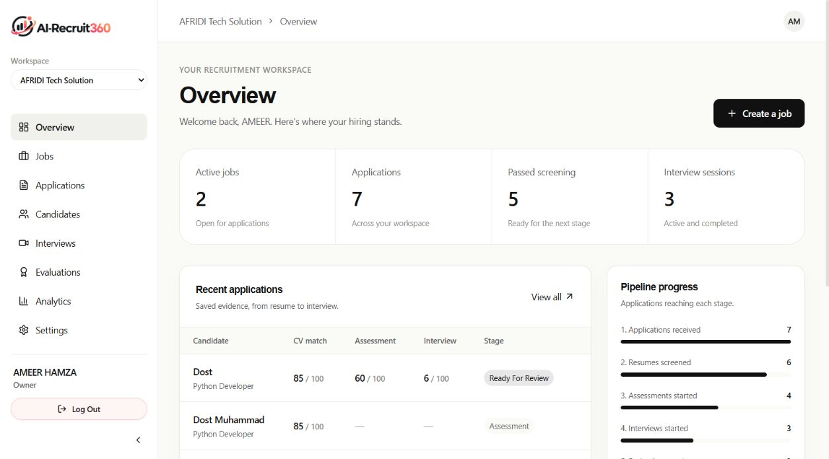
Figure 11 Recruiter Dashboard and Candidate Funnel Analytics
Authenticated deployed capture of the job management portal, illustrating published and draft requisitions, department filters, and applicant count badges.
Evidence Provenance: Authenticated deployed capture. Verified on production; shows proper multi-tenant filtering scoped strictly to the active organization ID.
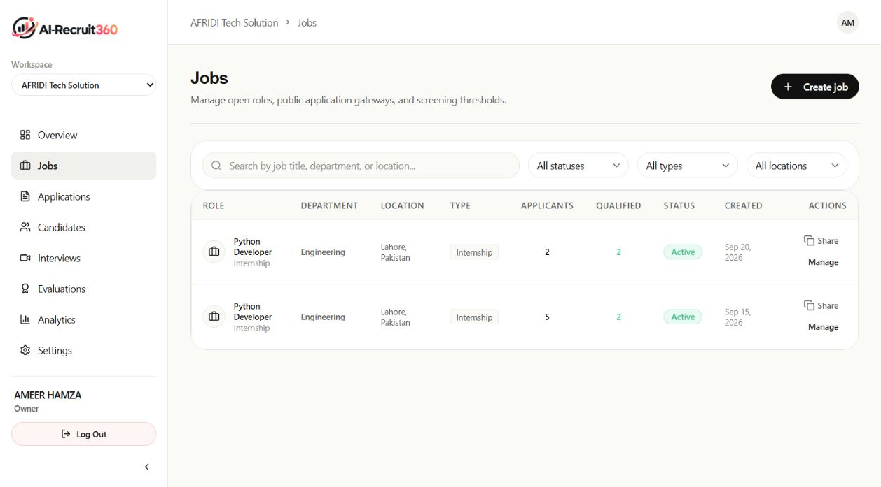
Figure 12 Job Requisitions Directory and Status Management
Authenticated deployed capture of job authoring interface, featuring Markdown description editor, technical skill tags, and assessment criteria.
Evidence Provenance: Authenticated deployed capture. Verified form validation; disallows submission with empty skill arrays or negative salary bounds.
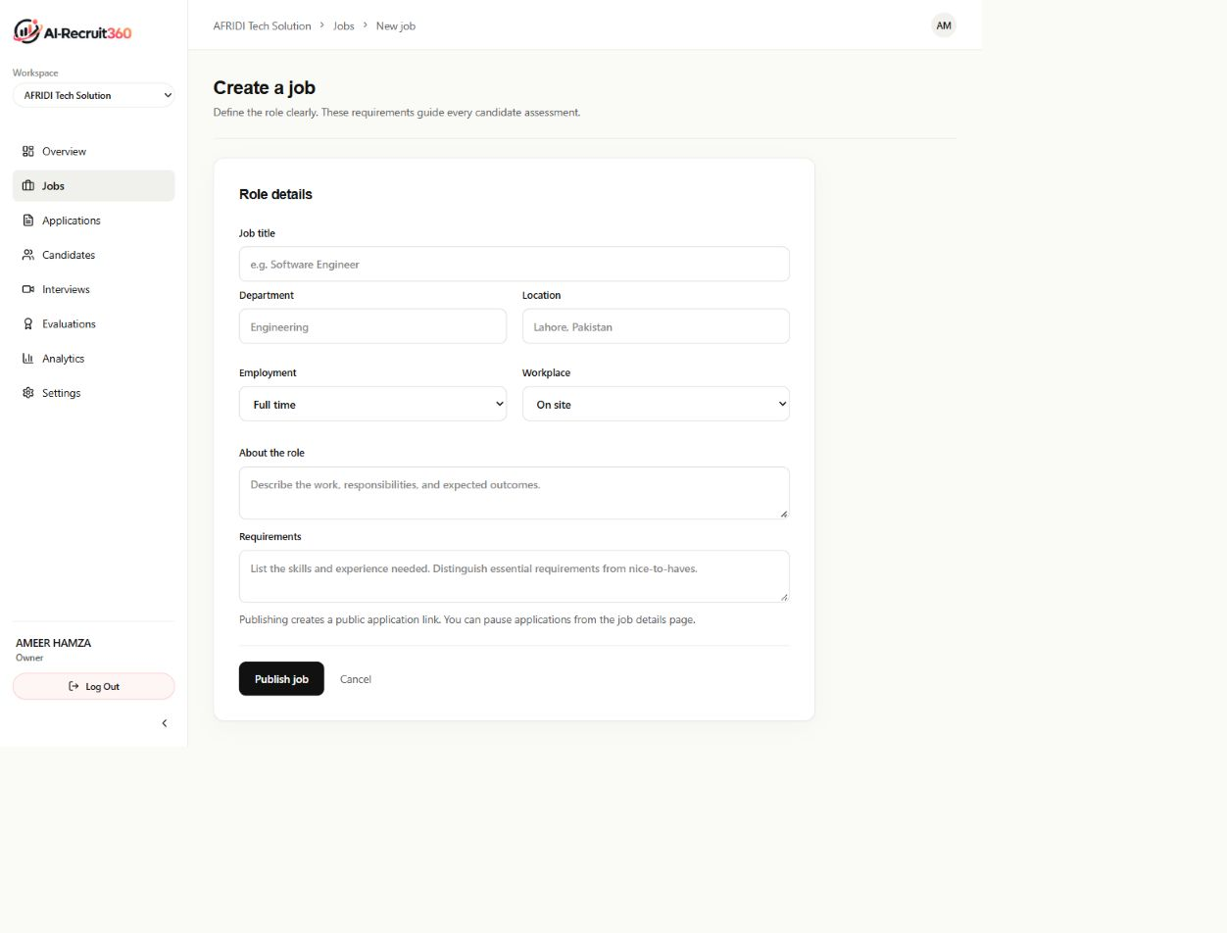
Figure 13 Job Creation and Evaluation Configuration Form
Authenticated deployed capture of job detail view, tracking candidate progression across Screening, Assessment, Interview, and Hired columns.
Evidence Provenance: Authenticated deployed capture. Verified drag-and-drop state transitions; updates database status via optimistic UI updates.
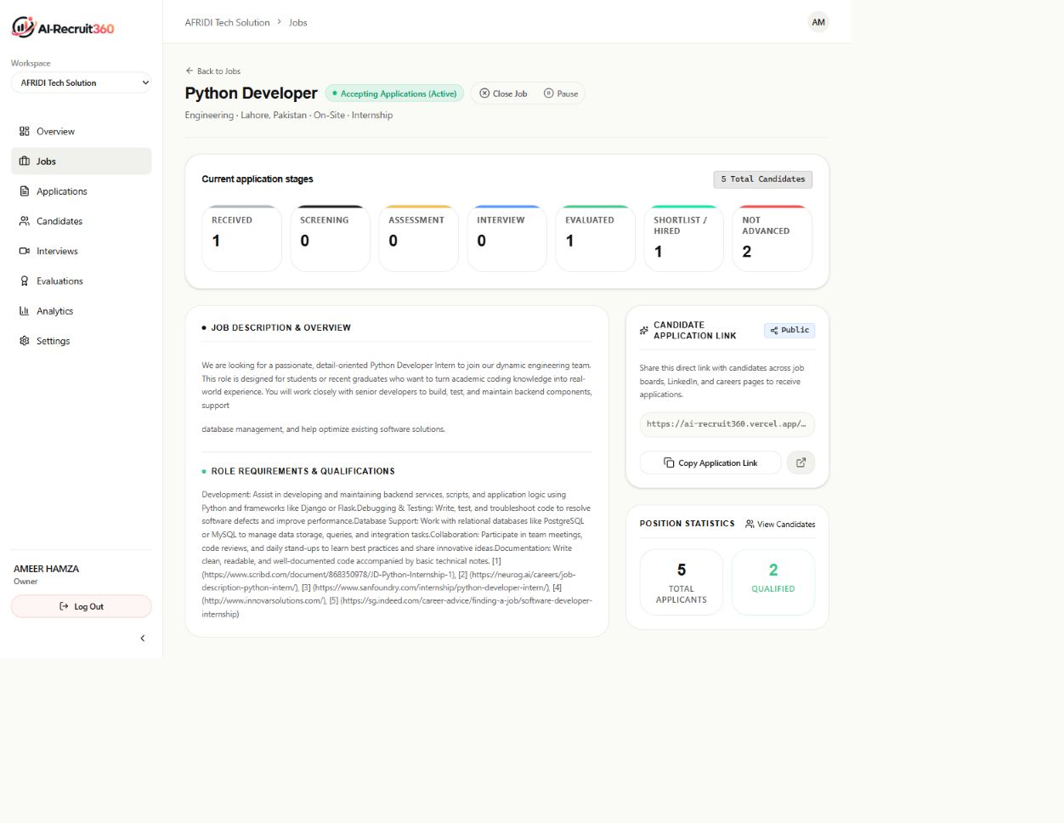
Figure 14 Job Requisition Details and Stage Triage Pipeline
Authenticated deployed capture of candidate directory, presenting contact details, associated applications, and composite evaluation badges.
Evidence Provenance: Authenticated deployed capture. Verified search indexing; filters candidates by skill tags and composite scores in real time.
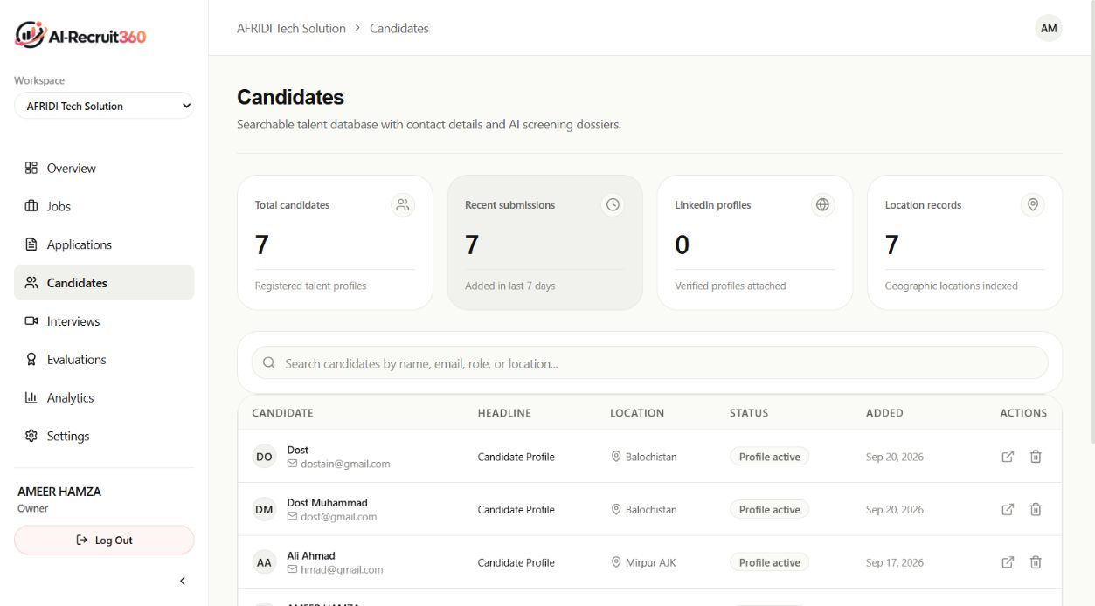
Figure 15 Candidate Directory with Search and Score Filtering
Authenticated deployed capture of organizational application records, displaying candidate names, applied roles, submission dates, and lifecycle statuses.
Evidence Provenance: Authenticated deployed capture. Verified table pagination and sorting; ensures sub-100ms render speeds across large application datasets.
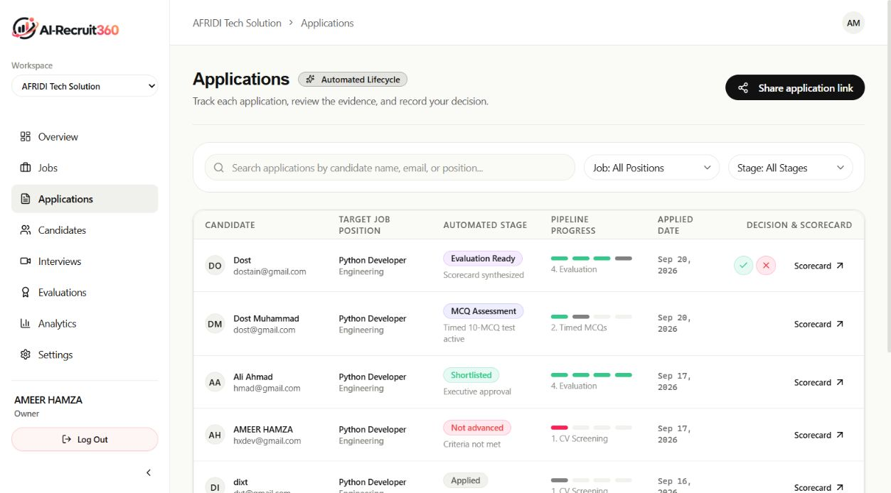
Figure 16 Application Lifecycle Tracker and Status Badges

C.2 CANDIDATE EXAMINATION AND EVALUATION INTERFACES
Authenticated deployed capture of candidate evaluation dossier, synthesizing resume match score, extracted skills, assessment marks, and interview feedback.
Evidence Provenance: Authenticated deployed capture. Verified evidence provenance; recruiter can expand individual matched skill pills to inspect verbatim source quotes from the resume.
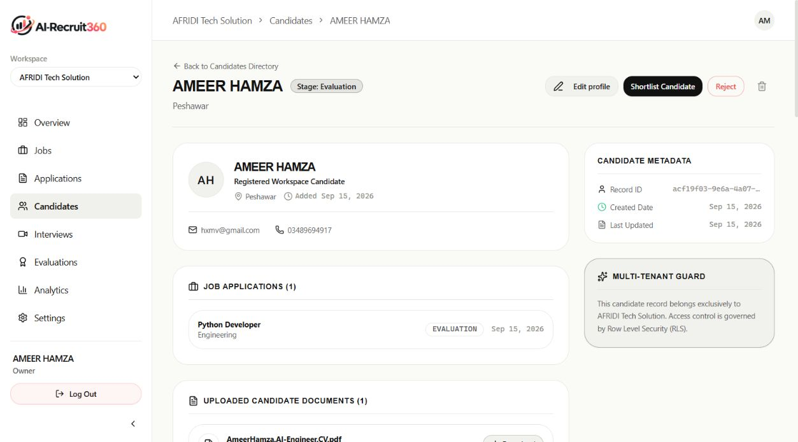
Figure 17 Candidate Comprehensive Evidence Dossier
Authenticated capture of candidate skills assessment room, displaying question stem, multiple-choice options, and 45-second countdown timer.
Evidence Provenance: Authenticated deployed capture. Verified server-authoritative timer; submissions after 50 seconds are rejected by the database.
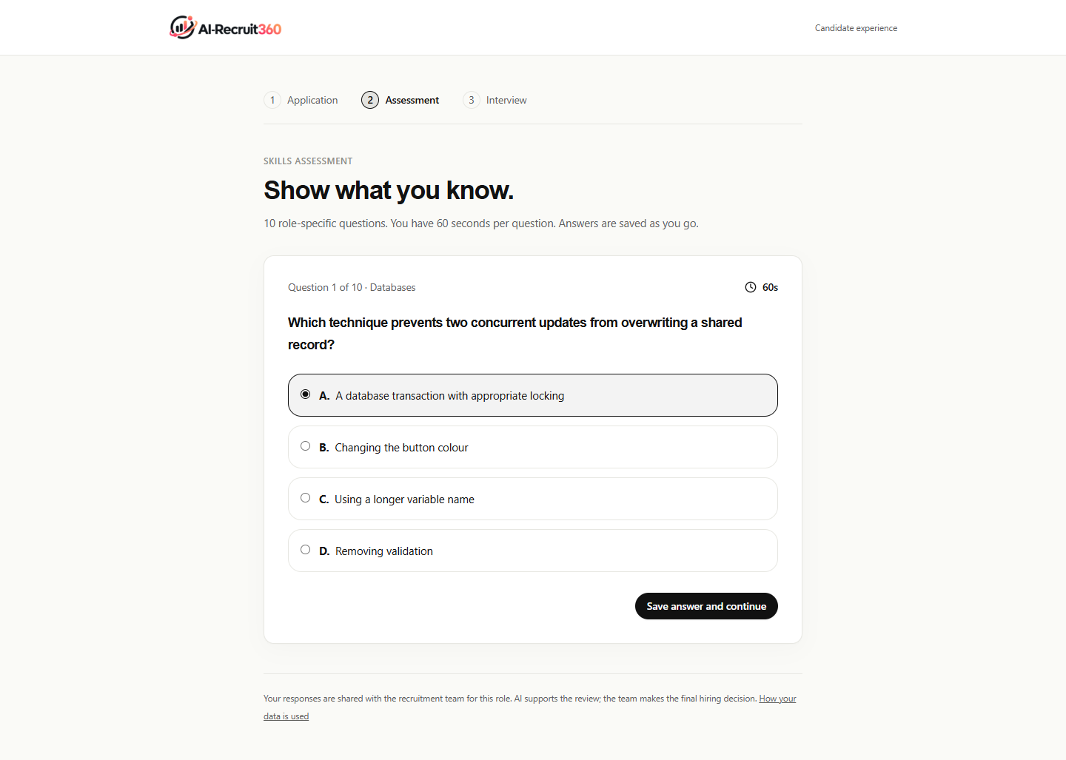
Figure 18 Candidate Timed Anti-Cheat Assessment Interface
Authenticated capture of candidate interview environment, featuring WebRTC video avatar rendering, real-time speech waveform, and transcript preview.
Evidence Provenance: Authenticated deployed capture. Verified WebRTC peer connection stability; audio streams over 16kHz PCM with sub-400ms speech-to-text latency.
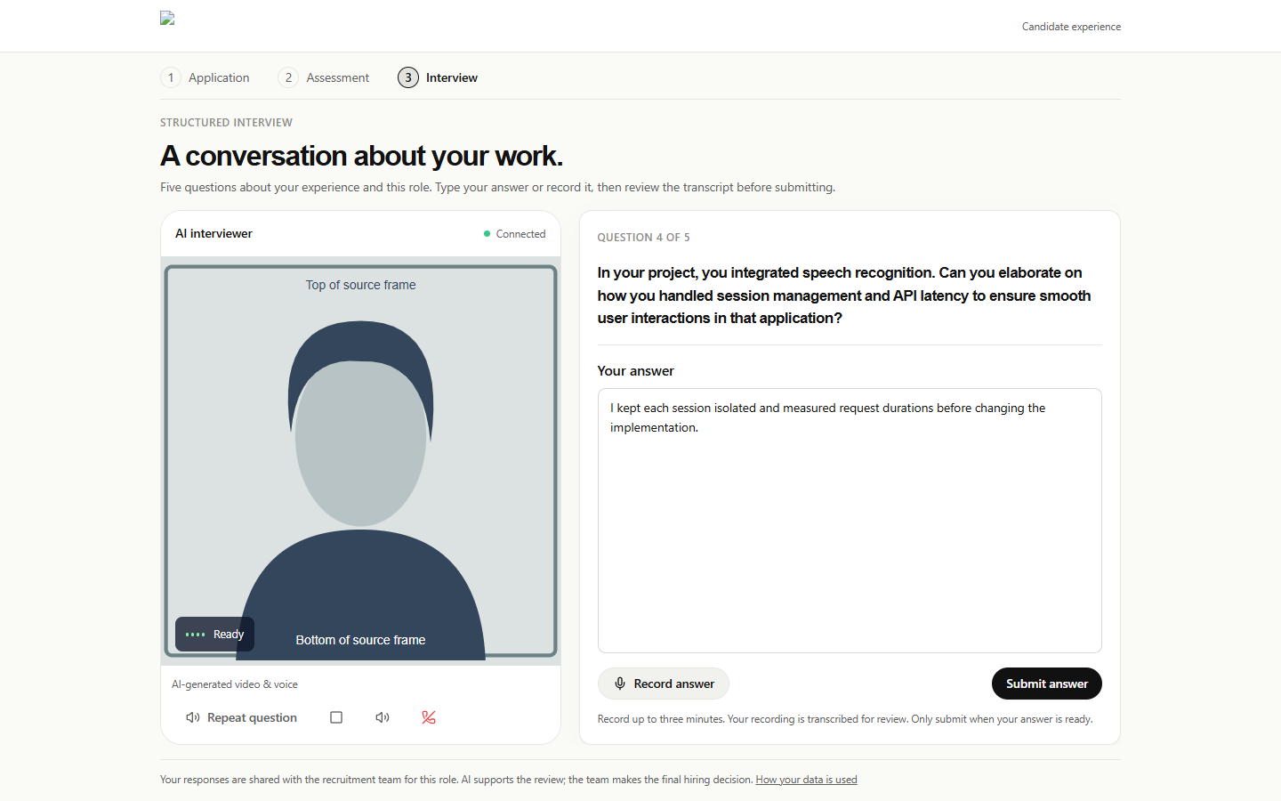
Figure 19 Simli AI Neural Video Avatar Interview Room
Authenticated deployed capture of interview evaluation review, illustrating sequential questions, candidate audio transcripts, and rubric ratings.
Evidence Provenance: Authenticated deployed capture. Verified rubric calculation; displays itemized scores for technical correctness, depth of explanation, and communication clarity.
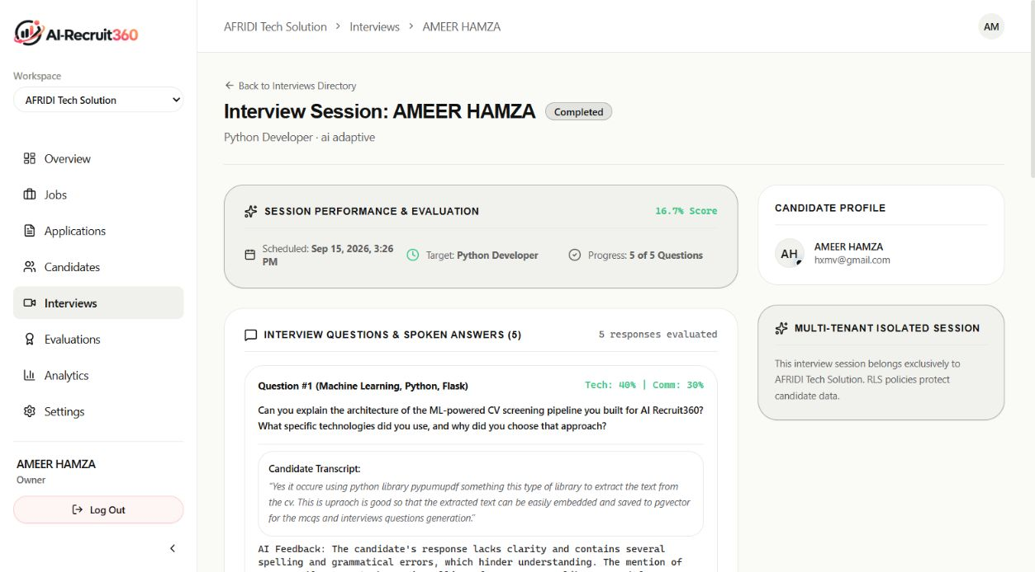
Figure 20 Completed Interview Transcript and Question Scorecards
Authenticated deployed capture of final candidate evaluation view, presenting weighted composite scores and recruiter decision override buttons.
Evidence Provenance: Authenticated deployed capture. Verified composite score mathematical consistency ($0.30 \times \text{CV} + 0.30 \times \text{Test} + 0.40 \times \text{Voice}$).
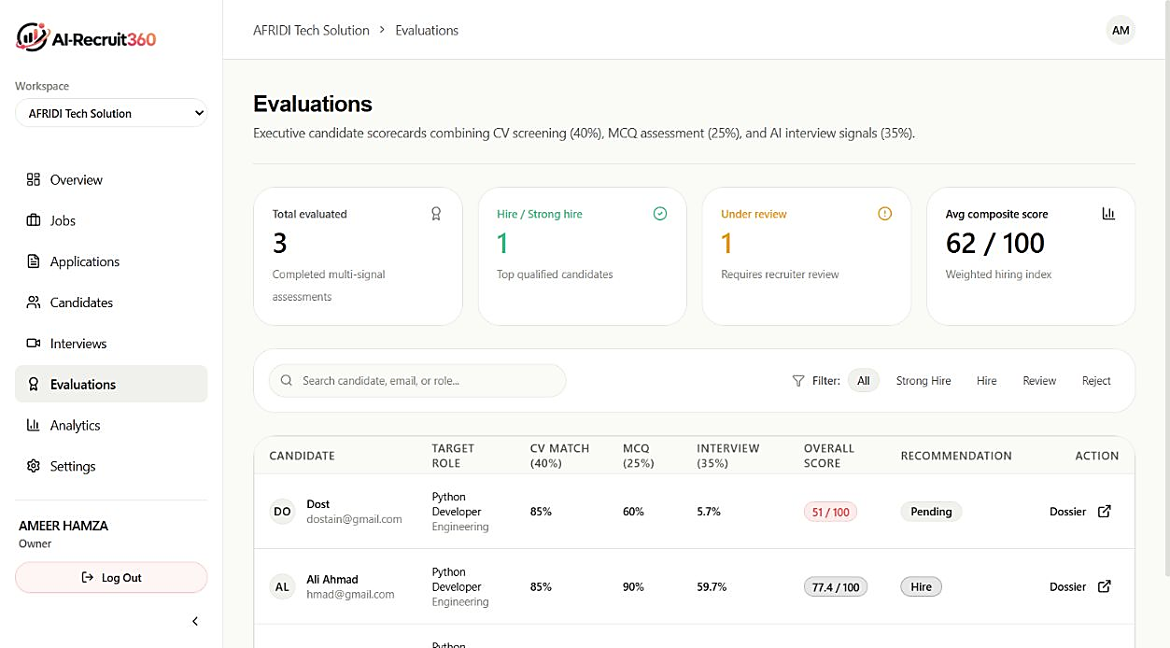
Figure 21 Multi-Dimensional Scorecard and Hiring Status Controller
Authenticated deployed capture of organization recruitment analytics, tracking applicant conversion rates, stage drop-offs, and time-to-hire statistics.
Evidence Provenance: Authenticated deployed capture. Verified analytical aggregation queries; charts render via responsive SVG visualizations.
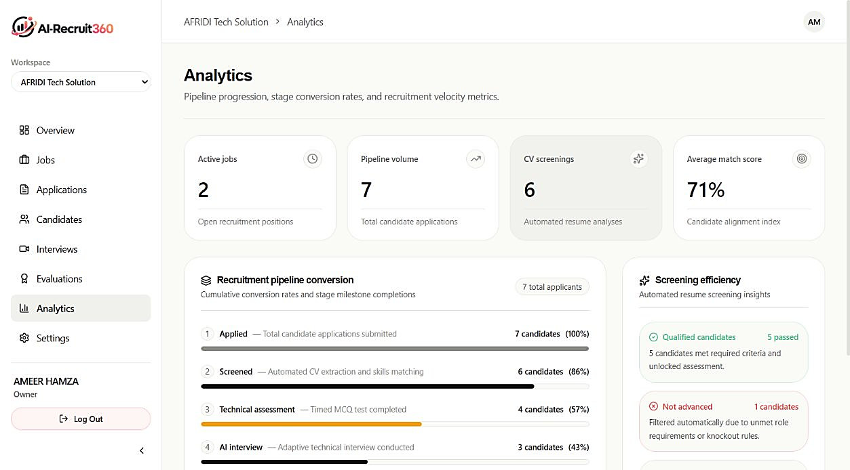
Figure 22 Recruitment Funnel Analytics and Operational Metrics

