Lab 9: ANN – Fashion MNIST and MNIST(DIGITS)
Bashar Shoumali: 318699154
Ameer Rhaiby: 213932718

Step 1: New Model with Extra Dense Layer
A new ANN model was built by adding an additional Dense layer with 32 neurons between the existing Dense(50) layer and the output layer. The model was trained on the Fashion-MNIST training set and achieved improved validation accuracy.
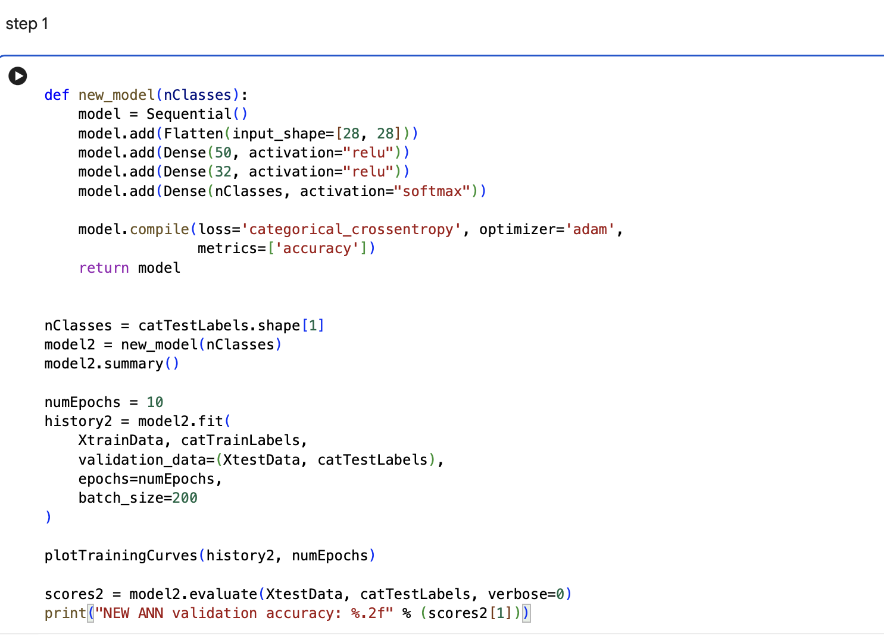
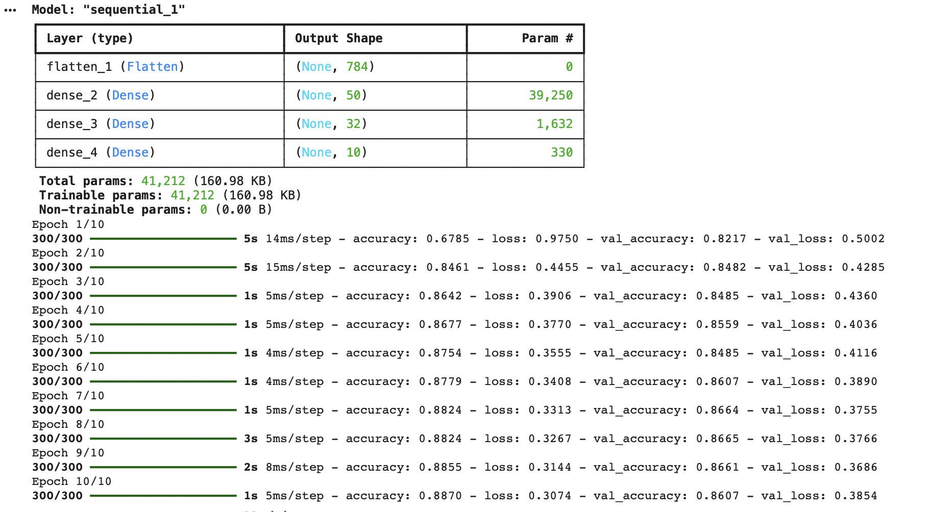

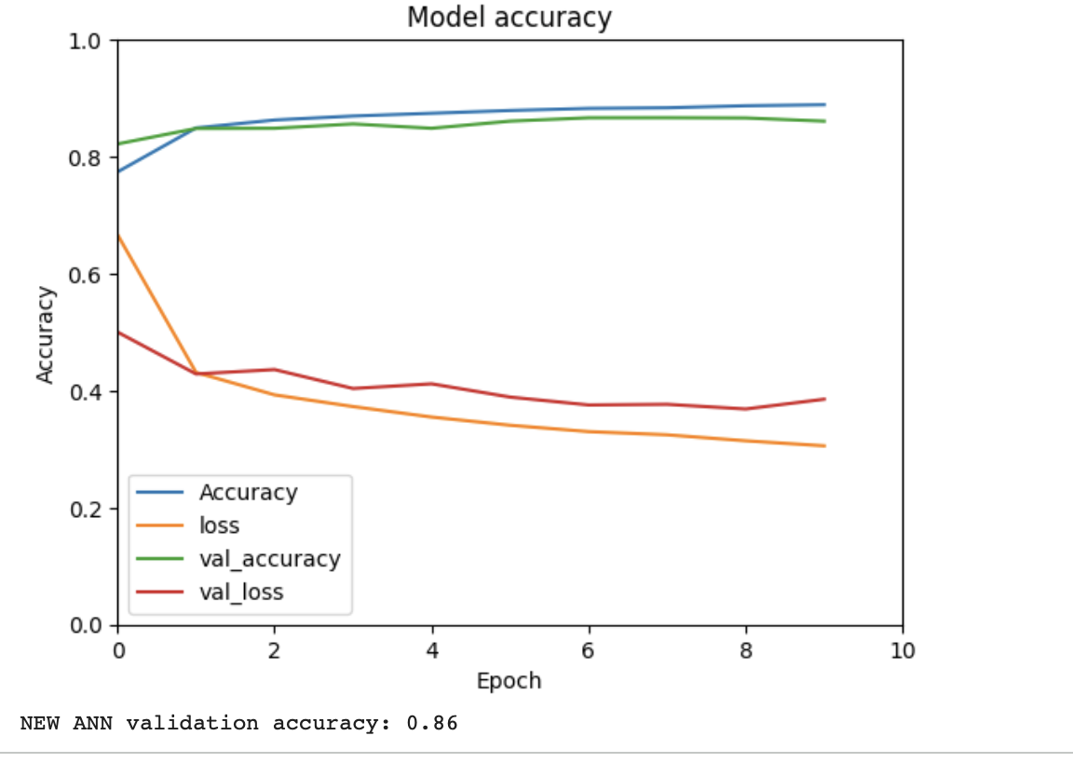

Step 2: Parameter Comparison
Original model parameters: 39,760
New model parameters: 41,212
Adding the Dense(32) layer increased the number of trainable parameters.

Step 3: Manual Parameter Calculation
Dense(50): (784 × 50) + 50 = 39,250
Dense(32): (50 × 32) + 32 = 1,632
Dense(10): (32 × 10) + 10 = 330
Total parameters = 39,250 + 1632 + 330 = 41,212
The manual calculation matches the Keras model summary.

Step 4: Training Curve Analysis
The new model shows higher training and validation accuracy compared to the original model. Loss and validation loss decrease in a slow way, showing stable learning and no severe overfitting.

Step 5: Confusion Matrix Analysis
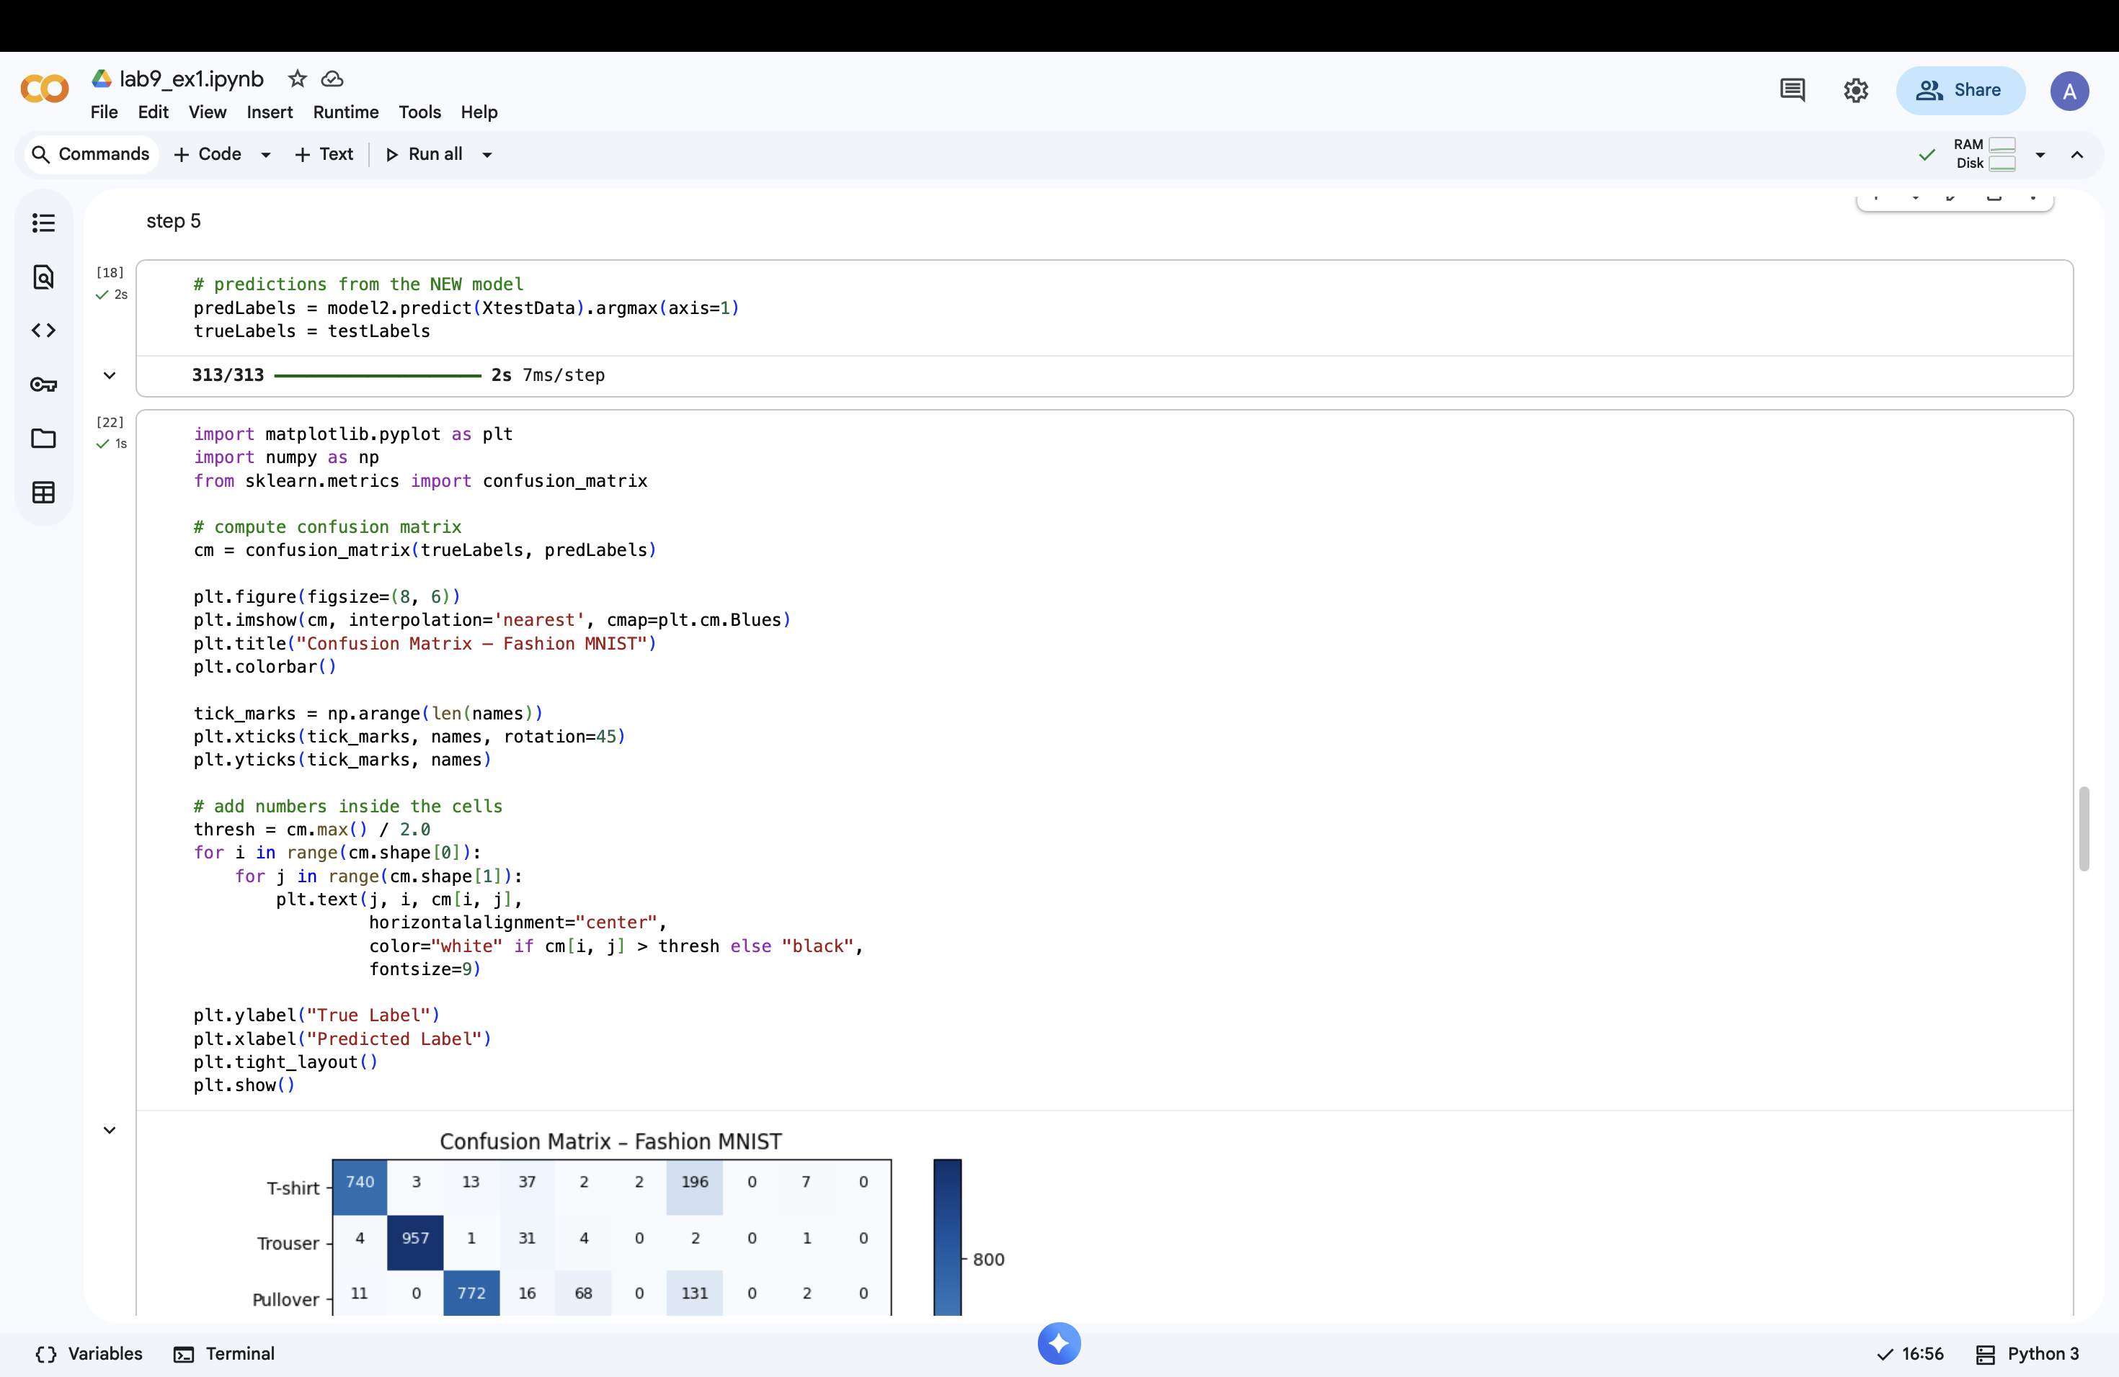
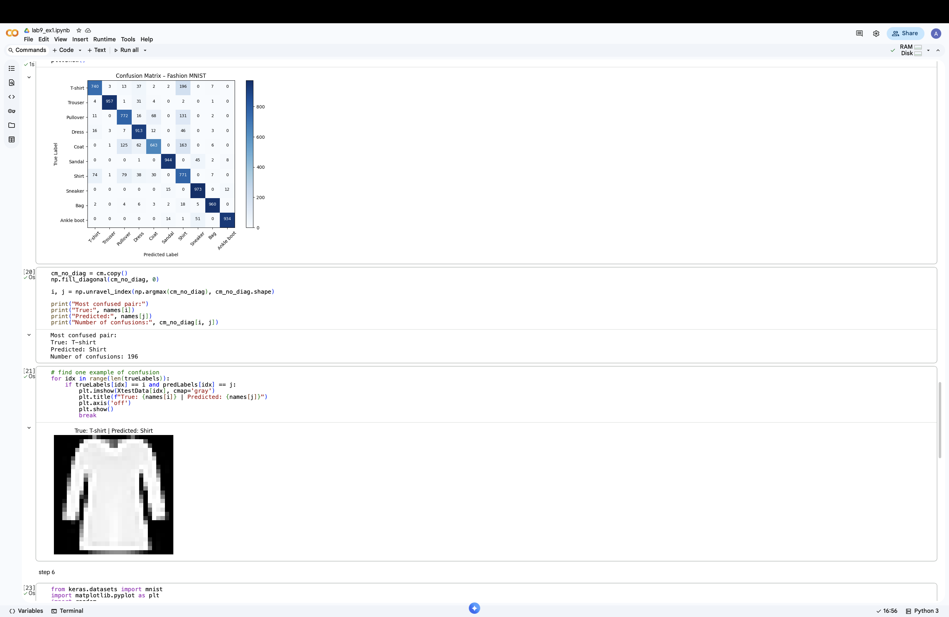
A colored confusion matrix was used to analyze classification errors. The most confused class pairs were visually similar fashion items were shirts and T-shirts.

Step 6: MNIST Dataset Visualization
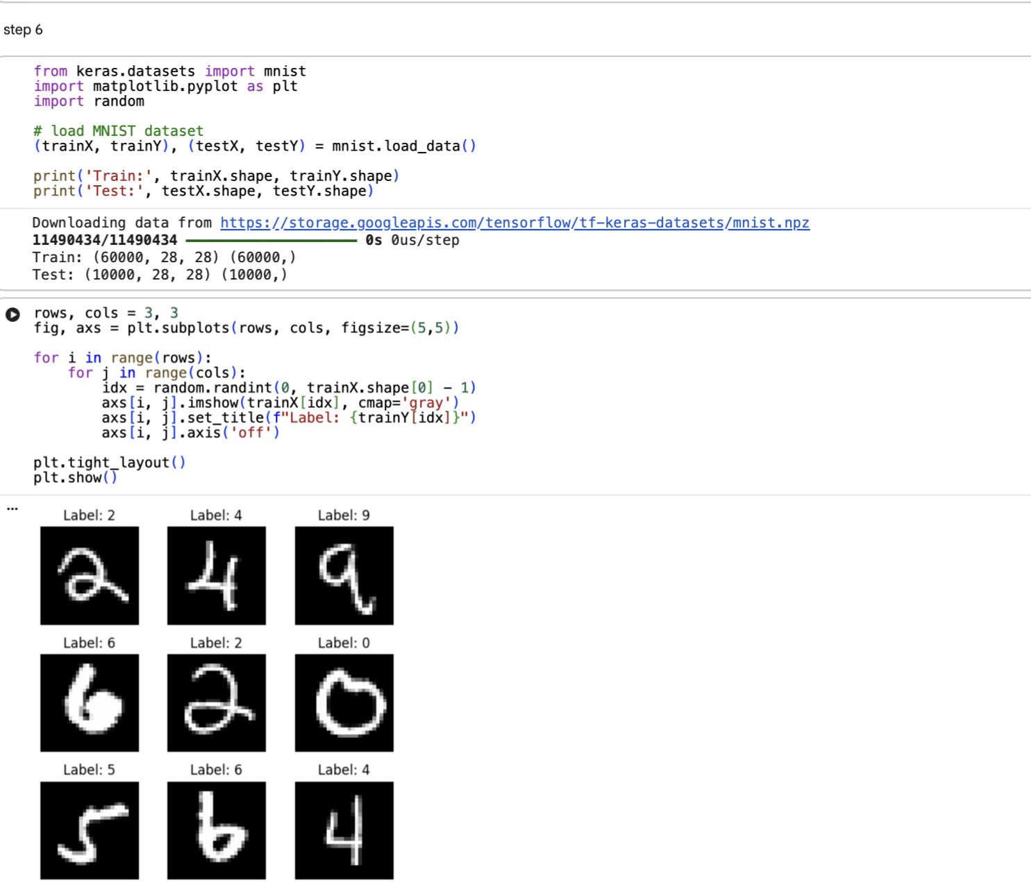
The MNIST dataset was loaded and 9 random digit images were plotted with their labels, showing clear digit shapes.

Step 7: Original ANN on MNIST
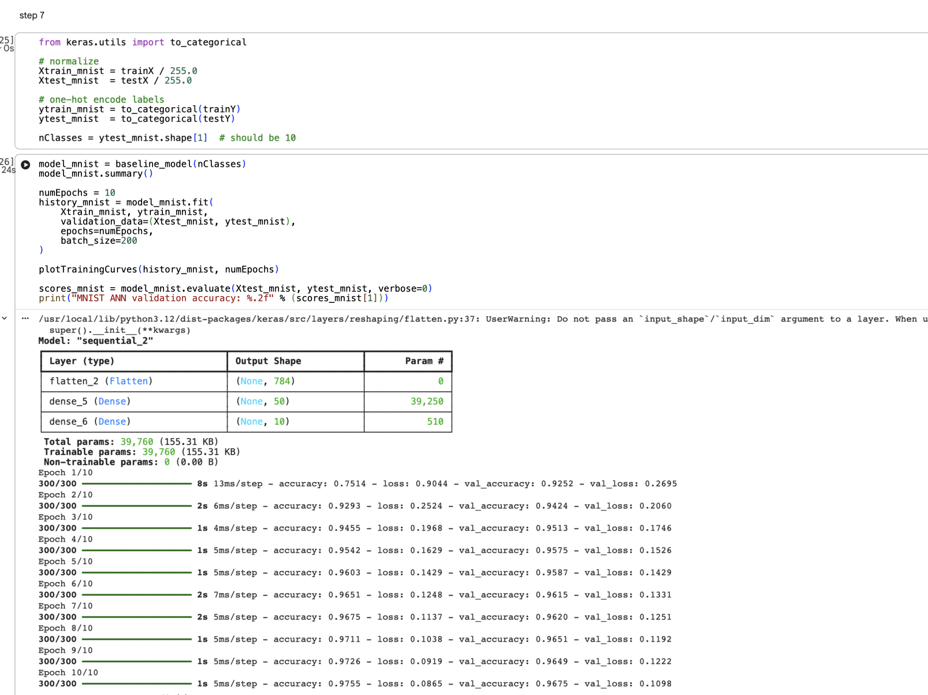
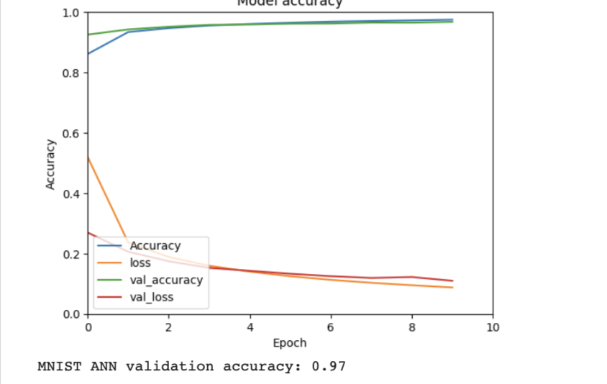
The original ANN was trained on the MNIST dataset. It achieved very high training and validation accuracy 97–99% with low loss values.

Step 8: Dataset Comparison

MNIST is better predicted by the ANN than Fashion-MNIST. Digits have clearer shapes and less class overlap than the fashion-MINST shirts and T-shirts, the class Coat is also frequently misclassified, mainly as Pullover or Dress. In conclusion the MINST(digits) are easier to classify using a fully connected ANN.

