Task 1 :
A confusion matrix was used to analyze how well the model predicts each digit. From the matrix, the accuracy for every digit was calculated and then compared between the augmented and non-augmented datasets. The augmented model achieved better results, showing that data augmentation improves generalization.
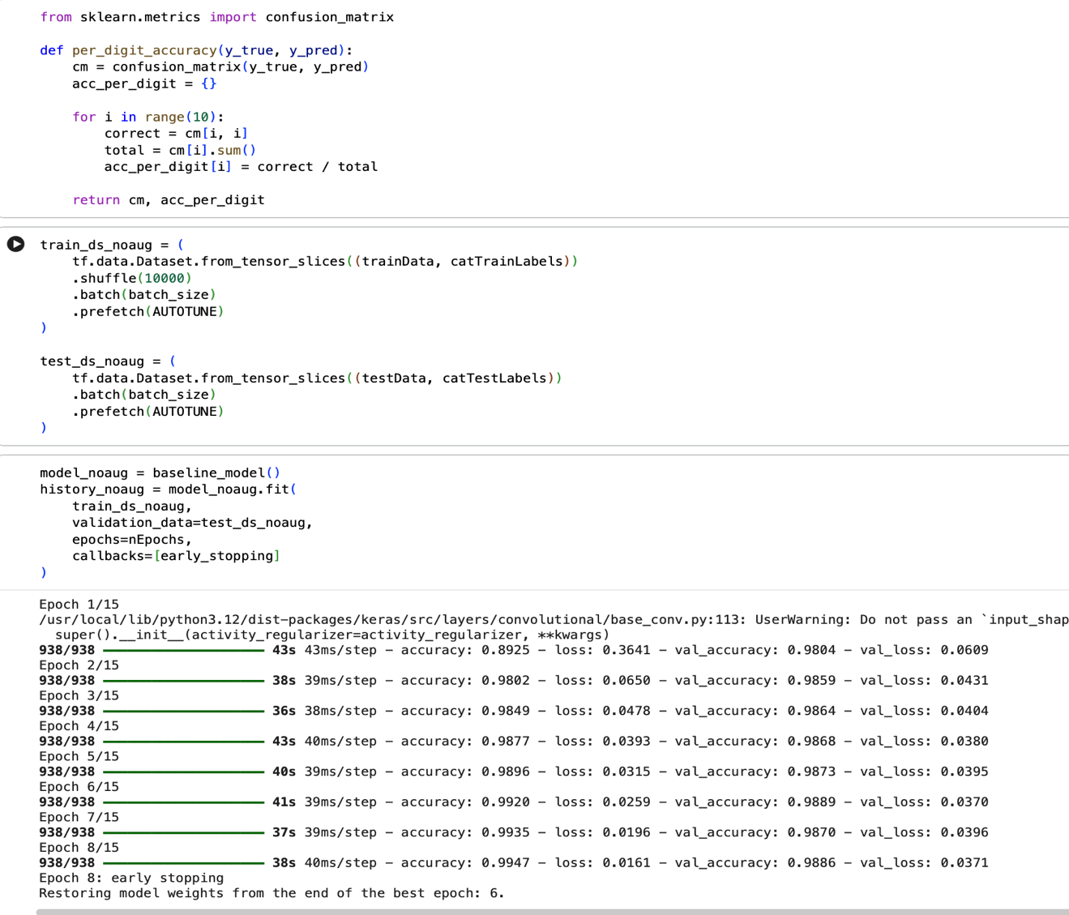
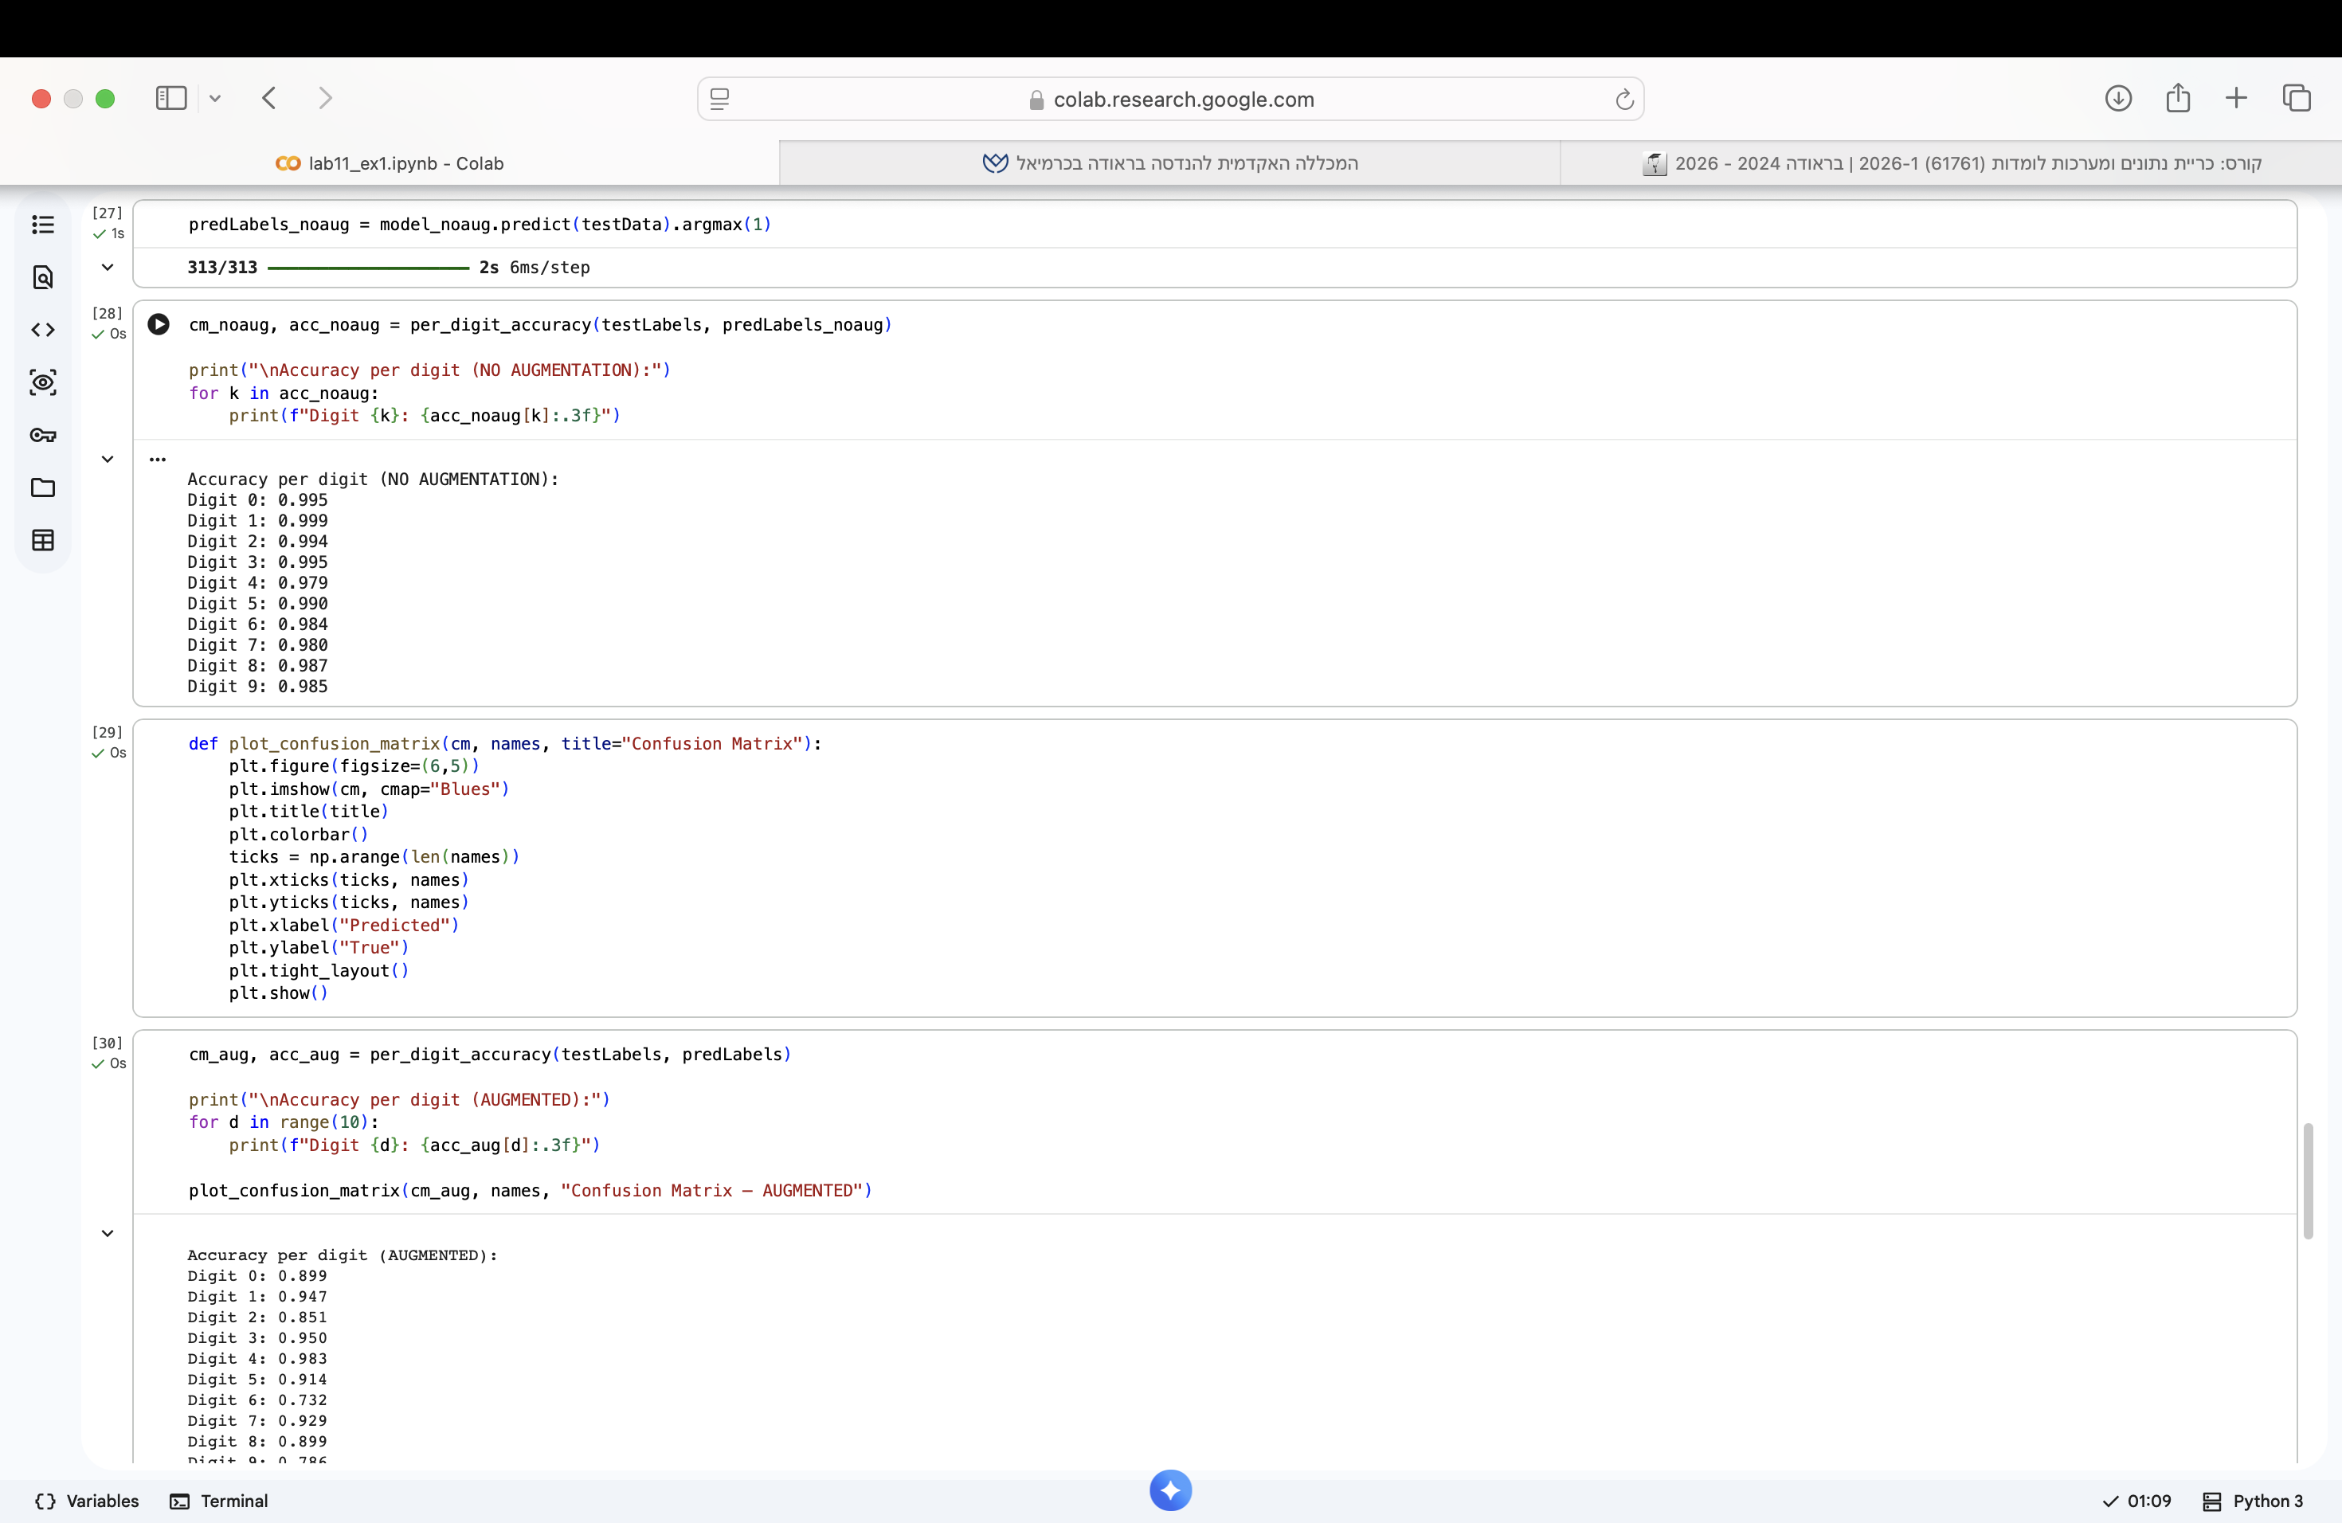
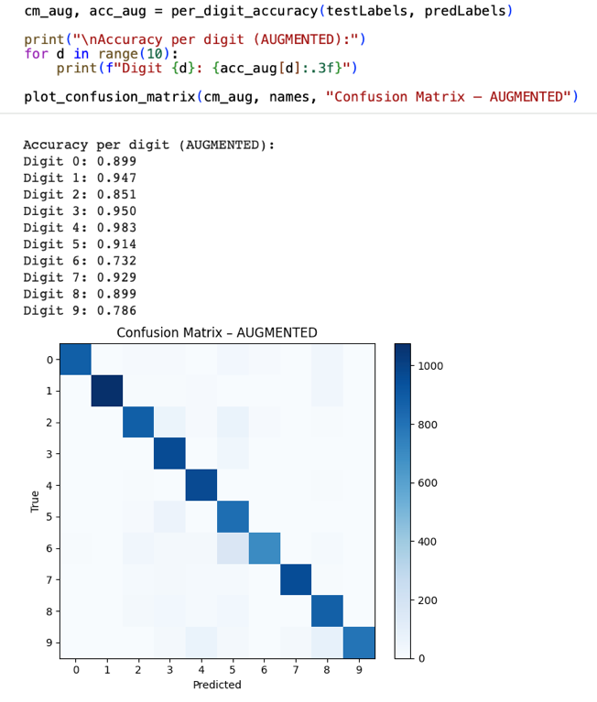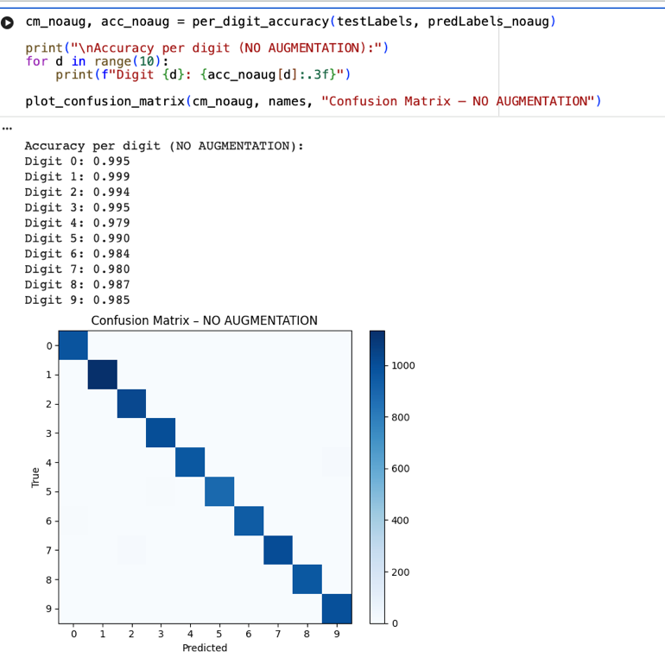

Task 2 :
A new augmentation function was created using additional transformations such as vertical flip, brightness and contrast changes, zoom and translation. The model was trained again with this stronger augmentation and the results were compared to the previous datasets. The comparison showed that richer augmentation helps the model perform better on varied images.
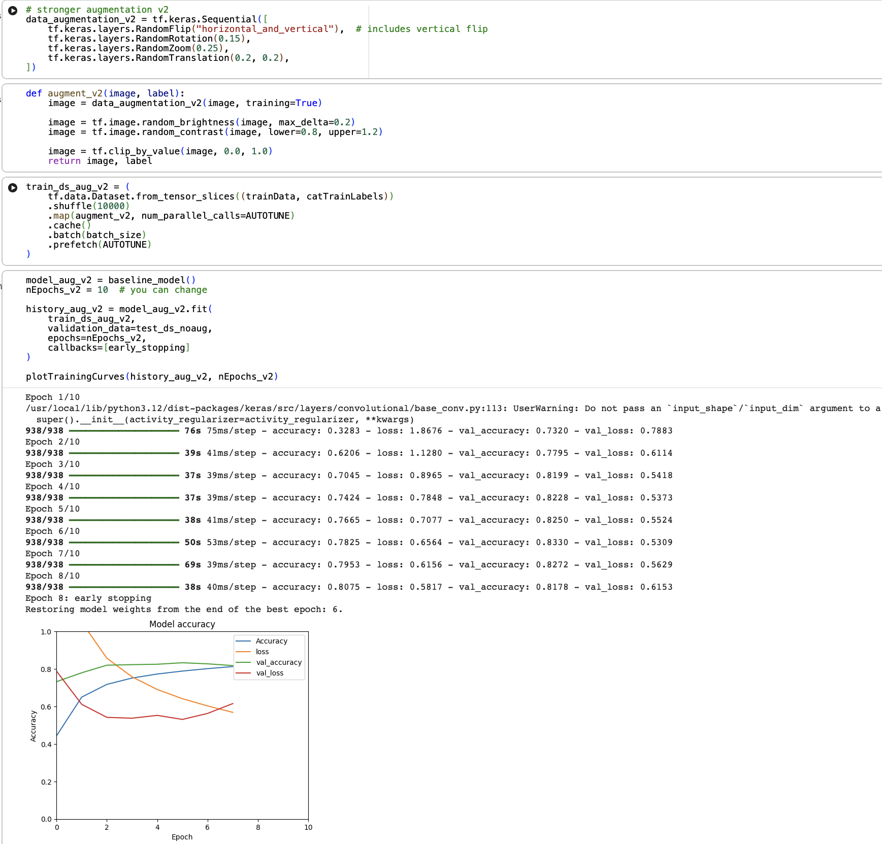
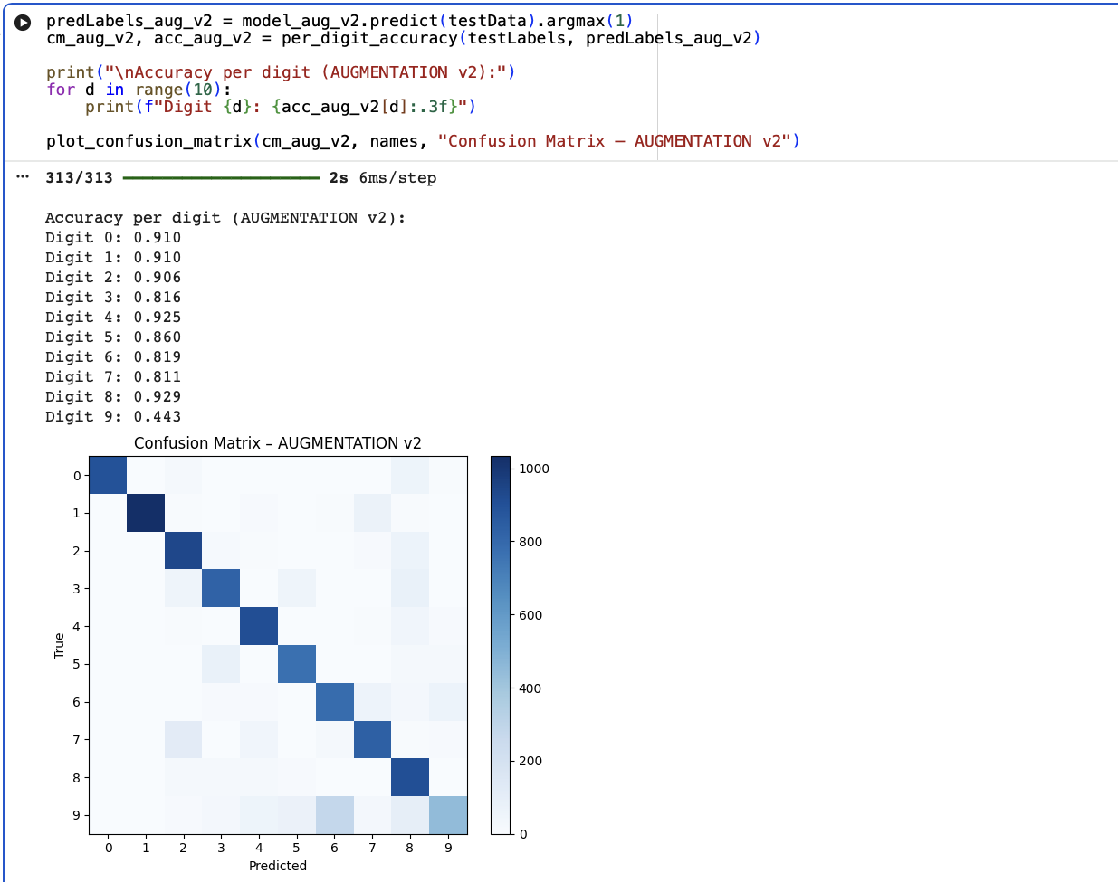
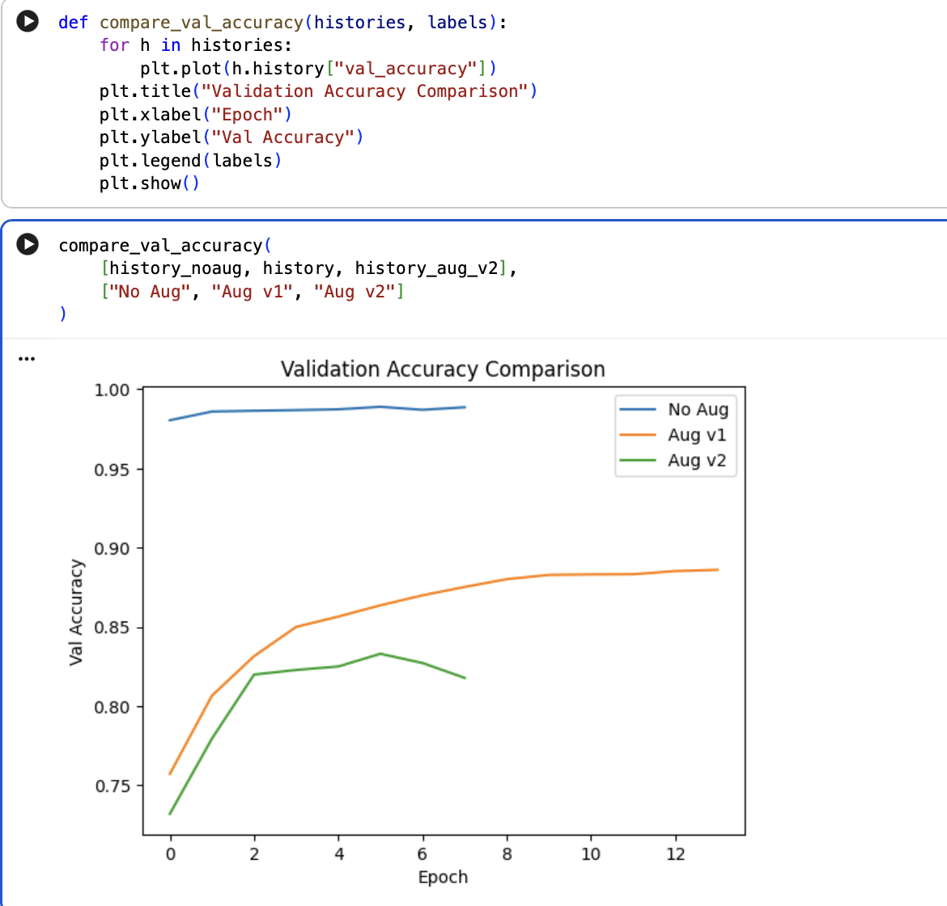
Task 3 :
2 More CNN layers were added to the original model to improve feature extraction. The deeper model was trained on the augmented dataset and compared with the baseline model. The results showed an improvement in accuracy, while keeping the training time reasonable , we tried adding more layers but the training time took a lot of time so we reduced layers.

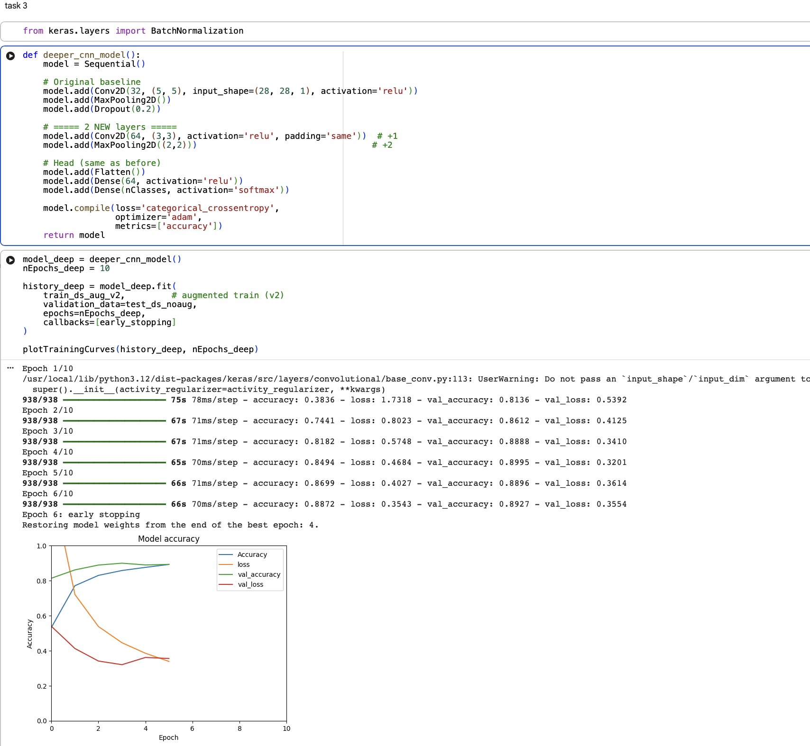
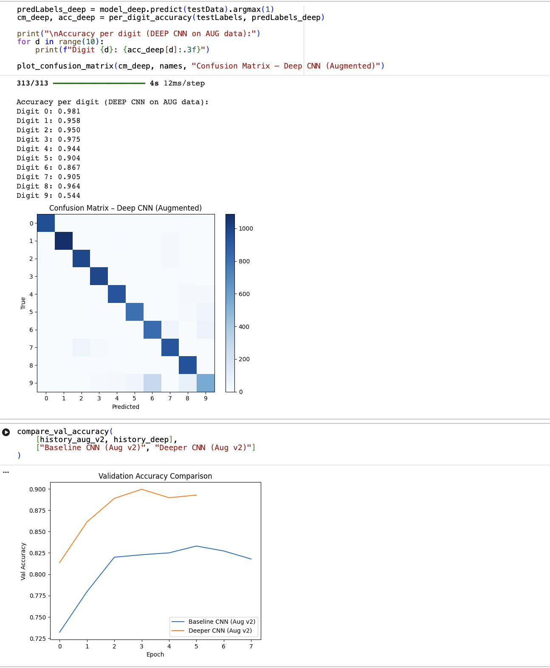

Task 4+5:
The digits were tested using different models.the non-augmented model gave the best accuracy, while the augmented models performed slightly worse. This shows that in this case, the non-augmented training data matched the painted digits better than the augmented versions.

