Lab 2: K-Nearest Neighbor KNN algorithm
Bashar Shoumali: 318699154
Ameer Rhaiby: 213932718
Tasks to do:
Independent work
- Compose a training set of 90 flowers, 30 flowers of every type.
// just like we did in the tutorial2 with 75 (0-24 , 50-74 ,100-124 ) for training we did it here the same but with 90 instead of 75.

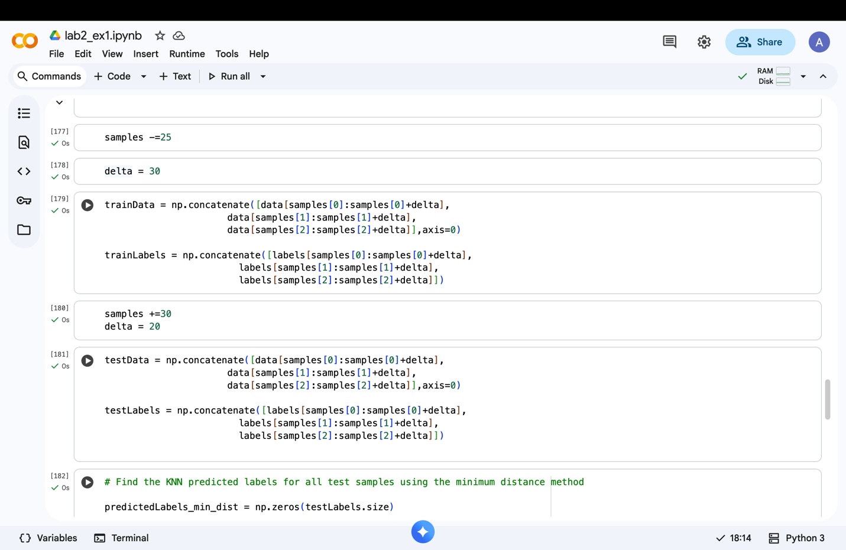

- Compose a testing set of 60 flowers that are not in the training set.
// just like we did in the tutorial2 with 75 (25-49 , 75-99 ,125-149 ) for testing we did it here the same but with 60 instead of 75.

- Find the KNN predicted labels of all the flowers in the test set using the minimum distance method and put them in a predicted vector.
//we did in tutorial2 an example about for a single data it was testI = 50
Here we did the same process but for all the 60 testData
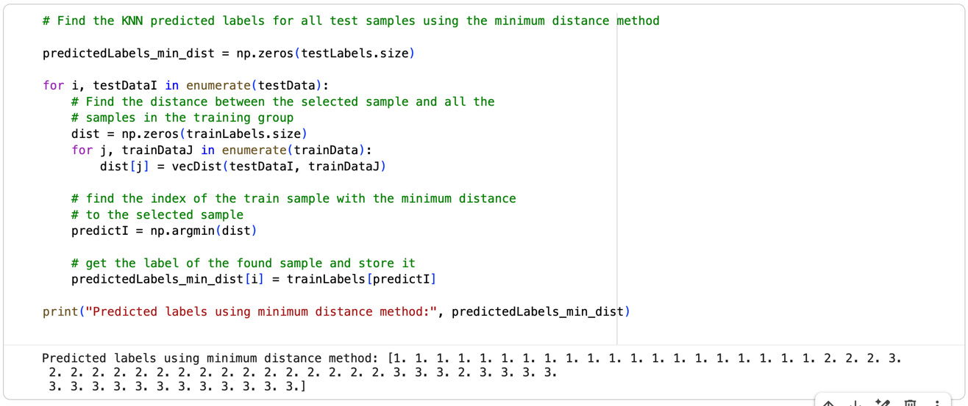

- Compare the predicted test labels to the true test labels and find the number of errors (the number of abels that are wrongly predicted).
// we compared the predictedLabels for the 60 testData with their true labels and we got 2 errors.
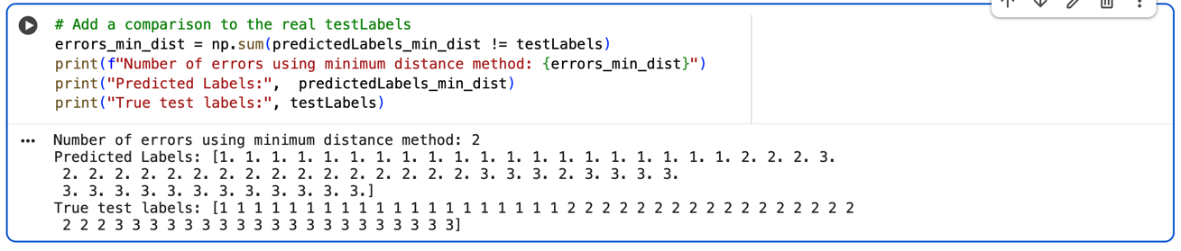

- Run the built-in KNN algorithm and compare it to your results. Did you get similar results? Explain your answer.
// we trained a KNN model by our 90 trainData and 60 trainLabels with k=1
And when we run the KNN model on our 60 testData we can see that we also got 2 errors when comparing to the true Labels , yes we got similar results and in the same places the errors ,I think it is because the k=1 ,I tried doing k=3 and k=5 and I got 1 error I think k=1 is does not give the most optimal result and what is the point of our model if want to use k=1 we can use the minimum distance method instead.
