Step 6:
Changes the training set to be 80% and testing set to be 20% and fitted a dtree alg for the train data and train labels.

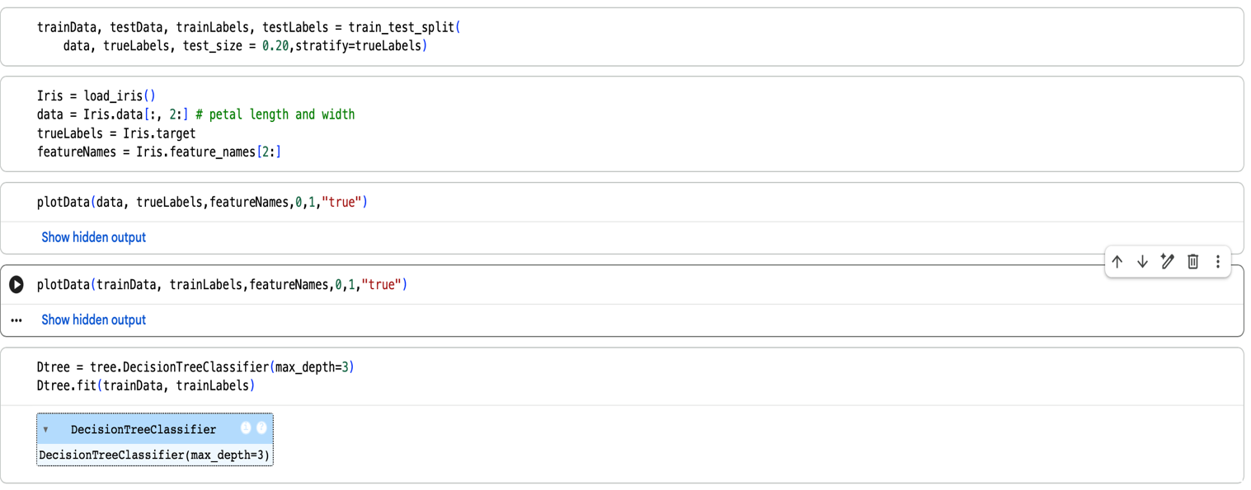

Step 7:
We took
2 data samples for the test set and found the prediction(it predicted correct) , we spent more time on the path and didn’t do it manually draw we made a function to get the tree path for these samples.

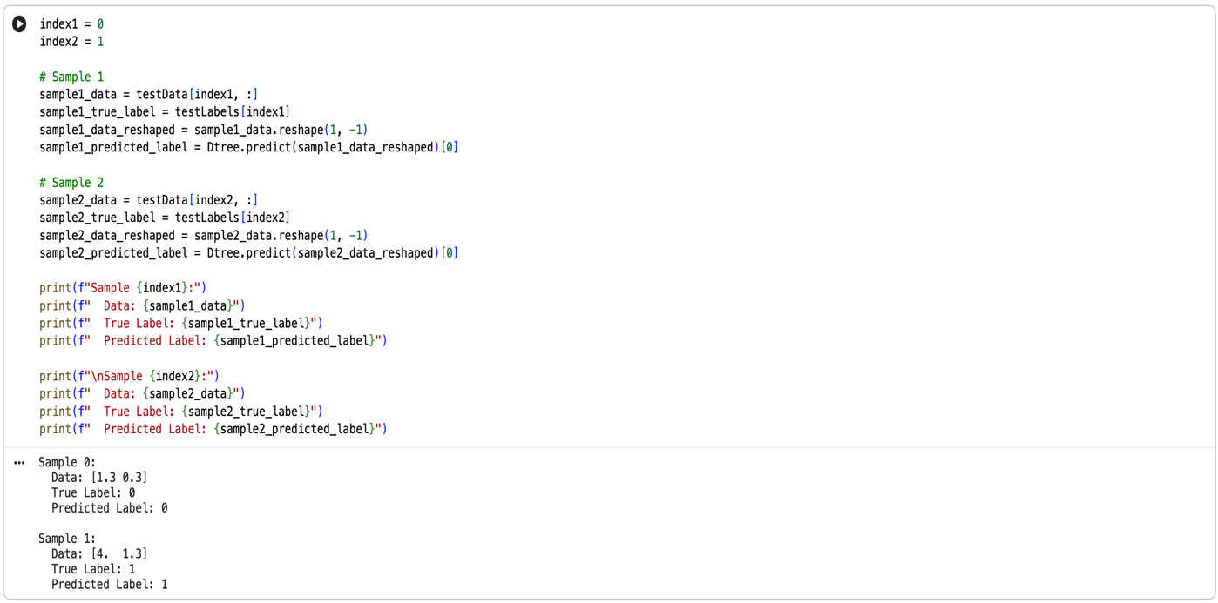
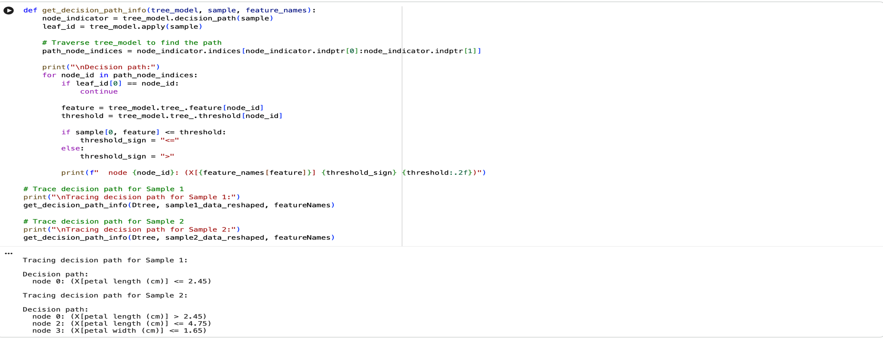

Step 8:
We made a function that calculates the gain for a node the function receives the dtree model and the node_id and the feature names and gives back the gain of the given node.

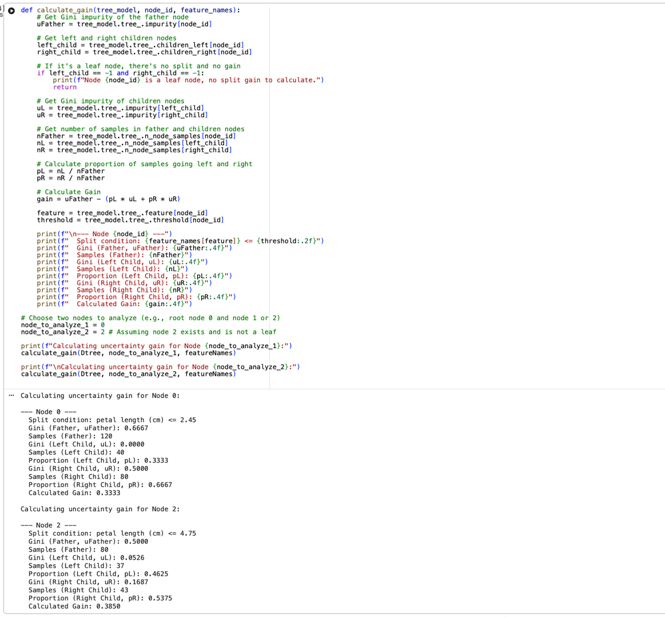

Step 9+10+11:
We trained 3 Dtree models and confusion matrix for the test and the predictedLabels for each of them just like we did in the lab6 with the lecturer , and after I ran those models many times i saw that the model with the depth of 3 is the most accurate one and has the best predictions.

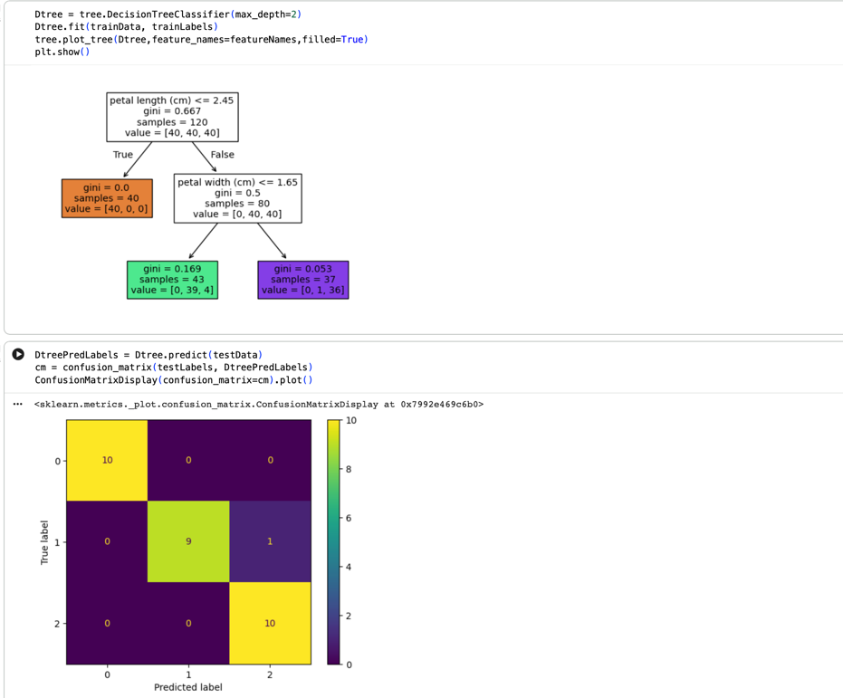

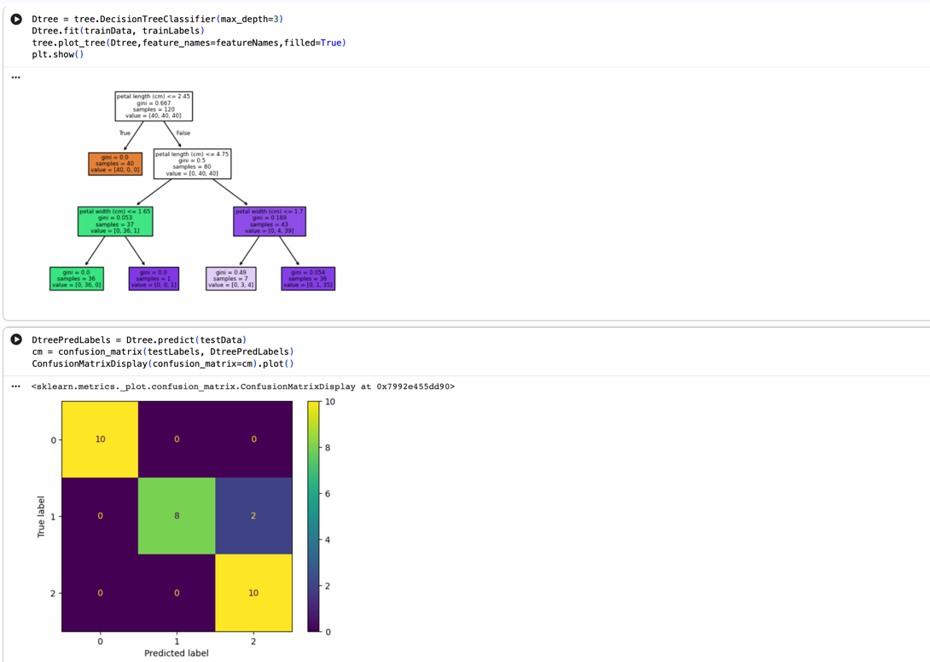

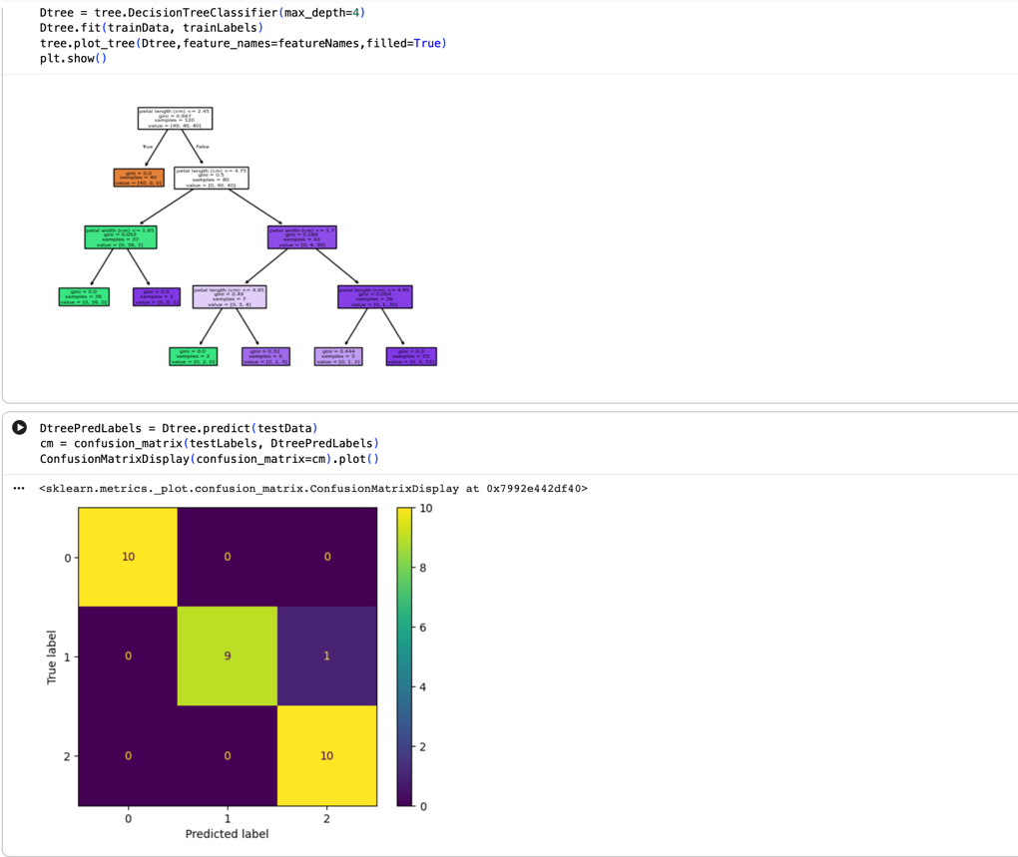

Step 12:
After we built a model of the sepal features we can see by comparing the confusion matrixes that the one with the petal features is more accurate .
The petal-based data gives better results. A 3-level decision tree trained on petal length and petal width achieved 93.3% accuracy, while the same model trained on sepal length and sepal width reached only 60%. This happens because the petal measurements separate the Iris species much more clearly, forming distinct clusters that allow the tree to create effective splitting rules. In contrast, sepal length and width overlap heavily between species, making it difficult for the tree to classify them accurately.

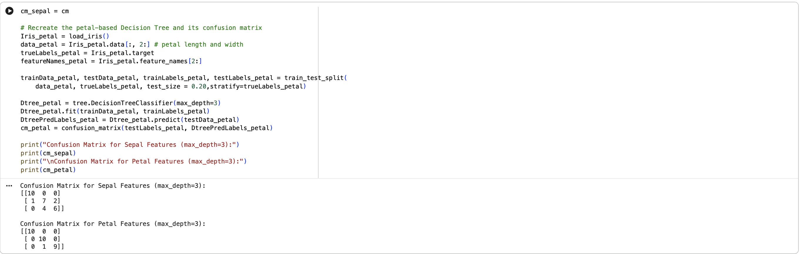

Step 13:

After we made a random forest model for the sepal feature we compared it to the model of the Dtree and we can see similar diffrences but the random forest is the more accurate model after running it many times.
On the first two columns (sepal length and sepal width), the Random Forest algorithm achieves better test accuracy than the single 3-level Decision Tree (X% vs Y%, respectively). This is because Random Forest is an ensemble method: it combines the predictions of many decision trees trained on different subsets of the data and features, which reduces variance and leads to more robust and generalizable decision boundaries. The single Decision Tree is more sensitive to the specific training set and can overfit or underfit, while the Random Forest smooths out these effects through averaging.

