Introduction:

Imagine the scenario where you are connected to a network and using various network resources, such as email and web browsing. Two questions arise. The first is how we can discover other live devices on this network or on other networks. The second is how we can find out the network services running on these live devices; examples include SSH and web servers.
One approach is to do it manually. If asked to uncover which devices are live on the 192.168.0.1/24 network, one can use basic tools such as ping, arp-scan, or some other tool to check the 254 IP addresses. Although this network has 256 IP addresses, we counted 254 IP addresses because two are reserved. Each tool has its limitations. For example, ping won’t give any information if the target system’s firewall blocks ICMP traffic. Moreover, arp-scan only works if your device is connected to the same network, i.e., over Ethernet or WiFi. In brief, this will be a significant waste of time without an advanced and reliable tool. With the right tools and enough time, one would have a list of the live hosts on a target network. We need a flexible tool that can handle the various scenarios.
Discovering the running services on a specific host is equally time-consuming if one relies on manual solutions or inefficient scripts. For instance, one can use telnet to try one port after the other; however, with thousands of ports to scan, this can be a very time-consuming task, even if a script was created to automate the telnet connection attempts.
A very efficient solution that can solve the above two requirements and many more is the Nmap network scanner. Nmap is an open-source network scanner that was first published in 1997. Since then, plenty of features and options have been added. It is a powerful and flexible network scanner that can be adapted to various scenarios and setups.
Learning Objectives
This room aims to provide you with the basics necessary to use the Nmap scanner or simply nmap. In particular, you will learn how to:
- Discover live hosts
- Find running services on the live hosts
- Distinguish the different types of port scans
- Detect the versions of the running services
- Control the timing
- Format the output

Host Discovery: Who Is Online
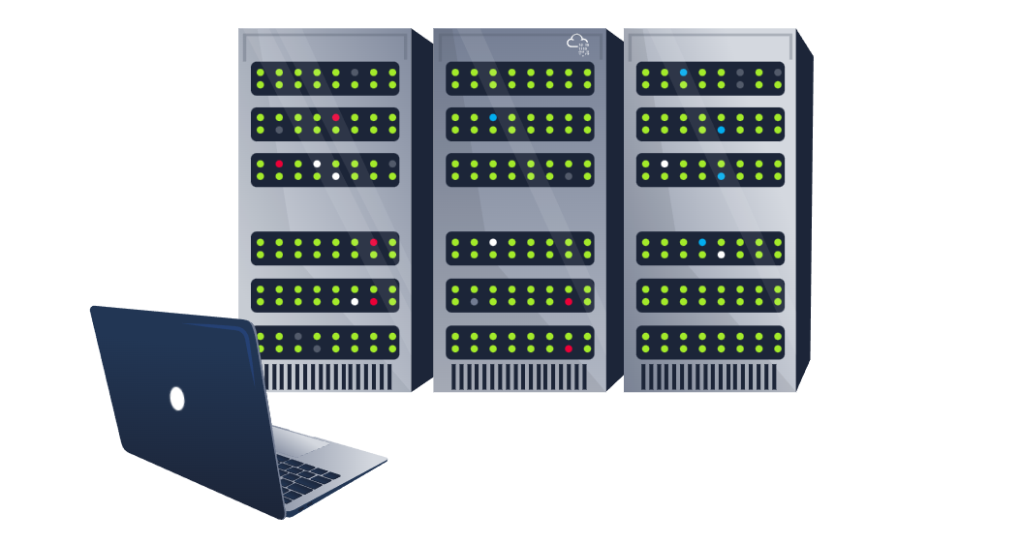
Let’s start with the first question: who is online? This task aims to find out how to use Nmap to discover the live hosts. Nmap uses various sophisticated ways to discover live hosts.
Before we start, we should mention that Nmap uses multiple ways to specify its targets:
- IP range using -: If you want to scan all the IP addresses from 192.168.0.1 to 192.168.0.10, you can write 192.168.0.1-10
- IP subnet using /: If you want to scan a subnet, you can express it as 192.168.0.1/24, and this would be equivalent to 192.168.0.0-255
- Hostname: You can also specify your target by hostname, for example, example.thm
Let’s say you want to discover the online hosts on a network. Nmap offers the -sn option, i.e., ping scan. However, don’t expect this to be limited like ping. Let’s see this in action.
Before we get started, we should note that throughout this room, we are either running nmap as root or using sudo because we don’t want to restrict Nmap’s abilities with our account privileges. Running Nmap as a local (non-root) user would limit us to fundamental types of scans such as ICMP echo and TCP connect scans; we will revisit this at the end of this room.

Scanning a “Local” Network
In this context, we use the term “local” to refer to the network we are directly connected to, such as an Ethernet or WiFi network. In the first demonstration, we will scan the WiFi network to which we are connected. Our IP address is 192.168.66.89, and we are scanning the 192.168.66.0/24 network. The nmap -sn 192.168.66.0/24 command and its output are shown in the terminal below. 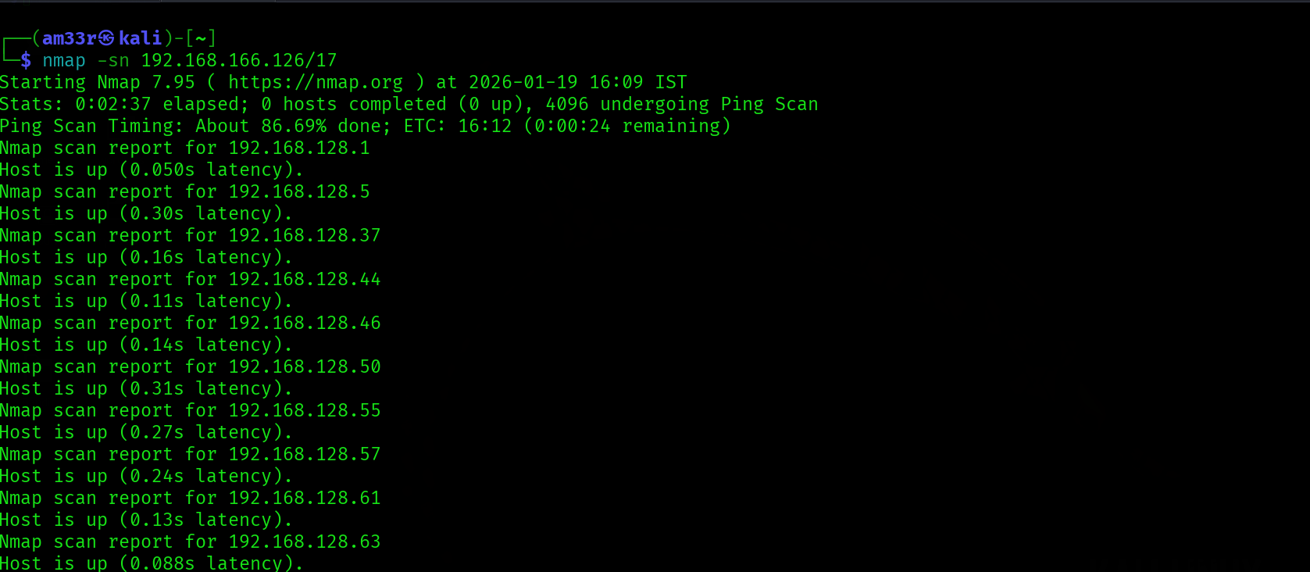

Scanning a “Remote” Network
Consider the case of a “remote” network. In this context, “remote” means that at least one router separates our system from this network. As a result, all our traffic to the target systems must go through one or more routers. Unlike scanning a local network, we cannot send an ARP request to the target.
Our system has the IP address 192.168.66.89 and belongs to the 192.168.66.0/24 network. In the terminal below we scan the target network 192.168.11.0/24 where there are two or more routers (hops) separate our local system from the target hosts.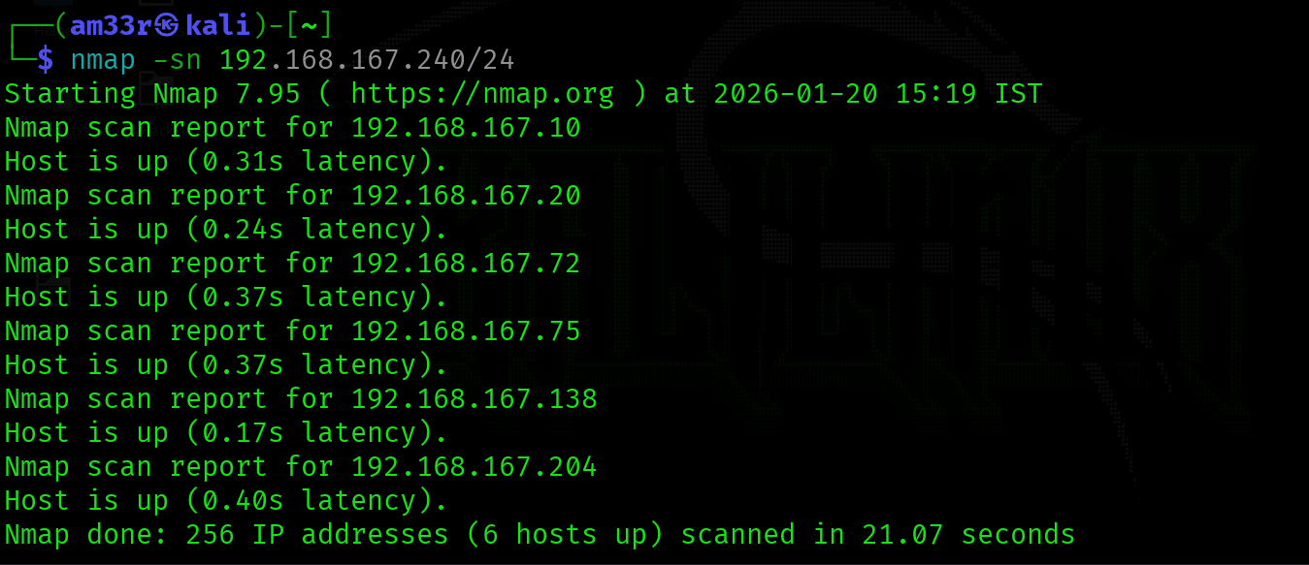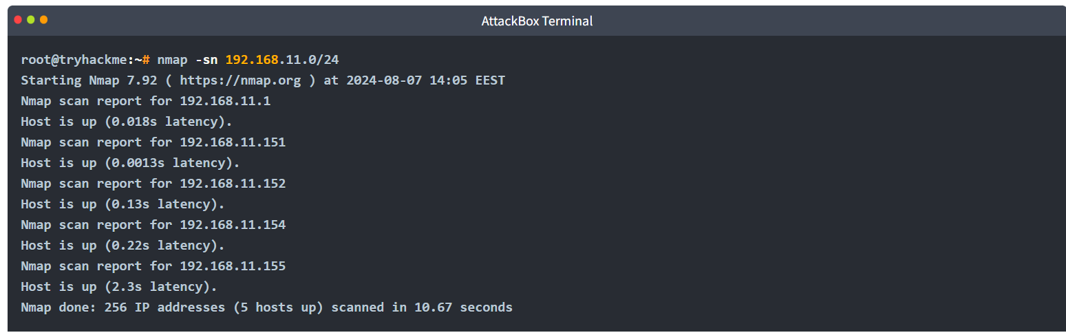
The Nmap output shows that five hosts are up. But how did Nmap discover this? To learn more, let’s see some sample traffic generated by Nmap. In the screenshot below, we can see the responses from two hosts:
- 192.168.11.1 is live and responded to the ICMP echo (ping) request.
- 192.168.11.2 seems down. Nmap sent two ICMP echo (ping) requests, two ICMP timestamp requests, two TCP packets to port 443 with the SYN flag set, and two TCP packets to port 80 with the ACK flag set. The target didn’t respond to any. We observe several ICMP destination unreachable packets from the 192.168.11.151 router.
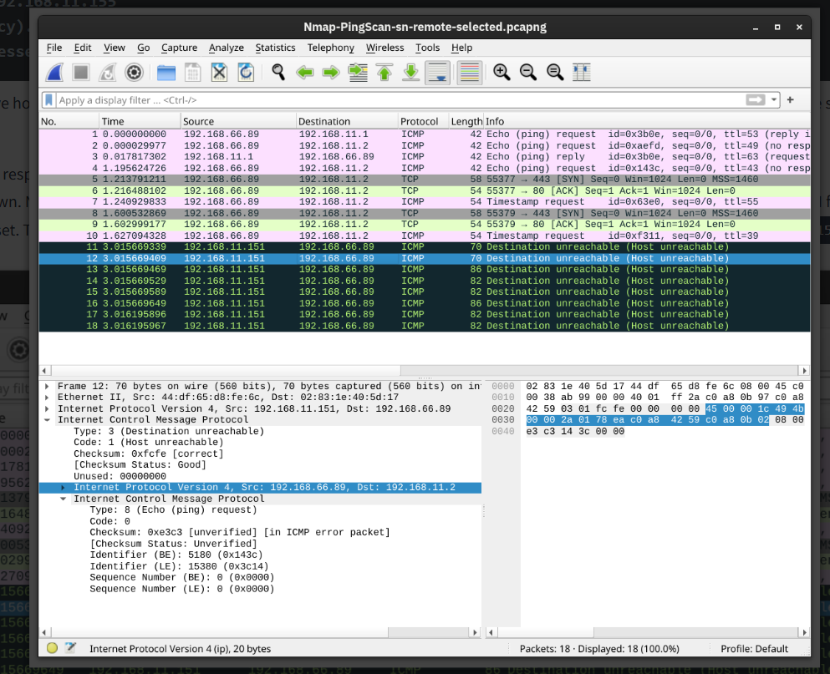
It is worth noting that we can have more control over how Nmap discovers live hosts such as -PS[portlist], -PA[portlist], -PU[portlist] for TCP SYN, TCP ACK, and UDP discovery via the given ports. However, this is beyond the scope of this room.
As a final point, Nmap offers a list scan with the option -sL. This scan only lists the targets to scan without actually scanning them. For example, nmap -sL 192.168.0.1/24 will list the 256 targets that will be scanned. This option helps confirm the targets before running the actual scan.
As we mentioned earlier, -sn aims to discover live hosts without attempting to discover the services running on them. This scan might be helpful if you want to discover the devices on a network without causing much noise. However, this won’t tell us which services are running. If we want to learn more about the network services running on the live hosts, we need a more “noisy” type of scan, which we will explore in the next task.
Click the Start AttackBox button at the top of the page and wait for it to load. Once the AttackBox is ready, open the terminal to access nmap and answer the questions in this and later tasks. Furthermore, click on the Start Machine button below to get your target system ready for later tasks.

Port Scanning: Who Is Listening
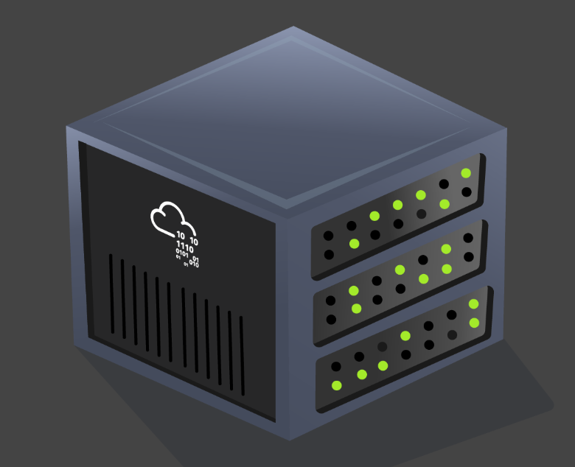
Earlier, we used -sn to discover the live hosts. In this task, we want to discover the network services listening on these live hosts. By network service, we mean any process that is listening for incoming connections on a TCP or UDP port. Common network services include web servers, which usually listen on TCP ports 80 and 443, and DNS servers, which typically listen on UDP (and TCP) port 53.
By design, TCP has 65,535 ports, and the same applies to UDP. How can we determine which ports have a service bound to it? Let’s find out.

Scanning TCP Ports
The easiest and most basic way to know whether a TCP port is open would be to attempt to telnet to the port. If you are inclined to scan with a Telnet client, try to establish a TCP connection with every target port. In other words, you attempt to complete the TCP three-way handshake with every target port; however, only open TCP ports would respond appropriately and allow a TCP connection to be established. This procedure is not very different from Nmap’s connect scan.

Connect Scan
The connect scan can be triggered using -sT. It tries to complete the TCP three-way handshake with every target TCP port. If the TCP port turns out to be open and Nmap connects successfully, Nmap will tear down the established connection.
In the screenshot below, our scanning machine has the IP address 192.168.124.148 and the target system has TCP port 22 open and port 23 closed. In the part marked with 1, you can see how the TCP three-way handshake was completed and later torn down with a TCP RST-ACK packet by Nmap. The part marked with 2 shows a connection attempt to a closed port, and the target system responded with a TCP RST-ACK packet.
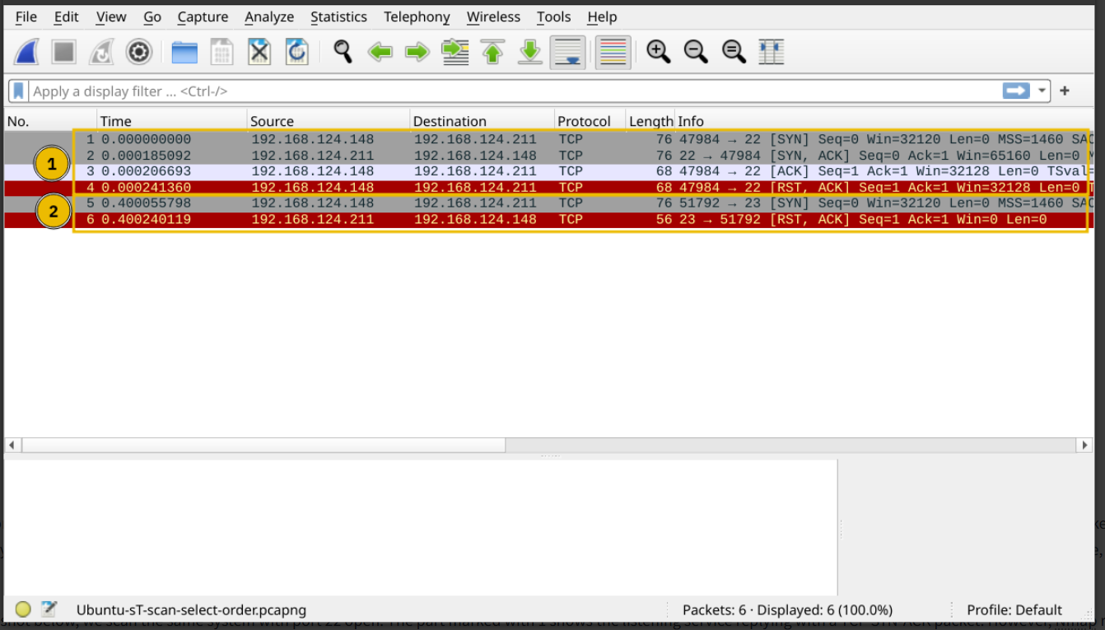

SYN Scan (Stealth)
Unlike the connect scan, which tries to connect to the target TCP port, i.e., complete a three-way handshake, the SYN scan only executes the first step: it sends a TCP SYN packet. Consequently, the TCP three-way handshake is never completed. The advantage is that this is expected to lead to fewer logs as the connection is never established, and hence, it is considered a relatively stealthy scan. You can select the SYN scan using the -sS flag.
In the screenshot below, we scan the same system with port 22 open. The part marked with 1 shows the listening service replying with a TCP SYN-ACK packet. However, Nmap responded with a TCP RST packet instead of completing the TCP three-way handshake. The part marked with 2 shows a TCP connection attempt to a closed port. In this case, the packet exchange is the same as in the connect scan.

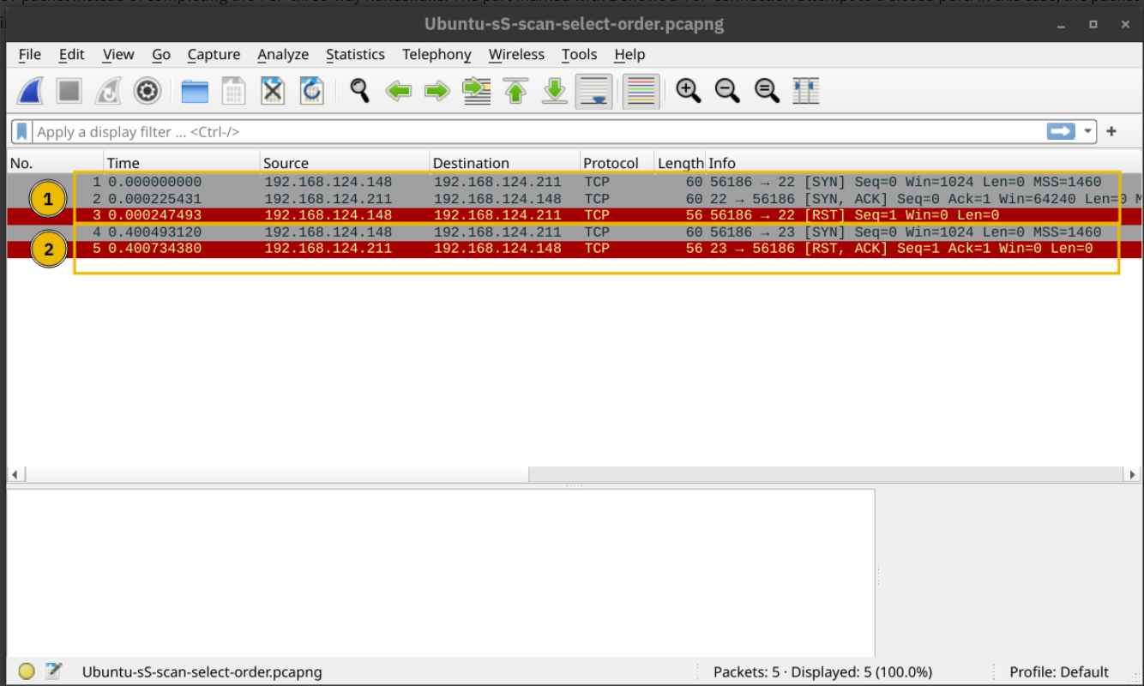

Scanning UDP Ports
Although most services use TCP for communication, many use UDP. Examples include DNS, DHCP, NTP (Network Time Protocol), SNMP (Simple Network Management Protocol), and VoIP (Voice over IP). UDP does not require establishing a connection and tearing it down afterwards. Furthermore, it is very suitable for real-time communication, such as live broadcasts. All these are reasons to consider scanning for and discovering services listening on UDP ports.
Nmap offers the option -sU to scan for UDP services. Because UDP is simpler than TCP, we expect the traffic to differ. The screenshot below shows several ICMP destination unreachable (port unreachable) responses as Nmap sends UDP packets to closed UDP ports.
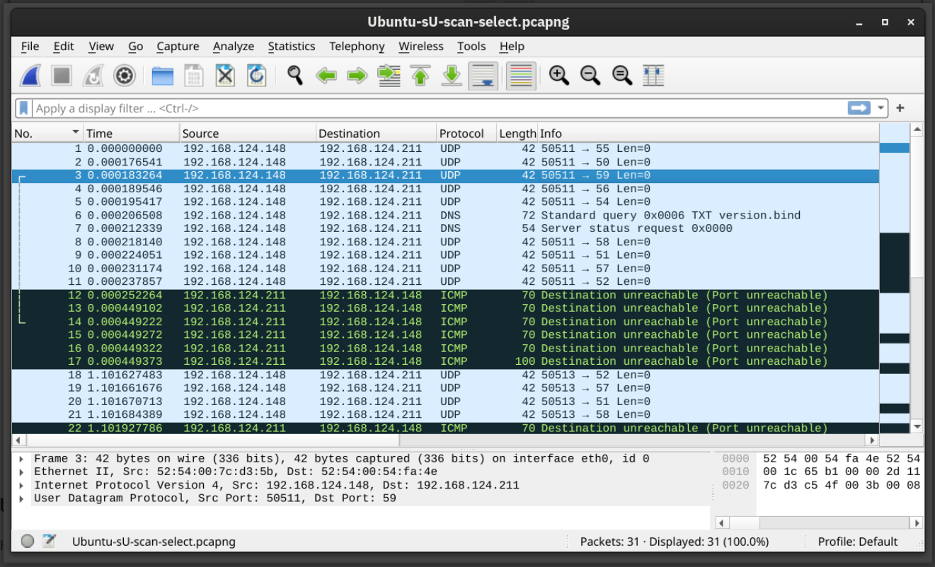

Limiting the Target Ports
Nmap scans the most common 1,000 ports by default. However, this might not be what you are looking for. Therefore, Nmap offers you a few more options.
- -F is for Fast mode, which scans the 100 most common ports (instead of the default 1000).
- -p[range] allows you to specify a range of ports to scan. For example, -p10-1024 scans from port 10 to port 1024, while -p-25 will scan all the ports between 1 and 25. Note that -p- scans all the ports and is equivalent to -p1-65535 and is the best option if you want to be as thorough as possible.
- Tip: The most common services use a port number between 1 and 1024 for either UDP or TCP. These ports are also known as well-known ports. Use -p1-1023 to scan for the well-known ports.

Summary
Option | Explanation
-sT | TCP connect scan – complete three-way handshake
-sS | TCP SYN – only first step of the three-way handshake
-sU | UDP scan
-F | Fast mode – scans the 100 most common ports
-p[range] | Specifies a range of port numbers – -p- scans all the ports

Practical:
How many TCP ports are open on the target system at MACHINE_IP [10.49.172.220]? 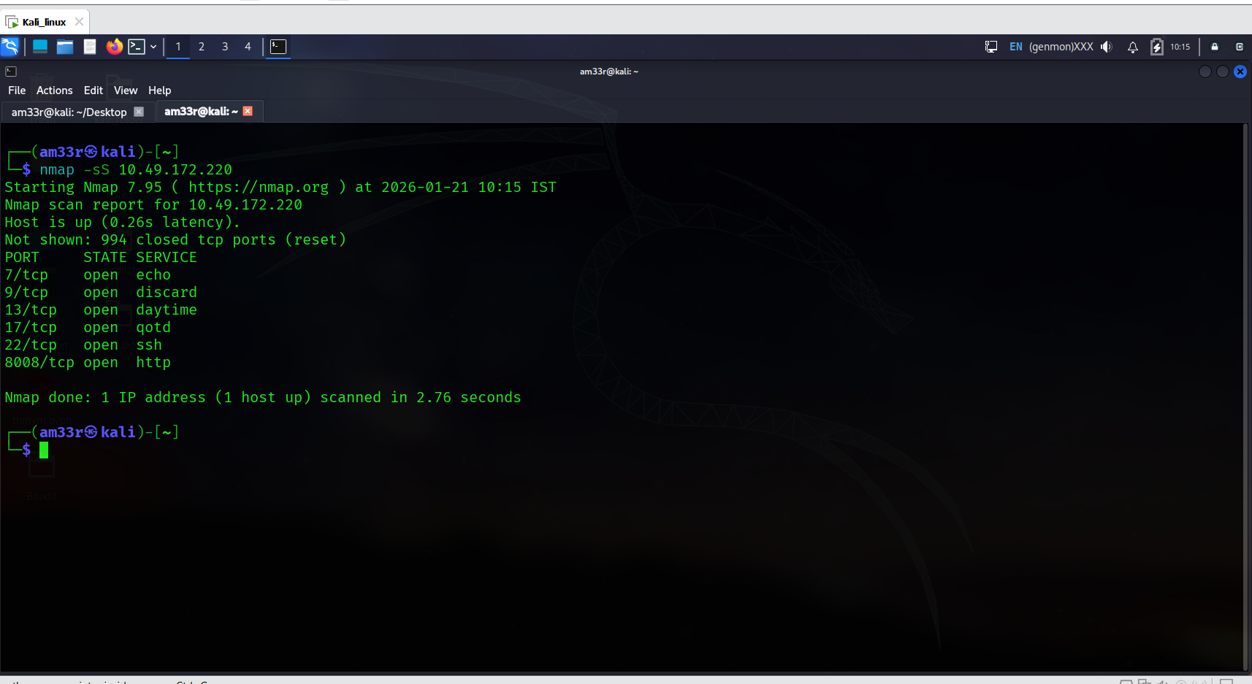
Find the listening web server on 10.49.172.220 and access it with your browser. What is the flag that appears on its main page? 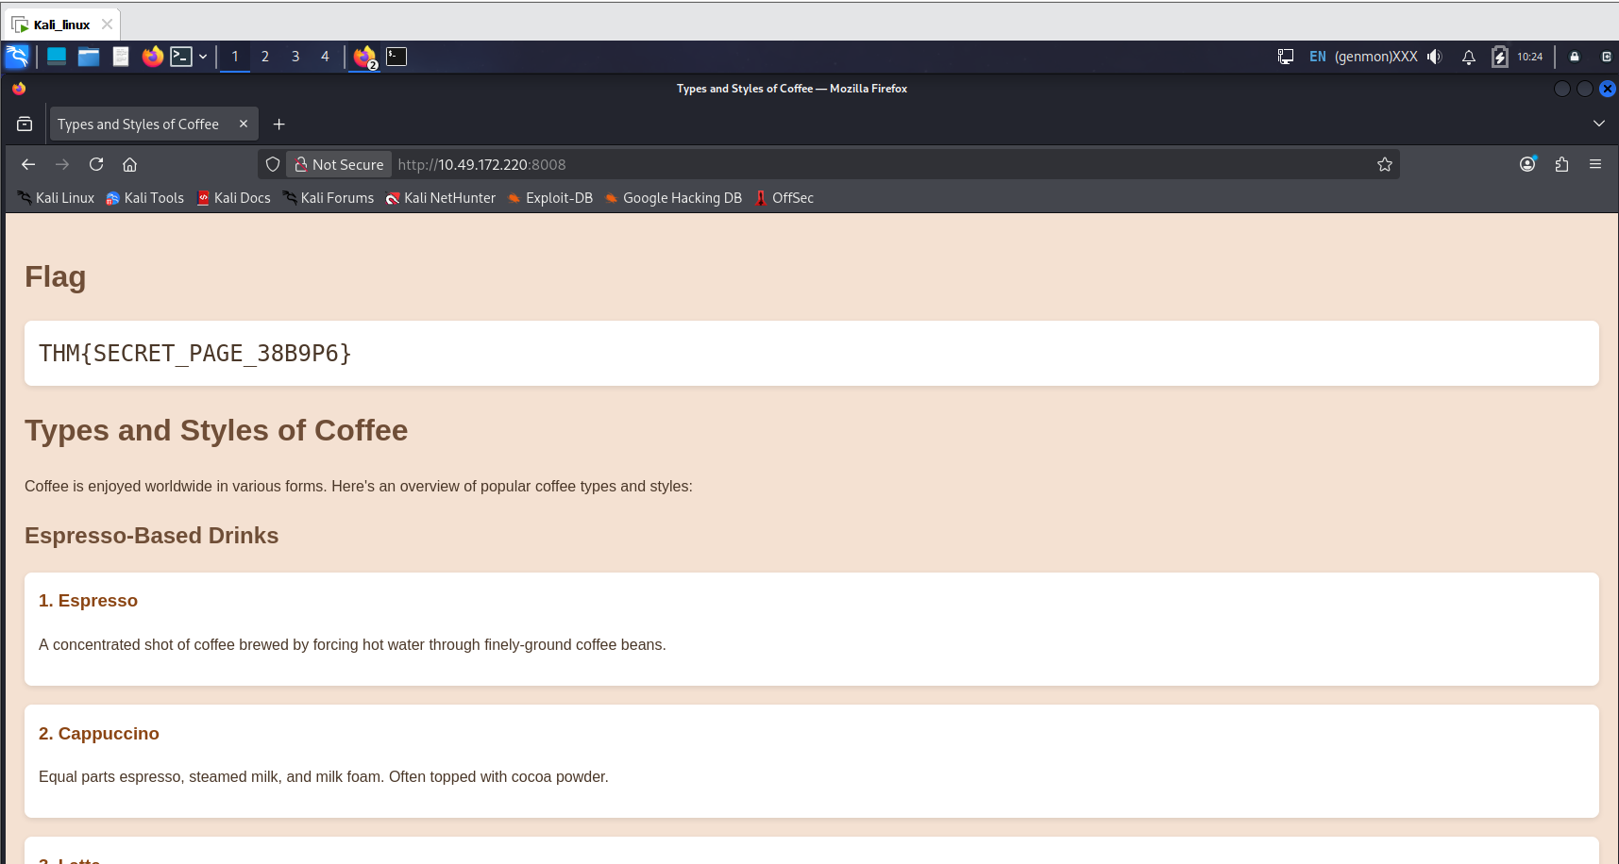

Version Detection: Extract More Information


OS Detection
You can enable OS detection by adding the -O option. As the name implies, the OS detection option triggers Nmap to rely on various indicators to make an educated guess about the target OS. In this case, it is detecting the target has Linux 4.x or 5.x running. That’s actually true. However, there is no perfectly accurate OS detector. The statement that it is between 4.15 and 5.8 is very close as the target host’s OS is 5.15.
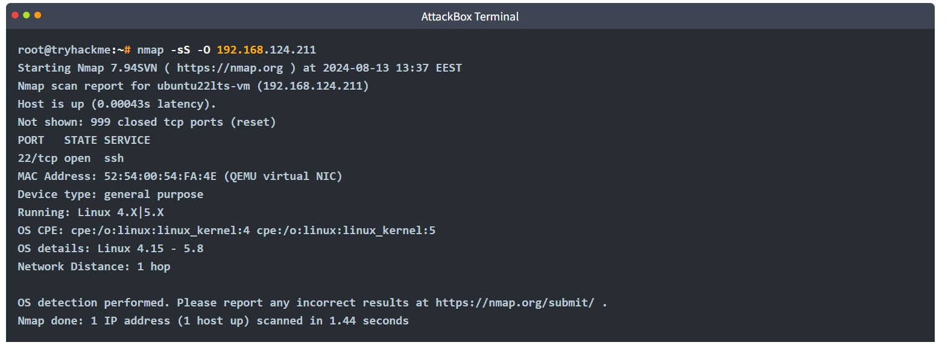

Service and Version Detection
You discovered several open ports and want to know what services are listening on them. -sV enables version detection. This is very convenient for gathering more information about your target with fewer keystrokes. The terminal output below shows an additional column called “VERSION”, indicating the detected SSH server version. 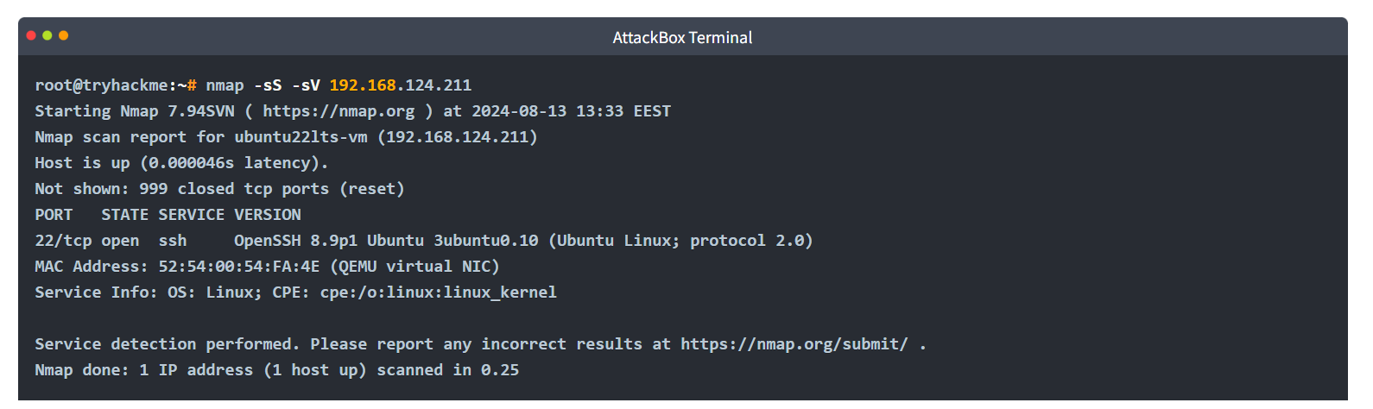
What if you can have both -O, -sV and some more in one option? That would be -A. This option enables OS detection, version scanning, and traceroute, among other things.

Forcing the Scan
When we run our port scan, such as using -sS, there is a possibility that the target host does not reply during the host discovery phase (e.g. a host doesn’t reply to ICMP requests). Consequently, Nmap will mark this host as down and won’t launch a port scan against it. We can ask Nmap to treat all hosts as online and port scan every host, including those that didn’t respond during the host discovery phase. This choice can be triggered by adding the -Pn option.

Summary
Option | Explanation
-O | OS detection
-sV | Service and version detection
-A | OS detection, version detection, and other additions
-Pn | Scan hosts that appear to be down

Practical:
What is the name and detected version of the web server running on 10.49.181.193? 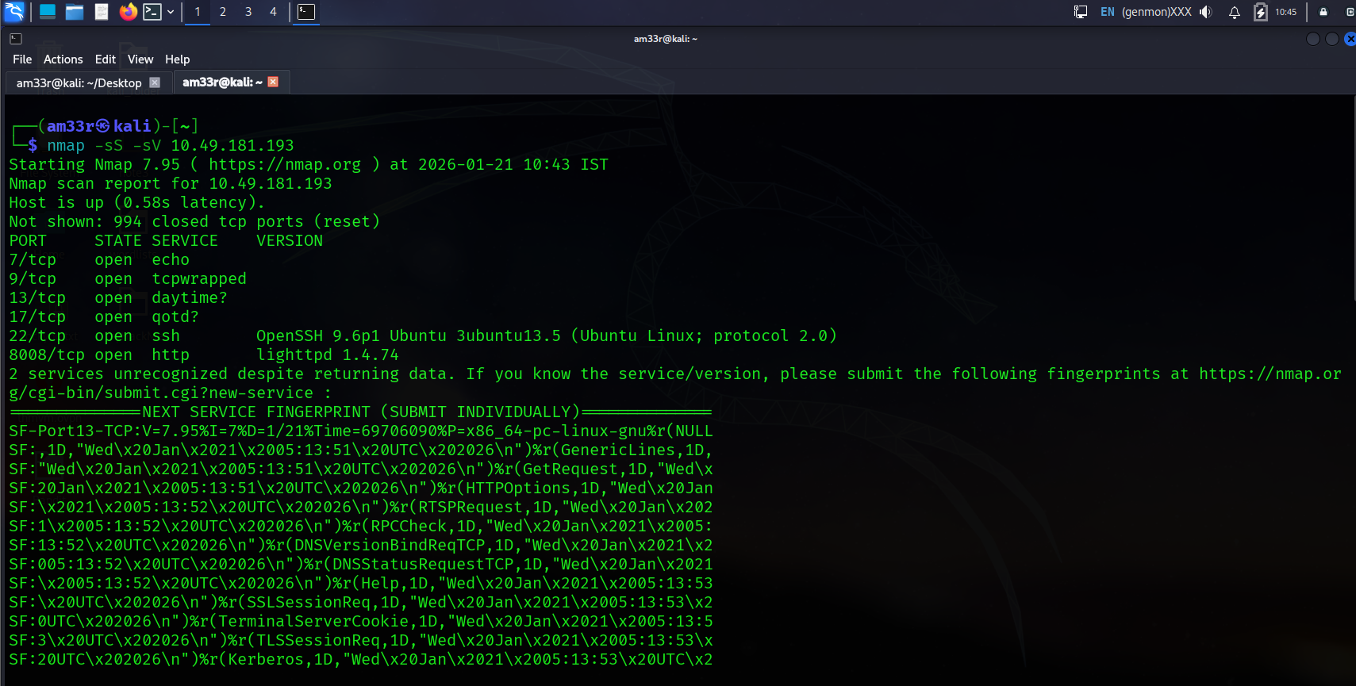

Timing: How Fast is Fast
Nmap provides various options to control the scan speed and timing.
Running your scan at its normal speed might trigger an IDS or other security solutions. It is reasonable to control how fast a scan should go. Nmap gives you six timing templates, and the names say it all: paranoid (0), sneaky (1), polite (2), normal (3), aggressive (4), and insane (5). You can pick the timing template by its name or number. For example, you can add -T0 (or -T 0) or -T paranoid to opt for the slowest timing.
In the Nmap scans below, we launch a SYN scan targeting the 100 most common TCP ports, nmap -sS MACHINE_IP -F. We repeated the scan with different timings: T0, T1, T2, T3, and T4. In our lab setup, Nmap took different amounts of time to scan the 100 ports. The table below should give you an idea, but you will get different results depending on the network setup and target system.
Timing | Total Duration
T0 (paranoid) | 9.8 hours
T1 (sneaky) | 27.53 minutes
T2 (polite) | 40.56 seconds
T3 (normal) | 0.15 seconds
T4 (aggressive) | 0.13 seconds

In the following screenshots, we can see the time when Nmap sent the different packets. In this screenshot below, with the scan timing being T0, we can see that Nmap waited 5 minutes before moving to the next port.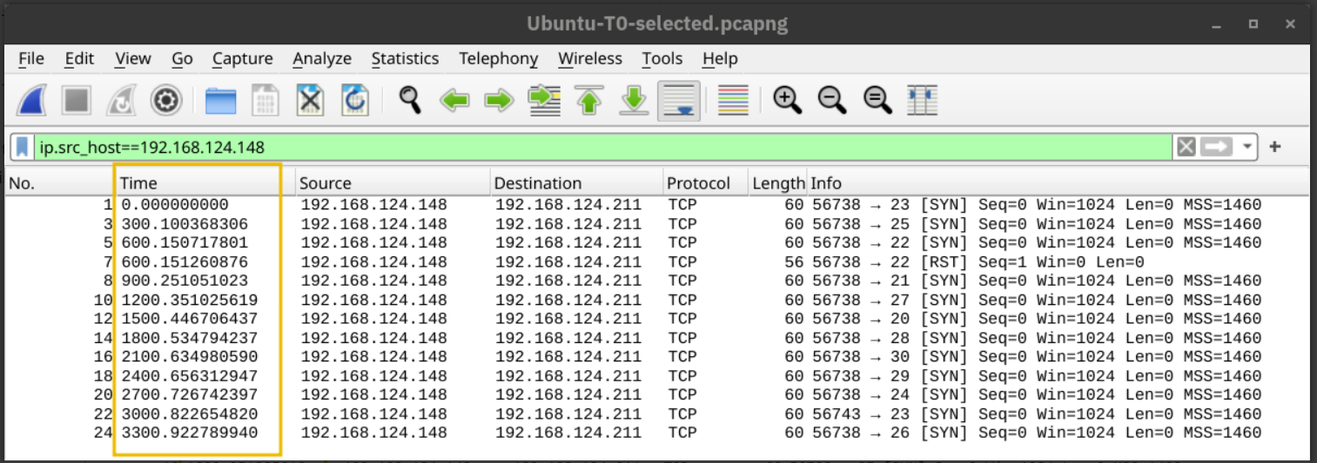
In the screenshot below, Nmap waited 15 seconds between every two ports when we set the timing to T1. 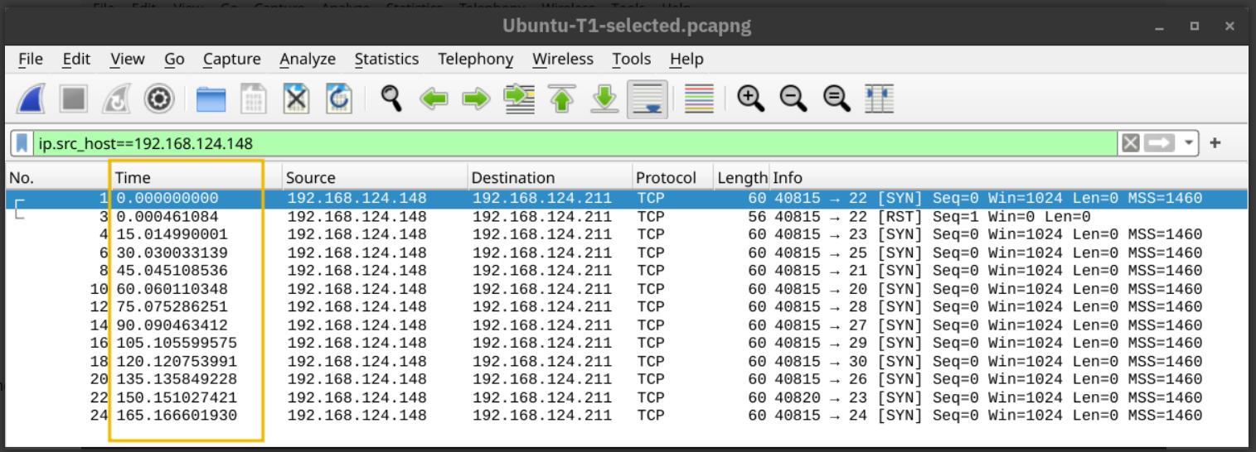
Then, the waiting dropped to 0.4 seconds for T2 as shown below. 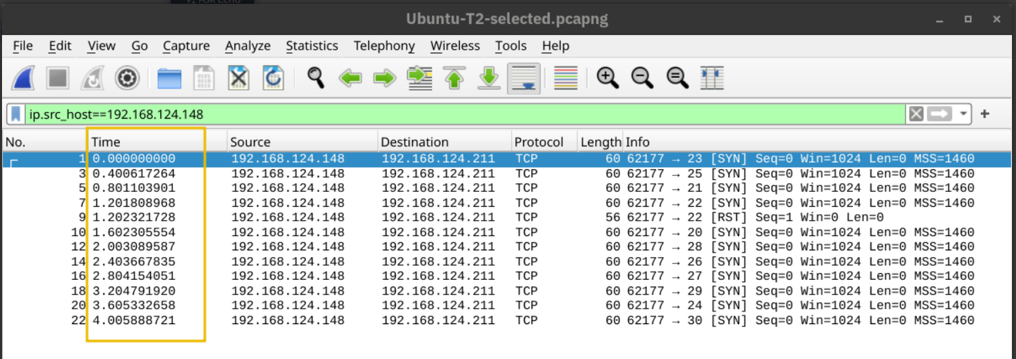
Finally, in the default case, T3, Nmap appeared to be running as fast as it could, as shown below. It is worth repeating that this would look different on a different lab setup. However, in this particular case, Nmap considered the connection to the target to be fast and reliable, as no packet loss was incurred. 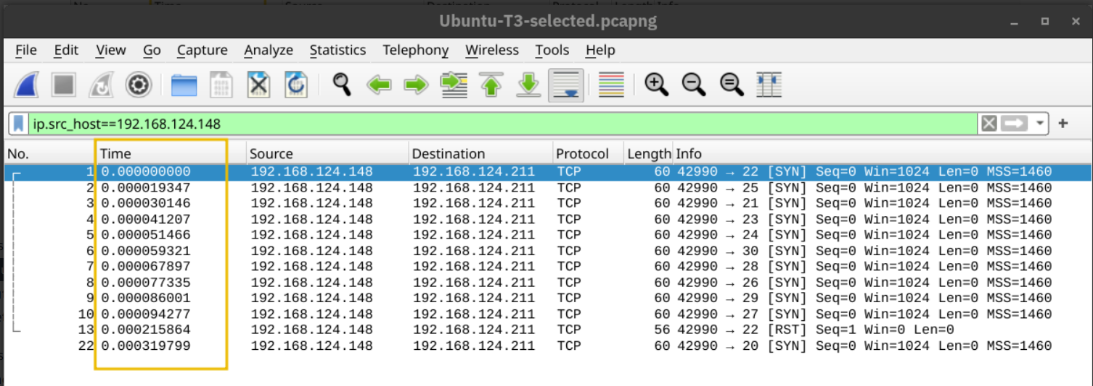
A second helpful option is the number of parallel service probes. The number of parallel probes can be controlled with --min-parallelism <numprobes> and --max-parallelism <numprobes>. These options can be used to set a minimum and maximum on the number of TCP and UDP port probes active simultaneously for a host group. By default, nmap will automatically control the number of parallel probes. If the network is performing poorly, i.e., dropping packets, the number of parallel probes might fall to one; furthermore, if the network performs flawlessly, the number of parallel probes can reach several hundred.
A similar helpful option is the --min-rate <number> and --max-rate <number>. As the names indicate, they can control the minimum and maximum rates at which nmap sends packets. The rate is provided as the number of packets per second. It is worth mentioning that the specified rate applies to the whole scan and not to a single host.
The last option we will cover in this task is --host-timeout <time>. This option specifies the maximum time you are willing to wait, and it is suitable for slow hosts or hosts with slow network connections.
Option | Explanation
-T<0-5> | Timing template – paranoid (0), sneaky (1), polite (2), normal (3), aggressive (4), and insane (5)
--min-parallelism <numprobes> and --max-parallelism <numprobes> | Minimum and maximum number of parallel probes
--min-rate <number> and --max-rate <number> | Minimum and maximum rate (packets/second)
--host-timeout | Maximum amount of time to wait for a target host

Output: Controlling What You See
This task focuses on two main features:
- Showing additional information while a scan takes place
- Choosing the file format to save the scan report

Verbosity and Debugging
In some cases, the scan takes a very long time to finish or to produce any output that will be displayed on the screen. Furthermore, sometimes you might be interested in more real-time information about the scan progress. The best way to get more updates about what’s happening is to enable verbose output by adding -v. Consider the following terminal output showing the network scan repeated twice. In the first case, we opted for the default output verbosity.
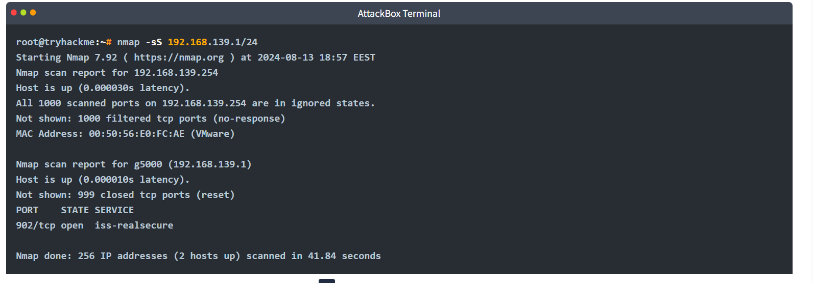Then, we repeated the same scan; however, the second time, we used the -v option for verbosity. The amount of details present below can be very useful, especially when you are learning about Nmap and exploring the different options. In the terminal output below, we can see how Nmap is moving from one stage to another: ARP ping scan, parallel DNS resolution, and finally, SYN stealth scan for every live host. 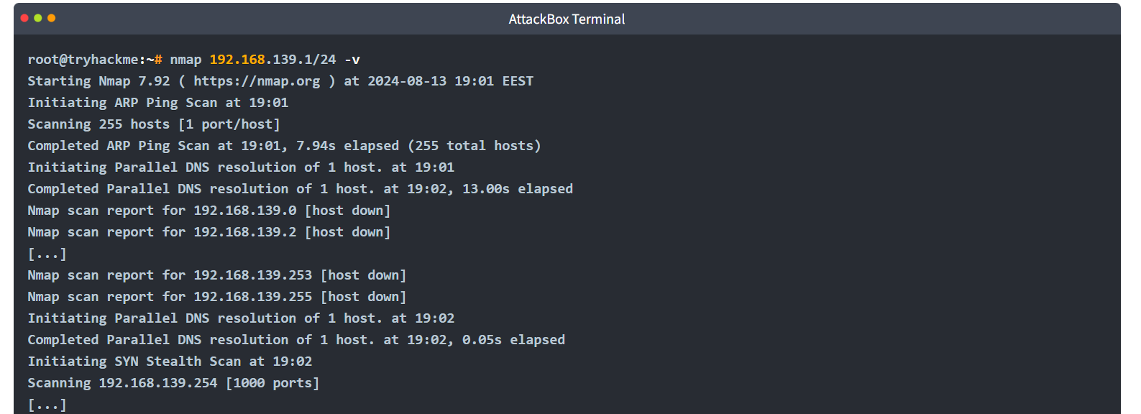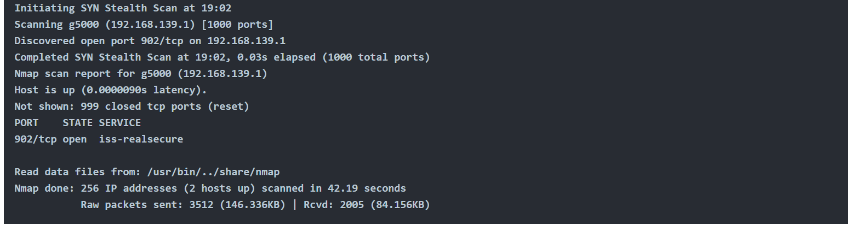
Most likely, the -v option is more than enough for verbose output; however, if you are still unsatisfied, you can increase the verbosity level by adding another “v” such as -vv or even -vvvv. You can also specify the verbosity level directly, for example, -v2 and -v4. You can even increase the verbosity level by pressing “v” after the scan already started.
If all this verbosity does not satisfy your needs, you must consider the -d for debugging-level output. Similarly, you can increase the debugging level by adding one or more “d” or by specifying the debugging level directly. The maximum level is -d9; before choosing that, make sure you are ready for thousands of information and debugging lines.

Saving Scan Report
In many cases, we would need to save the scan results. Nmap gives us various formats. The three most useful are normal (human-friendly) output, XML output, and grepable output, in reference to the grep command. You can select the scan report format as follows:
- -oN <filename> - Normal output
- -oX <filename> - XML output
- -oG <filename> - grep-able output (useful for grep and awk)
- -oA <basename> - Output in all major formats
In the terminal below, we can see an example of using the -oA option. It resulted in three reports with the extensions nmap, xml, and gnmap for normal, XML, and grep-able output.
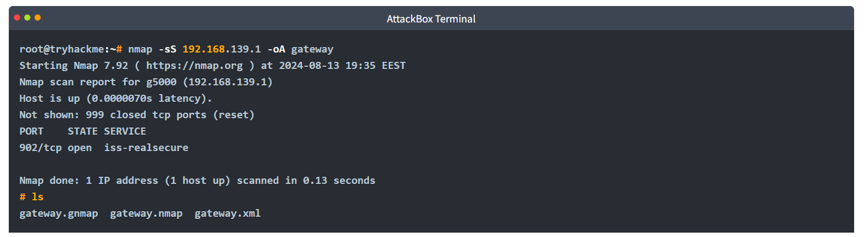

Conclusion:
In this room, we learned how to use Nmap to discover live hosts on any network. We also explored the common types of port scans and how we can use Nmap to find service version numbers. We also learned how to control the timing of the scan, and finally, we covered the different formats for saving Nmap scan results.
It is worth noting that it is best to run Nmap with sudo privileges so that we can make use of all its features. Running Nmap with local user privileges will still work; however, you should expect many features to be unavailable. You get a minimal portion of Nmap’s power when running it as a local user. For instance, Nmap would automatically use SYN scan (-sS) if you are running it with sudo privileges and will default to connect scan (-sT) if run as a local user. The reason is that crafting certain packets, such as sending a TCP SYN packet, requires root privileges.
Nmap is a very rich tool, and we only covered the most common and essential features in this room. In the Network Security module, four rooms are dedicated exclusively to Nmap. The table below lists most of the options we explained in this room to help you review and remember them.

Option | Explanation
-sL | List scan – list targets without scanning
Host Discovery
-sn | Ping scan – host discovery only
Port Scanning
-sT | TCP connect scan – complete three-way handshake
-sS | TCP SYN – only first step of the three-way handshake
-sU | UDP Scan
-F | Fast mode – scans the 100 most common ports
-p[range] | Specifies a range of port numbers – -p- scans all the ports
-Pn | Treat all hosts as online – scan hosts that appear to be down
Service Detection
-O | OS detection
-sV | Service version detection
-A | OS detection, version detection, and other additions
Timing
-T<0-5> | Timing template – paranoid (0), sneaky (1), polite (2), normal (3), aggressive (4), and insane (5)
--min-parallelism <numprobes> and --max-parallelism <numprobes> | Minimum and maximum number of parallel probes
--min-rate <number> and --max-rate <number> | Minimum and maximum rate (packets/second)
--host-timeout | Maximum amount of time to wait for a target host
Real-time output
-v | Verbosity level – for example, -vv and -v4
-d | Debugging level – for example -d and -d9
Report
-oN <filename> | Normal output
-oX <filename> | XML output
-oG <filename> | grep-able output
-oA <basename> | Output in all major formats

