Practical-2:
Capturing the data packets using tcpdump with -n to resolve them in less verbose. 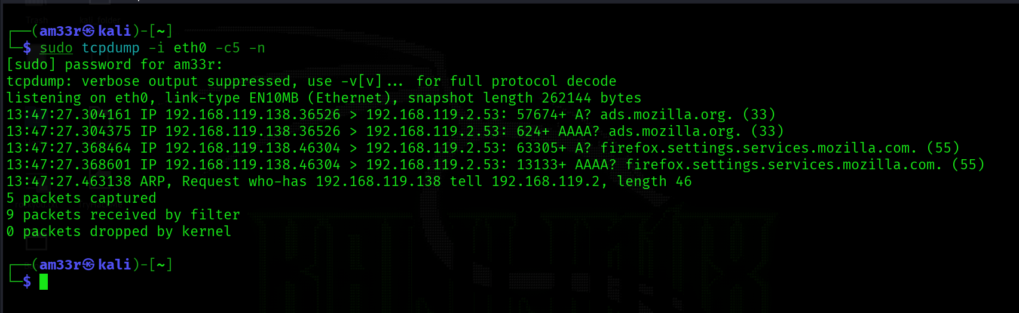

Filtering

Filtering by host
Different filters used in tcpdump to filter the packets
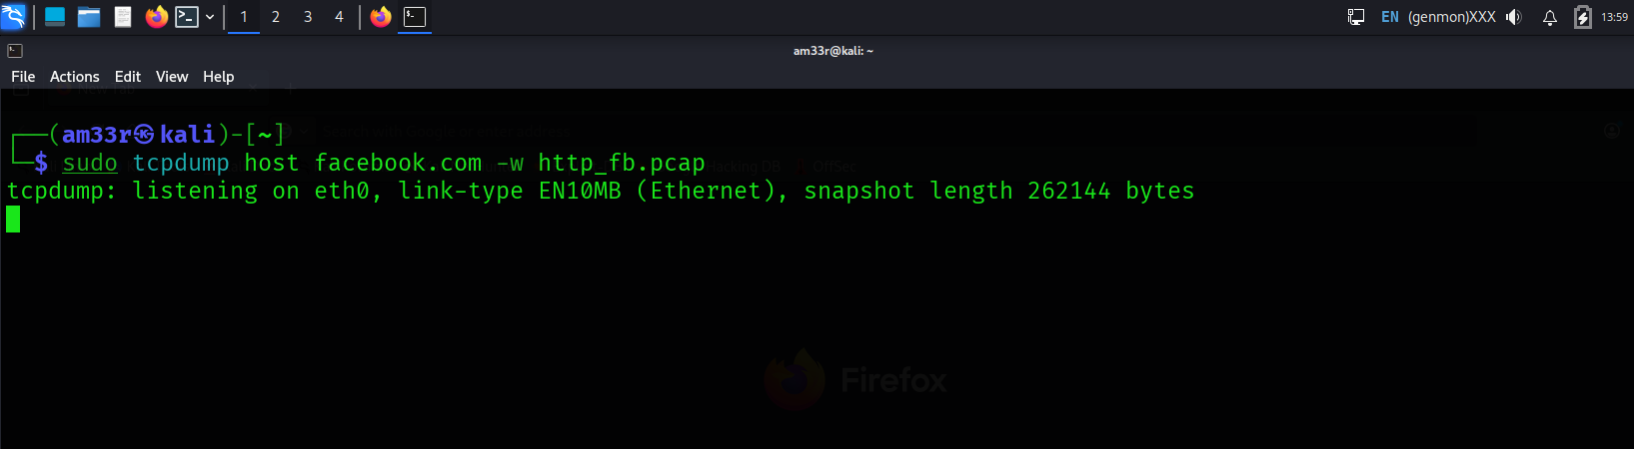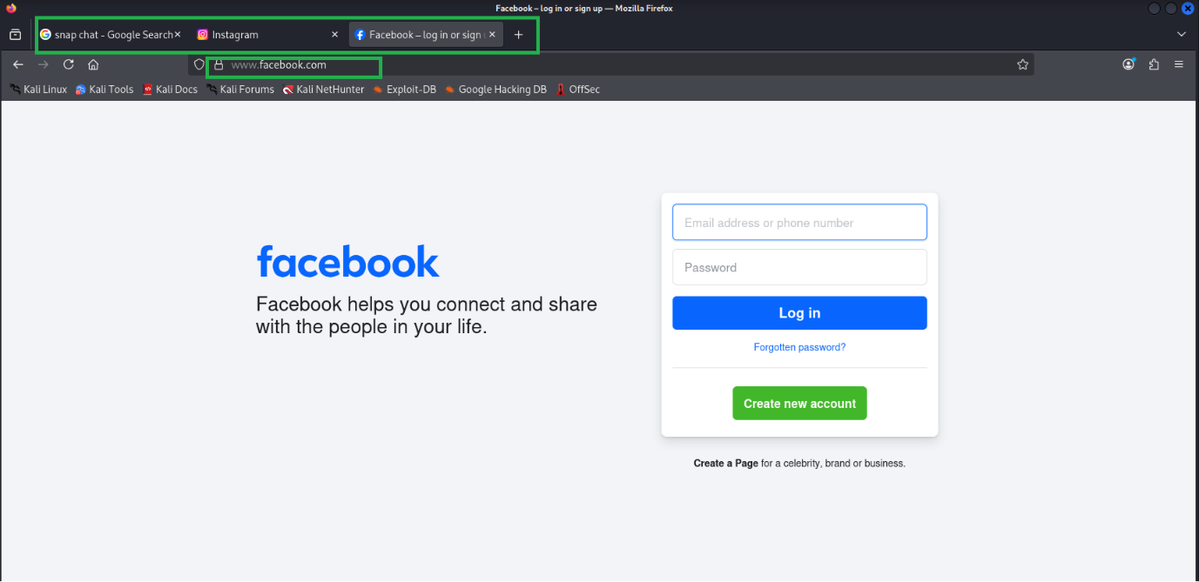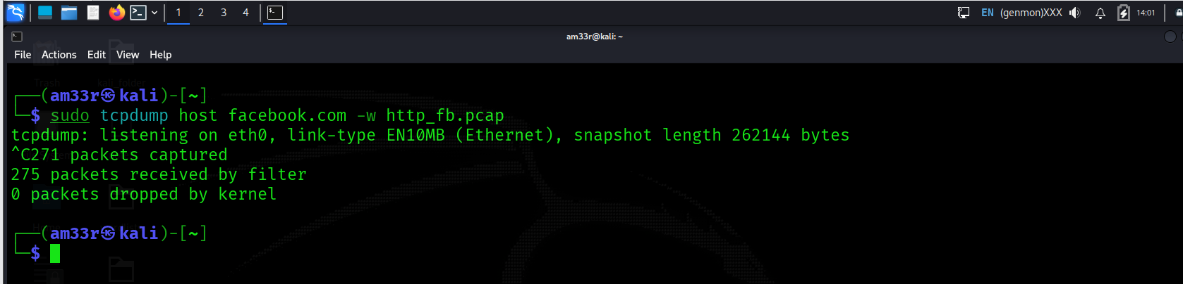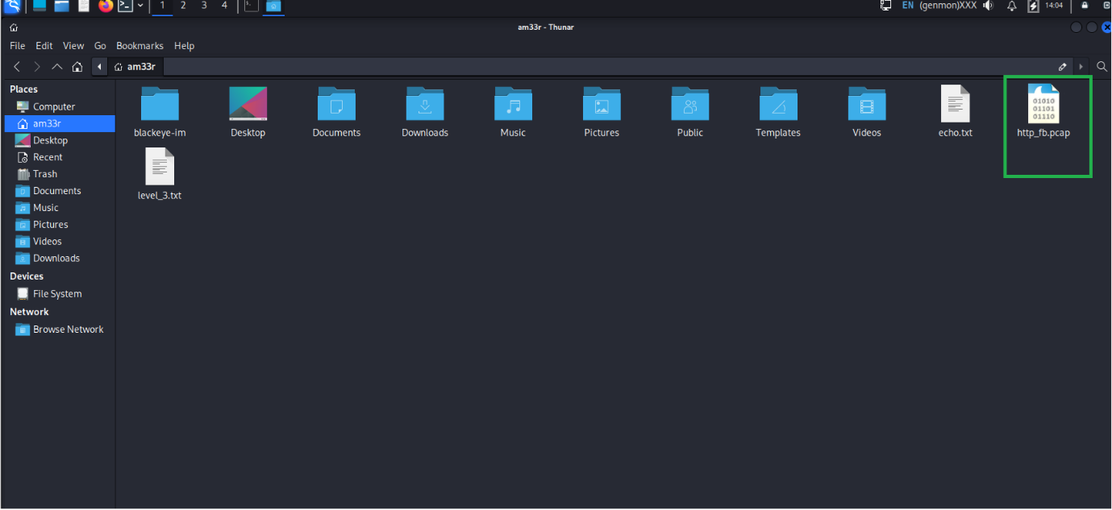
If you want to limit the packets to those from a particular source IP address or hostname, you must use src host IP or src host HOSTNAME. Similarly, you can limit packets to those sent to a specific destination using dst host IP or dst host HOSTNAME.

Filtering by Port
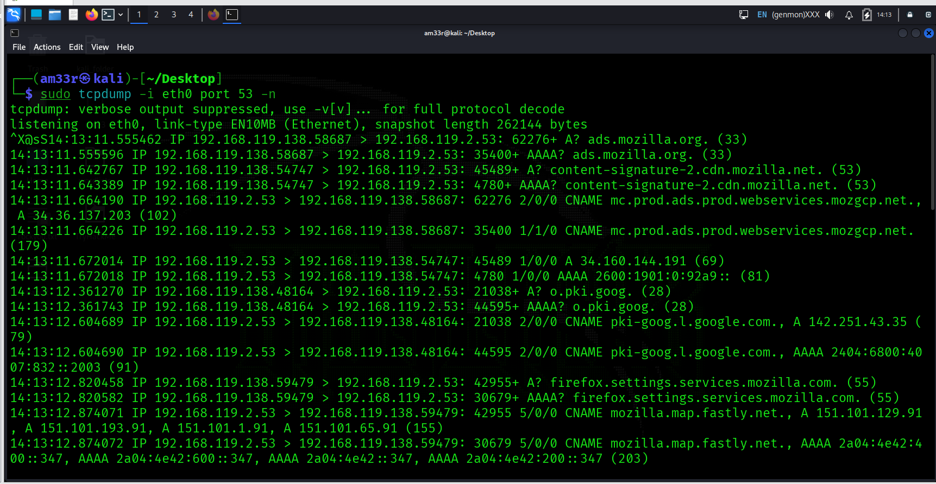
In the above example, we captured all the packets sent to or from a specific port number. You can limit the packets to those from a particular source port number or to a particular destination port number using src port PORT_NUMBER and dst port PORT_NUMBER, respectively.
Using other Filtering by Protocol, Logical Operators

Performing different operations
How many packets in traffic.pcap use the ICMP protocol? 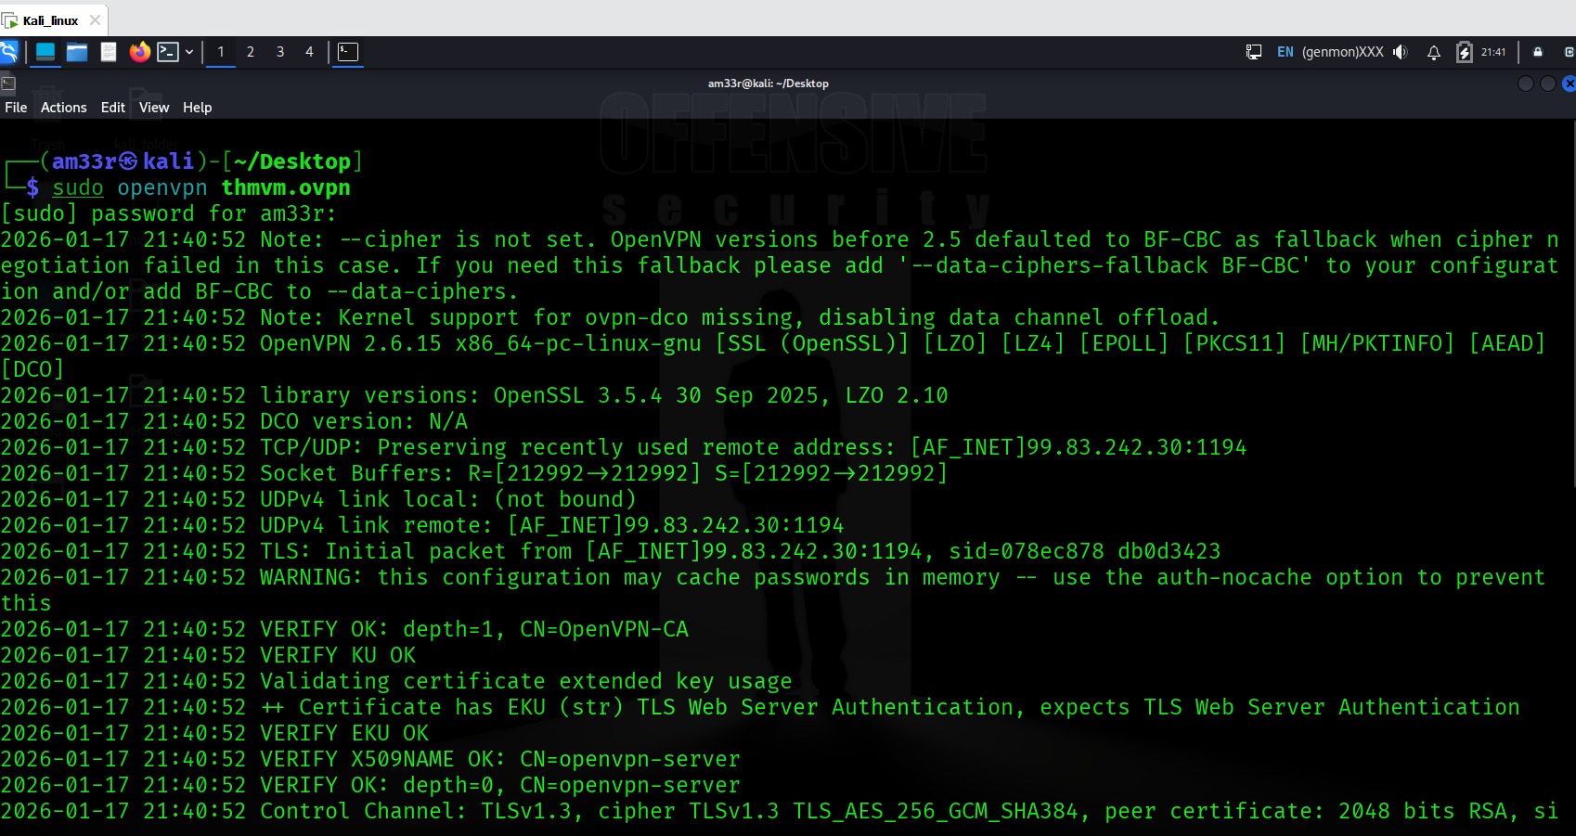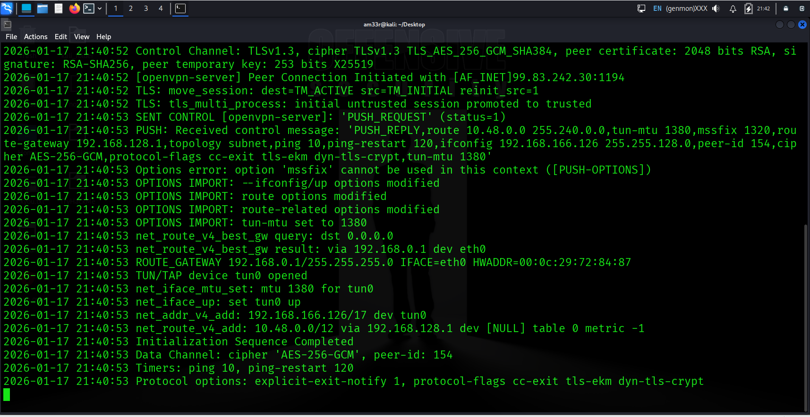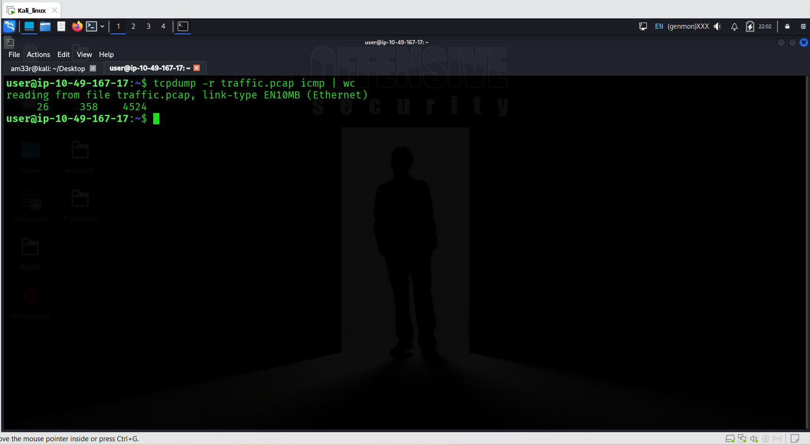

What is the IP address of the host that asked for the MAC address of 192.168.124.137?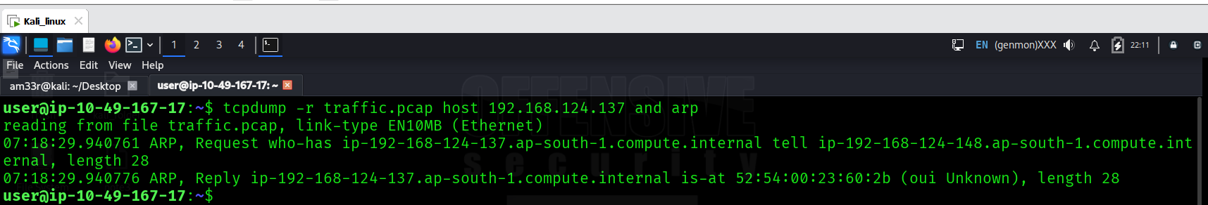

What hostname (subdomain) appears in the first DNS query? 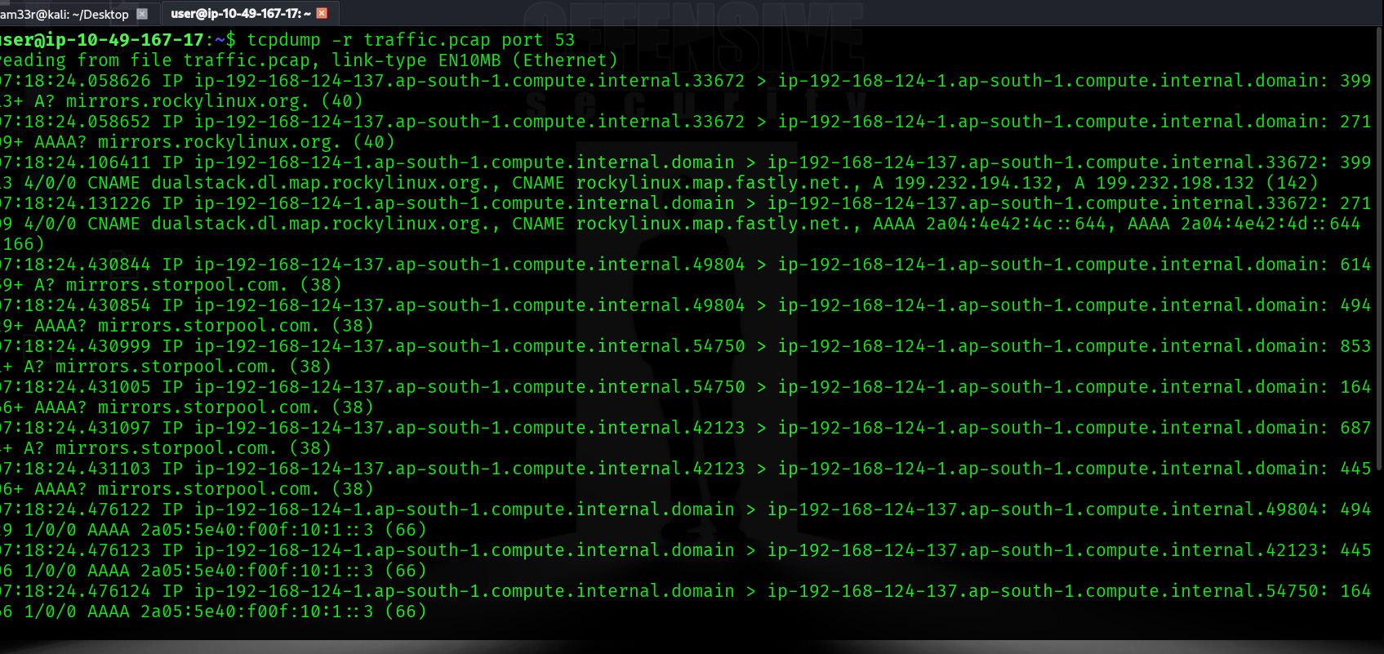

Advanced Filtering
Performing filtering using different tcp flags
How many packets have only the TCP Reset (RST) flag set? 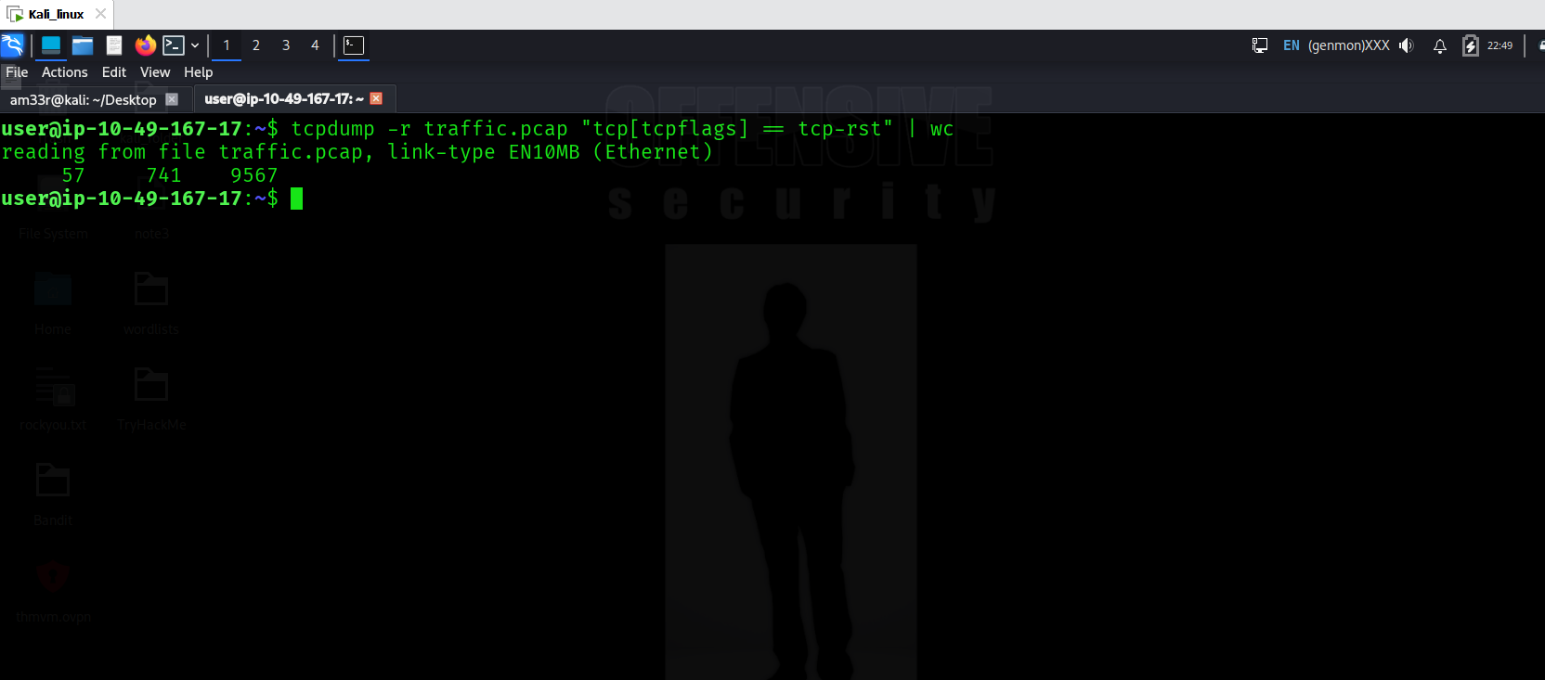

What is the IP address of the host that sent packets larger than 15000 bytes? 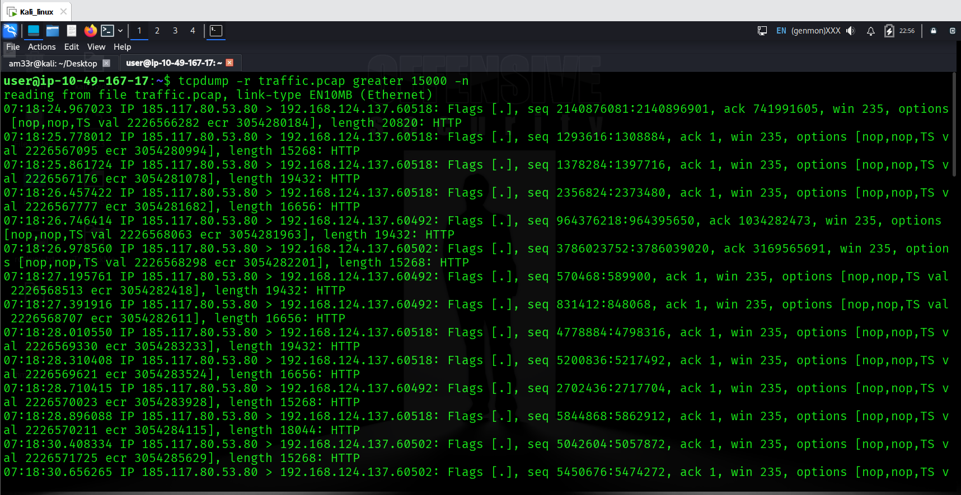

Displaying Packets
We can read the pcap data using different flag formats

Brief Packet Information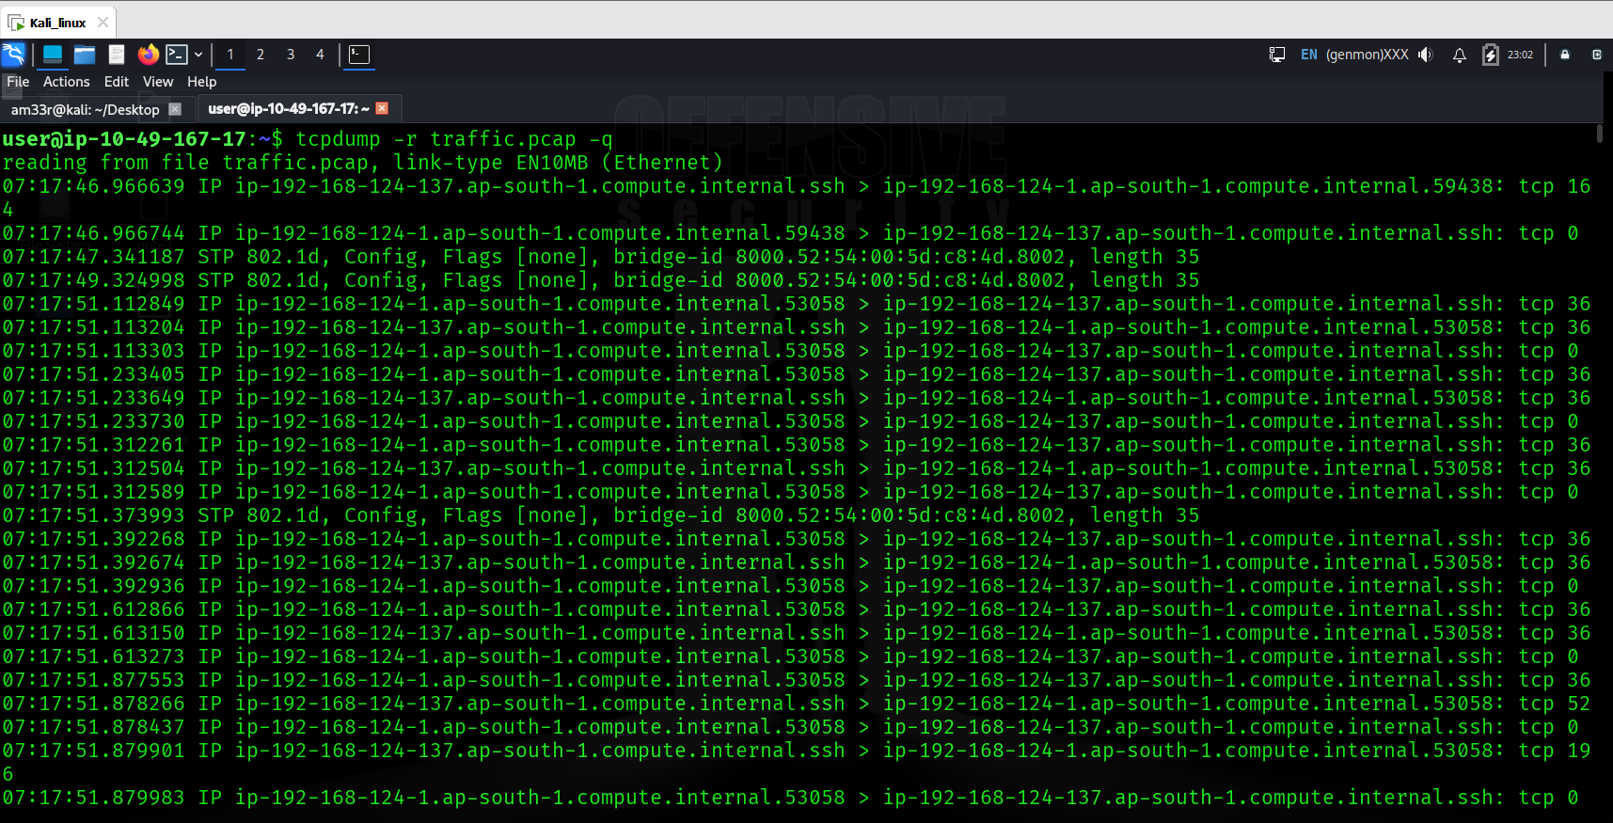

Displaying Link-Level Header
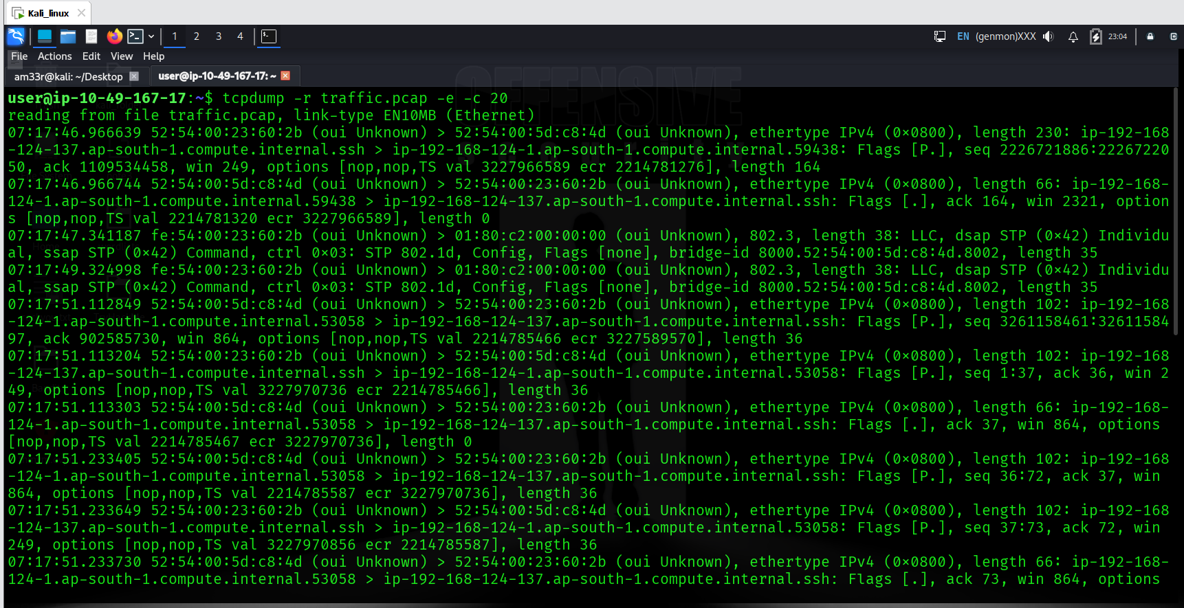
..etc.,

What is the MAC address of the host that sent an ARP request? 