Introduction
One of the challenges when analyzing potentially malicious software is that we risk our machine or environment being compromised when we run it unless we have a sandbox or a completely isolated environment where we can test all we want. Generally speaking, there are two types of analysis: dynamic analysis and static analysis. This room will focus on conducting static analysis using a tool called CAPA.
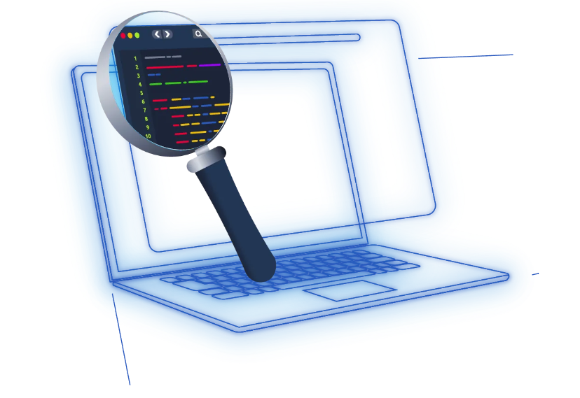

CAPA (Common Analysis Platform for Artifacts) is a tool developed by the FireEye Mandiant team. It is designed to identify the capabilities present in executable files like Portable Executables (PE), ELF binaries, .NET modules, shellcode, and even sandbox reports. It does so by analyzing the file and applying a set of rules that describe common behaviours, allowing it to determine what the program is capable of doing, such as network communication, file manipulation, process injection, and many more.
The beauty of CAPA is that it encapsulates years of reverse engineering knowledge into an automated tool, making it accessible even to those who may not be experts in reverse engineering. This can be incredibly useful for analysts and security professionals, allowing them to quickly understand potentially malicious software's functionality without manually reverse engineering the code.
This tool is particularly useful in malware analysis and threat hunting, where understanding a binary's capabilities is crucial for incident response and defensive measures.

Tool Overview: How CAPA Works
In this task, we will see how to use CAPA. Running the tool is as easy as 1..2..3. First, open a PowerShell, noting that it might take a while before the prompt appears. Next is to make sure that you are in the correct directory (C:\Users\Administrator\Desktop\capa); then you need to run capa or capa.exe, then point to the binary, and that’s it!
In this example, we will use cryptbot.bin; please note that the results of this file will be discussed throughout the succeeding task.
After running the command
Connected to windows rdp using remmina tool 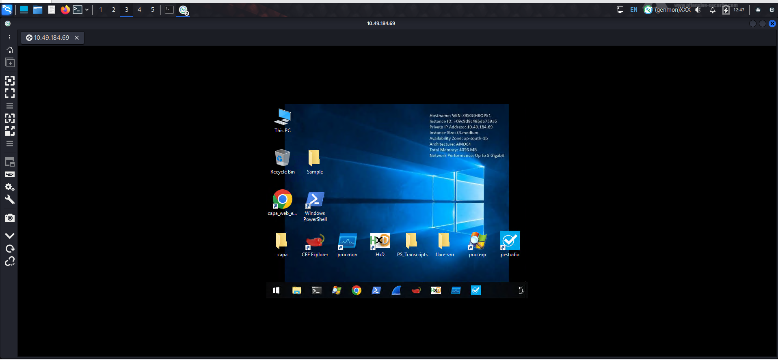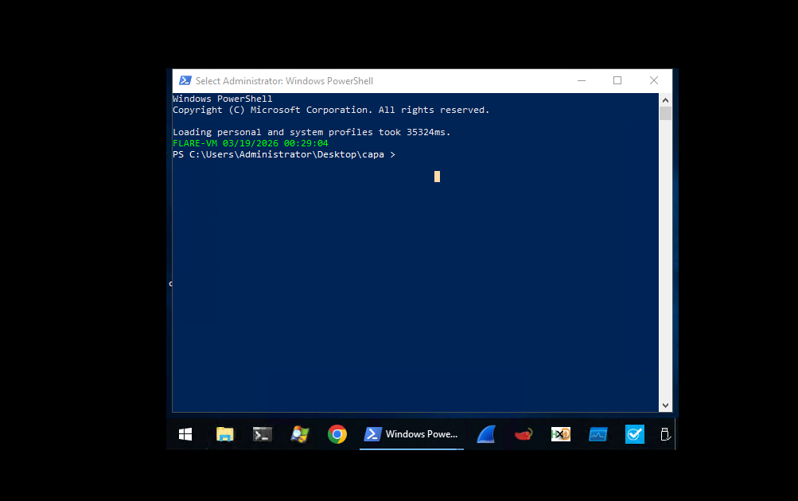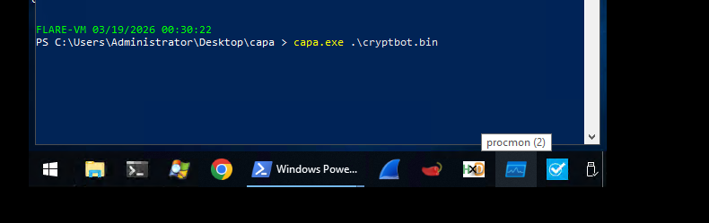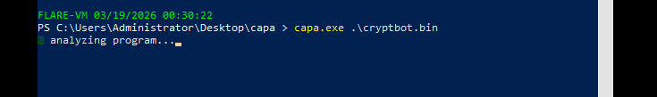

In addition to the -h command, which gives us more information about the parameters available with the tool, we will use two (2) most used parameters, which is the -v and -vv, which will give us a more detailed result. However, this will increase the processing time. We will have a discussion about the results of these options in the coming tasks.
Option | Description | Sample Syntax
-h or --help | Show this help message and exit. | capa -h
-v or --verbose | Enable verbose result document. | capa.exe .\cryptbot.bin -v
-vv or --vverbose | Enable a very verbose result document. | capa.exe .\cryptbot.bin -vv

This should be the output of the command. *Please take note that results may vary. If you ran CAPA on some files, it might or might not give the same information as below.

Since we know that the processing time takes several minutes, we have pre-processed this to a file named cryptbot.txt located in C:\Users\Administrator\Desktop\capa. At the same time, this has been attached to this task; just click the button Download tasks files from the upper right side of this task. Open another PowerShell terminal and use the command Get-Content cryptbot.txt
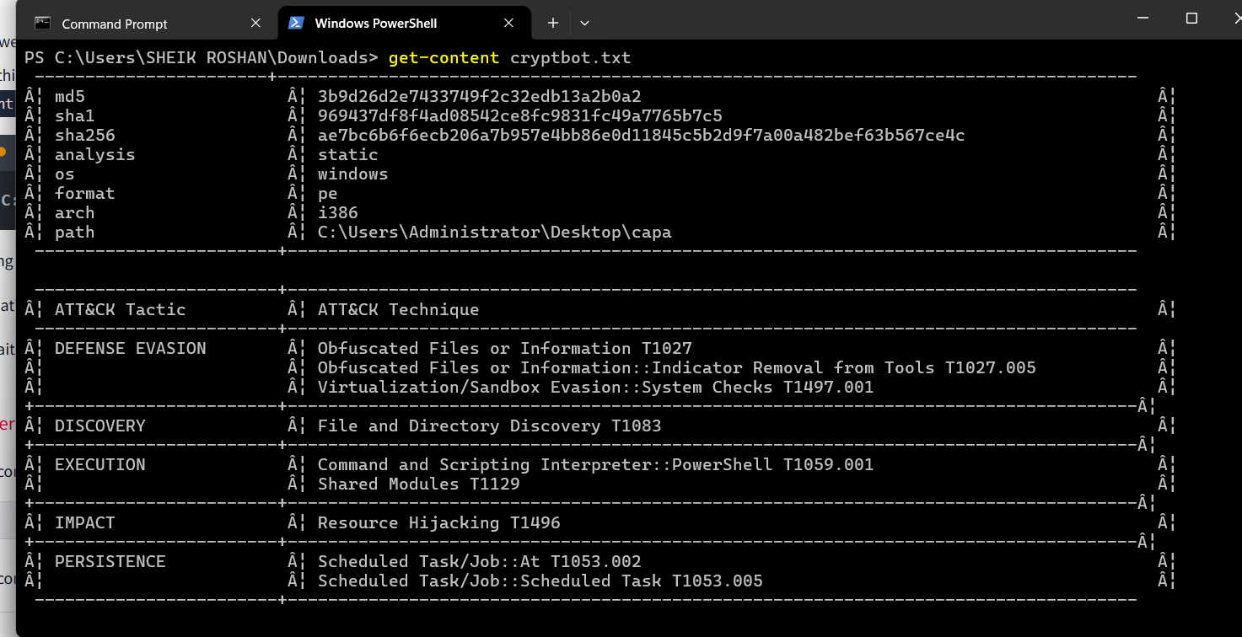

Dissecting CAPA Results Part 1: General Information, MITRE and MAEC
As mentioned in the previous task, the results of running CAPA against cryptbot.bin will be discussed in the succeeding task. As such, we will dissect the results per block and topic.
The first block contains basic information about the file. This includes the following:
- The cryptographic algorithms, such as the md5, and sha1/256.
- The analysis field tells us how CAPA performed its analysis on the file.
- The os field reveals the operating system (OS) context for which the identified capabilities apply.
- The arch field allows us to determine whether we are dealing with a binary related to x86 architecture.
- The path where the analyzed file was located.
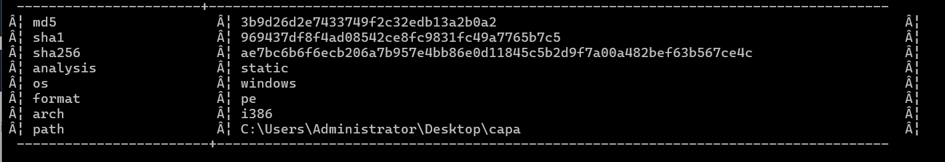

MITRE ATT&CK
The MITRE ATT&CK (Adversarial Tactics, Techniques, and Common Knowledge) framework is a comprehensive global knowledge repository that meticulously documents the tactics and techniques employed by threat actors at every stage of a cyber-attack. It functions as a strategic playbook, providing detailed insights into attackers' methods, from gaining initial access to maintaining a presence, escalating privileges, evading defenses, moving laterally within a network, and much more.
CAPA uses this format for the output. Note that some results may or may not contain the Technique and Sub-technique Identifier.
Format | Sample | Explanation
ATT&CK Tactic::ATT&CK Technique::Technique Identifier | Defense Evasion::Obfuscated Files or Information::T1027 | DEFENSE EVASION = ATT&CK Tactic  Obfuscated Files or Information = ATT&CK Technique  T1027 = Technique Identifier
ATT&CK Tactic::ATT&CK Technique::ATT&CK Sub-Technique::Technique Identifier[.]Sub-technique Identifier | Defense Evasion::Obfuscated Files or Information::Indicator Removal from Tools T1027.005 | DEFENSE EVASION = ATT&CK Tactic  Obfuscated Files or Information = ATT&CK Technique  Indicator Removal from Tools = ATT&CK Sub-Technique  T1027 = Technique Identifier  005 = Sub-Technique Identifier

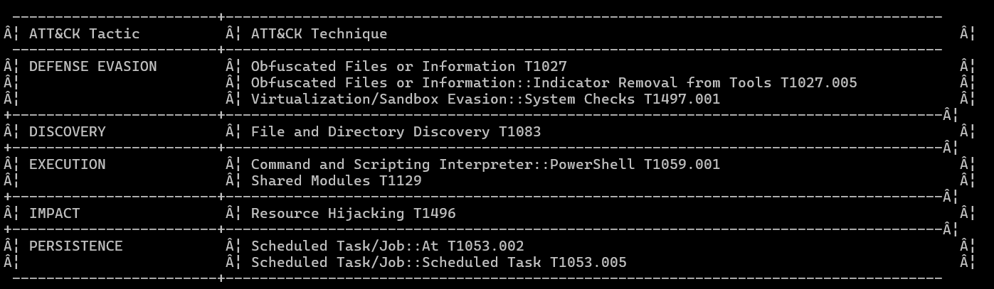

MAEC
Malware Attribute Enumeration and Characterization is a specialized language designed to encode and communicate complex details concerning malware. It contains an extensive range of attributes, including behaviours, artefacts, and interconnections among various instances of malware. This language functions as a standardized system for tracking and analyzing the complicated complexities of malware.
Let’s check the table below to see the most commonly used MAEC values by CAPA: Downloader and Launcher.
MAEC Value | Description
Launcher | Exhibits behaviours that trigger specific actions similar to malware behaviour.
Downloader | Exhibits behaviours wherein it downloads and executes other files, usually seen on more complex malware.

When CAPA tags a file with a “launcher” MAEC value, it indicates that the file demonstrates behaviour similar to but not limited to:
- Dropping additional payloads
- Activating persistence mechanisms
- Connecting to command-and-control (C2) servers
- Executing specific functions
This is interesting! Some of these behaviours are also present in the Malware Behavior Catalogue (MBC) and Capability block, which we will discuss in the next task!

Additionally, when CAPA tags a file with a “Downloader” MAEC value, it indicates that the file demonstrates behaviour similar but not limited to:
- Fetching additional payloads or resources from the internet
- pulling in updates
- executing secondary stages
- retrieving configuration files

practical:
What is the sha256 of cryptbot.bin? 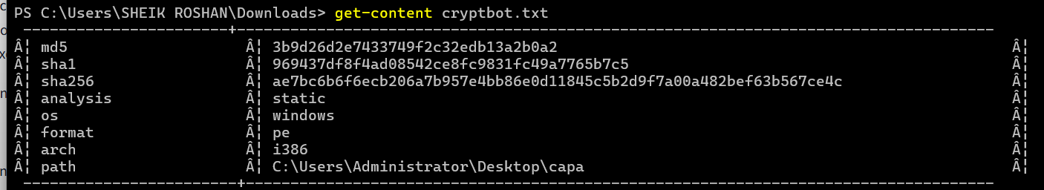
What is the Technique Identifier of Obfuscated Files or Information?
T1027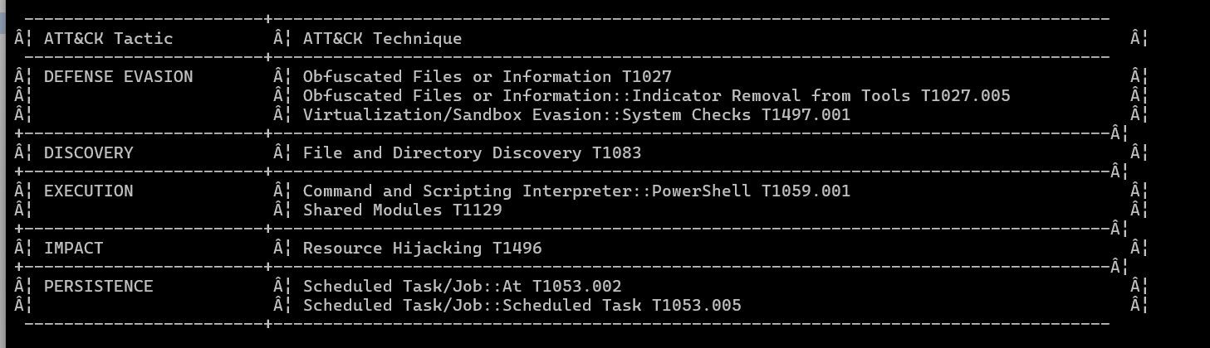
What is the Sub-Technique Identifier of Obfuscated Files or Information::Indicator Removal from Tools?

When CAPA tags a file with this MAEC value, it indicates that it demonstrates behaviour similar to, but not limited to, Activating persistence mechanisms?
When CAPA tags a file with this MAEC value, it indicates that the file demonstrates behaviour similar to, but not limited to, Fetching additional payloads or resources from the internet?

Dissecting CAPA Results Part 2: Malware Behavior Catalogue
In this task, we will cover the following topics:
In this task, we will cover the following topics:
- MBC
- Objective
- Micro-Objective
- MBC Behaviors
- Micro-Behavior
- Methods
Let's move on to the next block. This terminal can also be seen from Task 2, where we ran the CAPA tool. Click on the view terminal below.
Malware Behavior Catalogue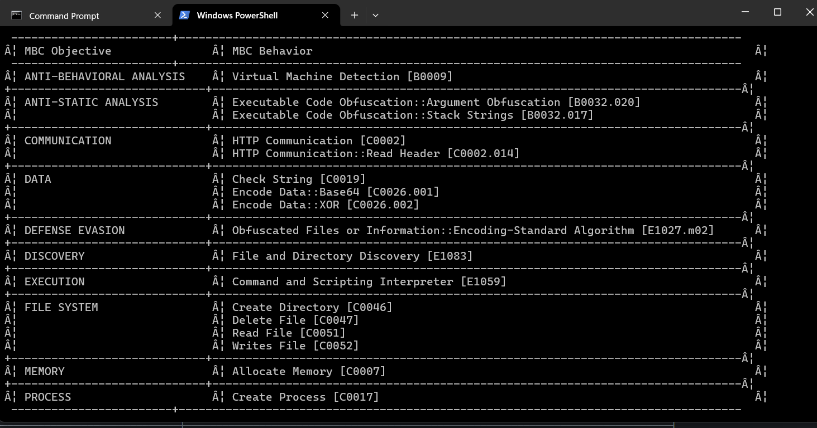
We'll tackle the Malware Behavior Catalogue to better understand the block above.

Malware Behavior Catalogue (MBC)
MBC is designed to support various aspects of malware analysis, such as labelling, similarity analysis, and standardized reporting. Essentially, it serves as a catalogue of malware objectives and behaviours. MBC can also link to ATT&CK methods and log all behaviours and code features discovered during malware analysis. It's important to note that the names of MBC behaviours may or may not match the corresponding ATT&CK techniques. The information on behaviour pages complements the content on ATT&CK pages. In other words, when recording malware behaviours, MBC users will reference ATT&CK, but MBC does not duplicate ATT&CK information.
The content of MBC below can be represented in two formats.
Format | Sample | Explanation
OBJECTIVE::Behavior::Method[Identifier] | ANTI-STATIC ANALYSIS::Executable Code Obfuscation::Argument Obfuscation [B0032.020] | Anti-static Analysis = OBJECTIVE  Executable Code Obfuscation = BEHAVIOR  Argument Obfuscation = METHOD  BOO32.020 = IDENTIFIER
OBJECTIVE::Behavior::[Identifier] | COMMUNICATION::HTTP Communication:: [C0002] | COMMUNICATION = OBJECTIVE  HTTP Communication = BEHAVIOR  C0002 = IDENTIFIER
The difference between the two formats is that the first format contains additional details called METHOD, which can also be coined as a sub-technique.

We must also discuss the Objective, Behavior, and Methods to better understand this part.

Objective
The Objective are based on ATT&CK tactics in the context of malware behaviour, though not all are included. Furthermore, MBC has Anti-Behavioral and Anti-Static Analysis. These objectives are tailored for malware analysis with the use case of characterizing malware. See the table below for an explanation of each.
Objective | Explanation
Anti-Behavioral Analysis | Malware attempts to avoid detection by hindering behavioural analysis using tools like sandboxes or debuggers.
Anti-Static Analysis | Malware attempts to obstruct or add complexity to static analysis, making it more challenging for security professionals to identify and understand its malicious behaviours and intentions.
Collection | Malware focuses on identifying and gathering information from the targeted machine or network.
Command and Control | Malware typically establishes communication with compromised systems through various methods such as command and control servers, peer-to-peer networks, or other means. This communication allows the malware to control the compromised systems, enabling the attackers to execute commands, exfiltrate data, or carry out other malicious activities.
Credential Access | The primary aim of malware is to steal account credentials, such as usernames and passwords.
Defense Evasion | The malware aims to bypass and circumvent the various detection and security mechanisms present within the system to avoid being detected or mitigated.

View More Objective
Discovery | Malware Seeks to collect detailed information about the configuration and setup of the system or network environment, including hardware, software, and network infrastructure.
Execution | Malware is designed to execute unauthorized commands or code on a targeted computer system without the user’s consent. This can include a wide range of harmful activities, such as stealing personal information, damaging files, or gaining unauthorized access to the system.
Exfiltration | Malware is designed to infiltrate computer systems or networks to steal and extract sensitive data. This can include personal information, financial details, and any other valuable data stored on the targeted system or network.
Impact | Malware aims to manipulate, disrupt, or damage computer systems and data. It can enter computers through infected emails, compromised websites, and other deceptive means, leading to financial loss, privacy breaches, and system instability.
Lateral Movement | Malware seeks to spread through the network, either actively through machine access or passively, such as via malicious emails.
Persistence | Malware is intentionally developed with the capability to remain undetected and operational on a computer system for an extended period.
Privilege Escalation | Malware seeks to infiltrate a computer system or network to gain elevated permissions or control. Once inside the target environment, malware can seek to escalate its privileges, access sensitive information, or take control of system resources for malicious purposes.

Micro-Objective
Micro-objectives are associated with micro-behaviors, which refer to an action or actions exhibited by potentially malicious software that isn't necessarily malicious and may serve various objectives. Example binaries are such as those in messaging apps. However, it's important to note that these behaviours are typically abused. That's why CAPA might have flagged this behaviour.
Micro-Objective | Description
PROCESS | exhibiting behaviours related to processes such as but not limited to Creating Process, Setting Thread Context, Terminating Process, and Checking Mutex.
MEMORY | exhibiting behaviours such as, but not limited to, Allocating Memory, Changing Memory Protection, and Freeing Memory.
COMMUNICATION | exhibiting behaviours such as (not limited to (DNS, FTP, HTTP, ICMP, SMTP) network traffic.
DATA | exhibiting behaviours such as but not limited to Checking strings, compressing, decoding and encoding data
The final output of CAPA, Objective, and Micro-Objective are shown only under the Objective column.

MBC Behaviors
The column MBC Behaviors contains behaviours and Micro-behaviors with or without its methods and identifiers. Please check the link MBC Summary(opens in new tab) for a listing of all MBC content.
Below is a compiled version of Behaviors/Micro-behaviors and its Identifier.
Objective | Behavior | Identifiers | Explanation
ANTI-BEHAVIORAL ANALYSIS | Virtual Machine Detection | B0009 | The malware checks to see if it is running in a virtual environment. During its system reconnaissance, the malware examines various user and system artifacts.
ANTI-STATIC ANALYSIS | Executable Code Obfuscation | B0032 | Executable code has been intentionally obscured to prevent static code analysis. This is a specific behavior related to the executable code of a malware sample, including its data and text sections.
EXECUTION | Command and Scripting Interpreter | E1059 | Malware can exploit command and script interpreters to run malicious commands, scripts, or binaries. It targets built-in interpreters like cmd.exe or PowerShell on Windows or Bash on Unix-like systems. Attackers may also use other scripting languages like Python, Perl, or JavaScript.
DISCOVERY | File and Directory Discovery | E1083 | Malware has the capability to search for specific files in particular locations by enumerating files and directories.
ANTI-STATIC ANALYSIS, DEFENSE EVASION | Obfuscated Files or Information | E1027 | Malware can obfuscate files or information by encoding, encrypting, or otherwise, making them hard to analyze. It can also encode or encrypt malware samples itself.

Micro-Behavior
The term "low-level behaviors" in malware analysis refers to actions exhibited by malware that aren't necessarily malicious and may serve various objectives. These behaviors are often documented as "micro-behaviors" in the Malware Behavior Characteristics (MBC) analysis. Examples of such low-level behaviors include the creation of TCP sockets and evaluating specific conditions within strings. It's important to note that just because a behavior is categorized as low-level does not mean it is harmless, as it may still be part of a larger malicious scheme.
Micro-Objective | Micro-Behaviors | Identifiers | Explanation
MEMORY | Allocate Memory | C0007 | Malware frequently utilizes memory allocation as part of its strategy to unpack itself and execute its malicious activities.
PROCESS | Create Process | C0017 | Malware creates a process via WMI or shellcode. It can also create a suspended process.
COMMUNICATION | HTTP Communication | C0002 | Malware is capable of initiating HTTP communications.
DATA | Check String | C0019 | Malware can inspect a string to identify specific characteristics, such as ASCII content, credit card numbers, and string length.
View More Tables
DATA | Encode Data | C0026 | Malware has the capability to encode data using base64 and XOR.
FILE SYSTEM | Create Directory | C0046 | Malware can create a directory.
FILE SYSTEM | Delete File | C0047 | Malware has the capability to delete a file.
FILE SYSTEM | Read File | C0051 | Malware can read a file.
FILE SYSTEM | Writes File | C0052 | Malware has the capability to write to a file.

Note that in the final output of CAPA, Behavior and Micro-Behavior are shown only under the Behavior column.

Methods
Lastly, let’s check the METHODS. Below are some methods included in the results from the previous sample. Methods are tied to behaviors; therefore, to fully see all methods, please refer to each specific behavior/micro behavior of interest.
Behavior | Methods or sub-technique | Identifier | Explanation
Executable Code Obfuscation | Argument Obfuscation | B0032.020 | Simple number or string arguments to API calls are calculated at runtime, making analysis more difficult.
Executable Code Obfuscation | Stack Strings | B0032.017 | Build and decrypt strings on the stack at each use, then discard to avoid obvious references.
HTTP Communication | Read Header | C0002.014 | HTTP read header.
Encode Data | Base64 | C0026.001 | Malware may encode data using Base64.
Encode Data | XOR | C0026.002 | Malware may use XOR to encode data.
Obfuscated Files or Information | Encoding-Standard Algorithm | E1027.m02 | Encoding malware samples, files, or other information uses a standard algorithm (e.g., base64).

Now that we have a good overview and understanding of the MBC's contents, we should be able to explain the result of the previous sample. Therefore, let's do a quick recap using one of the results. Shall we?
Here's the explanation for the above result. See the table below.
Label | Value | Explanation
MBC Objective | DATA | exhibiting behaviors such as, but not limited to, checking strings, compressing, decoding, and encoding data.
MBC Behavior | Encode Data | Malware has the capability to encode data using base64 and XOR.
Method | Base64 | Malware may encode data using Base64.
Identifier | C0026.001 | identifier relays information about a behavior. This also serves as a tag.

Knowing this information, you may simply say this file can use the base64 encoding scheme!

Practical:
What serves as a catalogue of malware objectives and behaviours?
Which field is based on ATT&CK tactics in the context of malware behaviour?
Objective

What is the Identifier of "Create Process" micro-behavior?
What is the behaviour with an Identifier of B0009?

Malware can be used to obfuscate data using base64 and XOR. What is the related micro-behavior for this?
Which micro-behavior refers to "Malware is capable of initiating HTTP communications"?

Dissecting CAPA Results Part 3: Namespaces
We will divide the discussion into two main topics: Capability and Namespace. In this task, we will focus on the discussion of Namespace.
Below, you will find the capa.exe output. Note that this can also be viewed in Task 2. Click on the View Terminal below.
Capability and Namespace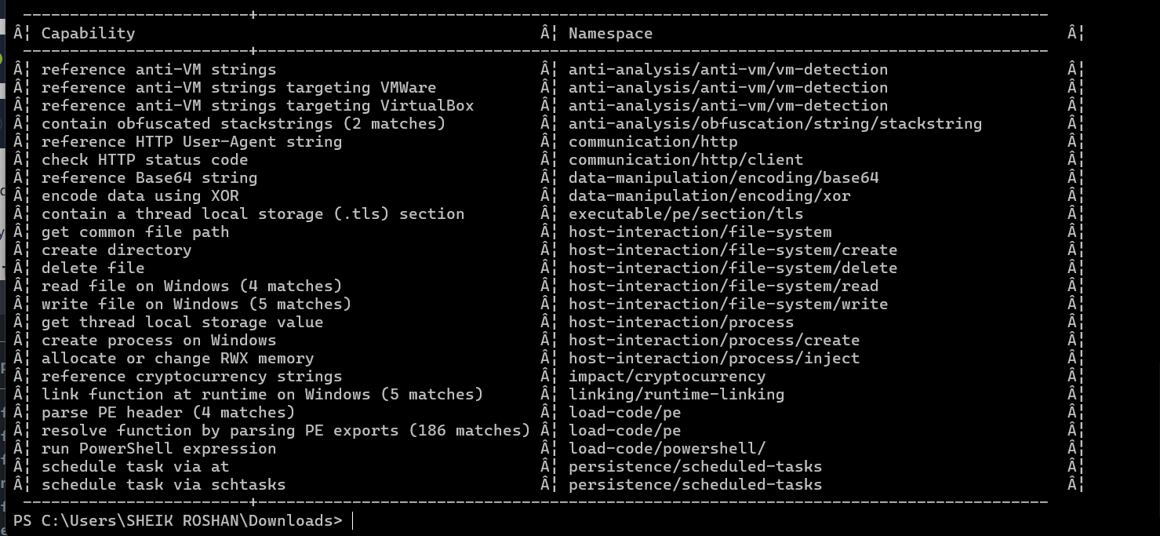
The content of this block is represented in the below format.
Format | Sample | Explanation
Capability(Rule Name)::TLN(Top-Level Namespace)/Namespace | reference anti-VM strings::Anti-Analysis/anti-vm/vm-detection | Reference anti-VM strings = Capability(Rule Name)  Anti-Analysis = TLN or Top-Level Namespace  anti-vm/vm-detection = Namespace

Namespaces
CAPA uses namespaces to group items with the same purpose.
Top-Level Namespace (TLN) |  | Explanation
anti-analysis |  | contains a set of rules specifically designed to detect behaviours exhibited by malware to evade analysis. These behaviours include obfuscation, packing, and anti-debugging techniques.
collection |  | contains a set of data-related rules that malware may enumerate and collect for exfiltration or other purposes. Think of it as the “data-gathering” aspect of malware behaviour.
communication |  | contains a set of rules that pertain to different communication behaviours demonstrated by malware. This encompasses how malware interacts with networks, including data transmission and reception, command and control communications, and other network-related behaviours.
compiler |  | contains a set of rules and configurations for recognizing specific build environments or compilers employed in generating executables. These namespaces essentially serve as the unique “signature” that identifies the compilation process of a program.
data-manipulation |  | contains a set of rules that govern the behaviours involved in altering data within executable files. This aspect can be considered the “data transformation” component of malware behaviour, encompassing actions such as String Encryption and Data Encoding.
executable | contains a set of rules pertaining to the attributes in executable files. These attributes include PE sections or debug info associated with the executable.
host-interaction | contains a set of rules related to behaviors involving interactions with the host system. This encompasses how malware interacts with its environment. Specifically, the rules in this namespace may capture behaviors related to reading, writing, or modifying files on disk, including creating, deleting, or modifying files and directories.”
impact | contains a set of rules related to the potential consequences or effects of a program’s behavior. Think of it as the aspect that focuses on the possible harm that this malware can cause. It may include behaviors related to establishing remote access, data exfiltration, destruction, or modification.”
internal | Rules contained within the system are not intended for direct use by analysts or for reporting. Instead, these rules are meant for internal purposes within the CAPA tool, serving as the behind-the-scenes aspect of rule development and execution.
lib | building blocks to create other rules
linking | contains rules to identify behaviors involving linking or dynamically loading external code or libraries during program execution. This is its primary function and is crucial for the program’s security. Understanding linking behavior is essential for several reasons. Malware often depends on external libraries or components (such as OpenSSL, Zlib, or other third-party libraries) to carry out specific tasks. Detecting these dependencies helps analysts understand the malware’s capabilities. External libraries also introduce an additional attack surface. If a vulnerability exists in a linked library, it can be exploited by the malware or defenders during analysis.
load-code | contains a set of rules and regulations related to the behaviors associated with dynamically loading or executing code during program execution. This concept can be equated to the “runtime code injection” aspect of malware behavior, which involves unauthorized code introduction during a program’s execution.
malware-family | contains a set of rules related to behaviors that are linked to particular malware families or groups. It serves as a way to identify the distinct characteristics or “signatures” associated with known malware families, allowing for more accurate detection and classification of potential threats.
nursery | this is a staging ground that contains rules for those who are not quite polished
persistence | contains rules related to behaviors associated with maintaining access or persistence within a compromised system. This namespace is essentially focused on understanding how malware can establish and maintain a presence within a compromised environment, allowing it to persist and carry out malicious activities over an extended period.
runtime | contains a set of rules that seek to identify the language or platform on which the program runs.
targeting | contains a set of rules related to behaviors exhibited by programs that interact with ATMs.

For this, we only used Anti-Analysis as the TLN or Top-Level Namespace. Under this TLN, we have grouped namespaces, such as anti-vm/vm-detection and obfuscation. Each namespace has a collection of rules inside them that are also grouped together. For anti-vm/vm-detection, we have rules, and it's config file, such as:
- reference-anti-vm-strings-targeting-virtualbox.yml
- reference-anti-vm-strings-targeting-virtualpc.yml
The same goes for the obfuscation namespace. We have rules that are grouped, such as:
- obfuscated-with-dotfuscator.yml
- obfuscated-with-smartassembly.yml
Again, do note that this is still under TLN Anti-Analysis!
Please also refer to the illustration below.
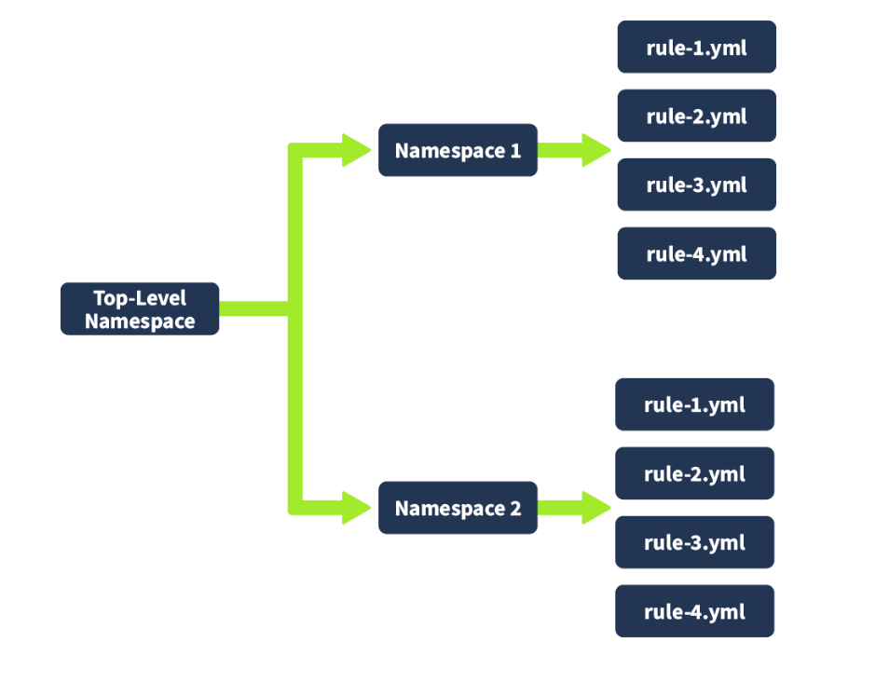
In addition to what was mentioned in the above table, there are still a few more namespaces under Anti-Analysis with corresponding rules. If you want to dig deeper, please check this link(opens in new tab).
Use this link(opens in new tab) if you are interested in the other TLN or Top-Level Namespaces, such as collection, compiler, persistence, linking, and impact.

Practical:
Which top-level Namespace contains a set of rules specifically designed to detect behaviours, including obfuscation, packing, and anti-debugging techniques exhibited by malware to evade analysis?
Anti-analysis
Which namespace contains rules to detect virtual machine (VM) environments? Note that this is not the TLN or Top-Level Namespace.
anti-vm/vm-detection
Which Top-Level Namespace contains rules related to behaviours associated with maintaining access or persistence within a compromised system? This namespace is focused on understanding how malware can establish and maintain a presence within a compromised environment, allowing it to persist and carry out malicious activities over an extended period.
Persistence
Which namespace addresses techniques such as String Encryption, Code Obfuscation, Packing, and Anti-Debugging Tricks, which conceal or obscure the true purpose of the code?
Obfuscation
Which Top-Level Namespace Is a staging ground for rules that are not quite polished?
Nursery

Dissecting CAPA Results Part 4: Capability
In this task, we will continue the discussion from the previous task.

Capability
Below is a table with the Capability and its related TLN, namespace, and the rules associated with the yaml file. Please have a good look.
Capability | Top-Level Namespace (TLN) | Namespaces | Rule YAML file | Notes
reference anti-VM strings | Anti-Analysis(opens in new tab) | anti-vm/vm-detection | reference-anti-vm-strings.yml | To check all rules under this namespace, click here(opens in new tab)
reference anti-VM strings targeting VMWare | Anti-Analysis | anti-vm/vm-detection | reference-anti-vm-strings-targeting-vmware.yml | To check all rules under this namespace, click here(opens in new tab)
reference anti-VM strings targeting VirtualBox | Anti-Analysis | anti-vm/vm-detection | reference-anti-vm-strings-targeting-virtualbox.yml | You may check the TLN(Top-Level Namespace).
reference HTTP User-Agent string | Communication(opens in new tab) | http/client | reference-http-user-agent-string.yml | To check all rules under this namespace, click here(opens in new tab))
check HTTP status code | Communication | http | check-http-status-code.yml | To check all rules under this namespace, click here(opens in new tab)
View More Capability
reference Base64 string | Data Manipulation(opens in new tab) | encoding/base64 | reference-base64-string.yml | To check all rules under this namespace, click here(opens in new tab)
encode data using XOR | Data Manipulation | encoding/XOR | encode-data-using-xor.yml | To check all rules under this namespace, click here(opens in new tab)
contain a thread local storage (.tls) section | Executable(opens in new tab) | pe/section/tls | contain-a-thread-local-storage-tls-section.yml | You may check the TLN(Top-Level Namespace) for more rules.
get common file path | Host-Interaction(opens in new tab) | file-system | get-common-file-path.yml | You may check the TLN(Top-Level Namespace) for more rules.
create directory | Host-Interaction | file-system/create | create-directory.yml | You may check the TLN(Top-Level Namespace) for more rules.
delete file | Host-Interaction | file-system/delete | delete-file.yml | To check all rules under this namespace, click here(opens in new tab)
read file on Windows | Host-Interaction | file-system/read | read-file-on-windows.yml | To check all rules under this namespace, click here(opens in new tab)
write file on Windows | Host-Interaction | file-system/write | write-file-on-windows.yml | To check all rules under this namespace, click here(opens in new tab)
get thread local storage value | Host-Interaction | process | get-thread-local-storage-value.yml | This rule is found under TLN Nursery(opens in new tab), a staging ground for unpolished rules.
allocate or change RWX memory | Host-Interaction | process/inject | allocate-or-change-rwx-memory.yml | To check all rules under this namespace, click here(opens in new tab)
create process on Windows | Host-Interaction | process create | create-process-on-windows.yml | To check all rules under this namespace, click here(opens in new tab)
reference cryptocurrency strings | Impact(opens in new tab) | impact/cryptocurrency | reference-cryptocurrency-strings.yml | This rule is found under TLN Nursery(opens in new tab), a staging ground for unpolished rules.
link function at runtime on Windows | Linking(opens in new tab) | runtime-linking | link-function-at-runtime-on-windows.yml | To check all rules under this namespace, click here(opens in new tab)
parse PE header | load-code(opens in new tab) | load-code/pe | parse-pe-header.yml  resolve-function-by-parsing-pe-exports.yml | To check all rules under this namespace, click here(opens in new tab)
resolve function by parsing PE exports | load-code(opens in new tab) | load-code/pe | resolve-function-by-parsing-pe-exports.yml | To check all rules under this namespace, click here(opens in new tab)
run PowerShell expression | load-code(opens in new tab) | load-code/PowerShell | run-powershell-expression.yml | To check all rules under this namespace, click here(opens in new tab)
schedule task via at | persistence(opens in new tab) | scheduled-tasks | schedule-task-via-at.yml | You may check the TLN(Top-Level Namespace) for more rules.
schedule task via schtasks | persistence(opens in new tab) | scheduled-tasks | schedule-task-via-schtasks.yml | You may check the TLN(Top-Level Namespace) for more rules.

To further explain this, let’s check the first capability on the table, “reference anti-VM strings”.
- We note that the related rules in YML format are reference-anti-vm-strings.yml
- This is under the namespace anti-vm/vm-detection
- which is also under the Top-Level Namespace Anti-Analysis
This tells us that CAPA was able to identify that the potentially malicious software searches for VMware-specific registry keys, the presence of VMware tools, or other VM-related elements by using the reference-anti-vm-strings.yml rule yaml file. Malware typically does this behaviour to avoid detection. That is why CAPA flagged this one.
Let’s have another example. Let’s look at "schedule task via schtasks".
- We note that the related rules in YML format is schedule-task-via-schtasks.yml*
- This is under the namespace scheduled-tasks
- which is also under the Top-Level Namespace persistence
This tells us that CAPA could identify behaviours related to scheduled tasks within the Windows operating system. It might have recognized patterns indicating that the executable registers itself as a scheduled task to maintain persistence using the rule defined in schedule-task-via-schtasks.yml.
Hold on! Have you noticed something?
That’s right! The item under Capability has the same name as the YML files under the Rules, with the addition of a dash (-) character between spaces! Simple because Capability is the name of the rule.
Now, we want to take note of some exceptions here. Where the Capability or rules are not located under its Namespace, let’s take the Capability reference cryptocurrency strings from the table above; this should be under the Impact Top-Level Namespace, right? However, if you go through the folders, you won’t be able to find the corresponding rules. It will be located under the Nursery TLN. This is the placeholder for rules that are not quite polished yet.
Now that we have a good overview and understanding of the Capability and Namespace contents, we should be able to explain the sample result from the previous tasks. Therefore, let’s do a quick recap using one of the results. Shall we?
Here's the explanation for the above result. See the table below.
Label | Value | Explanation
Capability | reference base64 string | Malware has the capability to encode data using a base64 scheme.
Top-Level Namespace | data-manipulation | contains a set of rules that govern the behaviors involved in altering data within executable files. This aspect can be considered the “data transformation” component of malware behaviour, encompassing actions such as String Encryption and Data Encoding.
Namespace | encoding/base64 | this namespace consists of rules for encoding and decoding data using Base64 and XOR
Rule YAML File Matched? | reference-base64-string.yml | Remember that the capability's name is also the rule's name with an additional dash (-) character between spaces.
Knowing this information, you may say this file can use the base64 encoding scheme!

More Information, more fun!
Aren't you curious about what precisely within the rule was matched? Well, I am!
In this task, we will seek to determine the reason for triggering the rules and the conditions involved. We will use the parameter -vv or **very verbose** to achieve this.
Option | Description | Sample Syntax
-v or --verbose | enable verbose result document | capa.exe -v .\cryptbot.bin
-vv or --vverbose | enable very verbose result document) | capa.exe -vv .\cryptbot.bin

Let's run it!
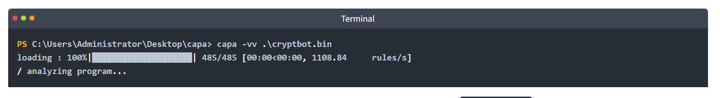
This will give us more detailed results; however, this will take a lot of time. We already processed this and named the file cryptbot_vv.txt in "C:\Users\Administrator\Desktop\capa". Remember, you don't need to wait for the tool to finish running; we did this so that you can get a feel for running the tool and experiment with its parameters.

CAPA Web Explorer
The second thing we need to do is upload the file to CAPA Explorer Web. We can either use their online version here on this link(opens in new tab), or the offline version already in the virtual machine. There is a Google Chrome browser on the desktop named capa_web_explorer_offline.html. Alternatively, you can access this using a regular Chrome browser bookmark. Note that the local page may take up to a minute to load in Chrome on the target machine.
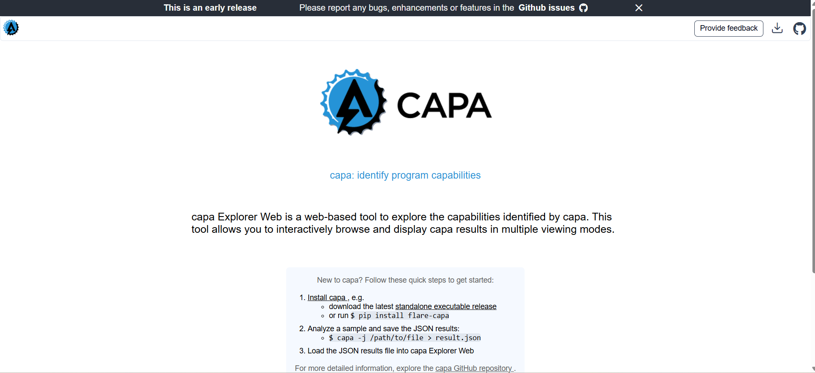
Look for the button Upload from local located at the bottom left of the page and select the file cryptbot_vv.json in C:\Users\Administrator\Desktop\capa. Once uploaded, you should have a similar output.
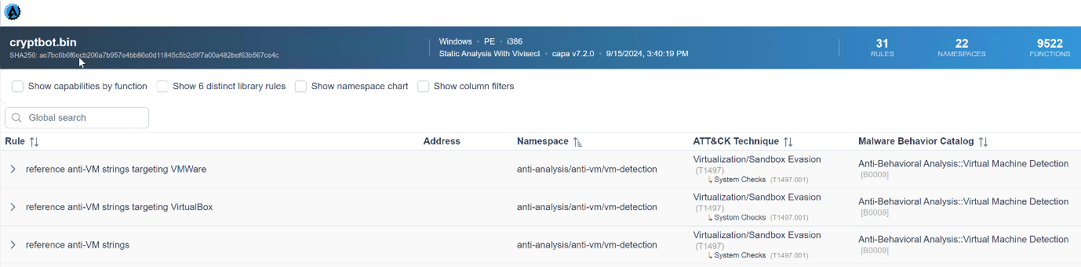

Doesn't this look good and easier to use? I bet it is!

Now, it's time to explore this excellent addition to the tool. We'll review some capabilities and check what precisely within the rule was matched. This will give us a better idea of how the rule works.
Let's go through our first example below. We know that the capability was to reference anti-VM strings targeting VMWare, and the corresponding rule config file or yaml file is anti-VM-Strings-targeting-VMWare.yml. Notice the box from the image.
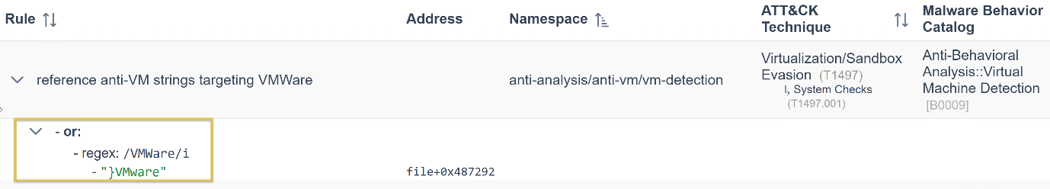
Then, let us show you an overview of the rule's content. Focus on the features as CAPA uses the succeeding strings below to check if strings are within the analyzed file. 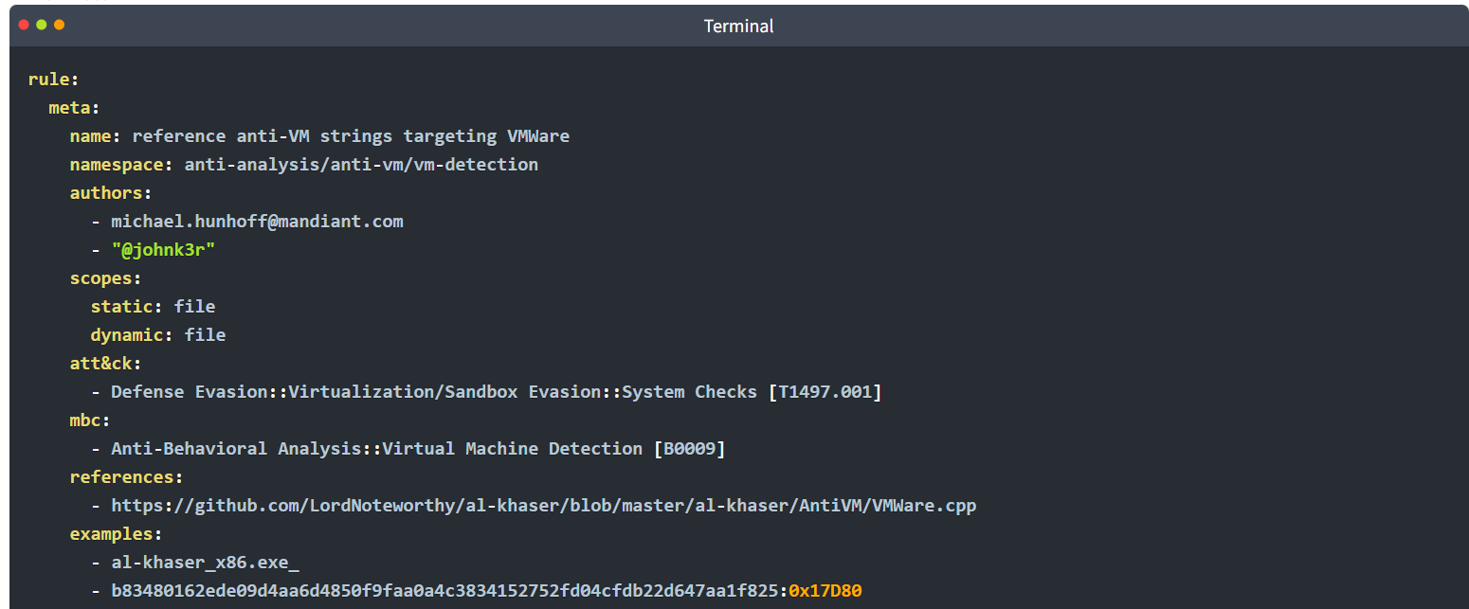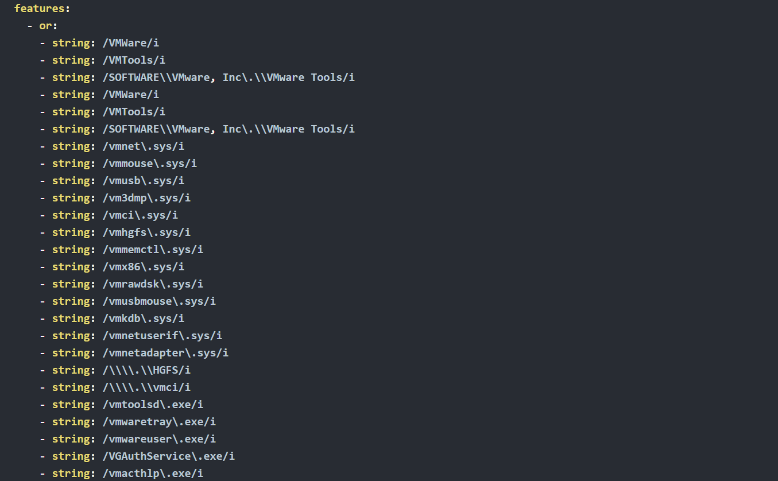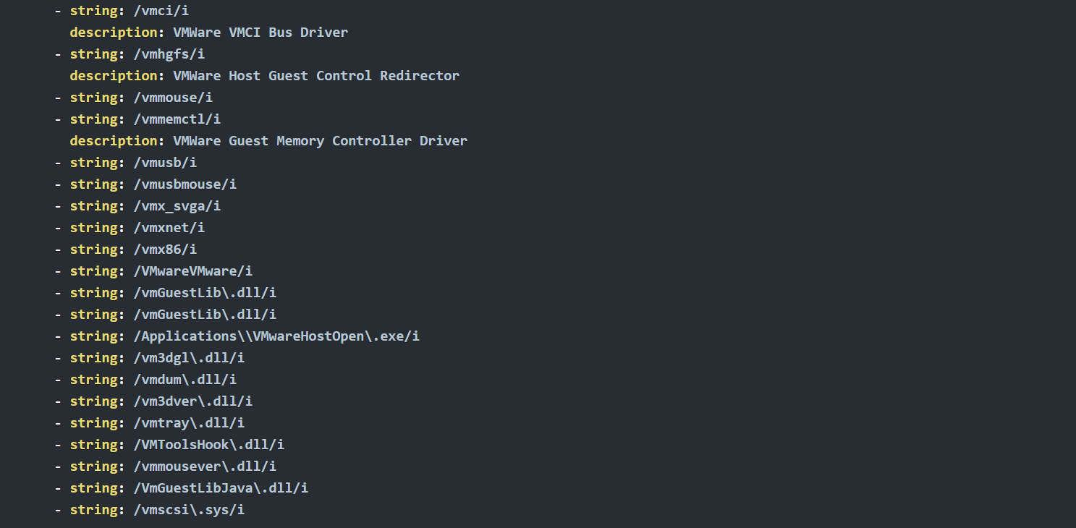
Did you see it? That's right! Under the features, the "string: /VMWare/i" is being referenced by CAPA Web Explorer. Simply, CAPA is saying that under this namespace, we could identify strings with a value of VMWare by using the conditions within the rule and with regex.
Let's have another sample. We know that the capability was to reference the scheduled task via schtasks, and the corresponding rule was to schedule the task via schtasks.yml. Notice the box from the image.
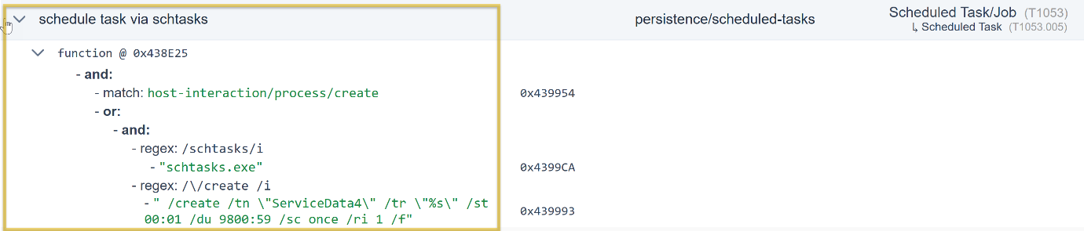
The same applies to our first example; we will show you the rule's content overview. Focus on the features, as CAPA uses the succeeding strings below to check if there are strings within the file being analyzed.
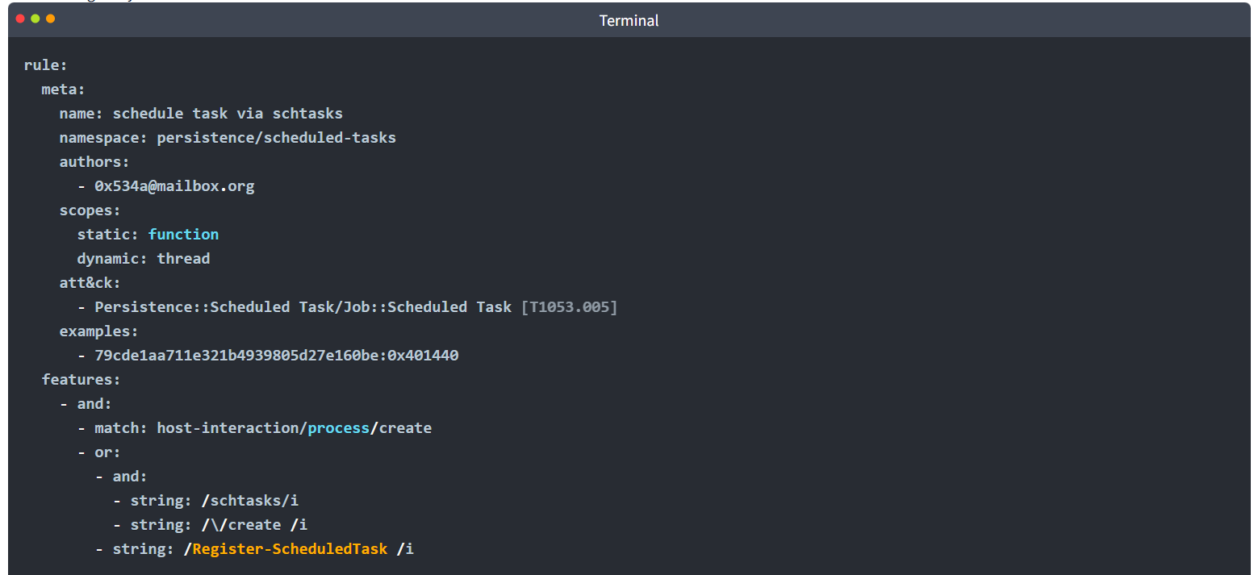
Under the feature, the "string: /schtasks/i and /\/create /i" is referenced by CAPA Web Explorer. Simply, CAPA is saying under this namespace, and by using the conditions within the rule and with regex, we could identify strings with a value of schtasks and create.

Global Search Box
Another cool feature of this tool is its filter options and the Global Search box, which are very helpful.
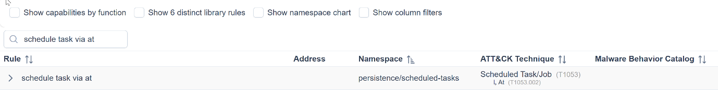
We could quickly examine this overwhelming information using CAPA Web Explorer compared to any text editor.
Feel free to explore more!

