Practical Example of Defensive Security

The Scenario
Let us pretend you are a Security Operations Center (SOC) analyst responsible for protecting a bank. This bank's SOC uses a Security Information and Event Management (SIEM) tool, which gathers security-related information and events from various sources and presents them in one dashboard. If the SIEM finds something suspicious, an alert will be generated.
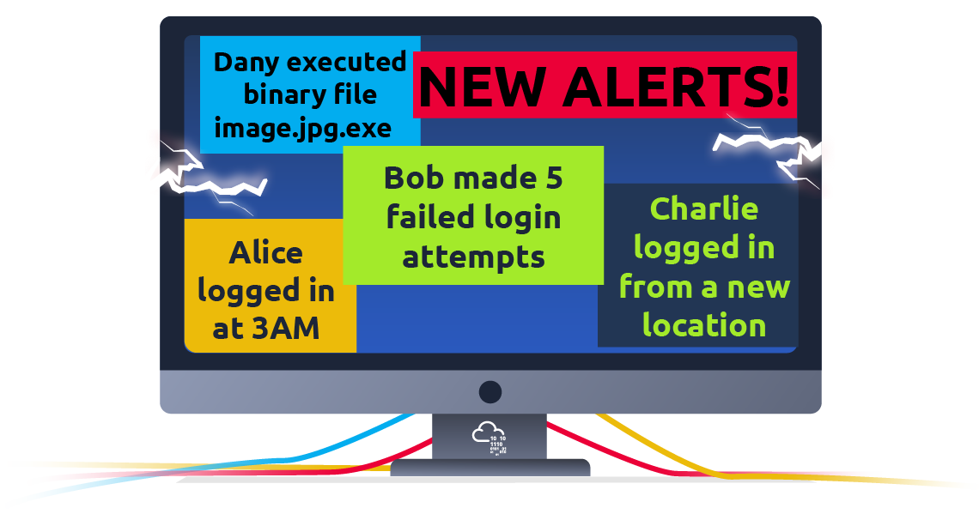
In THM

Simulating a SIEM
We have prepared a simplified, interactive simulation of a SIEM system to provide you with a hands-on experience similar to what cyber security analysts encounter.
To start this simulation, please click the "View Site" button below.
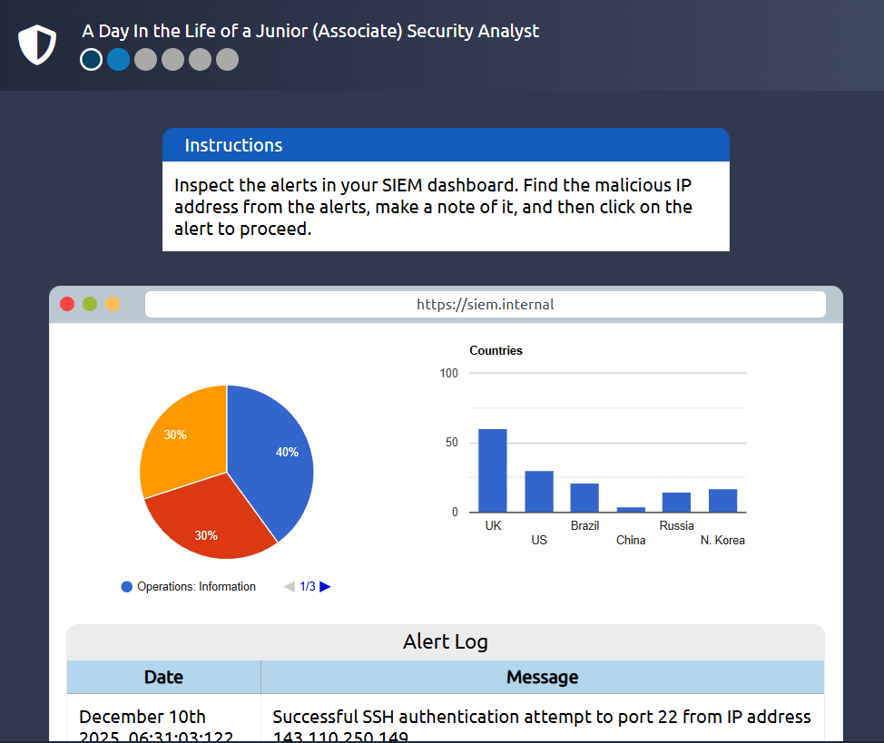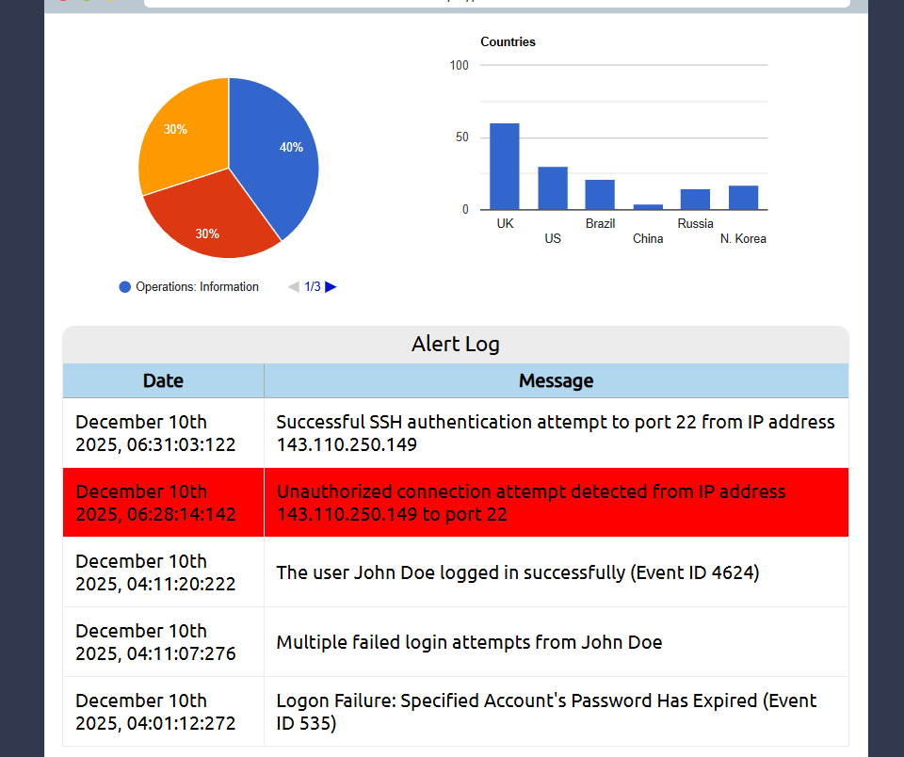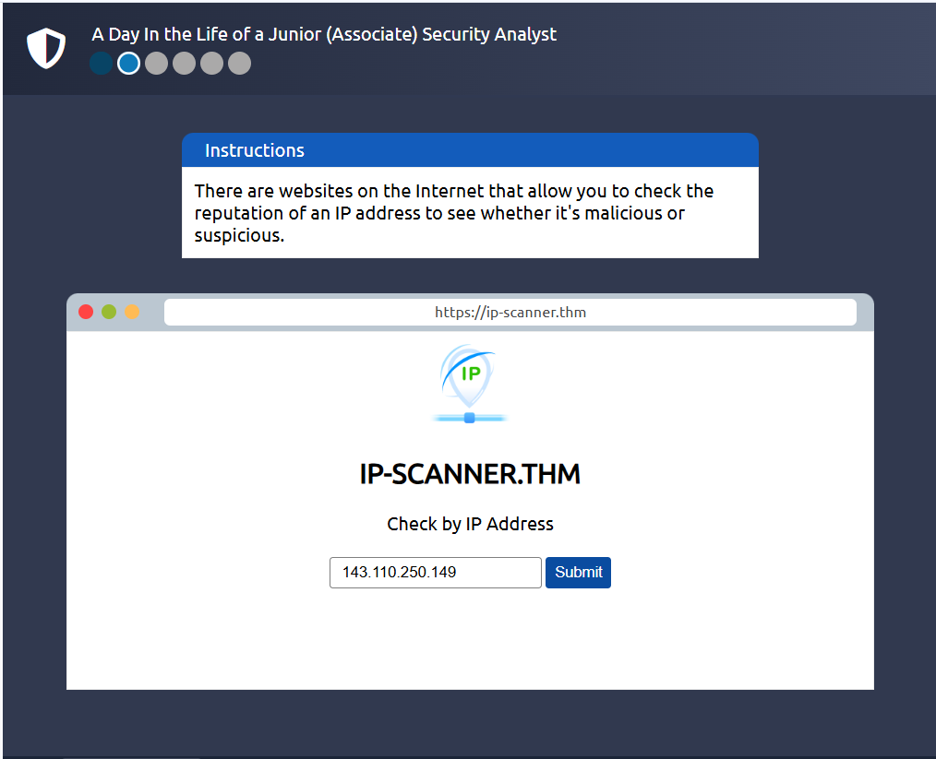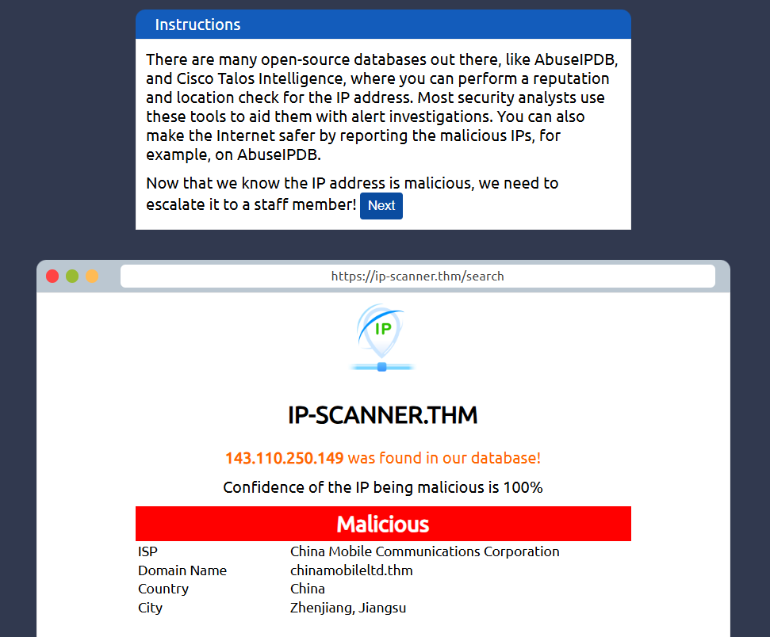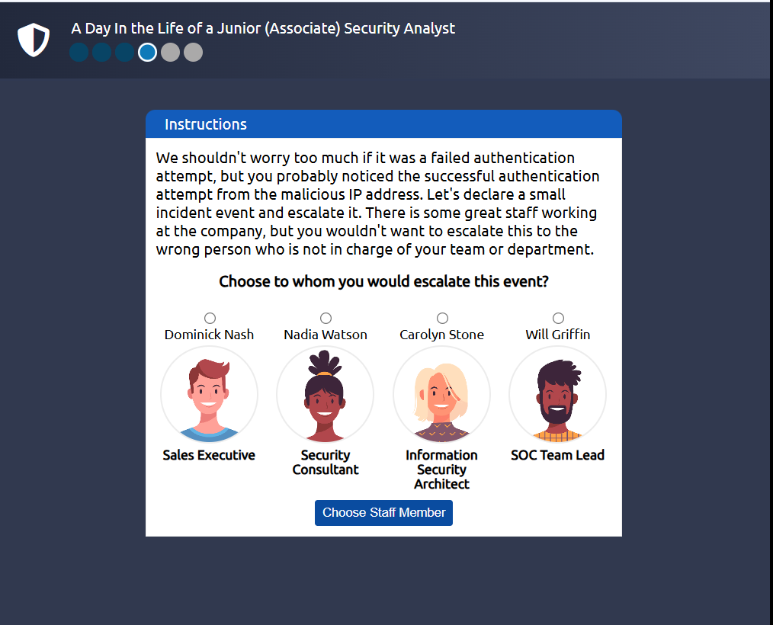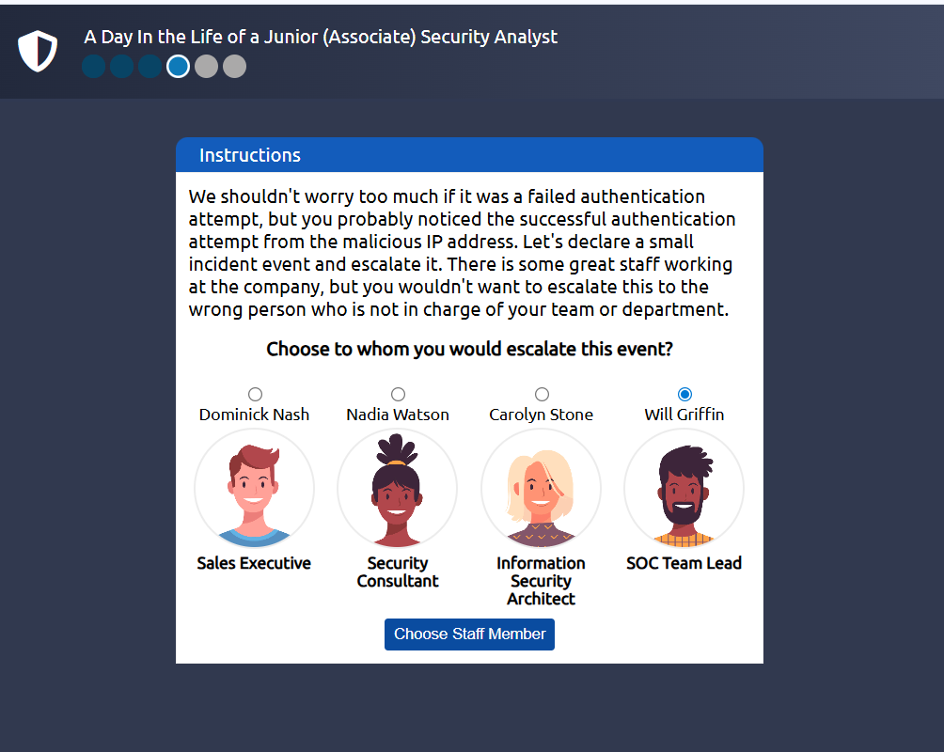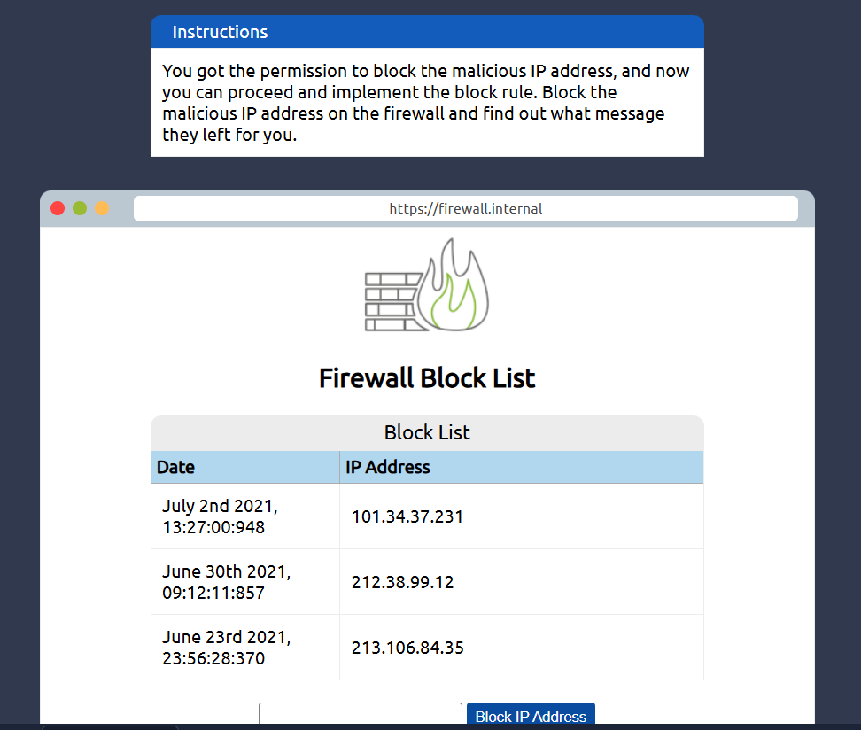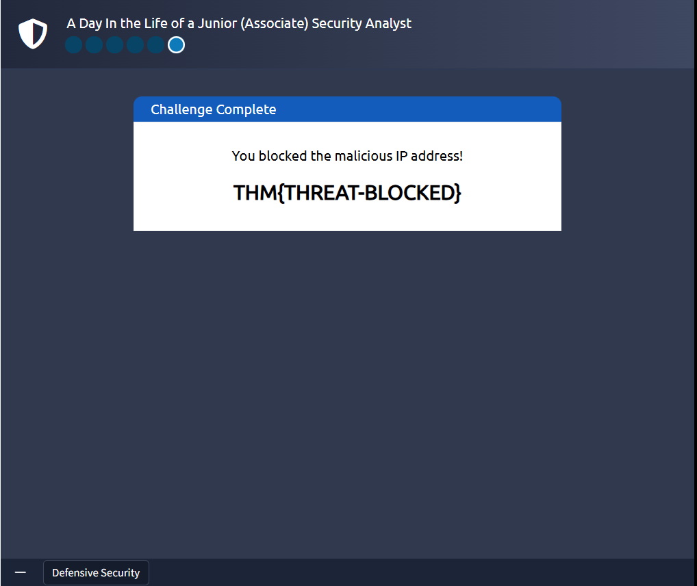

https://www.linkedin.com/sharing/share-offsite/?mini=true&url=https%3A%2F%2Ftryhackme.com%2Froom%2Fdefensivesecurityintro%3Futm_source%3Dlinkedin%26utm_medium%3Dsocial%26utm_campaign%3Dsocial_share%26utm_content%3Droom%26sharerId%3D6591813894e6fb47af016e74&text=I%20just%20completed%20Defensive%20Security%20Intro%20room%20on%20TryHackMe.%20Introducing%20defensive%20security%20and%20related%20topics%2C%20such%20as%20Threat%20Intelligence%2C%20SOC%2C%20DFIR%2C%20Malware%20Analysis%2C%20and%20SIEM.

