Introduction
Consider the scenario where you just downloaded a 6 GB file and want to know whether the copy you downloaded is identical to the original file, bit for bit. How would you do that? Or if a good Samaritan handed you this 6 GB file on a USB memory drive, how can you be sure it is identical to the file you want to download?
The answer to both of the above questions lies in comparing the hash values of the two files; if two hash values are equal, you can say with very high certainty that the two files are identical. But what is a hash value?
A hash value is a fixed-size string or characters that is computed by a hash function. A hash function takes an input of an arbitrary size and returns an output of fixed length, i.e., a hash value. We will cover various exciting and clever uses of hash functions and values in this room.
Note about terminology: We favoured the terms hash function and hash value. However, we occasionally use the word hash as a verb to mean calculate the hash value; moreover, we occasionally use the word hash by itself as a noun to refer to the hash value.

Hash Functions

What is a Hash Function?
Hash functions are different from encryption. There is no key, and it’s meant to be impossible (or computationally impractical) to go from the output back to the input.
A hash function takes some input data of any size and creates a summary or digest of that data. The output has a fixed size. It’s hard to predict the output for any input and vice versa. Good hashing algorithms will be relatively fast to compute and prohibitively slow to reverse, i.e., go from the output and determine the input. Any slight change in the input data, even a single bit, should cause a significant change in the output.
Let’s check an example. In the terminal below, we can see two files; the first contains the letter T, while the second contains the letter U. If you check T and U in an ASCII table or using hexdump, you will notice that the two letters differ by a single bit.
- The letter T is 54 in hexadecimal, i.e., 01010100 in binary.
- The letter U is 55 in hexadecimal, i.e., 01010101 in binary.
Consequently, the following two files differ by a single bit. However, if we compare their MD5 (Message-Digest Algorithm 5) hashes, their SHA1 (Secure Hash Algorithm 1) hashes, or their SHA-256 (Secure Hash Algorithm 256) hashes, we will notice that they are entirely different. We recommend that you try the commands below yourself. The files are located in ~/Hashing-Basics/Task-2/.
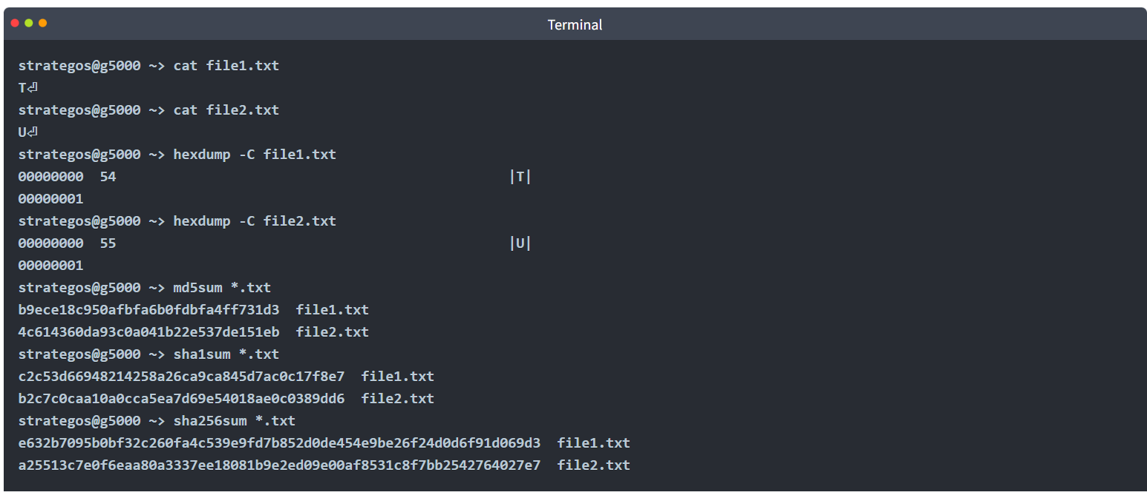
OR
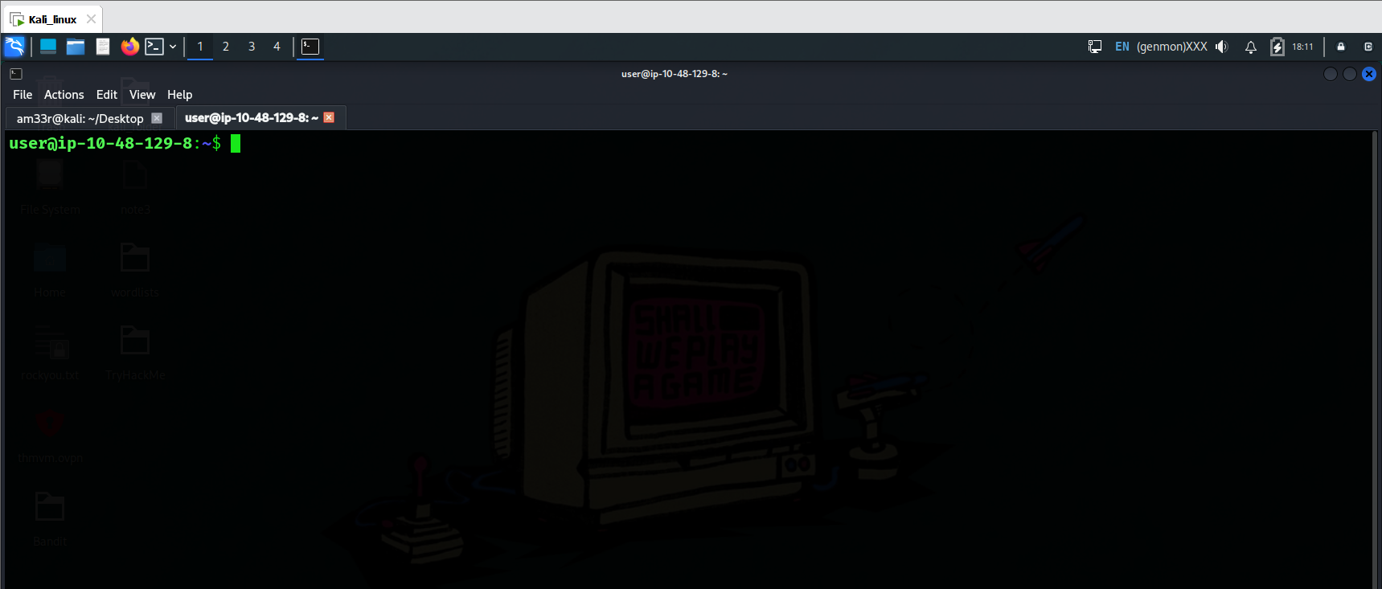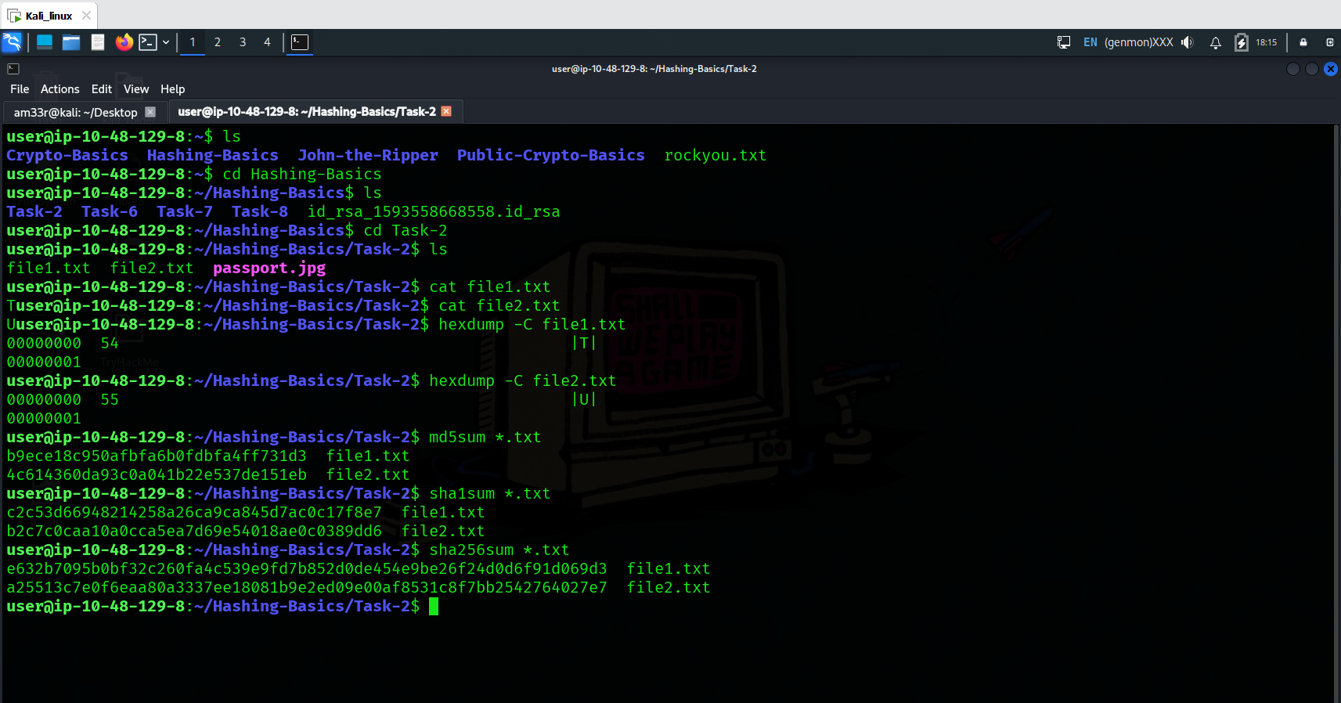
The output of a hash function is typically raw bytes, which are then encoded. Common encodings are base64 or hexadecimal. md5sum, sha1sum, sha256sum, and sha512sum produce their outputs in hexadecimal format. Remember that hexadecimal format prints each raw byte as two hexadecimal digits.

Why is Hashing Important?
Hashing plays a vital role in our daily use of the Internet. Like other cryptographic functions, hashing remains hidden from the user. Hashing helps protect data’s integrity and ensure password confidentiality.
Consider this example of hashing being used to protect your cyber security. When you log into TryHackMe, the server uses hashing to verify your password. In fact, as per good security practices, a server does not record your password; it records the hash value of your password. Whenever you want to log in, it will calculate the hash value of the password you submitted with the recorded hash value. Similarly, when you log into your computer, hashing plays a role in verifying your password. You interact more indirectly with hashing than you would think, and almost daily in the context of passwords.

What’s a Hash Collision?
A hash collision is when two different inputs give the same output. Hash functions are designed to avoid collisions as best as possible. Furthermore, hash functions are designed to prevent an attacker from being able to create, i.e., engineer, a collision intentionally. However, because the number of inputs is practically unlimited and the number of possible outputs is limited, this leads to a pigeonhole effect.
As a numeric example, if a hash function produces a 4-bit hash value, we only have 16 different hash values. The total number of possible hash values is 2^{number_of_bits} = 2⁴ = 16. The probability of a collision is relatively very high.
The pigeonhole effect states that the number of items (pigeons) is more than the number of containers (pigeonholes); some containers must hold more than one item. In other words, in this context, there are a fixed number of different output values for the hash function, but you can give it any size input. As there are more inputs than outputs, some inputs must inevitably give the same output. If you have 21 pigeons and 16 pigeonholes, some of the pigeons are going to share the pigeonholes. Consequently, collisions are unavoidable. However, a good hash function ensures that the probability of a collision is negligible.
MD5 and SHA1 have been attacked and are now considered insecure due to the ability to engineer hash collisions. However, no attack has yet given a collision in both algorithms simultaneously, so if you compare the MD5 and SHA1 hash, you will see that they’re different. You can view the MD5 collision example on the MD5 Collision Demo page; furthermore, you can read the details of the SHA1 collision attack at Shattered. Due to these, you shouldn’t trust either algorithm for hashing passwords or data.

Practical:
What is the SHA256 hash of the passport.jpg file in ~/Hashing-Basics/Task-2? 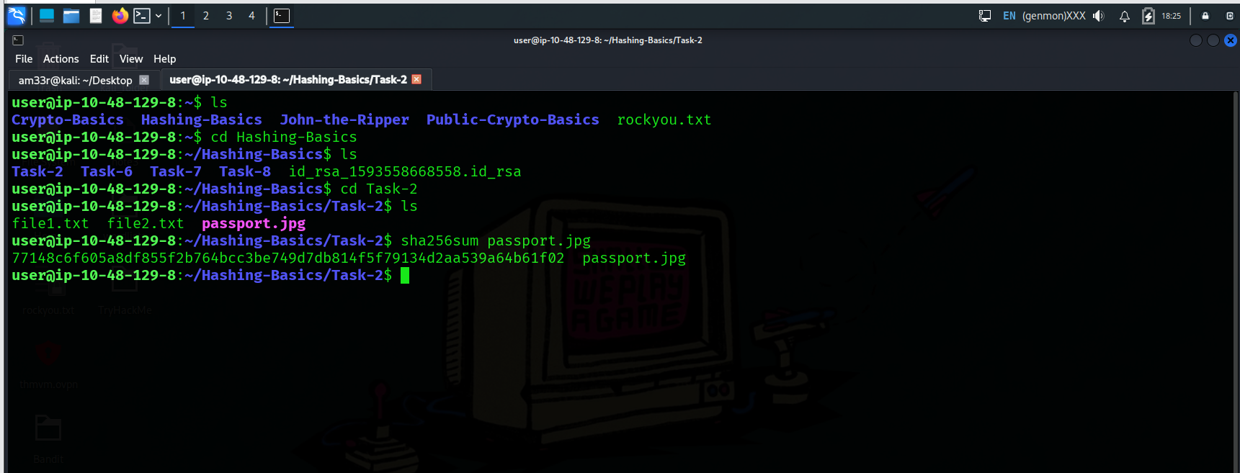

Insecure Password Storage for Authentication
Hashing has many uses in Cyber Security. In this room, we will focus on two uses: password storage and data integrity. We refer to password storage when used for authentication.
It is important to note that this does not apply to password managers, where you must retrieve your password in cleartext. On the other hand, authentication mechanisms only need to confirm that the user knows the password so they can be granted access to the resource; therefore, this problem differs from password managers.

Stories of Insecure Password Storage for Authentication
Most web applications need to verify a user’s password at some point. Storing these passwords in plaintext is a very insecure security practice. You’ve probably seen news stories about companies that have had their database leaked. Knowing that many people use the same password on their various accounts, including their online banking, leaking the password from one account jeopardises the security of all other accounts.
We will visit three insecure practices when it comes to passwords:
- Storing passwords in plaintext
- Storing passwords using a deprecated encryption
- Storing passwords using an insecure hashing algorithm
Storing Passwords in Plaintext
Quite a few data breaches have leaked plaintext passwords. You’re probably familiar with the “rockyou.txt” password list on Kali Linux, among many other offensive security distributions. This password list came from RockYou, a company that developed social media applications and widgets. They stored their passwords in plaintext, and the company had a data breach. The text file contains over 14 million passwords. You can find rockyou.txt in the /usr/share/wordlists directory.
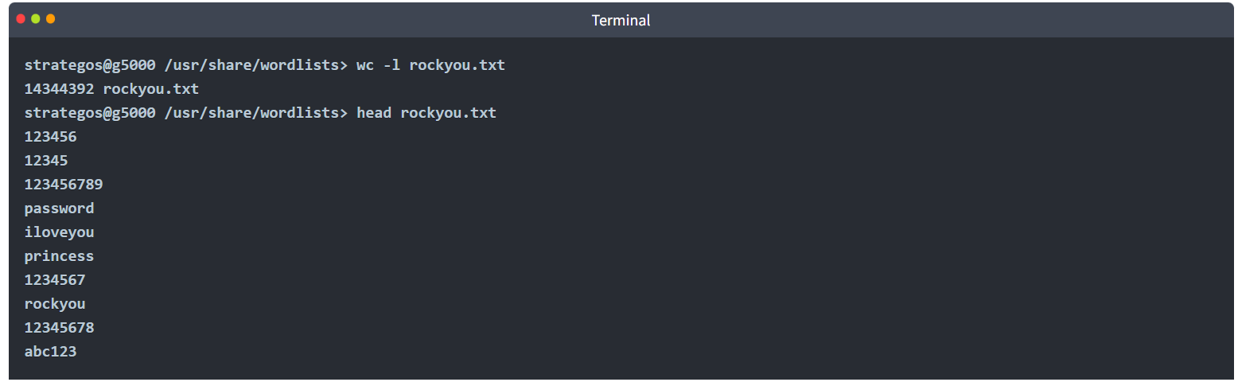
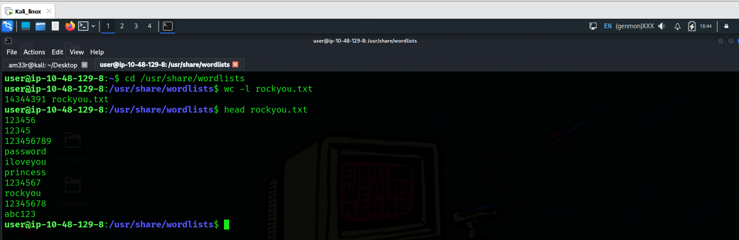
Using an Insecure Encryption Algorithm
Adobe’s notable data breach was slightly different. Instead of using a secure hashing function to store the hash values of the passwords, the company used a deprecated encryption format. Furthermore, password hints were stored in plain text, sometimes containing the password itself. Consequently, the plaintext password could be retrieved relatively quickly.
Using an Insecure Hash Function
LinkedIn also suffered a data breach in 2012. LinkedIn used an insecure hashing algorithm, the SHA-1, to store user passwords. Furthermore, no password salting was used. Password salting refers to adding a salt, i.e., a random value, to the password before it is hashed.

Practical:
What is the 20th password in rockyou.txt?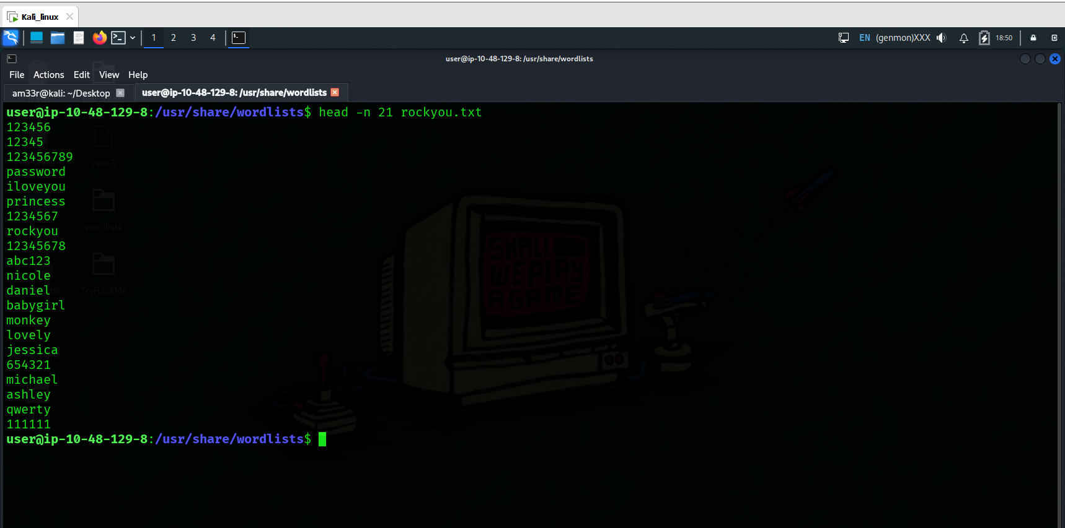

Using Hashing for Secure Password Storage
This is where hashing comes in. What if, instead of storing the password, you just stored its hash value using a secure hashing function? This process means you never have to store the user’s password, and if your database is leaked, an attacker will have to crack each password to find out what the password was.
There’s just one problem with this. What if two users have the same password? As a hash function will always turn the same input into the same output, you will store the same password hash for each user. That means if someone cracks that hash, they gain access to more than one account. It also means someone can create a Rainbow Table to break the hashes.
A Rainbow Table is a lookup table of hashes to plaintexts, so you can quickly find out what password a user had just from the hash. A rainbow table trades the time to crack a hash for hard disk space, but it takes time to create. Here’s a quick example to get an idea of what a rainbow table looks like.
Hash | Password
02c75fb22c75b23dc963c7eb91a062cc | zxcvbnm
b0baee9d279d34fa1dfd71aadb908c3f | 11111
c44a471bd78cc6c2fea32b9fe028d30a | asdfghjkl
d0199f51d2728db6011945145a1b607a | basketball
dcddb75469b4b4875094e14561e573d8 | 000000
e10adc3949ba59abbe56e057f20f883e | 123456
e19d5cd5af0378da05f63f891c7467af | abcd1234
e99a18c428cb38d5f260853678922e03 | abc123
fcea920f7412b5da7be0cf42b8c93759 | 1234567
4c5923b6a6fac7b7355f53bfe2b8f8c1 | inS3CyourP4$$

Websites like CrackStation and Hashes.com internally use massive rainbow tables to provide fast password cracking for hashes without salts. Doing a lookup in a sorted list of hashes is quicker than trying to crack the hash.
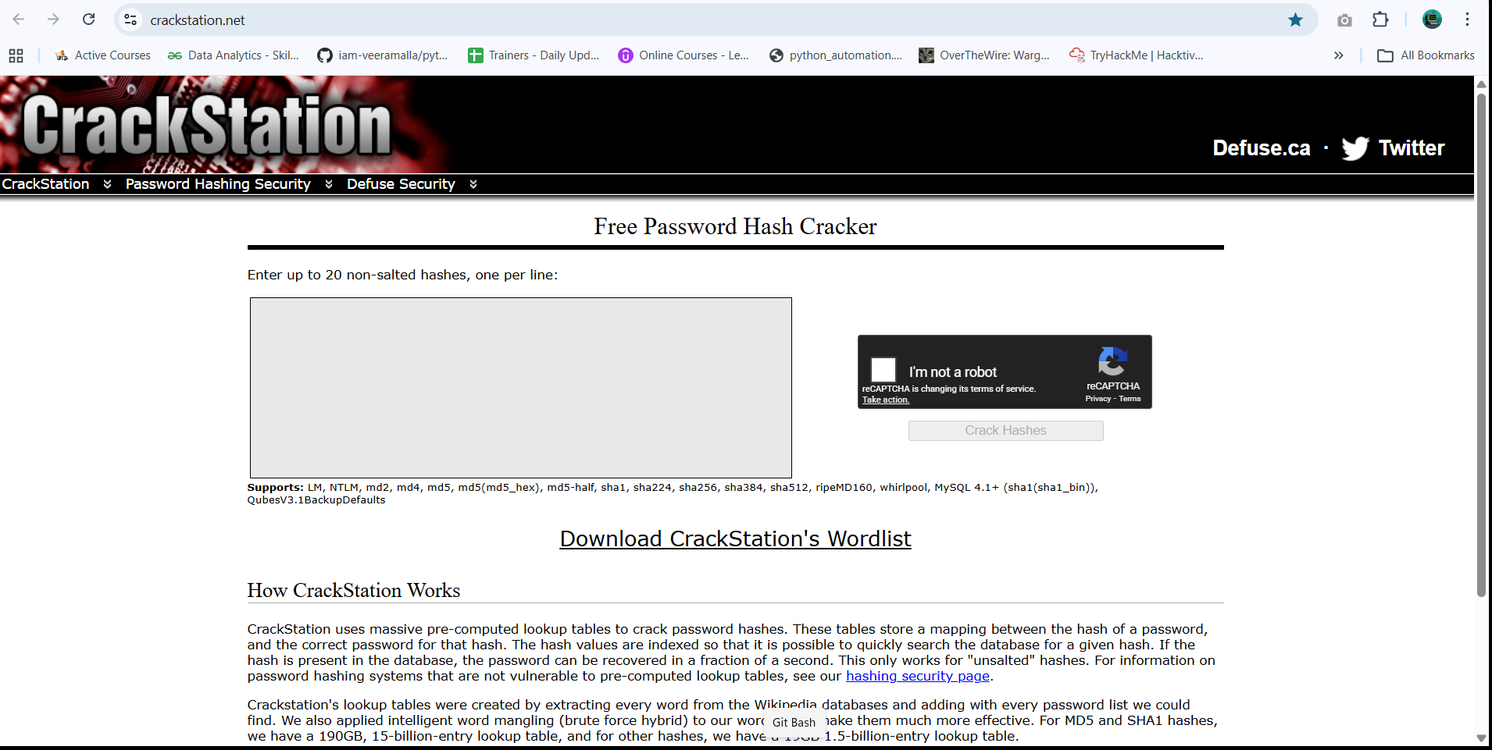
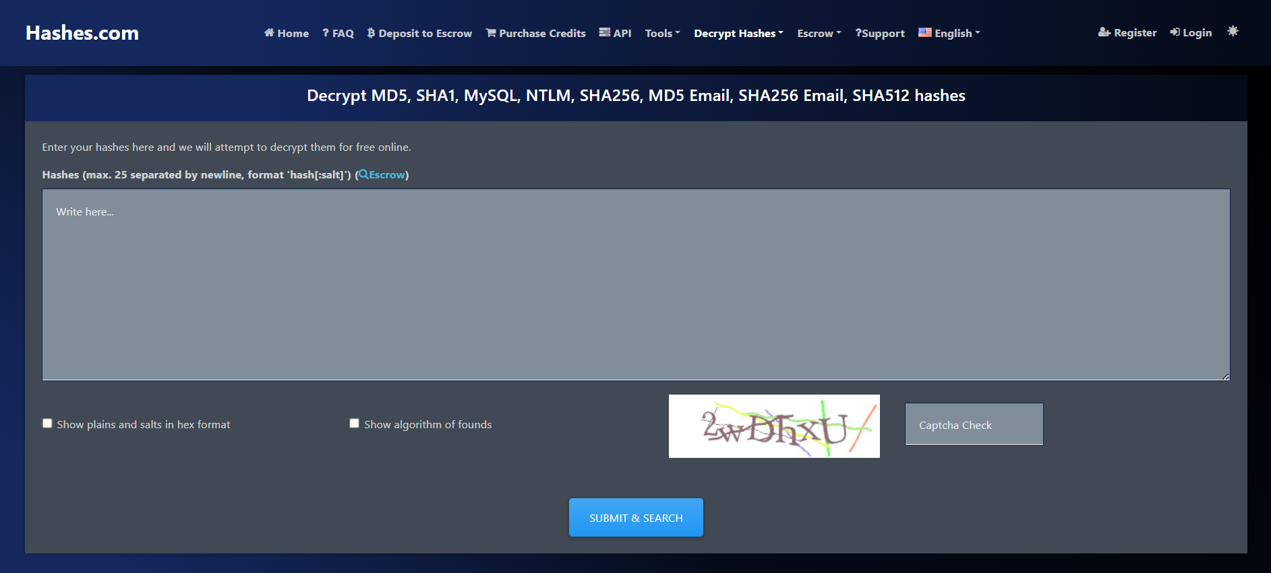
Protecting Against Rainbow Tables
To protect against rainbow tables, we add a salt to the passwords. The salt is a randomly generated value stored in the database and should be unique to each user. In theory, you could use the same salt for all users, but duplicate passwords would still have the same hash and a rainbow table could still be created for passwords with that salt.
The salt is added to either the start or the end of the password before it’s hashed, and this means that every user will have a different password hash even if they have the same password. Hash functions like Bcrypt and Scrypt handle this automatically. Salts don’t need to be kept private.
Example of Securely Storing Passwords
You can find many good guides online that promote best security practices when storing passwords. Please check if there are any standards you need to follow when storing passwords before adopting one. Consider this example following good security practices when storing user passwords:
- We select a secure hashing function, such as Argon2, Scrypt, Bcrypt, or PBKDF2.
- We add a unique salt to the password, such as Y4UV*^(=go_!
- Concatenate the password with the unique salt. For example, if the password is AL4RMc10k, the result string would be AL4RMc10kY4UV*^(=go_!
- Calculate the hash value of the combined password and salt. In this example, using the chosen algorithm, you need to calculate the hash value of AL4RMc10kY4UV*^(=go_!.
- Store the hash value and the unique salt used (Y4UV*^(=go_!).
Using Encryption to Store Passwords
Considering the problem of saving passwords for authentication, why don’t we encrypt passwords instead of all these cumbersome steps? The reason is that even if we select a secure hashing algorithm to encrypt the passwords before storing them, we still need to store the used key. Consequently, if someone gets the key, they can easily decrypt all the passwords.

Recognising Password Hashes
From the cyber defensive security perspective, we covered how to store passwords securely for authentication systems. Let’s tackle this from the offensive security perspective; if we start with a hash, how can we recognise its type, eventually crack it, and recover the original password?
Automated hash recognition tools such as hashID exist but are unreliable for many formats. For hashes that have a prefix, the tools are reliable. Use a healthy combination of context and tools. If you find the hash in a web application database, it’s more likely to be MD5 than NTLM (NT LAN Manager). Automated hash recognition tools often get these hash types mixed up, highlighting the importance of learning yourself.

Linux Passwords
On Linux, password hashes are stored in /etc/shadow, which is normally only readable by root. They used to be stored in /etc/passwd, which was readable by everyone.
The shadow file contains the password information. Each line contains nine fields, separated by colons (:). The first two fields are the login name and the encrypted password. More information about the other fields can be found by executing man 5 shadow on a Linux system.
The encrypted password field contains the hashed passphrase with four components: prefix (algorithm id), options (parameters), salt, and hash. It is saved in the format $prefix$options$salt$hash. The prefix makes it easy to recognise Unix and Linux-style passwords; it specifies the hashing algorithm used to generate the hash.
Here’s a quick table of some of the most common Unix-style password prefixes you might encounter. They are listed in the order of decreasing strength. You can read more about them by checking the man page with man 5 crypt.
Prefix | Algorithm
$y$ | yescrypt is a scalable hashing scheme and is the default and recommended choice in new systems
$gy$ | gost-yescrypt uses the GOST R 34.11-2012 hash function and the yescrypt hashing method
$7$ | scrypt is a password-based key derivation function
$2b$, $2y$, $2a$, $2x$ | bcrypt is a hash based on the Blowfish block cipher originally developed for OpenBSD but supported on a recent version of FreeBSD, NetBSD, Solaris 10 and newer, and several Linux distributions
$6$ | sha512crypt is a hash based on SHA-2 with 512-bit output originally developed for GNU libc and commonly used on (older) Linux systems
$md5 | SunMD5 is a hash based on the MD5 algorithm originally developed for Solaris
$1$ | md5crypt is a hash based on the MD5 algorithm originally developed for FreeBSD

Modern Linux Example
Consider the following line from a modern Linux system’s shadow password file.
The fields are separated by colons. The important ones are the username and the hash algorithm, salt, and hash value. The second field has the format $prefix$options$salt$hash.
In the example above, we have four parts separated by $:
- y indicates the hash algorithm used, yescrypt
- j9T is a parameter passed to the algorithm
- 76UzfgEM5PnymhQ7TlJey1 is the salt used
- /OOSg64dhfF.TigVPdzqiFang6uZA4QA1pzzegKdVm4 is the hash value
MS Windows Passwords
MS Windows passwords are hashed using NTLM, a variant of MD4. They’re visually identical to MD4 and MD5 hashes, so it’s very important to use context to determine the hash type.
On MS Windows, password hashes are stored in the SAM (Security Accounts Manager). MS Windows tries to prevent normal users from dumping them, but tools like mimikatz exist to circumvent MS Windows security. Notably, the hashes found there are split into NT hashes and LM hashes.
A great place to find more hash formats and password prefixes is the Hashcat Example Hashes page. For other hash types, you’ll typically need to check the length or encoding or even conduct some research into the application that generated them. Never underestimate the power of research.

Password Cracking
We’ve already mentioned rainbow tables as a method to crack hashes that don’t use a salt, but what if there’s a salt involved?
You can’t “decrypt” password hashes. They’re not encrypted. You have to crack the hashes by hashing many different inputs (such as rockyou.txt as it covers many possible passwords), potentially adding the salt if there is one and comparing it to the target hash. Once it matches, you know what the password was. Tools like Hashcat and John the Ripper are commonly used for these purposes.
Cracking Passwords with GPUs
Modern GPUs (Graphics Processing Units) have thousands of cores. They are specialised in digital image processing and accelerating computer graphics. Although they can’t do the same sort of work that a CPU can, they are very good at some mathematical calculations involved in hash functions. You can use a graphics card to crack many hash types quickly. Some hashing algorithms, such as Bcrypt, are designed so that hashing on a GPU does not provide any speed improvement over using a CPU; this helps them resist cracking.
Cracking on VMs?
It’s worth mentioning that VMs (Virtual Machines) normally don’t have access to the host’s graphics card(s). Depending on the virtualisation software you are using, you can set this up, but it is cumbersome. Furthermore, performance degradation occurs as you use the CPU from a virtualised OS, and when your purpose is to crack a hash, you need every extra CPU cycle.
If you want to run Hashcat, it’s best to run it on your host to make the most of your GPU, if available. If you prefer MS Windows, you are in luck; MS Windows builds are available on the website, and you can run it from PowerShell. You can get Hashcat working with OpenCL in a VM, but the speeds will likely be worse than cracking on your host.
John the Ripper uses CPU by default and works in a VM out of the box, although you may get better speeds running it on the host OS to avoid any virtualisation overhead and make the most of your CPU cores and threads.
Time to Crack Some Hashes
I’ll provide the hashes. Crack them. You can choose how. You’ll need to use online tools, Hashcat, or John the Ripper. Although you can use online rainbow tables to solve the following, we strongly advise against doing that as this will restrict your learning experience. For the first three questions, using hashcat along with rockyou.txt is enough to find the answers.
Hashcat uses the following basic syntax: hashcat -m <hash_type> -a <attack_mode> hashfile wordlist, where:
- -m <hash_type> specifies the hash-type in numeric format. For example, -m 1000 is for NTLM. Check the official documentation (man hashcat) and example page to find the hash type code to use.
- -a <attack_mode> specifies the attack-mode. For example, -a 0 is for straight, i.e., trying one password from the wordlist after the other.
- hashfile is the file containing the hash you want to crack.
- wordlist is the security word list you want to use in your attack.
For example, hashcat -m 3200 -a 0 hash.txt /usr/share/wordlists/rockyou.txt will treat the hash as Bcrypt and try the passwords in the rockyou.txt file.

Practical:
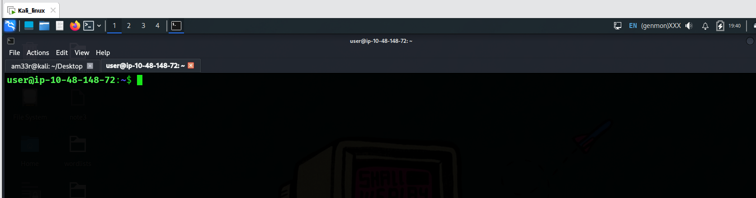
Use hashcat to crack the hash, $2a$06$7yoU3Ng8dHTXphAg913cyO6Bjs3K5lBnwq5FJyA6d01pMSrddr1ZG, saved in ~/Hashing-Basics/Task-6/hash1.txt.? 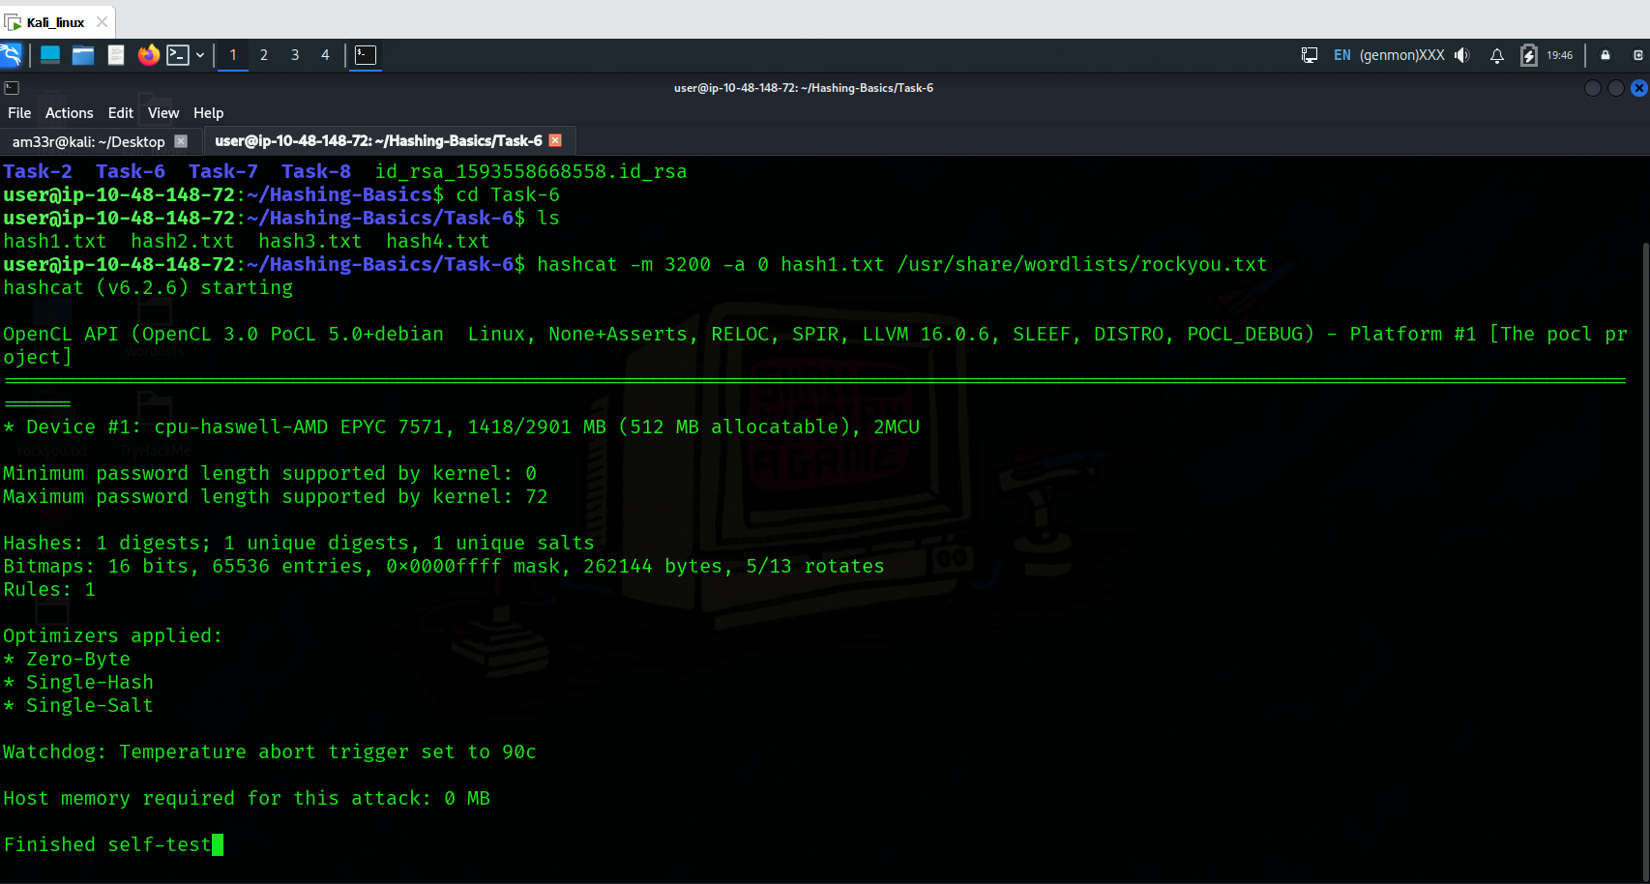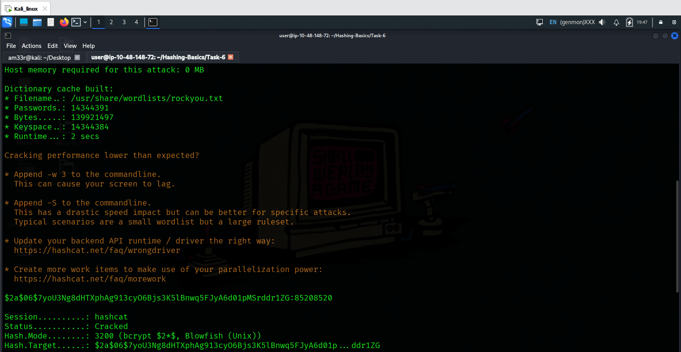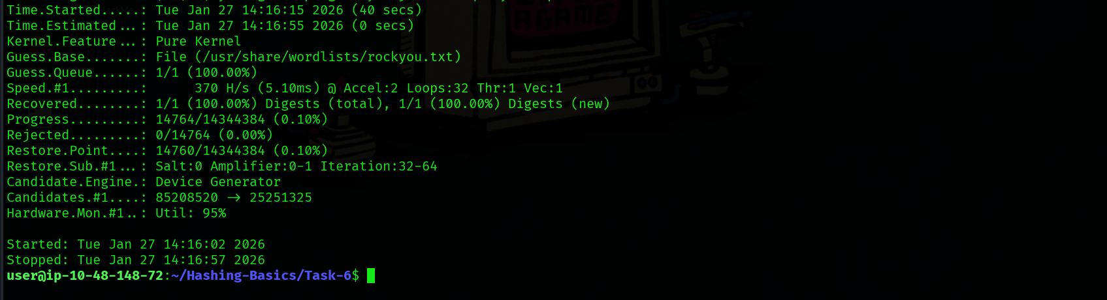
Use hashcat to crack the SHA2-256 hash, 9eb7ee7f551d2f0ac684981bd1f1e2fa4a37590199636753efe614d4db30e8e1, saved in saved in ~/Hashing-Basics/Task-6/hash2.txt.?
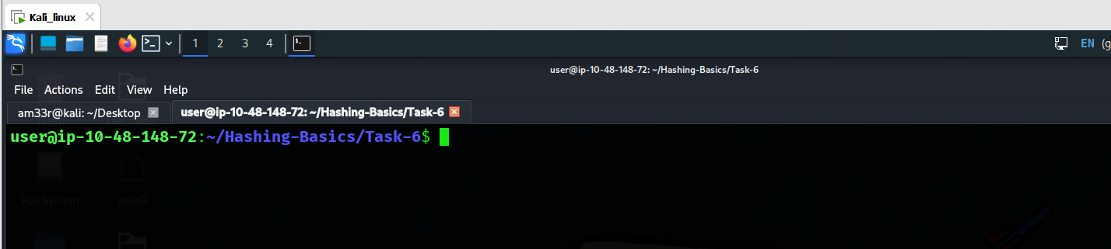
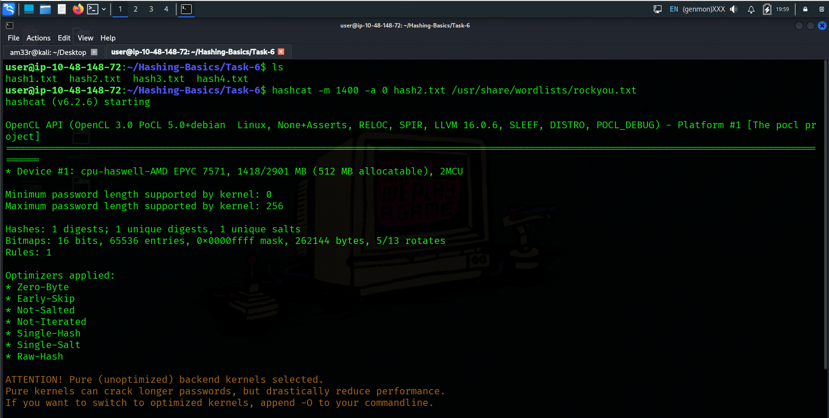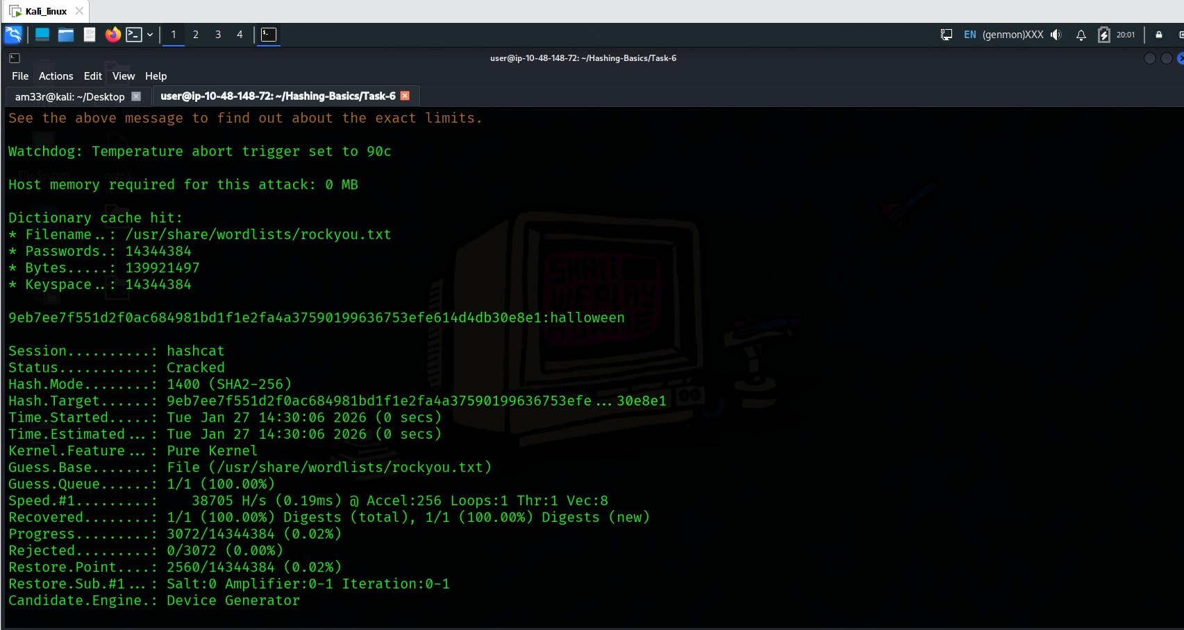

Use hashcat to crack the hash, $6$GQXVvW4EuM$ehD6jWiMsfNorxy5SINsgdlxmAEl3.yif0/c3NqzGLa0P.S7KRDYjycw5bnYkF5ZtB8wQy8KnskuWQS3Yr1wQ0, saved in ~/Hashing-Basics/Task-6/hash3.txt.? 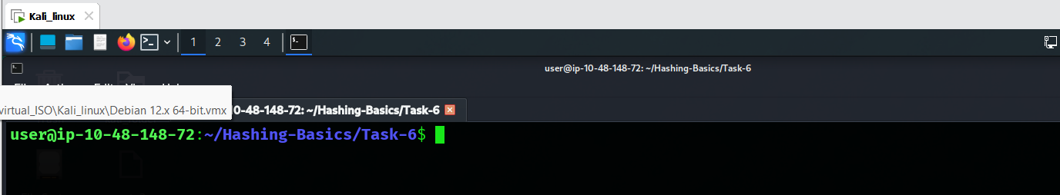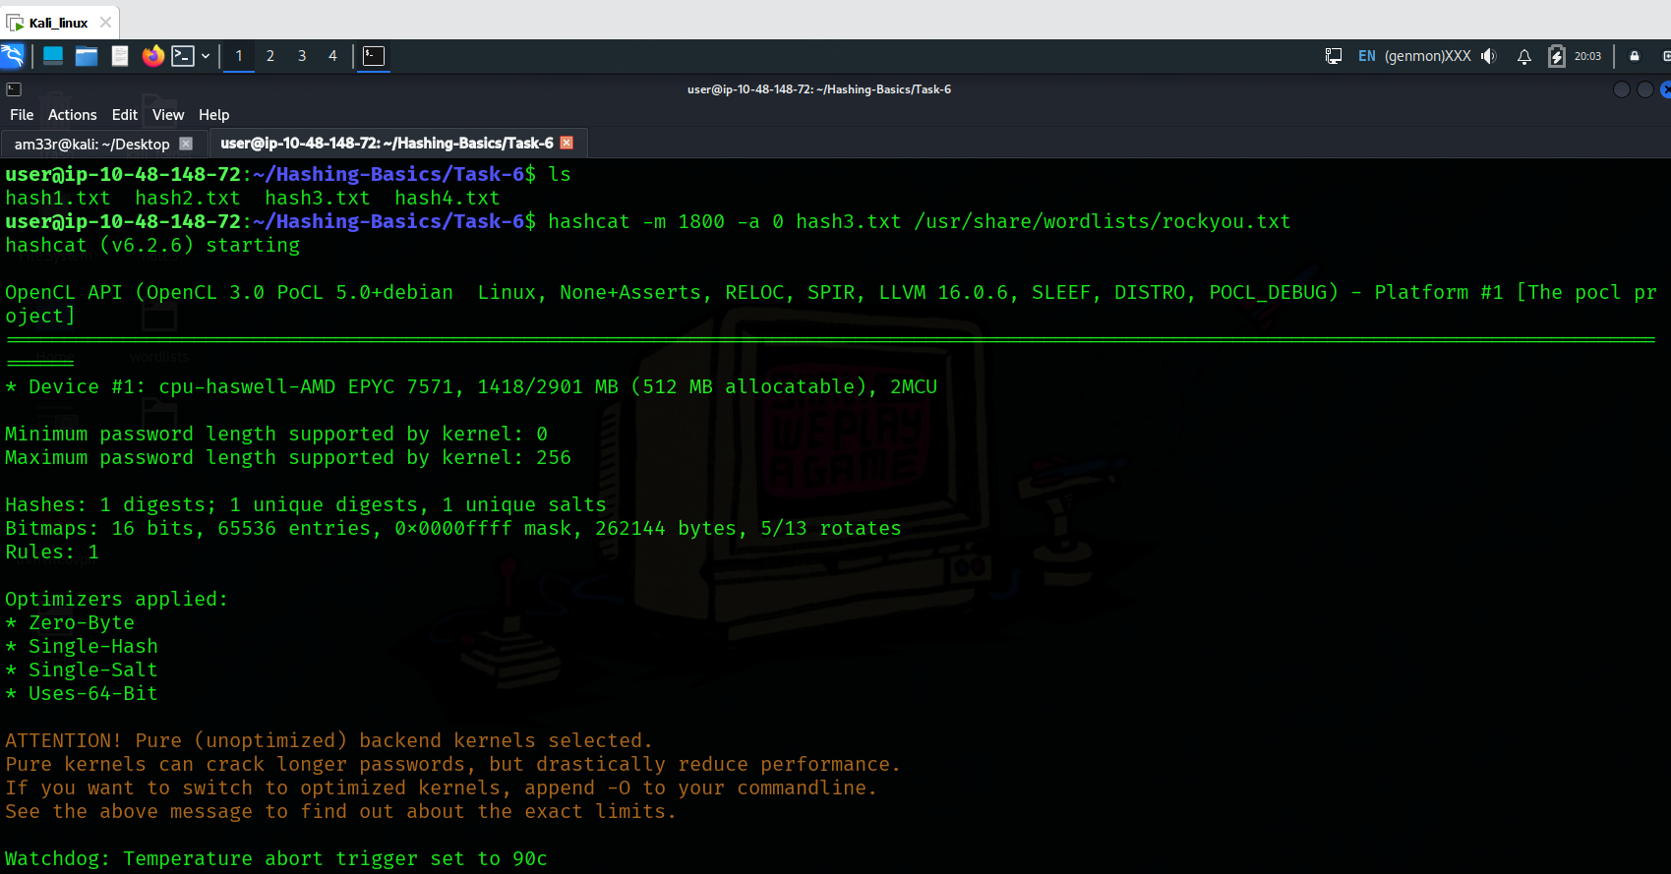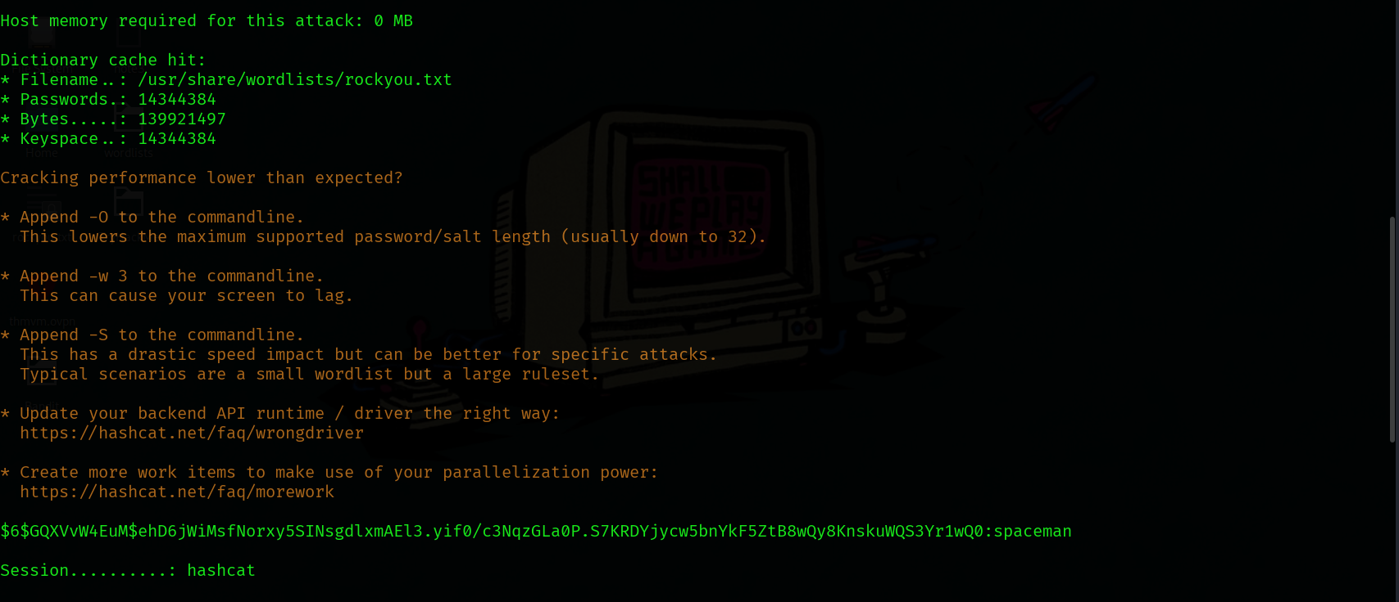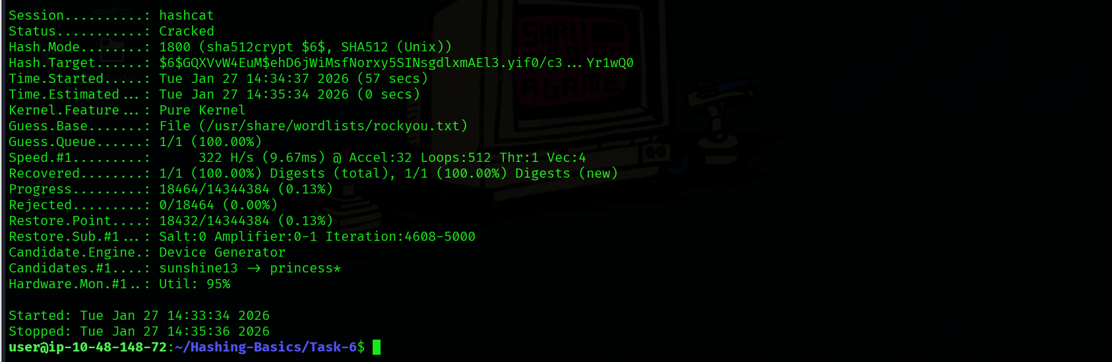

Crack the hash, b6b0d451bbf6fed658659a9e7e5598fe, saved in ~/Hashing-Basics/Task-6/hash4.txt.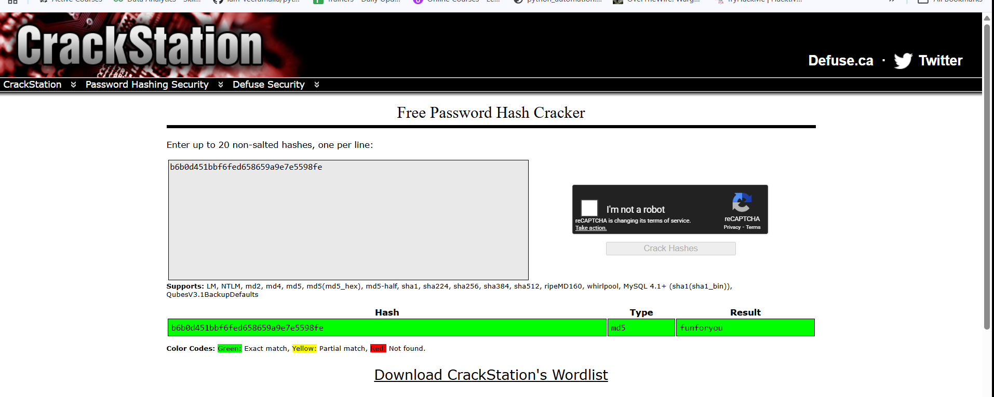

Hashing for Integrity Checking
In Task 3, we mentioned that we would focus on two uses of hashing: password storage and data integrity. We have extensively discussed how hashing secures passwords in authentication systems. In this task, we will discuss how we can use hash functions to check the integrity of files.

Integrity Checking
Hashing can be used to check that files haven’t been changed. If you put the same data in, you always get the same data out. Even if a single bit changes, the hash will change significantly, as demonstrated in Task 2. This means you can use it to check that files haven’t been modified or to ensure that the file you downloaded is identical to the file on the web server. The text file listed below shows the SHA256 hash of two Fedora Workstation ISO files. If running sha256sum on the file you downloaded returned the same hash listed in this signed file, you can be confident that your file is identical to the official one.
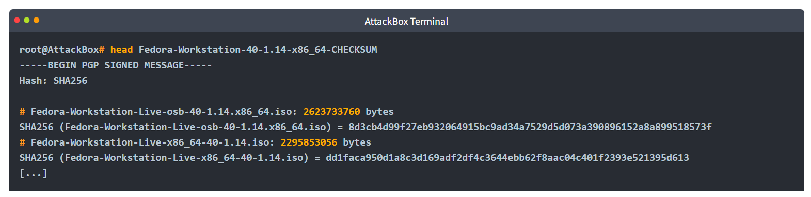
You can also use hashing to find duplicate files; if two documents have the same hash, they are the same document. This is very convenient for finding and deleting duplicate files.

HMACs
HMAC (Keyed-Hash Message Authentication Code) is a type of message authentication code (MAC) that uses a cryptographic hash function in combination with a secret key to verify the authenticity and integrity of data.
An HMAC can be used to ensure that the person who created the HMAC is who they say they are, i.e., authenticity is confirmed; moreover, it proves that the message hasn’t been modified or corrupted, i.e., integrity is maintained. This is achieved through the use of a secret key to prove authenticity and a hashing algorithm to produce a hash and prove integrity.
The following steps give you a fair idea of how HMAC works.
- The secret key is padded to the block size of the hash function.
- The padded key is XORed with a constant (usually a block of zeros or ones).
- The message is hashed using the hash function with the XORed key.
- The result from Step 3 is then hashed again with the same hash function but using the padded key XORed with another constant.
- The final output is the HMAC value, typically a fixed-size string.
The illustration below should clarify the above steps. 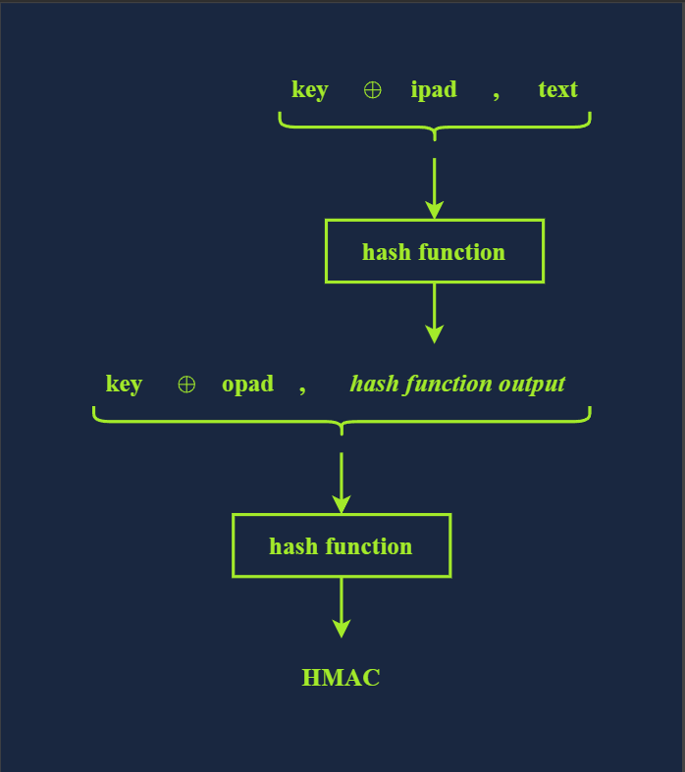
Technically speaking, the HMAC function is calculated using the following expression:
HMAC(K,M) = H((K⊕opad)||H((K⊕ipad)||M))
Note that M and K represent the message and the key, respectively.

Practical:
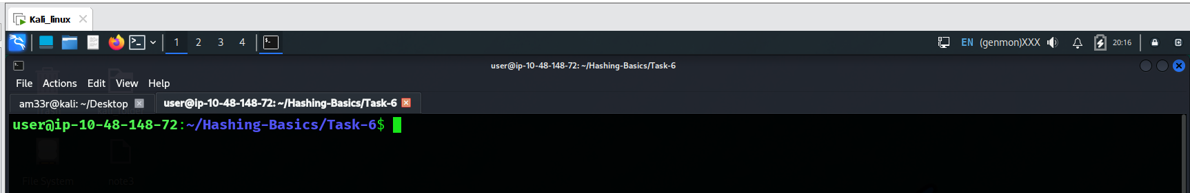
What is SHA256 hash of libgcrypt-1.11.0.tar.bz2 found in ~/Hashing-Basics/Task-7? 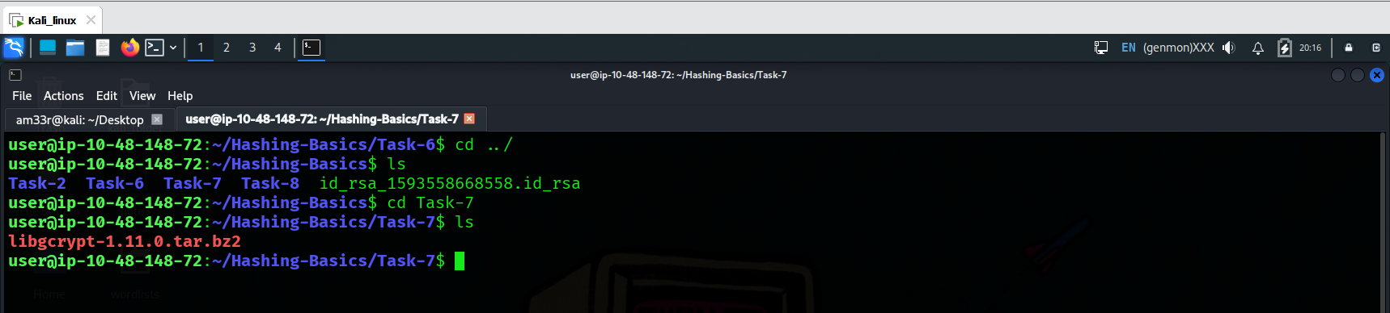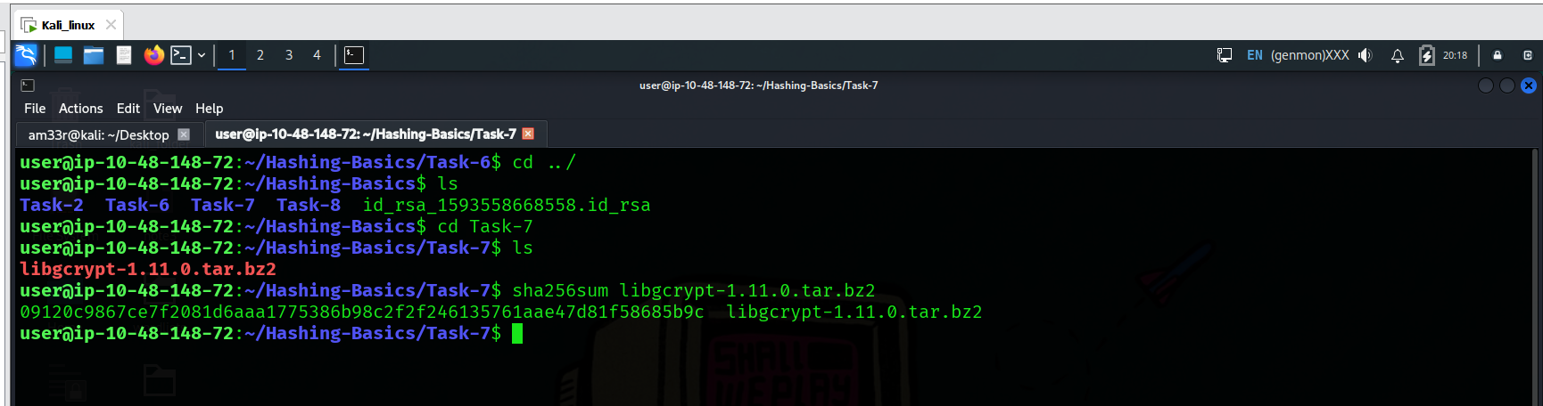
What’s the hashcat mode number for HMAC-SHA512 (key = $pass)?

Conclusion:
This room covered hashing functions and their uses from various perspectives. Before moving on, we should distinguish between hashing, encoding, and encryption.
Hashing, as already stated, is a process that takes input data and produces a hash value, a fixed-size string of characters, also referred to as digest. This hash value uniquely represents the data, and any change in the data, no matter how small, should lead to a change in the hash value. Hashing should not be confused with encryption or encoding; hashing is one-way, and you can’t reverse the process to get the original data.
Encoding converts data from one form to another to make it compatible with a specific system. ASCII, UTF-8, UTF-16, UTF-32, ISO-8859-1, and Windows-1252 are valid encoding methods for the English language. Note that UTF-8, UTF-16, and UTF-32 are Unicode encodings, and they can represent characters from other languages, such as Arabic and Japanese.
Another type of encoding commonly used when sending or saving data is not for any specific language. Examples include Base32 and Base64 encoding. Consider the following example of using base64 to encode and decode.
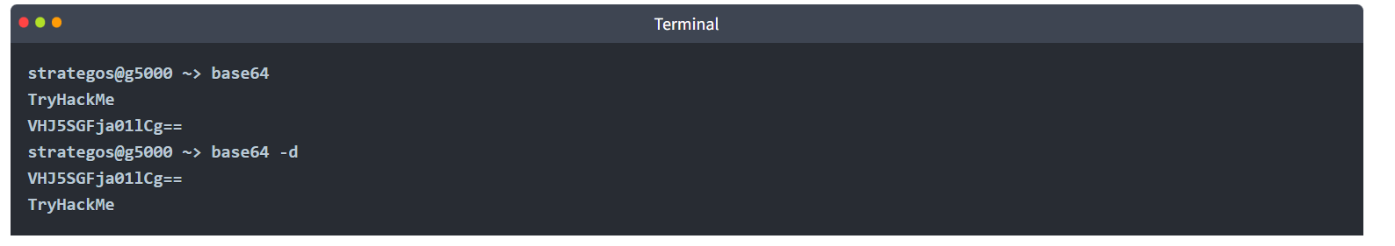
Encoding should not be confused with encryption, as using a specific encoding does not protect the confidentiality of the message. Encoding is reversible; anyone can change the data encoding with the right tools.
Only encryption, which we covered in the previous rooms, protects data confidentiality using a cryptographic cipher and a key. Encryption is reversible, provided we know the cipher and can access the key.
To continue with this module, join John the Ripper; however, if you would like to gain more in-depth information about cryptography, consider this room that dives into more concepts and showcases more tools related to cryptography.

Practical:

Use base64 to decode RU5jb2RlREVjb2RlCg==, saved as decode-this.txt in ~/Hashing-Basics/Task-8. What is the original word?