Introduction
Consider the following scenario from everyday life. Let’s say you are meeting a business partner over coffee and discussing somewhat confidential business plans. Let’s break down the meeting from the security perspective.

- You can see and hear the other person. Consequently, it is easy to be sure of their identity. That’s authentication, i.e., you are confirming the identity of who you are talking with.
- You can also confirm that what you are “hearing” is coming from your business partner. You can tell what words and sentences are coming from your business partner and what is coming from others. That’s authenticity, i.e., you verify that the message genuinely comes from a specific sender. Moreover, you know that what they are saying is reaching you, and there is no chance of anything changing the other party’s words across the table. That’s integrity, i.e., ensuring that the data has not been altered or tampered with.
- Finally, you can pick a seat away from the other customers and keep your voice low so that only your business partner can hear you. That’s confidentiality, i.e., only the authorised parties can access the data.
Let’s quickly compare this with correspondence in the cyber realm. When someone sends you a text message, how can you be sure they are who they claim to be? How can you be sure that nothing changed the text as it travelled across various network links? When you are communicating with your business partner over an online messaging platform, you need to be sure of the following:
- Authentication: You want to be sure you communicate with the right person, not someone else pretending.
- Authenticity: You can verify that the information comes from the claimed source.
- Integrity: You must ensure that no one changes the data you exchange.
- Confidentiality: You want to prevent an unauthorised party from eavesdropping on your conversations.
Cryptography can provide solutions to satisfy the above requirements, among many others. Private key cryptography, i.e., symmetric encryption, mainly protects confidentiality. However, public key cryptography, i.e., asymmetric cryptography, plays a significant role in authentication, authenticity, and integrity. This room will show various examples of how public key cryptography achieves that.
Learning Prerequisites
This room is the second of three introductory rooms about cryptography. Before starting this room, ensure you have finished the first one on the list.
- Cryptography Basics
- Public Key Cryptography Basics (this room)
- Hashing Basics
Learning Objectives
In this room, we will cover various asymmetric cryptosystems and applications that use them, such as:
- RSA
- Diffie-Hellman
- SSH
- SSL/TLS Certificates
- PGP and GPG
First, let’s start the Virtual Machine by pressing the Start Machine button below.

Common Use of Asymmetric Encryption
Exchanging keys for symmetric encryption is a widespread use of asymmetric cryptography. Asymmetric encryption is relatively slow compared to symmetric encryption; therefore, we rely on asymmetric encryption to negotiate and agree on symmetric encryption ciphers and keys.
But the question is, how do you agree on a key with the server without transmitting the key for people snooping to see?
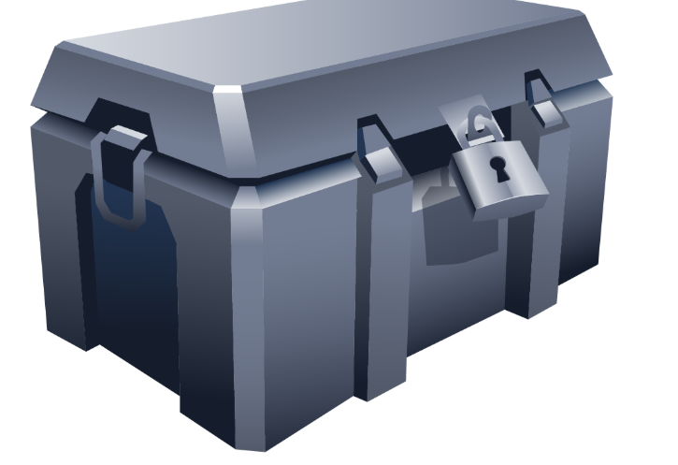

Analogy
Imagine you have a secret code for communicating and instructions for using the secret code. The question is how you can send these instructions to your friend without anyone else being able to read them. The answer is more straightforward than it seems; you could ask your friend for a lock. Only your friend has the key for this lock, and we’ll assume you have an indestructible box you can lock with it.
If you send the instructions in a locked box to your friend, they can unlock it once it reaches them and read the instructions. After that, you can communicate using the secret code without the risk of people snooping.
In this metaphor, the secret code represents a symmetric encryption cipher and key, the lock represents the server’s public key, and the key represents the server’s private key.
Analogy | Cryptographic System
Secret Code | Symmetric Encryption Cipher and Key
Lock | Public Key
Lock’s Key | Private Key

RSA
RSA is a public-key encryption algorithm that enables secure data transmission over insecure channels. With an insecure channel, we expect adversaries to eavesdrop on it.
The Math That Makes RSA Secure
RSA is based on the mathematically difficult problem of factoring a large number. Multiplying two large prime numbers is a straightforward operation; however, finding the factors of a huge number takes much more computing power.
It’s simple to multiply two prime numbers together even on paper, say 113 × 127 = 14351. Even for larger prime numbers, it would still be a feasible job, even by hand. Consider the following numeric example:
- Prime number 1: 982451653031
- Prime number 2: 169743212279
- Their product: 982451653031 × 169743212279 = 166764499494295486767649
On the other hand, it’s pretty tricky to determine what two prime numbers multiply together to make 14351 and even more challenging to find the factors of 166764499494295486767649.
In real-world examples, the prime numbers would be much bigger than the ones in this example. A computer can easily factorise 166764499494295486767649; however, it cannot factorise a number with more than 600 digits. And you would agree that the multiplication of the two huge prime numbers, each around 300 digits, would be easier than the factorisation of their product.

Numerical Example
Let’s revisit encryption, decryption, and key usage in asymmetric encryption. The public key is known to all correspondents and is used for encryption, while the private key is protected and used for decryption, as shown in the figure below.

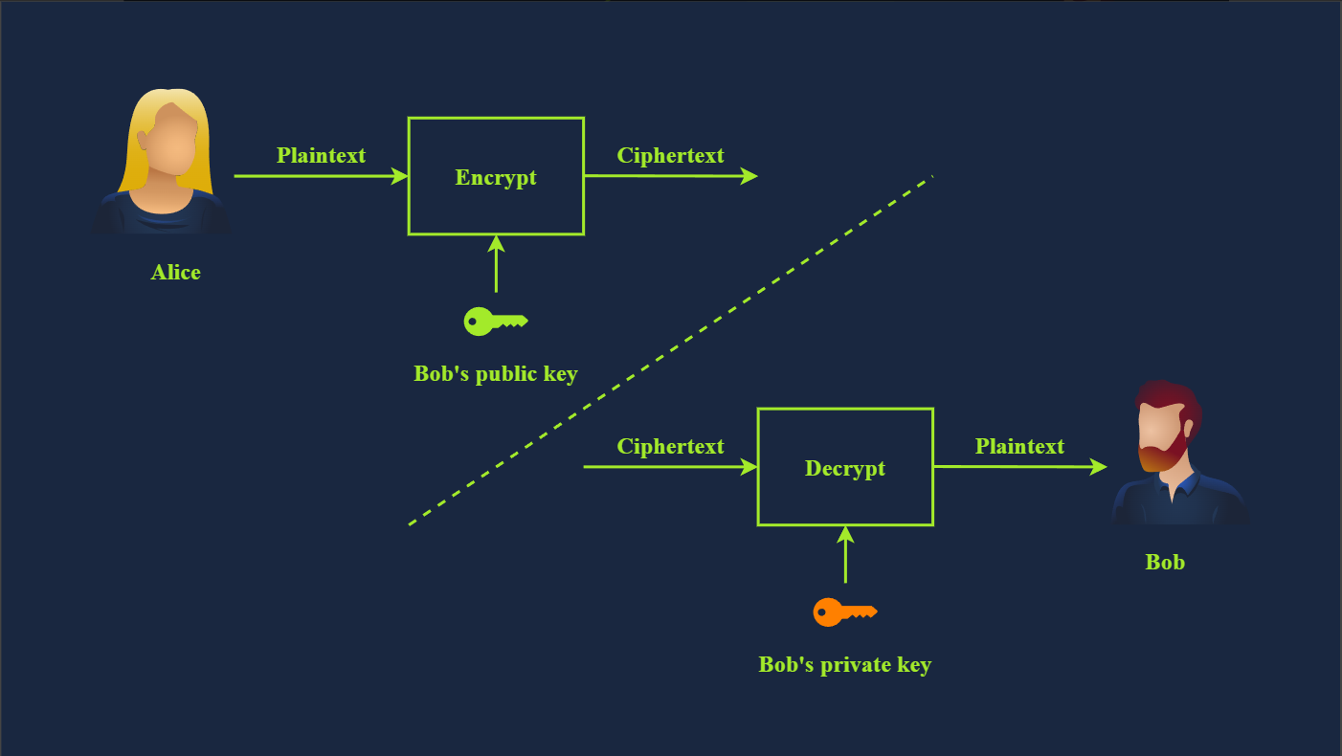
In the Cryptography Basics room, we explained the modulo operation and said it plays a significant role in cryptography. In the following simplified numerical example, we see the RSA algorithm in action:
- Bob chooses two prime numbers: p = 157 and q = 199. He calculates n = p × q = 31243.
- With ϕ(n) = n − p − q + 1 = 31243 − 157 − 199 + 1 = 30888, Bob selects e = 163 such that e is relatively prime to ϕ(n); moreover, he selects d = 379, where e × d = 1 mod ϕ(n), i.e., e × d = 163 × 379 = 61777 and 61777 mod 30888 = 1. The public key is (n,e), i.e., (31243,163) and the private key is $(n,d), i.e., (31243,379).
- Let’s say that the value they want to encrypt is x = 13, then Alice would calculate and send y = x^{e} mod n = 13¹⁶³ mod 31243 = 16341.
- Bob will decrypt the received value by calculating x = y^{d} mod n = 16341³⁷⁹ mod 31243 = 13. This way, Bob recovers the value that Alice sent.
The proof that the above algorithm works can be found in modular arithmetic and is beyond the scope of this module. It is worth repeating that in this example, we picked a three-digit prime number, while in an actual application, p and q would be at least a 300-digit prime number each.

RSA in CTFs
The math behind RSA comes up relatively often in CTFs, requiring you to calculate variables or break some encryption based on them. Many good articles online explain RSA, and they will give you almost all of the information you need to complete the challenges. One good example of an RSA CTF challenge is the Breaking RSA room.
There are some excellent tools for defeating RSA challenges in CTFs. My favourite is RsaCtfTool, which has worked well for me. I’ve also had some success with rsatool.
You need to know the main variables for RSA in CTFs: p, q, m, n, e, d, and c. As per our numerical example:
- p and q are large prime numbers
- n is the product of p and q
- The public key is n and e
- The private key is n and d
- m is used to represent the original message, i.e., plaintext
- c represents the encrypted text, i.e., ciphertext
Crypto CTF challenges often present you with a set of these values, and you need to break the encryption and decrypt a message to retrieve the flag.

Diffie-Hellman Key Exchange
One of the challenges of using symmetric encryption is sharing the secret key. Let’s say you want to send a password-protected document to your business partner to discuss confidential business strategies. How would you share the password with them? It would be best if you had a secure channel to send the password, knowing that adversaries cannot read or alter it.
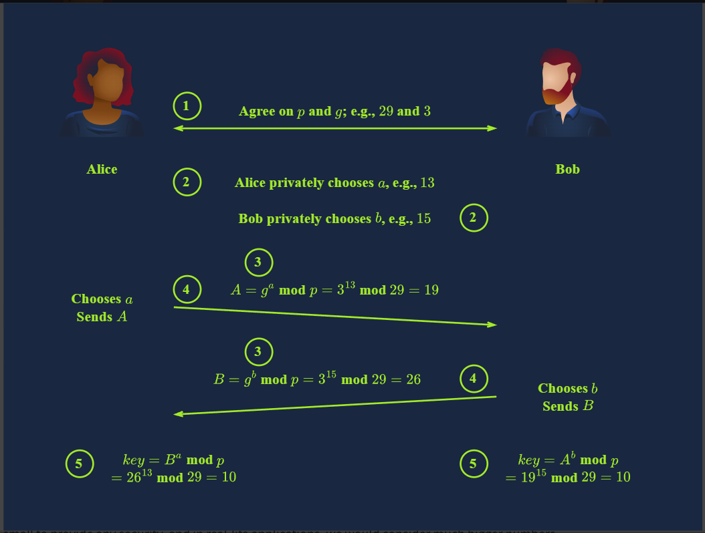
The chosen numbers are too small to provide any security, and in real-life applications, we would consider much bigger numbers.
Diffie-Hellman Key Exchange is often used alongside RSA public key cryptography. Diffie-Hellman is used for key agreement, while RSA is used for digital signatures, key transport, and authentication, among many others. For instance, RSA helps prove the identity of the person you’re talking to via digital signing, as you can confirm based on their public key. This would prevent someone from attacking the connection with a man-in-the-middle attack against Alice by pretending to be Bob. In brief, Diffie-Hellman and RSA are incorporated into many security protocols and standards to provide a comprehensive security solution.

SSH

Authenticating the Server
If you have used an SSH client before, you would know the confirmation prompt in the terminal output below.
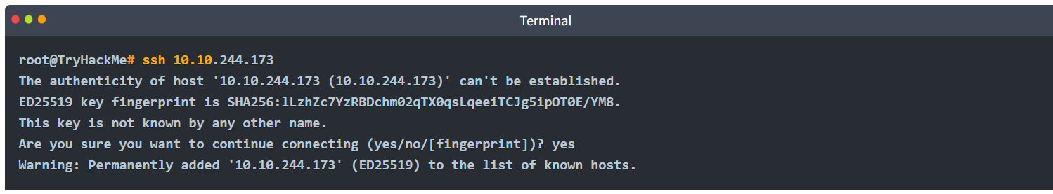
In the above interaction, the SSH client confirms whether we recognise the server’s public key fingerprint. ED25519 is the public-key algorithm used for digital signature generation and verification in this example. Our SSH client didn’t recognise this key and is asking us to confirm whether we want to continue with the connection. This warning is because a man-in-the-middle attack is probable; a malicious server might have intercepted the connection and replied, pretending to be the target server.
In this case, the user must authenticate the server, i.e., confirm the server’s identity by checking the public key signature. Once you answer with “yes”, the SSH client will record this public key signature for this host. In the future, it will connect you silently unless this host replies with a different public key.

Authenticating the Client
Now that we have confirmed that we are talking with the correct server, we need to identify ourselves and get authenticated. In many cases, SSH users are authenticated using usernames and passwords like you would log in to a physical machine. However, considering the inherent issues with passwords, this does not fall within the best security practices.
At some point, one will surely hit a machine with SSH configured with key authentication instead. This authentication uses public and private keys to prove the client is a valid and authorised user on the server. By default, SSH keys are RSA keys. You can choose which algorithm to generate and add a passphrase to encrypt the SSH key.
ssh-keygen is the program usually used to generate key pairs. It supports various algorithms, as shown on its manual page below.
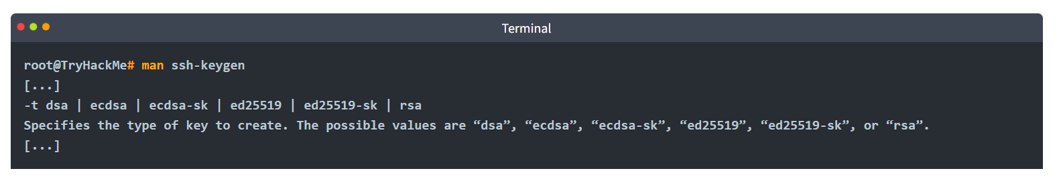
The following is just for your information. At this stage, we recommend that you recognise their names only.
- DSA (Digital Signature Algorithm) is a public-key cryptography algorithm specifically designed for digital signatures.
- ECDSA (Elliptic Curve Digital Signature Algorithm) is a variant of DSA that uses elliptic curve cryptography to provide smaller key sizes for equivalent security.
- ECDSA-SK (ECDSA with Security Key) is an extension of ECDSA. It incorporates hardware-based security keys for enhanced private key protection.
- Ed25519 is a public-key signature system using EdDSA (Edwards-curve Digital Signature Algorithm) with Curve25519.
- Ed25519-SK (Ed25519 with Security Key) is a variant of Ed25519. Similar to ECDSA-SK, it uses a hardware-based security key for improved private key protection.
Let’s generate a key pair with the default options.
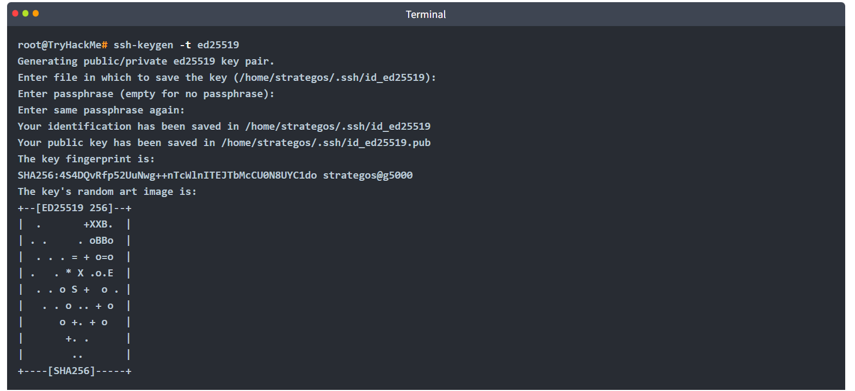
In the above example, we didn’t use a passphrase to show you the content of the private key. Let’s look at the generated public key, id_ed25519.pub, and the generated private key, id_ed25519. 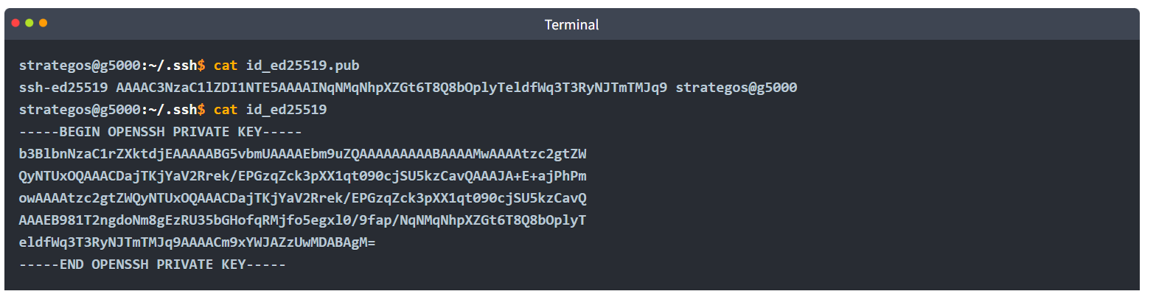
Note that the private key is shared above for demonstration purposes and was purged afterwards. Sharing a private key would be the most insecure act anyone can commit against their security. On another note, had we used -t rsa, the resulting keys would have been much longer.

SSH Private Keys
As just mentioned, you should treat your private SSH keys like passwords. Never share them under any circumstances; they’re called private keys for a reason. Someone with your private key can log in to servers that accept it, i.e., include it among the authorised keys, unless the key is encrypted with a passphrase.
It’s very important to mention that the passphrase used to decrypt the private key doesn’t identify you to the server at all; it only decrypts the SSH private key. The passphrase is never transmitted and never leaves your system.
Using tools like John the Ripper, you can attack an encrypted SSH key to attempt to find the passphrase, highlighting the importance of using a complex passphrase and keeping your private key private.
When generating an SSH key to log in to a remote machine, you should generate the keys on your machine and then copy the public key over, as this means the private key never exists on the target machine using ssh-copy-id. However, this doesn’t matter as much for temporary keys generated to access CTF boxes.
The permissions must be set up correctly to use a private SSH key; otherwise, your SSH client will ignore the file with a warning. Only the owner should be able to read or write to the private key (600 or stricter). ssh -i privateKeyFileName user@host is how you specify a key for the standard Linux OpenSSH client.
Keys Trusted by the Remote Host
The ~/.ssh folder is the default place to store these keys for OpenSSH. The authorized_keys (note the US English spelling) file in this directory holds public keys that are allowed access to the server if key authentication is enabled. By default on many Linux distributions, key authentication is enabled as it is more secure than using a password to authenticate. Only key authentication should be accepted if you want to allow SSH access for the root user.

Using SSH Keys to Get a “Better Shell”
During CTFs, penetration testing, and red teaming exercises, SSH keys are an excellent way to “upgrade” a reverse shell, assuming the user has login enabled. Note that www-data usually does not allow this, but regular users and root will work. Leaving an SSH key in the authorized_keys file on a machine can be a useful backdoor, and you don’t need to deal with any of the issues of unstabilised reverse shells like Control-C or lack of tab completion.

Practical:
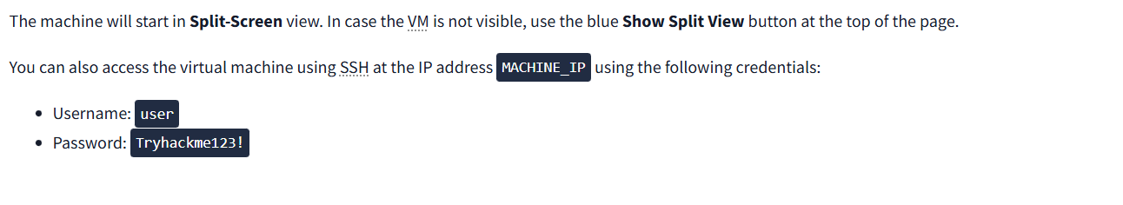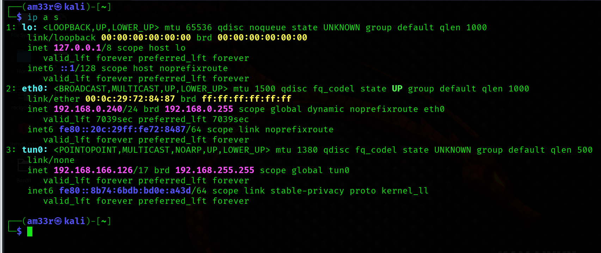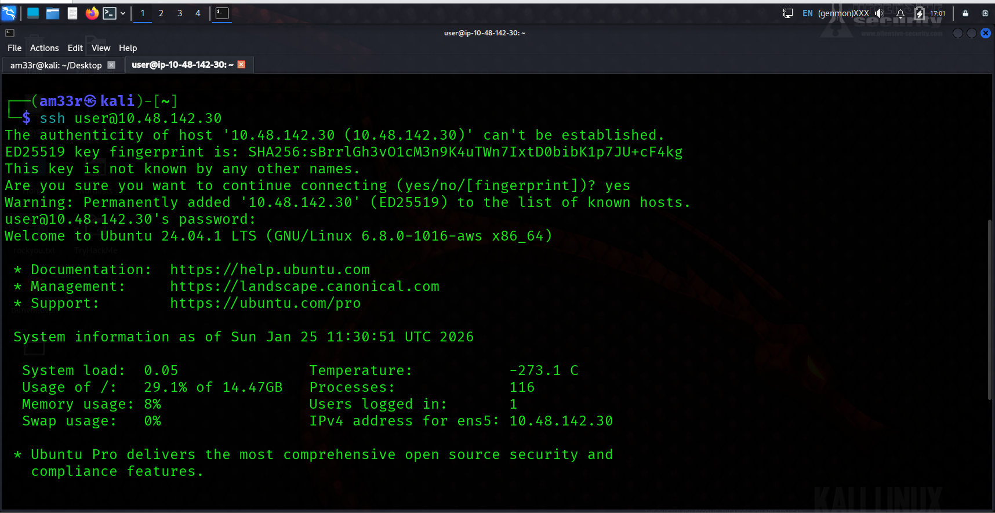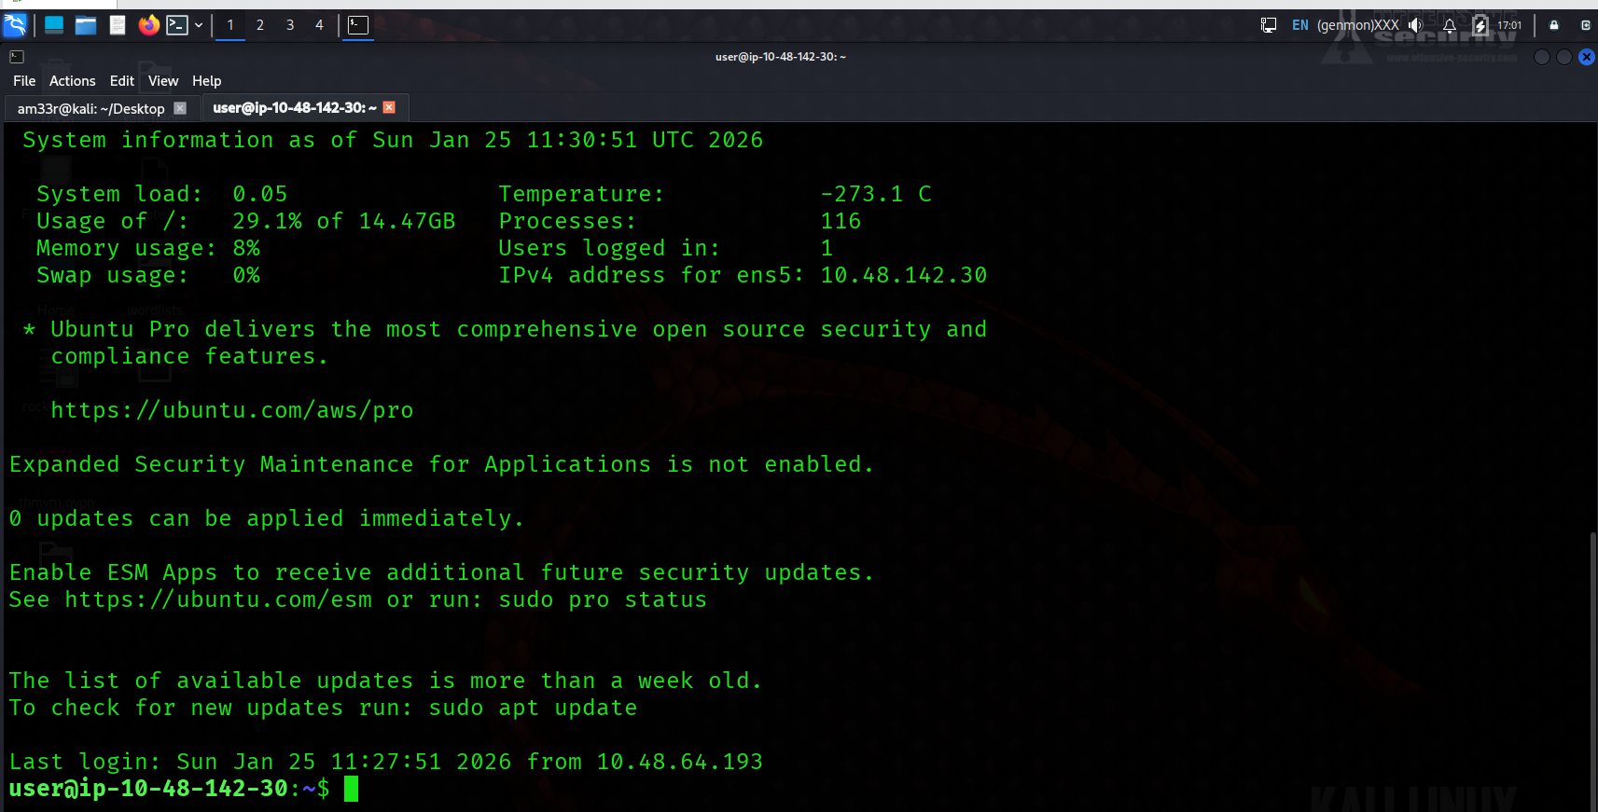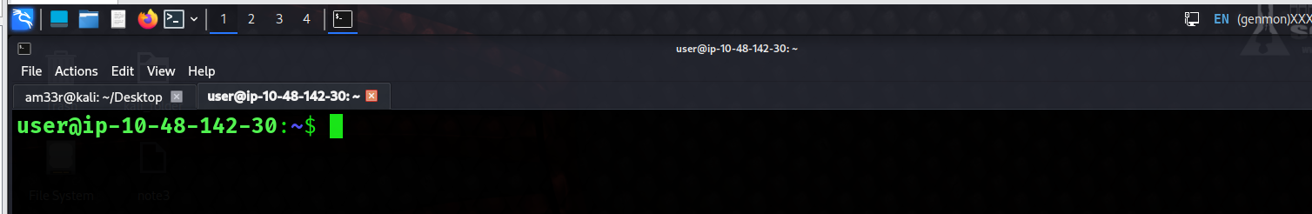
Check the SSH Private Key in ~/Public-Crypto-Basics/Task-5. What algorithm does the key use? 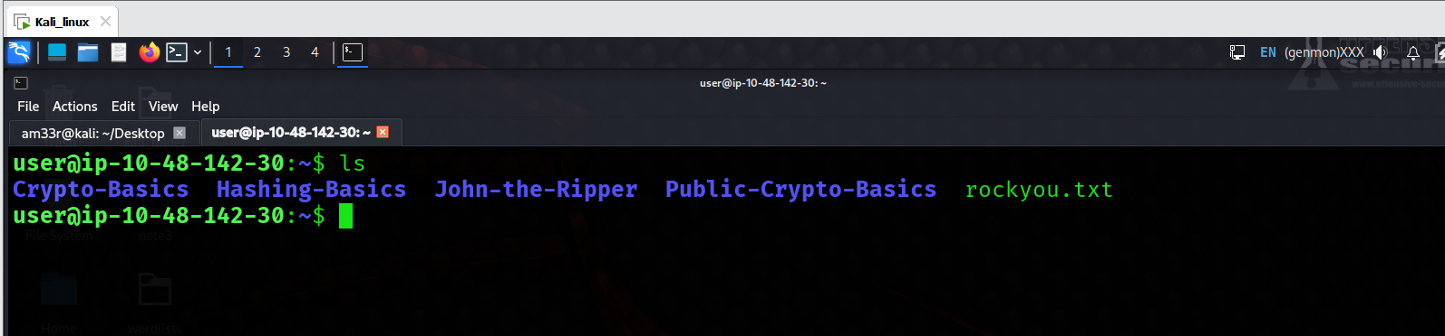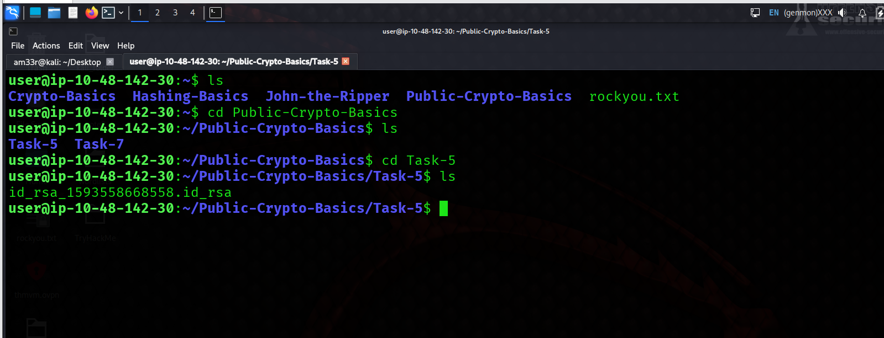

Digital Signatures and Certificates
In the “analogue” world, you are asked to sign a paper now and then. When you visit the bank to open a savings account, you are most likely asked to sign several documents. When you want to create an account at the local library, you will be asked to fill out and sign the application. The purpose can vary depending on the situation. For example, it can confirm that you agree to the terms and conditions, authorise a transaction, or acknowledge receiving an item. In the “digital” world, you cannot use your signature, stamp or fingerprint; you need a digital signature.

What’s a Digital Signature?
Digital signatures provide a way to verify the authenticity and integrity of a digital message or document. Proving the authenticity of files means we know who created or modified them. Using asymmetric cryptography, you produce a signature with your private key, which can be verified using your public key. Only you should have access to your private key, which proves you signed the file. In many modern countries, digital and physical signatures have the same legal value.
The simplest form of digital signature is encrypting the document with your private key. If someone wants to verify this signature, they would decrypt it with your public key and check if the files match. This process is shown in the image below. 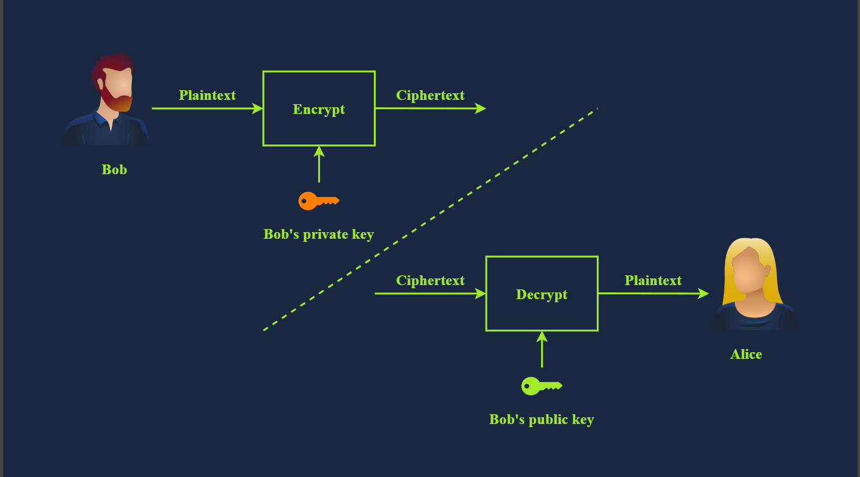

PGP and GPG
PGP stands for Pretty Good Privacy. It’s software that implements encryption for encrypting files, performing digital signing, and more. GnuPG or GPG is an open-source implementation of the OpenPGP standard.
GPG is commonly used in email to protect the confidentiality of the email messages. Furthermore, it can be used to sign an email message and confirm its integrity.
Below is an example of generating GPG. You are asked about the purpose of using gpg, whether signing only or signing and encrypting. Besides selecting the cryptographic algorithm, we needed to choose an expiry date for the generated key. Finally, we provided some information about us: our name, email address, and a comment usually about the purpose of this key.
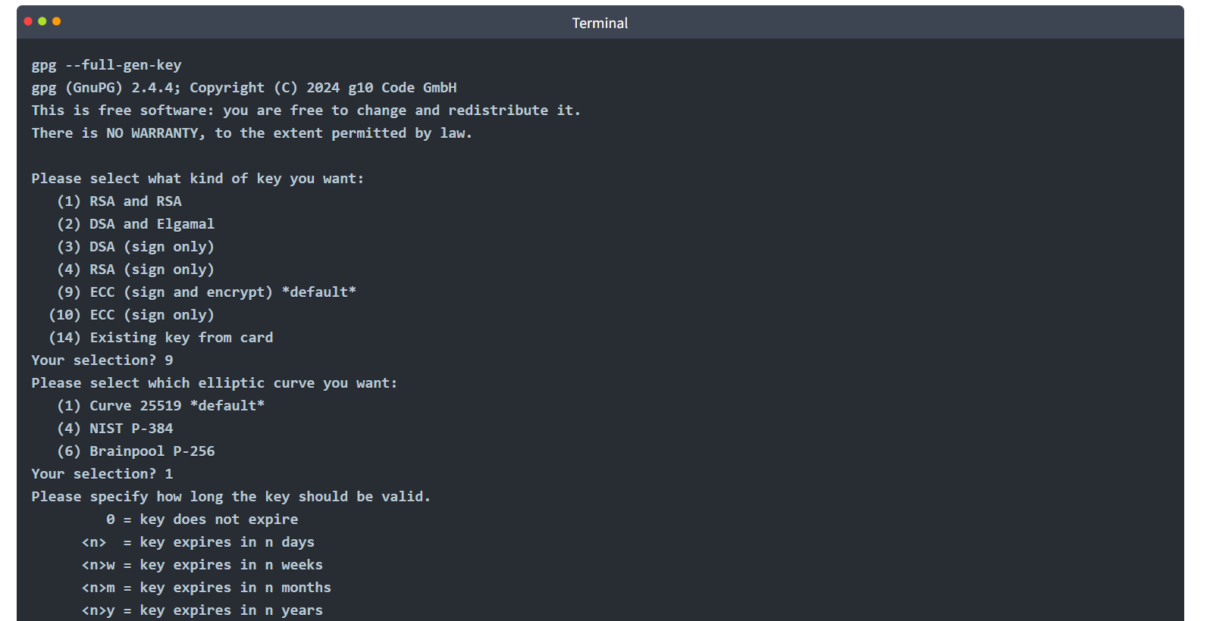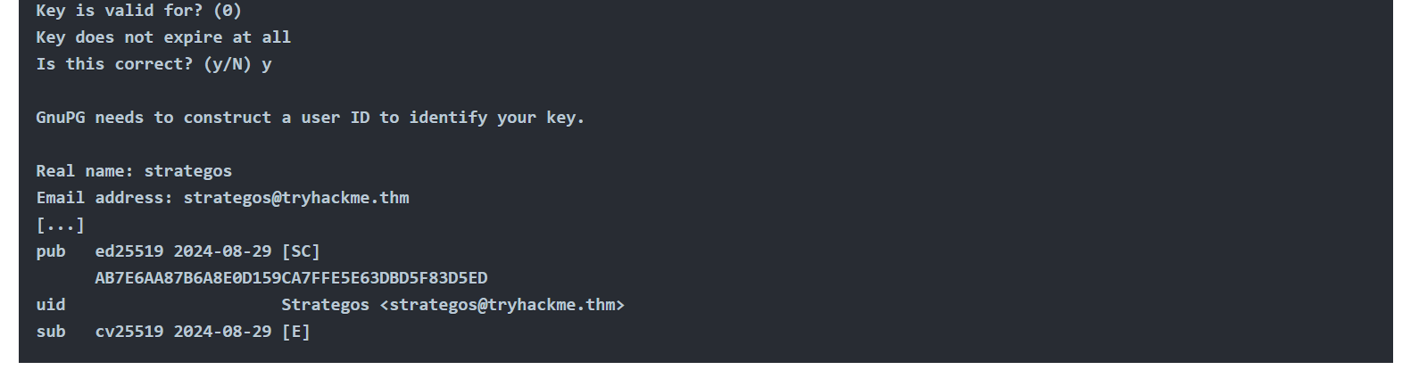
You may need to use GPG to decrypt files in CTFs. With PGP/GPG, private keys can be protected with passphrases in a similar way that we protect SSH private keys. If the key is passphrase protected, you can attempt to crack it using John the Ripper and gpg2john. The key provided in this task is not protected with a passphrase. The man page for GPG can be found online here.

Practi﻿cal Example
Now that you have your GPG key pair, you can share the public key with your contacts. Whenever your contacts want to communicate securely, they encrypt their messages to you using your public key. To decrypt the message, you will have to use your private key. Due to the importance of the GPG keys, it is vital that you keep a backup copy in a secure location.
Let’s say you got a new computer. All you need to do is import your key, and you can start decrypting your received messages again:
- You would use gpg --import backup.key to import your key from backup.key
- To decrypt your messages, you need to issue gpg --decrypt confidential_message.gpg

Use GPG to decrypt the message in ~/Public-Crypto-Basics/Task-7. What secret word does the message hold? 